Cincinnati & Covington Urban Development

Assessing Urban Heat in the Cincinnati and Covington Area using NASA Earth Observations

 **Technical Report**

Final Draft – March 30th, 2021

Paxton LaJoie (Project Lead)

Olivia Cronin-Golomb

Samuel Feibel

Katrina Rokosz

***Advisors:***

Dr. Cedric Fichot, Boston University (Science Advisor)

Dr. Kenton Ross, NASA Langley Research Center (Science Advisor)

# 1. Abstract

The Urban Heat Island (UHI) effect is a phenomenon characterized by urban areas experiencing temperatures that are, on average, warmer than surrounding suburban and rural regions. UHIs are fueled by expansive impervious surfaces, vehicle emissions, and insufficient urban green space. They can have negative health impacts on densely populated urban centers like Cincinnati, Ohio and Covington, Kentucky. NASA DEVELOP partnered with Groundwork USA and Groundwork Ohio River Valley (ORV) to combine environmental education and outreach with analyses of NASA Earth observations for the summers of 2010 - 2020. The DEVELOP team used Landsat 5 Thematic Mapper (TM) and ISS ECOsystem Spaceborne Thermal Radiometer Experiment on Space Station (ECOSTRESS) to calculate daytime and nighttime land surface temperature anomalies. The team found that the Cincinnati and Covington area is 8.32°F warmer during the day and 4.97°F warmer at night compared to non-urban areas. The team used the Natural Capital Project Integrated Valuation of Ecosystem Service and Tradeoffs (InVEST) Urban Cooling Model to map a heat mitigation index for the study area. The resulting maps show which communities are most vulnerable to impacts of increased urban heat. The team also assessed alternative tree canopy and albedo scenarios with the InVEST model to better understand the effectiveness of potential heat mitigation strategies. The team found that on a city scale, increasing tree cover was a more effective heat mitigation strategy than increasing albedo. This research provides partners at Groundwork USA and ORV with refined methodologies to support future education and outreach.

**Key Terms**

heat mitigation, land surface temperature anomalies, climate preparedness, ECOSTRESS, InVEST Urban Cooling Model, environmental justice

# 2. Introduction

***2.1 Background Information***

The Urban Heat Island (UHI) effect is the difference in temperature between warm urban areas and the cooler natural surrounding environment (Phelan et al., 2015). Differences in land surface temperature (LST) as large as 12° C have been observed due to the UHI effect (Tran et al., 2006). The intensity of UHIs and the number of people affected by UHIs is increasing annually as global urbanization continues (Phelan et al., 2015). UHIs pose an imminent public health risk, increasing respiratory hospital admission rates and heat-related health issues and mortalities (Michelozzi et al., 2009; U.S. Environmental Protection Agency [EPA], 2006).

Heat islands form as a combined result of solar radiation and heat waste from urban energy consumption. Surface materials found in urban environments, such as asphalt, often have low albedos, a measure of the proportion of radiation reflected by a surface. This means that these surfaces easily absorb solar radiation and transform it into sensible heat (Gago et al., 2013). During the day dark, opaque urban surfaces accumulate and store heat which is then slowly released at night (Gago et al., 2013; Natural Capital Project, 2021). Urban vegetation is also an important factor in urban heat management. City parks, urban green spaces, and green roofs help reduce daytime and nighttime LST through shading and evapotranspiration (Loughner et al., 2012; Taha, 1997).

With rapid urbanization occurring on a global scale, it is increasingly important to identify UHI extent in order to protect vulnerable populations. Remote sensing offers a unique, reliable method to assess UHI extent and utilize LST data to identify urban heat anomalies. The spring 2021 NASA DEVELOP project utilized the Landsat 5 Thematic Mapper (TM) and the International Space Station (ISS) Ecosystem Spaceborne Thermal Radiometer Experiment on Space Station (ECOSTRESS) to measure evapotranspiration, albedo, and LST across the study area.

In addition to using remote sensing data to identify urban heat anomalies, the team input Earth observation and ancillary data into the Integrated Valuation of Ecosystem Services and Tradeoffs (InVEST) Urban Cooling Model (Natural Capital Project, 2021). InVEST is a suite of open-source software models used to evaluate and map ecosystem services to better understand how ecosystem changes affect the relationship between humans and the environment. The Urban Cooling Model incorporates factors such as land use-land cover (LULC), evapotranspiration, albedo, shade, building intensity, and UHI magnitude to produce a map of heat mitigation index (HMI). HMI assesses the cooling capabilities of an area, incorporating the effect nearby greenspaces have on that area’s ability to mitigate heat. Identifying UHI extent and targeting areas most likely to benefit from UHI mitigation efforts is a pivotal first step in mitigating negative UHI impacts.

***2.2 Study Area***

The neighboring areas of Cincinnati, Ohio and northern Kenton County, Kentucky are densely populated urban spaces along the Ohio River with local communities vulnerable to extreme heat. Cincinnati has begun mitigating UHI impacts through their Green Cincinnati Plan (City of Cincinnati, 2018) and programs such as the Green Roof Loan Program (Project Groundwork, 2011). However, understanding the spatial distribution of urban heat vulnerabilities within the area will build local capacity for city-specific resilience planning. Based on project partner input, Cincinnati, Ohio and northern Kenton County, Kentucky were selected as the study area for this project.

The study area was limited to the 2010 city limits of Cincinnati, including the municipalities of Norwood, St. Bernard, and the village of Elmwood Place (Figure 1; ArcGIS Hub, 2010). The three areas, though administratively separate from Cincinnati,were included due to their geographic location within the boundaries of Cincinnati. The Kentucky portion of the study area was limited to the region of northern Kenton County between Interstate 275 and the Ohio River to reflect areas prioritized by partner input.

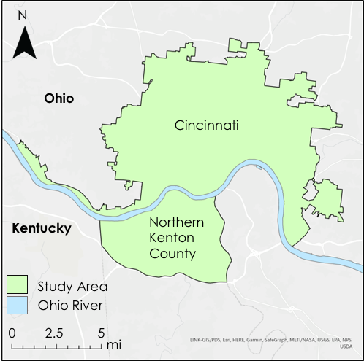

*Figure 1.* Study area map showing Cincinnati, OH and Northern Kenton County, KY.

***2.3 Project Partners & Objectives***

Groundwork USA and Groundwork Ohio River Valley (ORV) partnered with the spring 2021 MA – Boston DEVELOP team to complete this project. Groundwork USA, a network of nonprofit organizations, focuses on the regeneration, improvement, and management of urban spaces to help mitigate environmental, economic, and social inequalities within marginalized communities. Groundwork ORV, based in Cincinnati, is focused on expanding environmental awareness and environmental justice through the communication of spatial data. Both Groundwork USA and ORV use basic NASA Earth observations and geographic information systems mapping, though their previous work specialized in utilizing social and demographic data rather than remote sensing products. This work will be used to help integrate new NASA Earth observations into their decision-making processes.

The DEVELOP team’s primary goal for the term was to calculate a HMI, the cooling capacity, and UHI extent for the study area using the National Capital Project InVEST Urban Cooling Model. The DEVELOP team also calculated daytime and nighttime LST anomalies using NASA Earth observation data between June 2010 and August 2012. In addition, the team updated and refined urban heat monitoring methodologies to provide partners with a standard operating procedure (SOP). This SOP will be used by partners to produce consistent and reproducible vulnerability maps for Groundwork partner-cities nationwide.

# 3. Methodology

***3.1 Data Acquisition***

Earth observation data were acquired for the summer months, defined as June 1st through August 31st, of 2010 – 2012. Landsat 5 Surface Reflectance Tier 1 satellite imagery was retrieved and processed to calculate albedo and daytime LST in Google Earth Engine (GEE) (Table 1). ISS-ECOSTRESS nighttime LST and corresponding cloud mask Level 2 data were downloaded from NASA Application for Extracting and Exploring Analysis Ready Samples (AppEEARS) for 2018 – 2020 (Table 1; Hook & Hulley, 2019). Level-3 ISS-ECOSTRESS evapotranspiration satellite imagery was also downloaded from NASA AppEEARS for 2018 – 2020 (Table 1; Hook & Fisher, 2019).

Table 1

*Description of Earth observations and imagery used in data processing*

|  |  |  |  |  |  |
| --- | --- | --- | --- | --- | --- |
| **Platform** | **Sensor** | **Product ID** | **Dates** | **Purpose** | **Source** |
| Landsat 5 | TM  (6 Bands: Red, Blue, Near-infrared, Shortwave infrared 1&2, Brightness temperature) | LANDSAT/LT05/C01/T1_SR  USGS Landsat 5 Surface Reflectance Tier 1 | June 1st – August 31st of 2010, 2011, 2012 | Calculate daytime LST for input into InVEST | GEE |
| ISS-ECOSTRSS | N/A | ECO2LSTE.001 | June 1st – August 31st of 2018, 2019, 2020 | Calculate nighttime LST and evapotranspiration | AppEEARS |

To prepare the InVEST Urban Cooling Model to compute a HMI across the study area, the team utilized a 2010 USA National Land Cover Database (NLCD) LULC raster dataset. The Ohio-Kentucky-Indiana (OKI) Regional Council of Governments provided this 30m resolution dataset along with 2010 Hamilton County tree canopy cover. The team used this tree canopy data, along with 2012 Kenton County tree canopy cover data provided by Kenton County’s Planning and Development Services (PDS), to extract shade values for input to the Urban Cooling Model biophysical table. Additionally, OKI Regional Council of Governments and Kenton County’s PDS provided building footprint shapefiles which the team used to calculate building intensity for the nighttime LST calculation. To estimate heat reduction, the team used Yale University’s Global Surface UHI explorer to select daytime and nighttime UHI magnitudes as inputs to the Urban Cooling Model.

***3.2 Data Processing for InVEST Urban Cooling Model***

The primary outputs of the InVEST model were HMI rasters. The daytime HMI raster relied on weighted factors of shade, albedo, evapotranspiration, and distance from green spaces as predictors of temperature. The nighttime model required values for building intensity linked to each LULC class to predict nighttime temperature. Shade, albedo, and evapotranspiration were given the default weighting factors of 0.6, 0.2, and 0.2 respectively, which were recommended by the InVEST documentation. Both analyses required an Air Temperature Maximum Blending Distance and Baseline Air Temperature. The Air Temperature Maximum Blending Distance was given the default value of 2000m recommended by the InVEST documentation. The mean daytime and nighttime LST values for the Cincinnati and Northern Kenton County area were used as proxies for the Baseline Air Temperature.

*3.2.1 Daytime LST and Nighttime LST*

Daytime LST was calculated from Landsat 5 Surface Reflectance Tier 1 data by modifying a script developed by the NASA DEVELOP spring 2020 AZ Philadelphia Health and Air Quality team in GEE. The script first filtered the collection to include only 2010 – 2012 summer imagery and then filtered cloud pixels by applying a cloud mask to each image based on the quality assurance band.

Although Landsat 5 has a Provisional Surface Temperature product, it is not yet available in GEE. The team therefore applied a script utilizing Normalized Difference Vegetation Index (NDVI)-based Land Surface Emissivity (LSE) model to calculate LST (Zhang et al., 2006). The NDVI-derived LSE was used with the brightness temperature band on Landsat 5 to calculate LST [Kelvin] (Gianni, Belfiore, Parente, & Santamaria, 2015):

LST [K] = BT/(1+(0.0000115 x (BT/0.01438) x lnE)) (1)

where BT is brightness temperature [Kelvin] and E is Emissivity [unitless]. LST was then converted into Fahrenheit. The team created a mean LST image for the study period by averaging the LST derived for each pixel across the entire collection.

In this project, we used Nighttime LST from ECOSTRESS for 2018 – 2020 as the proxy data for the study period 2010 – 2012. Nighttime LST was processed in RStudio 4.0.0 by first filtering the downloaded ECOSTRESS LST collection to only include summer nighttime imagery, which returned 10 images. Nighttime was defined as 22:00 – 03:59 Eastern Standard Time. Pixels covered by clouds or cloud shadows were masked out using the corresponding ECOSTRESS QC collection. Mean nighttime LST was calculated for each pixel across the study period to create a single mean nighttime LST image.

*3.2.2 LULC*

The InVEST model used the LULC raster cell resolution to determine the resolution of the output files. The team used a pre-classified 30m resolution NLCD LULC raster file that needed no additional processing to run the model because the extent of the dataset contained the entire study area (Figure 2). This raster served as the central dataset for the biophysical table, where the team linked data on shade, crop evapotranspiration, albedo, building intensity, and green area classification to each unique LULC class.

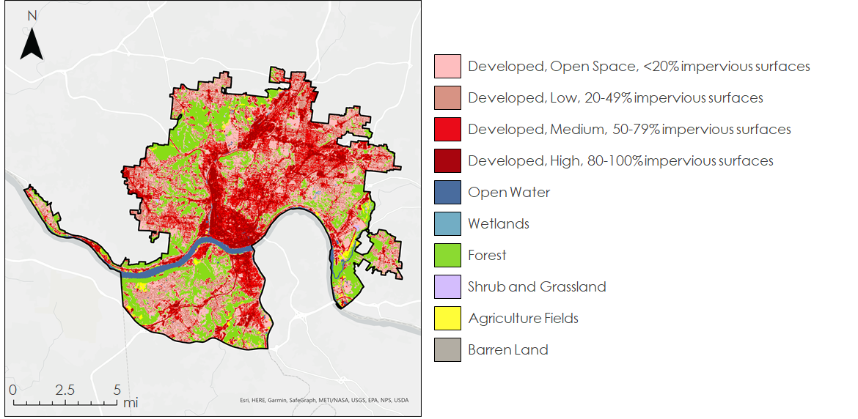

*Figure 2.* Map of the spatial distribution of LULC classes throughout the study area generated by the NLCD.

*3.2.3 Building Intensity*

Building footprint shapefiles and Lidar data provided by OKI Regional Council of Governments and Kenton County’s PDS were utilized to extract values for building heights within the study area. Building intensity captures the vertical dimension of built infrastructure and factors the number of floors per building separated out by landcover class within the given study area. It is a predictor of nighttime temperatures because the buildings store heat during the day and re-emit the heat throughout the night. To calculate building intensity for each LULC class in the biophysical table, a normalized value between 0 and 1, the team divided the cumulative floor area of each building in each LULC class by the overall LULC land area:

BI [unitless] = Σ(BA × F) / LA (2)

where BI is building intensity for each LULC class, BA is building rooftop area for each LULC class [m2], F is number of floors [unitless], and LA is area of each LULC class [m2].

Since building height data was only available for each building footprint polygon, the team relied on estimations to determine floor area for input to the InVEST model. The team first determined the average ceiling height for each building, designating each floor to be 7.5 feet high in residential buildings and 10 feet high in commercial buildings (Chun & Guldmann, 2012), then divided building height by ceiling height to estimate the number of floors in each building. These values were rounded to the nearest whole number, and zeroes replaced with a 1. Number of floors was multiplied by building footprint area to arrive at floor area. After calculating building intensity, the team performed a spatial join to link building intensity to LULC pixels to produce a set of values to include in the biophysical table.

*3.2.4 Shade*

Shade is another necessary input for the InVEST Urban Cooling Model. In accordance with the model requirements, the team used tree canopy cover as a proxy for shade by calculating the proportion of tree canopy cover within each LULC class. This value ranged from 0 to 1, with 0 representing no tree canopy cover and 1 representing full cover. The team used a 2012 Kenton County Forested Areas canopy cover raster (converted to vector) and a 2010 Hamilton County canopy raster (converted to vector) to calculate a mean tree canopy cover value for each LULC class via the Summarize Within Analysis tool in ArcGIS Pro. The resolution of this canopy data was 6.25 square meters. The team added these values to the biophysical table.

*3.2.5 Albedo*

Albedo, measured on a unitless scale between 0 and 1, is the fraction of incident irradiance reflected by a surface (Taha et al., 1997). The Landsat 5 Surface Reflectance Tier 1 collection of cloud-masked, summer imagery used to calculate daytime LST was also used to calculate albedo using the NASA DEVELOP spring 2020 AZ Philadelphia Health and Air Quality GEE script (Nisbet-Wilcox et al., 2020). This script uses empirically-derived weighting coefficients from Tasumi et al., 2008:

Albedo [unitless] = (0.254*B1) + (0.149*B2) + (0.147*B3) + (0.311*B4) + (0.103*B5) + (0.036*B7) (3)

where B1 refers to band 1 (red), B2 refers to band 2 (green), B3 refers to band 3 (blue), B4 refers to band 4 (near-infrared), B5 refers to band 5 (shortwave infrared 1), and B7 refers to band 7 (shortwave infrared 2) from Landsat 5 TM. The team calculated a mean albedo value for the 2010 – 2012 study period for each pixel within the collection for each LULC class using the Zonal Statistics tool in ArcGIS Pro Spatial Analyst. The results were incorporated into the biophysical table.

*3.2.6 Evapotranspiration*

The evapotranspiration dataset was manually filtered in Esri ArcGIS Pro to only include images that aligned with the criteria defined in section 3.1 Data Acquisition. The evapotranspiration values of cells in the remaining imagery were averaged using the Cell Statistics tool and then converted from W m-2 to mm day-1, as required by the InVEST tool:

ETA [mm day-2] *=* ETB [W m-2] * 0.0864 [MJ day-1]/[W] * 0.408 [mm day-1]/[ MJ day-1 m-2] (4)

where ETA and ETB are the numerical values of the evapotranspiration rate in unit of [mm day-1] and [W m-2] respectively. The evapotranspiration product applies a water mask to its imagery, thus the resulting raster had ‘no data’ values in the Ohio River (Halverson et al., 2019). As the InVEST model requires continuous raster imagery, the team converted all ‘no data’ values to 5.4 mm day-2, which was the minimum value of our mean evapotranspiration raster. This value was selected on the advice of our science advisor, using the logic that compared to any vegetated area water bodies would have the lower evapotranspiration value.

*3.2.7 Crop Evapotranspiration (Kc)*

The InVEST model uses the crop coefficient to estimate actual evapotranspiration from potential evapotranspiration. Potential evapotranspiration represents the maximum attainable quantity of water that can be removed from a surface through evaporation and transpiration. Actual evapotranspiration represents the quantity of water removed from a surface through evaporation and transpiration. The ECOSTRESS evapotranspiration product returns actual, as opposed to potential, evapotranspiration. Therefore, the crop coefficient is included in the processing steps of ECOSTRESS evapotranspiration product (Anderson, 2018). The Kc values required in the biophysical table for each LULC were set to 1 as to not impact the ECOSTRESS-provided actual evapotranspiration.

***3.3 Data Processing for Daytime and Nighttime Temperature Anomalies***

The mean daytime and nighttime LST raster layers were used to identify temperature anomalies throughout the study area. To quantify and visualize the magnitude of temperature anomalies, the team compared the daytime and nighttime LST throughout the study area to non-urbanized reference polygons:

TA [°F] = TSA - TRF (5)

where TA is temperature anomaly [°F], TSA is the temperature of the study area [°F], and TRF is the average temperature of the reference polygons [°F]. The size and location of these polygons were selected using the following criteria: outside study area limits, overlaying largely vegetated areas with the similar latitude and elevation as the study area, and not including large bodies of water or urban corridors such as freeways (Figure 3). Each reference polygon was located less than 50 miles from the study area. The team used local knowledge from project partners to determine areas that would satisfy these criteria.

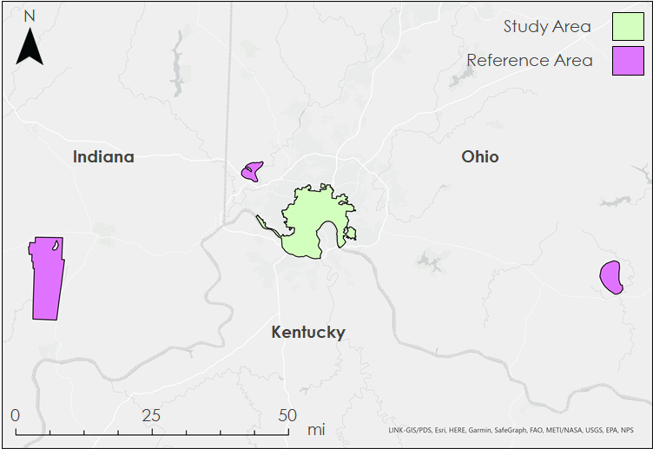

*Figure 3.* Location of reference polygons (pink) in relation to the study area (green) used to generate temperature anomalies.

***3.4 Heat Mitigation Scenarios***

The InVEST Urban Cooling Model offers the potential for decision-makers to visualize hypothetical environmental planning scenarios by changing model inputs. The DEVELOP team ran two potential scenarios involving increasing tree canopy cover in developed areas and enacting a white roof policy to increase building roof albedo. The metrics for these modeled scenarios, such as a 25% increase in canopy cover, were determined arbitrarily, and do not reflect the team’s opinions on potential real-world interventions. The purpose of these experimental model runs was to test the InVEST Urban Cooling Model’s capability of modeling the effects of potential heat mitigation strategies.

*3.5.1 Tree Canopy Cover Scenario*

The first InVEST hypothetical heat mitigation scenario focused on increasing tree canopy cover by a total of 25% across all areas classified as “developed” in the LULC raster file. The team accounted for the practicality of implementing this policy by presuming that tree canopy cover would be easiest to increase in open, slightly developed areas, and hardest to increase in dense, highly developed areas. Therefore, the team increased the modeled tree canopy cover in open developed areas by 35%, in low developed areas by 31%, in medium developed areas by 14%, and in high developed areas by 10%. The percent increases were determined by a model, weighted by the current area of tree canopy cover in each developed class.

*3.4.2 Building Rooftop Albedo Scenario*

The second hypothetical environmental planning scenario focused on a generic white roof policy that would increase the albedo of 25% of the buildings in each of the areas classified as developed by the LULC raster file to 0.9. The adjusted total albedo value was calculated for each developed LULC class in two parts, first by solving for the albedo of the proportion of pixels not covered by buildings:

αn = (αp1 - Pb1 * αb)/ Pn (6)

where αn is the albedo of the pixel not covered in buildings, αp1 is the albedo of the whole pixel before the hypothetical policy has been applied, Pb1 is the proportion of land covered by buildings, αb is the mean albedo of buildings, and Pn is the proportion of land not covered by buildings. Once αn was calculated, Equation 7 was used to calculate the adjusted mean albedo of the pixels (αp2) to model the white roof policy:

αp2 = Pn * αn + Pb2 * αb + Pm * αm  (7)

where Pb2 was adjusted from Equation 6 to exclude the 25% of buildings affected by the albedo increase (Pm) and the albedo of the modeled buildings (αm) was assigned the value of 0.9 (Table A1). The new αp2 calculated for each developed land cover class was then put in the biophysical table and run through InVEST. Equation 7 was used again to run a second hypothetical white roof scenario to increase the albedo of 75% of the buildings in each developed LULC class to 0.9.

# 4. Results & Discussion

***4.1 Analysis of Temperature Anomaly Results***

For both the daytime and nighttime temperature analyses, the Cincinnati and Northern Kenton County area was warmer than the average temperature of the reference polygons (Table 2). The temperature anomaly analyses estimate that the study area is an average of 8.3°F warmer during the day and 5.0°F warmer at night. Some regions of the study area had temperature anomalies reaching 33°F during the day, and 18°F during the night.

Table 2

*Temperature and temperature anomaly results for the study area and reference polygons*

|  |  |  |  |  |  |  |
| --- | --- | --- | --- | --- | --- | --- |
| **Location** | **Study Area** | | **Reference Polygons** | | **Temperature Anomalies** | |
| **Time** | Daytime | Nighttime | Daytime | Nighttime | Daytime | Nighttime |
| **Mean [°F]** | 83 | 70 | 75 | 65 | 8.3 | 5.0 |
| **Minimum [°F]** | 66 | 10 | 68 | 18 | -1.6 | -7.9 |
| **Maximum [°F]** | 120 | 99 | 89 | 81 | 33 | 18 |

Subtracting the mean daytime and nighttime temperatures of the reference polygons from the mean temperature raster of the study area revealed the spatial distribution of temperature anomalies (Figure 4). The temperature anomalies between the minimum temperature values resulted in negative values. This could have been caused by the low count or spatial distribution of cloud-free pixels in the input images in the mean nighttime calculation (Figure B1). The greatest temperature anomalies for both daytime and nighttime occurred in the most highly developed areas. While the greatest anomalies occurred during the daytime, these developed areas still experience elevated temperatures at night compared to the reference areas. The LULC classes within the study area that are less urbanized, made up of various vegetation types, experience lower temperature anomalies.

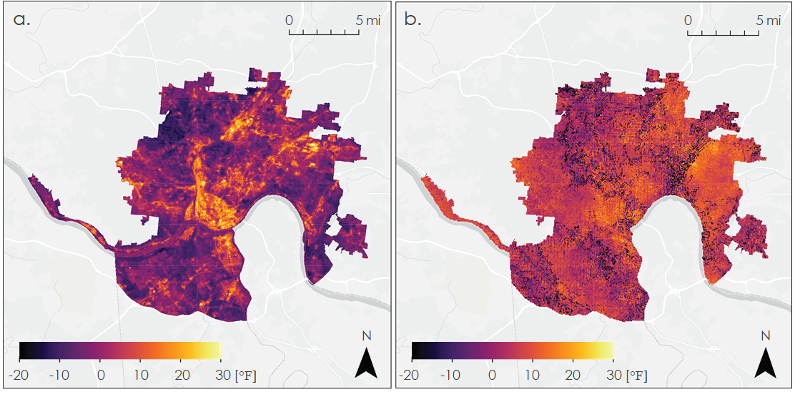

*Figure 4.* (a) Daytime and (b) nighttime temperature anomalies within the study area. Areas shown in shades of purple represent places where the study area is cooler than the reference polygons, while areas shown in shades of red, orange, and yellow represent places where the study area is warmer than the reference polygons.

***4.2 Analysis of InVEST Results***

HMI is quantified on a unitless scale. Areas with high HMI scores have the greatest ability to mitigate the effects of urban heat while areas with low heat mitigation scores are the most vulnerable to impacts of urban heat. As a note, the team realized that the color scales in the following maps did not encompass the distribution of HMI values for the nighttime analyses – the scales represent values ranging from 0.25 – 0.75, while the average nighttime HMI value was 0.93. Due to time constraints, the team could not update these color scales.

Both the daytime and nighttime InVEST HMIs reveal a similar spatial distribution of HMI scores (Figure 5), despite the fact that daytime anomalies were calculated from Landsat 5 TM while nighttime anomalies were calculated from ISS ECOSTRESS, meaning daytime and nighttime anomalies were calculated from different years. Comparing these patterns with the LULC map reveals that the most urbanized areas receive the lowest heat mitigation scores while the least urbanized areas receive the highest heat mitigation scores (Table C1). The lowest mean daytime HMI was 0.25 for the ‘Developed, High Intensity’ LULC class and the highest mean daytime HMI was 0.61 for the ‘Woody Wetlands’ LULC class. The lowest mean nighttime HMI was 0.71 for the ‘Barren Land’ LULC class and the highest mean nighttime HMI was 0.99 for the ‘Mixed Forest’ LULC class.

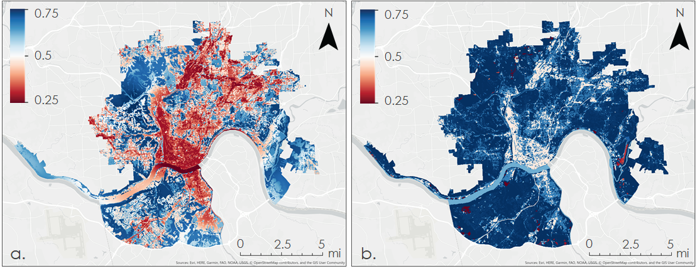

*Figure 5*. (a) Daytime and (b) nighttime HMI within the study area. Areas shown in shades of blue have high HMI scores while areas shown in shades of red have low heat mitigation scores. The color bar represents a range of unitless values as HMI is a unique model output.

The magnitude of the HMIs is where daytime and nighttime model outputs differ. The average daytime HMI value across the study area was 0.43while the average nighttime HMI value was 0.93. Spatially, as expected, the greatest difference in heat mitigation ability occurs between the urbanized and non-urbanized areas of the study area.

During the daytime, the Ohio River has low HMI values compared to other natural areas, such as forests. The low HMI values in the Ohio River may be due to the default weighting of the inputs used to calculate HMI in the InVEST model. Shade is the most heavily weighted input in calculating cooling capacity (a key component of HMI), and the Ohio River has little to no canopy cover. Albedo and evapotranspiration are equally weighted in the model. Water has a relatively low albedo, and the water in the Ohio River evaporates but does not transpire. Therefore, compared to highly vegetated areas that conduct both evaporation and transpiration, the evapotranspiration values over the Ohio River are relatively low.

The wide range of HMI values over the river is not surprising considering the varied levels of development along the riverbank in different parts of the study area. HMI accounts for proximity to green space, and the stretch of the Ohio River that passes through downtown Cincinnati and Covington is banked by pavement and parking lots. This may contribute to a lower HMI score for this section of the Ohio River than other sections further downstream where banks consist largely of green space.

The very low HMI areas in the nighttime HMI map correspond with agricultural areas. The building intensity of the few agricultural buildings was notably greater than the building intensity of buildings in other land classes. Because building intensity is normalized between 0 and 1, the agricultural buildings skew the building intensity for the LULC classes, and ultimately impact nighttime HMI calculated by InVEST which resulted in agricultural areas appearing to mitigate heat notably worse than other areas.

***4.3 Analysis of InVEST Heat Mitigation Scenarios***

A visual and quantitative inspection of the 25% increase in tree canopy cover for urbanized land covers revealed an increase in the magnitude of the HMI across the majority of the study area (Figure 6). The mean HMI value increased from 0.49 under the unmanipulated, or control, conditions to 0.56 under the increased tree canopy cover scenario. The spatial distribution of the HMI values in the tree cover scenario remained the same compared to the control conditions, just at a lower magnitude.

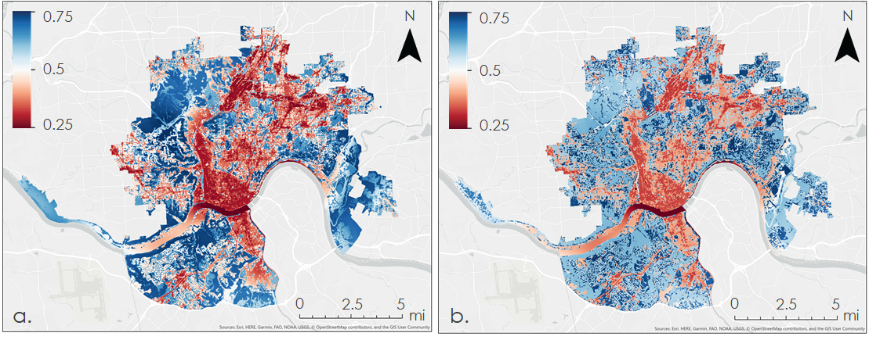

*Figure 6*. (a) Unmanipulated daytime HMI and (b) daytime HMI with an applied 25% increase in tree canopy cover for urbanized land covers. Areas shown in shades of blue have high HMI scores while areas shown in shades of red have low heat mitigation scores.

The vulnerable areas visible in the control HMI map, including downtown Cincinnati and Covington and Norwood, are able to better mitigate heat with the increase in tree canopy cover. In addition, air temperatures across the study area were reduced as a result of the increase in canopy cover. The maximum air temperature reduction within the study area was 1.2°C and the mean temperature reduction throughout the study area was 0.87°C (Figure D1).

In the second InVEST scenario, increasing the albedo had little effect on overall HMI regardless of whether 25% or 75% of the buildings increased albedo to 0.9 (Figure E1). The mean HMI value increased by 0.00075 for the 25% increase scenario, and only 0.0027 for the 75% increase scenario. InVEST weights albedo as 20% of the calculation for HMI, compared to shade accounting for 60% of the HMI calculation. Additionally, albedo was only increased for buildings, which compose a small fraction of the pixel areas. Therefore, increasing building albedo to any extent had a limited impact on the output of the model.

***4.4 Errors & Uncertainties***

*4.4.1 Temperature Anomaly Uncertainties*

The primary cause of uncertainty that arose within the nighttime temperature anomaly analyses resulted from an insufficient amount of raw temperature data. The team defined nighttime to be between 22:00 and 03:59 local time in our processing of nighttime LST. This was done to limit solar radiation influence on nighttime temperature, while maximizing the number of images collected. This filtration resulted in only remaining 10 images, which is not enough to make a robust mean. The number of pixels used to create the mean nighttime LST raster also varied spatially due to the removal of cloud-impacted pixels (Figure B1). The maximum number of inputs to the pixels in our mean raster was six and the minimum was one. This could impact the comparability of the derived mean nighttime temperatures across the study area, which would in turn impact the robustness of the temperature anomaly results.

Another source of uncertainty resulted from the dates of the available nighttime LST ECOSTRESS data. Due to ECOSTRESS not being launched until June 29th, 2018, the team was limited to using data from the summer months of 2018 – 2020, which did not align with our primary study period and partner provided data. However, for the purposes of this project, the team felt confident in using this data as a proxy for the 2010 – 2012 study period.

*4.4.2 InVEST Model Assumptions and Limitations*

In order to account for gaps in the supplemental datasets, the team made several necessary assumptions for the inputs into the InVEST model. For example, baseline air temperature was assumed to be 21°C for the nighttime analysis and 28°C for the daytime analysis. These values were based on the mean daytime and nighttime LST values for the study area. Ideally baseline temperature would be based on temperature monitoring in a natural area; however, the team could not find reliable temperatures meeting this requirement and used mean LST as a proxy.

The evapotranspiration raster also relied on several assumptions. Our evapotranspiration data was downloaded from ECOSTRESS, and therefore faced the same discrepancy in the primary study period and dates of available data as the nighttime LST imagery described above. Evapotranspiration generally does not change very much over time, so the team did not think that this uncertainty largely impacted the results of our analyses. Another evapotranspiration assumption the team was in reclassifying the no data pixels in the evapotranspiration raster, resulting from water masking, to 5.4 W m-2. Water bodies have much lower rates of evapotranspiration than vegetated areas because water evaporates, but does not transpire. The team chose 5.4 W m-2 because it was the minimum evapotranspiration value in the raster.

The InVEST model’s nighttime HMI primarily relies on building intensity, a metric dependent on the number of floors within each building. Because this information was not available, the team approximated the number of floors for all building inputs based on building height and average ceiling height. There is uncertainty as to whether these estimates reflect actual floor heights in the study area, specifically for buildings in agricultural land classes. Buildings in agricultural land classes had exceptionally large heights, resulting in large numbers of floors. However, the team was unable to determine the type of structures these buildings were, and whether the buildings had many floors or were instead tall structures with few floors, such as silos. This uncertainty was reflected in the map of nighttime HMI (Figure 5b). The red areas on that map all correspond to agricultural land.

The InVEST model is limited in its simplification of the factors affecting urban heat. For example, the model uses a single mean value for albedo, shade, and building intensity for each LULC class. As a result, entire LULC classes are simplified using mean values despite different areas within these classes having unique features or variance in albedo, shade, and building intensity. Additionally, multiple InVEST inputs ignore confounding variables. For example, nighttime cooling capacity only accounts for the effect of building intensity, despite the fact that factors such as albedo also impact nighttime cooling capacity. Additionally, the model’s shade input is based solely on tree canopy and thus ignores the impacts of building shade, which may be significant in many areas. Furthermore, the outputs of InVEST were limited to the 30m resolution of the NLCD LULC raster.

***4.5 Future Work***

The team’s project partners are currently in the process of acquiring updated data for the study area. Future work should use this new 2020 – 2021 data to update the team’s analyses and more accurately depict the current urban heat concerns of Cincinnati and Northern Kentucky. This can be combined with the 2010 – 2012 analyses to understand how UHI location and impact has changed over the last decade. Future projects should consider expanding the study area to other urbanized areas and use a county-wide analysis for both Hamilton and Kenton County.

# 

# 5. Conclusions

This study calculated the UHI magnitude in Cincinnati, OH and Northern Kenton County, KY. On average, the Cincinnati and Covington area was 8.32°F warmer during the day and 4.97°F warmer during the night compared to nearby natural areas, with the greatest average temperature difference being 47.36°Fduring the day and 34.26°F during the night. Mapping the UHI magnitude and HMI will allow urban planners to identify communities most at risk for impacts from urban heat. Highly developed areas, such as Norwood and downtown Cincinnati, experience the greatest urban heat during the daytime and nighttime, putting residents under constant heat stress.

InVEST can help urban planners understand effects of heat mitigation strategies by running hypothetical environmental planning scenarios through the model. Urban heat mitigation strategies can effectively increase HMI within the study area. Based on the results on the multiple scenarios run during this study, InVEST predicts that increasing tree canopy cover in the study area would be notably more effective in mitigating heat than increasing building albedo. Increasing green spaces benefits nearby areas by providing shade and evaporation to help mitigate heat, whereas increasing building albedo benefits the individual building more than the surrounding area.

These results help our partners provide information to local communities, and allow our partners to make more informed decisions to help mitigate the environmental and social inequalities cause by urban heat. Partners will utilize our methodology to create heat mitigation indices and map urban temperature anomalies with new data to assess the continued heat risk in the Cincinnati and Covington area. These results also provide a foundation for our partners to pursue future work identifying urban heat anomalies in other cities around the country.

# 6. Acknowledgments

The team would like to thank Dr. Kenton Ross from NASA Langley Research Center and Dr. Cedric Fichot from Boston University for their science advising during this project. Our thanks also go out to our partner points of contact Cate Mingoya and Lawrence Hoffman from Groundwork USA, and Tanner Yess and Sarah Morgan from Groundwork ORV. We would finally like to thank NASA DEVELOP Fellow Celeste Gambino for proposing this project and her guidance throughout the term.

Any opinions, findings, and conclusions or recommendations expressed in this material are those of the author(s) and do not necessarily reflect the views of the National Aeronautics and Space Administration.

This material is based upon work supported by NASA through contract NNL16AA05C.

# 

# 7. Glossary

**Albedo** – The proportion of solar radiation reflected by a surface

**Building intensity** – A measure of the vertical dimension of built infrastructure, calculated using building heights and number of building floors. This is an important predictor of nighttime temperature and is used to calculate nighttime heat dissipation

**Cooling capacity** – Measurement of a system’s ability to remove heat

**Earth observations** – Satellites and sensors that collect information about the Earth’s physical, chemical, and biological systems over space and time

**ECOSTRESS** – Ecosystem Spaceborne Thermal Radiometer Experiment on Space Station: measures the temperature of plants growing on Earth throughout the year using a thermal infrared radiometer

**Evapotranspiration** – The combined processes of water evaporation and transpiration from plants into the atmosphere

**Heat mitigation index** – An index modeling the cooling capacity of each pixel and the effect of green spaces on the pixel’s ability to mitigate heat.

**InVEST** – Integrated Valuation of Ecosystem Services and Tradeoffs: a suite of models used to map and evaluate the changes in ecosystems influencing natural goods and services that sustain human life

**Land surface temperature** – The given temperature of a location on the surface of Earth

**Urban heat island** – The difference in temperature between urban areas and the cooler surrounding rural areas

# 8. References

Anderson, Martha C. (2018). “Level-4 Evaporative Stress Index (ESI_ALEXI) Algorithm Theoretical Basis Document”

ArcGIS Hub. 2010. *Cincinnati city boundary*. https://arc-gis-hub-home- arcgishub.hub.arcgis.com/datasets/CAGISPortal::cincinnati-city-boundary [accessed 23 February 2021].

Chun, B., & Guldmann, J. M. (2012). Two- and Three-Dimensional Urban Core Determinants of the Urban Heat Island: A Statistical Approach. *Journal of Environmental Science and Engineering B*, *1*(3), 363-378.

City of Cincinnati. (2018). *2018 green Cincinnati plan.* <https://www.xavier.edu/economics-sustainability-and-society-program/documents/22018GreenCincinnatiPlan.pdf> [accessed 18 February 2021].

Gago, E. J., Roldan, J., Pacheco-Torres, R., & Ordóñez, J. (2013). The city and urban heat islands: A review of strategies to mitigate adverse effects. *Renewable and Sustainable Energy Reviews*. <https://doi.org/10.1016/j.rser.2013.05.057>.

Gianni, M. B., Belfiore, O. M., Parente, C, & Santamaria, R. (2015). Land Surface Temperature from Landsat 5 TM images: comparison of different methods using airborne thermal data. *Journal of Engineering Science and Technology Review, 8*(3), 83-90. <https://doi.org/10.25103/jestr.083.12>

Halverson, Gregory H, Joshua B Fisher, and Christine M Lee. “Level 4 Evaporative Stress Index Priestley Taylor Jet Propulsion Laboratory (PT-JPL) Data User Guide,” 2019, 19.

Hook, S., Fisher, J. (2019). ECOSTRESS Evapotranspiration PT-JPL Daily L3 Global 70 m V001 [Data set]. NASA EOSDIS Land Processes DAAC. Accessed 2021-03-30 from <https://doi.org/10.5067/ECOSTRESS/ECO3ETPTJPL.001>

Hook, S., Hulley, G. (2019). ECOSTRESS Land Surface Temperature and Emissivity Daily L2 Global 70 m V001 [Data set]. NASA EOSDIS Land Processes DAAC. Accessed 2021-03-30 from <https://doi.org/10.5067/ECOSTRESS/ECO2LSTE.001>

Loughner, C. P., Allen, D. J., Zhang, D. L., Pickering, K. E., Dickerson, R. R., & Landry, L. (2012). Roles of urban tree canopy and buildings in urban heat island effects: Parameterization and preliminary results. *Journal of Applied Meteorology and Climatology*, 51(10), 1775–1793. <https://doi.org/10.1175/JAMC-D-11-0228.1>.

Michelozzi, P., Accetta, G., De Sario, M., D’Ippoliti, D., Marino, C., Baccini, M., Biggeri, A., Andersin, H., Katsouyanni, K., Ballester, F., Bisanti, L., Cadum, E., Forsberd, B., Forastiere, F., Goodman, P., Hojs, A., Kirchmayer, U., Medina, S, Padly, ., … Perucci, C. A. (2009). High temperature and hospitalizations for cardiovascular and respiratory causes in 12 European cities. *American Journal of Respiratory and Critical Care Medicine*, 179(5), 383–389. <https://doi.org/10.1164/rccm.200802-217OC>.

NASA. (n.d.). *Welcome to ECOSTRESS.* <https://ecostress.jpl.nasa.gov> [accessed 22 February 2021].

Natural Capital Project. (2021). *Urban cooling model.* InVEST user guide. <https://invest-userguide.readthedocs.io/en/latest/urban_cooling_model.html>.

Nisbet-Wilcox, B.., Meltzer, S., Nelson, S., & Wagner, C. (2020). *Philadelphia health & air quality: Assessing land surface temperature, vegetation cover, and compounding vulnerability factors to identify high priority areas for cooling initiatives in Philadelphia, Pennsylvania.* [Unpublished scientific manuscript]. NASA DEVELOP.

Phelan, P. E., Kaloush, K., Miner, M., Golden, J., Phelan, B., Silva, H., & Taylor, R. A. (2015). Urban heat lsland: Mechanisms, implications, and possible remedies. *Annual Review of Environment and Resources*, 40, 285–307. <https://doi.org/10.1146/annurev-environ-102014-021155>.

Project Groundwork. (2011). *Green roof loan program*. <http://projectgroundwork.org/downloads/green_roof_loan_program_final.pdf> [accessed 18 February 2021].

Taha, H. (1997). Urban climates and heat islands: Albedo, evapotranspiration, and anthropogenic heat. *Energy and Buildings*, 25(2), 99–103. <https://doi.org/10.1016/s0378-7788(96)00999-1>.

Tasumi, M., Allen, R. G., & Trezza, R. (2008). At-surface reflectance and albedo from satellite for operational calculation of land surface energy balance. Journal of hydrologic engineering, 13(2), 51-63. doi: 10.1061/(ASCE)1084-0699(2008)13:2(51)

Tran, H., Uchihama, D., Ochi, S., & Yasuoka, Y. (2006). Assessment with satellite data of the urban heat island effects in Asian mega cities. *International Journal of Applied Earth Observation and Geoinformation*, 8(1), 34–48. https://doi.org/10.1016/j.jag.2005.05.003

U.S. Environmental Protection Agency. (2006). *Excessive heat events guidebook*. https://www.epa.gov/sites/production/files/2016-03/documents/eheguide_final.pdf [accessed 22 February 2021].

USGS. (n.d.). *Landsat 5.* <https://www.usgs.gov/core-science-systems/nli/landsat/landsat-5?qt-science_support_page_related_con=0#qt-science_support_page_related_con> [accessed 22 February 2021].

Zhang, Jinqu, Yunpeng Wang, and Yan Li. “A C++ Program for Retrieving Land Surface Temperature from the Data of Landsat TM/ETM+ Band6.” *Computers & Geosciences* 32, no. 10 (December 1, 2006): 1796–1805. <https://doi.org/10.1016/j.cageo.2006.05.001>.

# 9. Appendices

**Appendix A**

*Table A1*

*Calculations to alter the albedo for hypothetical environmental planning scenarios in InVEST*

|  |  |  |  |
| --- | --- | --- | --- |
| **Input** | **Variable** | **Step 1** | **Step 2** |
| Albedo of Pixel | αp1, αp2 | αp1 = mean albedo of pixels in albedo raster | αp2 = Pn * αn + Pb2 * αb + Pm * αm |
| Albedo of Building | αb | αb = mean building albedo in study area | Same as step 1 |
| Albedo of Non-Buildings | αn | αn = (αp - Pb1 * αb)/ Pn | Same as step 1 |
| Albedo of Modeled Buildings | αm | XXXXX | 0.9 |
| Proportion of land Buildings | Pb1, Pb2 | Pb1 = area of buildings/total area | Pb2 = Pb1 - Pm |
| Proportion of land Non-Buildings | Pn | Pn = 1- Pb1 | Same as step 1 |
| Proportion of land Modeled Buildings | Pm | XXXXX | Pm = 0.25 * Pb1 |

**Appendix B**

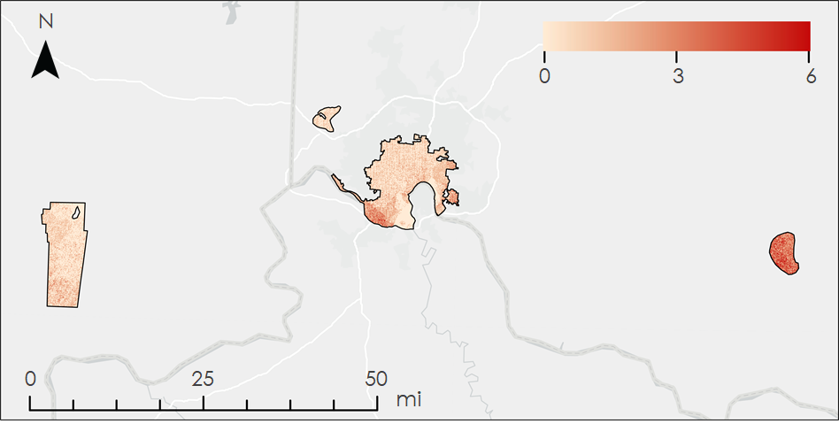

*Figure B1.* Number of pixels used in calculating the mean nighttime LST raster within the reference polygons and study area. Pixels impacted by clouds or cloud shadows were removed from the analysis.

**Appendix C**

*Table C1*

*Statistics describing the HMIs by LULC class*

|  |  |  |  |  |  |  |
| --- | --- | --- | --- | --- | --- | --- |
| **LULC** | **Mean HMI** | | **Minimum HMI** | | **Maximum HMI** | |
|  | **Daytime** | **Nighttime** | **Daytime** | **Nighttime** | **Daytime** | **Nighttime** |
| **Open Water** | 0.33 | 0.85 | 0.09 | 0.16 | 0.70 | 1 |
| **Developed, Open Space** | 0.49 | 0.98 | 0.15 | 0.16 | 0.72 | 1 |
| **Developed, Low Intensity** | 0.40 | 0.96 | 0.10 | 0.24 | 0.71 | 1 |
| **Developed, Medium Intensity** | 0.32 | 0.89 | 0.10 | 0.26 | 0.71 | 1 |
| **Developed, High Intensity** | 0.25 | 0.75 | 0.11 | 0.31 | 0.61 | 1 |
| **Barren Land (Rick/Sand/ Clay)** | 0.33 | 0.71 | 0.09 | 0.36 | 0.58 | 0.99 |
| **Deciduous Forest** | 0.57 | 0.99 | 0.17 | 0.22 | 0.71 | 1 |
| **Evergreen Forest** | 0.56 | 0.99 | 0.23 | 0.24 | 0.71 | 1 |
| **Mixed Forest** | 0.60 | 0.99 | 0.28 | 0.90 | 0.72 | 1 |
| **Shrub/Scrub** | 0.53 | 0.99 | 0.28 | 0.34 | 0.61 | 1 |
| **Grassland/ Herbaceous** | 0.49 | 0.96 | 0.27 | 0.67 | 0.61 | 1 |
| **Pasture/Hay** | 0.45 | 0.56 | 0.28 | 0.16 | 0.60 | 1 |
| **Cultivated Crops** | 0.49 | 0.9 | 0.26 | 0.38 | 0.60 | 1 |
| **Woody Wetlands** | 0.61 | 0.97 | 0.41 | 0.49 | 0.71 | 1 |
| **Emergent Herbaceous Wetlands** | 0.47 | 0.96 | 0.18 | 0.67 | 0.60 | 1 |

**Appendix D**

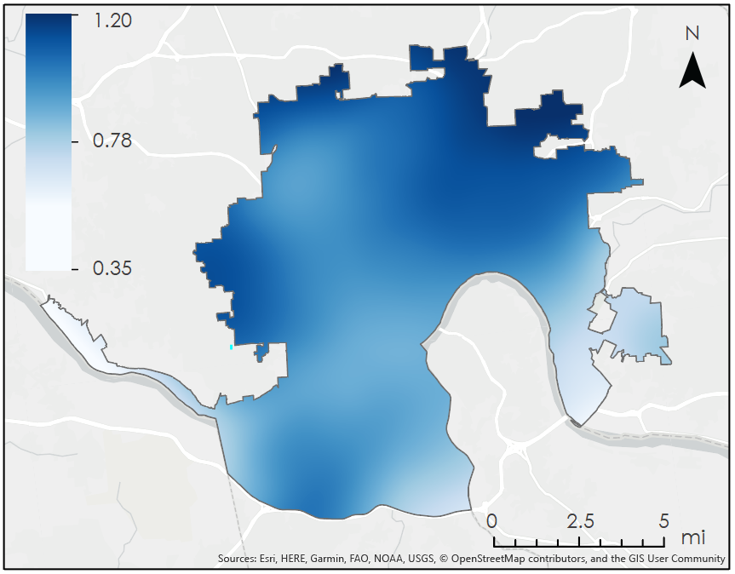

*Figure D1.* Daytime air temperature reduction (with mixing) [°C] resulting from the 25% increase in tree canopy cover in urbanized land cover classes. This raster was created by the subtraction of the 25% canopy scenario air temperature raster from the unmanipulated daytime air temperature raster. The color bar shows areas of high air temperature reduction in dark blues and areas of lower air temperature reduction in white.

**Appendix E**

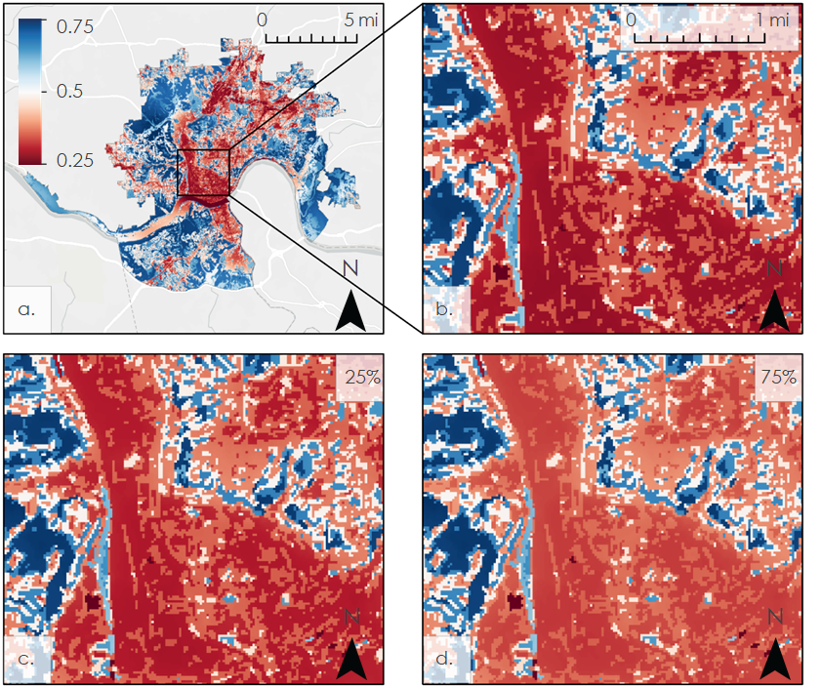

*Figure E1.* (a) Daytime HMI, (b) zoomed in daytime HMI, (c) daytime HMI with albedo increased to 0.9 for 25% of buildings in urbanized land covers applied, and (d) daytime HMI with albedo increased to 0.9 for 75% of buildings in urbanized land covers applied. Areas shown in shades of blue have high HMI scores while areas shown in shades of red have low heat mitigation scores. The color bar represents a range of unitless values as HMI is a unique model output.