**NASA DEVELOP National Program**



NASA Goddard Space Flight Center

*Fall 2016*

North Carolina Water Resources

Utilizing NASA Earth Observations and Hydrological Modeling to Monitor Nutrient Levels in Jordan Lake, North Carolina for Improved Water Quality Management

**Technical Report** 

Final Draft – November 17, 2016

Tammy Ashraf (Project Lead), tashraf@outlook.com

Elisa Ahern

Jessica Fayne

John Fitz

Dr. Sara Lubkin

Sean McCartney

Dr. Amita Mehta, NASA GSFC-UMBC (Science Advisor)

Dr. Prasad Daggupati, University of Guelph (Science Advisor)

# 1. Abstract

B. Everett Jordan Lake reservoir, located in Chatham County, North Carolina, provides drinking water for approximately 250,000 people in the state. Since 1974, the same year construction of the reservoir was completed, excessive nutrient levels from wastewater treatment plants and agricultural runoff has led to eutrophic and hypereutrophic conditions in the reservoir. As a result, the lake was determined to have nutrient-sensitive waters (NSW) and declared impaired by the North Carolina Environmental Management Commission. The Jordan Lake Nutrient Management Strategy was established to improve water quality. Monitoring of water quality is performed by the United States Geologic Survey (USGS) at six sampling sites on a bi-monthly basis in order to guide management and policy decisions. However, more frequent data collection would allow regulators to better understand how nutrient levels and management policies affect the lake. A Soil and Water Assessment Tool (SWAT) was run using ArcGIS for desktop to monitor nitrogen and phosphorus levels in Jordan Lake using Tropical Rainfall Measuring Mission (TRMM) and Global Precipitation Measurement (GPM) satellite data, ancillary data sources, and *in situ* data. This project is the first to model water quality using Earth observations in conjunction with the SWAT model within the watershed and provides information on nutrient levels for improved water management.

**Keywords**

ArcSWAT, remote sensing, eutrophication, TRMM, GPM, hydrologic modeling, nitrogen, phosphorus

# 2. Introduction

* 1. ***Background Information***

Algal blooms are a growing concern in water systems around the world. Blooms cover the surface of water and block light needed by submerged vegetation (Alonso-Rodriguez et al., 2003). As aquatic plants are the major source of oxygen in aquatic communities, algal blooms cause dangerously low levels of dissolved oxygen in the water, which can cause fish and other organisms to die and create large “dead zones” in the water (Minnesota Pollution Control Agency, 2008). Many algal bloom species also produce toxins which can be harmful to both wildlife and humans (Glibert et al., 2005).

Although algal blooms have been recognized as an environmental threat since the 1970’s, scientists have recently documented a global increase in the frequency and severity of blooms (Yang et al., 2008). Researchers attribute this increase in blooms to the increasing eutrophication of our water supplies. Eutrophication refers to high levels of nutrients in a water supply which promote algal growth, resulting in the depletion of dissolved oxygen and the death of aquatic life (Karadzic et al., 2010). These nutrients come from agricultural runoff, storm water drainage, and wastewater treatment (Yang et al., 2008). Eutrophication in reservoirs used for drinking water is of special concern because algal blooms may decrease water quality and affect human health (Glibert et al., 2005).

B. Everett Jordan Lake (Jordan Lake) is a man-made reservoir located in the Haw River Basin of central North Carolina. The lake provides drinking water for more than 250,000 residents within the Triangle Region, which includes the cities of Durham, Chapel Hill, and Raleigh, NC (NC Department of Environmental Quality [NCDEQ], 2016). Congress directed the Army Corps of Engineers to dam the Haw and New Hope rivers and construct Jordan Lake after a 1945 hurricane caused millions of dollars of devastation in the region (Agan, K., 2013). The lake was designed to prevent future flooding, as well as to protect fish and wildlife, provide recreational opportunities such as boating and camping, and to ensure a clean drinking water supply for municipalities in the region (NCDEQ, 2016).

Since the completion of the reservoir in 1983, eutrophication of Jordan Lake has been a growing problem. The North Carolina Environmental Management Commission (EMC) has consistently rated Jordan Lake as eutrophic or hypereutrophic (NCDEQ, 2016). Eutrophication has resulted in dense blooms of cyanobacteria and anoxic water conditions (Yang et al., 2008). In 2006, the lake exceeded the state’s chlorophyll-*a* limits, and the EMC determined that Jordan Lake is impaired. Although the water can still be used for drinking, fishing, and recreation, complaints about taste and odor problems have prompted local municipalities to add chemical treatment to its drinking water process.

As there is a strong correlation between eutrophication and an increase in nitrogen and phosphorus in impaired water systems (Yang et al., 2008), the Clean Water Responsibility Act of 1997 requires the North Carolina Environmental Management Commission (EMC) to implement management plans and establish improvement goals for nutrient-impaired waters (NCDEQ, 2016). Bi-monthly water sampling is carried out by the U.S. Geological Survey (USGS) at six sampling locations around Jordan Lake to aid in water treatment and management decisions. However, the current nutrient monitoring practices for Jordan Lake are inconsistent; samples are collected infrequently, and there are discrepancies in sample collection practices across monitoring sites.

The DEVELOP team at Goddard Space Flight Center (GSFC) used NASA Earth observations (EO), *in situ* data, and ancillary datasets to run a Soil and Water Assessment Tool (SWAT) for purposes of modeling water quality in Jordan Lake and its watershed. The model was used to measure nutrient levels to help guide efforts to improve water management in the reservoir. The project was carried out as a feasibility study to determine the efficacy of creating an operational tool providing utilities around the lake near-real time estimates of nutrient loadings into the reservoir.

Jordan Lake covers an area of 13,940 acres (56.5 km2), which includes approximately 322 km of shoreline. The Jordan Lake watershed that drains into the reservoir covers roughly 4,375 km2 of agricultural and urban areas in Alamance, Gilford, Orange, Durham, Wake, Chatham, Rockingham and Caswell counties in North Carolina (Figure 1). The initial study period extended from January 2009 to December 2014.

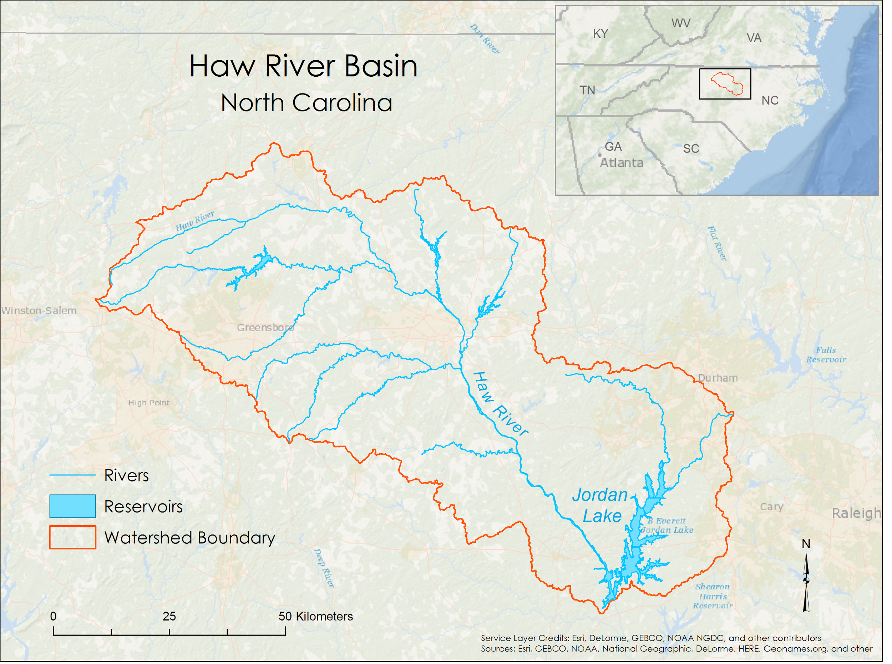

**Figure 1.** Map of the Jordan Lake watershed in North Carolina with red polygon delineating the watershed boundary. Jordan Lake dammed and flooded the Haw and New Hope Rivers. The watershed covers roughly 4,375 km2 of agricultural and urban areas.

* 1. ***Project Partners & Objectives***

This project addressed the Water Resources application area within NASA’s Applied Science Program. The team partnered with Hazen and Sawyer, an engineering firm focused on helping municipalities provide safe drinking water to their customers, and on controlling water pollution and its effects on the environment. The team also partnered with Dr. Prasad Daggupati, a professor of biological and cultural engineering at the University of Guelph. Dr. Daggupati is an expert on the use of ArcSWAT for watershed modeling, and served as a mentor and collaborator in running ArcSWAT to model nutrient loadings in the study area.

The first objective of the project was to calibrate the SWAT model for the Jordan Lake watershed using Earth observations from January 2009 to December 2014. The second objective was to compare the results using simulated weather data with those of Earth observations, and to provide the results to our end-user.

# 3. Methodology

***3.1 Data Acquisition***

***3.1.1 Watershed Boundary Shapefile –*** The Jordan Lake watershed boundary is based on USGS hydrologic unit (HU) HUC-8 0303002. A shapefile was downloaded from NCDEQ Division of Water Resources and imported into ArcMap. The unprojected file was projected to the NAD_1983_StatePlane_North_Carolina_FIPS_3200 coordinate system. The boundaries of three sub-watersheds were dissolved to form one larger unit.

A buffer was used to extend the watershed boundary by 50 meters. All other datasets were reprojected to NAD_1983_StatePlane_North_Carolina_FIPS_3200 and clipped to the extent of this file. The extended boundary was necessary to ensure that the entire study area was included when clipping raster datasets. The shapefile was converted into raster file format with 30 meter spatial resolution. This file was used as a binary mask in ArcSWAT to improve processing time.

***3.1.2. Digital Elevation Model (DEM) –*** ArcSWAT requires elevation data in order to delineate watersheds. National Elevation Dataset (NED) ⅓ arc-second resolution (approximately 10 meters) digital elevation data were downloaded from the National Map (TNM) web portal of the United States Geological Survey (USGS). A total of five DEM tile scenes were acquired in order to provide full coverage of the entire Jordan Lake watershed. The five DEM scenes were individually projected to NAD_1983_StatePlane_North_Carolina_FIPS_3200 and mosaicked to create a single DEM raster using ArcGIS 10.3. The mosaic DEM for the study area was then clipped to the 50 meter buffered watershed boundary for Jordan Lake.

***3.1.3. Soil Data (SSURGO) –*** ArcSWAT creates hydrological response units (HRUs) based on soil and land use data. The soil dataset acquired and used for this project was the Soil Survey Geographic Database (SSURGO). The SSURGO dataset was downloaded from the Geospatial Data Gateway website from the Natural Resources Conservation Service (NRCS) of the United States Department of Agriculture (USDA). SSURGO has a 10 m spatial resolution which provides higher detailed soil information. The SSURGO polygon shapefiles for eleven counties were downloaded and merged into a single shapefile to provide coverage for the entire study area. The merged SSURGO file was reprojected into NAD_1983_StatePlane_North_Carolina_FIPS_3200 and then clipped to the 50m buffered watershed boundary for the Jordan Lake watershed.

***3.1.4. Land Use (CDL) –*** The Cropland Data Layer (CDL) is a land use dataset commonly used for SWAT modeling. CDL data provide detailed land use information, including specific crops grown within the study area. CDL is derived from Landsat data and has a spatial resolution of 30 meters. The CDL data for 2014 were downloaded from the USDA’s National Agricultural Statistics Service web portal. The CDL file was reprojected into NAD_1983_StatePlane_North_Carolina_FIPS_3200 and clipped to the 50m buffered Jordan Lake watershed boundary.

***3.1.5. Daily Precipitation (GPM IMERG and TRMM TMPA) –*** Precipitation data for the SWAT model were obtained from NASA’s Global Precipitation Measurement (GPM) Integrated Multi-satellite Retrievals for GPM (IMERG) and Tropical Rainfall Measuring Mission (TRMM) Multi-satellite Precipitation Analysis (TMPA).

North Carolina TRMM and GPM daily data were downloaded from Mirador, an Earth science data search tool hosted online by NASA’s Goddard Earth Sciences Data and Information Services Center. The 3B42 TRMM daily product acquired between 01/01/2009 and 12/31/2014 was used in this study. The data were downloaded in NETCDF format and converted to TIFF format for ease of processing and file sharing using the python Geospatial Data Abstraction Library (GDAL). The NETCDF files were first converted to CSV files using MATLAB, and then from CSV to TIFF files using R.

The TRMM files have a spatial resolution of 0.25 degrees, while the newer GPM data have a higher spatial resolution of 0.1 degrees. A GDAL Python script was used to convert the files from NETCDF to TIFF format. Because the GPM data has the highest spatial resolution of the weather datasets, 42 centroids for the GPM data were extracted into a shapefile and used to compare all of the precipitation and weather data for the same 42 locations as ‘weather stations’. Once the daily TIFF files were created, the precipitation values for each of the 42 stations were extracted for the entire time series. For each of the 42 stations within the study region, a text file was generated with a start date (20081231 for TRMM, and 20140312 for GPM) followed by the precipitation value in millimeters for each time step by row. This extraction and conversion process was also used for the weather data required for the SWAT analysis.   
 ***3.1.6. NLDAS Weather Data (The North American Land Data Assimilation System (NLDAS) Forcing Factors) –*** The NLDAS incorporates a variety of hydrological, meteorological, and topographical datasets into models to create surface datasets of phenomena that cannot be measured directly. While the NLDAS output data can be useful in research studies, the input datasets can be equally useful, as the NLDAS processing takes disparate datasets and transforms them, making them spatially and temporally uniform. NLDAS using the North American Regional Reanalysis (NARR) hourly dataset for many of the NLDAS forcing; the NLDAS forcing (NLDASFORA) variables of hourly specific humidity, zonal and meridional wind speed, and 2-meter from surface air temperature, and well as downward shortwave radiation (as solar flux) from 01/01/2009 to 10/21/2016 were obtained from NASA’s Mirador web platform as NETCDF files.

The same process used to convert the precipitation files was used to generate text files for each of the 42 stations. The specific humidity was converted into relative humidity by dividing the vapor pressure (e) by the saturated vapor pressure (es), where:

$e=\frac{specific humidity × surface pressure}{0.378 ×specific humidity + 0.622}$

$e_{s}=6.112 ×exp⁡[\frac{17.67 ×temperature}{temp+243.5}]$.

The zonal and meridional wind speed were combined into one wind speed measurement, and all values were converted from hourly to daily measurements by mean ***–*** with the exception of the air temperature, for which the minimum and maximum values for each day were used. Finally, a reference text file was created for each of the variables, containing the list of the 42 station names, station elevations when pinned to the DEM grid, and station coordinates in decimal degrees. These reference files were used in the SWAT model to read from each of the 42 text files containing the daily measurements.

***3.1.7. In situ stream gauge data (USGS South Atlantic Water Science Center) –*** The United States Geological Survey (USGS) South Atlantic Water Science Center is the USGS web page for the water resources of Georgia, North Carolina, and South Carolina. The page contains current and historical streamflow and water quality data for USGS stream gauges in Jordan Lake, including nitrogen and phosphorus levels. This data was used to ground truth and validate model data.

***3.1.8. Streamflow data (USGS Surface-Water Data for the Nation) –*** The USGS National Water Information system maintains the Surface-Water Data for the Nation website. Data available on the site includes current and historical conditions at selected sites recorded at a fixed interval of 15 to 60 minutes as well as daily summaries and statistics. These data were used to ground truth and validate model data.

***3.2 Data Processing and Analysis***

The SWAT model is a process-based, river-basin scale hydrology model that was developed to evaluate the effects of alternative management decisions on water resources and nonpoint-source pollution in large watersheds (Arnold et al. 2012). The SWAT model uses land use, soil, elevation, streamflow, and weather data to estimate watershed conditions. More than 2,700 peer-reviewed articles have been published that document applications of SWAT models (SWAT.tamu.edu). SWAT programs are available as open source software for a number of platforms and systems. The ArcSWAT 2012.10.18 extension for ArcGIS 10.3 was used for this study.

*Watershed delineation:* Once the appropriate data layer maps (elevation, land use, and soil) were acquired, the data were incorporated into the ArcSWAT model. The first major step included delineating the watershed boundary from the digital elevation model input. The watershed delineation step also creates the stream network and establishes the outlet and monitoring points along the stream reaches. ArcSWAT model further divided the basin into subwatersheds. A total of 33 stream reaches and subwatersheds were delineated within our study area.

*HRU Analysis:* The next major step was the setting up the hydrological response units (HRUs) for the project. The HRUs are the smallest area of the watershed with similar landscape characteristics. HRU analysis and setup required reclassification of the land use and soil map inputs to match the ArcSWAT map formats. The slope classes were defined during these steps using the digital elevation model input. Four slope classes were created: 0 to 0.1, 0.1 to 2, 2 to 4, and greater than 4. HRU thresholds were set at 5% for land use over subbasin area; 10% for soil class over land use area; and, 5% for slope over soil area.

*Write Input Tables*: Next, weather data input were defined for the SWAT model. ArcSWAT provides an option for using simulated weather data generated by a weather generator model. The WGEN_US_FirstOrder option was used for the control model while satellite derived data were used to test our model.

The prepared weather data text files were added to the SWAT model project folder. Because the time period for the initial model run was 2009 to 2014, rainfall data from TRMM were used. However, GPM rainfall data were prepared for future model runs because the TRMM mission has been decommissioned and the GPM mission will provide an expanded extension for precipitation data into the future.

Relative humidity, solar radiation, wind speed, and temperature data were acquired from NLDAS. The prepared text files for each individual weather parameters were added to the SWAT model project file. Once the weather data files were formatted correctly, the definition file path for each parameter was entered into ArcSWAT. All input tables options were selected.

*SWAT Simulation:* The model was run using a time period of January 1, 2009 to December 31, 2014 with a warm up period of two years to produce monthly output. Output for hydrologic conditions and watershed processes were created and stored into database files at the reach, watershed, and HRU scale. These output data included a range of watershed parameters, including streamflow (m3/s) and nutrient data such as nitrogen (total Nitrogen in kg) and phosphorous (total Phosphorous in kg).

# 4. Results & Discussion

The SWAT model was run using simulated weather data and using climate data obtained from NASA Earth observations. The output from each SWAT model included a variety of parameters at the reach, HRU, and subbasin level. These parameters included organic nitrogen, organic phosphorus, total nitrate, soluble phosphorus, nitrate leaching, phosphorus leaching, nitrogen uptake, phosphorus uptake, fertilizer applied, and other measurements in kilograms per hectare, as well as precipitation (mm), and streamflow.

***4.1 Analysis of Results***

The team compared the measurements for total phosphorus (kg/ha), total nitrogen (kg/ha), and flow (m3/s) generated by both SWAT models. The resulting datasets were not identical (Figure 2a and 2b ).

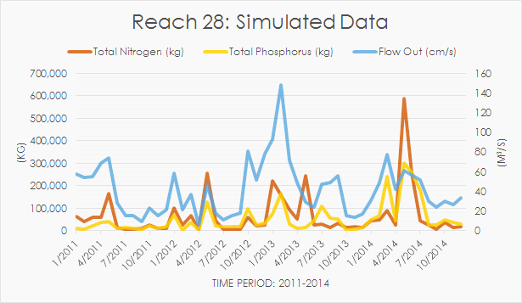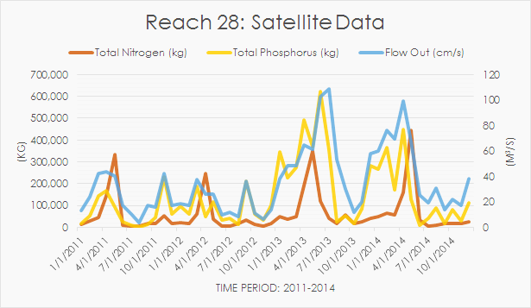

**Figure 2a.** SWAT model measurement results of total phosphorus (kg/ha), total nitrogen (kg/ha), and flow (m3/s) over time using simulated data from January 2011 to October 2014.

**Figure 2b.** SWAT model measurement results of total phosphorus (kg/ha), total nitrogen (kg/ha), and flow (m3/s) over time using satellite data from January 2011 to October 2014.

When nitrogen and phosphorus measurements for the two models were compared, the nitrogen estimates were more similar than phosphorus. A plot of nitrogen estimates from the SWAT model using simulated weather data against nitrogen estimates from the SWAT model using satellite data resulted in a coefficient of determination (R2) of 0.41. A comparison of phosphorus estimations from the two models resulted in a coefficient of determination (R2) of 0.0012.

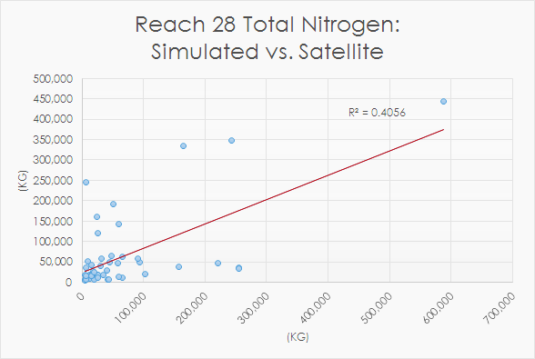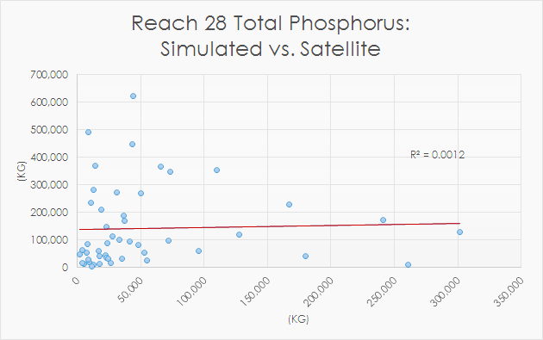

**Figure 3a.** Comparison of nitrogen estimates from the SWAT model using simulated weather data against satellite data resulted in a coefficient of determination R2 = 0.41.

**Figure 3b.** Comparison of phosphorus estimates from the SWAT model using simulated weather data against simulated data resulted in a coefficient of determination R2 = 0.0012.

However, model estimates of nitrogen and phosphorus could not be compared to *in situ* measurements. In-stream monitoring stations measured total nitrogen and total phosphorus in milligrams per liter from at the time of measurement, while the SWAT model provided estimates in kilograms per hectare of area for each reach, subbasin, and HRU. Since nitrogen and phosphorus were not calculated at the reservoir level in milligrams per liter, the two variables could not be compared. Therefore, modeled flow data were compared to *in situ* flow.

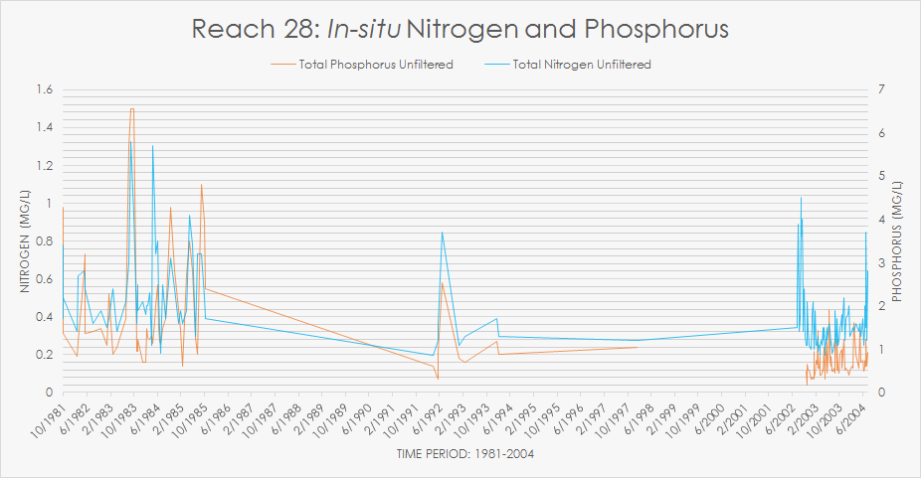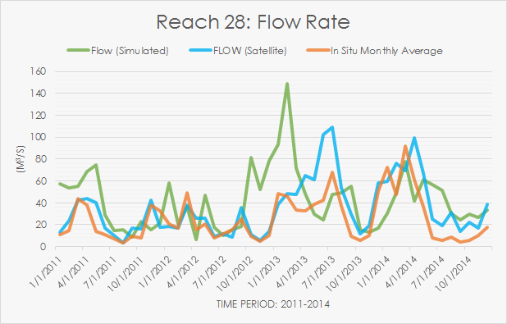

**Figure 4a.** Stream gauge data for nitrogen and phosphorous at USGS Sampling Site #24 along the Haw River from 1981 to 2004 as an example of inconsistent and missing data.

**Figure 4b.** Comparison of streamflow at stream reach #28 showing model output using simulated weather inputs (green), TRMM weather inputs (blue), and USGS stream gauge *in situ* streamflow (red).

While there are numerous USGS monitoring stations in the watershed, data collection is not consistent (Figure 4a) among stations. We chose to test our model against *in situ* data from station 24 (USGS site number 02096960) at the outlet of Reach 28. The station included daily flow data for the entire study period.

When the SWAT output datasets were compared to *in situ* data, a quick visual inspection (Figure 4b), revealed that the SWAT output obtained with satellite data was more similar to the *in situ* data than the SWAT estimates obtained with simulated data. The comparison of *in situ* data with the satellite data SWAT model resulted in a coefficient of determination of 0.66 (Figure 5a) compared to 0.09 (Figure 5b) with simulated data as demonstrated in figures 3a and 3b. While more comparison is needed, we are encouraged that using SWAT with satellite data does increase the accuracy of the model.

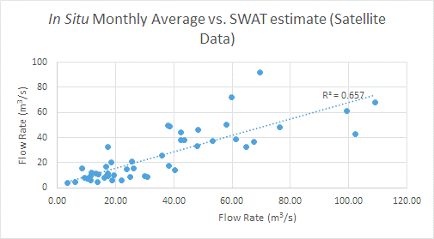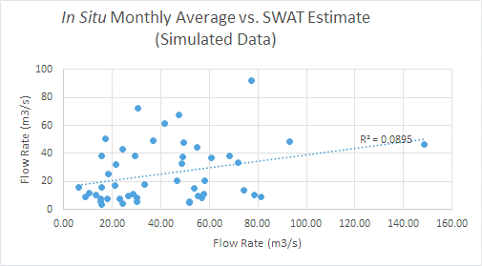

**Figure 5a.** Comparison of streamflow (m3/s) from USGS stream gauges and SWAT model output using TRMM weather inputs.

**Figure 5b.** Comparison of streamflow (m3/s) from USGS stream gauges and SWAT model output using weather generator inputs.

***4.2 Discussion***

The SWAT model calculates a large number of watershed parameters related to hydrology, sediment, plant growth, nutrients, and in-stream processes. Values for these parameters are available at a variety of scales, depending on input to the model. We obtained parameters at the HRU, reach, and subbasin levels.

The ability to test SWAT was strongly limited by *in situ d*ata. Because Lake Jordan is considered impaired by the North Carolina Environmental Management Commission, federal regulations require monitoring of the reservoir. However, data collection for water monitoring is inconsistent. Therefore, the team was only able to compare output for one reach with *in situ* data. Ideally, the team would be able to compare several parameters in order to assess model accuracy. Outflow of reach 28 compared to *in situ* flow data at Station 24 suggests a significant benefit to using satellite data for climate variables as compared to using SWAT generated weather simulations.

Future work will include delineating the reservoir in SWAT, effectively broadening the watershed analysis from just using watercourses. This will allow SWAT to estimate total nitrogen and phosphorus in grams per liter, a unit that can be compared to *in situ* data. With additional parameters, we will be able to continue refining model calibration and parameter adjustments. Validating the model in a different time period will impart the robustness of the model, in turn leading to an operational tool which can dynamically refresh SWAT model data and provide statistical outputs for water quality decision support to utilities.

# 5. Conclusions

SWAT flow estimates using NASA EO data show less variability from *in situ* data compared to SWAT flow estimates using weather simulations and suggest that using climate variables obtained from NASA observations with the SWAT model is not only feasible, but may significantly improve the model’s accuracy. Minor calibration is still needed to use the SWAT output for water monitoring efforts. However, the future development of an operational tool which uses satellite data will allow partners to obtain near real-time monitoring data for the entire watershed and will provide a great benefit considering the inconsistency of field measurements in the study area.

# 6. Acknowledgments

The North Carolina Water Resources team would like to thank the mentors and partners who provided their time and support to make this project possible:

Mentor/ Advisor

* Dr. Amita Mehta, NASA GSFC-UMBC

Project Partners

* Dr. Josh Weiss, Water Resources Engineer, Hazen and Sawyer
* Dr. Prasad Daggupati, Postdoctoral Research Assistant, University of Guelph

Any opinions, findings, and conclusions or recommendations expressed in this material are those of the authors and do not necessarily reflect the views of the National Aeronautics and Space Administration.

This material is based upon work supported by NASA through contract NNL11AA00B and cooperative agreement NNX14AB60A.

# 7. References

Agan, K. (2015). Jordan Lake State Recreation Area. In *NCpedia online*. Retrieved from http://www.ncpedia.org/jordan-lake-state-recreation-area

Alonso-Rodrı́guez, R., & Páez-Osuna, F. (2003). Nutrients, phytoplankton and harmful algal blooms in shrimp ponds: A review with special reference to the situation in the Gulf of California. *Aquaculture,* *219*(1-4), 317-336. doi:10.1016/s0044-8486(02)00509-4

Arnold, J.G., et al. (2012). SWAT Model Use, Calibration and Validation. *Journal of American Society of Agricultural and Biological Engineers*, 55(4), 1491-1508

EPA (2016). US Environmental Protection Agency - Fact Sheet - Falls Lake/Jordan Lake Stormwater Rule for New Development in Orange County. Retrieved October 06, 2016, from http://www.orangecountync.gov/document_center/PlanningInspections/Fallsrulesfactsheet.pdf

Glibert, P., Anderson, D., Gentien, P., Granéli, E., & Sellner, K. (2005). The Global, Complex Phenomena of Harmful Algal Blooms. *Oceanography Oceanog,* *18*(2), 136-147. doi:10.5670/oceanog.2005.49

Karadžić, V., Subakov-Simić, G., Krizmanić, J., & Natić, D. (2010). Phytoplankton and eutrophication development in the water supply reservoirs Garaši and Bukulja (Serbia). *Desalination,* *255*(1-3), 91-96. doi:10.1016/j.desal.2010.01.009

Minnesota Pollution Control Agency (2008, May). Nutrients: Phosphorus, Nitrogen Sources, Impact on Water Quality. Retrieved September 30, 2016, from https://www.pca.state.mn.us/sites/default/files/wq-iw3-22.pdf

NC Department of Environmental Quality. (2016). NC Department of Environment and Natural Resources - Jordan Lake Rules - Background. Retrieved October 05, 2016, from http://portal.ncdenr.org/web/jordanlake/background

SWAT: Soil and Water Assessment Tool. Retrieved September 19, 2016, from <http://swat.tamu.edu/>

USDA-NRCS. (2013). Soil Survey Geographic (SSURGO) Database. . U.S. Department of Agriculture, Natural Resources Conservation Service: Washington, D.C., USA Geospatial data gateway. Retrieved September 26, 2016, from <https://gdg.sc.egov.usda.gov>

USDA-NASS. (2014). Cropland Data Layer (CDL) Database. U.S. Department of Agriculture, National Agricultural Statistics Service: Washington, D.C., USA Geospatial Data Gateway. Retrieved September 26, 2016, from <https://www.nass.usda.gov/Research_and_Science/Cropland/Release/>

USGS-NED. (2013). National Elevation Dataset (NED). United States Geological Survey: Washington, D.C., USA. Retrieved September 26, 2016, from [https://viewer.nationalmap.gov/basic](https://viewer.nationalmap.gov/basic/)/

Yang, X., Wu, X., Hao, H., & He, Z. (2008). Mechanisms and assessment of water eutrophication. *Journal of Zhejiang University SCIENCE B,* *9*(3), 197-209. doi:10.1631/jzus.b0710626

# 8. Content Innovation

**Content Innovation #1**

VPS

<https://www.youtube.com/watch?list=PLL8pCbx5gnDaUglEO0269LJ95zp4r63V4&v=h1riVmc7zHA>

**Content Innovation #2**

Interactive Map

File Name: 2016Fall_GSFC_NorthCarolinaWaterResources_InteractiveMap_FD

**Content Innovation #3**

Inline Supplementary Material

Figure 2a/2b

Figure 3a/3b

Figure 4a/4b

Figure 5a/5b