**NASA DEVELOP Proposal**

**Landscape Vulnerability to Drought and Climate Change in National Parks of the Western U.S.**

**NPS collaborators:** David Thoma (Ecologist), Tom Olliff (Great Northern LCC Coordinator), Dana Witwicki (Ecologist), Mark Miller (Resource Manager), Terry Fisk (Resource Manager), Sandra Borthwick (Resource Manager)

**USGS collaborators:** Seth Munson (Plant Ecologist), Erin Bunting (Remote Sensing Scientist), Miguel Villarreal (Geographer), Mike Duniway (Soil Scientist), John Bradford (Ecosystem Ecologist)

**Project Summary:** To help land managers plan for and adapt to the impacts of climate change, we propose to determine vegetation responses to climate and water balance at coarse (250m) and moderate (30m) resolution using novel assessment tools across diverse landscapes of the western U.S. By pairing an extensive network of vegetation monitoring data collected by the National Park Service (NPS) Inventory and Monitoring (I & M) program and other agencies with MODIS and Landsat imagery, we will assess which vegetation types are vulnerable to drought and climate change, where across these landscapes these changes will be most pronounced, and how management actions, soils, and other landscape factors can accelerate or slow down these shifts. Our project will enable near-term forecasting of vegetation condition for early and effective management action to conserve and protect park resources.

**Background:** Land managers in western U.S. national parks and adjacent lands need information to help plan for and manage landscape- to regional-scale vegetation shifts that will likely accompany a forecasted warmer, drier and more variable climate (Cayan et al. 2010). Recent warming and protracted drought has triggered widespread declines and mortality of vegetation across deserts (Munson et al. 2016), grasslands (Gremer et al. 2015), low- (Breshears et al. 2005) and high-elevation forests (Ganey and Vojta 2011) in the western U.S. A forward-thinking strategy to plan for and manage parks under drought and climate change involves the development of early warning signs that indicate important shifts in the condition of ecosystems.

We have developed a “climate pivot point” framework to assess vegetation responses (slope of climate-vegetation relationships) and critical points over a range of climate and water balance conditions at which vegetation in the western U.S. shift from increasing to decreasing productivity (pivot point; Munson 2013). By relating changes in vegetation condition with climate and soil water availability, we will determine the capacity of vegetation to resist drought when water is scarce and respond when water is available. Extreme or sustained drought conditions beyond a pivot point, which negatively affect vegetation, may lead to ecological thresholds and undesirable and/or unpredictable changes in ecosystem condition.

The climate pivot point framework has multiple applications for park natural resource managers. For example, it can be used to assess water balance conditions that may be deleterious to plant diversity and productivity or to build near-term forecasts of weather conditions that will be conducive for restoration of a degraded area. The pivot point framework can be used to map vegetation responsiveness to water availability and identify locations that are vulnerable to warmer temperatures and drought at multiple spatial scales. At the plot scale, the climate pivot point framework can identify important climate-driven changes in plant species cover (Munson 2013), while at the Landsat (Bunting et al., in prep.) and MODIS (Thoma et al., in press) scale, pivot points can identify important shifts in vegetation across the landscape (Fig. 1). In addition to precipitation and temperature, biophysical estimates of water availability such as evapotranspiration, water deficit and soil moisture that vary by soil type and management history (due to changes in vegetation assemblage) have also been shown to be good indicators of vegetation response (Thoma et al., in press).

1. MODIS-derived pivot point
2. plot-derived pivot point

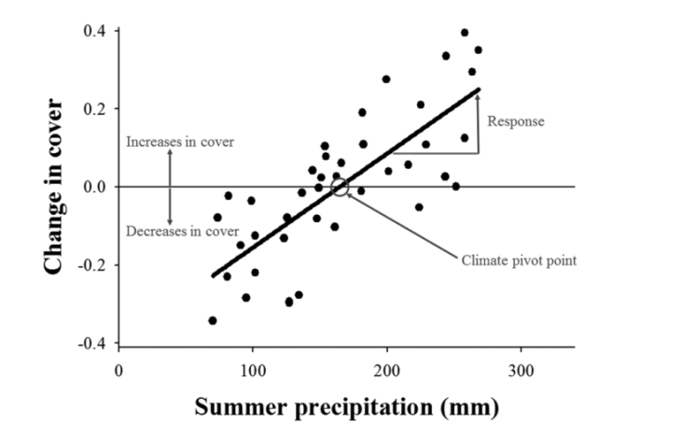 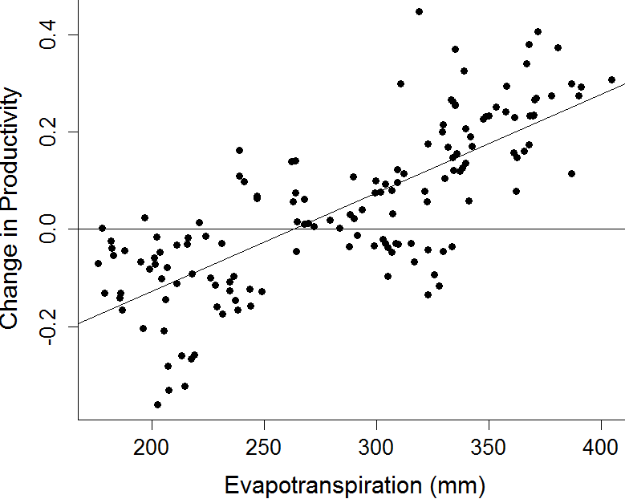

Figure 1. Climate pivot point framework for a) desert species in relation to summer precipitation determined from plot-based measures of species cover over time (Munson 2013); and b) a semi-arid grassland in relation to annual actual evapotranspiration determined from integrated annual NDVI (Thoma et al., in prep.).

**Objectives:** We propose to use the climate pivot point framework to 1) assess which vegetation types are vulnerable to drought and climate change based on pivot points as indicators of sensitivity, 2) determine where across these landscape these changes will be most pronounced, and 3) how management actions, soils, and other landscape factors can accelerate or slow down these shifts.

**Abbreviated Methods:** These objectives can be met by determining vegetation responses and pivot points using climate data, an existing water balance model, NPS vegetation maps and Landsat and MODIS satellite imagery (Fig. 2). We propose a coarse and fine scale study extent. The coarse extent using MODIS imagery to measure vegetation response will be the Rocky Mountain Region national parks and surrounding landscapes between Mexico and Canada, which covers broad gradients in climate, soils, and management activity. The fine scale study extent, within a few select parks, will focus on vegetation types, geomorphic settings and management histories that affect climate / vegetation relationships and will use Landsat imagery as the basis for assessing vegetation response. Climate and water balance conditions (derived from climate) will be related to multi-temporal satellite imagery to assess drought and climate change vulnerability. Climate will be extracted from weather stations and gridded rasters (PRISM). NPS and ReGAP vegetation maps will be used to stratify the landscape. Within vegetation types, NDVI and other vegetation indices will be extracted from Landsat and MODIS imagery. The relationships between climate/water balance and vegetation indices will be determined at a pixel-level. Once the vegetation responses and pivot points are mapped, they can be clipped or sampled as needed to answer questions about climate and vegetation relationships on different soils, geomorphic settings, and under different management regimes. This analysis informs management by demonstrating the spatial patterns of vegetation climate and water balance drivers and vulnerability to climate extremes, to help prepare for and possibly mitigate undesirable climate change effects. Vegetation responses and pivot points can be compared against evolving weather conditions within a growing season to provide near real-time assessment and near-term forecasting (Thoma et al., in press).

C:\Users\smunson\AppData\Local\Microsoft\Windows\Temporary Internet Files\Content.Word\NASA_conceptual.tif

Figure 2. The methods we will use to meet our three objectives in blue. Climate and water availability determined from a model will be related to MODIS and Landsat time series of vegetation condition through the climate pivot point approach. Plant responses and pivot points will be further separated according to management actions, soils, and landscape factors.

Current studies by USGS and NPS I&M have demonstrated the potential to scale-up the climate pivot point framework from plots to regional scales for broad understanding and management applications that in many cases cross jurisdictional boundaries. **However, we request help with image processing, building time series of vegetation indices, and relating climate and water balance variables to vegetation condition across broad regions.** Thus far our work has focused on targeted areas and relied on point or polygon-based analyses due to computational complexity of the grid based assessment proposed here.

We propose developing vegetation response and climate/water balance pivot point maps for NPS and adjacent lands using MODIS and Landsat imagery, climate, and a grid-based water balance model. Once vegetation responses and pivot points are determined, we can combine these metrics with climate change and water balance projections to determine how vegetation is likely to be affected in the future (Gremer et al. 2015). Results of this project would benefit 41 parks in 7 states by providing useful information on vegetation vulnerability to climate change for NPS and its conservation partners.

At finer scales within a park, variation in soil properties and vegetation patterns can be heterogeneous within a single MODIS pixel. Thus we propose exploring vegetation response and pivot points according to soil-geomorphic units, land-use activities, and disturbance types in and adjacent to parks in southeastern Utah. This research would target specific locations in parks to answer our objectives at a management unit scale, and address additional management-focused questions related to ecological thresholds that have been observed where vegetation response before drought is fundamentally changed after drought. This aspect of the study would expand the use of the pivot point framework by determining the degree to which pivot point exceedance by prolonged climate extremes or frequent climate extremes might result in vegetation state-transitions (or regime shifts).

Having the right science at the right time is paramount to short-term NPS management actions that contribute to long-term goals. The climate pivot point framework is a powerful tool for near-term forecasting and understanding spatial patterns of vulnerability and changes in productivity that can be used by managers to appropriately promote resistance, resilience and adaptation across vegetation types, parks, and regions of the intermountain West.

**Literature Cited:**

Bunting, E.L., S.M. Munson, and M.L. Villarreal. In Prep. The Effects of Climate Lags and Legacies on Dryland Plant

Communities in the Southwestern U.S. To be submitted to Ecological Indicators.

Cayan, D.R., T. Das, D.W. Pierce, T.P. Barnett, M. Tyree, and A. Gershunov. 2010 Future dryness in the southwest

US and the hydrology of the early 21st century. Proceedings of the National Academy of Sciences of the United

States of America 107: 21271–21276.

Munson, S.M., A. L. Long, C.S.A. Wallace, and R.H. Webb. 2016. Cumulative drought and land-use impacts to

perennial vegetation across a North American dryland region. Applied Vegetation Science, doi:

10.1111/avsc.12228.

Breshears, D.D., et al. 2005. Regional vegetation die-off in response to global-change-type drought. Proceedings of

the National Academy of Sciences of the United States of America 102: 15144–15148.

Ganey, J.L. and S.C. Vojta. 2011. Tree mortality in drought-stressed mixed-conifer and ponderosa pine forests,

Arizona, USA. Forest Ecology and Management 261: 162–168.

Gremer, J.R., J.B. Bradford, S.M. Munson, and M.C. Duniway. 2015. Desert grassland responses to climate and soil

moisture suggest divergent vulnerabilities across the southwestern U.S. Global Change Biology 21: 4049–4062.

Munson, S.M. 2013. Plant responses, climate pivot points, and tradeoffs in water-limited ecosystems. Ecosphere 4:

109.

Thoma, D.P., S.M. Munson, K.M. Irvine, D.L. Witwicki, and E.L. Bunting. In Press. Semiarid vegetation response to

antecedent climate and water balance windows. Applied Vegetation Science.  
Thoma, D.P., S.M. Munson, D.L. Witwicki. In Prep. Assessing climate and water balance pivot points across

Colorado Plateau national parks.