Bhutan Water Resources

Comparing Precipitation, Temperature, and Phenology Data Trends in Bhutan to Assist the Himalayan Environmental Rhythm Observation and Evaluation System (HEROES) Project

 **Technical Report**

Final Draft– August 6th, 2020

Kinley Dorji (Project Lead)

Tashi Kaneko

Tenzin Wangmo

Deki Namgyal

**Advisors**

Timothy Mayer, NASA SERVIR Science Coordination Office (Science Advisor)

Helen Baldwin, NASA SERVIR Science Coordination Office (Science Advisor)

Sean McCartney, Science Systems & Applications, NASA Goddard Space Flight Center (Science Advisor)

Dr. Robert Griffin, University of Alabama Huntsville (Science Advisor)

Dr. Jeffrey Luvall, NASA Marshall Space Flight Center (Science Advisor)

Dr. Patrick Taylor, NASA Langley Research Center (Science Advisor)

 Dr. Kenton Ross, NASA Langley Research Center (Science Advisor)

# 1. Abstract

Himalayan countries, including Bhutan, have become vulnerable to warming trends which result in increasing temperature and variable rainfall and snowfall. By combining phenological and meteorological data, Earth observation platforms and sensors were used to assess trends in precipitation, temperature, and vegetation phenology in Bhutan from 1996 through 2017. This project studied precipitation using Climate Hazards Center Infrared Precipitation with Station data, analyzed temperature using the Famine Early Warning System Network Land Data Assimilation System, incorporated elevation data from the Shuttle Radar Topography Mission, and assessed vegetation phenology using Aqua and Terra Moderate Resolution Imaging Spectroradiometer (MODIS) to evaluate climate variability and its effects on Bhutan. *In situ* temperature and precipitation data were also collected from the Himalayan Environmental Rhythm Observation and Evaluation System (HEROES) project and Bhutan’s National Center for Hydrology and Meterology. Modeled and *in situ* data showed similar trends in precipitation and temperature for the Thimpu, Chhukha, and Gasa regions. Aqua and Terra MODIS phenology data were variable from year to year. However, the data suggested a late onset of spring green up. Partners at the Bhutan Foundation and locally in Bhutan can use this information to better understand and monitor climate variability and replicate these methods for future analysis.

**Key Terms**

climate trends, elevation, precipitation, temperature, vegetation phenology, FLDAS, CHIRPS, MCD12

# 2. Introduction

* 1. ***Background Information***

Despite the relative isolation from the rest of the world, Himalayan countries like Bhutan remain vulnerable to warming trends, experiencing increasing temperature and variable precipitation in recent decades. Bhutan already faces the risk of glacial lake outburst floods, and this threat could increase through a warming climate (Parker et al., 2012). Over the 21st century, the Himalayas have experienced a worldwide rise in temperature with unpredictable rainfall patterns compared to historic records (Wangdi et al., 2017). Bhutan has also observed increasing potential snow melt and decreasing likelihood of precipitation falling as snow (Wiltshire, 2014). Farmers in the Bumthang district witnessed first-hand the effects of climate variability as growing seasons have become longer, with wet monsoon rain becoming less predictable now than in the past (Wangchuk et al., 2013). A study conducted by Lamchin et al. (2014) reported an increasing trend in temperature in southeast Bhutan from 1982 to 2014. Precipitation and temperature are two critical components for water cycles and help identify variability and trends over a given climatology (Khandu et al., 2017). Since Bhutan is largely an agricultural nation, the country is heavily reliant on water resources for economic, energy, and agricultural reasons. Many communities within the country are actively involved in farming, and they depend heavily on agricultural work for not just for their livelihoods, but also for actively conserving the environment.  

For the purpose of this research, the team accessed trends in precipitation, temperature, and vegetation phenology for Bhutan based on three districts in the western region. Geographically speaking, these locations are ideal because Gasa (north) experiences colder weather, whereas Thimphu (central) is usually temperate, and Chhukha (south) is warmer for most of the year (*Figure 1*). The three regions are topographically different in nature and with Bhutan having an geographically diverse climate given its small size (Stewart et al., 2017), it is important to assess the variability of climatic parameters between different districts. Application of data from Earth observations (EO) and ground-based stations assessed phenological and meteorological trends within Bhutan from 1996 to 2017. Data were used to characterize changes in temperature, precipitation, and phenology with the help of NASA satellite sensors like Aqua and Terra Moderate Resolution Imaging Spectroradiometer (MODIS) as well as ancillary datasets, like Climate Hazards Center InfraRed Precipitation with Stations (CHIRPS) and Famine Early Warning System Network Land Data Assimilation System (FLDAS).

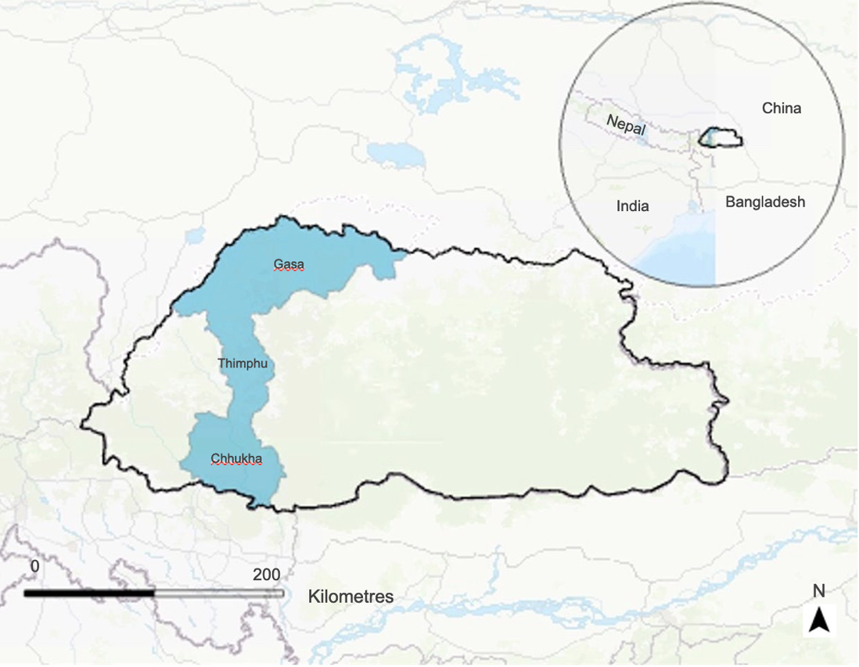

*Figure 1*. Map of Bhutan with the three focus districts: Gasa, Thimphu, and Chhukha.

* 1. ***Project Partners & Objectives***

The Bhutan Foundation is primarily concerned with serving the people of Bhutan by sharing the principles of Gross National Happiness (GNH), and its four pillars – good governance, sustainable socio-economic development, cultural preservation, and environmental conservation. The Foundation’s projects support decisions and priorities that are outlined in Bhutan’s 12th Five Year Plan (FYP). The team also worked closely with the Himalayan Environmental Rhythm Observation and Evaluation System (HEROES), a citizen science initiative project that supports schools and communities to monitor any changes in climatic conditions and impacts of the changes on Himalayan regions. The Bhutan Foundation and HEROES are interested in this project in the hopes of expanding their knowledge on decision-making tools, specifically from Earth observations to provide timely, objective, and consistent coverage for the entirety of Bhutan.

The Bhutan Foundation does not currently use EO in its research or project planning activities. The comparative analysis completed by this project using EO and *in situ* ground data will assist partners in reaching a decision on which methods to choose for future projects focused on water resources and climate variables. The objectives of the project were to analyze data using satellite sensors and ancillary datasets to identify trends in climate variables, like precipitation and temperature, and assess any changes observed over the last few decades. The team compared modelled satellite data to ground station data obtained from the Bhutan National Center for Hydrology and Meteorology (NCHM) to characterize the differences in the datasets. This research will help to better inform partners about Bhutan’s current climate status and facilitate further investigations related to climate variability. 

# 3. Methodology

***3.1 Data Acquisition***

*3.1.1 Precipitation Data*Ground data for precipitation were acquired from the NCHM. This contained a monthly rainfall report for each year, ranging from 1996 – 2017. The NCHM had annual average rainfall data for all the districts in Bhutan, including the three focus districts. However, the Gasa district only had rainfall data from 2003 to 2017. For the modelled satellite data, Google Earth Engine (GEE) served as the main platform of data acquisition. The CHIRPS dataset was acquired using GEE, and the team used it to calculate the total sum of precipitation for all the three focus districts. The GEE interface also allowed the team to threshold elevation to specify the regions of interest in each district using Shuttle Radar Topography Mission (SRTM) data.

*3.1.2 Temperature Data*Similarly, the *in situ* data for the average monthly monsoon temperature was also collected from the NCHM. Data were initially represented on the ground station report as maximum and minimum temperature for each month for every year. These were then processed further to find mean monsoon temperature for each district. As for the modelled satellite data, FLDAS was incorporated using GEE to calculate the mean land surface temperature within each district. The temperature code also accounted for the elevation threshold to specify the regions of interest in each district.

*3.1.3 Phenology Data* For the modelled data, the team had originally used NOAA Advanced Very High Resolution Radiometer (AVHRR) to look at a longer-term phenological dataset going back to 1981. Due to time constraints and in the interest of maintaining a similar study period to temperature and precipitation, the MCD12 product from Aqua and Terra MODIS, which goes back as far as 2001, was used instead to acquire land surface vegetation green up phenology data for each district. While *in situ* data were acquired from the HEROES project, the data reports contained different species. Although records show similar timing for most of the first leaf, flower, bud, fruit, and other plant-related observations, the team decided to only focus on the modelled satellite data to avoid this complication.

***3.2 Data Processing***

For all *in situ* data, the team filtered using elevation thresholds for each district so that data would be comparable to the collected satellite modelled dates (*Figure 2*). The team acquired the *in situ* data for each district from point ground stations with a given elevation. Team members had initially collected modelled satellite data from the entire region and found that it was not compatible with the *in situ* data. Upon learning how topography and altitude can affect climate variables like temperature and precipitation, the team processed the data in GEE to the regions of interest within each district at a similar elevation range as the ground stations. This was done by using elevation thresholds that narrowed the districts to regions of interest. These regions of interest were within the districts which had agricultural sectors and the most human population. For Thimphu, the ground station (Simtokha) had an elevation of 2310m, so an elevation threshold of 2000 – 2500m was used. Gasa’s ground station had an elevation of 2760 m, so the elevation threshold for Gasa was adjusted to 2000 – 2800 m. As for Chhukha, the ground station was at 1600 m and the elevation threshold was set to 1300 – 2000 m (Table 1).

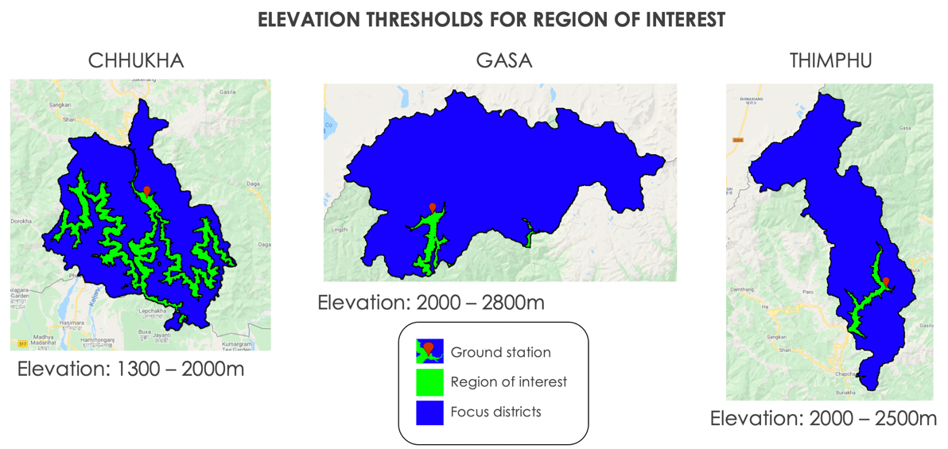

*Figure 2*. Representation of region of interest defined by elevation thresholds.

Table 1

*Threshold elevations for each district.*

|  |  |  |
| --- | --- | --- |
| **Station** | **Station Elevation (m)** | **Elevation threshold (m)** |
| Thimphu (Simtokha) | 2310 | 2000 - 2500 |
| Gasa | 2760 | 2000 - 2800 |
| Chhukha | 1600 | 1300 -2000 |

In the case of precipitation, the ground station provided a summary of the annual monthly total rainfall (in millimeters). The data for June, July, and August were imported to Excel, and an annual total rainfall for the monsoon period was calculated by adding the total rainfall for those months for each year. For the CHIRPS data, the team used GEE where total precipitation data were collected for each pixel for the entire region and then found the total sum of precipitation for only the region of interest within each district.

For temperature, the team populated the annual monthly maximum mean temperature for the monsoon period (June through August) from 1996 to 2017 into excel with the *in situ* data provided by NCHM. These monthly maximum mean temperatures were then averaged and the mean maximum temperature for the monsoon period was found. This was similarly done for the annual monthly minimum mean temperature data and the mean minimum temperature for the monsoon was computed. After obtaining both the mean maximum and minimum temperature for the monsoon period, another total average was calculated between the two to get the final mean temperature of the monsoon period for each year. These data were then compared to the satellite modelled data collected from FLDAS. Through GEE, the team computed the annual monthly land surface temperature within each district and then found the mean annual temperature for the monsoon period for the region of interest within each district.

***3.3 Data Analysis***

The team performed a comparative analysis to see if there was a correlation between the modelled and ground data using graphs, scatterplot trend lines, and box and whisker plots. Additional statistical analysis was also completed using the R square statistic to further validate and evaluate existing data. Through the visualization and statistical analysis of these graphs, the team drew conclusions from the results obtained. The scatterplot trend lines assisted the team in understanding and explaining the variation in climate trends over the years. A box and whisker plot were used to visually categorize data for both the modelled and ground data.

# 4. Results & Discussion

***4.1 Analysis of Results***

*4.1.1 Precipitation*After analyzing the *in situ* and CHIRPS datasets within Excel using trend line graphs and the box whisker plots (*Figure 3*) for Thimphu, the team noted that ground and modelled data were relatively similar to each other. Since the modelled and ground data were collected separately and using different methods, a disparity, however small, between the two datasets was expected. Among the three focal districts of interest, Thimphu had the lowest mean annual precipitation ranging between an average of 200 to 600 mm. The annual total precipitation for the monsoon period had remained relatively consistent over the years, but there was a slight decreasing trend observed in the amount of rainfall. An R2 value of 0.13 was found for the two datasets, suggesting that 13% of the variation in precipitation has been observed since 1996.

Precipitation for Thimphu: CHIRPS and *In Situ* Data

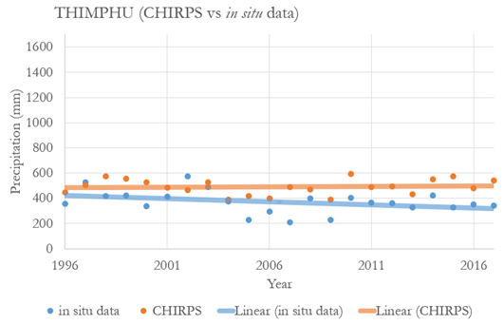

*Figure 3.* Thimphu precipitation totals, CHIRPS plotted with *in situ* data.

The Chhukha district had the highest mean annual precipitation, ranging between an average of 800 – 1,300 mm. While analyzing the two datasets on the trend lines graphs (*Figure 4*), a difference was noted between the two datasets. The *in situ* data was lower compared to the CHIRPS dataset. Both the datasets revealed an increasing trend in the total annual precipitation over the years. The difference between the two datasets arose from how the data were compared, as the team investigated a wider region dataset from the modelled data as compared to the *in situ* data obtained from a point location. This is also due to elevation differences in the country. To make the two datasets as comparable as possible, as mentioned earlier, elevation thresholds were used. Since the means are relatively close and the distribution is somewhat overlapping, the data are comparable despite visually observed differences. An R2 value of 0.12 was found for the two datasets, suggesting that 12% of the variation in precipitation had been observed since 1996.

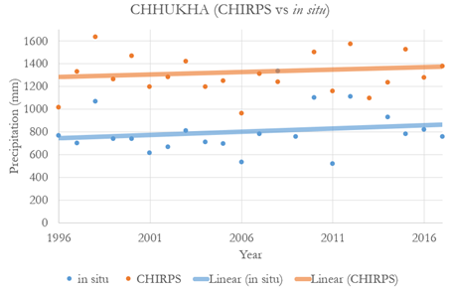

Precipitation for Chhukha: CHIRPS and *In Situ* Data

*Figure 4.* Chhukha precipitation totals, CHIRPS vs *in situ* data.

An anomaly was found for Gasa’s precipitation data, as there was a large difference between the *in situ* and the CHIRPS datasets. The *in* *situ* data indicated that there were high amounts of precipitation from 900 – 1400 mm during the monsoon period. However, this was not reflected in the CHIRPS dataset which was from 300 – 400 mm (*Figure 5*), even though the team had filtered down the CHIRPS data to match the elevation of the ground station. This was also represented in the box plot as the means of the total precipitation for the two datasets do not lie close to one another (*Figure 6*). This shows the difficulties in collecting data in mountainous regions. It also indicates that the team needs to either do a point-to-point location comparison or that there could have been human errors while collecting the *in situ* data.

Precipitation for Gasa: CHIRPS and *In Situ* Data

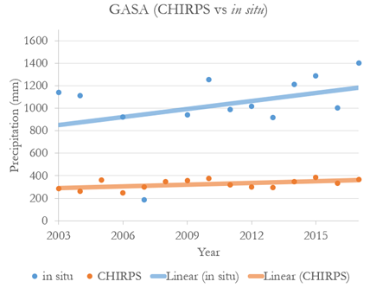

*Figure 5.* Gasa precipitation totals, CHIRPS plotted with *in situ* data.

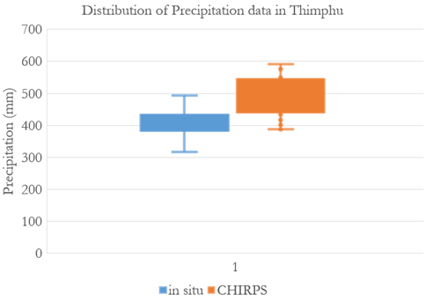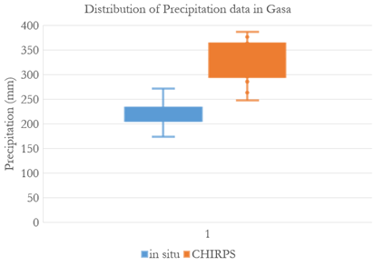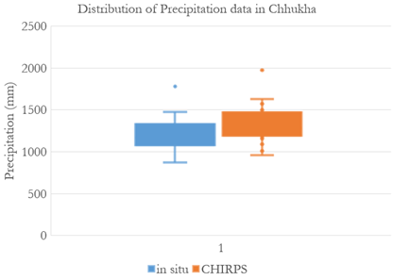

*Figure 6*. Box and whisker plots of precipitation totals for all three focus districts.

*4.1.2 Temperature*  
For temperature, the team performed the same analysis as aforementioned for each district. When analyzing the data for Thimphu, the annual monsoon temperature from FLDAS remained consistent at 15˚ C over the years. The *in situ* data showed a slightly decreasing trend over the study period, implying that the temperature during the monsoon for Thimphu had been dropping over the years by 1˚ C (*Figure 7*). There is a difference between the two datasets, as observed in both the scatterplot and the box and whisker plot (*Figure 10*). An R2 value of 0.05 was found, which was very low. Variation in slopes and elevations affected how the data were collected and this could explain the low R2 value.

Temperature for Thimphu: FLDAS and *In Situ* Data

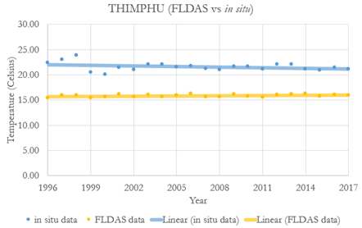

*Figure 7.* Thimphu, FLDAS plotted with *in situ* data temperature totals.

When investigating the monsoon temperature for Chhukha, the region had the highest mean temperature for the monsoon period among the three districts. Unlike Thimphu, both datasets for Chhukha where very similar to each other. It should be noted that the *in situ* data ranged from 15˚ C to 25˚ C, whereas the FLDAS data stayed around 20˚ C (*Figure 8*). This can also be noted in the box and whiskers plot where the mean monsoon temperature for *in situ* data was wider than the mean monsoon temperature obtained from FLDAS (*Figure 10*). The *in situ* data for Chhukha showed an increasing trend over the years indicating that temperature for that location had been increasing over the past year. The R2 value for these two data was 0.03 which was also comparatively low.

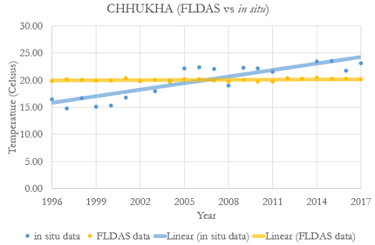

Temperature for Chhukha: FLDAS and *In Situ* Data

*Figure 8.* Chhukha, FLDAS plotted with *in situ* data temperature totals.

Similar to Chhukha, both datasets for Gasa were within the same range (*Figure 9*). The FLDAS data remained consistent at 15˚ C, and the *in situ* data showed that the temperature for that ground station had been dropping over the study period from a mean of 16˚ C to 15˚ C (*Figure 10*). The R2 value was found to be 0.04, which is low. It should be noted that Gasa’s *in situ* data was only recently recorded from 2003 and no further data was recorded in the preceding years.

Temperature for Gasa: FLDAS and *In Situ* Data

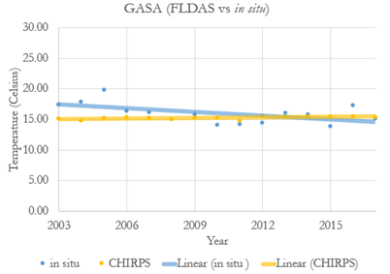

*Figure 9.* Gasa, FLDAS plotted with *in situ* data temperature totals.

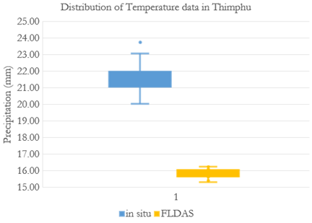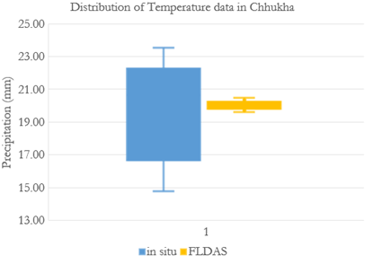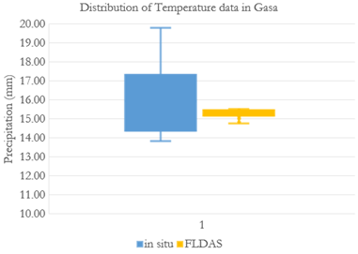

*Figure 10*. Box and whisker plots for all three focus districts

*4.1.3 Phenology*  
To understand if the start of spring had changed during the study period, the team used the Greenup_1 variable from Aqua and Terra MODIS. For all three districts, a slightly increasing trend was observed, suggesting the late arrival of spring. Due to time constraints, the team only looked at the phenology dataset using modelled satellite data. Through GEE, the annual mean green up for each district was calculated using the MCD12 data product. The Julian date for each year was calculated by subtracting how many days had passed since January 1, 1970 from the value for the green up data obtained from GEE. An overall conclusion can be made that spring has been starting later over the years for all three districts (*Figures 11, 12, & 13*).

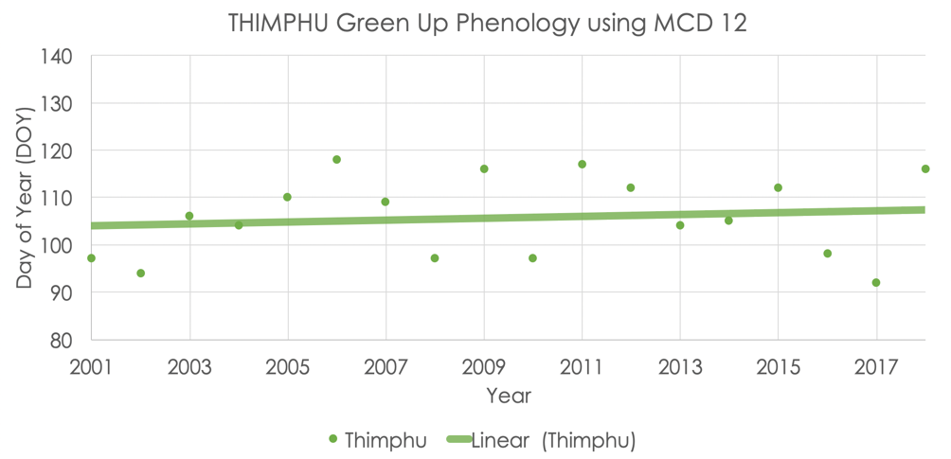

*Figure 11.* Thimphu green up phenology. Green up is defined as the date of onset of vegetation greenness.

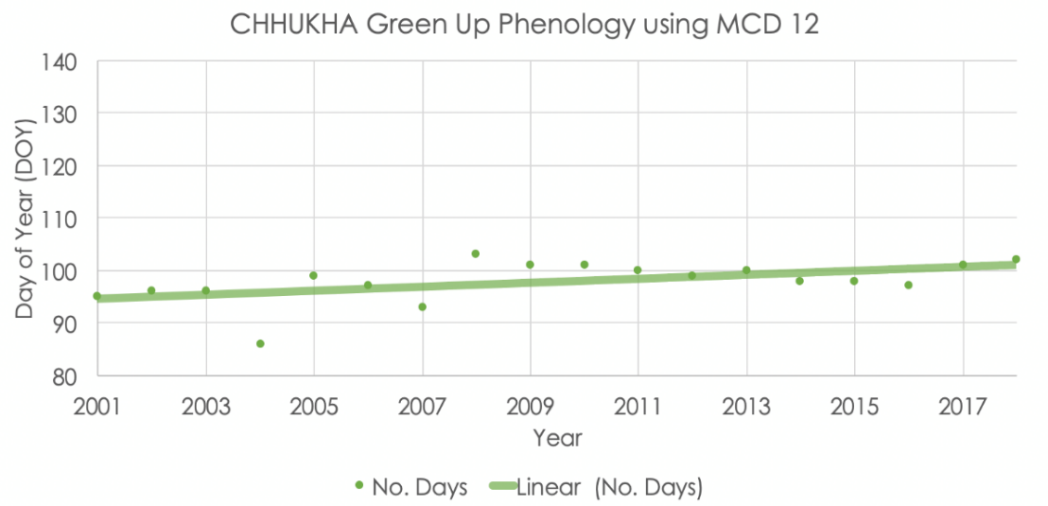

*Figure 12.* Chhukha green up phenology. Green up is defined as the date of onset of vegetation greenness.

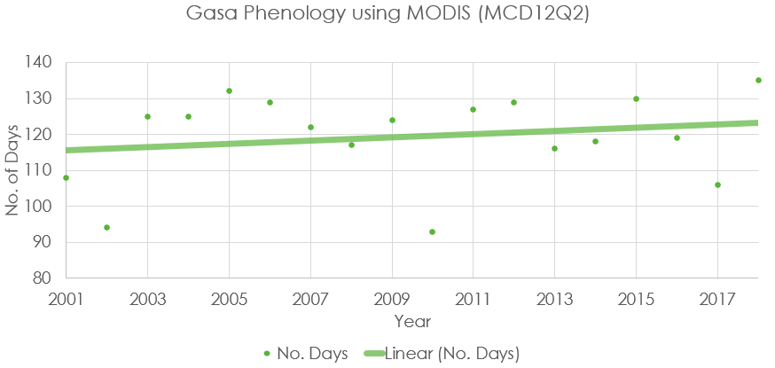

*Figure 13.* Gasa green up phenology. Green up is defined as the date of onset of vegetation greenness.

***4.2 Limitations***Initially, the project was intended to look at a longer study period, from 1981 to 2019. Due to the limited availability of *in situ* data, which went back as far as 1996, the team thought it would best to run the same analysis for the modelled satellite data as well. There were also differences and potential error observed with the comparison of point *in situ* data and modelled data averaged over an entire district. Team members also noticed missing ground station precipitation data for Gasa, as the district had only contained records from 2003 to 2017. Modelled data also has issues assessing highly mountainous regions due to wide and frequent variations in elevation. Even carefully designed studies reported difficulty with matching the satellite and ground data (Stewart et al., 2017). It is also possible that there was potential human error involved while collecting *in situ* data, such as bias and random error.

***4.2 Future Work***  
Since Bhutan is currently an agriculture-based nation, it is beneficial to understand how variation in climate trends could affect crop production and agriculture in general. More emphasis should be placed on the role precipitation and temperature play as well as how these factors influence blooming of plants and other phenological trends. Since we used Aqua and Terra MODIS for phenology, which only go back as far as 2000, it would be advisable to look into the NOAA AVHRR instrument to have a long-term vegetation phenology dataset from 1981. With regards to phenology, there is still a lot of ground to cover in terms of the late arrival of spring and what this could imply for Bhutan’s vegetation and wildlife. Our recommendation for any future continuation of this work would be to apply methods similar to the precipitation and temperature analysis we completed but for phenology. Three focal districts in the western region were chosen based on their location, with Gasa in north, Thimphu located more centrally, and Chhukha in the south. In future work, our partners or other teams can use this as a prototype and apply the same process to other districts within the country. Since the team only looked into the monsoon period for this project, team members would also suggest taking a look at other seasons and observe changes during different time periods.

# 5. Conclusions

Bhutan has been affected by seasonal and climatic variability, which is not only a major concern for local farmers, but also for the people of Bhutan (Wangchuk et al., 2013). The rainfall pattern for both the modelled and ground data was similar and remained consistent, with Chhukha district having observed the highest amount of rainfall. Based on the analysis, there was an overall increase in total rainfall for that region by roughly 7% – 9% from 1996 – 2017. This shows that the results obtained from data products that incorporate satellite sensors are reliable to a certain extent when looking at a wider region, or even entire districts. Gasa showed an anomaly for precipitation, as the modelled data varied greatly with 900 – 1400 mm of precipitation in comparison to the *in situ* data (300 – 400 mm). The variation in trends was a result of modelled data having averaged an entire region, whereas ground station data was collected at a point location. Aside from the slight variation in temperature from the *in situ* data, the modelled FLDAS data showed that the mean temperature for each district had remained consistent over the study period.

Due to Bhutan's topographical features, slight variations in trends were observed for all climate variables. Variation in slopes and elevations can influence how the data were measured, and this can make it difficult to match the satellite/modelled data and *in situ* data. Satellite precipitation data are challenged in the Himalayas, as it is difficult to measure rainfall above high mountains and dense forests. SRTM helped to resolve this issue by mainly focusing on the region of interest and matching the modelled data to the ground stations. As for phenology, the overall results from the vegetation green up data acquired from Aqua and Terra MODIS showed that spring for all three districts had been pushed back by 4 – 5 days over the study period. This is significant as it implies that all vegetation, not just agricultural crops, will experience delayed seasons. Ultimately, this research will help to inform the partners of variation in climate trends that affect local farmers and citizens.

# 6. Acknowledgments

The team would like to acknowledge the following individuals for their influence in our work:   
  
Timothy Mayer (NASA SERVIR Science Coordination Office)   
Helen Baldwin (NASA SERVIR Science Coordination Office)    
Sean McCartney (Science Systems & Applications, Inc., NASA Goddard Space Flight Center)    
Dr. Robert Griffin (The University of Alabama in Huntsville)    
Dr. Jeffrey Luvall (NASA Marshall Space Flight Center)   
Dr. Patrick Taylor (NASA Langley Research Center)   
Dr. Kenton Ross (NASA Langley Research Center)    
Christine Evans (The University of Alabama Huntsville)    
Madison Murphy (Optimal GEO)     
Caily Schwartz (NASA SERVIR Science Coordination Office)  
A.R. Williams (NASA DEVELOP)  
Sabine Nix (NASA DEVELOP)  
Thomas Quintero (NASA DEVELOP)

Any opinions, findings, and conclusions or recommendations expressed in this material are those of the author(s) and do not necessarily reflect the views of the National Aeronautics and Space Administration.

# This material is based upon work supported by NASA through contract NNL16AA05C.

# 7. Glossary

**AVHRR** – Advanced Very High-Resolution Radiometer

**CHIRPS** – Climate Hazards Group InfraRed Precipitation with Station

**Earth observations** – Satellites and sensors that collect information about the Earth’s physical, chemical, and biological systems over space and time  
**FLDAS** – Famine Early Warning System Network Land Data Assimilation System       
**GEE** – Google Earth Engine   
**MODIS** – MODerate Resolution Imaging Spectroradiometer  
**NCHM** – Natioanal Center for Hydrolgoy and Meterology   
**NDVI**– Normalized Difference Vegetation Index   
**SRTM** –  Shuttle Radar Topography Mission

# 8. References

Funk, C., Peterson, P., Landsfeld, M., Pedreros, D., Verdin, J., Shukla, S., Husak, G., Rowland, J., Harrison, L., Hoell, A., & Michaelsen, J. (2015). The climate hazards infrared precipitation with stations—a new environmental record for monitoring extremes. *Scientific Data, 2*, 150066. https://0-doi-org.lib.utep.edu/10.1038/sdata.2015.66

Khandu, Awange, J.L., L., Kuhn, M., Anyah, R., & Forootan, E. (2017). Changes and variability of precipitation and temperature in the Ganges-Brahmaputra-Meghna River Basin based on global high-resolution reanalyses. *International Journal of Climatology, 37*(4), 2141–2159. http://doi.org/10.1002/joc.4842

Lamchin, M., Lee, W., Jeon, S., Wang, S, K., Lim, H., Song, C & Sung, M. (2018). Long-term trend of and correlation between vegetation greenness and climate variables in Asia based on satellite

data. *MethodsX*, *5,* 803–807. https://doi.org/10.1016/j.mex.2018.07.006

Liu, J., Wang, Z., Gong, T., & Uygen, T. (2012). Comparative analysis of hydroclimatic changes in glacier-fed rivers in the Tibet- and Bhutan-Himalayas. *Quaternary International*, *282*, 104–112. [https://0-doi-org.lib.utep.edu/10.1016/j.quaint.2012.06.008](https://0-doi-org.lib.utep.edu/10.1016/j.quaint.2012.06.008 )

National Center for Hydrology and Meteorology Royal Government of Bhutan. (2018). *Climate data book of Bhutan.*https://www.nchm.gov.bt/attachment/ckfinder/userfiles/files/Climate%20Data%20Book%20of%20Bhutan%2C%202018.pdf

Parker, L., Guerten, N., Nguyen, T., Rinzin, C., Tashi, D., Wangchuk, D., Bajgai, Y., Subedi, K., Phuntsho, L., Thinley, N., Chhogyel, N., Gyalmo, T., Katwal, T., Zangpo, T., Acharya, S., Pradhan, S., & Penjor, Sonam. (2017). Climate change impacts in Bhutan: Challenges and opportunities for the agricultural sector. *Climate Change, Agriculture and Food Security, 191.*

Stewart, S. B., Choden, K., Fedrigo, M., Roxburgh, S. H., Keenan, R. J., & Nitschke, C. R. (2017). The role of topography and the north Indian monsoon on mean monthly climate interpolation within the Himalayan Kingdom of Bhutan. *International Journal of Climatology*, *37*, 897–909. <https://doi.org/10.1002/joc.5045>

Wangchuk, S., & Siebert, S. F. (2013). Agricultural change in Bumthang, Bhutan: Market opportunities, government policies, and climate change. *Society & Natural Resources, 26*(12), 1375–1389. https://doi.org/10.1080/08941920.2013.789575

Wangdi, N., Om, K., Thinley, C., Drukpa, D., Dorji, T., Darabant, A., Chhetri, P., B., Ahmed, I, U., Staudhammer, C, L., Jandl, R., Schindlbacher, A., Hietz, P., Katzensteiner, K., Godbold, D., & Gratzer, G. (2017). Climate change in remote mountain regions: A through fall-exclusion experiment to simulate monsoon failure in the Himalayas. *Mountain Research and Development, 37*(3), 294–309. https://doi.org/10.1659/MRD-JOURNAL-D-16-00097.1

Wiltshire, A. J. (2014). Climate change implications for the glaciers of the Hindu Kush, Karakoram and Himalayan region. *The Cryosphere, 3.*http://doi.org/10.5194/tc-8-941-2014

# 9. Appendix A

This appendix contains supplementary figures requested by partners that were not discussed within the body of this technical paper.

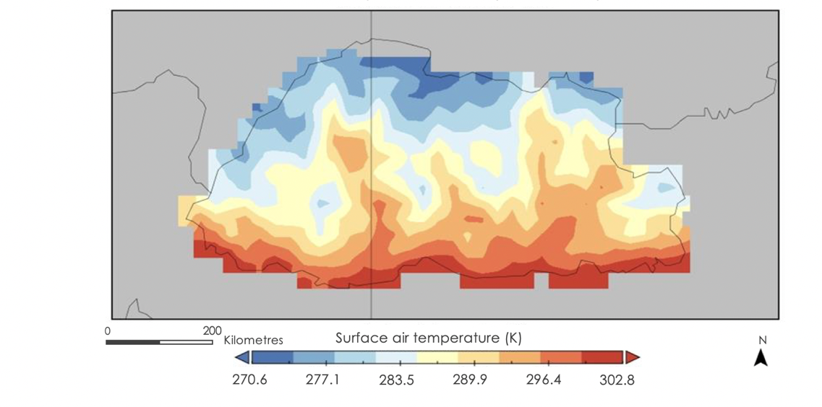

*Figure A1.* Bhutan’s June Average Temperature (2017 – 2019).

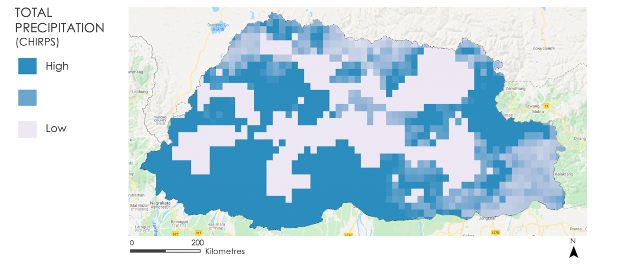

*Figure A2*. Bhutan’s 2019 Total Precipitation.