**NASA DEVELOP National Program**



Wise County Clerk of Court’s Office

*Spring 2014*

Rwanda Agriculture

Utilizing NASA’s Earth Observations to Estimate Rice Yield and

Study Soil Erosion in Rwanda

**Technical Report Rough Draft**

Feb 20, 2014

Faith Mwiza, California Baptist University (Project Lead)

Daria Blach, The University of Virginia’s College at Wise

Emmanuel Muzungu, Oklahoma Christian University

Rohini Swaminathan, Purdue University

Zachary Tate, The University of Virginia’s College at Wise

Dr. Kenton Ross, NASA DEVELOP National Program (Science Advisor)

Dr. DeWayne Cecil, Global Science and Technology Inc. (Science Advisor)

# I. Abstract

The Rwandan economy relies heavily on agriculture, with over 90% of the population engaged in subsistence farming. Over 70% of the country’s total land surface is exploited for agriculture. As part of the government’s efforts to grow the economy and reduce poverty, the Ministry of Agriculture established the National Rice Policy (NRP) coupled with the Rural Sector Support Program (RSSP). The goal of the NRP is attaining self-reliance and competitiveness in rice production whereas the RSSP’s purpose is the development of marshlands to rice fields in order to increase rice cultivation and yield.

This project used NASA’s Earth Observations such as Landsat 5 Thematic Mapper (TM) and Landsat 8 Operational Land Imager (OLI) to monitor rice fields. Crop production models were used to estimate rice yields. Additionally, modern practices are being implemented at the Land, Water and Hillside (LWH) development sites. Soil erosion susceptibility maps were developed in the identified LWH sites. Rainfall data was obtained from Modern Era Retrospective-Analysis for Research and Applications (MERRA) database. Elevation was calculated from Advanced Spaceborne Thermal Emission and Reflection Radiometer (ASTER) and land use data was obtained from the Rwanda Ministry of Agriculture and Animal Resources (MINAGRI). Soil erodibility map was downloaded from the Soil and Terrain Database of Central Africa. Partnering with, MINAGRI and the World Bank, meaningful maps were derived to monitor new practices and provide information to policy decision makers.

**Keywords**

Rwanda, National Rice Policy, Rice Yield, Soil Erosion, Remote Sensing

# II. Introduction

Agriculture is the backbone of the Rwandan economy with more than 90 percent of the population engaging in subsistence farming. Agriculture contributes 47 percent of the Gross National Product (GNP) and accounts for 71 percent of the country’s export revenue. Only 52 per cent of the land surface area is arable, of this land, approximately 165,000 hectares (ha) are marshlands of which 93,754ha (57%) has been cultivated. Unmonitored agriculture practices have led to the acceleration of land surface erosion, increasing the vulnerability to flooding, landslides and decreasing crop yields. This project was aimed at utilizing NASA Earth Observations to monitor land management practices and the development of marshlands into rice fields in Rwanda.

The Republic of Rwanda is located in the heart of Africa. Rwanda lies between latitudes 1° 04’S and 2° 51’S and longitude 28°45’E and 31°15’ E. Its surface area is 26,338 km2, which is slightly smaller than the area of Maryland. Rwanda borders with Tanzania (East), Uganda (North), Burundi (South) and the Democratic Republic of Congo (West). This study was mainly concentrated in the Eastern Province of Rwanda over the period from 2000 to 2013. The main economic activity of this province is subsistence farming, whereby farmers grow enough to feed themselves and their families. One of the drawbacks of this practice is that oftentimes farmers will plant crops that do not involve proper land management practices, thus making the land more susceptible to soil erosion.

The Government of Rwanda has invested in the advancement of agriculture with activities such as irrigation, marshland reclamation, and crop regionalization. Launched in 2001, the Ministry of Agriculture (MINAGRI) released the National Rice Policy which identified rice as a priority crop and set out to attain self-sufficiency in rice production. Partnering with the MINAGRI and the World Bank Open Data Initiative, this project not only addressed the NASA application area of agriculture, but also utilized NASA’s Earth Observations to monitor rice cultivation and land management practices in order to achieve increased crop productivity and food security. Using Landsat 5 Thematic Mapper (TM) and Landsat 8 Operational Land Imager (OLI), rice fields were delineated from the surrounding land.

Additionally, modern practices such as tillage, land husbandry, and hillside irrigation are being implemented at specific Land, Water and Hillside (LWH) development sites. To assist these practices, soil erosion susceptibility maps were developed in the identified LWH sites. These maps used land use classification, soil type, rainfall data and elevation data. The maps developed depict before and after the developmental phase which help our partners understand the progress and effect of introducing modern practices.

# III. Methodology

**Data Acquisition**

***Landsat Data***

Images were obtained from Landsat 5 TM and Landsat 8 OLI from United States Geological Survey (USGS) Earth Explorer database from 2010 – 2014.

***Terra, ASTER GDEM***

Digital Elevation Models from ASTER Global DEM was downloaded from USGS Global Visualization (GloVIS) Viewer.

***Modern Era Retrospective-Analysis for Research and Applications (MERRA) database***

Precipitation data was downloaded from Global Modeling and Assimilation Office, Goddard Space Flight Center.

***Ancillary Data Products***

Ground survey data and ground truth information was obtained as Excel files from the partner organizations.

**Data Processing**

***Landsat Data***

The Digital Numbers (DN) from the Landsat level 1 data were converted into surface reflectance values using automated python scripts in Arc GIS. All the resulting layers were cropped to a pilot study site. Modified Normalized Difference Water Index (MNDWI) was calculated by comparing the green and Short Wave Infra-Red (SWIR) bands of level 1 data. In Landsat 5, Band 2 represents green and Band 5 represents SWIR. In Landsat 8, Band 3 represents green and Band 6 represents SWIR.

MNDWI products were calculated as follows:

$${MNDWI}_{Landsat}= \frac{Green-SWIR}{Green+SWIR}$$

MNDWI was used as it highlighted the presence of irrigated rice fields from the surrounding area. The index was computed for three different years – 2010, 2013 and 2014 to study the progress of marshland to rice field conversion as shown in figure 2.

***ASTER GDEM***

The topographic analysis of Rwanda required that the ASTER images downloaded be processed in ArcGIS. The images downloaded were mosaicked using ArcGIS Toolbox’s Mosaic tool. The end product was a DEM indicating areas with the highest elevation and lowest elevation. Using the DEM, we were able to derive the slope, and flow accumulation, all which are factors/variables needed for the slope length factor calculation.

**Data Analysis**

***Rice Delineation***

All the images were analyzed in ArcGIS environment. Modified Normalized Differential Water Index (MNDWI) was used as it enhanced the presence of rice fields from the surrounding area and also differentiated the planted area to the area prepared for cultivation. Through manual delineation, rice masks were created in the identified RSSP sites for different years, showing the gradual process of development.

***Soil Erosion Modeling***

RUSLE Equation is used to map soil vulnerability in the study area. Developed by the US Department of Agriculture, the soil loss equation, originally USLE (Universal Soil Loss Equation), and today RUSLE (the Revised Universal Soil Loss Equation), has been used as a way to monitor soil loss and aid in conservation planning for agricultural practices (Wischmeier and Smith 1978). Both USLE and also RUSLE are linear models that predict long-term average rates of soil erosion, in which

$A = R×K×LS×C×P$, where:

**A** is the calculated average annual soil loss in tons per acre per year

**R** is the erosivity factor,

**K** is the soil erodibility factor,

**LS** is the both the slope length and the slope steepness factors,

**C** is the cover management factor,

**P** is the support practice factor.

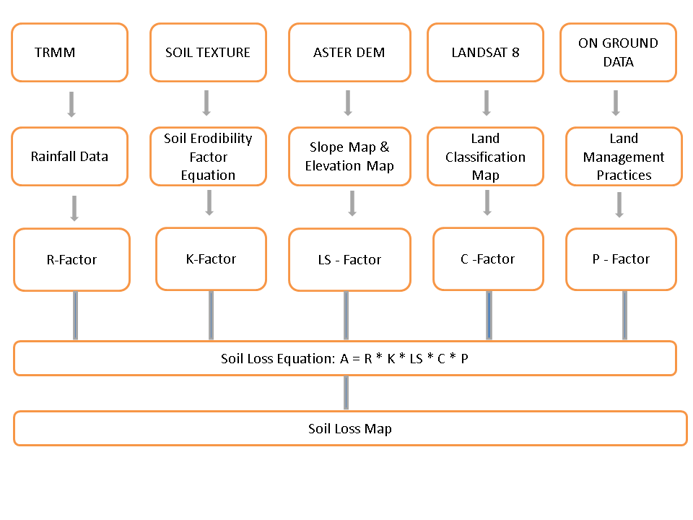

***Figure1:*** *Flowchart showing the estimation of soil loss incorporating all the factors – Rainfall, Soil Erodibility, Slope Length and Steepness, Land Cover and Practice factors*

# IV. Results & Discussion

**Analysis of Results**

***Rice Delineation***

See figure 2.

***Soil Erosion Susceptibility Map***

The Rainfall (R) and Soil Erodibility (K) factors were obtained from summer 2013 DEVELOP project (Rwanda Ecological Forecasting).

***LS - Slope Length and Steepness Factor***

Slope length is the distance from the origin of overland flow along its flow path to the location of either concentrated flow or deposition. Once soil particles are dislodged by raindrops or runoff, the steepness and length of a slope act as a medium of transportation that carries the soil particles downhill. Slope length and steepness were determined through topographic data obtained from the ASTER sensor.

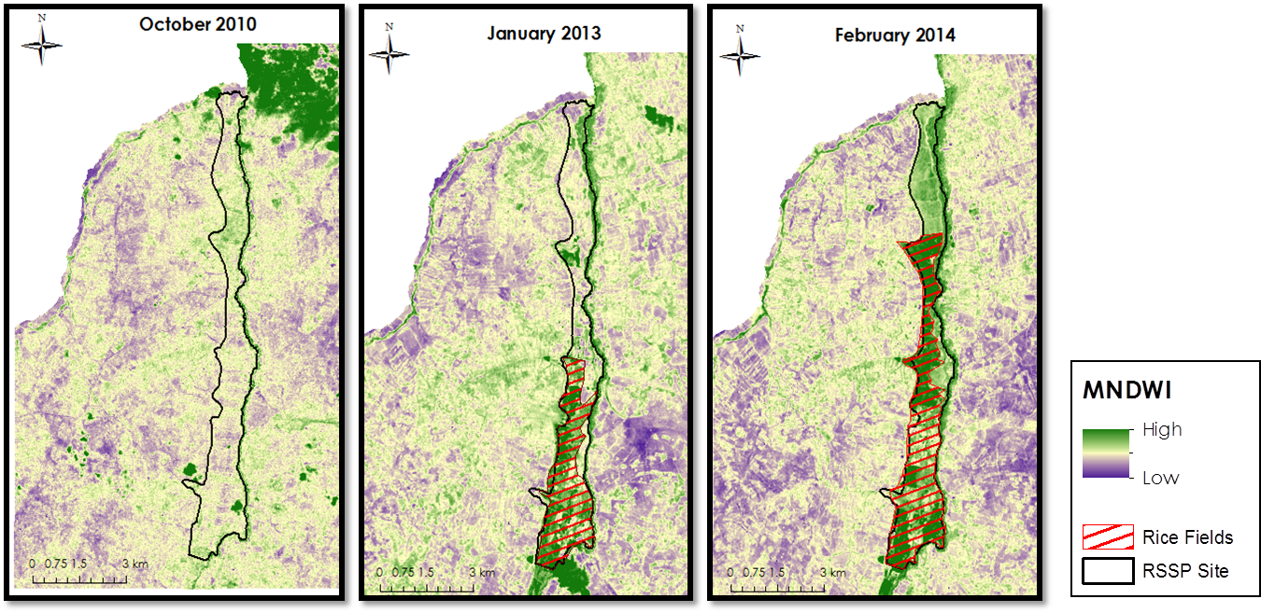***Figure 2:*** *Landsat images showing progress of marshland to rice field conversion in the northeastern Rwanda using Modified Normalized Difference Water Index (MNDWI) – January 2010 to February 2014*



***Figure 3:*** *LS factor shows that there are mountainous terrains and steep slopes but also flat areas in Rwanda. Slope plays a large part in the soil loss throughout the western and central part of Rwanda.*

***C - Cover Management Factor***

The cover management factor was determined through a land classification scoring system based upon how certain land covers affect erosion rates. The team then ranked each of the classes from that map with a C-value based on the previous study done in Malaysia (Teh, 2011). The C values are shown in the table below. Based on the C – values, a C factor map was created.

|  |  |
| --- | --- |
| Type | C – value |
| Built- up area | 0.25 |
| Closed agriculture | 0.30 |
| Forest plantation | 0.15 |
| Irrigation | 0.10 |
| Natural forest | 0.03 |
| Open agriculture | 0.50 |
| Open land | 0.90 |
| Runway | 0.00 |
| Water body | 0.01 |

***Table 1:*** *Table shows C values for each of the land use classes.*

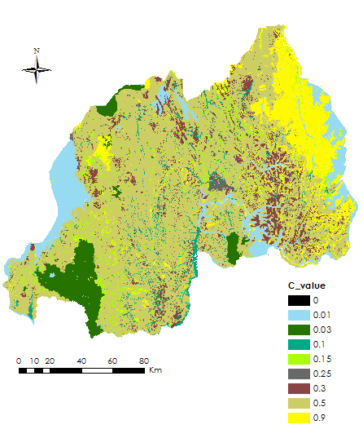

***Figure 4:*** *Land cover classification map showing different C-values throughout Rwanda. When C value is lower than 1, there is less soil erosion.*

***P- Land Management Practices Factor***

According to Teh, a P value is equal to 1, when poor agricultural practices are applied at the land. P values are lower and less than 1, when the adopted conservation practices reduce soil erosion. Since the government has implemented modern agricultural practices at the LWH sites, the P factor there was equal to 0.5. However, the areas that do not belong to the LWH sites had a P value equal to 1.

***Soil Erosion Susceptibility***

After a critical analysis of the factors mentioned above, the RUSLE equation was used to generate images showing soil erosion susceptibility as indicated below. Two images were derived; one before implementation of the LWH (Land, Water, and Hillside) project, and the other derived after the initiation of the project (LWH).

**Soil Erosion before LWH Project implementation**

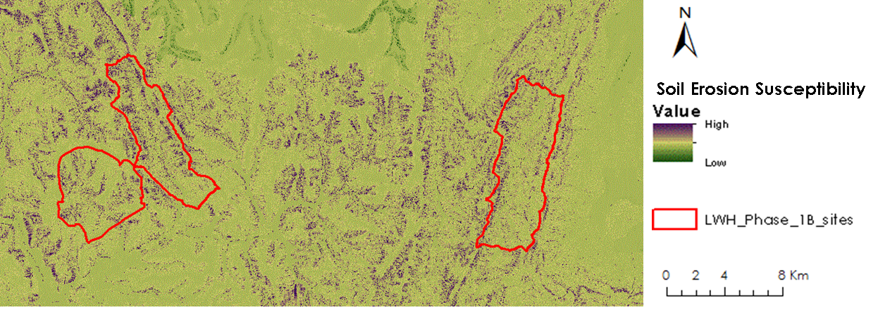

***Figure 5:*** *Image showing soil erosion susceptibility map before the LWH (Land, Water, and Hillside) project initiation*

The image above shows high levels of soil erosion due to poor land management practices. Initially the government of Rwanda had little or no intervention in land management practices, which led to over exploitation of land by farmers thus resulting to increased levels of soil erosion.

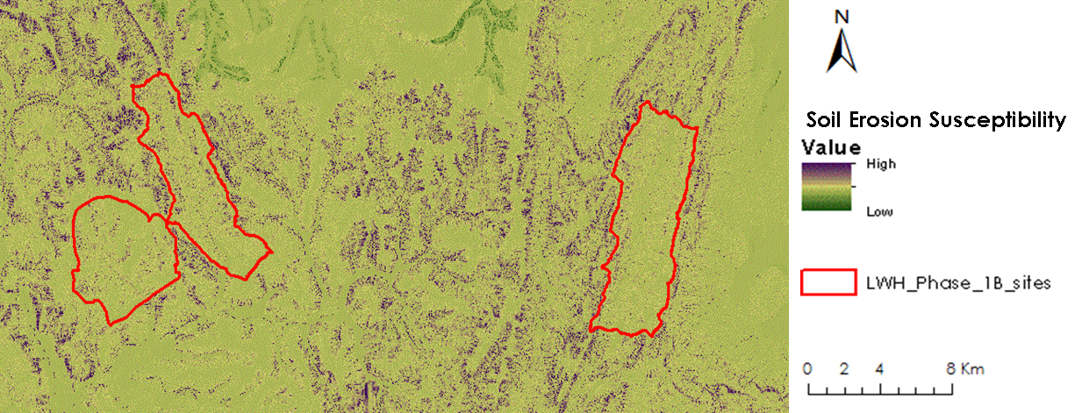

**Soil Erosion after LWH Project implementation**

***Figure 6:*** *Image showing a reduction in soil erosion susceptibility at the LWH (Land, Water, and Hillside)*

With the implementation of government programs such as LWH (Land, Water, and Hillside), there was a significant reduction in soil erosion as indicated by the image above.

***Errors & Uncertainty***

The process of rice delineation was carried out manually; therefore the accuracy of the results can be improved with validation from ground truth data. Other indices similar to MNDWI can be identified to improve the visual interpretation capabilities for manual delineation. The C and P values used in the RUSLE equation to quantify soil erosion susceptibility were obtained from one source which affected the accuracy of the results.

***Future Work***

Future teams will expand this project to all RSSP and LWH sites across Rwanda. Additionally, we will also assess the possibility of utilizing Decision Support System for Agrotechnology Transfer, known as DSSAT, a rice production estimation model to calculate rice yield in order to improve food security in Rwanda.

# V. Conclusions

In conclusion, the rice delineation shows that there is a notable conversion of marshlands into rice fields at the RSSP sites and satellite data can be very useful to monitor progress. Our results also show that there has been a significant reduction in soil erosion in the areas where the government has begun implementing modern practices at the LWH development sites. All the results from this project, along with tutorials will be handed over to our partners to support in informed decision making

# VI. Acknowledgments

We would like to acknowledge our science advisors Dr. Kenton Ross and Dr. DeWayne Cecil for their valuable guidelines and suggestions. We would also like to thank our partners in Rwanda, especially Mr. Alexis Rutagengwa for providing us with in-situ data and other useful information. We would also like to give our thanks to Jack Kennedy for his great support throughout the term.

# 

# VII. References

Arc2google Tool. www.arc2google.software.informer.com

Roose, Eric. 1996. Food and Agriculture Organization of the United Nations. “Land husbandry-Components and Strategy”.

MINAGRI (2014). Rural Sector Support Program for Marshland Development. Ministry of Agriculture and Animal Resources (MINAGRI). www.minagri.gov.rw

Renard KG, Foster GR, Weesies GA, McCool DK, Yoder DC. 1997. “Predicting Soil Erosion by Water: A Guide to Conservation Planning with the Revised Universal Soil Loss Equation (RUSLE)”. Handbook #703. US Department of Agriculture: Washington, DC; 404.

Teh, Soo Huey. 2011. “Soil Erosion Modeling Using RUSLE and GIS on Cemeron Highlands, Malaysia for Hydropower Development”. The School for Renewable Energy Science with University of Iceland and University of Akureyri.