**NASA DEVELOP National Program**



NASA Langley Research Center

*Spring 2016*

Texas Water Resources II

Using NASA Earth Observations to Assess Soil Moisture in Texas for Wildfire Mitigation

 **Technical Report**

Final Draft—April 1, 201

Gregory Hoobchaak (Project Lead)

Jessica Jozwik

Alyx Riebeling

Dr. Kenton Ross, NASA DEVELOP National Program (Science Advisor)

Previous Contributors:

Megan Buzanowicz

Laura Lykens

Zacary Richards

Jeff Close

# I. Abstract

Each year, Texas experiences severe droughts, making large areas of the state vulnerable to wildfires that damage agriculture, infrastructure, and habitats across Texas. Texas Fire Services stated in their most recent report that approximately 18,500 wildland fires occurred in 2014, causing almost two million dollars in damages. The Texas Forest Service utilizes precipitation, temperature, vegetation, and soil moisture data to identify particular areas in danger of wildfires. Several methods exist to monitor soil moisture, but these methods rely on estimates from precipitation and temperature data or from testing specific locations with sensors. By incorporating satellite data into their monitoring practices, the Texas Forest Service can monitor and compare changing soil moisture levels throughout the year. Soil Moisture data obtained from NASA’s Soil Moisture Active Passive (SMAP) satellite was correlated with *in situ* data from the Soil Climate Analysis Network (SCAN). A baseline climatology was also established from *in situ* data, allowing researchers to compare SMAP data with historical averages to determine patterns or abnormalities.

**Keywords**

SMAP, SCAN, TAMU, Soil Moisture, Precipitation, Temperature, Drought Severity Index (DSI)

# II. Introduction

In 2011, Texas experienced a record-breaking drought, resulting in $5.2 billion lost in agricultural resources, damaged roads, and infrastructure (Combs 2012). As a result of the drought, wildfire severity and frequency also increased (Combs 2012). Lack of precipitation resulted in a buildup of vegetative fuel loads, which aided in the intense and rapid spread of wildfires. From November 15, 2010 through September 29, 2011, 23, 835 fires burned more than 3.8 million acres and destroyed 2,763 homes (Combs 2012), Also, eighty percent of fires occurred within two miles of a community, thus threatening life, property, and infrastructure (Texas A&M Wildfires 2015). Wildfires also resulted in soil degradation, soil erosion, loss of biodiversity, and agricultural losses (Texas A&M Wildfires 2015).

Due to the prevalence and intensity of recent droughts and fire seasons, the Texas Forest Service (TFS) now identifies areas in danger of ignition. They utilize weather patterns, drought severity indices, and assessment of available vegetative fuels to identify these threatened areas (Texas A&M Wildfires). Popular drought indices, like the Standard Precipitation Index (SPI) and the Keetch-Byram Drought Index (KBDI), estimate evapotranspiration, fuel potential, and soil moisture from precipitation and temperature data to quantify severity of drought across varied spatial and temporal scales (Ambrosia et al. 1998). The Forest Service then uses these data to justify budget requests, coordinate between agencies across jurisdictions, educate and communicate alerts to the public, and craft response and suppression plans.

This study focuses on the soil moisture component of wildfire prediction. The KBDI assumes a 203 mm soil moisture storage capacity, and that moisture is lost exponentially throughout a 24-hour period (Keetch & Byram 1968). The model thus estimates soil moisture depletion based on a daily water budget, previous drought conditions, and daily precipitation and temperature data (Ambrosia et al. 1998). The KBDI is widely used by Fire Control Managers because it estimates dead fuel available for combustion as well as live fuel moisture—important indicators of fire susceptibility (P.E. Dennison et al. 2003; Dimitrakopoulos and Bemmerzouk 2003).

The NASA DEVELOP Texas Water Resources II team partnered with the Texas Forest Service to refine ways to accurately measure soil moisture content using satellite data from NASA’s recently launched Soil Moisture Active Passive (SMAP) mission. An ability to incorporate more accurate soil moisture data into existing drought indices will help the Texas Forest Service better monitor drought conditions and identify areas susceptible to wildfires. In doing so, this study addressed the Water Resources and Disasters NASA Applied Sciences National Application Areas.

SMAP launched in January 2015 to map global soil moisture and detect whether soils are frozen or thawed. By understanding soil moisture, scientists hoped to improve the ability to monitor and predict floods and droughts and model potential weather, fire, and crop yield scenarios. However, the radar instrument on SMAP failed in July and is no longer able to transmit data. Despite this, the SMAP Radiometer continues to transmit useful data at a lower resolution of 36 km.

This project was an initial exploration of early SMAP data from April 2, 2015 thru February 1, 2016. It had three primary objectives:

1. *Objective 1: Create a rolling three day minimum dataset*

Each SMAP Swath covers approximately one third of Texas. To allow researchers to visualize soil moisture for the entire state in one image, the minimum soil moisture in a rolling three day window was calculated.

1. *Objective 2: Correlate satellite and in situ data*

The second objective was to correlate SMAP satellite data with *in situ* data from the Soil Climate Analysis Network (SCAN).

1. *Objective 3: Establish a day of year baseline climatology*

Kriging was used to establish a baseline climatology, helping researchers compare SMAP data with historical averages on any given day.

These tools will help the Texas Forest Service distinguish areas of the state that have abnormally low soil moisture and therefore are more susceptible to forest fires. With this knowledge, they can better direct resources to prevent and respond to these events and educate the public about threats to their safety and property.

# III. Methodology

**Data Acquisition**

Two datasets were used in this project. SMAP satellite data were downloaded from the NASA National Snow and Ice Data Center (NSIDC) Distributed Active Archive Center (DAAC) and were downloaded as GeoTIFFS from NASA’s REVERB Website from April 2, 2015-February 1, 2016. Level 3 Soil Moisture Radiometer Data were downloaded for the state of Texas following the latitude and longitude grid used by Texas A&M Forest Service: N 36.50 S 25.837 E -93.508 W -106.645. These data have a 36 km resolution, a 50 hour latency period, and are from the top 5 cm of the soil column.

Data from the Soil Climate Analysis Network (SCAN) from stations in Texas, New Mexico, Oklahoma, and Arkansas were downloaded from the National Resources Conservation Service (NRCS) as .csv files for January 1 2014-February 1 2016. The sensor is a dielectric constant measuring device, at a depth of 5.08 cm (SCAN Brochure).

**Data Processing and Analysis**

*Objective 1: Create a rolling three day minimum dataset*

To combine 3 swaths of SMAP data, null data were removed and three consecutive dates of SMAP raster data were mosaicked together in ArcMap. Then the minimum soil moisture value was calculated to show the driest conditions throughout the state, and ModelBuilder was used to iterate this process for the entire dataset.

*Objective 2: Correlate SMAP and SCAN data*

In order to convert SCAN data from .csv to shapefiles, individual files of SCAN data were combined into one Excel table, then sorted by date. Null data were deleted. A separate file was created for each date, then the data were converted to a table. In ArcMap, a Table to Table conversion was used and coordinate data were displayed. These data were then converted to a new feature data set and organized by month. SMAP and the georeferenced SCAN data were compiled in Excel, and regression analyses were used to determine the strength of the correlations between the data.

*Objective 3: Establish a Day of Year Baseline Climatology and normalize SMAP*

To create the baseline climatology, *in situ* data for the entire state of Texas needed to be averaged. However, there were only seven SCAN stations within Texas. Ordinary kriging was used to examine the spatial relationships between these seven points and interpolate to fill in areas of the state without *in situ* measurements. To bolster these seven points, eight SCAN stations surrounding Texas in Oklahoma, Arkansas, and New Mexico were selected.

SCAN data were available by yearly segments, so the data were consolidated into a single excel worksheet. Latitude and longitude columns were added for the station locations. A pivot table was used to quickly and systematically calculate average soil moisture for each day of year. Finally, the worksheet was formatted as a table with the site ID’s site names, dates, average soil moisture for the 5 cm depth, and latitude and longitude as the columns headers. This table was used to import point data into ArcMap.

Shapefiles were created form these worksheets, and a geostatistical wizard was used to create semivariograms with the nugget set to 0 and maximum neighbors to 10. The semivariograms indicated spatial relationships between the SCAN locations and depicted the variance in distance among these sites. With these semivariograms, kriging outputs for each day of year were created.

A seven day rolling model was created to smooth the kriged rasters of any extreme weather events that would skew soil moisture values. These data were used as the baseline climatology.

To allow the Texas Forest Service to understand SMAP data in the context of historical precedent, the data from the rolling 3 day minimum was divided by baseline climatology for that date.

$$\frac{Rolling 3 day minimum}{Baseline Climatology}$$

This compared SMAP values with historical values to determine if soil moisture is higher, lower, or consistent with historical averages.

# IV. Results & Discussion

Overall, SCAN and SMAP were correlated (Table 1). The correlations were strongest in the fall and early winter months (September, October, November, December), and weakest in late winter and spring (January, April, May, June). Ideally, the coefficients for each month would have been 10:1. In general, SMAP and SCAN fell within this ratio. SMAP data, then, can be incorporated into the soil moisture component of wildfire predictions.

Table 1. R2 values of the correlations between SMAP and SCAN data.

|  |  |  |  |  |
| --- | --- | --- | --- | --- |
| **Time** | **R2 Value** | **Standard Error** | **X Coefficient** | **Y Coefficient** |
| **Yearly** | 0.646 | 8.753 | 100.193 | 6.765 |
| **April** | 0.575 | 10.498 | 95.450 | 9.627 |
| **May** | 0.585 | 9.602 | 99.072 | 11.303 |
| **June** | 0.512 | 10.226 | 90.898 | 11.894 |
| **July** | 0.336 | 8.989 | 66.816 | 13.616 |
| **August** | 0.342 | 5.922 | 52.793 | 8.271 |
| **September** | 0.760 | 4.503 | 84.339 | 4.334 |
| **October** | 0.774 | 6.354 | 101.916 | 2.546 |
| **November** | 0.701 | 7.975 | 105.797 | 5.607 |
| **December** | 0.720 | 7.426 | 107.874 | 7.601 |
| **January** | 0.541 | 8.351 | 97.782 | 10.647 |

It should be noted that July and August had much lower correlations, and SMAP tended to underestimate soil moisture during these months. Several attempts were made to create a model that would improve the correlations between SCAN and SMAP for these months, but these yielded no significant improvements. In the future, considering other spatial and temporal factors, like temperature, vegetation or distance from bodies of water could explain fluctuations in the accuracy of SMAP soil moisture data.

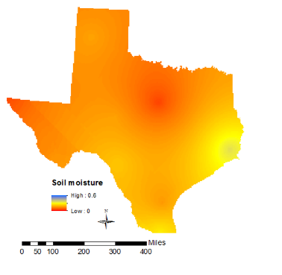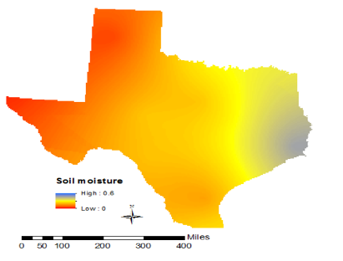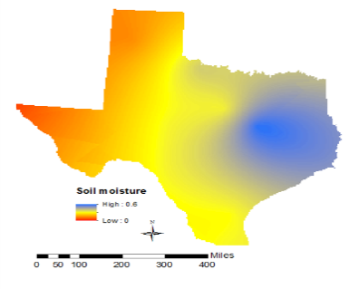The baseline climatology yielded images of the historical average soil moisture for any particular date.

October 7, 2015

April 6, 2015

January 1, 2015

Image 1. Historical average soil moisture data based on SCAN data from January 1, 2014-February 1, 2016.

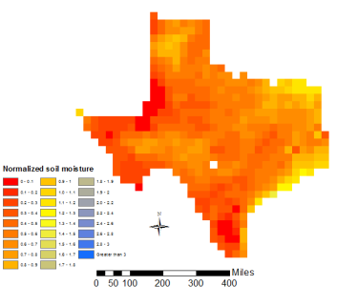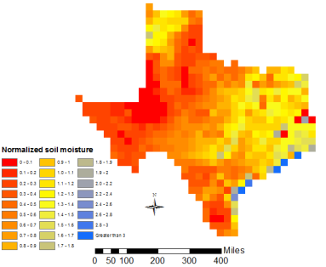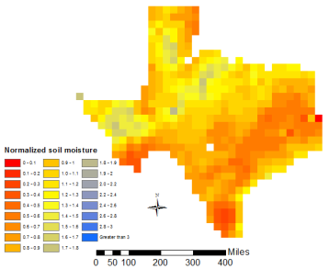When dividing SMAP by the baseline climatology, images of relative SMAP data were produced.

November 30, 2015

August 12, 2015

February 1, 2015

Image 2. SMAP data normalized by the baseline climatology.

To better highlight differentiation from the historical average, soil moisture values were divided into 0.1 increments for values between zero and two, and divided into 0.2 increments for values between two and three. The majority of the data fell between zero and two, so this allowed for a more detailed visualization of the data.

Kriging was an effective method to interpolate between SCAN stations and model soil moisture across Texas; however it did have limitations. Because the data were “smoothed”, short scale variability within the data was underrepresented. Thus, trends in soil moisture spikes or depressions during certain months or in certain areas of the state may have been hidden by the seven day rolling window. Additionally, density and distribution of *in situ* data stations may have impacted the accuracy of the kriged rasters. The SCAN stations were concentrated in the central and southern portions of the state and were sparse (Image 3). While SCAN stations from New Mexico, Oklahoma and Arkansas were used, hundreds of miles existed between these stations and there was not a uniform distribution. Thus, a significant amount of interpolation took place, potentially decreasing the accuracy of the results.

Image 3. Distribution of SCAN stations used in this study.

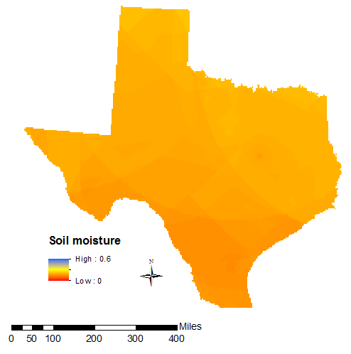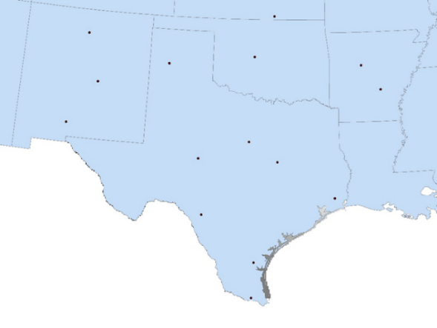Since the baseline climatology was created with limited data points and only over a three year period, far more data is required before specific trends and averages can be determined. The proposed methodology in this study will be strengthened as additional *in situ* and SMAP data is collected. Eventually, creating a baseline climatology using exclusively SMAP data will eliminate the need to create kriged rasters and can give a more accurate depiction of soil moisture in Texas.

Image 4. Kriged output with artifacts, creating a sharply divided and inaccurate image.

Furthur collection and exploration of SCAN data will also help eliminate the irregularities encountered in this project. For example, the kriged rasters in July and August contained artifacts not smoothed by the seven day window (Image 4). The curved lines and sharp changes in raster values indicated that the kriging abruptly switched SCAN stations when calculating the normalization, resulting in two adjacent raster pixels with different SCAN station data. This indicated errors with SCAN data and impacted the accuracy of the results for these months.

It is also interesting to note that 2015 was an El Nino year, bringing a wetter than normal winter for North and Central Texas (NOAA). Because the climatology only used data from 2014 thru January 2016, abnormal El Nino conditions in 2015 may overestimated historical soil moisture throughout the state, skewing the baseline.

# V. Conclusions

A great deal was learned about both SMAP and SCAN data as a result of this study. It was determined that SMAP was an effective tool for measuring soil moisture throughout Texas. SCAN only measures soil moisture at eight locations in Texas and seven locations in bordering states. A great deal of statistical interpolation is therefore needed to estimate soil moisture using SCAN measurements. Each SMAP pixel, however, is approximately 36 km, and one image of Texas has as many as 492 pixels. SMAP measurements can therefore give the Texas Forest Service detailed soil moisture readings, allowing the Texas Forest Service to see local variations in soil moisture that the SCAN data fails to depict.

This study also highlighted patterns in the data to explore further. July and August were identified as unusual months when both relating SMAP and SCAN data and when creating a baseline climatology. Future studies of both SMAP and SCAN can focus on these months to identify the cause of these abnormalities. Additionally, SCAN data only dated back to 2014, and only ten months of SMAP data were used. Supplementary *in situ* datasets and long term SMAP satellite data would add accuracy to the validation and climatology.

Eventually, the Texas Forest Service can incorporate SMAP data into its drought indices and fire prediction models. They can visualize both local patterns and abnormalities, improving their ability to predict areas susceptible to wildfires. Resources can more accurately be directed to these areas, saving the state and individuals millions of dollars.

# VI. Acknowledgments

Thank you Tom Spencer and Curt Stripling of the Texas Forest Service for their guidance and support during this project.

Thank you to the science advisor, Dr. Kenton Ross, for help with developing the project and detailed advising throughout the term.

Any opinions, findings, and conclusions or recommendations expressed in this material are those of the author(s) and do not necessarily reflect the views of the National Aeronautics and Space Administration.

This material is based upon work supported by NASA through contract NNL11AA00B and cooperative agreement NNX14AB60A.

# VII. References

Ambrosia, V., Buechel, S., Brass, J., Peterson, J., Davies, R., Kane, R., Spain, S. (1998). An integration of Remote Sensing, GIS, and information distribution for wildfire detection and management. *Photogrammetric Engineering and Remote Sensing* (64): 977-985.

Combs, Susan (2012). The Impact of the 2011 Drought and Beyond. Comptroller of Public Accounts Data Services Division, 1-14.

Dennison, P.E., D.A. Roberts, S.R. Thorgusen, J.C. Regelbrugge, D. Weise, and C. Lee. (2003). Modeling seasonal changes in live fuel moisture and equivalent water thickness using a cumulative water balance index. *Remote Sensing of Environment* (88): 442-452.

Heim, R. (2002). A review of twentieth century drought indices used in the United States. *Bulletin of the American Meteorological Society,* 1149-1165.

Keetch, J & Byram, G. (1968). A drought index for forest fire control. *USDA Forest Service Research Paper SE-38,* 1-32.

What Does El Nino Mean for North Texas? (2016). National Weather Service Dallas/Fort Worth TX Weather Forecast Office. http://www.srh.noaa.gov/fwd/?n=enso-faq

Qi, Y., P.E. Dennison, J. Spencer, and D. Riaño. (2012). Monitoring live fuel moisture using soil moisture and remote sensing proxies. Fire Ecology 8(3): 71-87.

Schaefer, G., Cosh, M., & Jackson, T. (2007). The USDA natural resources conservation service soil climate analysis network. *Journal of Atmospheric and Oceanic Technology,* (24):2073-2077.

# VIII. Content Innovation

1. Virtual Poster Session: https://drive.google.com/file/d/0BwgqQCDp0aUHQ1psc1ZNVnRqZzg/view?usp=sharing
2. Inline Supplementary Material (see figures above)
3. AudioSlides: https://drive.google.com/drive/folders/0BwgqQCDp0aUHeVVwMlBzbnhfd2s