NASA DEVELOP National Program
NASA Ames Research Center
Spring 2016

Caribbean Oceans
Utilizing NASA Earth Observations to Detect, Monitor, and Respond to Unprecedented Levels of Sargassum in the Caribbean Sea


Technical Report
Final Draft – April 6, 2016

Jordan Ped (Project Lead)
Erica Scaduto
Emma Accorsi

Dr. Juan Torres-Pérez, Bay Area Environmental Research Institute (Science Advisor)

I. Abstract
In 2011 and 2015, the nations of the Caribbean Sea were overwhelmed by the unprecedented quantity of Sargassum that washed ashore. This issue prompted international discussion to better understand the origins, distribution, and movement of Sargassum, a free-floating brown macro alga with ecological, environmental, and commercial importance. In the open ocean, Sargassum mats serve a vital ecological function. However, when large quantities appear onshore without warning, Sargassum threatens local tourist industries and nearshore ecosystems within the Caribbean. As part of the international response, this project investigated the proliferation of this macro alga within the Caribbean Sea from 2003-2015, and used NASA Earth observations to detect and model Sargassum growth across the region. The Caribbean Oceans team calculated the Floating Algal Index (FAI) using Terra Moderate Resolution Imaging Spectroradiometer (MODIS) data, and compared the FAI to various oceanic variables to determine the ideal pelagic environment for Sargassum growth. The project also examined the annual spread of Sargassum throughout the region by using Earth Trends Modeler (ETM) in Clark Labs’ TerrSet software. As part of the international effort to better understand the life cycle of Sargassum in the Caribbean, the results of this project will help local economies promote sustainable management practices in the region.

Keywords:
Remote Sensing, Pelagic Seaweed, MODIS, Ocean Color Satellites, Floating Algal Index (FAI), Sargassum

II. Introduction
Caribbean nations are becoming increasingly interested in the origin and drivers of the pelagic seaweed Sargassum, which has inundated their shorelines in recent years and caused both economic and environmental concerns. In particular, observers have reported higher than normal levels of Sargassum since 2011 (Gower, 2013), with levels reaching a critical high in 2015 (Arreguin-Sanchez, 2015). In a survey of 45 marine researchers and other stakeholders, 80% (36/45) agreed or highly agreed that the amount of Sargassum in the Caribbean in 2015 was significantly higher than in previous years, although they also reported major Sargassum events occurring in the previous four years (Appendix G).
Figure 1
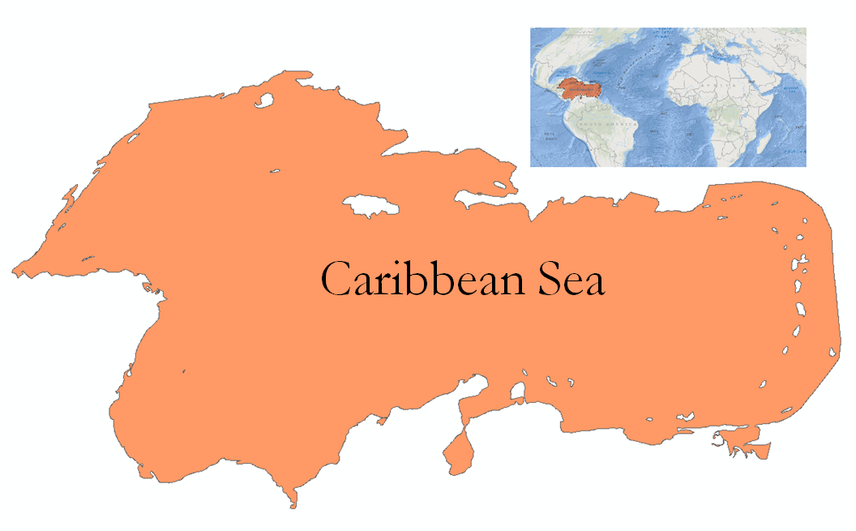
At moderate levels, Sargassum has many important functions in marine ecosystems. Laffoley et al. (2011) found that Sargassum often completes its entire life cycle at sea, making it the only holopelagic seaweed in the world. The floating mats provide a critical habitat for a diverse set of species, from the highly adapted Sargassum anglerfish to juvenile sea turtles. These pelagic ecosystems are also thought to be critical destinations for migratory species, such as whales and tunas, and for nutrient cycling to the ocean floor. Furthermore, beached Sargassum provides shelter to sea turtle hatchlings and reduces shoreline erosion (Laffoley et al., 2011).
The study examined oceanic conditions in the Caribbean Sea from January 2003 through December 2015.

During significant influxes, Sargassum detrimentally affects nearshore ecosystems and the economies of coastal communities. The large mats flood shallow bays and reefs, compressing sand and trapping sea turtles in their nests. One observer in Belize describes, “When the Sargassum comes...and stays there for months and starts to rot, everything dies - seagrass, crabs, conch, snail, fish, the list goes on,” and another reports “fish and crustacean kills” in the British Virgin Islands (Appendix G). Additionally, in a region where tourism is economically vital, tourists are deterred by seaweed-covered beaches and the smell of decomposing biomass. The tourist industry has faced a considerable financial burden, as many tourists have cancelled trips to these regions. Heavy machinery has been used in some locations to clear the beaches, further exacerbating the ecological problems. Although there has been a slight increase in employment by local governments for the hand-removal of Sargassum, this funding for the emergency removal has imposed a financial burden on both local and national governments (Dr. Alvarez, Personal Communication, Feb. 2016).
A better understanding of the geographic origin and cause of recent Sargassum inundation events is critical to the development of more sustainable management practices for Sargassum. Currently, these events are poorly understood, and a majority of surveyed marine researchers identified the origin of Caribbean Sargassum (62%, 28/45) and the causes of 2015 Sargassum levels (64%, 29/45) as topics in which further research is needed (Appendix G). Thus far, three theories have been proposed regarding the origin of the large quantities of Sargassum. The primary “Sargassum system loop” theory suggests that Sargassum from the Sargasso Sea is carried through the Caribbean Sea in a westward trajectory, then moves northwards into the Gulf of Mexico (GoM), and finally travels eastward past Florida to the Atlantic coast of the United States (Webster and Linton, 2013). Other theories suggest that Caribbean Sargassum is transported from the northern coast of Brazil (Gower and King, 2013) or originates in the Caribbean Sea. A variety of factors are debated as contributors to the problem, including ocean temperatures, ocean currents, nutrient levels, fertilizer run-off, oil spills, sewage and pollution, and global climate change (Arreguin-Sanchez, 2015).
Previous studies have supported the use of satellite remote sensing as a powerful tool for studying Sargassum (Hu et al, 2015). The distribution of Sargassum over a vast ocean area makes it challenging to study by boat, but Sargassum has a spectral signature that clearly distinguishes it from nearby water, making it a promising target for remote sensing (Gower and King, 2008). The existing literature on using satellite imagery to detect Sargassum has focused predominantly on the GoM and the Sargasso Sea (Gower et al., 2006). Gower et al. first used the European Space Agency’s (ESA) Medium Resolution Imaging Spectrometer (MERIS) to detect Sargassum in the GoM in 2006. Their Maximum Chlorophyll Index (MCI) successfully identified large pelagic mats from satellite imagery. Alternative detection methods have since improved the ability to identify Sargassum using remote sensing. The Floating Algal Index (FAI) (Hu, 2009) can be applied to both Landsat and Moderate Resolution Imaging Spectroradiometer (MODIS) imagery, and offers a reliable alternative to MCI. The current limitations in Sargassum detection lie in the spatial resolution of the sensors (Hu et al, 2015), and the interference of clouds and sun glint, which obscures the clarity of spectral signatures captured by satellite sensors (Chen and Zhang, 2015). In this project, the team built upon these detection methods and applied them to the Caribbean Sea and its surrounding nations.
This project addressed important questions about the origin and cause of Sargassum inundation events, within the NASA Applied Sciences Oceans Application Area, by using NASA Earth observations to (1) detect Sargassum in the Caribbean Sea, and (2) model drivers of its growth. The project utilized data spanning from 2003 through 2015 to understand historical and current patterns of Sargassum movement and growth in the Caribbean. This information was then compared against oceanic variables using Earth Trends Modeler (ETM) in Clark Labs’ TerrSet software to better understand the larger environmental context of the inundation events. The findings from the project are intended for use by Caribbean nations interested in the origin of the phenomenon. The DEVELOP team at the NASA Ames Research Center was fortunate to partner with Dr. Porfirio Alvarez Torres, Executive Secretary at Consorcio de Instituciones de Investigación Marina del Golfo de México y del Caribe (CiiMarGoMC), and a number of other researchers and organizations (Section VI).

III. Methodology
3.1 Data Acquisition
a) Earth Observation Data
Sargassum in the Caribbean Sea was detected using daily 500m resolution Terra MODIS imagery from 2003 through 2015. These data were obtained from the Level 1 and Atmosphere Archive and Distribution System (LAADS) web through FTP servers. In order to understand Sargassum distribution and growth, 8-day oceanic variable datasets were obtained from the NOAA CoastWatch Environmental Research Division’s Data Access Program (ERDDAP) via custom scripting and the Environmental Data Connector (EDC). Photosynthetically available radiation (PAR) data from 2003 through 2015 were obtained from Aqua MODIS. Sea surface temperature (SST) data from 2003 through 2013 were acquired from Aqua MODIS and calculated by Goddard’s Ocean Biology Processing Group (OBPG) using multi-sensor level-1 and level-2 (msl12) software. SST data for 2013 through 2015 were obtained from the Advanced Very High Resolution Radiometer (AVHRR) at 1km resolution onboard the NOAA-17 and NOAA-18 satellites, and were calculated using the modified version of the non-linear sea surface temperature (NLSST) algorithm (Walton et al, 1998; Kilpatrick et al. 2001).

b) Additional Data
Two additional datasets were used to complement the EOS imagery and data. First, through collaboration with the Sea Education Association (SEA), an internationally recognized education program specializing in ocean education, geolocated Sargassum density ground truth data were obtained. These datasets were used to validate the calculated Floating Algal Index and to determine threshold values for Sargassum identification. Second, to further investigate community concerns and to analyze observational data, the team designed and collected results from a survey with the assistance of partners Frederique Fardin, Dr. Porfirio Alvarez, and advisor Dr. Juan Torres-Pérez, who sent it to subject-matter experts residing or working in Caribbean nations.

3.2 Data Processing

a) Floating Algal Index
After data acquisition, MODIS data from 2003 through 2015 were pre-processed to represent the study region, and to remove atmospheric noise and scanlines. Cloud masking was performed using the Iso Cluster and Maximum Likelihood Unsupervised Classification tool, an iterative process in which cells are grouped based on an algorithm that determines similarity. The pre-processed imagery was then run through a Python script that calculated the Floating Algal Index (FAI) to detect the presence of Sargassum (Hu, 2015):

FAI = R_{NIR} - R'_{NIR}
R'_{NIR} = Red + (SWIR - Red) * (859-645) / (1240-645)

b) In Situ Measurements
After the FAI values were calculated, ground truth data points recorded by the SEA Association in 2012 around the Eastern Caribbean and Sargasso Sea were used as validation measurements (See Appendix A). The in situ measurements of Sargassum density were compared to an averaged FAI value. This value was calculated by averaging the FAI of each of the pixels transited during each SEA cruise tow. The result is a correlation between the MODIS-calculated FAI and the SEA in situ data, with an R² value of 0.1241 (See Appendix B). FAI values are lower than expected because the average values include pixels containing open ocean, which can cause a bias in the representation. To gain better insight and to further increase certainty, the FAI detection method in Hu et al. (2015) was replicated (See Appendix C). Using the range of FAI pixel values from these two sources, the threshold values 0.0001 - 0.003 were determined as the best representation of Sargassum detection. Finally, using these threshold values, newly reclassified 10-day composites were created and converted to ASCII files to run regressions via TerrSet’s ETM with the oceanic variables (See Appendix D).

c) Oceanic Variables
The oceanic variables were pre-processed to make them compatible with the TerrSet’s ETM specifications, and consistent with the reclassified FAI datasets. PAR and SST were reprojected, clipped to represent the study region, and converted to ASCII text file format. In addition, SST AVHRR datasets from 2013 through 2015 were resampled and reprojected within TerrSet to account for difference in resolution between the 1km AVHRR and 500m MODIS datasets.

3.3 Data Analysis

Clark Lab’s TerrSet ETM was used to analyze patterns within and between FAI, SST, and PAR. Within ETM, inter-annual trends analysis, seasonal trends analysis, and the calculation of anomaly series were used to identify spatial and temporal trends in SST and PAR from 2003 through 2015. Linear models were run to find relationships between FAI and the oceanic variables. In addition to the statistical results, these functionalities also allowed for a clear visualization of the data both spatially and graphically.

IV. Results & Discussion

The first step in understanding the relationship between Sargassum and oceanic variables was to analyze each variable independently. TerrSet’s ETM provides tools for analyzing both inter-annual and seasonal fluctuations. This initial analysis provides the context for modeling the relationship between the oceanic variables and the FAI.

4.1 Inter-Annual Trends Analysis

Over the study period, the Caribbean Sea showed significant and complex changes in environmental conditions. Ordinary least squares (OLS) regression was used to find the rate of change per an 8-day time step. This was multiplied by the number of time steps in the full series to estimate the total change of SST and PAR over the study period (Figs. 2-4). The Mann-Kendall test was used to assess the degree of a monotonic upward or downward trend (Figs. 3-5), i.e. consistently increasing or decreasing, although not necessarily in a linear fashion. The combination of these tools leads to a more statistically robust analysis, making it easier to understand spatial and temporal changes in SST and PAR over the course of the relatively long study period.

Figure 2
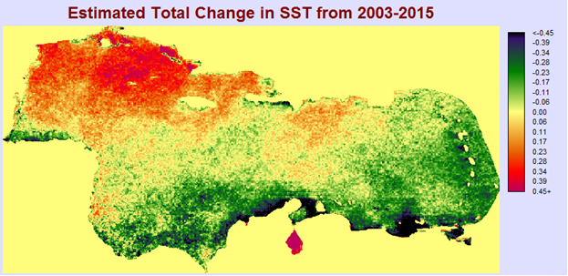
Total change in SST from 2003-2015 was estimated using ordinary least squares regression. Values are in degrees Celsius.

Figure 3 Figure 4
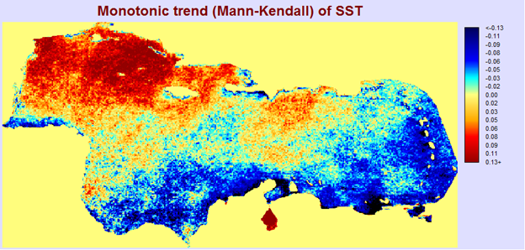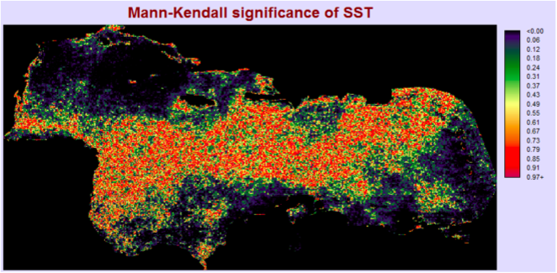
Results Figure 3 and significance Figure 4 (p-values) for the Mann-Kendall test applied to SST from 2003-2015.

SST remained roughly consistent in the Caribbean over the study period. The average total change as estimated by OLS was close to zero (Fig. 2). The northwestern corner of the Caribbean experienced slight warming (Fig. 3) of approximately half a degree Celsius (Fig. 2). The southern and eastern edges experienced slight cooling (Fig. 3), ranging from a quarter to half a degree Celsius (Fig. 2). The Mann-Kendall results were significant in these regions (Fig. 4). The central region experienced ambiguous and statistically non-significant change (Fig. 4).

Figure 5
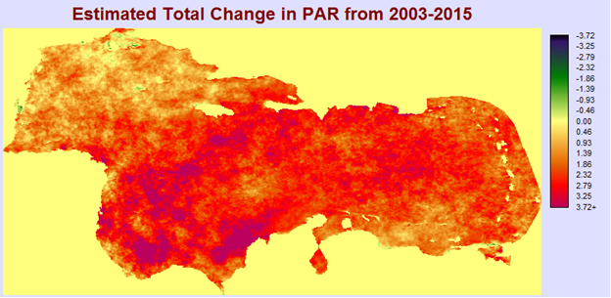
Total change in PAR from 2003-2015 was estimated using ordinary least squares regression. Values are in Einstein m⁻² day⁻¹.

Figure 6 Figure 7
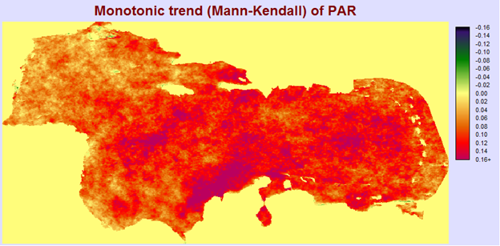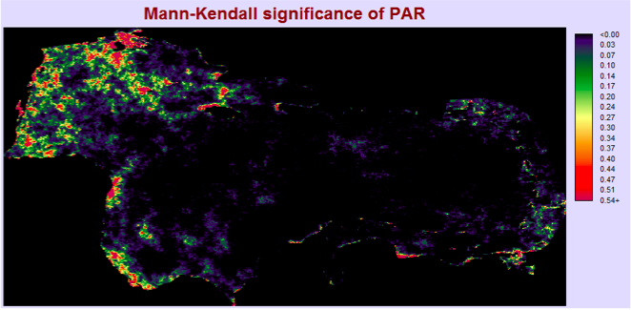
Results Figure 6 and significance Figure 7 (p-values) for the Mann-Kendall test applied to PAR for 2003-2015.

PAR showed a clear increase over the study period (Fig. 6) and, on average, increased by 2.12 units (Fig. 5). Some regions increased by over 5 units (Fig. 5). The p-values for the Mann-Kendall test indicate that this positive trend was highly significant through a large part of the Caribbean Sea (Fig. 6).

The inter-annual trends highlighted above are most apparent over the 13-year period. However, other trends can also be observed when the data are disaggregated by year. To calculate the anomalies series, the median value per pixel per time step is subtracted from all images with the same time step. For example, the median values per pixel for February 10 are subtracted from each February 10 image (February 10, 2003, February 10, 2004, etc.). The anomalies provide an indication of how regular or irregular values are between years.

Figure 8
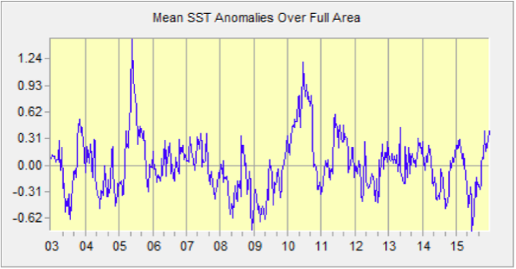
Mean SST anomaly from 2003-2015. Y-axis values are in degrees Celsius.
The mean SST anomaly varies over the study period (Fig. 8). The year 2010 was much warmer than usual – all but two months in 2010 were warmer than average and there was only one other year in the study period (2005) where anomalies reached as high. Mean SST anomaly peaked in June 2010 at 1.2°C, signifying that on average, the SST over the entire study region was 1.2°C higher than typical June temperatures. Additionally, the year 2011 was warmer than expected, although not as anomalous as 2010. In 2011, levels of Sargassum were reported to be extremely high, and it is possible that the warmer temperatures before or during this year are related to the 2011 influx (for example, by allowing more growth of Sargassum). Mean SST anomaly was colder than normal for 2014 and 2015, and there was another large Sargassum influx in 2015. This suggests that the presence of a spike in mean SST anomaly alone is not predictive of Sargassum levels. To investigate this trend further, future work will examine the years 2005 and 2006. There is a major spike in SST anomaly in 2005, with values as high as 1.46°C in May of 2005. We do not have reports on Sargassum levels in these years, but can use FAI calculations to determine relative Sargassum quantities.

Figure 9
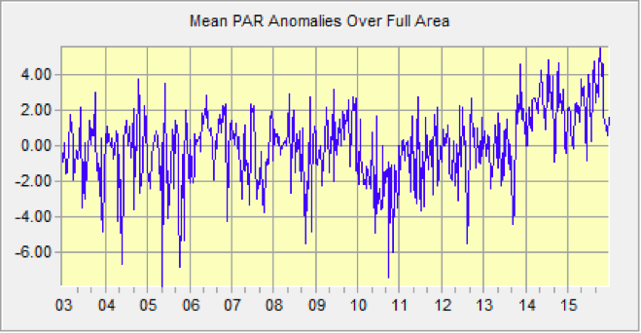
Fig 7. Mean PAR anomaly from 2003-2015. Y-axis values are in Einstein m⁻² d⁻¹.
Mean PAR anomaly remained somewhat evenly distributed around 0 from 2003 until 2010 (Fig. 9). It dipped during 2010, and then rose steadily from 2010 through 2015, hitting maximum values for the study period in June 2014 (4.89 Einstein m⁻² d⁻¹), October 2014 (4.66 Einstein m⁻² d⁻¹), and October 2015 (5.53 Einstein m⁻² d⁻¹) (Fig. 9).

The presence of anomalies in inter-annual trends in both SST and PAR in the same years as Sargassum events hint at a relationship, but these patterns do not imply causation between the trends in oceanic variables (SST and PAR) and Sargassum inundation.

4.2 Seasonal Trends Analysis

The inter-annual fluctuations and trends over the study period can be further disaggregated to find seasonal shifts. These seasonal shifts may also be related to Sargassum growth within the Caribbean.

Figure 10
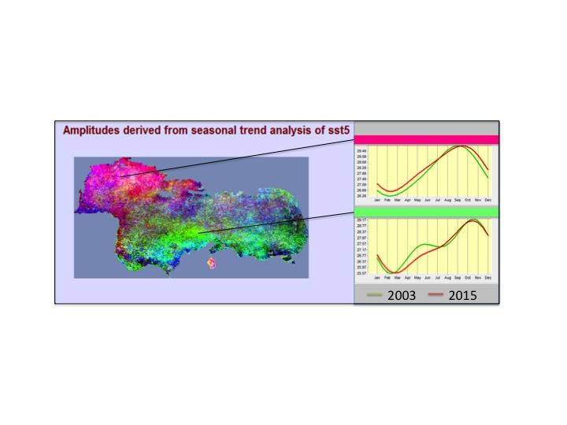
Seasonal trends analysis for SST from 2003-2015. Similar colors on the map represent similar shifts in seasonality over the study period that are expanded upon in the graphs.
The northwestern corner of the Caribbean Ocean experienced overall warming during the study time period (Fig. 6), along with concurrent changes in seasonality towards warmer temperatures in the spring, fall, and winter (Fig. 10). During the summer, when the maximum SST are reached, SST in this region remained similar over the course of the study period. The southern and eastern parts of the Caribbean cooled slightly over the study period (Fig. 6). The blue and green colors in these regions represent a shift towards cooler spring and summer temperatures in later years of the study (Fig. 10).

4.3 Linear Models

The linear models in TerrSet’s ETM provide a spatial statistic capable of establishing the significance of the relationship between the FAI and oceanic variables. A variety of specifications (Appendix F) of the single variate models were analyzed between FAI and the oceanic variables.

The results of the models for both SST and PAR suggest that there is not a statistically significant relationship between FAI and SST or PAR. In all linear models, the average R² was .027, with the highest being only .031. However, lagging the variables, which is appropriate given the time it may take for Sargassum to change in response to oceanic variables, caused a slight increase in R² (Fig.9), suggesting that a more carefully specified model might show a statistically significant relationship.

Figure 11 Figure 12
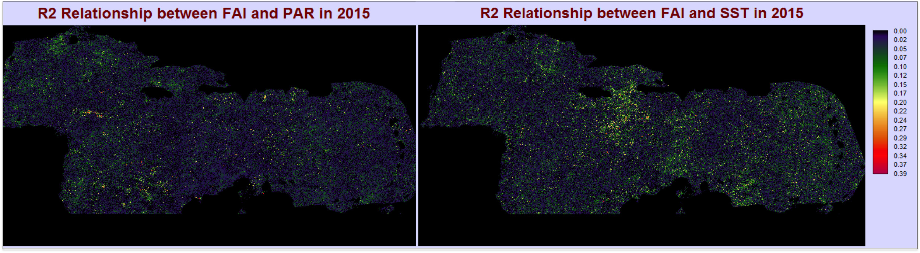
R² values between FAI and PAR Figure 11 FAI and SST Figure 12 from linear models.
Furthermore, the clustering (Fig.9) of high R² values also suggests that FAI is being influenced by oceanic variables. Unfortunately, the FAI calculated in the study period simply cannot be predicted by either SST or PAR alone.

4.4 Limitations

The significance of the results were primarily limited by the accuracy of the FAI. The index has three main problems which are potentially significant sources of error. The first is the width of the threshold. With a range of only .0029, FAI values can easily fall outside of the threshold even if Sargassum is present, introducing significant errors of omission. Errors of omission are likely even more common in the FAI because the ocean color is not vastly different between Sargassum-rich pixels and open ocean. Clouds, haze, or other unknown factors could fall within this narrow threshold, and therefore classified as Sargassum. In order to be confident in the threshold, more ground truth data will be required.

The second potential source of error is the cloud mask. The unsupervised classification used to identify the spectrally distinct clouds in the images may have left shadows or haze that has a similar spectral signature in the FAI to Sargassum. This leads to clouds being classified in the FAI and, given that clouds have a limited relationship with PAR and SST, this classification introduces noise into the linear models.
Figure 13
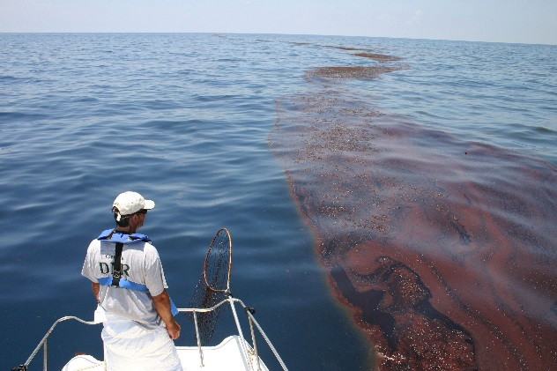
Finally, the shape of Sargassum mats is not always ideal for remote sensing. Large Sargassum mats are pushed by currents and wind into windrows (Fig. 13). There can be a very large quantity stretched across several kilometers, but the narrow rows may not be identifiable via low resolution satellite imagery. The majority of any given pixel must be filled with Sargassum for it to be detected, therefore the 500m resolution MODIS images are likely only capable of identifying the largest mats.
NOAA's National Ocean Survey

Each of these three issues alone would likely bias the results in a relatively predictable manner; however, this set of multiple limitations makes it difficult to interpret the lack of significant results. The oceanic variables suggest that the Caribbean Sea is undergoing complex and regionalized change, but the presence of Sargassum across the region does not point to any one variable as being the primary driver.

This complex relationship supports the conclusion that a single variate model, even assuming that the FAI is accurate, is unlikely to explain all the variation in FAI as a proxy for Sargassum presence.

V. Conclusions

a) Future work
The scientific community is highly interested in continued research on the origin, causes, and prediction of Sargassum events due to the major risks it poses for the tourism industry and the vitality of coastal ecosystems in the region. In the near future, we will be working to reduce the limitations associated with our current findings and to more accurately detect Sargassum. The major components of our future work include: increasing resolution, reducing atmospheric noise, introducing multivariate models, and looking closely into the biology of Sargassum.

b) Resolution
Resolution can be increased by rescaling 500m MODIS imagery to 250m resolution and potentially using Landsat 30m resolution imagery to identify smaller, finite amounts of Sargassum windrows. Increased resolution can help to better distinguish between pixels containing solely Sargassum, partial Sargassum, or open ocean.

c) Cloud mask
Clouds can be a major interference when trying to detect Sargassum. Cloud and haze masks can be used to substantially reduce atmospheric noise by eliminating non-Sargassum pixels that may have similar spectral signatures and FAI values as Sargassum. The increased accuracy can then provide a more valid comparison with the oceanic variables that can ultimately help with future prediction mechanisms and models. Furthermore, the detection approach of solely using the Floating Algal Index (FAI) can be improved by integrating a “funnel-approach” in which several indices such as NDVI, NIR/Red ratio, and chlorophyll-a provide additional validation and check-points.

d) Multivariate Model
Once the detection of Sargassum is improved, diversifying the oceanic variables is important to best represent the “natural environment.” Some of the variables that can influence both the growth of Sargassum and the occurrence of influx events are salinity, nutrient load, wind stress, and sea surface currents.

e) Biology
Furthermore, it is important to note the seasonal biology and lifecycle of Sargassum to better monitor and understand the influx phenomenon. Sargassum length and pigment composition can change depending on the season. For example, a study done at Bembridge Isle of Wight found that the average length of Sargassum increases between May to August, and substantially decreases in the colder months (Gorham and Lewey, 1984). The pigments beta-carotene, xanthophylls, and chlorophyll-a follow an opposite trend in which there is a significant drop towards July and an increase from August until October. Both chlorophyll-c and fucoxanthin remain relatively stable across the months, and can potentially help differentiate between Sargassum and other floating vegetation.

VI. Acknowledgments
We would like to thank Chippie Kislik and Victoria Ly for their support and supervision for the project as the DEVELOP management team at NASA Ames Research Center. Their connections with other researchers in the field and mentorship made the project possible.

We would also like to thank our partners:
-Dr. Porfirio Alvarez Torres, Executive Secretary at Consorcio de Instituciones de Investigación Marina del Golfo de México y del Caribe (CiiMarGoMC)
-Dr. Sergio Cerdeira, Marine Monitoring Coordinator at Comisión Nacional para el Conocimiento y Uso de la Biodiversidad (CONABIO)
-Dr. Roy A. Armstrong, Bio-optical Oceanography Laboratory University of Puerto Rico, Department of Marine Sciences
-Dr. Francisco Arreguin, researcher at Centro Interdisciplinario de Ciencias Marinas: Instituto Politécnico Nacional (CICIMAR-IPN)
-Dr. Laura Carillo, Oceanographer at El Colegio de la Frontera Sur (ECOSUR)
-Dr. Eduardo Santamaria del Angel, Professor and Researcher at Universidad Autónoma de Baja California (UABC)

Any opinions, findings, and conclusions or recommendations expressed in this material are those of the author(s) and do not necessarily reflect the views of the National Aeronautics and Space Administration.
This material is based upon work supported by NASA through contract NNL11AA00B and cooperative agreement NNX14AB60A.

VII. References

Arreguin-Sanchez, Francisco (2015, Sept.) Atlantic Oscillation Models and Climate Shifts.
Presented at Latin American and Caribbean Sea Large Marine Ecosystems Symposium, Cancun, Mexico.

Chen, S., & Zhang, T. (2015). An improved cloud masking algorithm for MODIS ocean colour data processing. Remote Sensing Letters, 6(3), 218–227.

Dierssen, H. M., Chlus, A., & Russell, B. (2015). Hyperspectral discrimination of floating mats of seagrass wrack and the macroalgae Sargassum in coastal waters of Greater Florida Bay using airborne remote sensing. Remote Sensing of Environment, 167, 247–258.

Gower, J., Hu, C., Borstad, G., & King, S. (2006). Ocean color satellites show extensive lines of floating Sargassum in the Gulf of Mexico. IEEE Transactions on Geoscience and Remote Sensing: A Publication of the IEEE Geoscience and Remote Sensing Society, 44(12), 3619–3625.

Gower, J., & King, S. (2008). Satellite Images Show the Movement of Floating Sargassum in the Gulf of Mexico and Atlantic Ocean. Fisheries and Ocean Canada, Institute of Ocean Sciences.

Gower, J. F. R., & King, S. A. (2011). Distribution of floating Sargassum in the Gulf of Mexico and the Atlantic Ocean mapped using MERIS. International Journal of Remote Sensing, 32(7), 1917–1929.

Gower, J., Young, E., & King, S. (2013). Satellite images suggest a new Sargassum source
region in 2011. Remote Sensing Letters, 4(8), 764–773.

Hu, C. (2009). A novel ocean color index to detect floating algae in the global oceans. Remote Sensing of Environment, 113(10), 2118–2129.

Hu, C., Feng, L., Hardy, R. F., & Hochberg, E. J. (2015). Spectral and spatial requirements of remote measurements of pelagic Sargassum macroalgae. Remote Sensing of Environment, 167, 229–246.

Kilpatrick, K.A., Podesta, G.P., & Evans, R. 2001. Overview of the NOAA/NASA advanced very high resolution radiometer Pathfinder algorithm for sea surface temperature and associated matchup database. Journal of Geophysical Research, 106, 9179-9197.

Laffoley, D.d’A., Roe, H.S.J., Angel, M.V., Ardron, J., Bates, N.R., Boyd, I.L., . . . Vats, V. (2011). The protection and management of the Sargasso Sea: The golden floating rainforest of the Atlantic Ocean. Summary Science and Supporting Evidence Case. Sargasso Sea Alliance, 44 pp.

Lewey, S.A., & Goham J. (1984). Pigment Composition and Photosynthesis in Sargassum muticum. Marine Biology, 80, 109-115.

Walton, C.C., Pichel, W.G., & May, D.A. 1998. The development and operational
application of nonlinear algorithms for the measurement of sea surface temperatures with the NOAA polar orbiting environmental satellites. Journal of Geophysical Research, 103, 27999-28012.

Webster, R. K., Linton, T. (2013). Development and implementation of Sargassum Early
Advisory System (SEAS). Shore and Beach, 81(3).

VIII. Content Innovation

Some options include:
AudioSlides
Database Linking Tool
Data Profile
Executable Papers
Featured Author Videos
Featured Multimedia for this Article (video and podcast options)
Glossary Viewer
Inline Supplementary Material (figures, tables, computer code)
Interactive Map Viewer
Interactive MATLAB Figure Viewer
Interactive Plot Viewer
Nomenclature Viewer
Virtual Poster Session

IX. Appendix

Appendix A:
Ground truth data points from the Semester at Sea Association (SEA) in the Eastern Caribbean and Sargasso Sea in 2012.

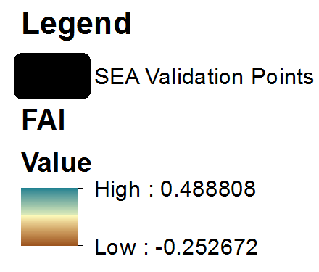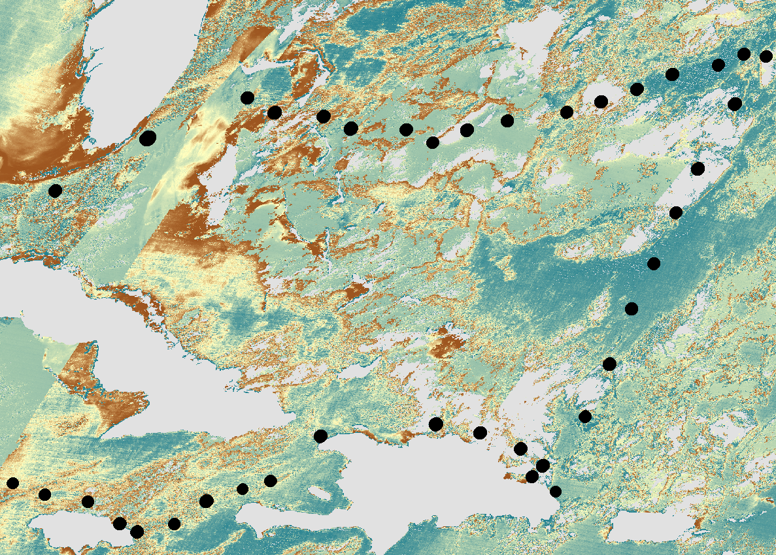

Appendix B:
The graph illustrates the correlation between Sargassum density, from in-situ measurements, and average FAI values. There is a low to moderate positive correlation of 0.1241 between the variables, indicating that the FAI can indeed show a representation of Sargassum. However, it is important to note that the FAI is relatively low, which may be due to the average FAI value taking into account the surrounding water pixels within the SEA cruise tow area.

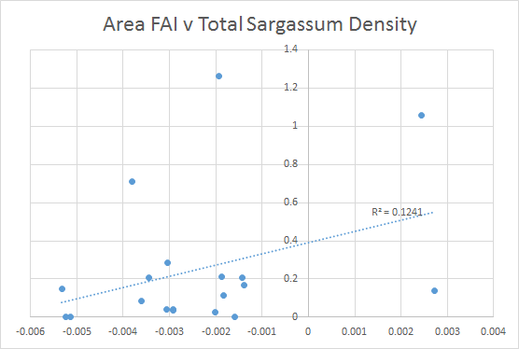

Appendix C:
Detection of Sargassum slicks using Terra MODIS imagery near Bermuda’s coast in December 2009 using the FAI. Compared with the Hu detection (left), the FAI detection of Sargassum slicks (right) are same in location and similar in clarity.
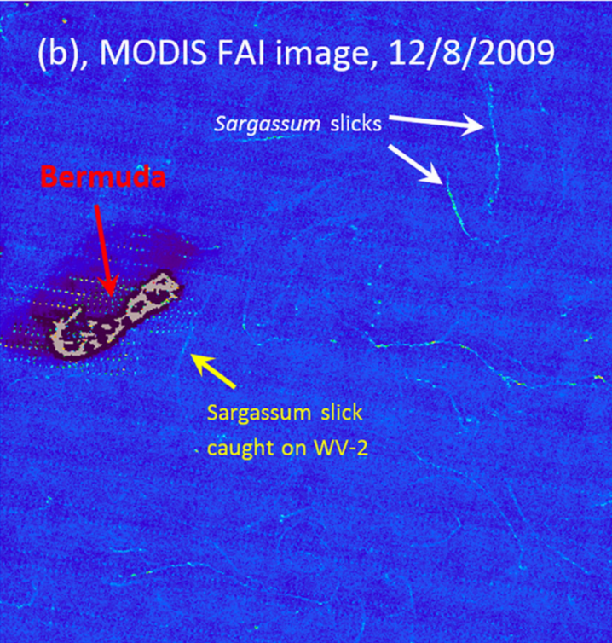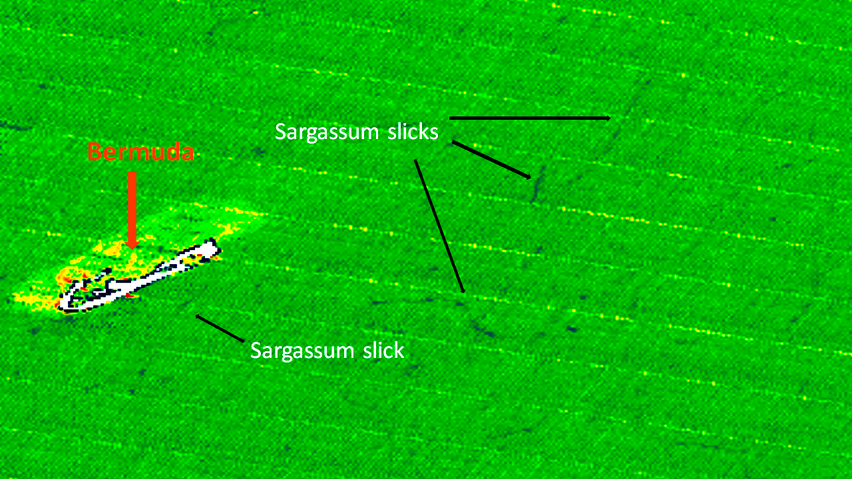
Credit: Hu et al. 2015
Appendix D:

Sample 10-day composite image of the reclassified Floating Algal Index (FAI) with threshold range 0.0001-0.003, representing the detection of Sargassum mats. It is evident from the image that there is room for improvement in the accuracy of Sargassum identification.

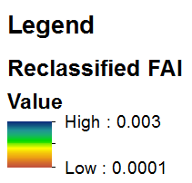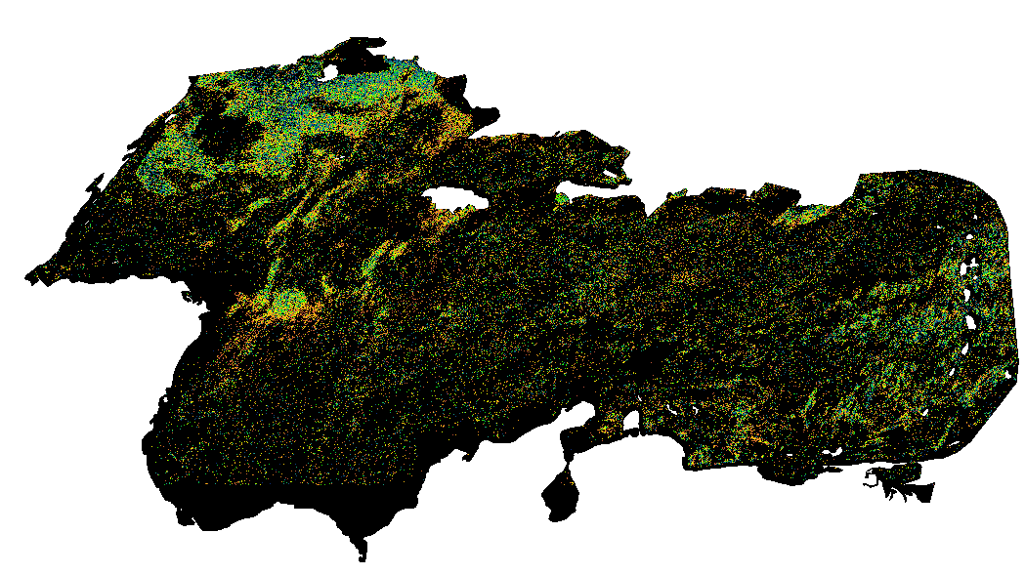

Appendix E:
Survey results indicate distinct spatial and temporal trends in Sargassum distribution. The seasonal fluctuations are evident; the majority of sightings are from June to September, during the summer months. Spatially, Sargassum tends to be distributed among the Eastern Isles and the North Western coasts of Quintana Roo and Yucatan.

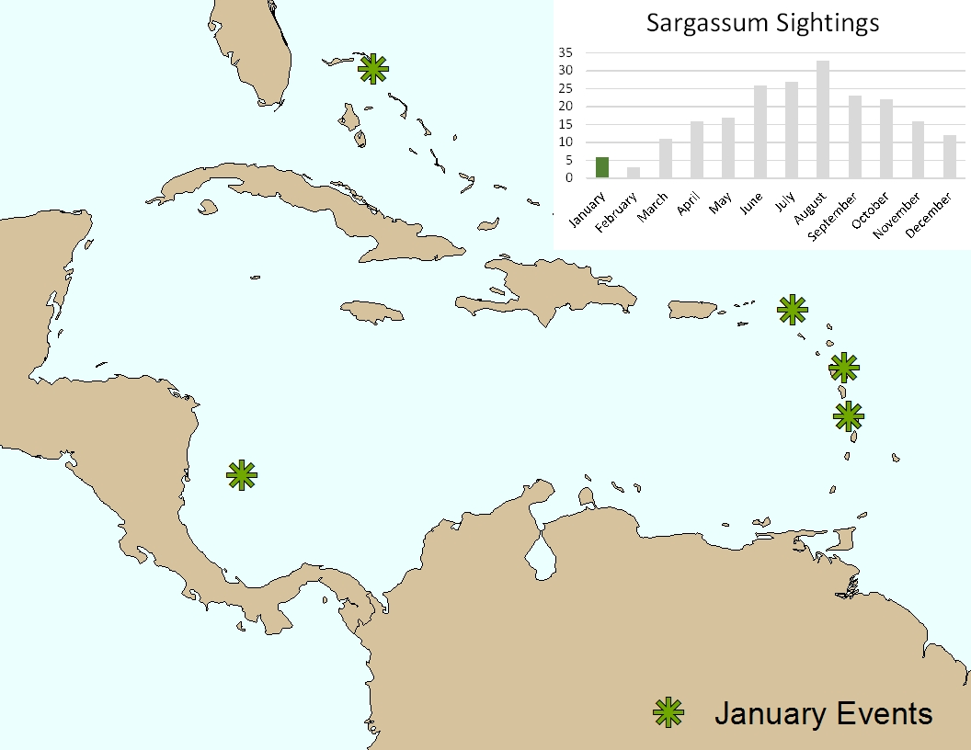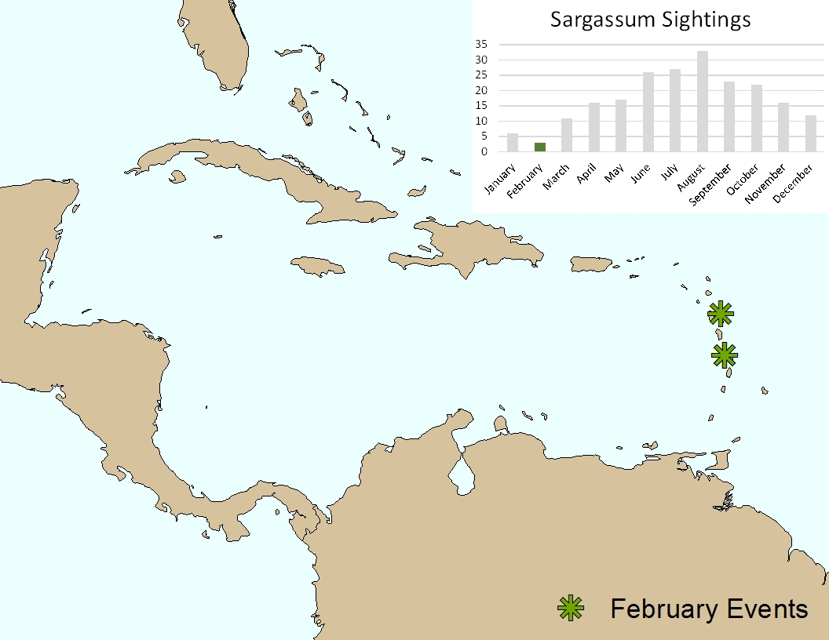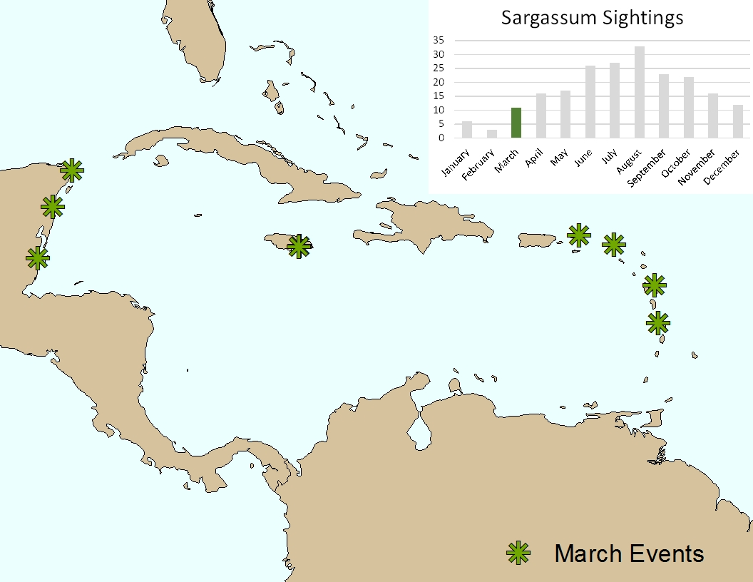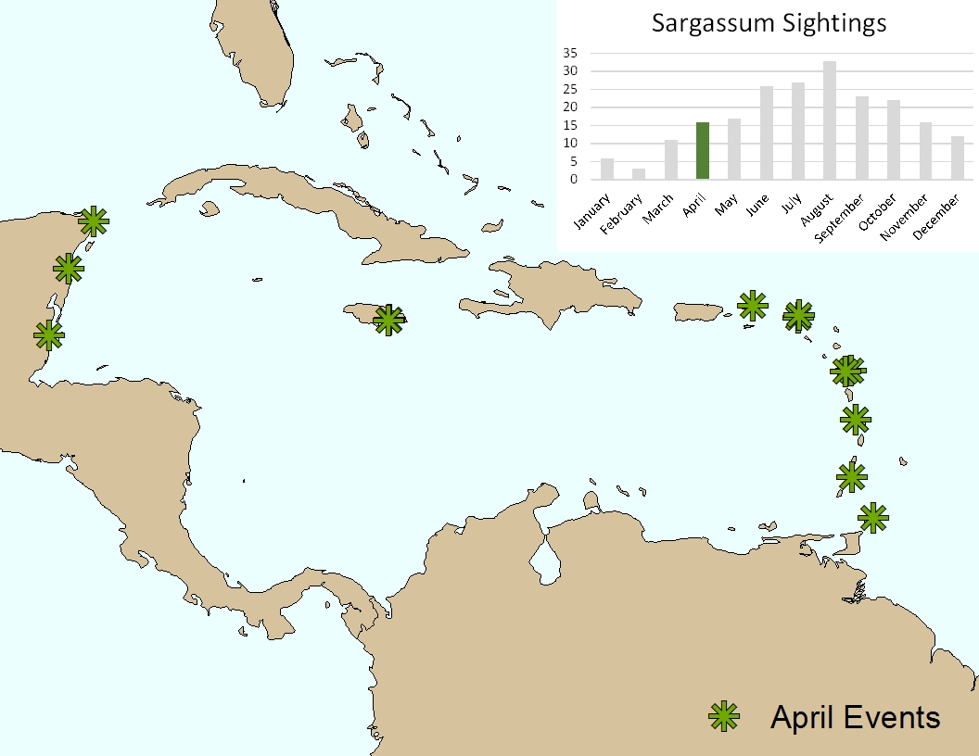
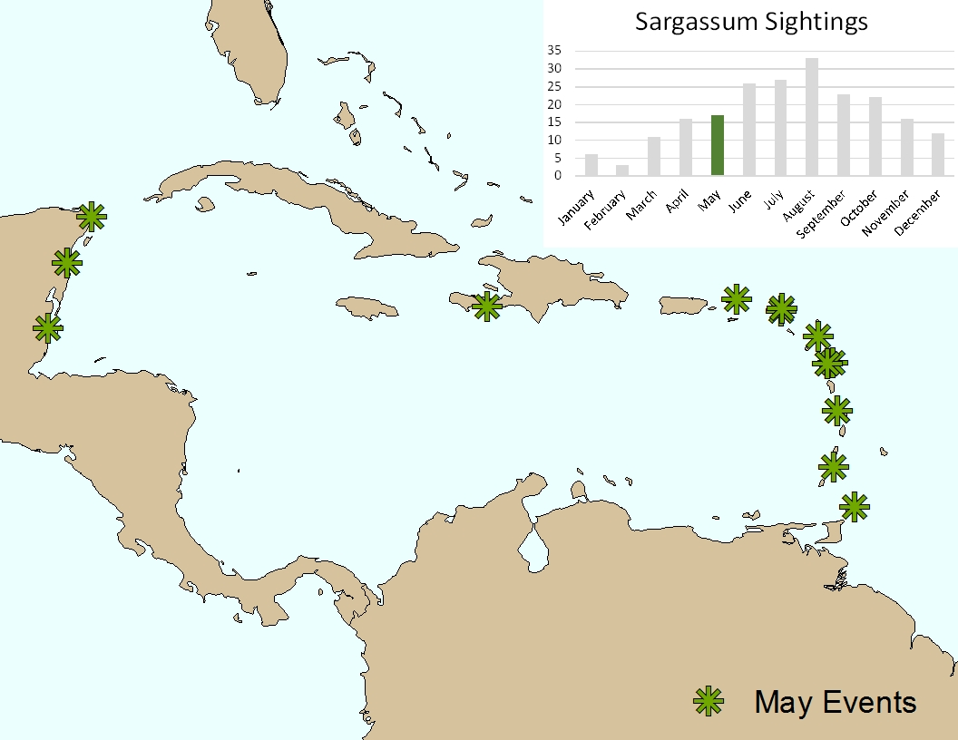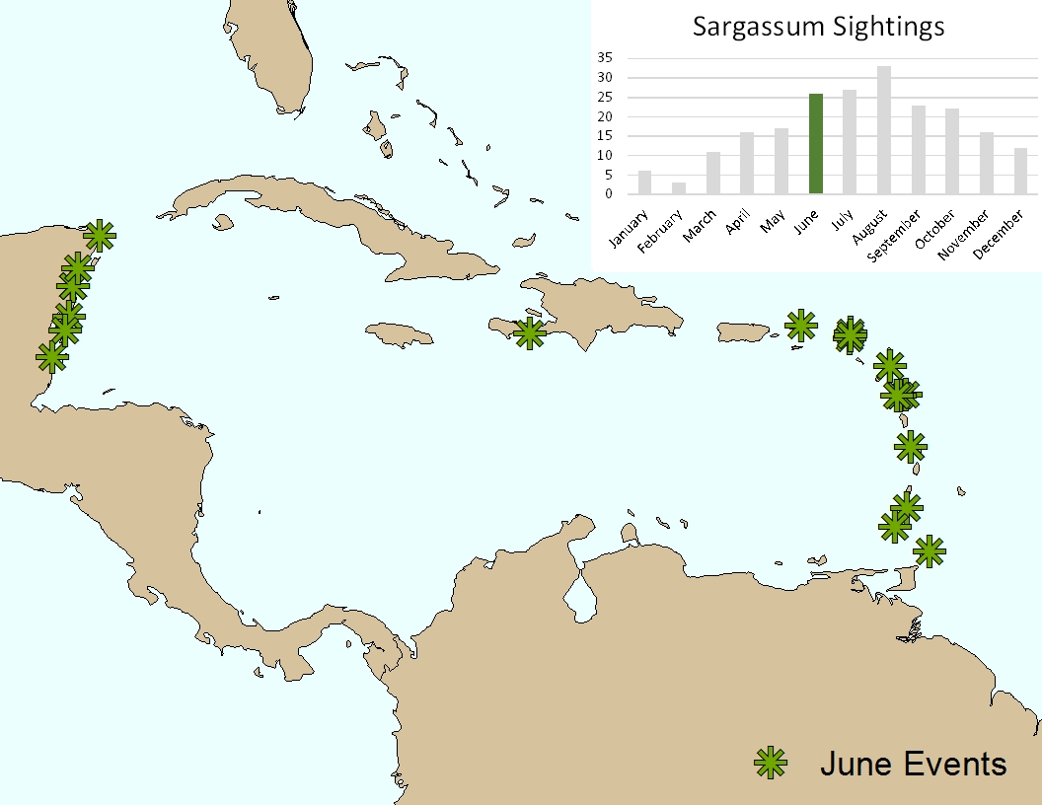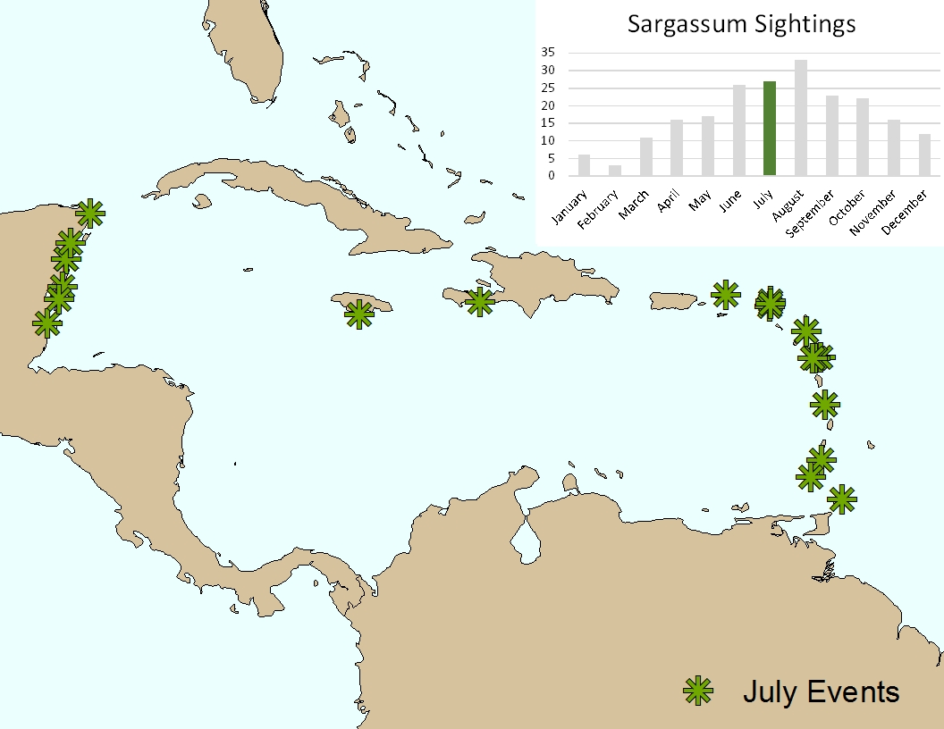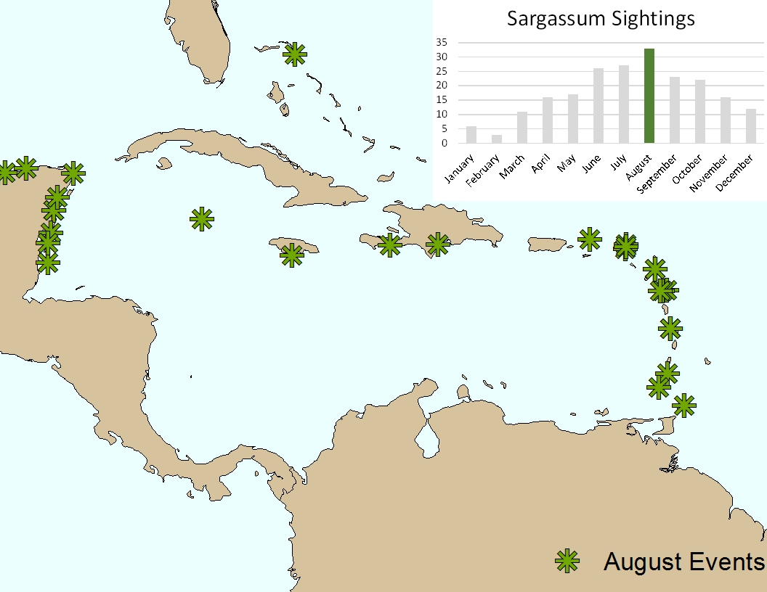
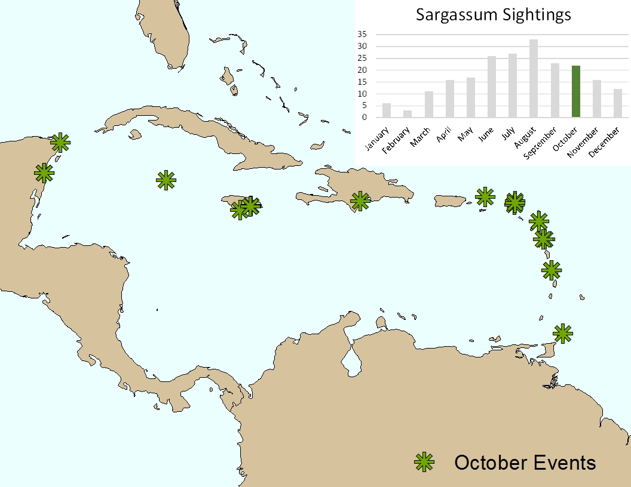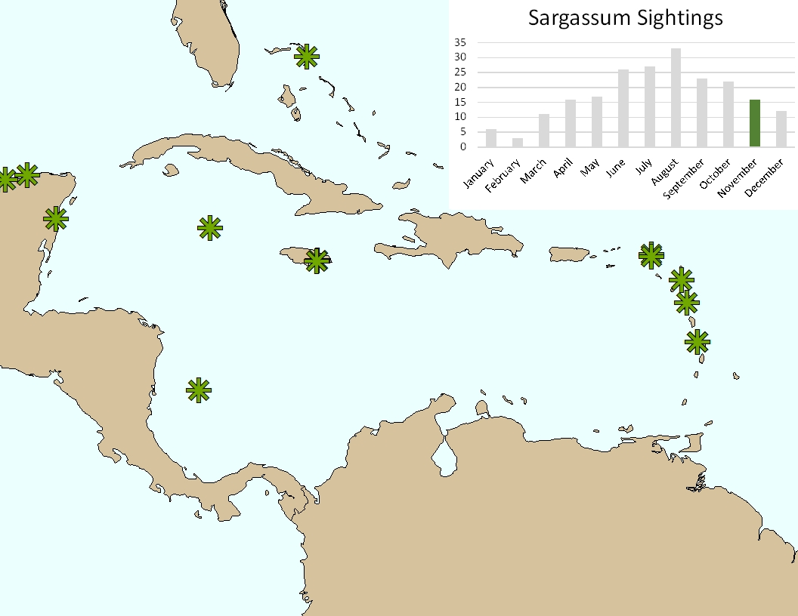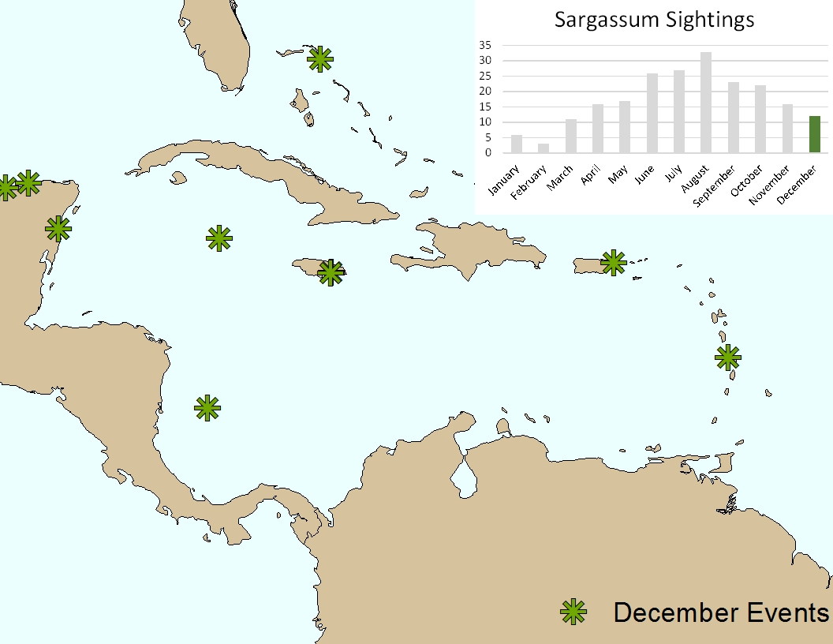

Appendix F:
Model Specification:
Series | R² |  |  |  | Slope
year = 2015 | Max | Min | Mean | Standard Deviation | Maximum | Min | Mean | Standard Deviation
fai = par | 0.4349262 | 0 | 0.02557308 | 0.03257948 | 6.20E-05 | -7.44E-05 | 2.25E-06 | 1.01E-05
fai = par-1 | 0.4314864 | 0 | 0.02520937 | 0.03257089 | 7.93E-05 | -8.38E-05 | 2.19E-06 | 1.05E-05
fai = par-2 | 0.529 | 0 | 0.025995 | 0.0352 | 7.59E-05 | -8.86E-05 | 2.40E-06 | 1.08E-05
fai = par-3 | 0.5533305 | 0 | 0.02606522 | 0.03577927 | 7.17E-05 | -7.50E-05 | 2.90E-06 | 1.12E-05
fai = par anom | 0.5990393 | 0 | 0.02541625 | 0.04019149 | 0.0001881721 | -0.0001880661 | 1.70E-06 | 1.97E-05
fai = par anom-1 | 0.7706568 | 0 | 0.0271174 | 0.04584986 | 0.000184057 | -0.0001513363 | 3.48E-07 | 1.94E-05
fai = par anom-2 | 0.7723473 | 0 | 0.03066895 | 0.04703549 | 0.0001541811 | -0.0001446903 | 2.32E-06 | 2.07E-05
fai = par anom-3 | 0.7521403 | 0 | 0.03128507 | 0.05224335 | 0.0001792738 | -0.0002277415 | 8.58E-07 | 2.08E-05
fai = sst | 0.448573 | 0 | 0.02802835 | 0.03745455 | 0.000560048 | -0.0005131724 | 1.36E-05 | 7.26E-05
fai = sst-1 | 0.3917312 | 0 | 0.02779922 | 0.03660653 | -0.0004002037 | 0.0005021681 | 7.09E-06 | 7.30E-05
fai = sst -2 | 0.505176 | 0 | 0.0275873 | 0.03623646 | 0.0004886737 | -0.0004854503 | 5.33E-06 | 7.22E-05
fai = sst -3 | 0.6393218 | 0 | 0.02790702 | 0.03602996 | 0.0004516701 | 0.0003847466 | 1.31E-06 | 7.24E-05
fai = sst anom | 0.7477213 | 0 | 0.02413299 | 0.0383483 | 0.004410908 | -0.005098904 | 5.73E-06 | 0.0001666316
fai = sst anom -1 | 0.7532792 | 0 | 0.02540008 | 0.04034941 | 0.0034216 | 0 | -1.21E-05 | 0.0001730703
fai = sst anom -2 | 0.8217316 | 0 | 0.02548973 | 0.04047179 | 0.003297525 | -0.004771406 | -1.30E-05 | 0.0001765852
fai = sst anom -3 | 0.7974143 | 0 | 0.02884324 | 0.04673124 | 0.003701917 | -0.004864399 | -1.93E-05 | 0.0001865026

Appendix G:
Survey responses to questions regarding the extent of observed Sargassum inundation events:
 | Strongly Disagree | Disagree | Neither Agree nor Disagree | Agree | Strongly Agree
Unprecedented Increase compared to previous years | 2.33%  1 | 9.30%  4 | 9.30%  4 | 23.26%  10 | 55.81%  24
Cost to Eco-Toursim | 4.76%  2 | 11.90%  5 | 4.76%  2 | 47.62%  20 | 30.95%  13
Cost to Local/Regional Governments | 4.65%  2 | 11.63%  5 | 9.30%  4 | 44.19%  19 | 30.23%  13
Environmental Damage From Removal | 2.33%  1 | 9.30%  4 | 25.58%  11 | 25.58%  11 | 37.21%  16
Environmental Damage from Non-Removal | 4.65%  2 | 23.26%  10 | 32.56%  14 | 23.26%  10 | 16.28%  7

*For additional survey data, please contact the authors.

X. Glossary Viewer

Sargassum: brown macroalga; generally spends its entire life cycle in the pelagic zone.

Inundation: flood, cover, or overspread with water.

Macroalgae: large-celled, photosynthetic algae, often referred to as seaweed.

Proliferation: rapid increase in numbers.

Pelagic: uppermost part of the ocean’s water column.

Holopelagic: completes its entire life cycle in the pelagic (top-most ocean) zone.

Spectral Signature: difference in the emitted characteristics of materials or objects in respect to wavelength using multispectral data.

Regression: a measure of relation between variables.

Photosynthetically available radiation: spectral range where photosynthetic organisms are able to photosynthesize to create energy.

Anomaly: something that deviates from what is normal or expected.

SEA Cruise Tow: Every Sea Education Association cruise collects tow data twice daily with a 1m tow net dragged for varying distances. Sargassum collected during these tows is measured and recorded as g/m².

