**NASA DEVELOP National Program**

Wise County and City of Norton Clerk of Court’s Office

**Fall 2016**

**Short Title:** Northern Great Plains Water Resources II

**Subtitle:** Utilizing NASA Earth Observations to Detect Changes in Annual Snowpack Coverage in Intermountain National Parks

**VPS Title:** A Not So Ice-olated Incident

**Project Team & Partners**

**Project Team:**

Kimberly Berry (Project Lead); kimberly.berry.mn@gmail.com

Alexander Black

Michael Brooke

Brooke Colley

Aubrey Hilte

**Advisors & Mentors:**

Dr. Kenton Ross (NASA Langley Research Center)

Dr. L. DeWayne Cecil (NOAA National Center for Environmental Information, Global Science and Technology Inc.)

Robert VanGundy (The University of Virginia’s College at Wise)

**Past or Other Contributors:**

Anne Gale

Xin Hong

Cody Vineyard

**Partner Organizations:**

|  |  |  |  |
| --- | --- | --- | --- |
| **Organization** | **POC (Name, Position/Title)** | **Partner Type** | **Boundary Org?** |
| National Park Service, Intermountain Region, Cultural Resources | Tom Lincoln, Archeologist/ Assistant Regional Director of Cultural Resources for the Intermountain Region of the National Park Service | End-User | No |

**Project Details**

**Applied Sciences National Applications Addressed:** Water Resources, Climate

**Study Area:** Glacier National Park, MT; Grand Teton National Park, WY; Yellowstone National Park, WY

**Study Period:** August 1984 - October 2016

**Earth Observations & Parameters:**

Landsat 5, Thematic Mapper (TM) – surface reflectance

Landsat 8, Operational Land Imager (OLI) – surface reflectance

**Ancillary Datasets Utilized:**

* USDA National Agriculture Imagery Program (NAIP) – high-resolution aerial imagery
* NPS – GIS database of Persistent Ice and Snow Cover (PISC)

**Software Utilized:**

* ESRI ArcGIS – data manipulation and map creation
* ERDAS Imagine – image processing of Landsat and MODIS data
* Google Earth Engine - image processing of Landsat and MODIS data

**Project Overview**

**80-100 Word Objectives Overview:**

Recent changes in climate have resulted in significant changes in ice and snow melt within the National Parks in the Intermountain region of the Northern Great Plains. As a result, areas that were previously covered by persistent ice and snow have now been exposed. The team mapped yearly changes in ice and snow cover in the region to detect areas of glacial boundary recession. This project will assist the National Park Service in locating archeological sites previously bound by ice, so that they may preserve and restore these areas where vegetative cover and fire regime has been altered.

**Abstract:**

National Parks in the Intermountain region of the United States Northern Great Plains are experiencing changes in Persistent Ice and Snow Cover (PISC) due to changes in climate. Part of the mission of the National Park Service is to discover and protect cultural heritage sites; mapping changes in PISC is a crucial step in identifying archaeological sites exposed by the receding ice and snow. This project focused on three National Parks in the Intermountain region: Glacier, Grand Teton, and Yellowstone. Multispectral, 30 m resolution imagery from Landsat 5 TM and Landsat 8 OLI were composited and cloud-masked. A supervised classification was performed to identify areas of persistent ice and snow, vegetative cover, and bare ground using Google Earth Engine and the Intermountain Classification Engine for Glacier Recession in Parks (ICE GRIP) tool developed by the team. The resulting classifications highlight areas where PISC decreased between the months of August and September from 1984 to 2016 and delineate areas of interest to the National Park Service for the search and preservation of archaeological sites. Vegetative change and glacial extent were validated with National Agriculture Imagery Program (NAIP) imagery.

**Keywords:**

National Park Service, Persistent Ice and Snow Cover (PISC), glaciers, climate change, Landsat, remote sensing

**Community Concerns:**

* Changing climate results in ice and snow melt in the National Parks in the Intermountain region of the United States Northern Great Plains region.
* Glacier, Grand Teton, and Yellowstone National Parks are experiencing changes in vegetative cover and fire regime due to receding ice sheets. Park officials are interested in mapping these changes in order to tailor management plans in response to the changing landscape.
* Part of the mission of the National Park Service is to discover and protect cultural heritage sites. Recent recession of ice sheets, uncover new archeological sites that must be located and preserved against damages caused by park use, weather, and wildfire.

**Current Management Practices & Policies**:

The National Park Service is responsible for protecting and documenting cultural resources across all parks. As annual ice and snow coverage recedes, previously buried archeological sites are exposed and must be documented and preserved. The National Park Service is familiar with NASA Earth Observations but currently relies on aerial photography and ground surveys to map and quantify changes in snowpack and ice extent.

**Decision Support Tools & Benefits:**

|  |  |  |  |
| --- | --- | --- | --- |
| **End-Product** | **Earth Observations Used** | **Benefit & Impact** | **Software**  **Release** |
| Max Snow Melt Area Map | Landsat 5 TM, Landsat 8 OLI | This product will be used to identify areas that have been historically covered by snow and ice in order to identify previously covered archeological sites. | I |
| Landcover Map of Exposed Areas | Landsat 5 TM, Landsat 8 OLI | This product will be used to help construct a land cover map which will assist researchers in assessing the paleoenvironment and cultural significance of archeological sites. | I |
| Vegetation Change Map of Exposed Areas | Landsat 5 TM, Landsat 8 OLI | This product will be used to identify areas of new vegetation within the land exposed by retreating snow and ice fields. | II |
| Intermountain Classification Engine for Glacier Recession in Park (ICE GRIP) | Landsat 5 TM, Landsat 8 OLI | This product will be used to delineate and monitor areas of PISC from other land cover types by providing partners with a thresholding code to be run in Google Earth Engine. | III |

**Project VPS/Booklet Imagery**

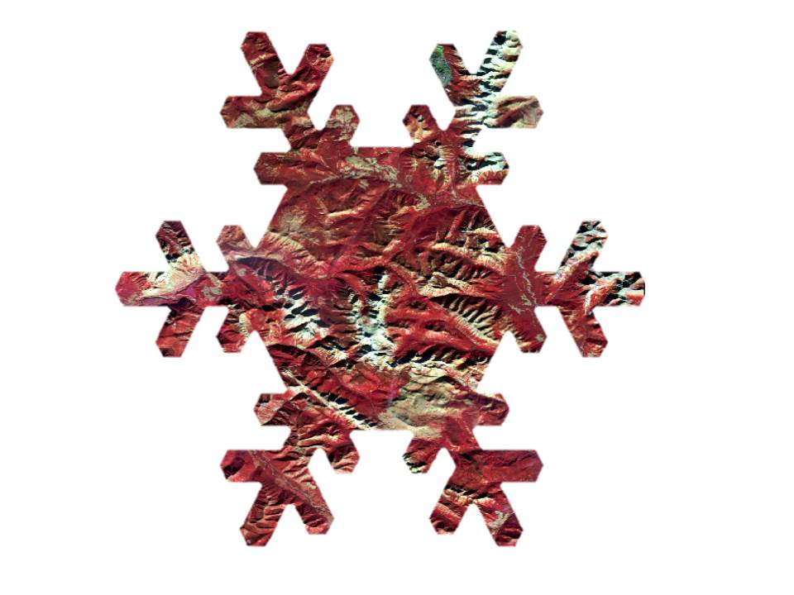

**Caption:** Landsat 8 NDSI used to classify persistent ices and snow cover in the Intermountain Region. Image Credit: Northern Great Plains Water Resources Team.

**Image:** SnowLoss.jpeg