**NASA DEVELOP National Program**



NASA John C. Stennis Space Center

*Summer 2015*

Texas Disasters

Utilizing NASA Earth Observations to Assist the Texas Forest Service in Mapping and Analyzing Fuel Loads in the Texas Grasslands

 **Technical Report**

Final Draft – August 6, 2015

Ben Beasley, (Project Lead)

Alex Holland

Kristen Kelehan

Joseph Spruce [Senior Scientist and Lead Science Advisor at NASA SSC]

James “Doc” Smoot [Senior Scientist and Assistant Science Advisor at NASA SSC]

Dr. Kenton Ross [NASA DEVELOP National Science Advisor, LaRC]

# I. Abstract

In recent years, the risk of severe wildfires has been increasing due to weather phenomena such as sequences of wet and drought years and recent urban expansion into wildland areas that are vulnerable to wildfire. The Texas Forest Service (TFS) is tasked with estimating and evaluating potential fire risk to manage and allocate resources for the prevention and containment of possible wildfires across the Texas landscape. A key for assessing fire risk is understanding vegetative fuel types and fuel loads. NASA Earth Observations provide a means for monitoring and evaluating wildfire fuel across a large temporal and spatial scales. This project aimed to assist the TFS by using MODIS and Landsat OLI data to calculate vegetation indices such as NDVI, and maps of fuel type and fuel load. This project leveraged the temporal advantages of MODIS with the more spatially resolved Landsat data to enable more informed wildfire risk assessment. This approach resulted in fuel maps that are more temporally resolved and updatable than the products derived previously with only Landsat data. Fuel maps were created for the 2010-2011 fire season, which saw some of the worst wildfires and drought impacts in recent history, and for the 2014-2015 season to provide a current assessment of wildfire fuels. The TFS are utilizing these products in order to better understand and evaluate wildfire risks throughout the state.

**Keywords**

Remote Sensing, Fuel Load, Wildfires, MODIS, Landsat,

# II. Introduction

**Background:**

Wildfire risk in Texas has increased due to climate change and recent urbanization into wildland areas with 80percent of fires occurring within 2 miles of developed areas. This increases the risk of the loss of life and property. As the population in Texas continues to grow these factors are expected to continue. In 2011, Texas declared a state of emergency due to the increase in wildfires that burned nearly 4,000,000 acres of Texas and destroyed nearly 3,000 homes, making this one of the worst fire season the state has ever seen. Things were so bad that Texas firefighters responded to 30,000 fires during 2011. All of this was exacerbated by a historic draught in 2011, which was preceded by an abnormally wet year in 2010. This lead to an increase in vegetation growth in 2010 that dried out in 2011, contributing to a more intense wildfire season. (Huffman, 2012)

The Possum Kingdom Complex wildfires burned 126,000 acres and destroyed 168 homes. In east Texas alone, the loss of forest product due to wildfire was estimated to be in the billions of dollars. (Huffman, 2012)

In 2011, the state of Texas experienced extremely abundant and costly wildfires and were forced to declare a state of emergency in the entire state of Texas. There were record-breaking high temperatures, very low humidity, and precipitation changes as a result of La Niña in the winter of 2010. According to NOAA’s Climate Prediction Center, La Niña is the period in the El Niño Southern Oscillation (ENSO) where sea surface temperatures are lower than normal in the equatorial Pacific. This can disrupt the normal climate patterns generally leading to drier conditions across the Southern Plains and the Southeastern United States.(CPC)

**Fuel Mapping:**

A key component for assessing wildfire risk is the classification and monitoring of vegetative fuel types and fuel loads and to model fire behavior based on the characteristics of each fuel. So in order to accurately predict fire behavior correct fuel type maps are necessary (Pausas and Vallejo, 1999). This is problematic due the large amounts of data and multidisciplinary approach, including the collection of ground data, remote sensing, and input from experts required for fuel mapping (Mckeinze, 2007).

Currently most fuel assessment is done using mostly Landsat data. Although this results in maps at moderate 30m resolution they are not easily updatable. This results in static fuel maps that require a large amount of work to create and become obsolete quickly (French, 2013). This outdating effect is even more rapid when it comes to naturally dynamic fuels such as grasslands, which are subject to variable climate conditions and anthropogenic disturbances (Mckeinze, 2007). These fuel models are extremely useful in fire modeling in areas where the fuels do not see seasonal fluctuations, but become less accurate for modeling more dynamic fuels.

**Project Objectives:**

The project objectives are to enhance fuel mapping capabilities using NASA Earth Observations. Use NASA data to assess seasonal variations in fuel loads and compile up to date fuel load maps. Specifically, this project will use the MODIS sensor which is on the Terra satellite. The MODIS data will be utilized to create a cumulative NDVI product.

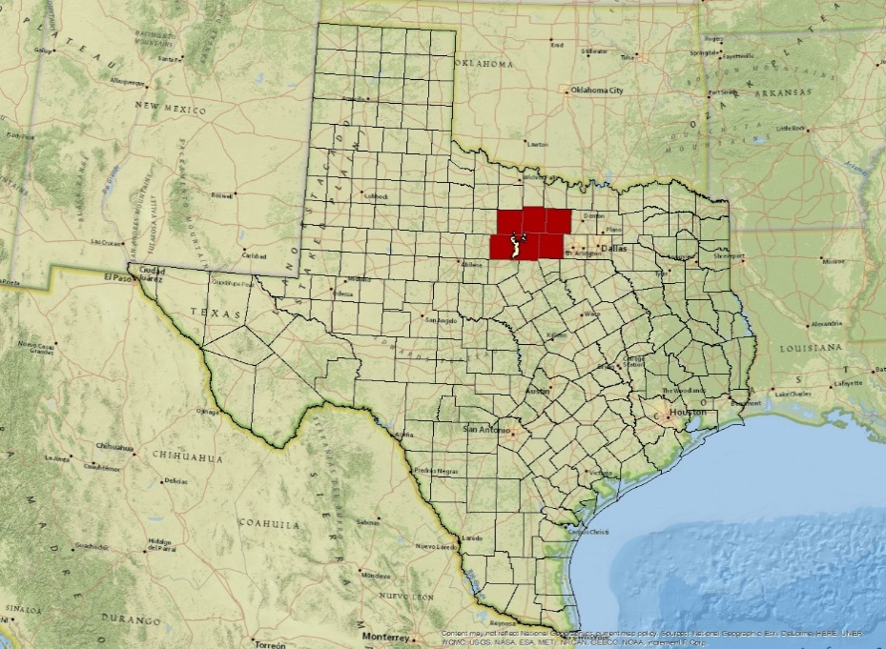

**Figure 1:** Study Area

**Study Area:**

This project analyzed the entire state of Texas which consists of 254 counties and spans over 268,800 square miles. Texas varies both climatically and topographically. In the eastern regions, the state is generally flat with large pine forests and is generally the wettest region of the state. The center part of the state is generally flat as well with the exception of the Hill Country region between Austin and San Antonio. This area is somewhat drier and the vegetation is in transition from forested to grasslands. Western Texas is a much drier area and the vegetation is mostly grassland or shrubland. The Texas Panhandle is extremely dry and is mostly short grasses and barren land. Far Southwest Texas is also very dry, but it is mountainous with interspersed desert regions. A specific six county study area around Possum Kingdom Lake west of Fort Worth was analyzed due to the Texas Forest Service’s specific interest in the area. These six counties were: Palo Pinto, Young, Stevens, Wise, Jack and Parker County.

**Study Period:**

The study period for this project was 2010-2015 with a special emphasis on the years 2010 and 2011. 2010 was an abnormally wet year in Texas and saw an unusual amount of biomass growth. 2011 saw a historic drought grip the state and much of the biomass grown in 2010 remained dormant. This setup can lead to extreme wildfire risk and 2011 was one of the worst years for wildfires in Texas history.

**Application Areas:**

The NASA Applied Sciences application areas addressed by this project were Disasters and Agriculture. The project was intended to help analyze vegetative wildfire fuels and provide additional information to aid in wildfire risk assessment and mitigation efforts. The prevention and containment of wildfires can help to save lives, property, and resources, including agricultural assets that are consumed during fires. In 2011, these losses totaled in the billions of dollars in agricultural damages alone.

**Project Partners:**

The Texas Forest Service was tasked with estimating and evaluating potential fire risk in order to manage and allocate resources for the prevention and containment of possible wildfires across the varied and dynamic Texas landscape. Texas Forest Service currently uses data derived from the LANDFIRE Program to predict and monitor wildfires in efforts to save lives, infrastructure, and natural resources. This program provides comprehensive and detailed maps that take a long time to produce and do not have the capability of representing current conditions. By combining data from Landsat and MODIS, this project created fuel maps that were produced based on the most current data available. The Texas Forest Service will utilize these products in order to better understand and evaluate wildfire risks throughout the state.

# III. Methodology

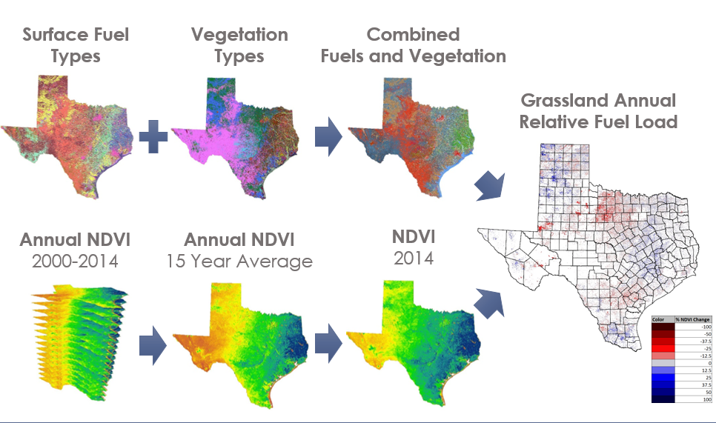

**Figure 2:** Methodology

**Fuel Types**

First, Surface Fuel Maps were collected from the Texas Forest Service. These maps classify the type of fuel that will drive a wildfire and the intensity that it will burn and are created by combining 30 meter Landsat data with other sources. These maps are based on the Rothermel method (Scott, 2015) of fuel characterization and allow for the input into standardized fuel models to predict fire behavior. This method first classifies fuels into several main classes such as grass, grass/shrub and forest litter. This is then further subdivided based on the characteristics within each of these types. Values are given for each based on how well each of these will burn. For example, a grass type 1 or gr1 would represent the lowest grass fuel type, which would be a low growing sparse grass that if ignited would produce a low flame fire that would not readily spread. As the rating increases the height and density increases with corresponding increases in the intensity of fire produced through burning. For this study the grass type fuels were isolated for analysis.

Vegetation Type Maps were also collected from the Texas Forest Service. These maps are tradition land cover classification maps that classify the dominant types of vegetation on the ground. These maps were combined with the fuel map to allow for the investigation of areas where the fuel expected to drive a wildfire and the dominant vegetation cover are not the same. We began by isolating only areas in the vegetation type map characterized as grass or herbaceous. The fuel type map was subset to the grass class so that the areas where the dominant vegetation was classified as grass and the grass fuel types could be analyzed separately or in combination. This process was repeated for other vegetation classes that also contained grass fuel types. This allow for the investigation of areas where the dominant vegetation was not grass but the fuel type was classified as a grass fuel.

**NDVI**

In order to make these maps sensitive to seasonal variations, Normalized Difference Vegetative Index (NDVI) was utilized. NDVI is the measure of the density of greenness of vegetation and is commonly used as a proxy for plant productivity. For this project, annual cumulative NDVI was chosen. This quantifies the amount of plant growth throughout the entire year instead of a snapshot. This product compiled MODIS, 8-day average NDVI and combines it over and annual basis to compute the accumulation of NDVI response for an entire year. Since MODIS is a daily pass sensor, this type of product works well for the computation of long term averages and accounts for anomalies within the data.

MODIS derived annual cumulative NDVI was compiled from 2000-2014 from the USDA Forest Service Forwarn Early Warning System. This data set was for the entire contiguous United States and was clipped to cover the study area for this project; first for Texas and then for the six counties that surround the Possum Kingdom Complex wildfire area. The 15-year average was calculated and compared to each annual cumulative NDVI to calculate the percent change from the mean. This was then combined with fuel and vegetation map and clipped to each of the fuel types to highlights areas that are above and below average for a particular year. Since NDVI is used to measure plant productivity, this indicates the amount of relative biomass accumulation or relative fuel load.

**Zonal Mean**

Another way that these MODIS derived cumulative NDVI products were used was to calculate zonal means or an average NDVI value for each type of fuel. This was first done on the six county study area. First the 15-year average was used to calculate the mean value for each fuel type. This indicated the typical NDVI response for the each of the grassland fuels. This data was then compared to each individual year of annual cumulative NDVI resulting the percent change from the fuel mean. This product allowed for analysis of how temporal and spatial variations related to the typical NDVI signature for each fuel.

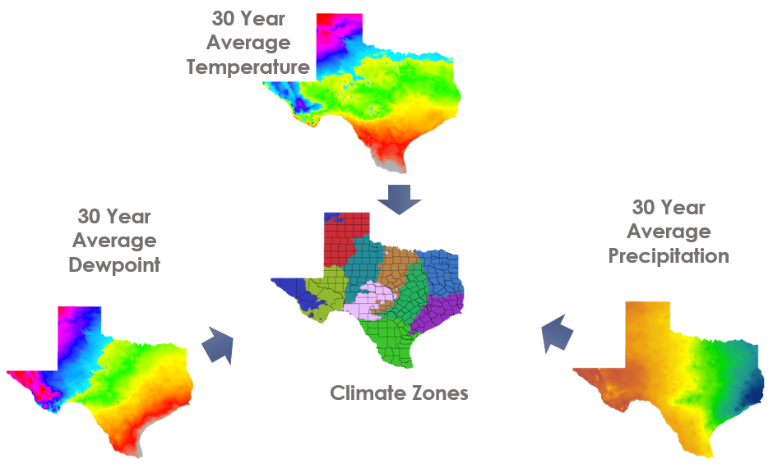

**Figure 3**: Climate Methodology

**State wide Zonal Mean**

Texas sees a wide range in climate. To adjust for this, 30 year average dewpoint temperature, temperature and rainfall was downloaded from PRISM. These climate layers were stacked together and then an iso cluster unsupervised classification was run on them in ArcGIS. 10 climate zones were derived from this classification. 10 climate zones were used because it provided a small enough spatial resolution that the NDVI signature for each class was similar.

Each of the fuel-vegetation types were then clipped to each climate class. A zonal mean was calculated for each of the grassland-vegetation types for each climate zone on the 15-year average annual cumulative NDVI. This provided an average NDVI number for each of the fuel-vegetation types. The difference between this number and the NDVI for the current year was taken and then normalized to provide a percent change.

# IV. Results & Discussion

**Analysis and Results:**

The resulting maps compare the annual cumulative NDVI to the 15-year average annual cumulative NDVI. Blue areas represent greater than average NDVI and red represents a less than average NDVI response. So as we expected to see there was an increase in vegetation productivity in the wetter 2010 (fig. 4) and a decrease in the much dryer 2011 (fig. 5). This illustrates how relative fuel load assessment can be useful for the analysis of fuels in the years prior to the current fire season can be a useful tool for fuel modeling. Fire managers knew that the increased rainfall in 2010 would contribute to an increase in fuel loads, but this method allows the quantification of the increase.

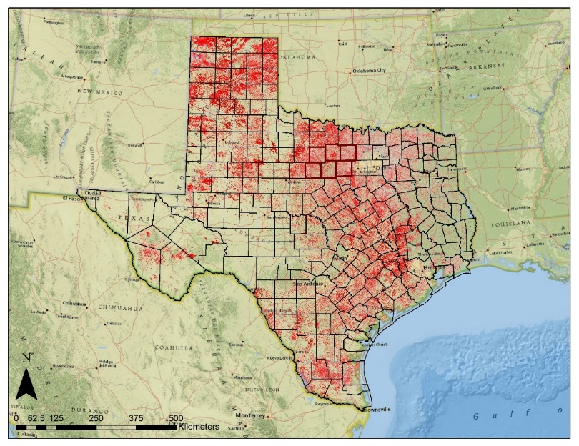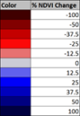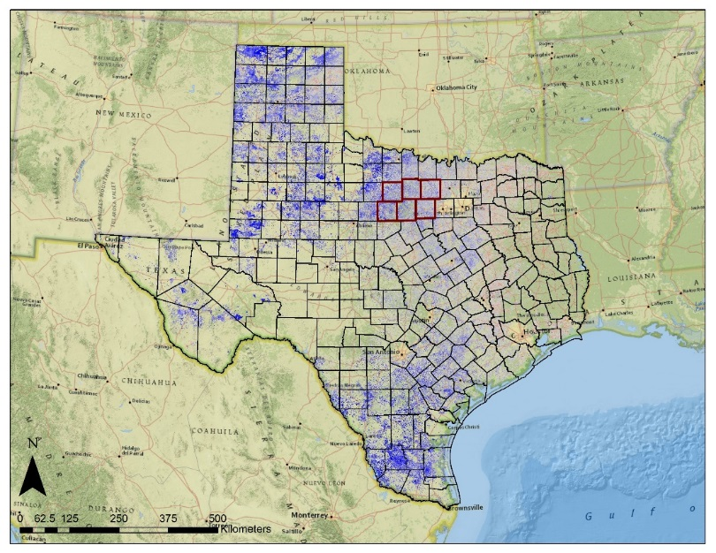

**Figure 5**:2011 Statewide Annual Comparison to 15-year Average NVDI

**Figure 4**:2010 Statewide Annual Comparison to 15-year Average NVDI

# In the study area around the Possum Kingdom Complex wildfires of 2011, this effect can be seen in greater detail (fig. 6 and 7). The increase in vegetation productivity increased the amount of grass available as fuel. In 2011, the larger amounts of biomass dried out resulting in a fire that had grassland fuel that contained greater biomass than normal, which contributed to the intensity and speed of the fires.

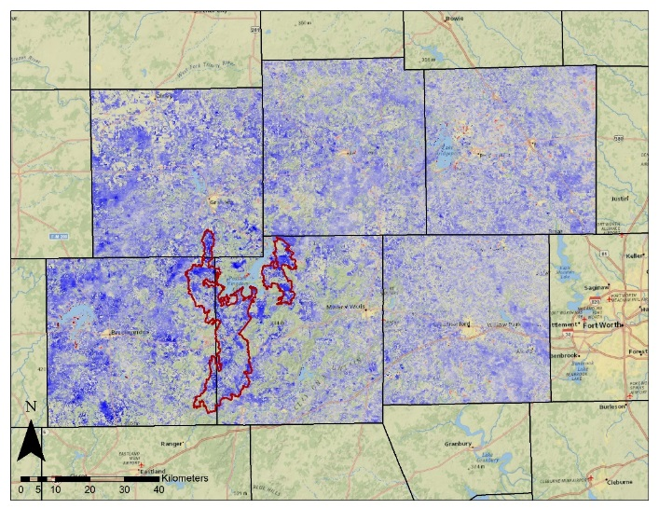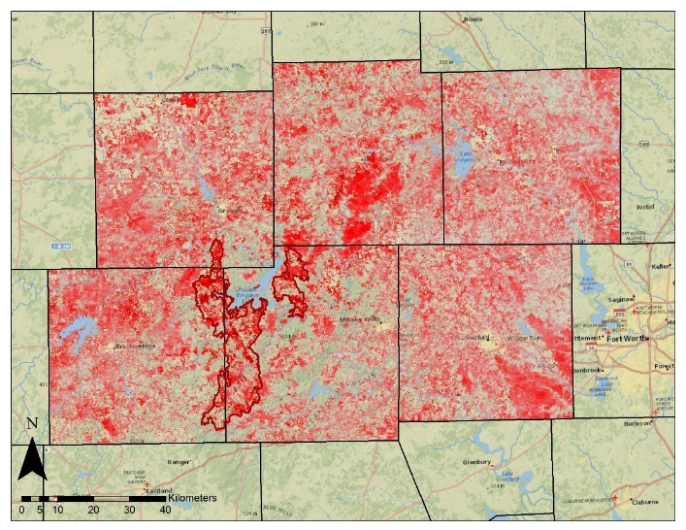

**Figure 6:** 2010 Possum Kingdom Annual Comparison to 15-year Average NVDI

**Figure 7:** 2011 Possum Kingdom Annual Comparison to 15-year Average NVDI



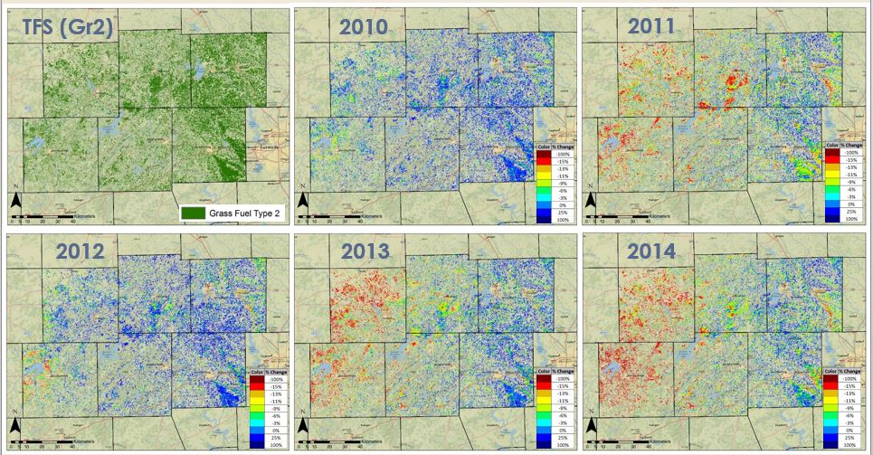

**Figure 8:** Zonal mean of the Grass Fuel type 2 for the Possum Kingdom study area

By calculating the zonal mean for each fuel type, the baseline or typical NDVI for each type was identified. This was then compared to the annual cumulative NDVI for each year. The results for the six county study area for Grass fuel type 2 or gr2 (fig. 8) show how variation occurs spatially as well as temporally throughout the study area. Some areas such as the southeast corner show consistently higher than average NDVI for Gr2. This could indicate that this area should be adjusted to a Gr3 fuel type due to the higher levels of productivity which may have caused the grass to be more dense or taller in that area, causing the fuel to behave more consistently with the higher level fuel type. The inverse may be applied to the western region of the study area where below average NDVI indicates lower productivity which suggests that the grasses in these areas may not be growing as well and should be reassessed.

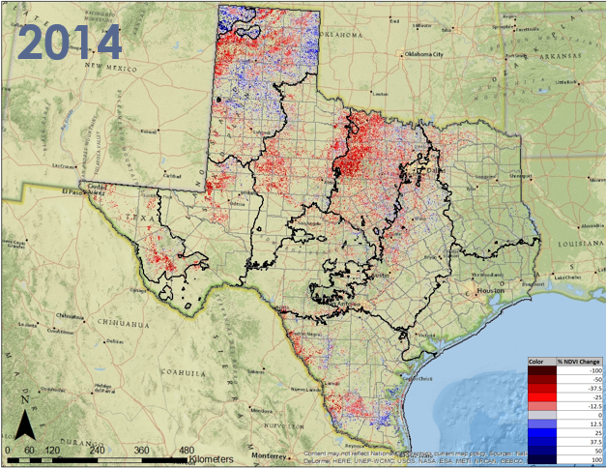

**Figure 9:** Zonal mean and climate zones 2014

The statewide zonal difference map (fig. 9) shows similar results for all of the grassland types. These types of maps could also the Texas Forest Service areas where the class type needs to be changed due to longer term factors such as climate change.

**Errors and Uncertainty:**

Using MODIS data only provided a 250 meter resolution, however the land cover and fuel type data was at a 30 m resolution. This may have led to pixel contamination in some areas of the state. NDVI measures the current greenness of the vegetation, even though a cumulative version of the NDVI product was used, none of the maps account for vegetation buildup that happened in previous years. Therefore all of the biomass estimations are at least slightly lower than the actual biomass on the ground. In wet years, cloudiness may prevent the measurement of even the 8-day NDVI during some periods. This is especially true in Southeast Texas. Other disturbances, such as the wildfires themselves that would prevent the sensor from accurately detecting reflectance.

**Future work:**

This project is planned to be continued in the next term and the methodology explored during this term can be expanded in various ways. First, by adjusting the time frame to reflect specific points in the growing season by calculating the averages based on sub-annual time scales. This would allow for more recent results and will allow for comparison other times in the growing season. Phenology studies on grasslands to pinpoint green up and brown down timeframes, which could be correlated to the cumulative NDVI data to identify key time periods for analysis. Other indices could also be introduced such as; Leaf Area Index (LAI) and the Enhanced Vegetation Index (EVI) to better depict the differences in the fuel types as well as providing a more accurate biomass number. Furthermore, using observations over areas of known biomass, the relative biomass numbers can be translated into actual biomass numbers. This type of data would be extremely useful in order to incorporate this data into fuel models. Other data fusion techniques such as STAR FM, which is a method for combining MODIS and Landsat data, could be explored to create up-to-date fuel type maps using the most current MODIS data available.

# 

# V. Conclusions

Geospatial information on grassland fuel loads are important for assessing wildfire risk and provide a method for analysis on a large spatial scale. This allows for the monitoring of fuels at scales that are not possible through any other means. Through the combination of this data with other sources, comprehensive understanding of vegetative fuels is possible.

Annual cumulative MODIS NDVI offers a means to monitor relative fuel loads by allowing for the calculation of an average NDVI values and then the comparison of each NDVI to that average. This indicates the percent change from the mean and shows the amount of relative biomass accumulation which is useful in determining relative fuel loads.

These MODIS NDVI products can serve as inputs to fuel load models to aid in the mapping of fuels by highlighting areas that are above and below average within a growing season and can inform decision making on the classification of fuel types.

Using MODIS data to detect seasonal changes in the Texas Grasslands was a crucial step in moving towards near real-time assessment in fuel loads. The Texas Forest Service can use this data in the future to better assess the wildfire risk based on recent observations rather than using a static fuel model.

# VI. Acknowledgments

Dr. Kenton Ross [NASA DEVELOP National Science Advisor, LaRC]

Joseph Spruce [Senior Scientist and Lead Science Advisor at NASA SSC]

James "Doc" Smoot [Senior Scientist & Assistant Science Advisor at NASA

Tom Spencer [Texas Forest Service-Predictive Services]

Curt Stripling [Texas Forest Service-Predictive Services]

William “Bill” Hargrove [USDA Forest Service ForWarn]

This material is based upon work supported by NASA through contract NNL11AA00B and cooperative agreement NNX14AB60A.

# 

# VII. References

Huffman, H., and Saginor, A., ”Texas Tackles Devastating Fire Season With Complex Interagency Response” Fire Management Today. May 2012. Vol. 72, No. 2, USDA

Mckenzie, D., C.l. Raymond, L.-K.b. Kellogg, R.a. Norheim, A.g. Andreu, A.c. Bayard, K.e. Kopper, and E. Elman. "Mapping Fuels at Multiple Scales: Landscape Application of the Fuel Characteristic Classification System This Article Is One of a Selection of Papers Published in the Special Forum on the Fuel Characteristic Classification System." *Canadian Journal of Forest Research Can. J. For. Res.* 37: 2421-437. Print.

Scott, Joe H., and Robert E. Burgan. "Standard Fire Behavior Fuel Models: A Comprehensive Set for Use with Rothermel’s Surface Fire Spread Model." Www.fs.fed.us. Rocky Mountain Research Station, 1 June 2005. Web. 29 July 2015. <http://www.fs.fed.us/rm/pubs/rmrs_gtr153.pdf>.

# VIII. Content Innovation

2015Sum_SSC_TexasDisaster_TechPaper_Interactive_Maps