Niagara Falls Disasters
Employing Remote Sensing Techniques to Evaluate Flood Extent and Environmental Parameters that Contribute to High Water Levels in Lake Ontario’s Coastal New York Communities


Technical Report
Final Draft – April 4th, 2019

Christine Fleming (Project Lead)
Celeste Gambino
Eric Deutsch
Oyut Amarjargal

Dr. Cédric Fichot, Boston University (Science Advisor)

Other Contributors:
Tyler Hennessee
Meryl Kruskopf
Isaac Gamoran
Elizabeth Swanson

1. Abstract
Approximately 11 million people reside in the Lake Ontario watershed. Extreme high water levels in the spring of 2017 caused severe flood damage to communities off the coast of Lake Ontario. Niagara Falls drainage infrastructure did not accommodate floodwater inundation, which led to the destruction of property and unsafe conditions for residents. City management required further assessment of maximum flood extent and regional impacts in order to determine high flood risk areas. The Niagara Falls Disasters team partnered with the City of Niagara Falls, the Great Lakes and St. Lawrence Cities Initiative, Cornell University, and University of Michigan to map flood extent and create tools to assess relevant environmental parameters used in flood risk evaluation. The team used Google Earth Engine to identify river and coastline changes in the Niagara Falls, NY region. Additionally, the team evaluated various environmental parameters derived from NASA Earth observations, including snow and ice cover, precipitation, and soil moisture, and generated time series analyses for the months prior to and during the 2017 flood event. These products will allow the partners to better prepare at-risk communities for future extreme weather events.
Keywords
remote sensing, flood extent mapping, disaster relief, inundation

2. Introduction
  - Background Information
The Lake Ontario watershed is the furthest downstream portion of the Great Lakes region and is home to approximately 11 million people (Carter & Steinschneider, 2018). In the spring of 2017, Lake Ontario reached its highest water level in over a century, causing widespread flooding in local communities (International Lake Ontario-St. Lawrence River Board, 2018). One of the areas impacted was the city of Niagara Falls, New York (Figure 1), located south of Lake Ontario and adjacent to the Niagara River, which connects Lake Ontario to the upper Great Lakes. During the 2017 flood, drainage infrastructure in Niagara Falls could not accommodate the floodwater inundation, leading to property damage and negative economic impacts.
Lake Ontario water levels are predominantly determined by net basin supply (NBS), which is defined as the combination of overlake precipitation, basin runoff, overlake evaporation, and outflow from Lake Erie (Carter & Steinschneider, 2018). From the late 1990s to approximately 2013, the Great Lakes experienced low water levels likely due to decreasing winter snow cover and high surface water temperatures increasing overlake evaporation (Gronewold & Snow, 2014). However, rather abruptly, the years 2015 to 2017 saw trends of increased precipitation (Gronewold & Rood, 2019). In the months leading up to the 2017 flooding, unusually high precipitation levels and increased snowmelt due to above average winter temperatures caused higher than average NBS in Lake Ontario and the upper Great Lakes. Hydrologic inputs entering Lake Ontario during the month of May were over double their historic average, leading to peak water levels in late May (Carter & Steinschneider, 2018). This increase, combined with anomalously high inputs from Lake Erie, led to historic flooding across Lake Ontario.
Impacted cities looking for ways to mitigate flood risk can utilize flood conditions monitoring to improve emergency preparedness. Remote sensing is a powerful tool for mapping flood extent due to the robustness of flood mapping methods, low to negligible costs for mapping a region, and availability of data (Wang, 2004). Notably, flood mapping in urban areas via remote sensing is currently challenging and less firmly constrained. For flood extent mapping, two separate sets of remotely sensed data are required: the first consisting of data acquired before the flooding event and the second consisting of data acquired during the flooding event, particularly as close to peak flooding levels as possible (Wang, Colby, & Mulcahy, 2002). These datasets can subsequently be used to map inundation extent and assess flood boundaries, typically involving some degree of water index such as the Normalized Difference Water Index (NDWI) (Fisher, Flood, & Danaher, 2016). This common technique has been used in a variety of different waterbody systems in past decades (Armenakis, Du, Natesan, Persad, & Zhang, 2017; Kyriou & Nikolakopoulos, 2015; Wang, 2004; Wang et al., 2002). Additionally, flood-related environmental parameters can be monitored via remote sensing with an extensive range of satellites and sensors (Taubenböck et al., 2011). Satellite remote sensing can provide information regarding how these parameters change through time and impact local water levels. Such information could be valuable for proper flood mitigation and emergency response decision making.
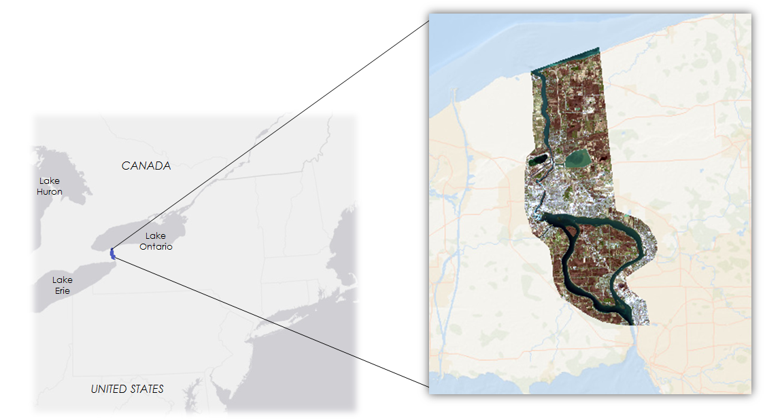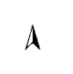
kilometers
300
0
kilometers
13
0
Figure 1. This project’s main region of interest contains a portion of the southern coast of Lake Ontario, the city of Niagara Falls, NY, and Grand Island, NY (Sources: Esri, DeLorme, HERE, MapmyIndia).

  - Project Partners & Objectives
Lake Ontario communities required further assessment of the 2017 flooding impacts in order to determine future at-risk areas. The NASA DEVELOP Niagara Falls Disasters team partnered with the Department of Planning and Economic Development from the City of Niagara Falls and the Great Lakes and St. Lawrence Cities Initiative (GLSLCI), a binational coalition of 131 mayors and officials working to protect and manage the Great Lakes (Great Lakes and St. Lawrence Cities Initiative, n.d.). This project also collaborated with professors at the University of Michigan and Cornell University. Our partner at University of Michigan and other researchers working with hydrological models can use data from this project to validate and test Weather Research and Forecasting Model Hydrological (WRF-Hydro) model system outputs. The provided snow-water equivalent (SWE) and soil moisture data can be used for relative comparison to remotely sensed data. Our partner at Cornell University is interested in integrating remotely sensed data into forecasting efforts to prepare New York communities for future flood events.
Currently, the City of Niagara Falls uses GIS to analyze water level spatial data and assess local environmental information (City of Niagara Falls, New York, 2019). However, remote sensing is not currently incorporated into their city preparedness procedures or flood management decisions. The City of Niagara Falls can benefit from incorporating NASA Earth observations (EO) into their flood management practices in order to better assess vulnerable areas. The GLSLCI does not uniformly incorporate remote sensing into their flood monitoring procedures. Therefore, the addition of NASA EO will aid in flood management capabilities across the Great Lakes. The GLSLCI and the City of Niagara Falls expressed a need for flood extent mapping products and flood management tools. Partners at the City of Niagara Falls and GLSLCI and collaborators at University of Michigan and Cornell University expressed a need for hydrologic input monitoring products and flood management tools.

The objectives of this project were as follows: (1) determine the feasibility of using satellite remote sensing techniques for urban flood extent mapping, (2) create flood extent maps that display the extent of high water levels prior to and including the 2017 flood, and (3) demonstrate how specific environmental parameters that contribute to flooding can be measured using satellite remote sensing. This project focused on the southern coast of Lake Ontario, the city of Niagara Falls, NY, and Grand Island, NY, from April 2015 to February 2019 (Figure 1).

End products from this project will help improve the partners’ flood condition monitoring capabilities as well as build partner capacity in the application of NASA EO to flood management. Flood extent maps will assist in identifying regions for future flood mitigation and aid. Monitoring how certain environmental parameters have contributed to past flooding events around Lake Ontario will provide the project partners with meaningful data to incorporate into future risk assessments and hazard forecasting practices.

3. Methodology
3.1 Data Acquisition for Coastal Annual Land Cover Change (CALCC) Tool
This tool is a modified version of the Coastal Annual Land Cover Change Tool (CALCC) that was developed by DEVELOP’s Hampton Roads Urban Development team during the fall 2018 term. The team decided to analyze flood-related satellite remote sensing imagery using Google Earth Engine (GEE). GEE is a free cloud-based geospatial research service that archives a variety of imagery collections from various NASA and European Space Agency (ESA) sensors. GEE also supplies imagery of pre-processed collections that consist of lightly-modified satellite imagery. Examples of these collections include datasets with various normalized difference indices applied. The cloud-based nature of GEE removes the hardware requirements for conducting such research locally, such as significant storage capacity (HDD and SSD), processing power (CPU), and memory (RAM) in favor of using Google’s advanced computing infrastructure.

The CALCC tool analyzed 761 raster images from Landsat 7 Enhanced Thematic Mapper Plus (ETM+) and Landsat 8 Operational Land Imager (OLI) between 1999 and 2018 (Table 1 and Figure 2). Prior to acquisition, this imagery was processed by the United States Geological Survey to the level L1TP. The processing steps entail radiometric calibration and orthorectification using ground control points and Digital Elevation Model (DEM) data, which make the imagery suitable for pixel-level time series analyses (United States Geological Survey, n.d.). We chose these data because they are the highest quality products readily available through GEE.
Table 1
The Coastal Annual Land Cover Change tool uses NASA Earth observations from Landsat 7 ETM+ and Landsat 8 OLI
 |  | Earth Observation Data
Platform & Sensor | Processing Level |  | Dataset Type | Number of Images | Dates
Landsat 7 ETM+ | Collection 1, Tier 1 |  | Surface Reflectance | 574 | 1999-01-01 to 2018-12-31
Landsat 8 OLI | Collection 1, Tier 1 |  | Surface Reflectance | 184 | 2013-04-11 to 2018-12-31

Figure 2. This table displays the annual distribution of utilized Landsat 7 ETM+ and Landsat 8 OLI imagery.
3.2 Data Processing and Analysis for CALCC
3.2.1 Cloud Masking and Cloud Shadow Masking
This tool maximizes its use of Landsat 7 and 8 imagery for the purpose of accurately representing coastlines for any given point between January 1, 1999, and December 31, 2018. Landsat satellites have a relatively coarse spatial resolution of 30 m. Since these are optical sensors, the resulting imagery is affected by cloud cover and cloud shadow cover. This tool utilizes cloud masking; however, we chose not to interpolate for the masked pixels as this would have introduced uncertainty that would propagate throughout the rest of the processing steps (Lenth, 2001).
3.2.2 Water Indices
Accurately identifying the boundary between land and water is critical for visualizing changes in hydrological features. Normalized difference equations are applied to satellite images to highlight certain features. For each Landsat image, the team computed a Normalized Difference Water Index (NDWI), as shown in Equation 1, and a Modified Normalized Difference Water Index (MNDWI), as shown in Equation 2 (Jiang et al., 2014). The resulting single band rasters were thresholded at NDWI = 0 and MNDWI = 0 to create binary land and water rasters. The thresholded rasters contain pixel values of either zero or one. Pixels with a value of zero are deemed to be land while pixels with a value of one are deemed to be water.

$\text{NDWI =}\frac{\text{GREEN - NIR}}{\text{GREEN + NIR}}$ (1)

$\text{MNDWI =}\frac{\text{GREEN - MIR}}{\text{GREEN + MIR}}$ (2)

3.2.3 Yearly Average
These binary rasters were separated into collections based on the year in which they were collected. The team calculated the average of all the rasters for each year, which resulted in a single synthetic raster output for each year from 1999 to 2018. These average rasters form the yearly average land and water boundary for each year of our 20-year study period. The imagery can be exported from Google Earth Engine as a Georeferenced Tagged Image File Format (GeoTIFF). The images are predominantly binary with intermediate values representing pixels that changed between water and land throughout the year. These non-binary pixel values identify boundary zones that have transitioned between land and water at least once throughout a given year.

The CALCC tool was designed to be used for difference analyses, although the team did not perform this type of study with the tool. A difference analysis entails finding the difference between two images by subtracting the earlier raster from the later raster. The resulting pixel values will indicate if a change has occurred between the two images, the direction of change, and the severity of identified change (Table 2).

Table 2
The table below highlights changes in land-water classification as a result of image differencing
Pixel Value Results from Difference Analysis
Final Raster - Initial Raster | Land --> Land | Water --> Water | Land --> Water | Water --> Land
Pixel Values | 0 | 0 | -1 | 1

3.3 Data Acquisition for Flood Extent Maps
The team acquired Landsat 8 OLI Level-1 data from USGS Earth Explorer, an online platform for Landsat imagery and other remote sensing data. In order to identify the peak flooding period, two images acquired close to the dates of the spring 2017 flooding on April 14, 2017 and June 1, 2017 were downloaded. The chosen dates were the only imagery to include <10% cloud cover over the study area in late spring and early summer of 2017.

3.4 Data Processing and Analysis for Flood Extent Maps
Three water indices were analyzed to identify areas with high wetness levels: (1) NDWI/MNDWI, (2) RED-SWIR1 Index, shown in Equation 3, and (3) Tasseled Cap transformation. The RED-SWIR1 Index is an alternative index for extracting wetness (Memon, Muhammad, Rahman, & Haq, 2015). The same calculations for deriving the NDWI/MNDWI indices were also applied to the RED-SWIR1 Index. The Tasseled Cap transformation reduces the amount of data from a few multispectral bands and produces three primary components: wetness, greenness, and brightness. It transforms the data of the image into a separate coordinate system with orthogonal axes, and it obtains its unique name due to the “tasseled” shape of its graphical distribution of data.

$\text{RED-SWIR1 Index =} \frac{\text{RED - SWIR}}{\text{RED + SWIR}}$ (3)

The CALCC Tool used the NDWI/MNDWI indices to produce a 2016 yearly average image, which was used in the Flood Extent Maps for comparison to the 2017 images. The team processed Landsat 8 OLI imagery based on the parameters for the 2016 image, first projecting onto a UTM-17N coordinate system and then cropping to the extent of the study area. Because the parameters for the Tasseled Cap transformation are only applicable to Top-of-Atmosphere (TOA) data for Landsat 8 OLI imagery, the team utilized TerrSet to first rescale the raw image values from 16-bit to 8-bit and then perform atmospheric corrections. The module ATMOSC produces real at-satellite reflectance values between 0.0 and 1.0. This transformation produced the Tasseled Wetness raster image for the project study area. The three designated water indices were applied to imagery identified from April and June 2017.
The team then created binary images of water and non-water by thresholding values more than 0 for the original three water indices. Next, one single binary raster of the 2016 base average image was created by thresholding at 0.75, with a value of 1 representing the pixels that are inundated 75% of the time in 2016. This raster image was then subtracted from each of the 2017 binary water images to obtain areas that were wetter than the 2016 base avera+ge image. The team also compared April and June 2017 across the three water indices to visualize the difference in wet areas (Appendices B, C, and D).
3.5 Data Acquisition for the Hydrologic Inputs Tool (HIT)
The Hydrologic Inputs Tool (HIT) displayed flood-related environmental data across the Lake Ontario watershed using the Google Earth Engine platform. The tool utilized data from the Global Precipitation Measurement Integrated Multi-satellite Retrievals for Global Precipitation Measurement (GPM IMERG), Terra Moderate resolution Imaging Spectroradiometer (MODIS), Shuttle Radar Topography Mission (SRTM), and Soil Moisture Active Passive (SMAP) L-band radiometer. Appendix A summarizes the NASA EO used by both the CALCC and HIT tools. The team acquired data from the GEE imagery archives to incorporate precipitation, snow/ice cover, elevation, and soil moisture into a user interface that allows users to display and analyze data from April 2015 to February 2019. All parameters were displayed using a modified version of the USGS Lake Ontario shapefile (Grannemann, 2010). GPM IMERG data were displayed in half-hourly increments. These data are computed using the 2014 Goddard Profiling Algorithm, then are gridded, inter-calibrated, and combined to produce the half-hourly availability (Huffman, 2017).

3.6 Data Processing and Analysis for HIT
In order to identify how snow/ ice cover and soil moisture changed from 2015 to 2019, the team calculated monthly median values using the Normalized Difference Snow Index (NDSI) and Surface Soil Moisture (SSM) to parse snow/ ice cover and soil moisture data into monthly time steps. Due to the sheer quantity of data available, and GPM IMERG’s 30-minute interval data collection, precipitation data were parsed into monthly time steps through monthly sum calculations across the years 2015 to 2019. Using the original SRTM digital elevation models, both slope and aspect were calculated.

3.7 HIT User Interface and Map Display
In order to allow easy access to the identified remotely sensed parameters, the team developed a graphical user interface in GEE. Upon running the base script, a user interface panel is launched to the main screen. Within the panel, users have access to all soil moisture, snow/ice cover, precipitation, and elevation data within the study period. For soil moisture and snow/ice cover data, users can select any year and month of interest and then choose to display that month’s mean or median value to a map of the Lake Ontario watershed (Figure 3). The same options are available for projecting a map of that month’s total precipitation. Maps of elevation, slope, and aspect are all also available for display in the watershed. The range of displayed elevations is limited to an upper bound of 1500 m in order to display a clear gradient in the Lake Ontario watershed. Multiple months and years of data can be layered and displayed on top of one another. Any generated map can then be exported from GEE to the user’s local Google Drive.
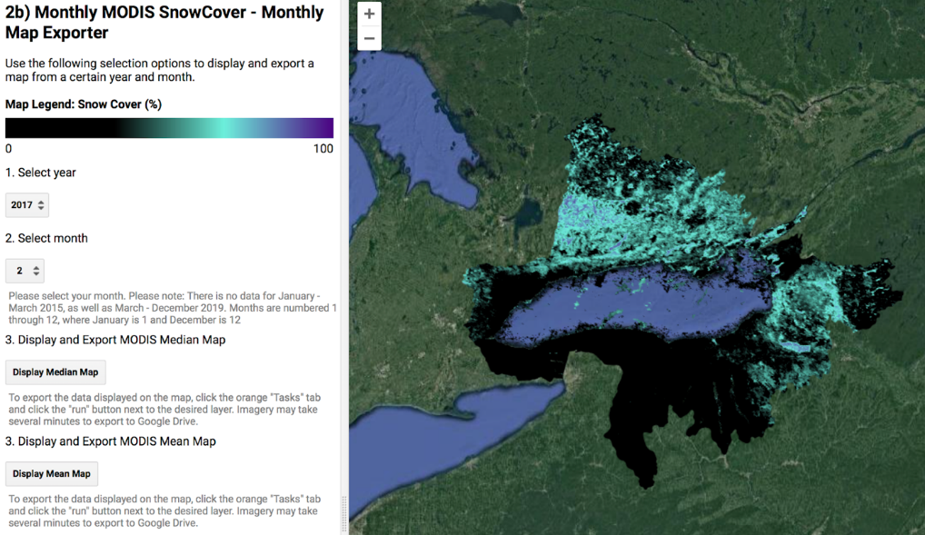

Figure 3. The image above shows a portion of the HIT user interface panel, display options, and generated map. Here, monthly mean snow/ice cover for February 2017 is projected over the Lake Ontario watershed and Niagara Falls region.
3.8 HIT User Interface and Time Series
Within the main user interface panel, users have the option to generate time series for all available soil moisture or snow/ice cover data (Figure 4). By clicking any location within the watershed on the associated map, both of these time series will automatically generate for all values at that latitude and longitude. The tool includes an option to export the desired time series from GEE as either a CSV, SVG, or PNG file.

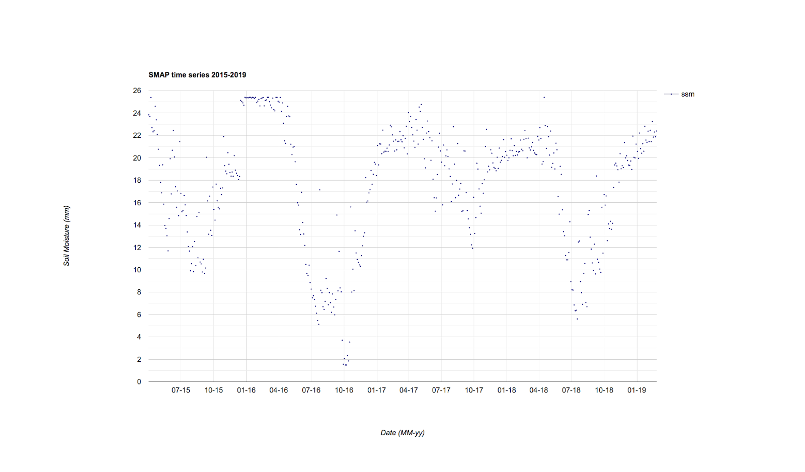

Figure 4. HIT’s user interface panel above shows an example time series, displaying all available surface soil moisture data for Grand Island, NY (latitude: 42.98, longitude: -78.95).

4. Results & Discussion
4.1 The Feasibility of Satellite Remote Sensing for Urban Flood Mapping
Satellite remote sensing is a powerful tool when used for certain flood-related applications. Despite this, there are considerable inherent shortcomings that are important to note when using optical satellite imagery. These shortcomings can partially be alleviated with the use of commercial satellite, aircraft, and drone imagery. The purpose of this research study is to address the feasibility of NASA Earth observations satellites. Landsat 7 ETM+ and Landsat 8 OLI were originally intended to be the primary sensors for flood mapping. While the spectral and radiometric resolutions of these sensors were satisfactory, these sensors had unsatisfactory temporal and spatial resolutions for the purpose of urban flood mapping.
Landsat 7 and 8 have a temporal resolution of 16 days with identical, yet antipodal orbital characteristics. Between the two satellites, there is an eight-day revisit period. In order to accurately map the maximum flood extent, a satellite must be overhead and unobscured by cloud cover. For the purpose of analyzing the spring 2017 flood event, the DEVELOP team was unable to locate imagery during the period of maximum flooding identified by partners at the City of Niagara Falls.
Flooding events caused by precipitation are somewhat random and transient. Flooding in urban environments is especially short term. The dynamics of stormwater discharge is dependent on the land cover type (Figure 5) (Water on the Web, 2004). Natural landscapes, such as forests, have a relatively gradual and low magnitude discharge curve while urban areas have much faster and higher amplitude curve (Water on the Web, 2004).
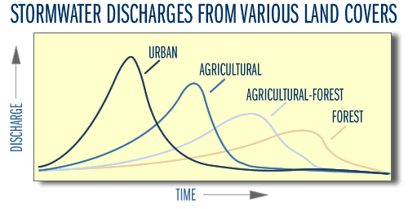

Figure 5. This image shows the approximate stormwater discharge curves from various types of development. According to the chart, urban development has the fastest and highest magnitude discharge rate (Water on the Web, 2004).

Landsat 7 and 8 both have a spatial resolution of 30 meters. In an urban environment, a 30-meter pixel is relatively coarse. This resolution does not allow for the discrimination of common sites of flood inundation such as streets and alleyways (Figure 6). The detail of satellite sensors such as Landsat 8 is relatively inadequate for this purpose.

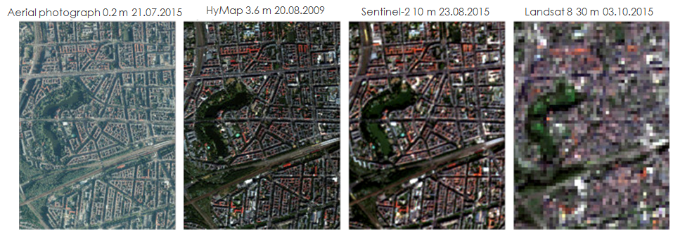
Figure 6. Sample images from various optical sensors show a significant loss in spatial acuity (Liang, 2012).

As a result of poor spatial resolution, the spectral signal of Landsat sensors cannot reliably identify flooded pixels in urban environments. Flood water in pixels will have their signal diminished almost entirely due to the presence of buildings and trees within the same pixel. Therefore, water is likely misrepresented in the final rasters. Additionally, we have found that the water depth for the Niagara Falls flooding event may not be deep enough for NDWI or MNDWI to detect. The team hypothesizes that the light the sensors detect simply penetrates the water, reflects off of the concrete beneath, and is ultimately received by the sensors with a spectral signature of concrete instead of water.
4.2 Results from the Flood Extent Maps
Upon comparing the three water indices to one another for both April and June 2017, the results for the area covered were relatively similar. Moreover, the total area that was wet 75% of the time in 2016 was 84.9 km². However, the areas measured for the two months for Tasseled Wetness, RED-SWIR1 Index, and NDWI/MNDWI were 91.8 km², 92.1 km², and 92 km², respectively (Table 3). For example, the Tasseled Cap Wetness analysis for the two months in 2017 highlighted wet areas in urban areas, agricultural fields, and in one reservoir (Figure 7). Although the team did not conduct a ground-truth assessment for wet areas, the provided Flood Extent Maps can be utilized as a proxy for locating areas that were wetter than the 2016 average.
Table 3
The table shows that the three water indices have more areas of wetness in both April and June 2017 than the 2016 average
Water Indices Area Coverage
Category | Area (km)²
2016 Average | 84.858
Tasseled Wetness | 91.802
Red – SWIR | 92.105
NDWI – MNDWI | 92.034

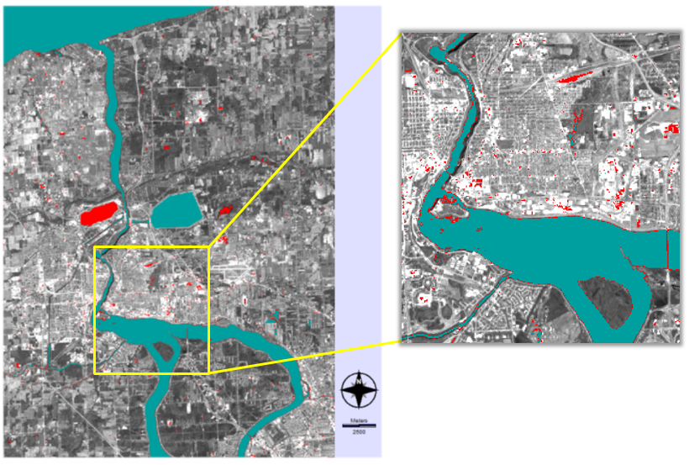Figure 7. The figure above shows the Tasseled Cap wet areas for April 2017 shown in red overlaid with the 2016 average in turquoise.
4.3 Results from HIT
HIT displays changes in environmental data over time, allowing for direct and relative comparison of parameters’ impacts on watershed water levels. Surface soil moisture, snow/ice cover, and precipitation patterns throughout the watershed were analyzed via the monthly map and time series generators to determine individual impacts on the 2017 flooding event. Months before, during, and after peak 2017 flooding were evaluated to determine any yearly fluctuations and patterns.
4.3.1 Surface Soil Moisture Results
In Grand Island, NY, during peak flooding of April and May of 2017, soil moisture was higher than any other month in 2017 and 2018 (Figure 8). In the months surrounding the spring 2017 flood, soil moisture progressively increased until peaking in late May. Particularly in May, median soil moisture across the entire watershed was considerably higher than May 2016 and slightly higher than May 2018 (Figure 9).

Soil moisture is influenced by other hydroclimatic conditions, such as melting snow/ice cover and precipitation. While it is useful in retrospective environmental condition analyses, it would not be a useful predictive flooding parameter. This is due to the fact that it fluctuates after a delay, once precipitation and other environmental factors have increased.

Figure 8. All available data for soil moisture from Grand Island, NY. Soil moisture increases in the months surrounding spring 2017 flooding (April to May).

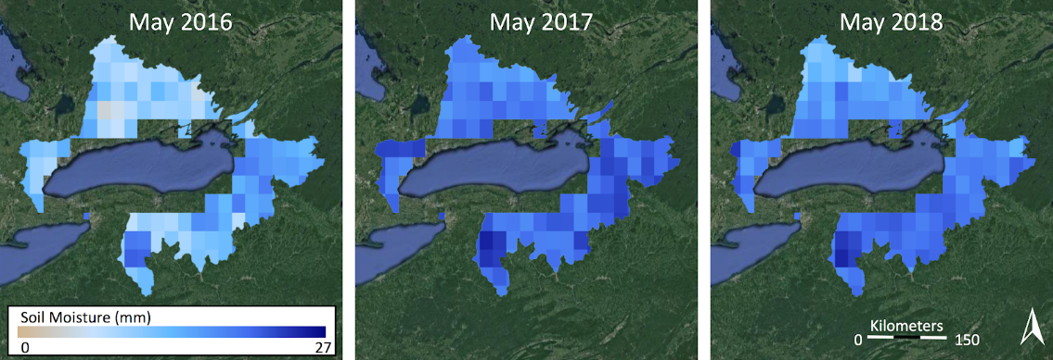
Figure 9. Median soil moisture values calculated for May 2016, 2017, and 2018 with dark blue representing higher soil moisture values and pale colors indicating lower soil moisture values.

4.3.2 Snow Cover Results
In terms of area covered, while some individual locations may have experienced higher than normal winter snow/ice cover in 2017, on average the entire watershed experienced a relatively normal, or even less extreme, snow/ice cover compared to other observed years. For example, during January 2017, there was less snow cover across the entire watershed compared to the Januarys the years before and after (Figure 10).
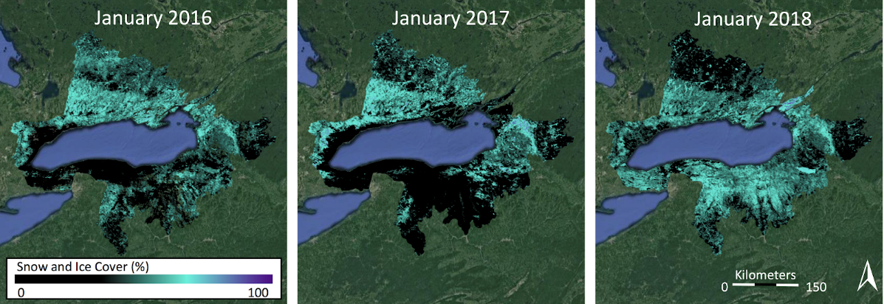
Figure 10. Median snow cover values calculated for January 2016, 2017, and 2018 with purple representing higher percentages and black indicating lower percentages.
4.3.3 Precipitation Results
During peak flooding in April and May of 2017 in Grand Island, NY, average cumulative precipitation was approximately 166 mm more than the average cumulative precipitation in April and May of 2016. It was also approximately 69 mm more than the average cumulative precipitation in April and May of 2018 (Figure 11). During April and May of 2017, precipitation was higher than any other month in 2016, 2017, or 2018 (Figure 12). While not individually perfect, precipitation would be useful as a predictive flooding parameter. Along with other environmental factors, such as in situ discharge from the Niagara River, precipitation has an extremely large impact on water levels in Lake Ontario.
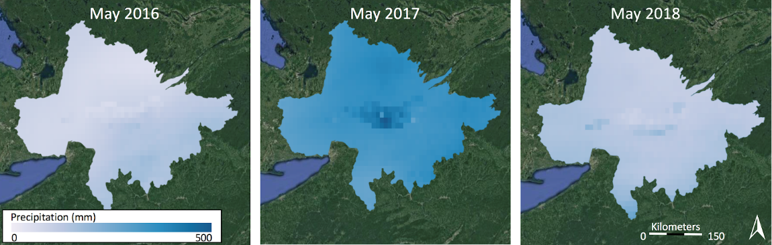
Figure 11. Cumulative monthly precipitation calculated for May 2016, 2017, and 2018 with blues representing higher amounts and white indicating lower amounts.
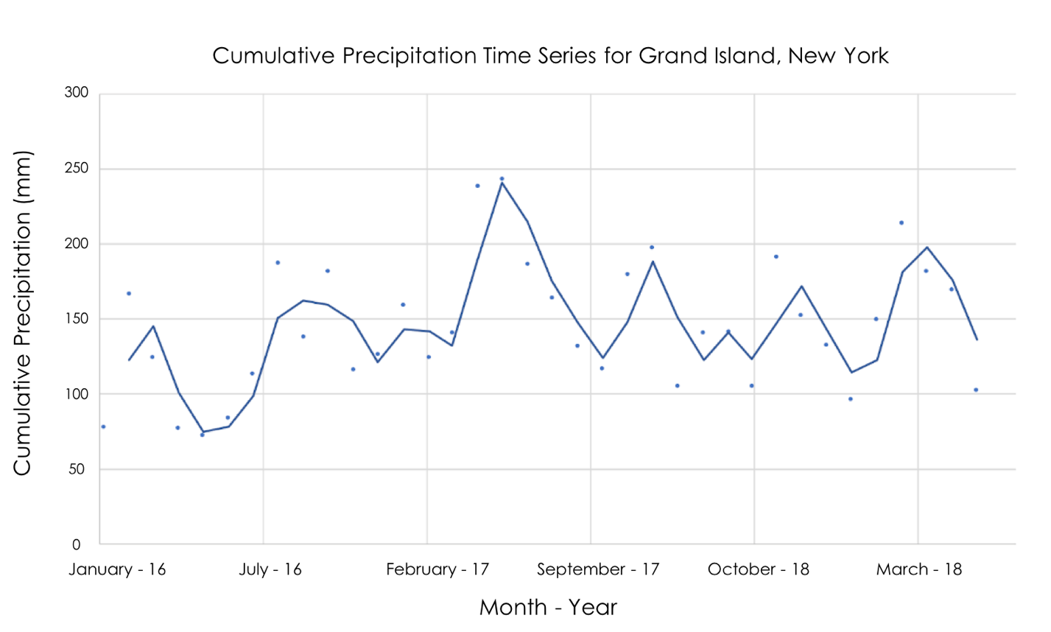

Figure 12. Time series of cumulative monthly precipitation from Grand Island, NY, with a period 2 moving average.

4.4 Future Work
While the team chose to focus on NASA EO, completing similar flood extent mapping using Sentinel-1 C-SAR (C-band Synthetic Aperture Radar) may potentially provide higher quality mapping. These data offer better spatial and temporal resolution and the wavelengths used have the capacity to penetrate through cloud cover. Nevertheless, SAR technology may experience some of the same issues as optical data for the purposes of flood mapping due to the spatial density and complexity of urban environments.

This research can also be expanded upon for future work through validation and forecasting efforts completed by partners at University of Michigan and Cornell University. Our partners and other researchers working with hydrological models such as the Weather Research and Forecasting Model Hydrological (WRF-Hydro) model system can use data from HIT to validate and test their model outputs. Snow-water equivalent (SWE) and soil moisture outputs from WRF-Hydro can be compared to snow/ice cover and soil moisture data integrated into the HIT product. In the future, remote sensing data from this project could be integrated into a forecasting model and used to help predict the extent of local flooding events.

As more SMAP, MODIS, and GPM data become available through time, these data can be integrated into HIT to extend both map visualization and time series components. HIT was originally designed for the Lake Ontario watershed and the Niagara Falls region. However, the code was created so that future projects can easily substitute another shapefile for their region of interest. Further use of this tool can allow similar assessments of environmental parameters in other areas vulnerable to flood events.

5. Conclusions
Flood extent mapping using remote sensing techniques can be an effective method of analysis because of the wide range of available data and resources for environmental decision makers. End users currently only utilize basic satellite imagery to visualize in situ data, so the addition of more in-depth NASA Earth observation applications will diversify data products available to inform flood management and introduce them to more complex environmental remote sensing techniques. Given the relatively coarse spatial resolution of Landsat 7 & 8, NASA optical satellites provide limited functionality for mapping floods in urban environments. The provided flood extent maps will be beneficial for hazard response planning, particularly for identifying areas at highest risk of flooding.

Our team found that using NASA EO to assess environmental parameters that contribute to high water can effectively enhance flood conditions monitoring, hydrological model validation, and flood forecasting efforts completed by our partner organizations. Time series products illustrating how snow cover, precipitation, and soil moisture conditions changed throughout the 2017 high water event provide a detailed assessment of how environmental parameters contribute to the regional water balance. During April and May of 2017, precipitation was approximately 166 mm more than April and May of 2016 and soil moisture was the highest of all months in 2017 and 2018. These measurements support literature that claims higher than normal hydrological inputs to the Lake Ontario watershed were the likely cause of 2017 flood events in the region.

Overall, this project demonstrated the utility of remotely sensed data products in landscape-scale environmental monitoring. Assessing the feasibility of urban flood extent mapping using currently available NASA EO data was informative for the project’s end users and will guide efforts to pursue more accurate flood mapping. The team connected municipal and regional decision-makers with accessible Earth science data via a graphical user interface to provide further context for the flood events of 2017. The export and study period extension features of HIT also ensure that work completed during the term can contribute easily to future flood modeling research.

6. Acknowledgments
The Niagara Falls Disasters team would like to thank their partners and mentors who dedicated their time to provide guidance and expertise throughout the entire project. We would especially like to thank:

- Tom DeSantis and Alan Nusbaum from the City of Niagara Falls, Department of Planning and Economic Development
- Melissa Soline from the Great Lakes and St. Lawrence Cities Initiative
- Dr. Scott Steinschneider from Cornell University
- Dr. Drew Gronewold from the University of Michigan

We wish to thank our Center Lead, Zachary Bengtsson, and Science Advisor, Dr. Cédric Fichot, for their continued assistance and support throughout this process. We would also like to thank the Lake Ontario Disasters team at the DEVELOP Arizona – Tempe Node for their support and collaboration on this project.

Any opinions, findings, and conclusions or recommendations expressed in this material are those of the author(s) and do not necessarily reflect the views of the National Aeronautics and Space Administration.

This material is based upon work supported by NASA through contract NNL16AA05C.

7. Glossary
Earth observations – Satellites and sensors that collect information about the Earth’s physical, chemical, and biological systems over space and time
ESA – European Space Agency
GEE – Google Earth Engine, an open source geospatial analysis tool
GeoTIFF – Georeferenced Tagged Image File Format
GLSLCI – Great Lakes and St. Lawrence Cities Initiative
GPM IMERG – Global Precipitation Measurement Integrated Multi-Satellite Retrievals for GPM
Landsat 7 ETM+ – Enhanced Thematic Mapper, a multispectral sensor aboard the Landsat 7 satellite
Landsat 8 OLI – Operational Land Imager, a multispectral sensor aboard the Landsat 8 satellite
MNDWI – Modified Normalized Difference Water Index
NBS – Net Basin Supply, the net volume of water entering or exiting a lake
NDSI – Normalized Difference Snow Index
NDWI – Normalized Difference Water Index, derived from the Normalized Difference Vegetation Index to indicate water features from satellite data
NIR – Near Infrared
RED-SWIR1 Index – A water index using a combination of the Red and Shortwave-Infrared
SMAP – Soil Moisture Active Passive
SRTM DEM – Shuttle Radar Topography Mission Digital Elevation Model
SSM – Surface Soil Moisture
Tasseled Cap Transformation – A type of data transformation that converts the original bands of an image into a new set of bands with defined interpretations
Terra MODIS – MODerate resolution Imaging Spectroradiometer sensor aboard the Terra satellite
TerrSet – A combined remote sensing and geographic information system software
TOA – Top-of-atmosphere; at-satellite values
WRF-Hydro – Weather Research and Forecasting Model Hydrological model system

8. References
Armenakis, C., Du, E. X., Natesan, S., Persad, R. A., & Zhang, Y. (2017). Flood risk assessment in urban
areas based on spatial analytics and social factors. Geosciences, 7(4), 123. https://doi.org/10.3390/geosciences7040123

Carter, E., & Steinschneider, S. (2018). Hydroclimatological drivers of extreme floods on Lake Ontario. Water
Resources Research, 54(7), 4461-4478. https://doi.org/10.1029/2018WR022908

City of Niagara Falls, New York. (2019). Planning and Environmental. Retrieved 4 April 2019 from
http://niagarafallsusa.org/government/city-departments/planning-and-environmental/

Farr, T.G., Rosen, P.A., Caro, E., Crippen, R., Duren, R., Hensley, S., … Alsdorf, D.E.. (2007). The shuttle radar topography mission. Reviews of Geophysics, 45(2), RG2004. https://doi.org/10.1029/2005RG000183

Fisher, A., Flood, N., & Danaher, T. (2016). Comparing Landsat water index methods for automated water
classification in eastern Australia. Remote Sensing of Environment, 175, 167-182. https://doi.org/10.1016/j.rse.2015.12.055

Grannemann, N. G. (2010). Great Lakes and watersheds shapefiles. Retrieved 7 March 2019 from
https://www.sciencebase.gov/catalog/item/530f8a0ee4b0e7e46bd300dd

Great Lakes and St. Lawrence Cities Initiative. (n.d). About the Great Lakes and St. Lawrence Cities Initiative.
Retrieved from https://glslcities.org/about/

Gronewold, A. D., & Rood, R. B. (2019). Recent water level changes across Earth's largest lake system and
implications for future variability. Journal of Great Lakes Research, 45(1), 1-3. https://doi.org/10.1016/j.jglr.2018.10.012

Gronewold, A. D., & Stow, C. A. (2014). Water loss from the Great Lakes. Science, 343(6175), 1084-1085.
https://doi.org/10.1126/science.1249978

Hall, D. K., & G. A. Riggs. (2016). MODIS/Terra Snow Cover Daily L3 Global 500m Grid, Version 6, MOD10A1.006. NASA National Snow and Ice Data Center Distributed Active Archive Center, accessed March 2019. https://doi.org/10.5067/MODIS/MOD10A1.006
Huffman, G. (2017). GPM IMERG Final Precipitation L3 Half Hourly 0.1 degree x 0.1 degree, V05. Goddard Earth Sciences Data and Information Services Center (GES DISC), accessed March 2019. doi:10.5067/GPM/IMERG/3B-HH/05

International Lake Ontario-St. Lawrence River Board. (2018). Observed conditions and regulated outflows in 2017.
Retrieved from https://www.ijc.org/sites/default/files/2018-08/ILOSLRB_FloodReport2017.pdf

Jiang, H., Feng, M., Zhu, Y., Lu, N., Huang, J., & Xiao, T. (2014). An automated method for extracting rivers
and lakes from Landsat imagery. Journal of Remote Sensing, 6(6), 5067-5089. https://doi.org/10.3390/rs6065067

Kautz, S. (2018). Landsat 8 OLI (Operational Land Imager) [Dataset]. US Geological Survey, accessed March 2019. https://doi.org/10.5066/f71835s6

Kyriou, A., & Nikolakopoulos, K. (2015). Flood mapping from Sentinel-1 and Landsat-8 data: A case study
from river Evros, Greece. Earth Resources and Environmental Remote Sensing/GIS Applications VI, 9644, 964405. https://doi.org/10.1117/12.2194449

Lenth, R. (2001). Some practical guidelines for effective sample size determination. The American
Statistician, 55(3), 187-193. Retrieved from http://www.jstor.org/stable/2685797

Memon, A., Muhammad, S., Rahman, S., & Haq, M. (2015, April 16). Flood monitoring and damage
assessment using water indices: A case study of Pakistan flood-2012. Retrieved from https://www.sciencedirect.com/science/article/pii/S111098231500006X

O'Neill, P. E., Chan, S., Njoku, E. G., Jackson, T., & Bindlish, R. (2016). SMAP L3 Radiometer Global Daily
36 km EASE-Grid Soil Moisture, Version 4. NASA National Snow and Ice
Data Center Distributed Active Archive Center, accessed March 2019.
doi:10.5067/OBBHQ5W22HME

Taubenböck, H., Wurm, M., Netzband, M., Zwenzner, H., Roth, A., Rahman, A., & Dech, S. (2011). Flood
risks in urbanized areas–multi-sensoral approaches using remotely sensed data for risk assessment. Natural Hazards and Earth System Sciences, 11(2), 431-444. https://doi.org/10.5194/nhess-11-431-2011

United States Geological Survey. (n.d.). Landsat Processing Details. Retrieved 2 April 2019 from
https://landsat.usgs.gov/landsat-processing-details
United States Geological Survey. (2015). USGS EROS Archive – Landsat Archives – Landsat 7 ETM+ Level-2 Data Products – Surface Reflectance. USGS EROS, accessed March 2019. https://doi.org/10.5066/F7Q52MNK
Wang, Y. (2004). Using Landsat 7 TM data acquired days after a flood event to delineate the maximum flood extent on a coastal floodplain. International Journal of Remote Sensing, 25(5), 959-974. https://doi.org/10.1080/0143116031000150022

Wang, Y., Colby, J. D., & Mulcahy, K. A. (2002). An efficient method for mapping flood extent in a coastal
floodplain using Landsat TM and DEM data. International Journal of Remote Sensing, 23(18), 3681-3696.
https://doi.org/10.1080/01431160110114484

Water on the Web. (2004, March 3). The watershed. Retrieved 4 March 2019 from
http://www.waterontheweb.org/under/lakeecology/06_watershed.html

9. Appendices

Earth Observation Data
Platform  & Sensor | Data Availability* | Acquisition Method | Use
Landsat 7 ETM+ | April 1999  to  present | Google Earth Engine | Surface reflectance was used to evaluate river and coastline change as well as assess flood inundation.
Landsat 8 OLI | April 2013  to  present | Google Earth Engine  &  USGS Earth Explorer | Surface reflectance was used to evaluate river and coastline change as well as assess flood inundation.
Terra MODIS | December 1999  to  present | Google Earth Engine | Surface reflectance was used to estimate snow cover.
GPM IMERG | March 2014  to  present | Google Earth Engine | Precipitation data were used to quantify precipitation in the years leading up to 2017 flood events.
SMAP L-band Radiometer | April 2015  to  present | Google Earth Engine | Soil moisture measurements were used to infer soil porosity.
SRTM | N/A | Google Earth Engine | The digital elevation model was used to map and predict flood extent in relation to land topography.
Appendix A. Sensors and relevant metadata

*Present = the submission date of this report (April 2019); some sensors may have stopped collecting data since then

Appendix B. NDWI/MNDWI difference

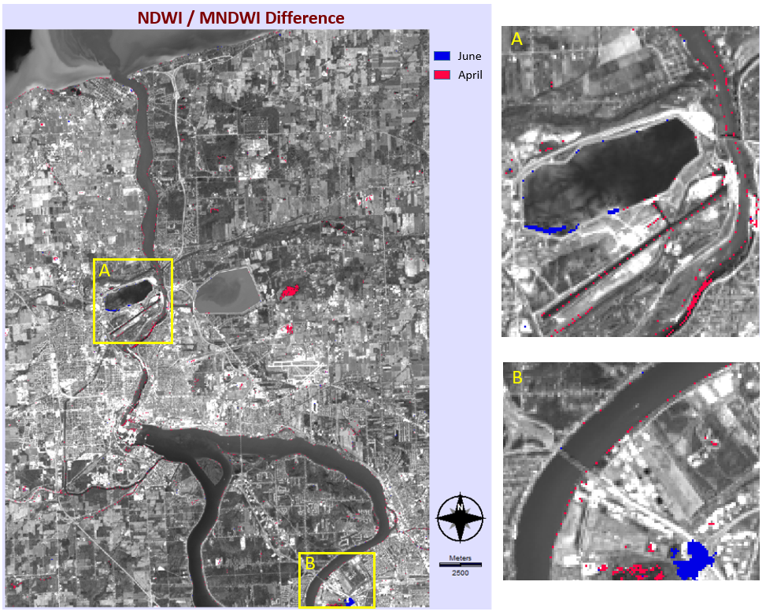

Appendix C. Red – SWIR1 Index difference
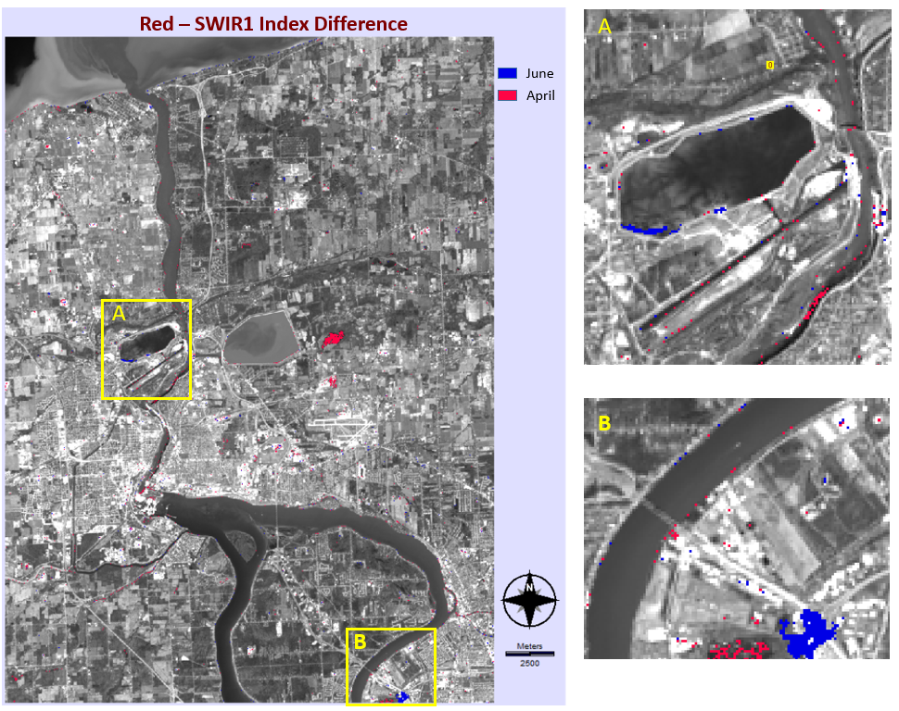

Appendix D. Tasseled cap wetness difference

