Getting Started with your Virtual Machine

Section 1: How to Connect/Setup your EC2 Instance for DEVELOP

- You will receive an email containing your EC2 instance, login name, and password. Use this to start your EC2 instance using the instructions in the Develop_Jenkins_User_Guide.pptx.
- You will need a Microsoft Remote Desktop client. This client is provided as part of the Windows operating systems.
  - Mac OS X users will need to download/install from the AppStore.
  - On Windows, if you search for “remote,” the Remote Desktop client is usually the first applications offered.
- Launch the Remote Desktop client, enter in your IP address in the box labeled “Computer.” Note that your IP address is provided in near the bottom of your Consol Output Log after you start your EC2 instance, at the end of a line similar to the following:

Develop-SGARA-jadavis5_T3 running ami-07ed7a6c8391a9c82 0.101 i-0a72ae989c58a83be May 27 2020 01:13 PM t3.xlarge Summer2020 54.165.146.9

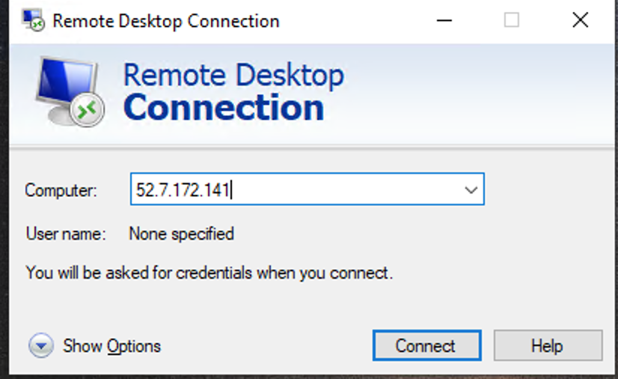

- Click Connect:
Then enter in your login information from your email: Below is an example only, note that your username is <first name><last name>@develop.amazoninstances.com
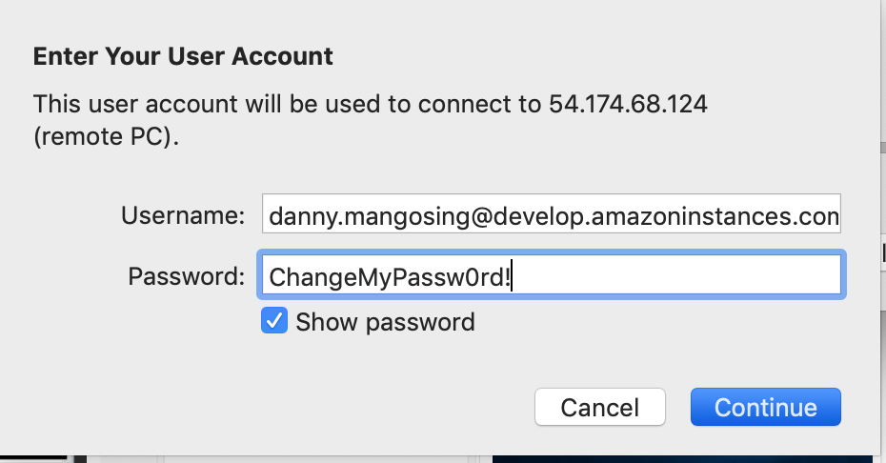

- You may get a pop-up about validity of certificate similar to the example below. Click continue, this is normal for Remote Desktop connections to EC2 instances.

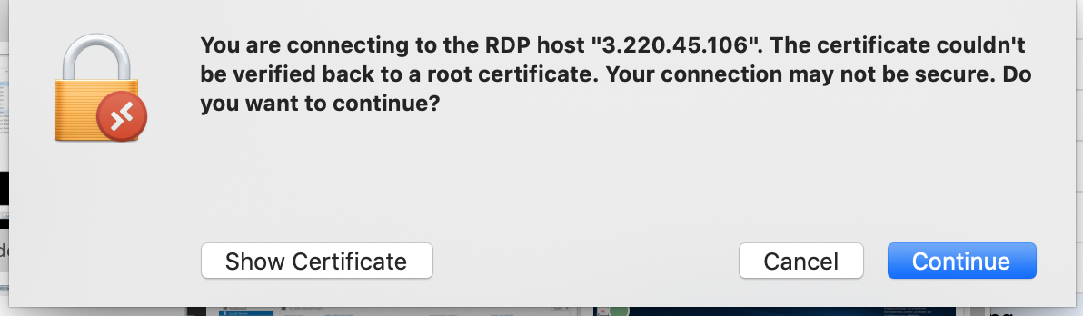

- After clicking Continue, you should be greeted with your EC2 instances’ desktop.

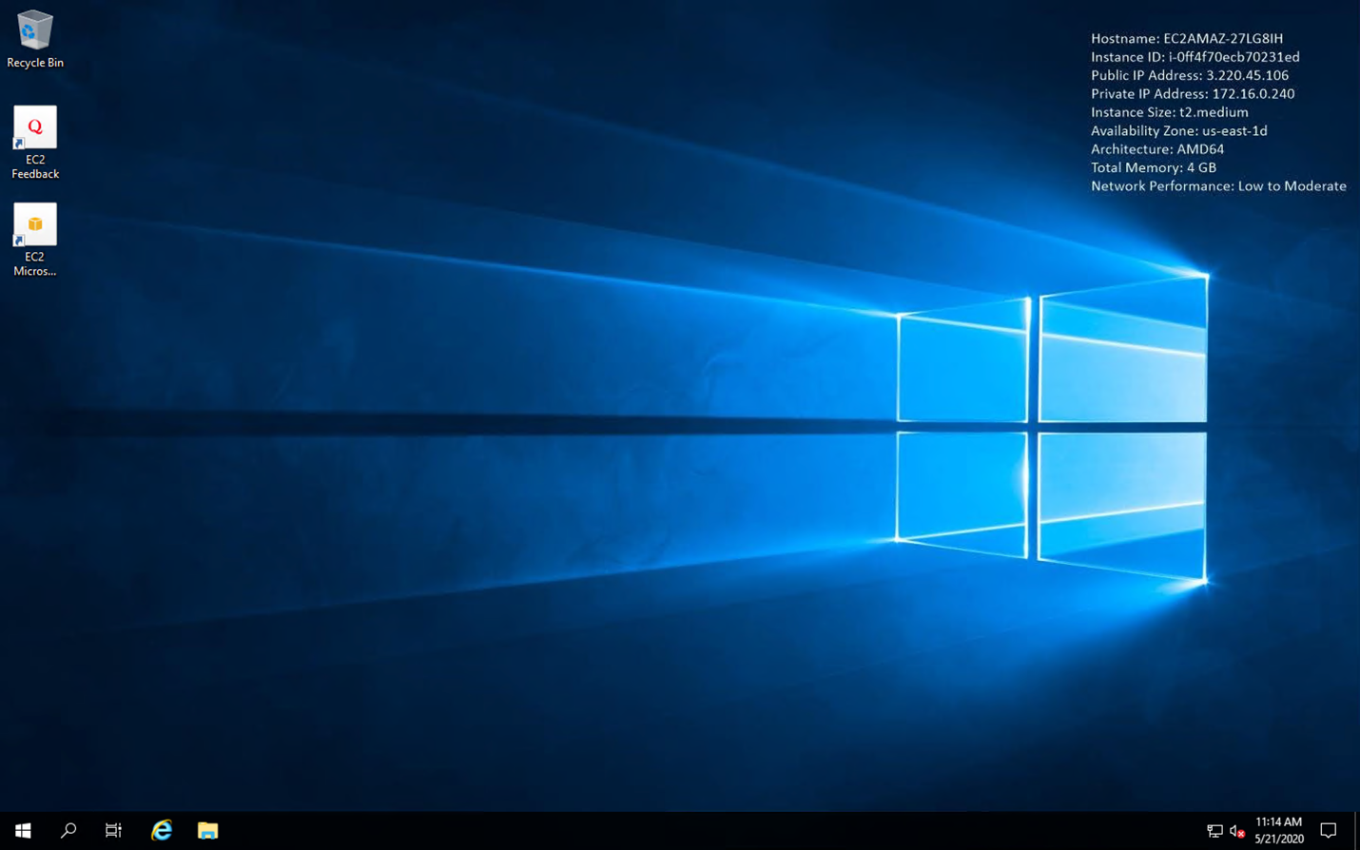

Section 2: Connecting to the Shared Drive

The first thing you will need to perform is mapping a network drive to letter D: for the 2TB shared drive for the DEVELOP project.

- Open File Explorer by double clicking the folder icon in the bottom left task bar of your desktop.

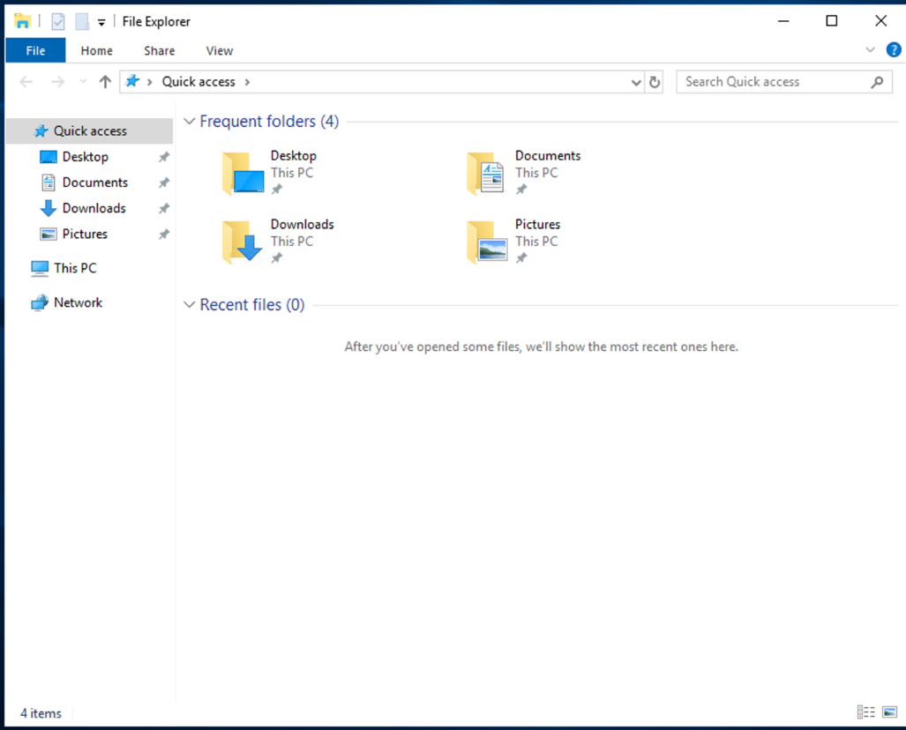

- Right click on the Network icon on the left-hand panel and select Map Network Drive from the pop-up selection screen.

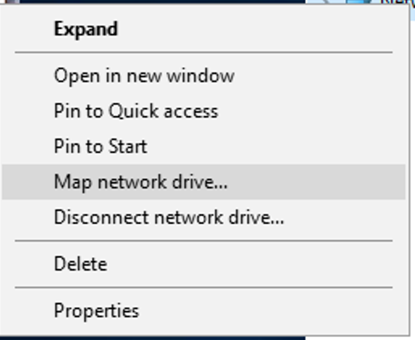

- Enter in the following for path: \\172.16.0.108\share
- Ensure the box is checked for Reconnect at login
- Select drive letter D: for the mapping. Click OK.
- Verify you see a C: and a D: drive mapping in File Explorer when you select This PC in the left side panel.
- This shared drive is your DEVELOP project space. With everyone mapping this drive to their EC2 instances, you can easily share files between systems and have applications access that shared data for processing. This shared is an AWS FSX shared space. AWS will perform periodic snapshots (backups) of this space.
- If your EC2 instance was terminated, any data on this shared drive will remain.

Section 3: Sharing files outside of your EC2 instance in Amazon’s WorkDocs.

You can install the AWS Amazon WorkDrive software to your EC2 instance to make available files stored in your Amazon WorkDocs to your EC2 instance.

- You can download the WorkDocs drive software for pc by launching Firefox on your EC2’s desktop, and entering the following URL: https://aws.amazon.com/workdocs/resources/?workdocs-whats-new.sort-by=item.additionalFields.postDateTime&workdocs-whats-new.sort-order=desc
- Select Download for PC and save the file when the pop-up appears.
- Launch the file to install WorkDocs. Select Yes.
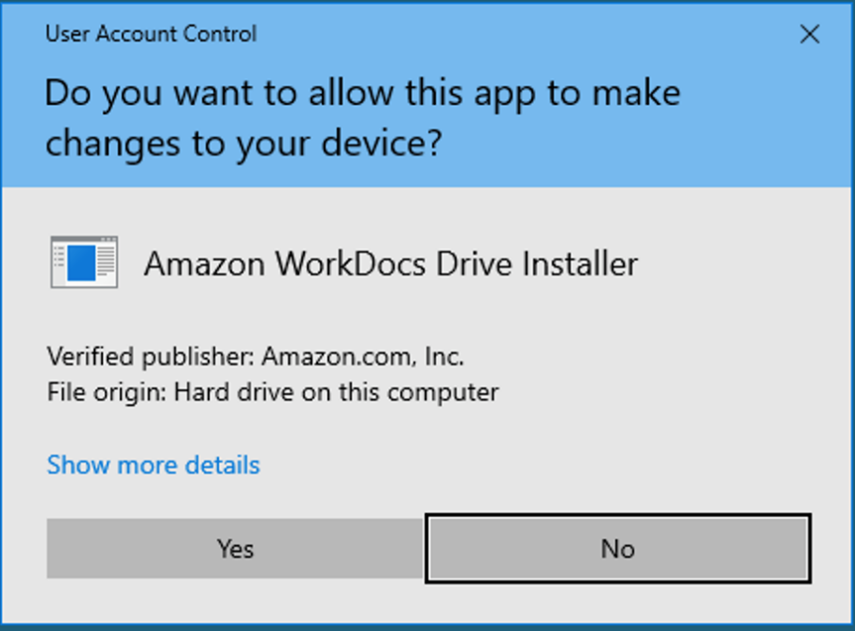

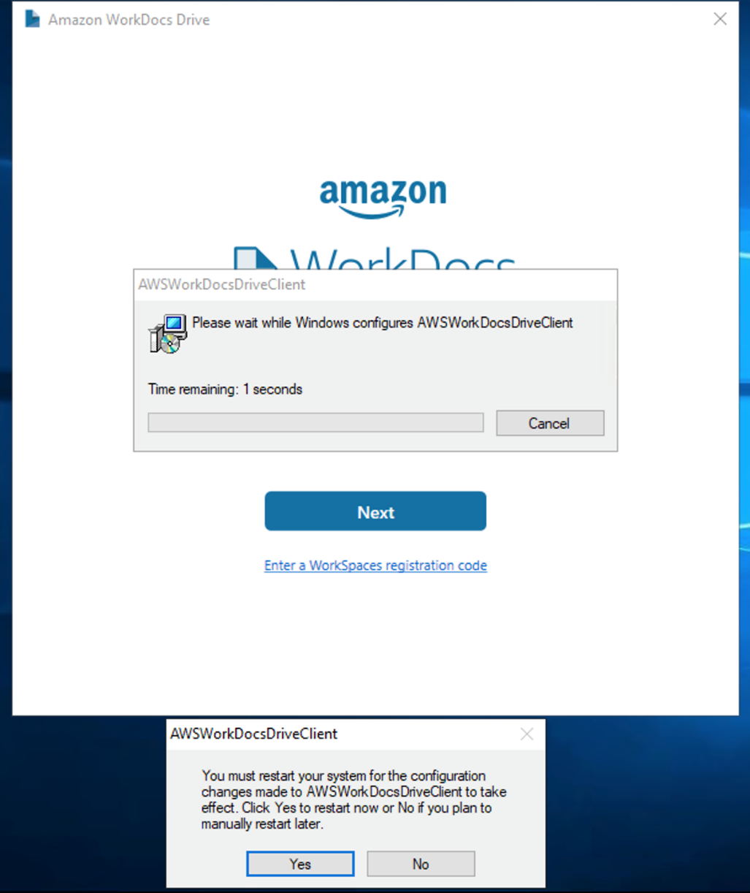

- Click NO, you will restart after completing the installation configuration.
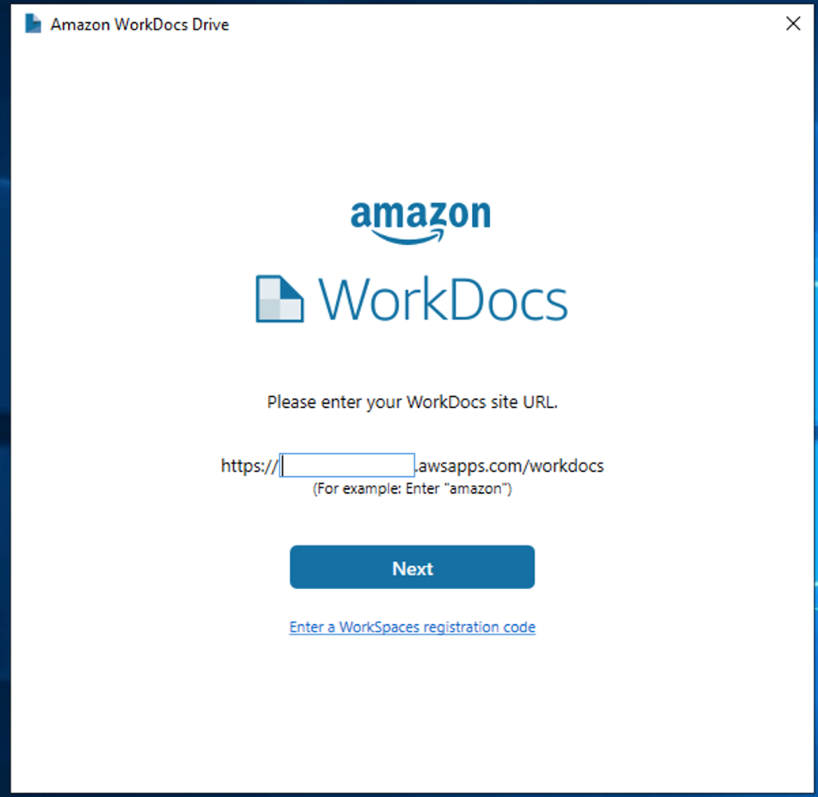

- Enter: d9067765911 for the URL entry above.
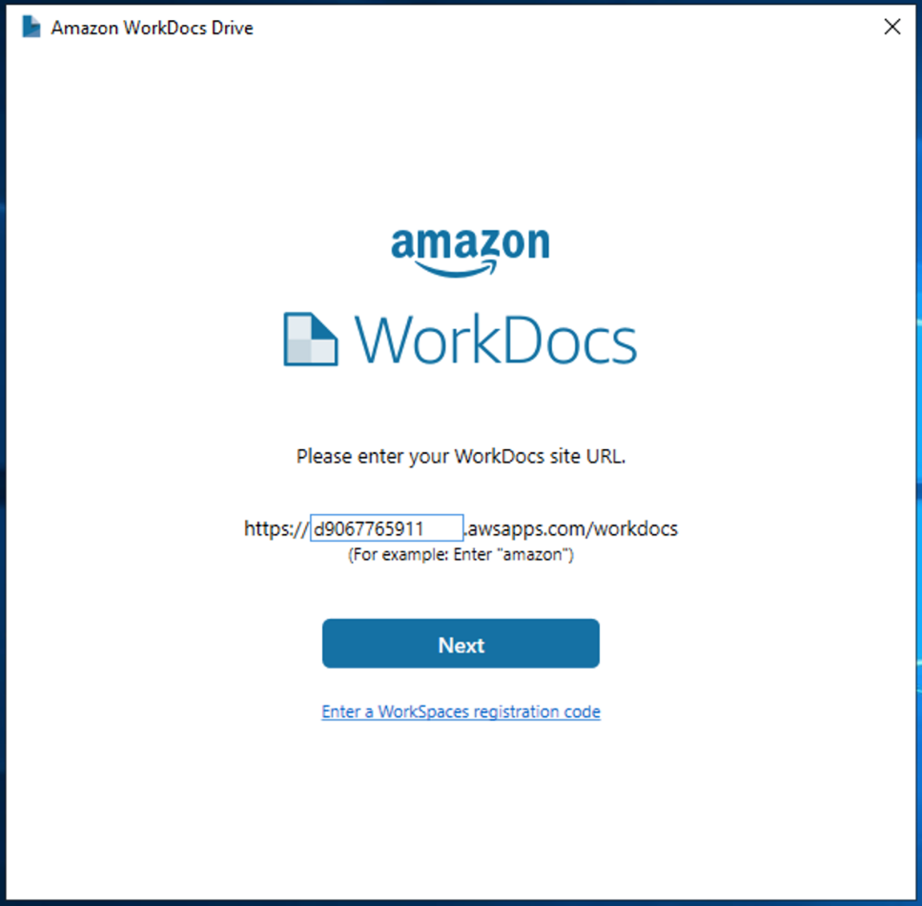

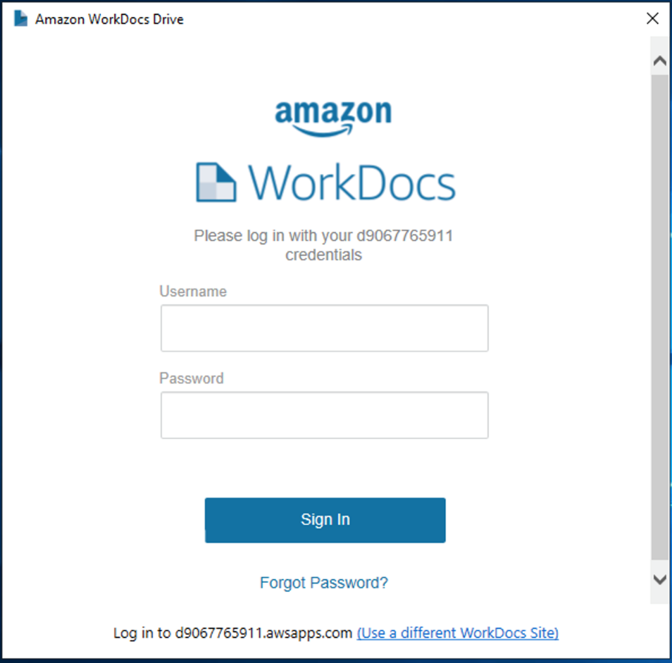

- WorkDocs uses your <first name>.<last name> part of your provided login information and the same password you used to login to the EC2 instance.

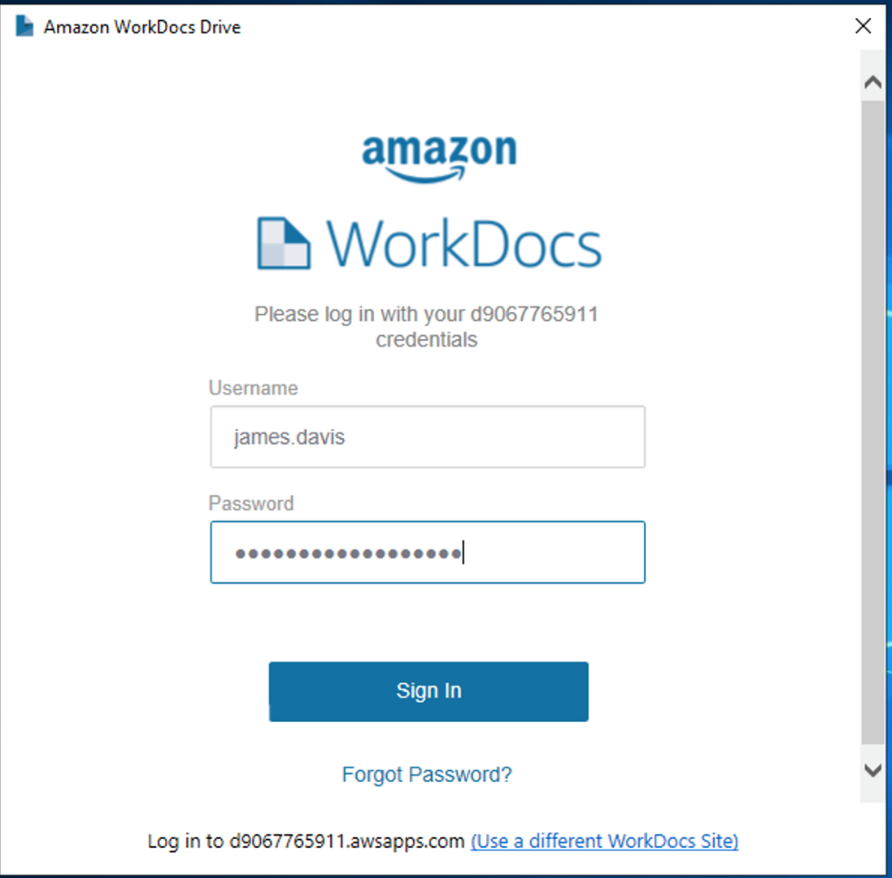

- Restart your EC2 instance to finish the installation of WorkDocs Drive.
- After your EC2 restarts and you are able to login, open up File Explorer and click on the This PC icon in the left panel. You should see a C: , D: and your amazon WorkDocs drives like the picture below:

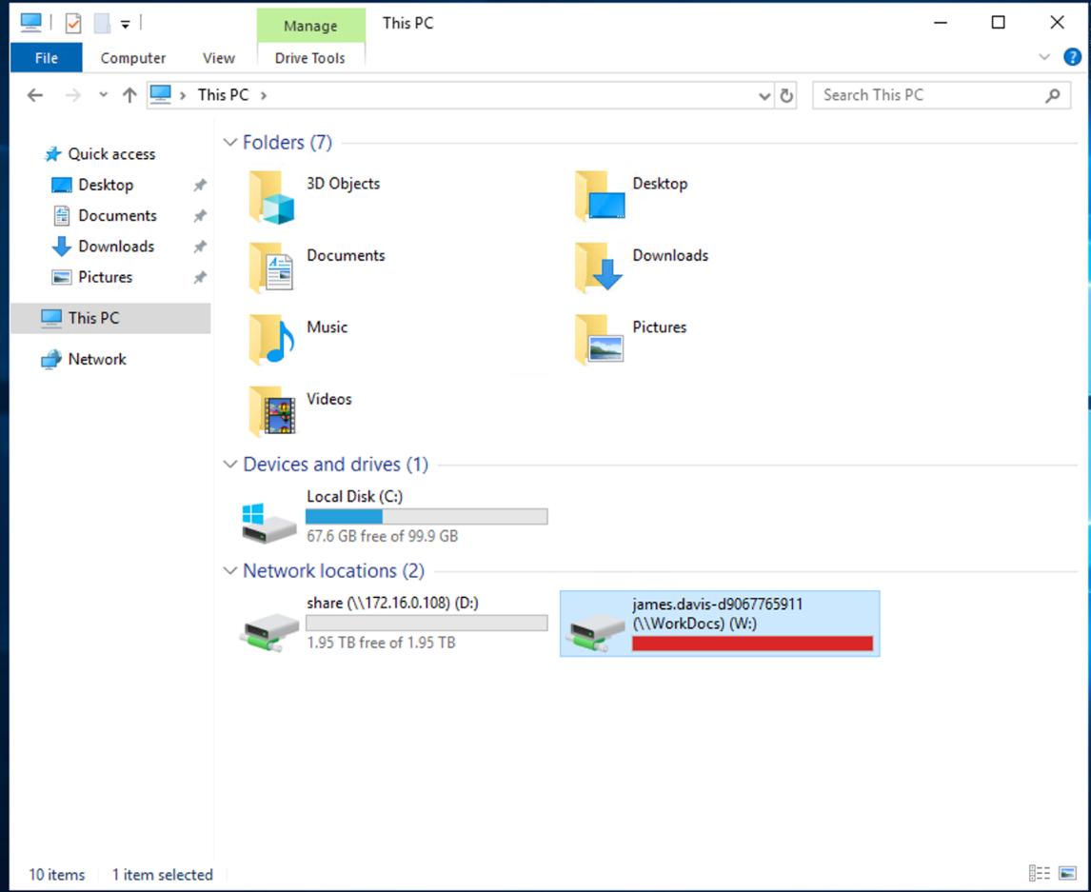

Section 4: Configuring ArcPro

- The first time you launch ArcGIS Pro, you will need to configure the licenses. Click on the Licensing option in the left panel.
- Then select Concurrent Licenses and enter in the following information for the License host: 172.16.0.240.
- After a few minutes, a list of license extensions will appear with available licenses having a blank white checkbox beside them. There should be 3 available license extensions (ie, 3D Analyst, Geostatistical Analyst, Spatial Analyst). Check each box before clicking OK/Submit to make your selections permanent.

