**NASA DEVELOP National Program**



University of Georgia

*Summer 2016*

Southeast US Ecological Forecasting III

Utilizing NASA Earth Observations and Proximal Remote Sensing for Mapping the Spatio-Temporal Distribution of *Hydrilla verticillata*

 **Technical Report**

Final Draft – August 10, 2016

Shuvankar Ghosh (Project Co-Lead)

Austin Haney (Project Co-Lead)

Frank Braun

Zachary Conner

Christopher Cooper

Abhishek Kumar

Dr. Deepak Mishra, University of Georgia (Science Advisor)

Dr. Susan Wilde, University of Georgia (Science Advisor)

Previous Contributors:

Pradeep Kumar Ragu Chanthar

Wuyang Cai

Elizabeth Dyer

Peter Hawman

Brandon Hays

Benjamin Page

Linli Zhu

# 1. Abstract

*Hydrilla verticillata* is an invasive aquatic plant which has rapidly spread through many inland water-bodies across the Southeastern United States (SEUS) mainly through inadvertent transfer. Once in a water body, this invasive species generally out-competes native aquatic plants and becomes established as the most dominant vegetative species. Consumption of water for drinking, power generation, and recreational use of lakes has been threatened by the spread of hydrilla. In recent years it was discovered that hydrilla serves as a host for an epiphytic, toxic cyanobacteria (*Aetokthonos hydrillicola*) in some water bodies. *Aetokthonos hydrillicola* is now known to be the causative agent of the neurodegenerative disease avian vacuolar myelinopathy (AVM), which affects waterfowl, raptors, and amphibians. Using Landsat 8 Operational Land Imager (OLI) imagery, a rapid assessment model was developed to accurately map the extent of hydrilla on Lake Thurmond and Long Branch reservoir in Henry County, Georgia. This model will also predict future locations in need of hydrilla management, providing a time-series phenology when applied to multiple imageries.

**Keywords**

Landsat 8 OLI, invasive aquatic plants, habitat modeling

# 2. Introduction

* 1. ***Background Information***

Hydrilla (*Hydrilla verticillata*) is an aquatic invasive plant introduced to the United States in the 1960’s. It first appeared in Florida, and has since become established or found in 30 states (Blackburn et al., 1969). The current US distribution can be found in Figure 1(USDA Plants Database, 2015). It was originally brought to the US as an aquarium plant, but it was accidentally introduced and became established. This aquatic invasive weed reproduces vegetatively and is generally spread by boat transfer between water bodies. Hydrilla will often outcompete native species by simply growing faster, and by forming a thick surface canopy that blocks out light for vegetation beneath. *Hydrilla verticillata* increases stratification and can create noxious conditions depending on water temperature, light, depth, and other dependent factors (Langeland, 1996).

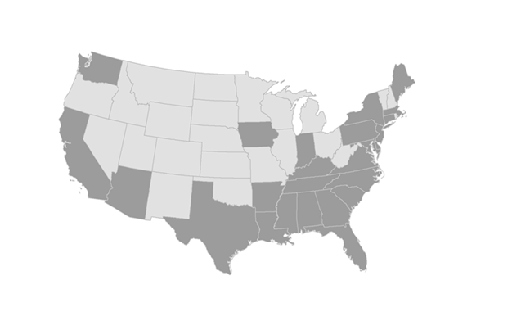

Source: USDA Natural Resource Conservation Service Plants Database

No Hydrilla

Hydrilla present

Figure 1. Hydrilladistribution across the United States.

In 1995, researchers began studying an unknown disease that was killing predatory birds and waterfowl (Lewis-Weis et al., 2004). This research eventually identified *Hydrilla verticillata* as one of the host plants for a cyanobacterium that was the causative agent of avian vacuolar myelinopathy (AVM) (Wilde et al., 2005). The cyanobacterium was later described as *Aetokthonos hydrillicola* (Wilde et al., 2014). Both field sites for our study have been known to contain hydrilla which has screened positive for AVM. Due to this fact, both sites demand higher priority in terms of the containment and management of hydrilla.

Addressing and understanding the magnitude of the spread of hydrilla is currently a major problem. Several different methods have been applied in an attempt to track and monitor this aquatic invasive. Satellite remote sensing has been used to measure the extent of floating and submerged aquatic vegetation in some waterways using IKONOS and hyperspectral imaging (Jakubauskas et al., 2002). The US Army Corps of Engineers (USACE), in partnership with researchers at the University of Georgia, have tried to track and monitor hydrilla by measuring shore scans using sonar in combination with systematic rake sampling. Both of these methods are somewhat accurate, but both are extremely expensive, laborious, and cannot display the full extent of the hydrilla problem at their respective sites.

NASA’s Landsat 8 Operational Land Imager (OLI) platform was launched on February 11, 2013. It is a 9-band push broom multispectral sensor with a 30 m spatial resolution and temporal resolution of 16 days. Spatially and temporally, it is an ideal candidate for targeting the smaller lakes along the borders of Georgia. However, the OLI sensor does not detect the wavelengths hydrilla most strongly reflects: around 710 nm and 765 nm (Blanco, 2013). In spite of these potential shortcomings, it is possible to leverage the capabilities of Landsat 8 OLI to address environmental problems it was not designed to solve. Using Landsat 8 OLI alongside *in situ* proximal remote sensing data, we intend to provide an accurate, efficient, and cost-effective model to map hydrilla present above and below the lake surface at the full extent of the study site.

**Study Area**

Lake J. Strom Thurmond and Long Branch Reservoir were chosen to be representative samples in our study (Fig. 2). Lake J. Strom Thurmond is a large reservoir (288 km2) created by the USACE in 1951 on the border between Georgia and South Carolina. USACE struggles to produce rapid accurate estimates of hydrilla density to determine which mitigation techniques provide the most cost-effective control throughout their reservoir. Long Branch Reservoir (1 km2) is located just south of Atlanta in Locust Grove, GA. The reservoir is managed by the Henry County Water Authority and is used primarily as a source for drinking water.

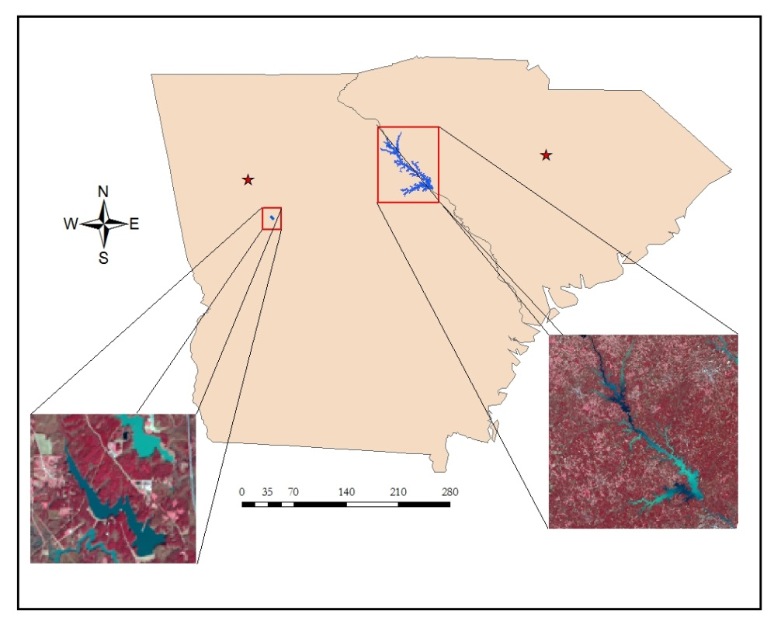

Georgia

South Carolina

Atlanta

Columbia

Long Branch Reservoir

Lake J. Strom Thurmond

Km

NASA DEVELOP Southeast Ecological Forecasting III

July 2016

WGS 1984 UTM Zone 17N

Data provided by USGS, Esri, Henry County Water Authority, and U.S. Army Corps of Engineers

Figure 2. Map of study area locations.

The study took place from June to August, 2016. Landsat 8 OLI imagery taken from June 2015 to July 2016 was used.

* 1. ***Project Partners & Objectives***

**Project Partners**

Lake J. Strom Thurmond is managed by the USACE. Long Branch Reservoir is managed by the Henry County Water Authority. The two management agencies are interested in being able to more effectively estimate hydrilla coverage in their reservoirs. More accurate estimations will allow them to cut costs of time-intensive manual surveying.  Finally, this will aid in assessing the effectiveness of management and control efforts.

**Project Objectives**

The objective of this project was to develop a model using NASA satellite remote sensing imagery and *in situ* data in order to accurately map the current distribution of hydrilla and also forecast potential areas of growth, when applied to imagery. These products can be used to assess current infestations and to facilitate adaptive management by measuring the efficacy of control efforts.

**National Application Areas**

This project falls under two areas in NASA’s National Application Areas: Ecological Forecasting and Water Resources. The main focus is to use Landsat 8 OLI imagery and *in situ* data to create a model capable of mapping submerged hydrilla distribution. The presence of hydrilla impacts nutrient and oxygen levels in lakes and reservoirs and is the host of neurotoxin-producing cyanobacteria. This project addresses water quality issues, and its results will aid our partners in focusing mitigation efforts to control current populations and further expansion.

# 

# 3. Methodology

***3.1 Data Acquisition***

Landsat 8 OLI scenes containing the study area were downloaded from the USGS Glovis online application (Table 1). Level 1 GeoTIFF products, meeting a cloud cover threshold of 20% and from June 2015 to July 2016, were included in the study.

|  |  |  |
| --- | --- | --- |
| **Lake** | **Path** | **Row** |
| Lake J. Strom Thurmond | 17,18 | 36,37 |
| Long Branch Reservoir | 18 | 37 |

Table 1. Study locations in WRS-2.

The *in situ* data for Lake J. Strom Thurmond were collected on June 21, 2016. Landsat 8 OLI passed over the study area on that same date, collecting data shortly beforedata were collected. Atmospheric and lake conditions can be assumed to be the same for both proximal and remote sensing data, since the two datasets were collected within a timespan of four hours. Fifteen different locations were included in the Lake J. Strom Thurmond *in situ* dataset, and coordinates were acquired for each location using a Garmin eTrex® 20x handheld GPS.

*In situ* proximal sensing data were collected using the SVC HR-1024i spectroradiometer. The machine collects radiance (L𝜆) measurements for all wavelengths from 350 nm to 2500 nm. The spectroradiometer was calibrated by taking a reference scan of the calibration panel, then by measuring irradiance (E𝜆) by taking a sky scan. At each site, three target L𝜆 measurements were taken.

We took various water quality measurements, in order to have abundant data with which we could tune our model. Water quality variables other than Secchi disk depth (SDD) and sonar sounding were collected using a YSI water quality sensor. The YSI measured dissolved oxygen (DO), pH, temperature (T), conductivity (C), and total dissolved solids (TDS). A LI-COR LI-192 sensor was used to measure downwelling photosynthetically active radiation (PAR) at depth intervals of 0.5 meters.

Data collection at Long Branch Reservoir took place on June 23, 2016. This was as temporally close to a Landsat 8 OLI passover as could be planned. We initially planned to take the same *in situ* measurements (L𝜆, SDD, DO, T, C, TDS, sonar) that we had collected on Lake J. Strom Thurmond, only we hoped to take the data from more locations.

We arrived at the study area and were informed that a chemical treatment had recently been applied to the reservoir, in order to combat a problematic algal bloom. We collected data at seven different locations, known to have previously been dense with hydrilla, but found that there was none present. We then determined that data collected from Long Branch Reservoir would not be included in the development of our prediction model.

***3.2 Data Processing***

***3.2.1 Atmospheric Correction of Landsat 8 OLI Imagery***

Raw Landsat 8 OLI imagery was corrected for any atmospheric interference by considering Rayleigh, Fresnel, and aerosol reflectance contributions over inland waters. Following the logic outlined in Dash/Mishra 2012, modified for the OLI sensor, an algorithm systematically converts the 16-bit top of atmosphere brightness values (BV) into Remote sensing reflectance (Rrs) (unit: sr-1) and outputs land-masked, water-only pixels.

***3.2.2 Converting in situ Radiance to Rrs***

The *in situ* target radiance data collected by the spectroradiometer were downloaded in ASCII format. The data were brought into a spreadsheet where algorithms can easily be run. The radiance data were converted to Rrs using Mobley, 1999:

Rrs = ( ( L𝜆 - ( 0.02 * E𝜆 ) ) / ( 𝜋 * Reference L𝜆 * .99 ) ) (1)

After conversion, a macro file was used to scale wavelengths at a 1 nm interval.

***3.3 Data Analysis***

***3.3.1 Spectral Data Analysis & Model Calibration***

The average of three target Rrs measurements at each *in situ* location was calculated and these were plotted against wavelengths from 400 nm to 900 nm. We used ERDAS Imagine’s layer stack tool to produce a multispectral image using Landsat 8 OLI bands 1-7. The output image was imported to NASA’s SeaDAS where Rrs values were extracted from pixels containing the fifteen *in situ* data locations. In order to validate the accuracy of atmospheric correction, Landsat 8 OLI Rrs values from band 1(440 nm) through band 5 (865 nm) were compared to *in situ* Rrs values at equal wavelengths (Fig. 4).

We calibrated the SDD model using methodology explained by Fuller et al. (2004) by incorporating Landsat 8 OLI bands 2, 3, and 4. The model for Kd (PAR) was calibrated using estimated SDD also using Landsat 8 OLI bands 2, 3, and 4.

We calibrated Kd (PAR) by plotting *in situ* LI-COR data against SDD. We calibrated maximum depth of hydrilla colonization (Zc) by plotting recorded hydrilla depth at each site against SDD. Percentage light through water column at Zc (PLW) was calculated according to Kemp et al. (2004):

PLW = 100 * exp(-Kd(PAR) *Zc) (2)

In order to determine the threshold limit of PLW at which hydrilla can grow, we compared model outputs with previous hydrilla distribution maps provided by the USACE and from peer reviewed articles on submerged aquatic vegetation.

***3.3.2 Maxent Historical Analysis & Model Validation***

In order to provide a basis of comparison for our model results, it was necessary to produce historical hydrilla distribution maps. The USACE provided one such map of Lake J. Strom Thurmond which was created in October 2015 using time consuming field observation data. We decided that to provide a more temporally broad comparison, Maxent (Phillips & Dudik, 2008) could be used to produce an estimated distribution map. Maxent is an executable java program that produces a species distribution map, color coded by probability that a species would be present. The program uses maximum entropy density estimation over a set of sites that the user specifies.

Maxent requires the user to input both data collection locations (latitude/longitude values in comma delimited .csv format) and environmental variables (in ASCII raster format). Hydrilla distribution had been estimated using this program in previous research. According to Peterson et al. (2003), the variables necessary to estimate hydrilla distribution are: elevation, slope, aspect, flow accumulation, flow direction, topographic index, mean-annual diurnal temperature (T) range, mean-annual precipitation, mean-annual solar radiation, mean-annual maximum T, mean-annual minimum T, mean-annual T, mean-annual water vapor pressure, mean-annual number of frost days, and mean-annual number of wet days. Each of these data were downloaded or derived for use in Maxent.

The first six variables were derived from a digital elevation model (provided by USGS Hydro dataset) using various tools featured in ESRI’s ArcMap 10.2. The next seven variables were downloaded from WorldClim and represented data from 1970-2000. Since the downloaded rasters represented world coverage at 30 arc second resolution, the datasets were trimmed to the study area, resampled to match the cell size of the previous six datasets, and re-projected to match the original coordinate system (WGS 1984 UTM Zone 17N). This process was data intensive and was therefore completed using ArcMap’s model builder and running the model on all datasets. The final two variables were not available for download, so rasters were created from historical weather observations from Lincolnton, GA (which is the closest locale to our study area). The final two rasters were assigned a uniform value in each cell, given the small size of our study area.

Once all inputs were converted to ASCII format, Maxent was run (Fig. 3) on the data to produce a probability of hydrilla distribution map from 1970-2000 (Fig. 10c).

# 4. Results & Discussion

***4.1 Atmospheric Correction***

Any research involving the remote sensing of aquatic variables must involve rigorous atmospheric correction techniques. It was necessary to test the accuracy of the correction algorithm that was applied to all involved imageries. Accuracy was tested by comparing Rrs values (of Landsat 8 OLI bands 1-5) from each pixel containing an *in situ* data collection point with the corresponding *in situ* Rrs values (Fig. 4). Linear regressions were run on each Rrs comparison to produce r2 values quantifying the accuracy of atmospheric correction.

***4.2 Model Calibration***

*In situ* Secchi disk depths from each site were correlated with Landsat 8 OLI Rrs values following logic from Fuller et al. 2004. The correlation produced the following model for SDD estimation using the bands 2-4 (RGB). The SDD model produces a SDD map with r2 = 0.612.

Ln(SDD) = (-95.534 * Band 2) + (171.4069 * Band 3) - (212.118 * Band 4) + 0.841359 (3)

The model for Kd(PAR) estimation was developed by correlating *in situ* LI-COR data (Fig. 5) with *in situ* SDD values from all 15 sites. The following model for estimating Kd(PAR) produces a light attenuation coefficient map with r2=0.6862.

Kd(PAR) = 1.592 * (SDD)-0.975 (4)

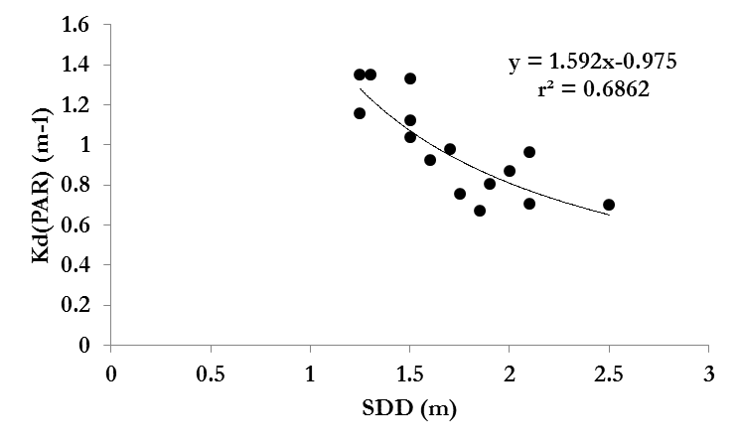

**y = 1.592 * x-0.975**

**r2 = 0.6862**

**SDD (m)**

**Kd(PAR) (m-1)**

Figure 6. Relationship of light attenuation coefficient and Secchi disk depth.

The model for Zc estimation was developed by correlating the maximum depth at which hydrilla was collected and *in situ* SDD. The following model for Zc produces a maximum depth of colonization map with r2 = 0.6082.

Zc = 1.021 * (SDD) + 0.378 (5)

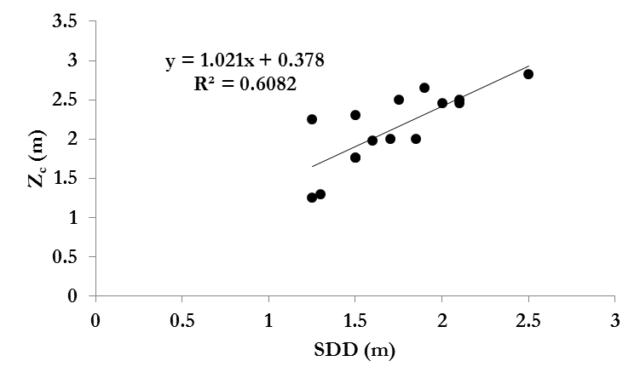

**y = 1.021x+0.378**

**r2 = 0.6082**

**SDD (m)**

**ZC (m)**

Figure 7. Relationship of maximum depth of colonization and Secchi disk depth.

With both Kd(PAR) and Zc values available, we were able to estimate PLW following logic of Kemp et al. 2004 (equation 2). After estimating these variables, we observed that the Landsat 8 OLI derived data shared the same trends as the field data used by Kemp et al. 2004 (Fig. 8). Application of this PLW model will produce a PLW map. This PLW map highlights areas of the water body that will have sufficient light for hydrilla growth. However, as PLW depends on both Kd(PAR) and Zc, it is difficult for the model to

distinguish the deeper part of the lake with clearer waters with high PLW values. Therefore, a mask was applied to nullify all areas beyond thirty feet of depth.

The maps produced, after considering the thirty foot maximum depth, highlight areas in which light conditions are sufficient for submerged hydrilla growth and represent the final product of our hydrilla prediction model. The model was executed on Landsat 8 OLI imageries over a nine month period producing a spatio-temporal distribution of hydrilla for the study area (Fig. 9).

Figure 9. Spatio-temporal variation in model parameters & corresponding hydrilla distribution maps.

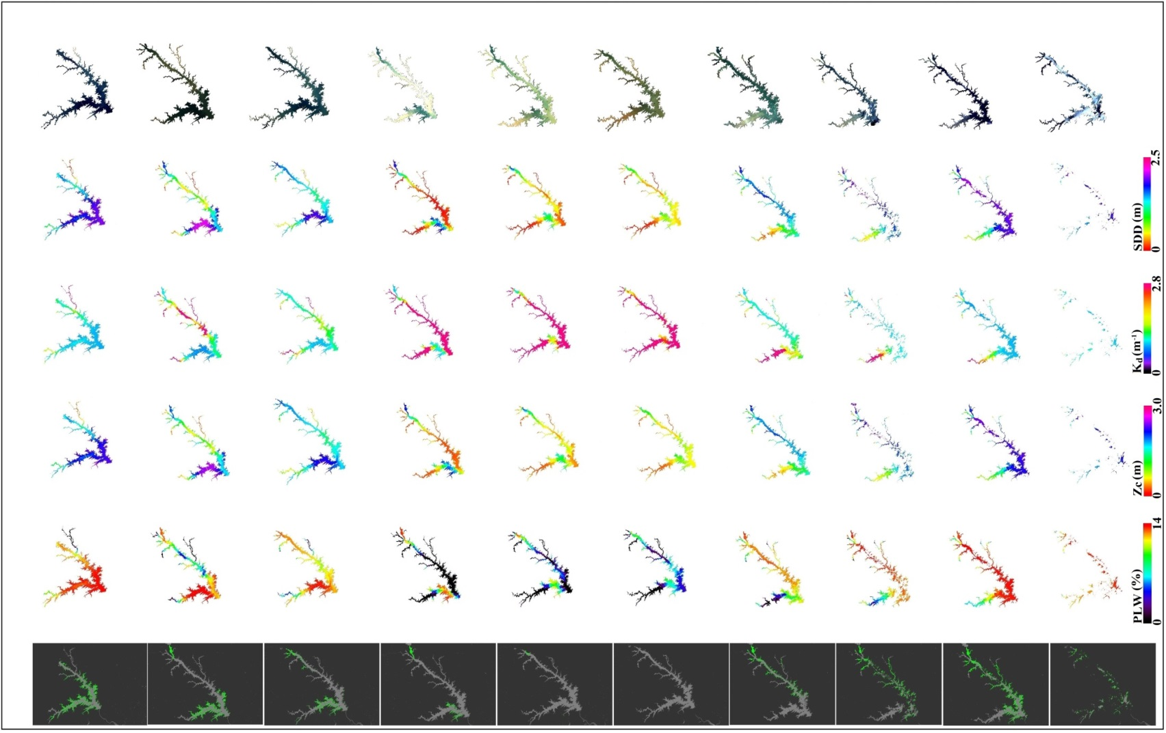

**18th October 2015**

**26th November 2015**

**12th December 2015**

**13th January 2016**

**29th January 2016**

**18th April**

**2016**

**2nd April**

**2016**

**17th March**

**2016**

**14th February**

**2016**

**21st June**

**2016**

True Color Images (RGB)

Secchi Disk Depth (SDD)

Light att. coefficient

(Kd)

Max. Depth Col.

(ZC)

% Light at ZC

(PLW)

Hydrilla Spatial Distribution

We were unable to perform field truthing of our model as another trip to the study area was not possible, so we decided that the best validation for our model results was to compare the October 18th Landsat 8 OLI output hydrilla map (produced by our model) with the hydrilla distribution map created by USACE for the same month and the Maxent probability map (Fig. 10). The USACE distribution map was created via field sampling, and is therefore assumed to be accurate.

Figure 10. Validation maps.

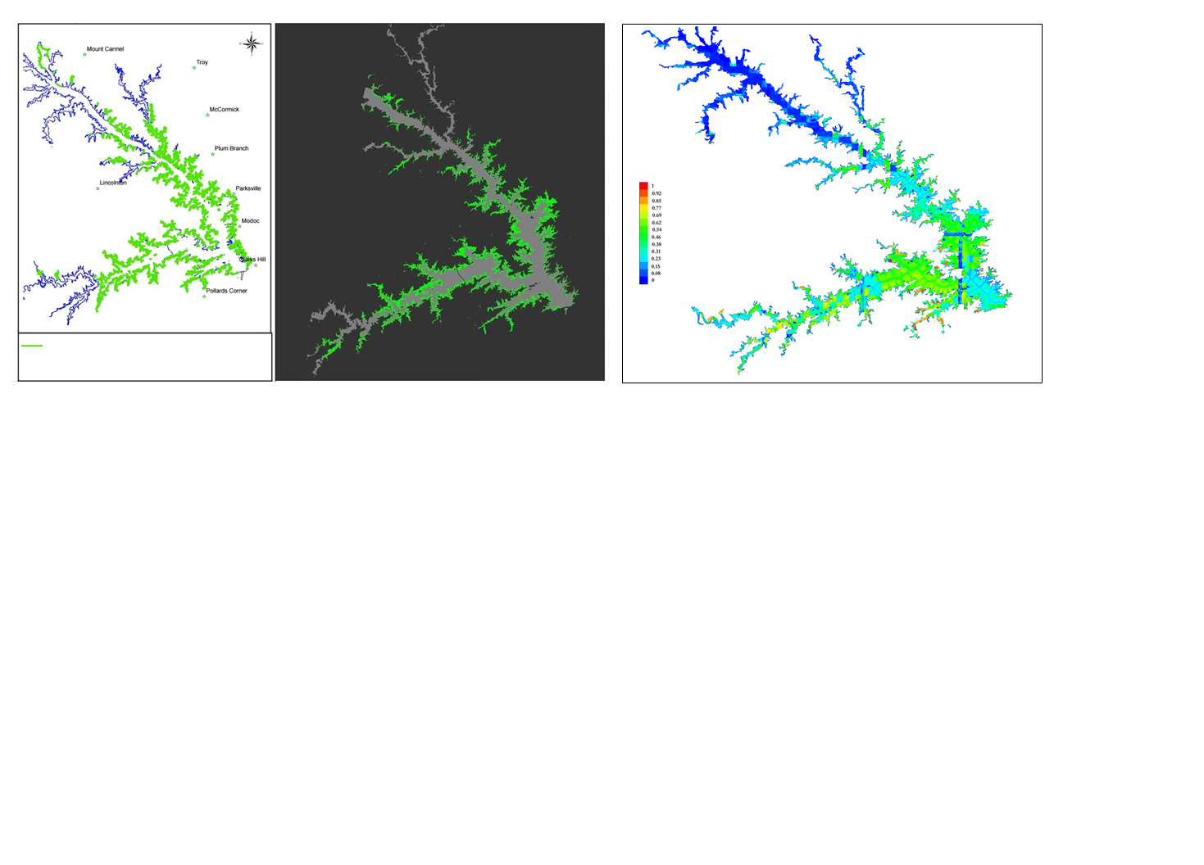

Hydrilla Distribution – Landsat 8 OLI Derived

Maxent historical probability map (1970-2000)

Hydrilla Distribution – October 2015

NASA DEVELOP

Southeast US Ecological Team III

18th October 2015

J. Strom Thurmond Lake

U.S. Army Corps of Engineers

Savannah District

**Hydrilla Distribution**

1in = 4 miles

**a**

c

b

***4.1 Analysis of Results***

The qualitative analysis of results corresponding to SDD and respective true color Landsat images suggested that areas with high turbidity (brownish in color in true color images) have low SDD and areas with clear water (dark blue in true color images) have high SDD values (Fig. 9). These results validated that our calibrated SDD model is working accurately. SDD was predicted lowest during the months of January and February, which were months of high precipitation and runoff (leading to high turbidity) during the timespan of the study (October 2015 – June 2016). The Little River branch (northeastern most branch of the lake) was found to be turbid during most of the months and showed lowest SDD range (Fig. 9).

The second parameter in our chain model, Kd, is a proxy for water transparency. Kd showed an inverse relationship with SDD and hence the turbid areas showed higher Kd values compared to clear waters where Kd values were found to be lower. This result, coupled with spatio-temporal Kd maps, further validated the calibration result between SDD and Kd again indicating an inverse relationship between the two parameters (Fig. 6 and 9).

Spatio-temporal Zc maps showed a similar pattern to SDD, validating the linear calibration result found between SDD and Zc (Fig. 7 and 9). SDD and Zc spatio-temporal maps were able to capture the dominant locations of hydrilla (pink colors in Fig. 6 representing waters with high SDD and Zc values), but were not able to capture the full extent of hydrilla distribution for the entire study area when compared against validation maps (Fig. 10).

PLW spatio-temporal maps (which take into account both Kd and Zc, derived from SDD values) were found to be more suitable to show the full extent of hydrilla distribution. The spatio-temporal PLW maps at Zc showed higher values for transparent regions and lower values for turbid parts of the lake. We considered a minimum light requirement threshold value of 13% PLW at Zc for survival of submerged aquatic vegetation (Kemp et al., 2004) to mask out hydrilla covered regions from the entire study area. However, in this process, deeper part of the lake also showed high PLW values because of high transparency. This caused the model to predict hydrilla in deeper waters than hydrilla can inhabit. Therefore, following expert advice, we applied a 30 foot depth mask after 13% threshold value of PLW at Zc in order to produce our final hydrilla distribution maps. The final maps display the spatio-temporal distribution of hydrilla and show a phenological pattern (Fig. 9).

From analysis of the final hydrilla distribution maps, we observed that hydrilla typically starts growing in the months of March-April in the northernmost waters of the lake, then spreads southward in following months (May-June). Hydrilla reaches peak distribution during October, begins retreating in the following months, and disappears completely in February. These results suggested that light is an important factor for hydrilla survival, as the lowest light levels were observed during the month of February due to high turbidity. The qualitative comparison between our Landsat 8 OLI derived hydrilla distribution map and the October 2015 hydrilla distribution map provided by USACE were very similar, excluding highly turbid regions such as the Little River branch where PLW model showed minimum hydrilla presence (Fig. 10a-b). This could be due to the fact that our model result is derived from one particular date in the month of October (October 18, 2015), while the hydrilla distribution map provided by USACE corresponds to the entire month of October. Furthermore, the averaged historical (1970-2000) hydrilla probability distribution map produced using Maxent also captured the hot spots of hydrilla locations with higher probability values (Fig. 10c).

***4.2 Future Work***

While the predictive model developed during this term can be used to accurately map and predict hydrilla distribution, it could be tuned further by adding more data. Nutrient and epiphyte biomass data for the study area could be used to derive the quantity of percent light at leaf (PLL) (Kemp et al., 2004) from values of PLW presented by this model. PLL would provide a more accurate estimation of hydrilla distribution, since the species demonstrates the ability to grow in low light conditions. Further improvements could be made by incorporating benthic substrate and soil type data. This data could identify areas of the lake where hydrilla could or could not root, due to the presence of rock.

# 5. Conclusions

The methodology developed during this term will be successful in accurately mapping hydrilla, characterizing its seasonal phenology, and therefore predicting potential areas of growth. Although the results were specific to only Lake J. Strom Thurmond, the methodology can be replicated to provide results for inland waterbodies throughout the SEUS. However, due to limited spectral bands, Landsat 8 OLI is unable to isolate hydrilla from other species of aquatic vegetation. Therefore, the models developed during this term will be most useful in bodies of water in which hydrilla is known to be the most prevalent species of aquatic vegetation. Management agencies can use these products not only to plan future removal efforts, but also to evaluate and adaptively change their current mitigation efforts.

Our model predicts ideal habitat for hydrilla in waters featuring high SDD, low values of Kd, and consequently both high Zc and PLW. Any project involving the remote sensing of submerged vegetation would ideally be conducted using cloud and haze free imagery, with no sunglint. Any atmospheric corrections to the imagery must be very accurate.

This project has demonstrated the capability of NASA’s Landsat 8 OLI to identify and map aquatic vegetation in southeastern inland water bodies at a high temporal resolution. Future work could utilize hyperspectral satellites to measure the wavelengths that hydrilla is most easily identified by, 710 and 765 nm. The use of a hyperspectral sensor could potentially differentiate hydrilla from other submerged vegetation, which would be useful in lakes where hydrilla is not the dominant aquatic vegetation species.

# 6. Acknowledgments

Science Advisors:

* Dr. Deepak Mishra, Associate Professor, Department of Geography, University of Georgia
* Dr. Susan Wilde, Assistant Professor, Warnell School of Forestry & Natural Resources, University of Georgia

Partners:

* Kenneth Boyd, Conservation Biologist, US Army Corps of Engineers
* Allen Dean, Chief Ranger, US Army Corps of Engineers
* Kenneth Presley, Assistant Reservoir Manager, Henry County Water Authority

Others:

* Southeast Ecological Forecasting II Team: Pradeep Kumar Ragu Chanthar, Brandon Hays, Benjamin Page, & Linli Zhu
* Southeast Ecological Forecasting I Team: Wuyang Cai, Elizabeth Dyer, Shuvankar Ghosh & Peter Hawman

Any opinions, findings, and conclusions or recommendations expressed in this material are those of the author(s) and do not necessarily reflect the views of the National Aeronautics and Space Administration.

This material is based upon work supported by NASA through contract NNL11AA00B and cooperative agreement NNX14AB60A.

# 7. References

Blackburn, R. D. et al. (1969). Identification and distribution of certain similar-appearing submersed aquatic weeds in Florida. *Hyacinth Control Journal,* 8(1), 17-21.

Blanco, Alfonso. (2013). Remote Sensing Techniques for Monitoring Aquatic Vegetation. PhD diss. George Mason University.

Dash, P., Walker, N., Mishra, D., D’Sa, E., & Ladner, S. (2012). Atmospheric Correction and Vicarious Calibration of Oceansat-1 Ocean Color Monitor (OCM) Data in Coastal Case 2 Waters. *Remote Sensing,* 4(6), 1716-1740.

Fuller, L. M., Aichele, S. S., & Minnerick, R. J. (2004). *Predicting water quality by relating Secchi-disk transparency and chlorophyll a measurements to satellite imagery for Michigan inland lakes, August 2002*. US Department of the Interior, US Geological Survey.

Hijmans, R.J., & Fick S. (2016). WorldClim Version 2. Available from www.worldclim.org

*Hydrilla* distribution. (2015). [*Hydrilla* distribution across the United States based on presence per state]. Source: USDA Natural Resources Conservation Service Plants Database.

Jakubauskas, Mark E., Legates, D., & Kastens, J. (2002). Crop identification using harmonic analysis of time-series AVHRR NDVI data. *Computers and electronics in agriculture,* 37(1), 127-139.

Kemp, W. M., Batleson, R., Bergstrom, P., Carter, V., Gallegos, C. L., Hunley, W., ... & Murray, L. (2004). Habitat requirements for submerged aquatic vegetation in Chesapeake Bay: Water quality, light regime, and physical-chemical factors. *Estuaries*, *27*(3), 363-377.

Langeland, K. A. (1996). Hydrilla verticillata (LF) Royle (Hydrocharitaceae), The Perfect Aquatic Weed. *Castanea*. 293-304.

Lewis-Weis, L. A., J. Fischer, & R. W. Gerhold. (2004). Attempts to reproduce vacuolar myelinopathy in domestic swine and chickens. *Journal of Wildlife Diseases,* 40, 476–484.

Mobley, C. D. (1999). Estimation of the remote-sensing reflectance from above-surface measurements. *Applied Optics*, *38*(36), 7442-7455.

Peterson, A. T., Papes, M., & Kluza, D. A. (2003). Predicting the potential invasive distributions of four alien plant species in North America. *Weed Science*, 51(6), 863-868.

Phillips, S. J., & Dudík, M. (2008). Modeling of species distributions with Maxent: new extensions and a comprehensive evaluation. *Ecography*, 31(2), 161-175.

Wilde, S., Johansen, J., Wilde, H., Jiang, P., Bartelme, B., & Haynie, R. (2014). *Aetokthonos hydrillicola gen. et sp. nov*.: Epiphytic cyanobacteria on invasive aquatic plants implicated in avian vacuolar myelinopathy. *Phytotaxa*, *181*(5), 243-260.

Wilde, S. B., T. M. Murphy, C. P. Hope, S. K. Habrun, J. Kempton, A. Birrenkott, F. Wiley, W. W. Bowerman, & A. J. Lewitus. (2005). Avian vacuolar myelinopathy (AVM) linked to exotic aquatic plants and a novel cyanobacterial species. *Environmental Toxicology,* 20, 348–353.

# 8. Content Innovation

Featured Author Videos- VPS

Glossary Viewer

In-line Supplementary Material (figures found in appendix)

# 9. Appendices

**In-line Supplementary Figures:**

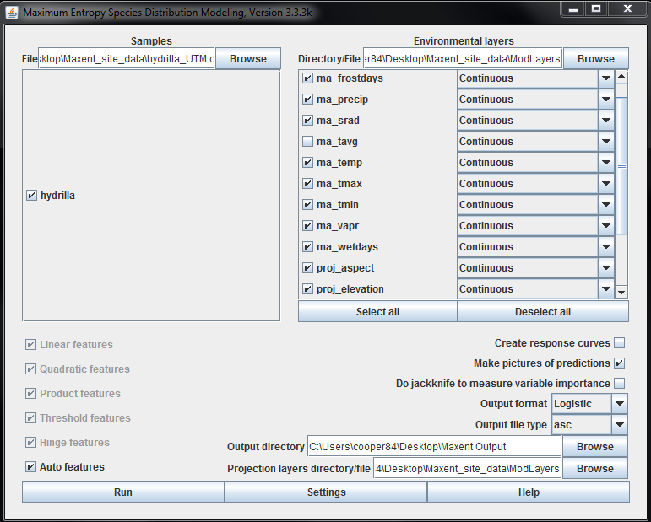

Figure 3. Maxent user interface with environmental layers.

Figure 4. Landsat 8 OLI Rrs compared with *in situ* Rrs and their corresponding r2 values at each data location.

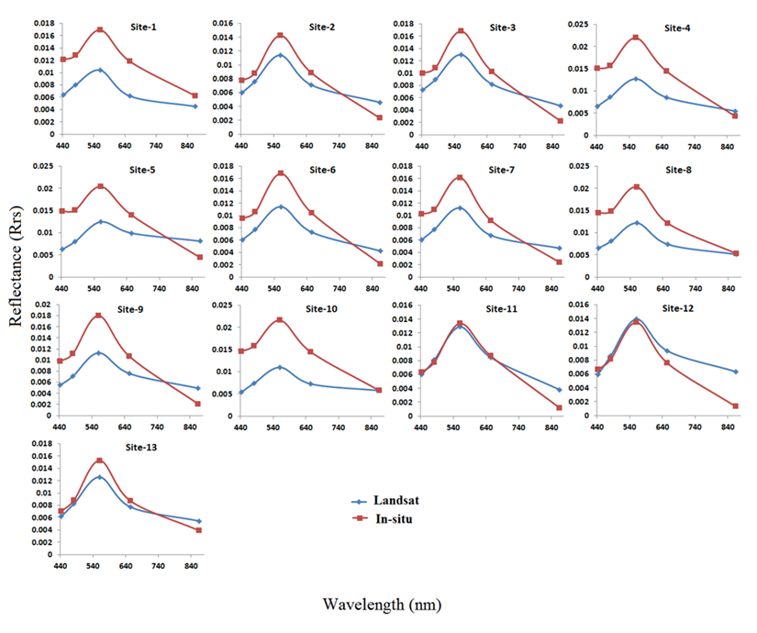

**r2= .887**

**r2= .9136**

**r2=. 9334**

**r2= .759**

**r2= .248**

**r2= .9191**

**r2= .8439**

**r2= .7996**

**r2= .816**

**r2= .6272**

**r2= .9564**

**r2= .758**

**r2= .965**

**Wavelength (nm)**

**Reflectance (Rrs)**

Figure 5. LI-COR data measurements at 0.5m depth intervals for each site.

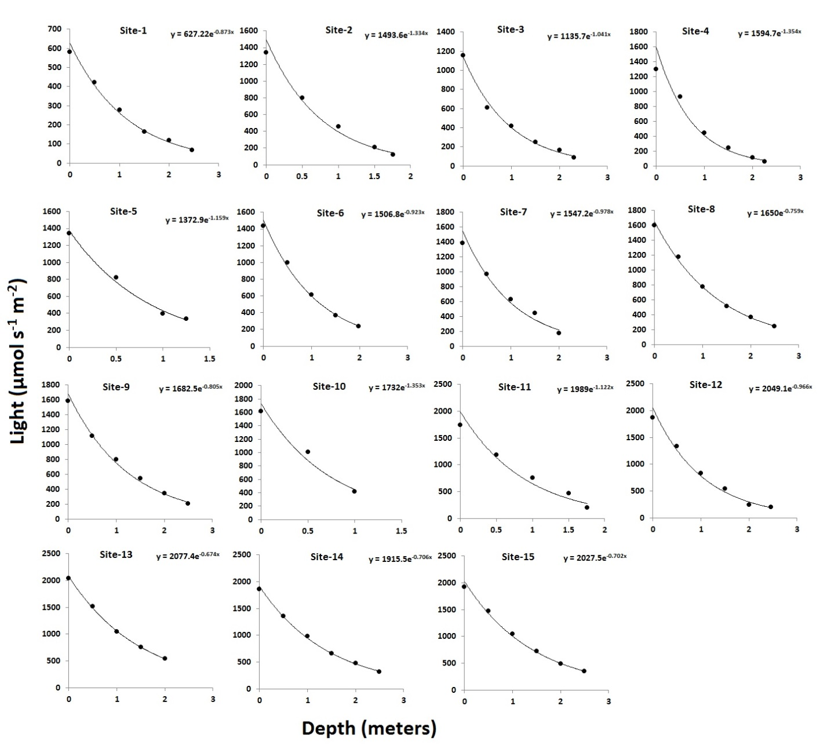

**Site-1 y = 627.22e-0.873x**

**Site-2 y = 1493.6e-1.334x**

**Site-3 y = 1135.7e-1.041x**

**Site-4 y = 1594.7e-1.354x**

**Site-5 y = 1372.9e-1.159x**

**Site-6 y = 1506.8e-0.923x**

**Site-7 y = 1547.2e-0.978x**

**Site-8 y = 1650e-0.759x**

**Site-9 y = 1682.5e-0.805x**

**Site-10 y = 1732e-1.353x**

**Site-11 y = 1989e-1.122x**

**Site-12 y = 2049.1e-0.966x**

**Site-13 y = 2077.4e-0.674x**

**Site-14 y = 1915.5e-0.706x**

**Site-15 y = 2027.5e-0.702x**

**Depth (meters)**

**Light (µmol s-1 m-2)**

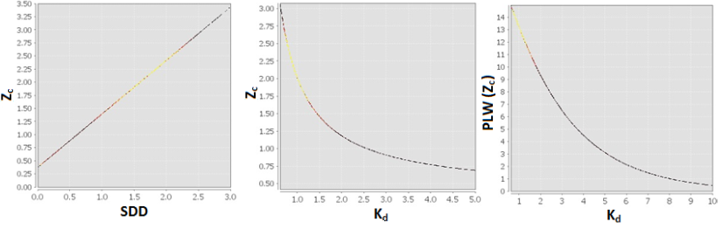

**SDD**

**Kd**

**Kd**

**Zc**

**Zc**

**PLW (Zc)**

Figure 8. Observed relationship of Landsat 8 OLI derived model variables.