

Risk Perception and Spatial Analysis of Environmental Factors Related to Tick-Borne Diseases in Alabama by Means of NASA Earth Observation Systems [Phase 3]

NASA Marshall Space Flight Center - DEVELOP National Program

at

The University of Alabama at Birmingham
Laboratory for Global Health Observation

Spring 2010 Team:

Nathan Renneboog, B.S., Student Director/Team Leader
Stephen Firsing III, M.P.A., M.A., Assistant Team Leader
Jonathan Adams, B.S.
Michael Behring, M.S.
Emily G. Capilouto
Joshua Harden
Sarah Hemmings, M.S.
Robyn Hyden, B.A.
Kathryn Jackson
Rusty Nall
Damien Willis, B.S.
Jeff Luvall, Ph.D., NASA Science Advisor
Risk Perception and Spatial Analysis of Environmental Factors Related to Lyme and Other Tick-Borne Diseases in Alabama by Means of NASA Earth Observation Systems [Phase 3]

2 April 2010

Team Members:

___________________________ ___________________________
Nathan Renneboog, Team Lead Stephen L. Firsing III, Assistant Team Lead

___________________________ ____________________________
Jonathan Adams, Team Member Michael Behring, Team Member

___________________________ ____________________________
Emily G. Capilouto, Team Member Joshua Harden, Team Member

___________________________ ____________________________
Sarah Hemmings, Team Member Robyn Hyden, Team Member

___________________________ ____________________________
Kathryn Jackson, Team Member Rusty Nall, Team Member

___________________________
Damien Willis, Team Member

Mentors:

___________________________
Jeffrey C. Luvall, Ph.D. NASA Marshall Space Flight Center
Senior Research Scientist 320 Sparkman Drive
Phone: (256) 961-7886 Mail Code VP61
Email: jluvall@nasa.gov Huntsville, AL 35805

___________________________
Lauren Childs NASA Langley Research Center
DEVELOP Science Projects Manager 4 Langley Boulevard
Phone: (757) 864-4204 Building 647, Room 301
Email: Lauren.m.childs@nasa.gov Hampton, Virginia 23681-2199

___________________________
Michael Ruiz NASA Langley Research Center
DEVELOP Program Manager 4 Langley Boulevard
Phone: (757) 864-3748 Building 647, Room 313
Email: Michael.L.Ruiz@nasa.gov Hampton, Virginia 23681-2199

1.0 Abstract
Lyme disease (LD) accounts for most vector-borne disease reports in the U.S. and although its existence in Alabama remains controversial, other tick-borne illnesses (TBI) such as Southern Tick-Associated Rash Illness (STARI) pose a health concern in the state. Phase One of the Marshall Space Flight Center-UAB DEVELOP study of TBI identified the presence of the chain of infection for LD and STARI in Alabama, yet popular knowledge of the risks of TBI and primary prevention strategies appeared to be low. Thus, Phase Two initiated a health communication campaign based on vector habitat mapping and a risk perception assessment survey for outdoor recreationalists, a high-risk group. This study, Phase Three of the project, builds on the prior phases by incorporating in situ tick population and soil moisture data into satellite imagery-based habitat maps to produce a model of spatial risk. NASA Advanced Spaceborne Thermal Emission and Reflection Radiometer (ASTER) satellite imagery provided remotely sensed measurements of vegetation vigor (Normalized Difference Vegetation Index) and soil moisture were combined with tick population and in situ soil moisture data, provided by Jacksonville State University, to create a predictive model. Analysis of this data portrayed a trend in which tick numbers increase with increasing soil moisture. Correlations could not be determined since tick counts were insufficient to conduct advanced statistical analyses.

2.0 Introduction
2.1 Project Background
Lyme disease (LD) accounts for most vector-borne disease reports in the U.S. (over 95%), and although its existence in Alabama remains controversial, other tick-borne illnesses (TBI) such as Southern Tick-Associated Rash Illness (STARI) pose a health concern in the state. Phase One of the Marshall Space Flight Center-UAB DEVELOP study of TBI identified the presence of the chain of infection for LD (Ixodes scapularis ticks carrying Borrelia burgdorferi bacteria) and STARI (Amblyomma americanum ticks and an as-yet-unconfirmed agent) in Alabama. Both LD and STARI are associated with the development of erythema migrans rashes around an infected tick bite, and while treatable with oral antibiotics, a review of educational resources available to state residents revealed low levels of prevention information. Anecdotal evidence from patients and physicians at stakeholder meetings and other professional gatherings indicated a high level of concern about the general low level of awareness regarding TBI risks and primary prevention strategies among Alabama residents.
To improve prevention, recognition, and treatment of TBI in Alabama, Phase Two initiated a health communication campaign utilizing vector habitat mapping and risk perception assessment for an at-risk group: outdoor recreation program participants at Alabama universities. Satellite data identified Oak Mountain State Park, Bankhead National Forest, and Talladega National Forest as likely tick habitats. To assess the at-risk group’s perceptions and behaviors, the DEVELOP team produced a survey instrument based on existing studies of TBI risk factors and theoretical constructs from the Social Ecological Model and Health Belief Model. The survey instrument was integrated with the habitat mapping by incorporating geographic variables into the assessment of TBI knowledge, attitudes, and prevention behaviors.
Phase Three of this project builds on the previous two phases by combining remotely sensed environmental data with risk perception assessments to inform an ongoing outreach campaign focusing on primary prevention messages. This phase formally broadens the scope of the project to include multiple tick-borne diseases and associated hosts, and not solely LD. This study also expands the vector habitat model to include in situ data, such as surveyed tick populations and soil moisture samples, which allow for spatial interpolation of risk. The in situ measurements were contributions of Jacksonville State University’s Department of Biology, a new partner in the project.

2.2 Epidemiology of tick-borne illness (TBI)
There are many tick-borne diseases affecting citizens in the United States. Ticks are vectors for a wide range of pathogenic viruses, bacteria, and protozoans which can manifest as LD, Rocky Mountain Spotted Fever, Southern Tick Associated Rash Illness, Babesiosis, Tularemia, Human monocytotrophic ehrlichiosis, Q Fever, and Powhassan encephalitis are only a few of the diseases carried by ticks. Of these diseases, Lyme disease is the most commonly reported vector-borne disease in the United States.

2.2.1 Lyme disease
The first case of Lyme disease reported in the state of Alabama was by Dr. Gary Mullen at Auburn University in 1986. A 42-year-old woman developed the characteristic skin lesion, erythema chronic migrans, after a tick bite in Choccolocco Wildlife Management Area, Cleburne County. The case was confirmed through serological testing by the Centers for Disease Control and Prevention (CDC), Atlanta, GA.
In Alabama, the primary vector of LD is Ixodes scapularis, or black legged tick, although a patient bitten by an A. americanum (Lone star tick) can also develop the characteristic red rash suggesting Lyme disease. Ixodes scapularis has a life span of two years and has three feeding stages: larva, nymph, and adult., The tick acquires B. burgdorferi during the larval stage when it gets its first blood meal. Borrelia burgdorferi is a bacterium of the spirochete class and is the causative agent of Lyme disease. It is found predominantly in North America but is also present in Europe and was named after Willy Burgdorfer who first isolated the bacterium in 1982. B. burgdorferi’s presence in Alabama is suggested by the presence of serum antibodies to the spirochete in deer and rodents. This spirochete has not been identified to proliferate in an environment outside of a vertebrate or invertebrate host. It is maintained in a natural cycle of infection by ticks and reservoir animals (enzootic transmission cycle); transovarial transmission is rarely observed.
Early localized infection of B. burgdorferi (Lyme disease) is identified by the appearance of erythema migrans, a characteristic red skin rash, which presents itself in 80% of patients on the site of the tick bite. Fever, fatigue and headache also indicate early-disseminated infection. Infection may also be characterized by meningeal irritation or cardiac involvement. If left untreated, approximately 60% of patients develop late, persistent infection that manifests as frank arthritis. Early treatment can lead to quick and complete recovery, thus avoiding any long-term health issues. Standard treatment for LD involves the administration of antibiotic regiments and pain relievers in order to treat the infection and provide symptomatic relief. A subgroup of treated LD patients continues to have subjective symptoms such as musculoskeletal pain, neurocognitive difficulties, or fatigue. Chronic LD or post-LD syndrome presents complications similar to those of chronic fatigue syndrome or fibromyalgia. Delayed treatment of LD may result in a longer convalescent period.
The first LD case in Alabama was reported in 1986 in a Lee County resident, who was bitten by a tick during a camping trip in Cleburne County. The CDC reported a total of 238 LD cases in the state of Alabama from the years 1986-2007 (see Chart 1 below). In 1988, the Alabama Department of Public Health (ADPH) requested that physicians and laboratories begin reporting LD cases to calculate the incidence and prevalence rates. Despite underreporting, diagnostic difficulties, and other social complication factors, LD cases are still prevalent in Alabama. Case patients are defined as Alabama residents reported to the ADPH and subsequently confirmed according to CDC case definition.

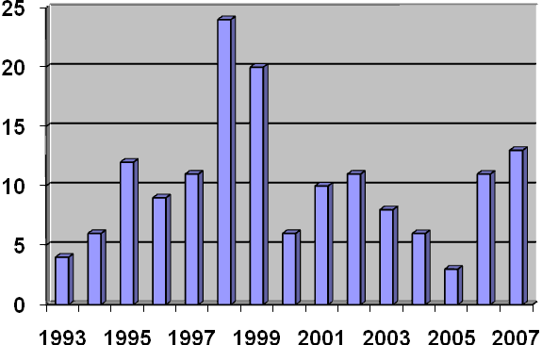
Y-axis: Number of LD
Cases Per Year
X-axis: years

Chart 1: Number of confirmed LD cases in Alabama from 1993-2007 reported by CDC.

2.2.2 Southern Tick-Associated Rash Illness (STARI)
Complicating the diagnosis of Lyme disease is an emerging illness called Southern Tick-Associated Rash Illness (STARI), or Master’s disease. The symptoms of STARI closely resemble those of Lyme disease. Dr. Edwin Masters first suggested that the rashes were not caused by Lyme disease spirochetes but by an unrecognized Lyme-like illness, which was initially termed Master’s disease. The cause of STARI was discovered by Barbour et al. in 1996 using molecular techniques. Their work revealed a newly discovered bacterium, Borrelia. lonestari, in Amblyomma americanum ticks. Since then, B. lonestari has been detected in A. americanum and hosts throughout the South,,,,,, and from at least one human. The spirochete, which resists culture in the Barbour-Stoenner-Kelly (BSK) medium suitable for B. burgdorferi, was finally cultured in a modified medium in 2004. One factor compounding the difficulty of study of this disease is the fact that only a small percentage of ticks has been shown to carry the spirochetes. Furthermore, B. lonestari infections may cause many of the same symptoms as B. burgdorferi infections, including: erythema migrans, fatigue, malaise, arthritis, and central nervous system problems. The STARI cases are predominantly located in the southern U.S. in areas that are not traditionally known to have high incidences of Borrellia infections.

2.2.3 Other tick-borne diseases
Ehrlichiosis is the general name used to describe several bacterial diseases that affect animals and humans. These diseases are caused by organisms in the genus Ehrlichia. In the United States, there are currently two ehrlichial species that are known to cause disease in humans: Ehrlichia chaffeensis and Ehrlichia ewingii. Ehrlichia chaffeensis causes human ehrlichiosis, also described as human monocytic ehrlichiosis (HME). Many individuals infected with ehrlichiosis are also infected with Lyme disease or babesiosis. Most people infected with ehrlichiosis experience fever, persistent headache, chills, muscle aches, and fatigue. Some might also experience abdominal pain, nausea, vomiting, diarrhea, cough, and joint aches.
Rocky Mountain spotted fever (RMSF) is the most severe tick-borne rickettsial illness in the United States. This disease is caused by infection with the bacterial organism Rickettsia rickettsii. Most people experience fever, nausea, vomiting, severe headache, muscle pain, or lack of appetite during the early stages of the disease. In the later stages, infected people experience a spotted rash, abdominal pain, joint pain, and diarrhea.
Tularemia, also known as “rabbit fever,” is a disease caused by the bacterium Francisella tularensis. The signs and symptoms people develop depend on how they are exposed to tularemia. Possible symptoms include skin ulcers, swollen and painful lymph glands, inflamed eyes, sore throat, mouth sores, diarrhea or pneumonia. If the bacteria are inhaled, symptoms can include abrupt onset of fever, chills, headache, muscle aches, joint pain, dry cough, and progressive weakness. People with pneumonia can develop chest pain, difficulty breathing, bloody sputum, and respiratory failure.
Babesiosis is an intraerythrocytic parasitic infection caused by protozoa of the genus Babesia and transmitted through the bite of the Ixodes scapularis tick. Many people who are infected with Babesia microti feel fine and do not have any symptoms. Some people develop nonspecific flu-like symptoms, such as fever, chills, sweats, headache, body aches, loss of appetite, nausea, or fatigue. Because Babesia parasites infect and destroy red blood cells, babesiosis can cause a special type of anemia called hemolytic anemia. This type of anemia can lead to jaundice and dark urine.
2.3 Tick ecology
Ticks (Acari: Ixodida) are blood-feeding ectoparasites second only to mosquitoes in importance as vectors of human diseases. Their importance as vectors of animal diseases is also widely recognized. Worldwide, ticks parasitize wild and domestic vertebrates, except fishes. The I. scapularis tick is recognized as the principal vector of spirochetes to humans in the Northeastern region of the U.S. Spirochetes have also been identified in Amblyomma americanum ticks in Alabama. As ticks are indiscriminate in their choice of host and will feed on humans, ticks can transmit pathogens from wildlife to humans.
The chain of infection is a model used to understand the infection process, that is, how a pathogen is transmitted by a vector to a host, causing a disease. In examining the LD chain of infection, the presence of the pathogen (bacterium: B. burgdorferi), vectors (ticks: I. scapularis), and hosts (deer, mice, mammals, birds and humans) must be identified. For Lyme disease to occur, these components must be in close proximity, while each component is influenced by other biotic and abiotic factors. For example, Ixodes scapularis is dependent on the biotic environment of its vector and hosts, the vectors are highly influenced by local temperature and humidity, and reservoir hosts may be attracted by environments that provide food and shelter.
Characterization of tick-borne disease foci may be done in three levels: microscale, mesoscale, and macroscale levels. The microscale level considers factors that determine individual tick survival, such as litter layer, where the larvae undergo diapause. The mesoscale level includes factors that determine the interaction between the parasites, hosts and vectors. This includes wooded areas where humans are at risk of infection. The macroscale level examines factors such as climate, vegetation, and land cover.
Ticks are vulnerable to desiccation, requiring temperatures between -10 to 35 ̊C and a constant humidity no lower than 80%. Climatic factors that reduce relative humidity (i.e. low precipitation) may decrease tick abundance. Areas with dense vegetation cover and/or decaying vegetation help maintain relative humidity above 80% at the base of vegetation, which supports tick populations. Ticks are mostly found in areas that support these microclimate and host requirements, which includes deciduous woodlands, particularly those with oak and beech trees that harbor significant numbers of large animals such as deer. However, ticks may also survive in coniferous forests as long as there is sufficient ground litter and moist climate.
Ecological factors such as vegetation, soil, topography and climate directly impact ticks’ survival. One study found that deciduous, dry/mesic and dry forests, fertile soils such as alfisols, and sandy and loamy/sand soil texture were positively associated with tick presence. Studies also suggest that soil type and texture influence the type of overlying vegetation and the extent of drainage, respectively. Soil texture influences soil moisture regardless of precipitation. Dry and/or mesic forests have vegetation such as oaks and jack pines that prefer well-drained, sandy soils. These trees provide a canopy layer for the underlying vegetation.
Spatial analysis in this study relies heavily on a review of the literature related to environmental and climatological characteristics associated with tick habitats. First, studies show that ticks survive in temperatures ranging from -10 to 35ºC.,, Secondly, with regard to vegetated cover, the preferred tick habitats are forest cover.,,,, Finally, ticks prefer moist soil.,,, The remote sensing analysis thus focuses on identifying areas with these environmental factors.
2.3.1 Blacklegged tick (Ixodes scapularis)
The primary vector of LD in the United States is Ixodes scapularis (blacklegged tick). This tick has a life span of two years and has three feeding stages: larvae, nymph, and adult., It acquires B. burgdorferi during the larval stage when it gets its first blood meal. The bacteria reside in the gut of the tick and are transmitted to the host during nymphal feeding. Nymphs usually parasitize small mammals including cotton mice. The proportion of nymphs infected with B. burgdorferi is substantially higher than adults of the same cohort. Because of their smaller size, nymphs are less likely to be detected on hosts, including humans, increasing the probability of transmission of B. burgdorferi resulting in LD. Most human cases of LD are seen during the spring and summer months when both tick activity and human outdoor activity is greatest. The preferred host for adult ticks is the white-tailed deer, which plays a major role in the transportation of ticks and tick population sustainability, although adult ticks do not infect the deer with B. burgdorferi.

2.3.2 Lone Star tick (Amblyomma americanum)
A. americanum is a very aggressive species of hard tick. Lone Star ticks are easy to identify because of the white dot appearing on the backs of adult females as well as their rounded shape. The mouthparts of A. americanum are also very large compared to many other ticks. The ticks are much more active in their questing behavior than most other species in the U.S. and are aggressive biters of humans. A. americanum is the dominant hard tick species throughout much of the southern U.S. The geographic range of A. americanum stretches from central Texas northward to Missouri and eastward in a broad swath across the southern United States continuing northward in a thin band up the coast to Maine. Lone Star ticks have a three-year life cycle. Eggs hatch into six-legged larvae in late summer. The larvae seek a host and feed. Once fed, the larvae drop from the host and morph into nymphs. Nymphs typically feed on a second host in the spring and early summer. Once fed, the nymphs fall from the host and become dormant for a period (usually winter). During this dormancy period, the ticks mature to the adult stage. Adult ticks feed on a third host during spring, summer, and fall. Once feeding is complete, the adults mate. Males die shortly after mating, and females die soon after laying eggs in forest floor duff in the late fall to early spring. A. americanum are relatively easy to collect using drag sampling. They have been shown to harbor Lyme spirochetes but have not proven to be capable of transmission of B. burgdorferi. All life stages of A. americanum are capable of transmitting spirochetes. Disease detection in unfed larvae provides evidence that the spirochetes can be transovarially transmitted. PCR has been used to isolate B. lonestari DNA from Lone Star ticks removed from humans with symptoms of STARI. Spirochetes from the B. burgdorferi group have also been detected in A. americanum although the capability of the Lone Star tick to transmit the spirochetes is not yet known., , A. americanum spends most of its time on the surface of plants or leaf litter, not buried in the leaf litter, although it quests in leaf litter. The adult Lone Star ticks climb to a height of 3-36” on a plant and wait for a host to brush against the plant. Overall, A. americanum is less susceptible to adverse habitat conditions, and is able to occupy diverse habitats. The hardiness of A. americanum along with its aggressive nature are likely to be reasons for its high survivability compared to other species. It is now known as a vector for the emerging B. lonestari and many other pathogens, including Ehrlichia chaffeensis, the agent of human monocytic ehrlichiosis (HME), E. ewingii and Anaplasma phagocytophila, both agents of human granulocytic ehrlichiosis (HGE), Francisella tularensis, the agent of tularemia, Coxiella burnetii, the agent of Q fever, Rickettsia rickettsii, the agent of Rocky Mountain spotted fever, and other species of Rickettsia. , , , ,

2.3.3 Other ticks
American dog tick females are about 1/4 inch (6.35mm) long and are chestnut brown with a silvery-gray or creamy-white scutum. Male ticks are slightly smaller, and are chestnut brown with similar light-colored vertical markings on the dorsal surface. Larvae feed on small mammals, and nymphs feed on small-to medium-sized mammals. Adults, sometimes called wood ticks, occasionally attack humans but are more common on dogs and other medium-sized animals. Dermacentor variabilis is a known vector of Rickettsia rickettsii, a bacterium that causes Rocky Mountain spotted fever in humans.

2.4 TBI prevention and control
2.4.1 Survey of existing campaigns
In Northeast and West Coast states where LD is highly endemic, public health communication campaigns are common. Educational materials include flyers, brochures, public service announcements, educational videos, and model homes demonstrating methods to tick-proof property. These materials are distributed at both the institutional and individual levels by state and local public health departments, mass-media outlets, teachers and doctors, and community organizations. Moreover, evaluation of such campaigns has found positive results in modifying behavior and knowledge, although follow-up campaigns, or “cues to action,” were found to be vital to maintaining preventive behaviors.
In the Southeast, examples of targeted public health interventions are less accessible. Although this project conducted a comprehensive search for health literature on Lyme and other tick-borne diseases in the Southeast, such materials were limited. However, many state departments of public health in the Southeast do provide information about the prevention of Lyme disease through their websites; examples include North Carolina, South Carolina, Georgia, Florida, Louisiana, Mississippi, Arkansas, and Texas. However, websites for the Alabama and Tennessee State Departments of Public Health do not acknowledge tick-borne diseases nor provide intervention suggestions or educational materials aside from basic reporting statistics for confirmed cases of LD.

2.4.2 Population at-risk
Transmission of B. burgdorferi to humans or domestic animals can occur if a) there is sufficient opportunity for exposure to infected ticks and b) removal of the infected tick does not occur within 36 hours after attachment.,, Exposure depends on demographic patterns, recreational, and occupational activities. Outdoor work has been found to be positively associated with LD risk. Outdoor recreation such as fishing, golfing, camping and hunting were also found to increase risk. Individuals living in forested areas have also been found to be more likely than those living in non-forested areas to have LD. Finally, younger individuals (0-16 years of age) have been found to have the highest prevalence rate of LD, and practice fewer preventive behaviors than older individuals.
Individuals exposed to likely tick habitats are most at risk for Lyme and other tick-borne diseases. These individuals, our targets for intervention, include:
- Outdoors enthusiasts – people who conduct recreational activities outdoors in tick infested areas, i.e. campers, hikers, rock climbers, off road bikers, hunters, fishermen.
- Outdoor workers – especially those who frequent high risk locations, including: fish and wildlife personnel, forest rangers, landscapers, utility and construction workers, military personnel conducting field training, farmers, large animal veterinarians making house calls, etc.
- Rural/peripheral settlement dwellers – people whose homes border woodlands or other likely tick habitats.
- Pet owners and veterinarians – particularly those exposed to animals that live or venture into tick infested areas.
- Other – anyone else who ventures into tick-infested areas during the spring, summer, and fall months.

2.4.3 Strategies for prevention of tick-borne diseases
No single, perfect prevention program has been developed for tick-borne diseases. Possible strategies include reduction of host numbers, tick habitat modification, chemical control, biological control, pharmacologic control, and personal protection. Given the scope of this project, a community outreach program— targeted at those most at-risk for tick-borne diseases— that highlights personal protection methods appears to be most adequate and feasible. Examples of personal protection methods include avoidance of areas where there are ticks, wearing of protective clothing, use of tick repellent, and removal of ticks within 24 hours. Previous literature explains that, “since the likelihood of human infection is a function of the duration of exposure, an increase in any or all of these preventive behaviors reduces the likelihood of infection.”

2.4.4 Community outreach in Alabama
When structuring an educational campaign to promote public health, theory-based programming is highly documented to be effective at provoking measurable changes in behavior. Studies in Massachusetts and Maryland show that carefully targeted, theoretically driven educational campaigns about tick-borne illnesses can lead to positive, measurable changes in attitudes, behaviors, and prevention behaviors among target populations.
As suggested by the aforementioned studies in Massachusetts and Maryland, constructs from the Health Belief Model (HBM) may prove supportive when developing a campaign or intervention on Lyme and other tick-borne diseases and include the following:
- Perceived susceptibility – the belief that one is susceptible to the condition, i.e. it is possible to contract tick-borne diseases in Alabama;
- Perceived severity – the belief that the condition has serious consequences, i.e. the associated short- and long-term heath effects of tick diseases can be severe;
- Perceived benefits – the belief that taking action would reduce susceptibility to the condition or the severity of the disease, i.e. prevention methods are effective in reducing the risk of contracting tick-borne diseases;
- Perceived barriers – the belief that the cost of taking action is too high, i.e., it is not worth the time/expense to perform tick checks, use repellent, etc;
- Cue to action – exposure to factors that prompt action, i.e., a sign or public service announcement reminding the individual to perform prevention behaviors, avoid tick infected areas, etc.; and,
- Self efficacy – confidence in one’s ability to successfully perform a specific action, i.e., confidence in one’s ability to properly and safely remove a tick, use repellent, recognize and remove ticks, recognize symptoms of Lyme disease, perform tick checks, and/or seek a qualified health professional as required.,
The ecological model may also prove helpful when constructing a campaign against tick-borne diseases in Alabama and proposes that multiple levels of influence affect an individual’s decision making. This model explains that health promotion and health communication involve more than simply educating people about healthy behaviors. It emphasizes that efforts to change organizational behavior, as well as physical and social environments, are necessary to address health problems. The ecological perspective highlights that health behavior both affects, and is affected by, multiple levels of influence, and that individual health behavior both shapes, and is shaped by, the social environment (reciprocal causation). These multiple levels of influence have been identified as the following:
- Intrapersonal level – individual characteristics such as knowledge, attitudes, beliefs, and personality traits that may positively or negatively influence behavior;
- Interpersonal level – social processes and primary groups, including friends, family, and peers that may positively or negatively influence behavior;
- Institutional/Organizational level – institutional/organizational rules, regulations, policies, and other informal norms, that may positively or negatively influence behavior;
- Community factors – social/community networks, standards, or norms which exist among people, groups, or organizations that may positively or negatively influence behavior;
- Public policy – local, state, and federal policies and laws that may negatively or positively support or regulate public health and behavior.
3. Methodology
3.1.1 Tick data collection
A total of 12 sites in the Shoal Creek District of the Talladega National Forest, AL were selected for tick population sampling from June 2008 until September 2008 as well as April and May 2009. Sites were selected based on prescribed burn history. The sites were located in an area that is managed under a prescribed burning regime to restore Pinus palustris forests (and manage Picoides borealis populations). Sites 1, 2, 3 were unburned for at least fifteen years prior to the start of sampling. Sites 5, 7, and 8 were burned within one year of the study. Sites 4, 6, and 9 were burned two years prior to the study. Sites 10, 11, and 12 were burned five years prior to the study.
Hardwood species were the dominant species of the tree and sapling strata at Sites 1 and 2. Pine species dominated trees at Site 3. Hardwoods dominated the sapling strata at Site 3. Pine species were dominant trees at Site 4. Mixed hardwoods and pines dominated Site 6. Site 9 was dominated by pine species. No saplings were found at Site 9. The tree strata at Site 5 were dominated by pine species. Site 7 canopy trees were mixed pine and hardwoods. Saplings at Site 7 were predominately hardwoods. Pines dominated the tree strata at Site 8. Mixed hardwoods dominated the trees at Site 10, and saplings were dominated by hardwoods. Site 11 trees were dominated by pine species, and hardwoods dominated saplings. Site 12 trees and saplings were dominated by hardwoods.

3.1.2 Vegetation analysis
The vegetation at each site was measured to include the tree, sapling, seedling, and herb strata. The methodology used was a modified Carolina Vegetation Survey using 20 meter x 40 meter plots divided into 10 meter x 10 meter subplots. The diameter of the trees and saplings was measured at breast-height (1.4m) using a diameter tape and recorded throughout each plot. Trees were classified as being greater than 11.4 centimeters in diameter at a 1.4m height. Saplings were classified as being less than 11.4 centimeters in diameter at breast height. A tree was considered to be a seedling if its total height was less than 1.4m. Cover calls for seedlings, shrubs, vines, grasses, ferns, and herbs were conducted in each of the 10 meter x 10 meter subplots at each site.

3.1.3 Forest canopy cover density
Density of forest canopy cover was calculated at each site during the study. A concave spherical densiometer was used for all measurements. The instrument used had 24 equally sized squares; 4 equally spaced dots were assumed within each square., The densiometer was held parallel to the ground in the center of each 10 meter x 10 meter subplot at each site. All measurements were taken following the procedures given by Lemmon., The number of densiometer cells not showing the reflection of forest canopy cover were counted and recorded. This value was multiplied by a conversion factor (1.04) and subtracted from 100 to determine percent cover of the forest canopy at each site.,

3.1.4 Soil moisture measurement
Soil moisture was measured monthly at each site (at the time of tick collection). A soil moisture probe (Soil moisture Equipment Corporation model 2900F1 “Quick Draw”) was used for all measurements. The probe was inserted 20-40 centimeters deep (variation due to rocks and other materials at some sites) and left for the duration of the twenty-minute tick sampling at the site. The moisture value (% available moisture) was then recorded and the probe removed from the soil.

3.1.5 Tick collection
Ticks were collected using a modified drag cloth method. The drag cloths used in the study were 1 meter x 1 meter squares of white flannel material attached to a 5/8” x 40” wooden dowel, forming a “flag” structure. The cloth was dragged through vegetation and across the forest floor at each site for 20 minutes once monthly for consistency. Every effort was made to ensure that the sites were dragged thoroughly and completely on each outing. The cloths were inspected approximately each 5-10 meters during the sampling. Any ticks found on the cloths were immediately removed using steel forceps and preserved for future laboratory processing in 1.5-milliliter centrifuge tubes containing 70% ethanol or isopropanol. Tubes were labeled with the site number and date of collection.

3.1.6 Tick processing/ DNA extraction
Preserved ticks were taken to the laboratory for analysis and screening for the presence of Borrelia lonestari deoxyribonucleic acid (DNA). Ticks were identified by species, sex, and life stage (adult or nymph; larvae were not collected). Ticks were cut along the sagittal and transverse planes with a sterilized razor blade to yield 4 sections. The sections were then mechanically ground using sterile plastic tissue homogenizers in 500 microliters of phosphate buffered saline (PBS) in 1.5-milliliter centrifuge tubes to release gut contents. The supernatant was then removed via pipettor (filtered tips were used for all procedures to prevent pipettor contamination) and placed in a clean DNAase, RNAase- free 1.5 milliliter centrifuge tube. This step was then repeated using an additional 500 microliters of PBS. The homogenate was then centrifuged at 12,000 x g for ten minutes. DNA extractions were performed using a QIAamp DNA mini kit (Qiagen, Valencia, CA). The supernatant was then discarded and the pellet was re-suspended in 180 microliters of Buffer ATL and 20 microliters of Proteinase K (Qiagen, Valencia, CA). Samples were incubated in a water bath at 56 degrees Celsius overnight. After incubation, samples were pulse-centrifuged to pellet any undissolved tick parts. The remaining supernatant was then removed via pipettor and placed into a clean 1.5 milliliter centrifuge tube. Further extraction procedures followed the manufacturer’s protocol starting at step 4 (Qiagen, Valencia, CA). The only other significant modification of the protocol was the use of Elution Buffer (EB) instead of Buffer AE at step 11 of the protocol.

3.1.7 DNA analysis
Real-Time Polymerase Chain Reaction (PCR) using species-specific primers for B. lonestari were used to screen samples for the presence of the bacteria. The target gene was the Glycerophosphodiester Phosphodiesterase (glpQ) gene in B. lonestari. PCR primers used to amplify the complete coding sequence (607 nucleotides) of glpQ from B. lonestari were : Forward 5’_GGTATGCTTATTGGTCTTC_3’; Reverse 5’_TTGTATCCTCTTGTAATTG_3’)., The Real-Time PCR thermocycler system used was a Cepheid Smart Cycler system (Cepheid, Sunnyvale, CA). Reagents added for each reaction were: glpQ forward reverse primers (final primer concentrations were 0.8μM), a dual-labeled glpQ-specific FCTC25 probe (5’-CAACCGAGCTAGGGAAGACG GACGATATT ACT-3’; final concentration was 75nM), a Smart Mix HM ½ bead (Cepheid, Sunnyvale, CA), which contained: 3U hot start Taq polymerase, 200μM deoxyneocleoside triphosphate (dNTP), 4mM Magnesium chloride and 4.25mM HEPES (pH 7.2 ± 0.1), 5 μL sample DNA template (10-100ng) and 19.25μL molecular-grade, DNAse/RNAse-free water. Final volume was 25μL. Reactions were run for 45 cycles. Reaction conditions were: 95°C for 30 seconds and 60°C for 30 seconds. Each sample assay was performed in duplicate. Positive controls from previously sequenced pools were used. Negative controls contained all reagents with the exception of DNA (5μL DNAse/RNAse-free water were used to bring total volume to 25μL).

3.2 Image collection
The ASTER imagery used was the same imagery from the UAB-Marshall Space Flight Center DEVELOP Fall 2009 Term. The images were chosen based on time of year and cloud cover; the cloud cover for all imagery was less than five percent to avoid complications during the image analysis. The images for the project were all from months, between July and September, since vegetation is at its apex during these months. The image years ranged between 2000 and 2006. The image of Talladega National Forest was captured on September 20, 2006. Figure 1 displays Soil Moisture and NDVI classifications for this area, which were used to create the habitat model.

3.3 Model development
3.3.1 Habitat classification
Likely tick habitats were determined by the UAB-Marshall Space Flight Center DEVELOP Team in the fall 2009 (Figure 1). A Normalized Difference Vegetation Index (NDVI) classification and a Soil Moisture classification were applied to all ASTER imagery (Figures 2 & 3). Areas containing both high soil moisture and dense vegetation were classified as potential habitats.

3.3.2 Spatial model
A GIS database was created to overlay the Jacksonville State University tick data from the Shoal Creek District of the Talladega National Forest on the completed soil moisture and NDVI maps to test correlations between the environmental variables and the tick populations. Shapefiles for each county were obtained first from the Alabama View website, an organization that provides free remote sensing and GIS data of Alabama and other select areas. The shapefiles were reconfigured using ArcView’s ArcMap data management tool to the WGS_1984 coordinate system as to allow them to be mapped with the satellite imagery. The Soil Moisture classification maps and NDVI classification maps were placed on top of the county shape files after converting the file format to a National Imagery Transmission file format (.ntf) in ER Mapper 7.1 to keep the coordinate system information when importing the image into ArcView GIS. The classifications’ coordinate systems were also converted using the same format. Jacksonville State University’s tick data, which consisted of twelve points where tick drags were done, were then plotted into the GIS map. The data coordinates were converted to Degrees-Minutes-Seconds by hand and then formatted in Microsoft Excel to contain all of the information needed for the spatial models. The file was then converted to an XY table using ArcView’s ArcCatalog. This produced a shape file that could be overlain on the GIS map of ASTER images and Alabama county shapefiles.
Two spatial autocorrelation models of the tick data were created using Inverse Distance Weighting (IDW) and ordinary kriging procedures in the geostatistical analyst in ArcGIS. IDW is a statistical analysis of the given data and presents a predictive map based on the information put into the analysis. Both IDW and ordinary kriging predict tick abundance in the study area based on the location and tick counts at each point.,, Based on the number of ticks at the known locations, a predictive model can be produced for tick density in the surrounding areas. A general expression for finding an interpolated value u for a given point x using IDW is:

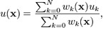

3.4 Community outreach
Phases One and Two of this project identified stakeholders in Alabama and those individuals most at-risk for Lyme and other tick-borne diseases. The current phase focused on analysis of socio-environmental conditions and determined the most appropriate elements – i.e., audience, message, source, and channel - for public communication. Previous literature explains that the audience must be provided a clear, simple message, which is positive, emotional, and rational. The source must have credibility to influence the effectiveness of a message. And the channel, or means of sending a message, is equally as important as the message itself. In many cases, interpersonal methods of channeling can change attitudes and behavior more than mass media messages.
Researchers felt the most appropriate audiences for community outreach included younger outdoor enthusiasts and workers. A list of possible stakeholders was created and the most feasible and appropriate organizations to approach included the local Boy Scouts of America and Girl Scouts of the U.S.A. troops/camps. Both organizations were contacted via telephone and email. The local Boy Scouts of America troops/camps indicated that Lyme and other tick-borne disease prevention methods are currently incorporated into its curricula. However, the local Girl Scouts of USA troops/camps expressed significant interest in researchers providing information and prevention material to both troops and staff.
In addition, researchers worked to identify relevant local, state, and national conferences to attend through internet searches and discussion with tick-borne disease experts. Attendance to these conferences allows researchers to present findings to the larger scholarly community for constructive criticism as well as to others interested in current tick-borne disease research and community dissemination methods.
Researchers are also continuing to work with UAB research experts and the UAB Institutional Review Board to satisfy requirements for delivery of the previously created survey instrument to a population at-risk for tick-borne diseases in Alabama.

4. Spatial model results
4.1 Ordinary kriging and inverse distance weighting
Ordinary kriging and inverse distance weighting (IDW) were applied to the tick population data using the tick count at each point and their latitude and longitude to predict tick densities in the surrounding areas of the collection points. Both models made good predictive models although the ordinary kriging model (Figure 4) proved to be slightly more accurate than the IDW model (Figure 5). The ordinary kriging model producing a root-mean-square error of 12.55, compared to the IDW root-mean-square of 13.54. The IDW method predicted tick counts from 10 to 50 while the kriging model predicted counts from 19 to 41.

4.2 Statistics
A trend between the collected tick data and the in situ soil moisture data was identified. A bar graph shows that as the soil moisture levels decrease, the tick population data decreases as well (Figure 6). Correlations between NDVI and soil moisture values from the ASTER images with the tick data could not be determined since there were 1) too few tick collection points and 2) too few collected ticks to conduct more advanced statistical analyses.

5. Discussion
5.1 Spatial analyses
The in situ soil moisture and tick population data showed promising trends. The trend reinforces the hypothesis that larger tick populations will be found when soil moisture levels are higher. Based on this observed trend it would be expected that there are significant relationships between the tick populations and the remotely sensed environmental variables assuming larger numbers of tick are collected in the summer 2010.
Relationships between the in situ soil moisture and remote sensed soil moisture data were not tested since the data was observed at different times. Therefore, any positive or negative correlations would be insignificant. Similarly, NDVI and tick population data were not compared because the satellite imagery used in the study was taken several years before the tick population and in situ soil moisture data were collected.
In order to properly test statistical relationships between tick populations and remotely sensed vegetation and soil moisture levels the team will order the Terra to take three ASTER images during June and July, 2010. The team will simultaneously be collecting geo-located tick population data and in situ soil moisture samples. Since all the data will be collected concurrently they will be able to reveal significant correlations, assuming sufficient tick data is collected. This will ultimately allow the team to test the validity of the predictive model for Lyme and other tick-borne diseases in Alabama.

5.2 Community outreach
5.2.1 Professional meetings and presentations
UAB-MSFC DEVELOP students performed outreach in the form of public presentations at professional and community meetings. Team leader Nathan Renneboog and team member Sarah Hemmings presented DEVELOP projects at the American Association for the Advancement of Science (AAAS) meetings in San Diego, CA, from Feb 18-21, 2010. AAAS is the world's largest general scientific society, and the meetings were attended by scientists, educators, decision-makers, and students representing numerous fields. This presentation allowed the team to perform outreach to a very broad cross-section, increasing awareness about MSFC-UAB’s DEVELOP program, recruiting possible DEVELOP applicants, and exploring future research topics and collaborations. The previous project on West Nile Virus and the ongoing project on Lyme disease were presented in the form of poster presentations on Saturday, Feb 20 from 1-5pm, as part of the student poster competition. If either project is selected as the winner in the Medicine and Public Health judging category, then the project will be mentioned in Science magazine (decisions announced in April, 2010).
Other ongoing DEVELOP presentation efforts include submission of an oral presentation abstract entitled “Reducing tick-borne disease in Alabama: Linking health risk perception with spatial analysis using the NASA Earth Observing System” to the American Public Health Association’s annual meetings in Denver, CO (November 6-10, 2010), for inclusion in NASA’s session: “Using Remote Sensing for the Study of the Environment and Possible Associations with Disease Occurrence.” The team will also present this project at the UAB Public Health Research Day in the student poster category on April 5, 2010. The MSFC-UAB team was awarded first place in that category in 2009.

5.2.2 Community meetings and presentations
A stakeholder meeting will be held on April 26, 2010, at the UAB School of Public Health. Presenters include current and past DEVELOP team members, and Dr. Jeffrey Luvall, MSFC DEVELOP Science Advisor. Invitees include all students, staff, and faculty in health-related disciplines at UAB and Jacksonville State University. Additional invitees include 1) Mary Hendking, Epidemiologist, Jefferson County Health Department, State of Alabama, 2) Dr. Anthony Frasier, Director, Alabama State Veterinarian, 3) Dr. Dee Jones, Director, Alabama State Public Health Veterinarian, 4) Drs. Gary Mullen and James C. Wright, Professors, Auburn University, 5) Dr. DeAtkine, Endocrinologist, St. Vincent’s Hospital, 6) Bill Pierce, Director, UAB Outdoor Campus Recreation, 7) Laura Elliot, Director, Camp Coleman, Girl Scouts of North-Central Alabama, 8) Terri Knowles, Director, Camp Kanawahala (KPC), Girl Scouts of North-Central Alabama, and 9) Sherri Davidson, Epidemiologist, Alabama Department of Public Health.
Other community meetings have been arranged for the summer 2010 DEVELOP team through a summer-long partnership created with Terri Knowles (Director, Camp KPC) and Laura Elliot (Director, Camp Coleman) of Girl Scouts of North-Central Alabama and the current DEVELOP team. Summer 2010 DEVELOP team members will present Lyme and other tick-borne disease information and prevention methods weekly at two local Girl Scout Camps to girls and boys, Girl Scouts and non-Girl Scouts, and Camp Staff. Educational seminars will begin the first week of June, 2010, and end the first week of August, 2010. Seminars will be developed using constructs from the Health Belief Model and aforementioned strategies for prevention of tick-borne diseases, and will be supplemented by written brochures developed by the Centers for Disease Control and Prevention (CDC), i.e. “Lyme Disease: A Public Information Guide,” that were donated by the International Lyme and Associated Diseases Society (ILADS), located in Washington, D.C. Approximately 500-750 Alabamians will be reached through these educational seminars, and camp directors expressed interest in working with DEVELOP team members to modify its curricula to include tick-borne disease information and prevention methods in the near future.

5.3 Knowledge management activities
A new goal for the DEVELOP project this semester has been to document and archive the team’s research approach. The purpose of this endeavor is to allow for outline the research practices of the team and build a collection of documents and deliverables that portray a set of best practices in project research. It is hoped that this organized collection of research and work will serve as: an aid in communicating approach and methods among new project leaders, a diagnostic tool in the evaluation of completed research, and a general framework for all project efforts, allowing user-friendly access and storage.
With the above rationale in mind, main components of the DEVELOP archive are: citation management, article catalog and archive, presentation toolbox, and collected best practice summaries. All articles cited in the technical paper were put in a file and double-checked for validity. During this process, a taxonomy of subjects was also created for future use as tags in an overall catalog. This classification of subjects serves as a vital link to all stored project information. Furthermore, the ability to quantify research topics also allows for analysis of subject areas with inadequate depth of research coverage (for example by tick species A. americanum there are 2 articles). The catalog will also be user-friendly enough to allow for the entry of new content each semester by any team member with minimal training. All past and future presentations and related materials will be pooled together into a toolbox that will facilitate summarizing work done as well as co-locate all past materials in a slide library that can be reused in the creation of new presentations. Finally, a series of best practice sheets will be created on various tasks and topics. These will be brief summaries of lessons learned. For example, various image analysis techniques can be described in individual sheets. Or key administrative tasks can be summarized and used as a point of reference for any team member in doubt of correct procedure for common jobs.

5.4 Limitations
As discussed above, ASTER imagery and tick population data were not collected contemporaneously and, because environmental characteristics and tick populations can be expected to fluctuate naturally between seasons and between years, it was not feasible to determine the significance of any relationships between variables. This limitation will guide future model development, encouraging collection of tick data and satellite data simultaneously if resources permit. The possibility of tasking the ASTER sensor has emerged as an attractive protocol. Numbers of sampled ticks were also not high enough to perform in-depth statistical analyses. This factor will also be taken into account during future sampling efforts.
The risk perception survey developed during the summer and fall 2009 DEVELOP terms at UAB-MSFC experienced significant delays during the UAB Institutional Review Board review process. Due to these delays, the spring 2010 DEVELOP team was unable to proceed with validating the survey of participants in university-sponsored recreation programs to assess knowledge, behavior, and perceptions regarding Lyme disease and ticks. For this reason, the proceeding DEVELOP team will utilize a validated, published survey to conduct the assessment of risk perception among participants in recreation programs at Alabama universities.

6. Conclusion
The GIS database developed during this phase of the study will be a useful tool for future presentations and public outreach forums. It provides a visualization of the possible tick habitats as well as the statistical interpolation models predicting tick densities. Presentations to the public may be more effective when combined with these visual representations of the data. By presenting the data visually, it allows for a connection based on area, not just information.
These models are also important because they can be used to help focus resources to the most at-risk areas. Funds can be allocated into a specific at-risk area to help control tick populations as well as set forth actions to help prevent the spread of disease. The findings from the assessment of environmental variables will be used in combination with findings from the survey of risk perception during the next phase of the study in order to further target prevention efforts.
The MSFC-UAB DEVELOP Lyme disease and other tick-borne illnesses project continues to receive favorable attention from stakeholder groups, fellow researchers, and the public. The team is aggressively pursuing outreach activities as well as expanding the habitat risk model for ticks in Alabama using NASA products and partner in situ data.
7. Acknowledgements
Sarah Parcak, Ph.D., Assistant Professor, UAB School of Social and Behavioral Sciences; Director, Laboratory for Global Health Observation (LGHO)
Donna Burnett, Ph.D., UAB Research Advisor for DEVELOP Summer 2009, LGHO
Karen Allsbrook, DEVELOP Financial Manager, Science Systems and Applications, Inc., NASA Langley Research Center
Tracey Silcox, DEVELOP National Program, NASA Langley Research Center
Carl M. Brezausek, Statistics Instructor, UAB School of Education
Robert Carter, Ph.D., Assistant Professor, JSU Department of Biology

8. Appendix: Tables and Figures

Figure 1: ASTER Soil Moisture and NDVI Classification maps of Talladega National Forest (Cherokee, Calhoun, Cleburne Talladega, and Clay Counties), September 20, 2006.

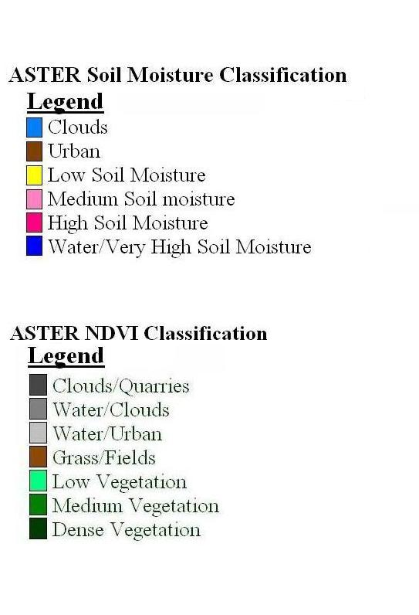
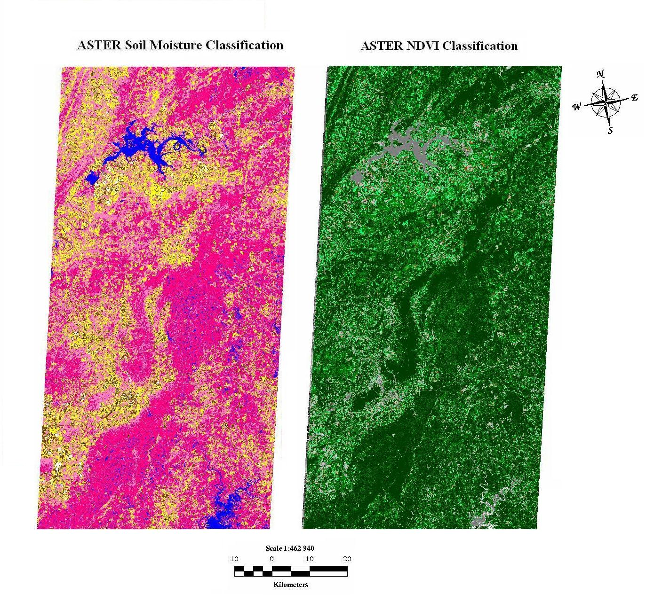

Figure 2: GIS map of Normalized Difference Vegetation Index Classifications of ASTER imagery for Alabama
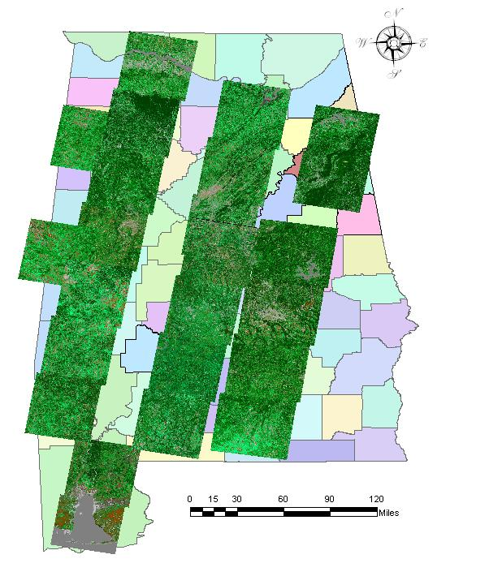

Figure 3: GIS map of soil moisture classifications of ASTER imagery for Alabama
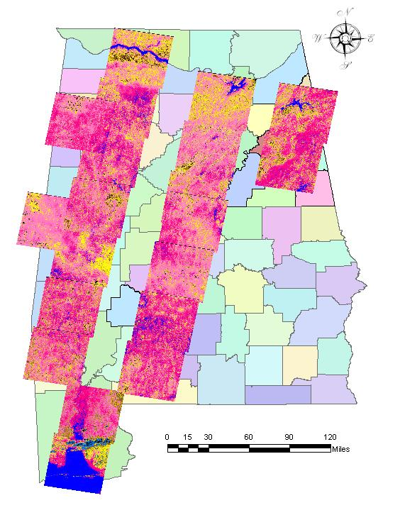

Figure 4: Ordinary kriging model showing tick collection points in Talladega National Forest

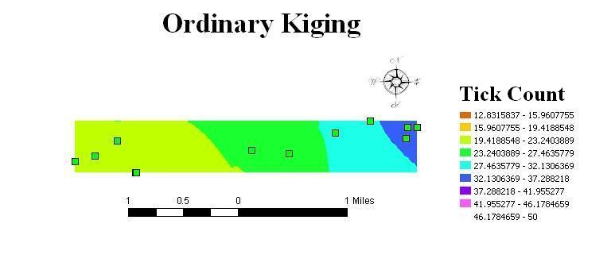

Figure 5: Inverse distance weighting model showing tick collection points in Talladega National Forest
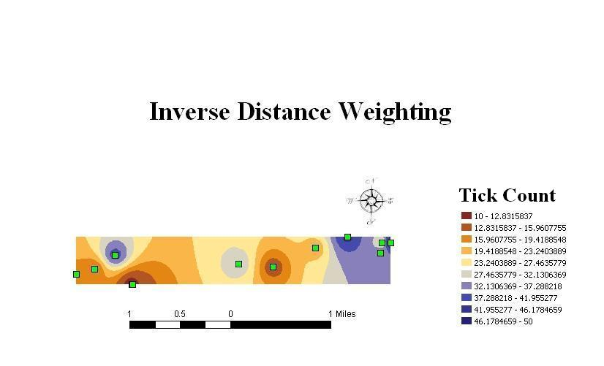

Figure 6: Bar graph of collected ticks at Camp Coleman vs. soil moisture

9. References

Center for Disease Control and Prevention (CDC). June 14 2007. Lyme Disease Press Release. Available at: http://www.cdc.gov/media/pressrel/2007/r070614.htm. Accessed March 8, 2010
Mullen GR, Piesman J. Serologically substantiated case of Lyme disease and potential tick vectors in Alabama. Ala J Med Sci. 1987 Jul;24(3):306-7.
Hayes EB, Piesman J. How can we prevent Lyme disease? N Engl J Med. June 12, 2003; 348: 2424-30.
CDC Lyme Disease Transmission Web Page. Available at http://www.cdc.gov/ncidod/dvbid/Lyme/ld_transmission.htm. Accessed Nov. 3, 2009.
Luckhart S, Mullen GR, Durden A, et al. Borrelia sp. in ticks recovered from white-tailed deer in Alabama. J Wildlife Dis. 1992;28:449-452.
Oliver JH. Lyme Borreliosis in the Southern United States: A Review. J Parasitol. 1996; 82 (6): 926-935.
Tibbles CD, Edlow JA. Does this patient have erythema migrans? JAMA. June 20, 2007; 297(23): 2617-27.
Lyme disease Clinical Presentation, The Johns Hopkins Arhtritis Center. Available at: http://www.hopkins-arthritis.org/arthritis-info/lyme-disease/clinical-presentation.html. Accessed Nov. 25, 2009.
CDC Lyme Disease Transmission Web page. Available at http://www.cdc.gov/ncidod/dvbid/lyme/ld_humandisease_treatment.htm. Accessed Nov. 25, 2009.
Lyme Disease Transmission Web page. Available at http://www.cdc.gov/ncidod/dvbid/lyme/ld_humandisease_treatment.htm. Accessed Nov. 25, 2009.
Fibromyalga Symptoms, Available at: http://www.fibromyalgia-symptoms.org/fibromyalgia_lyme.html . Nov. 25, 2009
Luckhart S, Mullen GR, Durden A, et al. Borrelia sp. in ticks recovered from white-tailed deer in Alabama. J Wildlife Dis. 1992;28:449-452.
CDC Lyme Disease Transmission Web page. Available at http://www.cdc.gov/ncidod/dvbid/lyme/ld_statistics.htm. Accessed Nov. 25, 2009.
Luckhart S, Mullen GR, Wright, C. Etiologic agent of Lyme Disease, Borrelia burgdorferi, detected in ticks (Acari:Ixodidae) collected at a focus in Alabama. J. Med Entomol. 1993; 28:652-657.
Centers for Disease Control and Prevention (CDC): Lyme Disease Cases Reported to CDC by State Health Departments, 1982-1997. Available at http://www.cdc.gov/ncidod/dvbid/ld82_97.pdf. Accessed Nov. 3, 2009.
Centers for Disease Control and Prevention (CDC): Lyme Disease Cases Reported to CDC by State Health Departments, 1982-1997. Available at http://www.cdc.gov/ncidod/dvbid/ld82_97.pdf. Accessed Nov. 3, 2009.
Barbour A.G., G.O. Maupin, G. J. Teltow, C. J. Carter, J. Piesman. 1996. Identification of an uncultivable Borrelia species in the hard tick Amblyomma americanum: possible agent of a Lyme disease-like illness. Journal of Infectious Disease. 1996 Feb;173(2):403-9.
Armstrong, P. M., L. R. Brunet, A. Spielman, and S. R. Telford, III. 2001. Risk of Lyme disease: perceptions of residents of a lone star tick-infested community. Bulletin 78 of the World Health Organization 79:916-925.
Bacon, R. M., R. D. Gilmore, Jr, M. Quintana, J. Piesman, and B. J. B. Johnson. 2003. DNA evidence of Borrelia lonestari in Amblyomma americanum (Acari: Ixodidae) in southeast Missouri. Journal of Medical Entomology 40:590-592.
Bacon, R. M., M. A. Pilgard, B. J. B Johnson, J. Piesman, B. J. Biggerstaff, and M. Quintana. 2005. Rapid detection methods and prevalence estimation for Borrelia lonestari glpQ in Amblyomma americanum (Acari: Ixodidae) pools of unequal size. Vector-Borne and Zoonotic Diseases 5:146-156.
Burkot, T.R., G.R. Mullen, R. Anderson, B.S. Schneider, C.M. Happ, and N.S. Zeider. 2001. Borrelia lonestari DNA in Adult Ambylomma americanum ticks, Alabama. Emerging Infectious Diseases 2001; 7:471-473.
Moore, V. A., Iv, A. S. Varela, M. J. Yabsley, W. R. Davidson, and S. E. Little. 2003. Detection of Borrelia lonestari, putative agent of Southern Tick-Associated Rash Illness, in white-tailed deer (Odocoileus virginianus) from the southeastern United States. Journal of Clinical Microbiology 424-427.
Stegall-Faulk, T., Clark, D.C., and Wright, S.M. 2003. Detection of Borrelia lonestari in Amblyomma americanum (Acari: Ixodidae) from Tennessee. Journal of Medical Entomology. 40:100-102.
Varela, A.S., Luttrell, M.P., Howerth, E.W., Moore, V.A., Davidson, W.R., Stallknecht, D.E., and Little, S.E. 2004. First Culture Isolation of Borrelia lonestari. Putative Agent of Southern Tick-Associated Rash Illness. Journal of Clinical Microbiology. Vol. 42, No. 3 p. 1163-1169.
James, A. M., D. Liveris, G. P. Wormser, I. Schwartz, M. A. Montecalvo, and B. J. B. Johnson. 2001. Borrelia lonestari infection after a bite by an Amblyomma americanum tick. Journal of Infectious Diseases 183:1810-1814.
Varela, A. S., V. A. Moore, and S. E. Little. 2004. Disease agents in Amblyomma americanum from northeastern Georgia. Journal of Medical Entomology 41:753- 759.
Mullen, G.R. and Wright, J.C. 1991. Etiologic Agent of Lyme Disease, Borrelia burgdorferi Detected in Ticks (Acari: Ixodidae) Collected at a Focus in Alabama. Journal of Medical Entomology. 28:652-657.
Center for Disease Control and Prevention (CDC). January 13, 2009a. Tickborne Rickettsial Diseases: Ehrlichiosis. Available at http://www.cdc.gov/ticks/diseases/ehrlichiosis/. Accessed March 8, 2010.
Center for Disease Control and Prevention (CDC). April 1, 2008. Tickborne Rickettsial Diseases: Rocky Mountain spotted fever. Available at http://www.cdc.gov/ticks/diseases/rocky_mountain_spotted_fever/. Accessed March 8, 2010.
Center for Disease Control and Prevention (CDC). October 8, 2003. Emergency Preparedness and Response: Frequently Asked Questions (FAQ) About Tularemia. Available at http://www.bt.cdc.gov/agent/tularemia/faq.asp. Accessed March 8, 2010.
Center for Disease Control and Prevention (CDC). May 5, 2009b. Babesiosis. Available at http://www.cdc.gov/babesiosis/. Accessed March 8, 2010.
Piesman J, Donahue JG, et al. Transovarially aquired Lyme disease spirochetes (Borrelia burgdorferi) in field-collected larval Ixodes dammini (Acari:Ixodidae). J Med Entomol. 1986;23:219.
Orloski KA, Hayes EB, et al. Surveillance for Lyme Disease - United States, 1992-1998. MMWR. April 28, 2000;49(SS03);1-11.
Luckhart S, Mullen GR, Durden A, et al. Borrelia sp. in ticks recovered from white-tailed deer in Alabama. J Wildlife Dis. 1992;28:449-452.
CDC Lyme Disease Transmission Web Page. Available at http://www.cdc.gov/ncidod/dvbid/Lyme/ld_transmission.htm. Accessed Nov. 3, 2009.
Guerra, M, Walker E, et al. Predicting the risk of Lyme disease: Habitat suitability for Ixodes scapularis in the north central United States. Emerg Infect Dis. 2002; 8(3):289-297.
Subak S. Effects of climate on variability in Lyme disease incidence in the northeastern United States. Am J Epidemiol. 2003;157:531-538.
Gray JS. The ecology of ticks transmitting Lyme borreliosis. Exp Appl Acarol. 1998; 22: 249–258.
Subak S. Effects of climate on variability in Lyme disease incidence in the northeastern United States. Am J Epidemiol. 2003;157:531-538.
Guerra M, Walker E, et al. Predicting the Risk of Lyme Disease: Habitat Suitability for Ixodes scapularis in the North Central United States. Emerg Infect Dis. 2002;8(3):289-297.
Mannelli A, Kitron U, et al. Influence of Season and Habitat on Ixodes scapularis Infestation on White-footed Mice in Northwestern Illinois. J Parasitol. 1994;80(6); 1038-1043.
Mannelli A, Kitron U, et al. Influence of Season and Habitat on Ixodes scapularis Infestation on White-footed Mice in Northwestern Illinois. J Parasitol. 1994. 80(6); 1038-1043.
Guerra, M, Walker E, et al. Predicting the risk of Lyme disease: Habitat suitability for Ixodes scapularis in the north central United States. Emerg Infect Dis. 2002; 8(3):289-297.
Estrada-Pena A. Increasing habitat suitability in the United States for the Tick that Transmits Lyme disease: A remote sensing approach. Environ Health Perspect. 2002; 10(7):635-640.
Eisen RJ, Lane RS, et al. Spatial patterns of Lyme disease risk in California based on disease incidence data and modeling of vector-tick exposure. Am J Trop. Med. Hyg. 2006; 75(4):669-676.
Guerra M, Walker E, et al. Predicting the risk of Lyme disease: Habitat suitability for Ixodes scapularis in the north central United States. Emerg Infect Dis. 2002; 8(3): 289-297.
Killilea M, Swei A, et al. Spatial dynamics of Lyme disease: A review. EcoHealth. 2008;5: 167-195.
Estrada-Pena A. Increasing habitat suitability in the United States for the Tick that Transmits Lyme disease: A remote sensing approach. Environ Health Perspect. 2002;10(7): 635-640.
Eisen RJ, Lane RS, et al. Spatial patterns of Lyme disease risk in California based on disease incidence data and modeling of vector-tick exposure. Am J Trop. Med Hyg. 2006; 75(4):669-676.
Lubelczyk CB, Elias SP, et al. Habitat associations of Ixodes scapularies (Acari: Ixodidae) in Maine. Environ Entomol. 2005;33(4): 900-906.
Guerra M, Walker E, et al. Predicting the risk of Lyme disease: Habitat suitability for Ixodes scapularis in the north central United States. Emerg Infect Dis. 2002;8(3):289-297.
Killilea M, Swei A, et al. Spatial dynamics of Lyme disease: A review. EcoHealth. 2008; 5:167-195.
Lubelczyk CB, Elias SP, et al. Habitat associations of Ixodes scapularies (Acari: Ixodidae) in Maine. Environ Entomol. 2005;33(4):900-906.
Rodgers SE, Zolnik CP, Mather TN. Duration of exposure to suboptimal atmospheric moisture affects nymphal blacklegged tick survival. J Med Entomol. 2007;44(2):372-375.
Hayes EB, Piesman J. How can we prevent Lyme disease? N Engl J Med. June 12, 2003; 348: 2424-30.
CDC Lyme Disease Transmission Web Page. Available at http://www.cdc.gov/ncidod/dvbid/Lyme/ld_transmission.htm. Accessed Nov. 3, 2009.
CDC Lyme Disease Transmission Web Page. Available at http://www.cdc.gov/ncidod/dvbid/Lyme/ld_transmission.htm. Accessed Nov. 3, 2009.
Pal U, Ynag X, Chen M, et al. OspC fascilitates Borrelia Burgdorferi invasion of Ixodes scapularis salivary glands. Journal of Clinical Investigation. January 15, 2004; 130(2): 220-230.
CDC Lyme Disease Transmission Web Page. Available at http://www.cdc.gov/ncidod/dvbid/Lyme/ld_transmission.htm. Accessed Nov. 3, 2009.
CDC Lyme Disease Transmission Web Page. Available at http://www.cdc.gov/ncidod/dvbid/Lyme/ld_transmission.htm. Accessed Nov. 3, 2009.
Luckhart, S., Mullen, G.R., and Wright, J.C. 1991. Etiolologic Agent of Lyme Disease, Borrelia burgdorferi, Detected in Ticks (Acari: Ixodidae) Collected at a Focus in Alabama. J. Med. Entomol. 28(5): 652-657.
Stegall-Faulk, T., Clark, D.C., and Wright, S.M. 2003. Detection of Borrelia lonestari in Amblyomma americanum (Acari: Ixodidae) from Tennessee. Journal of Medical Entomology. 40:100-102.
Keirans, J. E., and E. H. Lacombe. 1998. First records of Amblyomma americanum, Ixodes (Ixodes) dentatus, and Ixodes (Ceratixodes) uriae (Acari: Ixodidae) from Maine. Journal of Parasitology 84:629-631.
Stegall-Faulk, T., Clark, D.C., and Wright, S.M. 2003. Detection of Borrelia lonestari in Amblyomma americanum (Acari: Ixodidae) from Tennessee. Journal of Medical Entomology. 40:100-102.
Stromdahl, E.Y., Williamson, P.C., Kollars, T.M. II, Evans, S.R., Barry, R.K., Vince, M.A., and Dobbs, N.A. 2003. Evidence of Borrelia lonestari DNA in Ambylomma americanum (Acari:Ixodidae) Removed from Humans. Journal of Clinical Microbiology 41: 5557-5562.
Stromdahl, E.Y., Williamson, P.C., Kollars, T.M. II, Evans, S.R., Barry, R.K., Vince, M.A., and Dobbs, N.A. 2003. Evidence of Borrelia lonestari DNA in Ambylomma americanum (Acari:Ixodidae) Removed from Humans. Journal of Clinical Microbiology 41: 5557-5562.
Luckhart, S., Mullen, G.R., and Wright, J.C. 1991. Etiolologic Agent of Lyme Disease, Borrelia burgdorferi, Detected in Ticks (Acari: Ixodidae) Collected at a Focus in Alabama. J. Med. Entomol. 28(5): 652-657.
Schulze, T.L., Bowen, G.S., Bosler, E.M., Lakat, M.F., Parkin, W.E., Altman, R., Ormiston, B.G., and Shisler, J.K. 1984. Amblyomma americanum: a potential vector of Lyme disease in New Jersey. Science 224:601-603.
Levine, J.F., Apperson, C.S., and Nicholson, W.L. 1989. The occurrence of spirochetes in ixodid ticks in North Carolina. J. Med. Entomol. Sci. 24: 594-602.
Ginsberg, H.S., and Zhioua, E. 1999. Influence of Deer Abundance on the Abundance of Questing Adult Ixodes scapularis (Acari: Ixodidae). J. Med. Entomol. 36 (3) 376-381.
Ginsberg, H.S., and Zhioua, E. 1999. Influence of Deer Abundance on the Abundance of Questing Adult Ixodes scapularis (Acari: Ixodidae). J. Med. Entomol. 36 (3) 376-381.
Bishopp, F. C., and H. L. Trembley. 1945. Distribution and hosts of certain North American ticks. Journal of Parasitology 31:1-51.
Childs, J. E., and C. D. Paddock. 2003. The ascendancy of Amblyomma americanum as a vector of pathogens affecting humans in the United States. Annual Review of Entomology 48:307-337.
Kollars, T. M., JR, J. H. Oliver, Jr., L. A. Durden, and P. G. Kollars. 2000. Host associations and seasonal activity of Amblyomma americanum (Acari: Ixodidae) in Missouri. Journal of Parasitology 86:1156-1159.
Stromdahl, E. Y., M. P. Randolph, J. J. O’brien, and A. G. Gutierrez. 2000. Ehrlichia chaffeensis (Rickettsiales: Ehrlichieae) infection in Amblyomma americanum (Acari: Ixodidae) at Aberdeen Proving Ground, Maryland. Journal of Medical Entomology 37:349-356.
Varela, A. S., V. A. Moore, and S. E. Little. 2004. Disease agents in Amblyomma americanum from northeastern Georgia. Journal of Medical Entomology 41:753- 759.
Merten, H. A. and L. A Durden. 2000. A state-by-state survey of ticks recorded from humans in the United States. Journal of Vector Ecology. 25(1): 102-113.
Lawless KA, Brown SA. Applying Educational Psychology to Health Care Issues: Combating Lyme Disease. Available at http://www.ucc.uconn.edu/www.ucc.uconn.edu/~wwwlyme/health.html. Accessed November 3, 2009.
Communicable Disease: Tick-borne illness. Available at http://www.epi.state.nc.us/epi/tick. Accessed Nov. 3, 2009.
South Carolina DHEC Fact Sheet: Lyme Disease. Available at http://www.scdhec.gov/health/region7/docs/factsheets/lyme%20disease.pdf. Accessed Nov. 3, 2009.
Georgia Division of Public Health: Lyme Disease. Available at http://health.state.ga.us/epi/disease/lyme.asp. Accessed Nov. 3, 2009.
Bureau of Community Environmental Health: Lyme Disease. Available at http://www.floridashealth.com/Environment/community/arboviral/Tick_Borne_Diseases/Lyme_Disease.htm. Accessed Nov. 3, 2009.
Louisiana Office of Public Health – Infectious Disease Epidemiology Section Annual Report. Available at http://www.dhh.louisiana.gov/offices/miscdocs/docs-249/annual/LaIDAnnual_Lyme.pdf. Accessed Nov. 3, 2009.
Lyme Disease Questions and Answers. Available at http://www.msdh.state.ms.us/msdhsite/_static/14,0,227.html. Accessed Nov. 3, 2009.
Arkansas Department of Public Health. Available at http://www.healthyarkansas.com/news/1998archive/june15.html)
Lyme Disease. Texas Department of State Health Services Zoonosis Control brochure. http://www.dshs.state.tx.us/idcu/disease/lyme/lyme.pdf. Accessed Nov. 3, 2009. Available at
Piesman, J. (1993). Dynamics of Borrelia burgdorderi transmission by nymphal Ixodes dammini ticks. J Infect Dis, 167, 1082-1085.
Sood, S.K., Salzman, M.B., Johnson, B.J., et al. (1997). Duration of tick attachment as a predictor of the risk of Lyme disease in an area in which Lyme disease is endemic. J Infect Dis, 175, 996-999.
Nadelman, R.B., Nowakowski, J., Fish, D., et al. (2001). Prophylaxis with single-dose doxycycline for the prevention of Lyme disease after an Ixodes scapularis tick bit. N Engl J Med, 345, 79-84.
Pennsylvania Department of Health. Available at http://www.dsf.health.state.pa.us/health/cwp/view.asp?a=171&Q=230464
Smith, P.F., Benach, J.L, et al. Occuapational risk of Lyme disease in endemic areas of New York State. Ann. NY Acad. Sci. 1988; 539: 280-301.
Glass GE, Schwartz BS, et al. Environmental risk factors for Lyme disease identified with geographic information systems. Am J Public Health. 1995; 85:944-948.
Bronstein JS, Skelly DK, et al. Forest fragmentation predicts local scale heterogeneity of Lyme disease risk. Oecologia. 2005;146: 469–475.
Phillips, C., Liang, M.H., Sangha, O., Wright, E.A., Fossel, A.H., Lew, R.A., Fossel, K.K., & Shadick, N.A. (2001) Lyme disease and preventive behaviors in residents of Nantucket Island, Massachussetts. Am J Prev Med, 20(3), 219-224.
Centers for Disease Control and Prevention. (1996). Lyme disease-United States. MMWR, 46, 531-535
Phillips, C., Liang, M.H., Sangha, O., Wright, E.A., Fossel, A.H., Lew, R.A., Fossel, K.K., & Shadick, N.A. (2001) Lyme disease and preventive behaviors in residents of Nantucket Island, Massachussetts. Am J Prev Med, 20(3), 219-224.
Pennsylvania Department of Health. Available at http://www.dsf.health.state.pa.us/health/cwp/view.asp?a=171&Q=230464.
Pennsylvania Department of Health. Available at http://www.dsf.health.state.pa.us/health/cwp/view.asp?a=171&Q=230464.
Piacentino JD, Schwartz BS. Occupational Risk of Lyme Disease: an epidemiological review. Occup Environ Med. 2002 February; 59(2): 75–84.
Allan B, Keesing F, Ostfeld RS. Effect of Forest Fragmentation on Lyme Disease Risk. Cons. Biol. 2003 Feb 17(1): p. 267-272.
Centers for Disease Control and Prevention. Available at http://www.cdc.gov/ncidod/dvbid/LYME/ld_transmission.htm)
Pennsylvania Department of Health. Available at http://www.dsf.health.state.pa.us/health/cwp/view.asp?a=171&Q=230464.
Corapi, K.M., White, M.I., Phillips, C.B., Daltroy, L.H., Shadick, N.A., & Liang, M.H. (2006). Strategies for primary and secondary prevention of Lyme disease. Nature Clinical Practice Rheumatology, 3(1), 20-25.
Corapi, K.M., White, M.I., Phillips, C.B., Daltroy, L.H., Shadick, N.A., & Liang, M.H. (2006). Strategies for primary and secondary prevention of Lyme disease. Nature Clinical Practice Rheumatology, 3(1), 20-25.
Corapi, K.M., White, M.I., Phillips, C.B., Daltroy, L.H., Shadick, N.A., & Liang, M.H. (2006). Strategies for primary and secondary prevention of Lyme disease. Nature Clinical Practice Rheumatology, 3(1), 20-25.
Corapi, K.M., White, M.I., Phillips, C.B., Daltroy, L.H., Shadick, N.A., & Liang, M.H. (2006). Strategies for primary and secondary prevention of Lyme disease. Nature Clinical Practice Rheumatology, 3(1), 20-25.
CDC Theory at a Glance: A Guide for Health Promotion Practice. NIH Publication No. 05-3896. Sept.2005:12. Available at http://www.cancer.gov/PDF/481f5d53-63df-41bc-bfaf-5aa48ee1da4d/TAAG3.pdf. Accessed Nov. 3, 2009.
Daltroy, L.H., Phillips, C., Lew, R., Wright, E., Shadick, N. A. & Liang, M.H. A controlled trial of a novel primary prevention program for Lyme disease and other tick-borne illnesses. Health Educ Behav 2007; 34; 531-542.
Malouin R, Winch P, et al. Longitudinal Evaluation of an Educational Intervention for Preventing Tick Bites in an Area with Endemic Lyme Disease in Baltimore County, Maryland. Am J Epidemiol. 2003; 157(11):1038-1051.
CDC Theory at a Glance: A Guide for Health Promotion Practice. NIH Publication No. 05-3896. Sept.2005:12. Available at http://www.cancer.gov/PDF/481f5d53-63df-41bc-bfaf-5aa48ee1da4d/TAAG3.pdf. Accessed Nov. 3, 2009.
Becker MH. The Health Belief Model and Personal Health Behavior. Health Educ Monogr. 1974;2:324-473
Hayes, E.B. & Piesman, J. (2003). How can we prevent Lyme disease? The New England Journal of Medicine, 348, 2424-2430.
McLeroy K, Bibeau D, Steckler A, Glanz K. An Ecological Perspective on Health Promotion Programs. Health Ed & Beh. 1988; 15(4):351-377.
CDC Theory at a Glance: A Guide for Health Promotion Practice. NIH Publication No. 05-3896. Sept.2005:12. Available at http://www.cancer.gov/PDF/481f5d53-63df-41bc-bfaf-5aa48ee1da4d/TAAG3.pdf. Accessed Nov. 3, 2009.
Peet, R.K., Wentworth, T.R., and White, P.S. 1998. A Flexible Multipurpose Method for Recording Vegetation Competition and Structure. Castanea. 63: 262-274.
Lemmon, P.E., 1956. A Spherical Densiometer for Estimating Forest Overstory Density. Forest Science 2 (4) 314-320.
Lemmon, P.E., 1957. A New Instrument for Measuring Forest Overstory Density. Journal of Forestry 55 (9) 667-668.
Lemmon, P.E., 1956. A Spherical Densiometer for Estimating Forest Overstory Density. Forest Science 2 (4) 314-320.
Lemmon, P.E., 1957. A New Instrument for Measuring Forest Overstory Density. Journal of Forestry 55 (9) 667-668.
Lemmon, P.E., 1956. A Spherical Densiometer for Estimating Forest Overstory Density. Forest Science 2 (4) 314-320.
Lemmon, P.E., 1957. A New Instrument for Measuring Forest Overstory Density. Journal of Forestry 55 (9) 667-668.
Goddard, J. 1992. Ecological Studies of Adult Ixodes scapularis in Central Mississippi: Questing Activity in Relation to Time of Year, Vegetation Type, and Meteorologic Conditions. Journal of Medical Entomology. Vol. 29 No. 3 pp 501-506.
Bacon, R.M., Pilgard, M.A., Johnson, B.J.B., Raffel S.J., and Schwan, T.G. 2004. Glycerophosphodiester Phosphodiesterase Gene (glpQ) of Borrelia lonestari Identified as a Target for Differentiating Borrelia Species Associated with HardTicks (Acari:Ixodidae). Journal of Clinical Microbiology, May 2004,Vol 42, No 5. p. 2326–2328.
Bacon, R.M., Pilgard, M.A., Johnson, B.J.B., Piesman, J., Biggerstaff, B.J., and Quintana, M. 2005. Rapid Detection Methods and Prevalence Estimation for Borrelia lonestari glpQ in Amblyomma americanum (Acari: Ixodidae) Pools of Unequal Size. Vector-Borne and Zoonotic Diseases Vol. 5, No. 2. Pg. 146-156.
Anselin L. (1994). Exploratory spatial data analysis and geographic information systems. In: New Tools for Spatial Analysis ed. M.Painho. Luxembourg: EuroStat, 45-54.
Jacob B. G., Griffith, D. A., Gunter, J. T., Muturi, E. J., Caamano, E. X., Shililu, J. I., Githure, J. I., Regens, J. L., Novak, R. J. (2008b). A spatial filtering specification for an autonegative binomial model of Anopheles arabiensis aquatic habitats. Transactions in GIS, 12(4), 515-539.
Jacob, B. G., Griffith, D. A., & Novak, R. J. (2008a) Decomposing Malaria mosquito aquatic habitat data into spatial autocorrelation eigenvectors in a SAS/GIS Module. Transactions in GIS, 12(3), 341-364.
Freimuth, V., Linnan, H.W., & Potter, P. (2000). Communicating the threat of emerging infections to the public. Emerging Infectious Diseases, 6(4), 337-347.
Freimuth, V., Linnan, H.W., & Potter, P. (2000). Communicating the threat of emerging infections to the public. Emerging Infectious Diseases, 6(4), 337-347.

