**NASA DEVELOP National Program**

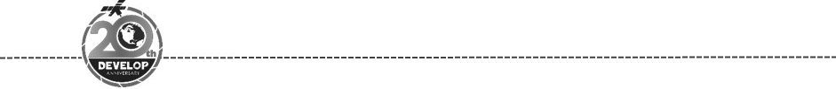Virginia – Wise

*Spring 2018*

Fremont River Basin Water Resources

Assessment of Annual Snow Cover and Its Effect on Water Availability in the Fremont River Basin

 **Technical Report**

Final Draft – March 29th, 2018

Margaret Mulhern (Project Lead)

Manda Au

Nolan Barrette

Austin Counts

Joe Spruce, Consultant, Science Systems & Applications, Inc. (Lead Science Advisor)

Dr. L. DeWayne Cecil, NOAA National Centers for Environmental Information,

Global Science & Technology, Inc. (Science Advisor)

Annette Hollingshead, Global Science & Technology, Inc. (Science Advisor)

Bob VanGundy, The University of Virginia’s College at Wise (Science Advisor)

Dr. Kenton Ross, NASA Langley Research Center (Science Advisor)

# 1. Abstract

The Fremont River in Utah provides water for wildlife, riparian habitats, and irrigation for approximately 16,000 acres of agricultural lands, which includes the historic orchards and pastures maintained by Capitol Reef National Park. Annual snowmelt is recognized as the primary water source within the Fremont River Basin. However, the predictions of seasonal water availability within the basin from *in situ* snowpack measurements have proven unreliable in the past. For this reason, a more robust method was required to provide accurate estimates. For better predictions of annual water resources from snowmelt, the team utilized daily Normalized Difference Snow Index (NDSI) snow cover data and daily Land Surface Temperature (LST) data from the Terra Moderate Resolution Imaging Spectroradiometer (MODIS). The team also integrated daily precipitation data from the Precipitation Estimation from Remotely Sensed Information using Artificial Neural Networks - Climate Data Record (PERSIANN - CDR). These datasets were incorporated into the SNowmelt Observational Watershed Model (SNOW-M) with *in situ* data, creating two graphical outputs that reveal the changes in snowmelt between 2000 and 2017. These graphical outputs included the actual flow versus the simulated water flow per annum and the snow covered area per annum. Furthermore, this model simulated the projected water flow for three months based on snow covered areas. Complementing the SNOW-M, monthly Terra MODIS NDSI snow cover data were utilized to produce maps displaying the change in snow cover extent. Capitol Reef National Park will employ these products to further predict the seasonal water availability for irrigation.

**Keywords**

Snowmelt, Capitol Reef National Park, Terra MODIS, PERSIANN - CDR, SNowmelt Observational Watershed Model (SNOW-M), ArcSWAT

# 2. Introduction

* 1. ***Background Information***

The Fremont Watershed, containing 1900 square miles of a mountainous landscape, flows through Capitol Reef National Park (CARE), as well as the southern Utah cities of Bicknell Bottoms, Caineville, and Hanksville (Figure 1). Beginning at Thousand Lake Mountain, the Fremont River collects in Fish Lake, Johnson Valley Reservoir, and Mill Meadow Reservoir for irrigation purposes (National Park Service, 2004). Transitioning from an elevation of 11,000 feet to the low deserts at 5,000 feet, the Fremont River flows eastwards for 95 miles, from the Johnson Valley Reservoir to the Dirty Devil River (Provo Area Office, 2017), and later converges with the Colorado River. These reservoirs contain the bulk of annual snowmelt for agricultural irrigation (EPA, 2016).

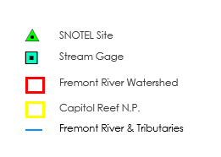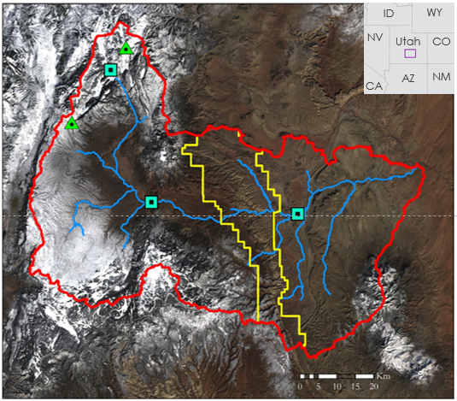

Landsat 8 OLI Real Color Image, January 23, 2018

Figure 1. Fremont River watershed in southern Utah

The Fremont River irrigates approximately 16,000 acres of agricultural land in southern Utah (Utah Department of Environmental Quality, 2002). Throughout CARE, several perennial rivers and streams provide water for wildlife, riparian habitats, livestock, and the historic apple, peach, and apricot orchards maintained by CARE (National Park Service U.S. Department of the Interior, 2004). Because of low percolation to recharge groundwater springs in the semi-arid environment, the Fremont River persists primarily on surface water (Fisk, 2018). Though rapidly melting snow poses flooding risks, this snowpack stores large amounts of valuable water throughout the winter season (Kuter, Akyurek, & Weber, 2018).

Globally, semi-arid environments depend on the annual snowmelt for yearly water resources (Rodriguez, Ohlanders, & McPhee, 2014). In semi-arid Chilean streams, direct snow runoff contributed up to 30 percent of groundwater discharge and 25 percent of seasonal river flow in a study by Rodriguez et. al. (2014). In the western United States, snow composes approximately 50 percent of the annual precipitation (Jin & Miller, 2007). In Utah, contributions to this valuable source of water from annual precipitation has decreased and snow has been melting earlier in the season over the past 50 years (EPA, 2016). The declining snowpack has the potential to affect the ecosystem, recreation, and landowners as water availability becomes increasingly restricted (EPA, 2016). A continued reduction in water availability will cause ranches and irrigated farms to suffer significantly, which accounts for 80 percent of water usage in the state of Utah (EPA, 2016). Previous research shows the feasibility of modeled streamflow within snow dominant water systems based on this annual snowmelt in high elevation environments, such as the Sierra Nevada mountains (Choi, 2015). To assess water availability in the Fremont River Basin the team modeled surface water and snowmelt within the basin from 2000 - 2017.

* 1. ***Project Partners & Objectives***

The NASA DEVELOP Fremont River Basin Water Resources Team partnered with the National Park Service (NPS) Northern Colorado Plateau Network and the National Park Service Capitol Reef National Park. CARE currently relies on Snow Telemetry (SNOTEL) data to monitor snowpack and snowmelt runoff. There are two SNOTEL sites located at similar elevations within the basin, and because of their similar elevations they do not provide data for the amount of snow the basin acquired at higher and lower elevations. Thus, the data from the SNOTEL monitoring stations in the Fremont River Basin alone do not provide accurate enough information to produce well informed decisions on the expected snowmelt. State offices currently do not manage the Fremont River Basin; however, the Utah Division of Water Rights ensures water allotments reaching the Dirty Devil River downstream are achieved. The Utah Division of Water Rights will request reductions in irrigation to assure the required water allotments are met during years with lower water flow. To better plan irrigation amounts and to more accurately predict annual snowmelt into the Fremont River Basin, CARE requested a snowmelt runoff modeling tool.

# 3. Methodology

***3.1 Data Acquisition***

This project acquired data from the Moderate Resolution Imaging Spectroradiometer (MODIS) sensor, aboard the Terra satellite, and Precipitation Estimation from Remotely Sensed Information using Artificial Neural Networks- Climate Data Record (PERSIANN-CDR) (Table 1). MODIS and PERSIANN-CDR daily data were downloaded for years 2000 - 2017. MODIS Normalized Difference Snow Index (NDSI) snow cover data were collected for the detection of frozen water reservoirs and snow cover throughout the year. To determine the temperature lapse rate, we collected MODIS Land Surface Temperature (LST) data. Landsat 8 Operational Land Imager (OLI) Land Surface Reflectance data were collected for NDSI comparison and validation with MODIS NDSI values to ensure MODIS adequately characterized snow cover in the Fremont River Basin. A ⅓ arc-second resolution LiDAR derived Digital Elevation Model (DEM) was acquired from the USGS National Elevation Dataset (NED) 3D Elevation Program (3DEP). The LiDAR derived DEM was applied due to the high spatial resolution of about 10 meters. Stream gage data were downloaded from the USGS website for the gages within the Fremont River Basin (Table 2). Temperature and precipitation *in situ* measurements from the SNOTEL sites 348 - Black Flat and 1149 - Fish Lake were collected.

Table 1.

Remote Sensing Data including NASA Earth Observations

|  |  |  |  |  |
| --- | --- | --- | --- | --- |
| **Satellite** | **Sensor** | **Data** | **Version** | **Source** |
| Terra | MODIS | Normalized Difference Snow Index (NDSI) | MOD10A1 MODIS/Terra Snow Cover Daily L3 Global 500m SIN Grid V006 | https://search.earthdata.nasa.gov/search |
| Terra | MODIS | Land Surface Temperature (LST) | MOD11A1 MODIS/Terra Land Surface Temperature/Emissivity Daily L3 Global 1km SIN Grid V006 | https://search.earthdata.nasa.gov/search |
| N/A | N/A | PERSIANN-CDR | N/A | https://www.ncei.noaa.gov/data/precipitation-persiann/access/ |
| Landsat 8 | OLI | Land Surface Reflectance data, WRS path 37, rows 33 and 34 | Collection 1 Level 2 | https://earthexplorer.usgs.gov/ |

Table 2.

Stream Gauge Data

|  |  |
| --- | --- |
| **Stream Gauge** | **Dates Active Within Study Time Frame** |
| USGS 09330230 Fremont River Near Caineville, UT | 01/01/2000 - 09/29/2011 |
| USGS 09329050 Seven Mile Creek Near Fish Lake, UT | 05/09/2008 - 12/31/2017 |
| USGS 09330000 Fremont River Near Bicknell, UT | 01/01/2000 - 12/31/2017 |

***3.2 Data Processing***

We derived the SNowmelt Observational Watershed Model (SNOW-M) from the Modified Snowmelt-Runoff Model (M-SRM) to perform snowmelt analysis. The Chile Water Resources teams of NASA DEVELOP’s fall 2013 and spring 2014 terms developed M-SRM, which had not undergone any additional updates prior to this project. SNOW-M updated the base and code structure of M-SRM to be compatible with current software packages and for application in the Fremont River Basin.

SNOW-M depends upon the creation of several input files for the program to run properly. For the extent of the Fremont River Basin, we acquired multiple LiDAR derived DEM tiles. We joined and reprojected these tiles to the WGS 1984 UTM projected coordinate system. The ArcGIS plugin for the Soil and Water Assessment Tool (ArcSWAT) delineated the watershed and corresponding sub-basins based on elevation gradients and subsequent flow regimes. Landsat 8 data were joined, reprojected, and clipped to the Fremont River Basin extent. We employed Landsat 8 data to calculate NDSI values to compare with MODIS snow cover data to ensure the resolution of MODIS data sufficiently represented the study area. Level 3 MODIS snow cover data only needed to be reprojected and clipped for the comparison. The NDSI formula divides the difference of the Green and Shortwave Infrared (SWIR) bands by the sum of the Green and SWIR bands (Equation 1):

$\text{NDSI=}\frac{\text{(Green-SWIR1)}}{\text{(Green+SWIR1)}}$ (1)

ArcSWAT identified the study area by calculating the watershed boundary, which SNOW-M requires as an input. Additionally, a created shapefile delineates the range of *in situ* precipitation data along with a raster dataset divided into elevation zones with unique snowpack and vegetation patterns. This step ensures the model calculates discharge values consistent with the characteristics of each distinct area within the basin.

Processing *in situ* data, we calculated degree day factor and runoff coefficients. We implemented the MODIS land surface temperature data to calculate the temperature lapse rate. We used these administered temperature and snow cover references to estimate snowpack accumulation and volume entering the watershed as overland flow. Zonal statistics were calculated from the MODIS land surface temperature, *in situ* data, and PERSIANN-CDR data, which produced comma-separated values for input within the model.

MODIS snow cover data were extracted, projected, and clipped in preparation for resampling and utilization of the model. PERSIANN-CDR data assisted basin characteristics in the determination of precipitation behavior in the area. The PERSIANN-CDR data files were extracted and reformatted for processing.

***3.3 Data Modeling***

SNOW-M applies the mathematical equation behind the Modified Snowmelt Runoff Model to quantify runoff estimates for a specified basin (Equation 2). This equation requires several datasets to successfully determine discharge simulations. These parameters include measured average daily discharge (***Q***), precipitation (***P***), average daily temperature (***T***), area of elevation zone (***A***), snow covered area (***S***), degree-day factor (𝞪), rain runoff coefficient (***Cr***), snow runoff coefficient (***Cs***), and recession coefficient (***k***). The 2013 fall NASA DEVELOP Chile Water Resources Project technical paper provides a more extensive explanation of model parameters.

$Q_{n+1}\text{=\{[}C_{s_{n}}∙α_{n}\left(T_{n}+∆T_{n}\right)S_{n}+c_{r_{n}}P_{n}]\frac{\text{A}*1000}{86400}(1-k_{n+1})\}+Q_{n}k_{n+1}$ (2)

A Graphical User Interface (GUI) within MATLAB allows for in-experienced user interaction with SNOW-M. The user has the ability to select years between several different basins and further process basin-specific data. The GUI assists by processing both daily MODIS NDSI snow cover data and *in situ* data, including discharge, temperature, and precipitation. Processing the *in situ* data requires the extraction of daily values from a spreadsheet format and averaging across all stations within the specified basin to produce an average daily value. Areal calculations and temporal cloud filtering performed on MODIS data produced output files assigning fractional daily snow cover values for each elevation zone from 0 to 1, where 1 is 100 percent snow cover. These processed data, along with the pre-defined basin characteristics and the NASA precipitation data, were compiled into a master file for a given year, which the model calls upon for calculations.

SNOW-M is capable of taking several basin-specific tuning parameters accessed through the GUI. These parameters include base flow, precipitation lag, and basin runoff coefficients. Base flow characterizes the water input into the basin from groundwater flow. The precipitation lag and runoff coefficients together characterize how long it takes for precipitation to reach the outlet of the basin and what percentage of the precipitation is available for overland flow. Available precipitation varies based on this parameter due to soil moisture content, where dry soil has a sponge effect, reducing the water available for runoff (Penna, Tromp-van Meerveld, Gobbi, Borga, & Dalla Fontana, 2011).

***3.4 Snow cover detection***

For the detection of changing fractional snow cover, we utilized Terra MODIS NDSI monthly data from 2000 - 2017. These maps indicated the fractional snow cover of each pixel within the study area, with 100 percent representing total ground coverage. To illustrate errors in snow detection caused by cloud cover, the monthly NDSI snow cover pixels are assigned values larger than 100. After grouping these data into water years, running from October 1st to September 30th of the following year, each water year was averaged across the study area utilizing the Cell Statistics tool within ArcMap. This process was repeated to obtain the maximum values for each water year to detect cloud presence. To correct for cloud cover, each pixel above 100 percent was reclassified to null values. Then, using Raster Calculator in ArcMap, the true values of these pixels were approximated from the average fractional snow cover values given by those pixels during the month before and after the discrepancy. The average of each water year was again taken using Cell Statistics within ArcMap after the removing data discrepancies.

We created a map of percent change for the 2016 - 2017 water year from the average during 2000 - 2010. Using Cell Statistics, each image from the beginning of the 2000 - 2001 water year to the end of the 2009 - 2010 water year was averaged per pixels, thus indicating the timeframe’s average fractional snow cover per pixel. By subtracting this image from the 2016 - 2017 water year average, this map indicated where the 2016 - 2017 year displayed higher or lower snow cover than the ten year average.

# 4. Results & Discussion

***4.1 Analysis of Results***

This simulation was set with a base flow of 2000 L/s and all other variables at default. The Actual vs. Simulated Flow graph shows a 25 percent error in the simulated value compared to the actual value within the projection zone. In addition, the Precipitation vs. *in situ* Temperature graph indicates the PERSIANN data was recording larger estimates of precipitation compared to the *in situ* SNOTEL stations. This may be due to the limited number of stations within the basin, possibly under-estimating actual precipitation in the basin. The last graph shows the fractional snow covered area within the basin (Figure 2).

***In Situ* Flow vs. Simulated Flow: 2017**

**Precipitation vs. Temperature: 2017**

**Snow Covered Area: 2017**

Tuning Zone

Tuning Zone

Tuning Zone

Projection Zone

Projection Zone

Flow (L/s)

Precipitation (cm/day)

Fractional

Area

Temperature (C)

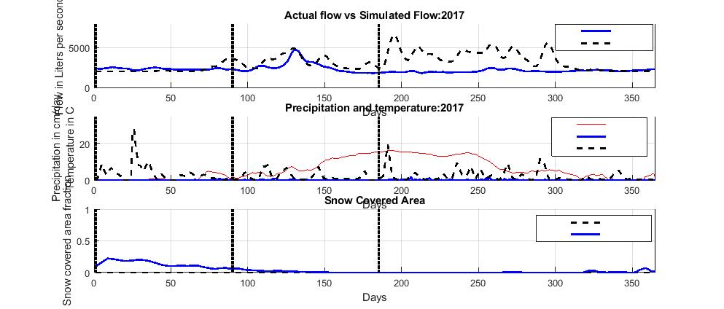

*In Situ*

Simulated



Temperature

Precipitation (*in situ)*

Precipitation (PERSIANN)



Low Elevations

High Elevations

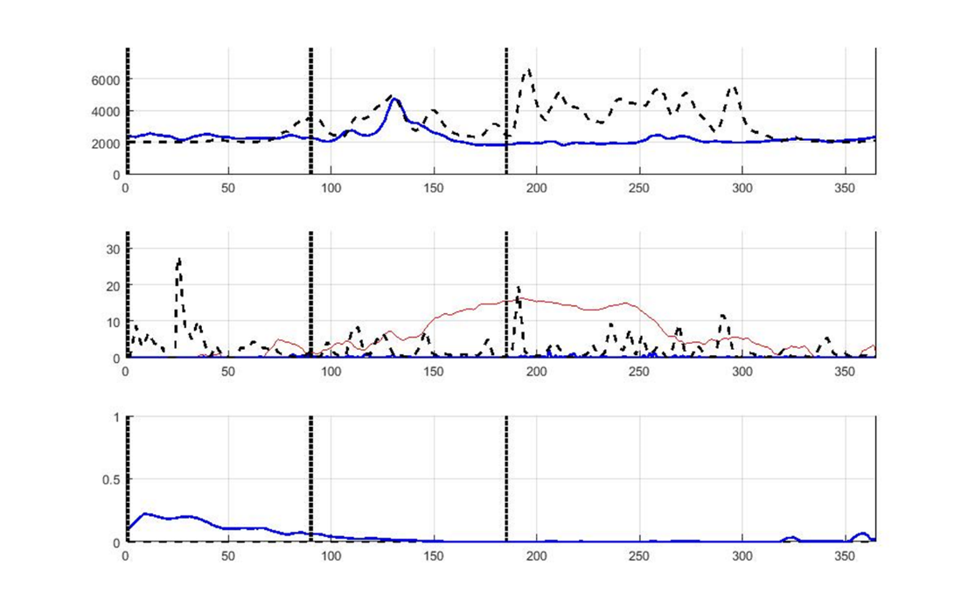

Projection Zone

Figure 2. Simulations based on the default simulation setting and 2000 L/s base flow

The 2016 - 2017 water year experienced less snow cover than the average observed from 2000 – 2010 (Figure 3). High elevations revealed increases in snow cover, such as around Johnson Reservoir and Fish Lake. At its highest, this change indicated a 6.32 percent increase in snow cover percentage. This aligns with SNOTEL data recording the annual snowpack at 100 to 110 percent of the normal average in these high elevations for the 2016 - 2017 water year. However, low elevation exhibited a decrease in percentage snow cover. Overall, the 2016 - 2017 water year experience a 2.37 percent decrease in snow cover. This is not suggesting a trend in the area, only showing a possible explanation for why less water flowed during the 2016 - 2017 water year.

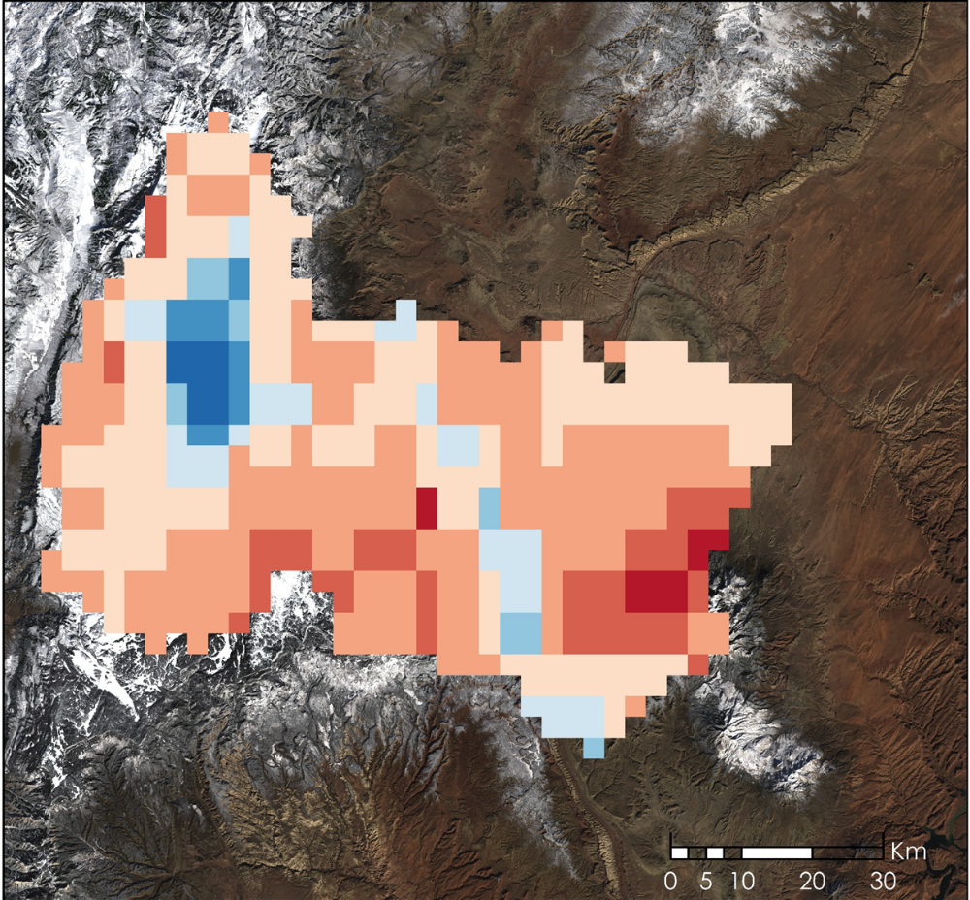

Landsat 8 OLI Real Color Image, January 23, 2018

-9.6 - -7.6

-7.6 - -5.1

-5.1 - -2.5

-2.5 - 0

0 - 1.6

1.6 - 3.2

3.2 - 4.7

4.7 - 6.3

**% Difference**

Figure 3. Percent difference between the average snow cover between 2000 - 2010 and the 2016 - 2017 water year based on monthly MODIS snow cover data.

***4.2 Future Work***

Currently, the model is written to analyze each calendar year. This was appropriate when the study region was in the southern hemisphere, however, for studying basins in the United States, the model will be updated to follow the USGS prescribed water year, from October 1st to September 30th. This time period would capture the total snowfall during the winter season, contributing to the snowmelt the following spring.   
  
SNOW-M still utilizes the Chilean format for *in situ* stream gauge, temperature, and precipitation data. The model will be updated to allow for a more user-friendly file input system which tolerates variations between data. The *in situ* file formats should be updated to align more seamlessly with USGS stream gauge data and USDA SNOTEL monitoring station data. Further tuning is needed for simulating water flow, as previously discussed. The second term of the project will also continue to update the code for further water basin flexibility. SNOW-M will be more adaptable from basin to basin for our partner’s future implementation in other water basins. The model would benefit from the addition of irrigation logs, showing the amount of water being pulled for irrigation purposes. This information can be employed in conjunction with the stream gauge data to better determine the amount of water available each season as a comparison to the simulated water flow from SNOW-M.

Additionally, our project partners primarily work in R and no longer have access to MATLAB. For the model to be a long-term tool for our partners, it should be updated to be in R. Additionally, since R is an open source software, this update will make the model more accessible to future end users.  
  
As the MODIS sensors will eventually be phased out, the second term of this project should adjust SNOW-M to accept the snow indices and land surface temperature data from Suomi NPP VIIRS for the longevity of this tool for our partners. We have also suggested the second term incorporate the precipitation data from Global Precipitation Measurement (GPM), because it has a better spatial resolution at 0.1 degrees than the current precipitations data set from PERSIANN at 0.25 degrees. The data for the VIIRS snow indices and the GPM precipitation data both began collection in 2014.

# 5. Conclusions

For the initial study, we compared 2016 - 2017 snow cover with the average snow cover for 2000 - 2010. We found a decrease in snow cover at lower elevations, and increased snow cover at higher elevations for 2016 - 2017 compared to the historic baseline. Despite increased snow cover in the higher elevations, the overall snow cover in the Fremont River Basin during the 2016 - 2017 water year was less than what was observed in the ten year average for 2000 - 2010. Though this does not provide enough information to suggest a trend within the basin, it may give better insight to decreases in water availability during the 2016 - 2017 water year despite snowpack data observed by the SNOTEL stations.

We noted the model precipitation results disagreed with available reference data, though the latter was in short supply and may not be synoptically relevant for the region at large. Next term will further analyze this through the model, with respect to the water year as opposed to calendar year. SNOW-M was adapted and updated for the Fremont River Basin from the previously made M-SRM. SNOW-M has the potential to model streamflow within the Fremont River Basin, though more research is required before accurate predictions can be made within the basin.

# 6. Acknowledgments

The Fremont River Basin Water Resources team would like to thank their team of a Geoinformatics fellow, science advisors, and those at the Wise County Clerk of Circuit Court’s Office for their guidance and collaboration:

* Joseph Spruce, Lead Science Advisor for NASA DEVELOP VA – Wise County
* Dr. L. DeWayne Cecil, Chief Climatologist at NOAA National Centers for Environmental Information and Program Manager of Global Science & Technology, Inc.
* Annette Hollingshead, Senior Scientist of Global Science & Technology, Inc.
* Bob VanGundy, Geology Instructor at The University of Virginia’s College at Wise
* Dr. Kenton Ross, Lead Science Advisor for NASA DEVELOP National Program
* Katherine Cavanaugh, Geoinformatics Fellow at NASA DEVELOP, Jet Propulsion Laboratory
* Eric White, Center Lead at NASA DEVELOP Wise County Clerk of Circuit Court’s Office
* Brooke Colley, Assistant Center Lead at NASA DEVELOP Wise County Clerk of Circuit Court’s Office

Additionally, the team appreciates the enthusiasm and assistance from the Fremont River Basin Water Resources project partners, who made this project possible:

* Rebecca Weissinger, National Park Service, Northern Colorado Plateau Network Ecologist
* Terry Fisk, Chief of Resource Management and Science at Capitol Reef National Park

The team would also like the acknowledge the previous two teams who created the Modified Snowmelt-Runoff Model (M-SRM) utilized in our project:

* Jeffry Ely, Project Lead, Chile Water Resources, Langley Research Center, Spring 2014; and Team Member, Chile Water Resources and Agriculture, Fall 2013
* Joshua Kelly, Team Member, Chile Water Resources, Langley Research Center, Spring 2014; and Project Lead, Chile Water Resources and Agriculture, Fall 2013
* Joseph Novak, Team Member, Chile Water Resources, Langley Research Center, Spring 2014
* Laura Macaluso, Team Member, Chile Water Resources, Langley Research Center, Spring 2014
* Lyndia Cuker, Team Member, Chile Water Resources, Langley Research Center, Spring 2014
* Bethany Burress, Team Member, Chile Water Resources and Agriculture, Fall 2013
* Amberle Keith, Team Member, Chile Water Resources and Agriculture, Fall 2013
* Ajoke Williams, Team Member, Chile Water Resources and Agriculture, Fall 2013

Any opinions, findings, and conclusions or recommendations expressed in this material are those of the author(s) and do not necessarily reflect the views of the National Aeronautics and Space Administration.

This material is based upon work supported by NASA through contract NNL16AA05C and cooperative agreement NNX14AB60A.

# 7. Glossary

**ArcSWAT** - Soil and Water Assessment Tool ArcMAP extension

**CARE** - Acronym for Capitol Reef National Park

**Dirty Devil River** - The Fremont River feeds into the Dirty Devil River and part of the Dirty Devil Watershed

**Earth observations** – Satellites and sensors, which collect information about the Earth’s physical, chemical, and biological systems over space and time

**M-SRM** - Modified Snowmelt-Runoff Model, modified in 2013 by DEVELOP from WinSRM (USDA)

**MODIS** - MODerate resolution Imaging Spectroradiometer

**PERSIANN-CDR -** Precipitation Estimation from Remotely Sensed Information using Artificial Neural Networks- Climate Data Record

**Riparian Habitats** - the habitat found between a stream and land

**Snow cover -** the area of land covered by snow

**SNOW-M -** SNowmelt Observational Watershed Model

**Snowmelt** - surface runoff produced from melting snow

**Snowpack** - persistent accumulated snow

**Suomi NPP VIIRS** - Suomi National Polar-orbiting Partnership Visible Infrared Imaging Radiometer Suite

**Terra MODIS** - Terra Moderate Resolution Imaging Spectroradiometer

**TRMM** - Tropical Rainfall Measuring Mission

# 8. References

Asaoka, Y. & Kominami, Y. (2013). Incorporation of satellite-derived snow-cover area in spatial snowmelt modeling for a large area: determination of gridded degree-day factor. *Annals of Glaciology, 54*(62), 205-213.

Bender, S., Miller, P., Bernard, B., & Lhotak, J. (2014). Use of snow data from remote sensing in operational streamflow prediction. Retrieved from [https://www.cbrfc.noaa.gov/papers/snow_rs_op_streamflow_prediction_2014WSC.8.pdf](https://www.cbrfc.noaa.gov/papers/snow_rs_op_streamflow_prediction_2014WSC.8.pdf%20)

Choi, M. L. (2015). Assessing the effect on streamflow of two snow dominated watersheds in Sierra Nevada, California using hydrologic modeling in GIS. *California State University*. <https://media.proquest.com/media/pq/classic/doc/3741711201/fmt/ai/rep/NPDF?_s=kCaf8FkyyhrdZ7IETdd4ziMiw%2BA%3D>

EPA. (2016). EPA 430-F-16-046 What climate change means for Utah, 2. Retreived from <https://19january2017snapshot.epa.gov/sites/production/files/2016-09/documents/climate-change-ut.pdf>

Fisk, T. (2018, Feb.). NASA DEVELOP National Program Partner Call [Personal interview].

Jin, J., & Miller, N. L. (2007). Analysis of the impact of snow on daily weather variability in mountainous regions using MM5. *Journal of Hydrometeorology, 8*(2), 245–258. <http://doi.org/10.1175/JHM565.1>

Kuter, S., Akyurek, Z., & Weber, G. W. (2018). Retrieval of fractional snow covered area from MODIS data by multivariate adaptive regression splines. *Remote Sensing of Environment, 205*, 236–252. <https://doi.org/10.1016/j.rse.2017.11.021>

MODIS Land Science Team. (2015) MOD10_L2 MODIS/Terra Snow Cover 5-Min L2 Swath 500m, V006, NASA LANCE MODIS at the MODAPS. DOI: 10.5067/MODIS/MOD10_L2.NRT.006

National Park Service U.S. Department of the Interior. (2004) Water resources management plan Capitol Reef National Park Utah. Retrieved from <https://www.nature.nps.gov/water/planning/management_plans/care_final_screen.pdf>

Penna, D., Tromp-van Meerveld, H.J., Gobbi, A., Borga, M., & Dalla Fontana, G (2011) The influence of soil moisture on threshold runoff generation processes in an alpine headwater catchment, *Hydrology and Earth System Sciences, 15*, 689-702. doi: 10.5194/hess-15-689-2011.

Provo Area Office | Upper Colorado Region - Bureau of Reclamation (2017). Draft environmental assessment Fremont irrigation company canal piping water conservation project Wayne County, Utah. Retrieved from: <https://www.usbr.gov/uc/envdocs/ea/pdf/FremontIrrigationDraftEA.pdf>

Rodriguez, M., Ohlanders, N., & McPhee, J. (2014). Estimating glacier and snowmelt contributions to stream flow in a Central Andes catchment in Chile using natural tracers. *Hydrology and Earth System Sciences Discussions, 11*(7), 8949–8994. <http://doi.org/10.5194/hessd-11-8949-2014>

Sorooshian, S., Hsu, K., Braithwaite, D., Ashouri, H., & NOAA CDR Program. (2014). NOAA Climate Data Record (CDR) of Precipitation Estimation from Remotely Sensed Information using Artificial Neural Networks (PERSIANN-CDR), Version 1 Revision 1. *NOAA National Climatic Data Center*. <https://doi.org/10.7289/v51v5bwq>

U.S. Department of the Interior, Bureau of Land Management (2005). Appendix 1-wild and scenic river suitability considerations. *Richfield RPM.* Retrieved from <https://eplanning.blm.gov/epl-front-office/projects/lup/68293/86878/104135/Richfield_Appendices.pdf>

US Geological Survey Earth Resources Observation and Science Center. (2014). Landsat 8 OLI/TIRS Level 2 Surface Reflectance. US Geological Survey. <https://dx.doi.org/10.5066/F78S4MZJ>

Utah Department of Environmental Quality. (2002). Fremont River watershed water quality management plan. Retrieved from <https://deq.utah.gov/ProgramsServices/programs/water/watersheds/docs/2006/09Sep/FREMONT_WQMP.pdf>

# Wan, Z., Hook, S., & Hully, G. (2015). MOD11A1 MODIS/Terra Land Surface Temperature/Emissivity Daily L3 Global 1km SIN Grid V006, NASA EOSDIS Land Processes DAACDOI:10.5067/MODIS/MOD11A1.006