**NASA DEVELOP National Program**



NASA Goddard Space Flight Center

*Summer 2017*

Niger Water Resources

Implementing a Global Tool Based on Spatially Continuous Precipitation

Analysis for Resiliency Monitoring and Measuring at the Community-Scale

**Technical Report**

Final Draft – August 10, 2017

Jared Tomlin (Project Lead)

Raghda “Didi” El-Behaedi

Ryan Lingo

Sean McCartney

Alison Thieme

Dr. John Bolten, NASA Goddard Space Flight Center (Science Advisor)

Dr. Kenton Ross, NASA Langley Research Center (Science Advisor)

# 1. Abstract

Global water resources are important for societies, economies, and the environment. In Niger, limited water resources restrict the expansion of communities and agriculture. Mercy Corps, a humanitarian aid agency, currently works in over forty countries around the world to address a variety of stresses. These include water resources and building long-term food resilience. A partnership between NASA DEVELOP and Mercy Corps was established as a means to facilitate the integration of NASA Earth observations into Mercy Corps’ resilience building process. Using the Tropical Rainfall Measuring Mission (TRMM), Global Precipitation Measurement (GPM), and Climate Hazards Group InfraRed Precipitation with Station data (CHIRPS), the team created a precipitation climatology that highlights low and high rainfall from 1981 to 2016. A Google Earth Engine tool, RAIn (Rainfall Analysis Integration), was built to help visualize and analyze both environmental and socioeconomic datasets. This tool allows for near real-time updates of trends in precipitation and improves Mercy Corps’ ability to spatially evaluate changes in resiliency by monitoring shocks and stressors.

**Keywords**

Niger, remote sensing, precipitation, Google Earth Engine, Mercy Corps, resiliency, drought

# 2. Introduction

* 1. ***Background Information***

Our study area, Niger, is a landlocked country located in Western Africa, surrounded by Mali, Algeria, Libya, Chad, Nigeria, Benin and Burkina Faso (Figure 1). The country has an area of 1,267,000 square kilometers and a population of over 20 million (DeSA, U.N., 2013). In 2010, 49% of the population in Niger was under the age of 15 (United Nations, 2012). Approximately a fifth of the country lies in the Sahel bioregion (southern area), while the remaining portions of the country are desert (northern and central areas). Within the Sahel there are two major agricultural zones: agropastoral and pastoral. It is for this reason that most Nigeriens are either farmers or herders (Thébaud & Batterbury, 2001).

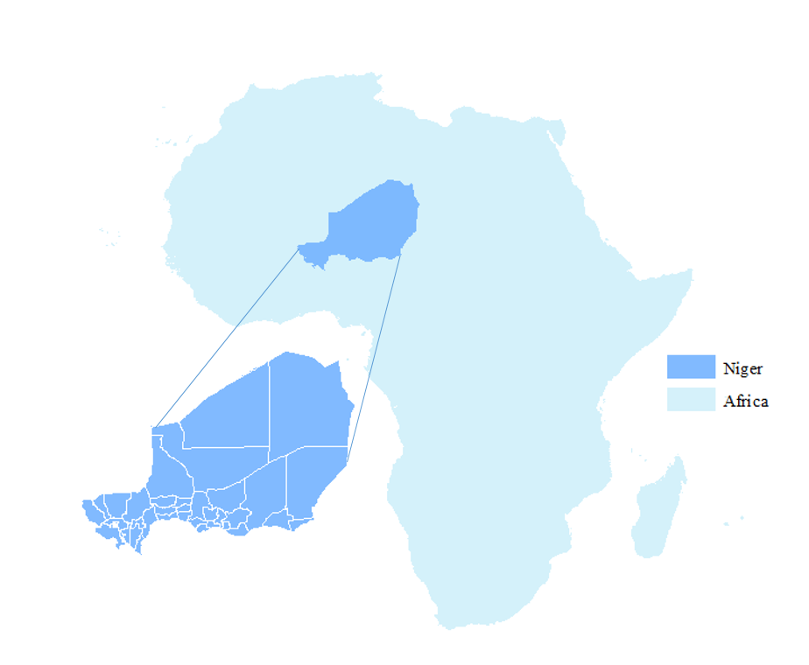

*Figure 1. Study Area Map*

Considering that most people in Niger rely on rainfed agriculture, water, particularly precipitation, is exceedingly important for their livelihoods. When the rainy season arrives, farmers quickly sow their land, most often planting millet, sorghum, or cowpea (Mercy Corps, 2016). Recently, the rainy season has become increasingly irregular, causing many agricultural issues. Herders who rely on grasses and shrubs also face similar difficulties with inconsistent seasons. “In the last 30 years the climate of the West African Sahel has shown various changes, especially in terms of rainfall, of which inter-annual variability is very high. This has significant consequences for the poor-resource farmers, whose incomes depend mainly on rainfed agriculture” (Mohamed, Van Duivenbooden, & Abdoussallam, 2002).

Precipitation plays an important role in understanding the availability of water resources, but does not provide a comprehensive overview of water resource utility. When examining areas with limited precipitation, “findings suggest that increasing agricultural drought does not originate from a decreasing annual amount of rainfall. However, other daily rainfall parameters more important for crop biomass productivity than total rainfall amount, such as the number of dry spells, do appear to have recently worsened” (Wildemeersch, Garba, Sabiou, Fatondji, & Cornelis, 2015). To gain a comprehensive understanding of water resources, incorporation of groundwater, surface water runoff, land cover type, frequency and quantity of precipitation, and land surface temperature is necessary. Global and tropical datasets were utilized to study the timeframe of 1981–2016.

* 1. ***Project Partners & Objectives***

Mercy Corps evaluates communities through what is termed the Strategic Resilience Assessment Process, or STRESS. By understanding the shocks and stressors that communities face, they are better able to connect people to necessary resources. A recent Mercy Corps STRESS analysis showed that poverty, conflict, political instability, and drought are of the highest concern in Niger (Mercy Corps, 2016). The STRESS process centers on local expert knowledge and quantitative data to develop a theory of change, system maps, and stakeholder maps. The four-phase process includes: scope, inform, analyze, and strategize. The theory of change and adaptive management processes then take an iterative approach to embrace complexity, develop capacity, foster “good enough” mentality, and fill knowledge gaps (Mercy Corps, 2016). STRESS does not currently incorporate NASA Earth observations into Mercy Corps’ decision-making processes largely because it is difficult to understand the interactions between the communities and their environment.

Products generated by this project enhance Mercy Corps and its in-country stakeholders’ ability to assess the role of precipitation as a shock or stressor for which a community must plan for in Niger. This addressed NASA’s water resources national application area by using precipitation Earth observations to aid Mercy Corps’ resiliency planning abilities. The main product, a tool called Rainfall Analysis Integration (RAIn), will help Mercy Corps visualize a variety of datasets, both relating to social and economic variables as well as remotely sensed variables. As most NASA Earth observations used in this project are spatially continuous data sets, with only a few minor adaptations, RAIn can be modified for use in decision-making regardless of the geographic interest of the Mercy Corps team. This tool provides Mercy Corps with a new, holistic view of resiliency that could provide lessons learned around shared characteristics between geographically-divided communities dealing with similar issues. Therefore, the main objective for this project was to enhance Mercy Corps’ ability to assess the role of precipitation as a shock or stressor by addressing historical precipitation trends and creating an easy-to-use interface for decision-making.

# 3. Methodology

***3.1 Data Acquisition***

A combination of NASA Earth observations available through Google Earth Engine and ancillary datasets from various sources were used. Table 1 includes the data type, source, dates of imagery, and product level for each dataset. For performing a harmonic trend analysis in TerrSet, Terra MODIS NDVI (MOD13A2), 16 day vegetation indices for 2001–2016, was manually downloaded from NASA’s Reverb ECHO tool.

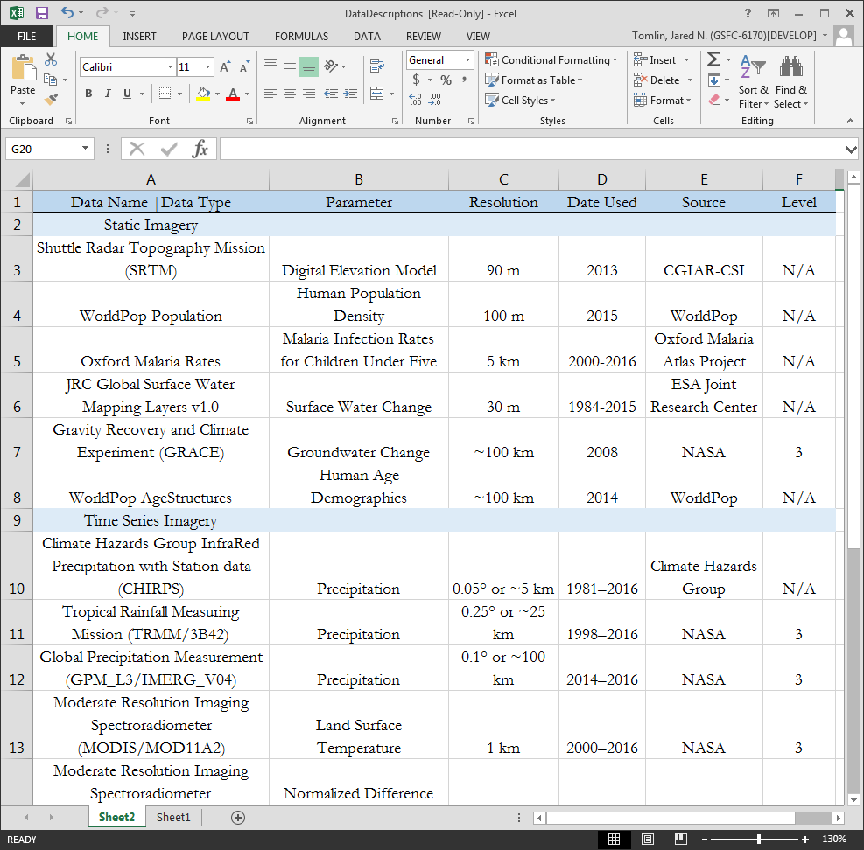

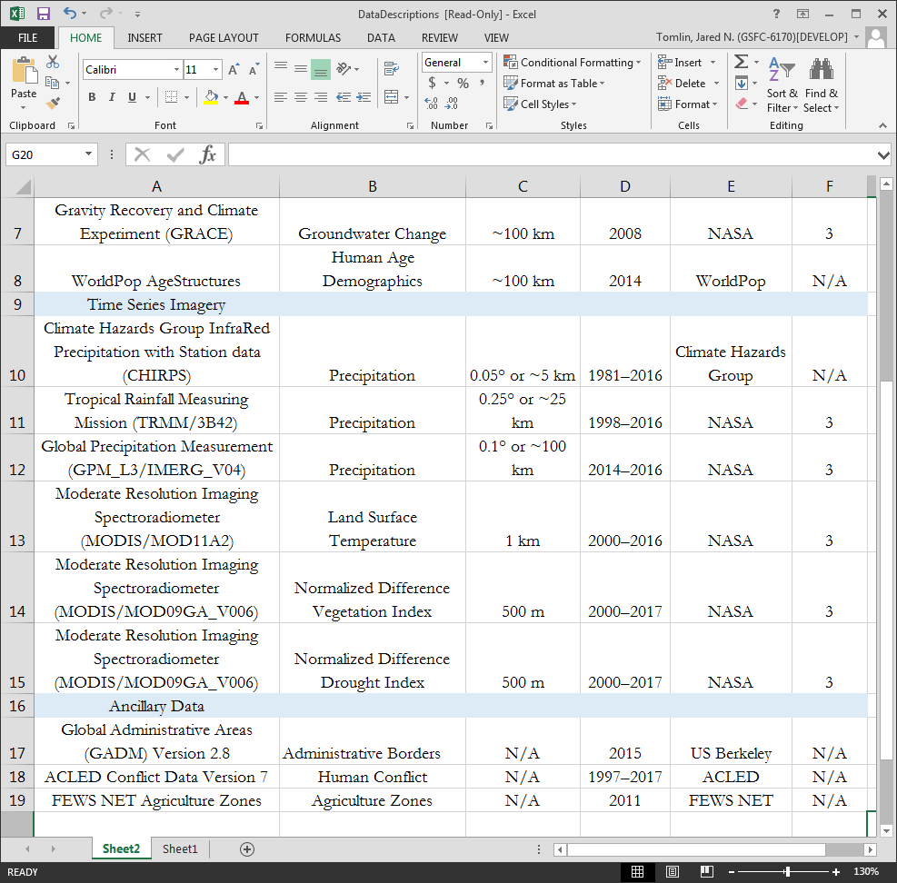

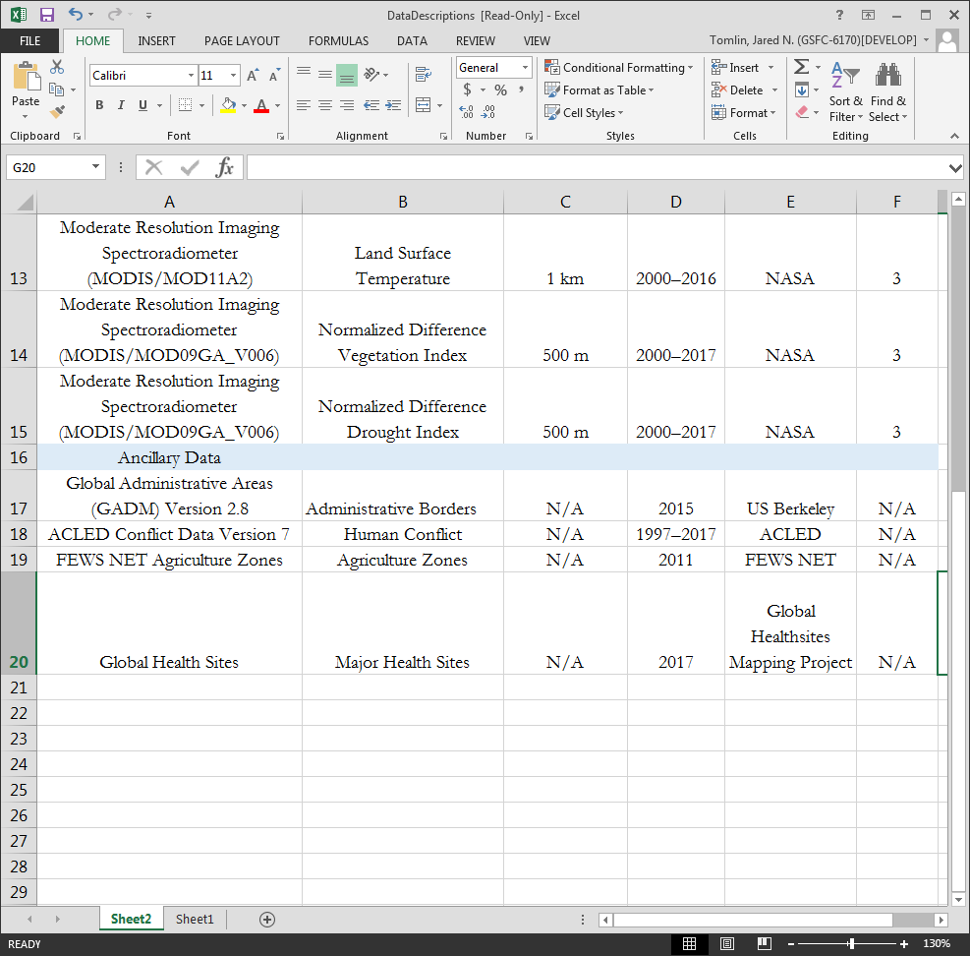

*Table 1. Data Descriptions*

***3.2 Data Processing***

All datasets were kept at their original resolution for visualization purposes. Much of the datasets were global, tropical, or regional in nature and, thus, were subset to Niger’s borders. In order to calculate the normalized difference drought index (NDDI), both the normalized difference vegetation index (NDVI) as well as the normalized difference water index (NDWI) were utilized. All three indices were calculated using the moderate-resolution imaging spectroradiometer (MODIS) surface reflectance bands. Equations for the aforementioned indices are listed below.

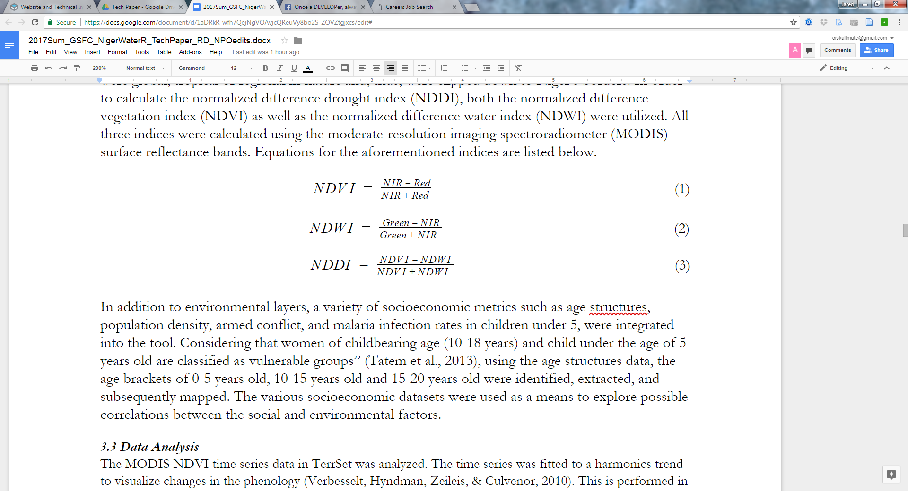

In addition to environmental layers, a variety of socioeconomic metrics such as age structures, population density, armed conflict, and malaria infection rates in children under 5, were integrated into the tool. Considering that women of childbearing age (10-18 years) and child under the age of 5 years old are classified as vulnerable groups” (Tatem et al., 2013), using the age structures data, the age brackets of 0-5 years old, 10-15 years old, and 15-20 years old were identified, extracted, and subsequently mapped. The various socioeconomic datasets were used as a means to explore possible correlations between the social and environmental factors.

***3.3 Data Analysis***

The MODIS NDVI time series data in TerrSet was analyzed. The time series was fitted to a harmonics trend to visualize changes in the phenology (Verbesselt, Hyndman, Zeileis, & Culvenor, 2010). This is performed in the Seasonal Trend Analysis tool in the Earth Trends Module of TerrSet and follows the methodology created by Eastman et al. (2009). The phenological graphs depict the start of season, length of season, and intensity of vegetation greenness in both 2001 and 2016 to give an idea of the changes over that time frame.

***3.4 Data Visualization***

A tool in Google Earth Engine (GEE) was created in order to facilitate visualization and reanalysis of data for our project partners. An introduction panel that contains instructions on how to use the tool as well as the origin, spatial resolution, and year for each dataset was also included. The tool includes the option to select a date of interest to create weekly totals of precipitation data and weekly averages of temperature, drought index, and vegetation index values. The user is also able to select social and economic datasets to explore potential relationships between environmental and community variables. Corresponding legends are available in a pop up box. The user can select a point on the map and time series charts of precipitation, land surface temperature, and NDVI are created. These charts are interactive and can be exported by the user in tabular format, thus, allowing the opportunity for more in-depth statistical analyses outside of the Google Earth Engine platform. A single GRACE groundwater model image is hosted within the tool as an example of how datasets can be incorporated as they are developed.

# 4. Results & Discussion

***4.1 Analysis of Results***

Within Google Earth Engine we created an easy to use interface which calls on the repositories of MODIS NDVI, NDDI, and land surface temperature (LST) as well as TRMM, CHIRPS, and global precipitation measurement (GPM). The user inputs a specific date and each dataset can be visualized almost instantaneously. For precipitation datasets, weekly totals are presented. For the other datasets and indices, weekly averages are presented. Time series of MODIS LST, MODIS NDVI, and CHIRPS are visualized through the Google Earth Engine console for the area that the user selects with the cursor. These charts are interactive and can be exported in multiple formats. An example of these charts are shown below (Figure 2).

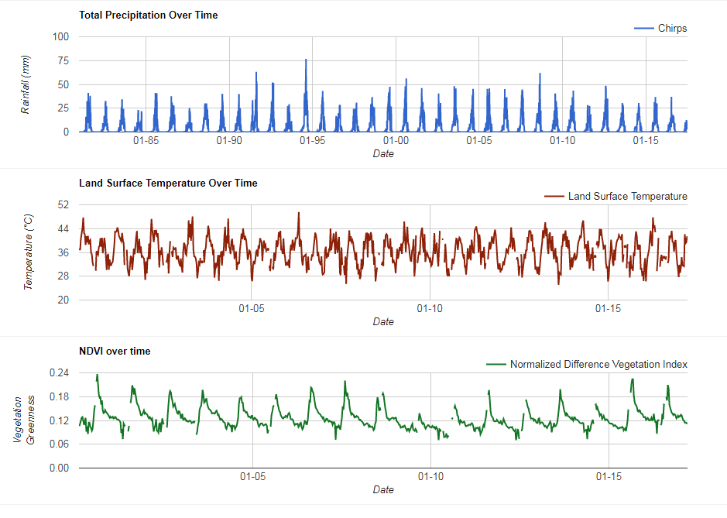

*Figure 2. Time Series Charts of Precipitation, LST, and NDVI*

While a variety of datasets are relevant to humanitarian aid, few are spatial and up to date. In RAIn, we incorporated administrative boundaries, elevation, and human population density to better orient the user to the country. If the user finds it helpful they can switch from a simple base map with cities to a satellite composite base map. In order to give further insight into the regional dynamics, we included the agricultural zones, demographic information, malaria infection rates, and armed conflict events. RAIn is designed to be user friendly and allows for multiple datasets to be displayed simultaneously with corresponding legends (Figure 3).

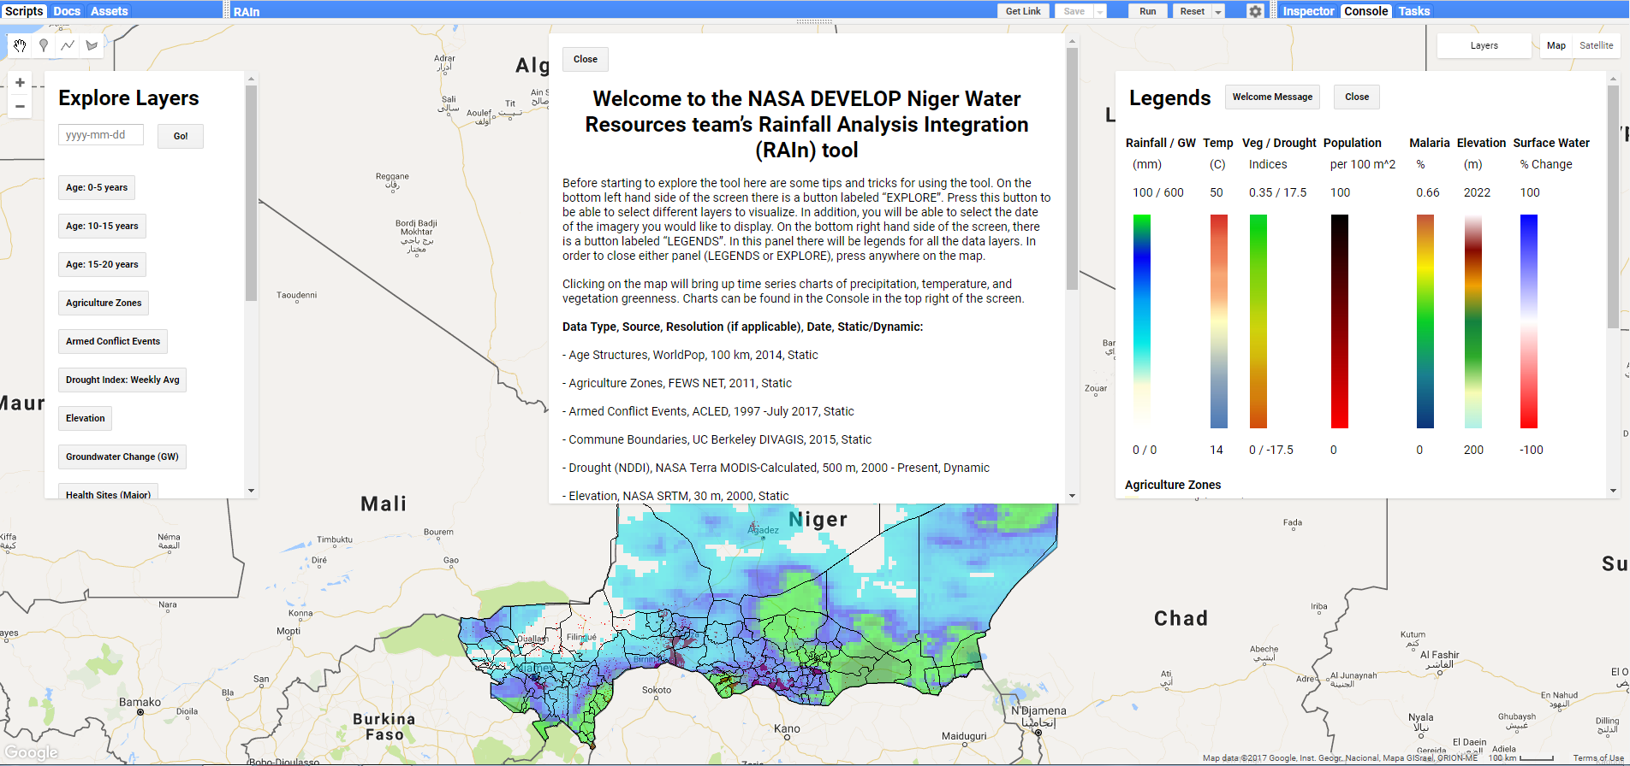

*Figure 3. Precipitation and population density layers visualized in RAIn*

As inconsistent seasons present major challenges to the dominant livelihoods in Niger, we began to examine this issue by performing a harmonic trend analysis using Google Earth Engine which produced the following trend visualization (Figure 4). While interesting, this chart is difficult to interpret and does not help us understand how different areas are experiencing change.

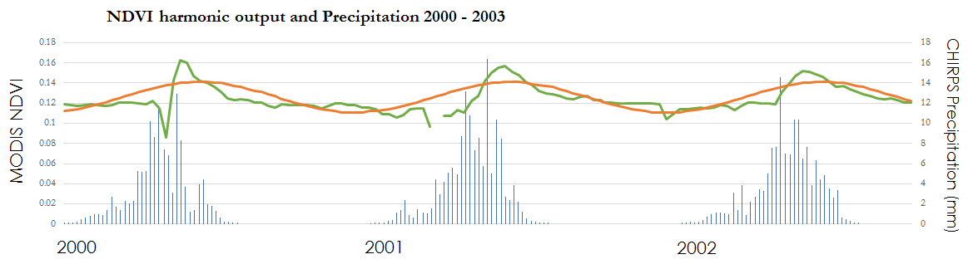

*Figure 4. Harmonic Trend of MODIS NDVI Produced in Google Earth Engine*

Therefore, in order to be able to interpret the harmonic trend, we performed a Seasonal Trend Analysis (STA) in TerrSet’s Earth Trends Modeler to better understand the changing phenology. We used Terra MODIS NDVI to perform a harmonic trend analysis in which provides an interpretation window to explore trends in specific areas. This allowed us to visualize changes in the seasons of Niger since 2001 (Figure 5). While some areas are experiencing earlier and more intense seasons (Figure 6), other areas are having later and less intense seasons (Figure 7).

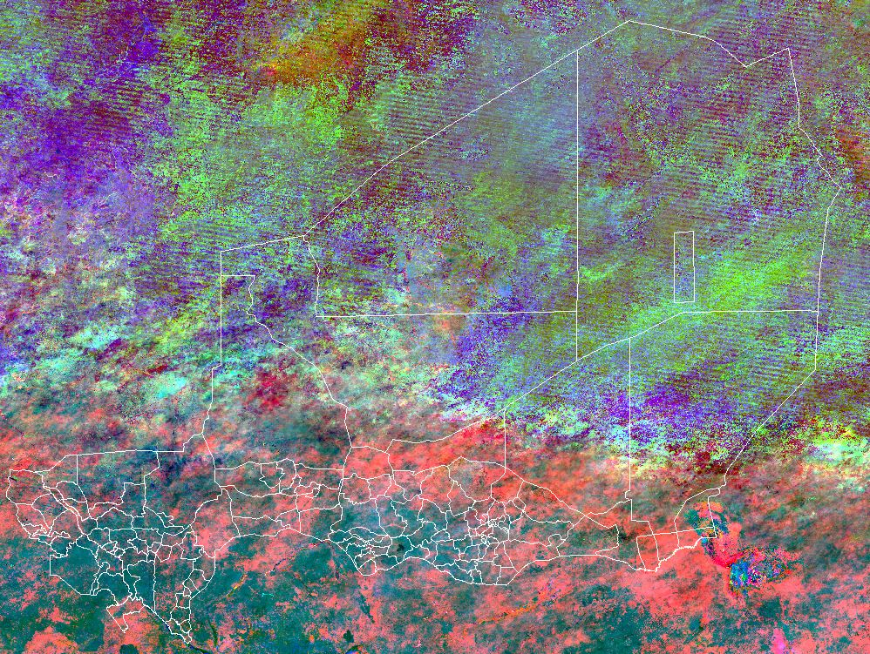

*Figure 5. Phases Derived from Seasonal Trend Analysis of 2001-2016 MODIS NDVI 1km 16 Day Time Series*

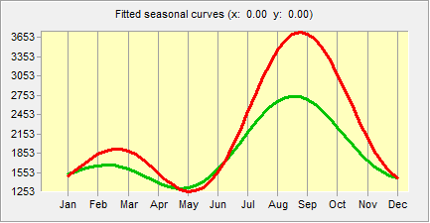

*Figure 6. Pink Areas of the Seasonal Trend Analysis Indicate Earlier, More Intense Seasons by 2016*

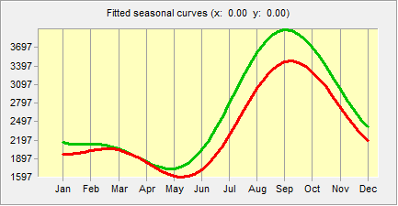

*Figure 7. Teal Areas of the Seasonal Trend Analysis Indicate Later, Less Intense Seasons by 2016*

***4.2 Future Work***

The NASA and Mercy Corps partnership is founded upon the overarching idea of using NASA Earth observations as a means to understand water resources, for the purpose of informing Mercy Corps’ decision-making processes. Many different factors heavily influence water resources in the region including agriculture, groundwater, surface water, and land cover. For this reason, multiple research teams at NASA are collaborating with Mercy Corps on better understanding these other environmental factors. At this current moment, most of these projects operate independently from one another. It would thus be much more effective for all the results from these ongoing projects (e.g. land cover change, GRACE groundwater) to be combined together and visualized on a single dashboard. This would make viewing and analysis of the various datasets profoundly easier for Mercy Corps. The hope is that in the coming years this project would be expanded to include all of the countries that Mercy Corps operates in. Ideally this will be built in Google App Engine in order to harness the abilities of Google Earth Engine, private datasets stored on geoservers, and have a more adaptable user interface.

Another future project could involve the creation of a Raspberry Pi based portable computing unit and geoserver, which could be taken directly into the field. Similar to the American Red Cross’ Portable OpenStreetMap (POSM), this tool would enable field teams to access and analyze data while disconnected from the internet. Taking into consideration the countries that Mercy Corps works in, such as Niger, being able to access and analyze data layers while offline would be profoundly important. Additionally, in the future we hope that the NASA and Mercy Corps partnership would be able to directly deliver this type of information and technology to individuals on the community level in order to inform farmers of planting conditions. While this falls outside of the scope of NASA DEVELOP’s projects, this could possibly be completed by NASA SERVIR.

# 5. Conclusions

By creating a tool in Google Earth Engine that incorporates both NASA Earth observations and socioeconomic data, Mercy Corps will be better able to understand relationships between the environment and communities. RAIn will allow Mercy Corps to expand the spatial component of their STRESS process and better inform planning and implementation of their programs. The Seasonal Trend Analysis will aid Mercy Corps’ agriculture team in addressing changing seasons and the various implications for farmers relying on rainfed agriculture. The analysis will also help them understand changes in traditionally pastoralist landscapes.

# 6. Acknowledgments

Thanks to Théodore Kabore, Kate McMahon, David Nicholson, Sandrine Chetail, and Eliot Levine at Mercy Corps for providing guidance in this effort. Additional thanks to James “Jamie” Favors, Dr. John Bolten, Dr. Kenton Ross, Dr. Frederick “Fritz” Policelli, Dr. Eric Brown De Colstoun, and Dr. David Green of NASA for their scientific advising throughout the duration of this project.

Any opinions, findings, and conclusions or recommendations expressed in this material are those of the author(s) and do not necessarily reflect the views of the National Aeronautics and Space Administration.

This material is based upon work supported by NASA through contract NNL16AA05C and cooperative agreement NNX14AB60A.

# 7. Glossary

**CHIRPS** – Climate Hazards Group InfraRed Precipitation with Station data

**Earth observations** – Satellites and sensors that collect information about the Earth’s physical, chemical, and biological systems over space and time

**FEWS NET** – Famine Early Warning System Network

**GADM** – Global Administrative Areas

**GEE** – Google Earth Engine

**GPM** – Global Precipitation Measurement

**GRACE** – Gravity Recovery and Climate Experiment

**LST** – Land Surface Temperature

**MODIS** – Moderate Resolution Imaging Spectroradiometer

**NDVI** – Normalized Difference Vegetation Index

**NDWI** – Normalized Difference Water Index

**NDDI** – Normalized Difference Drought Index

**POSM** – Portable OpenStreetMap

**Shocks** – Sudden environmental or human factors that decrease resilience of a community; examples include drought, political instability, locusts, food prices, and terrorism

**STRESS** – Strategic Resilience Assessments. The assessment focuses on scope, inform, analyze, and strategize processes to develop a “Theory of Change”. The guiding questions for STRESS are “Resilience of what?”, “Resilience for whom?”, “Resilience to what?”, and “Resilience through what?”

**Stresses** – Long term obstacles to resilience; examples include climate change, increased birthrate, and change in predictable rainy season.

**Theory of Change** – A document created out of the STRESS assessment that focuses on the long-term vision of development, relief, or recovery work

**TRMM** – Tropical Rainfall Measuring Mission

# 8. References

DeSA, U. N. (2013). World population prospects: the 2012 revision. Population division of the department of economic and social affairs of the United Nations Secretariat, New York.

Eastman, J. R., Sangermano, F., Ghimire, B., Zhu, H., Chen, H., Neeti, N., … Crema, S. C. (2009). Seasonal trend analysis of image time series. International Journal of Remote Sensing, 30(10), 2721–2726. doi://10.1080/01431160902755338

FEWS NET. (2011). FEWS NET Livelihood Zones. [Dataset] <https://www.fews.net/sectors/livelihoods>

Global Administrative Areas (2015). GADM database of Global Administrative Areas, version 2.0. [Dataset] [www.gadm.org](http://www.gadm.org).

Hay, S. I., & Snow, R. W. (2006). The Malaria Atlas Project: developing global maps of malaria risk. *PLoS medicine*, *3*(12), e473.

Healthsites.io (2017). Global Healthsites Mapping Project. [Data set] <https://healthsites.io>

Mercy Corps. (2016). Niger Strategic Resilience Assessment: Final Report. Retrieved July 29, 2017, from <https://www.mercycorps.org/sites/default/files/Niger%20STRESS%20Report_English.pdf>.

Mohamed, A. B., Van Duivenbooden, N., & Abdoussallam, S. (2002). Impact of climate change on agricultural production in the Sahel–Part 1. Methodological approach and case study for millet in Niger. *Climatic Change, 54*(3), 327–348.

NASA GSFC. (2015). TMPA/TMI/TRMM Precipitation and Uncertainty 3-Hourly Level-3 0.25-degree V001 (WC_MULTISEN_PREC_025) [Data set]. NASA Goddard Earth Sciences Data and Information Services Center. doi://10.5067/MEASURES/WATERCYCLE/DATA312.

NASA JPL. (2013). NASA Shuttle Radar Topography Mission Global 1 arc second [Dataset]. NASA EOSDIS Land Processes DAAC. doi://10.5067/measures/srtm/srtmgl3.003.

Pekel, J.F., Cottam, A., Gorelick, N., & Belward, A.S. (2016). High-resolution mapping of global surface water and its long-term changes. *Nature* 540, 418-422. doi://10.1038/nature20584

Raleigh, Clionadh, Andrew Linke, Havard Hegre and Joakim Karlsen. 2010. Introducing ACLED-Armed Conflict Location and Event Data. *Journal of Peace Research* 47(5), 1-10.

Resilience. (2017). Mercy Corps. Retrieved June 29, 2017, from <https://www.mercycorps.org/research-resources/resilience>.

Rodell M, P. R. Houser, U. Jambor, J. Gottschalck, K. Mitchell, C.-J. Meng, K. Arsenault, B. Cosgrove, J. Radakovich, M. Bosilovich, J. K. Entin, J. P. Walker, D. Lohmann, and D. Toll (2004) : The Global Land Data Assimilation System. Bulletin of the American Meteorological Society, vol 85 (3), pp 381-394.

Tatem, A. J., Garcia, A. J., Snow, R. W., Noor, A. M., Gaughan, A. E., Gilbert, M., & Linard, C. (2013). Millennium development health metrics: where do Africa’s children and women of childbearing age live?. *Population Health Metrics, 11*(1), 11.

Thébaud, B., & Batterbury, S. (2001). Sahel pastoralists: opportunism, struggle, conflict and negotiation. A case study from eastern Niger. *Global Environmental Change, 11*(1), 69–78.

UCSB CHG. (2015). Climate Hazards Group InfraRed Precipitation with Station data (CHIRPS 2.0) [Data set]. doi://10.15780/2pr4q.

United Nations, Department of Economic and Social Affairs, Population Division (2013). World Population Prospects: The 2012 Revision, Volume II: Demographic Profiles. ST/ESA/SER.A/345.

Verbesselt, J., Hyndman, R., Zeileis, A., & Culvenor, D. (2010). Phenological change detection while accounting for abrupt and gradual trends in satellite image time series. *Remote Sensing of Environment, 114*(12), 2970–2980.

Vermote, E. (2015). MOD09GA MODIS/Terra Surface Reflectance Daily L2G Global 1kmand 500m SIN Grid V006. NASA EOSDIS Land Processes DAAC. https://doi.org/10.5067/modis/mod09ga.006.

Wan, Z. (2015). MOD11A2 MODIS/Terra Land Surface Temperature/Emissivity 8-Day L3 Global 1km SIN Grid V006 [Data set]. NASA EOSDIS Land Processes DAAC. doi://10.5067/modis/mod11a2.006.

Wildemeersch, J. C. J., Garba, M., Sabiou, M., Fatondji, D., & Cornelis, W. M. (2015). Agricultural drought trends and mitigation in Tillaberí, Niger. *Soil Science and Plant Nutrition, 61*(3), 414–425. doi://10.1080/00380768.2014.999642.

WorldPop (2017). High resolution population maps. Retrieved June 29, 2017 [Dataset] [www.worldpop.org](http://www.worldpop.org).

WorldPop (2017). Mapping population age and sex structures at high resolution.. Retrieved June 29, 2017 [Dataset] [www.worldpop.org](http://www.worldpop.org).