**NASA DEVELOP National Program**



USGS at Colorado State University

*Fall 2015*

Wyoming Ecological Forecasting

Mapping Cheatgrass Distribution and Phenology in a Post-Wildfire Landscape in Wyoming’s Medicine Bow National Forest

 **Technical Report**

Final Draft – November 20, 2015

Darin Schulte (Project Lead)

Chandra Fowler

Stephanie Krail

Oliver Miltenberger

Dr. Paul Evangelista, Natural Resource Ecology Lab, Colorado State University (Science Advisor)

Dr. Amanda West, Natural Resource Ecology Lab, Colorado State University (Mentor)

# I. Abstract

The Medicine Bow National Forest (MBNF) consists of approximately 560,000 ha in South Central Wyoming. Elevation in MBNF ranges from approximately 1,000 m to 4,000 m and results in a relatively wide range of local climate variation, wildlife habitat types, and recreational usage. Dominant plant communities include ponderosa pine (*Pinus ponderosa*) forests and sagebrush (*Artemesia sp.*) steppe. Mammal populations of mule deer (*Odocoileus hemionus*), elk (*Cervus canadensis*), pronghorn (*Antilocapra americana*), and moose (*Alces alces*), constitute important ecological and economic management concerns within the National Forest. In 2012, the Arapaho wildfire burned approximately 40,000 ha of land within MBNF. Cheatgrass (*Bromus tectorum*), an invasive plant species in the Western United States, is known to rapidly colonize disturbed sites and dramatically alter historic fire regimes, nutrient/water dynamics, and outcompete native plant species. The Arapaho wildfire burned areas managed as critical habitat, as defined by the Endangered Species Act (ESA), for several wildlife species and the targeted reduction of cheatgrass cover in the region is a priority. To facilitate management practices conducted by project partners, we created a cheatgrass landcover map and phenological profile for the study area using Landsat 8 (Operational Land Imager (OLI)/Thermal Infrared Sensor (TIRS) and Terra Moderate Resolution Imaging Spectroradiometer (MODIS) data from the 2015 growing season. We used a series of vegetation and topographic indices as predictors of cheatgrass cover as well as field data to construct a Species Distribution Model (SDM) for the Arapaho wildfire site. The phenological profile for predicted cheatgrass locations was estimated using Landsat 8 OLI and Terra MODIS data for targeted aerial herbicide spraying.

**Keywords**

*Bromus tectorum,* Invasive Species, Landsat 8, Terra MODIS, Species Distribution Model

# II. Introduction

**Background Information**

The management of invasive plant species is a major concern for natural resource managers worldwide as they can alter historic fire regimes and water/nutrient cycling as well as outcompete native plant species (West et al. 2015). The winter annual grass downy brome, or cheatgrass (*Bromus tectorum*), has become an extremely prevalent invasive species in the Western United States, where its ability to germinate prior to the onset of winter temperature extremes provides it with a seasonal advantage relative to many native plant species (Bromberg et al. 2011, Wainwright et al. 2012, West et al. 2015).

Previous work has suggested that in North America, cheatgrass is among the most ecologically disruptive invasive plant species (Campagnoni & Adler 2014). It has been identified as one of the most serious threats to sagebrush steppe ecosystems in the Intermountain West (Mack 1981, Knapp 1996). Cheatgrass invasion and establishment has historically been more prevalent in lower elevation/more arid environments where it has noticeably decreased the fire return interval and fundamentally changed species composition by outcompeting native plant species. However, in considering future global climate change scenarios, cheatgrass encroachment into higher altitudes and latitudes has increasingly become a concern (Bromberg et al. 2011, Compagnoni & Adler 2014).

Within the study of Invasion Ecology, it is generally accepted that disturbance events increase the potential for the encroachment and establishment of invasive plant populations (Banks & Baker 2011, Bromberg et al. 2011, West et al. 2015, Sher et al. 2008). Of particular focus in the semiarid, Intermountain West region, is the increased likelihood of post-fire invasive species establishment and the resultant shifts in plant community composition. The establishment of cheatgrass populations after wildfires—human caused and/or resulting from natural processes—is an increasing area of research and poses important challenges for the management of natural resources (West et al. In Review).

**Project Objectives**

We created a Species Distribution Model (SDM) for the 2012 Arapaho wildfire site in the MBNF in Southeastern Wyoming using Landsat 8 Operational Land Imager (OLI) and Thermal Infrared Sensor (TIRS) as well as Shuttle Radar Topography Mission (SRTM) data for the 2015 growing season (i.e., May - September). Our goal was to test the abilities of four distinct modeling approaches in their ability to predict cheatgrass cover three

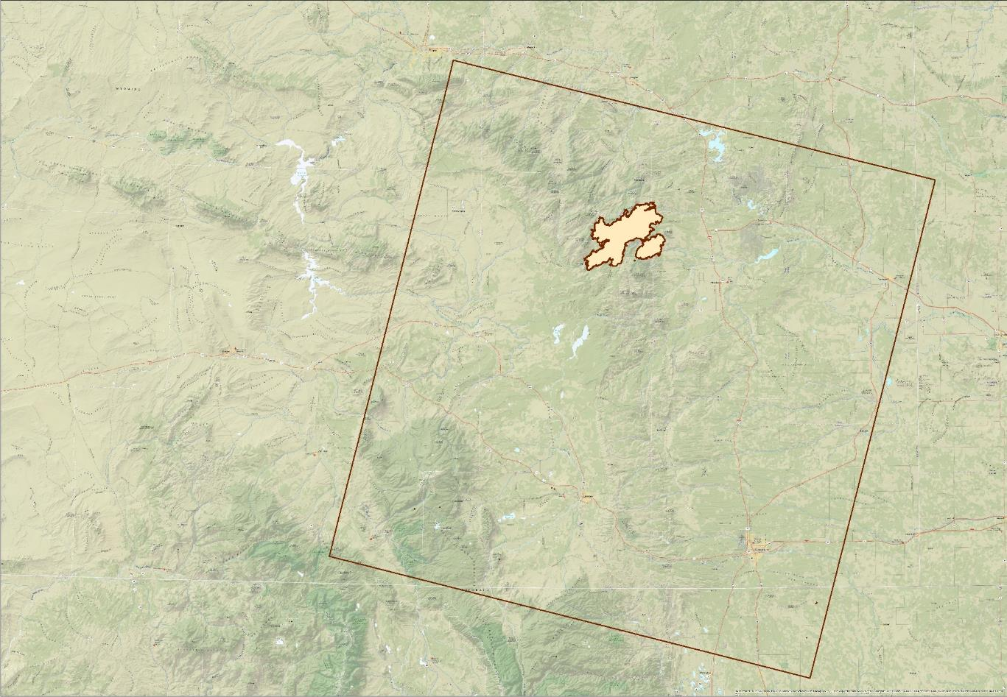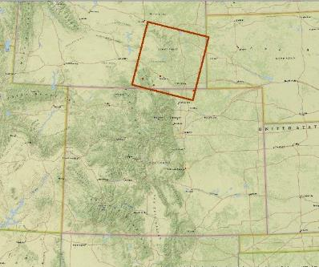

**Arapaho Wildfire Extent**

**Outline of Path 34 Row 31**

**Legend**



Figure 1. Study area for this project illustrating the extent of the 2012 Arapaho wildfire and the coverage of WRS2 Path 34, Row 31. Base map source: (National Geographic, Esri, DeLorme, HERE, UNEP-WCMC, USGS, NASA, ESA, METI, NRCAN, GEBCO, NOAA, increment P Corp.)

years after a fire event. Furthermore, we made use of Terra Moderate Resolution Imaging Spectroradiometer (MODIS) data pertaining to phenological stages of vegetation within the area to provide project partners with the necessary information for locating cheatgrass populations and timing the application of aerial herbicides.

**Study Area and Period**

The study area consists of the site of the 2012 Arapaho wildfire (42.201° N latitude, - 105.49° W longitude) in the Medicine Bow National Forest (MBNF) of Southeastern Wyoming (WRS2 Path 34, Row 31) (Figure 1). The Arapaho wildfire was one of the largest fires of the season in Wyoming, burning over 40,000 ha. Originally igniting from a lightning strike, the Arapaho wildfire burned from June 27 to August 23, 2012. The study area ranges in elevation from approximately 1500 m to approximately 3100 m and primarily consists of ponderosa pine forest and sagebrush steppe ecosystems. Landsat 8 OLI and TIRS data were collected for the 2015 growing season (May – September 2015), and Terra MODIS data were collected for a subset of locations within the study area from January 2009 through September 2015.

**National Application Addressed**

This project addressed the NASA National Application Area of Ecological Forecasting by creating predictive models of cheatgrass presence and absence in a post-wildfire area as well as providing detailed, spatially explicit, information regarding cheatgrass phenology. The results of this research will inform the management and mitigation of cheatgrass encroachment within the MBNF.

**Project Partners**

The primary project partners were the United States Department of Agriculture Forest Service, Laramie District,and Wyoming Game and Fish Department, organizations actively involved in the management of invasive species within the MBNF. Both organizations have a working relationship with the Natural Resource Ecology Laboratory (NREL) at Colorado State University. This project builds on the previous collaborative efforts of these groups.

# III. Methodology

**Data Acquisition**

This project made use of multiple NASA Earth observation data sources (Table 1). We acquired a 1-arc second, 30 m void-filled digital elevation model (DEM) from the SRTM using the United States Geological Survey (USGS) Earth Explorer portal (USGS, 2015). Also through the USGS Earth Explorer portal, we downloaded Landsat 8 Level 1, terrain corrected data for both the OLI and TIRS. All available scenes for Path 34, Row 31, with less than 10% cloud cover over the study area were acquired for the 2015 growing season (i.e., May – September), yielding a total of six scenes. Terra MODIS MOD13Q1 product data for multiple locations within the study area were downloaded from the Oak Ridge National Laboratory Distributed Active Archive Center (ORNL DAAC). The MOD13Q1 product data consisted of Normalized Difference Vegetation Index (NDVI) and Enhanced Vegetation Index (EVI) values for multiple locations within the study area, and all available dates were collected between 2009 and September 2015 (Table A2).

We were provided with an ESRI shapefile for the extent of the 2012 Arapaho wildfire from our project partners at USGS and NREL at Colorado State University, as well as point locations for cheatgrass percent cover field data gathered in 2014 and 2015.

Table 1. Summary of NASA Earth observation products used in this project.

|  |  |  |  |
| --- | --- | --- | --- |
| **Platform** | **Data Product** | **Spatial Resolution** | **Source** |
| Landsat 8 | OLI & TIRS | 30 m (OLI) & 100m (resampled to 30 m) (TIRS) | USGS Earth Explorer |
| Terra | MODIS MOD13Q1 product | 250 m | ORNL DAAC |
| SRTM | DEM | 30 m | USGS Earth Explorer |

**Data Processing**

We derived a series of vegetation indices for all Landsat 8 OLI images using an ArcMap toolbox created by our project partner at NREL at Colorado State University. Derived vegetation indices included the following; NDVI, Normalized Difference Water Index (NDWI), Modified Normalized Difference Water Index (MNDWI), EVI, Soil Adjusted Vegetation Index (SAVI), as well as three indices resulting from a tasseled cap (TCAP) transformation: TCAP soil brightness, TCAP vegetation greenness, TCAP soil/vegetation wetness.

In addition to vegetation indices, a series of topographic indices were derived from the 30 m DEM using the ArcGIS Geomorphometric & Gradient Metrics toolbox (Evans 2014). Derived topographic indices included slope, aspect, second derivative of slope (SDS), cosine transformation of aspect (COS), sine transformation of aspect (SIN), and compound topographic index (CTI). All vegetation and topographic indices were derived using ArcMap v. 10.2.

Field data consisting of percent cover of cheatgrass at 166 point locations within the study area were provided by our project partners at the USGS Fort Collins Science Center and NREL at Colorado State University in a comma separated values (CSV) file format. Field sampling locations were randomized within the Arapaho wildfire boundary and a sampling of an equal number of points within each distinct topographic zone was prioritized based on preliminary study site analysis. Percent cover was recoded such that locations with greater than or equal to 40% coverage were assigned a value of ‘1’ indicating cheatgrass presence and percent coverage values less than 40% were assigned a value of ’0’ indicating cheatgrass absence. The 40% threshold was supported in previous work as sufficient to accurately identify cheatgrass at a 30 m Landsat pixel resolution (West et al. In Review).

**Data Analysis**

SDMs were constructed using the USGS Software for Assisted Habitat Modeling (SAHM), an open-source species distribution and habitat suitability modeling software (Morisette et al. 2013). Input data consisted of derived vegetation and topographic indices as raster data and field data from 2014 and 2015 converted to presence/absence values. Data processing steps within SAHM ensured that all data were in the same projection, had the same coordinate system and geographic extent. All raster inputs were clipped to the study area and resulted in a ‘stack’ of predictor (i.e., covariate) raster layers. Covariate raster data at each of the field data locations was extracted and the field data were divided into cross validation folds for modeling and evaluation metrics. A final processing step identified cross-correlation and multicollinearity among covariates (Dormann et al. 2013, Morisette et al. 2013, West et al. 2015). In the event that two variables were strongly correlated (i.e., with a Spearman, Pearson, or Kendall correlation coefficient, |r| ≥ 0.70), the variable with either a greater percent variation explained (via Generalized Additive Modeling (GAM)), or biological/ecological relevance, was retained (West et al. In Review). A total of 16 covariates were used in the subsequent model runs.

SAHM allows for multiple models to be asynchronously run on the same data and each model generates a series of results including a continuous probability map, a binary classification map, and a set of model evaluation metrics. We ran four SDMs including: Boosted Regression Tree (BRT), Generalized Linear Model (GM), Multivariate Adaptive Regression Splines (MARS), and a Random Forest model (RF). GLM combines a random variable and linear combination of predictors to generate an ordinary linear regression describing their relationship. MARS utilizes a recursive partitioning technique to model nonlinear relationships between variables and predictors allowing it to fit highly complex relationships. BRT combines stochastic regression trees with diversified simple models to fit multiple trees and increase predictive ability. RF uses a bagging approach to aggregate and average a multitude of regression trees to create more accurate covariate classifications (West et al*.* 2015).

Five locations within the study area that exhibited a strong clustering of predicted cheatgrass presence values were selected to analyze seasonal phenology patterns. Terra MODIS NDVI and EVI data were collected from the MOD13Q1 product for coordinates approximately in the center of large presence clusters. Due to the relatively coarse spatial resolution of MODIS data (250 m pixel resolution for MOD13Q1), we limited our analysis to five locations with large numbers of contiguous presence values. The MOD13Q1 product provides NDVI and EVI data every 16 days. We compared seasonal and annual trends in the vegetation indices from 2009 through the 2015 growing season. Time series of NDVI and EVI data were plotted for all locations using the MODIS Subsetting Tool, an online data visualization tool from Oak Ridge National Laboratory (ORNL DAAC 2008). Data were plotted for the central pixel (approximately the latitude/longitude coordinates provided by the user) as well as the average pixel value within a user defined radius from the central pixel. We defined the radius to be the minimum allowed, 1 km.

# IV. Results & Discussion

Results suggested a general level of agreement between models with no individual model performing extremely well. Model outputs in SAHM are provided in an interactive ‘Spreadsheet view’ where maps and model evaluation metrics can be compared across all models (Figure 2). All models were run with default settings in SAHM and further exploration of parameter values should be expected to yield different results, though not necessarily improved model performance. While no individual model clearly outperformed others in all evaluation metrics, the BRT and RF models generally had stronger cross validation metrics than either GLM or MARS models.

BRT

GLM

MARS

RF

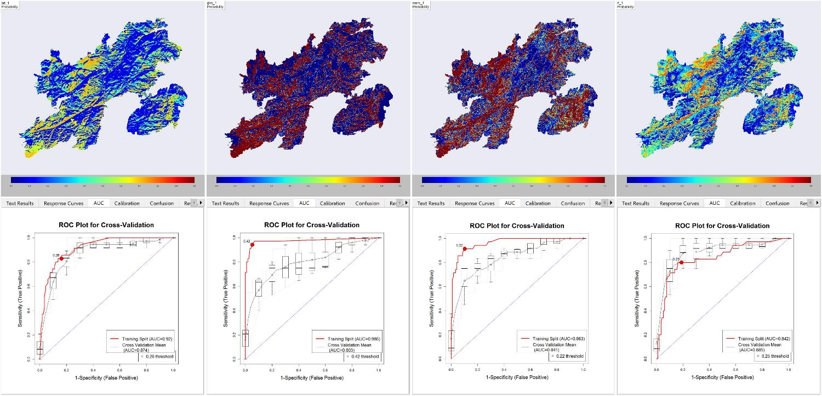

Figure 2. 'Spreadsheet' view in SAHM depicting the continuous probability map output (top row) and ROC model evaluation metric (bottom row) for each of the four models (columns). BRT: Boosted Regression Tree, GLM: Generalized Linear Model, MARS: Multivariate Adaptive Regression Splines, RF: Random Forest.

The RF model had less of a difference between training and cross validation in terms of mean Area Under the Curve (AUC) values (AUCtrain – AUCcvmean = 0.043; Figure 2) than did the BRT model. For discussion purposes, we continue with a description of RF results. It should be noted that direct comparison of AUC values between models has been criticized particularly in the area of SDMs (Lobo et al. 2008, Jiménez-Valverde 2012, and that the RF model did not outperform other models in all evaluation metrics (Table 2). Full parameter exploration for all models was beyond the scope of this project, but should be implemented for a rigorous interpretation of model performance.

The continuous probability map generated by the RF model theoretically illustrates the predicted probability of cheatgrass presence for each pixel within the study area (Figure 3). However, such a literal interpretation of probability values is cautioned against as the values only represent the probability of occurrence given the sampling design and not necessarily the true probability of occurrence (Talbert and Talbert 2014). Due to the ruggedness of the terrain in the study area, a completely random sampling design was not possible and this should be considered when interpreting the probability map.

Table 2. Cross validation evaluation metrics for all species distribution models. Initial value represents the mean statistic evaluated to two decimal places. Values in parentheses represent standard deviations evaluated to three decimal places.

|  |  |  |  |  |  |  |
| --- | --- | --- | --- | --- | --- | --- |
| **Model** | **AUC** | **% Correctly Classified** | **Sensitivity** | **Specificity** | **Kappa** | **True Skill Statistic** |
| BRT | 0.87 (0.037) | 82.87 (2.506) | 0.69(0.268) | 0.87 (0.068) | 0.53 (0.106) | 0.57 (0.206) |
| GLM | 0.80 (0.118) | 80.97 (4.616) | 0.61 (0.184) | 0.87 (0.092) | 0.47 (0.107) | 0.48 (0.132) |
| MARS | 0.84 (0.029) | 76.90 (5.019) | 0.71 (0.066) | 0.79 (0.058) | 0.44 (0.105) | 0.50 (0.098) |
| RF | 0.89 (0.063) | 86.23 (5.039) | 0.52 (0.259) | 0.97 (0.029) | 0.54 (0.194) | 0.49 (0.241) |

However, general summary observations can be made from the probability map. Project partners expressed the need for area estimates of cheatgrass cover. We produced a series of discrete probability classes and calculated the area of presence predictions within each class (Figure 4). Probability classes include ranges from 0.4-0.6, 0.6-0.8, and 0.8-1.0.

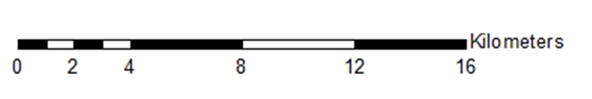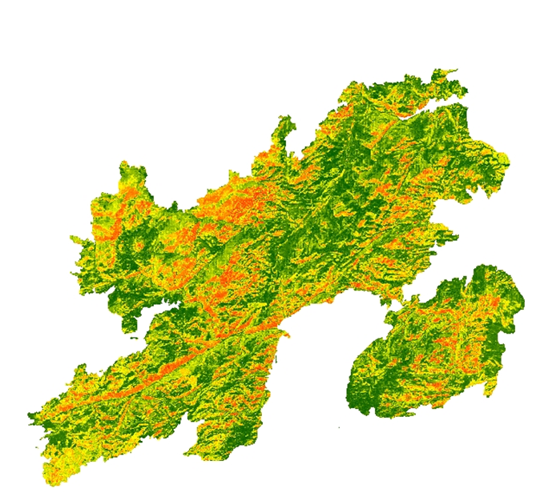

**Legend**

**Low**

**High**

Figure 3. Continuous probability map generated by the Random Forest model. Regions in red have the highest predicted probability of cheatgrass presence and dark green regions have the lowest.

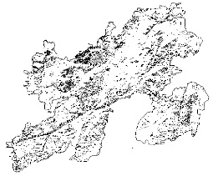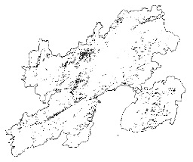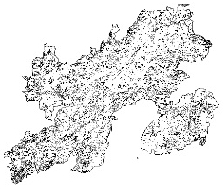

7495.56 ha

**0.6-0.8**

**0.8-1.0**

**0.4-0.6**

2191.5 ha

8862.93 ha

*Figure 4. Area estimate of cheatgrass cover by probability class. Class ranges are in bold above each of the maps, and area estimates (ha) are below each map.*

In effect, each of these maps constitute a binary classification map for different probability threshold ranges. SAHM automatically produces a binary classification map derived from the continuous probability map in a similar fashion (Figure 5).

Figure 5 Binary classification map produced in SAHM model outputs for the Random Forest model. The default setting of sensitivity = specificity returned a probability threshold of 0.472.

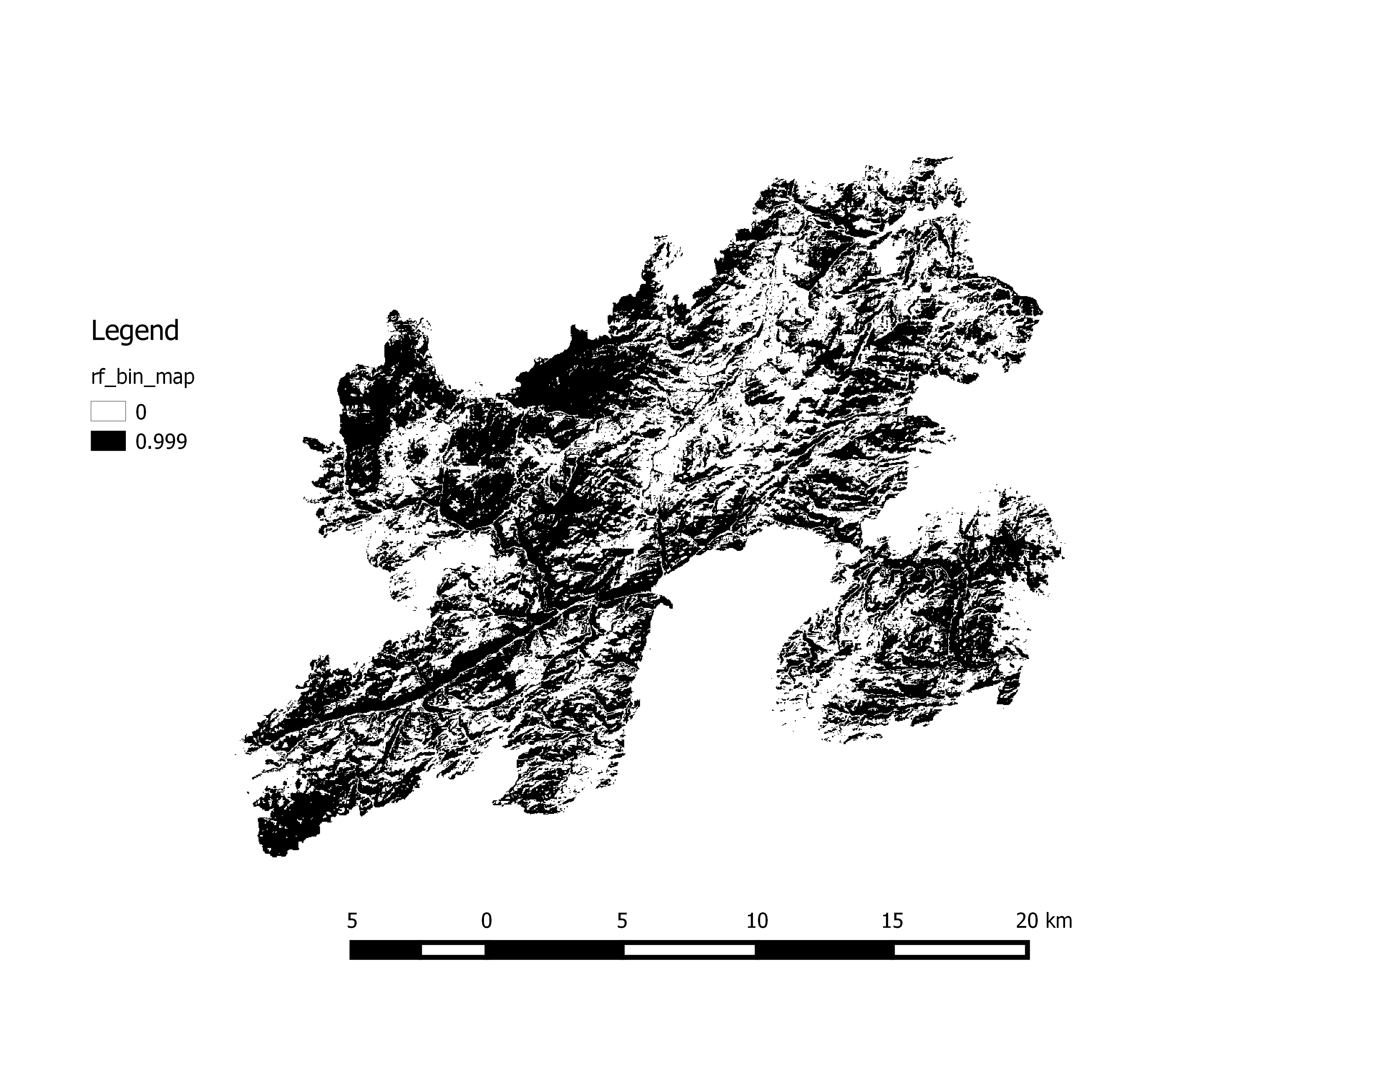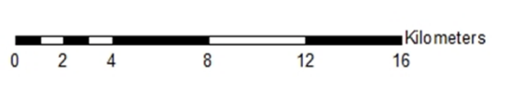

Absence

**Legend**

Presence

User defined thresholds for probability of cheatgrass presence can be supplied. Within the RF cross validation data, the default threshold classified pixels as cheatgrass presence when the continuous probability was equal to, or greater than 0.472.

Five locations within the study area that exhibited a clustering of predicted presence values were selected to analyze seasonal phenology patterns (Table A2). Terra MODIS NDVI and EVI data were collected from the MOD13Q1 product for coordinates approximately in the center of large presence clusters. MODIS data are at a relatively coarse spatial resolution (relative to Landsat data). In an attempt to get phenology information for cheatgrass populations in the study area, we limited our analysis to five locations with a large number of contiguous presence values.

The MOD13Q1 product provides NDVI and EVI data every 16 days. We compared seasonal and annual trends in the vegetation indices from 2009 through the 2015 growing season (Figure 6). Though the spatial resolution of MODIS data prohibits a per Landsat pixel analysis of seasonal trends, general differences between pre- and post-fire vegetation indices values were apparent. The Arapaho Fire in 2012 had a distinct effect on EVI values (Figure 6; red ovals). Additionally, noticeable differences in pre- and post-fire annual minimum and maximum EVI values can be seen.

Post-Fire EVI values

Pre-Fire EVI values

Absence

**Legend**

Presence

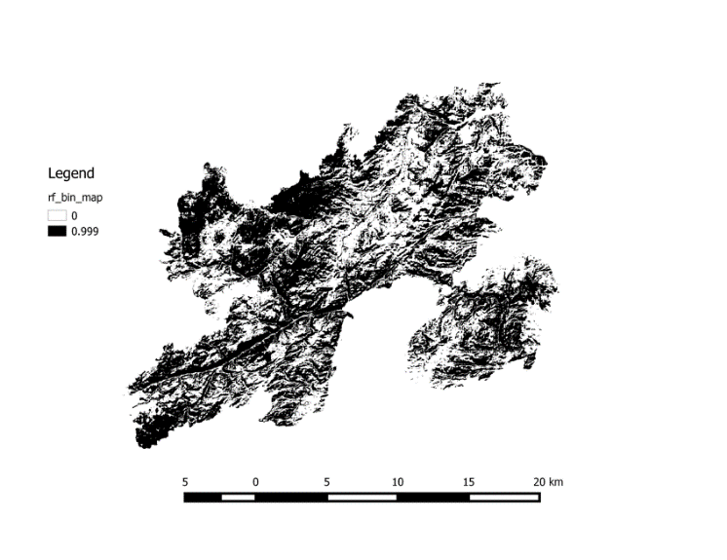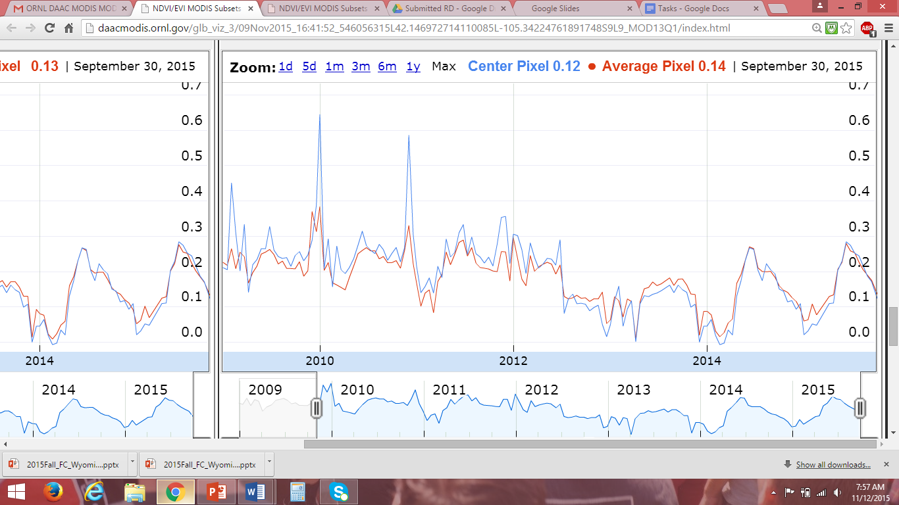

Arapaho

Fire

Pre-Fire EVI values

Post-Fire EVI values

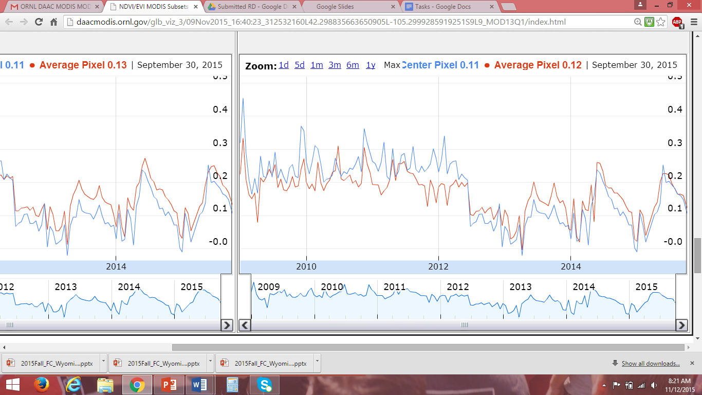

Arapaho

Fire

*Figure 6. Illustration of locations selected for analysis of seasonal phenology and MODIS EVI time series data. Plots were generated by the MODIS Subsetting Tool. Blue lines indicate the EVI data for the central pixel (approximately the user provided latitude/longitude coordinates) and the red lines indicate the average pixel value within a user defined radius from the central pixel (minimum allowed of 1 km).*

# V. Conclusions

The results for the project suggest that the application of species distribution models for management of invasive plant species such as cheatgrass holds promise as a valuable tool for land managers. The flexibility of modeling techniques provides great opportunity for refining and tailoring models to specific project needs, though a tradeoff between model complexity and interpretability exists. However, the performance of several of the models in this project using only default values provided by SAHM indicates that model refinement is certainly a worthwhile endeavor and may enhance model performance as well as usefulness.

A particular concern to our project partners is estimating the time of green-up and senescence for cheatgrass, which has noticeably different growth cycles than many native species. On regional and continental scales, this is often done by monitoring vegetation indices for periods of rapid change. While the approach holds promise for applications in the management of invasive plant species, the relatively coarse spatial resolution of data may limit its utility in small sites. Despite this limitation, the project provided strong indications of early growing season vegetation production. This data may be valuable for homogenous sites, even when the focal area is relatively small.

The final products delivered to our project partners included cheatgrass cover maps and area calculations based on these maps as well as general phenology time series data for locations predicted to have cheatgrass present.

# VI. Acknowledgments

* Dr. Paul Evangelista (Natural Resource Ecology Lab, Colorado State University)
* Dr. Amanda West (Natural Resource Ecology Lab, Colorado State University)
* Katherine Haynes (USDA Forest Service, Laramie District)
* Ryan Amundson (Wyoming Game and Fish Department)
* Catherine Jarnevich (USGS, Fort Collins Science Center)
* Colin Talbert (USGS, Fort Collins Science Center)
* Marian Talbert (USGS, Fort Collins Science Center)
* Ryan Anderson (Natural Resource Ecology Lab, Colorado State University)
* Brian Woodward (Natural Resource Ecology Lab, Colorado State University)
* Steve Chignell (Natural Resource Ecology Lab, Colorado State University)

Any opinions, findings, and conclusions or recommendations expressed in this material are those of the author(s) and do not necessarily reflect the views of the National Aeronautics and Space Administration.

This material is based upon work supported by NASA through contract NNL11AA00B and cooperative agreement NNX14AB60A.

# VII. References

Insert references here. Only include articles/content cited in the body of text above. It’s Banks ER, Baker WL (2011) Scale and Pattern of Cheatgrass (*Bromus tectorum*) Invasion in Rocky Mountain National Park. *Natural Areas Journal* 31:377-390.

Bromberg JE, Kumar S, Brown CS, Stohlgren TJ (2011) Distributional Changes and Range Predictions of Downy Brome (*Bromus tectorum*) in Rocky Mountain National Park. *Invasive Plant Science and Management* 4:173-182.

Campagnoni A and Adler PB (2014) Warming, Competition, and *Bromus tectorum* Population Growth Across an Elevation Gradient. *Ecosphere* 5(9): 121.

Dormann CF, Elith J, Bacher S, Buchmann C, Carl G, Carré G, Marquéz JRG, Gruber B, Lafourcade B, Leitão PJ, Münkemüller T, McClean C, Osborne PE, Reineking B, Schröder B, Skidmore AK, Zurell D, Lautenbach S (2013) Collinearity: a Review of Methods to Deal with it and a Simulation Study Evaluating their Performance. *Ecography* 36: 27-46.

Evans JS, Oakleaf J, Cushman SA, Theobald D (2014) An ArcGIS Toolbox for Surface Gradient and Geomorphometric Modeling, version 2.0-0. Available: http://evansmurphy.wix.com/evansspatial. Accessed: 2015 September 20th.

Jiménez-Valverde A (2012) Insights into the area under the receiver operating characteristic curve (AUC) as a discrimination measure in species distribution modelling. *Global Ecology and Biogeography* 21: 498-507.

Knapp PA (1996) Cheatgrass (*Bromus tectorum* L.) Dominance in the Great Basin Desert. *Global Environmental Change* 6: 37-52.

Lobo JM (2008) More complex distribution models or more representative data? *Biodiversity Informatics* 5: 14-19.

Mack RN (1981) Invation of *Bromus tectorum* L. into Western North America: an Ecological Chronicle. *Agro-Ecosystems* 7: 145-165.

Morisette JT, Jarnevich CS, Holcombe TR, Talbert CB, Ignizio D, Talbert MK, Silva C, Koop D, Swanson A, Young NE (2013) VisTrails SAHM: Visualization and Workflow Management for Species Habitat Modeling. *Ecography* 36: 129-135.

ORNL DAAC (2008) MODIS Collection 5 Land Products Global Subsetting and Visualization Tool. ORNL DAAC, Oak Ridge, Tennessee, USA. http://daacmodis.ornl.gov/.

Sher AA, Gieck S, Brown CS, Nissen SJ (2008) First-Year Responses of Cheatgrass Following *Tamarix* spp. Control and Restoration-Related Disturbances. *Restoration Ecology* 16(1): 129-135.

Talbert C, Talbert M (2014) User Documentation for the Software for Assisted Habitat Modeling (SAHM) package in VisTrails. *USGS Fort Collins Science Center.*

Wainwright CE, Wolkovich EM, Cleland EE (2012) Seasonal Priority Effects: Implications for Invasion and Restoration in a Semi-Arid System. *Journal of Applied Ecology* 49: 234-241.

West AM, Kumar S, Wakie T, Brown CS, Stohlgren TJ, Laituri M, et al. (2015) Using High-Resolution Future Climate Scenarios to Forecast *Bromus tectorum* invasion in Rocky Mountain National Park. *PloS ONE*.

West AM, Evangelista PH, Jarnevich CS, Kumar S, Swallow A, Luizza MW, Chignell SM (In Review) Developing Distribution Maps for Invasive Species in Post-Wildfire Landscapes Using Methods Relevant to Land Management. *For Environmental Management*.

# VIII. Content Innovation

**Glossary**

* **Area Under the Curve (AUC) Value** – Value used in classification analysis to determine which model predicts the classes best. The closer the AUC comes to 1, the more predictive the model is considered to be.
* **Cheatgrass (*Bromus tectorum*)** – In the Western United States, cheatgrass is a non-native, invasive grass species that rapidly encroaches on a landscape and outcompetes native species while also changing the fire regime of the area.
* **Phenology** – the study of cyclic and seasonal natural phenomena in relation to plant life.
* **Species Distribution Model (SDM)** – numerical tools that combine observations of species occurrence or abundance with environmental covariates.
* **Statistical Learning Models** – machine learning through the practice of ‘training’ a model with known data and ‘testing’ a model using withheld data
  + **Boosted Regression Trees (BRT)** – model that repeatedly partitions the provided data in two categories to reduce the variance within each partition; the methodology works well on non-linear relationships.
  + **Generalized Linear Model (GLM)** – model that applies a standard methodology to more than one dependent variable.
  + **Multivariate Adaptive Regression Splines (MARS)** – model that utilizes a non-parametric regression technique which processes non-linear interactions between variables.
  + **Random Forest (RF)** – model that uses an ensemble learning method to create a multitude of decision trees.
* **Tasseled Cap (TCAP) Transformation** – the conversation of the original bands into composite values.
  + Indices include TCAP soil brightness, TCAP vegetation greenness, TCAP soil/vegetation wetness.
* **Threshold** – chosen value to identify cheatgrass presence within the models.
* **Topographic Indices** – derivations from the Digital Elevation Model using the ArcGIS Geomorphometric & Gradient Metrics toolbox (Evans 2014).
  + Indices include slope, aspect, second derivative of slope (SDS), cosine transformation of aspect (COS), sine transformation of aspect (SIN), and compound topographic index (CTI).
* **USGS Software for Assisted Habitat Modeling (SAHM)** – a package of modules that takes predictor and field data inputs and simultaneously runs numerous species distribution models.
* **Vegetation Indices** – derivations from the Landsat 8 imagery using an ArcGIS toolbox.
  + Indices include Normalized Difference Vegetation Index (NDVI), Normalized Difference Water Index (NDWI), Modified Normalized Difference Water Index (MNDWI), Enhanced Vegetation Index (EVI), Soil Adjusted Vegetation Index (SAVI).
* **VisTrails** – an open-source workflow system that runs the USGS SAHM.

**Interactive Map Viewer**

KMZ file for Binary Map https://drive.google.com/file/d/0B-O6W-7h3WXkN1luOC1rWmRYOVk/view?usp=sharing

KMZ File for Probability Map https://drive.google.com/file/d/0B-O6W-7h3WXkMFBCQ1V4eDhSNGs/view?usp=sharing

**VPS**

https://drive.google.com/file/d/0B-O6W-7h3WXkZnpMeUlRZ3dNeXc/view?usp=sharing

# IV. Appendices

Table A 1. Final covariates used in all species distribution models.

|  |  |
| --- | --- |
| **Covariate** | **Description** |
| LC8_2015122_tcap3 | Landsat8 tasseled cap wetness (May 2, 2015) |
| LC8_2015250_tcap1 | Landsat8 tasseled cap brightness (Sept. 7, 2015) |
| Cos | Cosine of aspect |
| HLI | Heat Load Index |
| LC8_2015122_savi | Landsat8 soil adjusted vegetation index (May 2, 2015) |
| LC8_2015122_tcap1 | Landsat8 tasseled cap brightness (May 2, 2015) |
| LC8_2015154_nmdi | Landsat8 normalized multi-band drought index (June 3, 2015) |
| LC8_2015179_therm2 | Landsat8 thermal band 2 (June 27, 2015) |
| LC8_2015218_evi | Landsat8 enhanced vegetation index (Aug. 6, 2015) |
| LC8_2015218_nmdi | Landsat8 normalized multi-band drought index (Aug. 6, 2015) |
| LC8_2015218_ndvi | Landsat8 normalized differential vegetation index (Aug. 6, 2015) |
| LC8_2015218_tcap1 | Landsat8 tasseled cap brightness (Aug. 6, 2015) |
| SDS | Second derivative of slope |
| Slope | Mean slope of pixel |

Table A 2. MODIS MOD13Q1 data used for phenological time series. Links to the data viewer expire after 30 days. This table provides the information necessary to query the same locations and time periods used in this study. Link to ORNL DAAC MODIS Subsetting Tool where latitude and longitude coordinates can be entered: http://daacmodis.ornl.gov/. For all data requests, select Product as **[MOD13Q1] Vegetation Indices (NDVI, EVI)** and Kilometers Encompassing the Center Location as **1** Above and Below and **1** Left and Right.

|  |  |  |
| --- | --- | --- |
| **Latitude** | **Longitude** | **Time Period** |
| 42.298835663650905 | -105.2999285919251 | January 01, 2009 to September 30, 2015 |
| 42.23066465239649 | -105.40015763247062 | January 01, 2009 to September 30, 2015 |
| 42.146972714110085 | -105.34224761891748 | January 01, 2009 to September 30, 2015 |
| 42.216594623665536 | -105.25337751957767 | January 01, 2009 to September 30, 2015 |
| 42.23560285180904 | -105.50177465750662 | January 01, 2009 to September 30, 2015 |