Cape Hatteras Ecological Conservation II

Defining Methodology for Shoreline Delineation Using SAR and Optical Imagery to Inform Conservation Decision Making

 **Technical Report**

August 9th, 2024

Haley Baker (Project Lead)

David Babson IV

Alexandre Passin

Mia Schwartz

***Advisors:***

Dr. Xia Cai, NASA Langley Research Center (Science Advisor)

Dr. Kenton Ross, NASA Langley Research Center (Science Advisor)

***Previous Contributors:***

Ella Haugen

Alyson Bergamini

Julian Alcantara

***Lead:***  
Olivia Landry (Virginia – Langley)

# 1. Abstract

NASA DEVELOP’s Cape Hatteras Ecological Conservation II project partnered with the National Park Service (NPS) at Cape Hatteras National Seashore to delineate shorelines and map coastline change using an easily replicable methodology. This is a continuation of the previous DEVELOP Cape Hatteras project that utilized optical imagery from Landsat 8 Operational Land Imager (OLI), Landsat 9 OLI-2 and Sentinel-2 MultiSpectral Instrument; however, the second iteration of the project used Sentinel-1 C-band Synthetic Aperture Radar (C-SAR) and Landsat 8 OLI. Currently, the NPS uses time- and labor-intensive methods for delineation, primarily relying on walking or driving along the shoreline with a handheld global positioning system (GPS). To increase the efficiency of the current data collection methods, we aimed to utilize publicly available Sentinel-1 C-SAR and Landsat 8 OLI imagery to achieve the same results with significantly less work. This project focused on four high-risk areas of interest across the Cape Hatteras National Seashore: Haulover Day-Use Area, Sandy Bay, Northern Ocracoke Island, and the main cape at the tip of Hatteras Island. These National Seashore regions are important nesting sites for endangered shorebird and sea turtle species and day-use areas which provide park visitors with recreational opportunities. With focus on these areas, our methodology sought to delineate the shoreline of the entire Atlantic coast side of Cape Hatteras. The images were binarily classified using a threshold-based segmentation method and merged, then the output raster was vectorized to delineate the Atlantic coast side of Cape Hatteras. We validated the proposed method by running the output shoreline and a reference shoreline provided by NPS through a confusion matrix. We found that while our output shoreline is an average of the water line across an entire calendar year, the reference shoreline was gathered at high tide with a handheld GPS, leading us to overestimate water and skewing the percent accuracy and kappa coefficient. Despite the known bias, the percent accuracy returned at 0.796 and the kappa coefficient at 0.607, successfully validating the methodology for use by the NPS to analyze shoreline movement. By outlining a replicable methodology, NPS officials can continue to track shoreline change in the future and make informed decisions regarding shoreline conservation, mitigation, and restorative efforts – helping to not only improve the experience of visitors, but to understand the impact of shoreline movement on endangered species such as the Green Sea Turtle and Piping Plover.

**Key Terms**

remote sensing, SAR, geomorphology, coastal erosion, shoreline, Cape Hatteras, endangered species habitat, barrier island

# 2. Introduction

Established as the first national seashore in 1937, Cape Hatteras National Seashore is comprised of approximately 70 miles of the Outer Banks shoreline in North Carolina. The mission of Cape Hatteras National Seashore aims to preserve the delicate barrier island chain, maintain geomorphological processes that naturally shape the landscape, protect the wide variety of plant and animal species that inhabit the area, and facilitate safe recreation for humans and the environment. Frequent storms and other natural processes – such as sediment transportation and deposition, tidal and wave action, and sea level changes – have continually altered the Cape Hatteras’ coastline since its induction into the National Park Service (NPS) in 1937. As the coast migrates, essential ecosystems are disappearing; this includes nesting grounds for endangered sea turtles and shorebirds, and recreational areas of the Pamlico Sound on the estuary side of the Outer Banks. In addition to natural changes to the coastal landscape, the NPS has attempted efforts via human intervention many times over the years – beginning in 1934 with the Civilian Conservation Corps to preserve the barrier islands – such as dredging, creation of artificial dunes, and beach replenishment. While humans have tried to preserve and restore the seashore, the installation of Highway 12 (NC-12) and other infrastructure has increased the area’s vulnerability.

To monitor shoreline change over time, scientists at the NPS have been increasingly relying on remote sensing data. Remote sensing in Cape Hatteras began with aerial photography in the 1970s and was initially implemented to show that Hurricane Isabel had accounted for ~23% of the long-term shifting of Ocracoke Island (Conery et al., 2018). An additional remote sensing method is to utilize LiDAR imagery, which is exceedingly accurate, but also costly and generally only implemented following a recent storm event to observe immediate changes (Morton et al., 2005). Most commonly, the NPS collects global positioning system (GPS) data to create shoreline contours, though it is time-consuming, labor-intensive, and prone to human error.

Cape Hatteras’ geographic location at the intersection of the Gulf Stream and Main Development Region on the Atlantic coast vastly increases the area’s susceptibility to storms and their subsequent damage. The Main Development Region is bounded within 10 – 20° N and 20 – 60° W of the North Atlantic Ocean in which approximately 79% of all major hurricanes develop (Van Der Wal et al., 2005). Storms are largely responsible for the significant changes to the landscape of Cape Hatteras over time – specifically Nor’easters (named for their northeasterly winds), which occur over longer periods of time and more frequently than hurricanes (National Park Service, n.d.). Most recently, 2019’s Hurricane Dorian caused significant damage to Cape Hatteras with 98mph winds and 7ft inundation levels, leaving NC-12 inaccessible and trapping residents of Ocracoke on the isolated island (Avila-Alonso et al., 2020; Figure 1).

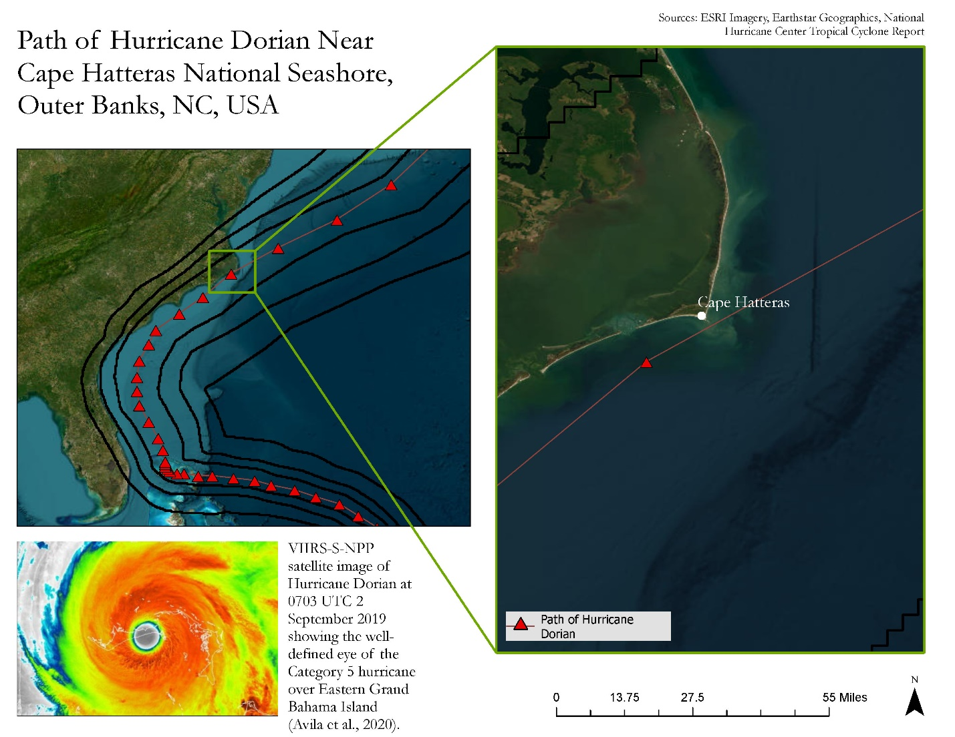

*Figure 1.* The above map depicts the path of Hurricane Dorian near Cape Hatteras National Seashore in 2019.

Waves from hurricanes and Nor’easters have contributed to widespread change of erosion rates in the northern and southern flanks of Cape Hatteras, creating an asymmetrical shoreline (Moore et al., 2013). Known as the “Graveyard of the Atlantic,” the Cape Hatteras National Seashore has many offshore, ever-changing underwater sandbars – colloquially called the Diamond Shoals – which extend seaward to the edge of the Gulf Stream (Ezer, 2020). These sandbars are formed by longshore drift, and the formation of dunes along the coastline can be attributed to wave action and winds. These factors lead to a dynamic and ever-changing landscape, with unique sediment depositional habits. Because of these depositional trends, the Outer Banks are greatly impacted by changes in sea level and storms (Geology and Ecology of National Parks, n.d.). The islands are often inundated during storms due to their low elevation, causing damage to private and commercial infrastructure alongside NC-12. While more vulnerable from June 1st to November 30th due to the hurricane season, the entirety of the barrier island chain remains vulnerable year-round, according to the United States Geological Survey (USGS) Coastal Vulnerability Index. The USGS found that more than 50% of the Outer Banks shoreline is either highly or very highly vulnerable (Pendleton et al., 2004). This vulnerability assessment of the Outer Banks indicates potential issues across many areas such as the main highway, NC-12, nesting sea turtle and shorebird habitats, hindrance to recreational activity in the area, and more.

The first iteration of this project, Cape Hatteras Ecological Conservation, utilized optical data from Landsat 8 Operational Land Imager (OLI), Landsat 9 OLI-2, and Sentinel-2 MultiSpectral Instrument (MSI) to create coastline change maps to support decision-making for Cape Hatteras National Seashore officials. Their research identified potential land loss in parts of their study area which prompted the NPS to focus mitigation efforts in the areas that were most impacted by coastal change, specifically Rodanthe and Cape Point (Haugen et al., 2024). For this study, Cape Hatteras Ecological Conservation II, we first intended to utilize the European Space Agency’s (ESA) Sentinel-1 C-band Synthetic Aperture Radar (C-SAR) to delineate and quantify shoreline change from 2015–2024 and create an easily replicable process to do so. The goal was to use radar imagery to compare differences in extracted shorelines from optical imagery. Synthetic Aperture Radar (SAR) imagery is ideal for tracking coastal shifting as it can see through cloud coverage and is captured at frequent intervals (Savastano et al., 2024). However, upon extensive manipulation of SAR data, we determined that for the scope of this project, it is infeasible to utilize SAR data alone to extract shorelines. This was determined because SAR data are unable to accurately capture sandy beaches along the Atlantic Coast, rendering any shorelines derived from the imagery inaccurate. Following this, we reviewed the limitations we found with SAR, as well as the limitations of the previous team’s work with optical data and determined that an integration of both data types could potentially provide a more holistic and accurate shoreline delineation. We then decided to couple SAR imagery with optical imagery, specifically NASA’s Landsat 8 OLI, to ensure accurate capture of both the Pamlico Sound and the sandy beach along the Atlantic Ocean (Figure 2). Because of the extent of Cape Hatteras’ vulnerability, we examined the entirety of the Cape Hatteras National Seashore, with focus on four specific locations designated by our partners at the NPS: Northern Ocracoke Island, Sandy Bay, Cape Hatteras, and Haulover. These areas all fall under High-Very High Vulnerability, according to the USGS Vulnerability Index (Pendleton et al., 2004).

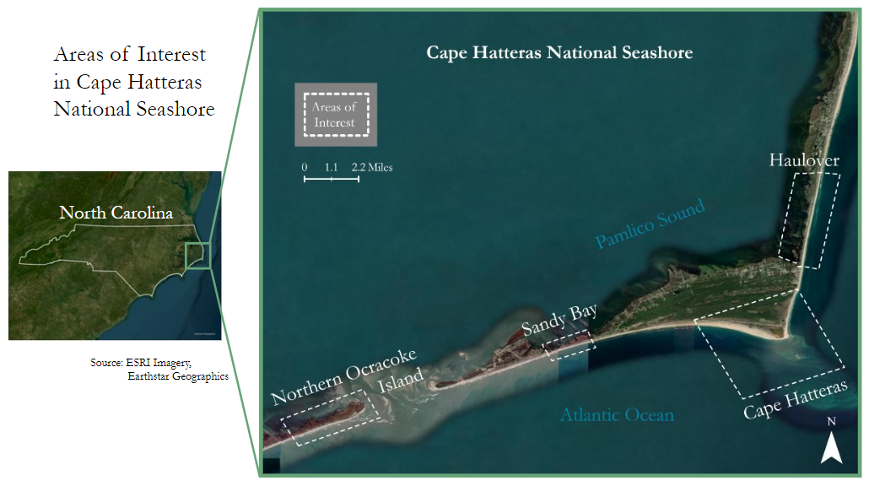

*Figure 2.* Cape Hatteras National Seashore, shown in relation to the seashore’s location in North Carolina and marked with pertinent locations addressed in this study

# 3. Methodology

***3.1 Data Acquisition***

To create a methodology for shoreline delineation, we acquired raster images from the publicly available Sentinel-1 C-SAR and Landsat 8 OLI collections located in the Google Earth Engine (GEE) online repository (Table 1). We chose to synthesize these imageries because of their respective abilities to capture opposing sides of the seashore. SAR is better suited to capturing the intricacies of the estuarine Pamlico Sound, while optical imagery better captures the sandy beaches along the Atlantic Ocean. The extent of these images was between 35° to 36° North and 75° to 76° West to capture the Outer Banks’ Cape Hatteras National Seashore. The Sentinel-1 imagery has a spatial resolution of 10m and a variable temporal resolution over the study period. The revisit period for Sentinel-1 from 2014 – 2015 and 2022 to present is 6 days while from April 2016 – December 2023, the revisit period is 12 days. The Landsat 8 imagery has a spatial resolution of 30m and a revisit period of 16 days throughout the project’s study period. Temporal resolution was important for this project because we collected images taken by each satellite over a full calendar year, so varying temporal resolution can affect the composite image we use in the proposed method.

Table 1

*Details regarding image acquisition from sensors on Sentinel-1 and Landsat 8*

|  |  |  |  |  |
| --- | --- | --- | --- | --- |
| **Platform/Sensor** | **Processing Level** | **Parameter** | **Spatial Resolution** | **Acquisition Dates** |
| Sentinel-1 C-SAR | Level 1 GRD | Backscatter | 10 meters | 2015/01/01 –  2023/12/30 |
| Landsat 8 OLI | Collection 2 Tier 1 | Top of atmosphere reflectance | 30 meters | 2015/01/01 –  2023/12/30 |

We filtered the data by varying percentiles based on the sensor with a set date range to create one composite image for each calendar year from 2015 – 2023. The SAR imagery we utilized comprised only of the VH polarization. The VH mode on the satellite transmits vertical waves and receives horizontal waves to create a SAR image and is generally more suitable for viewing mostly flat areas. We exported nine SAR images in the GeoTIFF file format, with each image being a composite raster filtered at the 80th percentile to maximize the visibility of the shoreline and comprised of all images Sentinel-1 acquired from January 1st – December 31st. The optical imagery we utilized comprised only of Band 5, the near-infrared (NIR) band, which provided high visibility of the shoreline while also maintaining some of the vegetated areas on the estuarine side of the Cape Hatteras National Seashore. We also exported nine optical images from Landsat 8 in the GeoTIFF file format, with each image being a composite raster filtered at the 65th percentile to minimize cloud coverage without hindering the visibility of the shoreline and comprised of all images acquired by Landsat 8 from January 1st – December 31st for all years in the study period. Filtering pixel brightness starting at the 65th percentile allowed us to remove the brightest pixels that were considered part of cloud cover in each image.

***3.2 Data Processing***

To convert the composite images collected from GEE to a delineated shoreline, we first used a threshold-based segmentation approach to classify the images by land and water (Figure 3). Threshold methods are used to generate a binary classification of images based on the pixel values within the image (Riehle et al., 2020). We implemented a manual threshold-based segmentation approach which required visual inspection of a histogram of all pixel values within the image. In theory, the lowest pixel value between two peaks on the histogram (Figure 4, 5) should be adopted as the threshold for classification. However, due to the complexity of the original Sentinel-1 and Landsat 8 rasters, which were each confounded by noise in some cases, it was challenging to establish a single threshold to apply to all images. Therefore, we evaluated the histograms of each individual image to determine the most accurate threshold for each instance. Once we determined the threshold values, we used them to generate a binary classification that resulted in a raster image in which land pixels were assigned a value of 1 and water pixels were assigned a value of 0.

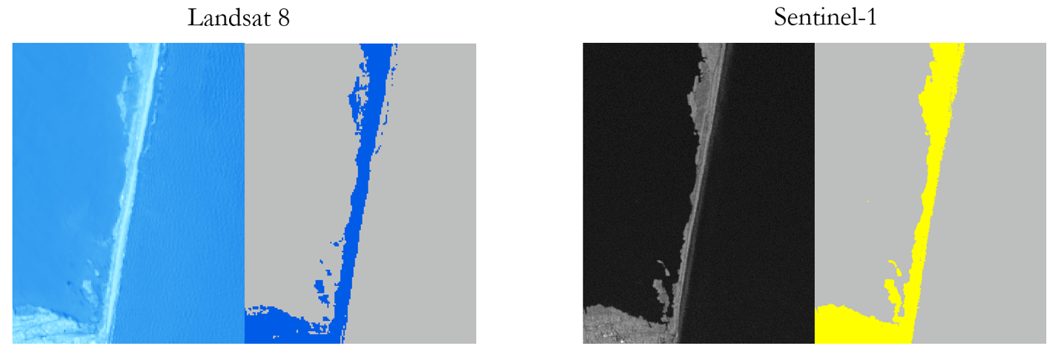*Figure 3.* Before & After classification for Landsat 8 and Sentinel-1 data at Haulover Beach in ArcGIS Pro 3.3.0. The left image of both comparisons is satellite imagery, while the right images are classified images.

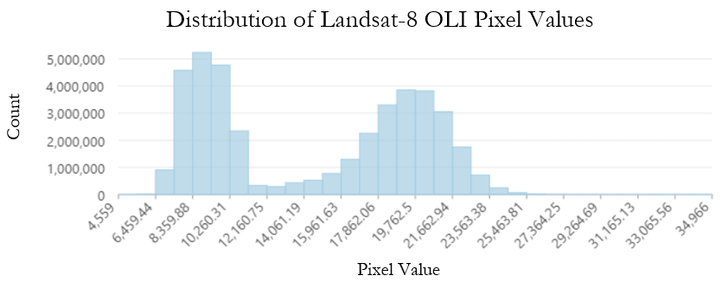

*Figure 4.* Histogram of Landsat 8 pixel values, with two peaks representing land and water

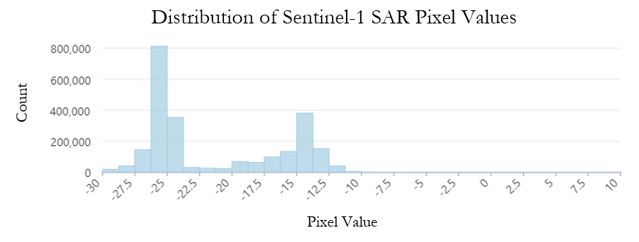

*Figure 5.* Histogram of Sentinel-1 pixel values, with two peaks representing land and water

Once both SAR and optical images were binarily classified, we needed to merge the two to mitigate SAR’s inability to capture the white sandy beaches of the Outer Banks, allowing for a delineation of the Atlantic Coast. We merged the two using a maximum overlay statistic, which means that the highest pixel value would determine the pixel value of the resulting merged raster. For instance, if a water pixel (value of 0) in the SAR imagery merged with an optical imagery land pixel (value of 1), the resulting pixel in the output raster would be considered land with a value of 1. After the rasters were merged, we reclassified isolated pixels within the raster by first applying a Majority Filter. For instance, if one land pixel was surrounded by many other water pixels, it would be reclassified as a water pixel based on the surrounding values. Next, we used the Boundary Clean tool to smooth the boundaries between land and water. Finally, the raster was vectorized to produce a delineated shoreline (Figure 6).

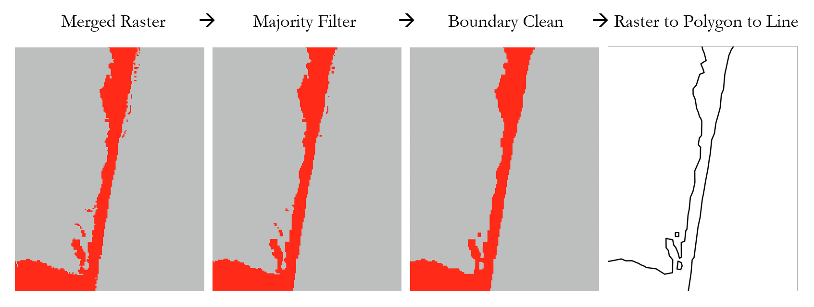*Figure 6.* Geoprocessing tools used to improve shoreline delineation in ArcGIS Pro 3.3.0. The left image is the initial merged raster, followed by the resultant rasters after applying the Majority Filter and Boundary Clean tools. The right image depicts the extracted shoreline following the vectorization process.

***3.3 Data Analysis***

We assessed the accuracy of the classified and merged raster against a reference shoreline provided by the NPS using a confusion matrix, a widely used accuracy assessment technique (Liu et al., 2016). We chose to generate a confusion matrix for this purpose because they are often used to assess the performance of a classification model (Dike et al., 2023). The NPS manually collected the reference shoreline in April 2021 under high-tide conditions with a handheld GPS. Using ArcGIS Pro 3.3.0, we performed a stratified random sampling to evenly distribute assessment points across the binary raster. We then extracted values at each assessment point over the reference shoreline raster. Then, we generated a confusion matrix with the extracted reference and generated values of the assessment points to calculate percent accuracy and the kappa coefficient. The percent accuracy describes the accuracy of the classification with random chance factored in, while the kappa coefficient describes the accuracy of the classification without factoring in the random chance of being correct, which provides a clearer understanding of the performance of the classification.

# 4. Results & Discussion

***4.1 Analysis of Results***

Based on the confusion matrix that compared the proposed shoreline with the NPS reference shoreline, the percent accuracy (approximately 80%) and kappa coefficient (approximately 61%) show good performance measurements between the two (Table 2). Because the kappa coefficient removes the possibility of a random chance agreement between the classifications, this indicates that the proposed shoreline is in substantial agreement with the shoreline collected by the NPS. The results of the confusion matrix also indicated that the majority of misclassified values were water values. Overall, the results suggest that the classifications of the proposed and reference rasters are comparable.

Table 2

*Confusion matrix output values*

|  |  |  |  |  |  |
| --- | --- | --- | --- | --- | --- |
| **Classification Value** | **0** | **1** | **Total** | **User Accuracy** | **Kappa** |
| **0** | 56 | 0 | 56 | 1 | 0 |
| **1** | 31 | 65 | 96 | 0.677 | 0 |
| **Total** | 87 | 65 | 152 | 0 | 0 |
| **Percent Accuracy** | 0.644 | 1 | 0 | 0.796 | 0 |
| **Kappa** | 0 | 0 | 0 | 0 | 0.607 |

***4.2 Errors & Uncertainties***

The first limitation we encountered was an expected bias – the confusion matrix results indicated that the majority of misclassified values were water values, likely due to a variation in water lines of the reference and proposed shorelines. The reference shoreline was gathered at the high-water line with a handheld GPS, while the proposed shoreline is the result of an average of the water line across an entire calendar year condensed into one composite image. Because of this, we expected to overestimate water, therefore skewing the percent accuracy and kappa coefficient. However, despite the known bias, the analysis results indicate good performance between the reference shoreline and proposed shoreline.

Another pertinent limitation of our methodology is that merging the SAR and optical classifications, while useful for the Atlantic Coast beaches of the Outer Banks, is incapable of capturing inlets and some internal water bodies due to the simplification of the classification and merging methods, especially along the estuarine Pamlico Sound (Figure 7). This could be due to the maximum overlay statistic used in the merging process, or the difference in spatial resolution between Sentinel-1 and Landsat 8. Either or both of these could have led to the water bodies being classified as land – meaning that we can only obtain the outer edge shoreline of the Cape Hatteras National Seashore (Figure 8).

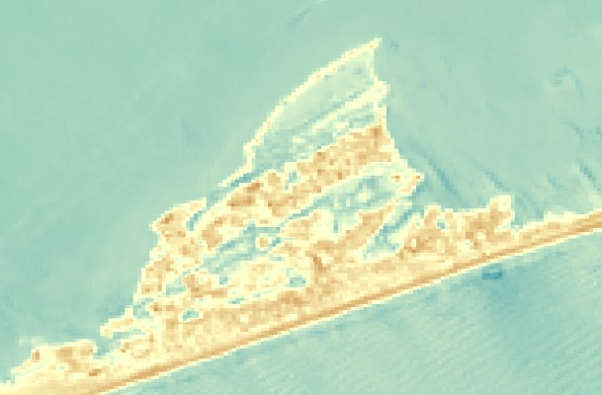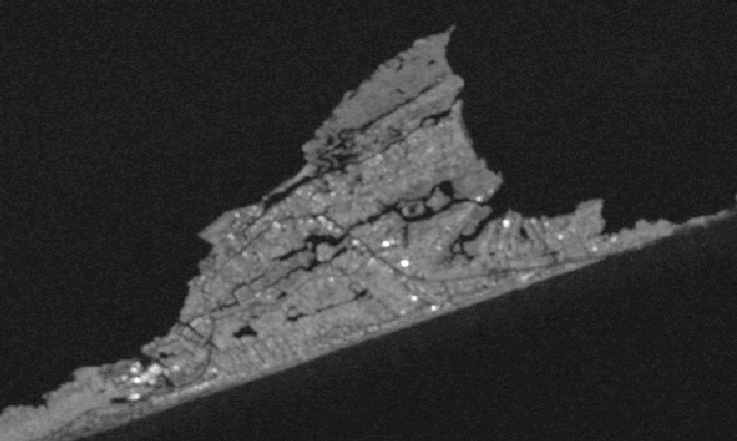

*Figure 7.* The above images depict Durant Point as viewed from Landsat 8 (left) and Sentinel-1 (right) to illustrate the loss of emergent wetlands in Landsat 8 imagery

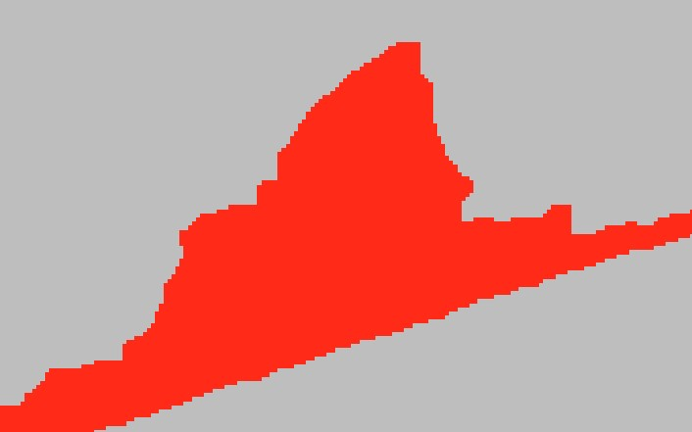

*Figure 8.* The above images depict Durant Point before (left) and after (right) classification and merging to illustrate the loss of inlets throughout the process

***4.3 Feasibility & Partner Implementation***

Overall, we found that it is feasible to delineate the shoreline along Cape Hatteras National Seashore by synthesizing Sentinel-1 C-SAR and Landsat 8 OLI imagery. The confusion matrix results indicate that our classifications are sufficiently accurate with the consideration of the known bias. Therefore, while we are unable to validate the shorelines on the Pamlico Sound, it is safe to assume that the proposed methodology can accurately delineate shorelines along the Atlantic Coast of the Cape Hatteras National Seashore.

Because of the laborious nature of the National Park Service’s current GPS based shoreline delineation methods, a replicable methodology utilizing remote sensing data can alleviate restrictions and limitations for their future analyses. Using this proposed methodology, Cape Hatteras National Seashore officials will be able to implement the use of satellite data as opposed to manual GPS collection of shoreline data, reducing the time and labor required to do routine checks on the status of the ever-changing coastline. This will allow NPS officials to conduct analyses more often, granting a better visualization of how the Atlantic Coast of the Outer Banks is shifting over time, as well as immediate change detection following storm events. The regularity at which remote sensing data is collected and has the potential to be analyzed will allow for more informed decision-making regarding environmental and human factors present in Cape Hatteras National Seashore.

# 5. Conclusions

Ultimately, we determined that it is largely feasible to synthesize Sentinel-1 C-SAR and Landsat 8 OLI imagery to accurately and efficiently delineate the Atlantic Coast shoreline by using a confusion matrix. Despite the overestimation of water pixels, the resultant percent accuracy value at approximately 80% confirms the accuracy of the classification method implemented and thus confirmed accuracy of the proposed method’s output shoreline. We are confident that NPS officials can implement this methodology in addition to their current collection methods.

To further the methodology if desired, the NPS could benefit from collecting a recent shoreline on the Pamlico Sound side of the Cape Hatteras National Seashore. We were unable to conduct a statistical analysis on the estuarine shoreline produced by our proposed methodology without a reference shoreline collected within our study period, so we cannot say if the method is accurate along the estuarine side. Once updated data is collected, the same analysis method – the confusion matrix – could be applied to the estuarine shoreline to determine whether the methodology is accurate for both the Atlantic Coast and Pamlico Sound shorelines.

Using remote sensing in addition to, as opposed to relying solely on, handheld GPS data collection allows the NPS to more regularly assess shoreline change over time. The ability to assess shoreline movement more frequently allows for informed decision-making regarding both human and environmental concerns. The proposed method could also be implemented by other agencies to delineate shorelines in National Parks or other natural areas with similar topography to the Cape Hatteras National Seashore.

# 6. Acknowledgements

The Cape Hatteras Ecological Conservation II Team would like to thank Michael Flynn (NPS), Dr. Kent Ross and Dr. Xia Cai for their science advising, our Lead Olivia Landry (Virginia – Langley), Marisa Smedsrud (Virginia – Langley) for Project Coordination support and the Cape Hatteras Ecological Conservation Team (Ella Haugen, Alyson Bergamini, and Julian Alcantara) for their efforts throughout the first term of this project.

Any opinions, findings, and conclusions or recommendations expressed in this material are those of the author(s) and do not necessarily reflect the views of the National Aeronautics and Space Administration.

This material contains modified Copernicus Sentinel data (2015 – 2023), processed by ESA.

This material is based upon work supported by NASA through contract 80LARC23FA024.

# 7. Glossary

**ArcGIS Pro** – A geospatial analysis platform developed by ESRI where users can analyze satellite imagery and create maps

**C-SAR** – The sensor that collects SAR data on the Sentinel-1 satellite

**Earth observations** – Satellites and sensors that collect information about the Earth’s physical, chemical, and biological systems over space and time

**GEE** – Google Earth Engine; a geospatial analysis platform which provides satellite imagery for users to analyze

**GeoTIFF** – A file format for georeferenced raster imagery

**GPS** – Global Positioning System

**Landsat 8** – A satellite, owned by both USGS and NASA satellite which collects optical data

**NC-12** – North Carolina Highway 12 which runs through Cape Hatteras and the Outer Banks

**NPS** – National Park Service

**OLI** – Operational Land Imager, an imager on the Landsat 8 satellite

**SAR** – Synthetic Aperture Radar

**Sentinel-1** – A European Space Agency satellite

**USGS** – United States Geological Survey

# 8. References

Avila-Alonso, D., Baetens, J., Cardenas, R., & De Baets, B. (2021). Oceanic response to the consecutive Hurricanes Dorian and Humberto (2019) in the Sargasso Sea. *Natural Hazards and Earth System Sciences, 21*(2),837 – 859. <https://doi.org/10.5194/nhess-21-837-2021>

Conery, I., Walsh, J. P., & Reide Corbett, D. (2018). *Hurricane Overwash and decadal-scale evolution of a narrowing barrier island, Ocracoke Island, NC*. Estuaries and Coasts, 41(6), 1626 – 1642. <https://doi.org/10.1007/s12237-018-0374-y>

Dike, E. C., Oyetunji, A. K., & Amaechi, C. V. (2023). *Shoreline delineation from synthetic aperture radar (SAR) imagery for high and low tidal states in data-deficient Niger Delta region.* Journal of Marine Science and Engineering, 11(8), 1528. <https://doi.org/10.3390/jmse11081528>

Earth Resources Observation and Science Center. (2020). *Landsat 8 OLI/TIRS* [Data set]. United States Geological Survey. <https://doi.org/10.5066/f78s4mzj>

Ezer, Tal. (2020). The long-term and far-reaching impact of hurricane Dorian (2019) on the Gulf Stream and the coast. *Journal of Marine Systems, 208*. 103370. <https://doi.org/10.1016/j.jmarsys.2020.103370>

Geology and Ecology of National Parks. (n.d.). *Geology of Cape Hatteras National Seashore.* United States Geological Survey. <https://www.usgs.gov/geology-and-ecology-of-national-parks/geology-cape-hatteras-national-seashore>

Haugen, E., Bergamini, A., & Alcantara, J. (2024). *Cape Hatteras Ecological Conservation: Delineating Shoreline and Mapping Change Along the Cape Hatteras National Seashore for Coastline Management and Transportation Corridor Adaptation Strategies.* NASA DEVELOP National Program, Virginia – Langley. <https://ntrs.nasa.gov/api/citations/20240005719/downloads/2024Spring_LaRC_CapeHatterasEco_TP_FD-final.pdf>

Liu, X., Gao, Z., Ning, J., Yu, X., & Zhang, Y. (2016). *An improved method for mapping tidal flats based on remote sensing waterlines: A case study in the Bohai Rim, China.* IEEE Journal of Selected Topics in Applied Earth Observations and Remote Sensing, 9(11), 5123 – 5129. <https://doi.org/10.1109/jstars.2016.2616514>

Moore, L., McNamara, D., Murray, A., & Brenner, O. (2013). Observed changes in hurricane-driven waves explain the dynamics of modern cuspate shorelines. *Geophysical Research Letters*, *40*(22) 5867 – 5871. <https://doi.org/10.1002/2013GL057311>

Morton, R. A., & Miller, T. L. (2005). *National Assessment of Shoreline Change: Part 2, historical shoreline changes and associated coastal land loss along the U.S. Southeast Atlantic Coast* (Open-File Report 2005-1401). United States Geological Survey. <https://doi.org/10.3133/ofr20051401>

National Park Service. (n.d.). *NPS geodiversity Atlas-Cape Hatteras National Seashore, North Carolina (U.S. National Park Service)*. U.S. Department of the Interior. <https://www.nps.gov/articles/nps-geodiversity-atlas-cape-hatteras-national-seashore-north-carolina.htm>

Pendleton, A., Thieler, E., & Williams, S. (2004). *Coastal Vulnerability Assessment of Cape Hatteras National Seashore (CAHA) to Sea-Level Rise.* United States Geological Survey. 2004 – 1064. <https://doi.org/10.3133/ofr20041064>

Riehle, D., Reiser, D., & Griepentrog, H. W. (2020). Robust index-based semantic plant/background segmentation for RGB-Images. *Computers and Electronics in Agriculture, 169*, 105201.

<https://doi.org/10.1016/j.compag.2019.105201>

Savastano, S., Gomes da Silva, P., Sanchez, J., Tort, A., Payo, A., Pattle, M., Garcia-Mondejar, A., Castillo, Y., & Monteys, X. (2024). Assessment of Shoreline Change from SAR Satellite Imagery in Three Tidally Controlled Coastal Environments. *Journal of Marine Science & Engineering, 12*(1), 163. <https://doi.org/10.3390/jmse12010163>

Van Der Wal, D., Herman, P., & Wielemaker-van den Dool, A. (2005). Characterisation of surface roughness and sediment texture of intertidal flats using ERS SAR imagery. *Remote Sensing of Environment, 98*(1)*,* 96 – 109. <https://doi.org/10.1016/j.rse.2005.06.004>