**NASA DEVELOP National Program**



Maricopa County Department of Public Health and Arizona State University

**Fall 2016**

**Short Title: Maricopa County Health & Air Quality II**

**Subtitle:** Modeling a Decade of PM10 Concentrations in Maricopa County, Arizona for Air Quality and Epidemiological Analysis

**VPS Title:** The Air Up There: Using Satellites to Monitor Particulate Matter

**Project Team & Partners**

**Project Team:**

Tamara Dunbarr (Project Lead), tdunbarr@asu.edu

Michael Pechacek

Jayanth Serla

Parul Singh

**Advisors & Mentors:**

Lance Watkins (NASA DEVELOP National Program)

David Hondula (Arizona State University)

**Past or Other Contributors:**

Jason Hodgson

Leslie Araujo

**Partner Organizations:**

|  |  |  |  |
| --- | --- | --- | --- |
| **Organization** | **POC (Name, Position/Title)** | **Partner Type** | **Boundary Org?** |
| Maricopa County Department of Public Health (MCDPH) | Kate Goodin, Epidemiologist and Data Services Program Manager | End-User | No |
| Maricopa County Air Quality Department | Ronald Pope, Atmospheric Scientist | Collaborator | No |

**Project Details**

**Applied Sciences National Applications Addressed:** Health and Air Quality

**Study Area:** Maricopa County, AZ

**Study Period:** January 2006 – December 2015

**Earth Observations & Parameters:**

Terra, Moderate Resolution Imaging Spectroradiometer (MODIS) – aerosol optical depth

Aqua, Moderate Resolution Imaging Spectroradiometer (MODIS) – aerosol optical depth

Landsat 7, ETM+ (SLC-off) – Thermal Band pixel DN values for correlation with PM10

**Ancillary Datasets Utilized:**

* NCEI Global Historical Climatology Network (GHCN) – Station location, elevation, temperature, wind speed, visibility, pressure, and precipitation
* Daymet – Gridded temperature
* NOAA Advanced Hydrologic Prediction Service (AHPS)– Recent Precipitation
* US Environmental Protection Agency AIRNow – PM10 Measurements
* US Census Bureau TIGER dataset – Arizona roads, county borders
* Maricopa County Department of Public Health (MCDPH) – Point locations of K-12 schools in Maricopa County

**Software Utilized:**

* ESRI ArcGIS – Raster manipulation/analysis, image enhancement & map creation of Aqua and Terra MODIS aerosol optical depth
* Python – Scripting to process satellite images, modeling of PM concentrations with additional variables.
* R – Statistical data analysis, mixed model development, and model application to other data

**Project Overview**

**80-100 Word Objectives Overview:**

The main goal of the project was to generate continuous and reliable predictions of PM10 throughout Maricopa County, Arizona. Our objectives this term were to enhance the previous term’s model of PM10,by potentially incorporating MODIS MAIAC, a different MODIS-based aerosol optical depth product and/or Landsat 7 ETM+ thermal band data and refined NOAA, USGS, and EPA ancillary data, in a mixed-effect, land use regression model. A secondary analysis combined the EPA’s Air Quality Index with the PM10 time series to identify communities that are at a greater risk of exposure to poor air quality.

**Abstract:**

Exposure to air pollution is associated with respiratory and cardiovascular morbidity and mortality. Particulate matter (PM) less than 10 microns in diameter is a key contributor to poor air quality, posing a significant public health hazard. In Maricopa County, Arizona the combination of a scarcely vegetated, semi-arid landscape and high anthropogenic activity (e.g. the prevalence of industrial and agricultural activity, wood burning, and vehicle emissions) results in atmospheric concentrations of particulate matter that can exceed federal air quality standards and threaten human health. Despite the presence of one of the Southwest’s most innovative pollutant monitoring networks, which benefits from the latest technologies in advanced real-time detection and prevention, the vast size and complex geography of Maricopa County make it difficult to monitor particulate matter in all communities of interest. Moderate Resolution Imaging Spectroradiometer (MODIS) Level 2 aerosol optical depth data were utilized in combination with Landsat 7 ETM+ thermal band data, environmental variables, elevation, and transportation to predict particulate matter concentrations throughout Maricopa County. The predicted particulate matter concentrations were further examined in the context of the US Environmental Protection Agency’s (EPA) Air Quality Index, which relates particulate concentration to health impact, to categorize the health risk around schools throughout the county. The end products produced from this project were given to the Maricopa County Department of Public Health and the Maricopa County Air Quality Department for future epidemiological research and public outreach efforts.

**Keywords:**

Remote Sensing, MODIS, Air Pollution, EPA, NAAQS, Mixed Effects Model

**Community Concerns:**

* Many studies have suggested that particulate matter 10 microns or less in size is epidemiologically significant to all populations, but is especially a concern for susceptible groups with pre-existing lung and heart disease, as well as elderly people and children.
* On June 10th 1996, the Environmental Protection Agency (EPA) designated Maricopa County as being in “serious non-attainment” of PM10 standards.
* Particulate matter also contributes to poor visibility in the valley which is responsible for “Valley Brown Cloud.”
* There is an ongoing legal battle on the policies that dictate air quality standards, and the lack of geophysical and biological considerations for the creation of those standards by the EPA. Changing EPA guidelines based on environment type to better achieve Maricopa County’s PM10 attainment status of federal standards.

**Current Management Practices & Policies**:

The monitoring of PM10 by the Maricopa County Department of Air Quality is conducted in compliance with the Environmental Protection Agency’s (EPA) federal air quality compliance standards. There are sixteen stations to monitor Maricopa County PM10 concentration, which are concentrated in and around the urban core of the county (the major cities of Phoenix, Mesa, Chandler, Glendale, Tempe, and Scottsdale). This means there are large areas of land that are unmonitored in the county’s rural places and many communities without a local monitor in the urban core. Every monitor has distinct representative area range; each monitor represents a given sample area, depending on the monitor type used, and the sampling specifications for that monitor. The PM10 concentration monitoring network data is used by the EPA to find out if the county is in attainment of federal air quality standards. Maricopa County was designated as a “serious non-attainment zone”, hence there is a necessity for the county to mandate the Clean Air Act.

**Decision Support Tools & Benefits:**

|  |  |  |  |
| --- | --- | --- | --- |
| **End-Product** | **Earth Observations Used** | **Benefit & Impact** | **Software**  **Release** |
| PM10 Land Use Regression Model | Terra MODIS aerosol optical depth, Aqua MODIS aerosol optical depth, Landsat 5 Thematic Mapper | This product will help our partners understand the spatial variation in PM10 concentrations and associated vulnerability throughout Maricopa County. | III |
| PM10 Time Series Database | Terra MODIS aerosol optical depth, Aqua MODIS aerosol optical depth, Landsat 5 Thematic Mapper | This database will allow our end-users to immediately explore and investigate PM related issues in Maricopa County that are outside the immediate scope of this project. | none |
| PM10 Concentration Time Series Analysis | Terra MODIS aerosol optical depth, Aqua MODIS aerosol optical depth, Landsat 5 Thematic Mapper | This product will help the partners identify areas in the county that have experienced consistently high PM10 over the past decade. | none |
| Air Quality Historical Overlay Analysis | Terra MODIS aerosol optical depth, Aqua MODIS aerosol optical depth, Landsat 5 Thematic Mapper | This product will be used to better understand the disproportionate amount of PM10 exposure experienced at schools throughout Maricopa County. | none |

**Project VPS/Booklet Imagery**

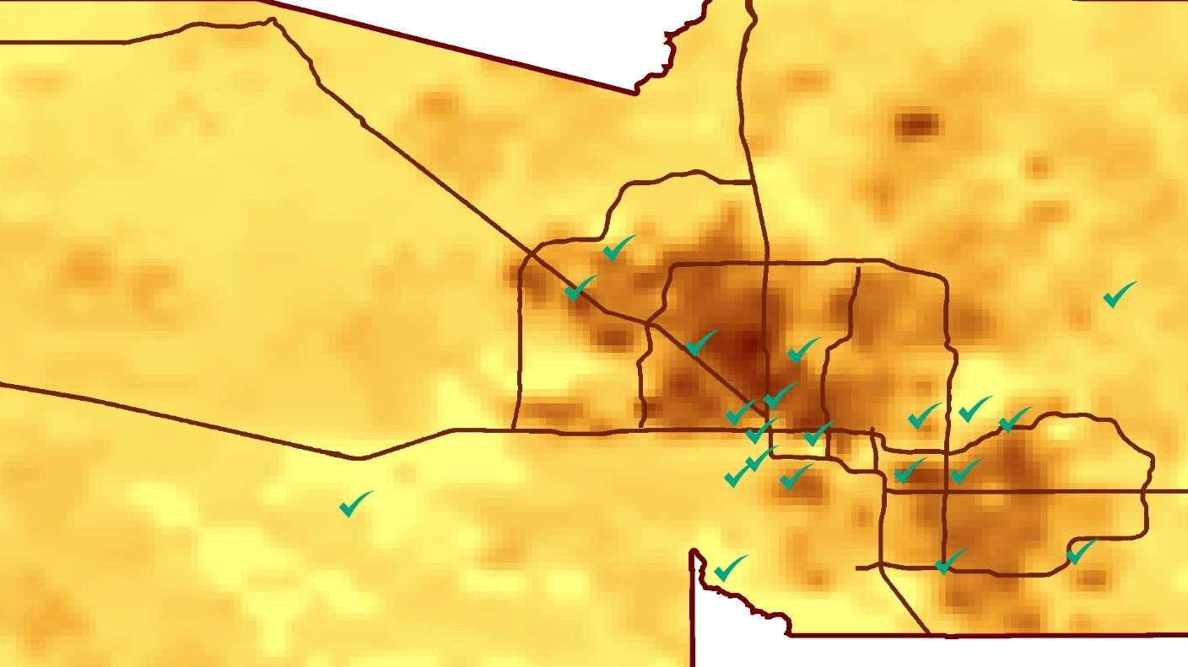

**Caption:** Interpolated photo of Aqua MODIS Aerosol Optical Depth over the Maricopa County area over the course of one month, overlaid with major highways and the points where particulate matter has ground based monitoring available. Image Credit: Maricopa County Health & Air Quality II Team.

**Image:** 2016Fall_AZ_MaricopaCountyHealthAQII_WebsiteImage.jpg