Dominican Republic Disasters

Mapping Landslide Susceptibility and Exposure in the Dominican Republic Using NASA Earth Observations

 **Technical Report**

Final Draft – August 8th, 2019

Sarah Aldama (Project Lead)

Chelsea Dandridge

Kyung “Robin” Kim

Gigi Pavur

Dr. Dalia Kirschbaum, NASA Goddard Space Flight Center (Science Advisor)

Dr. Kenton Ross, NASA Langley Research Center (Science Advisor)

# 1. Abstract

Rainfall-triggered landslides associated with tropical storms cause devastating damage to the communities in the Dominican Republic and surrounding Caribbean islands. With the predicted increase in the frequency and intensity of storms, the region would benefit from reliable disaster monitoring. Partnering with Servicio Geológico Nacional (SGN) and Oficina Nacional de Meteorología (ONAMET), the team created local landslide susceptibility maps and used them in combination with NASA Earth observations as inputs to the Landslide Hazard Assessment for Situational Awareness (LHASA) model to visualize potential landslide activity in near real-time. Susceptibility maps were based on slope derived from elevation data from the Shuttle Radar Topography Mission (SRTM), geology, road networks, fault lines, and forest loss. In LHASA, each map was combined with near real-time rainfall data from the Global Precipitation Measurement (GPM) mission. Using model outputs, the team identified areas of moderate and high potential landslide activity in a northern region of interest identified by our partners. Additionally, exposure maps were generated using a bivariate method that combined susceptibility with population and critical infrastructure data. The team created a LHASA standard operating procedure document for the end users at SGN and ONAMET. The partners can use this to update the susceptibility maps as new data becomes available and run the LHASA model independently to monitor near real-time landslide potential.

**Keywords**

LHASA, landslides, susceptibility, SICA, GPM, disaster monitoring, exposure

# 2. Introduction

* 1. ***Background Information***

The Dominican Republic, like other Small Island Developing States (SIDS) recognized by the United Nations, faces significant social, economic, and environmental challenges such as small geographic size, heavily populated coastal regions, and limited resource bases (UN-OHRLLS, 2011). Given its location in the Hurricane Alley and the Tropics, the Dominican Republic experiences heavy rainfall events that initiate the majority of their landslides (Negri et al., 2005). The country’s wet climate, combined with varying topography and unique geological conditions, evokes widespread landslides over the island. While landslides serve as natural and vital processes for continually shaping local topography, these events can be detrimental to nearby communities (Anderson & Anderson, 2010; Jeffrey, 1982; Sergio, 1995). With the predicted increase in the frequency and intensity of tropical storms, the region would benefit from reliable disaster monitoring (Knutson et al., 2015). In order to enhance the monitoring of potential landslide activity in the Dominican Republic, it is necessary to understand the country’s physical characteristics, including climate, geology, and population density.

The use of spatial data and the developments in the assessment of landslide susceptibility have vastly improved in the past decades. Consistent and reliable landslide inventories are important to quantify landslide hazard and risk (Van Westen, Castellanos, & Kuriakose, 2008). The NASA Global Landslide Catalog (GLC) serves as a citizen science platform to expand the global database of landslide occurrences (Kirschbaum, Adler, Hong, Hill, & Lerner-Lam, 2010; Kirschbaum, Stanley, & Zhou, 2015). This inventory relies on public input of landslides, often including media coverage or eyewitness accounts. Since the Dominican Republic lacks an extensive presence in the GLC, there is increased motivation to improve the historical record of landslide events in the Dominican Republic and to better understand the intricacies of this region (Kirschbaum, Stanley, & Simmons, 2015).

In conjunction with landslide inventories, satellite imagery plays an increasingly important role in the spatial analysis of landslide risk through the use of geological and meteorological data. Previous landslide research has identified a multitude of variables that contribute to landslide susceptibility, including lithology, regional rainfall, slope, tectonic activity, soil moisture, land cover, forest loss, and the presence of roads (Kirschbaum, Stanley, & Simmons, 2015; Klug, Grossman, & Cissell, 2016; Nadim, Kjekstad, Peduzzi, Herold, & Jaedicke, 2006). As a result, susceptibility mapping has been executed at a global scale in order to determine areas with a higher likelihood of landslide occurrence (Hong, Adler, & Huffman, 2006). Following this development, the Landslide Hazard Assessment for Situational Awareness (LHASA) was created as a dynamic tool for depicting global landslide potential through the integration of NASA Earth observations to create near-real-time global “Nowcasts” (Kirschbaum & Stanley, 2018; Kirschbaum, Stanley, & Simmons, 2015; Stanley & Kirschbaum, 2017). LHASA integrates a global susceptibility map and near-real-time precipitation data from the Global Precipitation Measurement (GPM) mission to visualize areas with a high potential for rainfall-triggered landslide events.

In this study, LHASA was catered to the Dominican Republic by adjusting the inputs of the susceptibility model using high-resolution local datasets. The study area for this project was focused on the northern coastal region of Cibao, which was identified as a region of interest by our partners (*Figure 1*). Due to the data availability of satellite precipitation estimates, the study period was chosen to be from June 2001 and March 2019.

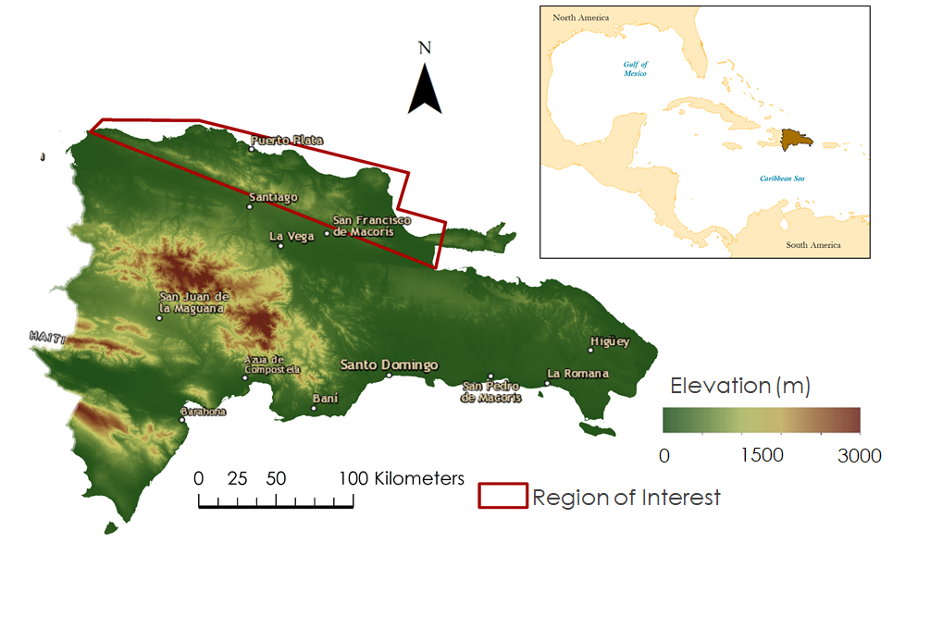

*Figure 1.*The study area of this research was focused on the northern coastal region of Cibao, which was identified as a region of interest by our partners. The topography of the Dominican Republic is generally mountainous with one central mountain range that runs east to west. Other notable geographic features include semi-desert plains, tropical rainforests, and sandy beaches.

* 1. ***Project Partners & Objectives***

In the Dominican Republic, the National Geological Service (Spanish: Servicio Geológico Nacional, or SGN) is responsible for evaluating and monitoring geological threats such as landslides, floods, earthquakes, and tsunamis to protect the welfare and safety of the Dominican Republic society (Ministry of Economy, Planning and Communications, 2013). Another government agency, the National Office of Meteorology (Spanish: La Oficina Nacional de Meteorología, or ONAMET), provides national meteorological services, including educating the public for risk prevention, maintaining a network of *in situ* stations to measure meteorological variables, and reporting present and expected weather and sea conditions (Oficina Nacional de Meteorología, 2019). The team also collaborated with BGC Engineering, Inc. (BGC), a private engineering firm based in Canada. This company is involved in mining operations in the Dominican Republic and has years of experience doing on-site research of the country’s geology. The team received valuable insights from collaborators regarding landslides in the country.

As a project supporting the joint statement between NASA and the Central American Integration System (Spanish: Sistema de Integración Centroamericana, or SICA), the team partnered with SGN and ONAMET to enhance their capacities for landslide hazard assessment. The overarching objective of this project was to increase the partners’ capacities to monitor landslides at a national scale through the implementation of LHASA. To achieve this, the team incorporated high-resolution data into a susceptibility map to produce localized inputs for LHASA. This project produced national landslide susceptibility and exposure maps. Additionally, the team created a LHASA tutorial document that provides end users with step-by-step instructions to independently operate and implement LHASA and update the susceptibility map as more *in situ* and Earth observation data become available.

# 3. Methodology

***3.1 Data Acquisition***

*3.1.1 Dominican Republic Landslide Inventory*

While the partners provided the team with thousands of proximal landslide points and polygons, the points appeared to follow roads and did not mark distinct landslide locations that correlated with satellite imagery. Since accurate landslide locations were necessary to calibrate the susceptibility map, the team manually created a landslide inventory using Google Earth Pro. Using the historical imagery tool, the team located landslides in the study region and created polygons around each landslide. A confidence rating of high, medium, or low was also included for each polygon by the identifier. Due to project time constraints, the team did not create a national landslide inventory and instead focused on the northern region of the country.

*3.1.2 Landslide Susceptibility Map*

Major variables considered for landslide susceptibility mapping included elevation, slope, lithology, tectonic activity, forest cover change, and clay percent. Digital elevation model (DEM) data from the Shuttle Radar Topography Mission Version 3 (SRTM V3) dataset were obtained as 1° x 1° tiles from the NASA EarthData website at a resolution of 1-arc-second (approximately 30 m) (NASA Jet Propulsion Laboratory, 2013). Forest loss raster data were downloaded from the University of Maryland (UMD) Global Forest Change project as 10° x 10° tiles at a 1-arc second resolution. This UMD project incorporated a time series analysis of Landsat images from 2000 through 2018 to determine global forest cover and change (Hansen et al., 2013). The country’s lithology and faults, which were used as a proxy for tectonic activity, were obtained from SGN as shapefiles at a scale of 1:250,000. A predicted layer of topsoil clay percent down to the first meter was downloaded from the World Soil Information’s SoilGrids system at a resolution of 1 km (Hengl et al., 2014).

*3.1.3 Landslide Exposure Map*

A bivariate map was created to depict the intersections of high population density and high landslide susceptibility because the protection of life and infrastructure was identified as a high priority by the partners. Global population data were obtained from the Oak Ridge National Laboratory as gridded global population distributions. At a spatial resolution of 30-arc seconds (approximately 1 km), the data represent an ambient population distribution, meaning the average distribution over 24 hours. LandScan was chosen for this study because it provided the most up-to-date population estimates at the highest spatial resolution compared to other global population datasets the team found.

*3.1.4 Landslide Hazard Model*

LHASA ingests two inputs: a susceptibility map and rainfall estimates. The R scripts for LHASA are publically available and were downloaded from GitHub. This study used rainfall data from the Global Precipitation Measurement Mission (GPM) Integrated Multi-satellitE Retrievals for GPM (IMERG), which were downloaded from the NASA Earth Science Data Systems (ESDS) Program (Huffman, 2016). The latest product (GPM_3IMERGDL), which has a spatial resolution of 0.1° x 0.1° and is available from June 2000 to March 2019, was chosen for this study.

***3.2 Data Processing***

*3.2.1 Landslide Inventory*

The landslide inventory created in Google Earth Pro was edited in Esri ArcMap. The team created attributes in the feature layer to clarify the confidence level of each landslide identification. Again, the team did not create a national landslide inventory and instead focused on the northern region of the country.

*3.2.2 Landslide Susceptibility Map*

Vector layers were first projected to WGS 1984 UTM Zone 19N, while raster layers remained in their original geographic coordinate system, WGS 1984. All layers were clipped to the Dominican Republic political borders. The DEMs and forest loss raster data were mosaicked prior to clipping. The mosaicked and clipped DEM was then used to create a slope raster layer using the Esri ArcMap Slope Tool. Additionally, both the elevation and slope layers had to be filled prior to further processing. The distances to faults values were calculated by applying the Euclidean Distance Tool to the SGN fault line inventory.

Lithology data were converted to raster format as well. The geological map of the Dominican Republic was then reclassified to values between 0 and 1, with 1 signifying the highest susceptibility rating. The lithology layer was first reclassified as integers ranging between 1 and 10, based on rock weakness and age (*Appendix Figure A1*). Then, the raster layers were averaged and divided by 10 to obtain a float value between 0.1 and 1. Finally, the predicted clay percent layer had to be bilinearly resampled to the resolution of the DEM in order to maintain the 30 m resolution of the final susceptibility map. These raster layers were then inputted into a fuzzy logic model in ArcMap, with calibrated parameters such as fuzzy membership type, midpoint, and spread (Appendix Table B4). The lithology, distance to faults, clay percent, forest loss, and elevation layers were first combined using the “gamma” fuzzy overlay function before the slope layer was overlaid using the “product” function (*Appendix Figure A2*). After producing the susceptibility map, the raster was reclassified into five classes (very low, low, moderate, high, and very high) based on the 50th, 75th, 90th, and 95th percentiles. These percentiles were selected to effectively highlight the most susceptible regions and were chosen based on previous literature (Kirschbaum, Stanley, & Yatheendradas, 2016).

*3.2.3 Landslide Exposure Map*

Once the LandScan Global 2017 dataset was obtained, it was clipped to the study area. Within Esri ArcMap, the Focal Statistics Tool was used to ensure that both the population data and susceptibility map were configured in the same resolution. Then, the susceptibility raster was reclassified to be low or high represented by values of 1 or 2. Population data were reclassified into three categories (determined by the 25th and 90th percentiles) and respectively reassigned values of 1, 2, or 3. Next, using the Raster Calculator Tool, the susceptibility raster was multiplied by ten and added to the population values. This output six distinct values (11, 12, 13, 21, 22, 23), which represented low, medium, or high population density with low or high susceptibility. Distinct colors were assigned to each value to further depict the intersection of susceptibility and population.

*3.2.4 Landslide Hazard Model*

LHASA generated a 7-day Antecedent Rainfall Index (ARI) from precipitation data for a specific day and the previous 6 days using a weighted average technique (*Appendix Figure A3*). The 7-day ARI was calculated for each day between 2000 and 2018 and then aggregated to create an extreme ARI threshold, which was calculated as the 95th percentile of the historical ARI values. Additionally, the 7-day ARI was calculated for each day in 2019 and then compared against the historical ARI threshold. If the ARI met or exceeded the threshold, the susceptibility map was consulted. If the susceptibility map indicated high susceptibility (categories 2, 3, or 4), a moderate hazard Nowcast was issued. If the susceptibility map indicated very high susceptibility (category 5), a high hazard Nowcast was issued. If the ARI was below the threshold or the susceptibility map indicated low susceptibility (category 1), the model assumed there was no landslide hazard and therefore, no Nowcast was issued. For more detailed information regarding LHASA, please refer to Kirschbaum & Stanley (2018).

***3.3 Data Analysis***

A combination of frequency ratio analyses was used to both calibrate and validate the susceptibility map (Kalimuthu, Tan, Lim, & Fauzi, 2015; Stanley & Kirschbaum, 2017). First, the polygons in the landslide inventory created from Google Earth imagery were converted to points to use for validation. The validation was performed using all landslides and landslides with high confidence ratings. The raster layer from each susceptibility factor was categorized into ten percentile breaks. The Extract Values to Points Tool was used to count the frequency of mapped landslides occurring in each tenth percentile of the raster. Then, the reclassified raster layer was clipped to the study area’s northern region where the majority of landslides were mapped in the landslide inventory. By dividing each number of pixel class by the total pixel count in the clipped extent and dividing each number of categorized landslides by the total number of landslides, a series of frequency ratios were obtained (*Equations 1, 2, and 3*). Ratios greater than 1 signal that the susceptibility factor is strongly related to the classification in which the frequency was counted (Appendix Table B1). A bar graph was used to visualize the frequency ratio trends, which helped determine the optimal fuzzy membership operator. The percentile value at which the frequency ratio begins to show signs of approaching 1 was selected as the midpoint in the fuzzy membership parameter for the respective susceptibility factor. A spread value was selected based on a qualitative assessment of how quickly or slowly the ratios changed.

$\text{Landslide Ratio = }\frac{\text{number of landslides in class i}}{\text{total number of landslides}}$ (1)

$\text{Pixel Ratio = }\frac{\text{number of pixels in class i}}{\text{total number of pixels}}$ (2)

$\text{Frequency Ratio = }\frac{\text{Landslide Ratio}}{\text{Pixel Ratio}}$ (3)

The transmission tower inventory provided by BGC was used for validation purposes but not for calibration of the susceptibility map. The inventory identified towers that were susceptible to slope movements and/or had landslide evidence within a 30 m radius. The tower inventory was reclassified into two categories: susceptible, which included towers with a presence of nearby landslides, and non-susceptible, which included towers considered to have no landslide risk. The frequency ratio analysis was performed using both tower classifications in a similar way as the landslide confidence categories.

# 4. Results & Discussion

***4.1 Analysis of Results***

*4.1.1 Landslide Susceptibility Map*

The resulting Landslide Susceptibility Map of the Dominican Republic is shown in *Figure 2*. The map is classified into five susceptibility categories based on the 50th, 75th, 90th, and 95th percentile breaks of continuous floating values ranging from 0 to 1, with the highest susceptibility being 1. The categories represent very high (red), high (orange), moderate (yellow), low (green), and very low (blue) landslide susceptibility.

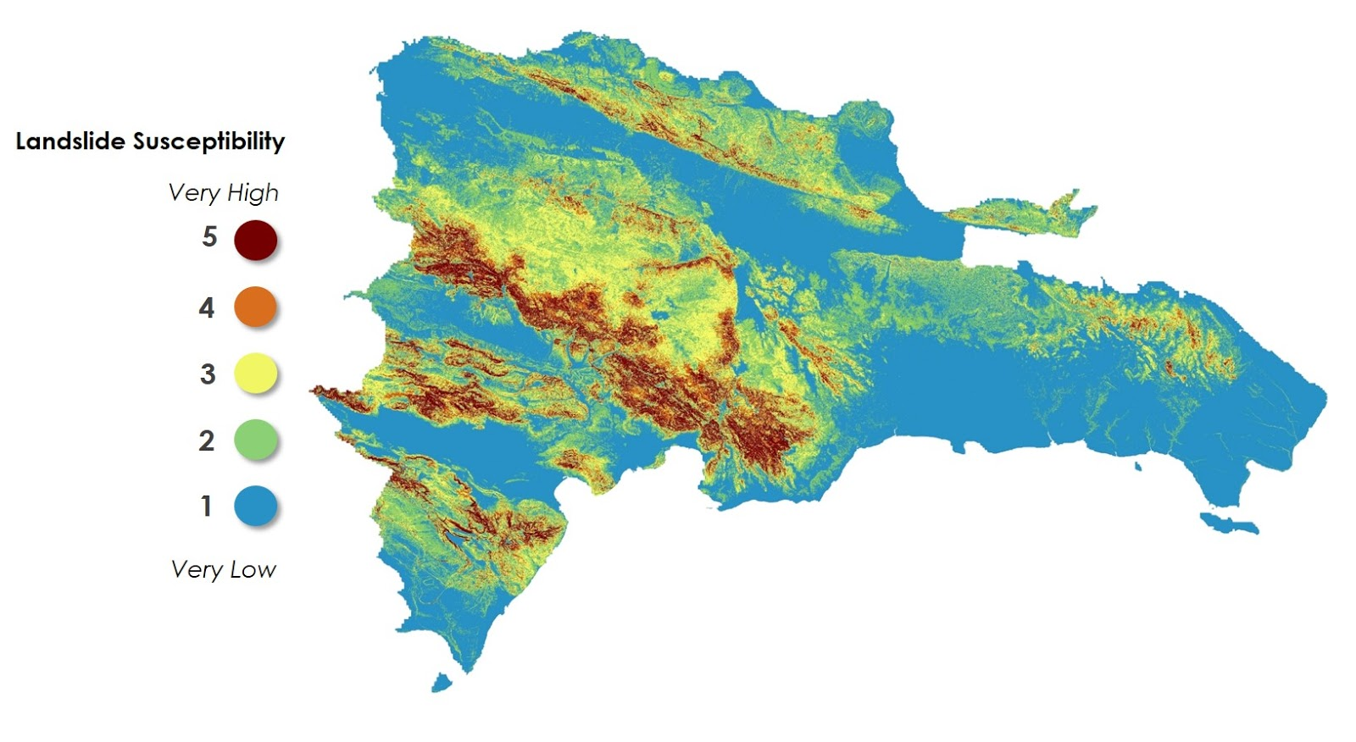

*Figure 2.* The Landslide Susceptibility Map indicates areas at risk of landslide events in the Dominican Republic as well as the degree of risk.The final map shows areas with the highest susceptibility, represented in red and orange, along the ridge of the northern mountains and in various regions throughout the central and southern mountain ranges. Areas with the lowest susceptibility (green and blue) are found in the valleys between mountain ranges and along the coastline.

*Frequency Ratio Analysis: Landslide Inventory*

Once calibrated to the appropriate susceptibility factors and parameters within the fuzzy logic model, the susceptibility map yielded comparable results to the landslide inventory (Appendix Table B2). The accuracy assessment using the entire landslide inventory (low, medium, and high confidence levels) resulted in frequency ratios approaching 1 beginning with the “low” susceptibility category, at a value of 0.7. The increasing trend of frequency ratios suggests that the “very high” susceptibility category captures the most landslide events, relative to each category’s pixel count. When validated against landslides with only high confidence ratings, the trend in frequency ratios becomes even more pronounced. This is most likely due to the larger, more pronounced landslides occurring in higher susceptibility areas while smaller, hard to identify landslides occur in lower susceptibility areas. For a visual of the comparison of frequency values between all landslides and high confidence landslides, see *Appendix Figure A4*.

*Frequency Ratio Analysis: Transmission Tower Inventory*

A frequency ratio analysis conducted with BGC transmission tower data allowed for an additional opportunity to validate the susceptibility map (Appendix Table B3; *Appendix Figure A5*). The towers, indicated by BGC, to be located in areas of susceptible slope movement appear to concentrate in regions of moderate, high, or very high landslide susceptibility. Conversely, the towers that were described as being in areas of no susceptibility were concentrated in regions of very low, low, and moderate landslide susceptibility. The geographical extent of the transmission tower locations spanned from the central interior province of Sanchez Ramirez in a southwest direction and ending in the coastal province of Peravia. Because of the variation in elevation found across this extent, these data provided a validation source outside of the northern region that was mapped by the landslide inventory in this study.

*Experimental Landslide Susceptibility Model from Unsupervised Machine Learning*

The team tested a preliminary susceptibility model, developed by Dr. Robert Emberson at NASA Goddard Space Flight Center (GSFC), to create a landslide susceptibility map using a machine learning approach. It is currently named the Experimental Landslide Susceptibility Model from Unsupervised Machine Learning. Its algorithm uses machine learning to identify correlations between landslide characteristics and has the capability to identify areas with similar characteristics as areas known to be susceptible. The areas identified by the model are also very likely to be susceptible to landslides.

Under the guidance of Dr. Emberson, the team implemented the model using the landslide inventory. While this model proved to be limited in use within the scope of this project, the team provided valuable feedback to Dr. Emberson who will use this as a case study to improve his model. Limitations of the model included the inability to extrapolate susceptibility beyond the northern region of the country (where the landslide inventory was located) primarily due to regional elevation differences across the rest of the country (*Appendix Figure A6*). The elevation is generally lower in the Northern region, compared to the central mountainous region where elevation is higher overall, yet the model failed to depict landslide susceptibility there. Conversely, the model works best with a large and consistently mapped landslide inventory that spans the entire country or region of interest. Currently, this model is for internal NASA use only, with plans to be published in the future.

*4.1.2 LHASA Results*

The LHASA output indicates areas of high and moderate potential landslide hazard for the entire country. The outputs, called Nowcasts, are generated when a 7-day ARI value meets or exceeds the extreme ARI threshold in areas with high susceptibility (*Figure 2*). LHASA Nowcasts can be generated daily to show the areas at high risk for potential landslides and moderate risk for potential landslides, such as this output from January 11, 2019 (*Figure 3*). The high hazard regions are in red and moderate hazard regions are yellow. The pixelated representation in the results is due to the spatial resolution of GPM IMERG satellite precipitation data (approximately 1 km). LHASA Nowcasts could be used by our partners to update their existing landslide warning system as this model has the capability to update every 30 minutes.

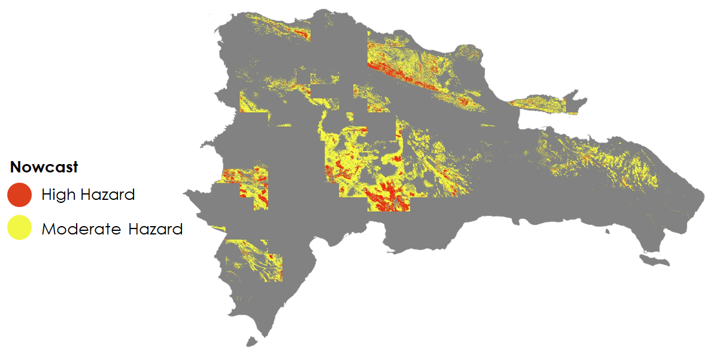

*Figure 3.* The LHASA Nowcasts indicated many areas to be at risk for landslides during a rainstorm on January 11, 2019. The areas in red represent locations that endured rainfall surpassing a historical threshold value (95th percentile) and indicated by the susceptibility map to have high landslide susceptibility. The areas in yellow also experienced rainfall that surpassed the threshold but were considered to have moderate landslide susceptibility.

*4.1.3 Exposure Map Results*

The exposure map below (*Figure 4*) utilized a heuristic approach for visualizing areas with both high susceptibility and high population density that may be at considerable risk for damage due to landslides. Very few locations on the map have both high population and susceptibility (dark red), as areas of high population density were predominantly located in areas of low susceptibility (dark yellow). For example, the capital city of Santo Domingo in the southern coast and the city of Santiago de Los Caballeros in the valley between the Cordillera Septentrional and the Cordillera Central both have high population density but are located in areas considered to have low landslide susceptibility.

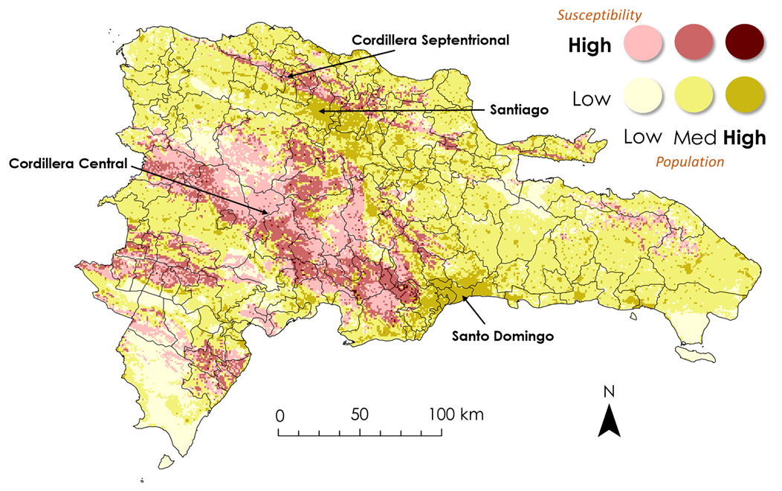

*Figure 4.* The landslide exposure map shows the intersection of population and susceptibility using a bivariate mapping technique. Susceptibility was categorized into low and high and population density into low, medium, and high. Each of the six colors represents the overlap of each combination of the respective variables. Areas of dense populations are represented by dark yellow and dark red. The darkest red areas have high population density and susceptibility. Luckily, the major cities of Santo Domingo and Santiago, where population density is high, are located in areas of low susceptibility. More mountainous regions, like the Cordillera Central and Cordillera Septentrional, have high susceptibility but low population density.

***4.2 Discussion***

*4.2.1 Landslide Susceptibility Map*

Although six variables (slope, elevation, clay percent, forest loss, lithology, and distance to faults) were ultimately selected for the final susceptibility map, many more could have been applied. For example, two variables were explicitly taken out after consulting expert scientists: distance to roads and distance to streams. Although proximity to both streams and roads were expected to contribute to higher landslide susceptibility, their frequency ratios showed opposite conclusions (i.e. increasing distances away from said streams and roads would be correlated with higher landslide frequency ratios). Interestingly enough, when the road vector from OpenStreetMap was cropped for only roads existing at high slopes (equal to or above 12 degrees), the distance to roads layer (rather, the distance to “mountainous” or sloped roads layer) exhibited expected behavior with the landslide inventory.

Another factor to consider is the fast recovery time of reforestation in the Dominican Republic, according to a consultation with BGC engineers who have years of experience performing fieldwork in the country. Including forest loss cover from only the past decade, rather than multiple decades, may be more appropriate for future landslide susceptibility mapping efforts in this country. The final susceptibility map performed very well according to the landslides collected by the team using Google Earth Pro. However, *in situ* calibration is ideal. The transmission tower data from BGC, therefore, provided invaluable insight into the functionality of the susceptibility map.

*4.2.2 LHASA Model*

LHASA proved to be a viable tool for mapping landslide potential in the Dominican Republic. Originally created for use on a global scale, LHASA allows for the user to cater the inputs and outputs to a particular country or region. For this project, LHASA was implemented across an area of 48,442 km2. A comprehensive landslide inventory covering the entire region of interest that includes event dates would have allowed the team to perform an extensive validation. By choosing a set of events, the team could have examined the historical LHASA outputs for particular coinciding rainfall and landslide events to assess conditions at that time. Lastly, the partners mentioned the presence of one rain gauge for each province, and another set of gauges at higher elevations in their mountainous regions, but these data were not obtained during this study. If available, the satellite precipitation estimates could be validated against rain gauge data, which would allow for further validation of LHASA in this country. Validation would have increased the confidence in satellite-based precipitation estimates being used in place of *in situ* measurements in LHASA.

*4.2.3 Exposure Map*

Given the 1 km spatial resolution of the bivariate map, this map is limited in its ability to capture trends at a localized scale, particularly in heavily developed and populated areas. To create the categories for the map legend, the team had to simplify the population density and susceptibility factors to two and three categories, respectively. In doing so, there is an inevitable risk of hiding the range of values within each category. However, in an attempt to provide a national scale map, this method proved effective in communicating general exposure trends that can sufficiently guide end users in identifying regions of concern.

Adding critical infrastructure data, such as the locations of schools, hospitals, emergency centers, and roads, would have provided more context to landslide exposure in this country. Due to time constraints, the team was not able to fully implement these data into the bivariate map. The team suggests performing a zonal statistics analysis with these data by province and municipality to gain region-specific insights into landslide exposure relating to infrastructure.

***4.3 Future Work***

With additional time for this project, the team could implement LHASA to further examine specific case study events within the regions of interest identified by our partners. By reducing the scale of analysis from a national to a regional, provincial, or city scale, new patterns may be visible that offer valuable information for landslide susceptibility, exposure, and historical landslide potential. For example, it would be worthwhile to examine local conditions in Puerto Plata, a city in the northern region of the island that has suffered from several major landslides in the past. Additionally, future research should focus on enhanced calibration and validation of the susceptibility model specifically for the Dominican Republic. This can be completed by using verified landslide event locations with dates that were consistently mapped through the study region. That being said, future landslide events in this country need to be precisely located with the date and time of the event. The temporal resolution of landslide data is crucial to the successful calibration and validation of landslide models.

The partners could greatly benefit from the validation of IMERG precipitation estimates against rain gauge measurements within each province. A validation would help identify possible IMERG underestimations and overestimations when compared to gauge measurements. This process would allow the partners to proceed with confidence in using satellite-based precipitation data in LHASA. Lastly, LHASA has the potential to be implemented in other Central American countries that may be facing similar risks for rainfall-triggered landslides. Efforts should specifically focus on providing countries with the knowledge and skills necessary to use LHASA through educational materials and on-site training sessions.

# 5. Conclusions

# As a result of this project, the team was able to execute four major components that will help SGN and ONAMET to better understand the physical conditions that contribute to rainfall-triggered landslides in their country. By identifying areas of high and low landslide susceptibility at a 30 m spatial resolution, the partners can further examine these conditions beyond the provincial level. By examining the country’s population density in relation to susceptibility, the partners can locate and properly manage housing and infrastructure expansion in landslide-prone areas in order to reduce the potential loss of life and property. Through the implementation of satellite-based precipitation data and the susceptibility map in LHASA, the partners can gain improved situational awareness of landslide hazard across their country.

# The susceptibility map produced by the team allows for the identification of potentially high priority areas. This includes high elevation areas, where slopes are generally steeper and thus more prone to unstable surfaces. Areas found to have the highest susceptibility include: The Cordillera Central, Cordillera Septentrional, the Sierra de Nelba, Sierra de Bahoruco, and the Cordillera Oriental. Additionally, many landslides were identified across the Samana Peninsula. At the provincial scale, the provinces of Azua, Bahoruco, Barahona, Duarte, El Seybo, Espaillat, Independencia, La Estrelleta, La Vega, Peravia, Puerto Plata, Salcedo, Samaná, San Cristóbal, San José de Ocoa, San Juan, Santiago Rodriguez, Santiago, and Valverde contained many areas with high landslide susceptibility.

The partners will benefit from the increased situational awareness of rainfall-triggered landslides across their country at a high spatial resolution provided by this study. Their knowledge is further enhanced by having access to a tutorial document created by the team that provides step-by-step instructions for how to create their own landslide inventory, create a susceptibility map, and implement LHASA. The goal of this tutorial is to build the partners’ capacities to use NASA Earth Observations to better inform their decision-making processes and GIS workflows relating to landslide monitoring and warning. Overall, this work has the potential to increase the end users’ knowledge and skillsets through the use of a state-of-the-art landslide monitoring tool and a variety of open-source datasets and tools. As a result, the end users in the Dominican Republic will have the ability to produce, interpret, and ultimately communicate information about rainfall-triggered landslides for the broader benefit of their society.

# 6. Acknowledgments

The Dominican Republic Disasters Team would like to thank our project partners at SGN and ONAMET for their support and collaboration: Dr. Santiago Muñoz and his colleagues at SGN and Dr. Andrés Campusano at ONAMET. The team would also like to acknowledge Dr. Dalia Kirschbaum and Dr. Kenton Ross for their guidance throughout this project term. Additionally, we would like to acknowledge Thomas Stanley, Dr. Robert Emberson, Garrett Benz, and Dr. Pakur Amatya for their contributions and support with this project. A special thanks as well to our Center Lead, Sydney Neugebauer.

Any opinions, findings, and conclusions or recommendations expressed in this material are those of the authors and do not necessarily reflect the views of the National Aeronautics and Space Administration.

This material is based upon work supported by NASA through contract NNL16AA05C.

# 7. Glossary

**ARI** – Antecedent Rainfall Index

**Earth observations** – Satellites and sensors that collect information about the Earth’s physical, chemical, and biological systems over space and time

**GLC** – Global Landslide Catalog

**GPM** – Global Precipitation Measurement (satellite)

**IMERG** – Integrated Multi-satellitE Retrievals for GPM

**LHASA** – Landslide Hazard Assessment for Situational Awareness, a model that indicates potential landslide activity in near real-time

**ONAMET** – Oficina Nacional de Meteorología; the Dominican Republic’s national office of meteorology

**SICA** – Sistema de la Integración Centroamericana; Central American Integration System

**SIDS** – Small Island Developing States; recognized by the United Nations

**SGN** – Servicio Geológico Nacional; the Dominican Republic’s national geological service

# 8. References

Anderson, R. S., & Anderson, S. P. (2010). Hillslopes. In *Geomorphology: The mechanics and chemistry of landscapes* (pp. 306-345). Cambridge, England: Cambridge University Press.

Hansen, M. C., Potapov, P. V., Moore, R., Hancher, M., Turubanova, S. A., Tyukavina, A., … Townshend, G. (2013). *Global Forest Change* [Data file]. Retrieved June 27, 2019, from http://earthenginepartners.appspot.com/science-2013-global-forest

Hengl, T., Mendes de Jesus, J., MacMillan, R. A., Batjes, N. H., Heuvelink, G. B. M., Ribeiro, E., … Gonzalez, M. R. (2014). SoilGrids1km – Global soil information based on automated mapping. *PLoS ONE*, *9*(12): e105992. https://doi.org/10.1371/journal.pone.0105992

Hong, Y., Adler, R., & Huffman, G. (2006). Evaluation of the potential of NASA multi-satellite precipitation analysis in global landslide hazard assessment. *Geophysical Research Letters, 33*, L22402. https://doi.org/10.1029/2006gl028010

Huffman, G. (2016). GPM IMERG Early Precipitation L3 1 day 0.1 degree x 0.1 degree V05. NASA Goddard Earth Sciences Data and Information Services Center, accessed June 4, 2019. https://doi.org/10.5067/GPM/IMERGDE/DAY/05

Jeffery, S. E. (1982). The creation of vulnerability to natural disaster: Case studies from the Dominican Republic. *Disasters, 6*(1), 38-43. <https://doi.org/10.1111/j.1467-7717.1982.tb00742.x>

Kalimuthu, H., Tan, W. N., Lim, S. L., & Fauzi, M. F. A. (2015). Assessing frequency ratio method for landslide susceptibility mapping in Cameron Highlands, Malaysia. *2015 IEEE Student Conference on Research and Development (SCOReD)*. Kuala Lumpur, Malaysia: IEEE. https://doi.org/10.1109/SCORED.2015.7449440

Kirschbaum, D., & Stanley, T. (2018). Satellite-based assessment of rainfall-triggered landslide hazard for situational awareness. *Earth’s Future, 6*(3), 505-523. doi:10.1002/2017ef000715

Kirschbaum, D., Adler, R., Hong, Y., Hill, S., & Lerner-Lam, A. (2010). A global landslide catalog for hazard applications: Method, results, and limitations. *Natural Hazards, 52*(3), 561-575. doi:10.1007/s11069 009-9401-4

Kirschbaum, D., Stanley, T., & Simmons, J. (2015). A dynamic landslide hazard assessment system for Central America and Hispaniola. *Natural Hazards and Earth System Sciences Discussions, 3*(4), 2847-2882. doi:10.5194/nhessd-3-2847-2015

Kirschbaum, D., Stanley, T., & Yatheendradas, S. (2016). Modeling landslide susceptibility over large regions with fuzzy overlay. *Landslides, 13*(3), 485-496. doi:10.1007/s10346-015-0577-2

Kirschbaum, D., Stanley, T., & Zhou, Y. (2015). Spatial and temporal analysis of a global landslide catalog. *Geomorphology, 249*, 4-15. doi:10.1016/j.geomorph.2015.03.016

Klug, M., Grossman, M., & Cissell, J. (2016). *East Africa disasters II: Assessing landslide characteristics and developing susceptibility and exposure maps in Malawi* (Technical Report prepared for the NASA DEVELOP National Program). Retrieved from [http://www.devpedia.developexchange.com/ dp/index.php?title=East_Africa_Disasters_II_MSFC](http://www.devpedia.developexchange.com/%20dp/index.php?title=East_Africa_Disasters_II_MSFC)_Summer_2016

Knutson, T. R., Sirutis, J. J., Zhao, M., Tuleya, R. E., Bender, M., Vecchi, G. A., … Chavas, D. (2015). Global projections of intense tropical cyclone activity for the late twenty-first century from dynamical downscaling of CMIP5/RCP4.5 scenarios. *Journal of Climate, 28*(1), 7203-224. https://doi.org/10.1175/JCLI-D-15-0129.1

Ministry of Economy, Planning and Communications. (2013). *Servicio Geológico Nacional (SGN).* Retrieved June 24, 2019, from http://economia.gob.do/despacho/servicio-geologico-nacional/

Nadim, F., Kjekstad, O., Peduzzi, P., Herold, C., & Jaedicke, C. (2006). Global landslide and avalanche hotspots. *Landslides, 3*(2), 159-173. doi:10.1007/s10346-006-0036-1

NASA Jet Propulsion Laboratory. (2013). NASA Shuttle Radar Topography Mission Global 1 arc second. NASA EOSDIS Land Processes DAAC, accessed June 4, 2019. https://doi.org/10.5067/ MEaSUREs/SRTM/SRTMGL1.003

Negri, A. J., Burkardt, N., Golden, J. H., Halverson, J. B., Huffman, G. J., Larsen, M. C., . . . Wieczorek, G. F. (2005). The hurricane–flood–landslide continuum. *Bulletin of the American Meteorological Society, 86*(9), 1241-1247. doi:10.1175/BAMS-86-9-1241

Oficina Nacional de Meteorología. (2019). *¿Quiénes somos?* Retrieved June 24, 2019, from <http://onamet.gob.do/index.php/sobre-nosotros/quienes-somos>

OpenStreetMap contributors. (2015) *OpenStreetMap* [Data file]. Retrieved June 4, 2019, from https://www.openstreetmap.org

Sergio, M. C. (1995). Extent and socio-cconomic significance of slope-instability on the island of Hispaniola (Haiti and Dominican Republic). In *Energy and Mineral Potential of the Central American Caribbean Region Circum-Pacific Council for Energy and Mineral Resources Earth Science Series* (pp. 403-410). doi:10.1007/978-3-642-79476-6_55

Stanley, T., & Kirschbaum, D. B. (2017). A heuristic approach to global landslide susceptibility mapping. *Natural Hazards, 87*(1), 145-164. <https://doi.org/10.1007/s11069-017-2757-y>

United Nations Office of the High Representative for the Least Developed Countries, Landlocked Developing Countries and Small Island Development States (UN-OHRLLS). (2013). *Small island developing states: Small islands big(ger) stakes.* Retrieved from [http://unohrlls.org/custom content/uploads/2013/08/SIDS-Small-Islands-Bigger-Stakes.pdf](http://unohrlls.org/custom%09content/uploads/2013/08/SIDS-Small-Islands-Bigger-Stakes.pdf)

Van Westen, C. J., Castellanos, E., & Kuriakose, S. L. (2008). Spatial data for landslide susceptibility, hazard, and vulnerability assessment: An overview. *Engineering Geology*, *102*(3-4), 112-131. https://doi.org/10.1016/j.enggeo.2008.03.010

# 9. Appendices

**Appendix A.** Figures of supplementary information

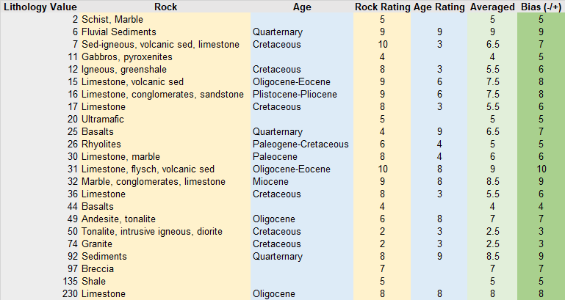

*Figure A1.*The susceptibility map required classification of rock weakness and age. The lithology layer was first reclassified to integers ranging between 1 and 10 based on rock weakness (column: Rock Weakness) and age (column: Rock Age), with 1 signifying the highest susceptibility rating. The assigned age and weakness values were averaged (column: Average) and divided by 10 to obtain a float value between 0.1 and 1 in order to produce the raster used as input in the susceptibility model.

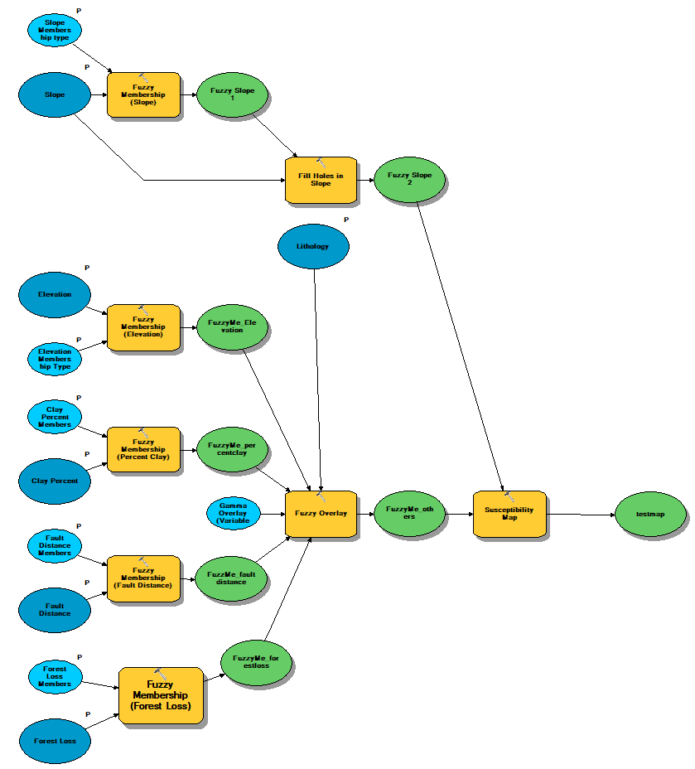

*Figure A2.*This is the fuzzy logic methodology created using ModelBuilder in Esri ArcMap.Raster layers (dark blue ovals) representing various susceptibility factors were input into the fuzzy logic model. The model combined the factors based on their fuzzy membership type (yellow boxes) and other parameters. The model runs from left to right, first combininglithology, distance to faults, clay percent, forest loss, and elevation layers using the “gamma” fuzzy overlay function. Then, the slope layer (topmost dark blue oval) is overlaid using the “product” function. The model output is a raster representing susceptibility values from 0 to 1.

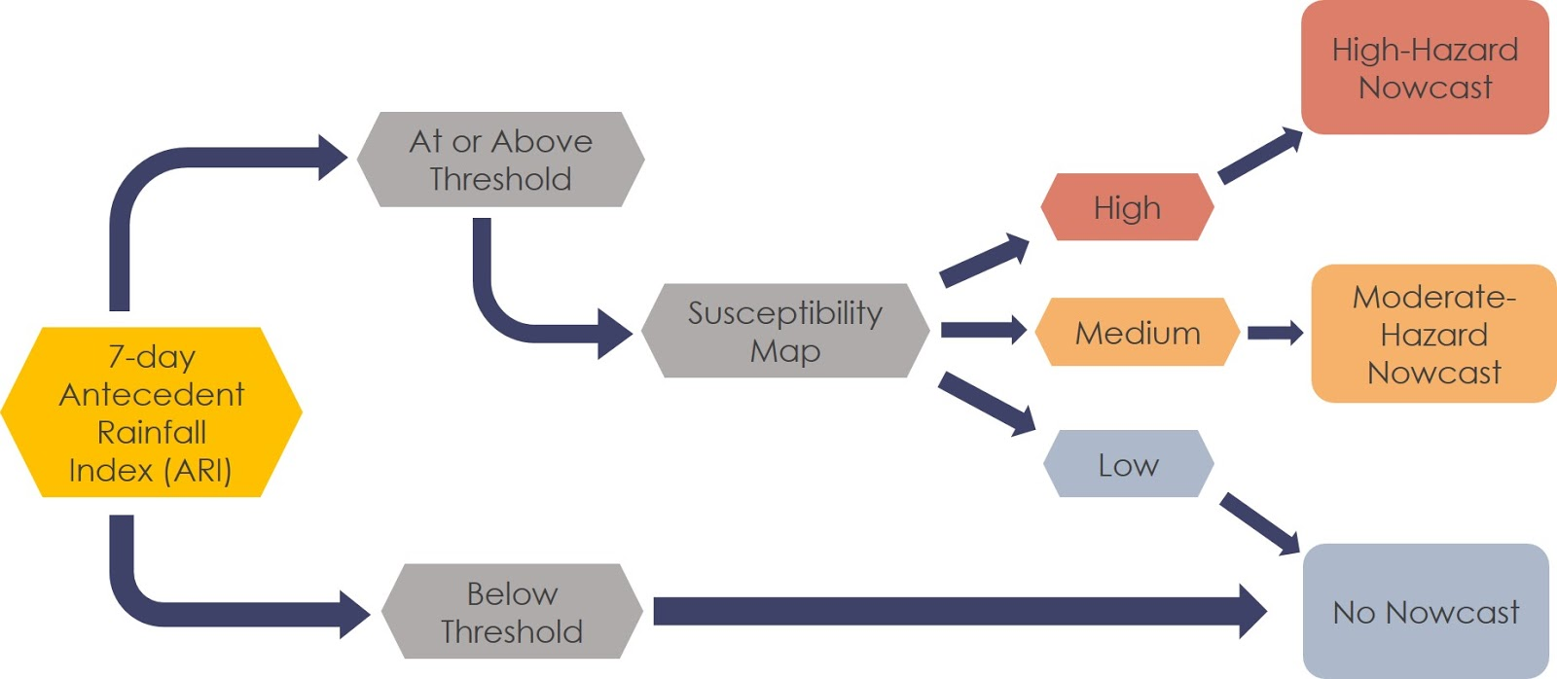

*Figure A3.*This is the methodology of LHASA.In this model, the 7-day ARI for each pixel is compared against the historical 95th percentile ARI threshold to determine the landslide hazard potential. If the ARI exceeds the threshold value, the model consults the susceptibility map to determine whether a moderate or high Nowcast is issued. If the ARI does not exceed the threshold or the susceptibility is considered low, the model assumes there is no landslide hazard and no Nowcast is issued.

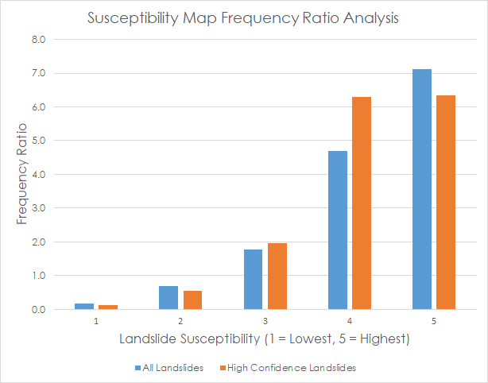

*Figure A4.* A bar graph is used to compare the results of the frequency ratio analysis using all landslides and only high confidence landslides. The ratio is shown for each susceptibility category, 1 through 5. The greater the frequency ratios are above 1 (y-axis), the stronger the category is as an indicator for landslides. The results show an overall positive trend, with ratio values surpassing 1 (y-axis) at the third susceptibility category (x-axis) for both landslide inventory categories.

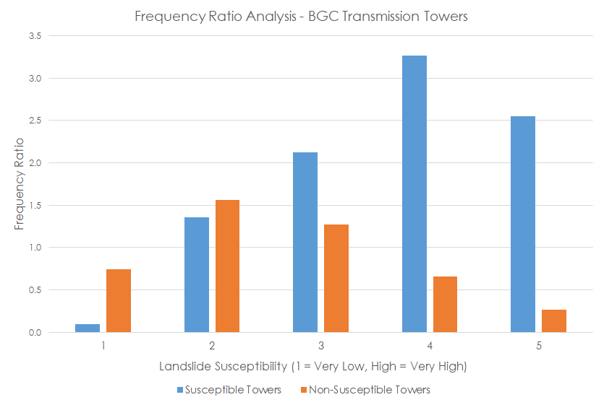

*Figure A5.* A bar graph is used to compare the results of the frequency ratio analysis between susceptible transmission towers and non-susceptible transmission towers. The ratio is shown for each susceptibility category, 1 through 5. The greater the frequency ratios are above 1 (y-axis), the stronger the category is as an indicator for landslides. Susceptible towers show a generally positive trend, with a ratio values surpassing 1 (y-axis) in the second susceptibility category, and remaining above a ratio of 1.0 thereon. Non-susceptible towers show a general negative trend, confirming that these towers are not located in high susceptible categories but rather in low susceptible categories.

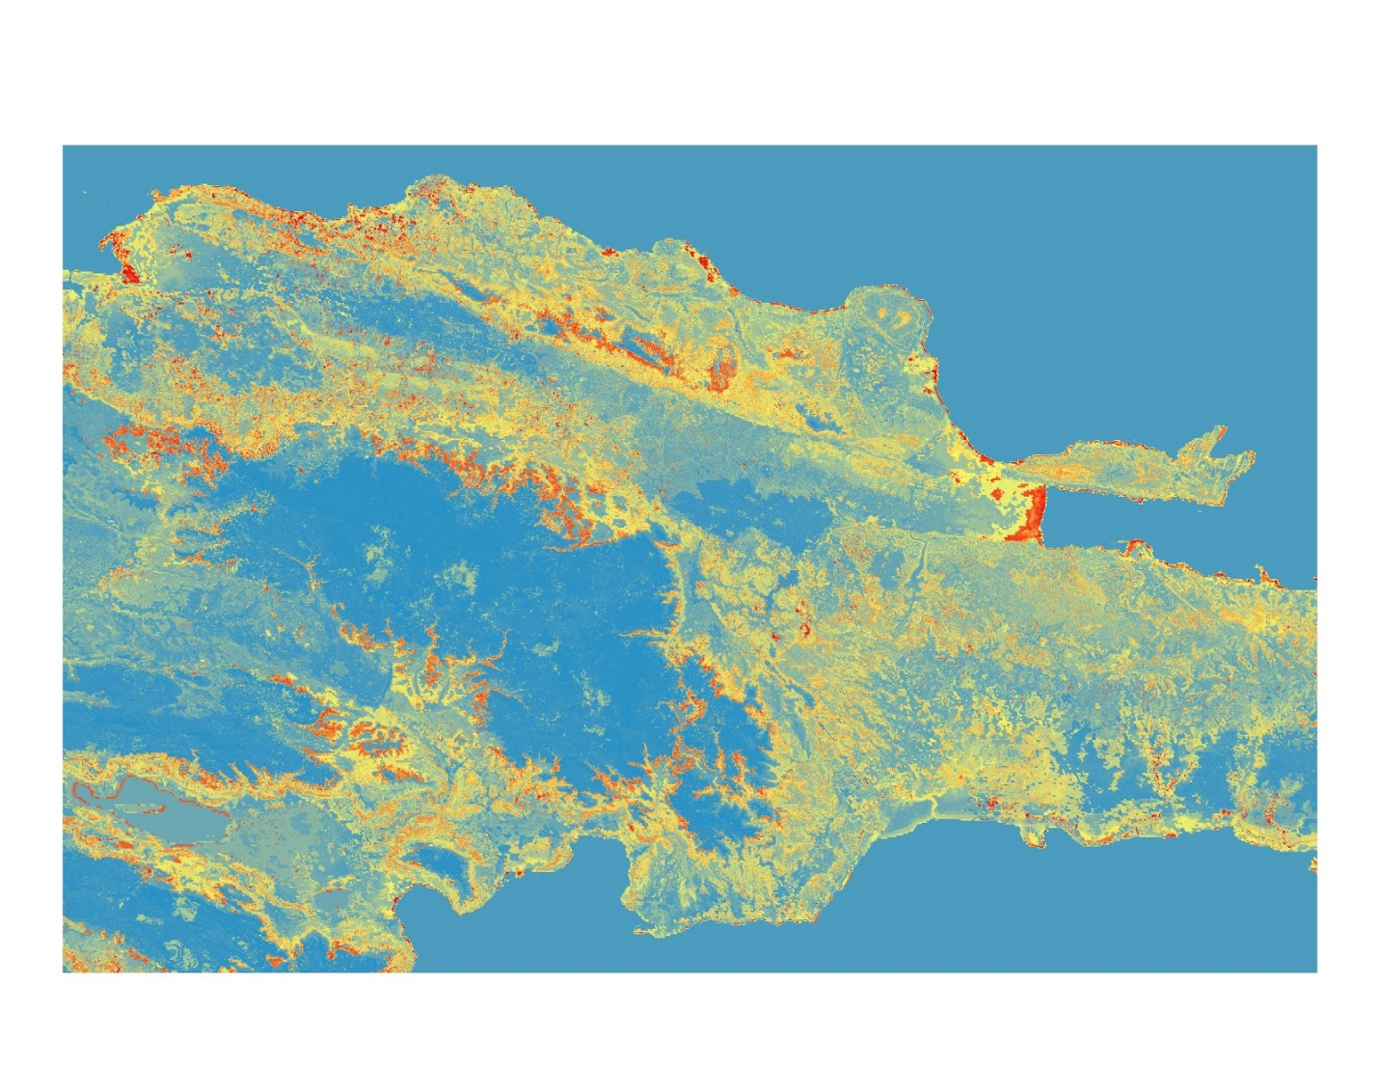

*Figure A6.* The team tested a random forest model, developed by Dr. Robert Emberson at NASA GSFC, to create a landslide susceptibility map using a machine learning approach. The model failed to successfully extrapolate susceptibility beyond the northern study region due to the landslide inventory being only in the north and the varying topography throughout the Dominican Republic. This is evident in the center region of this image, where a major high elevation mountain range (Cordillera Central) is located. Shown as a large area of blue, the map indicated this area as having low landslide susceptibility which we know to not be true. The model failed to match the general susceptibility trends mapped by the fuzzy logic model (*Figure 2*).

**Appendix B.** Tables of supplementary information

Table B1

*Calibration with Frequency Ratio Analysis*

|  |  |  |  |  |  |  |  |  |  |  |
| --- | --- | --- | --- | --- | --- | --- | --- | --- | --- | --- |
| **Frequency Ratio Analysis (in Percentiles)** | | | | | | | | | | |
| **Variable** | **10th** | **20th** | **30th** | **40th** | **50th** | **60th** | **70th** | **80th** | **90th** | **100th** |
| Slope | 0.15 | 0* | 0.27 | 0.10 | 0.38 | 0.66 | 1.04 | 1.67 | 2.61 | 6.21 |
| Elevation | 0.11 | 0.47 | 0.66 | 0.80 | 0.63 | 0.97 | 1.61 | 2.73 | 1.79 | 0* |
| Distance to Faults | 1.28 | 1.46 | 1.49 | 0.93 | 1.04 | 0.50 | 0.60 | 0.55 | 0.46 | 0* |
| Clay Percent | 1.07 | 0.91 | 1.33 | 0.41 | 0.43 | 0.76 | 1.41 | 1.59 | 2.10 | 0* |

The “*” indicates a zero-frequency ratio, which means that no landslides occurred in that percentile classification or that no pixels existed in that region of interest (since the percentile reclassification occurred for the entire island)

Table B2

*The table shows the results of a Frequency Ratio analysis using the landslide inventory. The ratios, by susceptibility category, were calculated using the entire landslide inventory and only high confidence landslides. Across susceptibility categories, ratios for all landslides and high confidence landslides show an increasing trend, greatly increasing from category 3 to 4. This trend suggests that the high and very high susceptibility categories capture the most landslide events, relative to each category’s pixel count.*

|  |  |  |
| --- | --- | --- |
| **Susceptibility Category** | **Frequency Ratio**  **All Landslides** | **Frequency Ratio**  **High Confidence Landslides** |
| Very Low (1) | 0.18 | 0.12 |
| Low (2) | 0.70 | 0.54 |
| Moderate (3) | 1.78 | 1.96 |
| High (4) | 4.70 | 6.30 |
| Very High (5) | 7.12 | 6.34 |

Table B3

*This table shows the results of the frequency ratio analysis using the BGC transmission tower inventory to validate the susceptibility map. For each susceptibility category, the ratio was calculated using susceptible towers and non-susceptible towers. Ratios for susceptible towers show a general increasing trend as susceptibility increases. Ratios for non-susceptible towers show a general negative trend, with the lowest ratio value of 0.26 in the highest susceptibility category.*

|  |  |  |
| --- | --- | --- |
| **Susceptibility Category** | **Frequency Ratio  Susceptible Towers** | **Frequency Ratio Non-Susceptible Towers** |
| Very Low (1) | 0.10 | 0.75 |
| Low (2) | 1.36 | 1.56 |
| Moderate (3) | 2.13 | 1.28 |
| High (4) | 3.26 | 0.66 |
| Very High (5) | 2.55 | 0.26 |

Table B4

*Each susceptibility variable input into the fuzzy logic model had a calibrated fuzzy membership*

|  |  |  |  |
| --- | --- | --- | --- |
| **Variable** | **Membership Type** | **Midpoint** | **Spread** |
| **Elevation** | Large | 200 meters | 1.5 |
| **Slope** | Large | 10 degrees | 2 |
| **Distance to Faults** | Small | 3700 meters | 1.5 |
| **Clay Percent** | Large | 40 % | 2 |
| **Lithology** | N/A | N/A | N/A |
| **Forest Cover Loss** | Linear | Minimum: -1  Maximum: 1 | Minimum: -1  Maximum: 1 |