**NASA DEVELOP National Program**

****University of Georgia

**Spring 2016**

**Short Title: Atlanta Water Resources**

**Subtitle:** Identifying Key Urban Areas to Reduce Stormwater Runoff and Maximize Conservation Efforts in Metropolitan Atlanta

**VPS Title:** Turning Over a New Leaf: Modeling Green Infrastructure in Atlanta

**Project Team & Partners**

**Project Team:**

Christopher Cameron (Project Lead), cscameron89@gmail.com

Beatriz Avila

Veronica Fay

Jason Reynolds

Alex Smith

Jacob Spaulding

Wenjing Xu

**Advisors & Mentors:**

Dr. Rosanna Rivero (University of Georgia, College of Environment & Design)

Dr. Marguerite Madden (University of Georgia, Center for Geospatial Research, UGA DEVELOP Lead Science Advisor)

**Partner Organizations:**

The Nature Conservancy (Collaborator), POC: Sara Gottlieb & Myriam Dormer; Boundary Organization

**Project Details**

**Applied Sciences National Applications Addressed:** Water Resources, Ecological Forecasting

**Study Area:** Atlanta, GA

**Study Period:** January 2001 - October 2015

**Earth Observations & Parameters:**

Landsat 8, OLI - land cover

Terra, ASTER - elevation

**Ancillary Datasets Utilized:**

* Atlanta Regional Commission (ARC) LandPro 2009 - land cover
* ARC LandPro 2010 - land cover
* ARC City of Atlanta Streams - rivers and streams
* ARC City of Atlanta Watersheds - watershed boundaries
* ARC Lakes, Ponds, Reservoirs, and Swamps of the Atlanta Region - water bodies
* ARC Developments of Regional Impact - locations of significant urban development centers
* ARC Aerial Imagery 2015 - land cover
* Conservation Biology Institute Protected Areas of Georgia 2012 - state protected lands
* Georgia Environmental Protection Division (GA EPD) Water Quality in Georgia - 305b and 303d lists
* United States Department of Agriculture (USDA) Gridded Soil Survey - soil type and attribute data
* United States Environmental Protection Agency (US EPA) Toxic Release Inventory - location of toxic release sites
* US EPA National Hydrography Dataset Plus V2.1 - stream and flow lines
* United States Geological Survey (USGS) National Land Cover Dataset (NLCD) -land cover
* The Nature Conservancy Southeast Aquatic Connectivity Assessment Project - connectivity of regional water resources

**Models Utilized:**

* University of Florida Land Use Conflict Identification Model (LUCIS plus model)
* The Texas A&M University Soil and Water Assessment Tool (SWAT) model
* The Texas A&M University Soil and Water Assessment Tool - Calibration and Uncertainty Procedures (SWAT - CUP)

**Software Utilized:**

ArcGIS - ancillary data processing, map creation, and LUCIS and SWAT model operation

ENVI - atmospheric correction, image classification, and raster manipulation/analysis

**Project Overview**

**80-100 Word Objectives Overview:**

Rapid development in Atlanta and its suburbs is expanding areas of impervious surface that will continue to exacerbate stormwater management problems. The goal of this project is to assist The Nature Conservancy in identifying locations within metro Atlanta to focus reforestation of degraded areas and forested land protection efforts, which will reduce sediment and nutrient-laden stormwater runoff in the Chattahoochee River watershed. This was accomplished by combining Landsat 8 and Terra ASTER data in the LUCIS and SWAT models to determine suitable reforestation targets.

**Abstract:**

Residents of metro Atlanta pay the highest rates in the nation for municipal water and sewer, in part, due to massive recent investments in infrastructure to manage stormwater runoff. As development continues at a rapid pace in Atlanta and its suburbs, expanding areas of impervious surface will continue to exacerbate this problem. Forested land is known to slow runoff during storms, allowing water to infiltrate, and the soil to absorb particles and contaminants before entering the surface water. Enabling the protection of existing green infrastructure, or strategically planting more trees to intercept stormwater runoff, will help reduce sediment and nutrient-laden stormwater runoff in the Chattahoochee River watershed in addition to limiting the needs of future city infrastructure. The DEVELOP team at the University of Georgia partnered with The Nature Conservancy to identify conservation targets in the Atlanta region to improve existing green infrastructure and locate additional areas suitable for expansion of reforestation efforts using NASA data from Landsat 8 and Terra satellites. This was accomplished through a combined, watershed-scale assessment of metro Atlanta using the Land-Use Conflict Identification Strategy (LUCIS) and Soil and Water Assessment Tool (SWAT) models. The LUCIS model was employed in this project to identify areas of land use conflict as it relates to existing and future conservation areas in Atlanta. The SWAT model produced an analysis of pollution sources and hydrologic processes in the study area. Together, these model results provided project partners with an integrated understanding of water resource issues in metro Atlanta that emphasized local land use scenarios.

**Community Concerns:**

* Costs of municipal water management in the metro Atlanta area are rising due to an increased demand of infrastructure required to handle stormwater runoff.
* Rapid, continued development in the city of Atlanta and its suburbs will expand areas of impervious surface cover, exacerbating stormwater management problems.

**Current Management Practices & Policies**:

The Nature Conservancy in Georgia uses a standard framework for decision-making and planning for conservation projects referred to as Conservation By Design. The framework takes into account science-based information about the current status of conservation targets, which is assessed through on-the-ground surveys, remote sensing—most often from freely-available sources such as NAIP imagery—or expert opinion. Stakeholder values are also assessed and considered before implementing the development of project goals and strategies. Project investments are monitored by senior managers and volunteer board members to ensure sound financial practices and adequate monitoring of project outputs and outcomes. The Atlanta Regional Commission is assessing impacts of the long-range transportation plans on air quality, working with local and state partners on strategies that protect watersheds and conserve resources as well as also developing a comprehensive regional green space plan with local governments. Trees Atlanta works to protect and improve Atlanta’s urban forest by planting, conserving, and educating. All of the partners have similar missions and work with each other and many other organizations to address this project’s community concern.

**Decision Support Tools & Benefits:**

|  |  |  |
| --- | --- | --- |
| **End-Product** | **Earth Observations Used** | **Benefit & Impact** |
| Analysis of Currently Forested Watersheds | Landsat 8 OLI, Terra ASTER | Will help identify where The Nature Conservancy may invest or advise partners in forested land protection |
| Analysis of Potential Reforestation Areas | Landsat 8 OLI, Terra ASTER | Will locate areas where The Nature Conservancy may invest or advise partners in reforestation efforts |

**Project Imagery**

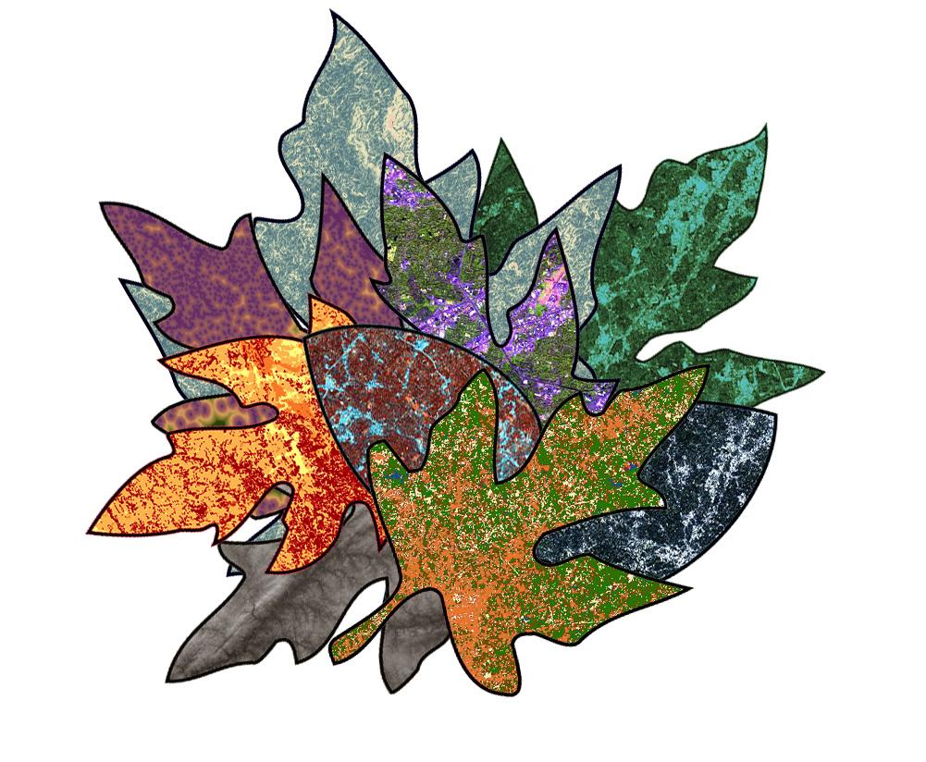

**Caption:** Overlay of selected data layers used in LUCIS and SWAT for this project. Image Credit: Atlanta Water Resources Team.

**Image:** 2016Spring_UGA_AtlantaWaterResources_VPSImage

**Software Release Requirements**

What category do the tools your project is creating fall within? Category I