NASA DEVELOP National Program
NASA Marshall Space Flight Center
Spring 2016

Alabama Ecological Forecasting
Assessing Southern Pine Beetle Epidemics in Alabama’s Bankhead National Forest Using NASA Earth Observations


Technical Report
Final Draft – March 31, 2016

Ryan Schick (Project Lead)
Kelsey Herndon
Maggi Klug
Leigh Sinclair

Dr. Jeffrey Luvall, NASA at National Space Science Technology Center (Science Advisor)
Dr. Robert Griffin, University of Alabama in Huntsville (Science Advisor)

I. Abstract
The Southern Pine Beetle (SPB), Dendroctonus frontalis, is an opportunistic species that attacks stressed trees weakened by drought, storm damage, or fire. In 2000, about 18,600 acres of pine forest were damaged throughout the Bankhead National Forest due to SPB. The United States Department of Agriculture (USDA) Forest Service currently uses expensive manned aerial surveys, such as aerial photography and Light Detection and Ranging (LiDAR), as well as Moderate Resolution Imaging Spectroradiometer (MODIS) ForWarn and Forest Disturbance Monitor data to help with mitigation efforts. This project used remotely sensed data to identify SPB infested areas throughout Alabama and determine outbreak patterns. Landsat 5 Thematic Mapper (TM) and Landsat 8 Operational Land Imager (OLI) were used to derive a Normalized Difference Vegetation Index (NDVI) and a Green-Red Vegetation Index (GRVI) to show vegetation health. Shuttle Radar Topography Mission Version 2 (SRTM-v2) Digital Elevation Models (DEMs) were used to understand how elevation and slope affect SPB susceptibility. In situ SPB data and various environmental variables were analyzed using the Princeton University Maximum Entropy model (MaxEnt) to assess areas susceptible to a SPB outbreak by creating a Southern Pine Beetle Prediction Map for 2050. Additionally, this project determined where mitigation efforts should be focused by creating a Near Real-Time Southern Pine Beetle Susceptibility Model. Historic Southern Pine Beetle Coverage Maps were created to understand patterns of previous outbreaks. The USDA Forest Service used these methodologies and maps to reduce costs and time associated with SPB suppression in Bankhead National Forest and Alabama.

Keywords
Remote Sensing, Economy, LANDFIRE, MaxEnt, USDA Forest Service, Alabama, Ecological Forecasting, National Forest

II. Introduction
The Southern Pine Beetle (SPB), or Dendroctonus frontalis, is an opportunistic species that attacks stressed trees weakened by drought, fire, storm damage, or mechanical damage caused during tree thinnings. The SPB is considered the most destructive pest throughout pine forests in the southern United States (Bridges 1987). SPB outbreaks typically occur at six to twelve year intervals and are estimated to destroy about 60,000 pine trees per year in Alabama, causing about $800,000 in damages annually (Alabama Forestry Commission). The Bankhead National Forest has lost over $20 million between 1981 and 2001 due to SPB outbreaks (Stanturf et al. 2012). Fluctuations in SPB outbreaks are believed to be caused by variations in climate, both directly and indirectly. For example, severe drought conditions reduce the pressure of oleoresin exudation, as well as lower the amount and duration of resin flow, in pine trees enhancing the susceptibility of a SPB outbreak (Turchin et al. 1991). Efforts, such as tree thinning, are being made by the United States Department of Agriculture (USDA) Forest Service to mitigate outbreaks in Alabama and the Bankhead National Forest by identifying areas susceptible to SPB infestations. Currently, the USDA Forest Service uses expensive manned aerial surveys, such as aerial photographs and Light Detection and Ranging (LiDAR), as well as Moderate Resolution Imaging Spectroradiometer (MODIS) ForWarn and Forest Disturbance Monitor data. With the aerial data, field surveys must also be used since the species of beetle must be positively identified before mitigation efforts can be implemented. For each species of beetle, specific management control and recommendations are needed as the beetles attack different pine trees at varying health and stress levels. Suppression techniques include the removal and salvage of infested trees, cut-and-leave, piling and burning, or chemical control.

Project Objectives
The objectives of this project were to create Historic Southern Pine Beetle Coverage Maps, a Southern Pine Beetle Prediction Map, and a Near Real-Time Southern Pine Beetle Susceptibility Model. The Historic Southern Pine Beetle Coverage Maps illustrate previous SPB infestations throughout Alabama, including the Bankhead National Forest, to determine what environmental thresholds SPB prefers. The Southern Pine Beetle Prediction Map was created using the information gathered from the Historic Southern Pine Beetle Coverage Maps using the Maximum Entropy Distribution Model (MaxEnt) developed at Princeton University. The Near Real-Time Southern Pine Beetle Susceptibility Model determines which areas are susceptible to a SPB outbreak in near real-time by automatically downloading and analyzing the most recent Landsat 8 Operational Land Imager (OLI) imagery. Project partners used these methodologies and end products to help with SPB mitigation efforts. This project addressed the ecological forecasting section of NASA Applied Science’s application areas. The partners for this project were Dave Casey, USDA Forest Service Bankhead District Ranger; Dr. John Nowak, USDA Forest Service Southern Pine Beetle Coordinator; and Dr. Chris Asaro, USDA Forest Service Forest Health Monitoring Coordinator.

Study Area
The study area includes Alabama, with a focus on the Bankhead National Forest (Figure 1), which is one of four National Forests in Alabama (USDA Forest Service). Land cover in Alabama is estimated to be 69% forest, consisting of mostly hardwoods and pine trees. Specifically, the pines in Bankhead National Forest are mostly loblolly and longleaf pines, the preferred host of the SPB (Alabama Forestry Commission).

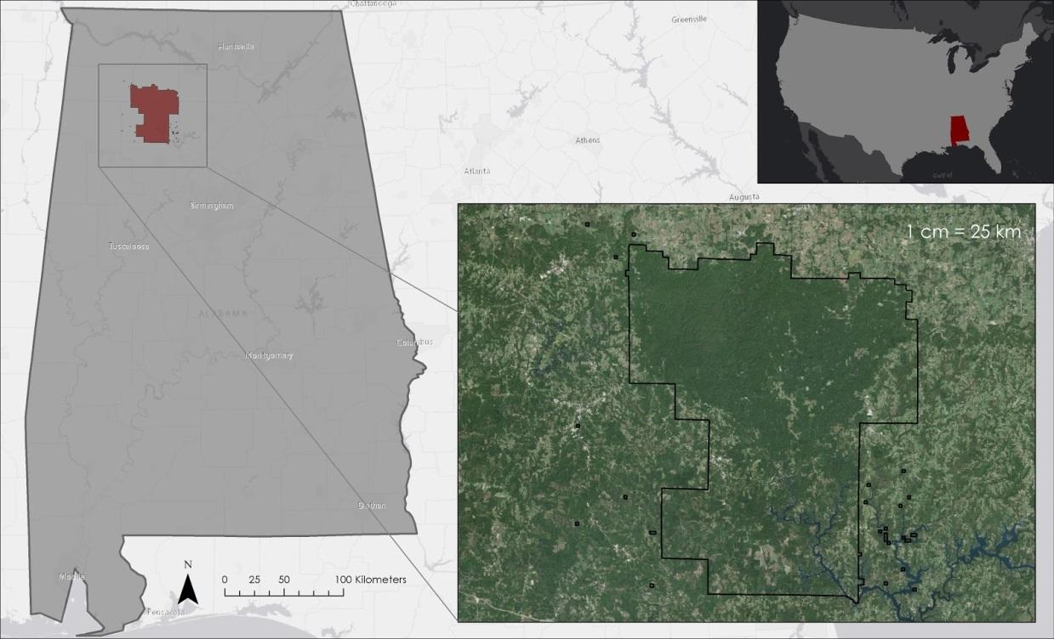
Figure 1: Study area

Study Period
The study period was from January 2010 to December 2015, focusing on May to October of each year. These dates were chosen due to availability of SPB in-situ data. Focus was placed on May to October since the peak of the SPB activity is during the summer months before the onset of winter conditions. SPB outbreak susceptibility was forecasted for 2050. This year was chosen because of restrictions of the future climate projection data used to create the prediction map.

III. Methodology
Data Acquisition
Landscape Fire and Resource Management Planning Tools (LANDFIRE) tree species 30m data were downloaded from the LANDFIRE website. Landsat 5 Thematic Mapper (TM), Landsat 8 OLI data were downloaded in monthly timesteps for May through October from USGS EarthExplorer. Shuttle Radar Topography Mission version 2(SRTM-v2) Digital Elevation Models (DEMs) 30m data were also downloaded from USGS EarthExplorer. Bioclim climatic variables and future climate prediction data were downloaded at 1km resolution from the WorldClim website. SPB in situ data for 2010 through 2015 were acquired from the Alabama Forestry Commission.

Data Processing
In situ data were provided by the Alabama Forestry Commission. Locations of SPB outbreaks were provided as a point shapefile for each year from 2010 to 2015. The original point shapefiles from the Alabama Forestry Commission were provided in the North American Datum (NAD) 1983 Universal Transverse Mercator (UTM) Zone 16N projection and were reprojected to World Geodetic System (WGS) 1984 UTM Zone 16N by using the “Project” tool in ArcMap 10.3. The shapefiles contained inconsistent attributes between each year. For example, the attribute tables from 2010-2012 did not contain latitude and longitude categories. These values had to be extracted from the plotted point locations in ArcMap 10.3 in order to create a .csv file for use in the Princeton Maximum Entropy Model. Additionally, 2015 did not include an attribute for pest type, so data from this year includes outbreaks from other beetle species, such as the engraver beetle, in addition to the southern pine beetle.

Landsat 5 TM data were projected to WGS 1984 UTM Zone 16N using the “Project Raster” tool and clipped to Alabama using the “Clip” tool. These data were used to calculate the Green-Red Vegetation Index (GRVI) and Normalized Difference Vegetation Index (NDVI) for use in the creation of the Southern Pine Beetle Prediction Map and the Near Real-Time Southern Pine Beetle Susceptibility Model. NDVI and GRVI measure the health of vegetation. NDVI was calculated using the following equation:

$$\frac{NIR-RED}{NIR+RED}$$

With,
RED = visible red (0.62 - 0.70μm)
NIR = near-infrared (0.725 - 1.1μm)

The application of the NDVI equation results in a raster with values ranging from -1 to 1. Values closer to 1 represent areas with dense green vegetation, values closer to zero represent areas with no green leaves, and values of zero and below represent areas without vegetation (Figure 2).

GRVI was calculated using the following equation:

$$\frac{GREEN-RED}{GREEN+RED}$$

With,
GREEN = visible green (0.500 - 0.570μm)
RED = visible red (0.62 - 0.70 μm)

The application of the GRVI equation results in a raster with values ranging from -1 to 1. Values closer to 1 represent areas with dense green vegetation, values closer to zero represent water/snow, and values below zero represent soil (Figure 3).

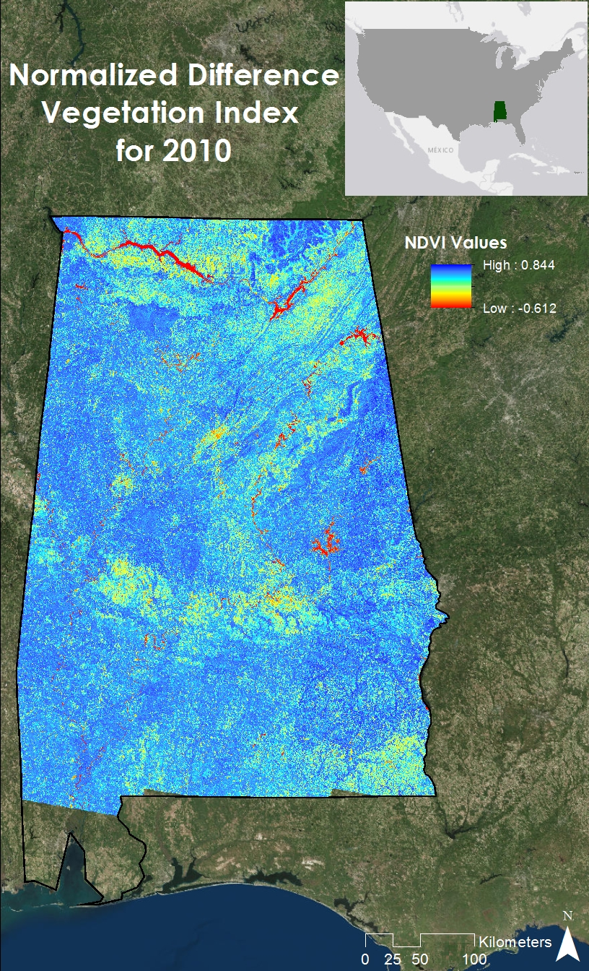
Figure 2: NDVI for 2010
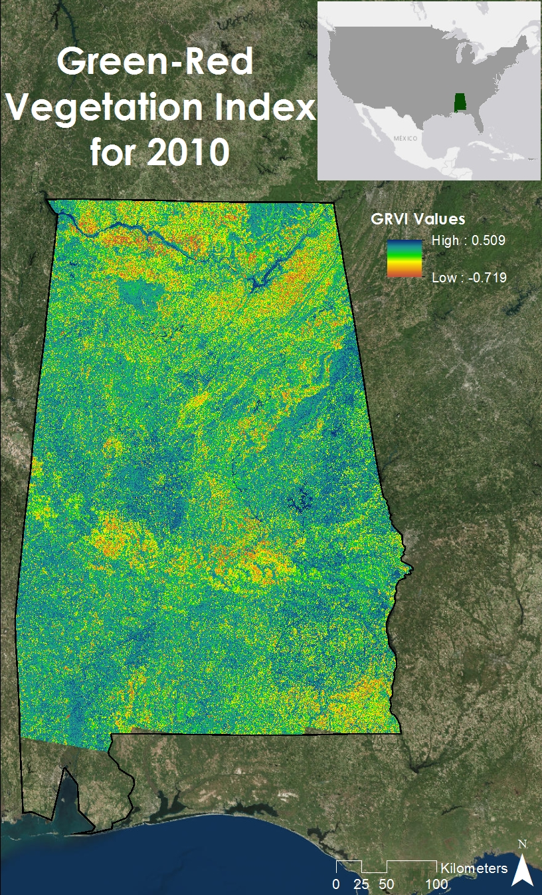
Figure 3: GRVI for 2010
The LANDFIRE land cover data were projected to WGS 1984 UTM Zone 16N using the “Project Raster” tool and clipped to Alabama using the “Clip” tool in ArcMap 10.3. These data were used in creating the Southern Pine Beetle Prediction Map and the Near Real-Time Southern Pine Beetle Susceptibility Model.

Future climatic variables for 2050, including minimum temperature, maximum temperature, mean temperature, and 19 bioclimatic variables were downloaded from the WorldClim website. These variables were used in the Near Real-Time Southern Pine Beetle Susceptibility Model to help predict future SPB susceptibility.

SRTM-v2 C-band data were reprojected to WGS 1984 UTM Zone 16N using the “Project Raster” tool, mosaicked using the “Mosaic to New Raster” tool, and clipped to Alabama using the “Clip” tool. These data were used to derive slope and elevation. The original SRTM-v2 C-band data already contained the elevation values for the study area. Slope was calculated using the “Slope” tool in ArcMap 10.3. The slope and elevation rasters were used as inputs for the Southern Pine Beetle Prediction Map.

Historic Southern Pine Beetle Coverage Maps
SPB density maps for each year from 2010 to 2015 were created using the “Point Density” tool in ArcMap 10.3. The symbology for each year was recategorized to include the entire range of possible values for all years. This allowed the density maps to be quickly compared between years. The minimum value for any given point in Alabama from 2010 to 2015 was 0 SPB outbreaks per square kilometer. The maximum value for any given point in Alabama from 2010 to 2015 was 0.4095 SPB outbreaks per square kilometer. This product illustrates temporal and spatial patterns of historic SPB outbreaks.

Southern Pine Beetle Prediction Map
In situ SPB data and environmental variables were loaded into MaxEnt to show which areas are predicted to be susceptible to a SPB outbreak in 2050. This year was chosen because 2050 was the earliest climate prediction from BioClim that were available for use in the model. The variables consist of elevation, slope, NDVI, GRVI, tree species, and 19 WorldClim bioclimatic variables (Appendix Table 1). All of these variables were set to have the same projection, snap raster, mask, cell size, and extent by using the “Extract by Mask” tool in ArcMap 10.3. The data were then converted into ascii (.asc) files and in situ data were converted into a comma separated values (.csv) file to use in the model.

The in situ data consisted of 1,794 points and 25% were withheld as test data. The model ran with 1,000 maximum iterations and 10 randomized replicates. In addition, the projection layer was the BioClim future climate prediction data for 2050. It consisted of monthly average maximum temperature, monthly average minimum temperature, and monthly average precipitation. The climate data factored in the Representative Concentration Pathway (RCP) 8.5, which calculates a climate prediction based on greenhouse gases continuing to rise throughout the end of the 21st century.

Near Real-Time Southern Pine Beetle Susceptibility Model
NDVI and GRVI were calculated for the months May through October from 2010 to 2015. To pull out the NDVI and GRVI values at the location of SPB outbreaks, 80% of the in situ data was put into the “Extract Multi Values to Points” tool in ArcMap 10.3. This determined the SPB preferred thresholds for NDVI and GRVI. The remaining 20% of the in situ data was used as test data to see how accurate the model is.

The Near Real-Time Southern Pine Beetle Susceptibility Model consists of a semi-automated Python script. This model downloads the most recent Landsat 8 OLI data for Alabama (Appendices Table 2) and mosaics all of the tiles together to create one image. Cloud cover caused errors in the reflectance data by giving negative values for reflectance, so the Near Real-Time Southern Pine Beetle Susceptibility Model removes these negative values by using the “Con” tool in ArcMap 10.3. NDVI and GRVI are then calculated and clipped to the shape of Alabama. LANDFIRE tree species data is then reclassified to only show tree species that are desired by the SPB with values closer to 0 being tree species not preferred and values closer to 1 being tree species preferred by SPB (Appendices Table 4). It is then also clipped to the shape of Alabama.

The Fuzzy Logic Model is more of a heuristic approach to make the Near Real-Time Southern Pine Beetle Susceptibility Model. This means that a list of variables and Southern Pine Beetle preferred thresholds were determined based on a combination of expert opinion from scientific journal articles, in situ data, and educated guesses on behalf of the team. This approach is appropriate for Southern Pine Beetle susceptibility studies because the details of what causes any individual Southern Pine Beetle outbreaks can be difficult to pinpoint. The “Fuzzy Membership” tool was used to rescale NDVI and GRVI on a scale from 0 to 1, with values closer to 0 representing lower Southern Pine Beetle susceptibility and 1 representing higher susceptibility. These Fuzzy Memberships were then combined with the “Fuzzy Overlay” tool using the “AND” operator. This takes the lowest value of all the variables and assigns that value on a pixel per pixel basis, resulting in a single layer with values from 0 to 1 with values closer to 0 representing lower Southern Pine Beetle susceptibility and 1 representing higher susceptibility.

IV. Results & Discussion
Historic Southern Pine Beetle Density Maps
The Historic Southern Pine Beetle Density Maps illustrate the prevalence of SPB outbreaks across the state, as well as the cyclical nature of SPB outbreaks. The southwestern portion of Alabama consistently had the highest density of outbreaks except for a brief respite in 2011 and 2012 (Appendices Figures 8 - 9). 2012 had the fewest cases reported throughout the state. There were only a few SPB outbreaks in or near Bankhead National Forest between 2010 (Figure 4) and 2015 (Appendices Figure 12).

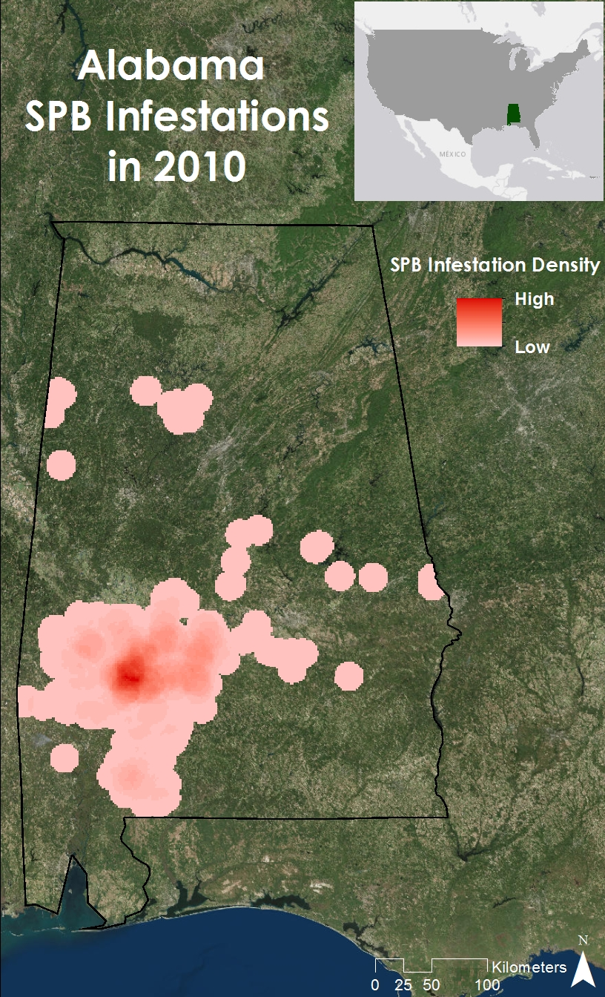
Figure 4: Historic Southern Pine Beetle Map for 2010
Southern Pine Beetle Prediction Map
The variables that had the greatest impact in the MaxEnt model (Appendices Table 3) were Bio 4 (temperature seasonality), Bio 5 (max temperature of the warmest month), Bio 11 (mean temperature of the coldest quarter), and tree species. The variable that had the least impact was the Bio 16 (precipitation of wettest quarter). Furthermore, the Area Under the Curve (AUC) for the MaxEnt results was 0.86 as an average of the ten trials conducted. The MaxEnt model calculated the AUC by ranking the outputs from 0 to 1, with 0 to 0.5 being no greater than random and values closer to 1 being the most accurate. The Southern Pine Beetle Prediction Map also showed that southwest Alabama was at greatest risk for a SPB outbreak in 2050 (Figure 5).

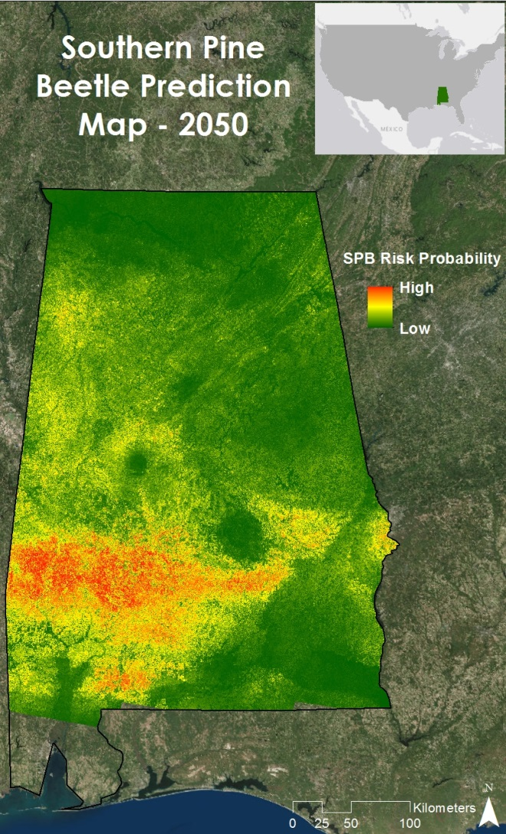
Figure 5: Southern Pine Beetle Prediction Map for 2050 using MaxEnt
Near Real-Time Southern Pine Beetle Susceptibility Model
The Near Real-Time Southern Pine Beetle Susceptibility Model has an overall accuracy of 88%. As of March 28, 2016, southwest and northeast Alabama were highly susceptible to a SPB outbreak (Figure 6). Also, northern Bankhead National Forest was highly susceptible to a SPB outbreak (Figure 7).

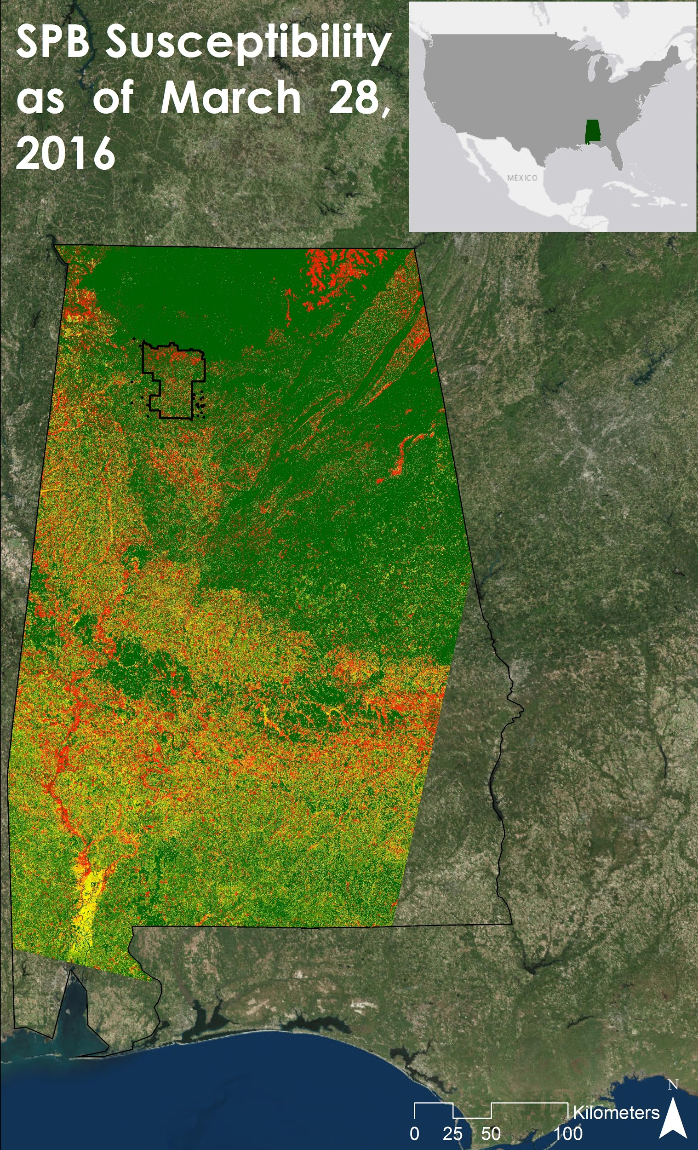
Figure 6: Near Real-Time Southern Pine Beetle Susceptibility Model output on March 28, 2016

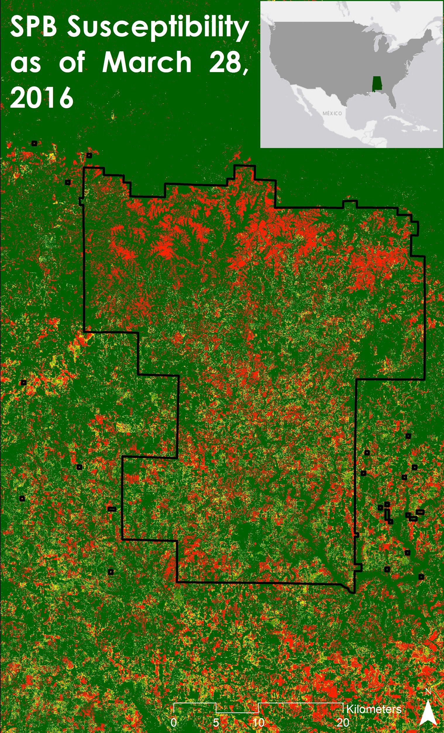
Figure 7: Near Real-Time Southern Pine Beetle Susceptibility Model output for Bankhead National Forest on March 28, 2016
Errors and Uncertainties
One potential source of error comes from the in situ SPB data. The 2015 in situ SPB data provided by the Alabama Forestry Commission included infestations of beetle species other than the SPB, such as the Engraver Beetle. It was not possible to differentiate between infestations of different species. Additionally, for some years in situ GPS points were taken from an aircraft and thus are not always located directly over the infestation spot. Another possible source of error is cloud cover in the imagery, as well as dashes of erroneous data in the Landsat 5 imagery (Appendices Figure 14).

Future Work
Future work for this project could include improving the Near Real-Time Southern Pine Beetle Susceptibility Model by increasing the number of variables to include land surface temperature, a thermal band drought index, proximity to previous and current outbreaks, proximity to storm damage, and tree density. Future work could also include improvement of the Southern Pine Beetle Prediction Map by including the location of planned mitigation procedures. It would also be beneficial to extend the time depth of the Historic Southern Pine Beetle Prediction Maps to include years prior to 2010 in order to strengthen the variable thresholds. Finally, future work could consider the relationship between SPB outbreaks and historic conditions.

V. Conclusions
While other parts of Alabama are at greater risk and see SPB outbreaks more frequently and with higher density, Bankhead National Forest is still considered at risk. The end products from this project will help the USDA Forest Service decide where to focus mitigation efforts to reduce or even prevent future SPB outbreaks.

VI. Acknowledgments
The Alabama Ecological Forecasting team would like to acknowledge their advisors and project partners for their guidance and support for this project:

Science Advisors:
● Dr. Jeffrey Luvall, NASA at the National Space Science and Technology Center
● Dr. Robert Griffin, University of Alabama in Huntsville

Project Partners:
● Dave Casey, USDA Forest Service
● Dr. Chris Asaro, USDA Forest Service
● Dr. John Nowak, USDA Forest Service

Other:
● Daryl Ann Winstead, NASA DEVELOP
● Tim Klug, University of Alabama in Huntsville Graduate Research Assistant
● Kel Markert, SERVIR Graduate Research Assistant
● Alabama Forestry Commission

Any opinions, findings, and conclusions or recommendations expressed in this material are those of the author(s) and do not necessarily reflect the views of the National Aeronautics and Space Administration

This material is based upon work supported by NASA through contract NNL11AA00B and cooperative agreement NNX14AB60A.

VII. References
"Alabama Forest Facts." Alabama Forestry Commission. Web. 17 Feb. 2016

Bridges, J. Robert. “Effects of Terpenoid Compounds on Growth of Symbiotic Fungi Associated with the Southern Pine Beetle.” Phytopathology 77.1 (1987): 83-85. 1 Nov. 1987. Web. 26 Jan. 2016.

“National Forests in Alabama.” National Forests in Alabama. United States Department of Agriculture Forest Service, n.d. Web. 26 Jan. 2016.

Turchin, P., P. L. Lorio, A. D. Taylor, and R. F. Billings. “Why Do Populations of Southern Pine Beetles (Cleoptera: Scolytidae) Fluctuate?” Environmental Entomology 20.2 (1991): 401-09. Web. 26 Jan. 2016.

"Southern Pine Bark Beetles." Alabama Forestry Commission. Web. 01 Mar. 2016.

Stanturf, John A., Palle Madsen, David Lamb, Weimin Xi, et. al. “Chapter 12: Restoration of Southern Pine Forests After the Southern Pine Beetle.” A Goal-oriented Approach to Forest Landscape Restoration. Dordrecht: Springer Verlag, 2012. 322. Web. 10 Feb 2016.

VIII. Content Innovation
VPS: 2016Spring_MSFC_AlabamaEco_VPS.mp4
Interactive Map Viewer: 2016Spring_MSFC_AlabamaEco_InteractiveMapViewer.kmz
AudioSlides: 2016Spring_MSFC_AlabamaEco_AudioSlides.mp4

IX. Appendices
Table 1: BioClim variables
Variable Title | Variable
Bio 1 | Annual Mean Temperature
Bio 2 | Mean Diurnal Range  [ Mean of monthly (max temp - min temp) ]
Bio 3 | Isothermality  [ (Bio 2 / Bio 7) * 100 ]
Bio 4 | Temperature Seasonality  [ Standard Deviation of Weekly Mean Temperature * 100 ]
Bio 5 | Max Temperature of Warmest Month
Bio 6 | Min Temperature of Coldest Month
Bio 7 | Temperature Annual Range  [ Bio - Bio 6 ]
Bio 8 | Mean of Temperature of Wettest Quarter
Bio 9 | Mean Temperature of Driest Quarter
Bio 10 | Mean Temperature of Warmest Quarter
Bio 11 | Mean Temperature of Coldest Quarter
Bio 12 | Annual Precipitation
Bio 13 | Precipitation of Wettest Month
Bio 14 | Precipitation of Driest Month
Bio 15 | Precipitation of Seasonality  [ Coefficient of Variation ]
Bio 16 | Precipitation of Wettest Quarter
Bio 17 | Precipitation of Driest Quarter
Bio 18 | Precipitation of Warmest Quarter
Bio 19 | Precipitation of Coldest Quarter

Table 2: Path and row numbers of Landsat 8 OLI tiles downloaded
Path | Row
19 | 36
19 | 37
19 | 38
20 | 36
20 | 37
20 | 38
21 | 36
21 | 37
21 | 38

Table 3: Contribution and Permutation Importance averages over the 10 trials in MaxEnt
Variable | Average Percent Contribution (%) | Average Permutation Importance (%)
Bio 4 | 20.98 | 8.27
Bio 5 | 20.08 | 0.89
Bio 11 | 9.53 | 0.38
Tree Species | 7.29 | 8.64
GRVI 10 | 7.26 | 8.31
Bio 13 | 5.91 | 10.50
NDVI 10 | 4.33 | 4.37
Bio 9 | 3.81 | 0.97
Bio 1 | 3.12 | 0.48
NDVI 15 | 2.80 | 4.26
Bio 18 | 2.50 | 4.11
Bio 7 | 1.88 | 12.45
Elevation | 1.57 | 0.65
Bio 10 | 1.44 | 9.86
Bio 3 | 1.44 | 1.94
Bio 8 | 1.38 | 4.00
Bio 17 | 0.87 | 2.27
Bio 2 | 0.85 | 4.58
Bio 15 | 0.70 | 1.18
Bio 14 | 0.69 | 3.61
Bio 6 | 0.65 | 1.18
Bio 19 | 0.43 | 4.80
Bio 12 | 0.28 | 1.76
Slope | 0.10 | 0.13
GRVI 15 | 0.09 | 0.25
Bio16 | 0.06 | 0.58

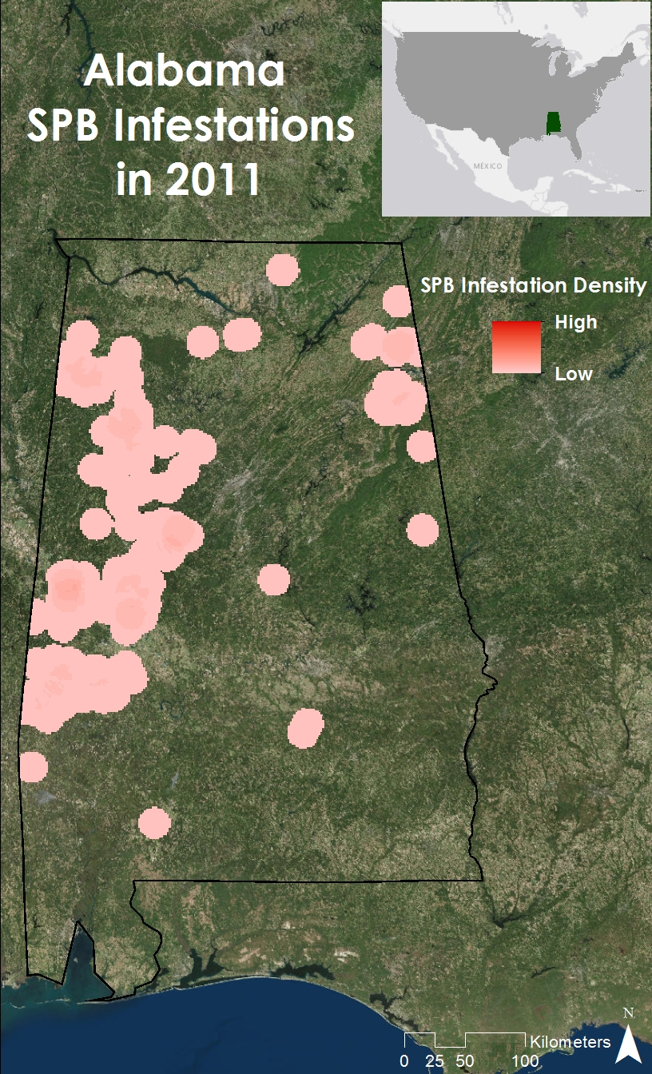
Figure 8: Historic Southern Pine Beetle Map for 2011
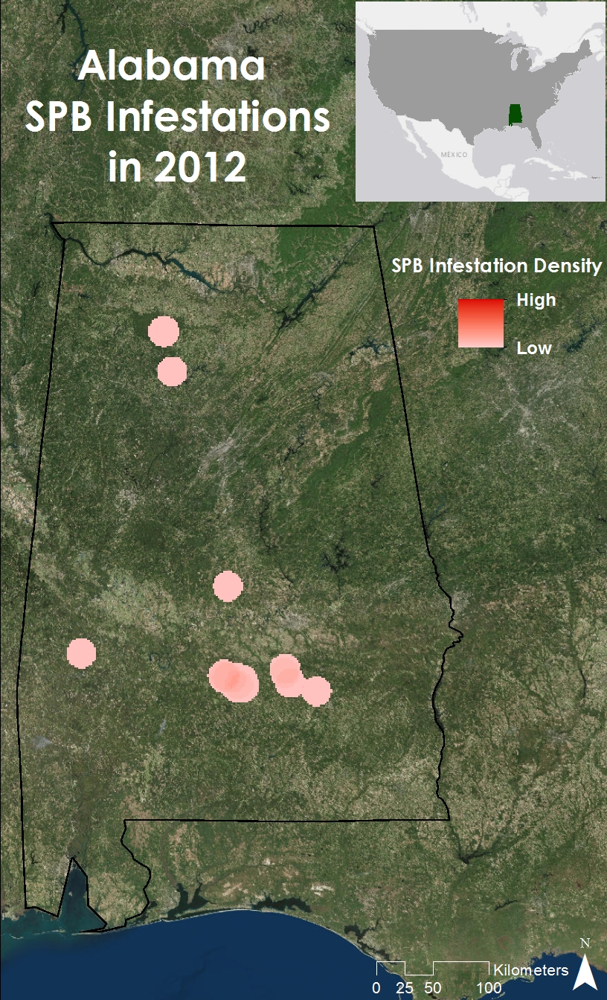
Figure 9: Historic Southern Pine Beetle Map for 2012
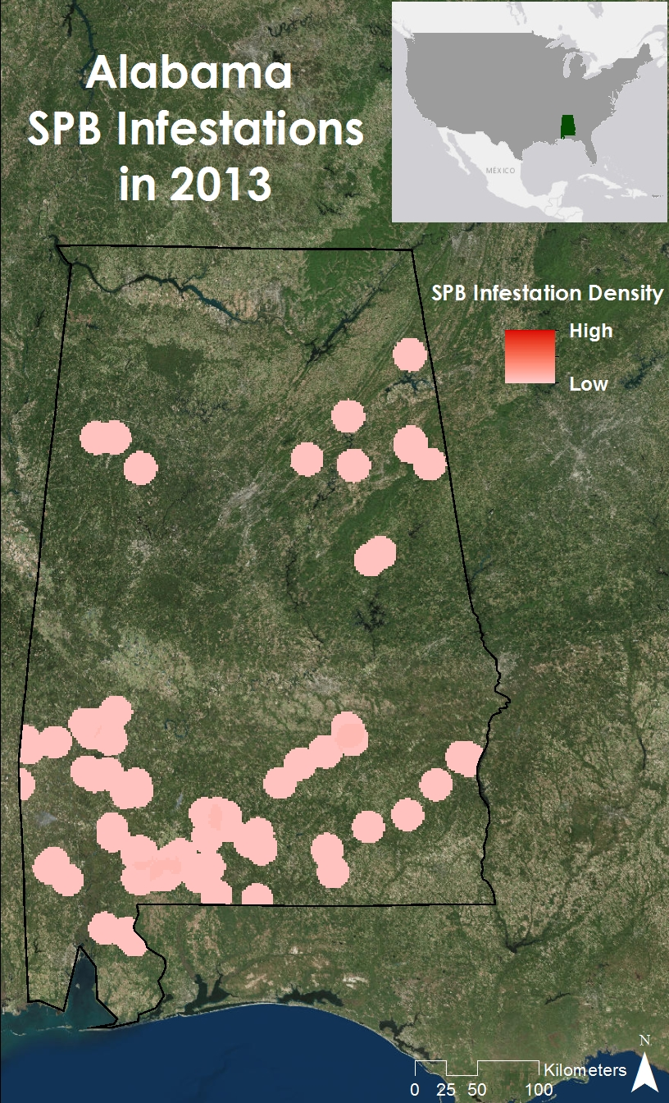
Figure 10: Historic Southern Pine Beetle Map for 2013
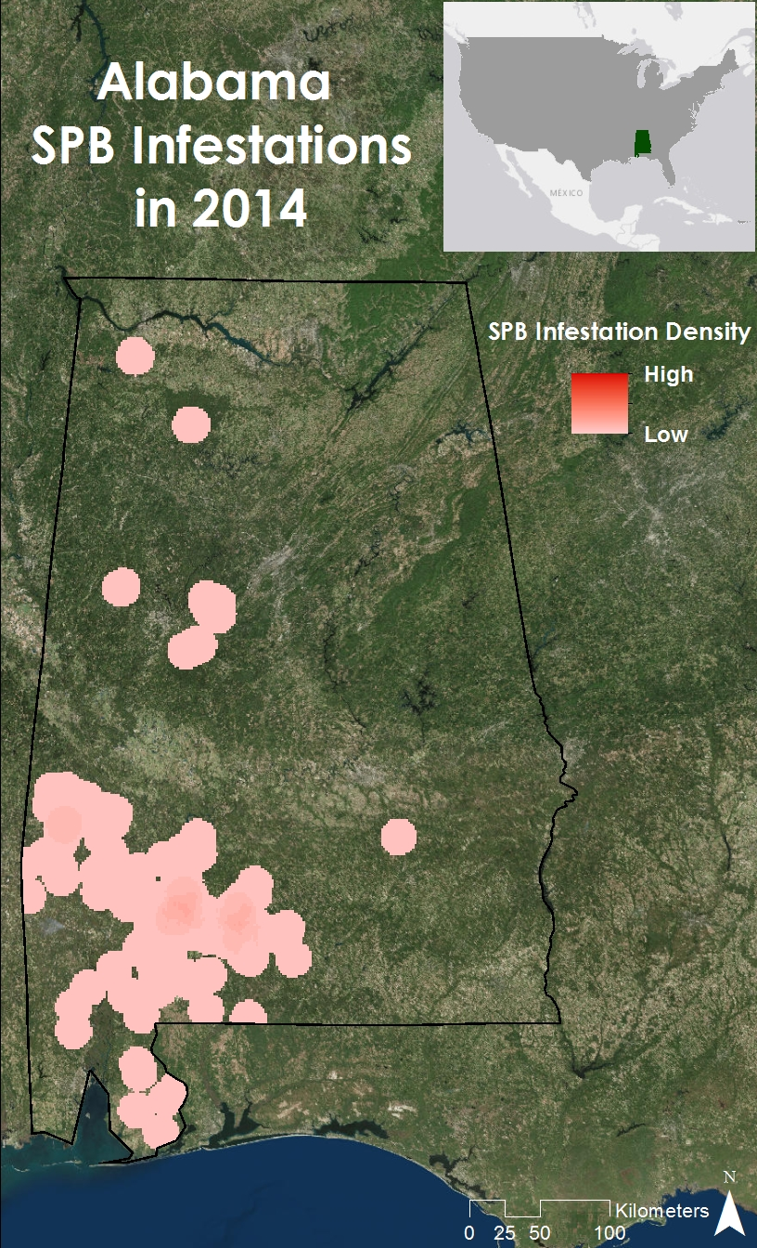
Figure 11: Historic Southern Pine Beetle Map for 2014
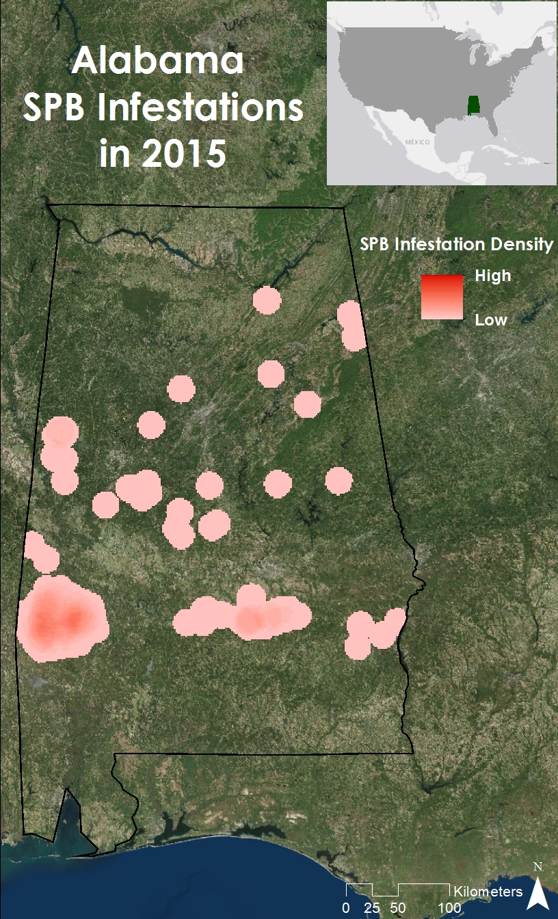
Figure 12: Historic Southern Pine Beetle Map for 2015
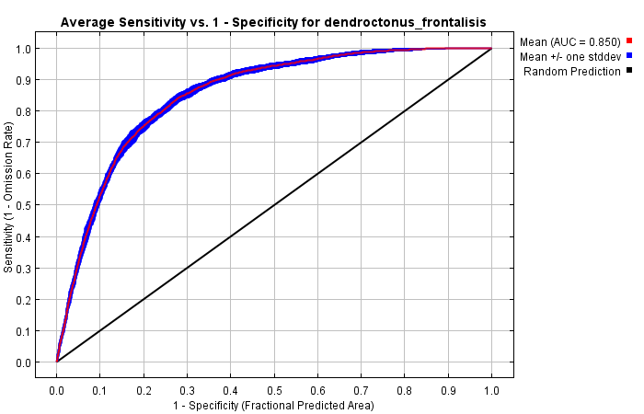
Figure 13: AUC for Southern Pine Beetle Prediction Map using MaxEnt
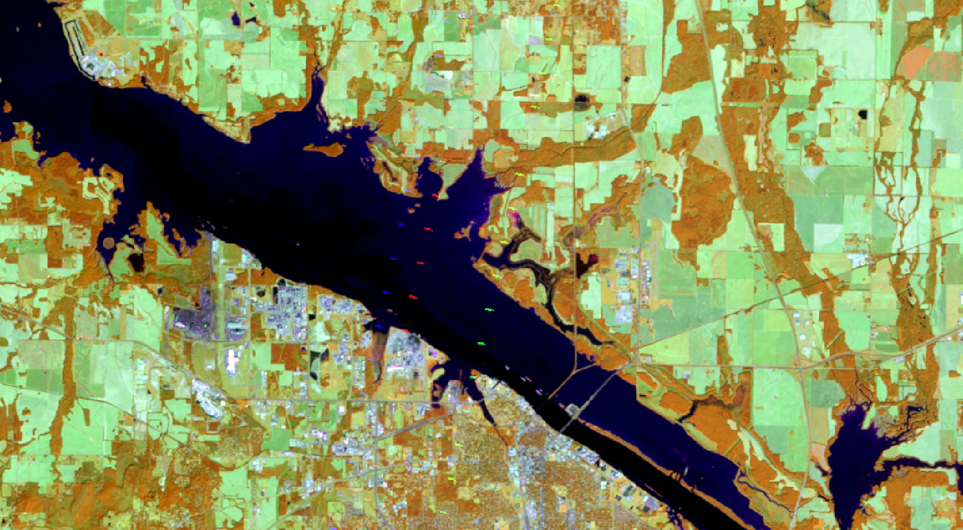
Figure 14: Dashes of erroneous data in Landsat 5 TM imagery
Table 4: SPB preferred tree species from LANDFIRE
