Southern Idaho Ecological Conservation

Investigating the Impact of Targeted Grazing to Improve Wetland Habitat in the Sterling Wildlife Management Area

 **Technical Report**

Final – March 31st, 2023

Preethi Malur Balaji (Project Lead)

Talissa Cota

Kangsan Lee

Melissa McNally

***Advisors:***

Keith Weber, Idaho State University, GIS Training and Research Center (Science Advisor)

***Fellow:***  
Ryan Healey (Idaho– Pocatello)

# 1. Abstract

Wetland ecosystems are vital for biodiversity conservation and ecosystem services. The Sterling Wildlife Management Area in Bingham County, Idaho, has management concerns about decadent and accumulated vegetation growth encroaching on wetland habitat, which presents challenges for wildlife, decreases biodiversity, and limits public access. Targeted grazing has been proposed as a sustainable alternative to chemical herbicides or burning. Land managers introduced targeted cattle grazing in January 2021 to reduce biomass. NASA DEVELOP partnered with the Idaho Department of Fish and Game to determine the impact of grazing using NASA Earth observations from Landsat 8 Operational Land Imager (OLI) in Google Earth Engine (GEE). Images were processed with TerrSet’s Land Change Modeler and ArcGIS Pro’s Change Detection Wizard to understand land changes following grazing. A Normalized Difference Vegetation Index (NDVI) analysis was performed to assess impacts on vegetation productivity and compare variance in biomass before and after grazing. A Normalized Difference Water Index (NDWI) was used to compare changes in the wetland and its vegetation content to evaluate the suitability of the area for migratory birds post-grazing. Results showed a decrease in the vegetation index and an increase in the water index post-grazing. The DEVELOP team’s analysis suggests that grazing helps break down thick, senesced vegetation and increase soil moisture. Providing a workflow model will aid partners in continuing to monitor this management area and other management areas across the state.

**Key Terms**

change detection, NDVI, NDWI, Landsat 8, Google Earth Engine, TerrSet2020, ArcGIS Pro, targeted grazing

# 2. Introduction

***2.1 Background Information***

Targeted (or prescribed) grazing is an adaptive management method employed to manage vegetation. Land managers utilize prescribed grazing to reduce dormant vegetation, control invasive plants, and create wildfire fuel breaks. This technique is often used in conjunction with other management practices, such as prescribed burning, herbicides, or the manual removal of vegetation using tools. Targeted grazing differs from traditional grazing in that the focus shifts from livestock production to landscape and vegetation enhancement (Weber & Gokhale, 2011). The practice’s effectiveness depends on a holistic approach that considers the specific ecosystem being treated, the goal(s) of the management, and the grazing intensity (Savory, 1999). This study focuses on wetlands, which are essential habitats for breeding amphibians and waterfowl, as well as critical stopover points for migratory birds.

Ungulates such as cattle create disturbance and impact plants in an ecosystem by a) consuming biomass, b) trampling plants, which creates open space, and c) adding nutrients through fecal matter. Grazing can also change how plants reproduce and compete for resources like nutrients (Jones et al., 2011). Disturbance is an important component of species richness and heterogeneity, and a lack of land management practices such as grazing, burning, and cutting has resulted in a loss of biodiversity (Middleton, 2013). A study has found that grazing timing has a strong effect on plant richness and diversity (Otfinowski & Coffey, 2022).

The wetlands study area is located within the Sterling Wildlife Management Area (SWMA), which the Idaho Department of Fish and Game (IDFG) established in 1968. SWMA land managers aim to increase the region’s waterfowl (*Anatidae*) and ring-necked pheasant (*Phasianus colchicus*) populations by managing and enhancing wetland habitats*.* The SWMA is at 4,400 feet elevation on 4,106 acres of land in Bingham County, Idaho. The landscape consists of low-rolling, loess-covered lava reefs vegetated by exotic and native species of forbs, trees, grasses, and shrubs (Rose, 2014). The area is a mixture of uplands (31 percent), marshes (20 percent), agricultural lands (17 percent), meadows (8 percent), and Russian olive (*Elaeagnus angu stifolia*) woodlands (6 percent). Game and non-game species of wildlife inhabit the region year-round.

SWMA is open to the public for seasonal hunting, hiking, and year-round wildlife viewing—particularly birding (Henry, A. & Scaup & Willet LLC, 2022). The expansion of tall emergent vegetation into wetland habitats has reduced both the horizontal and vertical structural components required by many waterbirds and has limited the potential to produce an abundance of high-energy and high-protein foods, especially in aquatic invertebrates (Larson et al., 2022). Extended surface water flooding, saturated soils, and the slow decay of robust emergent plant litter have reduced decomposition rates of residual vegetation on SWMA, which has created dense mats of dead vegetation on top of coarse particulate organic matter (Henry, A. & Scaup & Willet LLC, 2022). Biomass has limited SWMA access for wildlife and visitors.

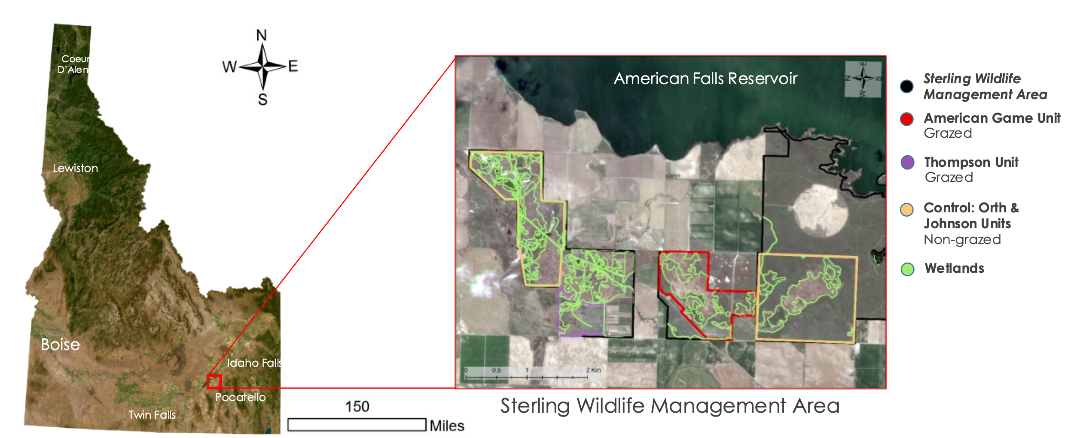Figure 1. SWMA is situated adjacent to the west side of American Falls Reservoir, approximately four miles southwest of Aberdeen and 25 miles southwest of Blackfoot.

***2.2 Project Partners & Objectives***

The IDFG conserves, protects, perpetuates, and manages wildlife, fish, and plants in Idaho. SWMA’s specific vision is to protect upland and wetland habitats for the benefit of diverse wildlife, and to provide wildlife-based recreation to the public, with a special focus on the demand for hunting. SWMA land managers previously managed the vegetation with mowing and prescribed fires. However, due to limited resources, staff, and funding, IDFG sought a more cost-effective approach. IDFG has collaborated with local ranchers to introduce high-intensity, short-duration targeted grazing at a small scale to help eliminate the senesced vegetation and reduce biomass. There was a trial run of 250 cattle grazing in the uplands of Thompson in the winter of 2019/2020. Then, the success of that program encouraged land managers to trial graze on the wetlands. The initial graze took place in January 2021, and this grazing has continued annually through to the present.

IDFG is interested in leveraging Earth observation data in addition to the LiDAR, ArcGIS, and ground data already in use. The organization has a strong interest in increasing their remote sensing capacity to assist with management and monitoring practices. To aid with this effort, the NASA DEVELOP team analyzed changes in vegetation productivity and surface water cover pre- and post-grazing using Landsat 8 imagery along with ancillary datasets. The main objectives of the project were to generate quantitative results showing the effects of grazing, quantify changes in vegetation productivity and surface water cover, compare biomass and surface water cover pre- and post-grazing, and develop a step-by-step tutorial to provide IDFG with tools to use for future monitoring.

# 3. Methodology

***3.1 Data Acquisition***

The team utilized Landsat 8 Operational Land Imager (OLI), PlanetScope SuperDove, and National Agriculture Imagery Program (NAIP) Earth observation (EO) datasets. First, the team obtained Landsat 8 imagery using Google Earth Engine (GEE), and commercial high-resolution imagery from Planet Labs. Then, the team used LiDAR imagery of SWMA to extract elevation and aspect information. The platform and sensor, data products, spatial resolution, acquisition period, and methods are listed in Table (1).

Table 1: *Earth observation sensors, data products, spatial resolution, acquisition period and methods*

|  |  |  |  |  |
| --- | --- | --- | --- | --- |
| Platform and Sensor | Data Product | Spatial Resolution | Dates | Acquisition Method |
| Landsat 8 OLI/TIRS | Landsat 8 Operational Land Imager and Thermal Infrared Sensor Collection 2 Level-1, and Collection 2 Level-2 | 30 m | 2013–2022 | GEE (Landsat Surface Reflectance | U.S. Geological Survey, n.d.) |
| NAIP | Digital Ortho Quarter Quad (DOOQ) | 1 m | 2021 | GEE (Earth Resources Observation and Science (EROS) Center, 2017) |
| Planet Labs | PlanetScope  SuperDove | 3 m | 2018–2022 | Downloaded from Planet Explorer (Explorer Beta, 2021) |
| Idaho LiDAR Consortium | LiDAR | 1 m | 2020 | Idaho LiDAR Consortium (Idaho Department of Fish and Game, 2020) |

The team used multiple ancillary datasets to meet their study objectives, listed in Table (2). An Idaho Wetlands data layer from the U.S. Fish and Wildlife Service helped to identify which areas on SWMA were classified as wetlands. IDFG provided SWMA shapefiles that delineated the grazed and non-grazed (control) units. The team acquired and utilized Historic AgriMet weather data from the Bureau of Reclamation to determine a phenological window for the study area. They also used the U.S. Drought Monitor to differentiate between wet and dry years for their study period. Next, they acquired the National Land Cover Database (NLCD) from the Multi-Resolution Land Characteristics Consortium (MRLC) for preliminary analysis. Finally, the team acquired existing vegetation height and existing vegetation type LANDFIRE datasets for the years 2020 and 2022.

Table 2: *Ancillary datasets utilized*

|  |  |  |  |
| --- | --- | --- | --- |
| Source | Data Product | Dates | Acquisition Method |
| U.S. Fish and Wildlife Service | Idaho Wetlands data layer | 2022 | Downloaded from National Wetlands Inventory  (National Wetlands Inventory | U.S. Fish & Wildlife Service, 2022) |
| Bureau of Reclamation | AgriMet weather data (min daily air temperature, max daily air temperature, daily precipitation, growing degree days [GDD]) | 2013–2021 | Downloaded from AgriMet Historical Archive Weather Data Access 9 (AgriMet Columbia-Pacific Northwest Region | Bureau of Reclamation, n.d.) |
| U.S. Drought Monitor | Drought conditions (percent area) | 2013–2022 (June) | Data accessed from U.S. Drought Monitor (Current Map | U.S. Drought Monitor, n.d.) |
| Idaho Department of Fish and Game | Boundary shapefile for SWMA | 2017 | From Idaho Department of Fish and Game (IDFG GIS Analyst, 2017) |
| Idaho Department of Fish and Game | Boundary shapefile for grazing and non-grazing allotment areas | 2023 | From the Idaho Department of Fish and Game (IDFG GIS Analyst, 2017) |
| U.S. Department of Agriculture Forest Service & U.S. Department of the Interior | LANDFIRE existing vegetation type (EVT) and existing vegetation height (EVH) | 2018 & 2022 | Downloaded from LANDFIRE (LANDFIRE Program: About LF, n.d.) |
| Multi-Resolution Land Characteristics Consortium | National Land Cover Database | 2019 | Downloaded from Multi-Resolution Land Characteristics Consortium (Multi-Resolution Land Characteristics (MRLC) Consortium | Multi-Resolution Land Consortium, n.d.) |

***3.2 Data Processing***

The methodology for this project involved four main steps: 1) preprocessing satellite imagery, 2) ecological forecasting to predict 2022 biomass production classes using Normalized Difference Vegetation Index (NDVI), 3) comparing predicted productivity to actual post-grazing NDVI data, and 4) conducting a suitability analysis to investigate the suitability of the study area for wetland wildlife habitats. The team selected image acquisition dates after gaining an understanding of the phenological dates for the vegetation within the study area and performed this with the use of Pheno-Calc (Weber, 2001)—software that takes temperature and precipitation data as inputs to calculate cumulative precipitation and growing degree days (GDD).

The team performed pre-processing using GEE and generated NDVI and Normalized Difference Water Index (NDWI) images for both the ecological forecasting and suitability analysis processes. They selected NAIP data with a high resolution of one meter to validate the georeferencing of Landsat data and set a baseline using the maximum NDVI across all the NDVI images for 2013–2019 (excluding two wet years, 2016 and 2017). To identify the wet and dry years, the team compared the cumulative precipitation of each year. First, they acquired precipitation data from the U.S. drought monitor (Current Map | U.S. Drought Monitor, n.d.). Appendix (C), Chart (C5) represents the cumulative precipitation over each year of the study period. This baseline was based on pre-grazing years. The team carried out ecological forecasting using TerrSet’s Land Change Modeler (LCM) with 2013 NDVI Maximum and 2018 NDVI Maximum images as inputs, set to forecast to 2022. Then they compared this with the NDVI 2022 image derived from GEE Landsat data. The team also used NDWI and NDVI for their suitability analysis and analyzed the changes in water index and vegetation productivity to assess the impacts of grazing on the study area.

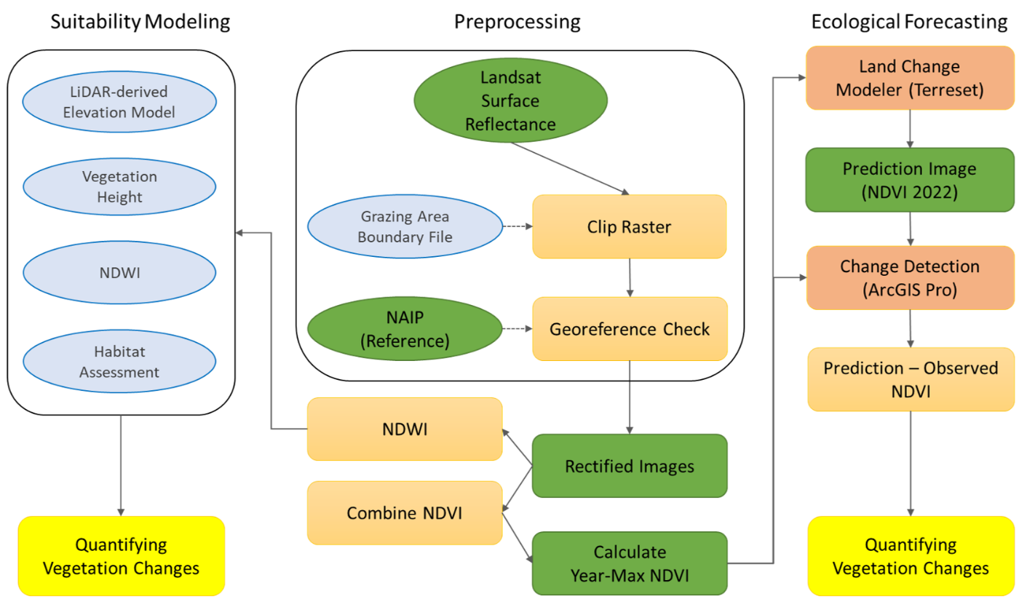

Figure 2. Flow chart illustrating the methodology including processing steps for Landsat data as well as for the ecological forecasting and habitat suitability analyses

*3.2.1 Landsat 8*

The team processed Landsat imagery in GEE. The Landsat surface reflectance data over the study area and period had less than 1% cloud cover for most images, and therefore, a cloud-masking function was not applied. However, clouds were observed in seven out of nine images from 2019, so the team did not consider the seven images for further processing. The processing steps included calculating the NDVI (Shevyrnogov et al., 2021) and NDWI (Kshetri, 2018). The equations for calculating the indices are provided in Appendix B (Equations B1 and B2).

*3.2.2 PlanetScope SuperDove*

PlanetScope satellites are capable of capturing imagery with a spatial resolution of up to 3 meters per pixel, providing a comprehensive view of Earth's surface. Satellites are designed to capture images frequently, with a revisit time of approximately once daily, which may vary depending on the location. The team downloaded orthorectified, and radiometrically corrected surface reflectance products containing near-infrared and visible range bands, facilitating the analysis of vegetation indices. Further details pertaining to the dataset are presented in Appendix A, Table A2.

*3.2.3 LiDAR*

LiDAR systems utilize laser technology, emitting light pulses which reflect off the Earth's surface and are detected by sensors integrated within the system. A LiDAR dataset for 2020 captured the pre-grazing condition of the study area (Idaho Department of Fish and Game, 2017). The dataset utilized in this project satisfies QL1, indicating vertical accuracy of roughly 10 cm (about 3.94 in), a point density exceeding 8 points per square meter, and data cell size of 1 meter (Appendix A, Table A1). The team set the horizontal projection to NAD83/UTM zone 12N and the vertical coordinate to NAVD88 and Geioid12B.

***3.3 Data Analysis***

*3.3.1 Historical Analysis of Drought Conditions and Phenology*

The team downloaded weather data consisting of minimum and maximum temperatures, daily precipitation, and GDD between 1/1/2013 – 2/1/2023 from AgriMet Historical Archive Weather Data (AgriMet Columbia-Pacific Northwest Region | Bureau of Reclamation, n.d.) for use in Pheno-Calc. One dry year and one wet year were input into Pheno-Calc. The team ran five iterations comparing dry and wet years at a 5% tolerance level, and four iterations at a 15% tolerance level. The phenological dates were slightly variable, depending upon which two years were input but, in general, the phenological dates were clustered toward the end of March and mid-to late-April.

*3.3.2 NDVI*

Using the phenological dates as a reference, the team acquired Landsat and PlanetScope images within a temporal window and generated NDVI in GEE for the study area and period (2013–2022). Batch processing in ArcGIS Pro’s clip raster function clipped each NDVI image to the four areas of interest. The team also generated NDVI from PlanetScope in ArcGIS Pro (Version 3.0.3) using a ModelBuilder that created raster layers from bands 3 and 4 of the imagery and ran the raster calculator to derive NDVI from those raster layers. The team transferred the generated NDVI layers to TerrSet2020 to derive maximum NDVI for each year using the NDVICOMP module and created a baseline for the pre-grazing study period. To focus the investigation on the wetlands, the team clipped the products to the wetland polygon layer. Then, the team conducted further analysis by extracting mean, median, and standard deviation values using the zonal statistics tool in ArcGIS Pro and examined the histogram and statistics of the baseline NDVI image and maximum NDVI from 2022.

*3.3.3 Vegetation change analysis*

The team used the Land Change Modeler (LCM) in TerrSet2020 to assess pre-grazing vegetation productivity on SWMA and forecasted to 2022 to compare the forecasted map to actual conditions using Landsat NDVI datasets. The idea behind this was to compare the forecasted NDVI image (using pre-grazing images) with the NDVI image from 2022. Grazing occurred in 2022, and this process provided an understanding of the effects of grazing based on the increase or decrease of NDVI. The team accomplished this by inputting the maximum NDVI images from 2013 and 2018 as the early and late land cover images into the LCM. They segmented the maximum NDVI into separate 0.1 interval classes using the ‘reclass’ module in TerrSet. Then they generated sub-models for each possible transition, which they used to create forecasted maps of maximum NDVI for 2022. Next, they exported the forecasted maps as TIF files to be compared with the actual maximum NDVI for 2022 using the Change Detection Wizard in ArcGIS Pro 3.0.3. This process was repeated several times for each unit in question (four grazing units and two control units). Lastly, the team used the output images to create maps that were used to perform a comparison between the forecasted image and the NDVI image generated from Landsat.

*3.3.4 Surface water change analysis*

The team analyzed changes in surface water cover on SWMA by comparing NDWI images of 2020 and 2022. They generated the NDWI images from GEE using Landsat data and analyzed them using the Change Detection Wizard in ArcGIS Pro. Next, they calculated the changed area between the pre- and post-grazing NDWI images.

*3.3.5 Comparison of NDVI PlanetScope SuperDove and Landsat 8*

The team compared derived NDVI from PlanetScope SuperDove and Landsat 8 imagery by generating 200 sample points across SWMA using the Create Random Points geoprocessing tool in ArcGIS Pro. Then they extracted the points to values using the Extract Values to Points tool. Lastly, they plotted a scatterplot with a trendline and correlation coefficients.

# 4. Results & Discussion

***4.1 Analysis of Results***

*4.1.1 Historical Analysis of Drought Conditions and Phenology*

Drought conditions in southeastern Idaho have been variable between 2013–2022, where 2013–2015 were classified as dry years, followed by an extended period of wet years between 2016–2020, which then transitioned back to dry during 2021–2022. For this reason, using the phenological date is paramount when conducting land change analysis, because observed changes could easily be attributed to changes in phenology when using calendar dates. The average cumulative precipitation for the study period was 7.69 inches with an average GDD of 4704.07. Important to note is that 2016 and 2017 received a significant amount of precipitation at 12.25 and 11.51 inches, respectively, compared to the other years. The phenological date range window for each year of the study period ranged from late March to late April. Since peak plant productivity is in June–July, the image acquisition window was extended to mid-July.

*4.1.2 Comparison of NDVI PlanetScope SuperDove and Landsat 8*

The results from comparing the derived NDVI PlanetScope SuperDove to Landsat 8 OLI suggest that Landsat 8 OLI and PlanetScope SuperDove vegetation indices are not comparable. The correlation coefficient (r2) was 0.013 and the data was non-linear, clustered between 0.15 and 0.35 in the scatterplot (chart C6). Given the very low correlation between the two datasets, further analyses focused only on Landsat 8 results.

*4.1.3 Vegetation change analysis*

To analyze the results, the team investigated the grazing periods for the different allotments.

1. The Harder American Game Vanderford Unit (American Unit) was grazed from January 27 through approximately March 4, 2021; January 14 through approximately March 1, 2022; and December 31, 2022, through February 24, 2023, with 400 Animal Unit Months (AUMs).
2. The Thompson Unit was grazed from January 14 through approximately March 1, 2022, with 400 AUMs.
3. The New Wells Segment Units allowed grazing from December 31, 2022, through approximately February 24, 2023, with roughly 395 AUMs.

It was not possible to acquire post-grazing Earth observations for 2023 before this study concluded, so the sample size consisted of two years of data for American Game, and one year of data for Thompson. New Wells was not included in the analysis.

The team compared the histograms from the baseline image to the maximum NDVI image from 2022, and these charts are presented in Appendix (C). Chart (C1) shows the histograms from the grazed units (American and Thompson wetland units) and Chart (C3) shows histograms from the control units. The histograms on the left represent the baseline and histograms on the right represent the maximum 2022 image. It can be clearly seen that the distribution is skewed in the right images of the grazed units, particularly for the American Game unit indicating that the land is responding to grazing. Results from Chart (C3) indicate no significant change between the two. The mean, median, and standard deviation for both images can be compared using Chart (C2) for grazed units wherein the mean and median of baseline image are higher than that from the maximum NDVI 2022 image. Chart (C4) represents the mean, median, and standard deviation comparison between the two images for control units.

For further analysis, the team subtracted the maximum NDVI 2022 image from the forecasted NDVI 2022 image to map changes between the two. Change maps for all the units are provided in Appendix (D). Figure (D2) shows a change map for the American unit for which the interpretation is as follows:

1. The green areas represent that forecasted NDVI < actual NDVI, indicating there has been an increase in vegetation in 2022. These areas indicate increased vegetation which is mostly concentrated outside of the black boundary where grazing did not occur.
2. The yellow areas represent no change between the two images. There has been no change in the vegetation productivity between the forecasted image and the actual image, which means grazing has not impacted these areas.
3. The orange and light orange areas represent that forecasted NDVI > actual NDVI, indicating a decrease in vegetation for 2022.

Figure (D1) shows results from the Thompson unit. Fewer orange areas indicate a decrease in the NDVI in the actual image compared to the forecasted image.

The Orth control unit (where grazing was not performed) shows increased vegetation in 2022 (Figure D3). The Johnson unit also shows increased vegetation areas (Figure D4), distributed throughout the wetlands layer, indicating that areas without grazing treatment have an increased vegetation productivity in comparison to areas with grazing treatment.

From these results, the team observed that grazing areas have decreased vegetation compared to non-grazed areas. The area within the red box in Figure (D2) belongs to a private landowner with grazing occurring from summer throughout fall. Results here are also in agreement with the decreased vegetation shown within the grazed SWMA units. The change detection maps and histograms support the analyses and interpretation of the team in determining the impacts of grazing treatment on the study area.

*4.1.4 Surface Water Change Analysis from NDWI*

The results of NDWI changes between 2020 and 2022, indicate an increase in surface water in both control units and the American Game grazing unit, and a decrease in the Thompson grazing unit. The American Game unit experienced the greatest increase of 33.2 acres in surface water cover, followed by the Orth control unit with 15.6 acres, and the Johnson unit with 5 acres (Figure D5). The Thompson grazing unit experienced a very small 0.6 acre decrease in surface water cover (Figure D5).

Numerous factors contributed to surface water levels on SWMA including precipitation, groundwater discharge, soil texture, evapotranspiration, irrigation developments, and water delivery infrastructure built after the establishment of SWMA to hold water within the wetland units (Henry, A. & Scaup & Willet LLC, 2022). Precipitation increased by 20% between 2020 and 2022 which could contribute to the observed overall increase in water levels. The Orth control unit had the second highest increase in surface water change; a meandering channel constructed through the east sides of the unit that provide wetland habitat using water that had previously flowed through a drainage ditch on the opposite side of the road could be a factor for the increase in surface water cover (Henry, A. & Scaup & Willet LLC, 2022). The American Game grazing unit had been grazed the longest and had the highest amount of surface water increase covering 33.2 acres which suggests that the grazing treatment has reduced vegetation. The Thompson grazing unit, however, showed a decrease of 0.6 acres in surface water cover. Due to time constraints, the team conducted only a preliminary investigation into soil on SWMA to determine the discrepancies between the Thompson grazing unit and the other three units analyzed. The team discovered that the areas showing surface water change within the maps were classified as hydric and were flooded frequently (Soil Survey Geographic Database (SSURGO), n.d.). The only hydric soil within the Thompson was located in the north to northeast boundary of the unit and consisted of only a small area within the unit. This could be a factor for why there was a decrease in surface water cover in the Thompson grazing unit as opposed to all other units, but more investigation is required.

***4.2 Study Limitations***

The greatest limitation to this study was the limited amount of post-grazing data available. Besides a test run conducted between January and February of 2019 on the Thompson unit, targeted grazing on SWMA began in January 2021 for the American Game unit and January 2022 for the Thompson unit, which is insufficient to perform forecasting into the future with any degree of certainty. Another limitation to this study was potential anomalous data. The team acquired Landsat 8 and PlanetScope SuperDove to compare NDVI between the datasets; however, we discovered that there was a very low correlation between the datasets causing PlanetScope SuperDove to be discarded from the study. The spatial accuracy of the PlanetScope dataset was good after comparing it with NAIP dataset, however, the NDVI was different from the Landsat 8 OLI dataset (Appendix C, Chart 6). More detailed information such as sensor calibration or atmospheric correction result is needed for further study.

***4.3 Future Work***

This study would greatly benefit from incorporating several years of post-grazing data to get a clearer understanding of the future impacts from targeted grazing. For future monitoring and analysis, investigation and incorporation of other indices such as an adjusted soil index may provide insightful results. Additionally, a higher spatial resolution dataset, such as from Sentinel-2 MultiSpectral Instrument (MSI) from the European Space Agency (ESA), which has a 10 m horizontal resolution, could be beneficial. Once more post-grazing data is available, leveraging the Suitability Modeler in ArcGIS Pro may provide insight into how grazing treatment has impacted wetland wildlife habitat and how continued grazing could impact the habitat in the future. Additionally, the team was unable to investigate soil types and hydric class on SWMA and suggest that this would be a productive avenue to take for future monitoring and analysis. For a better understanding of this area, we suggest using trail camera monitoring and aerial photogrammetry analysis using a small Unmanned Aerial Vehicle (UAV) equipped with a thermal camera and LiDAR sensor. Professional, scientific grade camera and sensor platforms with the software are now available from a private company (DJI H20T thermal camera, L1 LiDAR sensor, M300 UAV body, Terra Software), available from Matrice-300 (Matrice 300 RTK – Built Tough. Works Smart., n.d.).

# 5. Conclusions

The primary purpose of this study was to assess changes in biomass and surface water cover on SWMA since the introduction of targeted cattle grazing, and to provide IDFG with quantitative results of how grazing treatments have impacted the landscape. The team used Landsat 8 data to analyze NDVI and NDWI pre- and -post grazing, which showed a decrease in vegetation in the grazed units and an increase in vegetation in the non-grazed units. IDFG’s motivation for introducing targeted grazing in the area was to reduce dense, decadent vegetation and increase surface water cover to create more suitable habitat conditions for wetland wildlife. From the results of this study, it appears that targeted grazing has had the desired effect on SWMA by reducing biomass and increasing surface water cover. However, more post-grazing analysis will be necessary before definitive conclusions can be made. Although the small sample size of treated areas meant that we could not forecast into the future with a strong degree of confidence regarding the impacts of targeted grazing, the methodology described here can help guide IDFG with continued monitoring and analyses.

# 

# 6. Acknowledgments

The team would like to thank our node fellow, Ryan Healey; our science advisor, Keith Weber; and our partners from the Idaho Department of Fish and Game, Maria Pacioretty and Jeff May, for all of their support, encouragement, and guidance during the past ten weeks. Additionally, we would like to acknowledge the cattle ranchers, Chase and Dallin Carter, as well as the staff and student interns at Idaho State University's GIS Training and Research Center.

This work utilized data made available through the NASA Commercial Smallsat Data Acquisition (CSDA) Program.

Includes copyrighted material of Planet Labs PBC. All rights reserved.

Any opinions, findings, and conclusions or recommendations expressed in this material are those of the author(s) and do not necessarily reflect the views of the National Aeronautics and Space Administration.

This material is based upon work supported by NASA through contract NNL16AA05C.

# 

# 7. Glossary

**ArcGIS Pro** –Geospatial software package for raster/vector visualization and analysis from ESRI

**Change Detection Wizard** –Tool in ArcGIS Pro that compares numerous rasters or images of a single location to identify pixels that have changed

**Earth Observations** –Satellites and sensors that collect information about the Earth’s chemical, physical, and biological systems over space and time

**TerrSet** –Geospatial software package for raster processing and analysis from Clark Labs

**Landsat** –Series of NASA Earth observation satellites

**LCM** –Land Change Modeling tool in TerrSet

**LiDAR** –Light Detection and Ranging, high-resolution elevation data

**NDVI** –Normalized Difference Vegetation Index – Spectral index that quantifies vegetation by measuring the difference between near-infrared and red wavelengths

**NDWI** –Normalized Difference Water Index – Spectral index that quantifies content changes in surface water by measuring the difference between the green and near-infrared wavelengths

**PlanetScope SuperDove** – High-resolution (3 m) imagery created by Planet Labs

# 8. References

# AgriMet Columbia-Pacific Northwest Region | Bureau of Reclamation. (n.d.). Retrieved February 22, 2023,

# from [https://www.usbr.gov/pn/agrimet/webarcread.html](https://www.usbr.gov/pn/agrimet/webarcread.html )

Current Map | U.S. Drought Monitor. (n.d.). Retrieved February 16, 2023, from [https://droughtmonitor.unl.edu/](https://droughtmonitor.unl.edu/ )

Earth Resources Observation and Science (EROS) Center. (2017). National Agriculture Imagery Program (NAIP) [Tiff]. U.S. Geological Survey. https://doi.org/10.5066/F7QN651G

Explorer Beta. (2021, September 15). Planet. <https://planet.com/products/explorer/>

Heidemann, H. K. (2012). *Lidar base specification*. US Geological Survey

Henry, A. & Scaup & Willet LLC. (2022). *Wetland review report for Sterling Wildlife Management Area.* Idaho Department of Fish and Game, Southeast Region.

Idaho Department of Fish and Game. (2020). *IDFG LiDAR 2020 Sterling WMA* [Data set]. Accessed on January, 23 2023 from [https://giscenter.isu.edu/styler/?appid=163bf5887aa04f308a 15fe 8e4 496 3b f8](https://giscenter.isu.edu/styler/?appid=163bf5887aa04f308a%2015fe%208e4%20496%203b%20f%208)

IDFG GIS Analyst. (2017). Wildlife Management Areas. Idaho Fish and Game. https://data-idfggis. open data.arcgis.com/

Jones W.M., Fraser, L.H., Curtis, P.J, (2011). Plant community functional shifts in response to livestock grazing in intermountain depressional wetlands in British Columbia, Canada. *Biological Conservation* 144, 511–517. <https://doi.org/10.1016/j.biocon.2010.10.005>

Kshetri, T.B. (2018). NDVI, NDBI and NDWI calculation using Landsat 7 and 8. *GeoWorld* 2, 32-34.

LANDFIRE Program: About LF. (n.d.). Retrieved February 16, 2023, from <https://landfire.gov/about.php>

Larson, D.M., D. DeJong, M.J. Anteau, M.J. Fitzpatrick, B. Keith, E.G. Schilling, and B. Thoele.

(2022). High abundance of a single taxon (amphipods) predicts aquatic macrophyte

diversity in prairie wetlands. *Biodiversity and Conservation*,

[https://doi.org/10.1007/s10531-022-02379-9](https://doi.org/%2010.1007/s10531-022-02379-9)

Matrice 300 RTK—Built Tough. Works Smart. (n.d.). DJI Retrieved March 29, 2023, from https://www.dji.com/photo

Middleton, B. A. (2013). Rediscovering traditional vegetation management in preserves: Trading experiences between cultures and continents. *Biological Conservation*, 158, 271–279.

<https://doi.org/10.1016/j.biocon.2012.10.003>

Multi-Resolution Land Characteristics (MRLC) Consortium | Multi-Resolution Land Characteristics (MRLC) Consortium. (n.d.). Retrieved February 22, 2023, from <https://www.mrlc.gov/>

Otfinowski, R., & Coffey, V. (2022). Grazing Effects on the Composition, Diversity, and the function of Wet Meadow Grasslands in Manitoba, Canada. *Rangeland Ecology and Management* v.80, 78-86. <https://doi.org/10.1016/j.rama.2021.10.002>

Planet Labs. (2021). *Planetscope product specifications*. Planet Labs

Planet Labs PBC. (2023). *Understanding PlanetScope Instruments.* Planet Developers.

[https://developers.planet.com/docs/apis/data/sensors/](https://developers.planet.com/docs/apis/data/sensors/  )

Rose, D. (2014). Sterling Wildlife Management Area Management Plan 2014-2023 (p. 82). Idaho Department

of Fish and Game, Southeast Region. [https://idfg.idaho.gov/sites/default/files/2014-2023-](https://idfg.idaho.gov/sites/default/files/2014-2023-SterlingWMA-Plan-Final.pdf) SterlingWMA-Plan-Final.pdf

Savory, A. (1999). Holistic Management: A New Framework for Decision Making, second ed. Island Press,

616 pp. [https://doi.org/10.1017/S0889189300008146](https://doi.org/10.1017/S0889189300008146 )

Shevyrnogov, A. P., Emelyanov, D. V., Malchikov, N. O., Demyanenko, T. N., Ivchenko, V. K., & Botvich,

I. Y. (2021). Early Forecasting of Crop Yields Based on PlanetScope Dove Satellite Data. *Biophysics*,

*66*(6), 992-997. [https://doi.org/10.1134/S0006350921060166](https://doi.org/10.1134/S0006350921060166  )

Soil Survey Geographic Database (SSURGO). (n.d.). Natural Resources Conservation Service. Retrieved

March 23, 2023, from [http://www.nrcs.usda.gov/resources/data-and-reports/soil-survey-](http://www.nrcs.usda.gov/resources/data-and-reports/soil-survey-geographic-database-ssurgo) geographic-database-ssurgo

U.S. Fish & Wildlife Service. (2022). *USFS National Wetlands Inventory* [Data set]. Retrieved February 21,

2023. <https://www.fws.gov/node/264847>

U.S. Geological Survey. (n.d.). Landsat Surface Reflectance [Data set]. Retrieved February 22, 2023, from <https://www.usgs.gov/landsat-missions/landsat-surface-reflectance>

Weber, K. T., & Gokhale, B. S. (2011). Effect of grazing on soil-water content in semiarid rangelands of southeast Idaho. *Journal of Arid Environments*, *75*(5), 464-470. <https://doi.org/10.1016/j.jaridenv.2010.12.009>

Weber, K. T. (2001). A method to incorporate phenology into land cover change analysis. *Journal of Range Management*, *54*, A1–A7. <https://giscenter.isu.edu/research/Techpg/lcc/pdf/pheno-paper.pdf>

# 9. Appendices

**Appendix A (Tables)**

Table A1: LiDAR quality level requirements are defined in the 3DEP LiDAR Base Specification (Heidemann, 2012)

|  |  |  |  |  |  |
| --- | --- | --- | --- | --- | --- |
| QUALITY LEVEL | DATA SOURCE | VERTICAL ACCURACY RMSEz (cm) | NOMINAL PULSE SPACING (NPS) meters | NOMINAL PULSE DENSITY (NPD) points per square meter | DIGITAL ELEVATION MODEL (DEM) cell size (meters) |
| QL0 | LiDAR | 5 cm | <= 0.35 m | >= 8 pts/square meter | 0.5 m |
| QL1 | LiDAR | 10 cm | <= 0.35 m | >= 8 pts/square meter | 0.5 m |
| QL2 | LiDAR | 10 cm | <= 0.71 m | >= 2 pts/square meter | 1 m |
| QL3 | LiDAR | 20 cm | <= 1.41 m | >= 0.5 pts/square meter | 2m |
| QL4 | Imagery | 139 cm | N/A | N/A | 5 m |
| QL5 | IfSAR | 185 cm | N/A | N/A | 5 m |

*Table A2:* PlanetScope basic scene product specification (Planet Labs, 2021)

|  |  |
| --- | --- |
| Product Name | Description |
| Analytic Bands | 4-band multispectral image (blue, green, red, near-infrared) 8-band multispectral image (coastal blue, blue, green I, green, red, yellow, red edge and near-infrared - PSB.SD only) |
| Ground Sample Distance (Pixel Size) | Approximate, satellite altitude dependent PS2: 3.0 m-4.1 m PS2.SD: 3.0 m-4.1 m  PSB.SD: 3.7 m-4.2 m |
| Bit Depth | Analytic (DN): 12-bit Analytic (Radiance - W m-2 sr-1 μm-1): 16-bit |
| Product Size | At 475 km altitude PS2: 24 km by 8 km PS2.SD: 24 km by 16 km PSB.SD: 32.5 km by 19.6 km with some variability by satellite altitude. |
| Geometric Corrections | Spacecraft-related effects are corrected using attitude telemetry and best available ephemeris data and refined using GCPs. |
| Positional Accuracy | Less than 10 m RMSE |
| Radiometric Corrections | Conversion to absolute radiometric values based on calibration coefficients. Radiometric values scaled by 100 to reduce quantization error. Coefficients are regularly monitored & updated with on-orbit calibration techniques. |

**Appendix B (Equations)**

$$NDVI = Index\left(NIR,RED\right)=\frac{NIR - RED}{NIR + RED}$$

*Equation B1:* Normalized Difference Vegetation Index (NDVI) equation where *NIR* refers to Near Infrared band value (Band 5, 0.85–0.88 µm) and *Red* refers to the visible red band value (Band 4, 0.64–0.67 µm) for NASA’s Landsat 8/9 OLI sensor (Shevyrnogov et al., 2021). For PlanetScope SuperDove, *NIR* is Band 4 (0.84–0.88 µm), and *Red* is Band 3 (0.65–0.68 µm; Planet Labs PBC, 2023).

$$NDWI = Index\left(G,NIR\right)=\frac{G - NIR}{G + NIR}$$

*Equation B2:* Normalized Difference Water Index (NDWI) equation where *G* refers to the visible green band value (Band 0.53–0.59µm) and *NIR* refers to Near Infrared band value (Band 5 0.85–0.88 µm) for NASA’s Landsat 8/9 OLI sensor (Kshetri, 2018). For PlanetScope SuperDove, *G* is Band 2 (0.55–0.59 µm) and *NIR* is Band (0.84–0.88 µm; Planet Labs PBC, 2023).

**Appendix C (Charts)**

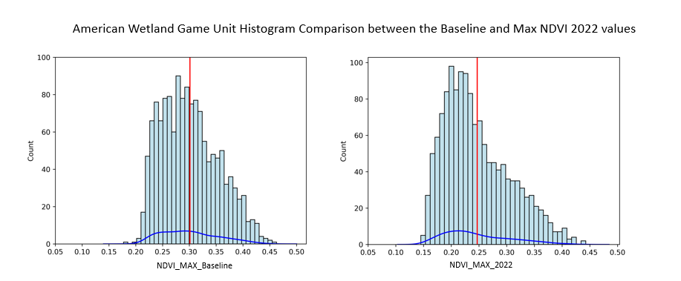

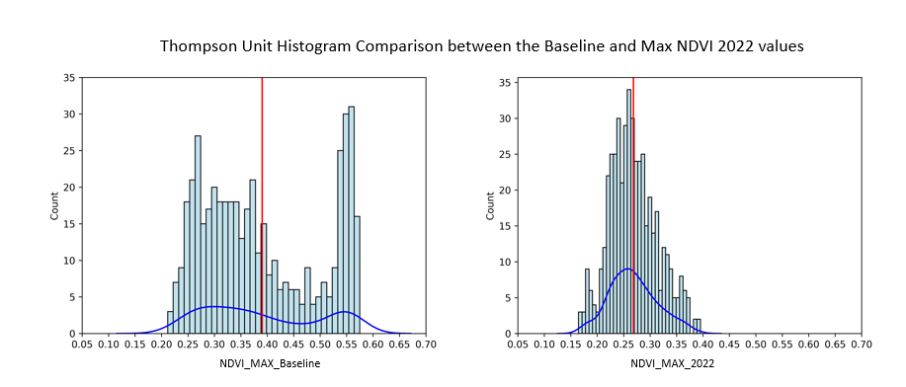

*Chart C1:* Change in distribution of pixels between pre-grazing baseline and post-grazing data for the American Game and Thompson wetland units.

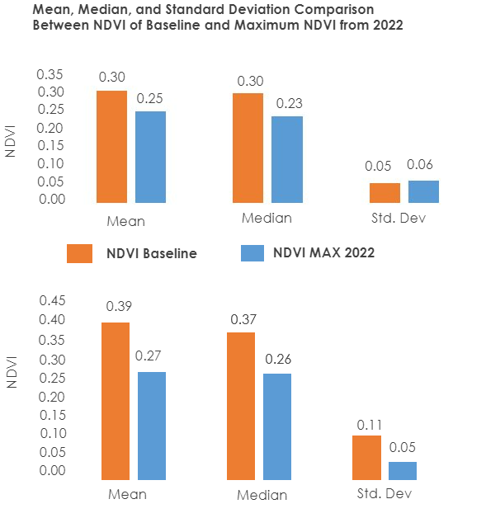

*Chart C2:* The mean, median, and standard deviation for comparison between the pre-grazing NDVI baseline and the derived maximum NDVI for 2022. The top chart represents the American Game unit, and the bottom chart represents the Thompson unit.

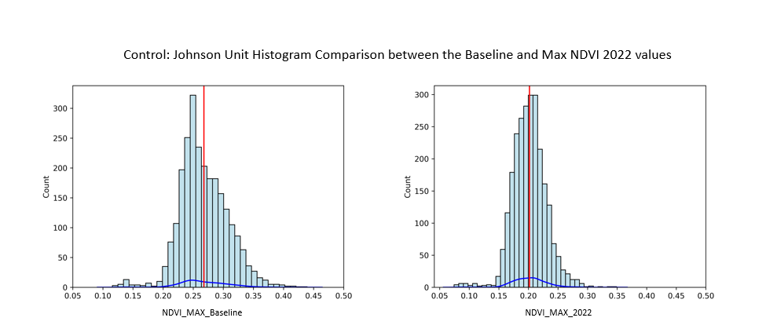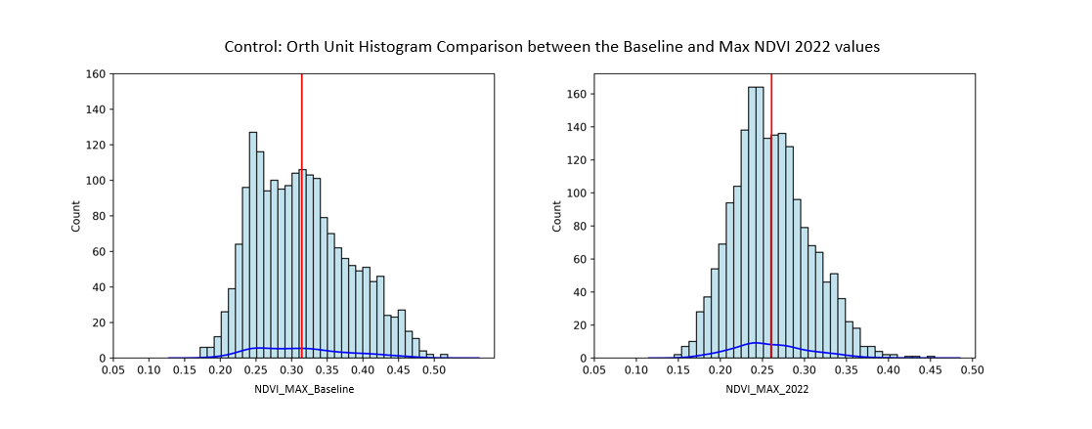

*Chart C3:* Change in distribution of pixels between pre-grazing baseline and post-grazing data for the Orth and Johnson control units.

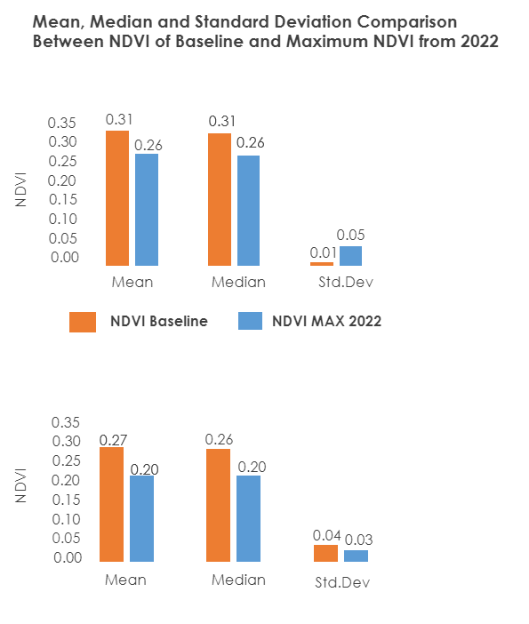

*Chart C4:* The mean, median, and standard deviation for comparison between the pre-grazing NDVI baseline and the derived maximum NDVI for 2022. The top chart represents the Orth control unit, and the bottom chart represents the Johnson control unit.

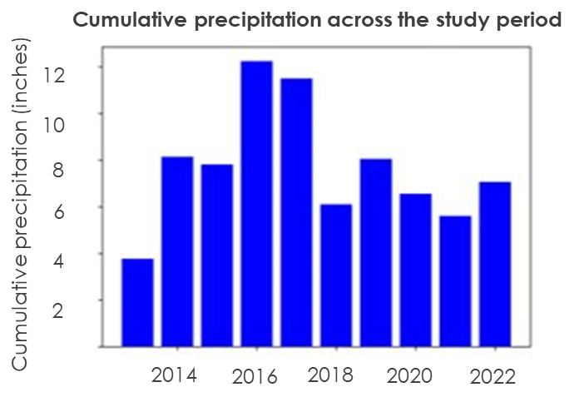

*Chart C5:* Cumulative precipitation in inches for study area between 2013–2022.

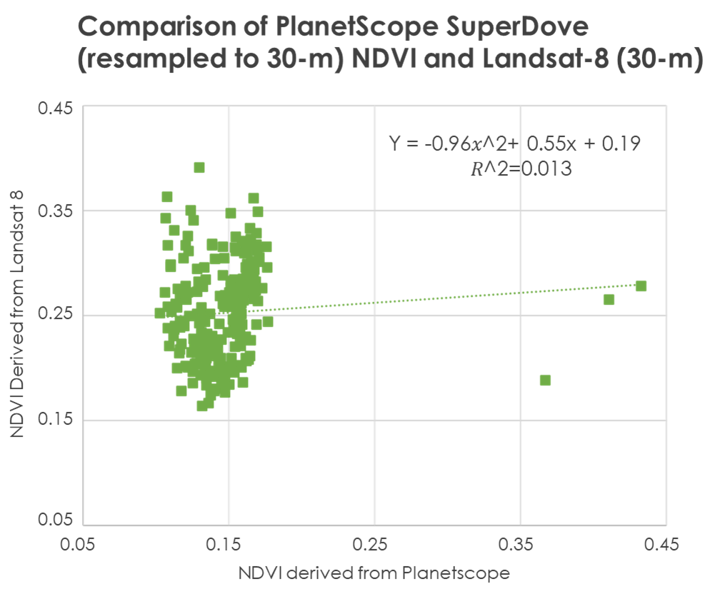

*Chart C6:* Comparison of NDVI between PlanetScope SuperDove and Landsat 8.

**Appendix D (Figures)**

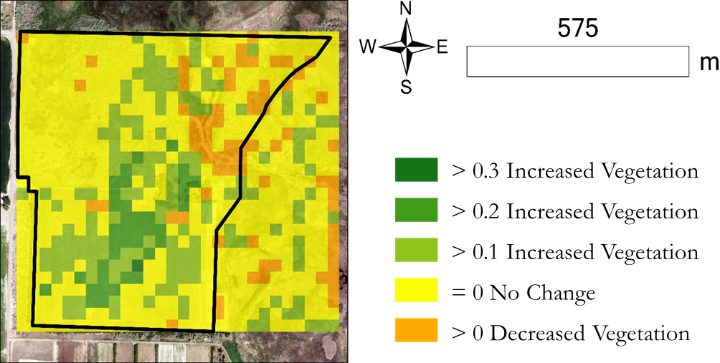

*Figure D1:* The change between forecasted maximum NDVI and actual maximum NDVI for 2022 in the Wells Thompson Grazing Area.

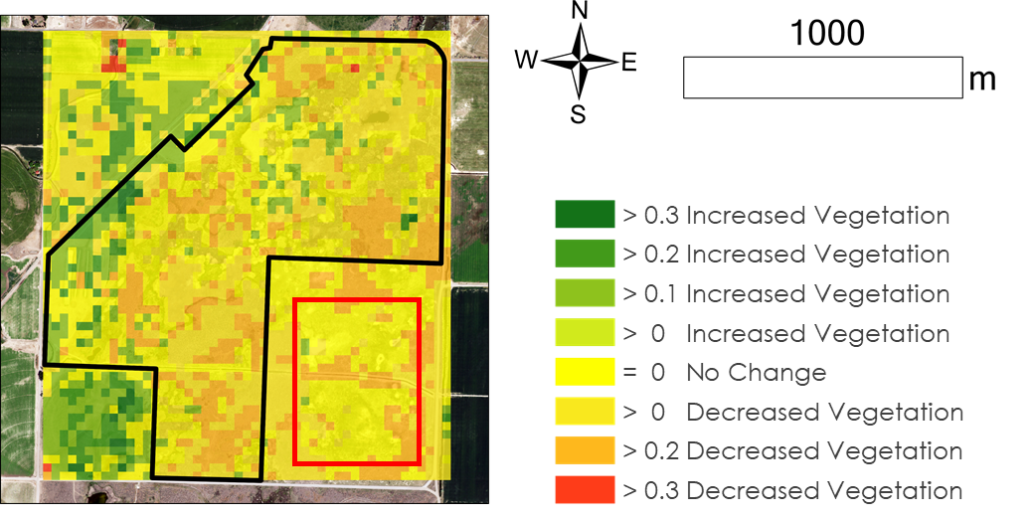

*Figure D2:* The change between forecasted maximum NDVI and actual maximum NDVI for 2022 in the American Game Grazing Area.

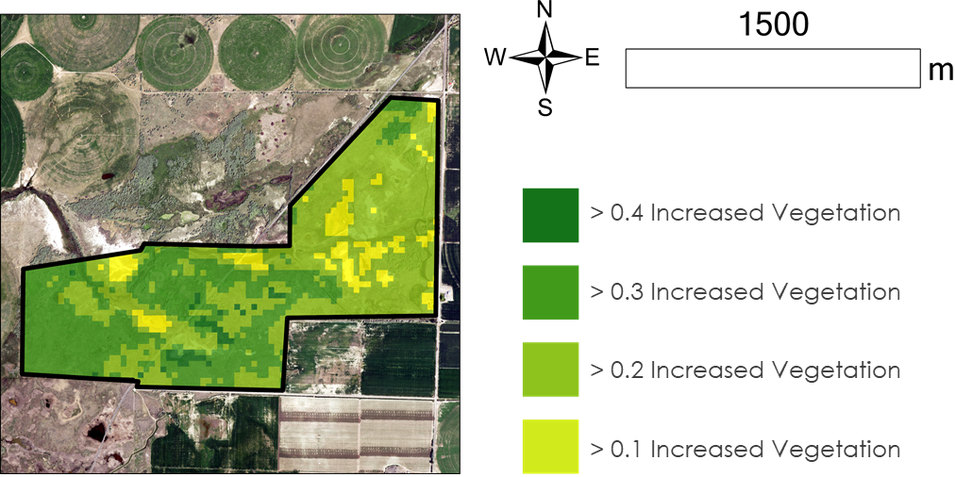

*Figure D3:* The change between forecasted maximum NDVI and actual maximum NDVI for 2022 in the Orth Control Area.

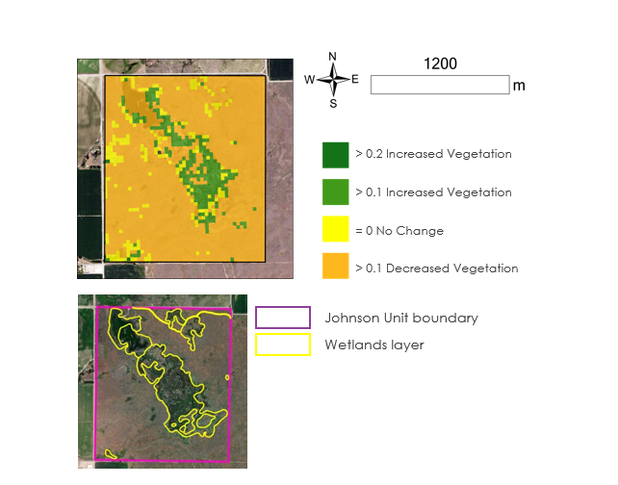

*Figure D4: (upper)* The change between forecasted maximum NDVI and actual maximum NDVI for 2022 in the Johnson Control Area; (lower) wetlands layer and unit boundary.

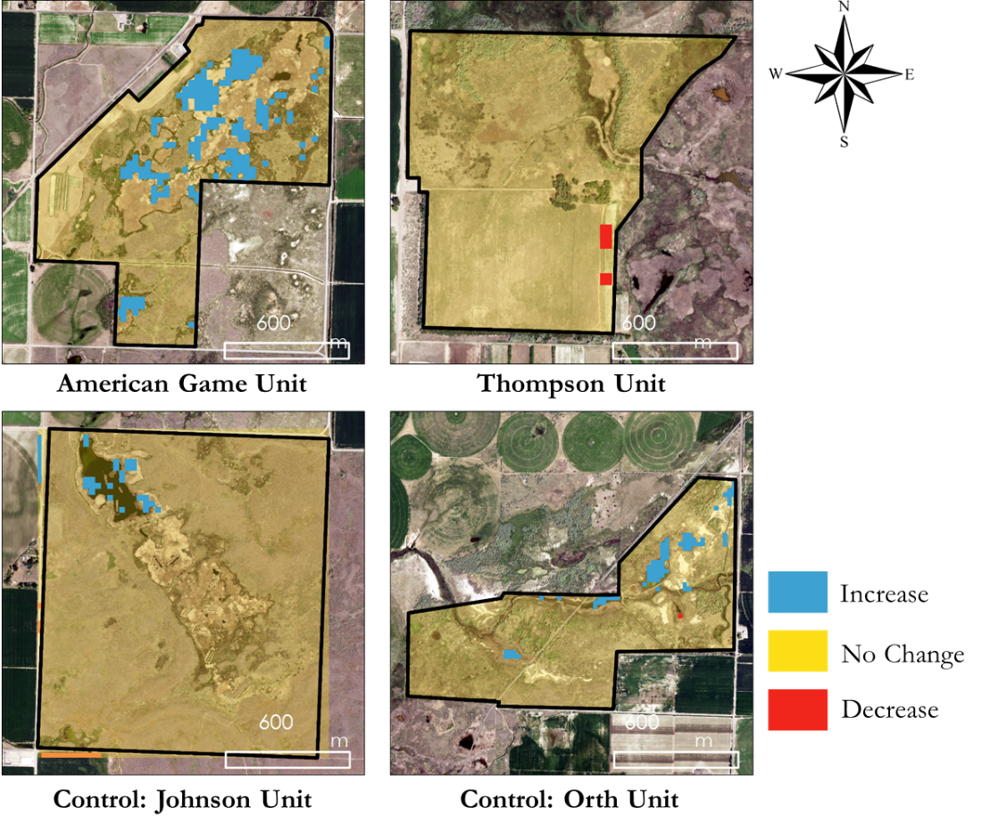

*Figure D5:* Change in surface water cover between 2020 and 2022.