**NASA DEVELOP National Program**



NASA Langley Research Center

*Summer 2016*

Western U.S. Water Resources

Assessing Landscape Vulnerability to Drought and Climate Change in National Parks of the Western United States

 **Technical Report**

August 11, 2016

Kelly Meehan (Project Lead)

Teresa Fenn

Thomas Smith

Molly Spater

Kaylie Taliaferro

Grant Jaccoud

Dr. Kenton Ross, NASA DEVELOP National Program (Science Advisor)

# 1. Abstract

A changing climate has been an issue of growing concern over recent decades. Drought frequency has increased and water availability has become more limited, especially in the western United States. With semi-arid regions typically becoming warmer and dryer, knowledge of how to identify shifts in vegetation productivity, which are early warning signs of changes in ecosystem stability, are of great interest to national park land managers. Guided by project partners from the National Park Service (NPS) and the United States Geological Survey (USGS), this project utilized a climate pivot point framework to assess the capacity of vegetation in Utah’s Capitol Reef National Park to resist drought when water is scarce. We analyzed multiple climatic variables including precipitation, temperature, and evapotranspiration, against delta NDVI across a 15 year time span from 2000 to 2014. This project will benefit our partners by providing information about which vegetation types are the most vulnerable to climate change and drought. The framework of this analysis can be replicated for other national parks and can be used by land managers to make critical decisions.

**Keywords**

Climate Pivot Points, NDVI, MODIS, Drought, Climate Change, Capitol Reef National Park, Vegetation Shifts, Water Scarcity

# 2. Introduction

* 1. ***Background Information***

The importance of understanding ecosystem stability in response to new climatic conditions increases as warmer and drier conditions are predicted globally. Predicting the impact of drought is especially significant in conservation of semiarid to arid regions in the western United States, which are projected to experience increased warming and limited water availability more quickly than the rest of country (Cook, Woodhouse, Eakin, & Meko, 2004). There is also a 5-10% predicted reduction in precipitation and a conservative estimate of 4º – 6º Celsius increase in temperature by the year 2100 within the region (Meehl et al., 2007; Seager et al., 2007). The daily duration and number of days with severe temperatures (over 90º Fahrenheit) is also projected to increase for the southwestern United States (Diffenbaugh, Pal, Trapp, & Giorgi, 2005). Drought, as well as more infrequent, but intense precipitation will impact the vertical distribution of water in the soil profile, which will impact the species of plants able to survive in the region (Comstock & Ehleringer, 1992; Groisman et al., 2004; Reynolds, Kemp, Ogle, & Fernández, 2004).

Drastic climatic projections require land managers to have adequate methods in assessing when vegetation is nearing an ecological threshold. Crossing this threshold puts an ecosystem past a point of irreversible change, transitioning from one ecosystem to another. Climate pivot points can be used as early warning signs of when plant communities may be approaching such a threshold. The progression to either increased or reduced plant mass in response to climatic variables are identified as climate pivot points which are symptomatic of drought tolerance in varying plant species (Munson, 2013). Climate pivot points are defined by related environmental indicators of drought such as actual evapotranspiration, precipitation, and temperature. The amount of water in the soil is directly impacted by the quantity and timing of precipitation as well as by temperature. Increased temperature factors into actual evapotranspiration (AET), the total monthly quantity of water lost from the soil due to evaporation and transpiration, as higher temperatures increase evaporation rates which can limit the impact of introduced precipitation (Munson et al., 2013; Thoma et al., 2016). Since water availability is already limited in the southwestern United States, monitoring climatic variables that further tax water resources is of heightened concern.

Knowledge of how to determine climate pivot points for specific vegetation types empowers land managers to properly formulate conservation strategies specific to their region. Much of the work done utilizing the climate pivot point framework has occurred on small-scales, such as at the plot level. This project incorporates remote sensing to broaden the spatial scope of the climate pivot point framework analysis. It also attempts to provide a model for land managers to determine the most important environmental variables impacting vegetation productivity within their park.

* 1. ***Study Area***

Capital Reef National Park in southcentral Utah served as the study area for this project. Located in the Colorado Plateau, the Park’s general coordinates are 38.4° N, 111.3° W. Capital Reef was selected as it is both topologically and ecologically diverse. Differences in topology impact local climate conditions directly affecting pivot points’ attributes, while variety in plant communities broadens the scope of response analysis. Average monthly temperature and precipitation values range from 5º – 31.7 º Celsius and 8.6 to 30.7 millimeters respectively ("Weather", 2014). On average about 52% of precipitation occurs during the cool season from October to March, while about 30% occurs in the warm season from July through September (Thoma et al., 2016)

* 1. ***Objectives***

The main objective of this project was to determine climate pivot points for different environmental factors (evapotranspiration, precipitation, and temperature) for varying vegetation types (shrublands, grasslands, woodlands) using MODIS data. The methodologies developed in this project will be provided to land managers of expansive areas to determine the impacts of a changing climate and to inform future conservation strategies.

* 1. ***Study Period***

This project analyzes the response of vegetation to climate variables over a fifteen year period spanning from January 2000 – December 2014. This study period was determined by availability of MODIS datasets.

* 1. ***Project Partners***

Ecologist David Thoma of the National Park Service Inventory & Monitoring Program, and plant ecologist Seth Munson of the United States Geological Survey Southwest Biological Science Center, are the end users of this project. Thoma and Munson have completed studies investigating climatic pivot points and the response of vegetation to a changing climate. Their research to date has primarily been at the plot level. Integrating NASA Earth observation data will dramatically increase the spatial scope and analysis of the climate pivot point framework.

* 1. ***National Application Area***

This project contributes to the Water Resources Application Area under NASA’s Applied Sciences Program.

# 3. Methodology

***3.1 Data Acquisition***

We obtained annual maximum NDVI data for the years 2000 to 2014 from the US Forest Service Satellite-Based Change Recognition and Tracking system (ForWarn). ForWarn data, derived from the MODIS sensor onboard Terra, is at a 231 meter resolution and is corrected for cloud errors. NDVI values below zero are eliminated from this dataset with the assumption that terrestrial vegetation will only have NDVI values greater than zero. Values within this dataset are also scaled by a factor of 10,000. We selected NDVI as a proxy for vegetation productivity over other indices as it is the most commonly used vegetation index and is easy for park managers to interpret.

We acquired evapotranspiration data from the Numerical Terradynamic Simulation Group at the University of Montana. This Global Terrestrial Evapotranspiration Data (MOD16) is derived from MODIS data and is estimated using Mu et al.’s improved evapotranspiration algorithm, based on the Penman-Monteith equation (Mu, Zhao, & Running, 2011). This evapotranspiration measure incorporates evaporation from soil, rainwater intercepted by the canopy before it reaches the ground, and the transpiration through stomata on plant leaves and stems. We used MOD16 annual data at a 1 kilometer resolution from 2000 to 2014 for the h09v05 tile.

We attained temperature (°C) and precipitation (mm) data from the Parameter-elevation Relationships of Independent Slopes Model (PRISM) Climate Group in a monthly and yearly format for the years 2000 to 2014 at a 4 kilometer resolution. The PRISM Climate Group, based at Oregon State University, develops spatial climate datasets to display short and long-term climate patterns in the form of continuous data across the United States (Daly et al., 2008).

We downloaded Digital Elevation Model (DEM) rasters from The National Map, available at the USGS website. This elevation data was published in 2013, has a 1/3 arc-second resolution (approximately 10 meters), and was collected for the coordinates of the tiles that overlap with our study area, N38W112, N39W112, N38W111, and N39W111.

We used two shapefiles from the National Parks Service (NPS) Inventory & Monitoring (I&M) Program. One contained the boundary of Capitol Reef National Park, and the other contained its various ecosystem zones, which classified areas based on the dominant plant species in the area.

We utilized Gridded Soil Survey Geographic (gSSURGO) data for the state of Utah from the Geospatial Data Gateway on the United States Department of Agriculture (USDA) website. This data was used as a reference for the soil types present within Capitol Reef. We utilized this dataset to identify clusters of the same vegetation class belonging to a single soil type.

***3.2 Data Processing***

The first step in data processing was reprojecting, resampling, and clipping all data to the extent of our study area via a model built in ArcMap’s ModelBuilder. All data was reprojected to NAD1983 UTM Zone 12N, and then resampled to the resolution of the ForWarn NDVI data. We used the bilinear interpolation method of resampling. We believed this method would produce the smoothest output as it uses the 4 nearest pixel values, located adjacent to a given pixel, and takes a weighted average to arrive at its final, interpolated value.

Before resampling the mosaicked DEM, it was first processed to derive slope. Next, utilizing focal statistics, cell values were reassigned to the maximum slope value within the immediate 30m by 30m neighborhood. This step was taken to account for possible errors in the location of high slopes in satellite imagery. A mask was then created from this raster to reclassify all slopes under 30 degrees as 1 and all slope values above 30 to 0 to account for shadowing, shading, and areas less likely to have vegetation.

To investigate whether time lags existed between precipitation events and vegetation responses, we created six new annual cumulative precipitation rasters. Each started the 12-month time period one month earlier than the previous. For example, instead of January to December 2002, the first new raster contained December 2001 to November 2002 data. We also assessed different measures of temperature, such as annual mean temperature and annual maximum temperature, and their impact on vegetation productivity. Our analysis revealed that the growing season (May to October) mean temperature was the highest correlated with changes in productivity.

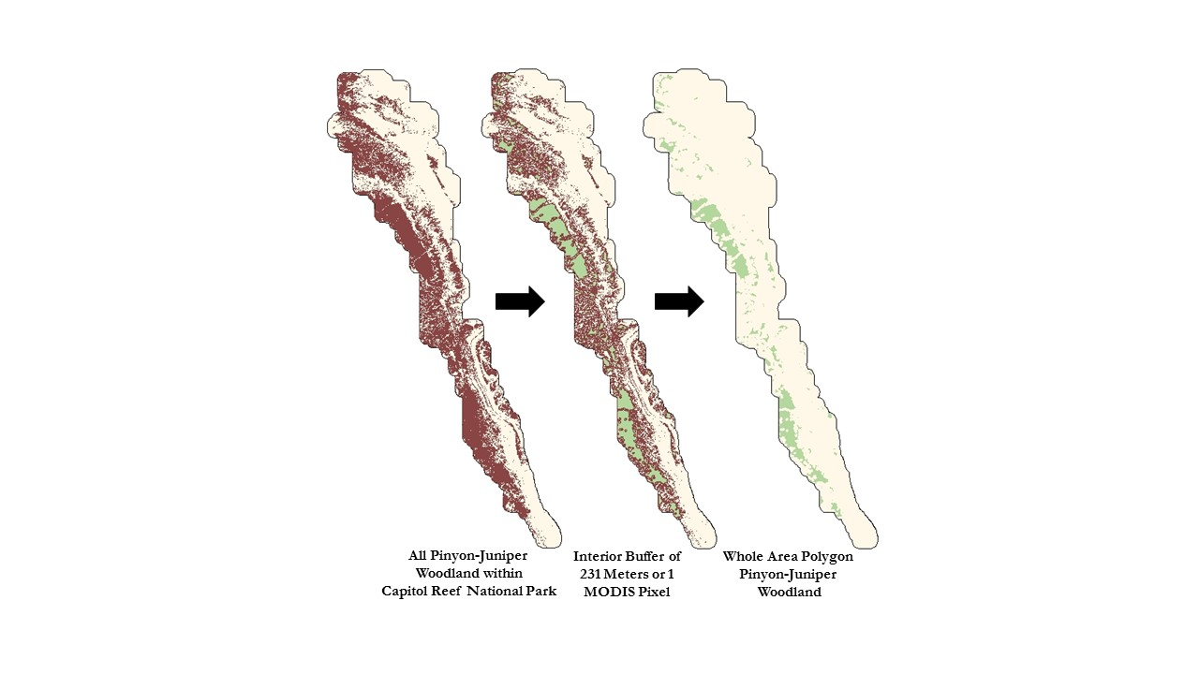

**Figure 1:** To select areas within the entire sample vegetation type (brown), a 231 meter interior buffer was created to reduce edge effects. The areas remaining (green) were rasterized and became our sample whole vegetation type polygon.

With the ForWarn data processed, we next identified samples within the three vegetation types that covered enough area to proceed with the analysis. The samples chosen were Colorado Plateau Mixed Low Sagebrush Shrubland, Colorado Plateau Pinyon-Juniper Woodland, and Inter-Mountain Basins Semi-Desert Grassland. These three samples were isolated individually from the NPS vegetation type shapefile to produce three new shapefiles. To be conservative in accounting for possible edge effects, we created a 231 meter (1 pixel) interior buffer for each. These interior buffers were then rasterized to produce sample vegetation zone rasters, reclassifying all values to 1. We refer to these sample vegetation zone rasters as Whole Area Polygons. Next, we overlaid these zone rasters on top of the gSSURGO soil type map. For each vegetation type we found the largest contiguous cluster of pixels on a single soil type and created a new raster containing only these pixels. We refer to these subsections as Small Polygons. Multiplying the slope mask and the sample zone raster for each whole area vegetation type polygon generated individual master masks used to clip all ForWarn, PRISM, and MOD16 rasters. We repeated this master mask creation process for all three small polygons.

∆NDVI = Observed– Theoretical (1)

We used delta NDVI as a proxy for change in vegetation cover and productivity. Delta NDVI was calculated by subtracting a theoretical value from an observed value for each pixel (Equation 1). The observed value was calculated in two different ways (Figure 2). The first method consisted of using the unique per pixel maximum value from each year in the study period. The second method utilized zonal statistics to calculate the average maximum NDVI value per year and reassigned all cells to that value. To create the theoretical NDVI raster, we averaged all the rasters created in the second method of finding the observed values.

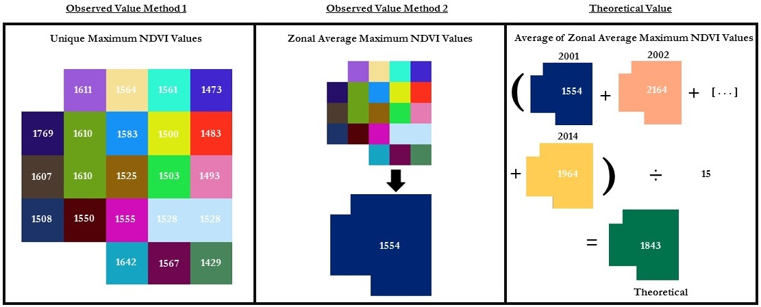

**Figure 2:** How observed and theoretical values were calculated.

***3.3 Data Analysis***

We created a multiple-linear regression (backward stepwise) model in R using delta NDVI as the dependent variable and the climatic factors as our independent variables. This model was used to determine which of the climate variables had a statistically significant correlation with delta NDVI values. We ran the model seven times to determine which precipitation lag time had the highest correlation with delta NDVI. Using the best lag time, the model was run again with any statistically insignificant variables removed. An equation was derived from this final run to solve for the pivot points of significant climactic variables (Equation 2) where *y* is delta NDVI, *P* is precipitation, *T* is temperature, and *E* is evapotranspiration. Using the coefficients for the climatic variables derived from the model, we solved for each significant climatic variable individually. The y-value was set to 0, and the other independent variables were set to their mean value over the course of the study period. For example, we used *equation 2* to find the temperature pivot point for the whole area polygon of Colorado Plateau Pinyon-Juniper woodland. In *equation 2*, the y value was set to zero, the precipitation was set to its mean of 241.02 mm, and the evapotranspiration was set to its mean of 1,766.90. Solving the equation gives the temperature pivot point of 18.69°C.

y = - 1.10513(P) -232.50463(T) + 0.35845(E) + 3,979.4436

0 = 1.10513(241.02) – 232.50463(T) + 0.35845(1,766.90) +3,979.4436 (2)

T= 18.69

# 4. Results & Discussion

***4.1.1 Comparing the Results of the Two Methods to Compute Observed Values***

For all vegetation types except Colorado Plateau Pinyon-Juniper Woodland (Table 1) the adjusted R-squared value resulting from the multiple-linear regression model was higher using Method 2 for the observed value than Method 1. One possible explanation for why we found higher adjusted R-squared values using the average zonal maximum is that it normalizes for errors in the NDVI data. Pixel values with raw NDVI scores of zero or near zero most likely exist due to errors in the ForWarn dataset or disturbances such as wildfires, grazing, and landslides. When subtracting the theoretical value from these low values, negative outliers occur in the delta NDVI data. Taking the average of the individual pixel values decreased the impact of these negative anomalies on the multiple-linear regression model. One possible explanation for why Pinyon-Juniper Woodlands had a higher adjusted R-squared value at the pixel level was due to the widespread extent of the pixels compared to those of the other vegetation types. Pinyon-Juniper Woodland pixels were located in more topologically diverse areas and spread across multiple soil types. Topology, as mentioned previously, impacts the local climate. Soil types and their associated characteristics, such as pore space and pH, impact the manner in which plants respond to the environment. Pinyon-Juniper pixels are found in clusters across ten different soil types, the majority being Nonip, dry-rock outcrop Moenkopi Formation complex. In comparison, the majority of Semi-Desert Grassland and Sagebrush Shrubland pixels were found within a single soil type, Mivida loamy fine sand and Daklos-Reef rock outcrop complex, respectively. Another possible explanation for the lower adjusted R-squared values of the Pinyon-Juniper Woodland community is that these species are evergreen throughout the year. NDVI measures the greenness of vegetation. An evergreen species inherently will not express as much change throughout the year as plants with a distinct growing season with an observed greening up and browning down.

**Table 1:**Comparison of Adjusted R-Squared values between the two methods of calculating the Observed NDVI value at the whole area polygon scale.

|  |  |  |  |
| --- | --- | --- | --- |
| Vegetation Type | Adjusted R- Squared  Pixel Level | Adjusted R- Squared  Zonal Maximum | Precipitation Lag Time (Months) |
| Colorado Plateau Mixed Low Sagebrush Shrubland | 0.413 | 0.7983 | 4 |
| Colorado Plateau  Pinyon-Juniper Woodland | 0.1924 | 0.0865 | 1 |
| Inter-Mountain Basin  Semi-Desert Grassland | 0.3882 | 0.4792 | 3 |

Despite having higher adjusted R-squared values, we decided to continue our research using Method 1 of determining the observed NDVI value. We chose this method because the residuals of this model appeared to be more normally distributed and thus better met the assumptions for a multi linear regression (Figure 3).

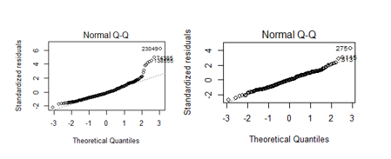

**Figure 3:** Normal Q-Q Plots of the Colorado Plateau Sagebrush Shrubland Whole Area Polygon Method 2 (Left) vs Method 1 (Right).

Also significant to note is the unique lag time value for each vegetation type. These demonstrated that plant communities react to precipitation input differently. In general, we found that precipitation accounting for lag time was the most highly correlated climate variable to delta NDVI.

***4.1.2 Analysis of Pixel Scale Pivot Point Results***

After selecting Method 1, we derived pivot points for vegetation types at the Whole Polygon scale as well as the Small Polygon scale. For all vegetation types except Pinyon-Juniper Woodland, adjusted R-squared values for the Small Polygon were substantially higher than those for the Whole Area (Table 2). We expected Small Polygon adjusted R-squared values to be higher as we assumed this would minimize variances in the environmental conditions, such as soil type and precipitation rates. Pinyon-Juniper Woodland did not fit this pattern, which indicates that the pivot point framework might be more complex for this and other vegetation types. Investigating other climatic factors not analyzed in this study could potentially help better explain delta NDVI for Pinyon-Juniper Woodlands.

**Table 2:** Comparison of Adjusted R-Squared values between the whole area polygon and small polygon by vegetation type.

|  |  |  |  |
| --- | --- | --- | --- |
| Vegetation Type | Adjusted R- Squared  Whole Area | Adjusted R- Squared  Small Polygon | Precipitation Lag Time (Months) |
| Colorado Plateau Mixed Low Sagebrush Shrubland | 0.413 | 0.5728 | 4 |
| Colorado Plateau  Pinyon-Juniper Woodland | 0.1924 | 0.1425 | 1 |
| Inter-Mountain Basin  Semi-Desert Grassland | 0.3882 | 0.4595 | 3 |

Despite difference in adjusted-R squared, both scales of analyzing vegetation types are beneficial to informing conservation efforts. Vegetation types with lower precipitation pivot point values, or higher temperature and evapotranspiration values, are more resistant to drought as these plant communities can potentially experience periods of low precipitation or high temperature and evapotranspiration without crossing a pivot point.

**Table 3:**Pivot Points for the Whole Area Polygons by Vegetation Type

|  |  |  |  |
| --- | --- | --- | --- |
| Vegetation Type  Whole Area Polygon | Temperature  (◦C)  Mean Pivot Pt | Precipitation  (mm)  Mean Pivot Pt | Actual Evapotranspiration  (0.1mm/year)  Mean Pivot Point |
| Colorado Plateau Mixed Low Sagebrush Shrubland | 27.47 20.18 | 204.08 202.59 | 1,739.93 N/A |
| Colorado Plateau  Pinyon-Juniper Woodland | 18.74 18.69 | 241.02 230.68 | 1,766.90 1,798.78 |
| Inter-Mountain Basin Semi-Desert Grassland | 18.10 18.08 | 217.32 216.49 | 1,788.20 1,783.19 |

When comparing the vegetation types, Sagebrush Shrubland was more resistant to higher temperatures and lower precipitation. Pinyon-Juniper Woodland and Semi-Desert Grassland are similar in terms of resistance to temperature and actual evapotranspiration; however, considering precipitation, Semi-Desert Grasslands are more resistant to lower rates. Actual evapotranspiration was not a significant variable in regards to Sagebrush Shrublands.

Generally speaking for temperature and actual evapotranspiration, a mean value higher than the pivot point can suggest that the vegetation type is out of equilibrium and is perhaps approaching a threshold. In the same vein, when interpreting precipitation values, a vegetation type may be approaching a threshold when a mean value is lower than the pivot point. For example, we can observe that the temperature pivot point for Sagebrush Shrubland is drastically lower than the mean, indicating that this vegetation type might be out of equilibrium due to recent climatic changes. Another possible explanation could be that the Sagebrush Shrubland is in equilibrium, but that other species present in the pixels, such as perennial grasses, are contaminating initial NDVI readings and creating discrepancies in resulting delta NDVI and pivot point values. Conversely, we might find that vegetation types are not approaching an ecological threshold. For example, Pinyon-Juniper Woodland has a buffer in the event that precipitation rates decrease or actual evapotranspiration rates increase.

**Table 4:** Pivot Points for the Small Polygons by Vegetation Type

|  |  |  |  |
| --- | --- | --- | --- |
| Vegetation Type  Small Polygon | Temperature  (◦C)  Mean Pivot Pt | Precipitation  (mm)  Mean Pivot Pt | Actual Evapotranspiration  (0.1mm/year)  Mean Pivot Point |
| Colorado Plateau Mixed Low Sagebrush Shrubland | 20.82 N/A | 199.67 198.67 | 1,714.05 1,732.44 |
| Colorado Plateau  Pinyon-Juniper Woodland | 19.56 19.51 | 254.74 237.52 | 1,550.95 N/A |
| Inter-Mountain Basin Semi-Desert Grassland | 18.08 18.08 | 218.58 218.34 | 1,789.02 N/A |

On the Small Polygon scale, Pinyon-Juniper Woodland was more resistant to higher temperatures, while Sagebrush Shrubland was more resistant to lower rates of precipitation. Pinyon-Juniper Woodland and Semi-Desert Grassland appeared to be in equilibrium in terms of temperature. Looking at precipitation, while all three vegetation types seemed to be in equilibrium, Pinyon-Juniper Woodland had the largest buffer between the mean and pivot point, suggesting that it is farthest from approaching a threshold.

Mean values changed between the two scales as these values were recalculated based upon which pixels were representing the vegetation classes. For the same reasons that the R-squared values varied between the Whole Area and Small Polygon regions, the average growing season mean temperature for Sagebrush Shrubland changed, as did means for Pinyon-Juniper Woodland precipitation and actual evapotranspiration values.

It was interesting to note that actual evapotranspiration altered between the two scales. It was significant for Pinyon-Juniper Woodland and Semi-Desert Grassland at the Whole Area scale and was only significant for Sagebrush Shrubland at the Small Polygon scale. Trends in precipitation were similar as pivot points at both scales were always below the mean. Similarly, trends in temperature mostly remained the same, though it was not significant to the Sagebrush Shrubland model at the Small Polygon scale.

***4.2 Future Work***

Future work might explore alternative vegetation indices such as the Soil Adjusted Vegetation Index (SAVI), which corrects for the reflectance of bare soil. Semi-arid regions do not have dense vegetation cover like other climate zones, meaning surface reflectance can contaminate pixel values. SAVI and Gross Primary Productivity datasets may be able to produce more accurate results for this region. Additionally, higher resolution imagery such as Landsat or Sentinel data could be utilized to determine more accurate vegetation index values. Vegetation groups could also be distinguished via remote sensing, thus improving the accuracy of vegetation classification and accounting for vegetation shifts that could occur during the course of the study period. Additional climatic and environmental variables could also be included within the analysis to gain a better understanding of how these variables interact and impact vegetation productivity. It would also be of interest to explore why some climatic variables fall in and out of significance between vegetation types and analysis scales. Lastly, this methodology could be expanded to other parks in the west and beyond.

# 5. Conclusions

Our analysis demonstrates that the pivot point framework can be successfully carried out with remote sensing. While this type of analysis has been completed at the plot level, incorporating remote sensing expands the potential range of analysis. It also offers a more cost and time effective method of predicting climate pivot points, not to mention enabling access to remote regions. The varying pivot points derived from this research indicate that plant communities will respond differently to a changing climate. This information can be utilized by land managers to understand how the vegetation in their parks will react to warming and drying conditions, and it can also be used to inform restoration decisions. For example, when addressing degraded landscapes, pivot points can serve as a guide in selecting which vegetation types will be the most successful given current climatic conditions. The equations derived from these models can be used not only to extract pivot point values, but also to estimate vegetation productivity in face of climate change.

# 6. Acknowledgments

We would like to thank the NASA DEVELOP Center Leadership Emily Gotschalk, Tyler Rhodes, Kathleen Moore, and Carrie Kelley for leading us with excellence through this summer term.

We would also like to thank Dr. Kenton Ross, David Thoma, and Seth Munson for their valuable insight and science advising.

Any opinions, findings, and conclusions or recommendations expressed in this material are those of the author(s) and do not necessarily reflect the views of the National Aeronautics and Space Administration.

This material is based upon work supported by NASA through contract NNL11AA00B and cooperative agreement NNX14AB60A.

# 7. References

Comstock, J. P., & Ehleringer, J. R. (1992). Plant adaptation in the Great Basin and Colorado plateau. *The Great Basin Naturalist*, 195–215.

Cook, E. R., Woodhouse, C. A., Eakin, C. M., Meko, D. M., & Stahle, D. W. (2004). Long-term aridity changes in the western United States. *Science*, *306*(5698), 1015+.

Daly, C., Halbleib, M., Smith, J. I., Gibson, W. P., Doggett, M. K., Taylor, G. H. & Pasteris, P. P. (2008). Physiographically sensitive mapping of climatological temperature and precipitation across the conterminous United States. International journal of climatology, 28(15), 2031-2064.

Diffenbaugh, N. S., Pal, J. S., Trapp, R. J., & Giorgi, F. (2005). Fine-scale processes regulate the response of extreme events to global climate change. *Proceedings of the National Academy of Sciences of the United States of America*, *102*(44), 15774–15778.

Groisman, P. Y., Knight, R. W., Karl, T. R., Easterling, D. R., Sun, B., & Lawrimore, J. H. (2004). Contemporary changes of the hydrological cycle over the contiguous United States: Trends derived from in situ observations. *Journal of Hydrometeorology*, *5*(1), 64–85.

Meehl, G. A., Stocker, T. F., Collins, W. D., Friedlingstein, P., Gaye, A. T., Gregory, J. M., … others. (2007). Global climate projections. *Climate Change*, *3495*, 747–845.

Mu, Q., Zhao, M., & Running, S. W. (2011). Improvements to a MODIS global terrestrial evapotranspiration algorithm. *Remote Sensing of Environment*, *115*(8), 1781–1800.

Munson, S. M. (2013). Plant responses, climate pivot points, and trade-offs in water-limited ecosystems. *Ecosphere*, *4*(9), art109. http://doi.org/10.1890/ES13-00132.1

Munson, S.M. (June, 21 2016). Personal communication.

Munson, S. M., Muldavin, E. H., Belnap, J., Peters, D. P., Anderson, J. P., Reiser, M. H., … Christiansen, T. A. (2013). Regional signatures of plant response to drought and elevated temperature across a desert ecosystem. *Ecology*, *94*(9), 2030–2041.

Reynolds, J. F., Kemp, P. R., Ogle, K., & Fernández, R. J. (2004). Modifying the “pulse–reserve” paradigm for deserts of North America: precipitation pulses, soil water, and plant responses. *Oecologia*, *141*(2), 194–210. http://doi.org/10.1007/s00442-004-1524-4

Seager, R., Ting, M., Kushnir, Y., Lu, J., Vecchi, G., Huang, H.-P., … Naik, N. (2007). Model projections of an imminent transition to a more arid climate in Southwestern North America. *Science*, *316*(5828), 1178–1181. http://doi.org/10.1126/science.1141040

S. Munson, National Park Service. Personal communication, June 21, 2016.

Thoma, D. P., Munson, S. M., Irvine, K. M., Witwicki, D. L., & Bunting, E. L. (2016). Semi-arid vegetation response to antecedent climate and water balance windows. *Applied Vegetation Science*, *19*(3), 413–429. http://doi.org/10.1111/avsc.12232

# 8. Content Innovation

**Content Innovation #1**

Audio Slides

Emailed to [Lauren.M.Childs@nasa.gov](mailto:Lauren.M.Childs@nasa.gov) with filename 2016Sum_LaRC_WesternUSWater_TechPaper_AudioSlides

**Content Innovation #2**

Glossary Viewer

* **Actual Evapotranspiration:** The actual amount of water that leaves the soil through evapotranspiration.
* **Climate Pivot Points:** An indicator of the general trend of vegetation growth in response to climatic factors. It can be used as an indicator for approaching environmental thresholds.
* **DEM:** Digital Elevation Model. A raster dataset displaying topographic data.
* **Evapotranspiration:** The amount of water that leaves the soil through evaporation from the soil and though transpiration from plants.
* **NDVI:** Normalized Difference Vegetation Index. It is used as a proxy for vegetation productivity when analyzing vegetation from a satellite sensor. NDVI is calculated using near infrared band reflectance (NIR) and red band reflectance (R) from a satellite sensor using the following formula: (NIR - R) / (NIR + R). It is used as a proxy for vegetation productivity.
* **Potential Evapotranspiration:** The amount of water that would leave the soil through evapotranspiration if enough water was available.
* **Soil Moisture:** The amount of water present in the vadose zone of the soil; that is, in the region above the water table.
* **SWE:** Snow water equivalent. The amount of water in a snowpack
* **Water Capacity:** The amount of water in the soil that is available for plant use.
* **Water Deficit:** The amount of water that would be used by plants if it were available. Calculated as PET - AET.

**Content Innovation #3**

VPS

**Content Innovation #4**

* Figure 1
* Figure 2
* Table 1
* Figure 3
* Table 2
* Table 3
* Table 4

# 9. Appendices

Appendix A: Partial Regression Plots of Whole Area Polygons by Vegetation Type

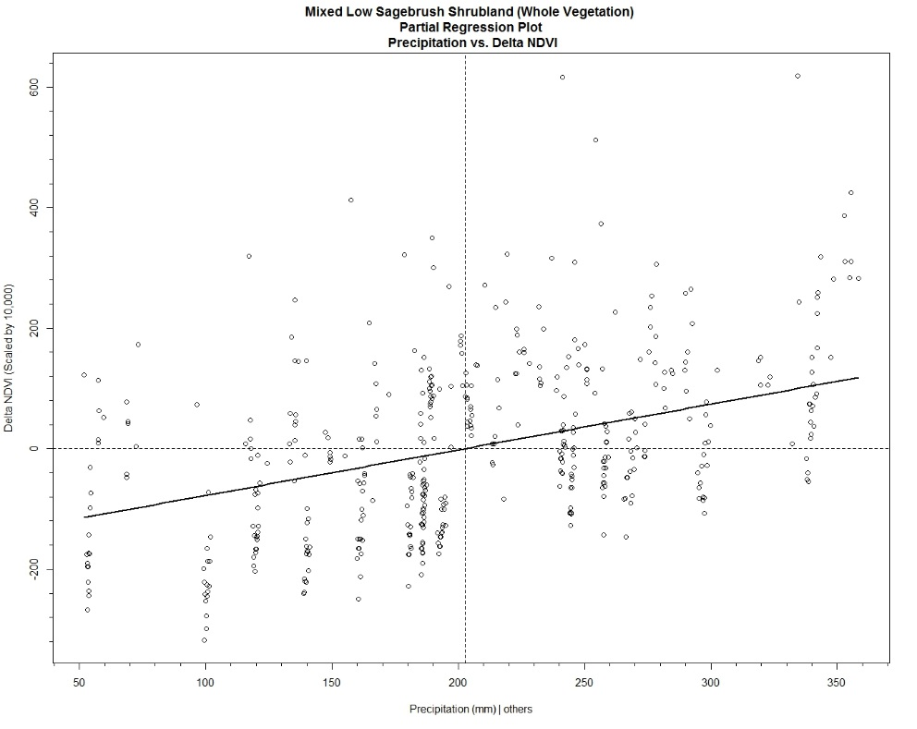

**Figure 1:** Colorado Plateau Mixed Low Sagebrush Shrubland (Whole Area) Partial Regression Plot Precipitation vs. Delta NDVI

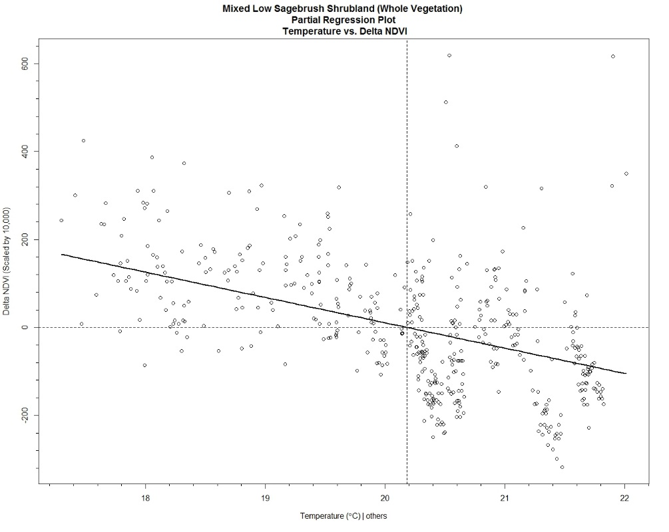

**Figure 2:** Colorado Plateau Mixed Low Sagebrush Shrubland (Whole Area) Partial Regression Plot Temperature vs. Delta NDVI

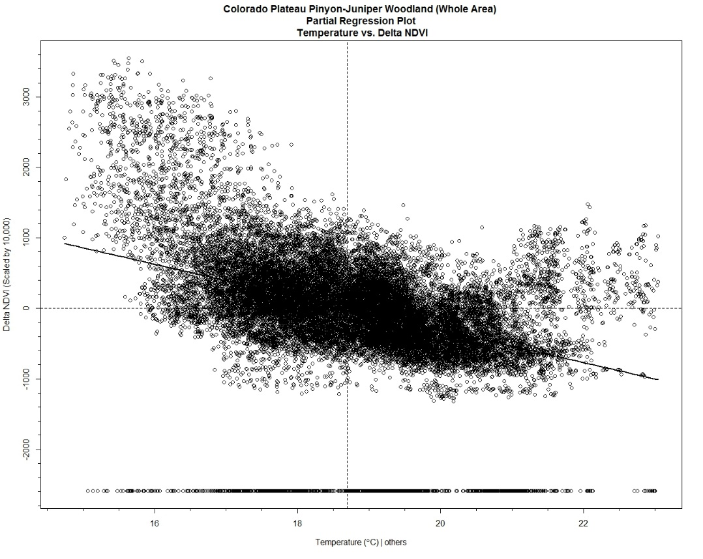

**Figure 3**: Colorado Plateau Pinyon-Juniper Woodland (Whole Area) Partial Regression Plot Temperature vs. Delta NDVI

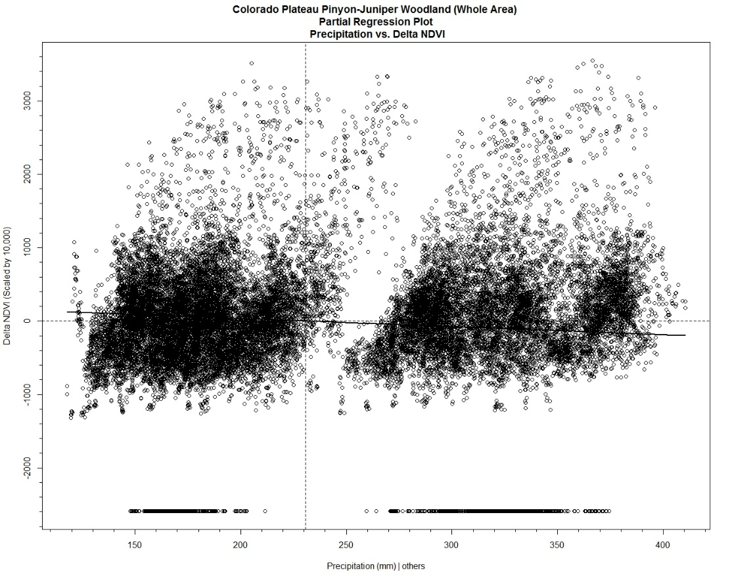

**Figure 4:** Colorado Plateau Pinyon-Juniper Woodland (Whole Area) Partial Regression Plot Precipitation vs. Delta NDVI

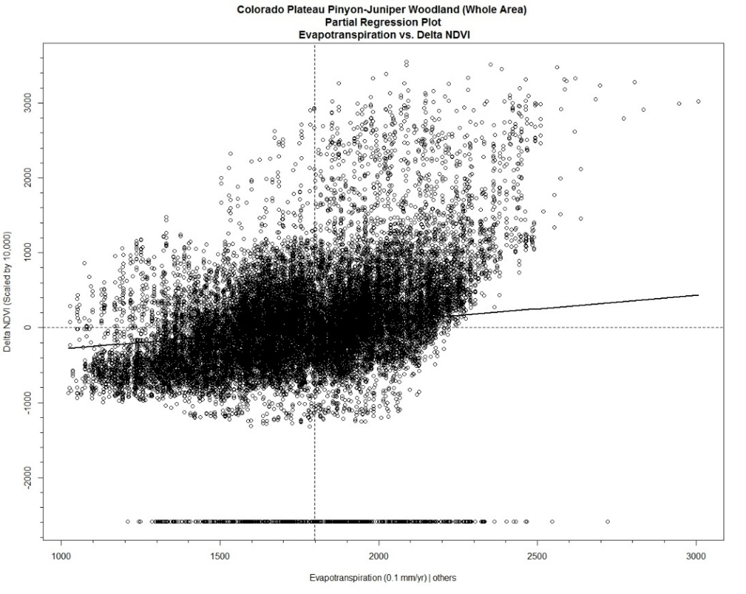

**Figure 5:** Colorado Plateau Pinyon-Juniper Woodland (Whole Area) Partial Regression Plot Evapotranspiration vs. Delta NDVI

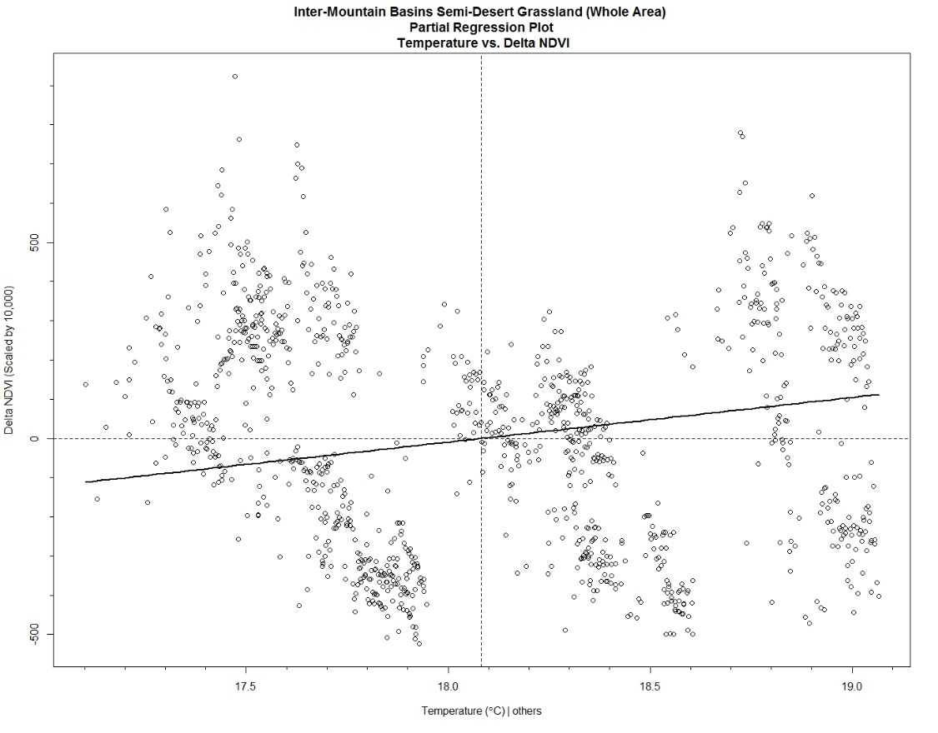

**Figure 6:** Inter-Mountain Basins Semi-Desert Grassland Partial Regression Plot (Whole Area) Temperature vs. Delta NDVI

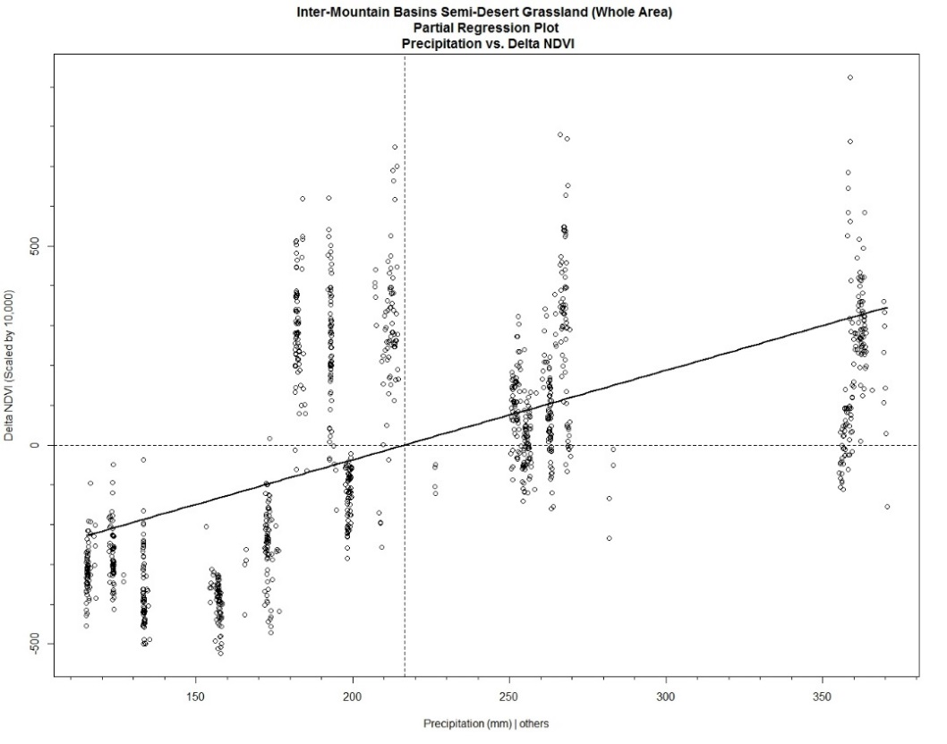

**Figure 7:** Inter-Mountain Basins Semi-Desert Grassland Partial Regression Plot (Whole Area) Precipitation vs. Delta NDVI

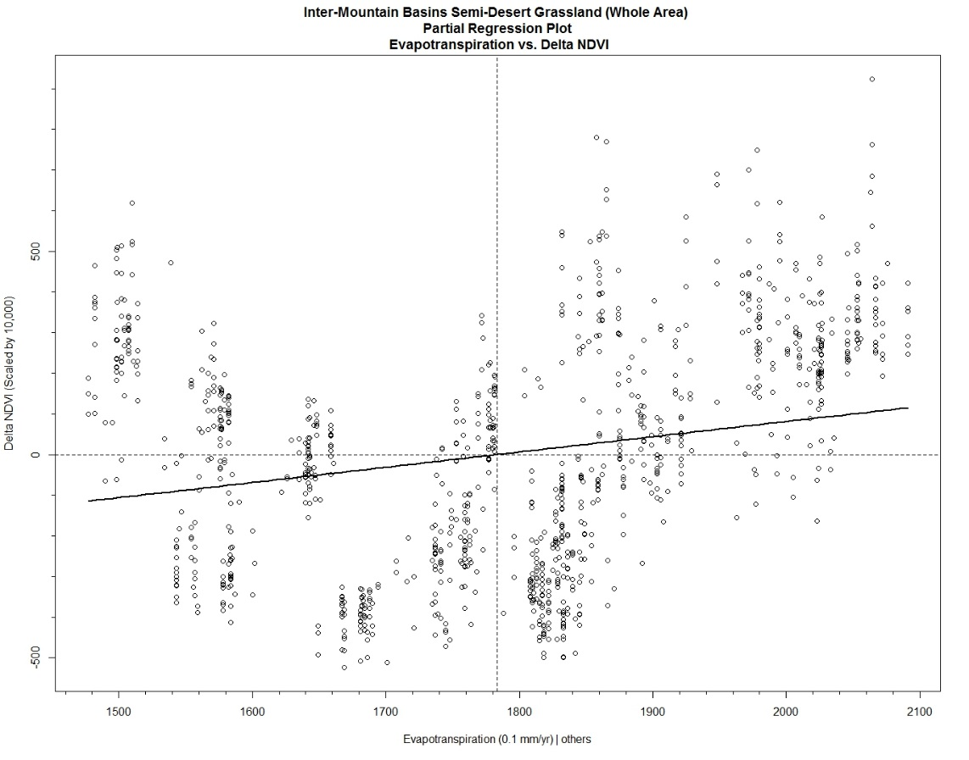

**Figure 8:** Inter-Mountain Basins Semi-Desert Grassland Partial Regression Plot Evapotranspiration vs. Delta NDVI

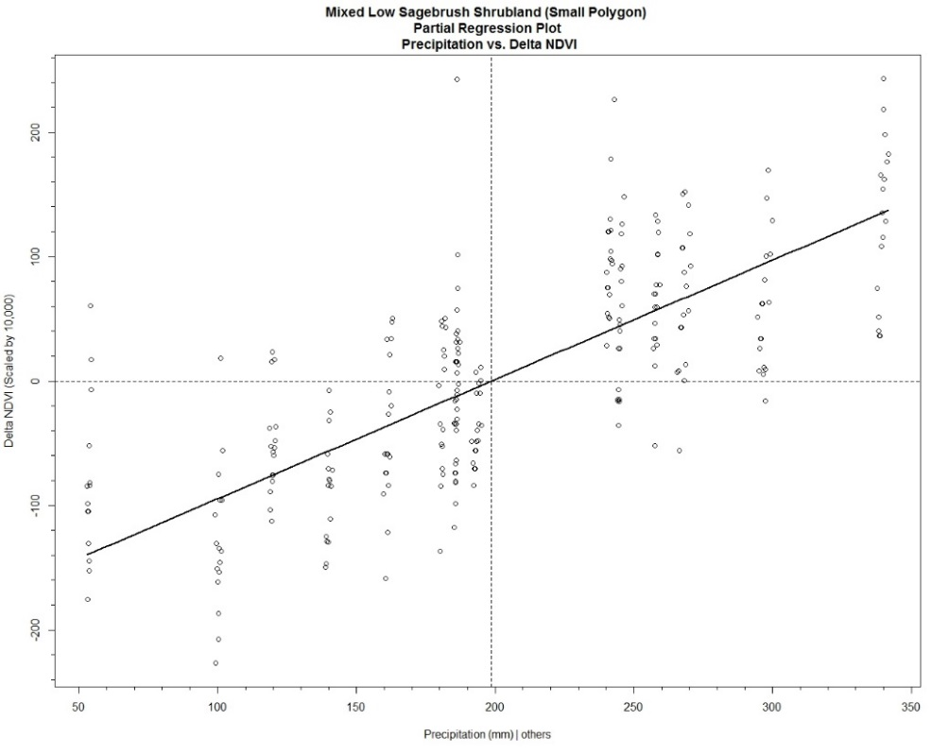

**Figure 9:** Colorado Plateau Mixed Low Sagebrush Partial Regression Plot (Small Polygon) Precipitation vs. Delta NDVI

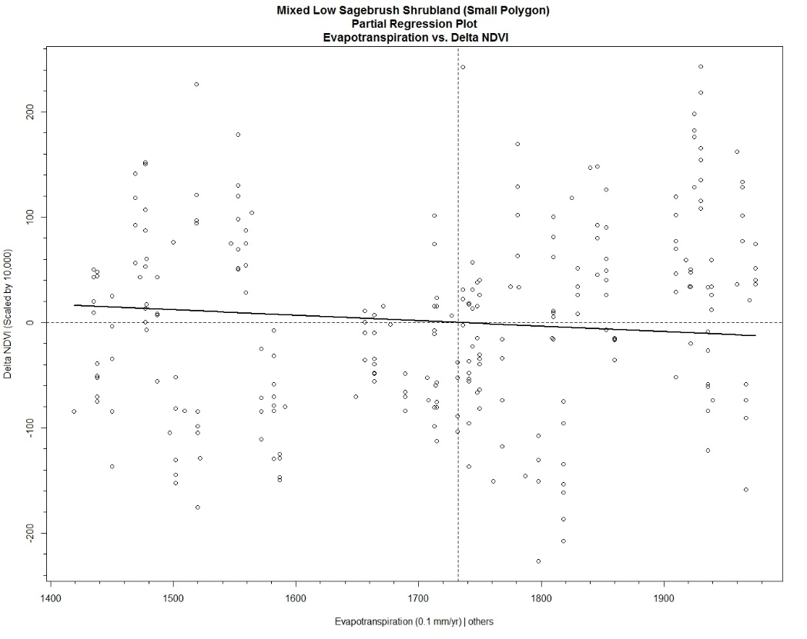

**Figure 10:** Colorado Plateau Mixed Low Sagebrush Partial Regression Plot (Small Polygon) Evapotranspiration vs. Delta NDVI

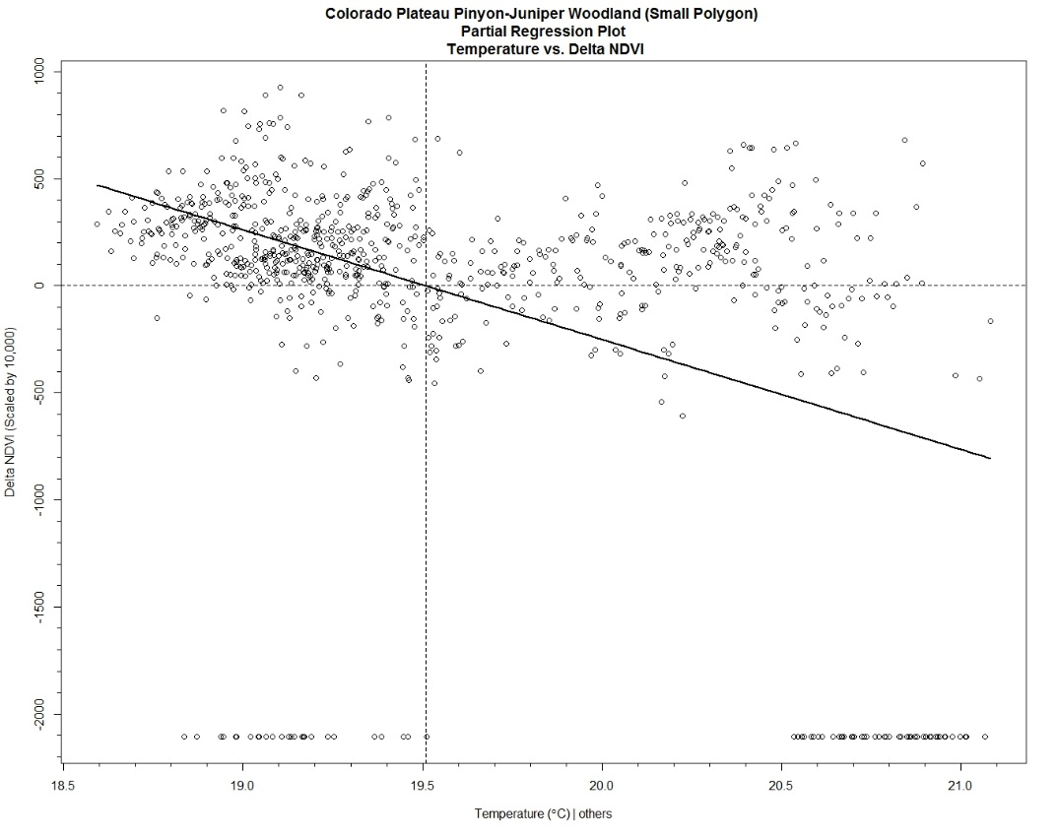

**Figure 11:** Colorado Plateau Pinyon-Juniper Woodland Partial Regression Plot (Small Polygon) Temperature vs. Delta NDVI

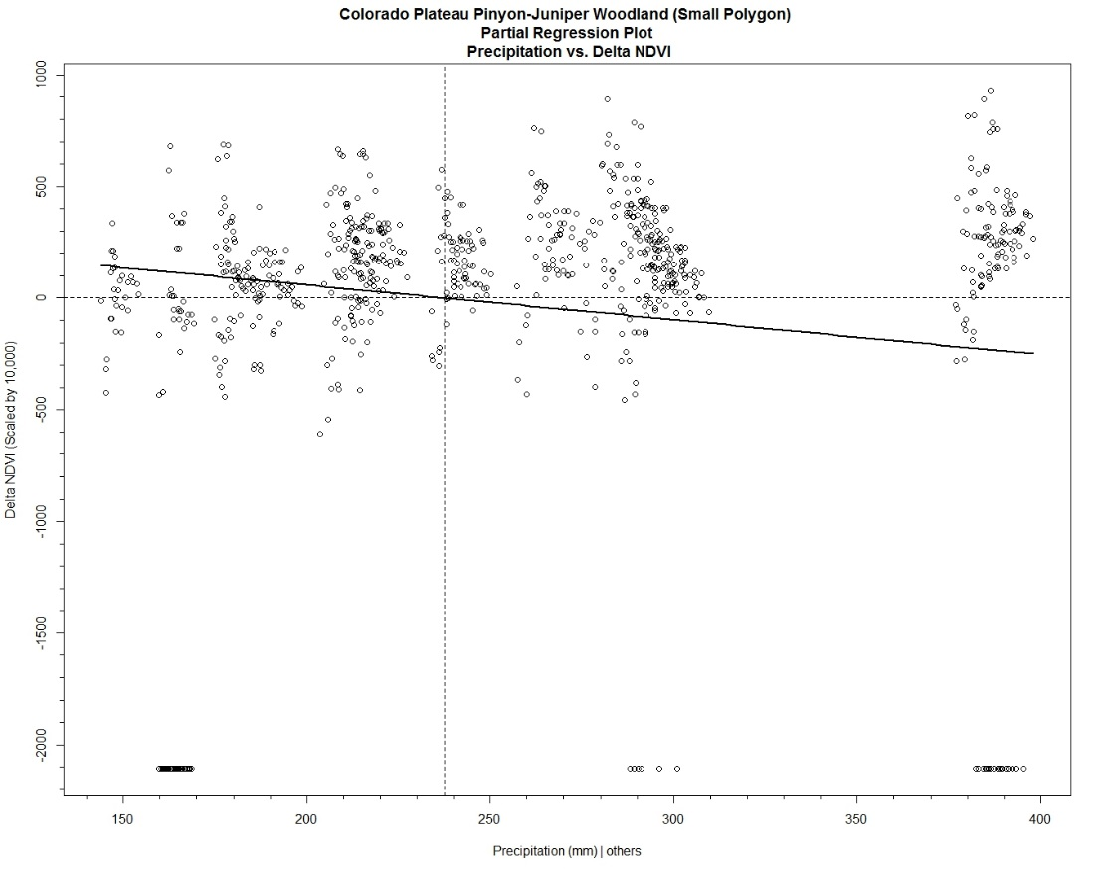

**Figure 12:** Colorado Plateau Pinyon-Juniper Woodland Partial Regression Plot (Small Polygon) Precipitation vs. Delta NDVI

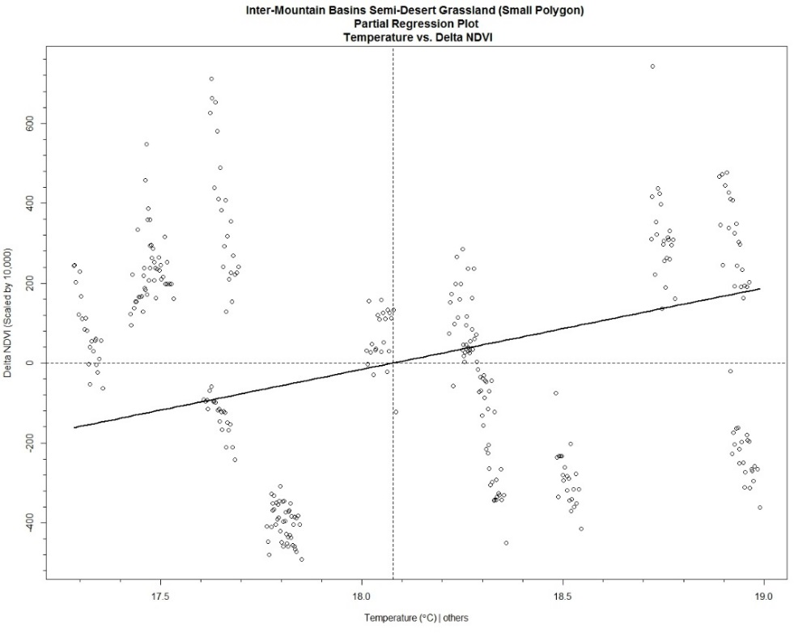

**Figure 13:** Inter-Mountain Basins Semi-Desert Grassland Partial Regression Plot (Small Polygon) Temperature vs Delta NDVI

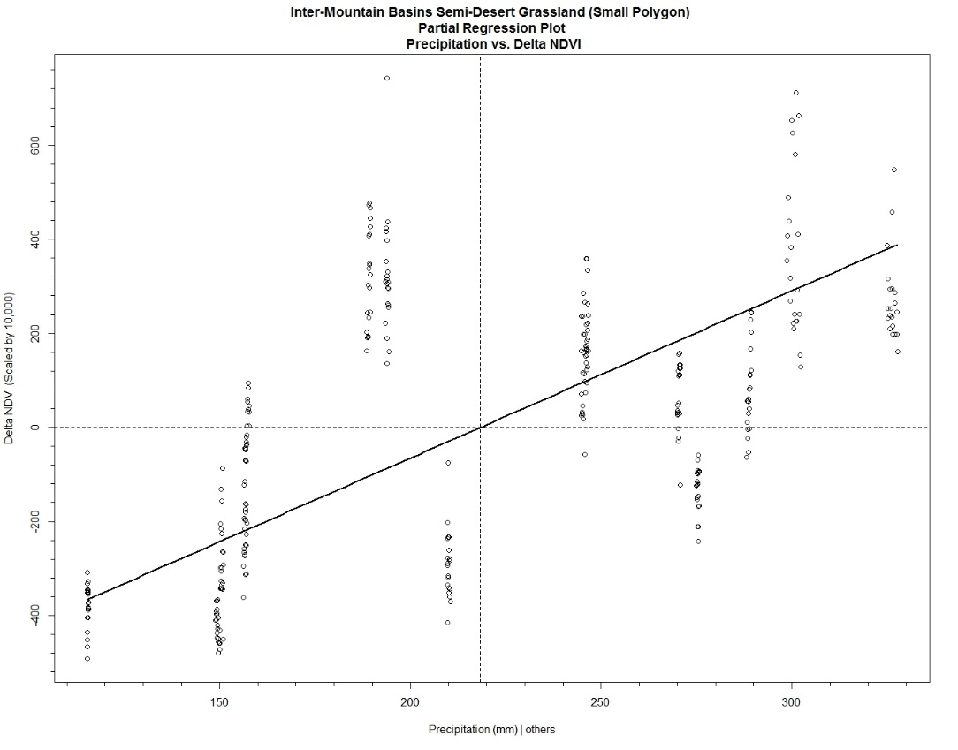

**Figure 14:** Inter-Mountain Basins Semi-Desert Grassland Partial Regression Plot (Small Polygon) Precipitation vs Delta NDVI