**NASA DEVELOP National Program**

 NASA Langley Research Center

**Summer 2015**

**Short Title: Northwest U.S. Agriculture III**

**Subtitle:** Applying Future Climate Patterns to Project Suitable Apple Orchard Conditions in Washington State

**VPS Title:** Climatic Apple Turnover: Forecasting Ideal Orchard Locations

**Project Team & Partners**

**Project Team:**

Madeline Ruid (Project Lead), madeline.r.ruid@nasa.gov

Teresa Fenn

Matthew Mullen

Sarah Philbrick

James Hendrickson

**Advisors & Mentors:**

Dr. Kenton Ross (NASA DEVELOP National Program)

Dr. Noel C Baker (NASA Postdoctoral Fellow)

**Past or Other Contributors:**

Lauren Makely

Idamis Del Valle-Martinez

Clarence Kimbrell

Zachariah Long

Chad Smith

Matthew Smith

Lydia Cuker

Laura Lykens

Alyssa Walzak

Timothy Stelter

**Partner Organizations**

United States Department of Agriculture - Agriculture Research Service (USDA-ARS), End-User,

POC: Dr. Michael Glenn, Ph.D., Appalachian Fruit Research Station, Kearneysville, WV.

**Project Details**

**Applied Sciences National Applications Addressed:**

Agriculture, Climate

**Study Area:** Washington State (WA), United States

**Study Period:** 2002-2099

**Earth Observations & Parameters**

Aqua, MODIS - Land Surface Temperature

**Ancillary Datasets Utilized**

* NOAA NCDC data- Weather station data used to convert MODIS LST to air temperature
* USDA Cropscape- Land cover

**Models Utilized**

* NEX (NASA Earth Exchange) DCP30 Climate Model- Aggregation of 32 climate models to create air temperature forecasts for the RCP 4.5 and RCP 8.5 Scenarios in years 2040-2050 and 2090-2099

**Software Utilized**

Python - Manipulation of MODIS data, & calculation of temperature averages and Growing Degree Days

ArcGIS - Raster manipulation/analysis, image enhancement & map creation

R- Statistical analysis on weather station and MODIS LST data to create a conversion equation

**Project Overview**

**80-100 Word Objectives Overview**

Apple production is a major part of Washington’s economy; however, apple trees have very specific climatic requirements that must be met in order to ensure a good harvest. Changes in regional climate due to global climate change could pose a threat to apple orchards as previously ideal conditions become unfavorable. By modeling Washington’s climate up to the year 2100, the team provided end-users with Plant Hardiness Zone (PHZ) maps for the coming decades. The maps will help inform apple growers of the challenges they will face, as well as suitable locations for future orchards.

**Abstract**

Washington State produces 65% of the nation’s apples, adding 2.2 billion dollars to the nation’s economy. Washington’s warm, dry summers and cool, wet winters provide excellent conditions for apple growth. However, there is a strong likelihood that Washington’s suitability for apple farming could be altered by current and future climate change. Currently, the USDA determines which plant species will thrive in a particular location based on their Plant Hardiness Zone (PHZ) Map. Apples grow best when climate conditions match zones 5, 6, or 7. By creating maps of current and projected PHZs, apple growers will be able to decide both if it would be beneficial to move apple orchards in the upcoming decades and where the most suitable conditions will be located. Using Aqua MODIS Land Surface Temperature (LST) from 2002 to 2015, minimum temperatures per day and month were extracted to create a present-day PHZ map. Additionally, future climate model air temperature forecasts from the Coupled Model Intercomparison Project phase 5 (CMIP5) for 2020 to 2100 were used to determine future PHZs. Growing Degree Days (GDD) were also calculated to create orchard suitability maps. Since the ability of apple trees to thrive is dependent on GDDs, PHZs, and average growing season temperature, these maps provided further insight into which regions of Washington State may be suitable for apple orchards in the future. Final maps of current and forecasted PHZs will allow stakeholders to identify regions that are currently optimal for apple production, and see how those regions may move with forecasted climate change.

**Community Concerns**

* For apples, ideal growing conditions can be found in Plant Hardiness Zones 5, 6, and 7 which characterize all of the major apple growing regions, including Washington. However, future climate change will result in changing temperature and precipitation patterns and may shift the locations of these ideal growing conditions.
* If winter temperatures include more extreme lows, apple trees are at a higher risk of dying.
* If overall temperatures increase - making apple trees reach their required number of Growing Degree Days earlier in the season - apple buds may be more at risk for spring frost.

**Current Management Practices & Policies**

Apple growers currently rely on models provided by NOAA’s climate prediction center, including models which predict the effects of various teleconnections, such as the El Niño Southern Oscillation. Additionally, potential evapotranspiration calculations are used to determine how much water will be required by apple trees to keep them healthy and prevent sunburn. Water rights allocations may be restricted from junior water rights holders if there is not enough water in the reservoir system, which may affect irrigation capabilities of apple growers.

**Decision Support Tools & Benefits**

|  |  |  |
| --- | --- | --- |
| **End-Product** | **Earth Observations Used** | **Benefit & Impact** |
| Plant Hardiness Zone maps | Aqua MODIS- Land Surface Temperature (LST) data | Highlights current Plant Hardiness Zones in Washington State to have a baseline to compare to the USDA maps for accuracy assessment, and to see how PHZs change with future climate scenarios |
| Forecasted Plant Hardiness Zone maps | CMIP5 forecasts | Highlights regions suitable for future plant growth in order to help orchard owners prepare for the impact of climate change |
| Orchard suitability maps | Aqua MODIS- Land Surface Temperature (LST) data | Highlights areas optimal for apple growth in Washington State with greater detail in order to have a baseline when comparing future regions of apple growth |
| Forecasted orchard suitability maps | CMIP5 forecasts | Highlights regions suitable for future growth of apples with detail to help orchard owners prepare for the impact of climate change |

**Project Imagery**

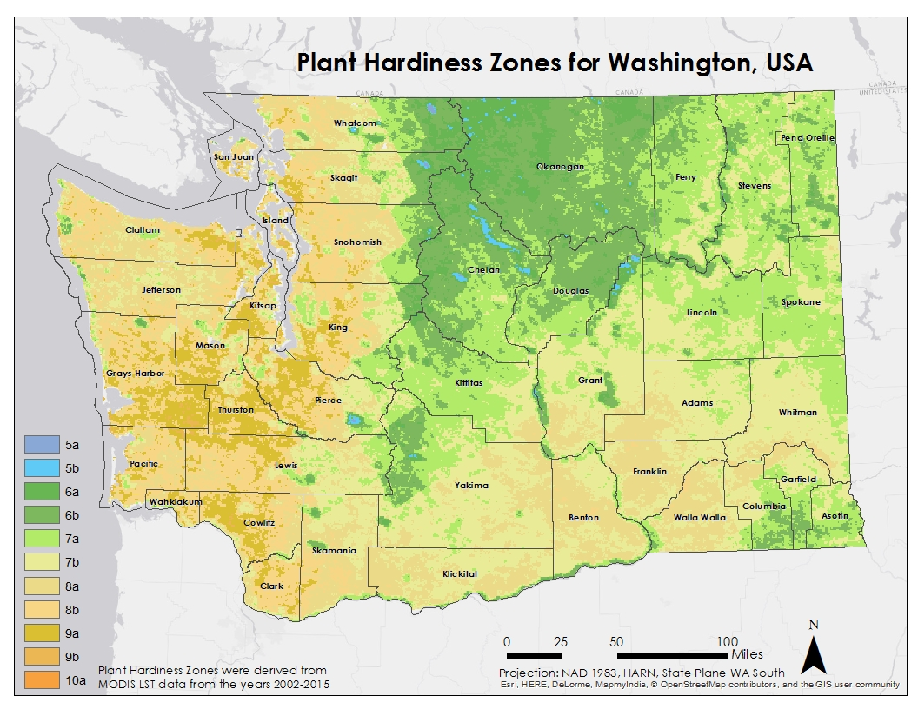

**Caption:** This Plant Hardiness Zone map of Washington State serves as a baseline for determining where apples thrive. This map was created using MODIS LST data from 2002-2015, and shows higher PHZs than the current USDA map which relies on data from 1976-2005. This may indicate Washington’s climate is warming. Zones 5-7 are best for apple growth, shown primarily in the northern and eastern parts of the state.

Image Credit: NW US Agriculture III Team.

**Image:** PHZ_Modis