**NASA DEVELOP National Program**

 NASA Ames Research Center

**Fall 2015**

**Short Title: Lake Tahoe Water Resources**

**Subtitle:** Creating a Global Continuous Detection Lake Level Monitoring Algorithm using Landsat Imagery

**VPS Title:** Prepare for the Future! Measuring Lakes from Space

**Project Team & Partners**

**Project Team:**

Nolan Cate (Project Lead), Nolan.R.Cate@NASA.gov

Anton Surunis

Chelsea Ackroyd

**Advisors & Mentors:**

Dr. Brian Coltin (NASA Ames Research Center)

Dr. Juan Torres-Pérez (Bay Area Environmental Research Institute)

**Partner Organizations:**

USDA Forest Service, Lake Tahoe Basin Management Unit (End-User), POC: Joey Keely

**Project Details**

**Applied Sciences National Applications Addressed:** Water Resources

**Study Area:** Lake Tahoe Basin, CA/NV

**Study Period:** April 1984 - present

**Earth Observations & Parameters:**

Landsat 5, Thematic Mapper (TM) – Land cover

Landsat 7, Thematic Mapper (ETM+) – Land cover

Landsat 8, Operational Land Imager (OLI) – Land cover

**Ancillary Datasets Utilized:**

* WWF Global Lakes and Wetlands Database (GLWD) - global lakes and reservoirs (levels 1 and 2)

**Software Utilized:**

Google Earth Engine - Landsat image classification

ArcGIS - raster and vector manipulation/analysis

ENVI - raster and vector manipulation/analysis

**Project Overview**

**80-100 Word Objectives Overview:**

As climate change becomes a growing concern across the globe, droughts are becoming an evermore present danger, making it increasingly important to get fast and accurate reports on available water resources. The lake level monitoring algorithm from this project aims to use Landsat imagery processed through Google Earth Engine to provide near real-time monitoring of water level and water quality of not only Lake Tahoe, but any terrestrial water body around the globe to better inform hydrologists and water managers.

**Abstract:**

As global climate change continues to escalate and droughts become more frequent and severe, it becomes increasingly necessary to monitor and regulate available water resources. Lake Tahoe (CA/NV) is an important reservoir for tourism, local ecosystems, and drinking water. Its nearly 5 million annual visitors contribute at least $300 million to the local economy, making it one of California’s most popular attractions. Decreasing water levels are a concern for residents, the economy, and a number of endangered species that live on Lake Tahoe’s shores, such as the yellow cress. Current methods of monitoring lake levels, however, rely on depth gauges that require time-intensive field work to retrieve data from and are limited in their spatial coverage. Satellite imagery provides a far greater spatial extent while still providing regular measurements. Utilizing satellite imagery from the Landsat program, the Lake Level Automated Monitoring Algorithm, or LLAMA, is a continuous detection lake level monitoring algorithm that uses an MNDWI, thermal band analysis, and visible band reflectance values processed through Google’s cloud-based geospatial program Earth Engine. In addition to a lake area measurement, LLAMA is able to show measurements of turbidity and algae levels over any given lake worldwide. Thus, LLAMA has the ability to provide water managers near real-time data regarding the turbidity, algae, and water levels for any lake or reservoir of sufficient size via Google Earth Engine.

**Community Concerns:**

* In early 2015, Governor Jerry Brown declared a State of Emergency regarding California’s severe drought.
* Lake Tahoe’s low water levels may have negative impacts on local endangered species, including yellow cress.
* Lake levels are of particular economic importance as Lake Tahoe is a major source of revenue, and attracts nearly 5 million tourists annually.

**Current Management Practices & Policies**:

Currently, the Lake Tahoe Basin Management Unit (LTBMU) team does not have a formal method for monitoring the water level of Lake Tahoe nor its surrounding lakes. Both USGS and the UC Davis Tahoe Research Group have *in situ* data for specific locations throughout Lake Tahoe, but the current methods have yet to assess the lake as a whole. Likewise, relatively small water bodies near Lake Tahoe, including Fallen Leaf Lake, do not have a precise system for measuring water level.

**Decision Support Tools & Benefits:**

|  |  |  |
| --- | --- | --- |
| **End-Product** | **Earth Observations Used** | **Benefit & Impact** |
| Lake level monitoring algorithm for Lake Tahoe and surrounding lakes. | Landsat 5 TM - Land cover  Landsat 7 ETM+ - Land cover  Landsat 8, OLI – Land cover | Will provide a quick and easy-to-use method for monitoring lake levels without the use of costly equipment and time-consuming field work |
| Google Earth Engine Tutorial | N/A | The end-user will have a clear understanding of how to install Google Earth Engine to Windows and will be instructed on how to use the algorithm |

**Project Imagery**

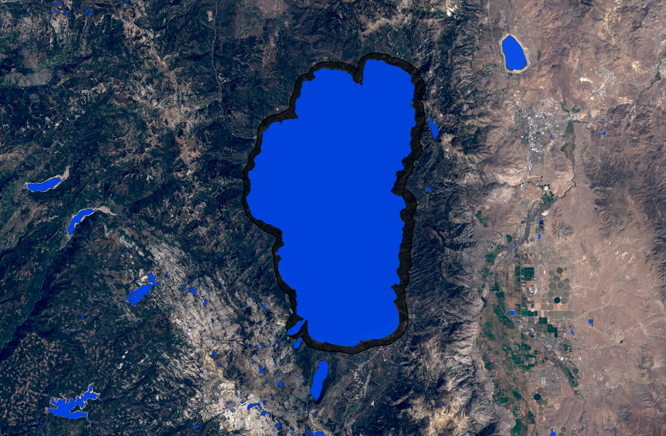

**Caption:** Landsat image with classified water as seen in the VPS video, “Prepare for the Future! Measuring Lakes from Space.”

Image Credit: Lake Tahoe Water Resources Team.

**Image:** Fall2015_ARC_LakeTahoeWaterResources_VPSImage.PNG

**Software Release Requirements**

Category V:

The algorithm being developed is run through Google Earth Engine which is free and open to developers. No imagery will need to be downloaded. Additionally the algorithm will be included in Dr. Brian Coltin’s Crisis Mapping Toolkit which has already passed software release. This project will not require any software release.