**NASA DEVELOP National Program**

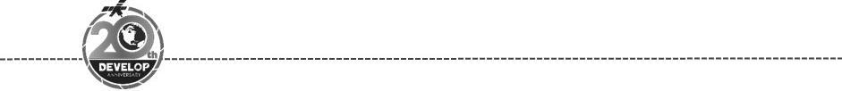Maryland – Goddard

*Spring 2018*

Western Europe Health & Air Quality II

An Interactive Model of Mosquito Presence and Distribution to Assist Vector-Borne Disease Management in Western Europe

**Technical Report**

Final Draft – March 29th, 2018

Gia Mancini (Project Lead)

Julia Heslin

Victor Lenske

Dr. Sara Lubkin

Luisa Silva

Dr. Assaf Anyamba, Universities Space Research Association, NASA Goddard Space Flight Center (Science Advisor)

Dr. John Bolten, NASA Goddard Space Flight Center, (Science Advisor)

Alison Thieme, University of Maryland (Science Advisor)

Past or Other Contributors:

Douglas Gardiner

Helen Plattner

Xhafer Rama

Aaron Warga

# 1. Abstract

Vector-borne diseases, caused by pathogens and parasites, are transmitted through living organism carriers known as vectors. Mosquitoes are the most common disease vectors and transmit illnesses such as Zika, West Nile, chikungunya, malaria, dengue, and yellow fever. These diseases affect millions of people around the world and kill more than one million people each year. While vector-borne disease outbreaks are difficult to predict, the Global Mosquito Alert Consortium strives to monitor and mitigate outbreaks through research and citizen science. This approach presents several challenges, including a lack of data standardization across different regions. During the first term of this project, the MaxEnt habitat modeling software was used to combine several environmental factors with mosquito presence points extracted from citizen science data to determine which variables are correlated with the presence of mosquitoes. During the second term, the NASA DEVELOP team utilized NASA Earth observations and the Global Mosquito Alert Consortium’s citizen science data to create an interactive, open-source map on Google Earth Engine to improve prediction models for vector-borne diseases.

**Keywords**

Species distribution modeling, Habitat suitability, Citizen science, MaxEnt, JavaScript, Google Earth Engine

# 2. Introduction

* 1. ***Background Information***

Vectors are living organisms that transmit illnesses to other organisms. Each year, vectors infect over one billion people worldwide, causing more than one million deaths (World Health Organization, 2017). *Culicidae* spp., more commonly known as the mosquito, is the most widely-known disease vector and transmits illnesses such as Zika, West Nile, chikungunya, malaria, dengue, and yellow fever (Anyamba et al., 2014). As global temperatures rise, areas that were previously low risk for mosquito-borne illnesses are likely to become more suitable habitats for mosquitoes (Seidel, Fu, Randel, & Reichler, 2008).

Mosquitoes thrive in a wide variety of habitats, making mosquito-borne illnesses difficult to eradicate. Mosquitoes live in warmer temperatures, breed in stagnant water, and prefer homogenous land cover consisting of either developed land or dense vegetation (Altizer, Ostfeld, Johnson, Kutz, & Harvell, 2013). In arid environments, mosquito breeding grounds arise around puddles after heavy rainfalls, whereas in typically wetter regions, periods of dry weather cause breeding grounds to form near standing water from dried up rivers and streams (Hahn et al., 2015). Rising temperatures, increased rainfall, and longer periods of warming in Western Europe are predicted to intensify the spread of mosquito-borne illnesses. Higher temperatures will prolong the mosquito breeding season and allow mosquito populations to travel to regions of higher altitude (Hongoh, Berrang-Ford, Scott, & Lindsay, 2012). Furthermore, forest clearing for natural resource extraction is expected to create more areas of homogenous land cover to which mosquitoes will spread. These environmental changes are expected to increase the range of suitable habitats for mosquitoes to survive and breed. Additionally, global travel has also expanded the spread of vector-borne disease. As a tourist hub and frequent stopover location for air, vehicle, rail, and boat travel, Western Europe’s status as a prominent travel destination increases the risk of not only disease contraction for those entering the region but, potentially, disease transmission to other mosquitoes in the area.

Researchers and public health officials are using citizen science data, which is scientific data and research collected by the general public, to aid in tracking mosquito presence and illness outbreaks. With a growing threat of vector-borne diseases, governments and organizations are encouraging people to report on mosquito activity. Through mobile applications with global positioning capabilities, anyone can fill out and submit questionnaires when they encounter mosquitoes. Within Western Europe, Belgium, Italy, The Netherlands, and Spain are highlighted (Figure 1), as they currently collect citizen science data related to mosquitoes. As part of the NASA DEVELOP team, we utilized citizen science data from these countries collected from June 2016 until September 2017.

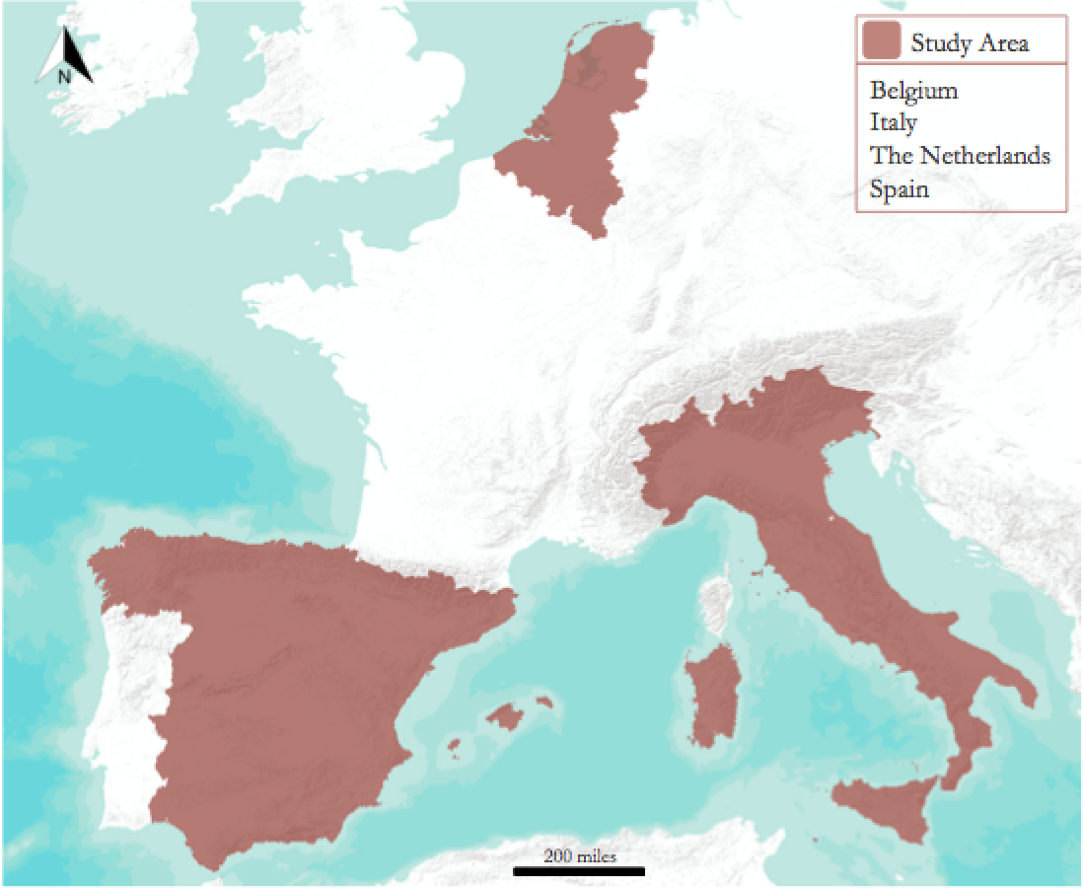

*Figure 1*. Western Europe study area

To assist in data visualization and outreach, we utilized Google Earth Engine (GEE), which is an open-source platform used to organize, analyze, and visualize geospatial datasets. With the platform already equipped with hundreds of environmental datasets, GEE makes accessing and retrieving data quick and simple. We used GEE to predict and visualize mosquito habitat suitability, and to make the data accessible to the general public.

* 1. ***Project Partners & Objectives***

The end user of this project was the Global Mosquito Alert Consortium, which uses mobile applications to collect citizen science vector data. The consortium has obtained support from the United Nations Environment Programme (UNEP) to display their data on UNEP’s “Environment Live” web platform, which is used to collect statistics and measure impacts from environmental factors. The consortium models mosquito population growth, invasive species concentrations, and potential epidemics. Our partner organizations within the consortium include The Woodrow Wilson International Center for Scholars, the Citizen Science Association, the European Citizen Science Association, the Institute for Global Environmental Strategies, Wageningen University, and Sapienza Università Di Roma. These partners collectively conduct international outreach with the goal of raising awareness of vector-borne diseases. The consortium aims to accomplish their goals by combining citizen science data from mobile crowdsourcing applications with NASA remote sensing data. This project focused on integrating NASA Earth observations and citizen science data onto an open-source platform that is readily accessible to researchers, health officials, and the public.

# 3. Methodology

***3.1 Data Acquisition***

We received mosquito data from several citizen science organizations in Western Europe, along with human population density, land cover, transportation routes, and public health data for ancillary visualization purposes (Table 1). Sapienza Università Di Roma provided Italian data collected through ZanzaMapp, Spanish data were acquired from Mosquito Alert Spain, and Wageningen University supplied data collected through Muggenradar for Belgium and The Netherlands. We obtained additional citizen science coordinate points from the GLOBE Mosquito Habitat Mapper. We utilized the geographic coordinate locations of the citizen science data collection points to indicate mosquito presence.

Table 1.

*List of ancillary datasets used to create models*

|  |  |
| --- | --- |
| **Dataset Name** | **Purpose** |
| Muggenradar | *in situ* mosquito presence data for The Netherlands and Belgium |
| ZanzaMapp | *in situ* mosquito presence data for Italy |
| Mosquito Alert Spain | *in situ* mosquito presence data for Spain |
| GLOBE Mosquito Habitat Mapper | *in situ* mosquito presence data for Western Europe |
| Gridded Population of the World, V4  UN-Adjusted Population Density | Human population density, 2015 |
| EuroGlobalMap Version 10 | European transportation routes (roads, railroads, ferries) |
| European Center for Disease Control | mosquito-borne illness case locations |
| ProMED | mosquito-borne illness case locations |

The citizen science datasets acquired from the various organizations were unstandardized and consisted of varying attributes. In order to keep the data consistent, only geographic coordinate points and associated time stamps were extracted from the datasets. Based on the entomologist notes within the datasets, we removed points that were not mosquitoes. We also removed absence data points, since absence data were not included in each dataset.

We utilized the maximum entropy (MaxEnt) habitat suitability model because it is a widely-used and well-performing species distribution model. The MaxEnt model uses presence-only data, which was ideal since absence data were omitted. Previous studies have utilized MaxEnt to predict habitat suitability for mosquitoes with successful results (Rochlin, Ninivaggi, Hutchinson, & Farajollahi, 2013; Almi et al., 2015). The MaxEnt model incorporates presence data and environmental data and runs a multinomial logistic regression. This allows for a range of probability outcomes on a scale from zero to one versus a binomial logistic regression that only allows for either zero or one.

When using MaxEnt, there are underlying assumptions that users must pay attention to. Phillips, Anderson, and Schapire (2006) outline some these assumptions in their article on maximum entropy species distribution modeling. Their article identified that presence data and the environmental data should be temporally consistent with each other. Phillips et al (2006) also determined that the spatial resolution of the environmental factors should be appropriately sampled based on the scale. In our study, all monthly environmental variables, with the exception of elevation which does not dramatically change over time, temporally corresponded with the presence data. In addition, based on the explanation from Phillips et al. (2006), the environmental variables we selected were appropriate for a mesoscale analysis.

It is also noted that careful attention should be paid to sampling bias. Citizen science data has sampling bias due to a number of factors. Data collection is typically clustered in densely populated areas and increases after media and outreach events. In addition, presence data is the primary type of data that is collected, and there was no distinction between mosquito larvae and adult mosquito presence points. It is possible a mosquito was reported on twice at different periods in its life cycle. To account for oversampling in populated areas and areas with a lot of outreach, the data were downsampled in ArcGIS using the fishnet tool. A fishnet shapefile was created with a resolution of 0.05 by 0.05 degrees (approximately 5.5 by 5.5 kilometers) to align with the resampled environmental datasets. The grid cells were then clipped to the study area. Each presence point was spatially joined with the corresponding grid cell in which it fell. If a cell contained at least one record of a mosquito, that cell was counted as one presence point. Cells without any record of mosquitoes were not considered. The grid cells were converted to points based on the cells’ centroids to retrieve the corresponding X, Y coordinates.

We used NASA Earth observation data from Terra Moderate Resolution Imaging Spectroradiometer (MODIS), Aqua MODIS, Shuttle Radar Topography Mission (SRTM), and Global Precipitation Measurement (GPM) to evaluate environmental variables. The variables considered for the mosquito habitat suitability analysis included elevation, humidity, land surface temperature (LST), vegetation greenness (NDVI), precipitation, and soil moisture (Table 2). NASA Earth observations were obtained through Earth Data for the MaxEnt standalone model, while the interactive tool utilized NASA Earth observations obtained through the GEE repository.

Table 2.

*List of satellite data products used to create maps*

|  |  |  |  |
| --- | --- | --- | --- |
| **Parameter** | **Data Product** | **Study Area Timeframe** | **Spatial Resolution** |
| Elevation (GEE) | CGIAR/SRTM 90m DEM V4 L3 Global  5 deg Lat/Lon Grid | Last Updated 2000 | 90 m |
| Elevation (MaxEnt) | CGIAR/SRTM 90m DEM V4.1 L3 Global 5 deg Lat/Lon Grid | Last Updated 2009 | 90 m |
| Humidity (GEE) | GLDAS_NOAH025_M GLDAS Noah  Land Surface Model L4 3-Hourly  0.25 deg Lat/Lon Grid V2.1 | June 2016 - September 2017 | 0.25 degree |
| Humidity (MaxEnt) | AIRS3STM V6 AIRS Humidity Monthly L3 Global 1 deg Lat/Lon Grid | June 2016 - September 2017 | 1 degree |
| LST  (GEE) | MOD11A1 MODIS/Terra Land Surface Temperature/Emissivity Daily L3 Global  1 km SIN Grid V6 | June 2016 - September 2017 | 1 km |
| LST  (MaxEnt) | MOD11C3 V6 MODIS/Terra Land Surface Temperature Monthly L3 Global 0.05 deg Lat/Lon Grid | June 2016 - September 2017 | 0.05 degree |
| NDVI  (GEE) | MOD09GA MODIS/Terra Land Surface Reflectance Daily L2G Global 1km and  500m SIN Grid V6 | June 2016 - September 2017 | 500 m |
| NDVI  (MaxEnt) | MOD13C2 V6 MODIS/Terra Vegetation Indices Monthly L3 Global 0.05 deg Lat/Lon Grid | June 2016 - September 2017 | 0.05 degree |
| Precipitation  (GEE) | GPM_3IMERGDL V4 GPM IMERG Late Precipitation Half-Hourly L3 Global  0.1 deg Lat/Lon Grid | June 2016 - September 2017 | 0.1 degree |
| Precipitation  (MaxEnt) | GPM_3IMERGDL V4 GPM IMERG Late Precipitation Daily L3 Global 0.1 deg Lat/Lon Grid | June 2016 - September 2017 | 0.1 degree |
| Soil Moisture  (GEE) | GLDAS_NOAH025_M GLDAS Noah Land Surface Model 3-Hourly L4 Global  0.25 deg Lat/Lon Grid V2.1 | June 2016 - September 2017 | 0.25 degree |
| Soil Moisture  (MaxEnt) | GLDAS_NOAH025_M v2.1 GLDAS Noah Land Surface Model Monthly L4 Global 0.25deg Lat/Lon Grid | June 2016 - September 2017 | 0.25 degree |
| Land Cover | MCD12Q1 MODIS Land Cover Type Yearly L3 Global 500m SIN Grid | Last Updated 2013 | 500 m |

***3.2 Data Processing***

Once we imported all of the datasets from the GEE repository, we calculated the monthly average precipitation, humidity, and soil moisture, that were recorded in three-hour increments. Land Surface Temperature and NDVI were converted from daily increments to monthly averages. To import the citizen science data into GEE, we loaded each monthly Excel file into a Google Fusion Table. Each table was assigned a unique ID that was used to call the data. Each month was then added as a map layer on the GEE interface. We obtained public health data by compiling outbreak reportings from ProMED and the European Center for Disease Control that occurred within our study period. We then added these data as a table asset in GEE.

From there, we explored multiple options to integrate the citizen science and environmental data in GEE. The first option was hard-coding the MaxEnt model directly into GEE, adapted from Padarian, Minasny, & McBratney (2015). In the code, there are two components to the model: constraint and entropy. The constraint component refers to the environmental covariates. The sum, minimum, maximum, and mean of each environmental variable was used in the model. Running the constraint through the hard-coded algorithm creates a classifier, in which different pixels are assigned to classes to visualize the probability of mosquito distribution. The entropy component refers to training the MaxEnt classifier using the citizen science data. To assign the pixels, 20 percent of the citizen science data were used to train the classifier. After concatenating the environmental data layers, the remaining citizen science data were incorporated into the model. The probability distribution is then clipped with respect to the environmental covariates. Colors are also assigned to represent probability on a scale of zero to one.

The second option involved utilizing the standalone version of MaxEnt as a foundation. The monthly citizen science and environmental datasets were run through the standalone model in order to generate monthly habitat suitability results. In addition to creating a habitat suitability map, the model outputs a comma-separated values file of lambda coefficients and entropy values for each month. These coefficient values were applied to a regression equation for computing the contribution of each variable included in the model. We took the coefficient values from the standalone MaxEnt model and plugged them into the MaxEnt equations within GEE. The equations produced a new image with different cell values based on the inputs. All the values were then normalized on a zero to one scale to create new images.

The third option also required running the MaxEnt standalone model. From the monthly habitat suitability results, we utilized the percent contribution of each environmental variable. In addition to assigning coefficients to each environmental variable, the MaxEnt results also include a table indicating the percent contribution of each variable in the model (Table 3). We used these percentages to weight the corresponding environmental variables in GEE. All cell values are then added together and normalized on a scale from zero to one, representing habitat suitability probability. Each probability value is assigned a color, producing a habitat suitability map layer. It should be noted that the variable importance percentages changed monthly due to seasonal changes; therefore, the percentages for each environmental dataset vary monthly.

Table 3.

*Environmental variables’ percent contribution to the MaxEnt model*

|  |  |  |
| --- | --- | --- |
| **Environmental Variable** | **June 2016 (%)** | **January 2017 (%)** |
| LST | 20.2 | 0.3 |
| NDVI | 31.9 | 0.7 |
| Precipitation | 1.8 | 1.5 |
| Humidity | 28.9 | 1.5 |
| Soil Moisture | 9.5 | 4.1 |
| Elevation | 7.8 | 91.9 |

***3.3 Data Analysis***

We ran the standalone MaxEnt habitat suitability model for each month of our study period, from June 2016 to September 2017. We utilized the downsampled citizen science data and the following environmental variables: elevation, humidity, LST, NDVI, precipitation, and soil moisture. We then analyzed the MaxEnt outputs to identify which environmental variables influenced mosquito activity the most. Besides the model visual itself, the MaxEnt standalone model also output a jackknife graph. The jackknife graph shows the environmental variables’ individual and combined influence on the citizen science coordinate data. MaxEnt also provides the area under the curve (AUC), which illustrates how well the model performed on a scale from zero to one. Reaching 100 percent accuracy is ideal; however, this is difficult to achieve since all models have some source of error. Achieving an AUC of above 70 percent indicates a well-performing model (UNMC, n.d.).

# 4. Results & Discussion

***4.1 Analysis of Results***

The MaxEnt model resulted in both the standalone model and GEE map (Figures 2 & 3) that revealed important relationships between mosquito presence and environmental variables. The NDVI and mosquito presence were positively correlated, indicating that homogenous land cover and greenness were associated with mosquito presence points. Temperature and mosquito presence were positively correlated, meaning higher temperatures were related to increased mosquito presence. Moisture characteristics like precipitation, humidity, and soil moisture were also positively correlated with mosquito presence. Elevation was an important factor in determining mosquito presence, however, elevation values were negatively correlated with 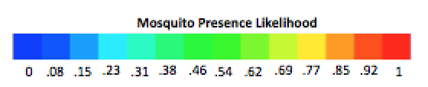presence points.

*Figure 2*. June 2016 MaxEnt standalone model mosquito habitat suitability results map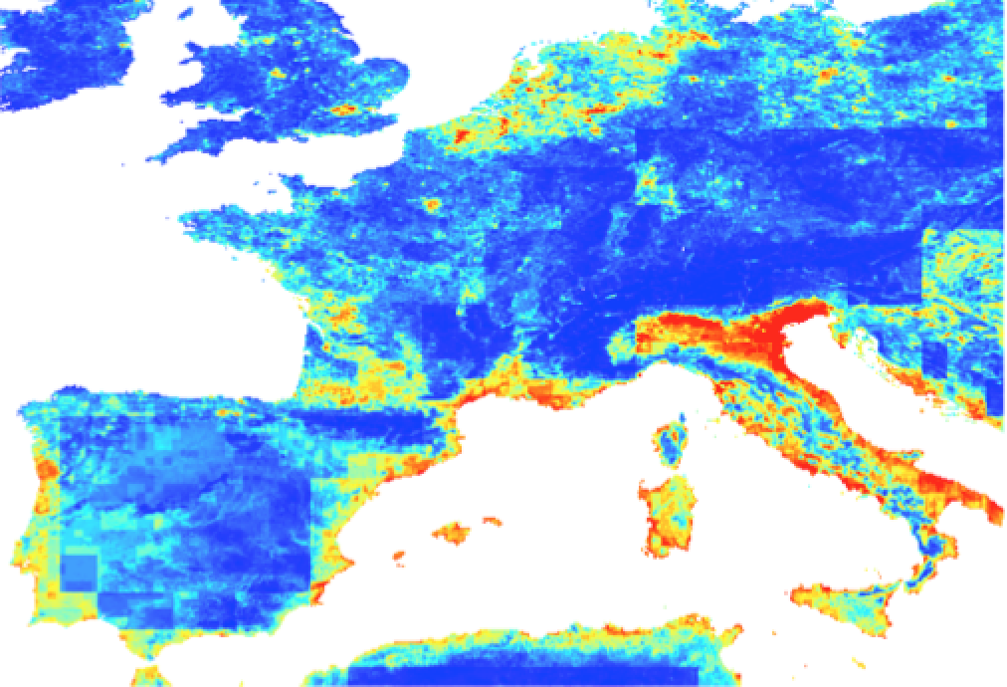

*Figure 3*. June 2016 mosquito habitat suitability results map in Google Earth Engine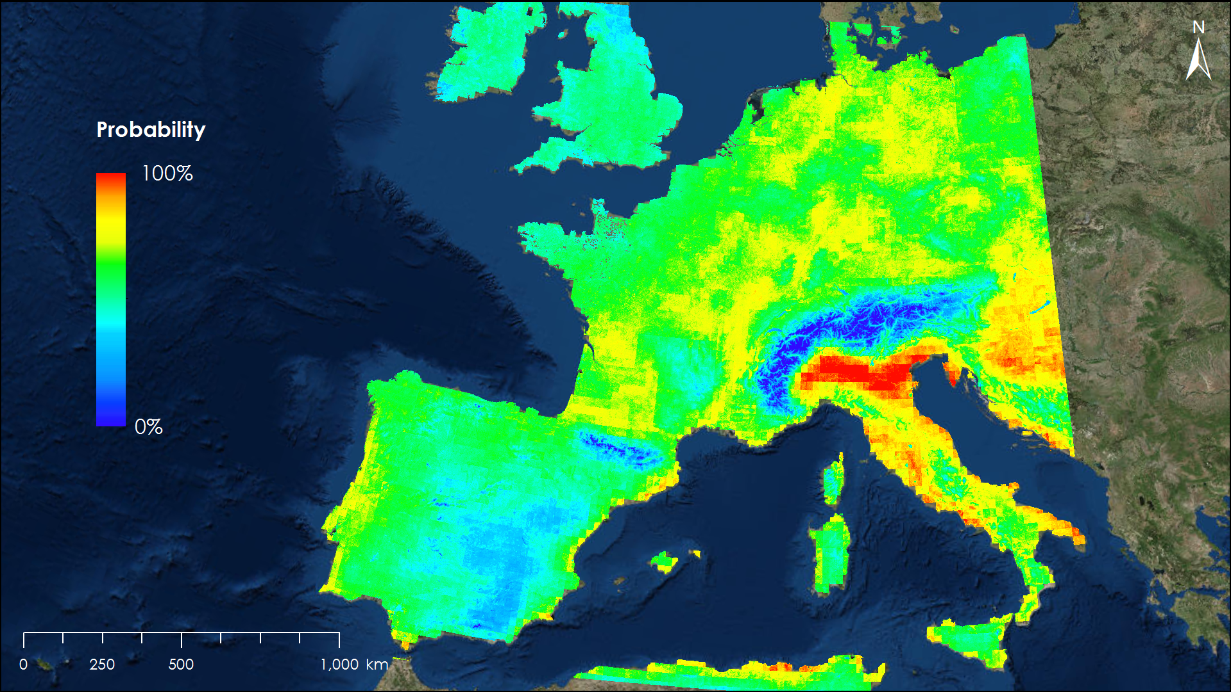

The jackknife graphs created by MaxEnt show environmental variable importance based on the monthly data. As seen in Figures 4 and 5, the environmental variable importance distribution changed based on the month. Elevation was the most important variable during the winter months, while variable importance was evenly distributed in the summer months. In the summer, LST, NDVI, and humidity were the highest contributors.

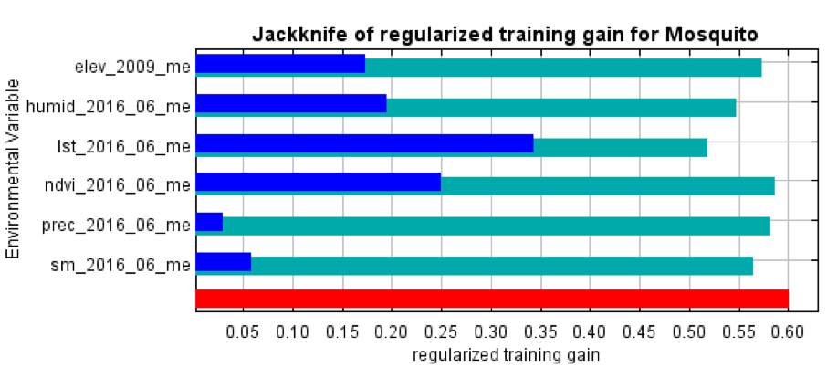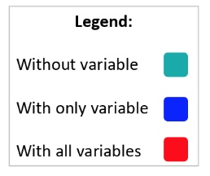

*Figure 4*. Jackknife graph showing mosquito habitat suitability environmental variable importance for June 2016

*Figure 5.* Jackknife graph showing mosquito habitat suitability environmental variable importance for January 2017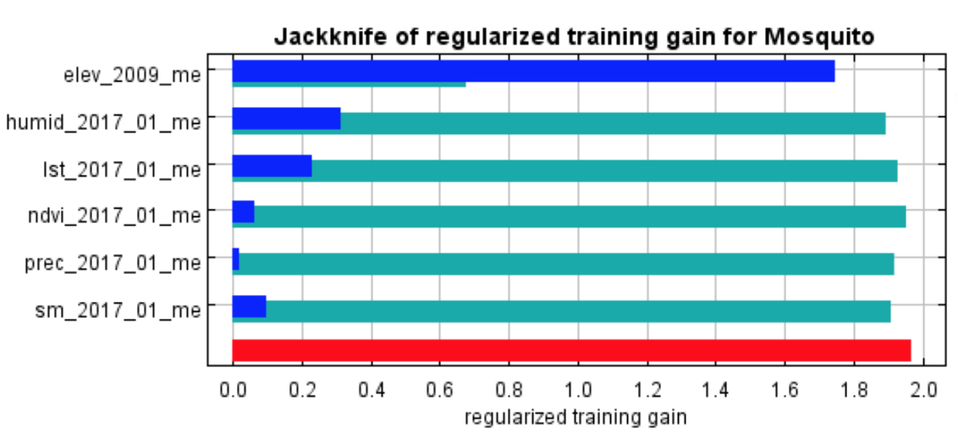

While the AUC changed monthly, the values remained over 80 percent (Figure 6). This shows that the model performed well in all months of the study period. In February, the model performed at its best with an AUC of 96 percent. There were very few citizen science data points in that month, so the environmental variables had little data to run against, skewing the AUC value.

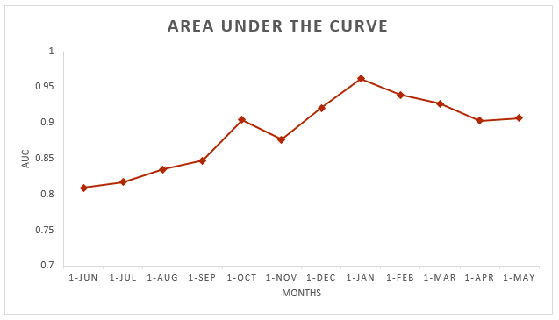

*Figure 6*. Area under the curve graph indicating model performance by month

***4.2 Errors & Uncertainties***

This interactive habitat suitability model is intended to serve as a foundation for work that can be done in the future. Over the course of the term, we came across sources of error and uncertainty that stemmed from this project. There was bias from citizen science data based on the population distribution of the study area. Citizen science data points were concentrated in areas with high population density. Media events hosted to encourage data collection also introduced bias. Interest in collecting citizen science data may have spiked after these media events, so the data may not be consistent over time. People may also lose interest in or forget about the data collection apps after having them for some time. Some citizen science datasets included absence points, but not all; thus only presence data were considered for this project to keep the data consistent across countries. This is acceptable since MaxEnt assesses habitat suitability with presence-only data.

***4.2 Future Work***

Once the software release process is complete, the interactive mapping tool on GEE will be live, meaning it will be open for public access. The end-users can input their own citizen science presence data into fusion tables and visualize the monthly environmental data that corresponds to that table. The tool will then allow users to output a map showing the probability of mosquito distribution based on past and future environmental factors. Additional layers could also be added to the map by any user to further visualize trends in mosquito distribution.

In the future, we recommend a set standard for citizen science data collection across all countries to streamline the process of data integration between countries. For example, we should encourage all citizen scientists to collect data on mosquito absence. This would broaden the platform options available for predicting habitat suitability. Citizen science data from all countries should strive to include species distinction in its data collection. Many species prefer different environmental factors and differentiating by species can help track species-specific diseases.

We would also like to see the inclusion of more data in general. More variables such as minimum and maximum temperatures and inundation data, amongst others, should be added to assess how those variables interact with mosquito presence. We encourage other countries to input their own citizen science data as it would increase the accuracy of the model and provide a more comprehensive analysis for the rest of the region. One way of reconciling the bias introduced from population-dense areas would be to encourage citizen scientists to collect data from remote locations for a more stratified sample of data.

In terms of implementing the model onto an open-source platform, we encourage the exploration of other platforms to host an interactive map. For example, a combined R package with Shiny Apps might allow for more flexibility for inputting a habitat suitability model such as MaxEnt.

# 5. Conclusions

There were pros and cons associated with each method of implementing a habitat suitability model onto an open-source platform. Regarding option one, the hard-coding method, anyone can edit the code and replace the environmental covariates with other variables. Calling in other datasets, such as consecutive days without rain or inundation data, can identify new variables that affect mosquito presence. However, GEE is limited in terms of analysis tools. Coding and visualizing a habitat suitability model proved difficult given the limited project timeframe, as every step involving MaxEnt had to be coded from scratch into the tool and the results could only be visualized in three bands.

For the second option we explored implementing the results from MaxEnt’s regression equation into GEE. This method cannot be replicated for future months outside of the study area because the model’s results, including its lambda coefficients and entropy values, would change. Consequently, it would be more efficient to simply run MaxEnt on the standalone platform.

Option three was the best method for our team. Implementing the weights for each environmental variable can be easily understood by the user and replicated for future months’ data. The percent contribution of variables within the MaxEnt model revealed some important seasonal differences amongst environmental variables and mosquito presence. The percent contribution varies by month as the environmental data fluctuates with the seasons. We found that Western Europe had high mosquito occurrence during the summer months. Land surface temperature, NDVI, and humidity were the largest environmental contributors in the summer months, while elevation was the dominant factor in the winter months. All variables were positively correlated with mosquito presence, except for elevation, which was negatively correlated to mosquito presence.

Using a habitat suitability map is helpful in determining which environmental variables influence species presence. The model also analyzes the entire region, even with limited data availability. The tool can be used to replicate habitat suitability for other time periods. Using an open-source platform is a great tool because it can be accessed by anyone, anywhere. We hope that the results and conclusions found during this project provide a basis for future mosquito habitat suitability projects and achieve the ultimate goal of assisting in predicting and monitoring mosquito-borne illness outbreaks.

# 6. Acknowledgments

The project team for this DEVELOP project would like to acknowledge:

* Assaf Anyamba, PhD, Universities Space Research Association, NASA Goddard Space Flight Center
* John Bolten, PhD, NASA Goddard Space Flight Center
* John Palmer, PhD, Global Mosquito Alert Consortium
* Anne Bowser, PhD, Woodrow Wilson International Center for Scholars
* Xhafer Rama, Universities Space Research Association
* Russanne Low, PhD, Institute for Global Environmental Strategies
* Dorian Janney, ADNET Systems Inc
* Greg Newman, PhD, Citizen Science Association
* Martin Brocklehurst, European Citizen Science Association
* Arnold van Vliet, PhD, and Sander Koenraadt, PhD, Wageningen University
* Beniamino Caputo, PhD, and Alessandra Dellatorre, PhD, Sapienza Università Di Roma
* Douglas Gardiner, Helen Plattner, Alison Thieme and Aaron Warga, DEVELOP

Any opinions, findings, and conclusions or recommendations expressed in this material are those of the author(s) and do not necessarily reflect the views of the National Aeronautics and Space Administration.

This material is based upon work supported by NASA through contract NNL16AA05C and cooperative agreement NNX14AB60A.

# 7. Glossary

**ArcGIS** – Geographic Information System program; takes raw data points from observations and applies

data to maps for various types of analysis

**Citizen Science Association** – A platform to gather knowledge across disciplines to “build collaboration,

community, and credibility”

**DAAC** – Distributed Active Archive Center. A database that stores NASA’s remotely sensed data directly

from various satellites for earth observations

**Earth Data** – Web portal application to access NASA satellite data

**Earth observations** – Satellites and sensors that collect information about the Earth’s physical, chemical,

and biological systems over space and time

**ECDC** – European Centre for Disease Prevention and Control

**ECSA** – European Citizen Science Association. See Citizen Science Association

**EOSDIS** – Earth Observing System Data and Information System

**GLDAS** – Global Land Data Assimilation Systems

**Global Mosquito Alert Consortium** – A conglomeration between the UNEP, the European Citizen

Science Association, and the Woodrow Wilson International Center for Scholars

**GEE** – Google Earth Engine; a planetary-scale platform for Earth science and data analysis

**IGES** – Institute for Global Environmental Strategies. Created to innovate policy development and

research for environmental measures

**LST** – Land Surface Temperature

**MODIS** – MODerate resolution Imaging Spectroradiometer

**MaxEnt** – Maximum entropy model used to map habitat suitability

**NASA Data Level 3** – Geospatially referenced data from NASA satellites

**NASA Data Level 4** – Previously analyzed data from NASA satellites

**NASA** – National Aeronautics and Space Administration

**NDVI** – Normalized Difference Vegetation Index. An algorithm that remotely measures greenness values

per pixel in order to determine vegetation presence or absence.

**ProMED** – The Program for Monitoring Emerging Diseases. An internet-based reporting system

dedicated to rapid global dissemination of information on outbreaks of infectious diseases and acute exposures to toxins that affect human health

**Remote Sensing** – Gathering data of an object(s) without making direct contact

**UNEP** – United Nations Environment Programme, an organization that coordinates environmental

activities and aides developing countries in sustainable practices

**Vector** – An organism that does not cause disease but can spread disease by transferring pathogens

between organisms

**Woodrow Wilson International Center for Scholars** – A center for scholars and experts from various

countries to come together to research and discuss policies and topics; Based in Washington, D.C.

# 8. References

AIRS Science Team/Joao Texeira (2013), AIRS/Aqua L3 Monthly Standard Physical Retrieval (AIRS-only) 1 degree x 1 degree V006, Greenbelt, MD, USA, Goddard Earth Sciences Data and Information Services Center (GES DISC), Accessed September 19, 2017. doi://10.5067/AQUA/AIRS/DATA321

Altizer, S., Ostfeld, R. S., Johnson, P. T., Kutz, S., & Harvell, C. D. (2013). Climate change and infectious

diseases: From evidence to a predictive framework*.* *Science, 341*(6145), 514–519. https://doi.org/10.1126/science.1239401

Almi, T.O., Fuller, D.O., Qualls, W.A., Herrera, S.V., Arevalo-Herrera, M., Quinones, M.L., …

Beier, J.C. (2015). Predicting potential ranges of primary malaria vectors and malaria in northern

South America based on projected changes in climate, land cover and human population. *Parasites and Vectors*, *8*(1), 431. https://doi.org/10.1186/s13071-015-1033-9

Anyamba, A., Small, J. L., Britch, S. C., Tucker, C. J., Pak, E. W., Reynolds, C. A., …

Linthicum, K. J. (2014). Recent weather extremes and impacts on agricultural production and

vector-borne disease outbreak patterns*.* *PLoS ONE*, *9*(3), e92538. https://doi.org/10.1371/journal.pone.0092538

Center for International Earth Science Information Network - CIESIN - Columbia University. (2016). Gridded Population of the World, Version 4 (GPWv4): Population Density Adjusted to Match 2015 Revision UN WPP Country Totals. Palisades, NY: NASA Socioeconomic Data and Applications Center (SEDAC), accessed February 15, 2018. https://doi.org/10.7927/H4HX19NJ

European Centre for Disease Prevention and Control. (2018). Transmission of West Nile fever, May to

November 2016 - Table of cases, 2016. European Union, accessed February 15, 2018. https://ecdc.europa.eu/en/publications-data/table-transmission-west-nile-fever-may-november-2016-table-cases-2016

Friedl, M. & Sulla-Menashe, D., Boston University and MODAPS SIPS - NASA (2015).

MODIS/Terra + Aqua Land Cover Type Yearly L3 Global 500 m SIN Grid. NASA EOSDIS Land Processes Distributed Active Archive Center (LP DAAC), USGS/Earth Resources Observation and Science (EROS) Center, accessed February 15, 2018. http://dx.doi.org/10.5067/MODIS/MCD12Q1.006

Hahn, M. B., Monaghan, A. J., Hayden, M. H., Eisen, R. J., Delorey, M. J., Lindsey, N. P., …

Fischer, M. (2015). Meteorological conditions associated with increased incidence of West Nile

Virus disease in the United States, 2004–2012*.* *The American Journal of Tropical Medicine and Hygiene*,

*92*(5), 1013–1022. https://doi.org/10.4269/ajtmh.14-0737

Hongoh, V., Berrang-Ford, L., Scott, M. E., & Lindsay, L. R. (2012). Expanding geographical distribution

of the mosquito, *Culex pipiens*, in Canada under climate change*.* *Applied Geography, 33*, 53–62. https://doi.org/10.1016/j.apgeog.2011.05.015

Huffman, G.. (2016). GPM IMERG Late Precipitation L3 1 day 0.1 degree x 0.1 degree V04, Greenbelt, MD, Goddard Earth Sciences Data and Information Services Center (GES DISC), Accessed 29 September 2017 doi://10.5067/GPM/IMERGDL/DAY/04

Institut National de l’Information Géographique et Forestière – France. (2017). EuroGlobalMap.

Eurographics, accessed February 15, 2018. www.eurographics.org/products-and-services/euroglobalmap

Jarvis, A., Reuter, H. I., Nelson, A., & Guevara, E. (2008). Hole-filled SRTM for the globe Version 4. CGIAR-CSI SRTM 90m Database, accessed February 15, 2018. http://srtm.csi.cgiar.org

MODIS Science Team/Kamel Didan. (2016). MODIS/Terra Level 3 Vegetation Indicies HDF file, Version 6. NASA Land Processes Distributed Active Archive Center, accessed 20 September 2017. doi://10.5067/MODIS/MOD13C2.006

MODIS Science Team/Zhengming Wan. (2016). MODIS/Terra Level 3 Land Surface Temperature and Emissivity netCDF file, Version 6. NASA Land Processes Distributed Active Archive Center, accessed 19 September 2017. doi://10.5067/MODIS/MOD11C3.006

NASA LP DAAC (2000). MODIS/Terra Land Surface Temperature/Emissivity Daily L3 Global 1 km

SIN Grid, Version 6. NASA EOSDIS Land Processes Distributed Active Archive Center (LP DAAC), USGS/Earth Resources Observation and Science (EROS) Center, accessed February 15, 2018. http://doi.org/10.5067/MODIS/MOD11A1.006

NASA LP DAAC (2000). MODIS/Terra Surface Reflectance Daily L2G Global 1km and 500m SIN

Grid, Version 6. NASA EOSDIS Land Processes Distributed Active Archive Center (LP DAAC), USGS/Earth Resources Observation and Science (EROS) Center, accessed February 15, 2018. http://dx.doi.org/10.5067/MODIS/MOD09GA.006

NASA PMM (2014). GPM: Global Precipitation Measurement (GPM), Version 4. NASA/JAXA, accessed

February 15, 2018. http://dx.doi.org/10.5067/GPM/IMERG/3B-HH/04

Padarian, J., Minasny, B., & McBratney, A.B. (2015). Using Google's cloud-based platform for digital soil

mapping. *Computers & Geosciences, 83*,80–88. https://doi.org/10.1016/j.cageo.2015.06.023

Phillips, S.J., Anderson, R.P., & Schapire, R.E. (2006). Maximum entropy modeling of species geographic

distributions. *Ecological Modelling, 190*, 231-259. https://doi.org/10.1016/j.ecolmodel.2005.03.026

ProMED-mail (2010). ProMED International Society for Infectious Diseases, accessed February 15, 2018.

https://www.promedmail.org

Rochlin, I., Ninivaggi, D.V., Hutchinson, M.L., & Farajollahi, A. (2013). Climate change and range

expansion of the Asian tiger mosquito (*Aedes albopictus*) in Northeastern USA: implications for public health practitioners. *PLoS ONE*, *8*(4), e60874. https://doi.org/10.1371/journal.pone.0060874

Rodell, M., & Beaudoing, H.K., NASA/GSFC/HSL (2016). GLDAS Noah Land Surface

Model L4 monthly 0.25 x 0.25 degree V2.1. Greenbelt, Maryland, USA, Goddard Earth Sciences Data and Information Services Center (GES DISC), accessed February 15, 2018.

http://dx.doi.org/10.5067/E7TYRXPJKWOQ

Seidel, D. J., Fu, Q., Randel, W. J., & Reichler, T. J. (2008). Widening of the tropical belt in a changing

climate. Nature Geoscience, *1*(1), 21-24. https://doi.org/10.1038/ngeo.2007.38

University of Nebraska Medical Center (UNMC). n.d. The area under an ROC graph, accessed March 27, 2018. http://gim.unmc.edu/dxtests/roc3.htm

World Health Organization. (2017). *WHO | Vector-borne diseases*. Retrieved from

http://www.who.int/mediacentre/factsheets/fs387/en/