**Early Detection of Bark Beetle Outbreaks in the Southeastern United States Using Earth Observations**

*Authors and Affiliations:*

Haley M.W. Ritger1,✱

Dionne B. Blanks1

Larissa R. Robinov1

Jacob S. Armistead1

Madison M. Murphy1

Danielle L. Quick1

1NASA DEVELOP National Program, Alabama Node, Mobile County Health Department, 251 North Bayou St., Mobile, AL 36606

✱Corresponding Author: Haley Ritger, 3988 Jones Center Dr., Newton, GA 39870, hritger@jonesctr.org

*Funding statement: This work was supported by the National Aeronautic and Space Administration (NASA) through contract NNL16AA05C and cooperative agreement NNX14AB60A. NASA sponsors the mission of the Landsat 8 satellite which collected some of the data used in this study; however, NASA did not have any role in study design, analysis and interpretation of the data, or the decision to submit the article for publication. The NASA DEVELOP National Program Project Coordination team served as a friendly reviewer in the preparation of this manuscript.*

*Any opinions, findings, and conclusions or recommendations expressed in this material are those of the authors and do not necessarily reflect the views of the National Aeronautics and Space Administration.*

**Highlights**

* Negative NDVI, NDMI, and IREC changes are correlated with known bark beetle activity and drought impacts to pine forests in the vicinity of the Oconee National Forest in Georgia, USA.
* Landsat 8 OLI and Sentinel-2 MSI data products offer a higher spatial resolution view of bark beetle activity than the 250m MODIS products used by the *ForWarn* system.
* Sentinel-2 IREC index change maps showed greater potential for identifying early indications of disturbance by bark beetles compared to non-red edge NDVI and NDMI change maps.

**Abstract**

Since 2015, bark beetle infestations have increased in the southeastern United States, increasing the potential for devastating wildfires. Bark beetle infestations begin in small spots, usually by attacking a weakened or stressed focal tree. Beetles then use aggregation pheromones to increase the breeding population in the area, boring into the trees and disrupting the flow of water and nutrients to reproduce and develop under the bark. This disrupting activity causes detectable canopy color changes, with needles fading and eventually turning red before falling off. The USDA US Forest Service currently uses *ForWarn* Moderate Resolution Imaging Spectroradiometer (MODIS) Normalized Difference Vegetation Index (NDVI) to identify locations of bark beetle outbreaks; however, the spatial resolution of MODIS can only detect infestation once a sufficiently large swath of trees have dying foliage, lost needles, or have been harvested via sanitation logging. This detection of widespread disturbance can be too late for effective intervention to reduce beetle populations using forest management practices. In response, the NASA DEVELOP team assessed the potential of higher resolution remotely sensed imagery from Landsat 8 Operational Land Imager (OLI) and Sentinel-2 MultiSpectral Instrument (MSI) to detect early stages of bark beetle outbreaks occurring in the Oconee National Forest between January 2015 and July 2017. The project assessed the possibility of enhanced early detection of bark beetle activity via remote sensing, which could improve the US Forest Service’s ability to mitigate beetle damage in forests of the southeastern United States. Project results suggest that Sentinel-2 MSI and Landsat 8 OLI data are useful for assessing co-occurring bark beetle outbreaks and drought impacts to pine forests.

**Keywords**

Remote sensing, Landsat, Sentinel-2, MODIS, vegetation indices, forest health, forest disturbance, bark beetles

**1. Introduction**

Forests provide important economic and ecological benefits including timber, wood products, carbon storage, nutrient and water cycling, wildlife habitat, and recreational opportunities. Southern forests comprise 32% of all US forests and 40% of US timberland (Oswalt et al., 2014; Wear, 1996). Many of the forests providing these benefits in the southeastern US are pine. Native bark beetle species coexist in these ecosystems as natural decomposers but under certain conditions their population can cause extensive tree mortality. Bark beetle-induced mortality negatively impacts forest ecosystem services and the forestry sector of the economy while increasing forest fuels and the risk of wildfire (Coulson & Klepzig, 2011; Tchakerian & Coulson, 2011). Bark beetle outbreaks between 1977 and 2004 resulted in economic losses approximated at $1.2 billion (Pye et al., 2011).

Since 2015, bark beetle activity has increased in the southeastern US, with resulting tree mortality mostly attributed to *Ips spp.* and the southern pine beetle (SPB, *Dendroctonus frontalis*) (USDA, 2017). Bark beetles begin infestations in small spots, usually by attacking a weakened or stressed focal tree (Coulson, 1979). Beetles then use aggregation pheromones to increase the breeding population in the area of the spot, boring into the trees and disrupting the flow of water and nutrients (Waring & Pitman, 1985; Lorio, 1986; Franceschi et al., 2005). This disruption causes detectable canopy color changes, with needles fading to yellow and eventually turning red before falling off (Meddens et al., 2013). Once an infestation has been identified, landowners and managers must intervene to stop the spread by cutting affected trees and creating a 20-70m buffer around the infestation (Billings, 2011). To minimize forest mortality, early identification of bark beetle outbreaks and timely intervention are necessary; however, many current monitoring techniques are costly and labor intensive, and often do not detect the infestation until widespread mortality has occurred.

Most federal and state forest management agencies use a combination of insect trapping surveys, aerial surveys, and ground surveys to monitor bark beetle outbreaks (Billings, 2011). These efforts require monetary and personnel resources. Using remote sensing technology to detect bark beetle outbreaks allows for a more efficient use of these scarce resources to monitor and employ mitigation practices. The USDA Forest Service’s Eastern Forest Environmental Threat Assessment Center (EFETAC) has used *ForWarn* Moderate Resolution Imaging Spectroradiometer (MODIS) Normalized Difference Vegetation Index (NDVI) change products to monitor forest disturbances, including insect outbreaks (Norman et al., 2013). However, the spatial resolution of MODIS (250m) can only detect bark beetle activity once a large swath of trees have red needles, and this is too late for effective intervention. Earth observing satellites Landsat 8 Operational Land Imager (OLI) and Sentinel-2 Multispectral Instrument (MSI), offer higher resolution imagery and additional sensor bands, which may improve early detection of bark beetle outbreaks. We applied and tested multiple forest disturbance detection algorithms utilizing the higher resolution data and vegetation indices to pinpoint early *Ips spp.* and SPB outbreaks at a finer spatial scale, and evaluated the methodology with aerial and *in situ* surveys confirming bark beetle infestations.

**2. Methods**

***2.1 Study Area***

The study focused on the Oconee National Forest (ONF) and its surrounding privately-held forested land in Georgia (Figure 1). This area experienced a high incidence of bark beetle outbreaks between 2016 and 2017, and it also has numerous validation datasets available, including oblique aerial photography. This area is part of the Piedmont and Southeastern plains ecoregions, with clay loam soils and annual growing season precipitation of 731 mm (Harrington & Bluhm, 2001). The ONF is a mixed oak-hickory-pine forest, while surrounding land is mostly pine plantations. The most common pine species found in the region are loblolly (*Pinus taeda*) and shortleaf (*Pinus echinata*), which are the most susceptible southern pine species hosts for SPB (Hodges et al., 1979; Oswalt et al. 2014).

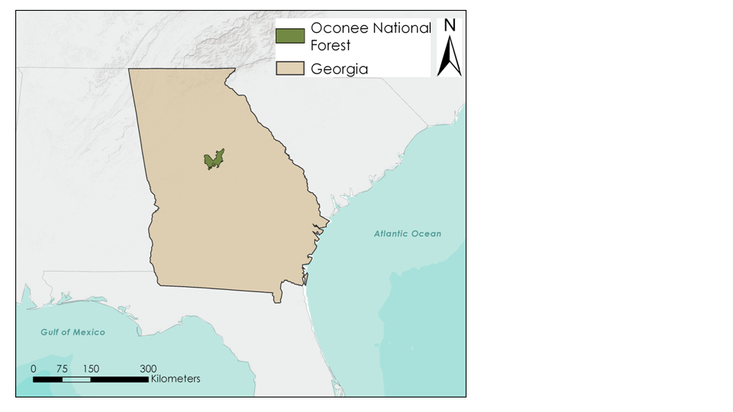

*Figure 1*. The study area included Oconee National Forest and the surrounding forested areas in central Georgia.

***2.2 Data Acquisition***

*2.2.1 Earth Observations*

In order to investigate the ability to detect canopy changes indicative of bark beetle outbreaks using remotely sensed data, we utilized NASA Earth observations Landsat 8 OLI imagery and European Space Agency (ESA) Sentinel-2A and 2B MSI imagery. Landsat 8 OLI has 30m spatial resolution for its reflectance bands and 16-day temporal resolution, while Sentinel-2 MSI data vary in spatial resolution from 10m to 60m, depending on the spectral band, with approximate temporal resolution of 5 days at the equator.

To analyze the utility of these data for identifying bark beetle outbreaks over varying timescales, we selected three intervals of time occurring within the recent period of high bark beetle outbreaks (Table 1). We manually acquired Landsat 8 OLI and Sentinel-2 MSI imagery for Path 18, Row 37 with ≤10% cloud coverage for the dates of interest. Level 2 Landsat 8 OLI data (Top of Atmospheric reflectance) were downloaded from the United States Geological Survey Earth Explorer and Sentinel-2 MSI pre-processed data was downloaded from ESA Open Access Copernicus Hub.

In order to contrast our map products with *ForWarn*-like maps, we created change maps for our dates of interest utilizing Global Inventory Modeling and Mapping Studies (GIMMS) Global Agricultural Monitoring (GLAM) 8-day composite NDVI data. To keep consistent with *ForWarn* processing protocols, we composited these 8-day NDVI values to 24-day NDVI values encompassing the date ranges of our imagery from Landsat 8 OLI and Sentinel-2 MSI.

Table 1. The three sets of comparisons analyzed to identify bark beetle disturbance using Earth observations and simulated *ForWarn* NDVI data.

|  |  |  |
| --- | --- | --- |
| **Annual Comparison: Spring 2016 to Spring 2017** | | |
| Source | Pre | Post |
| Landsat 8 OLI | April 16, 2016 | May 7, 2017 |
| Sentinel-2 MSI | May 7, 2016 | May 2, 2017 |
| GIMMS GLAM 8-day NDVI | April 22, 30, May 8, 2016 | May 1, 9, 17, 2017 |
| **Seasonal Comparison: Spring 2016 to Summer 2016** | | |
| Source | Pre | Post |
| Landsat 8 OLI | April 16, 2016 | June 21, 2016 |
| Sentinel-2 MSI | May 7, 2016 | June 16, 2016 |
| GIMMS GLAM 8-day NDVI | April 14, 22, 30, 2016 | June 1, 9, 17, 2016 |
| **Seasonal Comparison: Winter 2016 to Spring 2017** | | |
| Source | Pre | Post |
| Landsat 8 OLI | December 30, 2016 | March 4, 2017 |
| Sentinel-2 MSI | December 23, 2016 | March 3, 2017 |
| GIMMS GLAM 8-day NDVI | December 10, 18, 26, 2016 | February 10, 18, 26, 2017 |

2.2.2 Ancillary Datasets

Beetle outbreak locations recorded by state and federal agencies were used to validate our methodology. Oblique aerial photography tagged with geolocation information, provided by the US Forest Service, identified bark beetle outbreaks detected in September 2016. The Georgia Forestry Commission and the US Forest Service provided recorded geolocations of bark beetle spots within our study area detected in September 2017.

***2.3 Data Processing***

All images were clipped to a shapefile of our study area. In order to verify that areas of negative vegetation change were not due to clearcuts, barren land, water, or other geological oddities, we created a true color composite image for each date. For Landsat 8 OLI images, we composite stacked bands 1-7, and for Sentinel-2 MSI images we composite stacked all 10m bands (2, 3, 4, 8).

To isolate parts of our study area that could be impacted by bark beetles, we created a host mask consisting of coniferous forests and clipped our analyzed change maps to the mask. We performed an Isodata clustering unsupervised image classifications on a Sentinel-2 image for May 7, 2016 to develop the host mask identifying pine forest extent occurring prior to the outbreak. A 30-class classification was created and used to derive a four-class map, which included an evergreen forest type (Table 2).

*Table 2*. Input values of the ISO cluster unsupervised classification method for host map creation.

|  |  |
| --- | --- |
| Maximum Number of Classes | 30 |
| Maximum Number of Iterations | 50 |
| Maximum Number of Cluster Merges per Iterations | 5 |
| Maximum Merge Distance | 0.5 |
| Minimum Samples per Cluster | 20 |
| Skip Factor | 1 |
| Segmented Image (optional) | Left Blank |

***2.4 Data Analysis***

We calculated changes in vegetation indices over various time periods (Table 1) to determine if negative changes in these indices were correlated with bark beetle outbreaks, and then compare the change map products to each other and to our simulated *ForWarn* maps. We utilized two prevalent indices examined frequently in the context of forest pest outbreaks, NDVI and Normalized Difference Moisture Index (NDMI), and also experimented with an index, Inverted Red Edge Chlorophyll (IREC), that takes advantage of newly publicly available data sensed in the red edge region between red and near infrared wavelengths (Table 3).

*Table 3*. Vegetation indices used in this analysis. [NIR = Near Infrared band, R = Red band, SWIR = Shortwave Infrared band, X = Red Edge band sensing at X nm]

|  |  |  |
| --- | --- | --- |
| Vegetation Index | Formulation | Source |
| NDVI | (NIR - R) / (NIR + R) | Rouse et al. 1973 |
| NDMI | (NIR - SWIR) / (NIR + SWIR) | USGS, 2017 |
| IREC | ((783 - R) * 740) / 705 | Frampton et al. 2013 |

*2.4.1 NDVI*

NDVI is the most widely used vegetation index for many measurable variables (Frampton et. al, 2013). The NDVI ratio is determined by red wavelength and near infrared wavelengths, displaying values correlated with well-nourished vegetation (Frampton et. al,

2013). Negative changes in NDVI, which we expressed as a percent-change from historic to current imagery, effectively show a decline in vegetation health.

*2.4.2 NDMI*

We opted to use NDMI because of its demonstrated sensitivity to detect insect disturbances (Goodwin et al., 2008). The NDMI ratio is calculated utilizing the Near-Infrared (NIR) and Short Wave Infrared (SWIR) channels (Gao, 1996). The SWIR channel reflects change in vegetation water content and the mesophyll structure while the NIR reflectance is affected by leaf internal structure and leaf dry matter (Gao, 1996). The two channels remove variations brought on by leaf internal structure and leaf dry matter, allowing approximation of vegetation water content (Gao, 1996). By creating change maps utilizing NDMI and identifying areas with decreasing foliar moisture, we were able to detect areas of pine forest potentially impacted by bark beetles.

Because the study area was in extreme drought in the winter of 2016, the NDMI change for our early spring comparison required further processing to assess relevant changes (NDMC). We corrected the layer with a linear adjustment by excluding the ambient mean background change level; the mean ambient background change level was added to our percent change map to normalize the change due to drought and leaf senescence and allow for truly unusual levels of moisture stress in the foliage to be visualized. The Landsat 8 OLI and Sentinel-2 MSI imagery NDMI adjustments for this change map were +33.31 and -51.32, respectively. This linear adjustment resets the background changes to 0 to display as neutral change, allowing us to see the negative change due to factors of interest rather than the effects of the severe drought.

*2.4.3 IREC*

Red edge refers to the spectral region between red absorbance and the plateau of near infrared reflectance, ranging between wavelengths 680 -750nm. There is increasing interest in agricultural and natural sciences in using data sensed in the red edge region due to its ability to measure chlorophyll content, which is a direct indicator of plant health or stress (Dawson & Curran, 1998; Pinar & Curran, 1996). NDVI, though used routinely with success for forest disturbance monitoring, may not be the best option for detecting subtle changes in vegetation decline and is insensitive when measuring moderate to high chlorophyll concentrations, a region of particular interest when looking for early signs of stress (Eitel et al., 2011). Red edge indices address this limitation by having a high saturation threshold for Chl-ab levels (Eitel et. al., 2011). Using red edge vegetation indices is still relatively new due to the limited number of satellites with the appropriate sensors. Currently, Earth observing satellites equipped with these red edge sensors are the commercially available RapidEye (Brandenburg, Germany) and DigitalGlobe WorldView-2 (Longmont, CO, USA), and the publicly available Sentinel satellites developed by the European Space Agency (ESA).

To improve our ability to detect for early signs of beetle-induced forest impacts, we applied the red edge band data from Sentinel-2 MSI for through various spectral index formulas. Many of these red edge indices yielded noisy results but warrant further experimentation given the potential for earlier disturbance detection. The most promising red edge vegetation index we explored was the Inverted Red Edge Chlorophyll (IREC), an index shown to be highly effective in measuring canopy chlorophyll (Frampton et al. 2013).

*2.4.4 Data Validation*

To assess the accuracy of our derived change maps, we used all available 2016 damage points (n = 17) and randomly selected damage points from 2017 (n = 20) and checked for agreement with areas of negative change in our maps for each index. We also checked these areas against a true color composite map derived from Sentinel-2 imagery to make sure the area of negative change detected by the index was not a clearcut, man-made structure, water body, or other potentially misleading geological oddity. After creating and validating all of our change maps, we were able to conduct side-by-side comparisons to contrast the differences in resolution as well as the effectiveness and sensitivity of the various indices.

**3. Results**

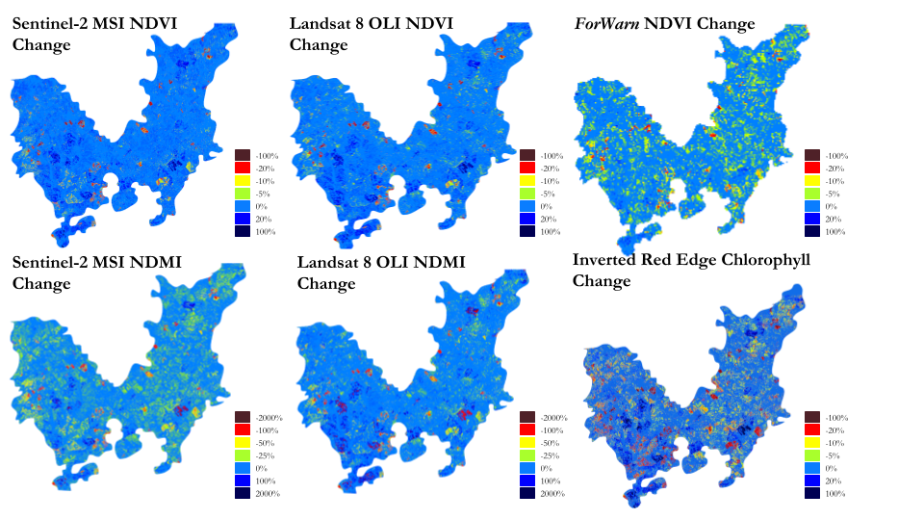

*Figure 2*. Maps showing annual change in indices from April/May 2016 to May 2017; non-evergreen forest areas of the map appear in the same blue color as no change values.

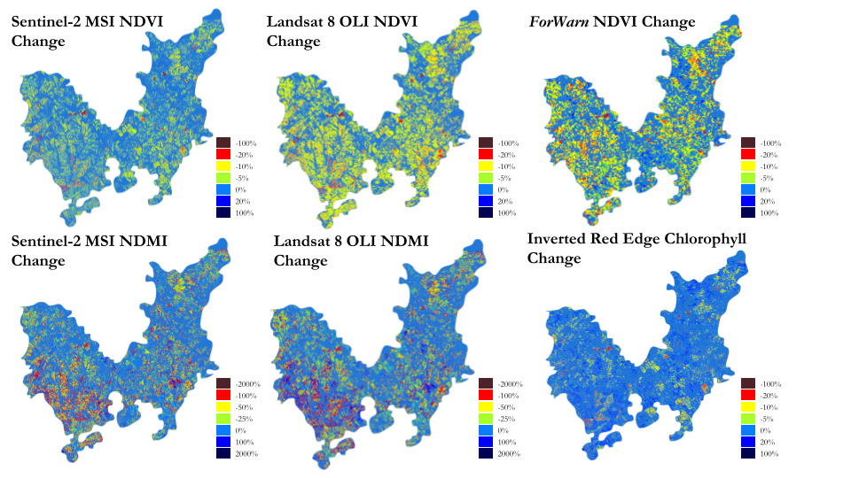

*Figure 3*. Maps showing winter/early spring changes in indices from December 2016 to March 2017; non-evergreen forest areas of the map appear in the same blue color as no change values.

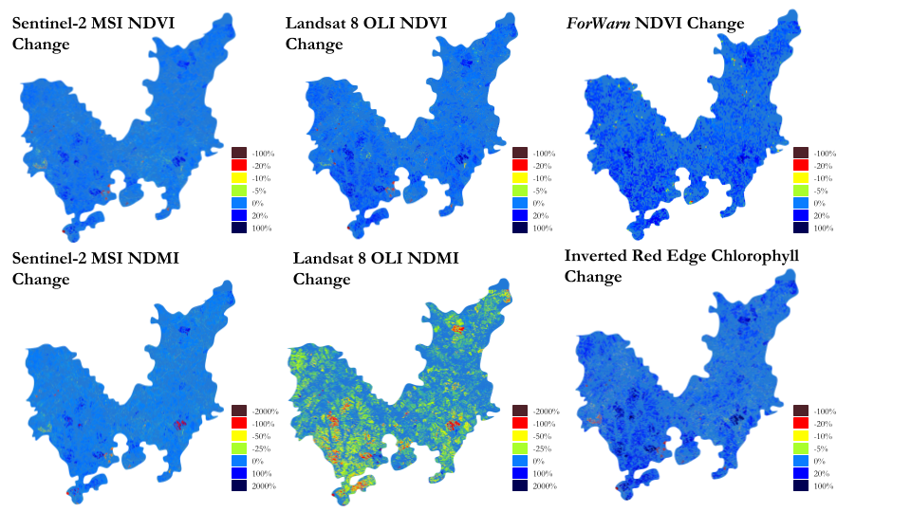

*Figure 4*. Maps showing spring to summer changes in indices from April/May 2016 to June 2016; non-evergreen forest areas of the map appear in the same blue color as no change values.

All of the change maps we produced and tested averaged about 70% agreement with the available *in situ* survey data. The simulated *ForWarn* maps showed the highest level of agreement with our validation methodology at 90-100%. Agreement between our verification data and maps derived from Landsat 8 OLI and Sentinel-2 MSI was consistently around 65-70%.

While a 232m MODIS pixel might display a negative NDVI change and correctly agree with the damage spot data, the 10-30m pixel images from Sentinel-2 MSI and Landsat 8 OLI show considerable more detail of the range of negative changes occurring within that area (Figure 2). In the quantitative analysis, the results from MODIS, Landsat 8 OLI and Sentinel-2 MSI are very similar because all show negative change within 1km of a damage spot location. However, the applicability of the various maps for land management usage are distinct. The detail provided by Landsat 8 OLI and Sentinel-2 MSI aids in pinpointing damage spots, making land management planning more feasible. Not only is a possible damage spot allocated to a much smaller area of land, but it also shows more information about the degree of damage. Whereas one MODIS pixel will display one value of percent change, Landsat 8 OLI and Sentinel-2 MSI change maps can show a range of light green, yellow and red within that area.

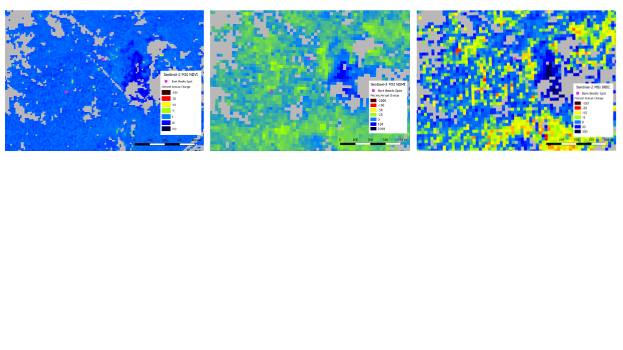

Figure 5. Closeup maps showing annual changes in indices sensed by Sentinel-2 MSI in annual change maps from May 2016 to May 2017; non-evergreen forest areas of the map appear in gray.

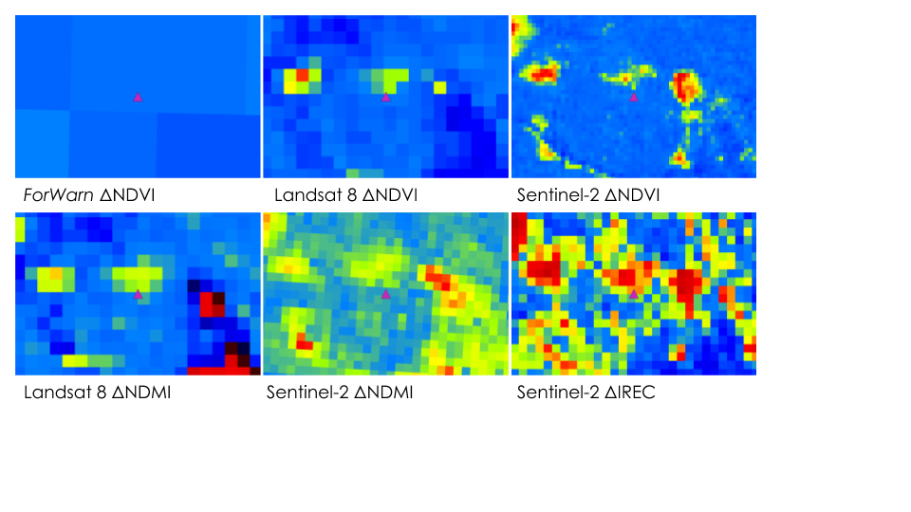

*Figure* 6. Zoomed images that show annual changes (April/May 2016 to May 2017) in the vicinity of two recorded beetle spot locations (pink triangle); non-evergreen forest areas of the map appear in the same blue color as no change values on this set of change maps, which are shown at a scale in which individual pixels can be observed.

**4. Discussion**

This study had several limitations that impeded our ability to come to decisive conclusions about the utility of these various indices for detecting bark beetle outbreaks early. The southeastern part of the U.S. has a temperate climate, which means frequent cloud cover can be a pervasive issue, especially during the growing season when beetle activity is likely to be detectable. The major issue in attempting to assess the accuracy of our methods is that the validation datasets contain locational errors. The points are recorded by human approximation from a moving plane and are typically not field-verified, so there is a lot of variability in proximity to the actual bark beetle spot. Also, annual damage surveys are typically conducted in September, which means there is often a mismatch in times when we have usable imagery and times in which bark beetle spots are recorded.

Nonetheless, the project showed some promising results, indicating a couple of alternative spectral indices that may be better for earlier detection of bark beetle damage to pine forests. Further testing of other narrow band spectral indices should be conducted with Sentinel-2 MSI data, including indices for detecting vegetation pigments other than chlorophyll that can be indicative of vegetation foliage decline. Also, this term focused work on one disturbance event predominantly from one kind of bark beetle (*Ips* spp.), which happened to be the more active beetle in the timeframe should be examined.

**5. Conclusions**

Higher resolution imagery from Landsat 8 OLI and Sentinel-2 MSI improves the ability to detect smaller patches of disturbed forest that would otherwise not be detected by MODIS 250m resolution data. Some of the indices we calculated, like NDMI and IREC, appeared to be more sensitive to changes in pine forest canopy condition, but all of the tested indices appeared to be conditionally useful. Further work is needed to investigate which of these products is most accurate for early detection of bark beetle attacks in pine forest, as well as for aiding land managers in mitigating bark beetle spots before they spread into adjacent forests.

The project assisted the US Forest Service in assessing promising methods for monitoring bark beetle induced forest disturbances at higher spatial resolutions than what is currently offered by the *ForWarn* system. The products from the project also aided further assessment of *ForWarn* products that were used for initially assessing forest damage from bark beetles and drought. Better tools for forest mortality detection from bark beetle attacks is potentially highly useful for aiding US Forest Service efforts to reduce wildfire hazards and disastrous impacts to our forest resources.

**6. Acknowledgments**

We thank: Farnaz Bayat for her wonderful efforts in facilitating meetings and editing project deliverables; our mentor, Bernard H. Eichold II, M.D., Dr.P.H. (Mobile County Health Department) for continuous support; our science advisors Joe Spruce (Science Systems & Applications, Inc) and Dr. Kenton Ross (NASA Langley Research Center) for their helpful input and technical guidance. We express appreciation to Dr. William “Bill” Hargrove (USDA, US Forest Service, Eastern Forest Environmental Threat Assessment Center), William “Bill” Christie (USDA, US Forest Service, Eastern Forest Environmental Threat Assessment Center) and Dr. Steven P. Norman (USDA, US Forest Service, Eastern Forest Environmental Threat Assessment Center) for their partnership on this project. Lastly, we would like to acknowledge and thank Micheal Torbett (Georgia Forestry Commission), Paul Merten (USDA, US Forest Service, Forest Health Protection, Southern Region), and Kenny Frick (USDA, US Forest Service Southern Research Station Benk Creek Experimental Forest) for the spatial points and aerial oblique photography used for verification and validation throughout the project.

This material contains modified Copernicus Sentinel data (2016-2017), processed by ESA.

The Moderate Resolution Imaging Spectroradiometer (MODIS) Normalized Difference Vegetation Index (NDVI) used in this study was processed and produced by the NASA/Goddard Space Flight Center’s Global Inventory Modeling and Mapping Studies (GIMMS) Group through funding support of the Global Agricultural Monitoring project by USDA’s Foreign Agricultural Service (FAS).

**7. References**

Billings, R. F. (2011). Aerial detection, ground evaluation, and monitoring of the southern pine beetle: state perspectives. In: Coulson, RN; Klepzig, KD 2011. Southern Pine Beetle II. Gen. Tech. Rep. SRS-140. Asheville, NC: US Department of Agriculture Forest Service, Southern Research Station. 245-261., 140, 245-261.

Coulson, R. N. (1979). Population dynamics of bark beetles. Annual Review of Entomology, 24(1), 417-447.

Coulson, R. N., and Klepzig, K. (2011). Southern pine beetle II. Gen. Tech. Rep. SRS-140. Asheville, NC: US Department of Agriculture Forest Service, Southern Research Station, 512 p., 140, 1-512.

Coops, N.C., Gillanders, S., Goodwin, N.R., Nelson, T., Nicholas, R.N. and Wulder, M.A. (2008). Estimation of Insect Infestation Dynamics Using a Temporal Sequence of Landsat Data. Remote Sensing of Environment, 9, 3680-3989.

Dawson T.P., and Curran P.J. (1998). A new technique for interpolating the reflectance red edge position. Int J Remote Sensing, 19, 2133-9

Eitel, J. U., Vierling, L. A., Litvak, M. E., Long, D. S., Schulthess, U., Ager, A. A., ... and Stoscheck, L. (2011). Broadband, red-edge information from satellites improves early stress detection in a New Mexico conifer woodland. Remote Sensing of Environment, 115(12), 3640-3646.

European Space Agency. (2015). Sentinel-2 Data (Version 1.0). Geoscience Australia. https://doi.org/10.4225/25/566a407cd2e2b

Frampton, W. J., Dash, J., Watmough, G., and Milton, E. J. (2013). Evaluating the capabilities of Sentinel-2 for quantitative estimation of biophysical variables in vegetation. ISPRS journal of photogrammetry and remote sensing, 82, 83-92.

Franceschi, V. R., Krokene, P., Christiansen, E., and Krekling, T. (2005). Anatomical and chemical defenses of conifer bark against bark beetles and other pests. New phytologist, 167(2), 353-376.

Gao, B.C. (1996). NDWI: A normalized difference water index for remote sensing of vegetation liquid water from space. Remote Sensing of Environment, 58: 257-266.

Goodwin, N.R., Coops, N.C., Wulder, M.A., Gillanders, S., Schroeder, T.A., Nelson, T. (2008). Estimation of insect infestation dynamics using a temporal sequence of Landsat data. Remote Sensing of Environment, 112, 3680-3689.

Harrington, T. B., and Bluhm, A. A. (2001). Tree regeneration responses to microsite characteristics following a severe tornado in the Georgia Piedmont, USA. Forest Ecology and Management, 140(2-3), 265-275.

Hodges, J. D., Elam, W. W., Watson, W. F., and Nebeker, T. E. (1979). Oleoresin characteristics and susceptibility of four southern pines to southern pine beetle (Coleoptera: Scolytidae) attacks. The Canadian Entomologist, 111(8), 889-896.

Lorio Jr, P. L. (1986). Growth-differentiation balance: a basis for understanding southern pine beetle-tree interactions. Forest Ecology and Management, 14(4), 259-273.

Meddens, A. J., Hicke, J. A., Vierling, L. A., and Hudak, A. T. (2013). Evaluating methods to detect bark beetle-caused tree mortality using single-date and multi-date Landsat imagery. Remote Sensing of Environment, 132, 49-58.

NDMC, USDA, NOAA. U.S. Drought Monitor. http://droughtmonitor.unl.edu/

Norman, S. P., Hargrove, W. W., Spruce, J. P., Christie, W. M., and Schroeder, S. W. (2013). Highlights of satellite-based forest change recognition and tracking using the ForWarn System. Gen. Tech. Rep. SRS-GTR-180. Asheville, NC: USDA-Forest Service, Southern Research Station. 30 p., 180, 1-30.

Oswalt, S. N., Smith, W. B., Miles, P. D., and Pugh, S. A. (2014). Forest Resources of the United States, 2012: a technical document supporting the Forest Service 2010 update of the RPA Assessment. Gen. Tech. Rep. WO-91. Washington, DC: US Department of Agriculture, Forest Service, Washington Office. 218 p., 91.

Pinar, A., and Curran, P.J. (1996). Grass chlorophyll and the reflectance red edge. Int J Remote Sensing, 19, 351-7.

Pye, J. M., Holmes, T. P., Prestemon, J. P., and Wear, D. N. (2011). Economic impacts of the southern pine beetle. Southern pine beetle II, 213-222.

Rouse, J.W., Haas, R.H., Schell, J.A., Deering, W.D. (1973). Monitoring vegetation systems in the Great Plains with ERTS. In: Third ERTS Symposium, NASA SP-351, 309–317.

Tchakerian, M. D., and Coulson, R. N. (2011). Ecological impacts of southern pine beetle. In: Coulson, RN; Klepzig, KD 2011. Southern Pine Beetle II. Gen. Tech. Rep. SRS-140. Asheville, NC: US Department of Agriculture Forest Service, Southern Research Station. 223-234., 140, 223-234.

USDA Forest Service. (2017). Major Forest Insect and Disease Conditions in the United States: 2015. Forest Health Protection, Washington D.C.

USDA FAS. GLAM-Global Agricultural Monitoring [Data set]. https://glam1.gsfc.nasa.gov/

USGS Product Guide. https://landsat.usgs.gov/sites/default/files/documents/si_product_guide.pdf

US Geological Survey Earth Resources Observation and Science Center. (2014). Provisional Landsat OLI Surface Reflectance [Data set]. US Geological Survey. https://dx.doi.org/10.5066/F78S4MZJ

Waring, R. H., and Pitman, G. B. (1985). Modifying lodgepole pine stands to change susceptibility to mountain pine beetle attack. Ecology, 66(3), 889-897.

Wear, D. N. (1996). Forest management and timber production in the US South [Document prepared for Canada/United States lumber consultations]. SCFER Working Paper 82. Research Triangle Park, NC: Southeastern Center for Forest Economics Research. 40.

**8. Supplemental Materials**

*Table S1*. Earth observations used in this analysis.

|  |  |  |
| --- | --- | --- |
| Satellite Sensor/Data | Date | Source |
| Landsat 8 OLI | April 16, 2016 | USGS Earth Explorer |
| Landsat 8 OLI | June 21, 2016 | USGS Earth Explorer |
| Landsat 8 OLI | December 30, 2016 | USGS Earth Explorer |
| Landsat 8 OLI | March 4, 2017 | USGS Earth Explorer |
| Landsat 8 OLI | May 7, 2017 | USGS Earth Explorer |
| Sentinel-2A | May 7, 2016 | Copernicus Open Access Hub |
| Sentinel-2A | June 16, 2016 | Copernicus Open Access Hub |
| Sentinel-2A | December 23, 2016 | Copernicus Open Access Hub |
| Sentinel-2A | March 3, 2017 | Copernicus Open Access Hub |
| Sentinel-2A | May 2, 2017 | Copernicus Open Access Hub |
| MODIS 8-day NDVI | April 14, 2016 | GIMMS Global Agricultural Monitoring System |
| MODIS 8-day NDVI | April 22, 2016 | GIMMS Global Agricultural Monitoring System |
| MODIS 8-day NDVI | April 30, 2016 | GIMMS Global Agricultural Monitoring System |
| MODIS 8-day NDVI | May 8, 2016 | GIMMS Global Agricultural Monitoring System |
| MODIS 8-day NDVI | June 1, 2016 | GIMMS Global Agricultural Monitoring System |
| MODIS 8-day NDVI | June 9, 2016 | GIMMS Global Agricultural Monitoring System |
| MODIS 8-day NDVI | June 17, 2016 | GIMMS Global Agricultural Monitoring System |
| MODIS 8-day NDVI | December 10, 2016 | GIMMS Global Agricultural Monitoring System |
| MODIS 8-day NDVI | December 18, 2016 | GIMMS Global Agricultural Monitoring System |
| MODIS 8-day NDVI | December 26, 2016 | GIMMS Global Agricultural Monitoring System |
| MODIS 8-day NDVI | February 10, 2017 | GIMMS Global Agricultural Monitoring System |
| MODIS 8-day NDVI | February 18, 2017 | GIMMS Global Agricultural Monitoring System |
| MODIS 8-day NDVI | February 26, 2017 | GIMMS Global Agricultural Monitoring System |
| MODIS 8-day NDVI | May 1, 2017 | GIMMS Global Agricultural Monitoring System |
| MODIS 8-day NDVI | May 9, 2017 | GIMMS Global Agricultural Monitoring System |
| MODIS 8-day NDVI | May 17, 2017 | GIMMS Global Agricultural Monitoring System |