**NASA DEVELOP National Program**



USGS at Colorado State University

*Summer 2016*

Rocky Mountain Agriculture

Utilizing NASA Earth Observations to Reconstruct and Identify Historical Forest Disturbances in the Southern Rocky Mountains for Enhanced Forest Management

 **Technical Report**

Final Draft – Aug 11, 2016

Peder Engelstad (Project Lead)

Christopher Beddow

Stephanie Krail

Amandeep Vashisht

Dr. Paul Evangelista, Colorado State University Natural Resource Ecology Laboratory (Science Advisor)

Tony Vorster, Colorado State University Natural Resource Ecology Laboratory (Mentor)

Brian Woodward, NASA DEVELOP USGS at Colorado State University (Center Lead)

# 1. Abstract

In recent decades, the Rocky Mountains of northern Colorado and southern Wyoming have experienced extremely high levels of forest disturbance. Methodologies for mapping and labeling disturbance and classifying historical harvest events on the landscape level have not been readily available in the past. However, recent literature has paved the way for refined approaches, such as change detection software and predictive classification models. This project provided a more complete dataset for the National Park Service Rocky Mountain National Park (RMNP), the Colorado Forest Restoration Institute (CFRI), and the Bioenergy Alliance Network of the Rockies (BANR) Feedstock Supply Team. Landsat 4 and 5 Thematic Mapper (TM), Landsat 7 Enhanced Thematic Mapper Plus (ETM+), and Landsat 8 Operational Land Imager (OLI) imagery were integrated into the LandTrendr algorithm to detect magnitude, duration, and extent of past forest disturbances. A suite of classification algorithms, including the Boosted Regression Trees (BRT) and the Random Forests (RF) classification models, were used to conduct analyses at the landscape level across a temporal scale of over 30 years. A labeled forest disturbance history was provided to project partners, which filled gaps in their past records and led to enhanced decision-making in the future.

**Keywords**

Timber Harvest, Landsat, Supervised Classification, Software for Assisted Habitat Modeling, LandTrendr, Remote Sensing

# 2. Introduction

* 1. ***Background Information***

The state of Colorado contains over 98,000 km2 of forest, comprised mostly of coniferous species, including ponderosa pine (*Pinus ponderosa)*, lodgepole pine (*Pinus contorta)*, engelmann spruce (*Picea emgelmannii*), blue spruce (*Picea pungens*), Douglas-fir (*Pseudotsuga menziesii*), subalpine fir (*Abies lasiocarpa*), and white fir (*Abies concolor*) (Binkley and Duncan, 2009). In recent decades, the region has experienced an increase in forest disturbance, mandating a more adaptive approach to forest management techniques. Many of these disturbances stem from extreme weather events, changing climate, and ecological issues, while others are direct human actions, such as timber harvest (Shinneman et al., 2000). Forest composition has also rapidly changed in recent decades, as the standard growing stock of wood has expanded and environmental issues related to forest health have increasingly become a concern (Binkley and Duncan, 2009).

Current monitoring of forest disturbances relies heavily on field data gathered by land managers during forest treatment events and an annual aerial forest health survey conducted by the Colorado State Forest Service (CSFS). The aerial survey data collection involves trained observers gathering information on land cover changes using small fixed-wing aircraft. These data are then mapped and classified to record location, intensity, and type of disturbance. The field data are incomplete for the study period of this project due to inconsistencies and inaccuracies of the data, which do not provide an accurate portrayal of disturbance history on a landscape scale (Ciesla, 2016). Additional difficulties with current methodologies include the expenditure of time and financial resources to complete the field work.

The project’s study area covers 21,927 km2 of forests throughout northern Colorado and southern Wyoming with an elevation range of 1,478 to 4,351 m (Figure 1). The study period encompasses June 1983 to August 2015. Public lands included in the area are State and National Forest lands as well as the National Park Service Rocky Mountain National Park (RMNP).

* 1. ***Project Partners & Objectives***

The Rocky Mountain Agriculture team collaborated with a variety of project partners, including RMNP, the Colorado Forest Restoration Institute (CFRI), and the Bioenergy Alliance Network of the Rockies (BANR) Feedstock Supply Team. Partner interactions indicated that historical records of forest disturbances are incomplete, inconsistently collected, or non-existent. Rocky Mountain National Park’s involvement stemmed from an interest in identifying a variety of disturbances within the park’s administrative boundaries. Our second partner, CFRI informs federal, state, and local entities on land management and fire reduction techniques. While their decision making process currently relies on field and historical data, they seek to better understand land cover change to restore healthy forest conditions at a landscape scale. Our third partner, BANR, works to quantify forest biomass to evaluate the possibility of using this live and dead biomass as a fuel source.

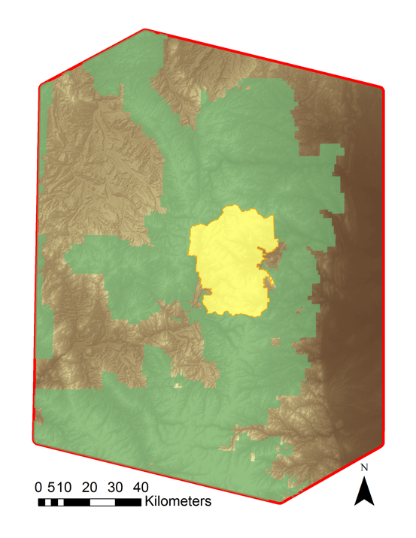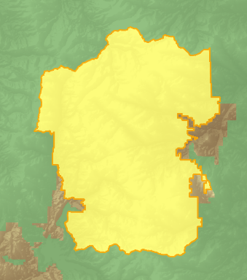

Rocky

Mountain

National

Park

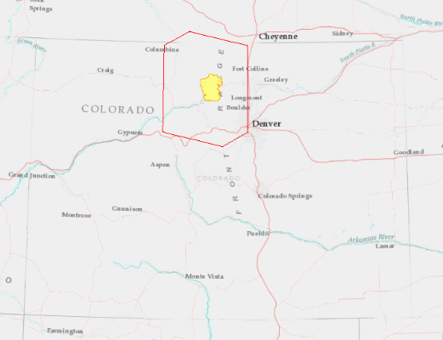

Study Area Boundary

Rocky Mountain National Park

National Forest Lands

Figure 1: Rocky Mountain Agriculture study area map and inset map highlighting the National Park Service Rocky Mountain National Park

To address partner needs, the Rocky Mountain Agriculture team modeled and characterized clearcut harvests at the landscape-scale over a 30-year Landsat time series, identified a variety of fine-scale forest disturbances within RMNP, and evaluated the feasibility of identifying forest thinning treatments at the landscape-scale.

# 3. Methodology

***3.1 Data Acquisition***

Landsat 4 and 5 Thematic Mapper (TM), Landsat 7 Enhanced Thematic Mapper plus (ETM+), and Landsat 8 Operational Land Imager (OLI) Level-1 imagery from 1983-2015 was acquired for Path 34, Row 32 from United States Geological Survey (USGS) EarthExplorer portal (Table 1). After identifying imagery with less than 50% cloud-cover that was captured between June and August, surface reflectance (SR) and cloud mask products as well as Normalized Difference Vegetation Index (NDVI) and Normalized Burn Ratio (NBR) indices were downloaded from the USGS Earth Resources Observation and Science (EROS) Center Science Processing Architecture (ESPA) interface using bulk ordering.

Digital Elevation Model (DEM) data from the Shuttle Radar Topography Mission (SRTM) were acquired through the USGS EarthExplorer portal (Table 1). These topographic data were processed at a 30 m resolution to be consistent with Landsat imagery spatial resolution.

Table 1: NASA Earth observations platforms, respective data products, spatial resolution, and number of images utilized

|  |  |  |
| --- | --- | --- |
| **Platforms & Sensors** | **Products** | **Number of Images** |
| Landsat 4 TM | Surface Reflectance | 13 |
| Landsat 5 TM | Surface Reflectance | 57 |
| Landsat 7 ETM+ | Surface Reflectance | 72 |
| Landsat 8 OLI | Surface Reflectance | 18 |
| SRTM | Digital Elevation Model | N/A |

Ancillary data were collected from several different sources (*See appendix A*). Forest management data (vegetation and fuel treatments) were downloaded from Landscape Fire and Resource Management Planning Tools (LANDFIRE), an aggregate database from federal, state, and private environmental data sources (LANDFIRE, 2010). Other land disturbance records were acquired from the CSFS, RMNP, and BANR. Records of USDA Forest Service (USFS) roads were acquired from OpenStreetMap. Data regarding land management and ownership were obtained from the Bureau of Land Management (BLM) geospatial databases for Colorado and Wyoming.

***3.2 Data Processing***

LandsatLinkr (LLR), an automated system executed in RStudio, was utilized to preprocess the Landsat 4 and 5 TM, Landsat 7 ETM+, and Landsat 8 OLI imagery (Braaten, 2015). LLR created cloud masked images, calibrated imagery from different sensors, and calculated Tasseled cap (tcap) indices.

Preprocessed imagery was input into LandTrendr, an advanced environmental modeling algorithm that analyzes spectral changes in pixels across years and classifies the instances of greatest disturbances according to year, magnitude, and duration of disturbance (Figure 2) (Kennedy et al., 2010).

For topographic indices, the DEM was utilized to calculate slope and aspect of the study area. Additionally, a Compound Topographic Index (CTI) was generated using Geomorphometric and Gradient Metrics Toolbox for ArcGIS (Evans, 2014). The projection utilized for all processing and analysis was World Geodetic System (WGS) 1984 Zone 13 N.

Ancillary data containing forest management records were compiled from LANDFIRE, CSFS, RMNP, and BANR. Forest management data were visually inspected, and validation was conducted using Google Earth Pro imagery at varying spatial resolutions by overlaying forest management polygons.

Accurately classified clearcut harvest polygons were buffered 30 m on the interior to ensure Landsat pixels represented an exclusively clearcut harvest area and served as an input for modeling land cover changes. A spatially-balanced sampling technique was utilized to generate training points from the buffered clearcut harvest polygons. Generated points were visually inspected against NAIP imagery to verify the points. A net total of 1,650 training points indicating presence of clearcut harvest polygons were chosen as inputs for the classification models.

***3.3 Data Analysis***

Duration

Magnitude

Time (Years)

Vegetation

Condition (Index)

Figure 2: Spectral trajectory of a pixel within LandTrendr (adapted from Kennedy et al., 2010)

Stability

Change

Recovery

Pre-Event

Vertex Value

Model runs were performed using the USGS Software for Assisted Habitat Modeling (SAHM) module package for VisTrails, an open-source provenance management and scientific workflow system (Morisette et al., 2013).  Modules in SAHM were divided into five main components: input data, preprocessing, preliminary model analysis, correlative models, and outputs. Training data were inputted as a comma separated file with x and y coordinates and a binary presence indicator of 1. A raster of our study area (with specified projection, spatial extent, and resolution) was used as the template layer. Model covariate inputs were magnitude of disturbance based on tcap wetness, duration of disturbance, pre-event vertex values (Figure 2), elevation, slope, aspect, CTI, and distance to roads. Model runs utilized five classification models: Random Forest (RF), Multivariate Adaptive Regression Spline (MARS), Generalized Linear Model (GLM), Boosted Regression Trees (BRT), and Maximum Entropy (MaxEnt) classification models.

Cross-validation and evaluation metrics for each model were compared to choose the best model for our study area. For cross-validation, the data set was divided into 10 equal folds and the models withheld a different subset for each run, thus minimizing spurious results due to a single random selection (Jarnevich et al., 2015). Performance metrics included Area Under Curve (AUC) and confusion matrix statistics. Multiple evaluations were used to assess model performance rather than relying on a single statistic to allow for a better overall model evaluation (Jarnevich et al., 2015). Additional statistics analyzed included Cohen’s Kappa, True Skill Statistic (TSS), sensitivity, specificity, and percent correctly classified.

Final outputs were refined by filtering out disturbances that were less than 11 pixels in size due to disturbance patch size characterization found in similar research (Kennedy et al., 2010). Summary statistics were calculated from these refined outputs.

To obtain Rocky Mountain National Park specific data, LandTrendr results were clipped to the park’s administrative boundaries. Disturbance patches were converted into polygons where the dominant disturbance year and average magnitude of disturbance were then calculated.

# 4. Results & Discussion

***4.1 Analysis of Results***

Through visual analysis of the original harvest data, we confirmed that of the existing data 75.45% of the clearcut harvest data from LANDFIRE was accurate whereas 52.54% of the CSFS harvest data was accurate.

Table 2: BRT model statistics for the training and cross-validation datasets

Importance

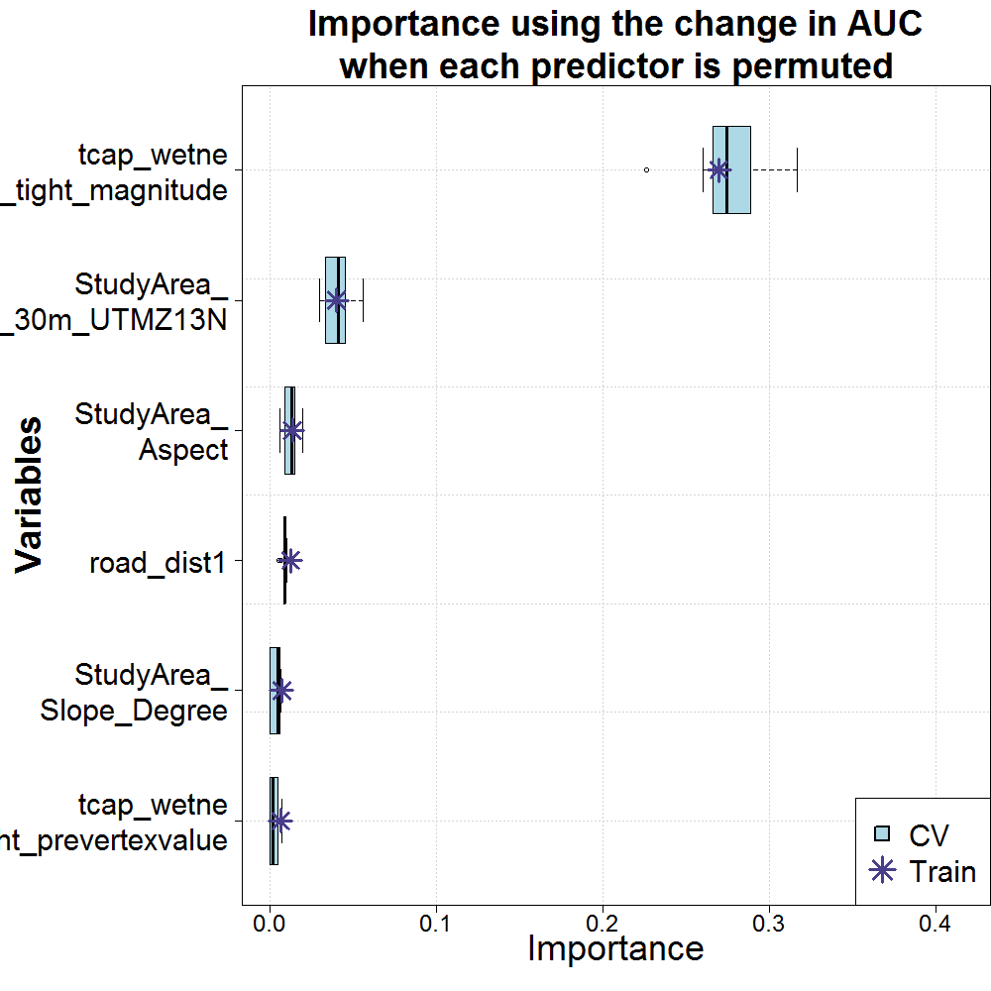

Magnitude

Variables

0.0

0.1

0.2

0.3

0.4

Figure 4: Variable importance for BRT model run

Elevation

Aspect

Distance to Roads

Slope

Pre-Event

Vertex Value

Sensitivity (True Positive)

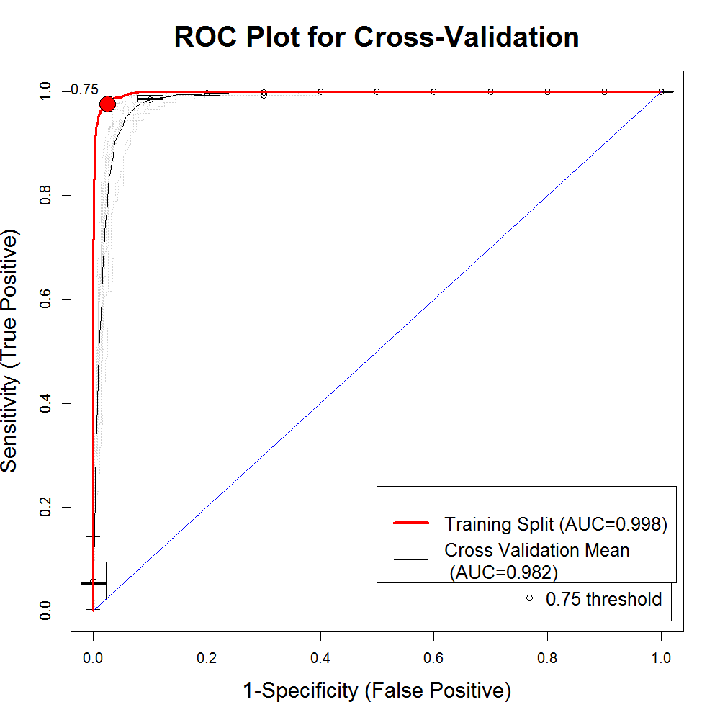

Figure 3: Response Operating Characteristic (ROC) curve for BRT model run

1.0

0.8

0.6

0.4

0.2

0.0

1-Specificity (False Positive)

0.0

0.2

0.4

0.6

0.8

1.0

|  |  |  |
| --- | --- | --- |
| **Evaluation Statistic** | **Training Dataset** | **Cross-Validation Dataset** |
| AUC | 0.998 | 0.982 |
| Cohen’s Kappa | 0.933 | 0.861 |
| True-Skill Statistic | 0.951 | 0.886 |
| Sensitivity | 0.977 | 0.933 |
| Specificity | 0.975 | 0.953 |
| **Percent Correctly Classified** | **97.5** | **94.8** |

Each classification model within the SAHM analysis produced a corresponding binary output map, indicating the presence of clearcut harvests within the study area based on training points. These outputs indicated that the classification models performed reasonably well. Overall, the BRT model performed the best (Table 2).

BRT’s AUC value for training and cross-validation dataset were between 0.9 and 1, which is considered highly accurate (Table 2) (Swets, 1988; Greiner et al., 2000). While the statistics for cross-validation are not as high as those for training, this is expected when partitioning the original dataset for training and testing the model. Since the sensitivity and specificity on the Receiver Operating Characteristic (ROC) curve are well above the diagonal line, the model fit is satisfactory (Figure 3) (Talbert and Talbert, 2001).

The most important predictive covariates were found to be magnitude of disturbance (derived from changes in tcap wetness) and elevation (Figure 4). Although aspect, slope, and distance to roads were less important predictor variables, adding them to the model improved our results.

***4.2 Summary & Discussion***

*Clearcut Harvest Summary*

In analyzing the clearcut harvest data (Figure 5), we observed that over half (55.8%) of all harvests have occurred since 2005. The last decade saw an average of 4.59 km2 harvest area per year, a 130% increase over the 1985-2004 average of 1.99 km2 of harvest per year (Figure 6). The close association of rising clearcut harvest activity and recent increases in biological disturbance events, i.e. mountain pine beetle outbreaks, over the same time period aligns with our project partner concerns to salvage the beetle-killed wood.

Figure 5: Clearcut harvest map for the study area (left) with close-up views displaying harvests (right)

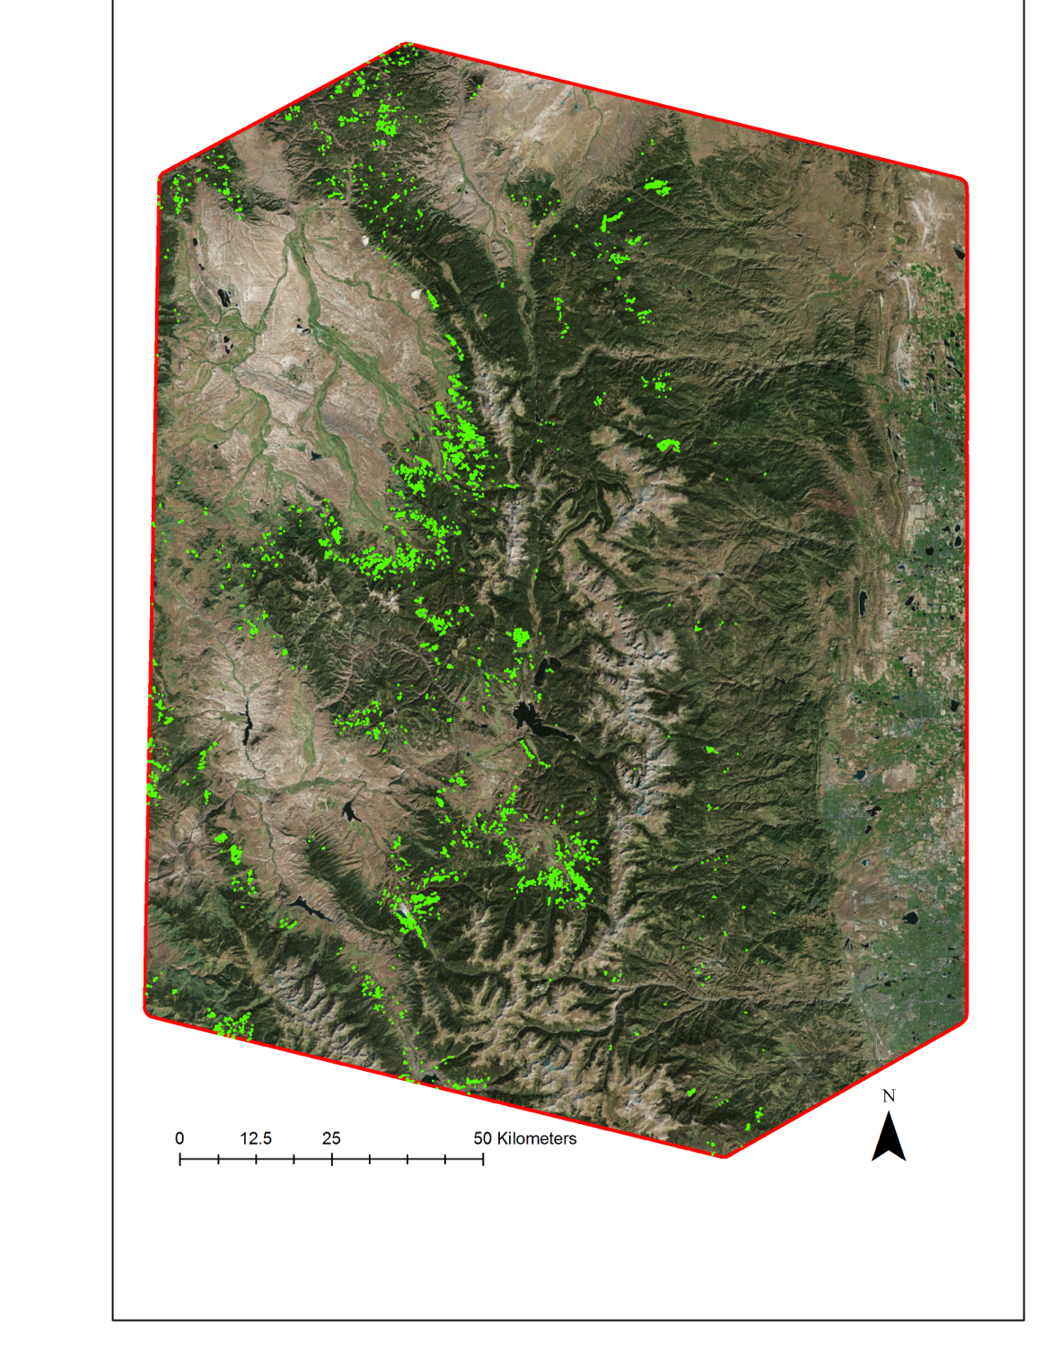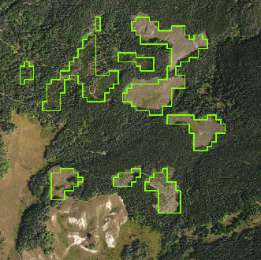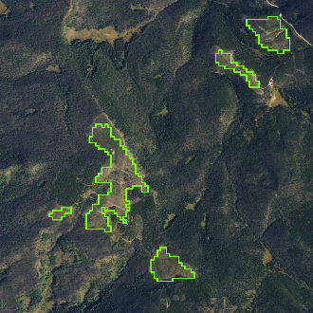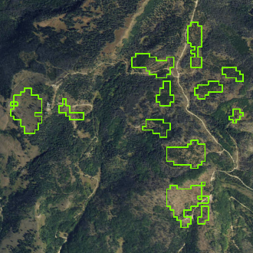

Study Area Boundary

Clearcut Harvest Polygons

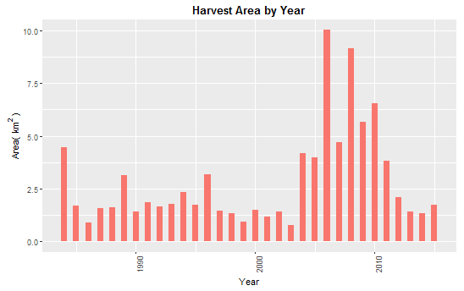

10.0

7.5

5.0

2.5

0.0.0

Area (km2)

1990

2000

2010

Year

Figure 6: Sum total of clearcut harvest area by year for the study area

Clearcut harvest data showed an elevation range between 2611 and 3126 m, with the highest frequency of clearcut harvests at elevations from 2750 to 2850 m. Lodgepole pine, which thrives in this elevation zone, has been clearcut harvested in response to the species being affected by the mountain pine beetle outbreak (Kauffman et. al., 2008). Clearcut harvesting in this elevation range mimics the characteristics of a stand-replacing fire, which creates an ideal environment for lodgepole pine to regenerate (Lotan and Perry, 1983).

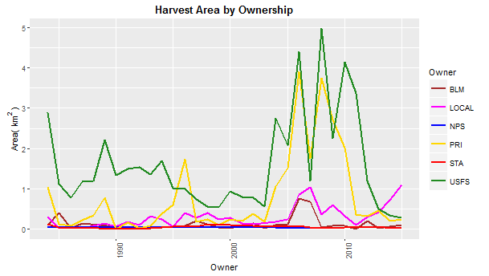

5

4

3

2

1

0

Area (km2)

1990

2000

2010

Owner



BLM

Local Govt

NPS

Private

State

USFS

Figure 7: Annual variation in clearcut harvest area for each category of ownership

The majority of clearcut harvests occurred at low-to-moderate slopes of 6 to 10 degrees. Overall, clearcut harvesting is unlikely in areas of extreme elevation and slope due to forest species composition, tree line, and equipment constraints. We found that the median distance of harvests from roads was 86.97 m (Appendix C). Overall, more than half of all harvests occurred less than 100 m from a road, underscoring the importance of road access. Many forest roads visible in satellite imagery were not present in the distance to roads dataset, which suggests that harvest polygons may often fall even closer to roads than our data suggests. Finally, 28% of the clearcut harvest events occurred on private land, with the remaining 72% on public lands. The majority of harvests (56.65%) were found on USFS-managed lands (Figure 7).

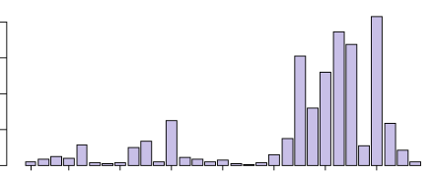

1985

1988

1992

1996

2000

2004

2008

2012

Year

20

15

10

5

0

Area (km2)

Figure 8: Sum total of disturbance area by year for Rocky Mountain National Park

*RMNP as a Case Study*

RMNP only contains a small fraction of our study area’s clearcut harvest model outputs (0.18 km2) (Figure 6). Harvesting was completed due to special circumstances such as campground development and helicopter landing areas. However, the park features a wide variety of other forest disturbances over the 30-year study period that total 133 km2 of the park’s 1075 km2 (Figure 8). These disturbances can be split into specific events throughout the park and can be visualized according to magnitude, year, and extent (Figure 9; Appendix B). The individual disturbance patches of highest magnitude occurred in 2010, 2012, and 2013. These years appear to correspond with events such as the Cow Creek Fire (2010), the Fern Lake Fire (2012), and ongoing beetle epidemics (Ciesla et al., 2016).

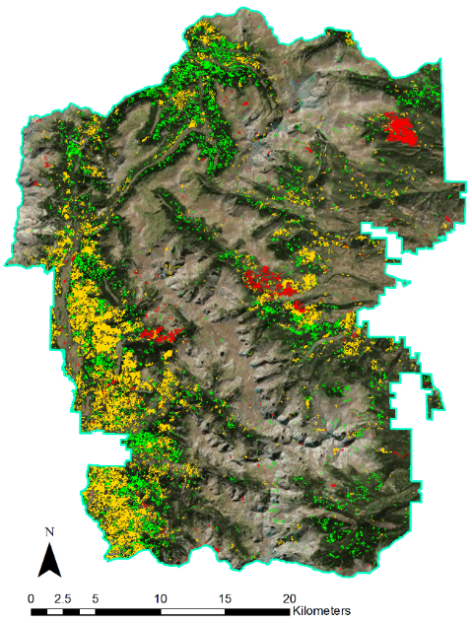

RMNP

Low Magnitude

Medium Magnitude

High Magnitude

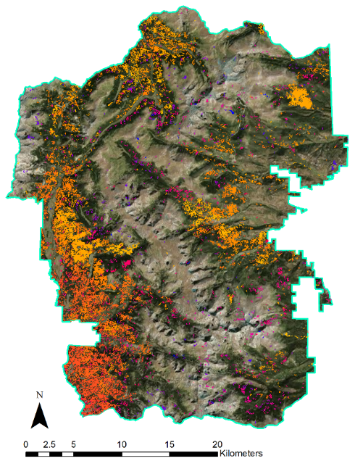

1985

2015

RMNP

Figure 9: Rocky Mountain National Park disturbances maps, indicating year of disturbance (left) and categorized magnitude of disturbance (right)

In RMNP, disturbance events ranged in elevation from 2344 to 4174 m, with the average elevation at 3051 m (Appendix D). However, compared to most clearcut harvest events, disturbances in RMNP exhibited a broad range of slope and aspect values. These variations indicated a wide variety of disturbance drivers, landscape variability, and park-specific forest management practices and goals.

***4.3 Errors, Uncertainties, and Understanding Data in Context***

The Landtrendr algorithm calculates deviations in the spectral signatures of pixels from each year on the basis of adjacent years’ values. In utilizing a study period of 1983-2015, the change detection for the first (1983) and last year (2015) is “more difficult to judge than deviations in all other years” (Kennedy, et al. 2010). To address this, the team dropped the first year of data from the refined model outputs and data summarizations, but chose to keep the last year as preliminary data.

Uncertainty also originated from the type of training data points used within SAHM. Potential errors could have stemmed from presence points not representing all spectral, geographical, and environmental conditions within our study area. Utilizing pseudo-absence points instead of true-absence points may also have affected the accuracy of the outputs. Pseudo-absence points can be affected by geographic and/or environmental sampling bias if they do not mimic sampling bias in the presence data (Jarnevich et al., 2015). We used several images spread over a period of one to three months within a year, which may have produced false indications of disturbances in the outputs due to small phenological variations within a year being detected as change.

One of the team’s objectives was to assess the feasibility of applying the clearcut harvest modeling methodology to forest thinning events. We found that it was not feasible to map thinning events in this area without authoritative datasets. The records obtained by the team were inconsistently labeled, lacked information about the prescription, and had unreliable boundaries. Additionally, thinning events were often treated as a single prescription, but the amount of overstory removed is typically heterogeneous within a treatment. Thinning events occur in varying magnitudes, and lower severity thinning events are not always discernible from aerial and/or satellite imagery.

***4.4 Future Work***

One natural expansion of this project would involve modeling other forested areas in the Rocky Mountains. This could help build a more complete picture of the disturbance history across the region and continue to aid forest and land managers. Additionally, the project’s methodology could be applied to historical disturbance events outside the context of those presented here. For example, attempts could be made to classify large-scale atmospheric phenomena, such as tornados, flood events, and hurricanes. These data could be of value to a variety of stakeholders including disaster forecasters, city planners, and the agricultural industry. Finally, ground-level validation of model outputs is highly recommended going forward. Additional data from field surveys, particularly in thinned areas, would continue to improve the confidence in disturbance classification types and overall model accuracy.

# 5. Conclusions

Our team successfully utilized LandTrendr outputs to model and characterize clearcut harvest in the Rocky Mountains of Colorado and Wyoming. More subtle disturbance types were identified and mapped within RMNP by comparing raw outputs, existing records, and visual interpretation. These products will inform state and federal land managers’ decision making processes by addressing crucial knowledge gaps over the last 30 years. The team also effectively assessed the feasibility of identifying forest thinning events using remote sensing and concluded that a more authoritative dataset and further research is needed.

# 6. Acknowledgments

Dr. Paul Evangelista (Colorado State University Natural Resource Ecology Laboratory)

Tony Vorster (Colorado State University Natural Resource Ecology Laboratory)

Brian Woodward (Colorado State University Natural Resource Ecology Laboratory)

Dr. Tony Cheng (Colorado Forest Restoration Institute)

Michael Caggiano (Colorado Forest Restoration Institute)

Hanem Abouelezz (National Park Service Rocky Mountain National Park)

Ryan Anderson (Bioenergy Alliance Network of the Rockies, Feedstock Supply Team)

Geoffrey Clark (National Park Service Rocky Mountain National Park)

Dave Frey (National Park Service Rocky Mountain National Park)

Dr. Catherine Jarnevich (United States Geological Survey Fort Collins Science Center)

Justin Braaten (Oregon State University, Laboratory for Applications of Remote Sensing in Ecology)

Any opinions, findings, and conclusions or recommendations expressed in this material are those of the author(s) and do not necessarily reflect the views of the National Aeronautics and Space Administration.

This material is based upon work supported by NASA through contract NNL11AA00B and cooperative agreement NNX14AB60A.

# 7. References

Binkley, D., & Duncan, S. L. (2009). The past and future of Colorado’s forests: connecting people and ecology. *Ecology and Society*, *14*(2).

Braaten, J. (2015). LandsatLinkr 0.1.4 User Guide.

Ciesla, W. M. (2016). *2015 Report on the Health of Colorado’s Forests*. Colorado State Forest Service. Retrieved from <https://csfs.colostate.edu/media/sites/22/2016/02/ForestHealthReport-2015.pdf>

Evans JS, Oakleaf J, Cushman SA, Theobald D (2014). An ArcGIS Toolbox for Surface Gradient and Geomorphometric Modeling, version 2.0-0. Available: <http://evansmurphy.wix.com/evansspatial> Accessed: 2015 Dec 2nd.

Greiner, M., Pfeiffer, D., & Smith, R. D. (2000). Principles and practical application of the receiver-operating characteristic analysis for diagnostic tests. *Preventive Veterinary Medicine*, 45(1), 23-41.

Jarnevich, C. S., Stohlgren, T. J., Kumar, S., Morisette, J. T., & Holcombe, T. R. (2015). Caveats for correlative species distribution modeling. *Ecological Informatics*, 29, 6-15.

Kaufmann, M. R., et. al. (2008). The status of our scientific understanding of lodgepole pine and mountain pine beetles-A focus on forest ecology and fire behavior.

Kennedy, R. E., Yang, Z., & Cohen, W. B. (2010). Detecting trends in forest disturbance and recovery using yearly Landsat time series: 1. LandTrendr—Temporal segmentation algorithms. *Remote Sensing of Environment*,*114* (12), 2897-2910.

LANDFIRE (2010). Existing Vegetation Type Layer, LANDFIRE 1.1.0, U.S. Department of the Interior, Geological Survey. Accessed June 10th, 2016. <http://landfire.cr.usgs.gov/viewer/>.

Lotan, J. E., & Perry, D. A. (1983). Ecology and regeneration of lodgepole pine. *Agriculture Handbook*, (606).

Morisette, J. T., et. al. (2013). VisTrails SAHM: visualization and workflow management for species habitat modeling. *Ecography*, 36(2), 129-135.

Shinneman, D., McClellan, R., & Smith, R. (2000). *The State of the Southern Rockies Ecoregion: A Report by the Southern Rockies Ecosystem Project*. Golden, CO: Colorado Mountain Club Press. Retrieved from <http://rockymountainwild.org/_site/wp-content/uploads/executive_summary.pdf>

Swets, J.A. (1988). Measuring the accuracy of diagnostic systems. *Science*, 240(4857), 1285-1293.

Talbert, C., Talbert, M. (2001). User documentation for the Software for Assisted Habitat Modelling (SAHM) package in VisTrails. Fort Collins, CO: US Geological Survey, Fort Collins Science Center. Retrieved from <https://www.fort.usgs.gov/publication/23401>

USGS (2015). “Monitoring Trends in Burn Severity.” *Monitoring Trends in Burn Severity (MTBS)*. Last modified April, 2015. Accessed February 1, 2016. <http://www.mtbs.gov>.

# 8. Content Innovation

**Content Innovation #1**

Glossary Viewer

* Area Under Curve (AUC) – a statistic obtained from Receiver Operating Characteristic (ROC) curve that is utilized for model evaluation and comparison
* Classification models
  + Boosted Regression Trees (BRT) – a model that repeatedly partitions data into two categories
  + Generalized Linear Model (GLM) – a model that employs a standard methodology
  + Maximum Entropy (MaxEnt) – a model that generalizes regression to multiple classes
  + Multivariate Adaptive Regression Spline (MARS) – a model that utilizes a non-parametric regression technique
  + Random Forest (RF) – a model that creates decision trees to delineate classes
* Cohen’s Kappa – a statistic to measure the performance of models generating presence-absence predictions
* Confusion Matrix – a table that contains information about actual and predicted classifications conducted through a binary classification system
* Digital Elevation Model (DEM) – a visual representation of elevation data acquired through the Shuttle Radar Topography Mission (SRTM) and National Elevation Data (NED)
* Disturbance Event – a land cover change resulting from a variety of anthropogenic or natural causes
* Landscape Fire and Resource Management Planning Tools (LANDFIRE) Project – an online aggregate database of vegetation, fuel, and disturbance information from federal, state, and private environmental data sources
* LandsatLinkr – an automated system that creates spectrally and spatially consistent imagery across sensors
* LandTrendr – a program that identifies and characterizes changes in pixels’ spectral signatures to identify disturbances in land cover; program identifies the year of onset, magnitude, and duration of disturbance
  + Year of Onset – the year that the disturbance began
  + Magnitude – the percentage of land cover that was affected
  + Duration – the length of time that the disturbance occurred for
* Receiver Operating Characteristic (ROC) Curve – a graphical plot between sensitivity and specificity that illustrates the performance of binary (presence and absence) classifier system
* Sensitivity – a statistic that measures the proportion of positives (presences) correctly identified
* Specificity – a statistic that measures the proportion of negatives (non-presences) correctly identified
* Tasseled-Cap (tcap) Transformation – the calculation of original Landsat imagery to product tcap brightness, tcap greenness, and tcap wetness bands
* Threshold – a data specification that designates which values are included in each class
* Topographic Indices – derivations from the DEM using the ArcGIS toolboxes as well as Geomorphometric and Gradient Metrics toolbox (Evans 2014)
  + Indices included aspect, Compound Topographic Index (CTI), and slope
* True-Skill Statistic – an evaluation statistic that is utilizes sensitivity and specificity
* USGS Software for Assisted Habitat Modeling (SAHM) – a package of modules that utilizes parameter data to simultaneously runs a suite of classification models

**Content Innovation #2**

Web Map of Clearcut Harvest History

* <https://geog568.carto.com/viz/5601f17a-5824-11e6-abae-0ef7f98ade21/public_map>

**Content Innovation #3**

Featured Multimedia for this Article

* <https://www.youtube.com/watch?v=-htgtUaxxxs>

**Content Innovation #4**

Interactive Map Viewer: LLR-Time Machine (http://landsatlinkr.jdbcode.com/visualization.html)

* <https://drive.google.com/open?id=0B7sc20AcMLAYTlJhSklEMXk5Y1U>

# IV. Appendices

**Appendix A – Tables**

Table A: Ancillary data types and their respective sources

|  |  |  |
| --- | --- | --- |
| **Data Type** | **Specific Data** | **Data Source** |
| Land Cover | National Agricultural Imagery Program (NAIP) | United States Department of Agriculture (USDA) Farm Service Agency |
| Land Management and Ownership | Colorado Land Ownership | BLM, Colorado State Office |
| Wyoming Land Ownership | BLM, Wyoming State Office |
| Administrative Boundaries | Colorado State Boundary | Colorado State University Natural Resource Ecology Laboratory (NREL) ColoradoView |
| Maps of Roads | Rocky Mountain National Park (RMNP) Boundary | National Park Service (NPS) National Parks Dataset |
| USDA Forest Service Roads | OpenStreetMap |
| Land Change and Disturbance Records | Forest Disturbance Data | USDA Farm Service Agency National Agricultural Imagery Program |
| Harvest History | Fire and Resource Management Planning Tools (LANDFIRE) Public Events Reference Database |
| Fire Records | National Park Service Rocky Mountain National Park (RMNP) Fire History Records |
| Insect Outbreak Data | USDA Forest Service Aerial Surveys |
| Forestry Measurements | Bioenergy Alliance Network of the Rockies (BANR) Feedstock Supply Team Field Data |

**Appendix B – Maps**

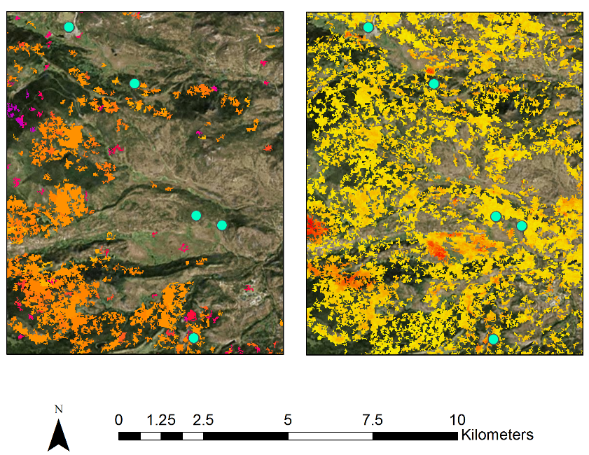

Appendix B: Inset map of disturbance years (left) and disturbance magnitude (right) within Rocky Mountain National Park with points corresponding to photos at the ground-level

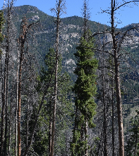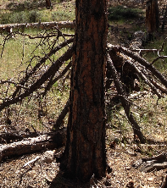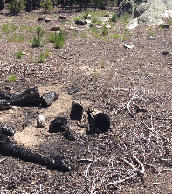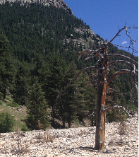

1985

2015



Low High



**Appendix C – Charts for the Study Area**

30

20

10

0

Area (km2)

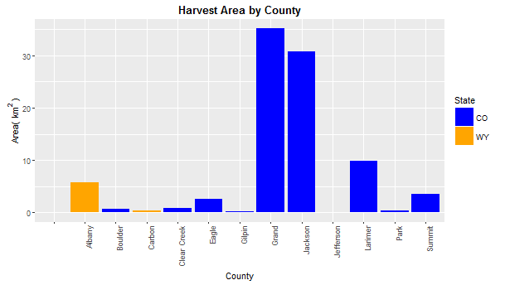

Albany

Boulder

Carbon

Clear Creek

Eagle

Gilpin

Grand

Jackson

Jefferson

Larimer

Park

Summit

Colorado

Wyoming

County

Appendix C: Sum of annual harvest area in the study area, grouped by county and color coded by state

0

500

1000

1500

2000

2500

3000

Distance from Nearest Road (m)

1500

1000

500

0

Frequency

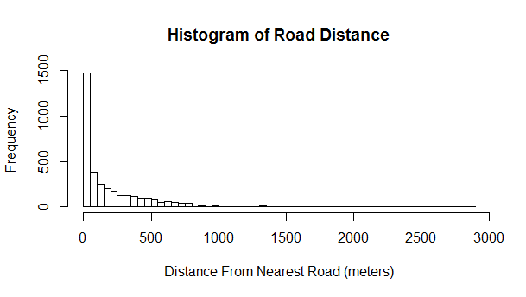

Appendix C: Count of harvest polygons at different ranges of distance from the nearest road in the study area

2600

2700

2800

2900

3000

3100

3200

Average Elevation (m)

300

200

100

0

Frequency

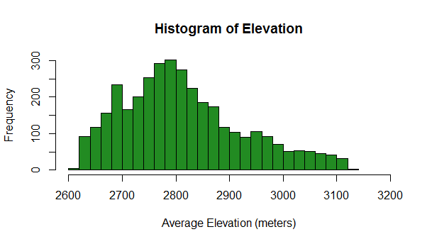

Appendix C: Count of clearcut harvest polygons at different ranges of elevation throughout the study area

**Appendix D – Charts for Rocky Mountain National Park**

Area (km2)

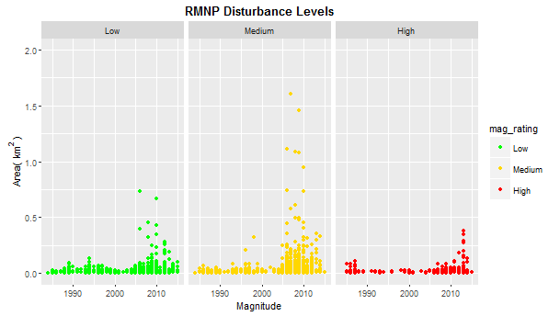

2.0

1.5

1.0

0.5

0.0

1990

2000

2010

Magnitude



Low

Medium

High

Appendix D: Scatterplot should the area of each disturbance event in Rocky Mountain National Park and the year of disturbance, group by magnitude

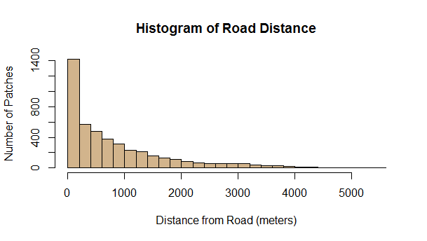

0

1000

2000

3000

4000

5000

Distance from Roads (m)

1400

800

400

0

Number of Patches

Appendix D: Count of disturbance events at different ranges of distance from the nearest road in Rocky Mountain National Park

1990

2000

2010

1990

2000

2010

Slope (degrees)

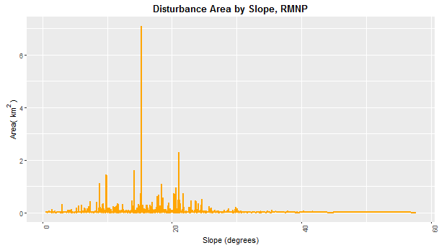

0

20

40

60

Area (km2)

Appendix D: Sum of disturbance areas occurring at different slopes in Rocky Mountain National Park

6.0

4.0

2.0

0.0

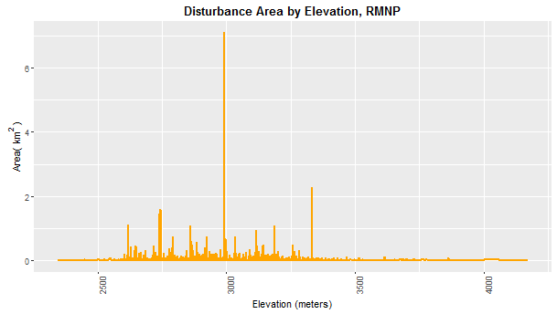

2500

3000

3500

4000

Elevation (m)

6.0

4.0

2.0

0.0

Area (km2)

Appendix D: Sum of disturbance areas occurring at different elevations in Rocky Mountain National Park