**NASA DEVELOP National Program**

Mobile County Health Department

**Summer 2015**

**Short Title: Coastal Texas Water Resources**

**Subtitle:** Utilizing NASA Earth Observations to Assess Estuary Health and Enhance Management of Water Resources in Coastal Texas through Land Cover and Precipitation Mapping

**VPS Title:** Rooting Out the Problem: Mesquite Trees’ Effect on Estuary Health

**Project Team & Partners**

**Project Team:**

Elaina Gonsoroski (Co-Team Lead), egonsoroski@gmail.com

Tyler Lynn (Co-Team Lead), tclynn11@gmail.com

Georgina Crepps

Rodrigo Pereira da Silva

Ryan Schick

**Advisors & Mentors:**

Joe Spruce (NASA Stennis Space Center)

Bernard Eichold, M.D., Dr.PH (Mobile County Health Department)

James “Doc” Smoot (NASA Stennis Space Center)

**Partner Organizations**

National Park Service, End-user, POC: Joe Meiman

**Project Details**

**Applied Sciences National Applications Addressed:** Water Resources

**Study Area:** Texas (TX): The project study area was the Laguna Madre of the Padre Island National Seashore located in southern Texas along the Gulf of Mexico. The latitude lines 27.6 N and 26.2 N were used for the northern and southern boundaries of the study area, respectively. The western boundary stretched past US Highway 77 while the eastern boundary extended into the Gulf of Mexico.

**Study Period:** 2000 - 2015

**Earth Observations & Parameters**

Landsat 5, TM - Thermal bands, land cover

Landsat 7, ETM+ - Thermal bands, Land cover

Landsat 8, TIRS & OLI - Thermal bands, land cover

GRACE, ACC/SCA/KBR - Root zone soil moisture content

TRMM, Precipitation Radar - Rainfall accumulation

**Ancillary Datasets Utilized**

* National Park Service - *In situ* and historic water temperature and salinity data
* Texas State Data Center - County shapefiles of Kleberg and Kenedy counties

**Software Utilized**

ERDAS IMAGINE - land classification of Landsat imagery

ArcGIS - raster analysis of GRACE derived data, Landsat 7 ETM+ and Landsat 8 TIRS, map creation, TRMM precipitation analysis

dnppy - scripts for converting Landsat imagery to TOA reflectance and surface temperature with Python

TerrSET Geospatial Monitoring and Modeling System - Land Change Modeler to compute changes in land cover over the study period

Exelis ENVI +IDL – Landsat 7 radiance calibration, digital numbers to radiance

R – Statistical analysis

Microsoft Excel – Statistical analysis, creation of graphs and tables

Python IDLE Graphical User Interface – Raster processing, applying TOA reflectance and cloud masks to raster data, calculating and exporting statistics from raster data

**Project Overview**

**80-100 Word Objectives Overview**

The project was conducted in conjunction with the National Park Service to address concerns regarding the salinity of the Laguna Madre in the Padre Island National Seashore. NASA Earth observation data were utilized to conduct precipitation analysis, in addition to creating a land use/land cover (LULC) map time series of vegetation in the study area, a root zone soil moisture content map time series, and thermal maps of the lagoon. These products were ultimately used to understand the suspected positive correlation between the increased salinity of the lagoon and the increased occurrence of mesquite trees in the surrounding area.

**Abstract**

This project partnered with the National Park Service (NPS) to help analyze the correlation between mesquite trees and the salinity of the Laguna Madre of Padre Island National Seashore. The lagoon is a hypersaline estuary; however, there is historical evidence that this was not always the case. It is hypothesized that the increase in the number of honey mesquite trees (*Prosopis glandulosa var. glandulosa)* in the area has contributed to the Laguna Madre’s increased salinity by decreasing the groundwater inflow to the lagoon. These mesquite trees have long taproots capable of extracting significant amounts of groundwater. This project utilized Earth observation data in ERDAS IMAGINE and ArcGIS software to create map time series and analyze the data. Landsat 5, 7, and 8 data were used to create land use/land cover (LULC) maps in order to analyze the change in the occurrence of mesquite trees over time. Thermal maps of the lagoon were generated using Landsat 5, 7, and 8 data to understand changes in groundwater inflow. In addition, TRMM and GRACE derived changes in root zone soil moisture content data were compared over the study period. By investigating the suspected positive correlation between the mesquite trees and the salinity of the Laguna Madre, the NPS can improve future land management practices.

**Community Concerns**

* Increasing salinity of Laguna Madre of the Padre Island National Seashore, an already hypersaline estuary
* Proliferation of mesquite trees (native but harmful to the ecosystem) in the ecosystem
* Decreased groundwater inflow to the estuary
* Increasing salinity could potentially disrupt the current ecosystem which is home to multiple threatened species including seagrasses and sea turtles
* The Laguna Madre is also a productive fishery and changes in salinity

**Current Management Practices & Policies**

As part of the Padre Island National Seashore, the Laguna Madre falls under federal land management. Currently, the water quality and nutrient levels of the Laguna Madre are monitored with *in situ* data collection in limited locations by the National Park Service. However, the relationship between mesquite trees, groundwater and the salinity of the lagoon is not systematically being studied. One challenge in conducting studies of the Laguna Madre is that much of the surrounding land is privately owned. There are policies on both the state and federal levels which protect the health of the Laguna Madre. The Texas General Land Office (TGLO) manages the Texas Coastal Management Program, which is federally approved, and allocates funds to a number of projects that address issues concerning coastal health (TGLO 2015). The lagoon also falls within national park boundaries and, therefore, is under the care of the National Park Service (NPS). Additionally on the federal level, the Office of Water (OW) under the Environmental Protection Agency (EPA) is responsible for ensuring water health nationwide with the help of entities at the regional, state and local level (EPA 2014a). The National Estuary Program (NEP), which was established by the 1987 Clean Water Act (CWA), is also managed by the EPA. The NEP is charged with creating a Comprehensive Conservation and Management Plan (CCMP) designed to ensure water quality and overall estuary health (EPA 2014). Some other federal policies which address the estuary’s health include the Shore Protection Act (SPA) of 1988, the BEACH Act of 2000 and the Coastal Zone Management Act of 1972 (EPA 2014b). Knowledge of the various environmental variables affecting the health of the lagoon is needed for the NPS’s effective management of the estuary and will be utilized in future management strategies for the park.

**Decision Support Tools & Benefits**

|  |  |  |
| --- | --- | --- |
| **End-Product** | **Earth Observations Used** | **Benefit & Impact** |
| Precipitation Analysis | TRMM Precipitation Radar | TRMM data will be used to identify how precipitation relates to the change in lagoon salinity, analyzing precipitation trends that may have affected groundwater levels. This will aid in assessing any potential correlation between mesquite trees and decreased groundwater. |
| Land Use/Land Cover Map Time Series | Landsat 5 TM,  Landsat 7 ETM+,  Landsat 8 OLI | Landsat 5, 7, and 8 data will be used to identify possible correlations between mesquite tree density, a decrease in groundwater flow, and an increase in salinity to aid in land management practices. |
| Root Zone Soil Moisture Content Map Time Series | GRACE ACC/SCA/KBR | GRACE data will be used to identify if there have been changes in root zone soil moisture content so these changes can be addressed through land management practices. |
| Thermal Maps of Lagoon | Landsat 5 TM,  Landsat 7 ETM+,  Landsat 8 TIRS | Landsat 5, 7, and 8 data will be used to identify changes in groundwater inflow to the lagoon and if these changes can be addressed through altered land management practices. |

**Project Imagery**

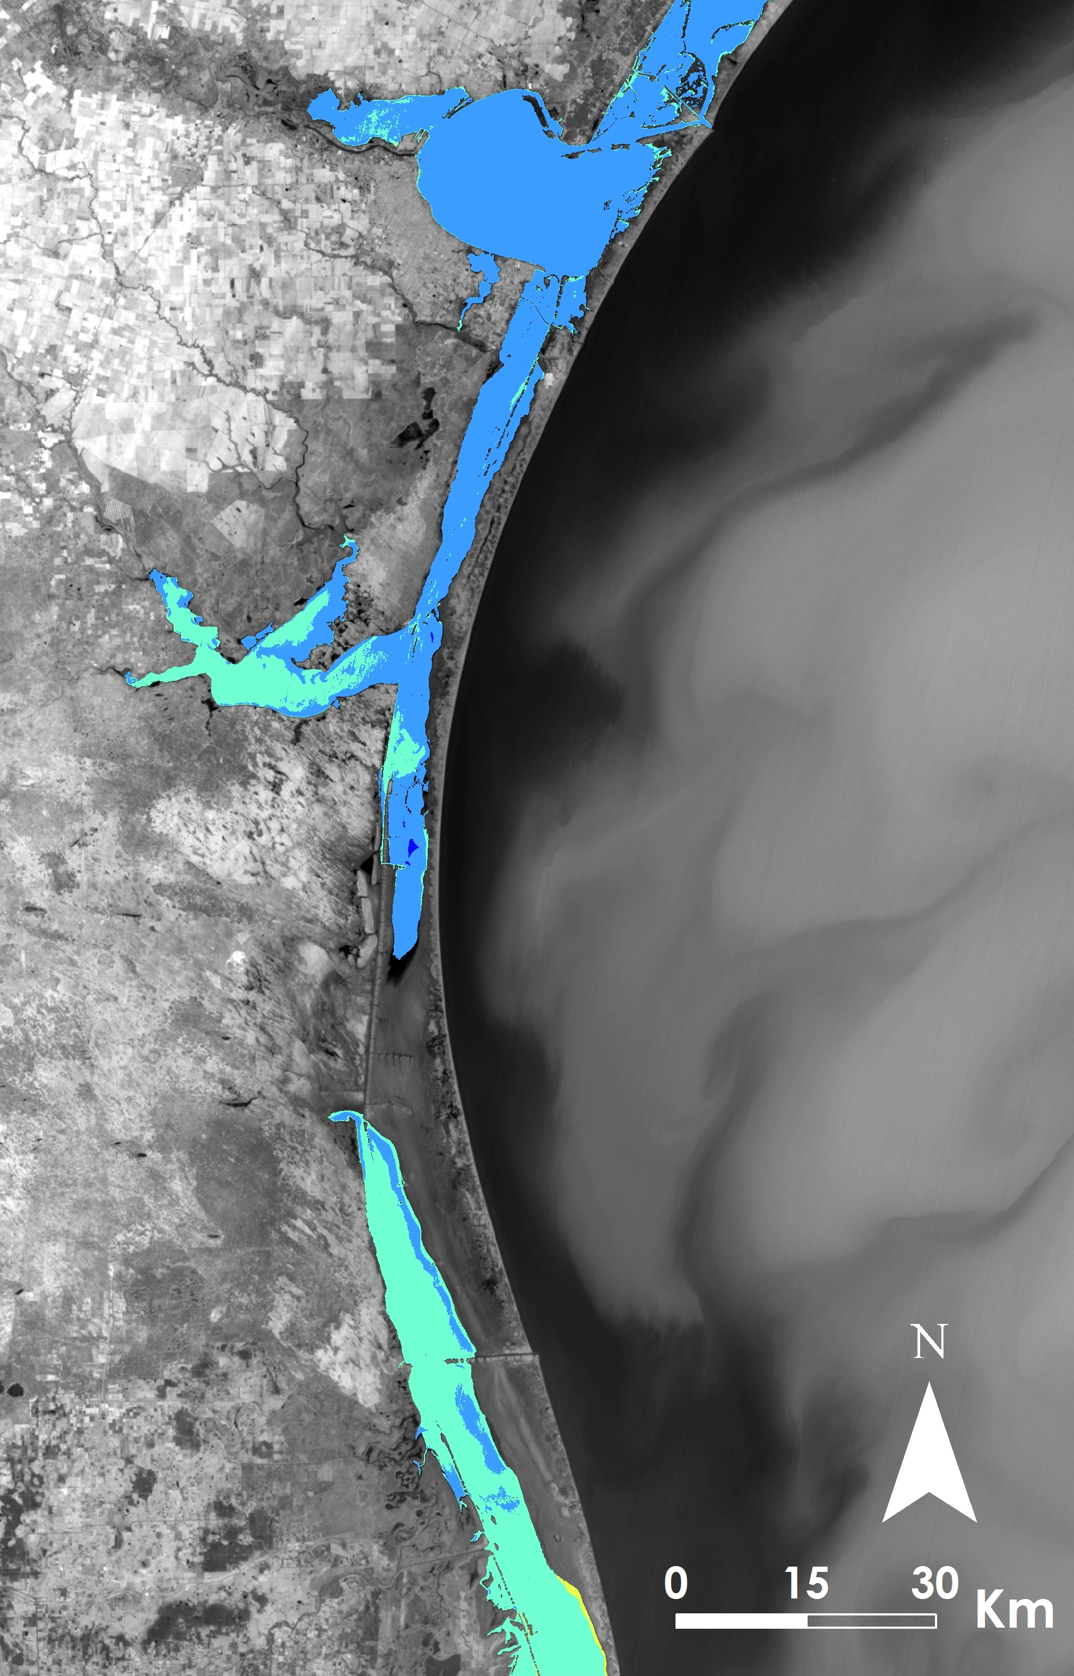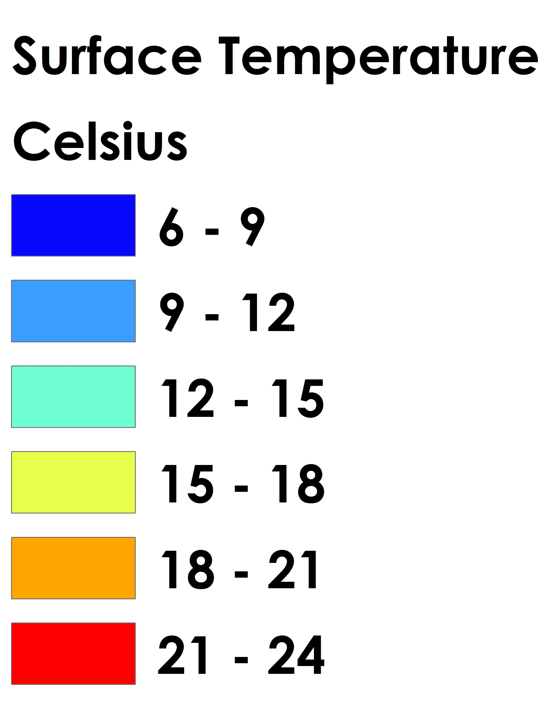

**Caption:** Thermal Map of the Laguna Madre for January 15, 2014. Image Credit: Coastal Texas Water Resources Team.

**Image:** File Name (2015Sum_MCHD_CoastalTXWaterResources_FinalImagery.jpg 2015Sum_MCHD_CoastalTXWaterResources_FinalImageryLegend.jpg)

**References:**

Environmental Protection Agency. 2014a. “About the Office of Water.” http://www2.epa.gov/aboutepa/about-office-water. (June 15, 2015).

Environmental Protection Agency. 2014b. “National Estuary Program (NEP) Overview.” http://water.epa.gov/type/oceb/nep/index.cfm#tabs-2. (June 15, 2015).

Texas General Land Office. 2015. “Coastal Management Program.” http://www.glo.texas.gov/what-we-do/caring-for-the-coast/grants-funding/cmp/. (June 15, 2015).