**NASA DEVELOP National Program**



NASA Marshall Space Flight Center

*Fall 2015*

North Mexico Ecological Forecasting

Using NASA Earth Observations to Monitor and Manage Ocelot Habitat Loss in North Mexico

 **Technical Report**

Rough Draft – October 8, 2015

Ryan Schick (Project Lead)

Padraic Conner

Maggi Klug

Leigh Sinclair

Dr. Jeffrey Luvall, NASA at NSSTC (Science Advisor)

Dr. Robert Griffin, University of Alabama in Huntsville (Science Advisor)

Previous Contributors:

Daryl Ann Winstead

Kaushik Narasimhan

Christina Fischer

Amberle Keith

# I. Abstract

[Placeholder - do not put anything here until the final draft submission. The abstract in the project summary is where the working draft of the abstract should “live”]

**Keywords**

Ocelot, Remote Sensing, Conservation, Mexico, Population, Ecological Forecasting

# II. Introduction

Ocelots (*Leopardus pardalis*) are a medium sized wild cat. They have a range that stretches from Argentina up to the southern tip of eastern Texas. The United States population of ocelots is currently listed as endangered as there is reported to be less than 100 left. The primary causes of the decline in ocelot populations are habitat loss and fragmentation (Harveson, et al.). This fragmentation is mainly due to anthropogenic causes, such as increased urbanization, road-kill, and involvement in the illegal fur trade. Furthermore, ocelot populations in the United States are isolated from ocelot populations in Mexico, which has led to inbreeding.  Inbreeding can cause a depressive effect, reducing survival and fertility of offspring due to the accumulation of deleterious recessive genes (Charlesworth and Willis 2009). Introduction of individuals from a healthy population into an inbred population has been shown to be effective at removing detrimental genes as well restoring neutral genetic variation. This results in an increase in fitness within the population (Westemeier 2009). Efforts are being made by the U.S. Fish and Wildlife Service in conjunction with partners to translocate ocelots from Mexico in order to increase the genetic diversity of the United States population.

**Project Objectives**

The objectives of this project were to create a Habitat Percent Cover Map and a Habitat Probability Map. The Habitat Percent Cover Map assessed the current extent of the ocelot habitat in Northeastern Mexico, and the Habitat Probability Map showed areas most likely to be inhabited by breeding populations. These end products helped project partners with conservation efforts. These project objectives address the ecological forecasting section of NASA’s Applied Science application areas.

**Study Area**

The study area (Fig. 1) was in northeastern Mexico, path and rows 26/42, 26/43, 26/44, 27/42, 27/43, and 27/44. This area consists of dense woody vegetation, low tropical forest, and ebony-grassland communities (Haines, et al.).

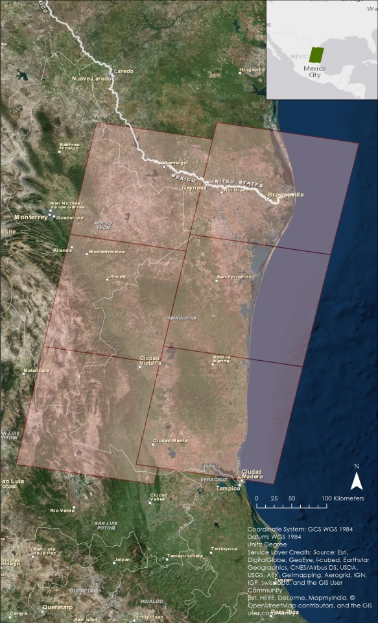

**Figure 1: Study Area**

**Study Period**

The study period for this project focused on the years 1996, 2004, and 2014. These years were selected to show how urbanization and agricultural areas have grown and/or changed. Data was downloaded during the dry season of the study area. This is so cloud cover would be at a minimum and so the data would show the least amount of vegetation available that would be suitable for an ocelot.

**Project Partners**  
Partners for this project were Mr. Ken Kaemmerer and Dr. Josh Gaspard from the Pittsburgh Zoo & PPG Aquarium, Dr. Michael Tewes from the Caesar Kleberg Wildlife Research Institute at Texas A&M University-Kingsville, Ms. Nanette Bragin from the Denver Zoo, Mr. Mitch Sternberg from the South Texas Refuge Complex, Dr. John Young Jr. from the Texas Department of Transportation, Dr. Arturo Caso and Dr. Arturo Flores-Martinez from the Secretaría de Medio Ambiente y Recusos Naturales (SEMARNAT), and Dr. Tyler Campbell from the East Wildlife Foundation.

# III. Methodology

**Data Acquisition**

Landsat 5 Thematic Mapper (TM) and Landsat 8 Operational Land Imager (OLI) Level 1 data were downloaded from the United States Geological Survey (USGS) EarthExplorer website for December through April in 1996, 2004, 2014. The resolution of the data was 30 meters. These data will be used to create land cover classification and Normalized Difference Vegetation Index (NDVI) maps.

Terra’s Moderate Resolution Imaging Spectroradiometer (MODIS) 250 meter resolution MOD09Q1 data were downloaded from the USGS Global Visualization Viewer website for the months of January through March of 2014. This data was used to compensate for cloud cover in the Landsat data.

Digital Elevation Model (DEM) data were downloaded from the USGS Earth Explorer website using Shuttle Radar Topography Mission Version 2 (SRTM-V2) void-filled 90 meter resolution from February 2011.

Suomi NPP Visible Infrared Imaging Radiometer Suite (VIIRS) reflectance data were acquired from NASA Land Web. The data were used to derive NDVI.

A shapefile of the protected areas of Mexico was downloaded from Protected Planet. This was then converted to a geoTIFF file using ArcMap 10.3. This will be assimilated into the SLEUTH model to help accurately depict future habitat growth or loss.

**Data Processing**

The “Composite Bands” tool in ArcMap 10.3 was used to create a composite image from the Landsat bands. Near-infrared, red, and green, bands 4, 3, 2 and 5, 4, 3 for Landsat 5 and 8, respectively, were used to create a false infrared image. The composite images were then mosaicked together using the “Mosaic to New Raster” tool to create an image of the entire study area for land use/land cover classification.

After the images were mosaicked together, training samples were collected to create the signature file. At least 100 training samples collected for each of the 7 classes used (Water, Sand, Urban, Grassland/Field/Growing Ag, Fallow/Bare Soil, Scrubland, and Forest). These samples were merged into each respective class and then the signature file was saved. Signature files were created for 1996, 2004, and 2014 to create a land cover classification map for each of those years to show change in land cover over the study period.

To generate NDVI using Suomi NPP VIIRS data, near infrared and red bands (bands M7 and M4, respectively) were georeferenced using ENVI Classic. The data were then exported as geoTIFFs for use in the “Raster Calculator” tool in ArcMap 10.3.  The following equation was used:

$NDVI=\frac{NIR - RED}{NIR + RED}$

**Data Analysis**

TBD

# IV. Results & Discussion

**Errors and Uncertainty**

The 2004 Landsat 5 data had an error which caused some small repeating dashes of erroneous data. Landsat 8 data acquired for 2014 had some cloud cover over path/row 27/43 and 27/44, which obscured some of the data and led to potential error in the land cover classification. Landsat 5 data from 1996 for paths 26 and 27 were taken a month apart, in March and April, respectively. Because of this, vegetation in the April images was greener than in the March images, potentially leading to errors. This data also had random pixels of bad data, further adding to errors in the analysis.

TBD

# V. Conclusions

TBD

# VI. Acknowledgments

The North Mexico Ecological Forecasting team would like to acknowledge Dr. Jeffrey Luvall, NASA at NSSTC, and Dr. Robert Griffin, the University of Alabama in Huntsville, for their guidance throughout this project. The team would also like to acknowledge their project partners for their guidance, data, and support for this project:

* Pittsburgh Zoo & PPG Aquarium
* Caesar Kleberg Wildlife Research Institute at Texas A&M University-Kingsville
* The Denver Zoo
* South Texas Refuge Complex
* Texas Department of Transportation
* Secretaría de Medio Ambiente y Recusos Naturales (SEMARNAT)
* East Wildlife Foundation

Any opinions, findings, and conclusions or recommendations expressed in this material are those of the author(s) and do not necessarily reflect the views of the National Aeronautics and Space Administration.

This material is based upon work supported by NASA through contract NNL11AA00B and cooperative agreement NNX14AB60A.

# VII. References

Charlesworth, D., & Willis, J. H. (2009). The genetics of inbreeding depression. *Nature Reviews Genetics*, *10*(11), 783-796.

Bouzat, J. L., Johnson, J. A., Toepfer, J. E., Simpson, S. A., Esker, T. L., & Westemeier, R. L. (2009). Beyond the beneficial effects of translocations as an effective tool for the genetic restoration of isolated populations. *Conservation Genetics*, *10*(1), 191-201.

# VIII. Content Innovation

TBD

# IV. Appendices

TBD