**NASA DEVELOP National Program**



NASA Langley Research Center

*Fall 2015*

Peru Climate

Monitoring and Forecasting Shifting Climate and Land Use Change Impacts in Peru’s Parque de la Papa for Enhanced Agricultural Management

 **Technical Report**

Final Draft – November 19, 2015

Rebekke Muench (Project Lead)

Kayla McDonald

Ryan Murphy

Michael Sclater

Richard Rose

Dajon Begin

Dr. Kenton Ross, NASA DEVELOP National Program (Science Advisor)

Noel Baker, NASA Post Doc Program (Advisor)

# I. Abstract

Changing climates are affecting agricultural production around the world. This impact will be particularly severe in tropical highland regions like the Peruvian Andes, where shifts in climate have caused changes in suitable areas for endemic crops. In the Parque de la Papa (Peruvian Potato Park), evidence suggests that potato cultivation has shifted to higher altitudes in response to increasing temperatures and pest populations. The primary concern is the current suitable lands within Parque de la Papa will eventually become unsuitable for traditional potato production. In addition, the impact of shifting climates threaten both agrobiodiversity and community livelihoods within the park and surrounding region. The objective of this project was to develop an increased understanding of changes in climate and their influence on potato cultivation in the park using NASA Earth observations. Land surface temperature data from the Aqua and Terra Moderate Resolution Imaging Spectroradiometer (MODIS) were used to derive growing degree days for the region. Historical and current precipitation was assessed using Tropical Rainfall Measuring Mission (TRMM) and Global Precipitation Measurement (GPM) data. Current and historical potato cultivation areas were estimated using Landsat 4, 5, 7, and 8, sensors. A digital elevation model (DEM) and a slope map were created from the Shuttle Radar Topography Mission (SRTM) data. These factors were incorporated into suitability maps for weevils, a pest in the park. Finally, current and future potato suitability maps were developed using growing degree days, precipitation, elevation, weevil suitability, and slope.

**Keywords**

# Remote Sensing, Climate, MODIS, Growing Degree Days

# II. Introduction

Increases in average global temperatures and shifting precipitation patterns are likely to alter agricultural practices around the world (Daccache et al., 2011). The location and sustainable growth of certain crops will be influenced by this complex and variable change.  In tropical highland regions like the Andes, the effects of climatic changes may be severe (Jamieson, Trowbridge, Raffa, & Lindroth, 2002). A study based on local meteorological data in this region showed significant warming after 1979 that is expected to continue into the future (Condori, Hijmans, Quiroz, & Ledent, 2014). Changes in temperature and precipitation have altered growing patterns (Daccache et al., 2011) and increased the presence of insect damage (David Ellis, CIP, personal communication, September 22, 2015). Subsequent research has shown that from 1982 to 2012, potato cultivation in the Andes ascended 150 m higher in elevation (Shaw & Kristjanson, 2013). Conservation of this genetic and cultural diversity will depend on a clear understanding of the effects a changing climate has on crop suitability.  These changes threaten the continued use of traditional farming practices and indigenous crop varieties.

Generally, locations suitable for potato cultivation are determined by biotic and abiotic factors as well as economic and social conditions. With respect to climate, potato production must occur during a time period that is both “heat free” and “frost free,” (Haverkort, De Ruijter, van Evert, Conjin, & Rutgers, 2013). Risk of frost increases below 3℃, and tuber production decreases at mean temperatures above 22℃ (Hijmans, Forbes, & Walker, 2000, p. 83). In addition to regulating plant growth, temperature also affects insect growth and development (Jamieson et al., 2002). Warming temperatures may also increase vulnerability of plants to insect damage, especially if water availability is reduced (Jamieson et al., 2002).

Potato weevils are one of the most prevalent pests for potatoes cultivated in the high Andean mountains (Cisneros, 1999). An increase in Andean weevil populations can be attributed to the rise in temperatures over time in Peru (Parsa, 2010). These pests cause irreparable damage to crops as well as surrounding fields. Weevil eggs are laid at the base of potato plants (Parsa, Ccanto, Olivera, Scurrah, Alcazar & Rosenheim, 2012), in the upper twenty centimeters of the soil profile (Rios, 2010) for a period of twelve to fourteen weeks (Cisneros, 1999). Larvae bore through tubers for eleven to seventeen weeks, then abandon these tubers and pupate in surrounding soil (Cisneros, 1999). The emergence of overwintering adult weevils lasts eight to fourteen weeks and coincides with the onset of rain (Cisneros, 1999). Infestations are then exacerbated by the travel of weevils to nearby potato fields (Parsa et al., 2012).

Remote sensing and Geographic Information Systems (GIS) have emerged as new tools to assess agricultural suitability (Rahman, 2008) and monitor the distribution of crops over large areas (Panigrahy & Chakraborty, 1998). This project addressed NASA’s Applied Sciences Program national application areas of climate, agriculture, ecological forecasting, and water resources. The objective was to use NASA Earth Observations to develop an increased understanding of changes in climate and their influence on potato cultivation in Peru’s Parque de la Papa. Growing Degree Days (GDD), elevation, soil moisture, and precipitation maps were created to serve as inputs for a potato suitability analysis in the park.

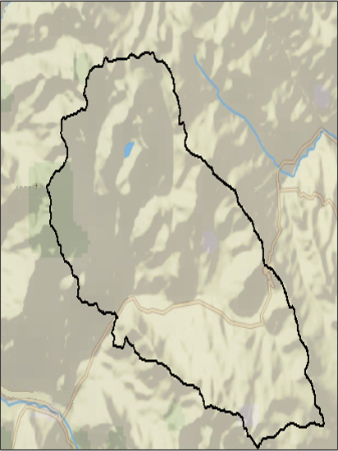

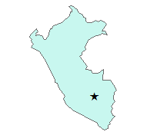

Parque de la Papa outline

**Legend**

**Area Map Legend**

Peru

Parque de la Papa

Figure 1: Study area map depicting the location of Parque de la Papa, Peru

The Parque de la Papa is located forty kilometers outside of Cusco, Peru (Argumedo, 2008) and is home to over 6,000 people (Fowks, 2015). Six indigenous communities reside within the park boundaries, five of which form the Parque de la Papa legal association (Argumedo, 2008; “Guardians of Diversity,” 2014). The park aims to protect and disseminate traditional knowledge systems (“We are five, but now we are one”), as well as construct a conservation model focused on the sustainable use of plant genetic resources (Argumedo, 2008; “Guardians of Diversity,” 2014). The International Potato Center (CIP) works jointly with indigenous farmers and the Association for Nature and Sustainable Development (ANDES) to promote the objectives of the park. This project provided insight to the CIP regarding the changing locations of potato suitability in order to make recommendations to local farmers.

# III. Methodology

**Data acquisition:**

Daily Aqua MODIS (Moderate Resolution Imaging Spectroradiometer) Land Surface Temperature (LST) level three, one kilometer resolution (MODIS tile, h11v10) data were gathered for the study area over the years of 2002 to 2015. Daily Tropical Rainfall Measuring Mission (TRMM) level three 0.25 degree resolution data were gathered for the study area from January 01, 1998 to July 31, 2015 TRMM_3B42_daily from NASA’s Mirador data portal. Landsat Surface Reflectance Climate Data Record (CDR) tiles (path 4, row 69) were obtained from United States Geological Survey (USGS) Earth Explorer for March 23, 1990 and March 22, 2007 in thirty meter horizontal resolution. The Digital Elevation Model (DEM) was acquired from the Shuttle Radar Topography Mission (SRTM), which is a radar based, absolute elevation raster image with a thirty meter horizontal resolution and sixteen meter vertical resolution.

**Data Processing and Analysis:**

The Aqua MODIS LST daily datasets from 2002 to 2015 were converted from Hierarchical Data Format (HDF) to Tagged Image File Format (tiff) files, reprojected, clipped to the study area and converted to degrees Celsius. Potential outliers that could represent cloud contaminated pixels were then removed.  Then, the NASA DEVELOP National Program Python (dnppy) package was used to implement a rolling window technique where data from each pixel over the thirteen year period was averaged with data from four days before and after its acquisition date to calculate average daily and nightly temperatures. Growing degree days (GDD), a temperature based metric used to predict the development and flowering of plants (Neteler 2010), were also calculated.  GDD are calculated by taking the mean daily temperature, then subtracting a base temperature. The base temperature used for this study was two degrees Celsius, which was also used to calculate GDD in a study of global potato production by R.J. Hijmans (2000).

The TRMM_3B42_daily dataset is part of a larger dataset formerly called the "TRMM and Other Data Precipitation Data Set." Version seven TRMM Multi-Satellite Precipitation Analysis (TMPA) (Huffman & Bolvin, 2014) was used in this study. The TRMM_3B42_daily dataset was downloaded and processed using Python to extract all daily data from January 1, 1998 to July 31, 2015.  This dataset was then stacked so that a value was given for each pixel every day over the period that TRMM data was available. As the TRMM_3B42_daily dataset is in such a coarse resolution (26,750 m) in comparison to the study area, the final precipitation time-series was converted from raster data to point data over a five by five block of pixels, and then interpolated to create a smoother surface.

Composite bands of bands six, four, and one of the two Landsat scenes were created using the ArcGIS tool “Composite Bands.” This band combination was chosen because it falsely colored the image to make agricultural lands more apparent. Lines were then drawn using the ArcGIS drawing tool to indicate the highest elevations of the potato crops for the given year. The values for the points on the lines were extracted and compared to determine the elevation change from 1990 to 2007. Additionally, slope was derived from the SRTM DEM using the ArcGIS slope tool.

# IV. Results & Discussion

To identify areas within the park that would be most suitable for potato growth, several different factors were considered, including current land-use, precipitation, temperature, slope, and elevation. These factors, alone and in combination, influence the suitability of any given area for potato cultivation.

Landsat imagery provided a visual representation of the changing locations of agriculture in the Parque de la Papa. There was a noticeable movement of agricultural activity to higher elevations in 2007 when compared to 1990 (Figure _).   Over this period, agricultural production in the target area shifted over 200 m higher in elevation. For example, in the Northeast area of the park, the potatoes shifted from an elevation of 4100 m to an elevation of 4350 m, as indicated by the black circle in Figure _.

The TRMM precipitation accumulation analysis concluded that the rainy season in the Parque de la Papa starts between late September to early October and lasts until mid-April (Figure 2). There is little to no rain accumulated from May to mid-September (Figure 2).

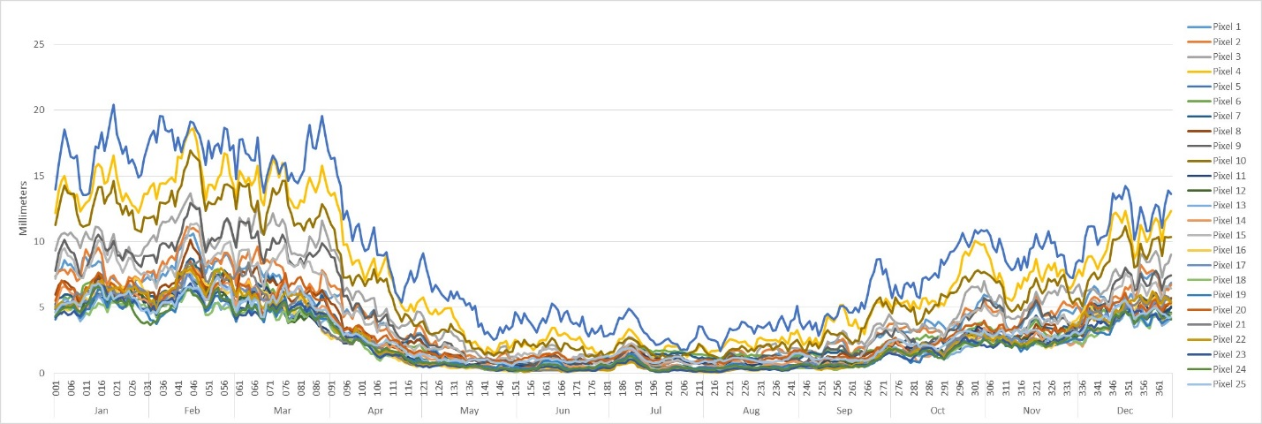

Figure 2: Weekly rolling average of TRMM data. Pixels 1 – 25 are the 25 pixels in the 5x5 pixel block that was clipped from the data (Appendix A, Figure 1)

Average precipitation totals during the growing season were higher than expected. According to the Food and Agriculture Organization of the United Nations, ideal rainfall amounts from 500 to 700 mm (“Crop Water Information: Potato”). Precipitation totals for the growing season in the Parque de la papa ranged from 700 to 940 mm (Figure 3).

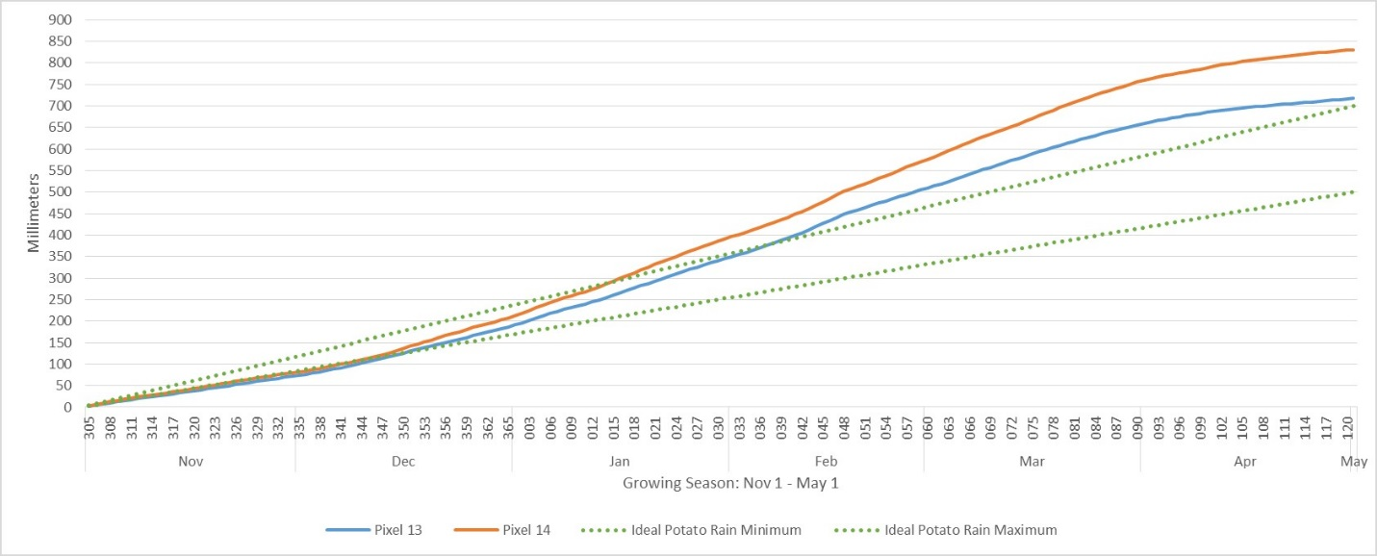

Figure 3: The accumulated precipitation for pixels thirteen and fourteen over the course of the growing season. Dotted lines indicate ideal potato rain accumulation while blue indicates the accumulation for pixel thirteen and orange indicates accumulation for pixel 14

In order to estimate the causes of this accumulation, a precise crop calendar would be needed to accurately measure the specifics of the growing season and how they would compare to TRMM data. Weather station data from Cusco was downloaded over the same timeframe as TRMM, and in subsequent terms will be compared to TRMM data.

Average daily temperatures over the study period generally fell within the ideal range for potato growth, with average daytime temperatures ranging from 15.5°C to 30.5°C (Figure 4).  Night time temperatures were lower on average than minimum thresholds for potato cultivation (Figure 4; Hijmans et al., 2000).  Potatoes are at risk of frost damage at temperatures below five degrees Celsius (Hijmans et al., 2000).  Although these conditions are not ideal, potato production can occur in areas where average temperatures fall below five degrees Celsius (Hijmans et al., 2000).

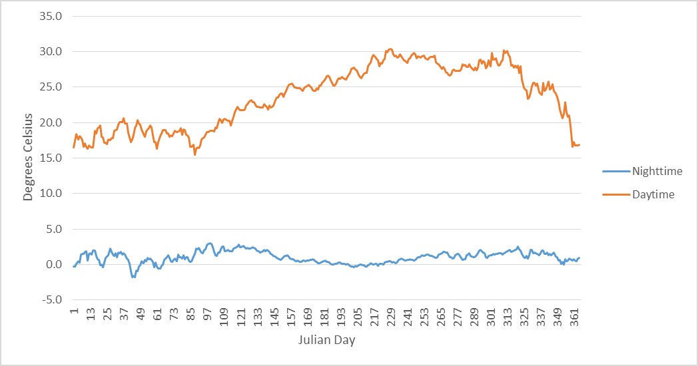

Figure 4: Aqua MODIS average daily daytime and nighttime temperatures (degrees Celsius) where blue indicates nighttime temperatures and orange indicates daytime temperatures

In addition, average monthly temperatures calculated from both Aqua and Terra satellites did not follow the trend expected for the region. Google Earth Engine tools indicated lower temperatures during the summer months of January through March (Figure 5). Reflectance from bare rock has the potential to falsely elevate temperature signals, and could be remedied through the creation of a mask applied prior to averaging MODIS data.

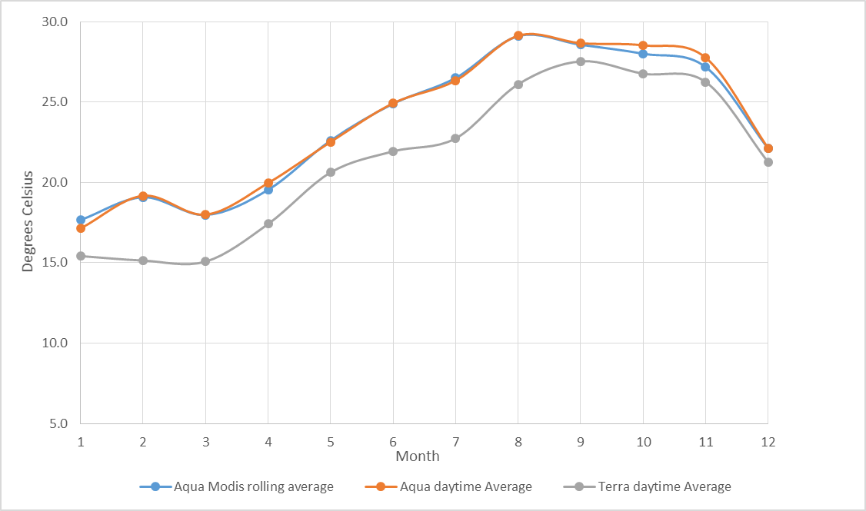

Figure 5: Monthly averages of daytime Aqua and Terra MODIS Land Surface Temperature in degrees Celsius where blue indicates the Aqua MODIS rolling average, orange indicates the Aqua daytime average, and grey indicates the Terra daytime average

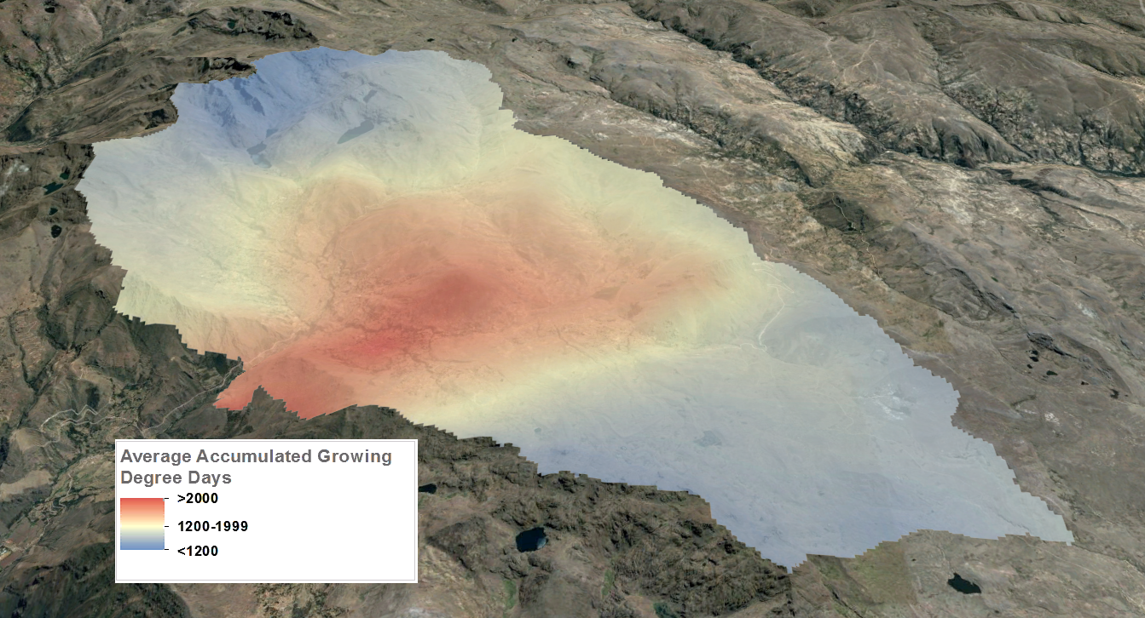

Figure 6: Average accumulated growing degree days from 2002 to 2015 over the period of November 1 to May 1 each year, where red indicates a high number of accumulated growing degree days and blue indicates a low number of accumulated growing degree days.

Legend

> 2200

< 200

On average, higher elevations within the park had lower accumulated growing degree days when compared to lower elevations (Figure 6).   The region shown in the Northeast corner or the park coincides with agricultural activity identified through analysis of Landsat imagery.  The smaller number of accumulated growing degree days over the cropping season in this area indicate that potatoes grown in regions of higher elevation take a longer time to mature.

**Limitations**

Inclusion of all MODIS LST data was prevented by cloud contamination causing irregularities in temperatures values for certain pixels. Despite careful analysis, the pervasiveness of cloudy data required additional consideration in order to calculate accurate temperatures. Integrating data from Aqua and Terra satellites, and using temporal modeling to fill data gaps could be used in this future consideration. Further validation of data may also be complemented by acquisition and analysis of weather station temperature measurements in the region.

Monitoring the movement of potato fields was precluded by the inability to differentiate between potato and other agricultural fields due to both field size and the coarse resolution of usable images. As a result, a mixed agricultural crop movement analysis was created, rather than an analysis of solely potato crops.

Precipitation can be easily impacted by the landscape and elevation of a given area. The coarse resolution of the TRMM data resulted in only two pixels of information for the study area which did not give a detailed representation of the precipitation.

# V. Conclusions

This study assessed factors that could influence the sustainable agricultural production in Parque de la Papa, Perú. Increased access to satellite data that can measure temperature, precipitation, and land cover over large areas can complement the use of ground observations in researching the impact of climatic changes on agricultural production.  Analysis of precipitation and growing degree days showed that the majority of the Parque de la Papa is currently suitable for potato production. However, average precipitation totals over the potato growing season were higher than expected. MODIS land surface temperature did not follow the expected seasonal pattern, indicating that further refinement of utilized methods are needed. Temperature and precipitation measurements derived from satellite imagery could be improved with additional data from meteorological stations. Analysis of land cover, in accordance with local observations, suggested that agricultural activity has shifted to higher elevations over time.  Further research will determine if this shift is the result of increased temperatures, altered precipitation patterns, or other factors.

# VI. Acknowledgments

Any opinions, findings, and conclusions or recommendations expressed in this material are those of the author(s) and do not necessarily reflect the views of the National Aeronautics and Space Administration.

This material is based upon work supported by NASA through contract NNL11AA00B and cooperative agreement NNX14AB60A.

# VII. References

Argumedo, A. (2008). The Potato Park, Peru: Conserving agrobiodiversity in an Andean indigenous biocultural heritage area. *Protected Landscapes and Agrobiodiversity Values. Volume 1 in the series, Protected Landscapes and Seascapes, IUCN & GTZ*, 45.

Condori, B., Hijmans, R. J., Quiroz, R., & Ledent, J. F. (2010). Quantifying the expression of potato genetic diversity in the high Andes through growth analysis and modeling. *Field crops research*, *119*(1), 135-144.

Cisneros, F. (1999). Controlling the Andean potato weevil through integrated pest management. *Horizon International Solutions Site*. Retrieved from http://www.solutions-site.org/node/90/

Daccache, A., Keay, C., Jones, R. J., Weatherhead, E. K., Stalham, M. A., & Knox, J. W. (2012). Climate change and land suitability for potato production in England and Wales: impacts and adaptation. *The Journal of Agricultural Science*, *150*(02), 161-177.

Haverkort, A. J., De Ruijter, F. J., van Evert, F. K., Conijn, J. G., & Rutgers, B. (2013). Worldwide sustainability hotspots in potato cultivation. 1. Identification and mapping. *Potato research*, *56*(4), 343-353.

Hijmans, R. J., Forbes, G. A., & Walker, T. S. (2000). Estimating the global severity of potato late blight with GIS‐linked disease forecast models. *Plant Pathology*, *49*(6), 697-705.

Huffman, G. J., & Bolvin, D. T. (2013). TRMM and other data precipitation data set documentation. NASA, Greenbelt, USA, 1-40.

Jamieson, M. A., Trowbridge, A. M., Raffa, K. F., & Lindroth, R. L. (2012). Consequences of climate warming and altered precipitation patterns for plant-insect and multitrophic interactions. *Plant physiology*, *160*(4), 1719-1727.

Panigrahy, S., and M. Chakraborty. "An integrated approach for potato crop intensification using temporal remote sensing data." *ISPRS journal of photogrammetry and remote sensing* 53.1 (1998): 54-60.

Parsa, S. (2010). Native herbivore becomes key pest after dismantlement of a traditional farming system. *American Entomologist*, *56*(4), 242.

Parsa, S., Ccanto, R., Olivera, E., Scurrah., Alcazar, J., & Rosenheim, J. A. (2012). Explaining andean potato weevils in relation to local and landscape features: a facilitate ecoinformatics approach. *PLoS One,* 7(5).

Rios, Alfred Arturo. (2010). *Land Use, Spatial Ecology and Control of the Andean Potato Weevil in the Central Andes of Peru* (Doctoral Dissertation). Retrieved from ProQuest Dissertations Publishing. (3447056)

Shaw A, Kristjanson P. 2013. Catalysing learning for development and climate change: an exploration of social learning and social differentiation in CGIAR. CCAFS Working Paper No. 43. Copenhagen, Denmark: *CGIAR Research Program on Climate Change, Agriculture and Food Security (CCAFS)*.

We are five, but now we are one. Retrieved from http://http://www.parquedelapapa.org/eng/02somos_01.html

# VIII. Content Innovation

* Use of Google Earth and KMLs to map climatology data
* Development of methods in Google Earth Engine to rapidly assess satellite information and compare to traditional analysis
* Virtual Poster Session

# IV. Appendices

Appendix A:

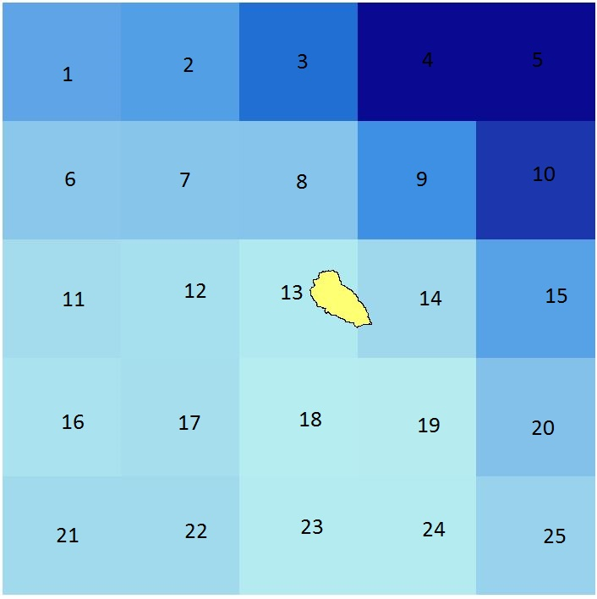

Figure 1: Diagram of the study area in reference to the TRMM dataset area used to determine precipitation