Tonlé Sap Food Security & Agriculture III

Evaluating Changes in Ecosystem Vitality and Freshwater Health in the Tonlé Sap Basin using Remotely Sensed Data

 **Technical Report**

November 18th, 2021

Joey Lindsay (Project Lead)

Keida Gaba

Lindsay Harmon

Susan Jarvis

***Advisors:***

Dr. Venkataraman Lakshmi, University of Virginia, Department of Engineering Systems and the Environment

Dr. Kenton Ross, NASA Langley Research Center

Dr. Derek Vollmer, Conservation International

***Previous Contributors:***

Brian Place

Jenna Johnston

Joseph Scarmuzza

Justine Spore

Marco Vallejos

Molly Farrell

Nick Pelaccio

Sonnet Phelps

# 1. Abstract

Tonlé Sap Lake, located in Cambodia, Southeast Asia, is one of the most productive inland fisheries in the world. With the unique reverse flow hydrology of the Tonlé Sap River, this freshwater system contains rich biodiversity and provides critical freshwater resources for the local community. Overfishing, stronger seasonality, drought, dam construction, forest fires, and untreated industrial domestic sewage threaten the ecosystem vitality and economic success of Tonlé Sap. In collaboration with Conservation International and the Cambodian Ministry of Water Resources and Meteorology’s Tonlé Sap Authority, we calibrated and finalized remotely-sensed (RS) proxies for sub-indicators of the Freshwater Health Index (FHI). We used NASA Earth observation data from Moderate Resolution Imaging Spectroradiometer (MODIS), and the Gravity Recovery and Climate Experiment (GRACE). These datasets were used in RS proxies and a Soil and Water Assessment Tool (SWAT) model that previous teams developed for sub-indicators of FHI. They included landcover, bank modification, and water quality metrics. It was determined that the ground water storage in Tonlé Sap Lake exhibited a slight declining trend over from April 1st, 2002 to February 3rd, 2017. To calculate chlorophyll-a concentration in the Tonlé Sap Lake, we used Copernicus Global Land Service mission data which provided a Trophic State Index of the lake. Between January 1st, 2000 and December 31st, 2020, the lake and surrounding region within the study area boundary displayed a slight decrease in vegetation density and consistently high chlorophyll-a concentrations. The SWAT model calculated nitrogen and phosphorus content measured in outlet points of the lake. We demonstrated that remotely sensed data is valuable for providing additional information for the FHI, but is not fully capable of replacing its *in situ* counterpart. We also concluded the water quantity is on a slowly declining trend within the basin.

**Key Terms**

SWAT, Tonlé Sap Basin, Freshwater Health Index, GRACE, NDVI, watershed health

# 2. Introduction

***2.1 Background Information***

The Tonlé Sap Lake is a critical freshwater ecosystem in southeast Asia threatened by recent agricultural developments, land degradation, water shortages, food insecurity, water pollution, and air pollution (Oeurng et al., 2019). Hydrological alterations, including dam construction and reservoir impoundment, are putting ecosystem productivity at risk. Additionally, longer dry seasons and decreased precipitation directly influence maximum water volume of the lake (Wang et al., 2020). The effects of dam construction and precipitation on the water quality of Tonlé Sap still require more research to prioritize management strategies effectively. To address these threats, our team partnered with Conservation International (CI) and the Cambodian Ministry of Water Resources and Meteorology to build upon previous DEVELOP terms’ work to address *in situ* data gaps for the Freshwater Health Index (FHI) web-based tool. Satellite imagery serves as a way to acquire lake health data when partners are unable to collect *in situ* measurements. Integrating satellite imagery to calibrate and produce inputs for the FHI will allow partners to track the changes and transformations of the Tonlé Sap Lake and watershed. This project aims to aid in decision-making, increase sustainability, and protect the region’s vital freshwater resources.

Previous studies have combined *in situ* data, computer-based modeling tools, and remotely-sensed data to assess climate change impacts, calculate river flows, and measure water quality parameters. Monitoring and assessing the quality of surface waters are critical for managing and improving water quality (Ritchie et al., 2003). The Soil & Water Assessment Tool (SWAT) is used to simulate the impacts of land management practices on the long-term environmental-hydrological system (Oeurng et al., 2019). SWAT is a valuable tool to understand climate change consequences and observe adaptation and mitigation management options (Touch et al., 2020). The Gravity Recovery and Climate Experiment (GRACE) has been used in previous research to estimate groundwater storage changes in the Mississippi River basin (Rodell et al., 2006).Current restrictions on travel and the COVID-19 pandemic have prevented consistent collection of *in situ* data in this region. Remote sensing technologies are utilized for detailed imagery of water quality parameters to better understand light, water, and substance interactions (Ritchie et al., 2003). Combinations of sensors, indices, and physical parameters are used to model drought and water storage changes. For example, the Normalized Difference Vegetation Index (NDVI) derived from Moderate Resolution Imaging Spectroradiometer (MODIS) imagery, in combination with Land Surface Temperature (LST), show merit for modeling regional drought in monthly intervals in the Lower Mekong Basin (Son et al., 2012). Remote sensing technologies are important tools to aid in mitigation efforts and ecological management. They can provide specific locations with a permanent database that can serve as a baseline for future comparisons (Ritchie et al., 2003).

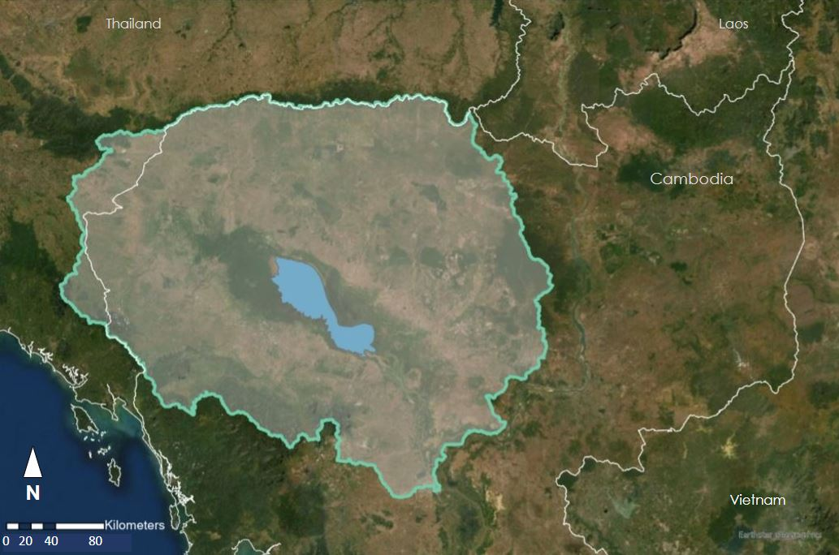

*Figure 1.* This image depicts the Tonlé Sap Lake and river basin, Cambodia, SE Asia, the study area for the Tonlé Sap Food Security & Agriculture III project.

This study focused on Cambodia’s Tonlé Sap Lake and River Basin from October 2000 to December 2020 (Figure 1). Our work is part of a multi-term project through NASA DEVELOP that began in Spring 2021. The first team created a time series analysis of water quality parameters for the Tonlé Sap Lake, calculated the deviation from natural flow, and established land use and land cover change maps to derive natural landscape information and bank modification FHI inputs. They observed a decrease in landcover naturalness and a breakdown in the volume and regularity of annual lake levels from 2000 to 2020, reflecting increased pressure on water supply and agricultural productivity. At least 8% of forested areas in the basin were lost and rice harvest intensity increased throughout the study period (Vallejos et al., 2021). These findings reflect the need to continue integrating Earth observations in monitoring efforts. In the summer 2021 term, the second team developed a beta version of a Google Earth Engine (GEE) toolkit for processing and formatting remotely sensed data for SWAT. Their SWAT model measured nutrient flows of phosphorus, nitrogen, and suspended sediments in the basin over a 20-year timespan, but it was both inaccurate and imprecise. The second term also saw the curation of a methodology to calculate groundwater storage depletion using GRACE satellite data.

***2.2 Project Partners & Objectives***

The partners for the Tonlé Sap Agriculture term III project were Conservation International (CI) and Cambodia’s Ministry of Water Resources and Meteorology (MOWRAM). CI works directly in Cambodia, in both the capital city of Phnom Penh and in a “floating office” on the lake itself. CI plays an active role in improving the livelihood and sustainability of the regional community, testing the FHI, and incorporating remote sensing to compensate for *in situ* data collection limitations. As a boundary organization, CI shares our findings with the Asian Development Bank and the World Bank. MOWRAM has experience with NASA Earth observation (EO) products. This project exposes more staff to EO products and their capability to inform decision-making. The project objectives were to model water quality properties using SWAT, and calibrate the model using SWAT-CUP. We also calculated groundwater storage metrics using GRACE satellite data and ultimately created a set of tools and software packages to integrate remotely sensed data into future FHI analyses. We established an FHI score for the Tonlé Sap Basin, which will enable CI to provide expedited information to policy makers on agricultural development in the basin that protects the lake’s fisheries and biodiversity.

# 3. Methodology

***3.1 Data Acquisition***

The majority of the data were sourced through GEE as open-source and pre-processed datasets. The Gravity Recovery and Climate Experiment (GRACE) data provided water thickness levels for change detection of terrestrial water through the dataset CSR TELLUS GRACE Level-3 Monthly Land Water-Equivalent-Thickness Surface Mass Anomaly. We derived NDVI values from the Terra MODIS Vegetation Indices 16-Day Global 250m dataset (MOD13Q1.006; Didan, 2015) to compute bank modification surrounding the Tonlé Sap Lake. Next, we gathered precipitation, wind, dew point, temperature, and surface solar radiation from the European Centre for Medium-Range Weather Forecasts (ECMWF) Reanalysis 5th Generation (ERA5) dataset. We downloaded landcover (Copernicus Climate Initiative Landcover Maps) and soil (Digital Soil Map of the World) datasets from the Copernicus Climate Initiative (CCI) and Food and Agriculture Organization (FAO) websites, respectively, and then uploaded to GEE for use in a custom SWAT data acquisition python tool. We obtained chlorophyll-a (chl-a) data from the CCI Lake Water Quality dataset, a Sentinel-3 reanalysis. CI and the Mekong River Commision (MRC) provided *in* s*itu* data that included water quality, chlorophyll-a, and flow timeseries across various portions of our study timeframe.

To support the FHI, all available remotely sensed data were compiled into a reusable GEE toolbox known as the Freshwater Health Index Remotely-Sensed Data Acquisition Companion (FHI-RDAC). This toolbox contains three scripts focused on downloading and formatting SWAT inputs, GRACE inputs, and NDVI inputs for the FHI. These scripts can be modified with an arbitrary study area for use anywhere in the world. The study timeframe can also be modified within the operational timeframes of the required satellites.

Table 1.

*Table detailing the name of each accessed dataset, the variables retrieved from the dataset, and the method of access*

|  |  |  |
| --- | --- | --- |
| **Dataset** | **Variables** | **Method of Access** |
| ERA5-Land Hourly – ECMWF Climate Reanalysis | Solar Radiation | Google Earth Engine |
| ERA5 Daily Aggregates – ECMWF Climate Reanalysis | Humidity, Precipitation, Temperature, Windspeed | Google Earth Engine |
| NASA SRTM Digital Elevation 30m | Elevation | Google Earth Engine |
| WWF HydroSHEDS Free Flowing Rivers Network v1 | River Locations | Google Earth Engine |
| CCI Initiative Landcover Maps | Landcover and Land Use | Retrieved from CCI website and uploaded to Google Earth Engine |
| FAO Digital Soil Map of the World (DSMW) | Soil Classification | Retrieved from FAO website and uploaded to Google Earth Engine |
| Gravity Recovery and Climate Experiment (GRACE) | Liquid Water Thickness (cm) | Google Earth Engine |
| Terra Moderate Resolution Imaging Spectroradiometer (MODIS) | Normalized Differentiated Vegetation Index (NDVI) | Google Earth Engine |
| CCI Lake Water Quality | Chlorophyll-a | Retrieved from the CCI website |
| *In-situ* data | Total Suspended Sediment, Nitrogen Concentration, Phosphorus Concentration, Flow, Chlorophyll-a | Delivered by CI and the MRC |

***3.2 Data Processing***

We gathered and processed GRACE and Terra MODIS remote sensing data products in GEE. Then, we exported these datasets as .csv or .xlsx files and reclassified them to meet SWAT and FHI specifications. Twin GRACE satellites measure changes in Earth’s gravity to provide Total Water Storage (TWS) Anomaly values, or the difference in water level compared to a 2004–2010 reference period. This metric is available for terrestrial water globally; however, we used a reducer function to calculate the median monthly values during the dry season in the Tonlé Sap Basin. Focusing on dry season (November to April) measurements only best highlights water storage depletion when wells are running dry and water resources are insecure. The groundwater storage depletion FHI sub-indicator, which falls under water quantity, requires an input of affected surface area in square meters over the total basin area. Our GEE script exported this feature collection of GRACE data as a .csv file to a Google Drive folder as a series of declining numerical values corresponding to water level metrics. Then, we extracted the lowest 5th percentile values to signify below normal water level trends, pointing towards a reduction in water table levels in the Tonlé Sap Lake.

The Copernicus Global Land Service mission provides Trophic State Index (TSI) values for the Tonlé Sap Lake. This Sentinel-3 OLCI-derived Lake Water Quality 1/3km monthly dataset from May 2016 to May 2021 gives TSI scores ranging from 0 to 100 based on chl-a concentration in the water. The raster dataset was resampled in ArcGIS Pro to find the median monthly value across all pixels in the dataset. This ensured any data gaps were addressed. The resulting lake-wide monthly TSI scores varied from 40 to 60; however, to serve as an input for the FHI, these values needed to be converted to chl-a concentration levels in µg/L. Following the Carlson (1977) classification, we reverted the median TSI outputs to chl-a concentration metrics. For further input into the FHI, we established a 15 µg/L threshold in accordance with partner recommendations; any value above that categorizes a lake as eutrophic and indicates a productive system.

The next step included quantifying bank modification data for the Tonlé Sap Lake and River as an additional variable input. One of the proposed methods of calculating bank modification for Tonlé Sap was creating a time series of Terra MODIS-derived NDVI values. By calculating changes in greenness reflectance values over time, potential bank modifications can be detected to better understand basin condition, agricultural changes, and physical land alterations. The first step of the NDVI process was importing Terra MODIS data into the GEE Code Editor. Next, we subset the NDVI band and filtered the image collection by date from January 1st, 2000 to December 31st, 2020. We clipped the filtered imagery to the specified study area boundaries. We grouped the images into a 16-day composite window using the Join command in GEE. Then, we computed the median of the study area. We used this median to reduce the composite groups into single images. Finally, we defined the visualization parameters and exported the data. Kriegler et al. (1969) proposed the equation we used for NDVI (Equation 1).

$$\begin{aligned}\text{NDVI} \text{=} \frac{\text{NIR}-\text{RED}}{\text{NIR} \text{+ }\text{RED}}\#1\end{aligned}$$

NASA’s Shuttle Radar Topography Mission (SRTM) produced a Digital Elevation Model (DEM) of the Tonlé Sap Basin. The World Wildlife Fund (WWF) Hydrosheds stream locations data were burned into the DEM to help guide SWAT during the stream creation phase. We acquired several types of land and stream data to incorporate in the SWAT model, including soil data from the United Nations Food and Agriculture Organization (FAO), land classification data from ESA’s Copernicus Climate Initiative (CCI), and basin and stream data from the WWF’s HydroSheds Initiative. We additionally collected weather data – precipitation, windspeed, maximum and minimum temperature, relative humidity, and solar radiation – from ERA5 observations. We used this data to simulate watershed dynamics within SWAT. This produced simulated water quantity and water quality parameters. The latter can be adapted for use as inputs to the FHI framework.

***3.3 Data Analysis***

The SWAT model water quality, groundwater depletion, and chl-a concentration outputs were validated against *in situ* observations retrieved from CI and the MRC. Because of the limited years of *in situ* data from the MRC, we were able to compare *in situ* to only the first year of simulation outputs. SWAT-CUP calibration involves using parameterization techniques that take into account the different attributes of different locations in which samples are being collected and measured. The parameterization simplifies uncertainty in the SWAT model and therefore increases the quality of the model as a whole.

The FHI software toolbox, created by Shaad and Alt (2020), requires a variety of data inputs in four different categories. The first, water quantity, calls for deviation from natural flow (DvNF) and groundwater storage data. The second, water quality, can accept a wide variety of indicators selected by the user, and it can be specific to individual watersheds. The selected parameters are aggregated together into a single statistic. For Tonlé Sap, we selected nitrogen balance, phosphorus balance, chl-a concentration, and total suspended sediments. Basin condition, the third category, requires channel modification, watershed connectivity, and landcover naturalness statistics. The last, biodiversity, can include a variety of data including species of concern and invasive species prevalence. However, it is most suited to *in situ* observation, so we elected not to include biodiversity data in our assessment.

As the FHI is a modular system, some of these inputs can be omitted, and the score will be calculated in their absence. For our purposes, water quantity, water quality, and basin condition parameters were used. The preliminary input to the FHI was a shapefile of the basin, which was carried over from the previous DEVELOP term. All data analysis must be completed before an FHI score can be computed.

# 4. Results & Discussion

***4.1 Analysis of Results***

The goal of our study was to test the feasibility and validity of incorporating remote sensing as means of calculating water quality and quantity values. We incorporated the *in situ* datasets provided by the Mekong River Commission to serve as a validation and testing baseline for these metrics. In comparing remotely sensed data products with *in situ* datasets, the following results were obtained for ecosystem vitality parameters within the FHI tool.

***4.1.1 Chlorophyll-a Concentration***

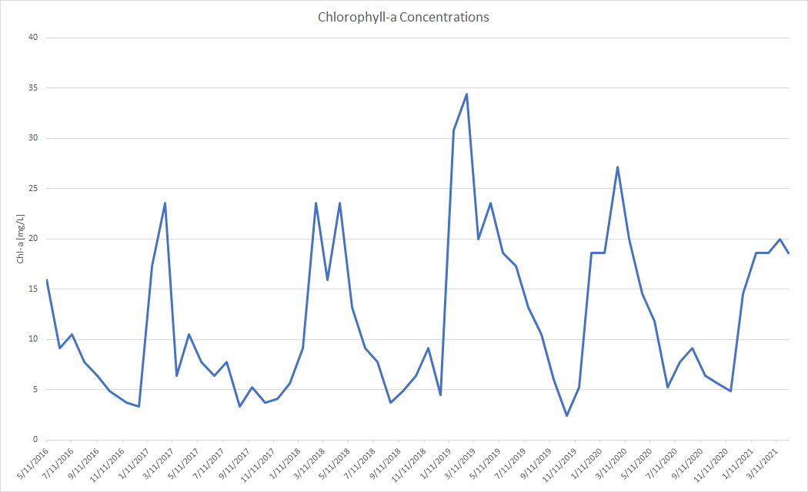

*Figure 2.* This chart shows modeled chlorophyll-a concentrations (mg/L) from May 2016 to April 2021.

The timeseries of remote sensing derived chl-a concentration shows a temporal trend of peaks and troughs during the different seasons (Figure 2). The peaks correspond to the dry season months, and the troughs to the wet season. This echoes MRC *in situ* data, which suggested a similar pattern of ebbs and flows. To cross-validate our findings against the MRC data, we ran a statistical t-test: two-sample assuming unequal variance (Table 2). Our null hypothesis, H0, stated that there was a mean difference value of 0 between *in situ* values and remote sensing product outputs for chl-a concentrations. Our alternative hypothesis, Ha, was that we expected to see a significant difference in chl-a concentration values between *in situ* data and data derived from remotely sensed products. Our results determine that at a 95% confidence level, due to the p-value being smaller than our Alpha (0.05), we reject the null hypothesis that there is no significant difference in the means of each sample. This signifies that the differences in sample means were too great, and the variance too significant to accept the complete use of remote sensing in place of *in situ* observation for chl-a concentration calculation.

Table 2.

*A t-Test: Two-Sample Assuming Unequal Variances run in Excel*

|  |  |  |
| --- | --- | --- |
|  | Variable 1 (remotely sensed) | Variable 2 (*in situ*) |
| Mean | 11.94923 | 22.50556 |
| Variance | 58.4291 | 360.7244 |
| Observations | 60 | 146 |
| Hypothesized Mean Difference | 0 |  |
| Df | 204 |  |
| t Stat | -5.68784 |  |
| P(T<=t) one-tail | 2.21 × 10-8 |  |
| t Critical one-tail | 1.652357 |  |
| P(T<=t) two-tail | 4.42 × 10-8 |  |
| t Critical two-tail | 1.971661 |  |

With the current data, our validation fails the t-test. We attribute this to several limitations including the lack of information in the spatial and temporal variance accompanying both remote sensing and *in situ* data. Our analysis of chl-a concentration accounting for a monthly median aggregate of the entire lake differs significantly from the *in situ* data, which represents a single sample point on the lake. It must be noted that the *in situ* data, while valuable, is inconsistent and may have human error associated with the data collection process. The data received from the MRC lacks the necessary metadata notifying users of the methods of acquiring it and the standards ensuring its accuracy. These uncertainties must be accounted for when testing the feasibility of these analyses.

***4.1.2 SWAT***

With our additional inputs, the SWAT model produced repeatable and precise values for the Tonlé Sap watershed, showing clear dry and rainy season cycles. These data demonstrate that SWAT is able to correctly model watershed dynamics over time, particularly when provided with all optional weather and stream location data. Particularly with Total Suspended Sediment (TSS), the model returned clear data that properly correlated with Cambodia’s dry and wet seasons, as illustrated in Figure 3. We determined that SWAT was able to model watershed dynamics of suspended sediments over time, but to achieve both precision and accuracy surrounding Tonlé Sap’s unique hydrology, further processing steps and *in situ* data validation must occur.

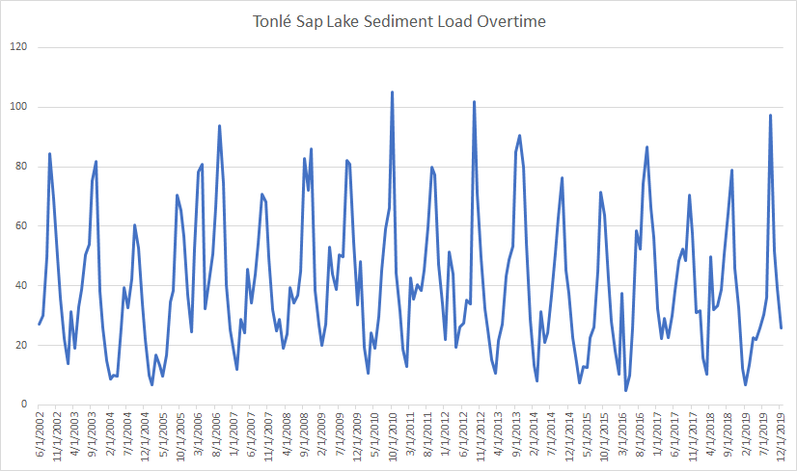

*Figure 3.* Modeled TSS (mg/mL) from June 2002 to December 2019.

However, as Figure 4 shows, while these data were precise and correctly responded to seasonal changes, they did not correlate with observed basin data. In particular, the observed extreme peaks in sediment, nitrogen, and phosphorus load were not reflected in the SWAT model. This is likely due to a variety of factors. The first is the Tonlé Sap River reversing in direction and back-flowing into the lake during the start of the rainy season, a phenomenon that is not modeled in SWAT. The lack of *in-situ* data also precluded us from calibrating the model. Landcover flow and runoff coefficients were drawn from a global dataset, and it is likely that researching local parameters would have improved the accuracy of the model. Removing these limitations represents an avenue for future research.

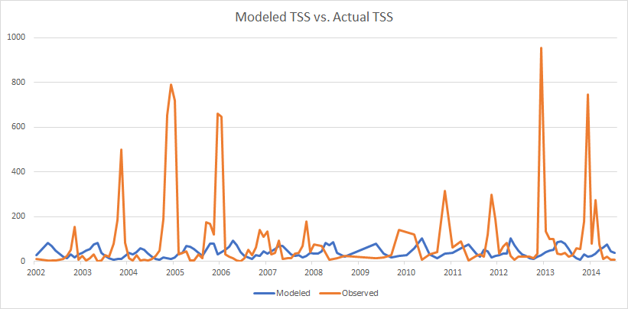

*Figure 4.* Modeled (blue) vs. Actual (orange) TSS (mg/mL) over time.

***4.1.3 MODIS NDVI***

We used Terra MODIS-derived NDVI as a proxy for bank modification, a sub-indicator of basin condition within the FHI. By analyzing green vegetation change over time, areas that have exhibited major bank modification are quickly pointed out. Figure 5 tracks the fluctuations of MODIS NDVI over 20 years.

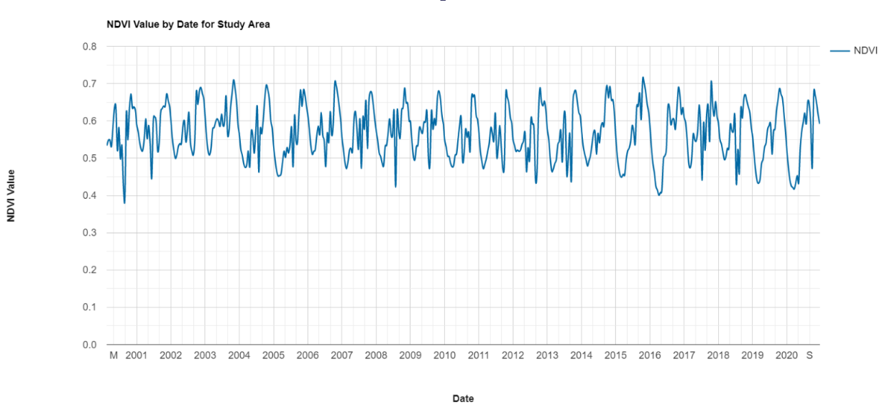

*Figure 5.* Terra MODIS NDVI outputs spanning January 1st, 2000 to December 31st, 2020.

The results from our GEE script output reveal that the greenness of the Tonlé Sap basin slightly decreased over our study timeframe. The fluctuations seen in Figure 5 are attributed to the seasonal wet and dry seasons of the Tonlé Sap Lake. The reversing of the Tonlé Sap River during October creates peak NDVI values, signifying a higher photosynthetic capacity. As the dry season approaches in April, NDVI falls from approximately 0.7 to 0.45, then gradually increases with the transition to the wet season. This pattern is consistent over the 20-year study period, and a decline is exhibited in the maximum NDVI values from 2000 to 2020.

***4.1.4 Groundwater Storage Depletion***

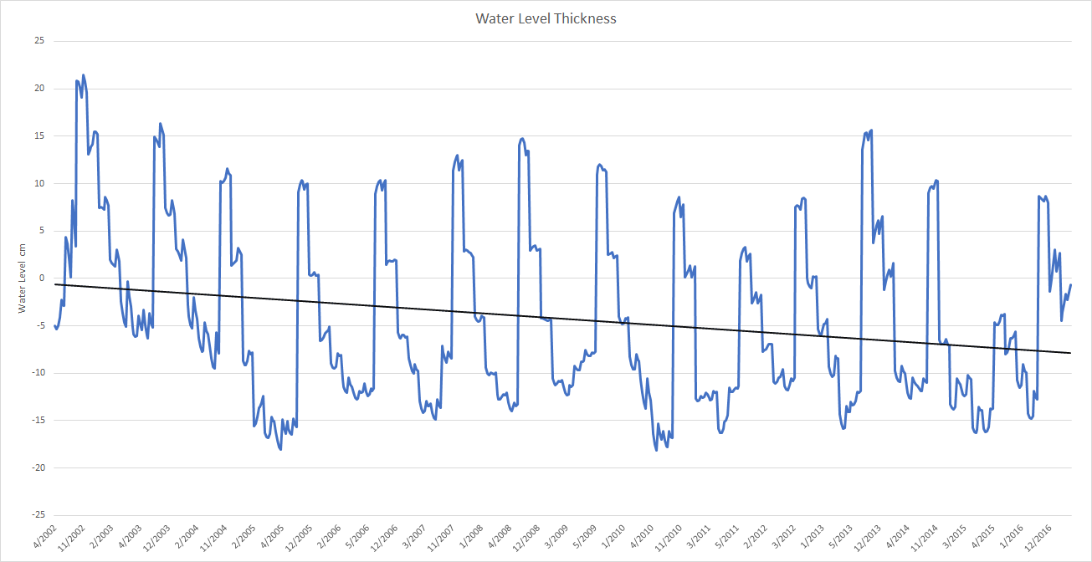

*Figure 6.* Dropping water levels signify groundwater storage depletion.

Our assessment of groundwater storage depletion in the Tonlé Sap basin using GRACE data reveals a slight declining trend in the water table over time (Figure 6). These groundwater changes reflect local groundwater responses driven by anthropogenic influences and seasonal climate variations. Comparing against historical *in situ* data and trends, we can confidently accept the use of remote sensing for calculating groundwater storage content. This study confirmed the feasibility of remotely-sensed data products as a proxy for water storage metrics as a sub indicator of water quantity parameters within the FHI tool. A limitation of our methodology was the inability to separate the different components of groundwater storage. We were unable to account for soil moisture, snow/water equivalent, or surface water individually, which are all important indicators in the total water storage. Nevertheless, GRACE liquid water thickness data are still a reasonable proxy for groundwater, and removing these additional components represents an avenue for future research.

***4.2 Future Work***

Furthering this project would involve gaining access to more comprehensive *in situ* flow, nitrogen, phosphorus, suspended sediment load, and chlorophyll-a concentration data for the Tonlé Sap Lake and the surrounding basin. This would allow for the full validation and calibration of models for more accurate representation of the basin’s freshwater health. Additionally, the code developed during the project could be released with a graphical user interface to make end-user application easier. Cross comparisons between NDVI values and crop health, water storage, or pollutant levels could provide useful metrics for the FHI tool. With these cross comparisons, NDVI could not only be used to speed up the bank modification process, but as a standalone bank modification proxy. Finally, as noted earlier, we were unable to remove the additional GRACE liquid water thickness components, so completing this step could be a significant source of future work.

# 5. Conclusions

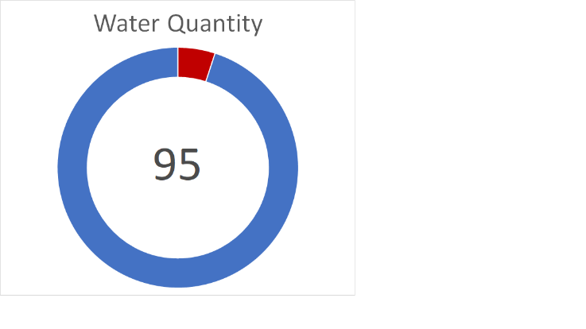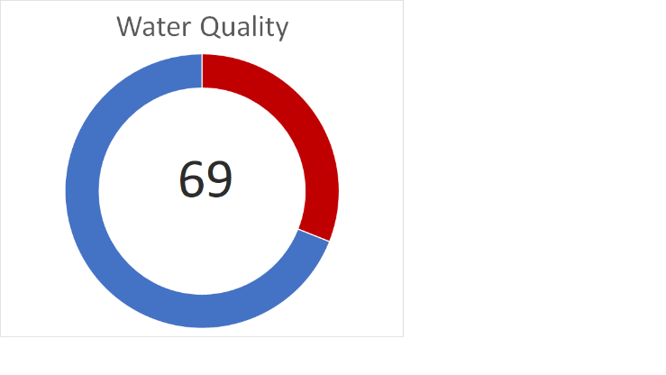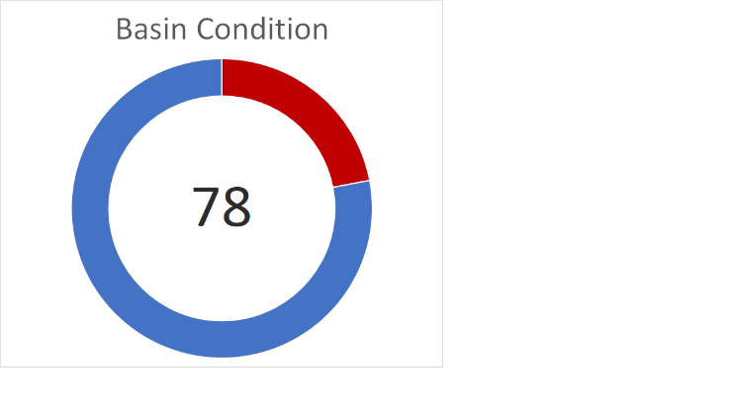

*Figure 7.* The FHI sub-indicator results based on our analyses. These scores are considered to reflect the current condition of the sub-indicators. That being said, FHI inputs for each sub-indicator vary widely in time scale and quantity requirements. For example, monthly median values from the past few years to the past twenty years were collected for some parameters.

Our results have several implications for our project partners and the applicability of remotely sensed data for the FHI. First, while we were able to develop a SWAT model that uses only remotely-sensed data to produce repeatable, precise values, there are significant differences when these results are compared with *in situ* data. These results lead us to conclude that while remotely sensed values are capable of augmenting *in situ* data collection by filling in missing values, the methodology presented here does not produce data that can completely replace *in-situ* data in a Tonlé Sap SWAT model. This is of particular note because calibration of the SWAT model is extremely difficult without *in situ* data available for at least a quarter of the study timeframe.

We additionally conclude that chlorophyll-a concentrations for inland lakes can be derived from Terra MODIS. However, without further calibration, the values are significantly different than *in situ* data for the Tonlé Sap Lake. In order to retrieve accurate values from remotely sensed imagery, our study indicates that calibrating the image color against lake water color is required, particularly in the sediment rich water of the Tonlé Sap.

Determining the percentage of modified bank area is an important input to the FHI that can involve scouring aerial photography over time for landscape changes. NDVI is an effective proxy for speeding up this process, as large changes in greenness are frequently associated with either the addition of impervious surfaces (a negative change) or the construction of farms (a positive change). Thus, an NDVI timeseries computed over a region of interest can be easily used to streamline the location of modified areas. It also has the potential to be used directly as a bank modification statistic if local calibration and adjustment statistics are properly applied.

Finally, while decreasing groundwater storage is currently a secondary concern within the community, with increased tourism, dam construction, and agricultural development in the region, groundwater will become an increasingly important metric to monitor going forward. We have also determined that GRACE data is fully capable of replacing *in situ* groundwater metrics for the FHI, particularly when surface water storage data are available to adjust the liquid water thickness data recorded in GRACE. Even in the absence of surface water storage data, however, GRACE metrics are still a meaningful proxy for groundwater.

Despite these uncertainties, we calculated sub-indicator FHI scores for the Tonlé Sap Basin based on our analyzed inputs (Figure 7). Future validation and calibration work can improve the remote sensing inputs and, therefore, the scores’ accuracy. More robust FHI scores can better guide decisions in policy that will impact the future of the Tonlé Sap Basin.

# 6. Acknowledgments

We’d like to thank Adriana Le Compte, our fellow at NASA DEVELOP LaRC, for providing much needed support throughout the DEVELOP term and making our time within the program a memorable one. Thank you to Dr. Venkataraman Lakshmi at the University of Virginia and Dr. Derek Vollmer at Conservation International for advising us each week and keeping us on track to achieve our project objectives. Manh-Hung Le at the University of Virginia was invaluable to our team for his expertise in SWAT, as he helped guide us through every complexity of the model. Lastly, we’d like to thank Dr. Kenton Ross at NASA Langley Research Center for meeting with us throughout the term to provide essential answers to our questions regarding data analysis and so much more.

This material contains modified Copernicus Sentinel data (2021), processed by ESA.

Any opinions, findings, and conclusions or recommendations expressed in this material are those of the author(s) and do not necessarily reflect the views of the National Aeronautics and Space Administration.

This material is based upon work supported by NASA through contract NNL16AA05C.

# 

# 7. Glossary

**CCI** – Copernicus Climate Initiative. Run by the European Space Agency (ESA), CCI provides several reanalyses of Copernicus satellite data. For our project, we utilized the landcover classification maps

**Earth observations** – Satellites and sensors that collect information about the Earth’s physical, chemical, and biological systems over space and time

**FAO** – Food and Agriculture Organization of the United Nations. An agency of the United Nations whose mission is to combat global hunger. To this end, they have created several publicly available data products for the benefit of improving agricultural systems. We utilized their Digital Soils Map of the World (DSMW) for soil classification inputs for the SWAT model.

**FHI** – Freshwater Health Index. The FHI gives scientists and policymakers easily understandable metrics on the health of freshwater watersheds. It does so by combining a series of weighted inputs of basin information and returning a series of scaled (0 to 100) indicators.

**GEE** – Google Earth Engine. A global, cloud-based, geospatial data acquisition and processing toolbox that our team utilized for acquiring all the SWAT inputs and performing all data processing for the other FHI inputs

**GRACE** – Gravity Recovery and Climate Experiment. GRACE consists of twin satellites, positioned on opposite sides of the Earth, that measure the strength of Earth's magnetic field at locations across the surface. This data is able to be derived into information about water storage, the use case of our project.

**MODIS** – Moderate Resolution Imaging Spectroradiometer. Capturing 36 spectral bands, MODIS is useful for documenting large landscape and climate changes worldwide, with its high temporal but low spatial resolution.

**NDVI** – Normalized Differentiated Vegetation Index. A measure of pixel greenness, NDVI is utilized for identifying plant material in remotely sensed imagery. We utilized NDVI for the computation of bank modification in the Tonlé Sap Basin.

**SWAT** – Soil and Water Assessment Tool. SWAT is a model used for simulating water quality and quantity data from weather, land use, soil type, and stream location inputs.

**Water thickness** – GRACE measures changes in gravity, which are attributed to changes in mass. Most of these changes occur in a surface layer of water that has a certain thickness and correlates to water level and storage.

# 8. References

Carlson, R. E. (1977). A trophic state index for lakes. *Limnology and Oceanography*, 22(2), 361–369.

Didan, K. (2015). *MOD13Q1 MODIS/Terra Vegetation Indices 16-Day L3 Global 250m SIN Grid V006* [Data set]. NASA EOSDIS Land Processes DAAC. https://doi.org/10.5067/MODIS/MOD13Q1.006

Fischer, G., Nachtergaele, F., Prieler, S., van Velthuizen, H. T., Verelst, L., & Wiberg, D. (2008). *Global Agro- ecological Zones Assessment for Agriculture (GAEZ 2008)*. IIASA, Laxenburg, Austria and FAO, Rome, Italy.

Kriegler, F. J., Malila, W. A., Nalepka, R. F., & Richardson, W. (1969, October 13–16). *Preprocessing transformations and their effects on multispectral recognition* [Paper]. Proceedings of the 6th International Symposium on Remote Sensing of Environment, Ann Arbor, MI: University of Michigan, 97–131.

Landerer, F. 2021. TELLUS_GRAC_L3_CSR_RL06_LND_v04. Ver. RL06 v04. PO.DAAC, CA, USA. Dataset accessed 2021-10-08 at https://doi.org/10.5067/TELND-3AC64

NASA JPL (2021). NASADEM Merged DEM Global 1 arc second V001. Distributed by OpenTopography. Data accessed 2021-10-01 at https://doi.org/10.5069/G93T9FD9

Oeurng, C., Cochrane, T. A., Chung, S., Kondolf, M. G., Piman, T., & Arias, M. E. (2019). Assessing climate change impacts on river flows in the Tonlé Sap Lake basin, Cambodia. *Water*, *11*(3), Article 618. https://doi.org/10.3390/w11030618

Ritchie, J. C., Zimba, P. V., & Everitt, J. H. (2003). Remote sensing techniques to assess water quality. *Photogrammetric Engineering & Remote Sensing*, *69*(6), 695 –704. https://doi.org/10.14358/PERS.69.6.695

Rodell, M., Chen, J., Kato, H., Famiglietti, J. S., Nigro, J., & Wilson, C. R. (2007). Estimating groundwater storage changes in the Mississippi River basin (USA) using GRACE. *Hydrogeology Journal, 15*(1), 159 –166. https://doi.org/10.1007/s10040-006-0103-7

Shaad, K. and Alt, H. (2020). An open source toolbox for integrating freshwater social-ecological indicators in basin management. *Journal of Open Research Software, 8*(1), Article 9. http://doi.org/10.5334/jors.291

Son, N. T., Chen, C. F., Chen, C. R., Chang, L. Y., & Minh, V. Q. (2012). Monitoring agricultural drought in the Lower Mekong Basin using MODIS NDVI and land surface temperature data. *International Journal of Applied Earth Observation and Geoinformation, 18,* 417–427. https://doi.org/10.1016/j.jag.2012.03.014

Touch, T., Oeurng, C., Jiang, Y., & Mokhtar, A. (2020). Integrated modeling of water supply and demand under climate change impacts and management options in tributary basin of Tonle Sap Lake, Cambodia. *Water*, *12*(9), Article 2462. https://doi.org/10.3390/w12092462

Vallegos, M., Johnson, J., Phelps, S., & Scarmuzza, J. (2021). *Evaluating the Effects of Land Use and Hydrological Change on Ecosystem Vitality using Remotely-Sensed Data in the Tonlé Sap Lake Basin*. [Unpublished Manuscript]. NASA DEVELOP National Program. https://develop.larc.nasa.gov/2021/spring/TonleSapAg.html

Wang, Y., Feng, L., Liu, J., Hou, X., & Chen, D. (2020). Changes of inundation area and water turbidity of Tonle Sap Lake: Responses to climate changes or upstream dam construction? *Environmental* *Research Letters*, *15*(9), Article 0940a1. https://doi.org/10.1088/1748-9326/abac79