Hawai’i Water Resources
Monitoring the Impacts of Land-Based Sources of Pollution on Water Quality Along the Coast of West Maui, Hawai’i, to Assess Coral Reef Condition


Technical Report

Arev Markarian (Project Lead)
Emily Deardorff
Arthur Platel
Sophia Skoglund

Dr. Juan Torres-Pérez, Bay Area Environmental Research Institute, NASA Ames Research Center (Science Advisor)

1. Abstract
West Maui is at risk of losing ecosystem services provided by coral reefs due to land-based sources of pollution (LBSP). In 2011, the US Coral Reef Task Force (USCRTF) identified the West Maui watershed as a priority watershed (along with its sub-watersheds of Wahikuli, Honokōwai, Kahana, Honokahua, and Honolua) after decades of coral decline, giving rise to the multi-agency West Maui Ridge to Reef (R2R) Initiative. The DEVELOP Hawai’i Water Resources team partnered with the R2R Initiative and the Hawai’i Department of Land and Natural Resources Division of Aquatic Resources (DLNR-DAR) to address the need for better watershed management practices. The team provided the partners with a Google Earth Engine tool that displays land use and land cover changes (LULCC) in the five watersheds and detects near-shore turbidity, chlorophyll-a (chl-a), and sea surface temperature using Landsat 4 Thematic Mapper (TM), Landsat 5 TM, Landsat 7 Enhanced Thematic Mapper Plus (ETM+), Landsat 8 Operational Land Imager (OLI), Terra Moderate Resolution Imaging Spectroradiometer (MODIS), and Aqua MODIS. Team members used ancillary data provided by the R2R Initiative and the USGS Pacific Coastal and Marine Science Center (PCMSC) to validate satellite parameter values. The land cover analysis captured a general trend of increasing impervious cover and decreasing vegetated cover from 1989 to 2019; however, the extent of this change varied between each watershed. This analysis, coupled with the tool, can help project partners continually monitor terrestrial and marine patterns associated with coral decline.

Keywords
remote sensing, Landsat, land use and land cover change (LULCC), turbidity, coral reefs, Google Earth Engine

2. Introduction
  - Background Information
Maui, Hawai’i is the second largest island in the Hawai’ian archipelago and is located between the Big Island of Hawai’i and Moloka’i, approximately 2,500 miles off the west coast of the United States (Fig. 1). The island was formed by two shield volcanoes, West Maui Mountain (now West Maui) and Haleakala, which are connected by a low-lying isthmus.
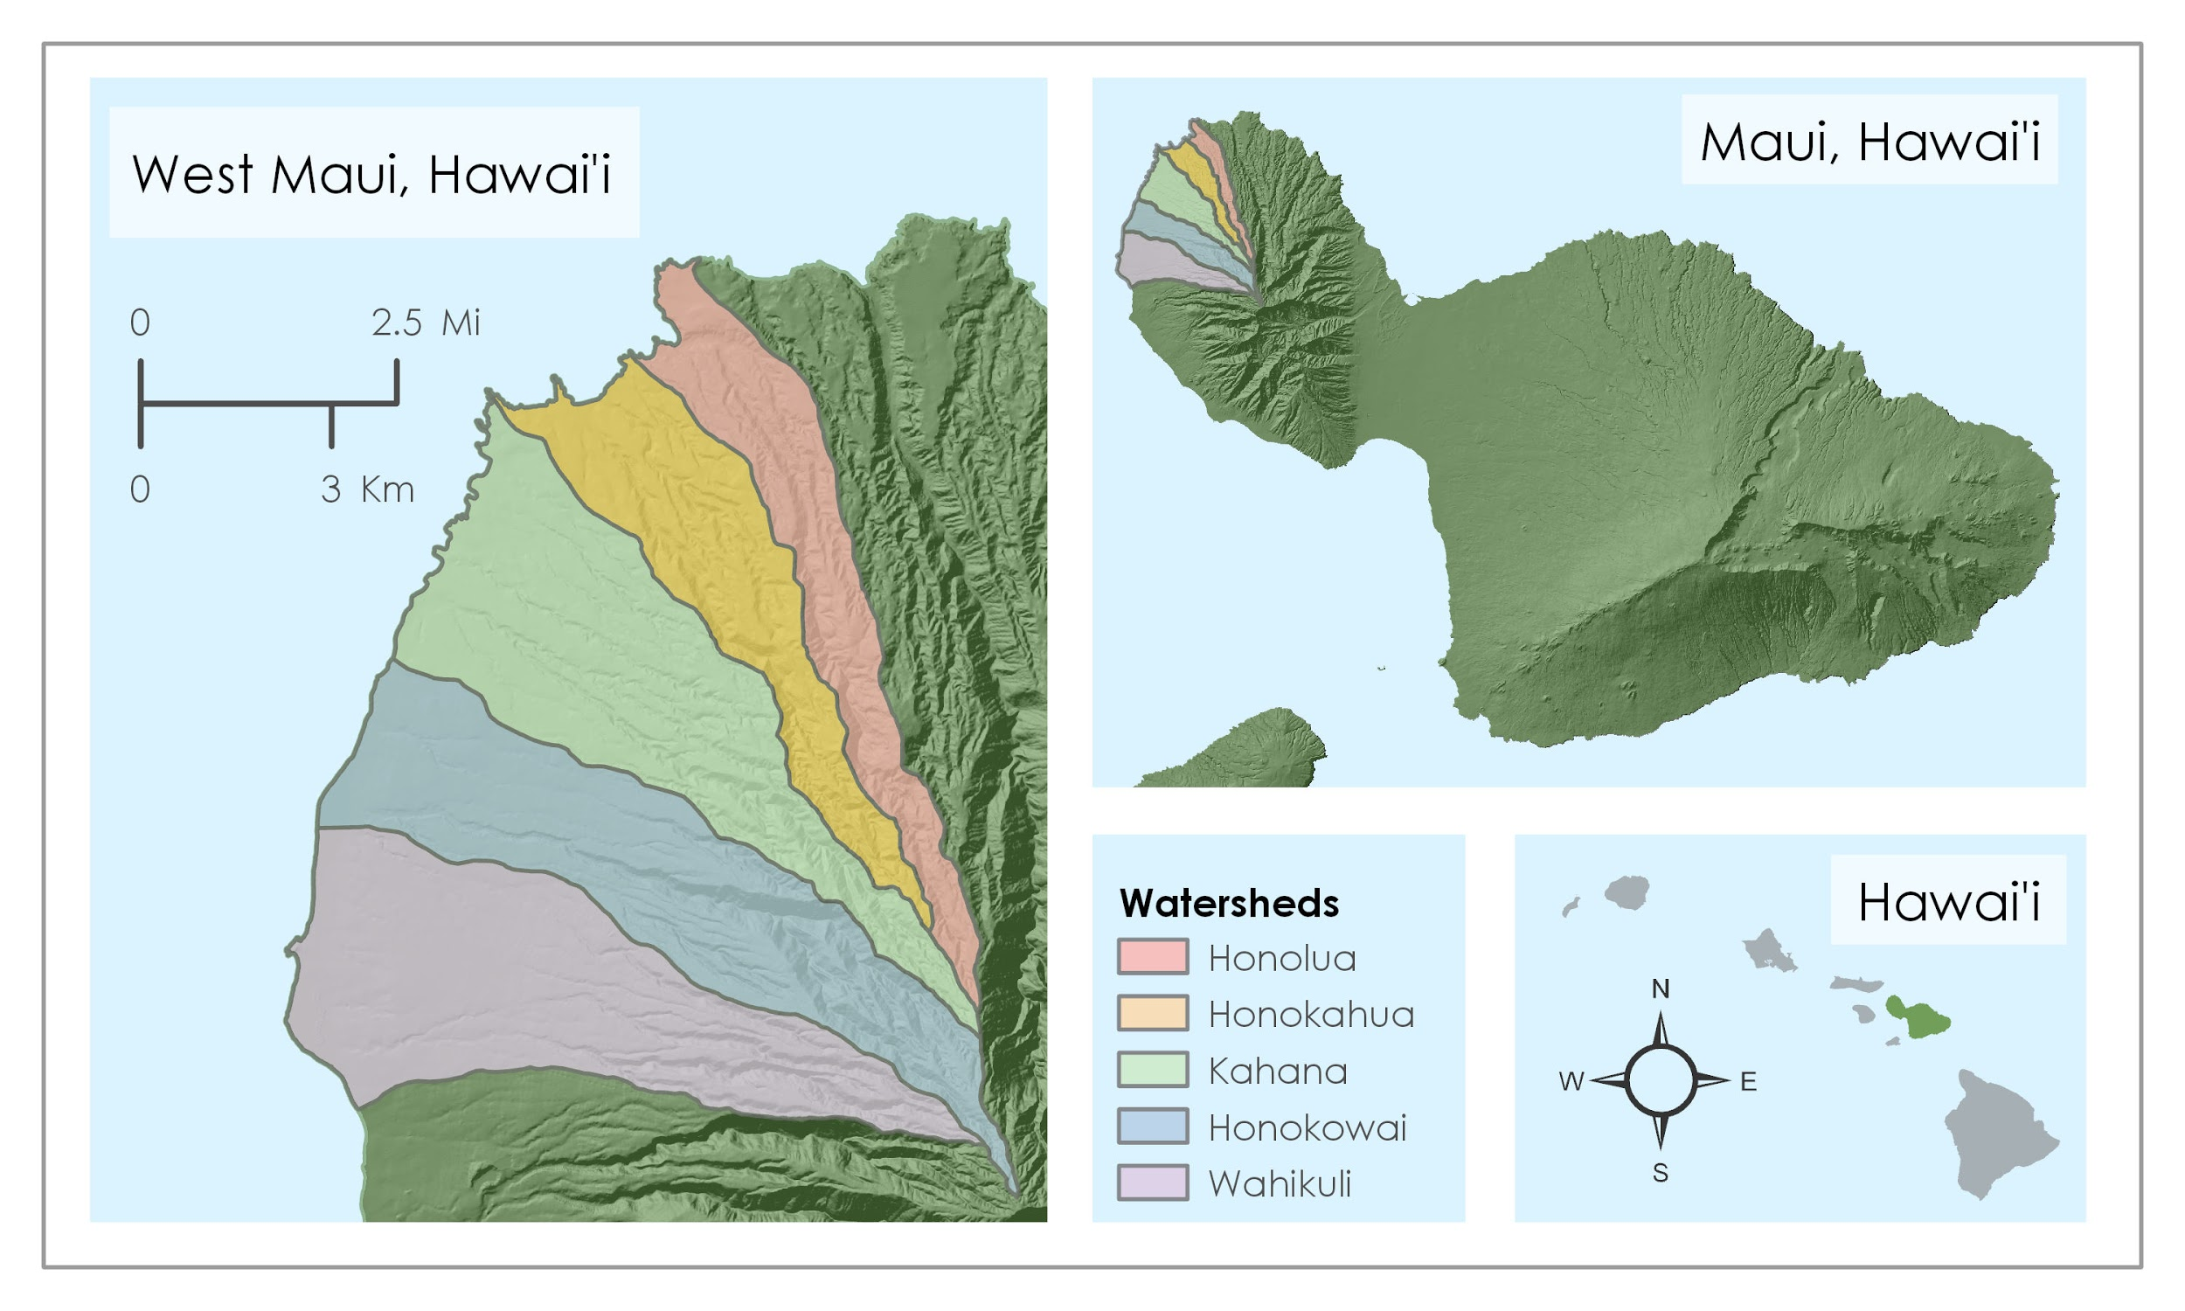
Figure 1. The study area is comprised of five watersheds in West Maui, HI.
This geology offers a steep vegetated terrain with shallow embayments composed of easily erodible basalt. The average temperatures are between 17°C and 31°C, with a wet season from October to April (US News, n.d.) and average annual rainfall between 200 and 300 cm (Department of Geology and Geophysics, n.d.).
West Maui is the western peninsula of Maui, which is surrounded by diverse coral reef beds that provide measurable economic and ecological benefits to the community. Reefs protect the shoreline and are habitat for many marine species while also attracting tourists for recreation and environmental education (Cesar & van Beukering, 2004). High volumes of visitors to the island promote development, and the popularity of the island as a destination has led to a population increase of 40 percent in the last two decades (Department of Planning, 2018).
Contemporaneous with these terrestrial changes, coral reef cover off the coast of West Maui has decreased between 30 and 75 percent in the last two decades (PIFSC, 2017). In response to this decline, the U.S. Coral Reef Task Force (USCRTF) identified West Maui watershed as a priority watershed (along with its sub-watersheds of Wahikuli, Honokōwai, Kahana, Honokahua, and Honolua) for coral reef protection in 2011, which has underscored an increasing effort across agencies to protect these valuable habitats (Figure 1). The steep terrain of the region, coupled with its tropical climate, results in high sediment flow from the heights of the mountains, through the embayments, and into near-shore waters (Department of Geology and Geophysics, n.d.). Heavy development and overgrazing from feral livestock is destabilizing soil and leading to more erosion (Timmons, n.d.). Sugarcane and pineapple production was also phased out during this period in the island’s history (Silver, 2013). These land based sources of pollution (LBSP), along with other environmental factors, drive the decline of coral reef coverage along the western coast of Maui.
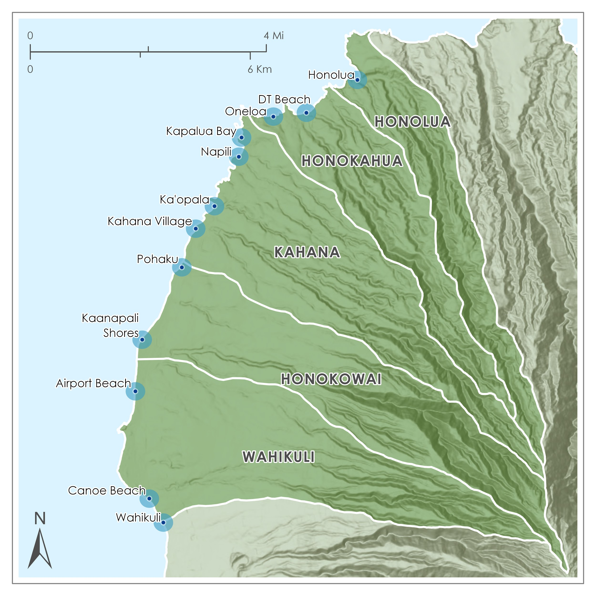
While the USCRTF has recently initiated citizen science efforts to monitor water quality through the West Maui Ridge to Reef Initiative (R2R), Hui O Ka Wai Ola group, limited funding and capabilities still result in insufficient monitoring. There are currently thirteen sampling sites along the five priority watersheds that are monitored by Hui O Ka Wai Ola (Figure 2). To monitor at a greater spatial and temporal scale, several studies have employed satellite remote sensing in environmental data collection efforts. Satellite-derived datasets have enabled the quantification of environmental and anthropogenic drivers on coral cover, supporting individual and cumulative impact analyses that reveal complex systems of relationships between land and water in Hawai’i (Wedding et al., 2018).

Figure 2. Thirteen sampling sites monitored by citizen science group Hui O Ka Wai Ola within our study area. Buffer zones around these sites are denoted in light blue and were used to remotely aggregate water quality data.

Classifying land use land cover change (LULCC) using remotely sensed data has also proven effective for island-scale analyses (Keuchel et al., 2003). There are efforts to ground-truth and validate satellite imagery for use in ocean waters ranging from deep, turbid waters to shallow, clear reef waters (Wei et al., 2018).
Building off the progress made by those previous studies, this project focuses on investigating the historical changes in water quality as a consequence of LULCCs within the five priority watersheds of West Maui: Wahikuli, Honokōwai, Kahana, Honokahua, and Honolua. Monitoring the water quality surrounding coral reefs via proxies including turbidity and chlorophyll-a (chl-a) can encourage better watershed management upstream. Watershed managers have had limited capacity for conducting historical and present-day analyses since the majority of in situ data has only been collected in the last few years. Therefore, this study aims to procure the historic data and analyze ecosystem patterns in the last 30 years and provide a geospatial tool within Google Earth Engine to analyze future trends.
  - Project Partners & Objectives
The Hawai’i Water Resources team, in collaboration with the USGS Pacific Coastal and Marine Science Center, partnered with the West Maui Ridge to Reef Initiative (R2R) and the Hawai’i Department of Land and Natural Resources Division of Aquatic Resources (DLNR-DAR) for this study. These organizations are responsible for statewide marine management and require spatial analysis for effective mitigation. The R2R aims to create management plans for highly impacted watersheds that drain into critical reef habitat, with the goal of facilitating healthier reefs by mitigating LBSP inflows (West Maui Ridge to Reef, n.d.). Previously collected data is either temporally or geographically limited, which has greatly hindered the long-term planning capabilities of R2R. The DLNR-DAR oversees herbivore management, subsistence fishing, and direct restoration efforts in the state. Monitoring the vast coral reef communities along the coastline of West Maui will help identify areas in need of restoration in the future. The USGS Pacific Coastal and Marine Science Center collaborated on the project to provide sediment data for validation of satellite-derived information for recent years. This study aims to classify land cover and land use in West Maui over a 30-year time period to assist partners in detecting patterns of development and to analyze eutrophication and water clarity trends around West Maui annually and seasonally. It also explores the relationship between LULCC and water quality degradation and produces a Google Earth Engine (GEE) application that allows partners to monitor these relationships over time.

3. Methodology
3.1 Data Acquisition
We embedded our imagery acquisition, processing, and analysis into a GEE application we developed called the Terrestrial Impacts on Marine Ecosystems (TIME) Tool. Within the tool, we acquire optical imagery from the GEE data catalog, an online repository that is easily accessed through the platform’s application programming interface. Cloud cover and historical Landsat sensor malfunctions limited the availability of usable imagery, resulting in two seven-year gaps in the data. We drew from the Landsat 4 and 5 Thematic Mapper (TM), Landsat 7 Enhanced Thematic Mapper (ETM+), and Landsat 8 Operational Land Imager (OLI) to obtain usable optical imagery to cover the entire study period (Table A1). Imagery from Terra and Aqua Moderate Resolution Imaging Spectroradiometer (MODIS) provided supplementary sea surface temperature (SST) data to be displayed in the TIME Tool.
In addition to satellite data, several ancillary datasets were compiled to reference within the GEE tool and bolster analysis (Table A2). A regional bathymetry map was used as a guide to identify the outer edge of the shallow nearshore marine habitat, which served as the outer boundary of the coastal portion of the study area. Hydrology and watershed boundary shapefiles were also used to contain data used for analysis. In situ turbidity data were used to evaluate the accuracy of values output by the turbidity algorithms. Precipitation data collected at a gage near Kapalua Airport was compared with near-shore in situ turbidity data collected at a nearby site. Remotely sensed precipitation was used from Daymet to capture regional precipitation levels between watersheds as they differed and was used to display averages in the tool as well.
3.2 Data Processing
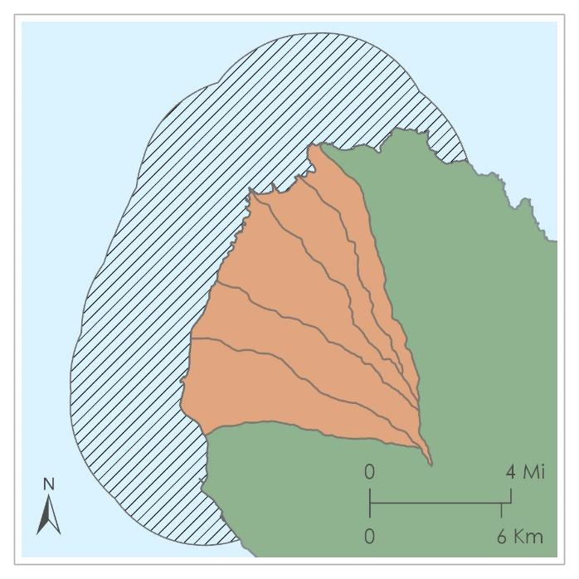
To process our data, we first imported our imagery into the GEE tool starting from 1989 through present day. Next, we masked out the clouds by removing pixels detected to be cloud cover. This was determined by examining spectral characteristics and using pixel quality assessment metadata associated with Landsat imagery. For land cover analysis, the cloud-masked images had to be composited before they could be analyzed. To create composites, the median brightness values of cloud-free pixels were taken for a given year and compiled over the study region to create a single yearly composited image. Finally, the yearly composites were clipped by the five priority watersheds identified by the project partners for land cover analysis while the non-composited individual images were clipped to a region beginning 5m from the coastline and extending 5km offshore for water quality analysis (Figure 3).

Figure 3. West Maui study area divisions. The five priority watersheds for land use analysis are shaded in orange. The hatched area represents the study area for water quality assessment.
3.2.1 Land Cover Classification
The Landsat imagery was classified into five different land cover types: pineapple, other agriculture, vegetated non-agriculture, barren soil, and urban. These classes were selected because they encompass the majority of the land cover observed in the priority watersheds throughout the last 30 years and can be accurately detectable from the 30m resolution Landsat imagery. Land cover types were mapped using the Classification and Regression Tree (CART) supervised classification function in GEE. We chose the CART method due to its consistently high accuracy as compared to other GEE supervised classification methods (Farda, 2017). We considered using a threshold classification method based on pixel values for each training band, but opted for the CART method because of difficulties in differentiating vegetated land cover classes with overlapping spectral values.
This analysis utilized three different satellite image collecting sensors: Landsat 4/5 Thematic Mapper, Landsat 7 Enhanced Thematic Mapper Plus, and Landsat 8 Operational Land Imager. Each sensor records slightly different spectral reflectance values for each band (Table A4). When looking at the histograms of the images collected from each sensor, we determined that the differences in spectral reflectance between sensors were large enough to necessitate the creation of a separate land classifier for each sensor (Table A5).
We selected 100 to 200 training points for each of the five classes in GEE. To train the classifier, the training pixels for each land cover category were sampled for the parameters listed in Table A3 (Rasul et l., 2018; Clow, Cova, Breen, & Zhang, 2019). Using the sampled values for each of the bands and indices, the classifier differentiated the unique spectral characteristics of each land class and accurately identified the land class for each pixel in the image. Due to similarities in spectral reflectance of most agricultural land, pineapple was the only agricultural area that we isolated from other types of agriculture in West Maui. The other agriculture classification encompasses a wide variety of land types, including sugarcane, fallow agriculture, and golf courses.
Our training data was visually validated through the high-resolution free imagery available in Google Earth, with further input being provided by our partners in West Maui. The validation of our land classification was done by employing a GEE confusion matrix to assess the overall accuracy as well as an error matrix to assess the accuracy for each specific land class. The data used to run these validation tests were manually created for each of the classifiers. The classifiers had an average accuracy of 94% across classes.
In addition to the land classification, NDVI change maps were created to further analyze changes in land cover over the study period. These maps were produced in GEE by calculating the NDVI values of two different yearly-composite images and completing an image difference with these values, as shown in Equation 1. Once calculated, the change maps were visualized as a single three-band composite image consisting of the NDVI_{Year 2} as the red band, the NDVI_{Year1} band as the green band, and the NDVI_{Change} as the blue band.

${NDVI}_{Year } = {NDVI}_{Year 2 }- {NDVI}_{Year 1}$ (1)
3.2.2 Water Quality
Several different algorithms were chosen to explore water quality along the West Maui coastline. Examining multiple parameters allowed for the detection of a variety of patterns as well as improved ability to validate the algorithm outputs with field measurements. These algorithms provide measures of water clarity and greenness, derived from ocean color, which give insight on pollution and light availability that affect corals.
Raster layers of turbidity in Formazin Nephelometric Units (FNUs) were produced using the algorithm by Nechad, Ruddick, & Neukermans (2009) (Equation 2).
$Turbidity (FNU) = \frac{A_{T}*ρw}{1-ρw/C}$ (2)
In this function, A_{T} and C are wavelength-dependent calibration coefficients derived from absorption and backscattering with the Inherent Optical Property (IOP) model, while ρw is the water leaving reflectance at red and near-infrared wavelengths highly correlated to turbidity (Nechad et al., 2009). These wavelengths also minimally penetrate the water column, thereby reducing interference by benthic reflectance. For comparison with Hui O Ka Wai Ola’s in situ turbidity measurements, the algorithm output was converted from FNUs to Nephelometric Turbidity Units (NTUs) (Gohin, 2011) (Equation 3).
$Turbidity (NTU) = \frac{Turbidity (FNU)}{1.267}$ (3)
Light attenuation in the photosynthetically active radiation domain (K_{d}(PAR)) was derived from optical imagery using the Landsat-specific algorithm developed by Song et al. (2017) via regression analysis (Equation 4). The blue-red spectral combination was shown to be the most effective in K_{d}(PAR) estimation. The red band typically exhibits strong association with suspended matter, while the blue band’s ability to penetrate the sea surface is thought to mimic the attenuation of light traveling through the water column (Song et al., 2017).
K_{d}(PAR) = -199.75 * (Blue - Red) + 11.702 (4)
A relative measure of chl-a concentration was derived from the satellite imagery with the Normalized Difference Chlorophyll Index (NDCI) created by Mishra & Mishra (2012) (Equation 5). This index displays a raster of relative values between -1 and +1, which allows for application to remote areas that lack in situ data necessary for calibration (Mishra et al., 2014).
$NDCI = \frac{R_{rs}(708) - R_{rs}(665)}{R_{rs}(708) + R_{rs}(665)}$ (5)

Because the algorithm was developed for use on Sentinel-2 MSI imagery, the wavelengths specified in Equation 5 denote bands of that instrument. The Landsat TM, ETM+, and OLI instruments do not have comparable bands centered around the R(708) input, and as a result, the Landsat version of the NDCI incorporates the NIR and red bands and consequently becomes the same function as NDVI.

4. Results & Discussion
4.1 Land Cover Results and Analysis
The results of our land cover change analysis for West Maui from 1989 to 2019 indicate that there have been two widespread land cover shifts during the study period in the 1990’s and early 2000’s in addition to small scale annual changes (Appendix B). These two major shifts correlate with large-scale economic changes that occurred in West Maui as sugarcane and pineapple production were phased out and replaced by tourism as the leading economic driver of the region (Silver, 2013). The first major shift occurred between 1990 and 2000 and is characterized by a significant decrease in agricultural vegetation and increase of barren land in the region (Figure 3). During that period, agricultural vegetation land cover decreased from 22% of the study area in 1990 to only 13% in 2000, a decrease of about 2753 acres (Figure 5).
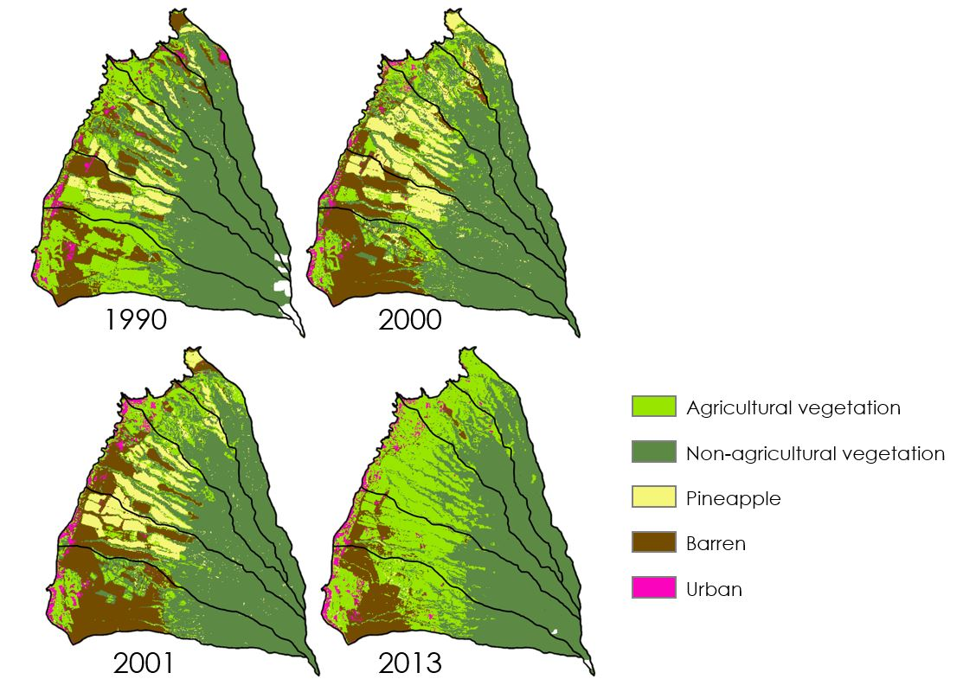
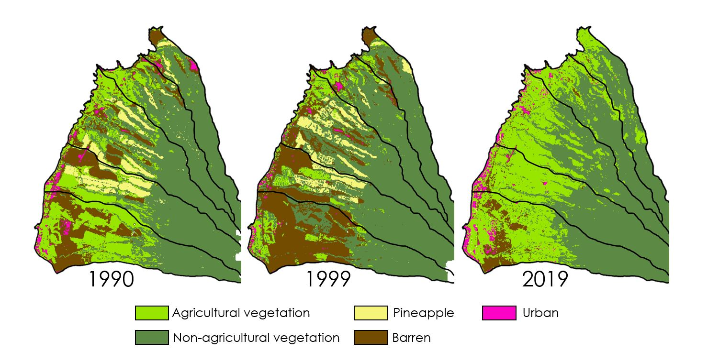
Figure 4. Land cover classifications for the five priority watersheds for 1990, 2000,2001, and 2013 illustrating the phasing out of sugarcane (between 2001 and 2013) and pineapple (between 1990 and 2000) in the region.
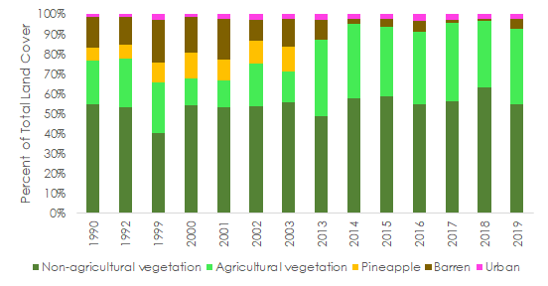
Figure 5. Land cover classifications for the five priority watersheds throughout the study period, displayed as a percentage of the total occupied by each land class (from Landsat 4/5 TM, 7 ETM+, 8 OLI, 2005).
This finding is consistent with the disappearance of sugarcane production that took place in West Maui in the 1990’s due to increasing labor conditions and their associated higher costs (Silver, 2013). Many of the fields initially classified as agricultural vegetation became barren and were then left to grow fallow in the years following the end of sugar cane. The second major shift in Maui's agricultural landscape occurred between 2001 and 2013 in which West Maui saw the near disappearance of pineapple fields in the study area (Figure 4). This result matches the known end of pineapple production statewide indicated by Maui Land and Pineapple Co. Inc., Hawai’i’s largest canned pineapple producer, stopping their planting of pineapple in 2010.
In addition to temporal changes in land cover, there were spatial trends in the agricultural distribution that may have affected nearshore water quality in the past and present. As shown in Figure 6, pineapple production was primarily focused in Kahana and Honokowai watersheds, until its disappearance between 2003 and 2013. Additionally, while we were unable to identify sugarcane individually in the land classification, the largest change in agricultural vegetation, that coincided with the end of sugarcane production in the 1990’s was in the southernmost Wahikuli watershed, where agricultural vegetation decreased 39 percent between 1990 and 2000.

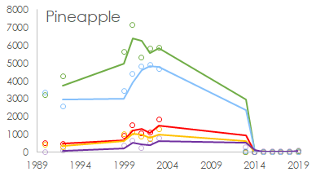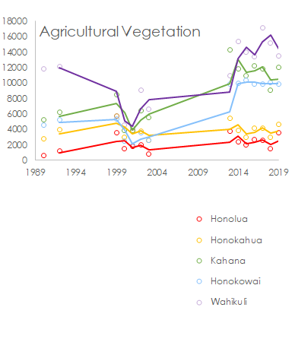
Year
Pixels
Year
Pixels
Figure 6. Amount of pixels classified as agricultural vegetation and pineapple land types for each of the five priority watersheds throughout the study period, displayed as pixel count (from Landsat 4/5 TM, 7 ETM+, 8 OLI, 2005). The trendline for each watershed consists of the moving average with a window of 2.
These spatial trends, which show a majority of the sugarcane and pineapple agriculture collectively in the central and southern watersheds, can also be observed in the NDVI change map over the entirety of our study period from 1989 to 2019 (Figure C1). In this map the highest changes in NDVI are located in the southern and central regions of the study area, indicating regions which were much higher in vegetation in 1989 than in 2019. These regions may reflect fields that were once planted with sugarcane and pineapple in 1989, but were left to grow fallow after their disappearance. Regions classified as agricultural vegetation further north in the study area appear to have much less significant changes in NDVI and could reflect other agriculture that was not phased out, such as golf courses like the Kapalua Plantation Golf Course, that would likely survive.
4.2 Water Quality Results and Analysis
The results of our water quality analysis for West Maui from 1989 to 2019 indicate that spatial variation is greatest within the first kilometer out from shore (Figure 7). NDVI appears to be an inverse of turbidity, which suggests that turbid waters are also less green, characterized by lower chl-a concentrations. The map of K_{d}(PAR) reveals a pattern not seen in the other maps, in which light attenuation is greater adjacent to shore, drops down a short distance from there, and then rises again beyond 1 km out. The increase in K_{d}(PAR) (decrease in clarity) far from shore may be explained by the bathymetry of the area, the ocean current that flows between islands, or a different physical, chemical, or biological feature that influences ocean color.
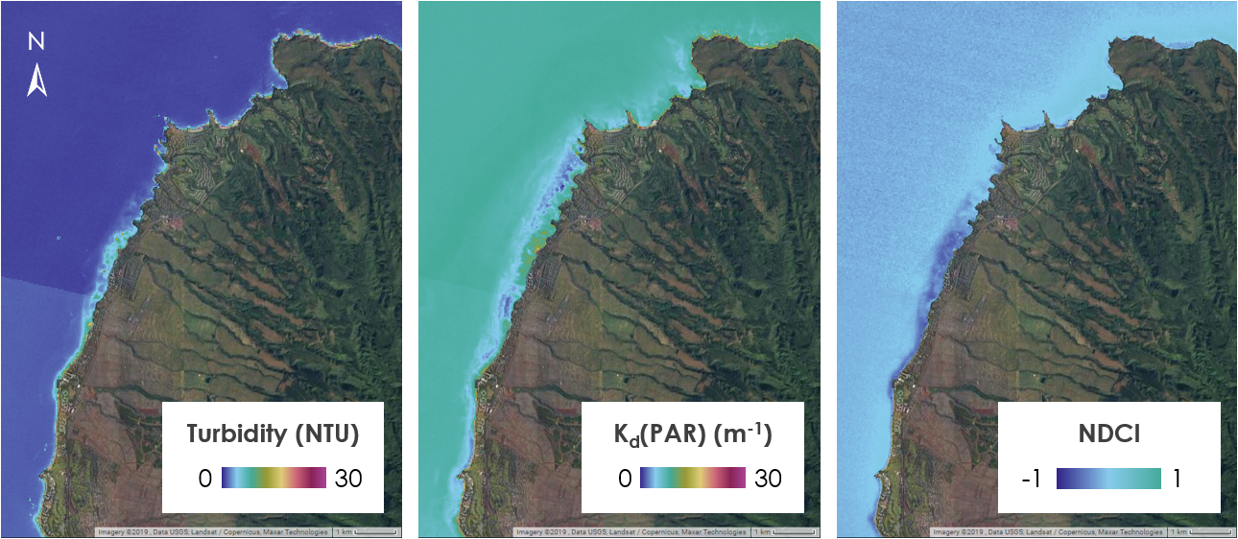
a. b. c.
Figure 7. TIME Tool outputs for (a) turbidity (FNU), (b) K_{d}(PAR), and (c) NDCI on February 10th, 2014 (Landsat 8 OLI).
The patterns seen here generally coincide with the locations of coral reefs. This warrants a note of caution that benthic reflectance of the reefs could be skewing the water quality algorithm outputs. For example, our TIME Tool may detect high turbidity when in fact the high values may be attributed to reflectance off the coral reefs themselves. Water quality data were extracted from the TIME Tool for D.T. Fleming Park, where no reefs are present, and for Kaanapali Shores, where a coral reef is present and may contribute to benthic reflectance (Figure 8). Both sites are located where streams flow into the ocean. Visual analysis of the 2017 data reveals similar value ranges for both locations.
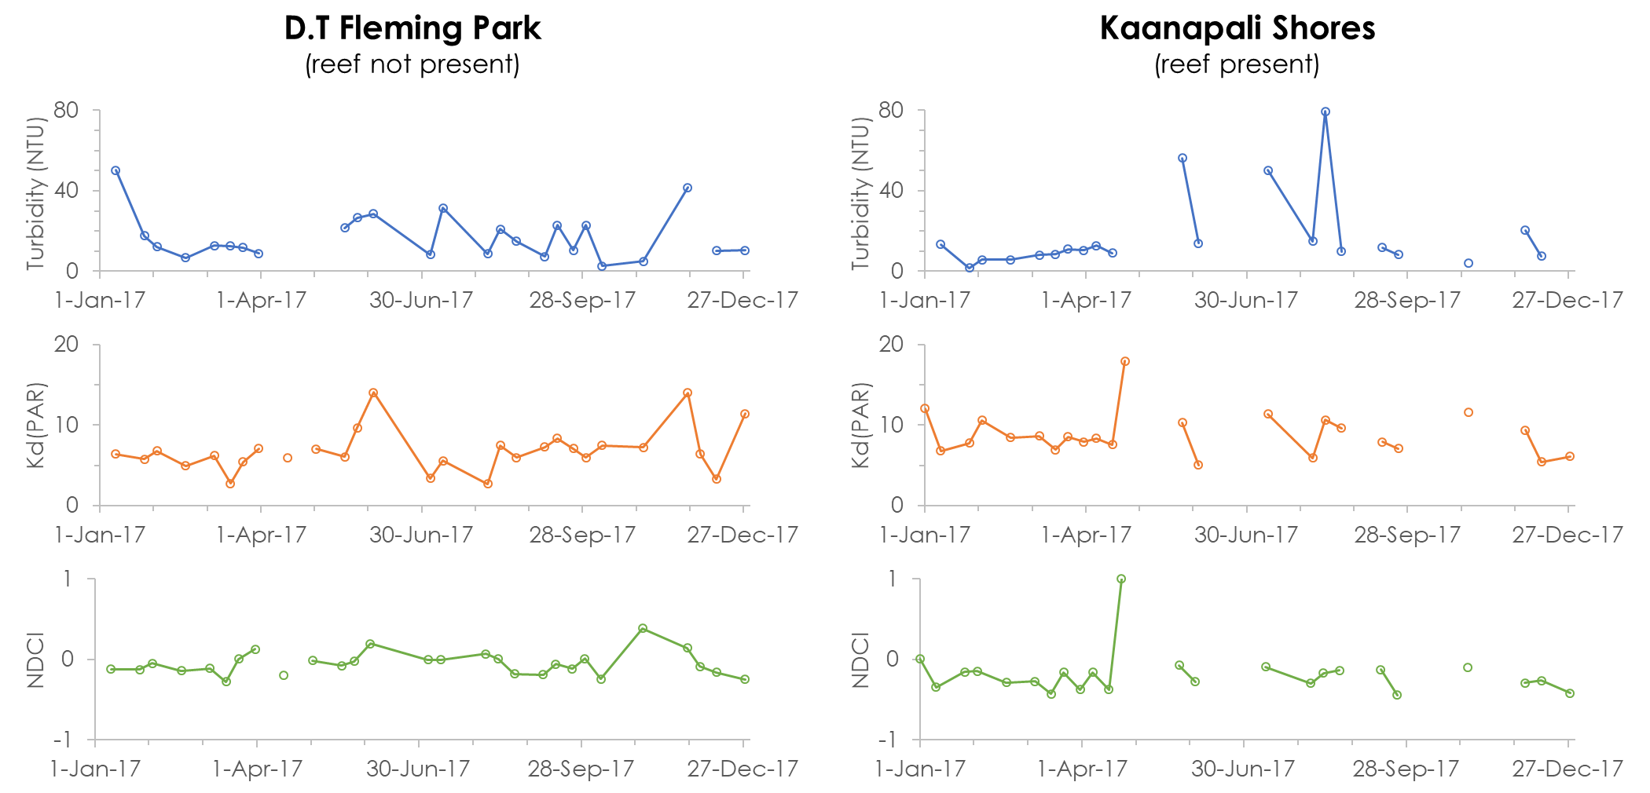
Figure 8. 2016 Time series of model-derived turbidity (FNU), K_{d}(PAR), and NDCI at (a) the D.T. Fleming Park sample site where no reefs are present and (b) the Kaanapali Shores sample site where a coral reef is present.
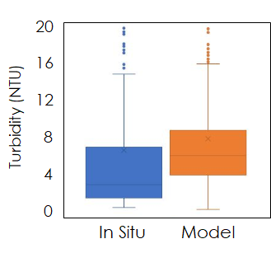
In situ turbidity data from the Hui O Ka Wai Ola citizen science dataset were used to assess the accuracy of turbidity values extracted from the satellite imagery model. The in situ data were matched to model outputs values from imagery collected within three days of the in situ sampling. Once the correct data were extracted, we compared the value range and distribution of the two datasets (Figure 9). These values were also analyzed alongside long-term patterns of precipitation, seasonality, and disturbance. The maximum in situ value is 160 NTU and the maximum model-derived value is 241 NTU for this timeframe.

Figure 9. Box and whisker plot summarizing 509 in situ and 1,112 model-derived turbidity values from January 2016 to October 2019. Note that outliers extend beyond the plot limits, with 14 additional in situ values and 18 additional model output values.

4.3 Trend Analysis
Temporal patterns were sought out between the monitored parameters and turbidity to understand potential relationships. Agricultural vegetation cover increased after 2000; however, this increase is not strongly correlated with changes in water quality. Sea surface temperature was higher than average in certain years throughout the study period, but did not exhibit a significant relationship with turbidity. Of the included variables in this system, precipitation had a significant relationship with turbidity.
The relationship between turbidity and precipitation was explored by comparing the model-derived turbidity, and Daymet V3 precipitation values averaged regionally, as well as in situ turbidity collected at sample sites and rain gage data collected near Kapalua Airport. We would expect precipitation and turbidity to be correlated. As mentioned before, precipitation in the upper watershed will affect the water quality in the lower watershed and the coastline. Remotely sensed precipitation was a strong predictor of turbidity (p = 0.02), and in situ precipitation was a strong predictor of turbidity (p = 0.0007). As seen in Figure 10, high monthly averages of precipitation correlate with high turbidity values compared to the previous month. Lag time was also seen where turbidity increased after precipitation increased.
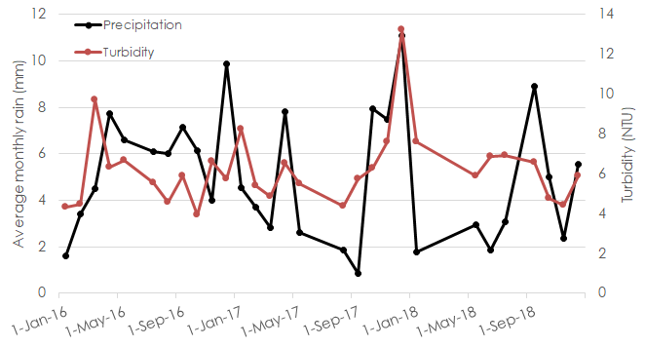
Figure 10. Model-derived precipitation over the Kahana watershed and turbidity from Kapalua Bay 2016-2019.
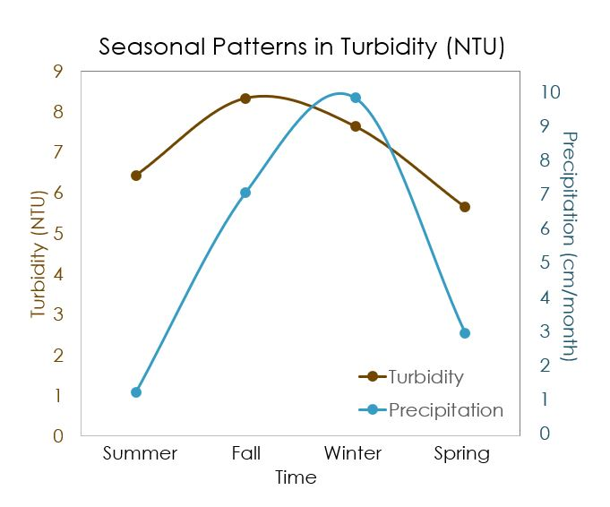
Precipitation did not vary greatly between the five watersheds in the study area, and therefore this comparison within one watershed reflects the general trend seen regionally. One would also expect to have seasonality in turbidity, given seasonality of precipitation over the years. Generally, the wet season is expected to be correlated with higher turbidity values. We found that fall is the season with the highest average turbidity values, followed by winter (Figure 11).

Figure 11. Seasonal precipitation and turbidity values throughout 2016-2019.
The high fall turbidity values correspond with the increase in precipitation as the rainy season begins. Earlier precipitation events seem to cause higher turbidity compared to later precipitation events that occur in the winter. This is likely explained by the following: after the first flush of the season moves the sediment and nutrients off the topsoil, there is less to be carried through runoff later in the season.
There were clear spatial patterns between the watersheds that were revealed by the land classification process. The two northernmost watersheds, Honolua and Honokahua, were characterized by their high amounts of non-agricultural vegetation as well as an increase in agricultural vegetation in the second half of the study period (Appendix D). The two middle watersheds, Honokowai and Kahana, were characterized by the prominence of pineapple farms in the early parts of the study period and the prominence of agricultural vegetation throughout the entire study period. The southernmost watershed, Wahikuli, was characterized by the highest amount of barren land, of which the exact amount fluctuated substantially throughout the study period.
This spatial distribution, particularly that of pineapple and sugarcane, can also be clearly seen in the NDVI change maps (Appendix C). These land shifts occurred most intensely in the Kahana, Honokowai and Wahikuli watersheds (Figure C1c). The usage of land for agricultural purposes correlates with coastal waters having the highest average nitrogen concentrations, as nitrogen-containing fertilizers are used heavily in both pineapple and sugarcane production (Soicher and Peterson, 1997) (Falinski et al., 2019). This effect was observed as higher amounts of nutrient loading, measured by the citizen science group Hui O Ka Wai Ola, in the watersheds where sugarcane and pineapple were most abundant—especially Honokowai, Kahana, and Wahikuli. This finding indicates that nutrients used in pineapple and sugarcane cultivation, specifically nitrogen, may still be present in the soils today, years after the cultivation ended in the region. The Honokowai watershed in particular, showed the highest average levels of nitrogen of the five priority watersheds. The higher levels of nitrogen may be the result of the region’s high pineapple production documented from the beginning of our study until the early 2000’s (Figure B2) along with the watershed often having the second highest yearly average precipitation of the five priority watersheds.
It was also noted by our partners at the Ridge to Reef initiative, that the water quality near the Honolua watershed was most dramatically impacted by sedimentation (Tova Callender, “Personal Correspondence”, Sept. 25, 2019). While we did not notice any specific trends in land cover that may account for this, the Honolua watershed received the highest levels of precipitation in 2013, and the higher precipitation may be responsible for increased erosion and subsequent coastal sediment runoff.

4.4 Limitations

Due to high amounts of cloud cover and Landsat system malfunctions, there are two 7-year gaps in our thirty-year analysis. The first gap occurs between 1992 and 1999, and the second gap occurs between 2003 and 2012. These time gaps hindered our ability to study the detailed processes of land change that occurred during this time frame, so we were required to interpolate the land classes during these periods in our analysis. Since water quality is more erratic than land cover, the gaps in our datasets prevented us from studying the water quality during the years in which we lacked data.
Another limitation that we encountered was the lack of accurate water quality algorithms to use. Satellite imagery water quality algorithms have largely been developed for individual locations, so their validity is heavily diminished when they are applied to a new location. It was difficult to find reliable ocean water quality algorithms suited for the clear and shallow coastal waters of West Maui, with ‘a particular shortage of high-quality chlorophyll-a algorithms for the area. This means that the water quality values output by the TIME Tool should not be directly compared with in situ values or values generated from outside the tool.
We also found that coral reef bottom reflectance inhibited our ability to accurately detect turbidity and K_{d}(PAR), although this interference did not have a uniform extent over the coral reefs in the region. Due to this interference, we would recommend that tool users interested in turbidity or K_{d}(PAR) in a coral reef area examine the values of areas just outside of the coral reef polygons supplied in the tool.
Another factor that could have influenced the results is seasonality. We found that detected changes in land cover and water quality may be strongly influenced by the dates during which data is available. For example, high turbidity events are known to occur during and after intense rain events, which occur when there is substantial cloud cover. This seasonal impact would likely cause the turbidity outputs from the rainy season calculated by the tool to skew lower, if averaged over a large amount of time. It is also likely that seasonal changes impacted the land classifications and NDVI change outputs, especially if a given year has had significant changes in precipitation from the training year. In order to account for the potential of a seasonal impact, it is important to reference the precipitation values provided by the tool. If two years have substantially different precipitation patterns, this will likely cause a difference in NDVI and potentially a difference in land classification.
4.5 Future Work
To further this study, we would recommend employing Sentinel imagery for land classifications and producing WQ algorithms to produce water clarity rasters in missing years of data. To strengthen the accuracy of our classification we would recommend exploring threshold method to classify land cover and increase distinguishability between classes of agriculture. Using high resolution NLCD and NRCS WorldView for available years would help validate areas of small change. Using larger and more continuous sample data sets would help validate turbidity values, as well as calibrated coefficients for WQ parameters' algorithms specific to West Maui. More accurate land classifications coupled with more widely validated water quality parameters with the knowledge of site-specific lag time of the hydrological system would allow statistical significance to be tested to conclude whether LBSP are the min stressor of coral reefs. Correlating coral reef mass coupled with the knowledge of ocean dynamics like currents would also shed light on spatial correlation with certain agricultural regions and decline nearby in coral.

6. Conclusion

This project provided the USCRTF and Hawai’i DLNR-DAR with a tool to monitor LULCC, turbidity, chl-a, precipitation, and sea surface temperature in West Maui, Hawai’i using NASA Earth observations. The tool allows users to input parameters including date range and desired watersheds. Once parameters have been set, the tool creates the desired maps of the watersheds along with complimentary time series charts to better understand trends in the data.
In our water quality analysis, we were able to reveal spatial patterns in turbidity, K_{d}(PAR), and chl-a using our water quality algorithms in Google Earth Engine. Due to limitations in validation data and a lack of calibrated algorithms, we were not confident that the scale of the values returned by these algorithms were accurate. We found that the bottom water reflectance of coral reef areas hindered the detection of turbidity in coastal waters, and that the field of remote sensing currently lacks a reliable chl-a algorithm that is suited to the tropical waters of West Maui.

In addition to the Google Earth Engine tool and the water quality analysis, we provided the end users with a mapped 30-year time series analysis of land cover and vegetation change in West Maui. Our land cover results show that yearly composites of Landsat imagery can reliably detect shifts in agricultural practices when classified by the CART classification method in Google Earth Engine. This process produced usable results for all of the years in the study period that had available imagery, but was severely hindered when there were only a few viable images or in areas that were covered by clouds for an entire year of images. We also found that NDVI change maps using these image composites were useful for studying specific vegetation shifts, and that they gave useful insight into some of the overarching economic and climatic drivers of landscape change in the area.

The TIME Tool and associated static products will improve the geospatial monitoring capabilities of the organizations by enabling them to correlate changes in water quality with changes in land use and potentially identify the sources of observed disturbances in reef cover. By being able to identify the sources of major historical disturbances, stakeholders will be able to create watershed management plans that better consider how changes in land use affect the health of coral reefs.

7. Acknowledgments
The Hawai’i Water Resources Team would like to thank all of our mentors and partners who helped make this project possible. We would like to especially thank:
- Tova Callender (West Maui Ridge to Reef Initiative)
- Russel Sparks (Hawai’i Department of Land and Natural Resources)
- Curt Storlazzi (US Geological Survey)
- Dr. Juan Torres-Pérez (Bay Area Environmental Research Institute, NASA Ames Research Center)
- Dr. William J Hernández-López (University of Puerto Rico)
- Gina Cova, DEVELOP Fellow (NASA Ames Research Center)
- Zachary Bengtsson, DEVELOP Fellow (NASA Ames Research Center)
- John Dilger, Science Advisor (Spatial Informatics Group, LLC)
- Lorenzo Terezi (NASA Ames Research Center)
Any opinions, findings, and conclusions or recommendations expressed in this material are those of the author(s) and do not necessarily reflect the views of the National Aeronautics and Space Administration.
This material is based upon work supported by NASA through contract NNL16AA05C.

8. Glossary
Chlorophyll-a - A form of chlorophyll used in photosynthesis; it reflects visible light in the green wavelength and it can be used to calculate concentrations of photosynthesizing aquatic organisms from satellite imagery.
DLNR-DAR - Department of Land and Natural Resources- Department of Aquatic Resources
Earth observations – Satellites and sensors that collect information about the Earth’s physical, chemical, and biological systems over space and time
Ecosystem Services – Natural ecological processes that are beneficial to humans
GEE – Google Earth Engine
LULCC - Land Use Land Cover Change
LBSP - Land Based Sources of Pollution
MODIS – MODerate resolution Imaging Spectroradiometer
Turbidity – A measure of water clarity in which high turbidity corresponds to a large presence of suspended matter
USCRTF - United States Coral Reef Task Force

9. References
Cesar H. S. J., & van Beukering J. H. (2004). Economic Valuation of the Coral Reefs of Hawai’i. Pacific
Science, 58(2):231-242.
https://www.researchgate.net/publication/29737940_Economic_ Valuation_of_the_Coral_Reefs_of_Hawai’i Hawai’i

Clow, G., Cova, G., Breen, G., Zhang, M. (2019). Chile Water Resources: Monitoring the Extent and Distribution of Saline Systems in Chile’s Atacama Desert Utilizing NASA Earth Observations. NASA DEVELOP.

Department of Geology and Geophysics (n.d.). Maui. University of Hawai’i Manoa, Coastal Geology Group,
2013. Retrieved from http://www.soest.Hawai’i.edu/coasts/publications/Hawai’iCoastline/maui.html. Last accessed: Oct. 8, 2019

Department of Planning (2018). West Maui Community Plan. County of Maui. Retrieved from
https://www.mauicounty.gov/DocumentCenter/View/111422/Draft_WestMauiCommunityProfile_20180111. Last accessed: Nov. 19, 2019

Division of Aquatic Resources (n.d.). Status of Maui’s Coral Reefs. Hawai’i Coral Reef Initiative. Retrieved
from http://dlnr.Hawai’i.gov/dar/files/2014/04/MauiReefDeclines.pdf. Last accessed: Oct. 8, 2019

Falinski, K., Reed, D., Callender, T., Fielding, E., Newbold, R., & Yurkanin, A.. (2019). Hui
O Ka Wai Ola Water Quality Data [Data set]. Zenodo. http://doi.org/10.5281/zenodo.1173717

Farda, N. M. (2017). Multi-temporal Land Use Mapping of Coastal Wetlands Area using Machine Learning
in Google Earth Engine. IOP Conf. Ser.: Earth and Environmental Science, 98(1), 012042.
doi:10.1088/1755-1315/98/1/012042

Gohin, F. (2011). Annual cycles of chlorophyll-a, non-algal suspended particulate matter, and turbidity
observed from space and in-situ in coastal waters. Ocean Science, 7(5), 705–732.
http://doi.org/10.5194/os-7-705-2011

Hawai’i State Office of Planning. (n.d.). Streams, Watershed Boundaries, Digital Elevation Model. Hawai’i
Statewide GIS Program: Geospatial Data Portal. http://geoportal.Hawai’i.gov/. Last accessed: Nov. 1, 2019

Hernandez, W. J. (2018). Ocean Color Water Quality West Maui [ArcGIS Web Map]. Retrieved from
https://www.arcgis.com/home/webmap/viewer.html?webmap=a0e653dbc05f46849dc478ac21e28788

Keuchel, J., et al. (2003). Automatic Land Cover Analysis for Tenerife by Supervised Classification Using
Remotely Sensed Data. Remote Sensing of Environment, 86(4), 530–541.
doi:10.1016/s0034-4257(03)00130-5.

Mishra, D., Schaeffer, B., & Keith, D. (2014). Performance evaluation of normalized difference chlorophyll
index in northern Gulf of Mexico estuaries using the Hyperspectral Imager for the Coastal Ocean.
GIScience & Remote Sensing, 51(2). https://doi.org/10.1080/15481603.2014.895581

Mishra, S., & Mishra, D. R. (2012). Normalized difference chlorophyll index: A novel model for remote
estimation of chlorophyll-a concentration in turbid productive waters. Remote Sensing of
Environment, 117, 394-406. https://doi.org/10.1016/j.rse.2011.10.016

NASA Goddard Space Flight Center, Ocean Ecology Laboratory, Ocean Biology Processing Group. (2014).
Moderate-resolution Imaging Spectroradiometer (MODIS) Aqua SST Data [Dataset]. NASA
OB.DAAC, accessed 8 Oct. 2019. https://data/10.5067/AQUA/MODIS/L3M/SST/2014

NASA Goddard Space Flight Center, Ocean Ecology Laboratory, Ocean Biology Processing Group. (2014).
Moderate-resolution Imaging Spectroradiometer (MODIS) Terra SST Data [Dataset]. NASA
OB.DAAC, accessed 8 Oct. 2019. https://data/10.5067/TERRA/MODIS/L3M/SST/2014

Nechad, B., Ruddick, K. G., & Neukermans, G. (2009). Calibration and validation of a generic multisensor
algorithm for mapping of turbidity in coastal waters. In C. R. Bostater Jr., S. P. Mertikas, X. Neyt, &
M. Velez-Reyes (Eds.), SPIE Remote Sensing of the Ocean, Sea Ice, and Large Water Regions 2009
(Proceedings Volume 7473, 74730H). https://doi.org/10.1117/12.830700

PIFSC. 2017. Baseline assessments for coral reef community structure and demographics on west Maui. Data Report. NOAA Fisheries Pacific Science Center, PIFSC Special Publication, SP-17-001, 44p. https://doi.org/10.7289/V5/SPPIFSC-17-001.

Rasul, A., Balzter, H., Faqe Ibrahim, G.R., Hameed, H.M., Wheeler, J., Adamu, B., Ibrahim, S., Najmaddin, P.M. (2018). Applying Built-Up and Bare-Soil Indices from Landsat 8 to Cities in Dry Climates. Land 7(3), 81. https://doi.org/10.3390/land7030081

Silver, J. (2013). Food Security on Maui: Reinventing Agriculture in the Aloha State. ). Scripps Senior Theses. Paper 143. [PDF] http://scholarship.claremont.edu/scripps_theses/143. Last accessed: Nov. 12, 2019

Soicher, A. J., Peterson, F. L. (1997) Terrestrial Nutrient and Sediment Fluxes to the Coastal Waters of
West Maui, Hawai’i.University of Hawai’i Press. Pacific Science, vol. 51, no. 3: 221-232

Song, K., Ma, J., Wen, Z., Fang, C., Shang, Y., Zhao, Y., Wang, M., Du, J. (2017). Remote estimation of K_{d} (PAR) using MODIS and Landsat imagery for turbid inland waters in Northeast China. ISPRS Journal of Photogrammetry and Remote Sensing, 123, 159-172.
http://dx.doi.org/10.1016/j.isprsjprs.2016.11.010
Thornton, P.E., Thornton, M.M., Mayer, B.W., Wei, Y., Devarakonda, R., Vose, R.S., and Cook, R.B. (2019).
Daymet: Daily Surface Weather Data on a 1-km Grid for North America, Version3. ORNL DAAC,
Oak Ridge, Tennessee, USA. https://doi.org/10.3334/ORNLDAAC/1328
Timmons, G. (n.d). Last Stand The Vanishing Hawai’ian Forest. Nature, The Nature Conservancy of Hawai’i. [PDF]
https://www.nature.org/media/Hawai’i/the-last-stand-Hawai’ian-forest.pdf.. Last accessed: Oct. 8, 2019

US Geological Survey Earth Resources Observation and Science Center. (2014). Landsat 8 OLI/TIRS
Level-1 Data Products – Surface Reflectance. [Image collection]. US Geological Survey, accessed
8 Oct 2019. https://doi.org/10.5066/F71835S6

US Geological Survey Earth Resources Observation and Science Center. (2003). Landsat 7 Enhanced Thematic Mapper Plus Level-1 Data Products – Surface Reflectance. [Image collection]. US Geological Survey, accessed 8 Oct 2019. https://doi.org/10.5066/F7WH2P8G.

US Geological Survey Earth Resources Observation and Science Center. (n.d). Landsat 4-5 Thematic Mapper Level-1 Data Products – Surface Reflectance. [Image collection]. US Geological Survey, accessed 8 Oct 2019. https://doi.org/10.5066/F7N015TQ

US Geological Survey. (1998). Maui Bathymetry Map. Pacific SeaFloor Mapping Project. [Data]. https://pubs.usgs.gov/dds/dds-55/pacmaps/mi_index.htm. Last accessed: Oct. 10, 2019

U.S. News, n.d. Why Go to Maui. U.S. News & World Report L.P, 2019. Retrieved from
https://travel.usnews.com/Maui_HI/. Last accessed: Oct 8, 2019

Wedding, L. M., Lecky, J., Gove, J. M., Walecka, H. R., Donovan, M. K., Williams, G. J., & Selkoe, K. A. (2018). Advancing the integration of spatial data to map human and natural drivers on coral reefs. Public Library of Science ONE, 13(3): e0189792. https://doi.org/10.1371/journal.pone.0189792

Wei, J., Lee, Z., Garcia, R., Zoffoli, L., Armstrong, R. A., Shang, Z., Sheldon, P., & Chen, R. F. (2018). An
assessment of Landsat-8 atmospheric correction schemes and remote sensing reflectance products in coral reefs and coastal turbid waters. Remote Sensing of Environment, 215, 18-32.

West Maui Ridge to Reef (n.d.). What is the West Maui Ridge to Reef Initiative? West Maui Ridge to Reef
Initiative. Retrieved from https://www.westmauir2r.com. Last accessed: Oct. 8, 2019

9. Appendices

Appendix A

Table A1
Description of remotely sensed data used.
Satellite & Sensor | Product | Spatial Resolution | Dates | Source
Landsat 4/5 TM | Level 1 Surface Reflectance Tier 1 | 30 m | 1989- 1992 | United States Geological Survey (USGS Earth Explorer), acquired in GEE
Landsat 7 ETM+ | Level 1 Surface Reflectance Tier 1 | 30 m | 1999- 2003 | USGS, acquired in GEE
Landsat 8 OLI | Level 1 Surface Reflectance Tier 1 | 30 m | 2013- 2019 | USGS, acquired in GEE
Terra MODIS | Level 3 Ocean Color Standard Mapped Image | 500 m | 2000- 2019 | USGS, acquired in GEE
Aqua MODIS | Level 3 Ocean Color Standard Mapped Image | 500 m | 2002- 2019 | USGS, acquired in GEE

Table A2
Ancillary data used in the study.
Source | Product | Area | Temporal Resolution | Years | Variables
USGS | Pacific SeaFloor Mapping Project Bathymetry Map | Molokai to West Maui | N/A | 1998 | Bathymetry
NASA Oak Ridge National Laboratory Daymet V3 | Daily Surface Weather and Climatological Summaries | Global | Daily | 1980-2018 | Precipitation
Hui O Ka Wai Ola | Hui O Ka Wai Ola Water Quality Data in PacIOOS Voyager | West Maui | 2-3 Weeks | 2016-2019 | Turbidity
National Oceanic and Atmospheric Administration (NOAA) | GHCN (Global Historical Climatology Network)-Daily | Global, Land | Daily | 1989-2019 | Precipitation
University of Puerto Rico | Maui Water Quality Samples | West Maui | Daily | 2018 | turbidity in Formazin Nephelometric Units (FNU), chl-a, Kd(490) (the vertical attenuation coefficient for downward irradiance at 490-nm)
Hawai’i Statewide GIS Program | Shapefiles and elevation raster | Hawai’i | N/A | N/A | Streams, watershed boundaries, coral reefs boundaries, Digital Elevation Model

Table A3
List of parameters used for land classifications.
Data Type | Parameter | Equation
Raw Bands | Blue, green, red, near-infrared (NIR), short-wave infrared 1 (SWIR1), temperature | N/A
Calculated Indices | Normalized Difference Vegetation Index (NDVI) | $$NDVI = \frac{PNIR - PRed}{PNIR + PRed }$$
 | Normalized Difference Water Index (NDWI) | $$NDWI = \frac{Pgreen - PNIR}{Pgreen + PNIR }$$
 | Normalized Difference Salinity Index (NDSI) | $$NDSI = \frac{PRed - PNIR}{PRed+ PNIR }$$
 | Normalized Difference Soil Index (NDSol) | $$NDSoI = \frac{PSWIR2 - PGreen}{PSWIR2 + PGreen }$$
 | Dry Built-up Index (DBI) | $$DBI = \frac{PBlue - PTIR}{PBlue + PTIR } - NDVI$$
 | Dry Bareness Index (DBSI) | $DBSI = \frac{PSWIR1 - PGreen}{PSWIR1 + PGreen }$ $-NDVI$

Table A4
List of bands used in each satellite.
Band Name | Band Number
 | Landsat 4/5 | Landsat 7 | Landsat 8
Blue | 1 | 1 | 2
Green | 2 | 2 | 3
Red | 3 | 3 | 4
Near-Infrared (NIR) | 4 | 4 | 5
Short-wave Infrared 1(SWIR1) | 5 | 5 | 6
Short-wave Infrared2 (SWIR2) | 7 | 7 | 7
Temperature (temp) | 6 | 6 | 10

Table A5
List of sensors used aboard each satellite.
Satellite | Imaging Sensor
Landsat 4 | Thematic Mapper
Landsat 5 | Thematic Mapper
Landsat 7 | Enhanced Thematic Mapper +
Landsat 8 | Operational Land Imager

Appendix B
a.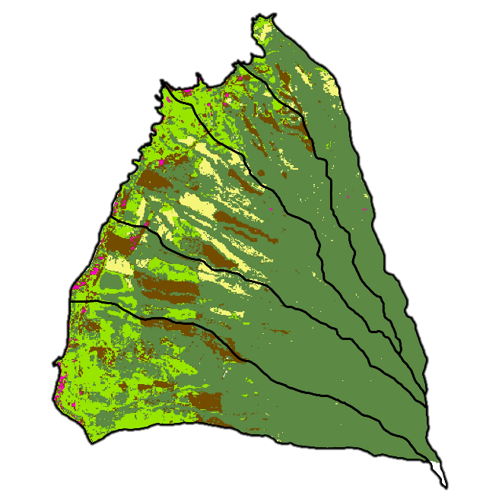b.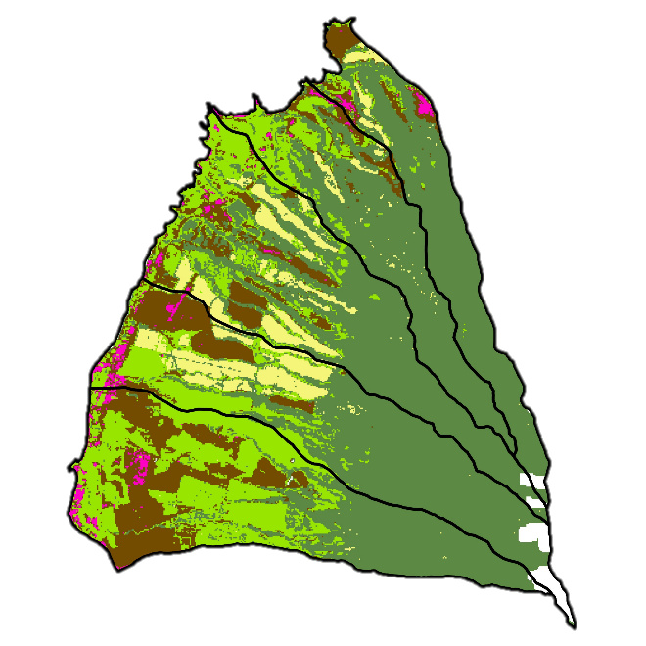
c.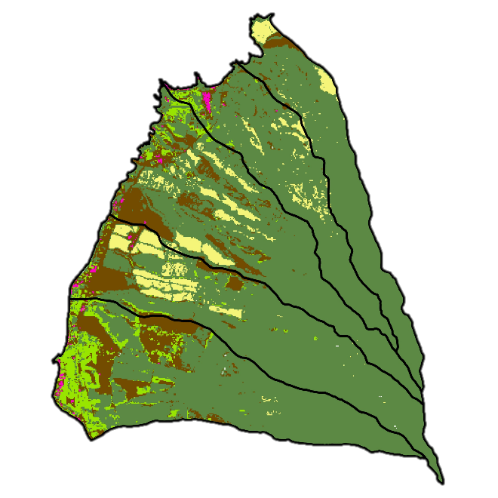d.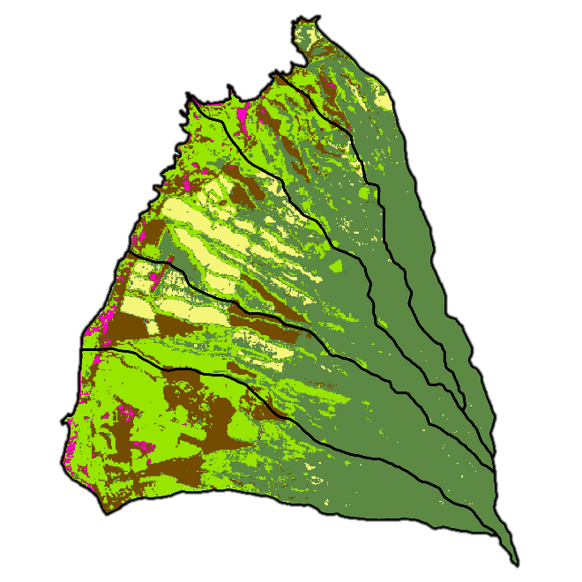
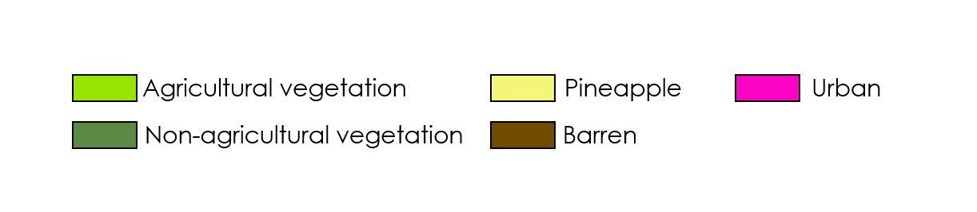
Figure B1. Land cover classes for 1989 (a), 1990 (b), 1991 (c), and 1992 (d).

a. 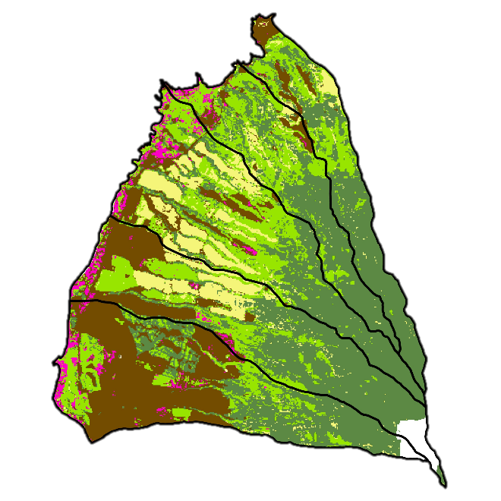 b. 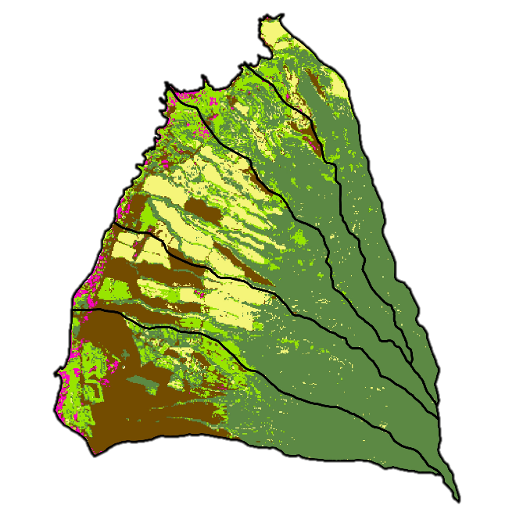 c. 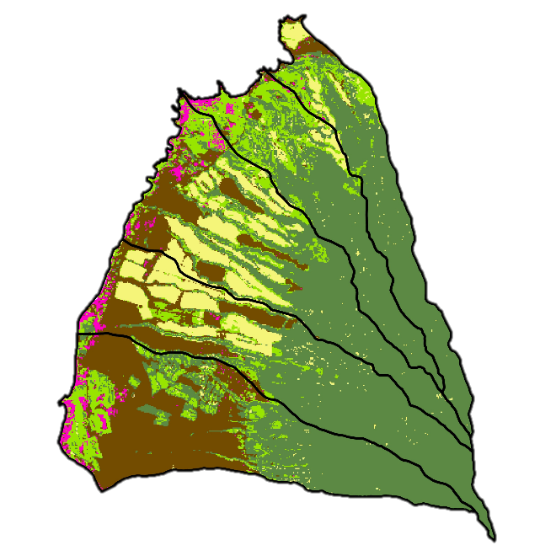 d. 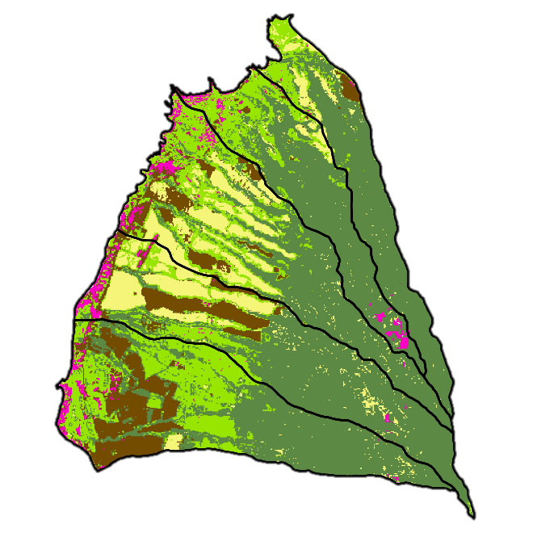
Figure B2. Land cover classes for 1999 (a), 2000 (b), 2001 (c), and 2002 (d).

a. 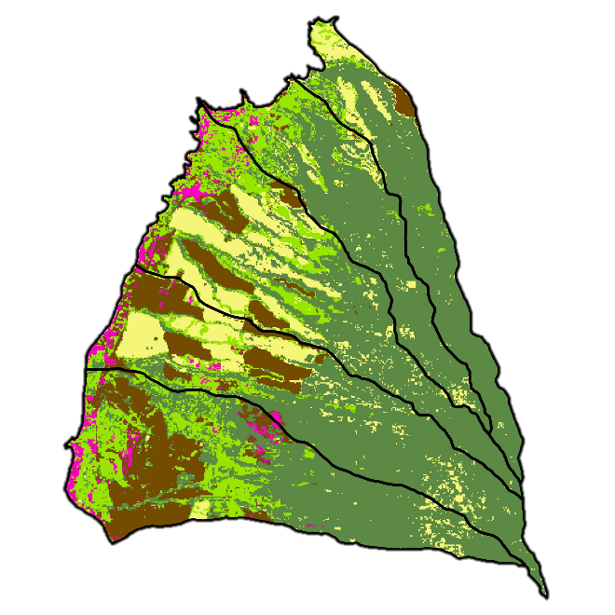b.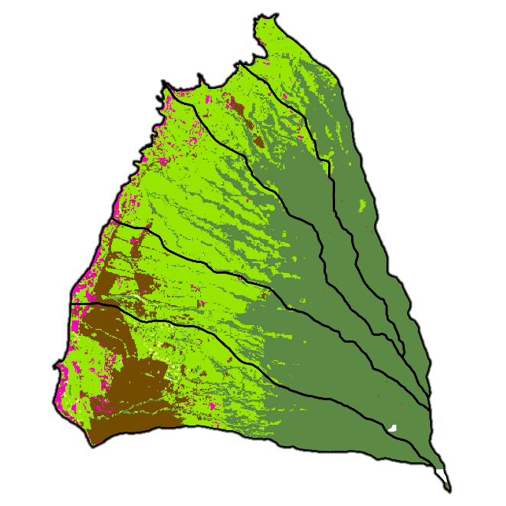
c. 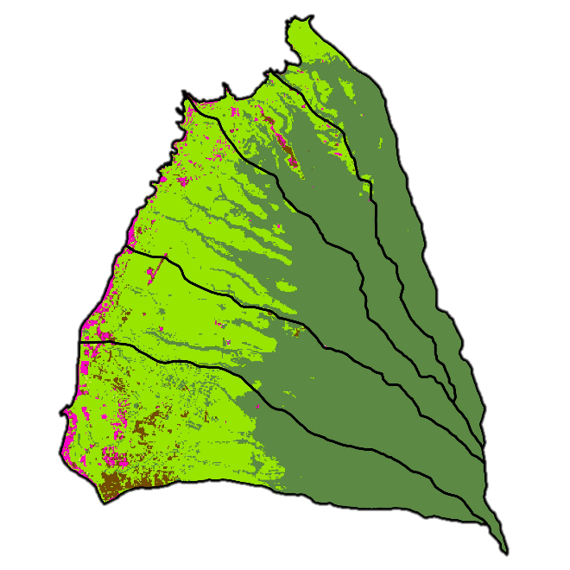 d. 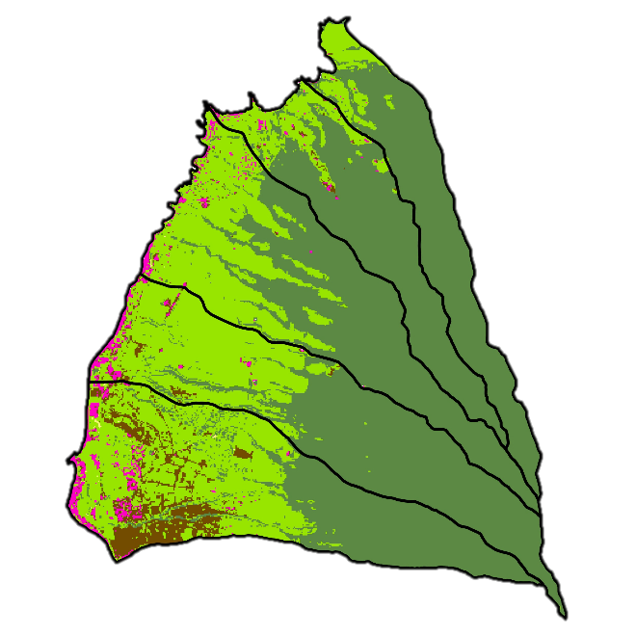
Figure B3. Land cover classes for 2003 (a), 2013 (b), 2014 (c), and 2015 (d).
a. 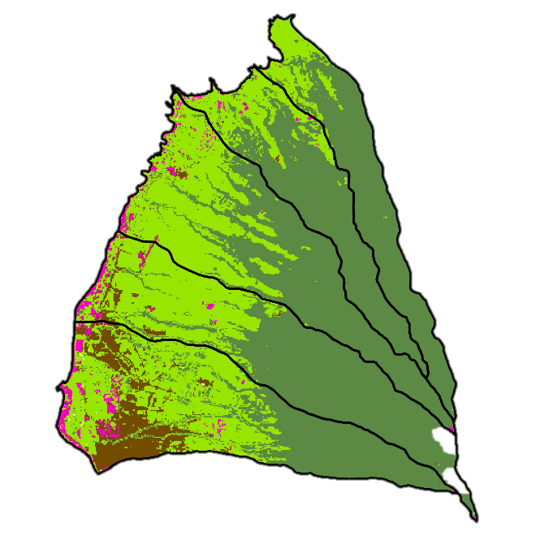b. 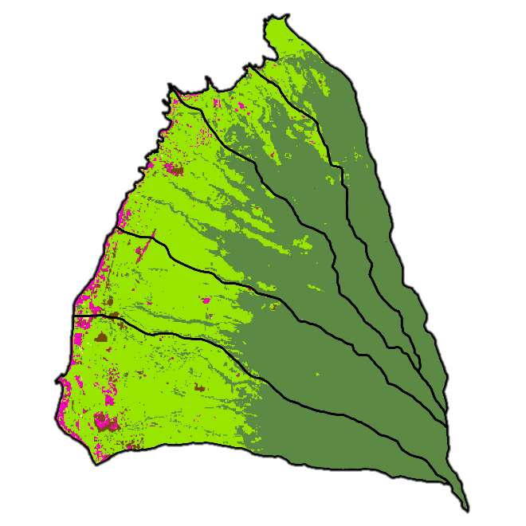
c. 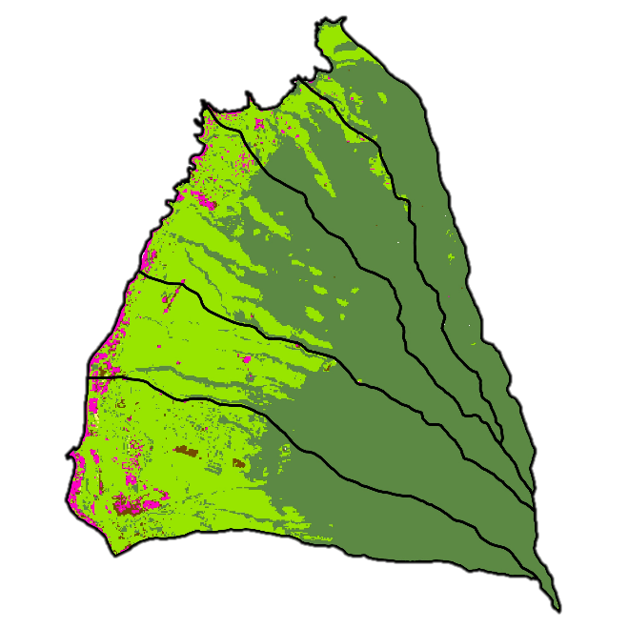d. 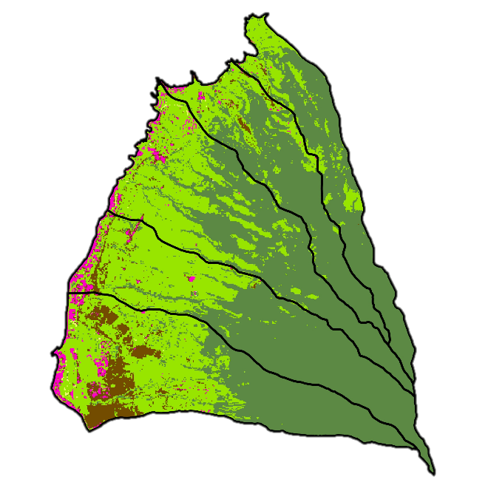
Figure B4. Land cover classes for 2016 (a), 2017 (b), 2018 (c), and 2019 (d).

Appendix C.

a. 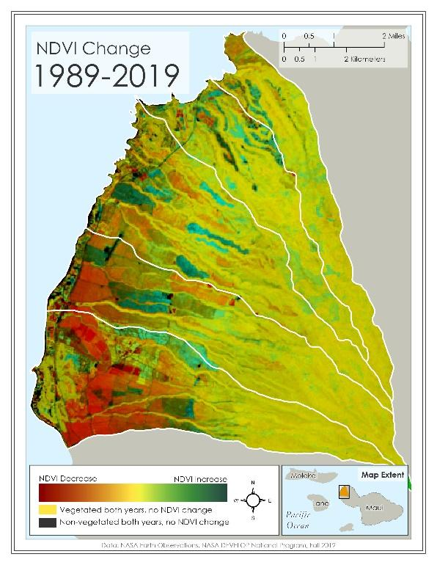 b.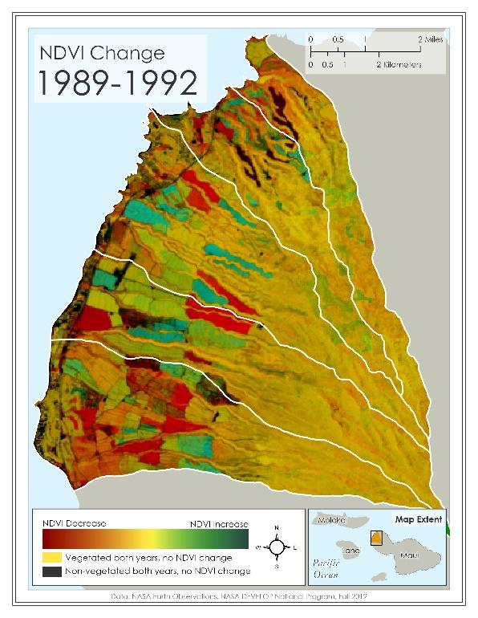

c. 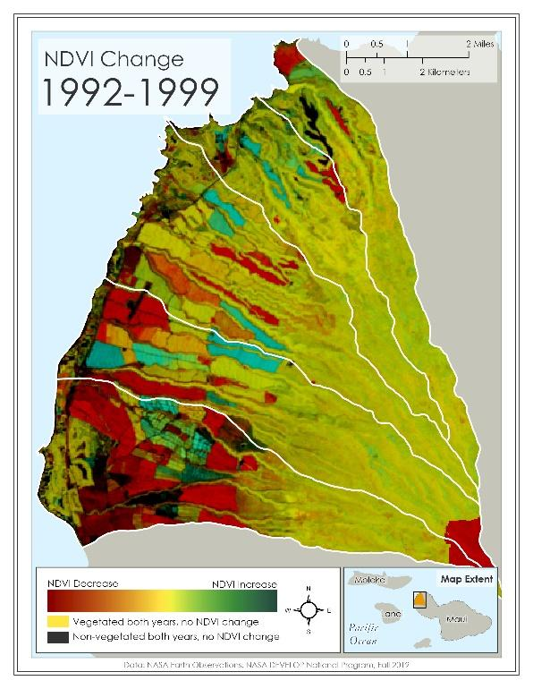 d.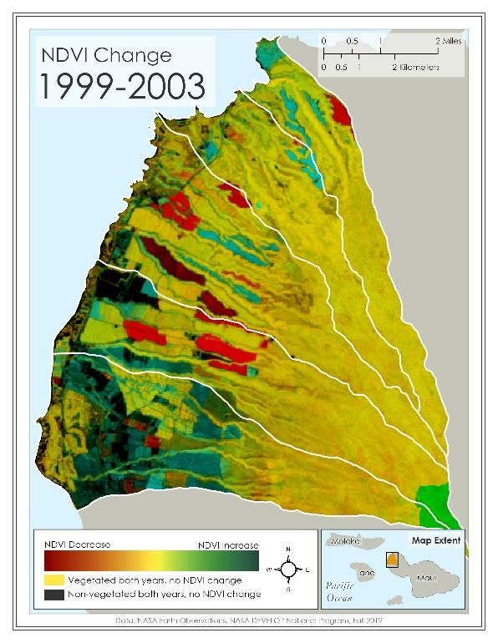
Figure C1. NDVI change maps for 1989 to 2019 (a), 1989 to 1992 (b), 1992 to 1999 (c), and 1999 to 2003 (d). Green marks the areas that increased in NDVI, red marks areas that decreased in NDVI, yellow marks vegetated areas that did not change in NDVI, and black marks areas that were not substantially vegetated either year (from Landsat 4/5 TM, 8 OLI, 2005).
a. 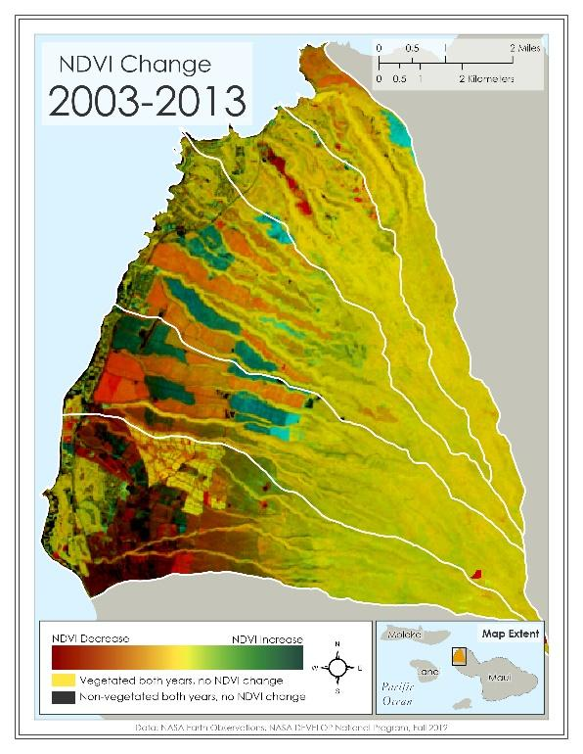 b.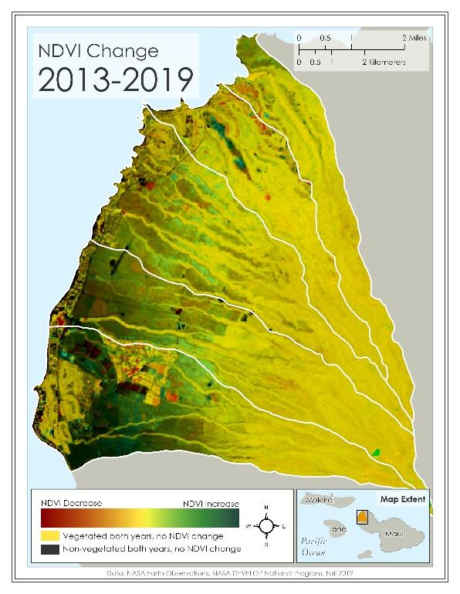
Figure C2. NDVI change maps for 2003 to 2013 (a) and 2013 to 2019 (b). Green marks the areas that increased in NDVI, red marks areas that decreased in NDVI, yellow marks vegetated areas that did not change in NDVI, and black marks areas that were not substantially vegetated either year (from Landsat 4/5 TM, 8 OLI, 2005).

Appendix D.

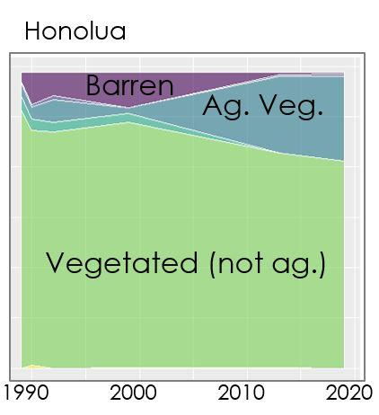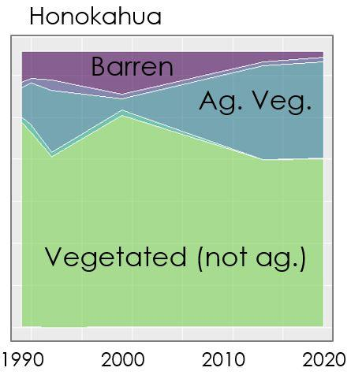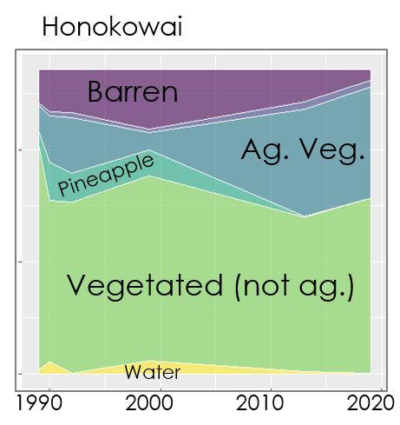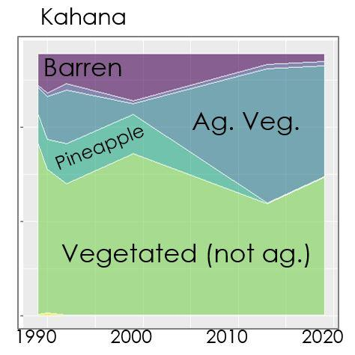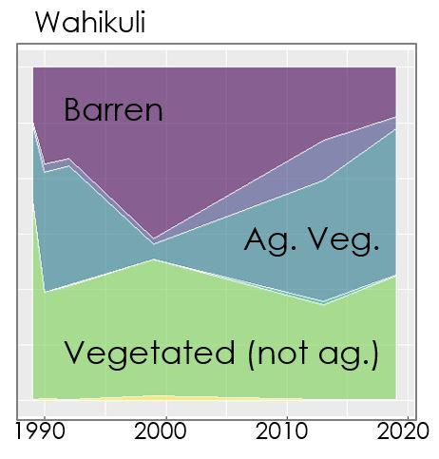
Figure D1. Land classification proportions over time, divided by watershed. The x-axis represents the total pixels of the watershed.

