**NASA DEVELOP National Program**



NASA Goddard Space Flight Center

*Fall 2016*

Kenya Ecological Forecasting

Estimating Carbon Sequestration within Global Environment

Facility Funded Protected Areas in Kenya to Aid Future Policy

 **Technical Report**

Final Draft – November 17, 2016

Madeline Ruid (Project Lead)

Erin Glennie  
Perry Oddo  
Alison Thieme

Dr. Compton J. Tucker, NASA GSFC  
Dr. John Bolten, NASA GSFC

# 1. Abstract

Global deforestation continues to pose a major environmental problem that threatens biodiversity and increases the number of species facing extinction. In Kenya and worldwide, agriculture is the main driver of forest conversion. Each year, Kenya loses 12,000 hectares (ha) of forest out of its total 4.34 million ha. In order to increase forest cover and protect biodiversity, the Global Environment Facility (GEF) funded projects to establish twelve PAs within Kenya from 1995–2008. Currently, GEF utilizes a global dataset to track changes in forest cover in the PAs. Creating maps of past and forecasted above-ground carbon estimates will enable GEF to gain a better understanding of how the PAs are both conserving biodiversity and addressing climate change mitigation through carbon sequestration. Using Landsat 5 TM, Landsat 7 ETM+, and Landsat 8 OLI imagery from 1995–2016, land cover in each PA was classified to map past changes in forest cover and above-ground carbon stock. Additionally, these maps were processed with ancillary datasets in TerrSet Land Change Modeler to forecast above-ground carbon stocks for 2020 and 2030, given current deforestation rates. Final maps of past and forecasted above-ground carbon estimates will aid GEF in future policy and program decisions.

**Keywords**

remote sensing, Random Forest, Support Vector Machine, Landsat, carbon sequestration, protected areas, Land Change Modeler, Google Earth Engine

# 2. Introduction

* 1. ***Background Information***

Deforestation is a major environmental issue that threatens biodiversity and increases the numbers of endangered species facing extinction (Brooks, 2002). In the tropics and subtropics, agriculture is the primary driver of forest loss, with local subsistence agriculture accounting for up to 33% of all conversions, and large-scale commercial agriculture accounting for 40% (FAO, 2016). The study area for this project was Kenya, which follows the trend of agriculture and public or private development projects being the main drivers of deforestation (KFS, 2010). Other reasons for forest loss and degradation include illegal logging, uncontrolled grazing, and exploitation for charcoal (KFS, 2010). This deforestation has led to a decrease in closed canopy forest cover from the original 12% coverage to only 2% by 2010 (KFS, 2010). The country continues to lose an average of 12,000 hectares (ha) per year of forest and 33,500 ha of open woodland, which results in an annual loss of 2 million metric tons of carbon (KFS, 2010).

This drastic decrease in forest cover has led to a decline in multiple endemic species’ populations in Kenya. In Southeast Kenya, the Eastern Arc Mountains and Coastal Forests of Kenya and Tanzania (EACF) is one of 25 designated Global Biodiversity Hotspots. This region has lost 70% of its original primary vegetation and is expected to suffer the most extinction events from a loss of habitat (Cumberlidge, 2016). Some endemic species, such as the Tana River Mangabey (*Cercocebus galeritus*) have since become highly endangered. Habitat loss, degraded conditions within the remaining forests, a higher susceptibility to parasites, and lower reproductive rates have caused this species’ average group size to greatly decline (Mbora, 2009).

Kenya also faces challenges regarding future climate change, as the country is expected to become hotter and drier throughout the century (IPCC, 2013). The Intergovernmental Panel on Climate Change (IPCC) climate models project temperature and precipitation under various emissions scenarios, known as the Representative Concentration Pathways (RCPs). Moderate emissions scenarios, RCP4.5 and RCP6.5, predict an average seasonal temperature increase by 1.5–4°C by 2100. In addition, the rainy season is expected to become shorter, due to the weakening of the Somali Jet and Indian Monsoon (IPCC, 2013). More extreme scenarios like RCP8.5 predict temperature increases that could potentially exceed 5°C for June–August and 6°C for December–February by 2100 (IPCC, 2013).

In order to combat deforestation and biodiversity loss, organizations like the Global Environment Facility (GEF) have invested in the creation and maintenance of Protected Areas (PAs). The World Conservation Union defines PAs as managed terrestrial or maritime areas that are specifically designated for the protection of biodiversity, natural, and cultural resources (Hayes, 2006). Today, there are more than 100,000 PAs worldwide (Hayes, 2006). These PAs may also provide the co-benefit of climate change mitigation through increased carbon sequestration.

Within Kenya, GEF has funded nineteen PAs since the mid-1990s. The PAs range in size from 11 km2 to 855 km2, and span a total of 5,035 km2 and a range of IUCN designations. Here we examine twelve of the terrestrial PAs (Figure 1). Additionally, they cover a wide range of land cover types from montane forests, coastal mangrove forests, deserts, grasslands and shrub. Regionally-specific land cover classifications within each of the PAs provide historical baselines for above-ground biomass and carbon stock changes. Using these baselines, we evaluated the relationships between known drivers of land cover change, and created projections for future land cover in each of these PAs.

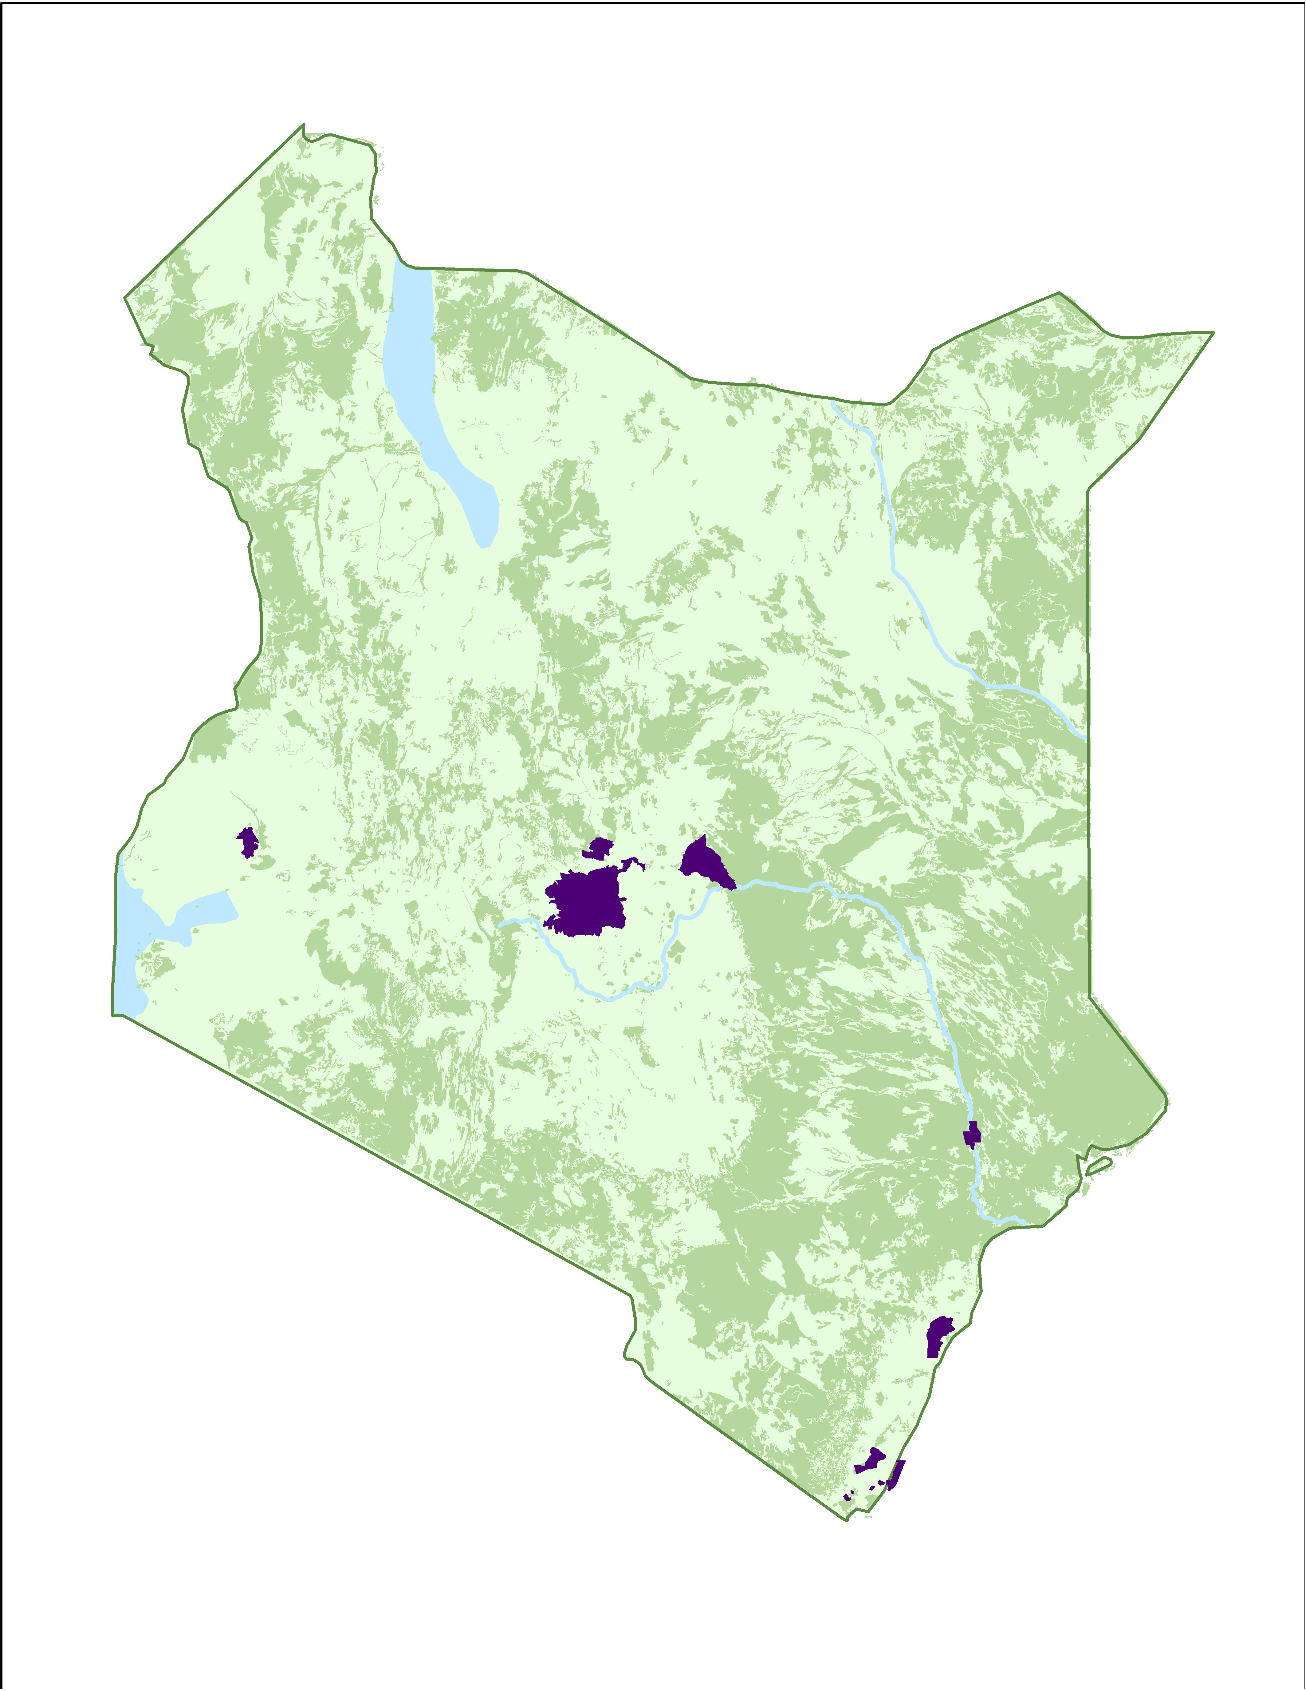





Protected Areas

2010 Biomass Extent

**Figure 1.** Study area map of the twelve GEF-funded PAs within Kenya

* 1. ***Project Partners & Objectives***

The objectives of the project were twofold: First we classified changes in land cover in order to estimate the amount of above-ground carbon that has been stored within the twelve GEF-funded PAs from selected dates between 1995 and 2016. Second, we forecasted the amount of above-ground carbon sequestered in PAs in 2020 and 2030.

The project partner for this study was the Global Environment Facility’s Independent Evaluation office (GEF IEO). GEF IEO was designed to work “with partners to tackle the planet’s biggest environmental issues” through strategic investments (GEF, 2016). Past investments have included funding to support a number of PAs across the globe. GEF’s IEO is interested in quantifying past and future estimates of forest cover and above-ground carbon stocks in order to aid future policy and programmatic decisions. According to Dr. Geeta Batra (Chief Evaluation Officer, GEF IEO), the results will be incorporated into reports for their upcoming replenishment period, which takes place every four years, and includes 12–18 months of negotiations. The reports, which will include the project results, are used to showcase the effectiveness of past projects and illuminate how future funding will help continue to meet sustainable development goals.

The project also addressed NASA’s Ecological Forecasting application area within the Applied Sciences program. NASA Earth Observations from Landsat 5 Thematic Mapper (TM), Landsat 7 Enhanced Thematic Mapper Plus (ETM+), and Landsat 8 Operational Land Imager (OLI) were used to create classified land cover maps, which were used to quantify past and future above-ground carbon stock estimates.

# 3. Methodology

***3.1 Data Acquisition***

Landsat 5 TM, Landsat 7 ETM+ and Landsat 8 OLI Level 1 products were acquired through Google Earth Engine for the study period of 1995–2016. As the study area encompasses several PAs, Landsat scenes encompassed Worldwide Reference System 2 (WRS-2) paths 167, 168, 170 row 60, and WRS-2 path 166 rows 61-63 (Figure 2, Table 1).

**Table 1:** Information on each PA’s name, designation, and encompassing Landsat scene

|  |  |  |
| --- | --- | --- |
| **PA Name** | **Designation** | **Path/Row** |
| Arabuko Sokoke | Forest Reserve | 166/62 |
| Buda | Forest Reserve | 166/63 |
| Diani | Marine National Reserve | 166/63 |
| Gogoni | Forest Reserve | 166/63 |
| Kakamega | National Reserve | 170/60 |
| Lewa Wildlife Conservancy | Community Conservancy | 168/60 |
| Marenji | Forest Reserve | 166/63 |
| Meru | National Park | 167/60 |
| Mount Kenya | National Park | 168/60 |
| Mrima | Forest Reserve | 166/63 |
| Shimba Hills | National Reserve | 166/63 |
| Tana River Primate | National Reserve | 166/61 |

Several additional ancillary datasets were downloaded and used as driver variables for future land cover projections. Present-day mean annual precipitation and temperature values, aggregated from 1970–2000, were acquired as 1 km2 resolution geotiffs from WorldClim (Hijmans, Cameron, Parra, Jones, & Jarvis, 2005). Vector files describing present-day roads and waterways were downloaded from OpenStreetMap (OpenStreetMap contributors, 2015). Human population density raster data, adjusted to match United Nations (UN) population estimates, were acquired from WorldPop as a geotiff with 100 m resolution for 2015 (WorldPop, 2015). Livestock (cattle, goats, chickens) density estimates from the Food and Agricultural Organization of the United Nations (FAO) were also downloaded for 2006 as geotiffs with a 1 km2 resolution (Robinson et al., 2014). Shuttle Radar Topography Mission 30 m resolution topography data were downloaded from the USGS Earth Explorer.

In place of *in situ* data regarding land cover in each PA, high resolution commercial imagery in Google Earth Pro was utilized in the creation of training and testing sites for the land cover classifications. ArcGIS was also used to convert training sites from a kml format to shapefiles when needed.

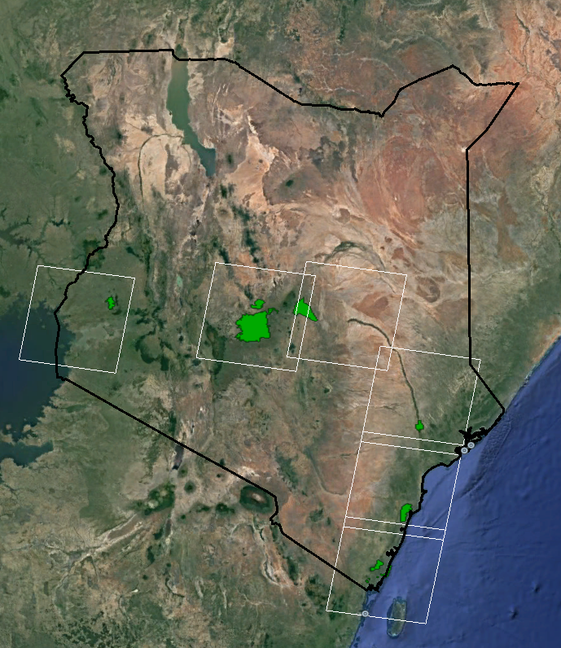

166/63

166/62

166/61

167/60

168/60

170/60

**Figure 2.** Landsat scenes providing coverage for GEF-funded PAs in Kenya

***3.2 Data Processing***

Landsat 5 TM, Landsat 7 ETM+, and Landsat 8 OLI images were processed in Google Earth Engine to remove clouds, cloud shadows, and water bodies through a technique called f-masking (Zhu & Woodcock, 2012). Additional data processing involved converting digital numbers to Top of Atmosphere reflectance and clipping each scene to the extent of the PA. Each masked reflectance image was then classified using training and testing points using Google Earth Engine. These classified maps were exported to perform change detection and future projections in TerrSet Land Change Modeler (LCM).

For ancillary data, vector datasets were converted to 30 m resolution raster datasets to match that of Landsat. Similarly, raster datasets were scaled to the same spatial resolution as Landsat using resampling tools in TerrSet and ESRI ArcGIS. All datasets were projected to the WGS 1984 UTM Zone 37 North and clipped to the extent of each PA.

***3.3 Data Analysis***

Land cover classifications were performed in Google Earth Engine using Classification and Regression Tree (CART) and Random Forest classifiers. Each classified image was compared using confusion matrices to evaluate the performance of the classifier. The best performing classifier was used in each image and resulting clipped image was downloaded.

TerrSet’s Land Change Modeler was used to evaluate change detection. Within LCM, Multi-Layer Perceptron (MLP) was used to evaluate the relationships between driver variables and these land cover changes. This neural network comparison is used for the generation of transition potential maps, and to understand the historical rates of change. Models were tailored to each PA by eliminating the least influential variables until peak predictive power was achieved. After each model was trained, we utilized LCM’s Markov Chain Projection which incorporates past rates of change to project future rates of change for 2020 and 2030. These rates of change were applied to the transition potential maps to create future projections of land cover change for the years 2020 and 2030. Finally we used allometric equations to relate the area of each land cover type (in hectares) to the amount of biomass stored in the land cover as well as the carbon fraction in the biomass.

The following equation was used to estimate above-ground carbon:

*(Area Land Cover Class) x (Above-ground Biomass by Land Cover Class) x (Carbon Fraction) = Above-ground Carbon*

Units were as follows:

*(ha) x (Mg dry matter/ha) x (Mg C/Mg dry matter) = Mg C*

For most PAs, the values of above-ground biomass by land cover class and carbon fraction were obtained from both the Intergovernmental Panel on Climate Change (IPCC) Good Practice Guidance for Land Use, Land-Use Change and Forestry (LULUCF) and the IPCC Guidelines for National Greenhouse Gas Inventories (Penman et al., 2003; Buendia, Miwa, Ngara, & Tanabe, 2006). Locally-specific values were used as available for areas such as Kakamega Forest Reserve and Arabuko Sokoke Forest Reserve (Table 2).

**Table 2: Land cover types and associated carbon stock estimates for each GEF Protected Area.**

|  |  |  |  |
| --- | --- | --- | --- |
| Land Cover Type | Protected Areas | Above-ground Carbon Stock Estimate | Source of Estimate |
| Rainforest/Dense Forest | Kakamega, Lewa | **173.3** | Lung & Espira, 2005 |
| Shrub | Kakamega, Lewa, Meru, Mt. Kenya, Tana, Mrima, Marenji, Diani, Gogoni | **22.9** | Colgan et al., 2012 |
| Bamboo | Mt. Kenya | **103.6** | Teng et al., 2016 |
| Cynometra Forest | Arabuko Sokoke | **35** | Glenday, 2005 |
| Brachystegia Forest | Arabuko Sokoke | **46** | Glenday, 2005 |
| Mangrove | Diani | **146.8** | Jones et al., 2014 |
| Coastal Forest (Moist Tropic Forest with short rainy season) | Marenji, Mrima, Buda, Gogoni, Shimba Hills, Tana River | 260 x 0.47 = **122.2** | IPCC, 2013;  Buendia et al., 2006 |
| Montane Moist Forest | Mt. Kenya | 191 x 0.47 = **89.77** | IPCC, 2013; Buendia et al., 2006 |

Each step, including classifications, past change detections, future change predictions, and biomass estimates, was repeated in each of the twelve GEF-funded PAs.

**4. Results & Discussion**

***4.1 Analysis of Results***

The twelve PAs were classified using a CART or Random Forest for each of the three years from 1995–2016, and the accuracies can be found in Table 3 (Appendix). Classifications of PAs with fewer land cover classes or low amounts of cloud cover generally had higher classification accuracy. Land cover types were limited to forest, non-vegetated, shrub, grassland, mangrove forests, bamboo, water, *Cynometra* forest, and *Brachystegia* forest. Bamboo was only found in Mount Kenya Forest Reserve, *Cynometra* forest and *Brachystegia* forest were only found in Arabuko Sokoke Forest Reserve, and mangrove forest was only found in the Diani Marine National Reserve. Examples of these classified maps can be seen in Figures 3 and 4.

In LCM each MLP model began with all nine driver variables and was modified to use only variables that improved the model accuracy. In most of the models, livestock densities (cattle, goats, and chickens) and distance to roads were not influential, while distance to rivers and irrigated agriculture were influential. Human population density was influential to the models when there was variation across the landscape. In remote areas, however, this impact was minor.

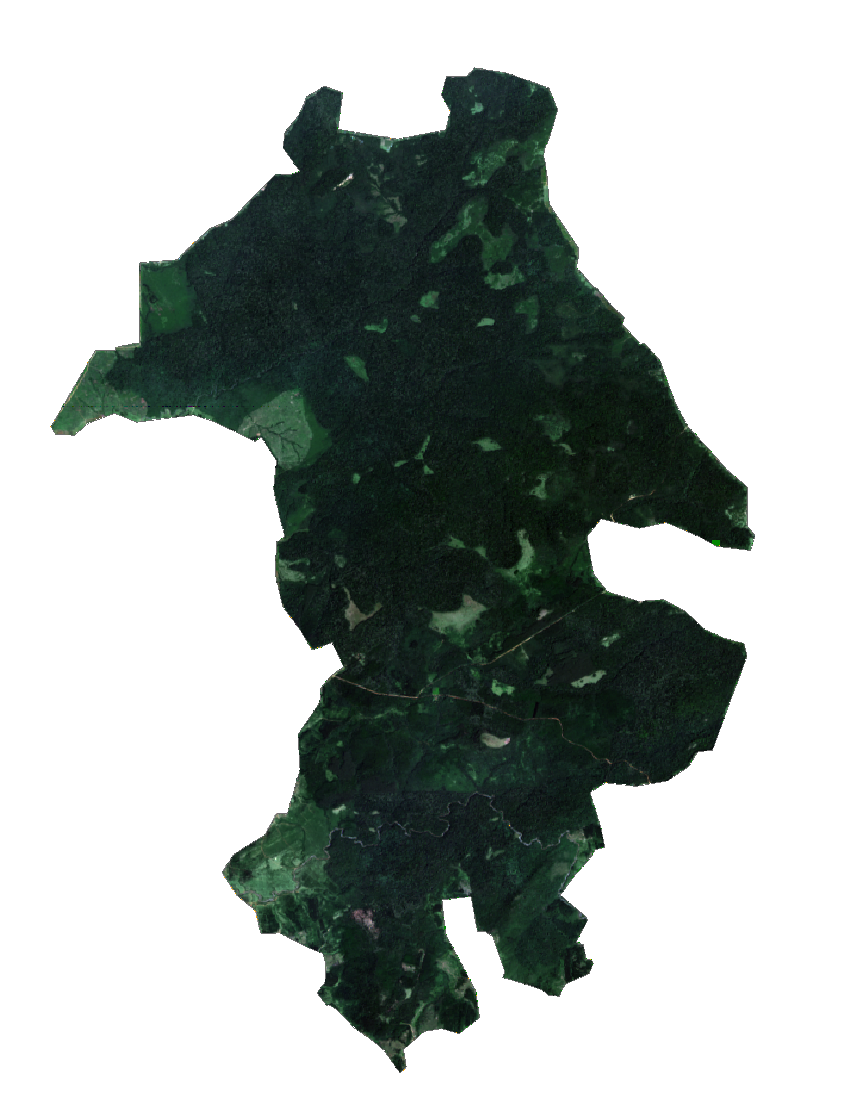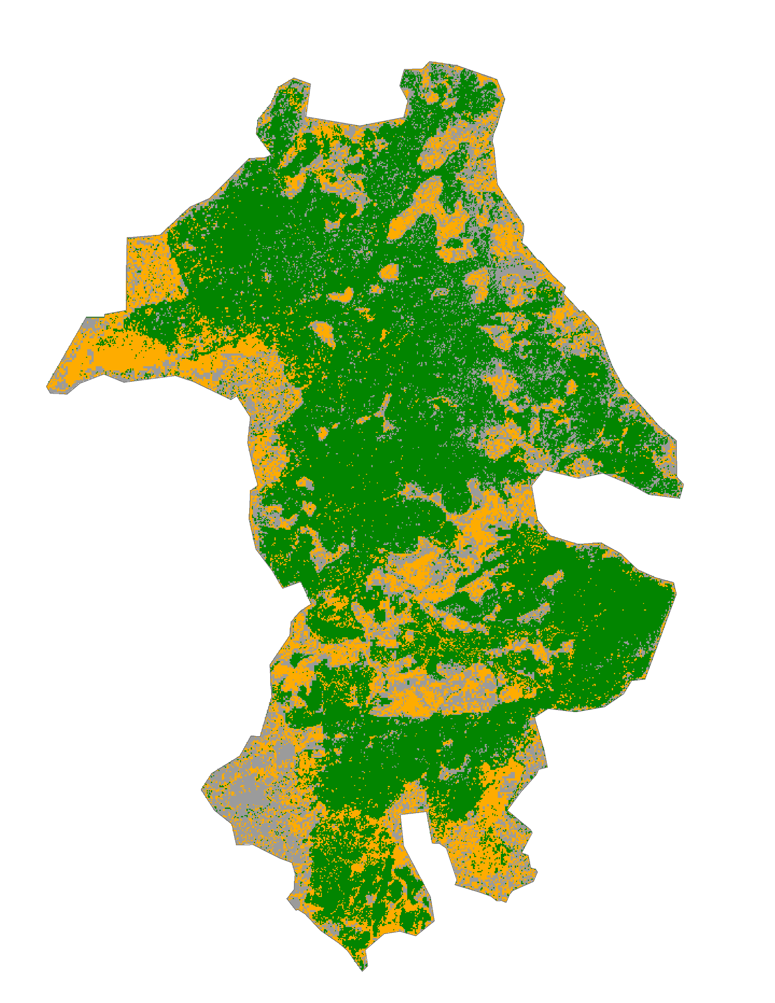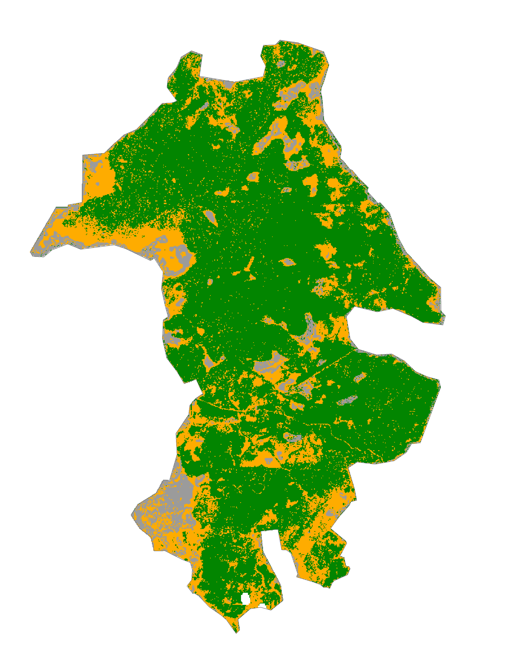

Forest

Non-vegetated

Shrub

**A**. Landsat 8 OLI (2016)

**C**. Land Cover Classification (2015)

**B**. Land Cover Classification (1999)

**Figure 3**: Land cover classification for the Kakamega Forest Reserve PA. Google Earth imagery of the PA was used to produce training sites for different land cover classes (panel A). Classified maps produce spatial distribution of land cover classes for 1999 (panel B) and 2015 (panel C).

The results from LCM suggested that vegetated land cover has increased in the Kakamega Forest Reserve site between 1999 and 2015 (Figure 3). Panels B and C show the spatial distribution of forest, non-vegetated, and shrub for the two time periods. Within Kakamega, areas that were previously agriculture have been transitioning back to forest. Forested areas have noticeably expanded, particularly in the southern half of the forest reserve. Shrub has also expanded into previously non-vegetated areas along the western edge of the forest. Corresponding above-ground carbon estimates in the Kakamega Forest Reserve increase throughout the study period and in projections for 2020 and 2030.

The Tana River Primate National Reserve shows a slightly different story (Figure 4). In this riparian forest in eastern Kenya, the landscape has four land cover types: forest, grass, shrub and water. White regions represent cloud cover and scan lines that were masked from the analysis. In this study area, there are sporadic shifts in land cover, likely associated with flooding events near the Tana River. Throughout the study period of 2000–2015 there are slight increases and decreases in above-ground carbon estimates as shrub and forest area expand and contract. Grass was not included in above-ground carbon estimates as it is not generally considered a long-term carbon store.

In the protected areas that GEF has previously funded, above-ground carbon estimates and projections were generally stable (Figure 5). Few PAs experienced positive or negative change in the 15-20 year study. Some PAs like the Kakamega Forest Reserve and the Marenji Forest Reserve experienced a moderate increase in forested area and corresponding above-ground carbon. In the Mount Kenya Forest Reserve and the Shimba Hills National Reserve, moderate decreases in above-ground carbon were estimated and projected for 2020 and 2030. The observed decreases may be a result of development, agriculture, and agroforestry within the PAs. In all cases, these estimates coincided with the years during and following GEF involvement in the reserve. Without controlling for potentially confounding factors, it is not possible to determine how much of the observed reforestation can be attributed to the PA. An additional control study would be a valuable supplement to this analysis by contrasting the Tana River site with a reference area that had similar geographic characteristics (e.g. land slope, rainfall, proximity to infrastructure) yet did not receive funding for biodiversity conservation. Comparable areas are difficult to find within Kenya as remaining landscapes that have biodiversity and above-ground carbon are also PAs.

**A**. Landsat 8 OLI (2016)

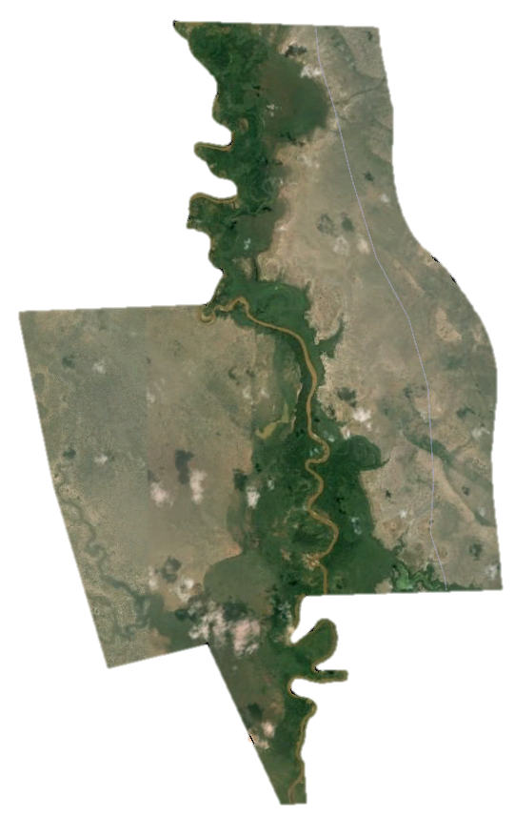

**C**. Land Cover Classification (2015)

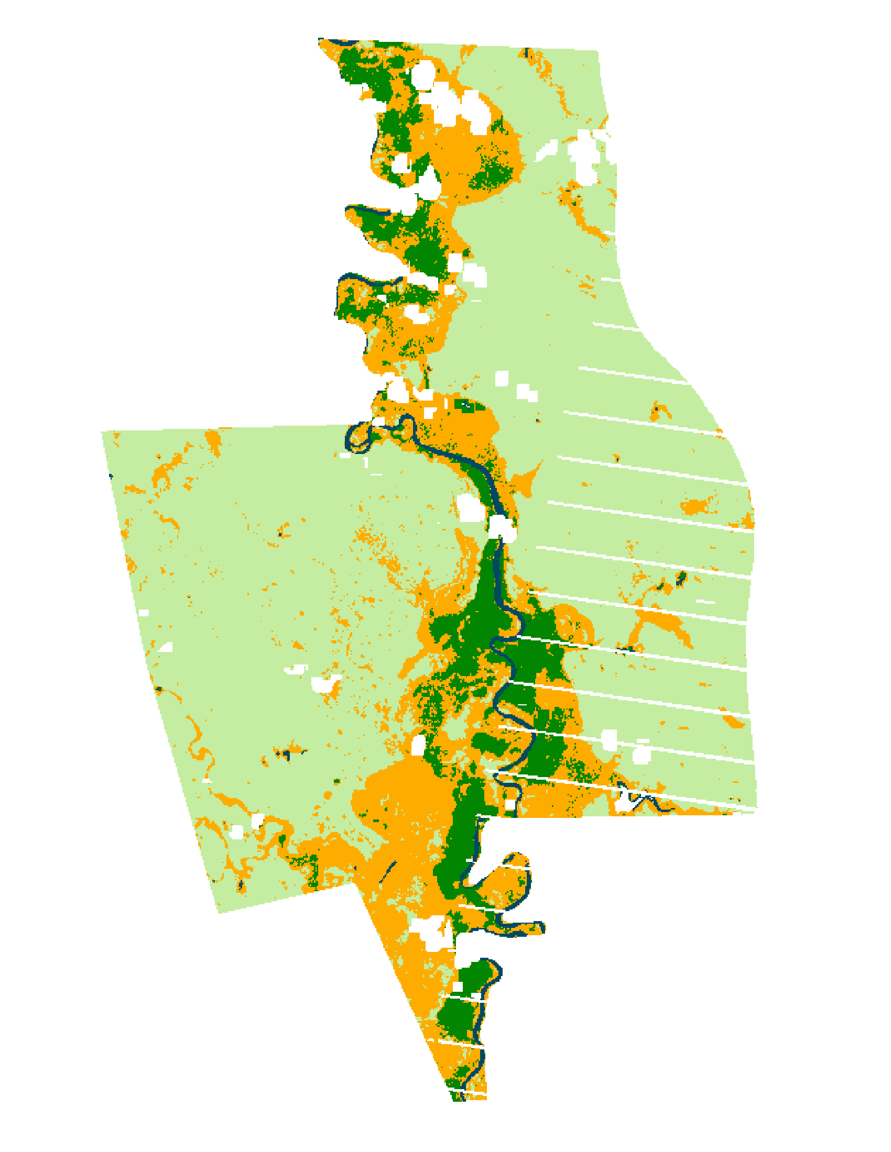

**B**. Land Cover Classification (2000)

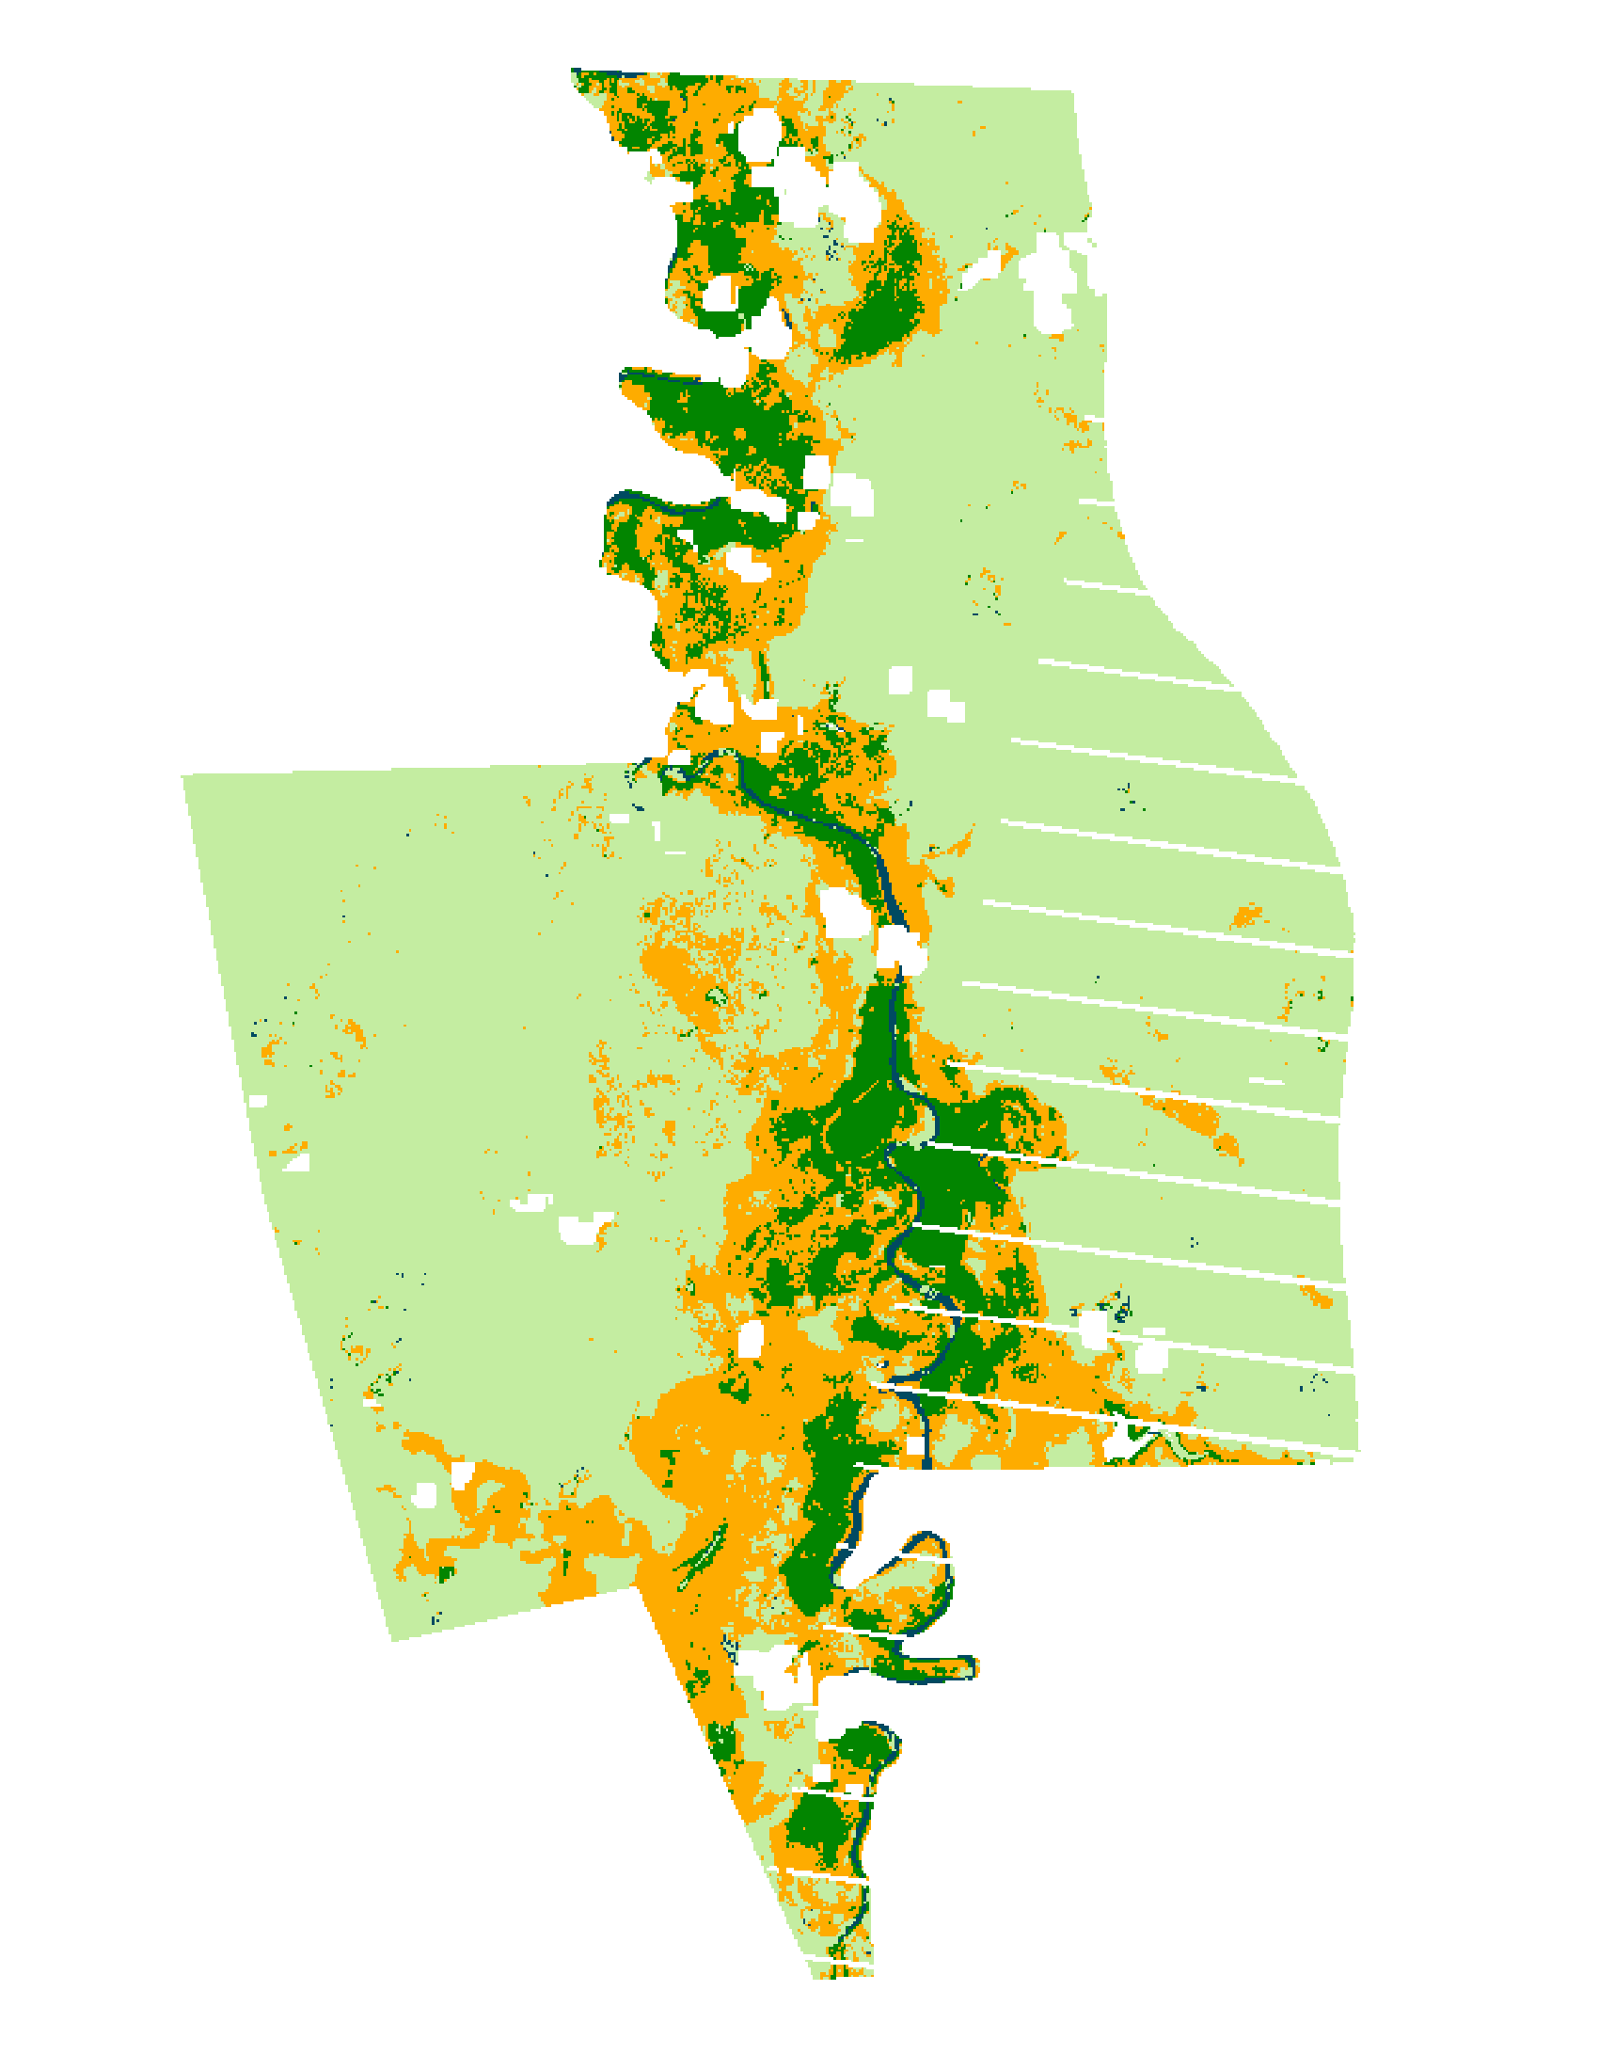

Forest

Grass

Shrub

Water

**Figure 4**: Land cover classification for the Tana River Primate National Reserve PA. Google Earth imagery of the PA was used to produce training sites for different land cover classes (panel A). Classified maps produce spatial distribution of land cover classes for 2000 (panel B) and 2015 (panel C).

Above-ground Carbon Estimates and Projections

**Figure 5**: Above-ground carbon estimates and projections for all twelve protected areas. Note the varied scales in each graph.

***4.2 Future Work***

Regarding future work, we would like to perform more in-depth accuracy assessments by including *in situ* data for above-ground carbon stock estimates and land cover types. Field observations will allow us to capture higher accuracy for both land cover classifications and final carbon stock estimates. Additionally, we could incorporate high-resolution imagery, including GeoEye-1, QuickBird-2, and WorldView-2 products, to perform more robust validation exercises for the land cover types within each PA.

We would also like to assess the impact of protected areas on the surrounding communities. While protected areas have clear impacts for biodiversity and carbon sequestration, they also impact local communities in terms of tourism and economic costs and benefits. Landscapes may also represent particular cultural importance. The value of these factors is not currently being incorporated into this study.

# 5. Conclusions

Of the twelve protected areas included in this study, most experienced little to no change over the 15-20 year study period. The Kakamega Forest Reserve, a moderately sized dense rainforest in Western Kenya and home to 380 plant species, experienced an increase in above-ground carbon from 1995–2015. This may be attributed to a regrowth of forest since the protections have been put in place and agriculture is being removed from the protected area. The Marenji Forest Reserve, a small coastal forest in southeastern Kenya, also experienced an increase in above-ground carbon from 1999–2016. Shimba Hills National Reserve, a moderately sized coastal forest in southeastern Kenya, has experienced a slight decrease in forest and corresponding above-ground carbon. Mount Kenya Forest Reserve, by far the largest PA in the study, has also seen a decrease in above-ground carbon around the perimeter of the PA. This was largely due to what appears to be agroforestry and agriculture but has tapered off in recent years.

These changes in above-ground carbon are strikingly different when compared to the rest of the region. While landscapes inside of PAs are relatively stable, the vast majority of unprotected arable land has been converted to agriculture and/or developed. Since the GEF began funding projects in Kenyan in the 1990s, the PAs have had continued success in maintaining forest extent and preserving biomass.

Land cover changes between 1995 and 2016 in the twelve protected areas each related to the potential driver variables slightly differently. Among the driver variables that were evaluated in LCM using MLP, distance to rivers and irrigated agriculture were consistently among the most influential drivers of change. Throughout the diverse landscapes that we examined, water appears to be a limiting factor for human expansion in the region.

# 6. Acknowledgments

We would like to thank our science advisors, Dr. Compton J. Tucker and Dr. John Bolten at NASA Goddard Space Flight Center (GSFC). We would also like to thank Sean McCartney, Center Lead with the DEVELOP program at GSFC and Heather Mitchell, volunteer. Additionally, we would like to thank our liaisons at the Global Environment Facility’s Independent Evaluation Office, Dr. Anupam Anand, Dr. Geeta Batra, and Dr. Juha Uitto.

Any opinions, findings, and conclusions or recommendations expressed in this material are those of the author(s) and do not necessarily reflect the views of the National Aeronautics and Space Administration.

This material is based upon work supported by NASA through contract NNL11AA00B and cooperative agreement NNX14AB60A.

# 7. References

Brooks, T. M., Mittermeier, R. A., Mittermeier, C. G., Da Fonseca, G. A., Rylands, A. B., Konstant, W. R., ... & Hilton‐Taylor, C. (2002). Habitat loss and extinction in the hotspots of biodiversity. *Conservation Biology*, *16*(4), 909-923.

Buendia, L., Miwa, K., Ngara, T., & Tanabe, K. (2006). IPCC Guidelines for National Greenhouse Gas Inventories. *Prepared by the National Greenhouse Gas Inventories Programme. IGES, Hayama, Japan.*

Colgan, M. S., Asner, G. P., Levick, S. R., Martin, R. E., & Chadwick, O. A. (2012). Topo-edaphic controls over woody plant biomass in South African savannas. *Biogeosciences Discussions*, 9(1), 957–987. https://doi.org/10.5194/bgd-9-957-2012.

Food and Agriculture Organization of the United Nations. (2016). *State of the World’s Forests 2016*. Retrieved from http://www.fao.org/3/a-i5850e.pdf.

Gereau, R., Cumberlidge, N., Hemp, C. Hochkirch, A., Jones, T., Kariuki, M., .... & Shirk, P. (2016). Globally threatened biodiversity of the Eastern Arc Mountains and Coastal Forests of Kenya and Tanzania. *Journal of East African Natural,* 105(1), 115-201.

Glenday, J. (2005). Preliminary Assessment of Carbon Storage & the Potential for Forestry Based Carbon Offset Projects in the Arabuko-Sokoke Forest. *Unpublished Report to Critical Ecosystem Partnership Fund*. Retrieved from http://www.cepf.net/Documents/Final.ASFreport.pdf.

Global Environmental Facility. (2016). *About Us* [Website]*.* Retrieved from https://www.thegef.org/about-us.

Hayes, T. (2006). Parks, People, and Forest Protection: An Institutional Assessment of the Effectiveness of Protected Areas. *World Development*, *34*(12), 2064–2075. https://doi.org/10.1016/j.worlddev.2006.03.002.

Hijmans, R. J., Cameron, S. E., Parra, J. L., Jones, P. G., & Jarvis, A. (2005). Very high resolution interpolated climate surfaces for global land areas. *International Journal of Climatology*, *25*(15), 1965–1978. http://doi.org/10.1002/joc.1276

[IPCC] Intergovernmental Panel on Climate Change. (2013). Annex I: Atlas of Global and Regional Climate Projections. *Climate Change 2013: The Physical Science Basis. Contribution of Working Group I to the Fifth Assessment Report of the Intergovernmental Panel on Climate Change*. Cambridge University Press, Cambridge, United Kingdom and New York, NY, USA.

Jones, T., Ratsimba, H., Ravaoarinorotsihoarana, L., Cripps, G., & Bey, A. (2014). Ecological Variability and Carbon Stock Estimates of Mangrove Ecosystems in Northwestern Madagascar. *Forests*, 5(1), 177–205. https://doi.org/10.3390/f5010177.

[KFS] Kenya Forest Service. (2010). Revised REDD Readiness Preparation Proposal, Kenya. Retrieved from http://www.forestcarbonpartnership.org/sites/forestcarbonpartnership.org/files/Documents/PDF/Oct2010/Revised%20RPP%20for%20Kenya.pdf.

Lung, M., & Espira, A. (2015). The influence of stand variables and human use on biomass and carbon stocks of a transitional African forest: Implications for forest carbon projects. *Forest Ecology and Management*, 351, 36–46. https://doi.org/10.1016/j.foreco.2015.04.032.

Mbora, D., Wieczkowski, J., & Munene, E. (2009). Links Between Habitat Degradation, and Social Group Size, Ranging, Fecundity, and Parasite Prevalence in the Tana River Mangabey (Cercocebus galeritus). *American Journal of Physical Anthropology*, *140*, 562-571. Retrieved from https://www.researchgate.net

OpenStreetMap contributors. (2016). Planet dump [Data file from Oct 1 2016]. Retrieved from http://planet.openstreetmap.org.

Penman, J., Gytarsky, M., Hiraishi, T., Krug, T., Kruger, D., Pipatti, R., ... & Wagner, F. (2003). Good practice guidance for land use, land-use change and forestry. Good practice guidance for land use, land-use change and forestry.

Robinson, T. P., Wint, G. W., Conchedda, G., Van Boeckel, T. P., Ercoli, V., Palamara, E., ... & Gilbert, M. (2014). Mapping the global distribution of livestock. *PloS one*, 9(5), e96084.

Teng, J., Xiang, T., Huang, Z., Wu, J., Jiang, P., Meng, C., … Fuhrmann, J. J. (2016). Spatial distribution and variability of carbon storage in different sympodial bamboo species in China. *Journal of Environmental Management*, 168, 46–52. https://doi.org/10.1016/j.jenvman.2015.11.034.

World Bank. (n.d.). Tana River National Primate Reserve Project. Global Environment Facility. Retrieved from http://www.thegef.org/sites/default/files/project_documents/TanaRiverProjDoc.pdf

WorldPop. (2015). *UN Adjusted Population 2015 Version 2b* [Data set]*.* Retrieved from http://www.worldpop.org.uk/data/summary/?contselect=Africa&countselect=Kenya&typeselect=Population.

Zhu, Z. & Woodcock, C.E., 2012. Object-based cloud and cloud shadow detection in Landsat imagery. *Remote Sensing of Environment*, 118, 83-94. Retrieved from http://www.sciencedirect.com/science/article/pii/S0034425711003853.

# 8. Content Innovation

**Content Innovation #1**

Virtual Poster Session (VPS)

Emailed to [Tiffani.N.Miller](mailto:Lauren.M.Childs@nasa.gov)@nasa.gov with filename:

2016Fall_GSFC_KenyaEco_VPS

**Content Innovation #2**

Interactive Map: Map showing the locations of 12 GEF funded protected areas in Kenya used in this study

Emailed to [Tiffani.N.Miller](mailto:Lauren.M.Childs@nasa.gov)@nasa.gov with filename:

2016Fall_GSFC_KenyaEco _TechPaper_InteractiveMap

**Content Innovation #3**

Glossary Viewer

Emailed to [Tiffani.N.Miller](mailto:Lauren.M.Childs@nasa.gov)@nasa.gov with filename:

2016Fall_GSFC_KenyaEco _TechPaper_GlossaryViewer

# 9. Appendices

**Table 3: Landsat scenes, classification method, and classification accuracy for each PA in analysis.**

|  |  |  |  |  |
| --- | --- | --- | --- | --- |
| **Protected Area** | **Landsat Scene** | **Year** | **Classification** | **Accuracy (%)** |
| Arabuko Sokoke | LT51660621995144AAA02 | 1995 | CART | 82.98 |
| LE71660622011020ASN00 | 2011 | CART | 78.3 |
| LC81660622016298LGN00 | 2016 | CART | 81.36 |
| Buda | LE71660631999291EDC00  LE71660632001328SGS00 | 2000 | CART | 94.12 |
| LE71660632009094ASN00 | 2009 | CART | 95.31 |
| LC81660632016026LGN00 | 2016 | CART | 97.06 |
| Diani | LE71660632000342SGS00 | 2000 | Random Forest | 70.89 |
| LE71660632010097ASN00 | 2010 | Random Forest | 75.27 |
| LC81660632016122LGN00 | 2015 | CART | 84.95 |
| Gogoni | LE71660631999291EDC00  LE71660632000278SGS00 | 1999  2000 | CART | 86.79  94.19 |
| LE71660632011036ASN00 | 2011 | CART | 83.33 |
| LC81660632016026LGN00 | 2016 | CART | 85.39 |
| Kakamega | LE71700601999351EDC00 | 1999 | CART | 95.41 |
| LT51700602010021MLK00 | 2010 | CART | 87.76 |
| LC81700602015003LGN00 | 2015 | CART | 90.37 |
| 77.05 | LE71680602000052EDC00 | 2000 | CART | 72.13 |
| LT51680602010039MLK01 | 2010 | CART | 85.25 |
| LC81680602015005LGN00 | 2015 | CART | 77.05 |
| Marenji | LE71660631999323SGS00 | 1999 | CART | 97.22 |
| LT51660632009182MLK00 | 2009 | Random Forest | 92.11 |
| LC81660632015359LGN00 | 2015 | CART | 89.47 |
| Meru | LE71670602000029EDC00  LE71680602000052EDC00 | 2000 | CART | 100.00  89.39 |
| LT51680602010039MLK01  LT51670602009157MLK00 | 2010  2009 | CART | 96.25  91.94 |
| LC81680602015005LGN00  LC81670602015014LGN00 | 2015  2015 | Random Forest CART | 97.26  90.14 |
| Mrima | LE71660631999323SGS00 | 1999 | CART | 95.65 |
| LT51660632009182MLK00 | 2009 | CART | 100.00 |
| LC81660632016090LGN00 | 2016 | Random Forest | 91.3 |
| Mount Kenya | LT51680601995030XXX00 | 1995 | CART | 75.08 |
| LE71680602000052EDC00 | 2000 | CART | 85.53 |
| LC81680602016088LGN00  LC81680602014034LGN00 | 2016  2014 | CART  CART | 89.31  66.20 |
| Shimba | LT51660631997053JSA00 | 1997 | Random Forest | 95.24 |
| LT51660632009182MLK00 | 2009 | Random Forest | 94.44 |
| LC81660632016026LGN00 | 2016 | Random Forest | 95.79 |
| Tana | LE71660612000022EDC01 | 2000 | CART | 93.4 |
| LE71660612010001ASN00 | 2010 | CART | 94.61 |
| LE71660612015015PFS00 | 2015 | CART | 90.53 |