DEVELOP Virtual Machine Guidebook

Your virtual machine is an AWS EC2 instance. Here’s a quickguide on getting it started and using some of its helpful features. Navigate to any of the sections directly by clicking on its name in the Table of Contents.

Table of Contents
I. Launch the EC2 1
II. Remote into Your VM 6
III. Connecting to the Shared Drive 8
IV. Sharing Files Outside of Your EC2 10
V. Accessing GitLab 13
Via the User Interface 13
Via the Command Line 14
VI. Shutting Down Your EC2 16

Troubleshooting Note: If you are experiencing any difficulties with your VM, reach out to James (Jim) Davis via Microsoft Teams or email (james.davis@ssaihq.com).

I. Launch the EC2
- Navigate to the Jenkins server login page: https://jenkins.ssai-cloudhelp.com/login?from=%2F
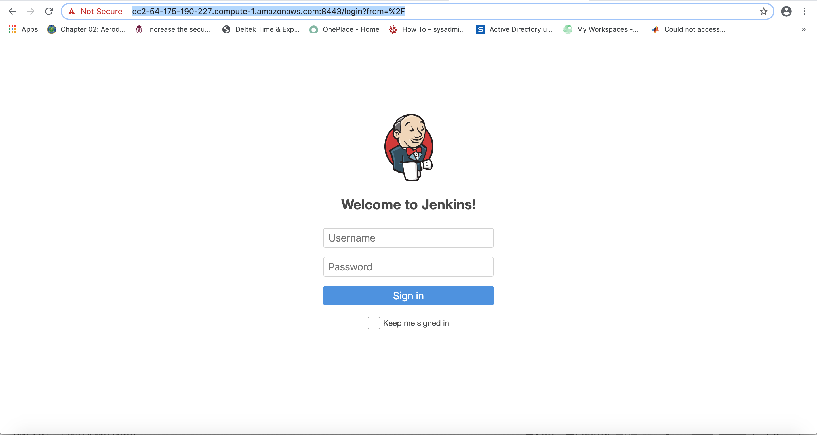
- Sign in with the password provided to you by James (Jim) Davis. The username should look something like firstname.lastname, and the password will be pretty long!
- Select DevelopAWS. This is where you will be able to view the job build history and start a new job.

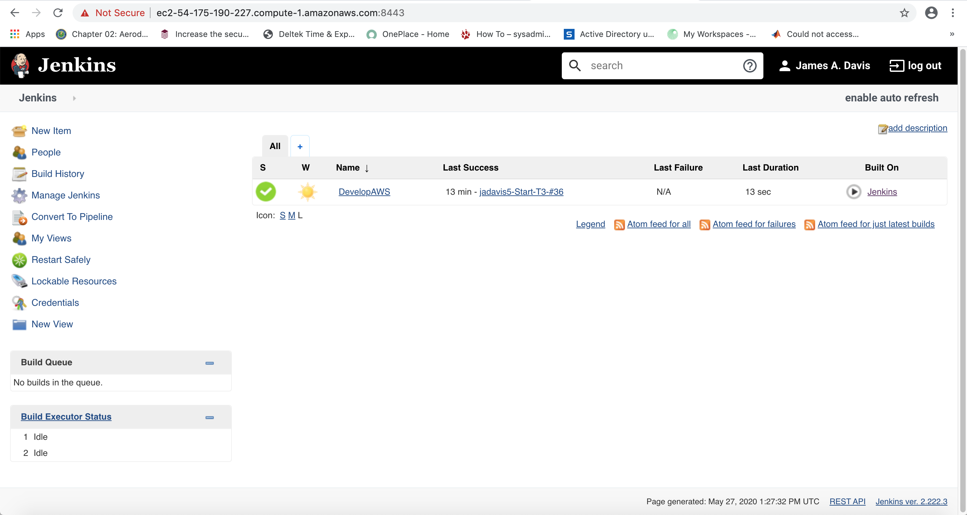

- In the left-hand panel, select Build with Parameters. This is where you can start, stop, reboot, or check the status of your EC2.

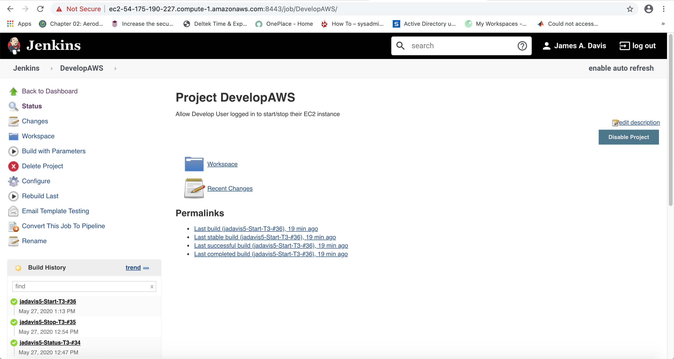

- If this is not your first time starting your EC2, skip to step 8. Before you start the EC2, you will need to create it. Under the Action dropdown menu, select Create, then click the blue Build button.

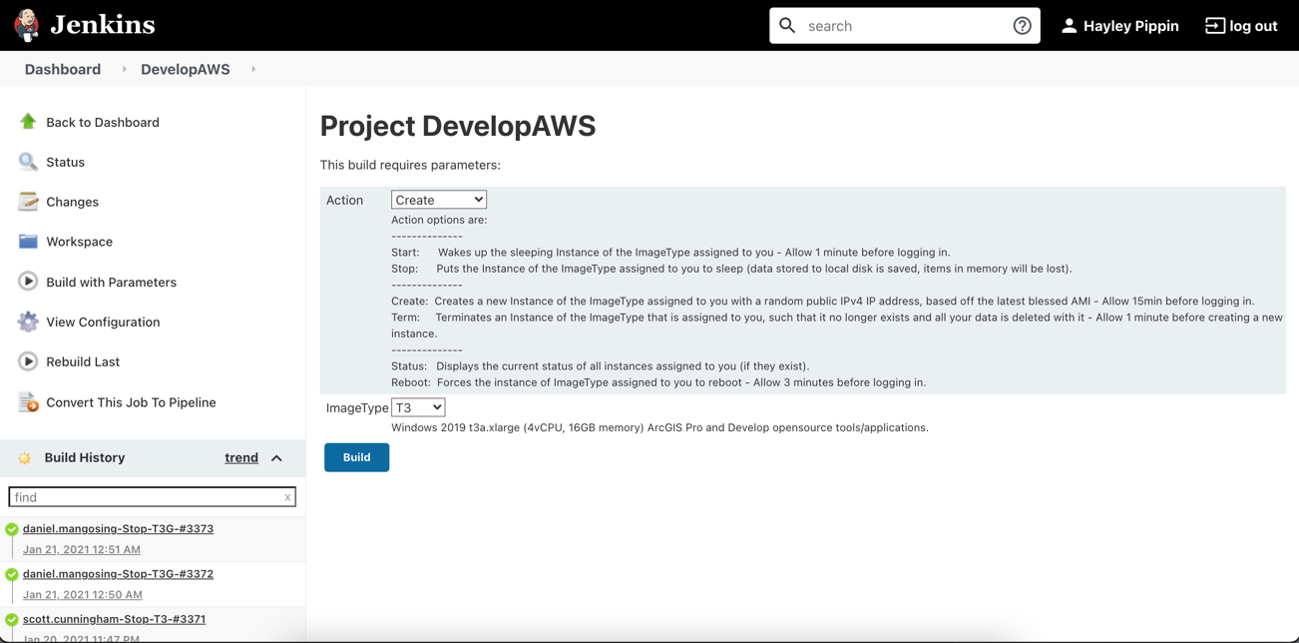

- You can view the progress of your build under the Build History panel on the left-hand side.

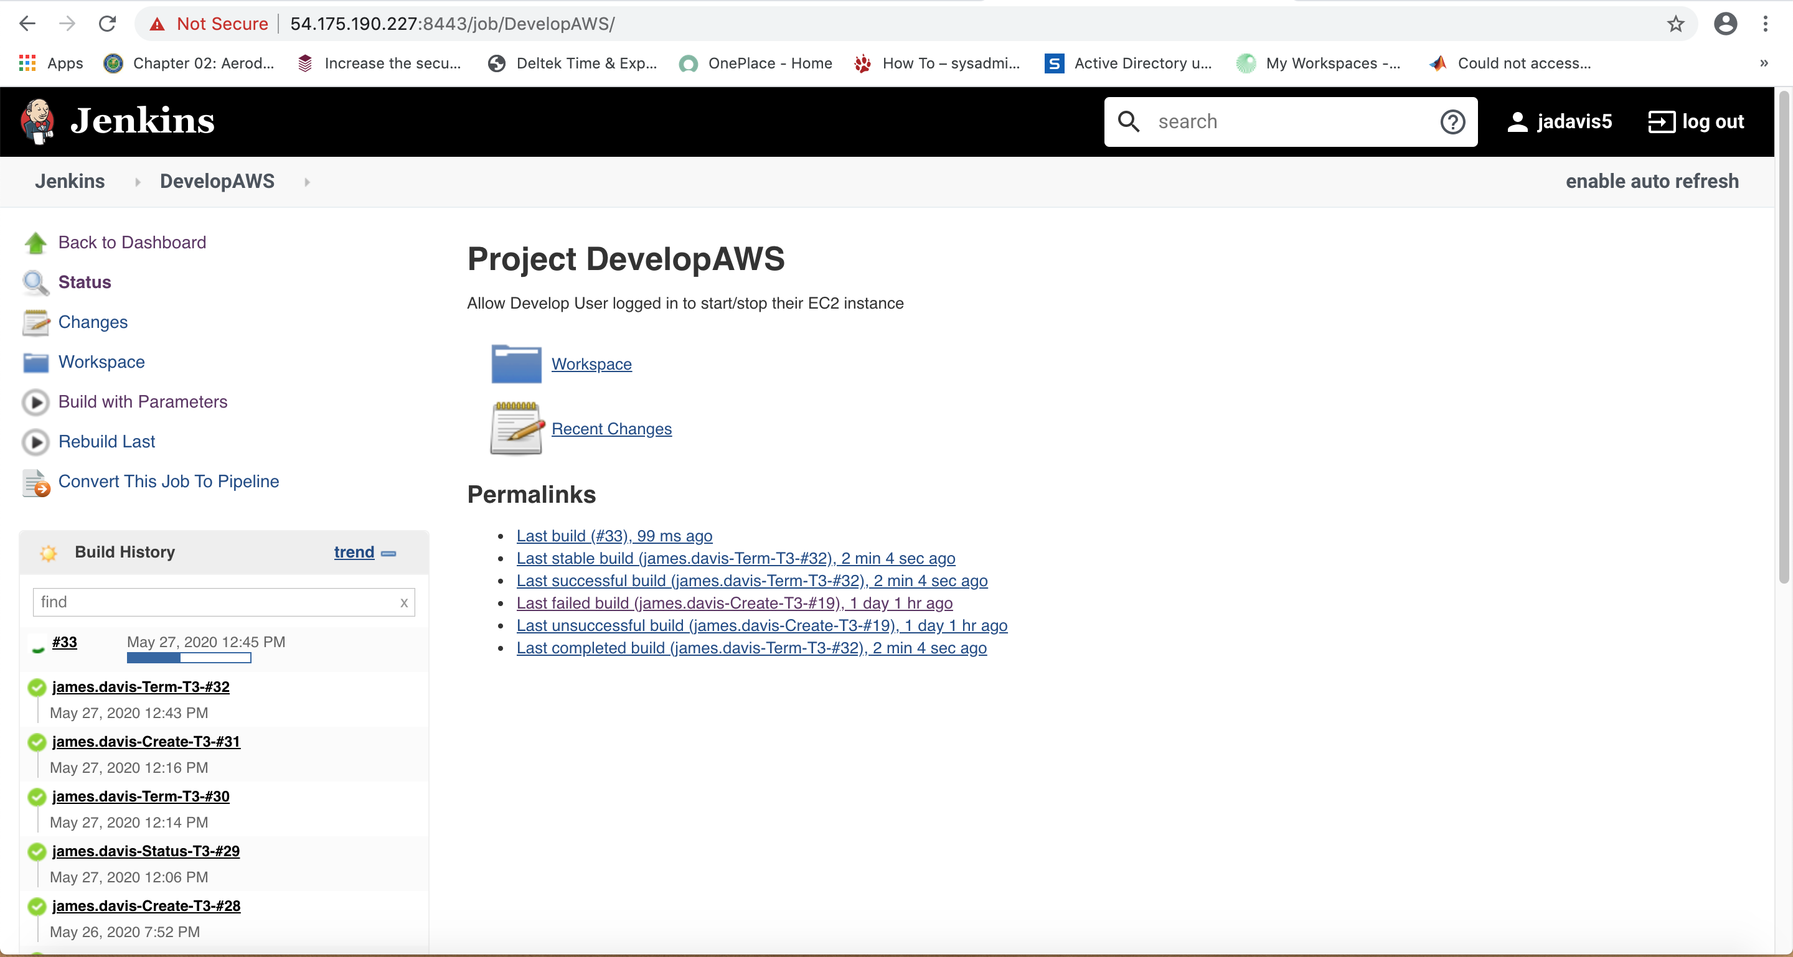

- You have to wait ~20 minutes from the initial creation of your build before you actually start up your EC2. After 20 minutes, click on Build with Parameters on the left side again.
- The Action dropdown menu is set to Start as the default. Click on the blue Build button and monitor the progress of your build job on the left-hand side Build History panel.

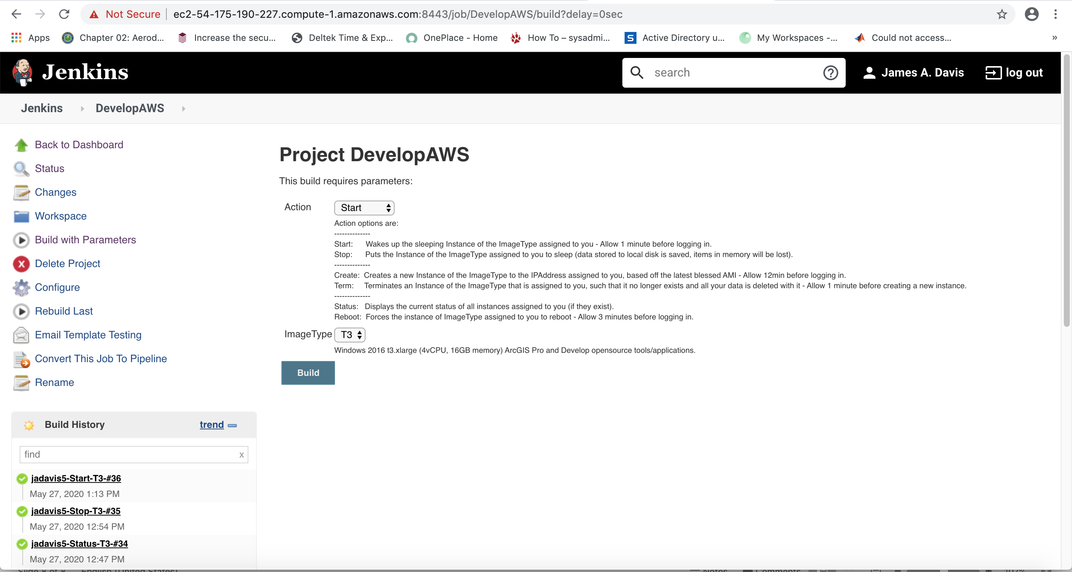

- Click on your job in the Build History panel once the progress bar shows it is complete (it should have a green checkmark next to it). It will always be the first one in the list.
- Select Console Output on the left-hand side.

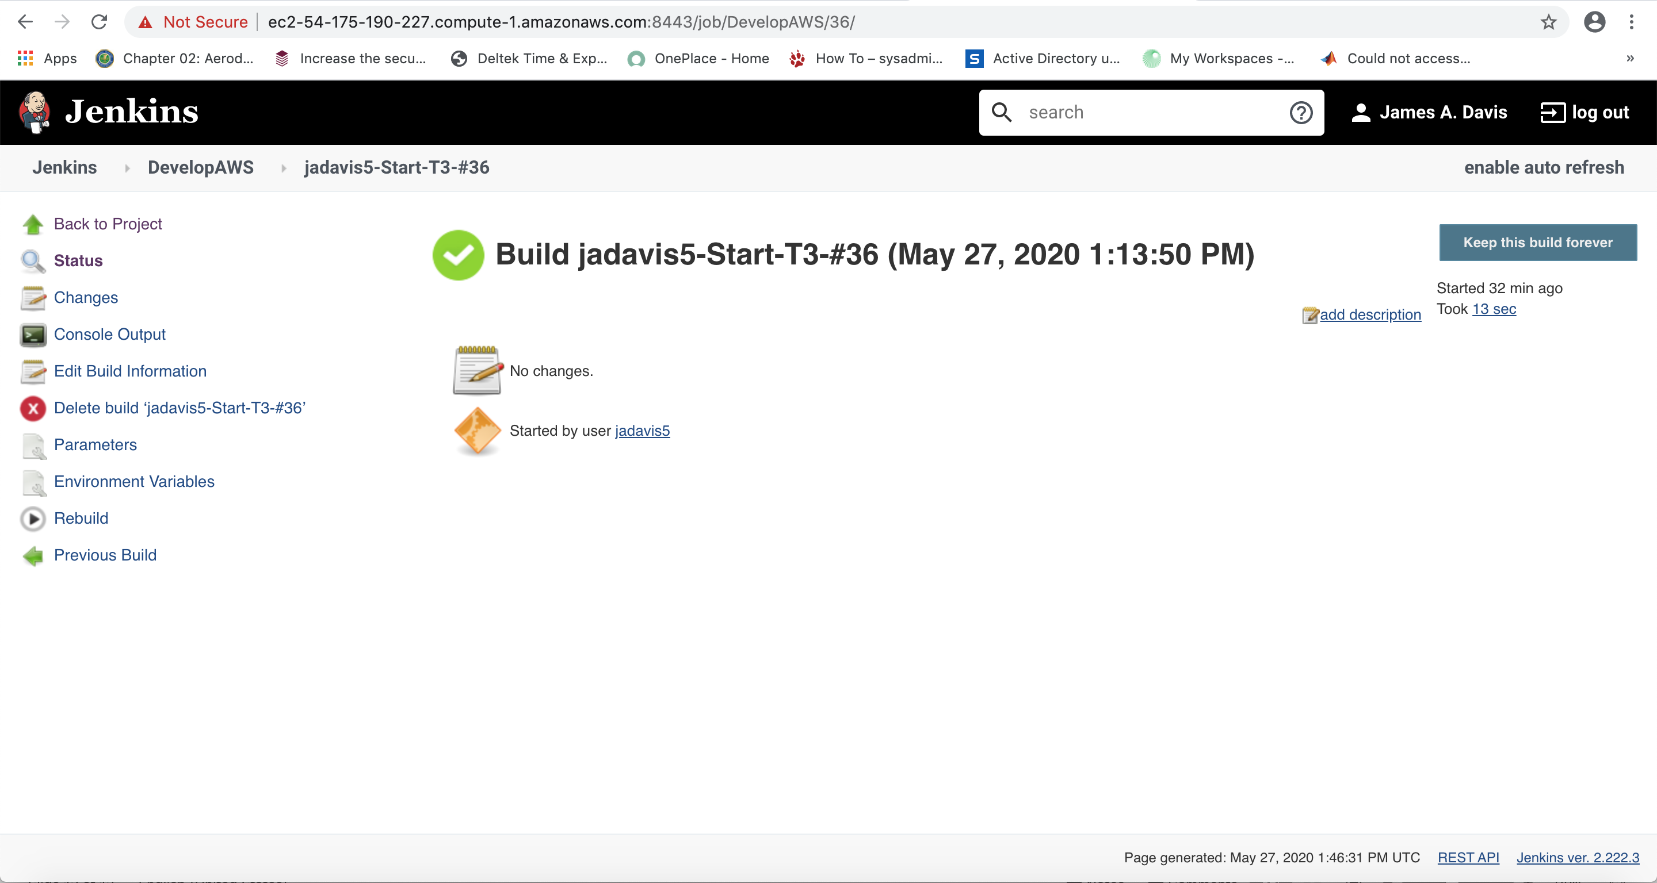

- Scroll to the bottom of your console output and find your IP address. It will be towards the bottom half of the screen, nested in an entry that will look like this: Develop-SGARA-jadavis5_T3 running ami-07ed7a6c8391a9c82 0.101 i-0a72ae989c58a83be May 27 2020 01:13 PM t3.xlarge Summer2020 54.165.146.9

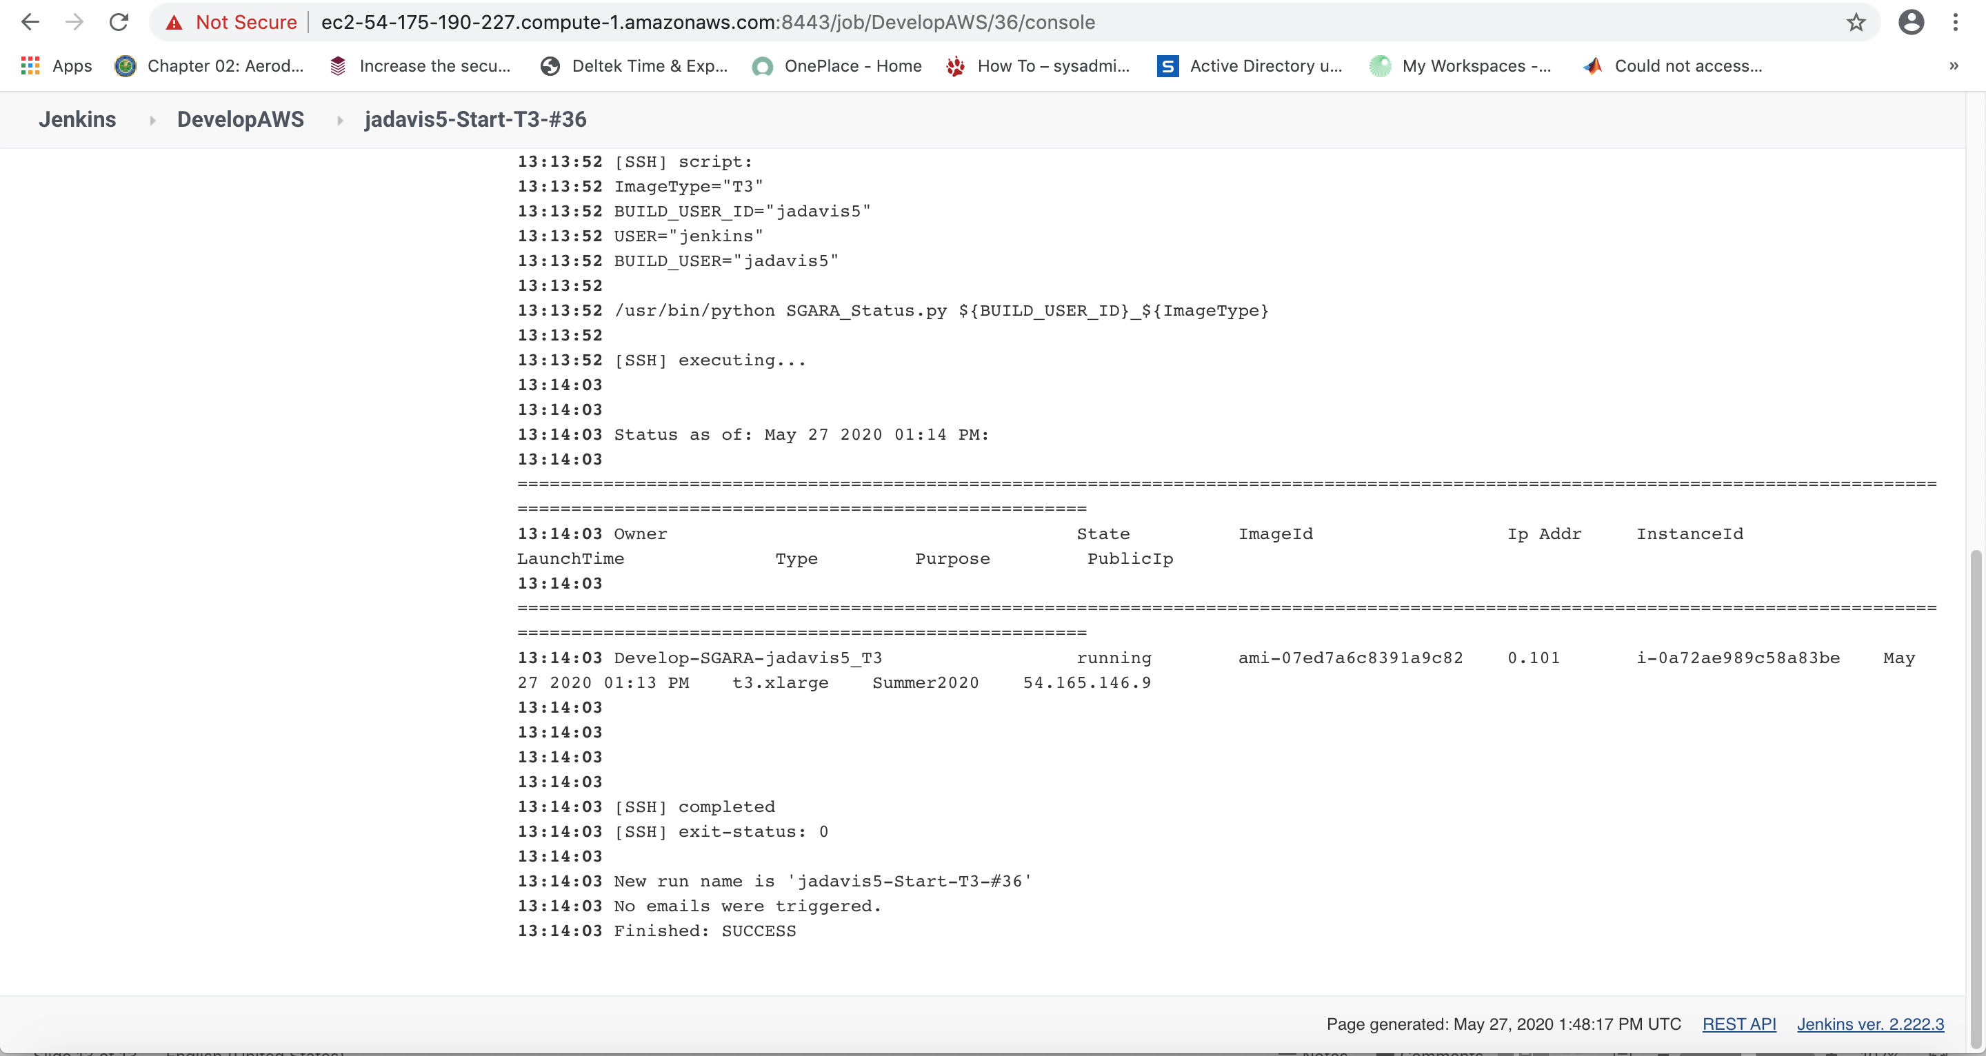

- Highlight and copy the IP address and continue to Section II.

II. Remote into Your VM
- You will need a Microsoft Remote Desktop client. This client is provided as part of the Windows operating systems.
  - Mac OS X users will need to download/install from the AppStore.
  - On Windows, if you search for “remote,” the Remote Desktop client is usually the first applications offered.
- Launch Microsoft Remote Desktop. Enter the IP address you located in Section I, Step 11 in the field labeled Computer (Windows) or PC name (Mac).

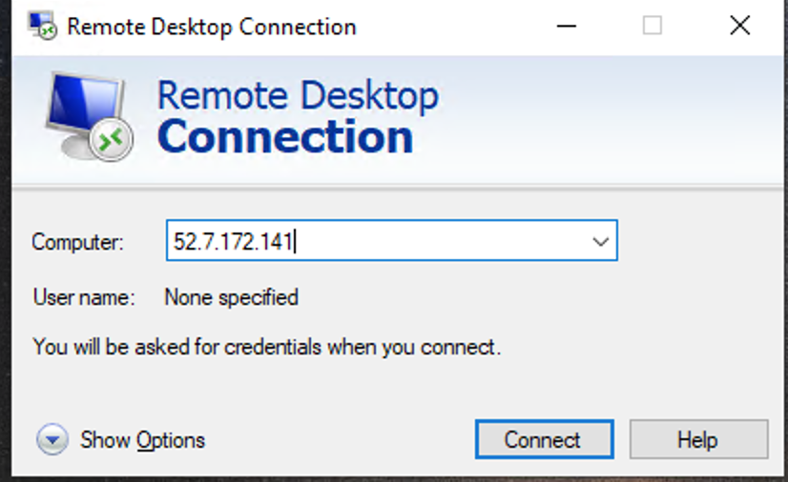
v

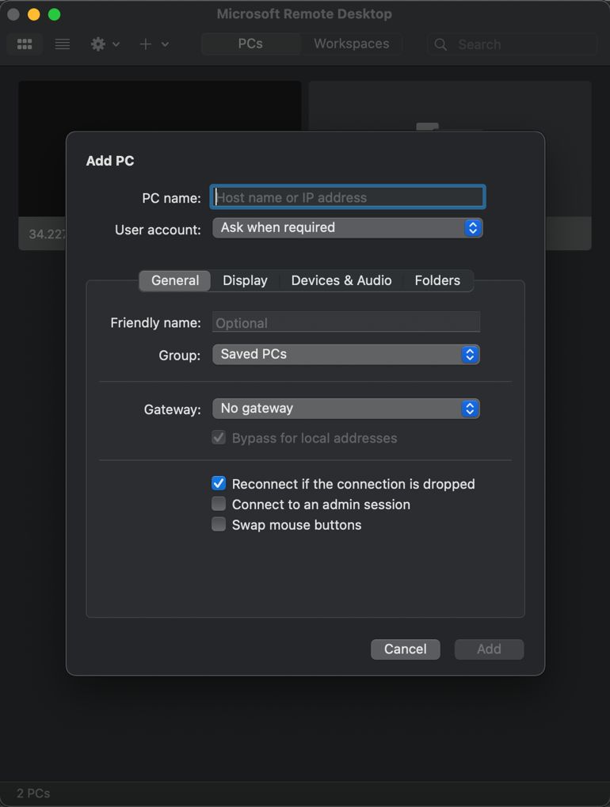

- Click Connect (Windows) or Add (Mac) and double click the PC you just added in the Remote Desktop main page.
- Enter your login information. Your username is firstname.lastname@develop.amazoninstances.com, and the password is the same you used to get into the Jenkins server in Section I, Step 2.

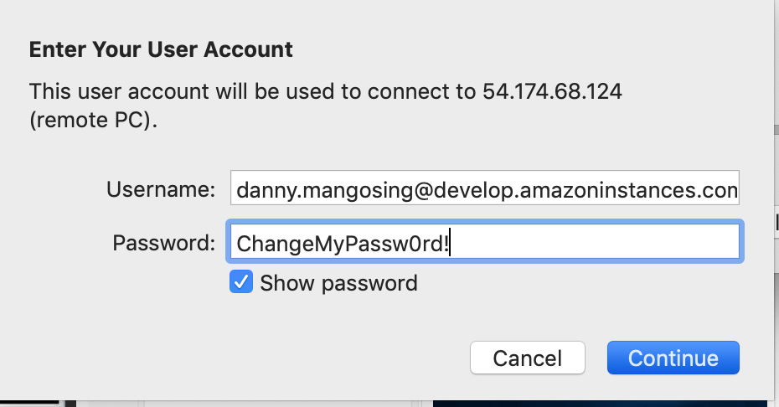

- You may get a pop-up about validity of certificate similar to the example below. Click Continue, this is normal for Remote Desktop connections to EC2 instances.

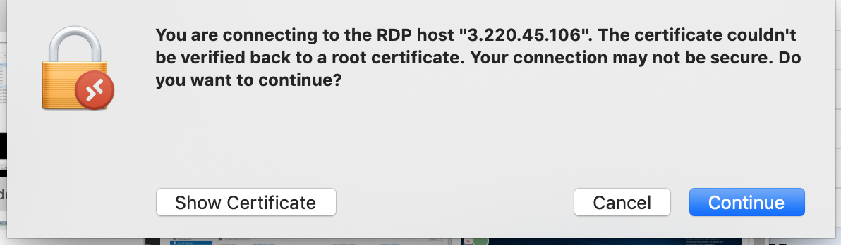

- After clicking Continue, you should be greeted with your EC2 instances’ desktop!
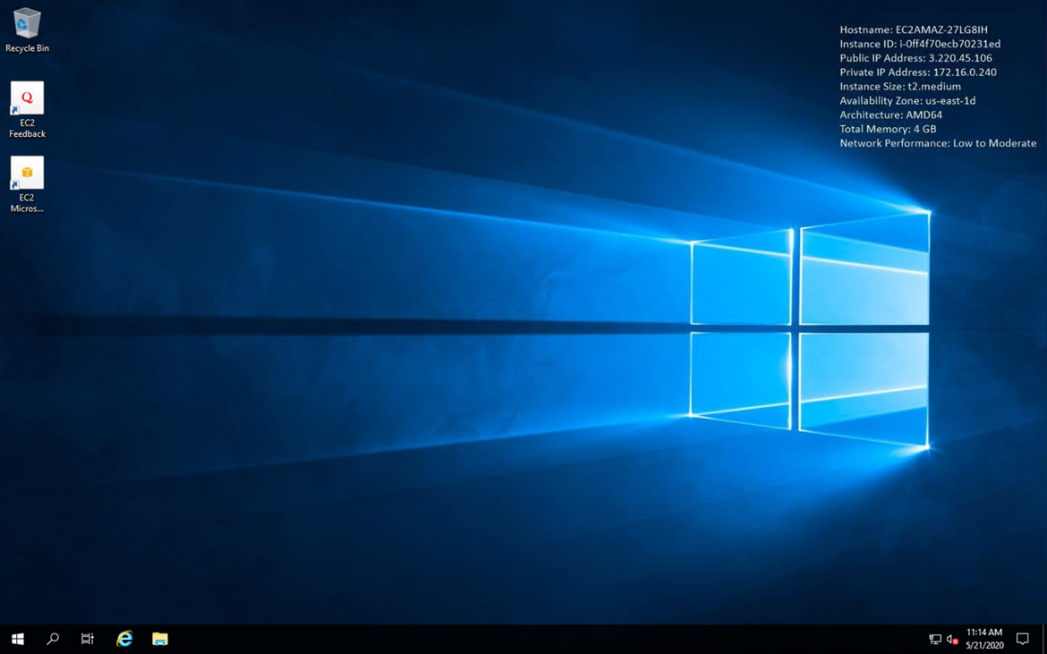

III. Connecting to the Shared Drive
Map your network drive to the D: drive to share files and data between your team’s VMs.

- Open File Explorer by double clicking the folder icon in the bottom left task bar of your desktop.

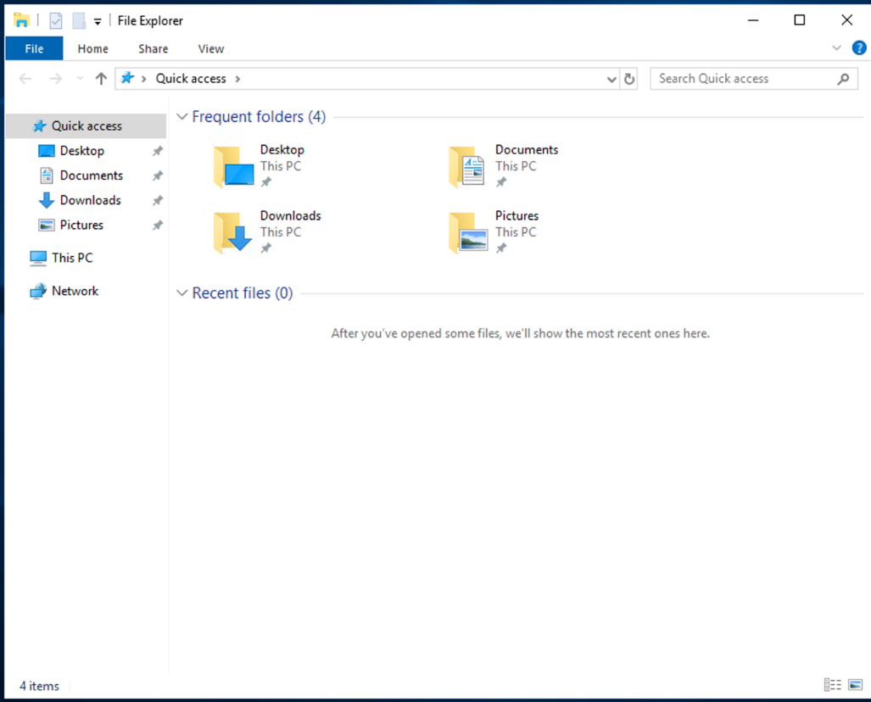

- Right click on the Network icon on the left-hand panel and select Map network drive… from the pop-up selection screen.

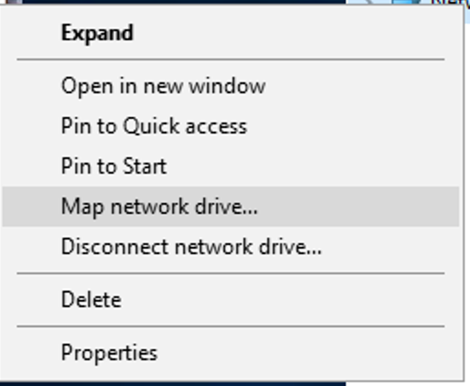

- Select drive letter D: for the mapping.
- Enter \\172.16.0.171\share in the Folder: path field.

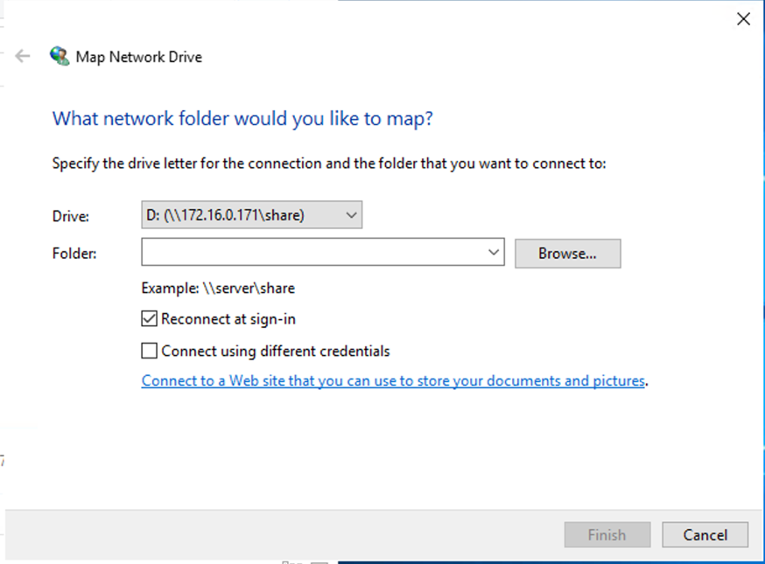

- Ensure the box is checked for Reconnect at sign-in. Click OK.
- Verify you see a C: and a D: drive mapping in File Explorer when you select This PC in the left side panel.

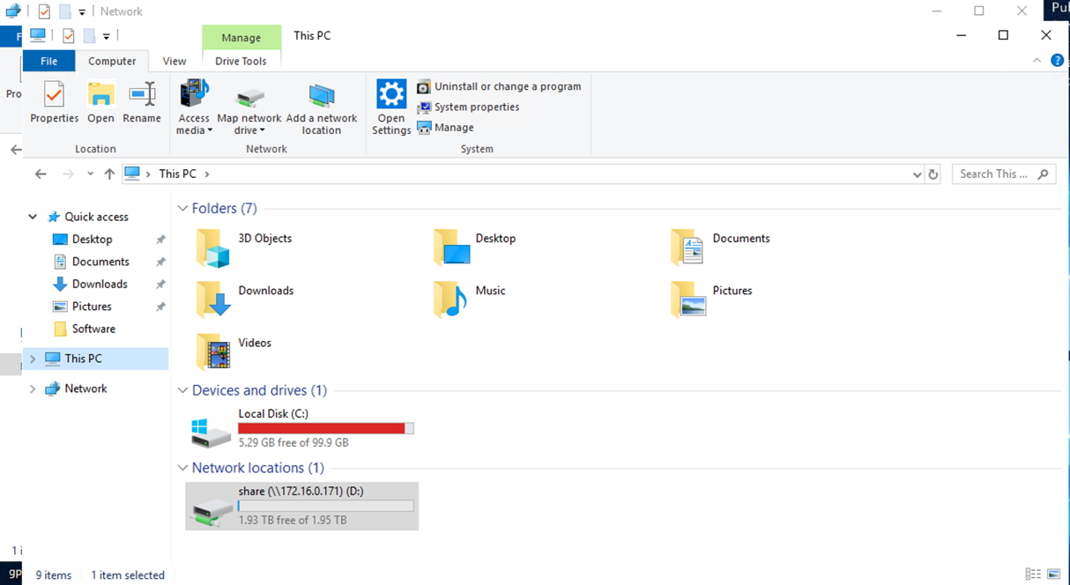

Things to Note:
- This shared D: drive is your DEVELOP project space. With everyone mapping this drive to their EC2 instances, you can easily share files between systems and have applications access that shared data for processing.
- AWS will perform periodic snapshots (backups) of this space.
- If your EC2 instance was terminated, any data on this shared drive will remain.

IV. Sharing Files Outside of Your EC2
Install the AWS Amazon WorkDrive software to your EC2 instance to make files available between your EC2 and local machine (i.e., your laptop).

- You can download the WorkDocs drive software for pc by launching Firefox on your EC2’s desktop, and entering the following URL: https://aws.amazon.com/workdocs/resources/?workdocs-whats-new.sort-by=item.additionalFields.postDateTime&workdocs-whats-new.sort-order=desc
- Select Download for PC and save the file when the pop-up appears.
- Launch the file to install WorkDocs. Select Yes.

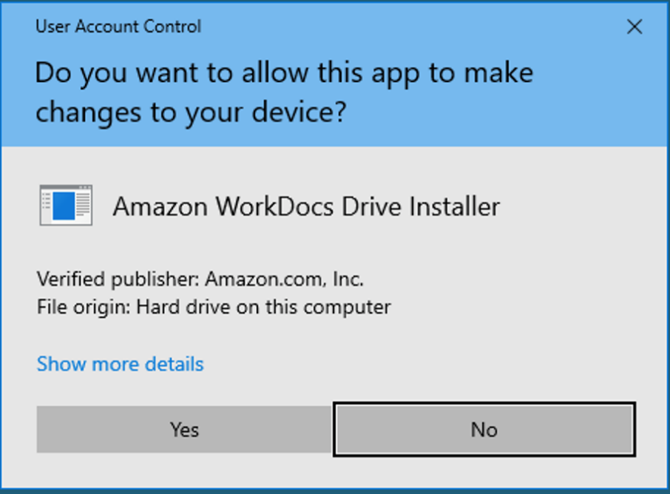

- Click No, you will restart after completing the installation configuration.

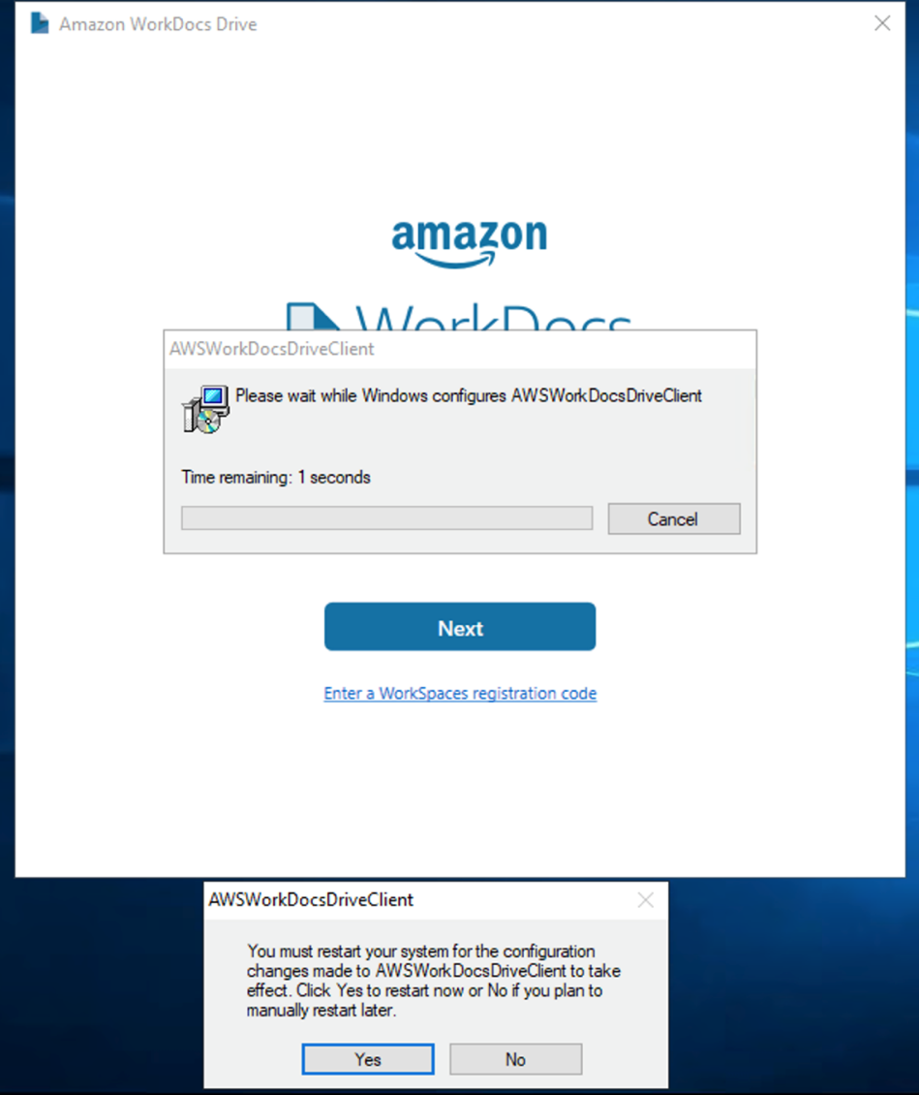

- Enter d9067765911 as the WorkDocs site URL and click Next.

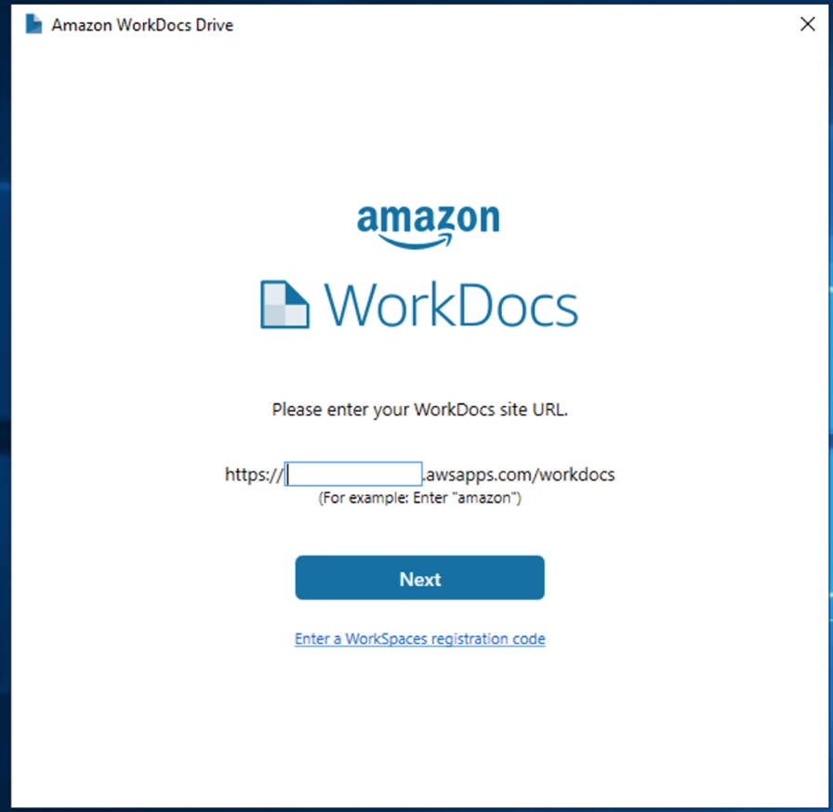

- Enter the same username and password you used to login to the Jenkins server to sign in.

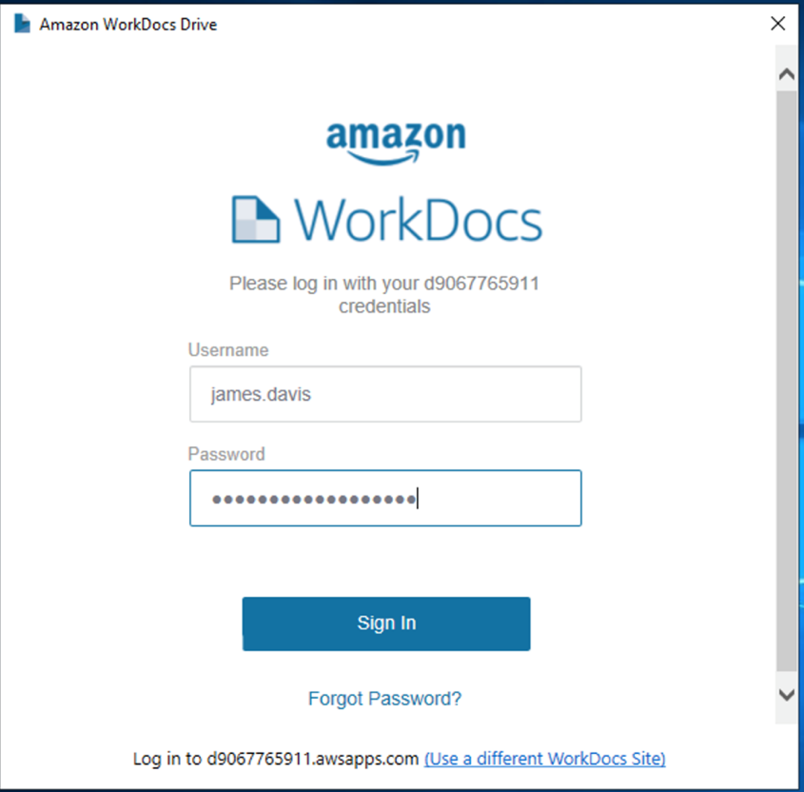

- Restart your EC2 instance to finish the installation of the WorkDocs Drive.
- After your EC2 restarts and you are able to login, open up File Explorer and click on the This PC icon in the left panel. You should see a C: , D: and WorkDocs drives listed like the picture below.

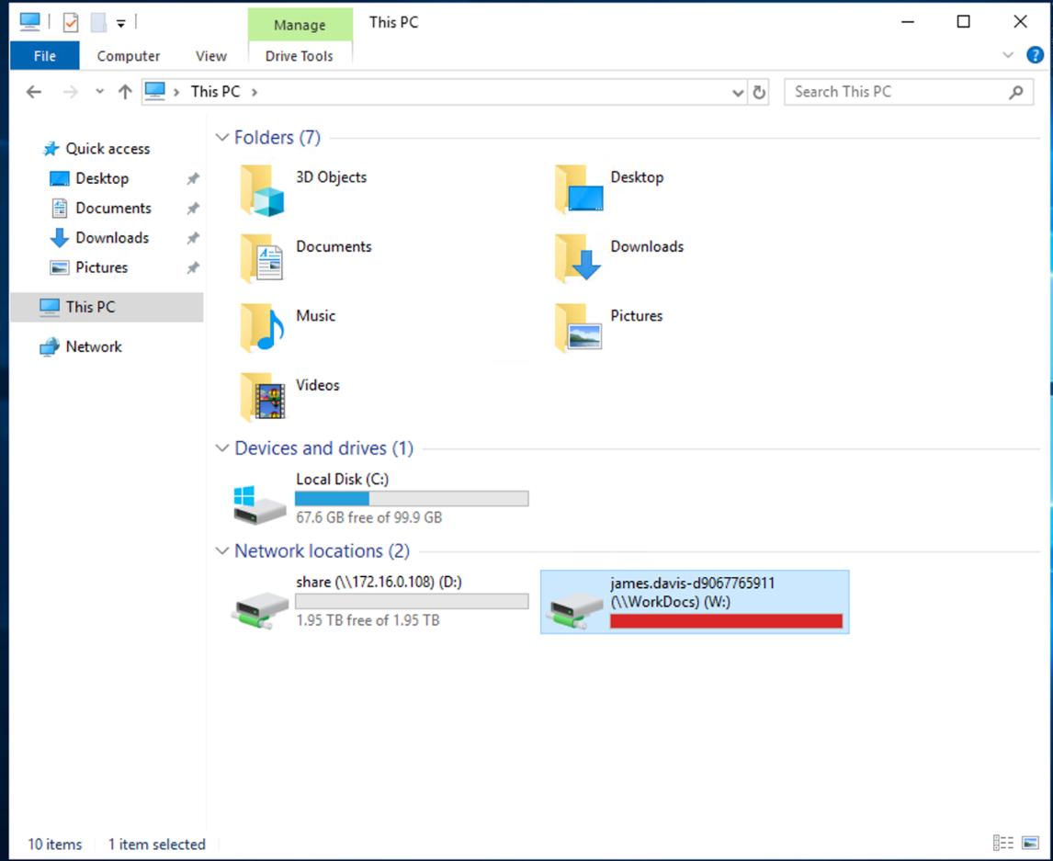

V. Accessing GitLab

Via the User Interface
- Use Google Chrome or Microsoft Edge to navigate to https://gitlab-develop.ssai-cloudhelp.com.
- You will get to the login page. Choose the Active Directory tab and login with the same username you used to login to Jenkins in Section I, Step 2.
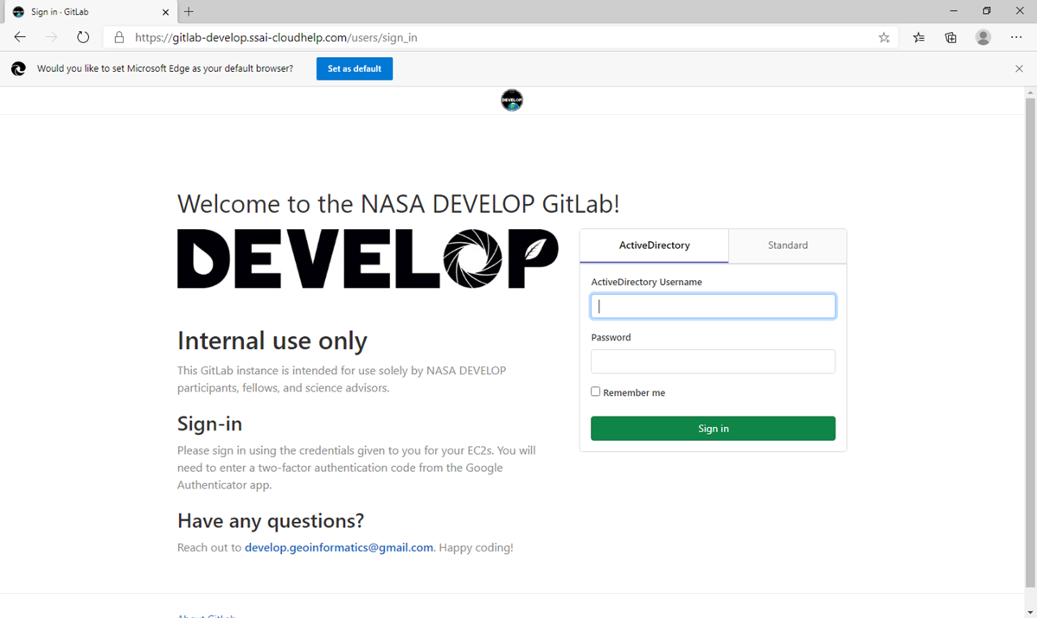
If you are not logging in for the first time, skip to Step 5.
- You will be asked to set up two-factor authentication (2FA). Download the Google Authenticator app on your phone.
- Launch the Google Authenticator app and use it to scan the barcode on the screen.
- Fill in the PIN code to complete the 2FA process.
- If successful up to this point, you should be at the main GitLab dashboard and can begin to explore the system.

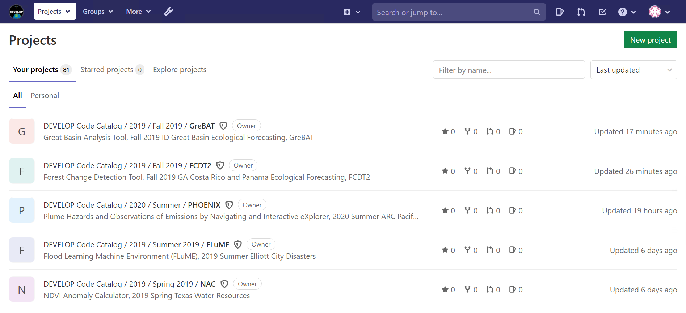

Via the Command Line
GitLab has great documentation on using the command line! We will be following the Start Using Git on the Command Line instructions: https://docs.gitlab.com/ee/gitlab-basics/start-using-git.html

Note: The domain name you will replace gitlab.com with is gitlab-develop.ssai-cloudhelp.com.

- Open Git Bash by clicking on the magnifying glass icon in the lower left corner and typing “Git Bash.”

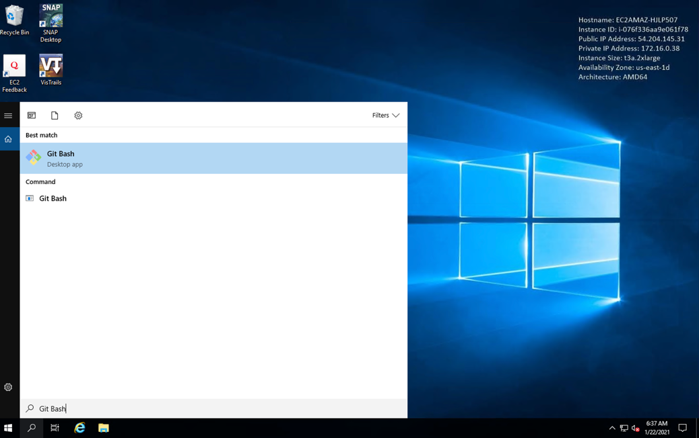

- First, check that there are no other SSH keys set up on your VM. Jim Davis may have set one up, and you will have to remove it.
    - In Git Bash, type cd .ssh
    - If you get an output that says bash: cd: .ssh: No such file or directory then you can proceed to Step 3.
    - Type the command start . to open the directory.
    - Left click and Delete any files in the .ssh folder.
    - Return to Git Bash and type cd – to navigate back to the home directory.
    - Type rmdir .ssh to remove the empty .ssh folder. Continue to Step 3.
- Now that your SSH keys are clear, complete the steps from Requirements through Configure Git for Windows.
- Once you reach the section titled Git Authentication Methods, we recommend authenticating via an ED25519 SSH key, though you can use whatever type of SSH key you’d like. You can find the instructions for generating a new key pair here: https://docs.gitlab.com/ee/ssh/README.html
    - Complete the steps from Requirements through Generating a New Key Pair.
    - Note that when you enter your passphrase, nothing will show up! (This is a security reason.) If you entered the passphrase twice and it was accepted successfully, your passphrase should be whatever you entered the first time. Write it down so you don’t forget it! You also have the option to simply press “Return” and not have a passphrase at all.
- Follow the steps in the section Adding an SSH Key to Your GitLab Account to add your new key to your account.
- Finally, test that everything is set up correctly. You can follow the instructions in this section.
- Congratulations! You can now access GitLab from the command line.

VI. Shutting Down Your EC2
You MUST shut down your EC2 every single time you are done using it! We don’t want to waste energy or money on an unused virtual machine.
  - If you are not currently logged in to Jenkins, you will need to log back into the Jenkins server: https://jenkins.ssai-cloudhelp.com/login?from=%2F
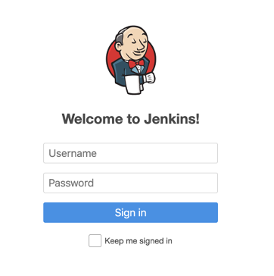
  - Click on DevelopAWS to navigate back to the DEVELOP AWS project page.
  - Select Build with Parameters on the left-hand side panel.

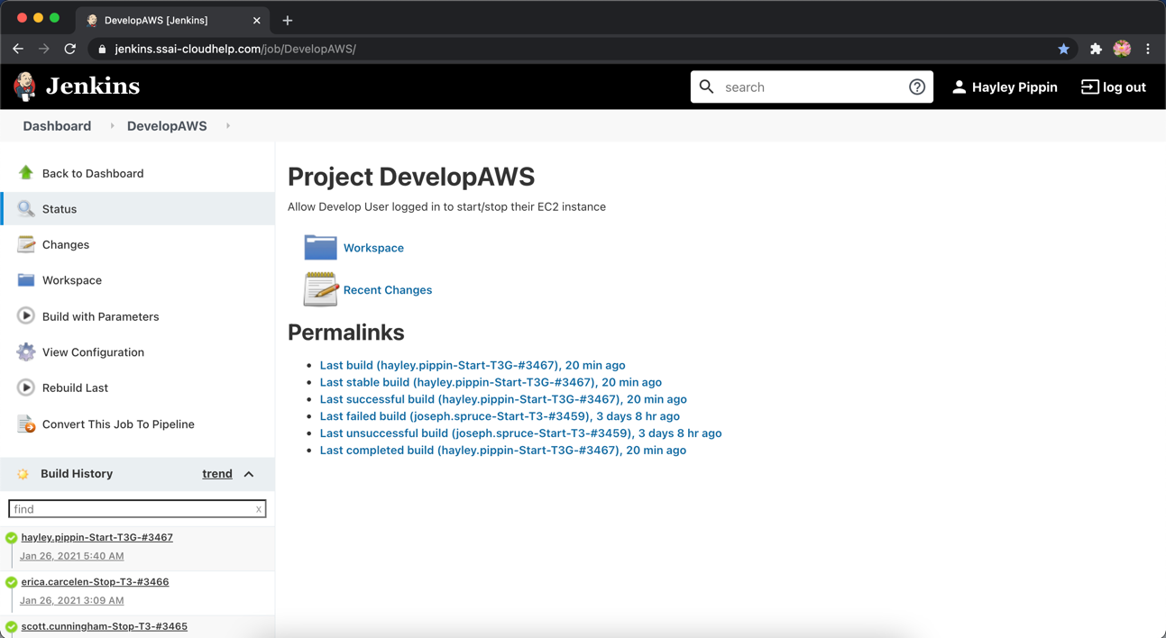

  - In the Action dropdown menu, select the option Stop and make sure the ImageType is set to the same one you started (T3, T3G, etc.).

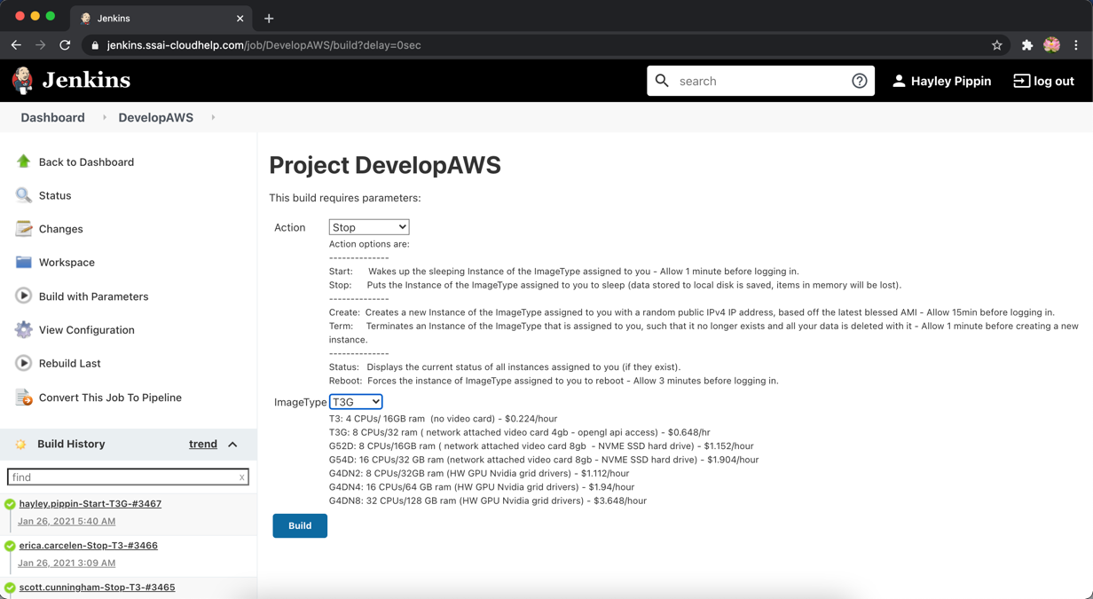

  - Click the blue Build button.
  - You can view the progress of your Stop job in the bottom left-hand panel under Build History. Your job will always be the first one listed.
  - Once you see a green checkmark next to it, you know that your EC2 has shut down and you are good to log off for the night.

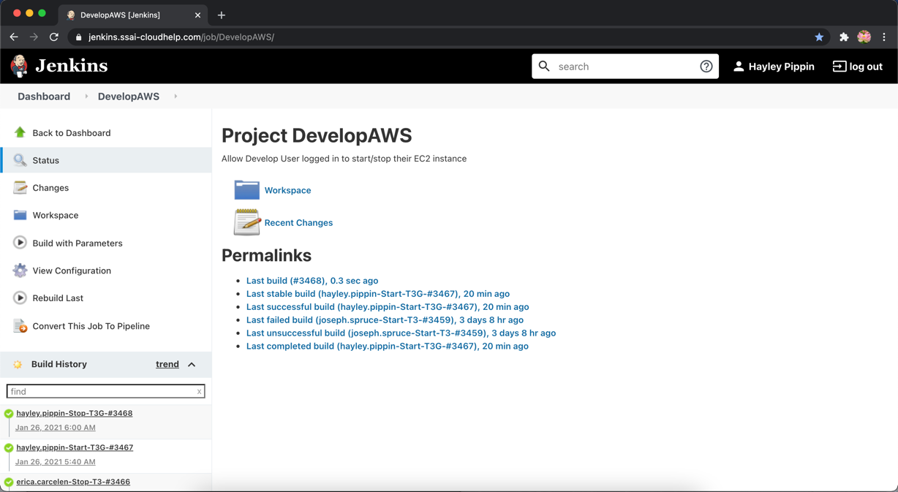
c

