**NASA DEVELOP National Program**



USGS at Colorado State University

*Fall 2015*

Wyoming Ecological Forecasting

Mapping Cheatgrass Distribution and Phenology in a Post-Wildfire Landscape in Wyoming’s Medicine Bow National Forest

 **Technical Report**

Rough Draft – October 8, 2015

Darin Schulte (Project Lead)

Chandra Fowler

Stephanie Krail

Oliver Miltenberger

Dr. Paul Evangelista, Natural Resource Ecology Lab, Colorado State University (Science Advisor)

Dr. Amanda West, Natural Resource Ecology Lab, Colorado State University (Mentor)

# I. Abstract

[To be inserted in final draft]

**Keywords**

*Bromus techtorum*, Cheatgrass, Invasive Species, Phenology, Landsat 8, Species Distribution Model, Wyoming, Wildland Fire

# II. Introduction

**Background Information**

The management of invasive plant species is a major concern for natural resource managers worldwide as invasive plant species can alter historic fire regimes and water/nutrient cycling, as well as outcompete native plant species (West et al. 2015). The winter annual grass downy brome, or cheatgrass (*Bromus tectorum*), has become an extremely prevalent invasive species in the Western U.S., where its ability to germinate prior to the onset of winter temperature extremes provides it with a seasonal advantage relative to many native plant species (Bromberg et al. 2011, Wainwright et al. 2012, West et al. 2015).

Previous work has suggested that in North America, cheatgrass is among the most ecologically disruptive invasive plant species (Campagnoni & Adler 2014) and it has been identified as one of the most serious threats to sagebrush steppe ecosystems in the Intermountain West (Mack 1981, Knapp 1996). Cheatgrass invasion and establishment has historically been more prevalent in lower elevation/more arid environments where it has noticeably decreased the fire return interval and fundamentally changed species composition by outcompeting native plant species. However in considering future global climate change scenarios, *Bromus tectorum* encroachment into higher altitudes and latitudes has increasingly become a concern (Bromberg et al. 2011, Compagnoni & Adler 2014).

Within the study of Invasion Ecology, it is generally accepted that disturbance events increase the potential for the encroachment and establishment of invasive plant populations (Banks & Baker 2011, Bromberg et al. 2011, West et al. 2015, but see Sher et al. 2008). Of particular focus in the semiarid, Intermountain West region, is the increased likelihood of post-fire invasive species establishment, and the resultant shifts in plant community composition. The establishment of cheatgrass populations after wildland fires—human caused and/or resulting from natural processes—is an increasing area of research and poses important challenges for the management of natural resources (West et al. In Review).

**Project Objectives**

We created a Species Distribution Model (SDM) for the 2012 Arapaho wildfire site in the Medicine Bow National Forest (MBNF) in Southeastern Wyoming using Landsat 8 OLI and TIRS imagery for the 2015 growing season (i.e., May - September). Our goal was to test the abilities of five distinct modeling approaches in their ability to predict cheatgrass cover three years after a fire event. Furthermore, we made use of MODIS data pertaining to phenological stages of vegetation within the area in order to provide the Forest Service with the necessary information for locating cheatgrass populations and timing the application of aerial herbicides.

**Study Area and Period**

The study area consists of the extent of the 2012 Arapaho wildfire (42.201° N latitude, -105.49° W longitude) (Figure 1) in the MBNF of Southeastern Wyoming (WRS2 Path 34, Row 31). Data acquired for the project consisted of Landsat 8 images with less than 10% cloud cover over the study area from May – September 2015.

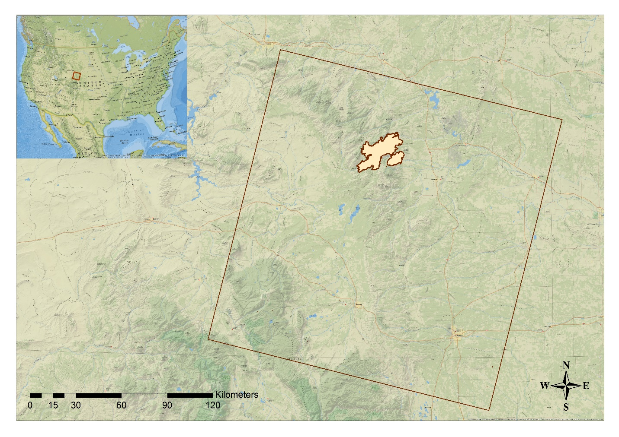

Figure 1: Study Site - Arapaho Fire extent, Medicine Bow National Forest, WY. [LEGEND to be inserted in Final Draft]

**National Application Addressed**

This project addressed the NASA National Application Area of Ecological Forecasting by creating predictive models of cheatgrass presence and absence in a post-burn area, as well as providing detailed, spatially explicit, information regarding cheatgrass phenology. The results of this research will inform the management and mitigation of *Bromus tectorum* encroachment within MBNF.

**Project Partners**

The primary project partners were the Wyoming Game and Fish Department and the US Forest Service, organizations actively involved in the management of invasive species within MBNF. Both organizations have a working history with the Natural Resource Ecology Laboratory at Colorado State University and this project builds on the previous collaborative efforts of these groups.

[Further detail regarding the direct application of the results from this project by project partners to be included after interviews with POCs taking place later this week].

# III. Methodology

**Data Acquisition**

This project made use of multiple NASA Earth observation data sources (Table 1). We acquired a 1-arc second, 30 m void-filled digital elevation model (DEM) from the Shuttle Radar Topography Mission (SRTM) using the USGS Earth Explorer portal (USGS, 2015). Also through the USGS Earth Explorer portal, we downloaded Landsat 8 Level 1, terrain corrected data for both the Operational Land Imager (OLI) and Thermal Infrared Sensor (TIRS). All available scenes for Path 34, Row 31, with less than 10% cloud cover over the study area were acquired for the 2015 growing season (i.e., May – September), yielding a total of six scenes.

Phenology data were obtained from the MODIS Land Cover Dynamics product (MCD12Q2) using the NASA’s Earth Observing System (EOS) Data and Information System Reverb platform (2015).

[NOTE: We are actively searching for appropriate dates for the MCD12Q2 data product. Currently, we have only been able to ascertain data through 2012 which is not appropriate for use in this project. If we are unable to obtain more recent data (i.e., 2015) we will pursue other avenues for phenology mapping].

We were provided with an ESRI shapefile for the extent of the 2012 Arapaho wildfire from our project partners at USGS and NREL at Colorado State University, as well as point locations for cheatgrass presence/absence field data gathered in 2014 and 2015.

Table 1: Summary of NASA Earth observation products used in this project.

|  |  |  |  |
| --- | --- | --- | --- |
| **Platform** | **Data Product** | **Spatial Resolution** | **Source** |
| Landsat 8 | OLI & TIRS | 30 m (OLI) & 100m (resampled to 30 m)(TIRS) | USGS Earth Explorer |
| Terra / Aqua | MODIS Land Cover Dynamics product (MCD12Q2) | 500 m | NASA Reverb |
| SRTM | Digital Elevation Model (DEM) | 30 m | USGS Earth Explorer |

**Data Processing**

We derived a series of vegetation indices for all Landsat 8 OLI images using an ArcMap toolbox created by our project partner at NREL at Colorado State University. Derived vegetation indices included the following; Normalized Difference Vegetation Index (NDVI), Normalized Difference Water Index (NDWI), Modified Normalized Difference Water Index (MNDWI), Enhanced Vegetation Index (EVI), Soil Adjusted Vegetation Index (SAVI), as well as three indices resulting from a tasseled cap transformation: TCAP soil brightness, TCAP vegetation greenness, TCAP soil/vegetation wetness.

[Table summarizing vegetation indices and their respective formulae to be included in the final draft].

In addition to vegetation indices, a series of topographic indices were derived from the 30 m DEM using the ArcGIS Geomorphometric & Gradient Metrics toolbox (Evans 2014). Derived topographic indices included slope, aspect, second derivative of slope (SDS), cosine transformation of aspect (COS), sine transformation of aspect (SIN), and Compound Topographic Index (CTI). All vegetation in topographic indices were derived using ArcMap v. 10.2.

[Table summarizing topographic indices and their relevance to be included in the final draft].

Field data consisting of percent cover of cheatgrass at 166 point locations within the study area were provided by our project partners at USGS Fort Collins Science Center, and NREL at Colorado State University in the form of a comma separated values (CSV) file format. Percent cover was then recoded such that locations with greater than 40% coverage were assigned a value of ‘1’ indicating cheatgrass presence, and percent coverage values less than 40% were assigned a value of ’0’ indicating cheatgrass absence. The 40% threshold was supported in previous work as sufficient to accurately identify cheatgrass at a 30 m pixel resolution (West et al. In Review).

[Will include complete description of ancillary field data (percent cover of cheatgrass) in final draft. We will be meeting with our project mentor at NREL at Colorado State University next week to ensure we accurately represent the field sampling/data collection].

**Data Analysis**

Species Distribution Models (SDM) were constructed using the USGS Software for Assisted Habitat Modeling (SAHM; Morisette et al. 2013) and open-source species distribution and habitat suitability modeling software.

[Note: detailed description of data analysis/modeling procedure to be included in final draft. We will be meeting with our project mentor Amanda West next week to review/refine preliminary model runs].

Vegetation and topographic indices were supplied to the SDM as predictor variables (covariates). Initial stages of SDM in SAHM identify cross-correlation and multicollinearity among covariates (Dormann et al. 2013, Morisette et al. 2013, West et al. 2015). In the event that two variables were strongly correlated (i.e., with a Spearman, Pearson, or Kendall correlation coefficient, |r| ≥ 0.70), the variable with either a greater percent variation explained (via Generalized Additive Modeling (GAM)), or biological/ecological relevance, was retained (West et al. In Review).

[Final covariate inputs to the SDM to be provided in the final draft].

Five species distribution models were used in SAHM: Generalized Linear Model (GLM), Multivariate Adaptive Regression Spline (MARS), Boosted Regression Trees (BRT), Random Forest (RF), and Maximum Entropy (MaxEnt).

[Detailed description of each species distribution model to be provided in the final draft]

Field Data and Model Testing: [To be included in final draft]

Model Performance Evaluation: [To be included in final draft]

# IV. Results & Discussion

Coming soon!

# V. Conclusions

Coming soon!

# VI. Acknowledgments

* Dr. Paul Evangelista (Natural Resource Ecology Lab, Colorado State University)
* Dr. Amanda West (Natural Resource Ecology Lab, Colorado State University)
* Ryan Amundson (Wyoming Game and Fish Department)
* Katherine Haynes (US Forest Service)
* Catherine Jarnevich (USGS, Fort Collins Science Center)
* Colin Talbert (USGS, Fort Collins Science Center)
* Marian Talbert (USGS, Fort Collins Science Center)
* Brian Woodward (Natural Resource Ecology Lab, Colorado State University)
* Steve Chignell (Natural Resource Ecology Lab, Colorado State University)

Any opinions, findings, and conclusions or recommendations expressed in this material are those of the author(s) and do not necessarily reflect the views of the National Aeronautics and Space Administration.

This material is based upon work supported by NASA through contract NNL11AA00B and cooperative agreement NNX14AB60A.

# VII. References

Banks ER, Baker WL (2011) Scale and Pattern of Cheatgrass (*Bromus tectorum*) Invasion in Rocky Mountain National Park. *Natural Areas Journal* 31:377-390.

Bromberg JE, Kumar S, Brown CS, Stohlgren TJ (2011) Distributional Changes and Range Predictions of Downy Brome (*Bromus tectorum*) in Rocky Mountain National Park. *Invasive Plant Science and Management* 4:173-182.

Campagnoni A and Adler PB (2014) Warming, Competition, and *Bromus tectorum* Population Growth Across an Elevation Gradient. *Ecosphere* 5(9): 121.

Dormann CF, Elith J, Bacher S, Buchmann C, Carl G, Carré G, Marquéz JRG, Gruber B, Lafourcade B, Leitão PJ, Münkemüller T, McClean C, Osborne PE, Reineking B, Schröder B, Skidmore AK, Zurell D, Lautenbach S (2013) Collinearity: a Review of Methods to Deal with it and a Simulation Study Evaluating their Performance. *Ecography* 36: 27-46.

Evans JS, Oakleaf J, Cushman SA, Theobald D (2014) An ArcGIS Toolbox for Surface Gradient and Geomorphometric Modeling, version 2.0-0. Available: <http://evansmurphy.wix.com/evansspatial>. Accessed: 2015 September 20th.

Knapp PA (1996) Cheatgrass (*Bromus tectorum* L.) Dominance in the Great Basin Desert. *Global Environmental Change* 6: 37-52.

Mack RN (1981) Invation of *Bromus tectorum* L. into Western North America: an Ecological Chronicle. *Agro-Ecosystems* 7: 145-165.

Morisette JT, Jarnevich CS, Holcombe TR, Talbert CB, Ignizio D, Talbert MK, Silva C, Koop D, Swanson A, Young NE (2013) VisTrails SAHM: Visualization and Workflow Management for Species Habitat Modeling. *Ecography* 36: 129-135.

Sher AA, Gieck S, Brown CS, Nissen SJ (2008) First-Year Responses of Cheatgrass Following *Tamarix* spp. Control and Restoration-Related Disturbances. *Restoration Ecology* 16(1): 129-135.

Wainwright CE, Wolkovich EM, Cleland EE (2012) Seasonal Priority Effects: Implications for Invasion and Restoration in a Semi-Arid System. *Journal of Applied Ecology* 49: 234-241.

West AM, Kumar S, Wakie T, Brown CS, Stohlgren TJ, Laituri M, et al. (2015) Using High-Resolution Future Climate Scenarios to Forecast *Bromus tectorum* invasion in Rocky Mountain National Park. *PloS ONE*.

West AM, Evangelista PH, Jarnevich CS, Kumar S, Swallow A, Luizza MW, Chignell SM (In Review) Developing Distribution Maps for Invasive Species in Post-Wildfire Landscapes Using Methods Relevant to Land Management. *For Environmental Management*.

# VIII. Content Innovation

Coming soon!

# IV. Appendices

Coming soon!