Hampton Roads Health & Air Quality

Monitoring Air Quality using MODIS and CALIPSO Data in Conjunction with

Socioeconomic Data to Map Air Pollution in Hampton Roads Virginia

 **Technical Report**

August 9th, 2024

Marilee Karinshak (Project Lead)

Brooklyn Appling

Sidney Hipp

Piper Coleman

***Advisors:***

Dr. Travis Toth, NASA Langey Research Center (Science Advisor)

Dr. Xia Cai, NASA Langley Research Center (Science Advisor)

***Lead:***  
Olivia Landry (Virginia – Langley)

# 1. Abstract

Situated along Virginia’s southeastern coast, Hampton Roads is a historic and modern hub for coal storage and transportation. When inhaled, aerosols like coal dust can cause respiratory and cardiovascular issues, raising concerns among community members about the potential human health risks associated with particulate matter (PM) pollution. For this project, NASA DEVELOP partnered with the Virginia Department of Environmental Quality (DEQ) to determine the feasibility of using NASA Earth observations to better understand the distribution of PM across the region. This project incorporated data from NASA’s Terra/Aqua MODIS and CALIPSO CALIOP satellite sensors with ground stations to monitor PM concentration, the vertical distribution of pollutants, and air quality trends over time. Leveraging both satellite and sociodemographic data, we mapped the spatial distribution of pollutants across the entire region, as requested by the Virginia DEQ to address low spatial coverage from a limited number of ground monitors. Thus, we identified areas experiencing disproportionately high PM pollution—with historically marginalized communities near coal facilities being the most consistently at-risk. This analysis provided the Virginia DEQ with important resources in understanding spatial air pollution trends and helped inform future sensor placements. However, current Earth observations are not sufficiently accurate to act as primary methods for ground-level PM monitoring in Hampton Roads; a joint approach combining in situ monitors and satellite data proved to be the most effective for this region.

**Key Terms**

remote sensing, MODIS, CALIPSO, aerosol optical depth, particulate matter, human health, Hampton Roads

# 2. Introduction

***2.1 Background Information***

Hampton Roads is a metro area that lies along Virginia’s southeastern coast and is home to over 1.7 million residents, 47% of which identify as people of color (Hampton Roads Planning District Commission, 2021). Since 1885, coal transportation and storage has taken place throughout these communities and established Hampton Roads as an important region for trading and industry, with over 40 million tons of coal being dumped, stored, and transported in 2018 alone (Hampton Roads Planning District Commission, 2021). In addition to typical urban air pollution sources like vehicle emissions, coal—often stored in large, uncovered piles—spreads from storage and transportation facilities, emits pollutants, and increases concentrations of airborne fine particles within 25 miles of storage facilities (Jha and Muller, 2017). This has contributed to increased health and air quality concerns in the region regarding the possibility of heightened particulate matter (PM) pollution.

PM is a general term for solid particles found suspended in the air and are categorized by size. The two main categories are PM10 and PM2.5 (particles with diameters under 10 μm and 2.5 μm, respectively), which includes airborne dust, pollen, mold, combustion particles, organic compounds, and metals (United States Environmental Protection Agency [US EPA], 2024b). Inhaling PM is linked to numerous adverse health effects including premature death in people with heart or lung disease, nonfatal heart attacks, irregular heartbeat, aggravated asthma, decreased lung function, and increased respiratory symptoms, such as irritated airways, coughing, or difficulty breathing (US EPA, 2024b). Those with heart or lung diseases, children, and older adults are most likely to be affected by PM exposure (US EPA, 2023). While all PM can have adverse health effects, smaller particles, like PM2.5, pose the greatest health risks as they can be inhaled deeper into the lungs and may even reach the bloodstream (US EPA, 2023). Thus, the Clean Air Act requires the US EPA to set National Ambient Air Quality Standards for 6 principal pollutants, including PM (US EPA, 2024a). While the EPA has set the national PM2.5 standard to 9 µg/m3, academic research indicates that there are no safe levels for PM2.5 exposure (US EPA, 2024a; Papadogeorgou et al., 2019).

***2.2 Project Partners & Objectives***

Founded in 1993, the Virginia Department of Environmental Quality (DEQ) is the government agency responsible for managing the commonwealth’s natural resources, protecting its environment, and improving citizens’ health and well-being. In 2022, the Virginia DEQ received $526,603 from the EPA to assess air quality related to coal dust in two Hampton Roads communities—Lambert’s Point in Norfolk and the Southeast Community in Newport News (Virginia DEQ, n.d.a). With the EPA grant, the DEQ established the Tidewater Air Monitoring Evaluation Project (TAME) which aims to monitor air pollution resulting from coal storage and transportation and to inform citizens about the potential human health risks associated with PM pollution. The TAME project was largely in response to longstanding community concerns about air pollution from coal dust. Lamberts Point and Newport News’ Southeast Community are known as “environmental justice communities” according to the Virginia Environmental Justice Act. Under this Act, environmental justice communities are defined as “any low-income community or community of color” who have been historically excluded in “the development, implementation, or enforcement” of environmental regulations (Virginia Environmental Justice Act, 2020). To address these concerns, the DEQ and TAME officials placed PurpleAir sensors throughout these target communities to monitor PM pollution and to provide residents with real-time air quality readings.

To understand the distribution of air pollution across the entire Hampton Roads region, the Virginia DEQ partnered with NASA DEVELOP to explore the use of Earth observations for visualizing environmental disparities and to provide resources to better support community engagement. The study area, Hampton Roads, consists of the following seven cities: Chesapeake, Hampton, Newport News, Norfolk, Portsmouth, Suffolk, and Virginia Beach (Figure 1). The study period ranged from January 2014 to May 2024, allowing us to establish annual trends for air pollutants and track changes over time. Previous scientific literature (Rubin et al., 2017; Chen et al., 2022; Toth et. al, 2022) used data from NASA’s Moderate Resolution Imaging Spectroradiometers (MODIS) and Cloud-Aerosol Lidar and Infrared Pathfinder Satellite Observations (CALIPSO) to validate ground monitors, measure vertical distribution of PM aerosols, and analyze regional PM concentrations. Thus, our project objectives looked to incorporate these methodologies to determine the feasibility of using NASA Earth observations to: measure PM Aerosol Optical Depth (AOD) and the PM aerosol altitudes, validate ground-based monitors, model PM aerosol distribution across Hampton Roads, visualize disparities based on social vulnerability, and help inform future sensor placement to support the TAME project.

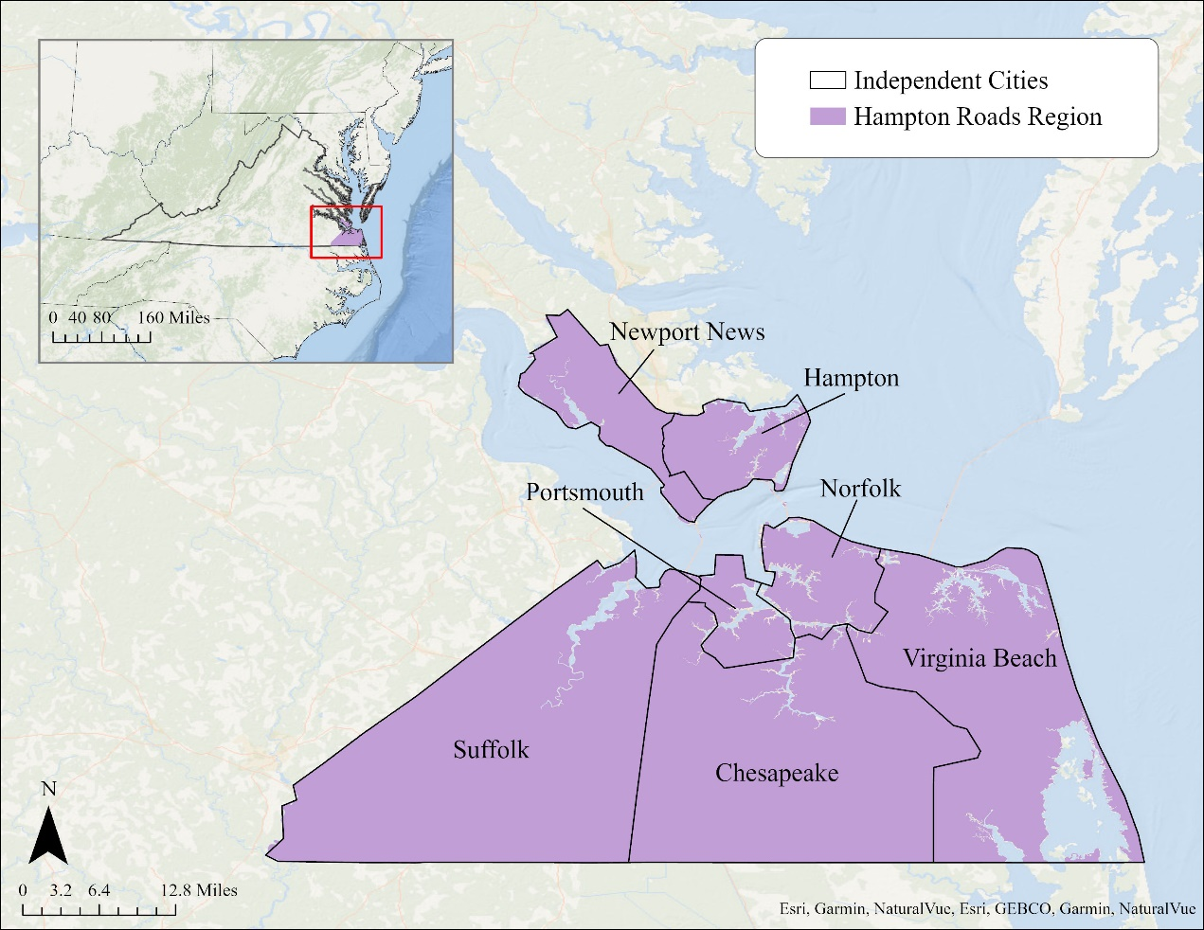

[Basemap: Esri, GEBCO, Garmin, NaturalVue]

*Figure 1*. The study area includes the independent cities of Newport News, Hampton, Portsmouth, Norfolk, Virginia Beach, Suffolk, and Chesapeake.

# 3. Methodology

***3.1 Data Acquisition***

*3.1.1 PM Aerosol Optical Depth*

PM AOD, sometimes referred to as aerosol optical thickness (AOT), is not a direct measurement of atmospheric PM aerosols; it is a measure of the total amount of light absorbed or scattered by PM aerosols in a column of the atmosphere (Chen et al., 2015; Giles et al., 2019). Because AOD relies on interactions between PM aerosols and light, different wavelengths result in different optical depths. Due to its ubiquity across monitors and in the literature, we used 550 nm (green light) as our default and used 500 nm and 675 nm for Ångström interpolation to 550 nm where it is not present (Giles et al., 2019). AOD has no units but is scaled consistently across monitors (Bhaskaran et al., 2011). Lower AOD values around 0.1 represent clear skies, while AOD values nearer to 1.0 represent thick haze.

Compared with in situ measurements taken by PM monitors and sensors, PM AOD is significantly less representative of conditions near the ground because PM AOD measurements take PM aerosols at all elevations into account. Therefore, PM aerosols will have equal effects on optical depth regardless of their elevation (Bhaskaran et al., 2011). Ground monitors, however, do not encompass our entire study area and have large data gaps, requiring interpolation which introduces errors. Terra and Aqua MODIS combined Multi-Angle Implementation of Atmospheric Correction (MAIAC) Land AOD measurements cover the entire study area and eliminate these concerns (Figure 2). Thus, PM AOD may be a mediocre proxy of ground-level PM in any one location but is reflective of variation between locations (Bhaskaran et al., 2011).

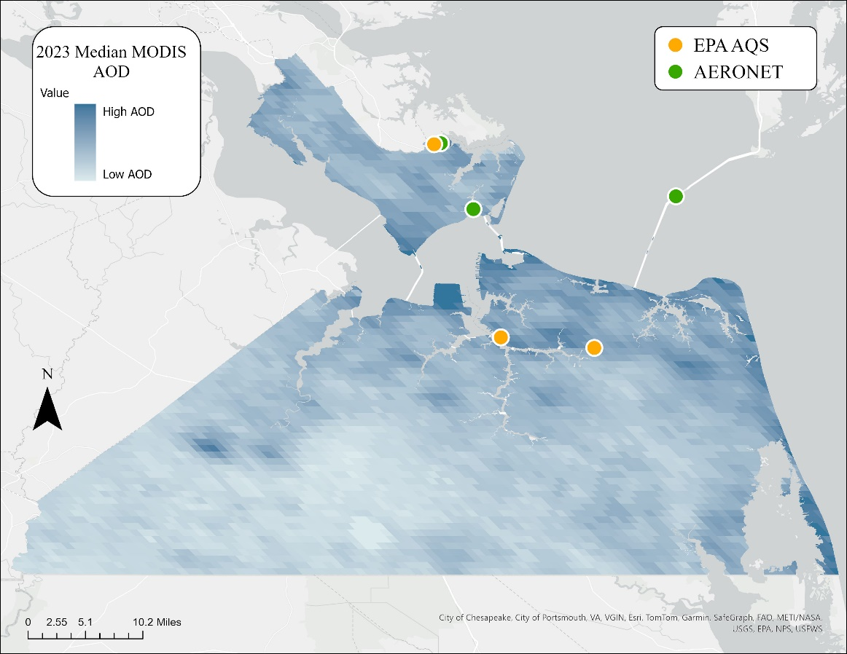

[Basemap: City of Chesapeake, City of Portsmouth, VA, VGIN, ESRI, TomTom, Garmin, SafeGraph, FAO, METI/NASA, USGS, EPA, NPS, USFWS].

*Figure 2*. The study area and period contained data from only six ground monitors, including three AERONET ground monitors and three EPA Air Quality System ground monitors, whereas Aqua/Terra satellite MODIS sensor AOD data encompassed nearly the entire study area and period.

We obtained AOD from MODIS and NASA’s ground-based Aerosol Robotic Network (AERONET), which provides high accuracy, ground-truth measurements of AOD (Bhaskaran et al., 2011; Chen et al., 2015; Rubin et al., 2017). To ensure accuracy, we acquired data at level 2.0, meaning it is “quality assured” with calibration and cloud masking already applied (Table 1). To create the most comprehensive dataset, we collected all MODIS and AERONET datapoints within our study area and study period, filtered out null and missing values, and maintained timestamps to the nearest hour in Coordinated Universal Time (UTC). While several AERONET monitors had been placed in our study area, only three monitors had data available within our study period: Hampton University, the Chesapeake Bay Bridge–Tunnel, and NASA Langley Research Center. In contrast, MODIS AOD readings covered the entire study area throughout the entire study period. For use in time series analyses and social vulnerability map we obtained MODIS AOD for the entire study period and each full year within the decade (2014 – 2023). In addition to descriptive statistics across the entire study area, we obtained and timestamped all AOD values in pixels directly over AERONET and EPA Air Quality System (AQS) monitors for dataset validation.

Table 1

*List of monitors, sensors and data products used in this project*

|  |  |  |  |  |
| --- | --- | --- | --- | --- |
| **Sensor** | **Parameter** | **Dataset (Citation)** | **Dates** | **Source** |
| Terra/Aqua MODIS | AOD | MCD19A2 MODIS/Terra+Aqua Land Aerosol Optical Depth Daily L2G Global 1km SIN Grid V061 (Lyapustin & Wang, 2022) | 01/01/2014 to 05/31/2024 | Google Earth Engine |
| AERONET | AOD | Aerosol Optical Depth (AOD) with Precipitable Water and Angstrom Parameter Level 2.0 (Giles et al., 2019) | 01/03/2014 to 03/20/2024 | AERONET Data Download Tool |
| EPA AQS | PM2.5 | Hourly FRM/FEM PM2.5 (US EPA n.d.) | 04/11/2017 to 04/29/2024 | AQS API |
| CALIPSO CALIOP | Aerosol Profile | CALIPSO Lidar Level 2 Aerosol Profile, V4-51 (NASA/LARC/SD/ASDC n.d.b) | 01/01/2014 to 05/06/2023 | NASA Langley Atmospheric Science Data Center DAAC. |
| CALIPSO CALIOP | Vertical Feature Mask | CALIPSO Lidar Level 2 Vertical Feature Mask, V4-51 (NASA/LARC/SD/ASDC n.d.a) | 01/01/2014 to 05/06/2023 | NASA Langley Atmospheric Science Data Center DAAC. |
| PurpleAir | PM2.5 | PM2.5 ALT-CF3 (Wallace, 2022) | 08/06/2020 to 05/20/2024 | PurpleAir Data Download Tool |

*3.1.2 PM2.5*

While data from ground-based PM monitors and sensors cannot be extrapolated across our entire study area, it is important for validating and contextualizing MODIS AOD readings. Two networks of PM2.5 monitors and sensors operated within our study area during our study period: the EPA AQS monitors—containing publicly available data—and PurpleAir—a proprietary network of sensors owned by several public and private entities, including the Virginia DEQ. Three EPA monitors collected data within our study area and study period: the NASA Langley Research Center monitor in Hampton, the National Oceanic and Atmospheric Administration monitor in Norfolk, and the DEQ Tidewater Regional Office monitor in Virginia Beach. We also received data from thirteen PurpleAir sensors placed in our study area. To note, the PurpleAir company began monitoring air quality in 2016; however, the earliest PurpleAir data in Hampton Roads was not available until August 2020.

Each EPA AQS datapoint contained data detailing its collection procedure. Collection procedures are outlined in Title 40 of the Code of Federal Regulations Part 53: there are federal reference methods, federal equivalent methods (methods that are at least as accurate), or neither (About AQS Data, n.d.; Clean Air Act, 1975). Additionally, EPA monitors vary in data collection duration—ranging from continuous data reported as hourly averages, to intermittent data reported once every 12 days (About AQS Data, n.d.). Due to monitor upgrades throughout our time period, both intermittent and continuous data were present. For standardization purposes we obtained only EPA AQS datapoints within our study area, study period, and that followed either federal reference methods or federal equivalent standards. We then filtered out null and missing values and maintained timestamps of PM2.5 measurements to the nearest hour UTC. For PurpleAir, we acquired daily “pm2.5_alt” data for each of the sensors within our study area and filtered out all null and missing values.

*3.1.3 CALIPSO CALIOP*

The Cloud-Aerosol Lidar with Orthogonal Polarization (CALIOP) sensor aboard the CALIPSO satellite provided data related to the vertical structure of aerosols in the atmosphere. We specifically acquired aerosol profile and vertical feature mask datasets using the NASA Earthdata Search Tool to filter for CALIPSO paths that intersected with our study area during the study period. However, the data did not span our entire study period as the CALIPSO scientific mission ended August 1, 2023.

*3.1.4 Sociodemographic Data*

We sourced sociodemographic data from the United States Census Bureau 2020 Census Demographic Data using the Virginia DEQ’s EJScreen+ Tool (Virginia DEQ n.d.b). According to the Virginia DEQ, an Environmental Justice Community is defined as low-income, a community of color, or both (Virginia DEQ n.d.b). They further define a low-income community as any community where at least 30% of the population has an income (a) less than 80% of annual national median income according to the U.S. Department of Housing and Urban Development and (b) under twice the federal poverty level (Virginia DEQ n.d.b). Conversely, communities of color are defined as areas consisting of higher proportions of people of color than the state as a whole—at least 37.8% in Virginia (Virginia DEQ n.d.b). We used this data in conjunction with MODIS AOD data to create a bivariate analysis to aid partners in demonstrating if air pollution exposure compounds upon pre-existing disparities and injustices.

***3.2 Data Processing***

*3.2.1 Processing Data for Validating MODIS with Ground Monitors*

Using Google Earth Engine, we exported all MODIS “Optical_Depth_055” spectral band values from each pixel corresponding with a ground monitor or sensor during our study period. The resulting CSV included these AOD measurements along with the corresponding date and time (UTC, to the nearest hour). Since MODIS AOD is scaled relative to other measures of AOD, we divided all values by 1000 to be standardized with AERONET AOD data.

Although AERONET monitors collect AOD values at many wavelengths, they do not collect data at 550 nm, rather they collect data at 500 nm and 675 nm. From these measurements, we were able to use Ångström interpolation to get our target AOD measurement of 550 nm (Ångström, 1929; Equation 1). This interpolation associates optical depth with the wavelength of light, based on particle size. However, the relationship can be established without needing particle size by using two AOD measurements at known wavelengths. The equation we used is as follows, where *λn* is the wavelength in *n* nanometers and *τn* is the AOD at wavelength *λn*:

After we cleaned and processed all the MODIS and AERONET data, we used ArcGIS Pro 3.3.0 to create joins between MODIS and AERONET data and between MODIS and EPA data. We joined the data based on hourly UTC time and deleted any values that did not have a corresponding measurement. The resulting data showed any MODIS AOD and ground monitor measurements taken at the same location within the same hour. We used these datasets to validate MODIS AOD data with ground monitors by running linear correlations among the two.

*3.2.2 Processing Data for Time Series Analyses*

We further processed MODIS AOD data in preparation for building a time series analysis. Using the same MODIS data and spectral band as previously used in Google Earth Engine, we exported reduced images of the mean, median, 90th percentiles, and 98th percentiles of AOD for each year in our study period. We used AOD values for the mean, median, and 90th percentile analyses, but converted the 98th percentile values into PM2.5 measurements and then into the Air Quality Index. Additionally, we obtained daily mean MODIS AOD and EPA PM2.5 for decomposing our series into trend, seasonality, and noise components.

*3.2.3 Processing Data for Social Vulnerability Index Map*

We used the sociodemographic data and AOD data to make a bivariate social vulnerability index map. To process the sociodemographic data for this analysis, we assigned factors to each census tract. We assigned a factor of zero to census tracts that did not meet the thresholds for classification as a low-income community or a community of a color. A factor of one signified either a low-income community or a community of color. Finally, we assigned a factor of two to census blocks that were both low-income and communities of color.

*3.2.4 Processing CALIPSO CALIOP Data to PM2.5*

In addition to MODIS AOD, we used CALIPSO to gain a better understanding of the vertical distribution of aerosols. After gathering the relevant CALIPSO paths, we assessed their lidar images using the CALIPSO Browse Images Tool and removed any faulty data or data with cloud cover that would obstruct ground aerosol readings. Next, using HDFViewer, we extracted the latitude, longitude, vertical feature mask, relative humidity, and extinction coefficient at 532 nm. CALIPSO CALIOP level 2 data is produced in 5 km horizontal averages, with each one consisting of 15 different lidar pulses. For our PM2.5 values we used points at an altitude of 100 m to avoid ground-object interference. For each pass we chose 5 km swaths whose center point fell between 36 and 38°N and between 75.5 and 77.5°W to reduce processing time. Next, we filtered out all values whose vertical feature mask classification was not “aerosol” or “clear,” and that had extinction coefficient data between 0 and 1.25 km-1 to help maintain data quality (Toth et al., 2019). Finally, we plotted the center points of each 5 km swath in ArcGIS Pro using the latitude, longitude, and PM2.5 in µg/m3 using the equation derived from Toth et al. (2019; Equation 2):

$$\begin{aligned}PM_{2.5}=\frac{1000⋅σ⋅φ}{a_{scat}⋅{\frac{1-RH}{1-RH_{ref}}}^{-Γ}+a_{abs}}\#\left(2\right)\end{aligned}$$

In this equation, *σ* represents the extinction coefficient; *φ* represents the PM2.5 to PM10 ratio and is assumed to be 0.6; *ascat* and *aabs* are the dry mass scattering and absorption efficiencies that are assumed to be 3.40 m2/g and 0.37 m2/g, respectively; *RH* is the relative humidity; *RHref* is the reference relative humidity of 30%; and Γ is a parameter that describes the hygroscopic increase in scattering and is assumed to be 0.63 (Toth et al. 2019). In total, this method for deriving PM2.5 from CALIPSO produced 282 datapoints within 5 km of the study area across 40 different CALIPSO paths.

However, the data was still not fully usable as an estimate for ground-level patterns because the variation between paths overpowered the variation within them. As a result, rather than showing which parts of a CALIPSO pass had the highest PM2.5 it shows which passes were taken during high PM2.5 events, like the 2023 Canadian wildfires. To partially account for this, we normalized PM2.5 by path instead of showing the difference between each point’s PM2.5 value and the mean PM2.5 of points along the same path within ~1 degree of the study area. This approach emphasizes regions with abnormally high or low PM2.5 concentration for the area, better drawing out spatial differences, especially in the north–south axis.

*3.2.5 Processing CALIPSO CALIOP Data for Extinction Coefficient Plot*

In preparation for building extinction coefficient plots, we chose three CALIPSO case studies. The first case study was a swath on March 12, 2021, from 07:33:14 to 08:19:19 UTC, which crossed over Lambert’s Point near the coal export facility and a residential area. The second case study was on May 3, 2023, from 08:50:21 to 09:35:45 UTC, which crossed directly over the coal storage and transportation facility in Newport News. The third case study was on October 31, 2018, from 17:46:59 to 18:39:28 UTC, which collected data on a low pollution day.

After visualizing all the CALIPSO swaths in ArcGIS Pro, we found the specific lidar pulse coordinates from each case study that intersected with our areas of interest. Within the *Latitude* and *Longitude* tables of the HDF4 files for each case study, we found the row numbers that corresponded with the coordinates of interest. We then found the same rows in the *Extinction_Coefficient_532* tables. These rows gave us the mean 532 nm extinction coefficient values for approximately 5 km of the case study CALIPSO swaths over our coordinates of interest. Each column of the *Extinction_Coefficient_532* table corresponded with a specific altitude. These altitude values were not included in the science data sets via the HDFView tool, so we had to extract altitude information from metadata. Once we aligned the altitude measurements, we removed the first 254 columns as they included measurements above our altitude range of interest (8.2 km to -0.5 km). Next, we removed any missing data, which appeared as values of -9999. Finally, we applied quality control and extinction confidence filters as outlined in Tackett et al. (2018), ultimately leading to the rejection of our May 3, 2023 case study. This processed data was used to create mean 532 nm extinction coefficient plots for each of our case studies.

***3.3 Data Analysis***

*3.3.1 Validating MODIS with Ground Monitors Analysis*

The MODIS sensors do not directly measure AOD but rather the data is derived algorithmically from other data products. For this reason, before using MODIS in our analysis, we compared it against AERONET monitors to demonstrate its validity as a measure of AOD. Similarly, the correlation between AOD and PM2.5 varies by region, so we compared MODIS AOD readings against EPA monitors to evaluate the efficacy of MODIS AOD for estimating PM2.5. For both comparisons, we performed linear regression analyses using the tabular data joined in ArcGIS Pro and plotted the results in Python 3.12.4.

*3.3.2 Time Series Analyses*

The Virginia DEQ was also interested in possible change over time throughout our study period. We used ArcGIS Pro to extract a mean value across our study area of mean, median, and 90th percentile AOD for each year. To examine any trends across our entire 10-year study period, we then plotted these points and performed linear regressions to get both the trend (slope) and significance (R2). We also produced animations showing the year-to-year changes in AOD throughout the ten-year study period using maps of the mean, median, and 90th percentile AOD and the Air Quality Index.

However, not all changes occur on a decadal scale, so we also conducted two seasonal decomposition analyses using Python to look at annual and subannual trends. For these, we used daily and monthly mean EPA PM2.5 and MODIS AOD values. First, we extracted seasonality on a monthly scale (too high of a temporal resolution would overfit the data) and then used seasonality adjustments (Table A1) to create a season-blind Gaussian moving average to show variation between years.

*3.3.3 Social Vulnerability Index Map Analysis*

Our partner was also interested in how sociodemographic factors might affect certain communities’ levels of vulnerability when it comes to air quality. Therefore, to create a social vulnerability index, we first imported the Virginia DEQ’s socioeconomic data into ArcGIS Pro along with an AOD concentration map showing the average AOD level across the entire study period. We then used ArcGIS Pro to create a bivariate analysis to visualize vulnerable populations based on census blocks. The resulting map showed the environmental justice communities, areas with higher aerosol concentrations, and the areas where both of those factors co-occurred.

*3.3.4 CALIPSO CALIOP-Derived PM2.5 Analysis*

After obtaining normalized PM2.5 values for each CALIPSO point, we used inverse distance weighted interpolation to visualize spatial trends across the dataset. This method of interpolation assumes that values nearest to a surface have the most impact, and thus is a moderately good method of displaying regional spatial trends. To reduce the impact of any single point and to produce a smoother surface, we used a power of 1.

*3.3.5 CALIPSO CALIOP Case Study Extinction Coefficient Profiles Analysis*

Our partner was interested in knowing if the aerosols over the coal facilities—detected via MODIS AOD—were near the ground, as these would impact human health. The CALIPSO CALIOP 532 nm extinction coefficient is a measure of the total amount of light absorbed or scattered by aerosols at a specific altitude in the atmosphere. By plotting the 532 nm extinction coefficients at each altitude in a specific column of the atmosphere, we could gain a better understanding of whether the area around coal facilities had high- or low-altitude aerosols. To visualize this, we plotted the average 532 nm extinction coefficient at each altitude along an approximately 5 km CALIPSO swath for the March 12, 2021 and October 31, 2018 case studies to see where aerosols were concentrated around coal facilities.

# 4. Results & Discussion

***4.1 Analysis of Results***

*4.1.1 Validating MODIS with Ground Sensors Results*

The first phase of analysis for our project was validating MODIS AOD against in situ ground monitors. Although AOD can be derived from MODIS imagery, the satellite was not originally designed to measure it. Therefore, we validated the sensor’s accuracy against NASA’s AERONET ground monitors using a linear regression (Figure 3, left). The resulting R2 value of 0.74 indicated a strong correlation and confirmed that we could rely on MODIS data to measure AOD for the remainder of the project.

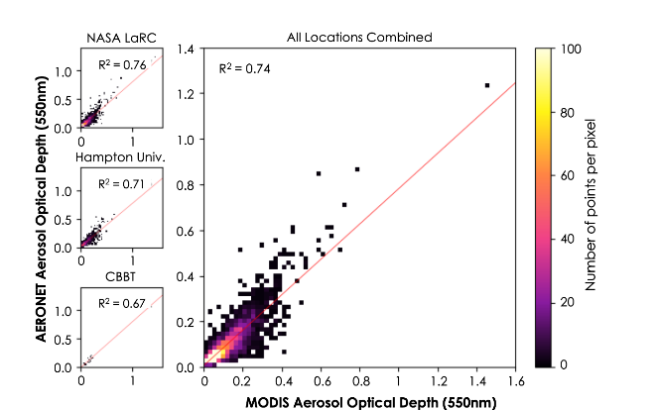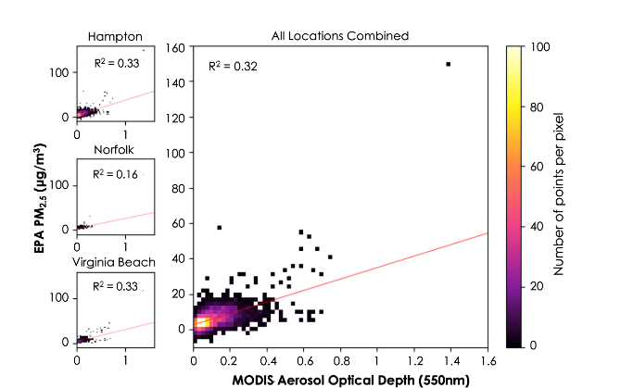

*Figure 3*. MODIS-derived AOD correlates strongly with AERONET AOD (left) but correlates only fairly with EPA PM2.5 (right). Individual locations are shown in small plots and represent the locations of AERONET (left) and EPA (right) ground monitors. NASA LaRC is NASA Langley Research Center and CBBT is the Chesapeake Bay Bridge–Tunnel.

While AOD measures aerosols of any size in an entire column of the atmosphere, only small aerosols near the ground impact human health. Therefore, we also wanted to determine how well MODIS AOD could act as a proxy for ground-level PM2.5. Here we used the same process, using a linear regression between MODIS AOD and EPA PM2.5 (Figure 3, right). We found a weak correlation with an R2 value of 0.32 which suggests that MODIS AOD is not a reliable proxy for individual PM2.5 measurements. However, MODIS AOD is still useful in identifying broad patterns.

*4.1.2 AOD Concentration Maps and Time Series Analysis Results*

We visualized average daily AOD concentrations across our study period (Figure 4). Over the ten-year study period, the highest AOD levels were concentrated along the coast, in southern Newport News, and in northern Norfolk. Conversely, the lowest levels were seen in the Great Dismal Swamp, a protected area with almost no human development. Importantly, we saw similar spatial trends across different years and for varying descriptive statistics of MODIS AOD—mean, median, 90th percentile, and 98th percentile-derived Air Quality Index—all showing the highest and lowest values in the same areas (Figure 4, Figure A1, Figure A2).

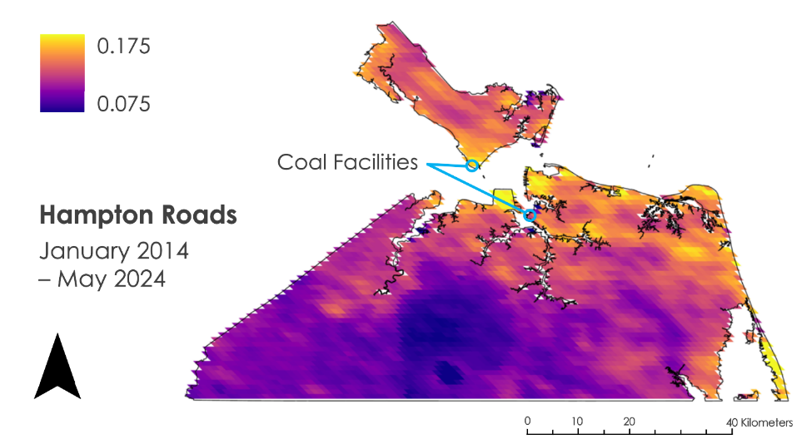

*Figure 4*. Average AOD over the ten-year study period shows heightened AOD values along the coastline, southern Newport News, and northern Norfolk.

We further analyzed AOD by looking at temporal aerosol trends. While there was much variation in daily AOD values and some variation in monthly mean AOD values, AOD generally followed a pattern with higher values in the summer and lower values in the winter (Figure 5, Table A1). One possible explanation for this trend is the increase in pollen during the spring and summer months. This pattern is called seasonality and was factored out to produce a general trendline. While there were some increases in MODIS AOD in years with wildfires (2021 and 2023), there was no broader trend in AOD, with only minimal increases and decreases (-0.0001 < slope < 0.0001 and R2 < 0.01).

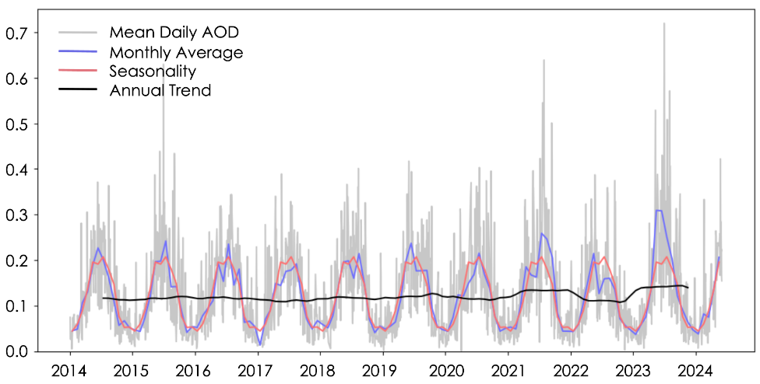

*Figure 5*. Daily MODIS AOD was quite variable across our study period but exhibited relatively consistent seasonality and annual trends over time.

We also produced an identical graph but plotted daily mean PM2.5 instead of daily mean MODIS AOD and saw a similar overall trend (Figure 6). Importantly, the EPA classifies an annual PM2.5 average of above 9.0 µg/m3 as unsafe for sensitive populations, and the annual trend stayed below that threshold (US EPA, 2024a). This was corroborated by our MODIS-derived Air Quality Index which showed that no locations crossed the EPA’s daily PM2.5 threshold of 35.4 µg/m3. Finally, the seasonality in PM2.5 readings was much less regular, with the highest values in the late summer and late fall while the winter and spring months had low readings (Table A1). Despite this difference, accounting for seasonality had a minimal effect on our MODIS AOD to EPA PM2.5 correlations, increasing the R2 value from 0.32 to 0.34.

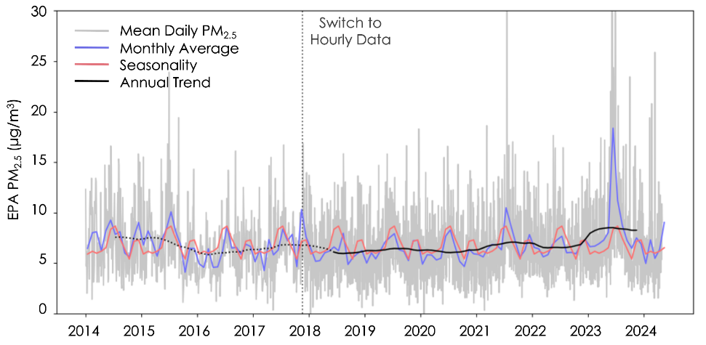

*Figure 6.* Daily PM2.5 closely followed MODIS AOD in annual trends but exhibited different seasonality. The monitor changed from intermittent daily values to consistent hourly values in late 2017, indicated by the vertical dotted line. Parts of the annual trendline in solid black were wholly produced by the new, better data.

*4.1.3 CALIPSO CALIOP-Derived PM2.5 Results*

Next, we produced a map of relative CALIPSO-derived PM2.5 concentration (Figure 7). Here we saw a somewhat similar pattern to MODIS AOD: higher concentrations along the James River and lower concentrations near the Great Dismal Swamp (Figure 8). However, CALIPSO and MODIS disagreed on concentrations in Virginia Beach, with MODIS detecting high AOD and CALIPSO detecting below-average PM2.5. Still, the level of agreement lends credence to the validity of patterns detected by MODIS.

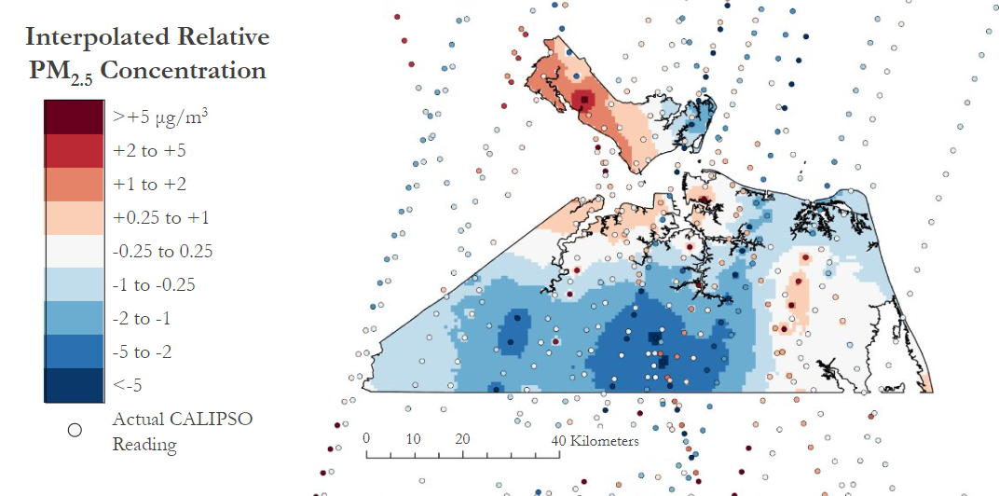

*Figure 7*. Interpolated relative CALIPSO-derived PM2.5 values show higher relative PM2.5 in Newport News, while the lowest are in rural areas adjacent to the Great Dismal Swamp.

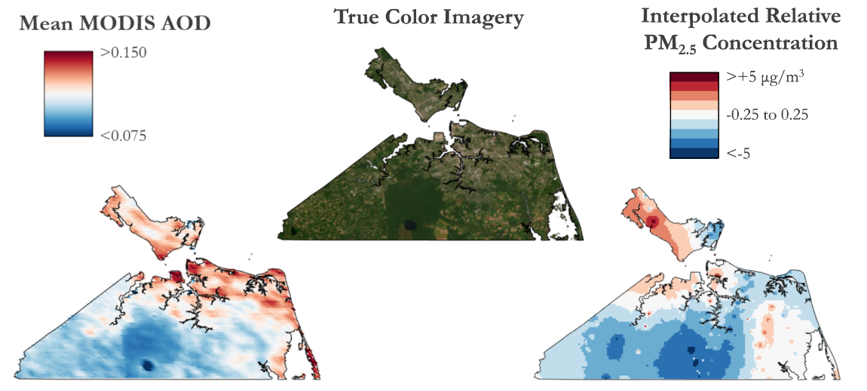

[True Color Basemap: Earthstar Geographics]

*Figure 8*. Spatial patterns of interpolated relative CALIPSO-derived PM2.5 distribution somewhat align with those of MODIS AOD, lending credence to the datasets’ validity.

While ideally, we could have used CALIPSO PM2.5 instead of MODIS AOD, there were two main factors limiting its viability. First, there were only forty CALIPSO paths with usable data that intersected our study area during our study period, leading to relatively high margins of error and low spatial resolution. Additionally, due to its polar orbit, CALIPSO primarily passed in a north–south orientation. Because of the way relative PM2.5 concentrations are calculated, changes along the north–south axis are more valid than those from east to west.

*4.1.4 CALIPSO CALIOP Case Study Extinction Coefficient Plots Results*

The extinction coefficient profile created for our case studies showed the number of aerosols detected at each altitude, with higher extinction coefficients indicating more aerosols. The extinction coefficient plot from the March 12, 2021 case study over the Norfolk coal facility revealed that all the aerosols over our region of interest were within one kilometer of the ground (Figure 9, bottom right). The extinction coefficient value of 0.0 at approximately 40 meters was likely due to ground-object interference. Additionally, we referenced the CALIPSO lidar browse images to view the aerosol subtype for this case study. The vertical feature mask indicated that the primary aerosols were polluted dust and polluted continental (Figure 9, left). Furthermore, we created a map of the median MODIS AOD readings collected on the same day as the case study to supplement our understanding of the distribution of aerosols. We found that there were relatively high AOD values in the same region as the CALIPSO path (Figure 9, top right). These three aerosol distribution figures indicate that MODIS AOD was due to low-altitude aerosols.

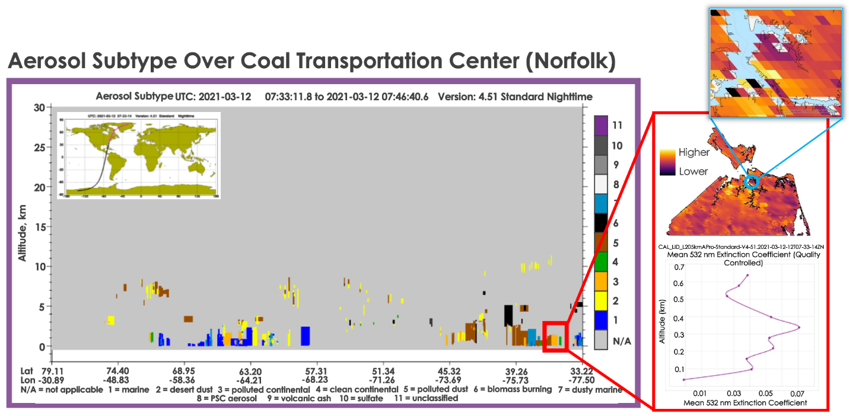*Figure 9.* March 12, 2021 CALIPSO path from 7:33:11 to 7:36:40 UTC aerosol subtype with red box indicating region and altitudes of interest (left), extinction coefficient profile (bottom right), median MODIS AOD map with inset map of the Norfolk coal export facility location (top right).

The other case study was from a clear day on October 31, 2018. Both CALIPSO and MODIS detected low amounts of aerosols in our study area, which is reflected by the three aerosol distribution figures. The extinction coefficient profile and the aerosol subtype are blank because there were no detected aerosols in our region and altitudes of interest (Figure A3, bottom right). Additionally, the median MODIS AOD from October 31, 2018 were relatively low. This case study helped to confirm that the MODIS AOD were generally consistent with CALIPSO aerosol retrieval (Figure A3).

*4.1.5 Social Vulnerability Index Map Results*

Finally, the Virginia DEQ was interested in a social vulnerability map to assess community vulnerability based on PM2.5 exposure and sociodemographic factors at the census tract block level. Therefore, we visualized the intersection between the degrees of social vulnerability and mean MODIS AOD over the ten-year study period 2014 – 2023 (Figure 10). The degree of social vulnerability was based on the factors assigned to each census tract block based on whether they were low-income communities or communities of color. Notably, some of the most vulnerable communities were located near the region’s coal facilities. The Virginia DEQ intended to use this map to help guide future PurpleAir sensor placement (Figure A4). We also found that PurpleAir sensors can provide relatively accurate PM2.5 measurements in Hampton Roads when compared to EPA measurements (Figure A5).

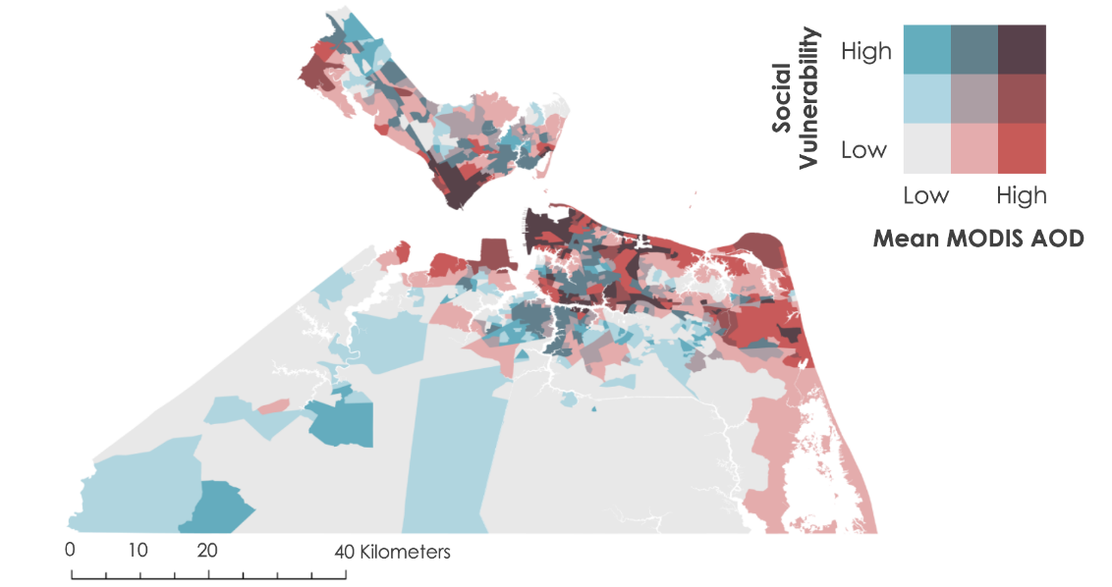

*Figure 10*. Social Vulnerability Bivariate Map. The blue axis represents the degree of social vulnerability, and the red axis represents the mean MODIS AOD of the ten-year study period 2014 – 2023, with the darkest color in the upper right is where these two intersect.

***4.2 Errors & Uncertainties***

*4.2.1 Additional Factors Influencing Air Quality*

In completing this project, there were clear limitations that impacted our analysis. First, there are additional factors that affect PM aerosol distribution that we did not have time to include such as meteorological data and wind patterns. Examining meteorological trends throughout the study period could help determine the sources of PM aerosols present in the study area. While our aerosol analysis using CALIPSO provided insight into general aerosol types, we could have determined if aerosols were consistently blowing into the study area from other locations. Moreover, while we cannot conclude that the coal facilities were the main contributors of aerosols in the region, using wind pattern data could help track how coal dust travels away from the coal facilities. Incorporating these additional data would likely enhance the conclusions we drew from our analysis. Notably, the next term of this project could consider including different data to further build upon our results. Specifically, they could use TEMPO and TROPOMI observations to monitor NO2 and ozone and investigate different types of pollutants that may impact Hampton Roads’ air quality.

*4.2.2 Potential MODIS MAIAC Error*

The second limitation we faced throughout the project was a potential error in the MODIS MAIAC algorithm because it sometimes struggles to discern between land and water. We observed that MODIS was measuring unusual levels of AOD, particularly at land-water interfaces. Specifically, we saw the highest and lowest AOD levels right next to each other in the Mockhorn Wildlife Management Area, which is a tidal flat in Virginia’s Eastern Shore (Figure 11). Because the Hampton Roads region is along the coast, it would have been beneficial to have more ground-level data for MODIS validation. It is also important to note that the next term of this project will likely use newer satellites such as PACE, TEMPO, and VIIRS, which may eliminate this error.

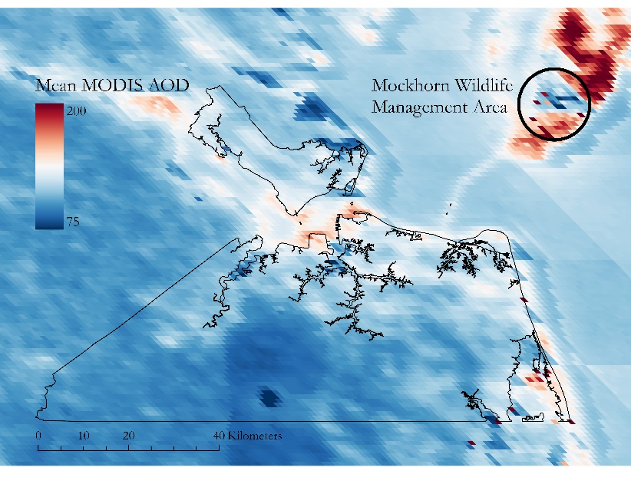

*Figure 11*. This map of mean MODIS AOD across our time period highlights possible errors at land-water interfaces, which can most clearly be seen in the tidal flats of the Mockhorn Wildlife Management Area.

*4.2.3 Limited Data Availability*

Lastly, we encountered limited data availability in important areas of the project. As mentioned previously, MODIS does not directly measure PM2.5, and at the time of this project, there were no available NASA Earth observing satellites that did. Because of this, it would have been beneficial to have additional ground sensors across Hampton Roads to increase PM2.5 data availability for validation purposes. Moreover, all ground monitors in our study area were concentrated in more urban and northern areas, limiting our ability to account for systemic biases that may occur in other environments (Figure 2). Also, we could only obtain a few hundred CALIPSO datapoints for our relative PM2.5 map as the satellite was often obscured by clouds, collected data in narrow paths, seldom passed overhead, and retired in 2023.

***4.3 Feasibility & Partner Implementation***

The methodology that our team implemented was effective in revealing aerosol patterns across Hampton Roads. Using NASA Earth observations, we could improve past methodologies that relied exclusively on using in situ ground monitors which can only show accurate air quality measures at their exact coordinates. While we were unable to convert MODIS AOD into exact PM2.5 surface concentrations due to low correlations, the MODIS AOD map provides the Virginia DEQ a better understanding of previously unknown spatial patterns. Now, our partner can easily identify areas of high PM aerosol concentration and vulnerability to focus their community engagement efforts and sensor placements to get detailed surface PM2.5 concentration measurements.

# 5. Conclusions

# Based on our results, PM aerosols were not equally distributed throughout Hampton Roads. Holistically, higher levels of AOD were consistently found in the region’s more urban areas. There were also clear areas of high social vulnerability and higher levels of PM aerosols, especially southern Newport News and northern Norfolk, where the region’s two major coal facilities were. While we cannot conclude whether these facilities were directly causing this increase in PM aerosols, we do have evidence to conclude that these two areas were experiencing higher levels of PM aerosol pollution in comparison to their surrounding areas.

Throughout Hampton Roads, AOD concentrations followed similar seasonal patterns with higher values in the summer and lower values in the winter. PM2.5, however, was more irregular with the highest values being in the late summer and late fall. Despite these seasonality differences, there was no broader trend in AOD or PM2.5 increasing or decreasing within our study period, and the annual averages remained at safe air quality levels.

Overall, we found that satellite remote sensing can be used to estimate PM aerosols patterns more accurately than they can quantitively estimate PM in Hampton Roads. We identified strong correlations between MODIS AOD and AERONET ground monitors but found that MODIS struggled to strongly correlate to PM2.5, indicating that MODIS cannot be used in lieu of PM2.5 ground monitors in Hampton Roads. Supplemented with CALIPSO case studies, we further supported MODIS AOD in relation to human health by demonstrating how its detected aerosols were also present at the ground level and an inhalation risk. Thus, satellite sensors could be powerful tools for visualizing air quality trends across large regions—especially in instances such as ours with limited in situ monitors. In this region, a joint approach using both ground and satellite data produced the most accurate results and further supported the Virginia DEQ’s goal to prioritize sensor placement and community engagement in more vulnerable areas.

# 6. Acknowledgements

We would like to thank our partner, the Virginia Department of Environmental Quality, for their collaboration and input on this project. We would also like to thank our Science Advisors at Langley Research Center, Dr. Xia Cai and Dr. Travis Toth, Center Lead Olivia Landry, and Project Coordination Fellow Marisa Smedsrud, for their continued support and guidance throughout this term.

This material is based upon work supported by NASA through contract 80LARC23FA024.

Any opinions, findings, and conclusions or recommendations expressed in this material are those of the author(s) and do not necessarily reflect the views of the National Aeronautics and Space Administration.

# 

# 7. Glossary

**AERONET** – NASA’s ground-based AOD air quality monitors called the Aerosol Robotic Network

**Aerosol Optical Depth (AOD)** – a dimensionless measure of the amount of light lost due to the presence of aerosols on a vertical path through the atmosphere

**Aerosol Profile –** a CALIPSO product that shows the vertical distribution of aerosols within the atmosphere

**ArcGIS Pro** – Esri’s Geographic Information System software

**Bivariate Analysis –** a statistical method used to examine the relationship between two different variables

**CALIOP** – Cloud-Aerosol Lidar and Infrared with Orthogonal Polarization instrument aboard the CALIPSO satellite

**Earth observations** – satellites and sensors that orbit Earth and collect information about its physical, chemical, and biological systems over time and space

**Environmental Justice –** refers to how historically marginalized groups may endure environmental risks disproportionately

**EPA AQS** – the EPA’s ground-based PM2.5 air quality monitors called the Air Quality System

**Extinction Coefficient** – a parameter that describes how strongly a material absorbs or reflects light at a specific wavelength

**Google Earth Engine** – Earth observations processing software

**In situ monitors** – air quality monitors that remain stationary and in one place over time

**Lidar** – Light Detection and Ranging

**MAIAC** – Multi-Angle Implementation of Atmospheric Correction, an algorithm that combines MODIS AOD measurements from the Aqua and Terra Satellites

**MODIS** – Moderate Resolution Imaging Spectroradiometer aboard the Aqua and Terra satellites

**Particulate Matter (PM)** – a mixture of solid particles and liquid droplets found suspended in the air that are categorized by their size

**Purple Air** – small, commercial air sensors that measure particulate matter, including PM2.5, for community science

**Tidewater Air Monitoring Evaluation (TAME) Project –** the Virginia DEQ’s ongoing air quality project focused on monitoring air pollution resulting from nearby coal storage and transportation facilities at two Virginia Tidewater region communities – Lambert’s Point in Norfolk and the Southeast Community in Newport News – to better inform citizens about potential health risks

**Vertical Feature Mask** – a CALIPSO data product describing the vertical and horizontal distribution of cloud and aerosol layers observed by CALIPSO lidar

# 8. References

*About AQS Data*. (n.d.) United States EPA Web Server. Retrieved June 10, 2024 from <https://aqs.epa.gov/aqsweb/documents/about_aqs_data.html>

Bhaskaran, S., Phillip, N., Rahman, A., & Mallick, J. (2011). Applications of satellite data for Aerosol Optical

Depth (AOD) retrievals and validation with Aeronet Data. *Atmospheric & Climate Sciences*, *1*(2), 61 – 67. <http://dx.doi.org/10.4236/acs.2011.12007>

Chen, A., Howl, B., & Sidel, A. (2015). *How aerosols are measured: The science of deep blue.* NASA Earth Sciences.

<https://earth.gsfc.nasa.gov/climate/data/deep-blue/science>

Chen, B., Song, Z., Pan, F., & Huang, Y. (2022). Obtaining Vertical Distribution of PM2.5 from CALIOP Data and Machine Learning Algorithms. *Science of The Total Environment,* *805*, 150338. <https://doi.org/10.1016/j.scitotenv.2021.150338>

Clean Air Act. 40 U.S.C § 1857g(a) § 301(a) (1975).

Giles, D. M., Sinyuk, A., Sorokin, M. G., Schafer, J. S., Smirnov, A., Slutsker, I., Eck, T. F., Holben, B. N.,

Lewis, J. R., Campbell, J. R., Welton, E. J., Korkin, S. V., & Lyapustin, A. I. (2019). Advancements in the Aerosol Robotic Network (AERONET) Version 3 database – automated near-real-time quality control algorithm with improved cloud screening for Sun photometer aerosol optical depth (AOD) measurements. *Atmospheric Measurement Techniques*, *12*, 169 – 209. <https://doi.org/10.5194/amt-12-169-2019>

Hampton Roads Planning District Commission. (2021). *Benchmarking 2021 Demographics.* City of Hampton. 3 –8. <https://www.hamptonroads.gov/DocumentCenter/View/1717/Demographics-PDF>

Jha, A., & Muller, N. Z. (2017). Handle with Care: The Local Air Pollution Costs of Coal

Storage. *National Bureau of Economic Research, 2*. <https://doi.org/10.3386/w23417>

Lyapustin, A. & Wang, Y. (2022). *MODIS/Terra+Aqua Land Aerosol Optical Depth Daily L2G Global 1km SIN*

*Grid V061* [Data set]. NASA EOSDIS Land Processes Distributed Active Archive Center. <https://doi.org/10.5067/MODIS/MCD19A2.061>

NASA/LARC/SD/ASDC. (n.d.a). CALIPSO Lidar Level 2 Aerosol Profile, V4-51 [Data set]. NASA Langley Atmospheric Science Data Center DAAC. Retrieved from <https://www.doi.org/10.5067/CALIOP/CALIPSO/CAL_LID_L2_05kmAPro-Standard-V4-51>

NASA/LARC/SD/ASDC. (n.d.b). CALIPSO Lidar Level 2 Vertical Feature Mask (VFM), V4-51 [Data set]. NASA Langley Atmospheric Science Data Center DAAC. Retrieved from <https://doi.org/10.5067/CALIOP/CALIPSO/CAL_LID_L2_VFM-Standard-V4-51>

Papadogeorgou, G., Kioumourtzoglou, M.-A., Braun, D., & Zanobetti, A. (2019). Low levels of Air Pollution and Health: Effect Estimates, Methodological Challenges, and Future Directions. *Current*  *Environmental Health Reports*, *6*(3), 105 – 115. <https://doi.org/10.1007/s40572-019-00235-7>

Rubin, J. I., Reid, J. S., Hansen, J. A., Anderson, J. L., Holben, B. N., Xian, P., Westphal, D. L., & Zhang, J. (2017). Assimilation of aeronet and modis AOT observations using variational and ensemble data assimilation methods and its impact on aerosol forecasting skill. *Journal of Geophysical Research:*  *Atmospheres*, *122*(9), 4967 – 4992. <https://doi.org/10.1002/2016jd026067>

Tackett, J., Winker, D., Getzewich, B., Vaughan, M., Young, S., & Kar, J. (2018). CALIPSO Lidar Level 3 Aerosol Profile Product: Version 3 Algorithm Design. *Atmospheric Measurement Techniques*, *11,* 4129- 4152.<https://doi.org/10.5194/amt-11-4129-2018>

Toth, T.D., Zhang, J., Reid, J.S., & Vaughan, M.A. (2019). A bulk-mass-modeling-based method for retrieving particulate matter pollution using CALIOP observations. *Atmospheric Measurement Techniques*, *12*, 1739 – 1754. <https://doi.org/10.5194/amt-12-1739-2019>

Toth, T.D., Zhang, J., Vaughan, M.A., Reid, J.S., & Campbell, J.R. (2022). Retrieving Particulate Matter Concentrations Over the Contiguous United States Using CALIOP Observations. *Atmospheric Environment*, *274*, 118979. <https://doi.org/10.1016/j.atmosenv.2022.118979>

United States Environmental Protection Agency. (n.d.) Air Quality System API [internet database for ambient air sample data from pollution control agency monitoring stations] retrieved June 10, 2014 from <https://aqs.epa.gov/aqsweb/documents/data_api.html>

United States Environmental Protection Agency. (2023). *Health and Environmental Effects of Particulate Matter (PM)*. <https://www.epa.gov/pm-pollution/health-and-environmental-effects-particulate-matter-pm>

United States Environmental Protection Agency. (2024a). *Final Reconsideration of the National Ambient Air Quality Standards for Particulate Matter (PM).* [https://www.epa.gov/pm-pollution/final-reconsideration-](https://www.epa.gov/pm-pollution/final-reconsideration-national-ambient-air-quality-standards-particulate-matter-pm)national-ambient-air-quality-standards-particulate-matter-pm

United States Environmental Protection Agency. (2024b). *Particulate Matter (PM) Basics*. <https://www.epa.gov/pm-pollution/particulate-matter-pm-basics#PM>

Virginia Department of Environmental Quality. (n.d.a) *Tidewater Air Monitoring Evaluation Project*. <https://www.deq.virginia.gov/topics-of-interest/tidewater-air-monitoring-evaluation-project>

Virginia Department of Environmental Quality. (n.d.b) [Virginia EJScreen+ Tool]. Accessed from

<https://vadeq.maps.arcgis.com/apps/webappviewer/index.html?id=bad3e23c0d6545a1b6b36c1a45e8ed43>

Virginia Environmental Justice Act, Va. Code Ann. § 2.2-234 (2020). <https://law.lis.virginia.gov/vacodefull/title2.2/chapter2/article12/>

Wallace, L. (2022). Intercomparison of PurpleAir sensor performance over three years indoors and outdoors at a home: Bias, precision, and limit of detection using an improved algorithm for calculating PM2.5. *Sensors*, *22*(7), 2755. <https://doi.org/10.3390/s22072755>

# 9. Appendices

Appendix A: *Supplementary Material*

Table A1

*Seasonality adjustments for MODIS AOD and EPA PM2.5 by month, to four significant figures*

|  |  |  |
| --- | --- | --- |
|  | MODIS AOD | EPA PM2.5 (µg/m3) |
| *January* | -0.07516 | -0.8909 |
| *February* | -0.05960 | -0.6204 |
| *March* | -0.03063 | -0.8095 |
| *April* | +0.01715 | -0.6088 |
| *May* | +0.07626 | -0.2691 |
| *June* | +0.07168 | +1.566 |
| *July* | +0.08786 | +1.878 |
| *August* | +0.06109 | +0.6519 |
| *September* | +0.02787 | -0.3883 |
| *October* | -0.04312 | -1.391 |
| *November* | -0.06715 | +0.3749 |
| *December* | -0.06624 | +0.5071 |

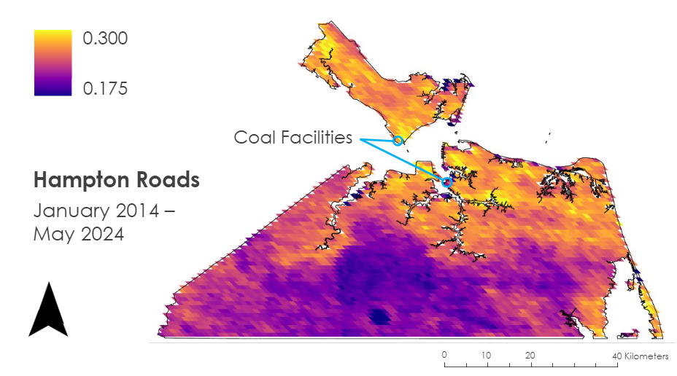

*Figure A1.* 90th percentile AOD map from 2014 – 2024 shows heightened AOD values along the coastline and in the more urban parts of our study area

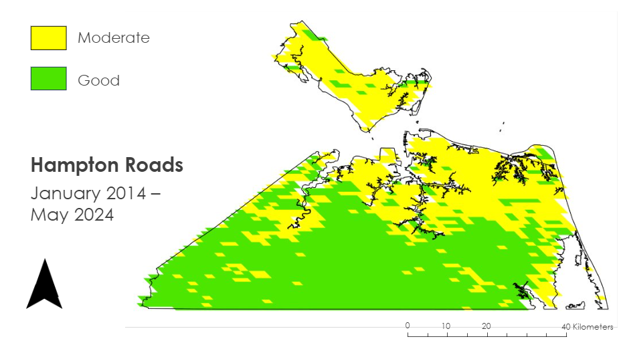

*Figure A2.* MODIS-derived Air Quality Index from 2014 – 2024 shows heightened values along the coastline and in the more urban and northern parts of our study area. Importantly, no locations across any years crossed the threshold to qualify for unhealthy air quality for sensitive groups as defined by EPA

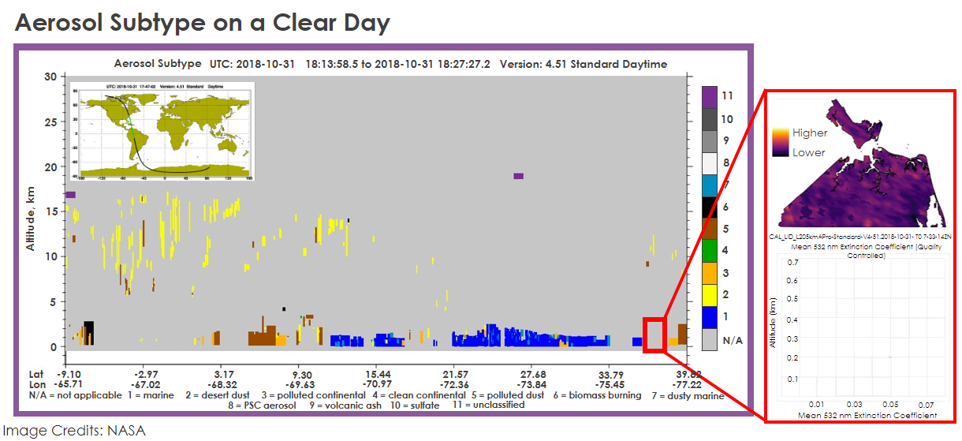*Figure A3.* October 31, 2018 CALIPSO path from 18:13:58 to 18:27:27 UTC aerosol subtype with a red box indicating region and altitudes of interest (left), extinction coefficient profile (bottom right), October 31, 2018 median MODIS AOD map (top right). These aerosol distribution figures show the agreement between MODIS and CALIPSO of the low amounts of aerosols in the region on October 31, 2018.

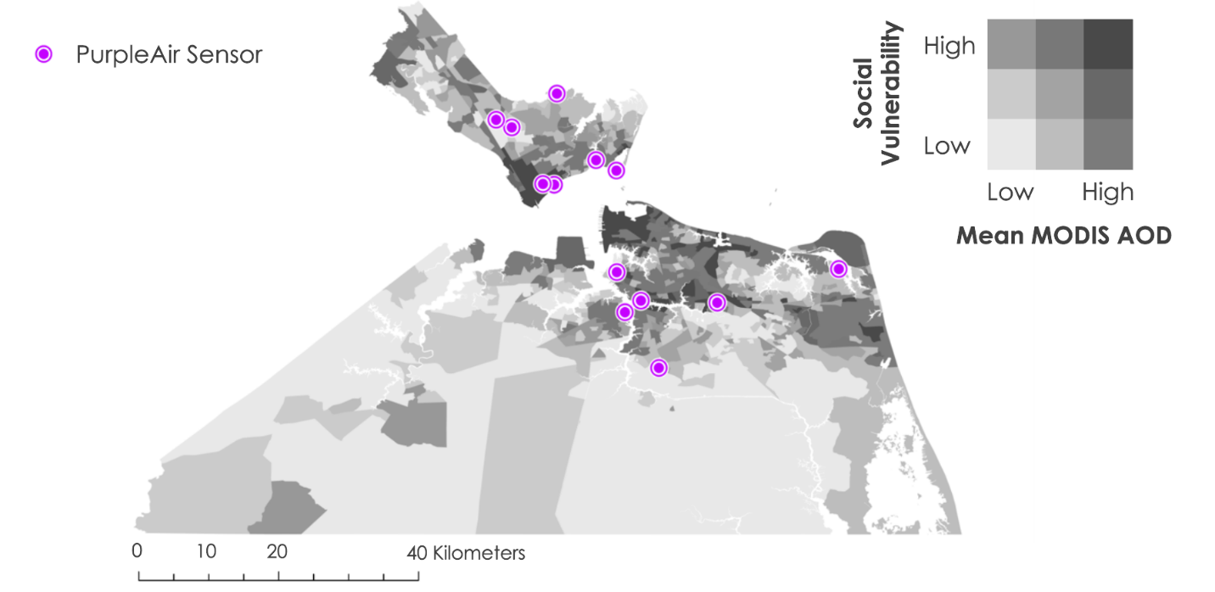*Figure A4.* Grayscale version of social vulnerability map, overlayed with the locations of the thirteen PurpleAir sensors that we acquired data from for this study

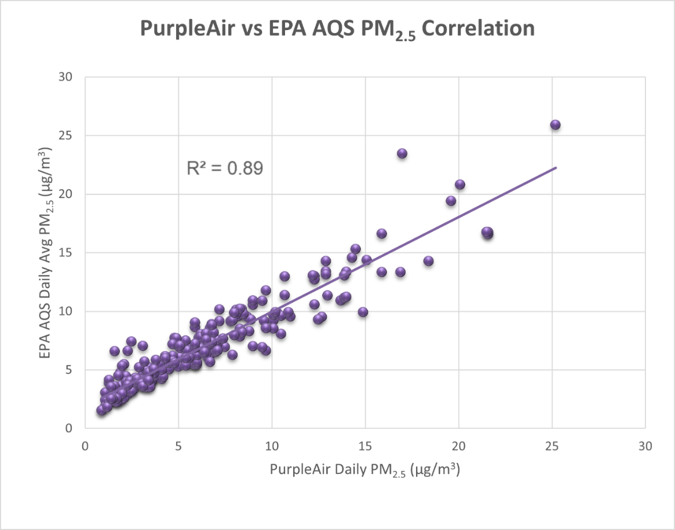

*Figure A5.* The correlation between the PM2.5 (measurements from the CAPABLE2 PurpleAir sensor) and the Langley Research Center EPA AQS. The PurpleAir sensor and the EPA monitor were in the same location and received an R2 value of 0.89.