Hawai‘i Island Disasters

Using NASA Earth Observations to Assess Coastal Flood Risk with Measures of Land Cover Change, Flood Extent, and Vulnerability for Adaptation and Mitigation Planning on Hawai‘i Island

 **Technical Report**

Final Draft – November 18th, 2021

Garren Kalter (Project Lead)

Anna Mikkelsen

Rose Eichelmann

Sanketa Kadam

Erin Azuma

***Advisors:***

Dr. Roberta Martin, Arizona State University (Science Advisor)

Dr. David Hondula, Arizona State University (Science Advisor)

# 1. Abstract

As the County of Hawai‘i faces an increased risk of extreme flooding events, sea-level rise, and other hazards associated with climate change, the need for building geospatial capacity to make better-informed decisions is critical. The County of Hawai‘i and Arizona State University partnered with NASA DEVELOP to complete a macro-scale risk analysis for the island of Hawai‘i analyzing flooding, land cover, vulnerability, and exposure factors using Earth observations and socio-economic data. The team assessed the variation in urban coastal vulnerability around the entire island of Hawai‘i, using satellite imagery of coastal land cover typology from satellite products such as Landsat 8 Operational Land Imager (OLI), Landsat 7 Enhanced Thematic Mapper Plus (ETM+), and Sentinel-1 Synthetic Aperture Radar (SAR). The team made a sharable geodatabase containing datasets modeling vulnerability to coastal flooding as well as the Hawai‘i Flood Risk Toolbox (HiFloRT) which contains multiple tools for the County to map land cover, extreme rainfall and flood extent across the Island. The end products will allow the County of Hawai‘i to establish a protocol and standard framework for the utilization of Earth observations in future planning.

**Key Terms**

Remote sensing, flooding, Landsat 8 OLI, Landsat 7 ETM+, Sentinel-1 SAR, land cover, social vulnerability

# 2. Introduction

***2.1 Background Information***

The Hawaiian Islands are comprised of eight main islands and governed by five counties located in the middle of the Pacific Ocean. At 4,028 square miles, Hawai‘i County is the state’s largest sub-administrative governmental structure and is coextensive with Hawai‘i Island, known to locals as the Big Island (Figure 1). The Hawaiian Islands, amongst other tropical islands, face a complex array of issues caused by climate change. These include sea-level rise, coastal flooding, amplified storms impacts, and higher-frequency events such as high tide flooding (IPCC, 2021; Knutson et al., 2019; Thompson et al., 2021; Vitousek et al., 2017). Small islands are also particularly vulnerable to coastal threats due limited capacity to withstand disaster events and increased anthropogenic pressure on coastlines (i.e., urbanization). These intensified impacts were seen during the 2018 Pacific hurricane season, which was one of the most active hurricane seasons on record (NOAA 2021). Hurricane Lane, a category 5 hurricane, brought record breaking rainfall and flooding to Hawai‘i Island during August 24-28 (National Hurricane Center 2019). The east side of Hawai‘i Island, including the city of Hilo, was particularly impacted by this storm. The team drew on this event as a case study to assess their model outputs and demonstrate how impacts of such disasters could be quantified.

*Figure 1.* The study area is comprised of the Island of Hawai‘i.

Coastal communities are critical for the social, ecological, and economic survival of islands and help to form the culture of the islands themselves (Ng et al., 2019). Specific to Hawai‘i Island, there are a multitude of factors to consider when assessing coastal risk. The island comprises a unique and diverse landcover of native, non-native, and invasive species, as well as an array of agriculture and urban development especially around coastal areas. There are five volcanoes on the island, including one currently active volcano. Lava flows from intermittent volcanic activity create a wide variety of substrate ages, and thus a variety of soil fertility around the island as well as adding landmass to the island, extending shorelines and altering the coastline. The coastline itself is characterized by cliffs, small areas of sandy beaches and largely rocky shorelines. These rocky shores add to the complexity of assessing shoreline impacts and coastal change. Additionally, there is a large range of socio-economic diversity and cultural diversity in the human populations on this island. As a result, the island is a rich, complex socio-ecological matrix.

Past studies have modeled passive flood extent for Hawai‘i Island for multiple scenarios of sea-level rise, extreme precipitation, and marine resources and coastal reefs (Anderson et al., 2018; Asner et al., 2020; Chu et al., 2008). Onat et al., (2018) modelled shoreline vulnerability across the Hawaiian Islands and found that island geomorphology and wave exposure have the strongest influences on determining coastal vulnerability in Hawai‘i. This modelling study expanded knowledge on coastal threats but did not provide insight into the changing dynamic system. Climate change increases the frequency of high-tide flood events, causing disruptions to local economic activity (Hino et al., 2019). Further, extreme El Niño events are anticipated to increase in frequency (Cai et al., 2015). These are associated with stronger trade winds and larger swell events in Hawai‘i. Extreme El Niño events may also result in elevated water levels as Rossby waves propagate sea level anomalies from the west coast, as observed following the 2015 El Niño (Long et al. 2020). These factors contribute to accelerate the frequency of coastal threats. However, the remoteness and inaccessible shorelines complicate efforts to accurately measure and monitor coastal impacts and coastal change, and a current system to update exposures is not in place. Due to these factors, coastal risk and coastal change remains poorly understood.

Currently, the County of Hawai‘i relies upon contractors to conduct GIS analysis to inform thorough hazard mitigation plans such as the Climate Adaption Plan, the Hazard Mitigation Plan, the Shoreline Setback and the Kīlauea Eruption Risk Vulnerability Assessment (County of Hawai‘i, 2020; Hawai‘i Climate Change, 2017). Collaboration with the University of Hawai‘i at Hilo has provided the capacity to use high-resolution coastal and riparian change data for two areas of interest: Kona and Honoli‘i. However, the County is looking to internally expand geospatial intelligence capacity to utilize NASA and European Space Agency (ESA) Earth observation data in decision-making and risk assessment throughout the whole island. The utilization of Earth observation data may aid the County in creating informed policies based on more frequently updated and easily accessible data.

***2.2 Project Partners & Objectives***

The Hawai‘i Island Disasters team, in collaboration with Arizona State University’s Center for Global Discovery and Conservation Science (GDCS), partnered with the County of Hawai‘i for this study. Arizona State University (ASU) professors Dr. Roberta Martin, affiliated with GDCS and the School of Geographical Science & Urban Planning (SGSUP), and Dr. David Hondula, affiliated with SGSUP, served as advisors. Dr. Martin, based in Hilo, Hawai‘i, was able to provide relevant knowledge based upon her own work in Hawai‘i. Additionally, Dr. John Burns of the University of Hawai‘i at Hilo and Dr. Haunani Kane of GDCS and SGSUP were involved in the proposal of this project. The County of Hawai‘i utilizes available and accessible sea-level rise data for creating its policies, and having access to geospatial data is critical in order to make successful decisions and adapt to a changing climate.

The Hawai‘i Island Disasters team sought to provide the necessary frameworks for the County of Hawai‘i to begin utilizing Earth observations in their environmental related decision-making and planning. These data are available for free and are consistently updated through various platforms. The team created a flexible framework to assess coastal threats that allows for the sustainable, post-term usage of the framework by the County in other disaster-related application areas, (i.e., lava flow, fire hazard, and erosion analyses). Utilizing Earth observation data from January 1981 through November 2021, the team created several tools that were combined into the Hawai‘i Flood Risk Toolbox (HiFloRT) for the County to use in future environmental and disaster mitigation research, including a program to classify land cover across the island, a tool to extract storm flood extents from historical floods, and a tool that maps extreme rainfall over a period of interest. For the purposes of this project, the team used the 2018 disaster of Hurricane Lane as a case study on which to test the flood and precipitation tools. The team incorporated social and physical vulnerability variables as well as exposure metrics such as building and population data to create an example for the County to use in future disaster risk analyses once they acquire the data to do so. Lastly, the team created a StoryMap for use as outreach and to communicate hazards of coastal flooding and risk identification methods to the public.

# 3. Methodology

***3.1 Data Acquisition***

Data were obtained from a variety of sources including Earth observations, governmental entities, and modeled outputs. First, to set the study site parameters, the team obtained the study area shapefile of Hawai‘i County, a 2020 Hawai'i Island Agriculture shapefile, and also sea-level rise passive flooding scenario maps from the Hawai‘i Statewide GIS Program Data portal by the State of Hawai‘i’s Office of Planning and Sustainable Development. From the Google Earth Engine (GEE) data catalog, the team retrieved Landsat 8 Operational Land Imager (OLI) Surface Reflectance Level 2 Collection 2 Tier 1 imagery for the years 2013 to 2021 and Landsat 7 Enhanced Thematic Mapper Plus (ETM+) Level 2 Collection 2 Tier 1 Surface Reflectance data for the years 1999 to 2003, sourced by the U.S. Geological Survey (USGS). This project also utilized socioeconomic data from the U.S. Census Bureau American Community Survey (ACS), building footprints developed from Open Street Maps, precipitation data from Climate Hazards Group InfraRed Precipitation with Station data (CHIRPS) Daily, as well as 2020 Esri Land Cover and 2001 NLCD Land Cover maps. Table A1 displays the Earth observations used in this study and Table A2 shows a list of data indicators used and their sources.

***3.2 Data Processing***

In the following sections we describe data processing and tools developed in the HiFloRT. Figure 2 depicts the overall methodology undertaken by the team.

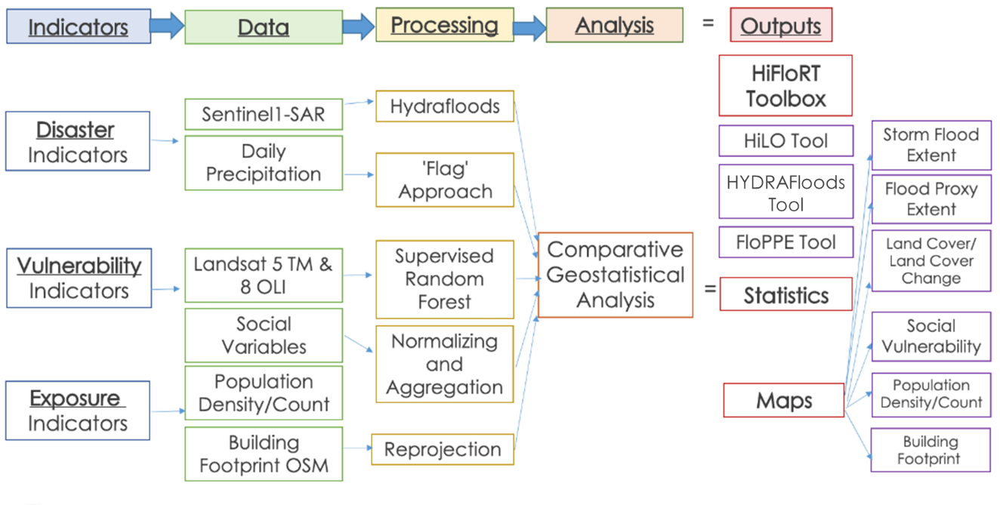

*Figure 2:* A flowchart depicting the project’s methodology, broken up into discrete sections*.*

***3.2.1 Storm Flood Extent - Hydra Floods Tool***

To map flooded extent following hurricanes or extreme rain events, the team modified the HYDRAFloods Tool to delineate surface water from Sentinel-1 SAR imagery. HYDRAFloods is an existing open-source tool that works through a python API for Google Earth Engine. The team modified the tool, again utilizing Hurricane Lane as a case study. For this case, we chose a 5-day window following the hurricane, yielding 4 Sentinel-1 C-SAR Ground Range Detected (GRD) Level 1 images with VV/VH polarization. SAR images are affected by speckle (granular noise) due to interreference of signals reflected from the ground. Following the workflow of HYDRAFloods (Figure B1), a speckle filter was applied to the images to reduce this speckle. Additionally, a pseudo-terrain filter was applied to correct hill-shadowing. For this particular map (Figure B2), the algorithm “Edge_Otsu” is used (Markert et al., 2020). This uses an Otsu thresholding to differentiate water/no water, by maximizing inter-class variance (or minimizing intra-class variance). Once surface water is detected, areas with slopes above 10 degrees and areas that are 20 m above nearest drainage are masked out. In urban areas, Sentinel-1 imagery is brighter due the signal double-bouncing on buildings, resulting in very limited flood extents extracted in urban areas. To account for this, the team added 20- and 50-meter buffers around flooded pixels to assess areas impacted by floods. This algorithm can be used following similar events in the future.

***3.2.2 Precipitation Flood Extent - FloPPE Tool***

The Flood Proxy Precipitation Extent (FloPPE) Tool was built in GEE (Google Earth Engine) to provide a higher estimate for spatial extent that might flood due to extreme precipitation (Figure C1). The tool for the flood extent was derived by selecting the dates during which Hurricane Lane occurred within the CHIRPS Daily product. To create a historical baseline, the team used the precipitation totals in the wet season (October to April) from 1981 to 2010. As per studies conducted by Chu et al. (2008) and Groisman et al. (2004), heavy rainfall and extreme rainfall is defined as rainfall above 90th and 99th percentile. Breinl et al. (2021) showed that extreme rainfall has a higher probability of causing flooding. The team thus calculated the 90th and 99th percentile of the historical baseline to use as a heavy rainfall and extreme rainfall threshold in present case scenarios. The selected 4 days of Hurricane Lane were passed through operational equations to create maps of areas showing rainfall above the historical 90th and 99th percentile baseline. The binary map was created as a default for 99th percentile threshold, showing areas with rainfall above below that threshold. The tool also gives the option to look at rainfall above 90th percentile. This tool allows the end-users to select any number of days they want to explore in flooding scenarios to examine precipitation.

***3.2.3 Supervised Land Cover Classification - HiLO Tool***

Land cover can be used to assess the vulnerability of physical landscapes to various natural disasters, such as flooding (Rahman et al., 2021). The team created an application within GEE titled the Hawai‘i Landcover Observations (HiLO) Tool that classifies land cover across the island for user-selected years (Figure D1). The HiLO tool is wrapped into a graphical user interface (GUI) that queries the user for their years of interest, as seen in Figure D5. The tool first aggregates all available imagery for Landsat 7 ETM+ and Landsat 8 OLI into an image collection, starting from the launch of Landsat 7 in 1999 to the current day. However, there is a 10-year data gap between the years of 2003 and 2013, as the team chose not to include data from Landsat 7 after the scan line corrector began malfunctioning, which caused erroneous data values. The script then applies a scaling factor to all of the data within the collection, which is necessary when utilizing Landsat Surface Reflectance data. Then, the script masks clouds and cloud shadows in each image by utilizing the 'QA_PIXEL' band that accompanies Landsat Surface Reflectance products. The team calculated the Normalized Difference Vegetation Index (NDVI), Normalized Difference Moisture Index (NDMI), Normalized Difference Water Index (NDWI) and Normalized Difference Built-Up Index (NDBI) of each image and added the indices to the image bands; the parameters used in the land cover classifications can be seen in Table A3 (Jensen, 2000; Wilson & Sader, 2002; Gao, 1996; Zha et al., 2010). NDVI is helpful for classifying vegetation, while NDMI helps detect the varying moisture levels within leaves. NDWI aids in the detection of water bodies and NDBI is useful for classifying urban and impervious surfaces. The tool then creates image composites for each of the user-selected years by calculating the median pixel values across all of the imagery for that year and clipping the image to the bounds of the island.

In order to classify land cover, the HiLO Tool utilizes a supervised random forest classification algorithm, which requires training points for each land cover class to be collected and used to train the classifier. The team created separate landcover classifiers for each sensor used and collected between 100 to 300 training points for each landcover class (Table A4). The Landsat 8 classifier was trained using a 2021 composite image while the Landsat 7 classifier was trained with a 2001 composite image. The team used past landcover classification maps developed by the State of Hawai‘i as a basis for the land cover classes selected for this study: urban, water, barren land, forest, shrubland, grassland, and cropland. For cross-referencing purposes and support in determining the locations of training points for the Landsat 8 classifier, the team utilized the Esri 2020 Land Cover map as well as the high-resolution 2021 satellite image base map within GEE. To support the location of training points for the Landsat 7 2001 image, the team utilized the 2001 NLCD Land Cover map for Hawai‘i Island. To assess the overall accuracy of the classifiers, the team created a confusion matrix within GEE and derived the overall accuracy of each classifier. The team withheld 10% of the training points to be used as validation data to test the ability of the classifier to accurately predict land cover class. The 2021 land cover output was used for analysis in the rest of this study.

Because much of the island's crops are composed of trees (i.e., coffee, papaya, macadamia nut), the classifiers were not successful in differentiating between forests and croplands, thus a croplands class was not included in the supervised classification and was instead manually extracted for the 2021 land cover map using the 2020 agriculture shapefile from the Hawai‘i GIS portal. The team removed the 'pasture' and 'commercial forest' classes from the agriculture shapefile, which the team instead wanted to classify as 'grassland' and 'forest', respectively. Then, the team used this agriculture layer to mask out and add the 'croplands' class to the 2021 land cover raster. Therefore, the HiLO Tool does not output land cover rasters with a cropland class, but such a class can be manually added in postprocessing. The team then created a binary raster map depicting flood susceptible land covers for 2021 (Figure D4). The lack of vegetation and the presence of impervious surfaces in the urban land cover class makes it more susceptible to flooding (Rahman et al., 2021). Agricultural land classes are also very susceptible to flooding, which can cause major damage to crops. This damage can last multiple seasons, adversely affecting future harvests. Thus, the urban and croplands classes were masked within GEE to create the flood susceptibility map.

***3.2.4 Building Footprints and Population***

To quantify exposure, the team derived building footprints generated by OpenStreetMap (Figure E2). This layer also functioned as a base layer for the County of Hawai‘i’s geodatabase. Additional exposure variables considered for this analysis were the population count and population density data from GPWv411: Population Density (Gridded Population of the World Version 4.11) for the year 2020, available on GEE. This was then cross validated with population count and density data from the American Community Survey 2019 at the Census block group resolution.

***3.2.5 Social Vulnerability Index***

The Social Vulnerability Index was generated with data of interest from the U.S. Census Bureau and the Hawai‘i Statewide GIS Program. The Social Vulnerability Index (Figure E1) was built to highlight populations which may be at higher risk of disproportionate impact in natural disasters as defined by EPA guidelines (EPA, 2015) or as defined by the County itself. Given its modular nature, indicators can be added and removed as the County desires. Four indicators were chosen -- poverty, population with limited English proficiency, non-white population, and population over 65. Populations with limited English language proficiency and populations over 65 fulfill County-specified criteria whereas poverty and minority (non-white) population lay the groundwork to address EPA guidelines. Furthermore, all variables were available in authoritative sources like the American Community Survey (ACS). It should be stressed that these indicators are simply a first iteration and require more in-depth work to adequately reflect the unique needs and interest of the Island of Hawai‘i.

Total population and poverty are original indicators from tables in the ACS, whereas the team derived the remaining variables. The team derived population over 65 by adding all population fields for individuals above 65 years of age, and derived population with limited English proficiency by adding together limited English proficiency fields, as several languages and language families were given their own fields. Given that the ACS subcategorizes race in a variety of ways with the potential for error in double-counting, we used a simple subtractive binary -- total population minus white population-- to derive the minority population indicator for the first iteration of this model. The team used Microsoft Excel for preprocessing the raw test files, which included combining the aforementioned fields into one table, normalizing and aggregating variables. To ensure compatibility among data types, a geodatabase was generated, indexed, and cleaned in ArcGIS Pro 2.8.2. These data were joined with Census block group shapefiles from the statewide GIS Program and rasterized to create the Social Vulnerability Index. Finally, the team downscaled Census Bureau sociodemographic estimates to flood and storm affected areas (Table 1). Census block groups were clipped to flood and storm extents and normalized by population density and the percentage of the population exhibiting the social indicator.

Data validation is of extreme importance for accurate remote sensing. For this iteration of the index only 25 Census block groups featured a sample population with high reliability using a standard confidence variance test. All of the remaining populated Census block groups except for one exhibited medium reliability. Thus, findings from this index should only be used with caution. Future versions of this index should be conducted at the Census tract level to leverage the larger sample size to increase the reliability and subsequent quality of the data. Further data validation should be conducted on the remaining indicators in the index before deriving usable results as reliability will likely not be higher due to smaller samples in subsets of the population. When testing validation, original variables should have a confidence variance calculated whereas derived variables should have both a margin of error and confidence variance calculated. Best practice can be found in the 2020 ACS Handbook with detailed guidelines for margin of error and confidence variance in Chapter 8.

***3.3 Data Analysis***

***3.3.1 Overlay Analysis***

The team overlaid each variable of buildings, land cover and social vulnerability data with storm and precipitation extent to extract zonal statistics for further analysis (Figure 3). In order to analyze the relationship between land cover and flood extent, the team uploaded the 2021 land cover susceptibility raster into QGIS where it was vectorized in order to get calculate geometry attributes, such as area. Then, the team masked the polygonised land cover map over the storm flood and precipitation extent layers. The attribute tables of these two layers were then exported as .csv files and further analyzed within Excel to retrieve statistics on the total area of susceptible land covers within the different flood risk zones. The building polygons and population data from satellite sources were similarly masked with flood and precipitation layers to get a summary of the number of buildings in these zones.

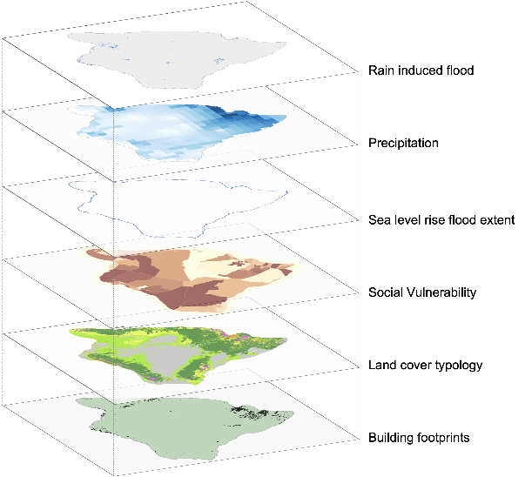

*Figure 3:* Overlay analysis of the Island of Hawai‘i, including several parameters: rain-induced flood, precipitation, sea level rise flood extent, social vulnerability, land cover typology, and building footprints.

# 4. Results & Discussion

***4.1 Toolbox Outputs***

The Hawai‘i Landcover Observations (HiLO) Tool, Flood Proxy Precipitation Extent (FLoPPE) and HYDRAFloods tools are the outputs make up the Hawai‘i Flood Risk Toolbox (HiFloRT). Accompanying the toolbox is an ongoing and iterative Social Vulnerability Index to contextualize the impacts on population.

***4.1.1 Supervised Land Cover Classification***

The land cover classification output of the HiLO Tool for 2021 is displayed in Figure D3. This map shows that the forest class was the largest, making up about 3333 km2 of the island, or roughly 31%. It was followed by barren land, shrubland, grassland, cropland, urban and lastly, water (Table D1, Figure D2). Much of the barren land class is made up of lava flow and volcanic materials. As expected, the urban pixels are mainly congregated in Hilo and Kailua-Kona, as these are the most densely populated towns on the island. From the map it can be seen that the urban and cropland classes are generally close to the coast, making them more vulnerable to coastal threats such as flooding or sea-level rise. This is significant because these land cover classes are of high value in terms of their population density, infrastructure, and economic assets. The Landsat 8 (2021) classifier had an overall accuracy of 92.86% while the Landsat 7 (2001) classifier had an overall accuracy of 97.09%.

These results exhibit that the use of GEE for conducting supervised classifications using Earth observation data is a suitable method to acquire fairly accurate (above 90%) land cover classification maps. This tool will allow the County to continue mapping land cover in future years as data becomes available in the GEE cloud database as it will automatically update to include new data. The County may use the tool to analyze land cover change, urban expansion, and how the relationship between various natural disasters and land cover vulnerability contributes to risk.

***4.1.2 Extreme Precipitation***

The team’s precipitation analysis results imply that eastern side of the island receives extreme rainfall, particularly around Hilo, when looking at the 4-day accumulation map. This is in line with the trade winds that blow from East-Northeast direction on the island, usually causing wet conditions on the windward slide of the slope. However, it is also important to note that the topography of the island is complicated and orographic rainfall is not the only contributor. The maximum 4-day rainfall accumulation amount for Hurricane Lane for the entire island reaches up to approximately 500mm (Figure C2). From the map in Figure C3 we see that the areas receiving more than 99th percentile of rainfall are around Hilo, some parts of Puna Reserve on the eastern side of the island and the western seaboard from Pu‘u O ‘Umi Reserve to Manukā State Wayside. This could be explained by the historical rainfall considered for the 99th percentile threshold having lower amounts in general on the Western side.

***4.1.3 Storm Event Flooding***

Storm induced flooding was assessed from Hurricane Lane (Figure B2). The team found that areas that experienced storm-induced flooding corresponded to areas receiving extreme rainfall for 4 days – the duration of the storm. However, flood extent was consistently under-estimated in urban areas due to signal double bouncing in an urban environment. To accommodate this, a 20- and 50-meter buffer was created around flooded pixels, yielding a flood impact area. The extent of flooding across the island was 6.2 sq. km (0.5 % of island) with a 20 m buffer and 13.0 sq. km (1.1 %) with a 50 m buffer. The east side received some flooding, particularly around Hilo, where Bayfront and the airport are characterized as flooded. In reality, the flood extent across Hilo Bayfront was larger than delineated in this output, but our calculated locations of flooding align with observed floods. Larger flooded areas are detected along the northwest part of the island, resembling the locations identified in the extreme precipitation map. However, these locations are remote and are more difficult to evaluate the accuracy of.

***4.1.4 Social Vulnerability Index***

Using bivariate mapping as sampled in Figure E3, the team identified areas that scored highly in both the aggregate Social Vulnerability Index (Figure 6) and the population count from the U.S. Census Bureau. The following sample analysis and results should be used with caution and ground truthing given the outcome of validation testing in section 3.2.5. Areas within the flood extent model that exhibit high social vulnerability with high population counts included the Kaʻū Forest Preserve, a cluster of block groups just South of Hawai‘i Route 200 and ʻĀinaloa. In overlaying with the storm extent model, areas to note included Hilo Bay, and secondary areas to note are South of Route 11 in the Kaʻū Desert and block groups North of Mauna Loa.

***4.1.5 Overlay Analysis***

Figure 4 is a visual representation of how the team’s methodology can be deployed. The left map highlights building footprints and the right map highlights susceptible land cover types. By identifying a low estimate (storm flood extent) and a high estimate (extreme precipitation) the County can now model the impact of Hurricane Lane. For example, the Northeastern portion of Hilo, by the airport, shows up as flooded in both models, whereas the central part of Hilo (downtown & Bayfront) shows up in the storm extent. This is in part due to distinctions in the methodology between the two models but provides a baseline that the County can use to assess the impact of flood events as they occur. When overlaid further with other products, like the Social Vulnerability Index, at risk populations and their characteristics can roughly identified. This allows the County to better focus attention where resources and mitigation efforts are most needed.

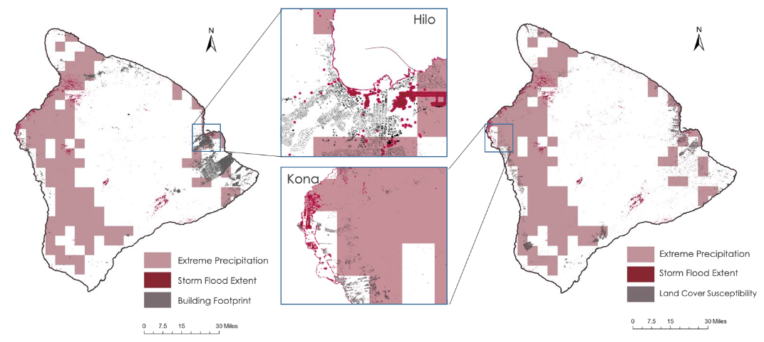

*Figure 4:* Overlay maps showing areas classified as “extreme precipitation,” extent of storm flooding, building footprints, and land cover susceptibility.

While there are many applications for the tools that the team has created, Table 1 shows sample outputs that the team’s package of products was able to produce. As this is modeled data, it should be ground tested and validated as events occur. Given the limited validation completed on the following statistics, they should be used with caution and are primarily meant to highlight some of the ways these tools can illuminate the impact of flood events. The distinction between the modeled outputs is due to the varying methodologies deployed between the storm flood extent and extreme precipitation. Because the storm extent output underrepresents flooding in urban areas, we used two buffers (20 meter & 50 meter) noted here as lower and low estimates to assess affected assets. We also deployed a high estimate model using extreme precipitation extent as an alternative means to estimate where flooding might have occurred, as the output of this model displays a much larger area of potential flooding.

Table 1. *Affected exposure variables within the risk extent*

|  |  |  |  |
| --- | --- | --- | --- |
| **RESULTS** | **STORM FLOOD EXTENT**  **Lower Estimate (20m)** | **STORM FLOOD EXTENT**  **Low Estimate (50m)** | **PROBABLE PASSIVE FLOOD EXTENT**  **High Estimate (Extreme Precipitation) ESTIMATE** |
| Data from Census Bureau | | | |
| Population in Risk | ~1,481 | ~3,536 | ~75,780 |
| % Population in Risk | ~0.7% | ~1.77% | ~ 38.0% |
| Population over 65 years | ~303 | ~744 | ~15,066 |
| Non-white Population in Risk | ~958 | ~2,227 | ~52,428 |
| Population in Poverty in Risk | ~224 | ~567 | ~11,086 |
| Population with Limited English in Risk | ~56 | ~122 | ~2,396 |
| Population from Satellite Products | | | |
| Population in Risk | ~ 1,151 | ~ 2,782 | ~ 87,122 |
| Physical and Biophysical Layers | | | |
| No. Of Buildings in Risk | ~ 218 | ~ 875 | ~ 24712 |
| Cropland Land Cover in flood risk zone | ~0.32 km2 | ~0.45 km2 | ~71.3 km2 |
| Urban Land Cover in flood risk zone | ~2.28 km2 | ~5.76 km2 | ~42.6 km2 |

***4.1.5 Errors and Limitations***

Sources of error for this project include determination of actual flood extent from Sentinel-1 in comparison to false positive and false negative signals. For example, floods were mapped along steep slopes on the southern part of Hawai‘i Island. The team masked out flood extents on slopes above 10 degrees, but the slope masking had a possibility of false positives. The land cover classification also had sources of error – some pixels were missing due to cloud cover and the determination of training points for classes such as the "shrubland" class could be subjective. Another limitation of the land cover classifier is its inability to differentiate between croplands and forests, thus the croplands class was manually extracted in postprocessing by using agriculture data available for Hawai‘i Island. Rainfall estimates were also a limitation in this project due to its large resolution and lack of available rain gauge data from the Island. Furthermore, there are implicit limitations to utilizing models because they are not exact representations of reality.

***4.2 Future Work***

Using the HiFloRT toolbox, the County can compile future flood events along with historic data to create a repository of flood extents. This can provide insights into the frequency of flooding for each pixel and can be combined with probabilistic flood models to create a robust disaster index in the future. This disaster index can be multiplied with a vulnerability index composed of social and physical variables to calculate risk. The team has initiated this process by creating a Social Vulnerability Index while physical vulnerability can be derived from landcover classes most vulnerable to specific disasters.

This framework (Figure 5) can be employed by the County to analyze risk for other types of disasters, such as wildfires; however, different disaster variables will need to be considered for analysis. The County can adjust the variables used in the vulnerability index depending on what is most important for that specific type of disaster. For example, in the flood analysis, urban and agriculture types are more susceptible for flooding, however in a wildfire disaster scenario, other land cover types are more susceptible to fire such as grassland. Following this, exposure variables such as number of people or buildings in the risk zone can be calculated.

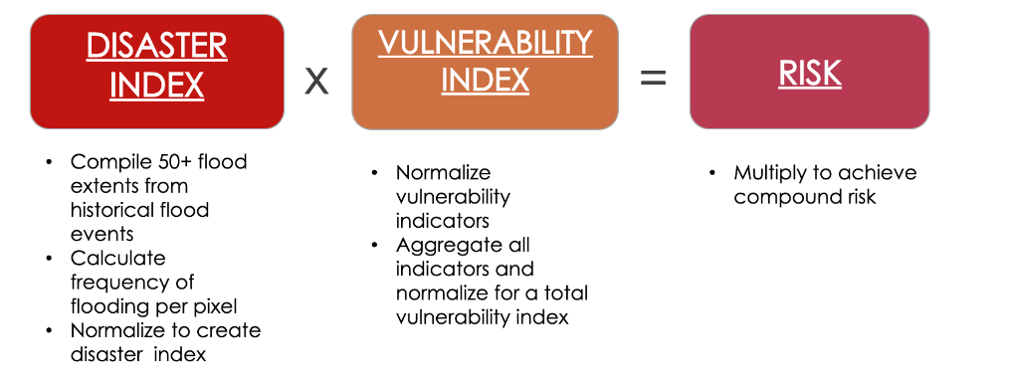

*Figure 5*: Formula for calculation of risk

There are many strategies to improve and expand the scope of this project. First, acquiring higher resolution satellite data will allow for a more detailed analysis on the building footprint extraction. As the County is looking to improve their capacity to assess physical susceptibility to disasters, they require regularly updated building footprint data. Secondly, future work could involve incorporating Jason satellite products or Sentinel-6 data for clarifying sea surface height variability around the island. Third, including the most recent U.S. Census Bureau data that is set to come out by the end of 2021 and would perhaps give a more current picture into exposed communities and their demographics like age and language. This project can also invest efforts into examining consecutive disasters. Lastly, these methods are created so that the County can build on it and tailor risk assessment to other application areas such as food systems, infrastructure, wetlands etc. Future work can also explore other disaster risks such as wildfires and lava flows.

# 5. Conclusions

This project demonstrated that Earth observations can be useful in investigating flooding risk in Hawai‘i County and also for identifying areas that need to be prioritized in the future. The framework created by the DEVELOP team can be used by the County to enable a more data-driven approach to enhance its mitigation and adaptation strategies. Conducting in-house assessments and having estimates can not only help policymakers assess resources, but also help plan precautionary policies. Future and past disaster events can provide insights into areas of high risk. The team tested this framework on Hurricane Lane 2018 and found that the number of people within the flood extent ranged from 1,481 (low estimate) to 75,780 (high estimate). The large range is attributed to different methods; the low estimate is based on detected floods and high estimate on extreme precipitation proxy. Social vulnerability measures were compiled to quantify different vulnerable populations in the low and high disaster extents. These results further highlight areas most at risk due to both disaster, physical and social vulnerability, and can provide direction in where to allocate mitigation resources. However, further validation is necessary before the County can reliably use this Index. To effectively inform both the County and the public of these findings and overarching framework, the team has assembled an ArcGIS StoryMap. This contains motivation for the study, interactive maps, and background on using Earth observations to better understand and monitor disaster impacts.

# 6. Acknowledgements

A special thank you to Dr. Roberta Martin, Associate Professor with Arizona State University’s Center for Global Discovery and Conservation Science (GDCS), Dr. David Hondula, Associate Professor with Arizona State University’s School of Geographical Sciences and Urban Planning (SGSUP), Dr. Kenton Ross, Lead Science Advisor at NASA Langley Research Center, and Ryan Hammock, Fellow for the Arizona NASA DEVELOP Node, for taking the time to collaborate with us. Additionally, we'd also like to thank our contacts at the County of Hawai‘i – Bethany Morrison, Erik Lash, and Kevin Sullivan – for partnering with us and being great collaborators on this project.

This material contains modified Copernicus Sentinel data, processed by ESA from 2014 to 2021.

Any opinions, findings, and conclusions or recommendations expressed in this material are those of the author(s) and do not necessarily reflect the views of the National Aeronautics and Space Administration.

This material is based upon work supported by NASA through contract NNL16AA05C.

# 

# 7. Glossary

**Bivariate mapping** – A mapping technique often used to compare the relative occurrence of two variables.

**Canny edge detection** – It is a technique to extract structural information and edges in images -- here used for edges between water and no water.

**CHIRPS** – CHIRPS is an acronym for Climate Hazards Group InfraRed Precipitation with Station data, a global rainfall dataset spanning 50°S-50°N (and all longitudes) and ranging from 1981 to near-present.

**Disaster** – Disaster is a severe alteration in the normal functioning of a community (IPCC, 2021)

**Edge-Otsu** – a specific algorithm in HYDRAFloods to differentiate water/no water using Otsu thresholding and Canny edge detection

**Exposure** – The nature and degree to which a system is exposed to significant climatic variations (IPCC, 2021).

**HiFLoRT** – HiFLoRT is an acronym for Hawai‘i Flood Risk Toolbox.

**King Tide** – King tide is a particularly large spring tide.

**MHHW** – MHHW is an acronym for mean higher high water, a vertical datum standard used for coastal and sea level rise studies. It refers to the average of the highest daily tides from 1983 – 2001.

**Otsu thresholding** –A thresholding technique that maximizes inter-class variance or minimizes intra-class variance between two classes.

**Passive flooding** – Passive flooding is still water high tide flooding, which provides an initial assessment of low-lying areas susceptible to flooding by sea level rise.

**Random Forest Classifier** – A supervised learning algorithm that creates a set of decision trees and votes on the best solution in order to classify each pixel within an image.

**Risk** –Risk is the potential for adverse consequences (IPCC, 2021)

**Rossby waves** – Large waves that naturally occur in the ocean due to the Earth’s rotation, having a major effect on coastal flooding as well as weather and climate

**Speckle filter** – A filter, such as an averaging window, that reduces noise in Sentinal-1 SAR images.

**Vulnerability** –Vulnerability is the degree to which a system is susceptible to, or unable to cope with, adverse effects of climate change, including climate variability and extremes (IPCC, 2021)

# 8. References

Anderson, T. R., Fletcher, C. H., Barbee, M. M., Romine, B. M., Lemmo, S., & Delevaux, J. M. S. (2018).

Modeling multiple sea level rise stresses reveals up to twice the land at risk compared to strictly passive flooding methods. *Scientific Reports*, *8*(1), 14484.

<https://doi.org/10.1038/s41598-018-32658-x>

Asner, G. P., Vaughn, N. R., Heckler, J., Knapp, D. E., Balzotti, C., Shafron, E., Martin, R. E., Neilson, B. J.,

& Gove, J. M. (2020). Large-scale mapping of live corals to guide reef conservation. *Proceedings of the National Academy of Sciences, 117*(52), 33711–33718. <https://doi.org/10.1073/pnas.2017628117>

Breinl, K., Lun, D., Müller-Thomy, H., & Blöschl, G. (2021). Understanding the relationship between rainfall

and flood probabilities through combined intensity-duration-frequency analysis. *Journal of Hydrology, 602*, 126759. <https://doi.org/10.1016/j.jhydrol.2021.126759>

Collection 2 Landsat 7 Enhanced Thematic Mapper Plus (ETM+) Level-2 Science Product Digital Object Identifier. <https://doi.org/10.5066/P9C7I13B>

Collection 2 Landsat 8-9 OLI (Operational Land Imager) and TIRS (Thermal Infrared Sensor) Level-2 Science Product Digital Object Identifier. <https://doi.org//10.5066/P9OGBGM6>

Center for International Earth Science Information Network (CIESIN) Columbia University. (2018). *Gridded*  *Population of the World, Version 4 (GPWv4.11): Population Density Adjusted to Match 2015 Revision of UN*  *WPP Country Totals, Revision 11*. Palisades, NY: NASA Socioeconomic Data and Applications Center (SEDAC). [https://doi.org/10.7927/H4F47M65. Accessed 01 10 2021](https://doi.org/10.7927/H4F47M65.%20Accessed%2001%2010%202021).

Chu, P.-S., Zhao, X., Ruan, Y., & Grubbs, M. (2009). Extreme rainfall events in the Hawaiian Islands. *Journal*  *of Applied Meteorology and Climatology, 48*(3), 502–516. <https://doi.org/10.1175/2008JAMC1829.1>

County of Hawai‘i . (2020). *Multi-Hazard mitigation plan 2020.*

<https://www.hawaiicounty.gov/departments/civil-defense/multi-hazard-mitigation-plan-2020>

De Zan, F., & Guarnieri, A. M. (2006). TOPSAR: Terrain observation by progressive scans. *Geoscience and Remote Sensing, IEEE Transactions on,* *44*(9), 2352-2360.

<https://doi.org/10.1109/TGRS.2006.873853>

Deepak, S., Rajan, G., & Jairaj, P. G. (2020). Geospatial approach for assessment of vulnerability to flood in

local self governments. *Geoenvironmental Disasters, 7*(35). <https://doi.org/10.21203/rs.3.rs-22816/v2>

Environmental Protection Agency. (2015). *Guidance on Considering Environmental Justice During the Development of*  *Regulatory Actions*.

Eshrati, L. Mahmoudzadeh, A., & Taghvaei, M. (2015). Multi hazards risk assessment, a new methodology.

*International Journal of Health System and Disaster Management, 3*(2), 79-88. <https://doi.org/10.4103/2347-9019.151315>

Funk, C., Peterson, P., Landsfeld, M., Pedreros, D., Verdin, J., Shukla, S., Husak, G., Rowland, J., Harrison, L., Hoell A., & Michaelsen, J. (2015). *"The climate hazards infrared precipitation with stations—a new environmental record for monitoring extremes"*. Scientific Data 2, 150066. <https://doi.org/10.1038/sdata.2015.66>

Gao, B. (1996). NDWI - a normalized difference water index for remote sensing of vegetation liquid water from space. *Remote Sensing of Environment*, 58, 257–266. <https://doi.org/10.1016/S0034-4257(96)00067-3>

Groisman, P., Knight, R., Easterling, D., Karl, T. R., Hegerl, G., & Razuvaev, V. (2005). Trends in

precipitation intensity in the climate record. *Journal of Climate., 18*(9)*, 1326-1350.*

<https://doi.org/10.1175/JCLI3339.1>

Hawaiʻi Climate Change Mitigation and Adaptation Commission. (2017). *Hawaiʻi sea-level rise*

*vulnerability and adaptation report.* Prepared by Tetra Tech, Inc. and the State of Hawaiʻi Department of Land and Natural Resources, Office of Conservation and Coastal Lands, under the State of Hawaiʻi Department of Land and Natural Resources Contract No: 64064.

Hino, M., Belanger, S. T., Field, C. B., Davies, A. R., & Mach, K. J. (2019). High-tide flooding disrupts local economic activity. *Science Advances, 5*(2). <https://doi.org/10.1126/sciadv.aau2736>

Jensen, J.R. (2000). An Earth Resource Perspective. *Remote Sensing of the Environment.* Prentice Hall, New Jersey. <https://www.pearson.com/us/higher-education/program/Jensen-Remote-Sensing-of-the-Environment-An-Earth-Resource-Perspective-2nd-Edition/PGM200207.html>

IPCC. (2021). *Summary for policymakers.* Climate Change 2021: The Physical Science Basis.

Contribution of Working Group I to the Sixth Assessment Report of the Intergovernmental Panel on Climate Change [Masson-Delmotte, V., P. Zhai, A. Pirani, S. L. Connors, C. Péan, S. Berger, N. Caud, Y. Chen, L. Goldfarb, M. I. Gomis, M. Huang, K. Leitzell, E. Lonnoy, J.B.R. Matthews, T. K. Maycock, T. Waterfield, O. Yelekçi, R. Yu and B. Zhou (eds.)]. Cambridge University Press. In Press.

Knutson, T., Camargo, S. J., Chan, J. C. L., Emanuel, K., Ho, C.-H., Kossin, J., Mohapatra, M., Satoh, M.,

Sugi, M., Walsh, K., & Wu, L. (2020). Tropical cyclones and climate change assessment: Part II: Projected response to anthropogenic warming. *Bulletin of the American Meteorological Society*, *101*(3), E303–E322. <https://doi.org/10.1175/BAMS-D-18-0194.1>

Long, X., Widlansky, M. J., Schloesser, F., Thompson, P. R., Annamalai, H., Merrifield, M. A., & Yoon, H.

(2020). Higher sea levels at Hawaii caused by strong El Niño and weak trade winds. *Journal of Climate, 33*(8), 3037–3059. <https://doi.org/10.1175/JCLI-D-19-0221.1>

Markert, K. N., Markert, A. M., Mayer, T., Nauman, C., Haag, A., Poortinga, A., Bhandari, B., et al. (2020).

Comparing Sentinel-1 Surface Water Mapping Algorithms and Radiometric Terrain Correction Processing in Southeast Asia Utilizing Google Earth Engine. *Remote Sensing*, *12*(15), 2469. MDPI AG. Retrieved from <http://dx.doi.org/10.3390/rs12152469>

National Hurricane Center, *Central Pacific Hurricane Center* (2019)*.* Tropical Cyclone Report: Hurricane Lane (EP142018). Retrieved on November 17, 2021

from https://www.nhc.noaa.gov/data/tcr/EP142018_Lane.pdf

Ng, K., Borges, P., Phillips, M. R., Medeiros, A., & Calado, H. (2019). An integrated coastal vulnerability

approach to small islands: The Azores case. *Science of the Total Environment, 690,* 1218-1227. <https://doi.org/10.1016/j.scitotenv.2019.07.013>

NOAA *National Centers for Environmental Information*, State of the Climate: Tropical Cyclones for Annual 2018, published online January 2019, retrieved on November 17, 2021 from

<https://www.ncdc.noaa.gov/sotc/tropical-cyclones/201813>.

Rahman, M., Ningsheng, C., Mahmud, G. I., Islam, M. M., Pourghasemi, H. R., Ahmad, H., […] & Dewan,

A. (2021). Flooding and its relationship with land cover change, population growth, and road density. *Geoscience Frontiers*, *12*(6), 101224.

Thompson, P. R., Widlansky, M. J., Hamlington, B. D., Merrifield, M. A., Marra, J. J., Mitchum, G. T., &

Sweet, W. (2021). Rapid increases and extreme months in projections of United States high-tide flooding. *Nature Climate Change*, *11*(7), 584–590. <https://doi.org/10.1038/s41558-021-01077-8>

U.S. Census Bureau. (2020). *Understanding and Using American Community Survey Data: What All Data Users Need*  *to Know.*

Vitousek, S., Barnard, P.L., Fletcher, C. H., Frazer, N., Erikson, L., & Storlazzi, C. D. (2017). Doubling of coastal flooding frequency within decades due to sea-level rise*.* *Scientific Reports, 7,* 1-9.

<https://doi.org/10.1038/s41598-017-01362-7>

Wilson, E.H. and Sader, S.A. (2002). Detection of forest harvest type using multiple dates of Landsat TM imagery. *Remote Sensing of Environment*, *80*(3), 385-396*.* <https://doi.org/10.1016/S0034-4257(01)00318-2>

Zha, Y., Gao, J., Ni, S. (2010). Use of normalized difference built-up index in automatically mapping urban areas from TM imagery. *International Journal of Remote Sensing*, *24*(3), 583-594. <https://doi.org/10.1080/01431160304987>

# 9. Appendices

**Appendix A: Data**

Table 1.

*Earth observations used in the project.*

|  |  |  |  |
| --- | --- | --- | --- |
| **Platform & Sensor** | **Parameters** | **Time Range** | **Spatial Resolution** |
| Landsat 8 OLI | Spectral indices of coastal land cover: NDVI, NDMI, NDWI, NDBI | April 2013 - Present | 30 meters |
| Landsat 7 ETM+ | Spectral indices of coastal land cover: NDVI, NDMI, NDWI, NDBI | April 1999 - May 2003 | 30 meters |
| Sentinel-1 SAR | Sentinel-1 SAR Ground Range Detected (GRD) Level 1 images; VV/VH polarization | August 24-27, 2018 | 10 meters |

Table 2.

*Data sources and their associated indicators.*

|  |  |
| --- | --- |
| **Indicators** | **Data Source** |
| Disaster: Sea Level Rise | County: State of Hawai‘i Sea-level Rise Passive Flooding Scenario Maps |
| Disaster: Storm Extent | Satellite: Sentinel-1 Synthetic Aperture Radar (SAR) Ground Range Detected (GRD) |
| Disaster: Precipitation | Satellite: Climate Hazards Group InfraRed Precipitation with Station Data (CHIRPS) Daily |
| Vulnerability: Land Cover | Satellite: Landsat 8 Operational Land Imager (OLI), Landsat 7 ETM+ (Enhanced Thematic Mapper Plus) |
| Vulnerability: American Community Survey | U.S. Census Bureau, Hawai‘i Statewide GIS Program |
| Exposure: Building Footprint | OpenStreetMap |
| Exposure: Population | U.S. Census Bureau |
| Exposure: Population | Gridded Population of the World Version 4.11 (GPWv411) |

Table 3.

*List of parameters used for land classifications.*

|  |  |  |
| --- | --- | --- |
| **Data Type** | **Parameter** | **Equation** |
| Raw Bands | Blue, green, red, near-infrared (NIR), short-wave infrared 1 (SWIR1), short-wave infrared 2 (SWIR2) | N/A |
| Calculated Indices | Normalized Difference Vegetation Index (NDVI) | *NDVI = NIR − Red/NIR + Red* |
| Normalized Difference Water Index (NDWI) | *NDWI = green − NIR/green + NIR* |
| Normalized Difference Built-up Index (NDBI) | *NDSI = SWIR1− NIR/SWIR1+ NIR* |
| Normalized Difference Moisture Index (NDMI) | *NDMI = NIR − SWIR1/NIR+ SWIR1* |

Table 4.

*Number of training points used to train the 2001 Landsat 7 ETM+ classifier and 2021 Landsat 8 OLI classifier.*

|  |  |  |
| --- | --- | --- |
| **Land Cover Class** | **2001 Hawai‘i Island Points** | **2021 Hawai‘i Island Points** |
| Urban | 140 | 167 |
| Water | 102 | 142 |
| Barren Land | 213 | 291 |
| Forest | 191 | 129 |
| Shrubland | 206 | 172 |
| Grassland | 230 | 124 |

**Appendix B: HydraFloods Tool**

Figure 1.

*Methodology for HydraFloods Tool.*

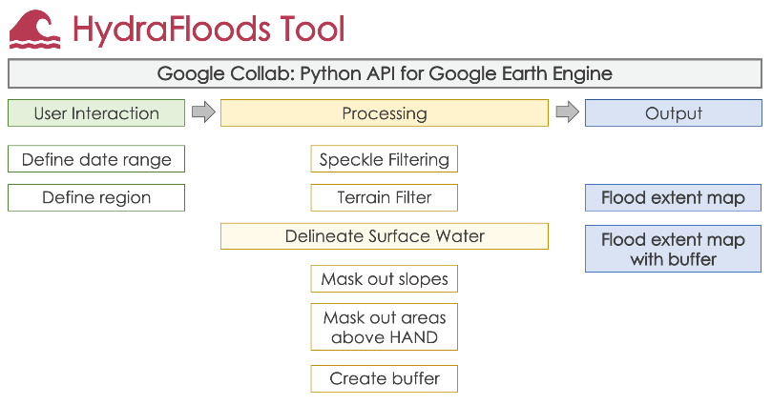

Figure 2.

*Hawai‘i County 2018 Hurricane Lane Storm Flood Extent.*

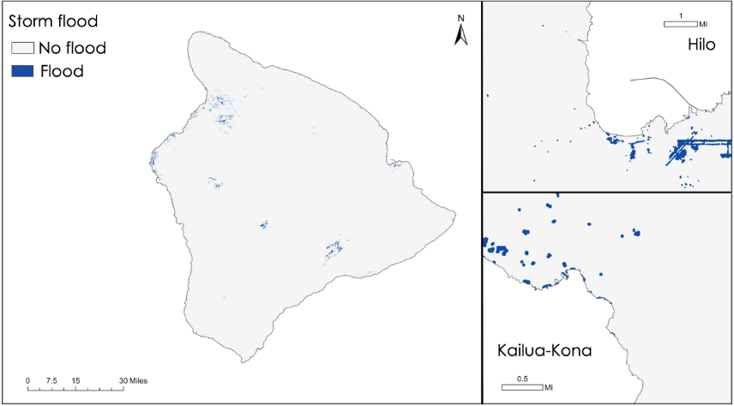

**Appendix C: FLoPPE Tool**

Figure 1.

*Methodology for FLoPPE Tool.*

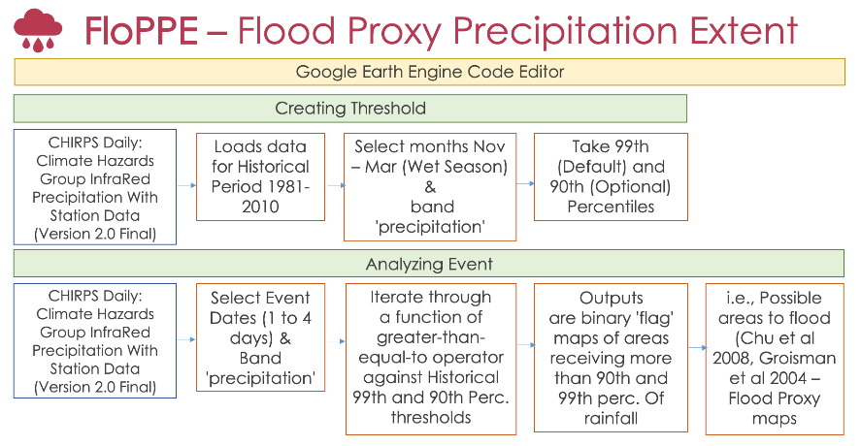

Figure 2.

*Hawai‘i County 2018 Hurricane Lane Accumulated Precipitation.*

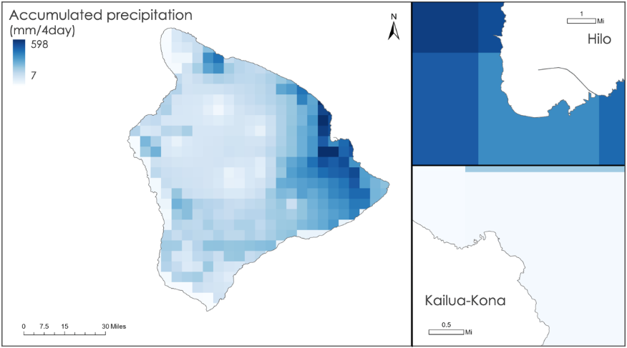

Figure 3.

*Hawai‘i County 2018 Hurricane Lane Extreme Rainfall.*

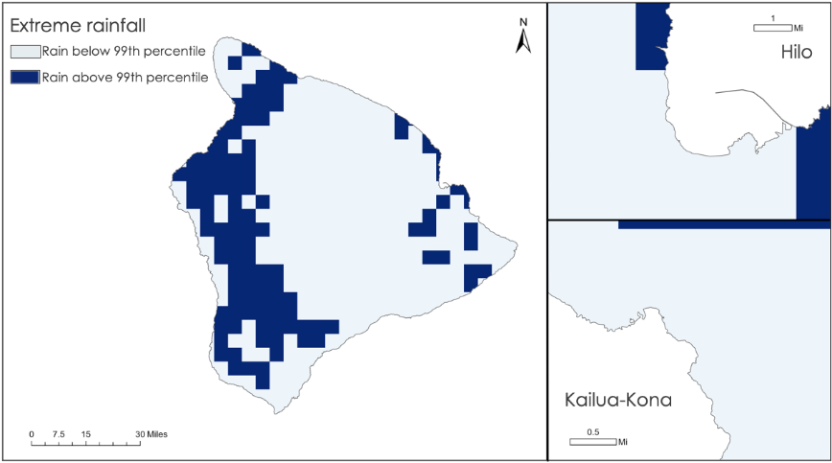

**Appendix D: HiLO Tool**

Figure 1.

*Methodology for HiLO Tool.*

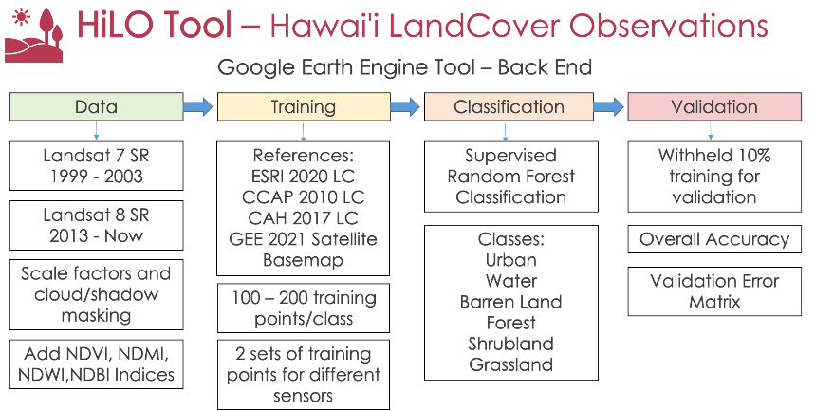

Figure 2.

*Pie chart breakdown of each land cover class in 2021 Hawai‘i County Land Cover.*

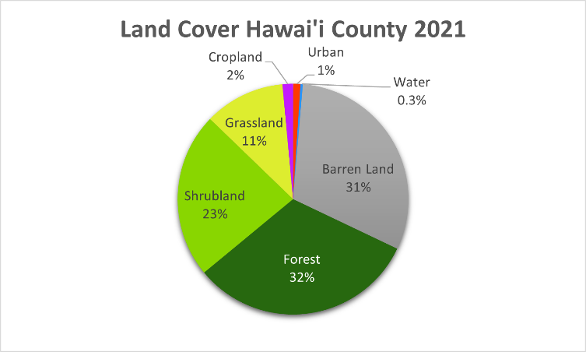

Figure 3.

*Hawai‘i County 2021 Land Cover Map.*

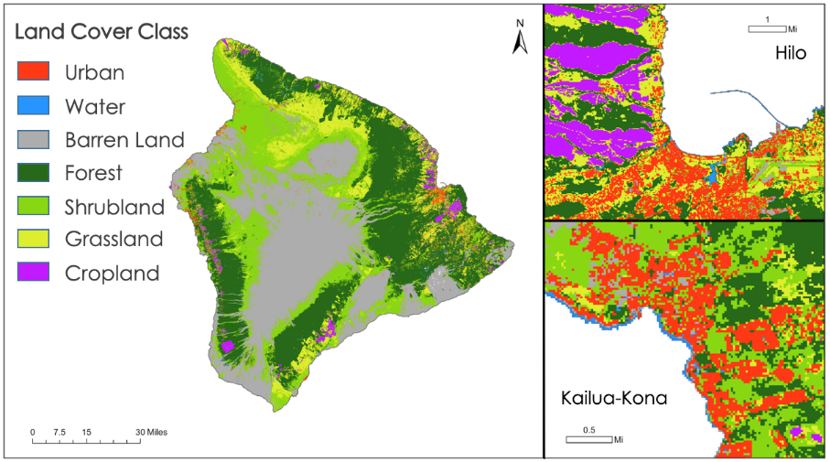

Figure 4.

*Hawai‘i County 2021 Land Cover Susceptibility Map.*

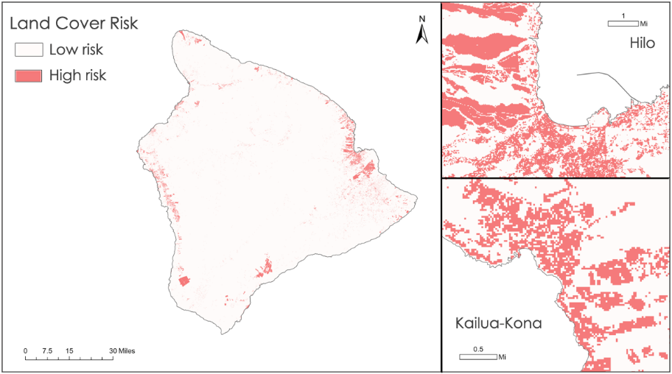

Figure 5.

*The graphical user interface within the HiLO Tool.*

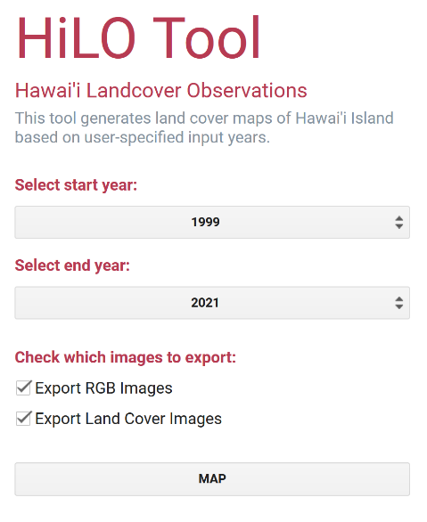

Table 1.

*Area and percent total area of each land cover class in 2021 Hawai‘i County Land Cover.*

|  |  |  |
| --- | --- | --- |
| **Land Cover Class** | **Area (km2)** | **% Total area** |
| Urban | 107.8 | 1.0 |
| Water | 34.1 | 0.3 |
| Barren Land | 3206.2 | 30.7 |
| Forest | 3333.9 | 31.9 |
| Shrubland | 2422.6 | 23.2 |
| Grassland | 1180.1 | 11.3 |
| Cropland | 153.7 | 1.5 |

**Appendix E: Other Maps**

Figure 1.

*Hawai‘i County 2020 Social Vulnerability.*

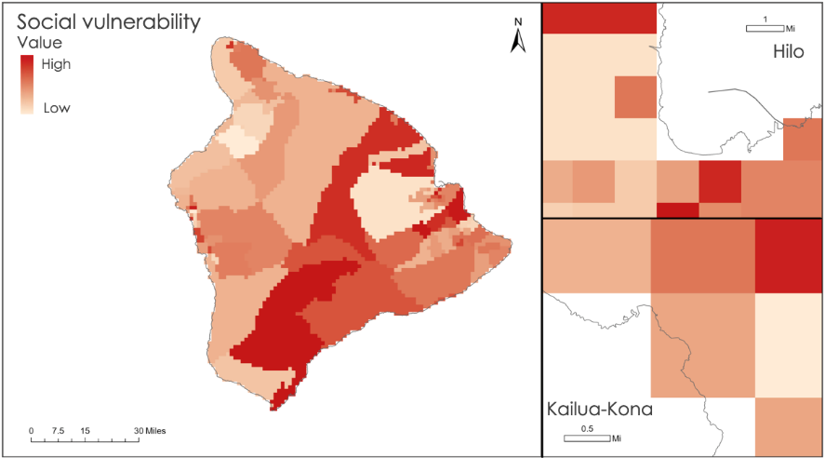

Figure 2.

*Hawai‘i County Building Footprints.*

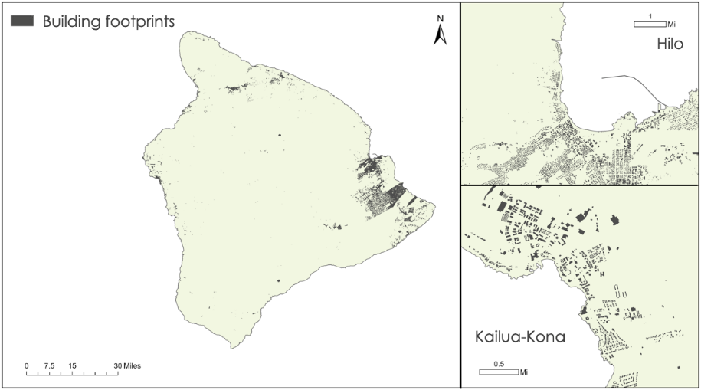

Figure 3.

*Hawai‘i County Population & Aggregate Bivariate Map Sample*

