**NASA DEVELOP National Program**



NASA Langley Research Center

*Summer 2017*

Shenandoah Health & Air Quality

Monitoring Air Quality in Shenandoah National Park to Address National Park Service Initiatives Using NASA Earth Observations

**Technical Report**

Final Draft – August 10, 2017

Ellen Bubak (Project Lead)

Amanda Clayton

Doug Gardiner

Nicholas Lenfant

Julie Terhune

Dr. Bruce Doddridge, NASA Langley Research Center (Science Advisor)

Dr. Kenton Ross, NASA Langley Research Center (Science Advisor)

# 1. Abstract

Gases such as ozone (O3), nitrogen dioxide (NO2), and sulfur dioxide (SO2) have impeded visibility and impacted air health in Shenandoah National Park, one of the primary attractions of Virginia. Air quality is considered one of the park’s fundamental resources and is essential to maintaining its significance as a premier park with world-class views. This project utilized NASA Earth observations, including Aura's Ozone Monitoring Instrument (OMI), to monitor ozone and nitrogen dioxide that threaten visibility and plant, animal, water, and human health in the park. Trend maps were created to assess spatial and temporal trends in pollutant species over Shenandoah National Park and the surrounding airshed. A methodology was created to help the National Park Service incorporate remote sensing data into their management decisions related to park health and air quality concerns. *In situ* station data from Big Meadows monitoring station were used to validate the NASA Earth observations. This information will aid in future decisions related to visitor education and ecological management in accordance with mandates from the Clean Air Act, the National Park Service Organic Act of 1916, and the Wilderness Act.

**Keywords**

Aerosol pollutants, air pollution, atmospheric gases, Health & Air Quality, Shenandoah National Park, remote sensing

# 2. Introduction

* 1. ***Background Information***

Approximately 200,000 acres in area, Virginia’s Shenandoah National Park is well known for the 105-mile road, known as Skyline Drive, which provides visitors with scenic views of the nearby Blue Ridge Mountains (NPS, 2015). Shenandoah is interested in learning about air pollutants with regards to visibility, acidic deposition, and park visitor health (Sullivan et al., 2003). Compared to other national parks, it has higher levels of air pollution leading to concerns for the park’s wildlife and park attendees (NPS, 2007). Poor air quality can impede the park’s goals including ecological integrity, preservation of views as seen from the park, and visitor safety and enjoyment (Sullivan et al., 2003).

Atmospheric pollutants including ozone (O3), sulfur dioxide (SO2), and nitrogen dioxide (NO2) contribute to poor air quality and can have negative effects on the environment. Ground-level ozone is harmful to both human and plant life. In humans, it can cause eye, nose, and lung irritation, along with breathing issues. For sensitive plants, ground-level ozone at 8 to 12 parts per million can be damaging (NPS, 2007). Ozone is created by the splitting of oxygen molecules that then re-bond with a non-split molecule, a precursor of which is NO2 (Venkanna et al., 2015). Increased levels of NO2 have been linked to cardiovascular and respiratory problems, including impairment of lung function growth in children and asthma prevalence (Faustini et al., 2014; Greenberg et al., 2017). Sulfur dioxide is the primary cause of acid rain which affects flora, wildlife, and building materials (Smith et al., 2001). Further, aerosol forms of sulfur dioxide impair visibility and affect human health, similar to other atmospheric pollutants (Adon et al., 2010).

The Clean Air Act requires that parks monitor visibility and identify harm caused by manmade pollution (NPS, 2015). Since 1981, Shenandoah has been monitoring precipitation amounts, pH levels in the soil and water, and ammonium in the atmosphere at its Big Meadows station, located in the central district of the park. In 1983, the park began recording ground-level ozone, sulfur dioxide, and nitric acid and continues to record various atmospheric parameters weekly, hourly, and by the minute (NPS, 2015). To add to the current air quality monitoring in the park, this project utilized the Ozone Monitoring Instrument (OMI) aboard NASA’s Aura satellite and compared its measurements to the data collected at Big Meadows. OMI provides daily global coverage and measures various atmospheric parameters at a resolution of 0.25 degree by 0.25 degree (NASA Goddard, n.d.).

Combining remote sensing and ground-level measurements to address health and air quality, as done in this project, is becoming more common. Before 2009, satellite data had not been used to address National Ambient Air Quality Standards (NAAQS), which were established under the Clean Air Act amendments of 1990. Satellites had instrumentation capable of tracking air pollutants, such as the OMI sensor, but these instruments had not been used to corroborate data obtained by ground level sites (Hoff & Christopher, 2009). Other instruments on Aura, such as TES (Tropospheric Emissions Spectrometer), have been used alongside various monitoring stations in North America to analyze patterns of emission spread and locate possible sources of atmospheric pollution (Zhu, 2015).

Initially, the study area included only Shenandoah National Park in Virginia. After assessing the spatial resolution available from OMI and air pollution transportation characteristics, the study area was expanded to include a significant portion of the Chesapeake Bay airshed (Figure 1). Park scientists are concerned about air transport of atmospheric pollution. Ohio, Pennsylvania, West Virginia, Kentucky, and Virginia were included in this new, larger study area because they have been identified as the most important contributors of air pollution in the park (NPS, 2007). With this larger study area, it became possible to account for transport and mixing of airborne pollutants and to identify the locations of possible pollutant sources affecting the park, over the study period of 2005 to 2016.

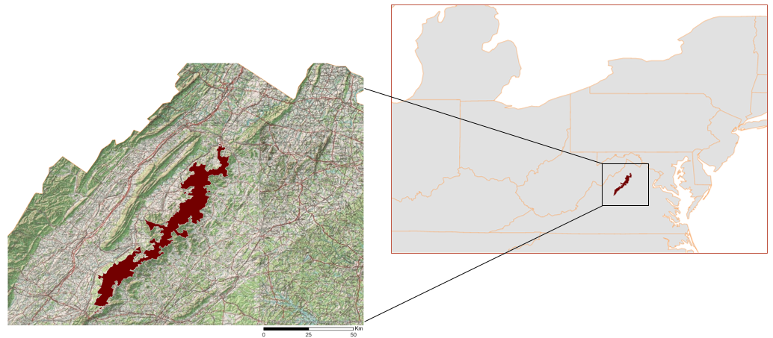

*Figure 1*. Study area maps depicting Virginia’s Shenandoah National Park and the Chesapeake Bay airshed.

* 1. ***Project Partners & Objectives***

This project collaborated with Shenandoah National Park and the National Park Service’s Air Resources Division. Primary concerns from the partners included air quality, visibility of scenic views, the health of visitors and inhabitants of the park, as well as park attendance. The overall objectives of this project were to identify trends between remotely sensed datasets and data measured at Shenandoah, to analyze the data monthly and annually, and to create a methodology to visualize data over time. The results of this project provided Shenandoah National Park with information regarding air pollutants and pollutant sources in the airshed surrounding Shenandoah.

# 3. Methodology

***3.1 Data Acquisition***

Gridded level 3 atmospheric data from January 2005 to December 2016 taken by Aura’s Ozone Monitoring Instrument and obtained through the Goddard Earth Sciences Data and Information Services Center (GES DISC). The OMI data for ozone and SO2 were given in Dobson Units (DU). Data for NO2 were in molecules/cm2.

Table 1.

*List of satellite data products used to create maps and correlation graphs*

|  |  |  |  |
| --- | --- | --- | --- |
| **Parameter** | **Data Product** | **Atmospheric Layer Measured** | **Study Area Timeframe** |
| Ozone (O3) | OMDOAO3e OMI/Aura Ozone (O3) DOAS Total Column Daily L3 Global 0.25deg Lat/Lon Grid | Total column | 2005 - 2013, 2015 - 2016 |
| Nitrogen Dioxide (NO2) | OMNO2d OMI/Aura NO2 Cloud-Screened Total and Tropospheric Column Daily L3 Global 0.25deg Lat/Lon Grid | Total column  &  Tropospheric | 2005 - 2016 |
| Sulfur Dioxide (SO2) | OMSO2e OMI/Aura Sulfur Dioxide (SO2) DOAS Total Column Daily L3 Global 0.25deg Lat/Lon Grid | Total column | 2005 - 2007, 2009 - 2016 |

*In situ* data were obtained from the Big Meadows monitoring station in Shenandoah National Park. Big Meadows station data included weekly measurements for SO2 particulates and hourly measurements of ozone concentrations collected through the EPA’s Clean Air Status and Trends Network (CASTNET). No *in situ* data were available for NO2. Data provided by the monitoring station were given in parts per billion (ppb).

***3.2 Data Processing***

For ozone, NO2, and SO2 data products, a python script using ArcPy was created to separate the correct sub-dataset containing the corresponding total column or tropospheric values from within the ‘.he5’ files. The daily OMI data were projected to WGS 1984 to ensure that comparison between scenes would be possible. Daily values were averaged into monthly values and saved in ‘.tif’ files to be used within ArcGIS. Finally, each raster was masked to the study area (Figure 2). This process was done for each month between 2005 and 2016, excluding 2014. The data values for 2014 were significantly lower than other years in the study period, resulting in a skewed data set. In order to generate maps that accurately represented the data, 2014 was omitted from any calculations (Table 1).

As there were no *in situ* data for NO2 at Big Meadows, both tropospheric and total column NO2 data were used for this project to see if there was any correlation between the two datasets. We hypothesized that tropospheric NO2 could be used as a measure of the pollutants close to the monitoring station at Big Meadows. All years from 2005 to 2016 were included for both tropospheric and total column NO2 (Table 1).

After initial processing of the SO2 data using the methods explained, it was discovered that the Level 3 SO2 files obtained had incorrect latitude values, which had been inverted and needed correction. A new script was created to include a latitude inversion, and processing of SO2 resumed with the correct spatial parameters. All years for the study period were included in the SO2 data except 2008 (Table 1). The data values for 2008 were significantly higher than other years in the study period and if included resulted in a skewed data set.

Big Meadows *in situ* monitoring data were filtered using Microsoft Excel to select measurements when OMI was sensing the park area. This overlap generally occurred at 1:00 pm Eastern Standard Time (EST), however occasionally measurements from within an hour of the overpass time were used to account for missed measurements at 1:00 pm. Of the 4,383 total daily observations, only 101 values were not taken at 1:00pm EST. These data from 2005 to 2016 were averaged by month to use for comparison and correlation analysis with the remote sensing data.

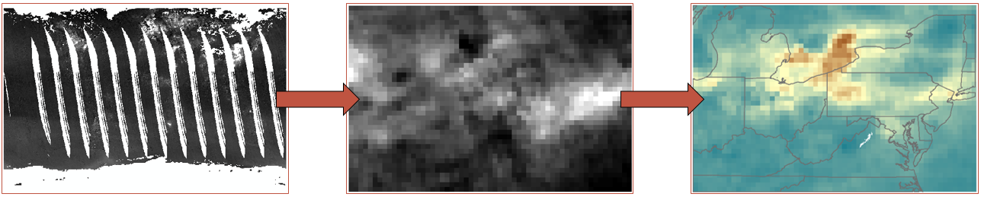

*Figure 2*. Progression of daily Level 3 tropospheric NO2 OMI data to processed monthly averages

***3.3 Data Analysis***

For analysis, the project compared different atmospheric parameters between the *in situ* data and the satellite data obtained by OMI. OMI data selected for final analysis were from nine pixels over and surrounding the park, not the entire airshed. This provided analysis that is more applicable to the park and relatable to management decisions. Linear correlations were conducted to compare tropospheric NO2 to total column NO2, total column SO2 to *in situ* SO2, and total column ozone with *in situ* ozone. Graphs to compare *in situ* data to OMI data were created despite the different unit measurements. The correlation graphs were used to analyze any comparable trends between remotely sensed and ground level data.

OMI total column ozone data and Big Meadows ground level ozone data were processed into monthly averages. A direct comparison between the two datasets was not possible, as they were measured in different units. The OMI data were in Dobson Units and the *in situ* data were in parts per billion, which are not comparable. Instead, a trend analysis was performed by creating a graph including the averages from both sensors. Maps depicting monthly ozone averages were also created using the spatially referenced OMI data.

NO2 measurements are not recorded at Big Meadows, so a comparison of satellite data from OMI to *in situ* data for NO2 was not possible. Instead, a comparison between total column NO2 and tropospheric NO2 was performed. Maps were created representing the monthly average values for both tropospheric and total column NO2, and graphs showing a comparison of the trends were also created.

Similar analysis was performed on SO2 data. However, rather than representing on a map the monthly average values recorded by OMI, the monthly maximum was used. This ensured that high values were visible in the resulting map graphics, rather than hidden in the mass of data. For the comparison between satellite and *in situ* SO2 data, a graph representing the monthly averages was created.

# 4. Results & Discussion

***4.1 Analysis of Results***

*4.1.1 Ozone*

There was not a significant correlation (R2 = 0.0004) between the *in situ* data and the satellite observations for ozone (Figures 3 & 4). This is likely because the project used total column ozone data for its analysis. Acquisition of tropospheric ozone residuals may improve the correlation with the ground level data, given the atmospheric dynamics of ozone. Within the total column measurements, the majority of ozone is located in the stratosphere, which would not correlate with ground level observations (Wayne, 1993). A tropospheric ozone residual product is available through a research team at NASA Goddard Space Flight Center, but was not accessed during the timeframe for this project. Although there was no significant annual variation detected, the ozone data collected did exhibit cyclical and seasonal trends. High values were found each year during the study period during the fall months. During the study period, the month with the highest ozone level each year was August, September, or October (Figure 5). Ozone trend maps illustrated higher levels of concentration in the summer and fall months, and a decrease in the winter months (Figure 6). The maps reiterated the cyclical nature of ozone levels that the graphical analysis showed. They also did not illustrate a noticeable decrease over time, similar to the graphical analysis.

*Figure 3*. Comparison of OMI total column ozone with *in situ* data.

*Figure 4*. Correlation analysis of OMI total column ozone versus *in situ* measurements.

*Figure 5*. Graph of monthly ozone *in situ* data.

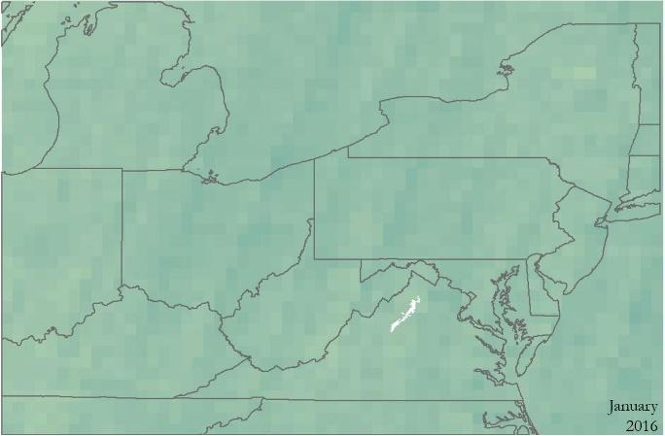 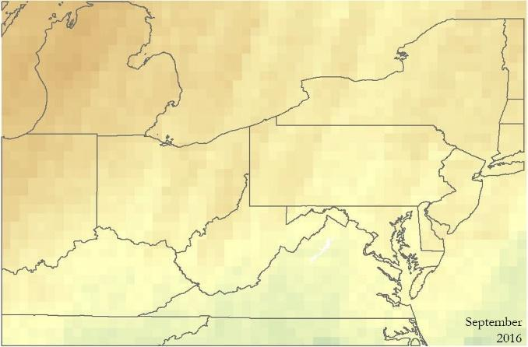

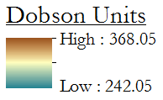

*Figure 6*. Monthly variation in total column ozone shown through January and September 2016 monthly averages

*4.1.2 Nitrogen Dioxide*

Upon analysis of the linear correlation graphs, the only strong relationship (R=0.9736) found was between the tropospheric NO2 and total column NO2 (Figure 7). The graph of tropospheric versus total column NO2 indicates the overall amount of NO2 has been decreasing since 2005 by approximately 28 percent. The trend lines are near parallel; this is likely because of the total column being driven by tropospheric NO2 (Figure 8). When comparing the maximum values of the tropospheric NO2 to the average values of the tropospheric NO2, the decrease over the study period appears more dramatically than only looking at average values. It shows that the days with very high levels of NO2 have decreased over the study period of 2005 to 2016 (Figure 9). Trend maps identified high concentrations of NO2 over large cities, such as New York City and Pittsburgh, and in regions such as the Ohio River Valley. The trend maps showed a visible decrease in NO2 levels from the beginning of the study period (2005) to the end (2016). Levels of NO2 were higher in winter months because of photochemical decomposition. Winter levels were consistently higher than summer levels, and decreased over time throughout the study period (Figure 10).

*Figure 7*. Correlation graph for total column and tropospheric NO2 values.

*Figure 8*. Comparison graph of OMI total column to tropospheric for NO2.

*Figure 9.* Maximum and average values for OMI tropospheric NO2 data between 2005 and 2016.

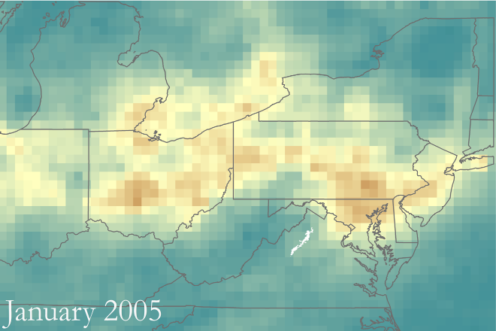 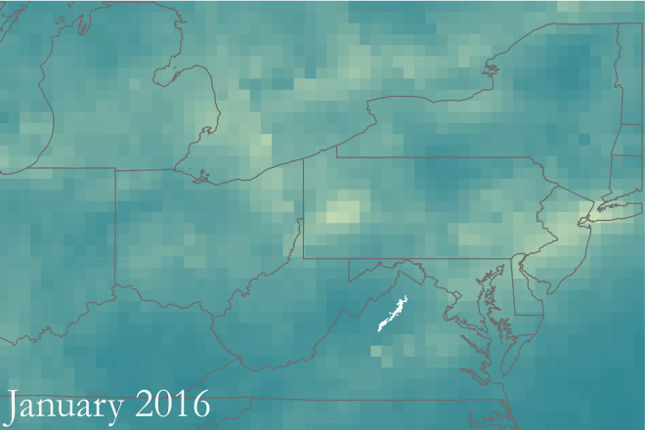

Molecules/cm2

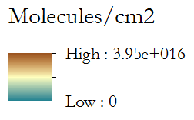

*Figure 10*. Average tropospheric NO2 for January 2005 and January 2016 (*Note*: blue values are low, orange values are high).

*4.1.3 Sulfur Dioxide*

There was no distinct pattern identified with SO2 (Figure 11). Any decrease that might have occurred was not picked up by our analysis, likely because of changes in pollution control since the original Clean Air Act and other state and national legislation. The detection level for SO2 from the OMI sensor is not sensitive enough for the low levels of SO2 in the study area during this study period. These results are positive for Shenandoah because they imply the levels of SO2 around the park are so low they are not easily detected by remote sensing. Trend maps did not illustrate distinguishable patterns in SO2 levels as were shown in NO2. However, lower values do appear more often in the later years of the study period than in the earlier years (Figure 12). This was likely because of similar issues from the graph comparison analysis regarding the low detection levels of the OMI sensor for SO2 data.

*Figure 11*. Comparison graph of OMI total column SO2 to *in situ* data.

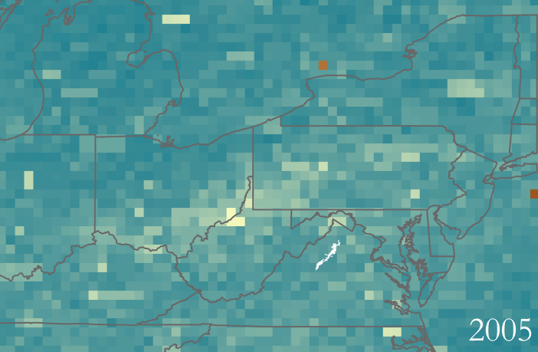 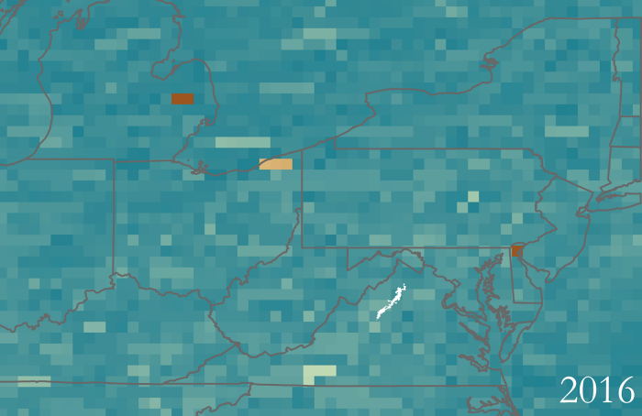

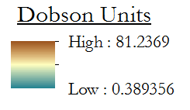

*Figure 12.* Annual maximum values of total column SO2 in 2005 and 2016

***4.2 Future Work***

Due to time constraints for this project, a limited number of atmospheric parameters were considered. The pollutants analyzed in this project include only a sampling of the partners’ concerns for air quality in the park and does not address visibility concerns. Data for alternate parameters can be found using NASA Earth observation resources and could be pursued in the future such as methane, formaldehyde, carbon dioxide, and ammonia.

This project could be improved by finer spatial resolution data. Future NASA Earth observation technologies, such as the TEMPO (Tropospheric Emissions: Monitoring Pollution) instrument, will provide this. TEMPO will track hourly measurements of tropospheric air pollutants over North America at a scale 50 times better than what is currently available with the OMI sensor.

The second term will focus on parameters affecting visibility, such as smog, aerosols, and other atmospheric pollutants not addressed by this project. The methodology created by this project could be used to assess other atmospheric compounds that can be monitored by additional sensors aboard NASA’s Earth observing satellites. Tropospheric ozone residuals could be considered as it may better relate to the *in situ* data obtained from Big Meadows than total column ozone.

# 5. Conclusions

Based upon available data, total column ozone follows a cyclical pattern which is consistent across both OMI data and *in situ* data. Generally, our analysis of ozone showed high levels in the summer months and low levels in the winter months. NO2 concentration levels have decreased over time, which likely can be attributed to measures towards emission control to meet the NAAQS. There was no visible decrease in SO2 satellite data due to the low detection limit of OMI. There was also no decrease for the *in situ* SO2. While improvement in air quality can be identified with remote sensing, it is still vital for greater actions to take place to ensure healthy environments both for national park visitors and for the flora and fauna inside the parks. Higher concentrations of total column ozone during the late summer and early autumn months indicates a greater level of protection from harmful ultraviolet rays during the park’s busiest time of year.

Data regarding atmospheric parameters were requested by Shenandoah National Park to help identify air quality trends in pollutants such as ozone, nitrogen dioxide, and sulfur dioxide. In addition to utilizing data collected by Shenandoah from their single monitoring station at Big Meadows, the project utilized remote sensing to expand the study area and provide a more regional view of pollutant sources and transport. Understanding potential pollutant sources for Shenandoah can help park policymakers plan for the future, and can also enable park employees to warn visitors of days with a higher concentration of pollutants. Keeping the park’s air clean can help preserve and promote pristine views, healthy plants and animals, and high park attendance for years to come.

# 6. Acknowledgments

The project team for this DEVELOP project would like to acknowledge:

* Dr. Bruce Doddridge and Dr. Kenton Ross of NASA Langley Research Center
* Jalyn Cummings and Liz Garcia of the National Park Service’s Shenandoah National Park
* Dr. Barkley Sive of the National Park Service, Air Resources Division

Any opinions, findings, and conclusions or recommendations expressed in this material are those of the author(s) and do not necessarily reflect the views of the National Aeronautics and Space Administration.

This material is based upon work supported by NASA through contract NNL16AA05C and cooperative agreement NNX14AB60A.

# 7. Glossary

**Acid Deposition** – The accumulation of acid in soil, plants or the tissue of animals; main contribution is from acid rain

**AIRS** – Atmospheric Infrared Sounder, sensor aboard the Aqua satellite

**Ammonia** (NH3) – Used in fertilizers, cleaners and in food preservation in smaller quantities. Concerns are found in the contribution to nutrient runoff after dry deposition occurs

**Ammonium** (NH4+) – Created when ammonia is charged with a positive hydrogen ion. Commonly found after digestion in fish and animals

**Aqua** – NASA satellite launched in 2002 as part of the Earth Observation Series

**ArcGIS** – Program used for Geographic Information Systems, takes raw data points from observations and applies data to maps for various types of analysis

**Aura** – NASA satellite launched in 2004 as part of the Earth Observation Series

**Carbon Monoxide** (CO) – Formed when not enough oxygen is present to create the more popular carbon dioxide, CO2; can be found with incomplete combustion of carbon-based fuel such as ethanol, methane, or propane

**Clean Air Act** – The Clean Air Act is a government act first enacted in 1963 to promote public health by limiting the release of airborne particles. The amendment of 1977 expanded the reach of the act to National Parks and included visibility measurements. The amendment of 1990 expanded the concerns to specific air pollutants such as ozone, nitrogen oxides, particulate matter, and sulfur oxides.

**Dobson Unit** – A unit of thickness, in units of 10µm, to determine the abundance of an atmospheric parameter, typically used for ozone.

**Earth observations (EO)** – Satellites and sensors that collect information about the Earth’s physical, chemical, and biological systems over space and time

**HE5 files** – Hierarchical Data Format (also HDF) version 5; a data format used by government and non-government organizations for data that can be accessed and utilized by common scripting programs

**Level 3 Data** – Geospatially referenced data from NASA satellites

**NASA** – National Aeronautics and Space Administration

**National Park Service Organic Act** –Government act first enacted in 1916 for the formation of the National Park Service

**Nitrogen Dioxide** (NO2) – Found by the formation of nitrogen gas, N2, and oxygen gas, O2; highly reactive to other compounds, can be found by incomplete combustion for gasoline-based vehicles

**OMI** – Ozone Monitoring Instrument, sensor aboard the Aura satellite

**Ozone** (O3) – Comprised of three oxygen atoms, caused by the breakdown of oxygen gas in the upper atmosphere and blocks harmful ultraviolet rays; at lower atmosphere, ozone breaks down protective tissues and membranes of organisms, making them vulnerable

**pH** (Potential of hydrogen) – Unit of measure for how basic or acidic a solution is with seven meaning ‘neutral’, lower numbers being ‘acidic’, and higher numbers being ‘basic’

**Remote Sensing** – Gathering data of an object(s) without making direct contact

**Sulfur Dioxide** (SO2) – Formed after incomplete combustion of sulfur-based compounds such as coal and then combined with oxygen gas; can lead to the formation of sulfuric acid, H2SO4, which is better known as ‘acid rain’

**TES** – Tropospheric Emission Spectrometer, sensor aboard the Aura satellite

**TIF files** - Also known as TIFF files. Tagged Image File Format; a computer file format used as a raster for storing graphics with values for each pixel generated

**Wilderness Act** – Government act first enacted in 1964 that defined ‘wilderness’ and preserved 9.1 million acres of federal land to be protected by the federal government

**WGS 1984** – Standard coordinate system for the Earth, established in 1984, the system has its origin point at the center of the earth

# 8. References

Adon, M., Galy-Lacaux, C., Yoboué, V., Delon, C., Lacaux, J. P., Castera, P., et al. (2010). Long term measurements of sulfur dioxide, nitrogen dioxide, ammonia, nitric acid and ozone in Africa using passive samplers. *Atmospheric Chemistry and Physics, 10,* 7467-7487.

EPA (2012) Fact Sheet - Final Revisions to the Secondary National Ambient Air Quality Standards for Oxides of Nitrogen and Sulfur. Retrieved August 3, 2017, from [https://www.epa.gov/sites/ production/files/2016-06/documents/20120320factsheet_secondary_standards.pdf](https://www.epa.gov/sites/production/files/2016-06/documents/20120320factsheet_secondary_standards.pdf)

Faustini, A., Rapp, R., & Forastiere, F. (2014). Nitrogen dioxide and mortality: Review and meta-analysis of long-term studies*.* *European Respiratory Journal*, *44*(3), 744–753. [https://doi.org/10.1183/ 09031936.00114713](https://doi.org/10.1183/09031936.00114713)

Hoff, R. F. & Christopher, S. A. (2009) Remote sensing of particulate pollution from space: have we reached the promised land? *Journal of the Air & Waste Management Association*, *59*(6), 645-675.

Greenberg, N., Carel, R.S., Derazne, E., Tiktinsky, A., Tzur, D., & Portnov, B.A. (2017). Modeling long-term effects attributed to nitrogen dioxide (NO2) and sulfur dioxide (SO2) exposure on asthma morbidity in a nationwide cohort in Israel. *Journal of Toxicology and Environmental Health*, Part A,, 1–12. <https://doi.org/10.1080/15287394.2017.1313800>

Krotkov, Nickolay A. (2013). OMI/Aura NO2 Cloud-Screened Total and Tropospheric Column L3 Global 0.25deg Lat/Lon Grid. NASA Goddard Earth Sciences Data and Information Services Center. Accessed June 28, 2016. doi: 10.5067/Aura/OMI/DATA3007

Krotkov, Nickolay A., Li, C., & Leonard, P. (2012). OMI/Aura Sulfur Dioxide (SO2) Total Column L3 Best Pixel Global 0.25deg Lat/Lon Grid. NASA Goddard Earth Sciences Data and Information Services Center. Accessed June 30, 2016. doi: 10.5067/Aura/OMI/DATA3008

NASA Goddard. (n.d.). The Aura Mission. Retrieved June 27, 2017, from https://aura.gsfc.nasa.gov/

Shenandoah National Park (U.S. National Park Service). (2015, February 26). Monitoring - Air Quality Retrieved June 15, 2017, from <https://www.nps.gov/shen/learn/nature/mon_air.htm>

Shenandoah National Park (U.S. National Park Service). (2011). Park Statistics. Retrieved June 15, 2017, from <https://www.nps.gov/shen/learn/management/statistics.htm>

S[h](https://www.nps.gov/shen/learn/management/statistics.htm)e[n](https://www.nps.gov/shen/learn/management/statistics.htm)a[n](https://www.nps.gov/shen/learn/management/statistics.htm)d[o](https://www.nps.gov/shen/learn/management/statistics.htm)a[h](https://www.nps.gov/shen/learn/management/statistics.htm) [N](https://www.nps.gov/shen/learn/management/statistics.htm)a[t](https://www.nps.gov/shen/learn/management/statistics.htm)i[o](https://www.nps.gov/shen/learn/management/statistics.htm)n[a](https://www.nps.gov/shen/learn/management/statistics.htm)lP[a](https://www.nps.gov/shen/learn/management/statistics.htm)r[k](https://www.nps.gov/shen/learn/management/statistics.htm) [(](https://www.nps.gov/shen/learn/management/statistics.htm)U[.](https://www.nps.gov/shen/learn/management/statistics.htm)S[.](https://www.nps.gov/shen/learn/management/statistics.htm) [N](https://www.nps.gov/shen/learn/management/statistics.htm)a[t](https://www.nps.gov/shen/learn/management/statistics.htm)i[o](https://www.nps.gov/shen/learn/management/statistics.htm)n[a](https://www.nps.gov/shen/learn/management/statistics.htm)l P[a](https://www.nps.gov/shen/learn/management/statistics.htm)r[k](https://www.nps.gov/shen/learn/management/statistics.htm) [S](https://www.nps.gov/shen/learn/management/statistics.htm)e[r](https://www.nps.gov/shen/learn/management/statistics.htm)v[i](https://www.nps.gov/shen/learn/management/statistics.htm)c[e](https://www.nps.gov/shen/learn/management/statistics.htm))[.](https://www.nps.gov/shen/learn/management/statistics.htm) [(](https://www.nps.gov/shen/learn/management/statistics.htm)2[0](https://www.nps.gov/shen/learn/management/statistics.htm)0[7](https://www.nps.gov/shen/learn/management/statistics.htm))[.](https://www.nps.gov/shen/learn/management/statistics.htm) [W](https://www.nps.gov/shen/learn/management/statistics.htm)h[a](https://www.nps.gov/shen/learn/management/statistics.htm)t[’](https://www.nps.gov/shen/learn/management/statistics.htm)su[p](https://www.nps.gov/shen/learn/management/statistics.htm) [w](https://www.nps.gov/shen/learn/management/statistics.htm)i[t](https://www.nps.gov/shen/learn/management/statistics.htm)ht[h](https://www.nps.gov/shen/learn/management/statistics.htm)ea[i](https://www.nps.gov/shen/learn/management/statistics.htm)r[?](https://www.nps.gov/shen/learn/management/statistics.htm) R[e](https://www.nps.gov/shen/learn/management/statistics.htm)t[r](https://www.nps.gov/shen/learn/management/statistics.htm)i[e](https://www.nps.gov/shen/learn/management/statistics.htm)v[e](https://www.nps.gov/shen/learn/management/statistics.htm)dJ[u](https://www.nps.gov/shen/learn/management/statistics.htm)n[e](https://www.nps.gov/shen/learn/management/statistics.htm) [1](https://www.nps.gov/shen/learn/management/statistics.htm)5[,](https://www.nps.gov/shen/learn/management/statistics.htm) [2](https://www.nps.gov/shen/learn/management/statistics.htm)0[1](https://www.nps.gov/shen/learn/management/statistics.htm)7 <f>r[o](https://www.nps.gov/shen/learn/management/statistics.htm)mhttps://www.nps.gov/shen/learn/nature/upload/SHEN_NR_Air_Pamphlet_2007-11.pdf

Smith, S. J., Pitcher, H., & Wigley, T.M.L. (2001). Global and regional anthropogenic sulfur dioxide emissions. *Global and Planetary Change, 29*, 99-119.

Sullivan, T. J., Cosby, B. J., Lawrence, J. A., Dennis, R. L., Savig, K., Webb, J. R., Bulger, A. J., Scruggs, M., Gordon, C., Ray, J., Lee, E. H., Hogsett, W. E., Wayne, H., Miller, D., & Kern, J.S. (2003). Assessment of air quality and related values in Shenandoah National Park. *Philadelphia: US Department of the Interior, National Park Service, Northeast Region.* Technical Report No. NPS/NERCHAL/NRTR-03/090. Retrieved from http://www.academia.edu/download/43626666/ Assessment_of_Air_Quality_and_Related_Va20160311-26489-1500f8c.pdf

Veefkind, P. (2012). OMI/Aura Ozone (O3) DOAS Total Column Daily L3 Global 0.25deg Lat/Lon Grid. NASA Goddard Earth Sciences Data and Information Services Center. doi://10.5067/Aura/ OMI/DATA3005

Venkanna, R., Nikhil, G.N., Sinha, P.R., Rao, T.S., & Swamy, Y.V. (2016). Significance of volatile organic compounds and oxides of nitrogen on surface ozone formation at semi-arid tropical urban site, Hyderabad, India. *Air Quality, Atmosphere & Health*, *9*(4), 379–390. <https://doi.org/10.1007/s11869-015-0347-2>

Wayne, R.P. (1993). Chemistry of atmospheres, 2nd edition. United States: New York, NY (United States); *Oxford Univ. Press*.

Zhu, L., Henze, D. K., Bash, J. O., Cady-Pereira, K. E., Shephard, M. W., Luo, M., & Capps, S. L. (2015). Sources and Impacts of Atmospheric NH3: Current Understanding and Frontiers for Modeling, Measurements, and Remote Sensing in North America. *Current Pollution Reports*, *1*(2), 95–116. https://doi.org/10.1007/s40726-015-0010-4