**NASA DEVELOP National Program**

****NASA Marshall Space Flight Center

**Fall 2015**

**Short Title: North Mexico Ecological Forecasting**

**Subtitle:** Using NASA Earth Observations to Monitor and Manage Ocelot Habitat Loss in North Mexico

**VPS Title:** Days of Our Ocelot: Finding an Elusive Cat’s Habitat in North Mexico

**Project Team & Partners**

**Project Team:**

Ryan Schick (Project Lead), ryanschickwx@gmail.com

Padraic Conner

Maggi Klug

Leigh Sinclair

**Advisors & Mentors:**

Dr. Jeffrey Luvall (NASA at the National Space Science Technology Center)

Dr. Robert Griffin (University of Alabama in Huntsville)

**Past or Other Contributors:**

Amberle Keith

Christina Fischer

Kaushik Narasimhan

Daryl Ann Winstead

**Partner Organizations:**

Caesar Kleberg Wildlife Institute at Texas A&M University - Kingsville (End-User), POCs: Michael Tewes & Dr. Humberto Perotto

The Denver Zoo (End-User), POC: Nanette Bragin

South Texas Refuge Complex (End-User), POC: Mitch Sternberg

Texas Department of Transportation (End-User), POC: Dr. John Young, Jr.

East Wildlife Foundation (End-User), POC: Dr. Tyler Campbell

Pittsburg Zoo & Pittsburgh Plate Glass (PPG) Aquarium (Boundary Organization), POCs: Ken Kaemmerer & Dr. Josh Gaspard

Mexican Secretariat of the Environment and Natural Resources (SEMARNAT, Secretaría de Medio Ambiente y Recusos Naturales) (Boundary Organization), POCs: Dr. Arturo Caso & Dr. Arturo Flores-Martinez

**Project Details**

**Applied Sciences National Application Addressed:** Ecological Forecasting

**Study Area:** Northeastern Mexico - Tamaulipas, Nuevo Leon, San Louis Potosi

**Study Period:** Jan 1996 - Jan 2014

**Earth Observations & Parameters:**

Landsat 5, TM - spectral vegetation indices, land cover classifications, land cover change

Landsat 8, OLI - spectral vegetation indices, land cover classifications, land cover change

Suomi NPP, VIIRS - spectral vegetation indices

SRTM-v2 - digital elevation models

**Ancillary Datasets Utilized:**

* SEMARNAT *in situ* ocelot sighting data - known ocelot locations
* International Union for Conservation of Nature (IUCN) Ocelot habitat data - Current ocelot habitat
* USGS U.S. - Mexico Border Environmental Health Initiative (BEHI) population data - Ocelot population
* ESRI Roads of Mexico and Central America GIS data - Road locations

**Models Utilized:**

* Princeton University Maximum Entropy Distribution Model (MaxEnt)

**Software Utilized:**

ArcGIS - land classification of Landsat imagery - Landsat TM & OLI, spectral vegetation indices map creation - Landsat TM & OLI, Suomi NPP VIIRS, Aqua/Terra MODIS

ENVI - georeferencing of Suomi data - Suomi NPP VIIRS

**Project Overview**

**80-100 Word Objectives Overview:**

Ocelots (*Leopardus pardalis*) are a medium sized wild cat found from Argentina to the extreme southern United States, where they are listed as endangered. U.S. ocelot populations are isolated from populations in Mexico, which has led to inbreeding. Efforts are being made to translocate ocelots from Mexico to increase the genetic diversity of the U.S. population. This project created a Habitat Percent Map to assess the current extent of ocelot habitat in northeastern Mexico and a Habitat Probability Map to show areas most likely to be inhabited by breeding populations. These end products will help project partners with conservation efforts.

**Abstract:**

Ocelots (*Leopardus pardalis*) are medium sized wild cats that have a distribution reaching from Argentina to the southwestern portion of the United States (U.S.). Although the ocelot is one of the most abundant wild cats throughout most of its range, the population in the U.S. is less than 100 and is protected under the Endangered Species Act. This ocelot population is separated from the main population by the U.S.-Mexico border and is facing a loss of habitat due to anthropogenic disturbance. Because of this separation, the U.S. population is now showing signs of inbreeding, which causes health issues and decreases the chance of survival. The U.S. Fish and Wildlife Service, along with other partners, are preparing to translocate ocelots from Mexico to the United States to bolster the gene pool of the U.S. population.  This project aided in this goal by using remotely sensed data to delineate suitable habitat areas and examine where ocelots are most likely to be found in northeastern Mexico. Landsat 5 and 8 were used to create supervised land cover classifications for 1996, 2004, and 2014 to assess temporal changes. Suomi National Polar-orbiting Partnership (NPP) was used to derive Normalized Difference Vegetation Index (NDVI) for use in the MaxEnt model and to verify land cover classifications. SRTM-v2 data was used to create digital elevation models. The land cover and elevation data, along with presence data and environmental variables, were analyzed by the Princeton Maximum Entropy model and the “Fuzzy Logic” tool to identify suitable ocelot habitat.

**Community Concerns:**

* The ocelot (*Leopardus pardalis*), a type of cat that can be found from Texas to Northern Argentina, is an endangered species in the United States.
* Ocelots require seven square miles of dense vegetation to hunt for prey, but urban development, agricultural land use, road development, and border fences have led to habitat fragmentation.
* Inbreeding, caused by population isolation due to habitat fragmentation, has further reduced the survivability of the species.
* Due to increased agriculture and urbanization, over 95% of Tamaulipan brushland habitat in northeastern Mexico has been eliminated (Connolly, A.R., 2009).

**Current Management Practices & Policies**:

Currently, remote sensing is not being utilized by any of the project partners to monitor the decrease of the ocelot habitat. Research on the cat typically consists of using radio collars and traps to track their movement. Other management practices that the partners are using include the occasional collection of aerial imagery, translocating up to four ocelots from Mexico to south Texas each year, restoring native vegetation in the area that is preferred by the ocelots, and planning wildlife crossing structures. The use of field techniques can be costly and time consuming for researchers, as well as traumatic for ocelots. The use of sedation, which can have negative side effects, poses a risk to their safety.

**Decision Support Tools & Benefits:**

|  |  |  |
| --- | --- | --- |
| **End-Product** | **Earth Observations Used** | **Benefit & Impact** |
| Habitat Percent Cover Map | Landsat 5 TM  Landsat 8 OLI  Suomi NPP VIIRS  SRTM-v2 | Where the project partners should focus ground-truthing and prioritize conservation efforts |
| Habitat Probability Map | Landsat 5 TM  Landsat 8 OLI  SRTM-v2 | Where conservation groups should focus efforts to connect habitat patches |

**Project Imagery**

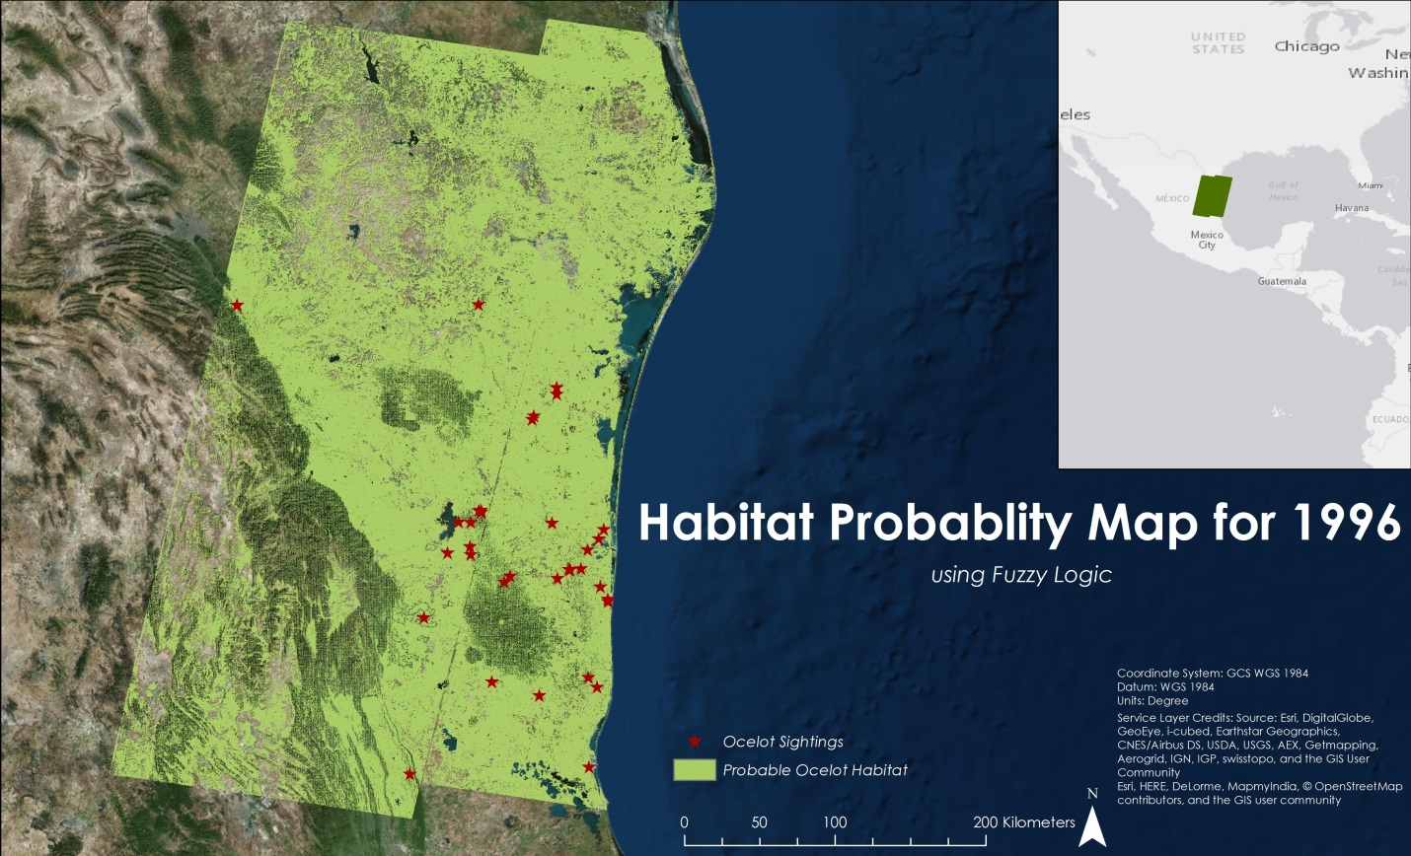

**Caption:** Habitat Probability Map created using Fuzzy Logic to show areas likely to be inhabited by ocelots. Image Credit: North Mexico Ecological Forecasting Team.

**Image:** 2015Fall_MSFC_NorthMexicoEco_VPS_Image.jpg

**Software Release Requirements**

What category do the tools your project is creating fall within? Category 1

**References**

Connolly, A. R. (2009). *Defining Habitat for the Recovery of Ocelots (Leopardus pardalis) in the United States* (Doctoral dissertation, Texas State University-San Marcos).