Washington Health & Air Quality

Quantifying Air Quality Parameters and Validating Air Pollution Sources Impacting the Health of Puget Sound Residents Through the Use of NASA and ESA Remote Sensing Data

 **Technical Report**

Final Draft – April 2nd, 2020

Amiya Kalra (Project Lead)

Rachel Deininger

Rachel Earwood

Richard Murray

Dr. Robert Griffin, University of Alabama in Huntsville (Science Advisor)

Dr. Jeffrey Luvall, NASA Marshall Space Flight Center (Science Advisor)

Dr. Mike Newchurch, University of Alabama in Huntsville (Science Advisor)

Dr. Mohammad Al-Hamdan, NASA Marshall Space Flight Center (Science Advisor)

# 1. Abstract

In the Puget Sound region of Washington, high levels of air pollutants put residents’ health at risk by increasing their likelihood of developing critical respiratory conditions. This project used remotely-sensed data to investigate aerosol optical depth (AOD) from NASA satellite sensors including the Terra and Aqua MODerate Resolution Imaging Spectroradiometer (MODIS) and European Space Agency Copernicus Sentinel-5 Precursor TROPOspheric Monitoring Instrument (TROPOMI). The team visualized the most recent data in Google Earth Engine (GEE) API to display air pollution trends in Washington State, which will support the Puget Sound Clean Air Agency’s (PSCAA) decision-making processes. The team performed linear regressions using the Multi-Angle Implementation of Atmospheric Correction (MAIAC) algorithm to form a relationship between ground-level microscopic particles (PM2.5) and AOD in the Puget Sound region, validating the relationship using concentration readings taken from Environmental Protection Agency (EPA) air quality monitors. The team utilized estimated PM2.5 and other satellite data to produce a web-based tool and to evaluate the effectiveness of using such a tool for near real-time air quality monitoring within a particular region. The team found that the tool provides useful supplementary data that fills in the gaps of the PSCAA’s air monitoring network.

**Keywords**

public health, MODIS, Multi-Angle Implementation of Atmospheric Correction, Sentinel-5P, TROPOMI, Google Earth Engine

# 2. Introduction

* 1. ***Background Information***

Over the last decade, understanding of the dangers to human health from poor air quality has increased and led to heightened concerns over air quality worldwide. On a global scale, mortality from air pollution in urban areas ranges from 13 to 125 deaths per 100,000 people (Anenberg et al., 2019). Pollution levels spiked during the Industrial Revolution, and negative conditions peaked in the United States in 1948, when a deadly smog event occurred in Donora, Pennsylvania. Due to the city’s bowl-like geological features, an inversion event trapped clouds of toxic smog from the city’s many industrial plants at ground level, impairing visibility and triggering health consequences. The smog killed 20 people and left thousands with serious respiratory health conditions (Jacobs et al., 2018). This event sparked the Clean Air Act, giving the federal government authority to enforce regulations on air pollution (Ross et al., 2012). Despite improvement since the Clean Air Act passed, air quality remains one of the top ten risks to human health in urban areas around the world, even in those with generally low pollution levels (Anenberg et al., 2019).

Aerosols are categorized based on the size of particulate matter (PM); ultrafine PM ranges from less than 0.1 µm to <2.5 µm, fine PM is 2.5 µm, and coarse PM ranges from >2.5 µm to 10 µm. Fine and ultrafine particles (PM2.5) can originate from a variety of natural and anthropogenic sources, including volcanic eruptions, wildfires, and industrial combustion. Of all aerosols, fine and ultrafine particles are responsible for most of the damage to human health, and pose a serious health risk both from short-term and long-term exposure (Kennedy, 2007). Health effects include lung cancer and cardiopulmonary mortalities (Liu et al., 2009). Cells in the lungs absorb inhaled particulate matter, allowing it to enter the circulatory system and become lodged in vital organs (Kennedy, 2007). Populations at high risk include children, elderly people, pregnant women, and people with pre-existing respiratory conditions (Balbus & Malina, 2009). Johnston et al. estimated that 339,000 premature deaths occur annually due to exposure to landscape fire smoke (2012). Research on hazardous pollutants found that biomass burning from wildfires or stoves and black carbon from diesel exhaust are the primary sources of atmospheric PM2.5 in Seattle, Washington (Wu et al., 2007). Wildfires in particular cause concern for residents in Washington. Although not all of Washington State suffers from wildfires each year, particulate matter from fires elsewhere in the Pacific Northwest reaches Washington and worsens air quality there. Seattle and the Puget Sound region, in particular, suffer from poor air quality due to wildfire particulate matter because of the topography of the region; atmospheric inversions frequently trap pollutants in the valley (E. Saganić, personal communication, February 6, 2019).

On-the-ground networks of air quality sensors tend to be sparse, and their data do not cover large areas, leaving gaps in available air quality data. Remote sensing makes it possible to fill in those gaps by providing spatially comprehensive data on pollutant concentrations (Hu et al., 2013), although it also only provides data influenced by the entire atmospheric column and with a coarser temporal resolution than *in situ* data (Lyapustin & Wang, 2018). Satellite sensors can detect concentrations of pollutants such as nitrogen oxides, sulfur dioxide, and ozone directly. PM2.5 concentrations must be estimated from satellite aerosol optical depth (AOD), which is a measure of the amount of light scattered or absorbed by aerosols in the atmosphere (Hu et al., 2013). To estimate PM2.5 concentrations from AOD, previous studies have created models from on-the-ground data and satellite-derived AOD, which begins to provide accurate estimates (Schaap et al., 2009). Some studies included other meteorological and land use variables such as relative humidity, boundary layer height, and population density to improve model accuracy (Hu et al., 2013; Hu et al., 2014). Local meteorology and land use patterns influence the relationship between AOD and PM2.5, so local calculations are necessary to create accurate models (van Donkelaar, 2010). To further improve accuracy, some studies use geographically weighted regression models to provide information specific to smaller regions (Hu et al 2013, Fotheringham et al., 1998).

For this study, the Spring 2020 NASA DEVELOP Washington Health & Air Quality team investigated current air pollution trends in Washington State using a tool created in Google Earth Engine (GEE) (*Figure 1*). The tool uses remote sensing data from the Terra, Aqua, and Sentinel-5P satellites to display up-to-date concentrations of air pollutants. The tool allows for a view of air pollution that would be difficult to monitor using ground sensors alone due to their inability to track the pollutants higher in the troposphere (M. Newchurch, personal communication, February 26, 2020).

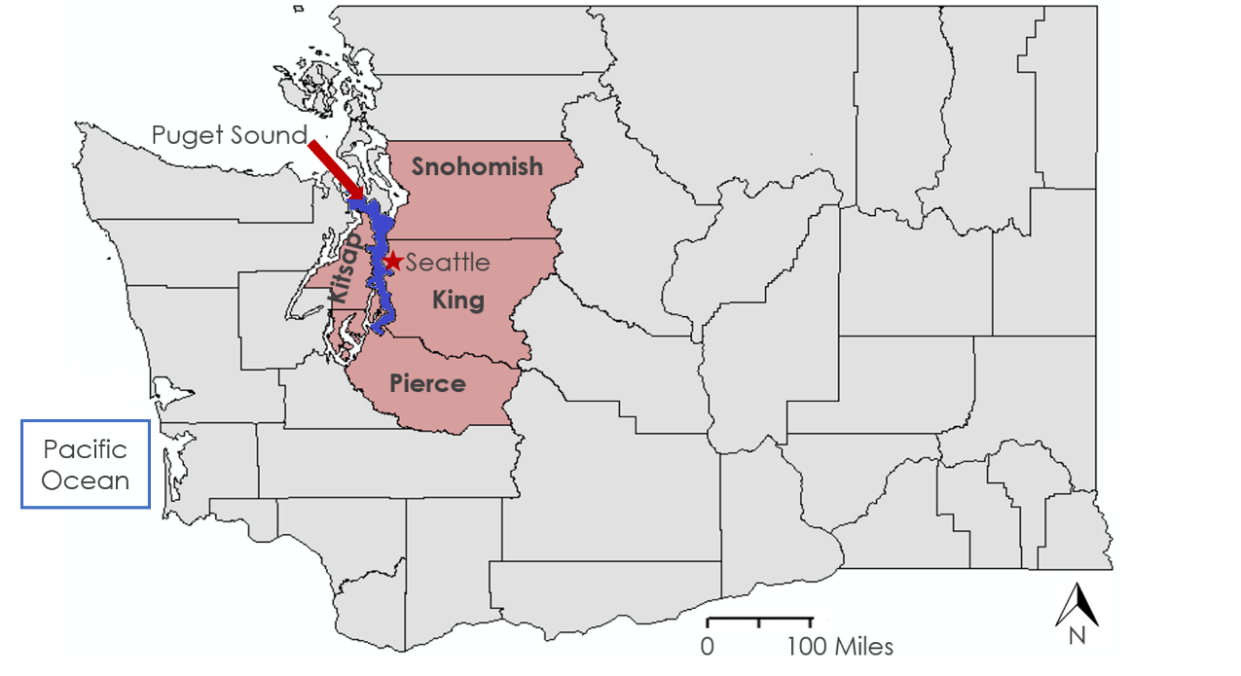

Figure 1. Study area map of Washington State with Snohomish, King, Pierce, and Kitsap Counties highlighted.

* 1. ***Project Partners & Objectives***

The team partnered with the Puget Sound Clean Air Agency (PSCAA), a regional governmental organization working in four counties surrounding the Puget Sound in Washington State. The PSCAA works to enforce regulations set by the federal Clean Air Act and the Washington Clean Air Act and to monitor and educate residents about local air quality (PSCAA, 2014). The agency has eighteen on-the-ground air quality sensors in their jurisdiction, mostly around Seattle, which provide information on concentrations of air pollutants including PM2.5 and nitrogen oxides (PSCAA, n.d.a; PSCAA, n.d.b). Because their ground sensors do not provide data for the entire region and cannot track pollutants above the ground level, the PSCAA expressed interest in using remote sensing data to fill in the gaps. To meet the PSCAA’s needs, this project identified sources and dispersion patterns of air pollutants in the Pacific Northwest region and created a web-based tool allowing the partner to access and display the data in GEE. The team used data from EPA on-the-ground sensors to calibrate and validate the tool. The PSCAA will be able to use the tool to identify areas with high concentrations of air pollutants, facilitating the agency’s work in establishing burn bans, declaring public notices, and educating the public during harmful air quality events.

# 3. Methodology

***3.1 Data Acquisition***

The team acquired data from the Multi-Angle Implementation of Atmospheric Correction (MAIAC) algorithm of Aqua and Terra Moderate Imaging Spectroradiometer (MODIS) and Sentinel-5P Tropospheric Monitoring Instrument (TROPOMI) (*Table 1)*. MAIAC provided high-quality data on AOD since quality issues such as cloud cover and sea glint had already been corrected in the dataset. The AOD data were unitless. The team used MAIAC data from June through September of 2018 to establish PM2.5 prediction equations, and the tool will provide predicted PM2.5 up to present day. TROPOMI provided data showing atmospheric column density for nitrogen dioxide (NO2), sulfur dioxide (SO2), ozone (O3), carbon monoxide (CO), methane (CH4), and formaldehyde (HCHO). The column density data are provided in units of molecules/m2. To make the TROPOMI data more usable for the PSCAA, the team converted the data to μg/cm3. To do this, the team divided the column density value for each pixel by the sensor altitude value for each pixel (P. Swartzendruber, personal communication, March 23, 2020; Kira, 2016). The final TROPOMI data values represented averaged concentrations for each pollutant across the entire atmospheric column.

Table 1.

*Description of platform/sensor, along with data source, level of product, and spatial resolution.*

|  |  |  |  |
| --- | --- | --- | --- |
| **Platform & Sensor** | **Data Source** | **Product Level** | **Spatial Resolution** |
| Sentinel-5P TROPOMI | GEE | Level 3 | 0.01 arc degree (1.11 km) |
| Terra MODIS | GEE | Level 3 | 1 km |
| Aqua MODIS | GEE | Level 3 | 1 km |

***3.2 Data Processing***

The MAIAC algorithm retrieves AOD using a combination of time series analysis and pixel and image-based processing (Lyapustin & Wang, 2018). AOD measures the distribution of aerosol particles within a column of air extending from the Earth’s surface to the top of the atmosphere. Aerosol particles in the atmosphere either scatter or absorb light; AOD is the calculation of the quantity of light removed from a beam by such aerosol particles (Gupta, 2016). AOD does not measure concentration of PM2.5, but there are multiple statistical approaches to relate these two parameters (N.a., 2016). The team chose to use the two-variable statistical approach (Schaap, et al. 2009) using methodology shared by NASA ARSET (2016) and beginning with data from EPA on-the-ground air sensors. The team chose 29 of Washington State’s 58 EPA Federal Reference Method on-the-ground PM2.5 sensors at random and extracted the MAIAC AOD data over each sensor location. To make the results more accurate, they extracted monthly median AOD data for June, July, September, and August 2018, and performed separate analyses of each month. This led to separate equations to calculate PM2.5 for each month in the study period. The team performed the AOD extraction in GEE; the AOD value for the pixel lying above each sensor point was applied to that point. With the AOD point data, the team performed linear regressions between the AOD and measured PM2.5 for each of the 29 sensor points, with measured PM2.5 as the independent variable and AOD as the dependent variable. The line of best fit from the linear regression served as the equation to predict PM2.5 concentrations based on the AOD value for each MAIAC pixel. There are separate equations for June (*Equation 1)*, July (*Equation 2*), August (*Equation 3*), and September (*Equation 4*). These equations can be applied to those months in future years as well to predict PM2.5 values in different study periods. The team found Air Quality Index (AQI) values for the PM2.5 concentration estimates and TROPOMI NO2, SO2, O3, CO, CH4, and HCHO concentrations using the U.S. Environmental Protection Agency (EPA) online AirNow AQI Calculator, which is based on the EPA’s definitions of national air quality standards (see Appendix A) (Environmental Protection Agency, n.d.; Environmental Protection Agency, 2019).

(1)

$${\text{PM}}_{\text{2.5}}\text{=11.6535057602808(AOD) + 127.447165636683}$$

(2)

$${\text{PM}}_{\text{2.5}}\text{= 7.60636503245922(AOD) + 96.9238526808914}$$

(3)

$${\text{PM}}_{\text{2.5}}\text{= 9.98426796516342(AOD) + 351.330679000716}$$

(4)

$${\text{PM}}_{\text{2.5}}\text{= 0.279424207388697(AOD) + 3.16597334016399}$$

***3.3 Data Analysis***

The team validated the statistical relationship between AOD and PM2.5 by comparing the predicted PM2.5 values with the measured PM2.5 concentrations from the 29 EPA on-the-ground sensors not used to establish the relationship. To do this, the team extracted predicted PM2.5 values over each sensor point in GEE and the PM2.5 value for the pixel over each sensor point was applied to that sensor. The team then performed linear regressions between predicted PM2.5 and measured PM2.5 values, with the measured PM2.5 as the independent variable and the predicted PM2.5 as the dependent variable. They performed one linear regression each for June, July, August, and September 2018 to evaluate the accuracy of the predicted PM2.5 on a monthly basis, and also performed one linear regression for August 14, 2018 to evaluate the predicted PM2.5 values on a finer temporal scale. August 14, 2018 is on record as having especially poor air quality in the Puget Sound region due to recent Pacific Northwest wildfires and an atmospheric inversion over the Puget Sound, which trapped pollutants close to the surface (Mass, 2018).

# 4. Results & Discussion

***4.1 Analysis of Results***

R-squared values greater than 0.5 indicate a statistically significant correlation between measured and predicted PM2.5. The linear regressions performed to validate the predicted PM2.5 values for the months of June, July, August, and September 2018, as well as August 14, 2018, all had r-squared values below 0.5 (*Figures 2 – 6*). The r-squared value for June was 0.003, for July was 0.0002, for August was 0.4798, for September was 0.0298, and for August 14 was 0.1512. The r-squared values for each predicted PM2.5 attempt were below 0.5 and did not meet the team’s threshold for accuracy. This is evident when predicted and measured PM2.5 data are compared in map form as well, which confirms that the relationship found by the regression models does not reflect actual on-the-ground conditions (*Figure 7*). The consistently low r-squared values indicated that the team’s methods of calculating PM2.5 concentration estimates were not the most accurate for this region. Including more variables in the statistical analysis of the relationship between AOD and PM2.5 would improve the accuracy of the PM2.5 estimates.

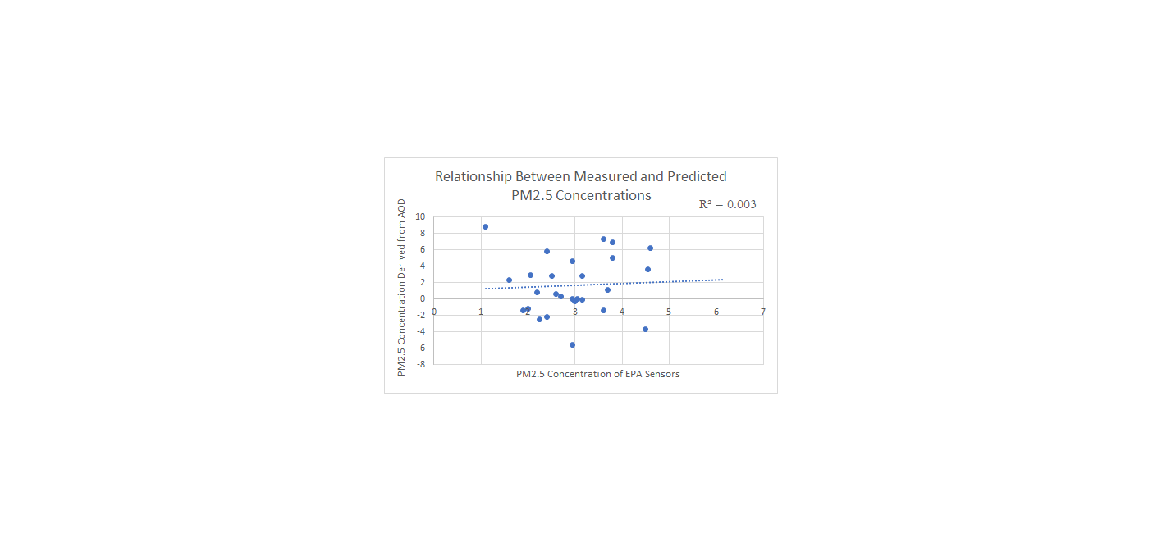

*Figure 2*. Scatterplot displaying relationship between monthly averaged PM2.5 concentrations derived from Aqua and Terra MODIS (MAIAC) data versus concentration of EPA Sensors at selected stations. The results are for June 2018.

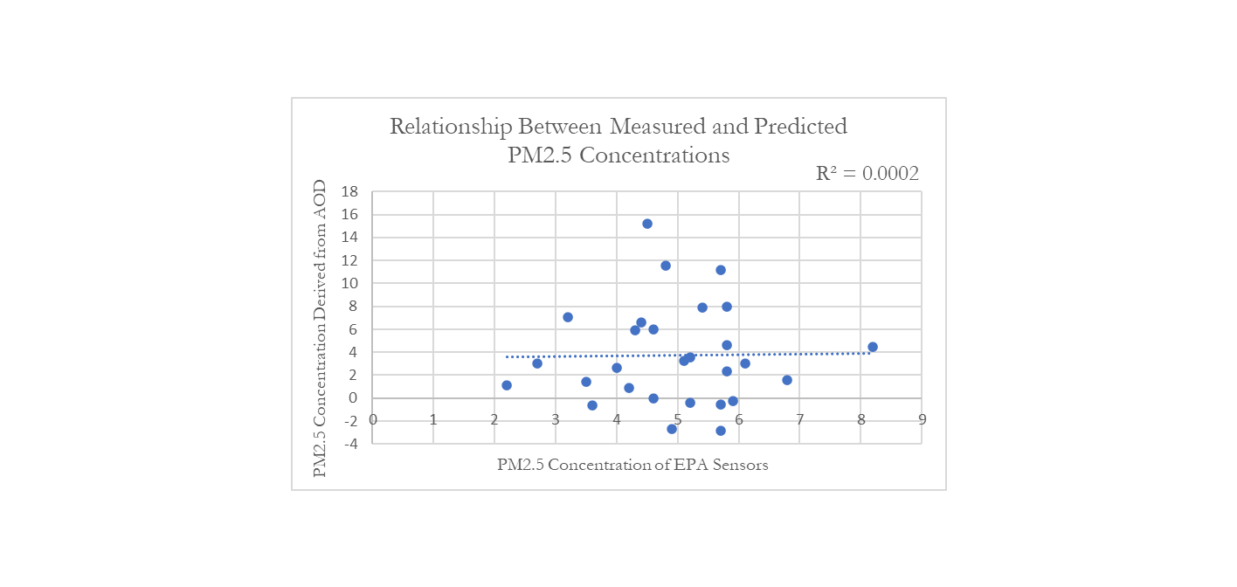

*Figure 3*. Scatterplot displaying relationship between monthly averaged PM2.5 concentrations derived from Aqua and Terra MODIS (MAIAC) data versus concentration of EPA Sensors at selected stations. The results are for July 2018.

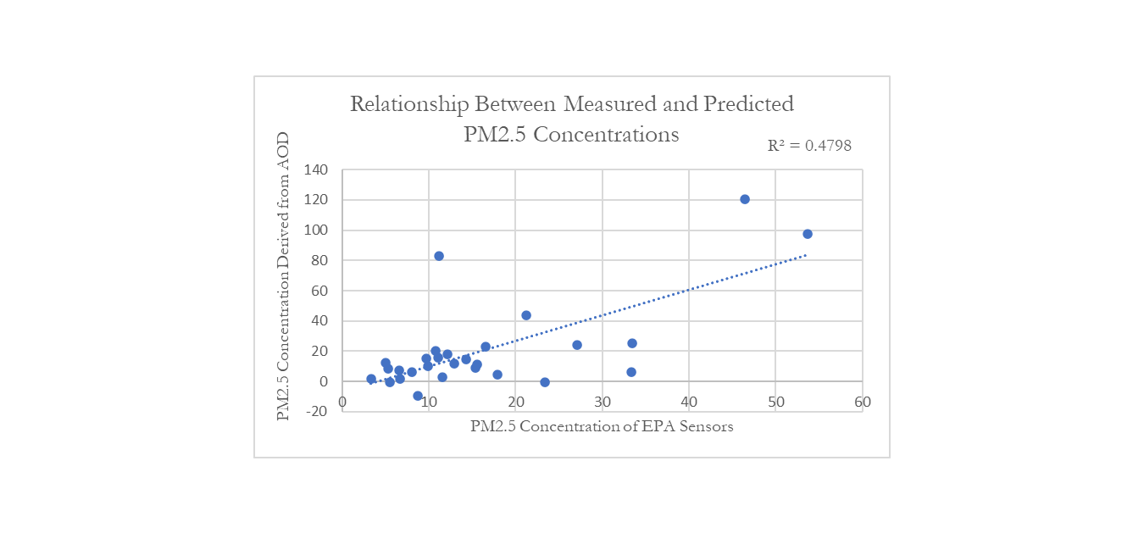

*Figure 4*. Scatterplot displaying relationship between monthly averaged PM2.5 concentrations derived from Aqua and Terra MODIS (MAIAC) data versus concentration of EPA Sensors at selected stations. The results are for August 2018.

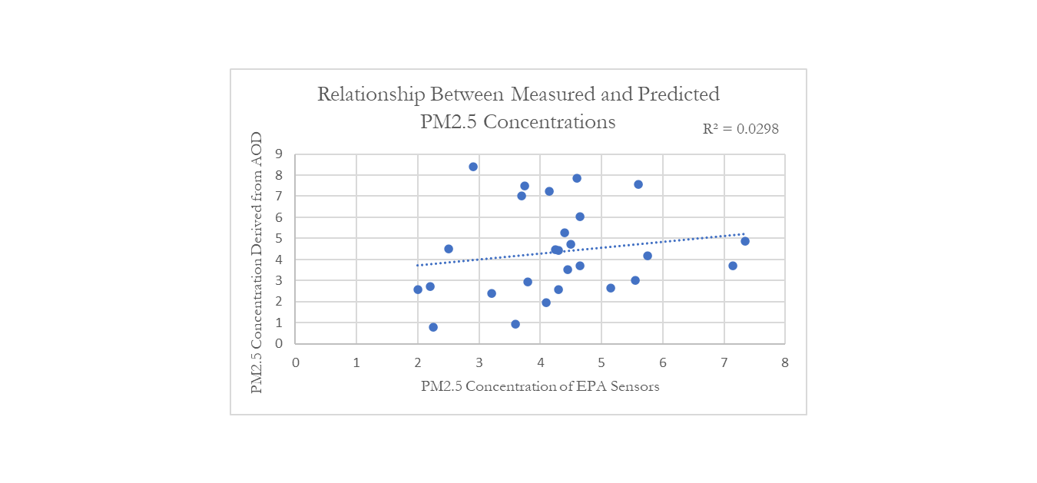

*Figure 5*. Scatterplot displaying relationship between monthly averaged PM2.5 concentrations derived from Aqua and Terra MODIS (MAIAC) data versus concentration of EPA Sensors at selected stations. The results are for September 2018.

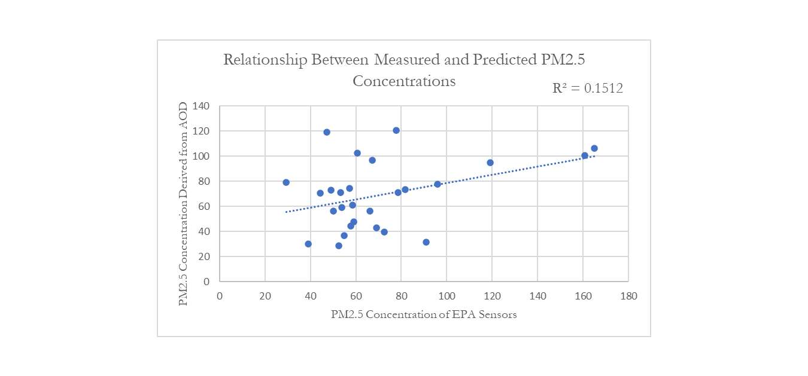

*Figure 6*. Scatterplot displaying relationship between daily PM2.5 concentrations derived from Aqua and Terra MODIS (MAIAC) data versus concentration of EPA Sensors at selected stations. The results are for August 14, 2018.

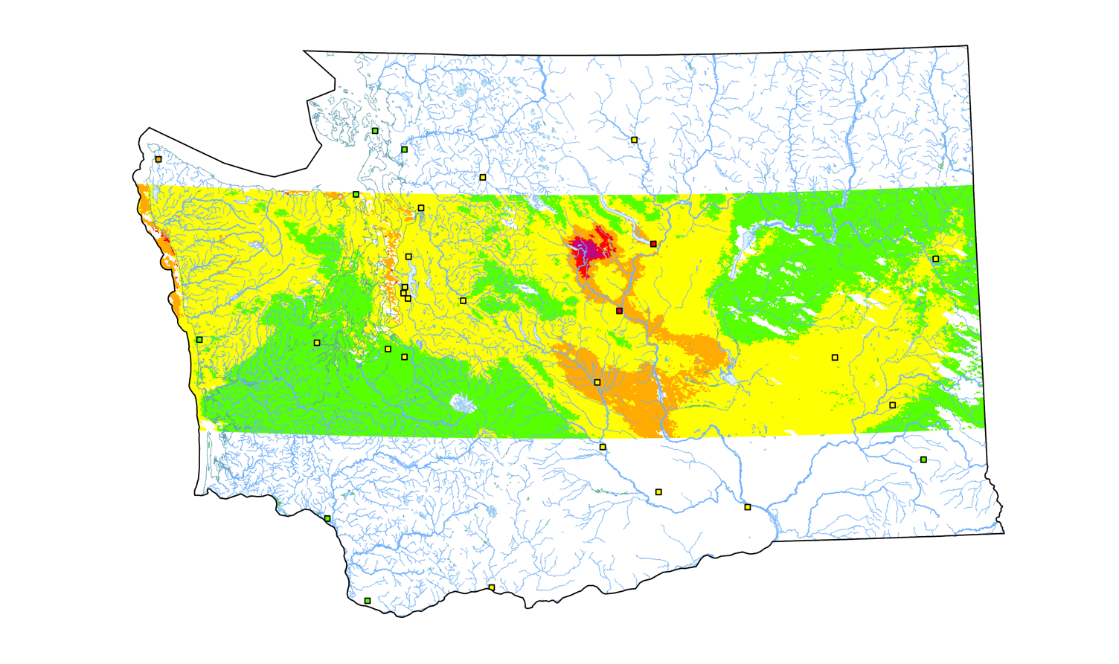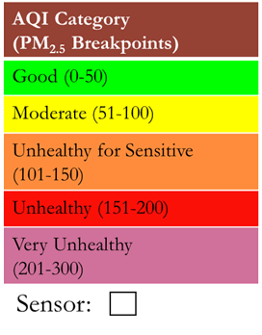

0 60 120 Kilometers

N

*Figure 7.* Map of Washington State displaying Aqua and Terra MODIS (MAIAC) predicted PM2.5 data and EPA sensor data points for August 14, 2018.

The team worked to validate TROPOMI data in the same method as PM2.5 to ensure that the data were as accurate as possible. However, TROPOMI data were limited for the dates the team chose to validate, and the team was ultimately unable to confirm the accuracy of the TROPOMI data. The network of on-the-ground sensors for pollutants aside from PM2.5 is limited as well, which made it more difficult for the team to perform TROPOMI validations. The TROPOMI data is still included in the team’s Air Pollutant Identification Tool (AirPIT) along with the predicted PM2.5 data. Despite low r-squared values and limited data availability for validation, the data displayed by the tool will provide the PSCAA with useful information on pollutant gradients and trends in their region.

***4.2 Future Work***

Identifying areas at risk of wildfires in the Pacific Northwest would further aid the PSCAA and other Pacific Northwest organizations in their air quality work since wildfires in the region contribute significantly to particulate matter concentrations in the atmosphere. A NASA and NOAA joint venture called Fire Influence on Regional to Global Environments Experiment – Air Quality (FIREX – AQ) investigates natural and prescribed fires and could be helpful with assessing the accuracy of satellite detections (Murphy, 2020).

In 2017, the Ozone Water-Land Environmental Transition Study (OWLETS) used Light Detection and Ranging (LiDAR) to examine ozone in the Chesapeake Bay air-shed (Aknan, 2019). In 2018, OWLETS-2 provided a follow-on study to better understand the behavior of ozone and related trace gases across the water-land transition zone in the upper portion of the Chesapeake Bay (Aknan, 2019). Because of the similar geography and patterns of nitrogen dioxide emissions caused by cargo ships shared by the Bay and the Sound, it would be useful to incorporate the OWLETS missions’ findings in future studies of air quality in the Puget Sound.

Two NASA satellites aiming to advance air quality monitoring, the Multi-Angle Imager for Aerosols (MAIA) and Tropospheric Emissions: Monitoring Pollution (TEMPO), are set to launch in the early 2020s. MAIA’s primary objective is to determine the relative toxicity of various particulate matter components and to assess the effects of particle size and composition on adverse birth outcomes, cardiovascular and respiratory disease, and premature death at 1-km spatial resolution (Liu & Diner, 2017). TEMPO will obtain data of air pollutants with higher spatial and temporal resolution than is currently available (Aknan, 2019). Both MAIA and TEMPO data could be incorporated here to improve the spatial and temporal resolution of the work in this study.

Gupta and Christopher (2009) and Hu et al (2013) found that including meteorological and land-use variables in models using satellite data to assess air quality significantly improves model accuracy. Including variables such as boundary layer height, relative humidity, air temperature, and wind speed in the relationship between AOD and PM2.5 established in the team’s GEE tool would improve the accuracy of the tool. Including further wind data to display the dispersion of air pollutants, rather than only their most recently recorded locations and concentrations, would make it possible for the PSCAA to better track the movement of air pollutants during poor air quality events.

# 5. Conclusions

MAIAC provides high-quality, high-resolution aerosol data which is useful for air quality studies utilizing remote sensing. In contrast, Level 3 TROPOMI data does not cover the entire state of Washington, which leads to significant gaps in available data for remote sensing air quality studies; combined with a limited on-the-ground air sensor network, these limitations curtail the information that researchers can glean from TROPOMI data. Finally, the two-variable statistical method is viable for estimating PM2.5 concentrations from satellite-derived AOD, but it is not as accurate as a multi-variable or modeling method. Although the results of this project were limited, the PSCAA will be able to incorporate them into their decision-making processes.

# 6. Acknowledgments

* Dr. Robert Griffin (University of Alabama in Huntsville)
* Dr. Jeffrey Luvall (NASA Marshall Space Flight Center)
* Dr. Mohammad Al-Hamdan (NASA Marshall Space Flight Center)
* Dr. Mike Newchurch (University of Alabama in Huntsville)
* Erik Saganić (Puget Sound Clean Air Agency)
* Joel Creswell (Puget Sound Clean Air Agency)
* Phil Swartzendruber (Puget Sound Clean Air Agency)
* A. R. Williams (NASA DEVELOP)
* Helen Baldwin (NASA SERVIR)
* Christine Evans (University of Alabama in Huntsville)
* Madison Murphy (Optimal GEO)
* Tim Mayer (NASA SERVIR)
* Dr. Manil Maskey (NASA Marshall Space Flight Center)
* Dr. Sundar Christopher (University of Alabama in Huntsville)

This material contains modified Copernicus Sentinel data (2018-2019), processed by ESA.

Any opinions, findings, and conclusions or recommendations expressed in this material are those of the author(s) and do not necessarily reflect the views of the National Aeronautics and Space Administration.

This material is based upon work supported by NASA through contract NNL16AA05C.

# 7. Glossary

**Aerosols** – suspended semi-solid particles in the atmosphere

**AOD** – aerosol optical depth; a measurement of the quantity of light removed from a beam by aerosol particles

**AQI** – Air Quality Index

**Black carbon** – emissions from diesel engines as a result of incomplete combustion

**CH4** – methane

**Clean Air Act** – federal legislation implemented in 1970 to improve national air quality

**CO –** carbon monoxide

**Earth observations** – Satellites and sensors that collect information about the Earth’s physical, chemical, and biological systems over space and time

**EPA** – Environmental Protection Agency

**ESA** – European Space Agency

**GEE** – Google Earth Engine

**Inversion event** – an atmospheric phenomenon where warmer air gets trapped at the surface due to colder air above it

**LiDAR** – Light Detection and Ranging

**MAIAC** – Multi-Angle Implementation of Atmospheric Correction algorithm

**MODIS** – MODerate Resolution Imaging Spectroradiometer

**NAAQS** – National Ambient Air Quality Standards

**NO2 –** nitrogen dioxide

**NOAA** – National Oceanic and Atmospheric Administration

**O3** – ozone

**PM2.5** – particulate matter with a diameter equal to or less than 2.5 µm

**PSCAA** – Puget Sound Clean Air Agency

**SO2** – sulfur dioxide

**TROPOMI** – Tropospheric Monitoring Instrument

# 8. References

Aknan, A. (2019, May 31). NASA Airborne Science Data for Atmospheric Composition. Retrieved from https://www-air.larc.nasa.gov/missions/owlets/index.html

Anenberg, S.C., Achakulwisut, P., Brauer, M. et al. (2019). Particulate matter-attributable mortality and relationships with carbon dioxide in 250 urban areas worldwide. *Scientific Reports* 9,11552. https://doi.org/10.1038/s41598-019-48057-9

Copernicus Sentinel Data [2018-2019]. Retrieved from Google Earth Engine [3 March 2020], processed by ESA.

Fotheringham, A. S., Charlton, M. E., & Brunsdon, C. (1998). Geographically Weighted Regression: A Natural Evolution of the Expansion Method for Spatial Data Analysis. *Environment and Planning A: Economy and Space, 30*(11), 1905–1927. https://doi.org/10.1068/a301905

Jacobs, E. T., Burgess, J. L., & Abbott, M. B. (2018, April). The Donora Smog Revisited: 70 Years After the Event That Inspired the Clean Air Act. Retrieved from https://www.ncbi.nlm.nih.gov/pmc/articles/PMC5922205/

Johnston, F. H., Henderson, S. B., Chen, Y., Randerson, J. T., Marlier, M., Defries, R. S., Kinney, P., Bowman D. M., & Brauer, M. (2012, May). Estimated global mortality attributable to smoke from landscape fires. Retrieved from https://www.ncbi.nlm.nih.gov/pubmed/22456494

Hu, X., Waller, L. A., Al-Hamdan, M. Z., Crosson, W. L., Estes, M. G., Estes, S. M., Quattrochi, D. A., Sarnat, J. A., & Liu, Y. (2013). Estimating ground-level PM2.5 concentrations in the southeastern U.S. using geographically weighted regression. *Environmental Research, 121*, 1-10. http://dx.doi.org/10.1016/j.envres.2012.11.003.

Hu, X., Waller, L. A., Lyapustin, A., Wang, Y., Al-Hamdan, M. Z., Crosson, W. L., Estes, M. G., Estes, S. M., Quattrochi, D. A., Puttaswamy, S. J., & Liu, Y. (2014). Estimating ground-level PM2.5 concentrations in the Southeastern United States using MAIAC AOD retrievals and a two-stage model. *Remote Sensing of Environment, 140*, 220-232. http://dx.doi.org/10.1016/j.rse.2013.08.032.

Kennedy, I. M. (2007, January). The health effects of combustion-generated aerosols. Retrieved from https://www.sciencedirect.com/science/article/pii/S1540748906003798

Kira, O. [Oz Kira]. (2016, July 7). *How can I convert the unit from molecules/cm2 to ppm?* [Online forum post]. ResearchGate. https://www.researchgate.net/post/How_can_I_convert_the_unit_from_molecules_cm2_to_ppm

Liu, J., Mauzerall, D. L., & Horowitz, L. W. (2009, May 28). Evaluating inter-continental transport of fine aerosols:(2) Global health impact. Retrieved from https://www.sciencedirect.com/science/article/pii/S1352231009004610

Liu, Y., & Diner, D. J. (2017). Multi-Angle Imager for Aerosols: A Satellite Investigation to Benefit Public Health. *Public Health Reports, 132*(1), 14–17. Retrieved from https://www.jpl.nasa.gov/missions/web/MAIA_Liu&Diner_PublicHealthReports.pdf

Lyapustin, A., Wang, Y. (2018). *MCD19A2 MODIS/Terra+Aqua Land Aerosol Optical Depth Daily L2G Global 1km SIN Grid V006* [Data set]. NASA EOSDIS Land Processes DAAC. Accessed 2020-03-03 from https://doi.org/10.5067/MODIS/MCD19A2.006

Lyapustin, A., & Wang, Y. (2018, June). 1MODIS Multi-Angle Implementation of Atmospheric Correction (MAIAC) Data User’s Guide. Retrieved from https://lpdaac.usgs.gov/documents/110/MCD19_User_Guide_V6.pdf.

Mass, C. (2018, August 15). Seattle's Worst 24h Air Quality on Record. Retrieved February 3, 2020, from https://cliffmass.blogspot.com/2018/08/seattles-worst-24h-air-quality-on-record.html

Murphy, C. (Ed.). (2020, February 18). FIREX-AQ. Retrieved March 3, 2020, from https://espo.nasa.gov/firex-aq/content/FIREX-AQ

Puget Sound Clean Air Agency. (2014). *Strategic Plan 2014-2020 Clean Healthy Air for Everyone, Everywhere, All the Time.* Retrieved February 6, 2020, from www.pscleanair.gov/DocumentCenter.

Puget Sound Clean Air Agency. (n.d. a). *Air Quality Sensors*. Retrieved on March 3, 2020 from https://wa-pugetsoundcleanair.civicplus.com/539/Air-Quality-Sensors.

Puget Sound Clean Air Agency. (n.d. b). *Air Quality Network Map.* Retrieved on March 3, 2020 from https://secure.pscleanair.org/AirQuality/NetworkMap.

Ross, K., Chmiel, J. F., & Ferkol, T. (2012, November). The Impact of the Clean Air Act. Retrieved from https://www.jpeds.com/article/S0022-3476(12)00752-4/abstract

Schaap, M., Apituley, A., Timmermans, R. M. A., Koelemeijer, R. B. A., & de Leeuw, G. (2009). Exploring the relation between aerosol optical depth and PM2.5 at Cabauw, the Netherlands. *Atmospheric Chemistry and Physics, 9*, 909-925. https://doi.org/10.5194/acp-9-909-2009, 2009.

van Donkelaar, A., Martin, R. V., Brauer, M., Kahn, R., Levy, R., Verduzco, C., & Villeneuve, P. J. (2010). Global estimates of ambient fine particulate matter concentrations from satellite-based aerosol optical depth: development and application. *Environmental health perspectives, 118*(6), 847–855. https://doi.org/10.1289/ehp.0901623

# 9. Appendices

***Appendix A***

Table A1.

*EPA Air Quality Index Values*

|  |  |  |  |  |  |  |
| --- | --- | --- | --- | --- | --- | --- |
| **Levels of Health Concern** | **AQI Values** | **PM2.5 Concentration Ranges**  **(µg / m3)** | **NO2 Concentration Ranges**  **(µg / m3)** | **CO Concentration Ranges**  **(µg / m3)** | **Ozone Concentration Ranges**  **(µg / m3)** | **SO2 Concentration Ranges**  **(µg / m3)** |
| Good | 0 to 50 | 0 to 12 | 0 to 53 | 0 to 4.4 | 0 to 0.054 | N/A |
| Moderate | 51 to 100 | 12.1 to 35.4 | 54 to 100 | 4.5 to 9.4 | 0.055 to 0.07 | N/A |
| Unhealthy for Sensitive Groups | 101 to 150 | 35.5 to 55.4 | 101 to 360 | 9.5 to 12.4 | 0.071 to 0.085 | N/A |
| Unhealthy | 151 to 200 | 55.5 to 150.4 | 361 to 649 | 12.5 to 15.4 | 0.086 to 0.105 | N/A |
| Very Unhealthy | 201 to 300 | 150.5 to 250.4 | 650 to 1249 | 15.5 to 30.4 | 0.106 to 0.2 | 305 to 604 |
| Hazardous | 301 to 500 | 250.5+ | 1250+ | 30.5+ | 0.21+ | 605+ |

(Environmental Protection Agency, n.d.)

