**NASA DEVELOP National Program**



NASA Marshall Space Flight Center

*Summer 2017*

Rwanda Ecological Forecasting

Utilizing NASA Earth Observations to Classify Wetland Extent in Rwanda in Support of United Nations Sustainable Development Goals

**Technical Report**

Final Draft – August 10, 2017

Nicholas McVey (Project Lead)

Jennifer Gelmis

Dashiell Cruz

Julia Bayer

Dr. Jeffrey Luvall, NASA Marshall Space Flight Center (Science Advisor)

Dr. Robert Griffin, University of Alabama in Huntsville (Science Advisor)

Emily Adams, NASA SERVIR Science Coordination Office (Science Advisor)

Leigh Sinclair, University of Alabama in Huntsville/Information Technology and Systems Center (Mentor)

# 1. Abstract

Balancing the demands of economic development and environmental protection is a challenge which requires policy-makers to be well informed about the extent and value of key natural ecosystems. Wetlands have long been known to regulate hydrological processes, reduce erosion and flooding, safeguard local biodiversity, mitigate climate change, and contribute to food security. Nonetheless, due to the threat of increasing population pressure, east African wetlands face significant reduction if a concerted effort to identify, map, and protect these areas is not rapidly undertaken. To advance the wetland conservation efforts of the Rwanda Environmental Management Authority (REMA) and the UN’s Sustainable Development Goals (SDG), a time series and land change extent map were generated to provide a baseline inventory of Rwandan wetlands and pinpoint critical areas that should be targeted for enhanced research and protection. Wetlands were identified by a supervised maximum likelihood classification conducted in Google Earth Engine API using Landsat 5 Thematic Mapper (TM) and Landsat 8 Operational Land Imager (OLI) data. The TerrSet Land Change Modeler software was used to generate a forecast of the land changes predicted to occur by the year 2030. These predictive models will optimize REMA’s conservation efforts of wetlands, and provide future wetlands researchers with a replicable methodology that can be used to continue monitoring global wetland extent.

**Keywords**

Landsat 5, Landsat 8, wetland, Rwanda, classification, TerrSet

# 2. Introduction

* 1. ***Background Information***

Wetlands provide many important environmental and economic services. In addition to providing a habitat to thousands of mammal, reptile, and plant species, wetlands offset global warming through carbon sequestration, purify water through breakdown of harmful pollutants, protect surrounding infrastructure after floods, and contribute to local food security (Amsler et. al, 2015). As the research body surrounding wetlands continues to grow, so does the heightened need to protect these valuable areas from the urbanization and industrial growth which threatens their extent on a global scale. Increasing land changes in the East African nation of Rwanda has caused severe wetland degradation, and the subsequent consequences of declining ecosystem productivity have enticed the government to establish sweeping policy changes to reverse years of environmental mismanagement (Byers et al, 2014).

Although Rwanda is a small country, it has one of the highest population densities and growth projections of East African nations (African Economic Outlook, 2016). The economy of Rwanda is largely agrarian, and thus critically dependent upon the vitality of its natural resources. Unfortunately, the majority of wetland degradation stems not from industrial growth, but from farmers who are forced to drain swamps for subsistence farming purposes. According to a national wetland inventory conducted in 2008, 53% of wetlands had been converted for agricultural use, especially for rice cultivation (Byers et. al 2014). Past policies implemented by REMA have attempted to reduce soil erosion into rivers by establishing farming boundaries around waterways and preventing the drainage of wetlands, but these mandates have been difficult to enforce and thus largely ineffective (Byers, et al 2014). The population pressures have directly caused severe soil erosion, reduced soil productivity, mass deforestation, and loss of biodiversity (Byers et al, 2014). Officials with REMA have recognized the potential for wetlands to mitigate these problems, and have made conservation efforts a top national priority. In 2013 the Rwandan Ministry of Natural Resources released a five-year strategic plan to develop the country’s economy while preserving environmental integrity. In addition to promoting eco-tourism, the government has plans to restore wetlands which have been repurposed for agricultural use or degraded to the point of low-productivity (Rwanda, 2013). Rwanda is currently involved in a collaborative, multi-national effort to reestablish eco-services and conserve biodiversity through identification, protection, and enhancement of wetland range. For this project, the Rwandan Ecological Forecasting team at Marshall Space Flight Center (MSFC) used NASA’s Earth Observations to help policy-makers at the REMA to achieve their conservation goals.

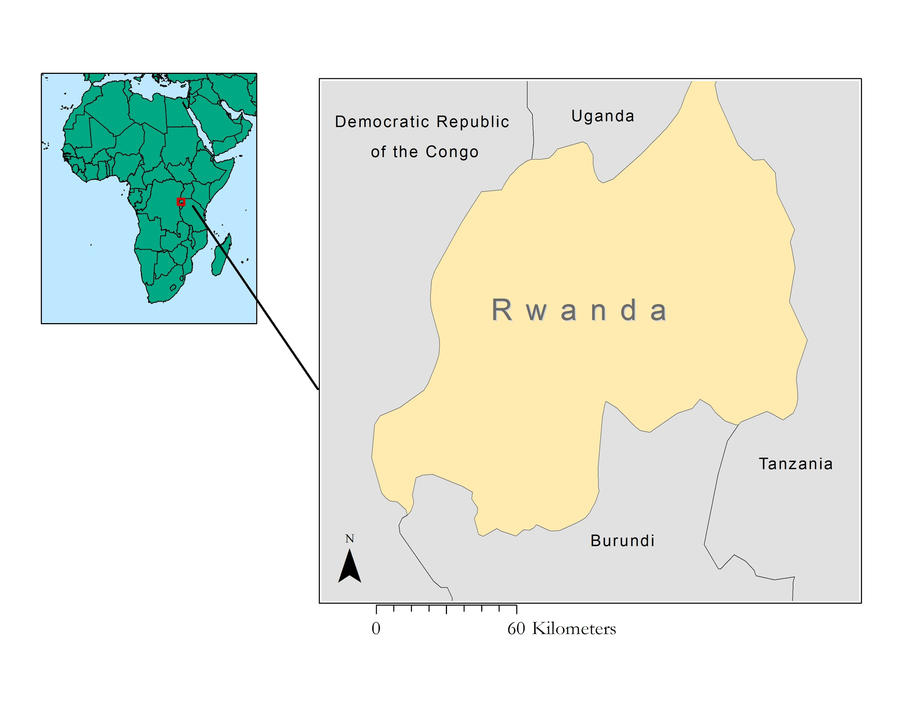

*Figure 1.* Project study area. Rwanda.

***2.2 Project Partners & Objectives***

This project utilized Google Earth Engine and TerrSet Land Change Modeler to generate a Wetland Extent Time Series, a Wetland Change Map, and a Wetland Prediction Map. Landsat Series imagery spanning from 2007-2016 was used to identify, map, and generate a model to forecast land changes until the year 2030. These maps will be used by REMA officials to propose effective environmental legislation and to enhance protective efforts to wetlands which are most likely to be negatively affected until the year 2030.

REMA is a non-sectorial organization dedicated to passing legislation in accordance to the United Nations SDGs. The SDGs are a part of an intergovernmental agenda which seeks to preserve ecosystems and prevent land degradation in developing countries. REMA is working to achieve these goals in conjunction with international partners from the Regional Centre for Mapping of Resources for Development (RCMRD), NASA SERVIR, and the Group on Earth Observations Wetlands (GEO-Wetlands) Initiative—a collaboration between the University of Bonn, the Ramsar Convention Secretariat, and Wetlands International. This effort will provide REMA with access to advanced satellite technology and field experts to aid decision makers in creating an effective policy which balances environmental protection and steady economic growth.

This project addressed NASA’s Applied Sciences Program national application area of Ecological Forecasting by utilizing Earth Observations and modeling programs to analyze and predict the changes which affect the health and range of wetlands in Rwanda. The deliverables generated from this study help policy-makers within the key stakeholder partner REMA to create more effective environmental protection strategies. The work will add comprehensive, replicable data to the growing body of literature that seeks to optimize wetland protection through remote sensing classification strategies.

# 3. Methodology

***3.1 Data Acquisition***

Landsat 5 Thematic Mapper (TM) and Landsat 8 Operational Land Imager (OLI) orthorectified with Fmask (cloud mask) data was imported through the Google Earth Engine API for analysis. These image collections contained all imagery taken by the respective satellite and sensor at a spatial resolution of 30 meters over a 16-day cycle.

***3.2 Data Processing***

Datasets imported into Google Earth Engine were already corrected by the United States Geological Survey (USGS) to Top of Atmosphere (TOA) values (including the Fmask band for cloud masking). The TOA correction is a common correction method for Landsat imagery as the radiance values recorded by the satellite are converted to digital numbers (DN) in either 8-bit or 16-bit sizes depending on the satellite. This conversion was necessary as DN does not account for changes in the radiance measured. For example, annual changes in the angle of the sun’s rays as they strike the earth will change the measured radiation depending on the time of year, while the same target object will have the same ratio of light reaching and being reflected from itself at all times (USGS, 2016; Ray, 2002). The TOA correction converts these DNs back to a reflectance value, specifically a ratio of measured reflectance to the total energy output. This process is a simple linear scaling method applied to the DNs downloaded with the Landsat scenes, which is shown in Equation 1.

*ρλ'* = *MρQcal* + *Aρ* (1)

where *ρλ'* is TOA planetary reflectance, *Mρ* is band-specific multiplicative rescaling factor from the metadata, *Qcal* is quantized and calibrated DN values, and *Aρ* is band-specific additive rescaling factor from the metadata (USGS, 2016).

The imagery was then cloud masked using the Fmask band included on Google Earth Engine with Landsat 5 and Landsat 8. Utilizing the Google Earth Engine API, a simple code removed areas with a cloud score less than two in the image collection, creating a collection of cloud free images. With this methodology, some images contained missing cell data for scenes in the collection if they had clouds in the same location throughout the year.

Rwanda was isolated in ArcMap 10.4 and later exported to Google Earth to clip the Landsat data to the study area.

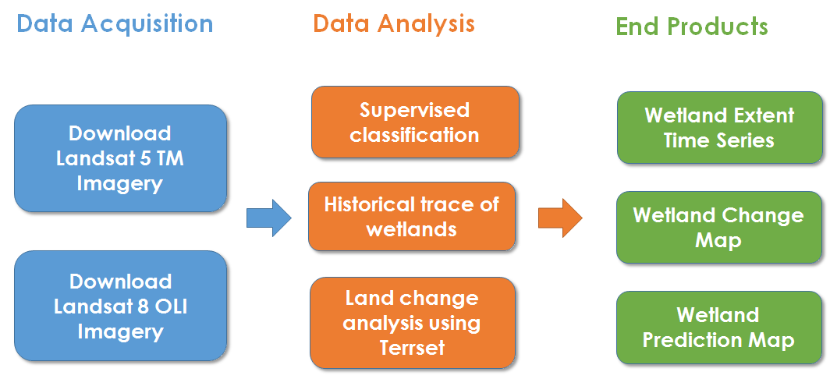

*Figure 2.* Methodology for Data Processing

***3.3 Data Analysis***

Over the course of the 10-year study period from 2007 to 2017, there were several years that had Landsat data recorded with minimal cloud cover. With seven years of data available--2008, 2010, 2011, 2013, 2014, 2015 and 2016- each image was classified using a supervised classification technique with the following five classifiers: land, water, urban, forest, and wetlands. Each classifier contained 150 samples for a total of 750 samples of signatures for the maximum likelihood classification method. This process was conducted independently for both the eastern and western sections of Rwanda.

With the 7 years of classified data, a change analysis was conducted year to year using the TerrSet Land Change Modeler. The change analysis illustrated an average change rate of the conversion of areas classified as wetland to other land use types, such as urban or open land, agricultural fields included. This product served as a historical trace of wetlands.

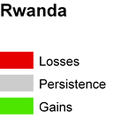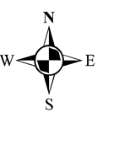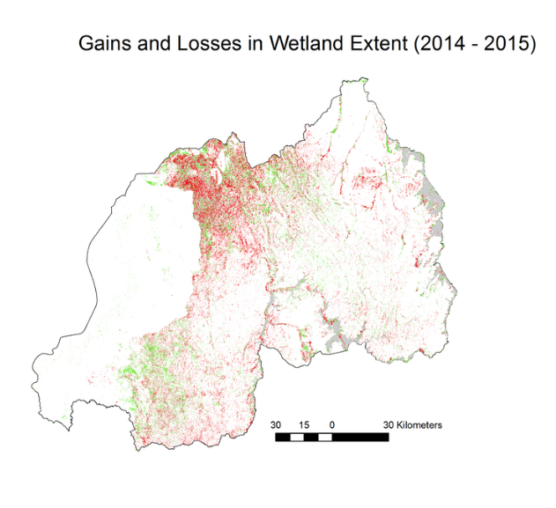

*Figure 3.* Change Map for Rwanda 2014-2015

For the second component of the project, the Terrset Land Change Modeler was used to forecast wetland extent through the year 2030. This year was selected because it coincides with the year that the SDGs are aimed to be completed by participating nations. This forecast identified areas of wetlands that may be facing reductions in the near future and allowed for the detection of areas facing significant reductions or areas changing the most rapidly. In order to create this map, the wetland extent time series from 2015-2016 was used to represent the current land cover. To create a forecast, variables relating to development such as distance to roads and population density were used as influencing factors in the model. This allowed the creation of a forecast model that predicts land cover, in particular wetland extent, for the year 2030. This implied the areas of wetlands facing the most critical impact and the areas that are most in need of aid and protection. This product will benefit the project partners as it provides useful information about where aid and resources will be the most effective at protecting current wetlands and reducing wetland degradation.

# 4. Results & Discussion

***4.1 Analysis of Results***

The most prominent change in wetlands was observed in Eastern Rwanda between the years 2014 and 2016. In the images from these years there is a clear decline in wetlands especially in the north, inland near Lake Burrea and Lake Ruhondo. The most common conversion of these wetlands was to land/cropland and urban use. There was also a detected loss of forest, highlighting a potential escalation of deforestation. Landsat 5 and 8 both have temporal resolutions of 16-day return periods, and has a return period of 10 days. This can make it challenging to obtain a cloud free image for a given area in a study period. Clouds pose an obvious problem to the approach in that when the area is covered in clouds, no conclusions can be drawn about the surface underneath. In the maps of the western part of the country, the results were more inconclusive and challenging to yield results from. This is for a variety of reasons: there are significantly less wetlands in the western part of the country and as many of these are seasonal it was difficult to obtain data. In addition, during the wetlands peak, the rainy season, they were frequently cloud covered.

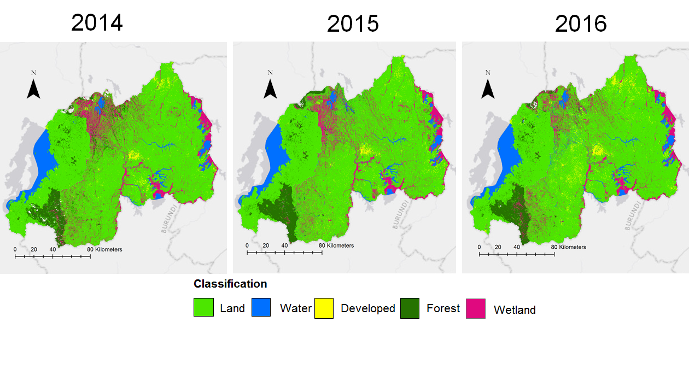

**Classification**

Land

Water

Developed

Forest

Wetland

*Figure 4.* Wetland Extent Time Series. Eastern Rwanda 2014-2016

The Terrset Land Change Modeler predicts for the year 2030 a further decrease in wetlands in Rwanda. The model predicted a net loss in wetland extent with only 15,000 hectares remaining from the 200,000 hectares in 2016. These losses are predicted to be in much of the same places where there is a current decline in wetlands: the eastern edge of the country and inland near Lake Burrea and Lake Ruhondo. The Terrset model shows an increase in urbanization in many areas where there are currently wetlands. Much of this is due to the population growth rate, currently 2.4%, which will lead to a dramatic increase in population by 2030.

******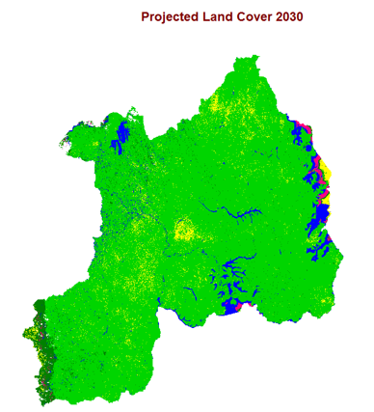

**Classification**

**Land**

**Water**

**Developed**

**Forest**

**Wetland**

*Figure 5.* Projection for Wetland Extent in 2030

Another potential source of error was the variability of signatures. In fact, the variability between the two halves of the country is so different that the analysis had to be done separately. What looks like wetlands and what appears as open land can vary immensely depending on time of year, location, and timing of recent weather events. The projection model itself is an uncertainty, as any model would be, influencing factors could act much quicker or significantly slower than what is anticipated. Population growth in Rwanda is high, but recently has shown trends of slowing, demands for food security will likely continue to be significant throughout the near future, which does provide a threat to wetlands as they are ample sources for agricultural production. Increase aid and scientific discovery in the region could also slow the degradation of wetlands and policy is enacted protecting this valuable resources.

***4.2 Future Work***

The focus of future research on this topic could be to create a more accurate set of maps. The focus could be on using Synthetic Aperture Radar (SAR) as a more accurate tool for this kind of analysis. During this project, one of the major challenges was working with the Landsat series with the cloud cover found over the wetlands especially during the wet season. However, with SAR this will be mitigated as the SAR sensor can acquire data without regard to cloud cover. Another potential for future work would be to improve upon the classification method. This project used a supervised classification to create a base for the forecast model and extent maps. This could be improved upon in further terms by using a Digital Elevation Model (DEM) and incorporation decision trees that make use of this data. The classification was purely visual and having quantitative data available would allow for the creation of more accurate classifiers.

# 5. Conclusions

Primary results illustrated a noticeable trend for declining wetland extent throughout Rwanda over the course of the past 3 years, specifically in the years 2014 to 2016 in Eastern Rwanda. This is enlightening as the most common influencing factor in the degradation of wetlands was a conversion to the “land” classification. It is important to note that our “land” classification includes agricultural fields and uses. This likely points to the conversion from wetlands to agricultural use as one of the primary factors for the reduction in wetland extent. As mentioned in the community concerns section, wetlands have been converted to agriculture use to help mitigate food insecurity in Rwanda. Interestingly, we also noticed a decreasing trend in the “forest” classification as well. The noticeable decline could also point to increased deforestation efforts as the population continues to grow. The conversion from “forest” to “land” was the second most common influencing factor. Ultimately we validated the use of remote sensing as valuable methodologies for the preliminary study of wetland extent in Rwanda, but we do have cautions. Significant cloud cover during times most critical for the study is extremely detrimental. Ideally SAR would be utilized to eliminate the biggest barrier to the most accurate study of the region. High-accuracy maps and forecast models are important because they enable Rwandan policy-makers to generate effective legislation to protect their wetlands from further degradation, and thus ensure that future populations have the opportunity to enjoy the rich biodiversity and valuable eco-services that wetlands provide.

# 6. Acknowledgments

A special thank you is extended to all the people who have contributed to the project and helped create impactful results to the benefit of our project partners and the local Rwandan agencies.

* Dr. Jeffrey Luvall – NASA Marshall Space Flight Center at NSSTC
* Dr. Robert Griffin – University of Alabama in Huntsville
* Emily Adams – NASA SERVIR Science Coordination Office
* Leigh Sinclair – University of Alabama in Huntsville/Information Technology and Systems Center
* Maggi Klug – NASA DEVELOP MSFC Center Lead
* Adrian Strauch – GEO Wetlands Initiative
* Konrad Hentze – GEO Wetlands Initative
* Jonas Franke – GEO Wetlands Initative
* Robinson Mugo – Regional Centre for Resource Mapping and Development
* Marie-Laetita Busokeye – Rwanda Environmental Management Authority

Any opinions, findings, and conclusions or recommendations expressed in this material are those of the author(s) and do not necessarily reflect the views of the National Aeronautics and Space Administration.

This material is based upon work supported by NASA through contract NNL16AA05C and cooperative agreement NNX14AB60A.

# 7. Glossary

**DN** – Digital Number; amount of radiance measured by the satellite

**Earth Observations** – Satellites and sensors that collect information about the Earth’s physical, chemical, and biological systems over space and time

**OLI** – The Operational Land Imager instrument aboard the Landsat 8 satellite that collects high resolution data in the visible, near infrared, and shortwave infrared portions of the energy spectrum

**MODIS** – MODerate resolution Imaging Spectroradiometer

**RCMRD** – Regional Centre for Mapping Resource for Development

**REMA** – Rwanda Environment Management Authority

**SDG** – Sustainable Development Goals

**TIRS** – Thermal Infrared Sensor

**TM** – Thematic Mapper

**USGS** – United States Geological Survey

# 8. References

"African Economic Outlook 2016 (Summary in English)." African Economic Outlook African Economic Outlook 2016 (2016): 23-40. Web.

Amsler, E., M. Schmidt, and G. Menz. "Definitions and Mapping of East African Wetlands: A Review." Remote Sensing 7.5 (2015): n. pag. Research Gate. Web. 14 June 2017.

Byers, B., S. Nsengimana, E. Hakizimana, E. Rutagaramama, L. Granier, and P. Deeks. "Rwanda Environmental Threats and Opportunities Assessments." USAID (2014): n. pag. Web.

Erwin, K. L. (2008). Wetlands and global climate change: the role of wetland restoration in a changing

world. *Wetlands Ecology and Management, 17*(1), 71-84. doi:10.1007/s11273-008-9119-1

Ozesmi, S., & Bauer, M. (2002). Satellite remote sensing of wetlands. Wetlands Ecology and Management, 10(5), 381-402. Retrieved July 11, 2017.

Ray, Terrill W. (2002). Radiance vs. Reflectance. Retrieved February 14, 2017, from http://www.harrisgeospatial.com/Company/PressRoom/TabId/190/ArtMID/786/ArticleID/3377/3377.aspx/

“REMA (2009): Rwanda State of Environment and Outlook Report” Rwanda Environment Management

Authority P.O. Box 7436 Kigali, Rwanda

Rwanda. Ministry of Natural Resources. Five Year Strategic Plan for the Environment and Natural Resources Sector 2014-2018. N.p.: n.p., 2013. Print.

United Nations Environment Programme. (2011). Key Ecological Regions. Rwanda: From Post-Conflict

To Environmentally Sustainable Development.

US Geological Survey. (2012). Provisional Landsat TM Surface Reflectance. US Geological Survey Earth Resources Observation and Science Center. https://doi.org/10.5066/F7KD1VZ9

US Geological Survey. (2014). Provisional Landsat OLI Surface Reflectance. US Geological Survey Earth Resources Observation and Science Center. https://doi.org/10.5066/F78S4MZJ