**NASA DEVELOP National Program**



NASA Ames Research Center

*Spring 2016*

Caribbean Oceans

Detection and Monitoring of *Sargassum* Utilizing NASA Earth Observations in Response to Unprecedented Levels Observed in the Caribbean Sea

**Technical Report** 

Rough Draft – Feb 18, 2016

Jordan Ped (Project Lead)

Erica Scaduto

Emma Accorsi

Dr. Juan Torres-Pérez, Bay Area Environmental Research Institute (Science Advisor)

# **I. Abstract**

[Placeholder - do not put anything here until the final draft submission. The abstract in the project summary is where the working draft of the abstract should “live”]

**Keywords:**

Remote Sensing, Pelagic Seaweed, Floating Macroalgae, MODIS, MERIS, Ocean Color Satellites, Floating Algal Index, Maximum Chlorophyll Index

# **II. Introduction**

Caribbean nations are becoming increasingly interested in the origin and drivers of the pelagic seaweed *Sargassum*, which has inundated their shorelines in recent years and caused both economic and environmental concerns. In particular, observers have reported higher than normal levels of *Sargassum* since 2011, with levels reaching a critical high in 2015. In a survey of 21 marine researchers, 71% (15/21) agreed or highly agreed that the amount of *Sargassum* in the Caribbean in 2015 was significantly higher than in previous years, although they also reported major *Sargassum* events occurring in the previous four years (See Section IX).

At moderate levels, *Sargassum* has many important functions in marine ecosystems. Laffoley et al. (2011) write that *Sargassum* often completes its entire life cycle at sea, making it the only holopelagic seaweed in the world. The floating mats provide a critical habitat for a diverse set of species, from the highly adapted *Sargassum* Anglerfish to juvenile sea turtles. These pelagic ecosystems are also thought to be critical destinations for migratory species, such as whales and tunas, and for nutrient cycling to the ocean floor. Furthermore, beached *Sargassum* provides shelter to sea turtle hatchlings and reduces shoreline erosion (Laffoley et al., 2011).

During significant influxes, *Sargassum* detrimentally affects nearshore ecosystems and the economies of coastal communities. The large mats flood shallow bays and reefs, compressing sand and trapping sea turtles in their nests. One observer in Belize describes, “When the *Sargassum* comes...and stays there for months and starts to rot, everything dies - sea grass, crabs, conch, snail, fish, the list goes on,” and another reports “fish and crustacean kills” in the British Virgin Islands (See Section IX). Additionally, in a region where tourism is economically vital, tourists are deterred by seaweed-covered beaches and the smell of decomposing biomass. The tourist industry has faced a considerable financial burden, as many tourists have cancelled trips within these regions. Heavy machinery has been used in some locations to clear the beaches, further exacerbating the ecological problems. Although there has been a slight increase in employment by local governments for the hand-removal of *Sargassum*, this funding for the emergency removal has imposed a financial burden on both local and national governments.

Critical to the development of more sustainable management practices for *Sargassum* is an understanding of the geographic origin and cause of recent *Sargassum* inundation events. Currently, these events are poorly understood, and a majority of surveyed marine researchers identified the origin of Caribbean *Sargassum* (62%, 13/21) and the causes of 2015 *Sargassum* levels (67%, 14/21) as topics in which further research is needed (See Section IX). Thus far, three theories have been proposed regarding the origin of the large quantities of *Sargassum*. The primary “*Sargassum* system loop” theory suggests that *Sargassum* from the Sargasso Sea is carried through the Caribbean Sea in a westward trajectory, then moves upward into the Gulf of Mexico, and finally travels eastward past Florida to the Atlantic coast of the United States (Webster and Linton, 2013). Other theories suggest that Caribbean *Sargassum* is transported from the northern coast of Brazil (Gower and King, 2013) ororiginates in the Caribbean Sea. A variety of factors are debated as contributors to the problem, including ocean temperatures, ocean currents, nutrient levels, fertilizer run-off, oil spills, sewage and pollution, and global climate change.

Previous studies have supported the use of satellite remote sensing as a powerful tool for studying the problem of *Sargassum* over-proliferation. *Sargassum* is distributed over a vast area of the ocean, making it challenging to study by boat but much easier to remotely sense as it has a spectral signature that clearly distinguishes it from nearby water (Gower and King, 2011). The existing literature on using satellite imagery to detect *Sargassum* has focused predominantly on the Gulf of Mexico and the Sargasso Sea (Gower et al., 2006). Gower et al.first used MERIS to detect *Sargassum* in the Gulf in 2006. Their Maximum Chlorophyll Index (MCI) successfully identified large pelagic mats from satellite imagery. Alternative detection methods have since improved the ability to identify *Sargassum* using remote sensing. The Floating Algal Index (FAI) (Hu, 2009) can be applied to both Landsat and MODIS imagery, and offers a reliable alternative to MCI. The current limitations in *Sargassum* detection lie in the spatial resolution of the sensors (Hu, 2015), and the interference of clouds and sun glint, which obscure the clarity of spectral signatures captured by satellite sensors (Chen and Zhang, 2015). In this project, the team built upon these detection methods and applied them to the Caribbean Sea and its surrounding nations.

Within the NASA Applied Sciences Oceans Application Area, this project addressed important questions on the origin and cause of *Sargassum* inundation events by using NASA Earth observations and the European Space Agency Envisat to (1) detect *Sargassum* in the Caribbean Sea, (2) model drivers of its growth, and (3) identify the origin of the influx.The project utilized data spanning from 1980 to March 2016 in order to understand historical and current patterns of *Sargassum* movement and growth in the Caribbean. This information was then incorporated into a predictive model for inundation events. The findings from the project are intended for use by Caribbean nations interested in the origin of the phenomenon and by the Mexican government to inform policy on the effective timing of coastal *Sargassum* removal.

In order to assess the extent of the problem and build upon existing work, the DEVELOP team at the NASA Ames Research Center was fortunate to partner with a number of researchers and organizations (See Section VI).

**III. Methodology**

**3.1 Data Acquisition**

To better detect *Sargassum* in the Caribbean, Terra Moderate Resolution Imaging Spectroradiometer (MODIS), and Medium Resolution Imaging Spectrometer (MERIS) Envisat imagery were obtained through FTP servers. Level 1 imagery for the Terra MODIS sensor from 2003 until March 2016 was accessed and downloaded from the Atmosphere Archive and Distribution System (LAADS) web. Envisat MERIS imagery from 2002 to 2012 was accessed and downloaded via the European Space Agency (ESA) Merci Product Query. To understand *Sargassum* distribution and growth, oceanic variables were obtained from the NOAA Coastwatch Environmental Research Division’s Data Access Program (ERDDAP). The primary oceanic variables that were used in this project include: colored dissolved organic matter (CDOM), photosynthetically available radiation (PAR), chlorophyll-a (CHLA), primary productivity, wind stress, wind diffusivity, sea surface salinity, and sea surface temperature (SST).

**3.2 Data Processing**

After data acquisition, the MODIS imagery were rescaled from a 500 m resolution to a 250 m resolution and clipped to the extent of the Caribbean Sea. To reduce atmospheric noise, cloud masking was performed using Matlab’s Fmask function. Data processing of the MODIS imagery was automated using a Python script that calculates the Floating Algal Index (FAI) and Normalized Difference Vegetation Index (NDVI) to detect the presence of *Sargassum*. In addition, the MCI was calculated for the MERIS imagery. A threshold value was determined for both indices that best represented *Sargassum* detection. The correlation between *Sargassum* presence and oceanic variables was tested via Terrset Earth Trends Modeler (or spatial regression).

**3.3 Data Analysis**

To better visualize the temporal distribution and pattern of *Sargassum* presence with the oceanic variables, monthly values were averaged and then plotted from 2002 until March 2016 via matplotlib, a Python library.

# **IV. Results & Discussion**

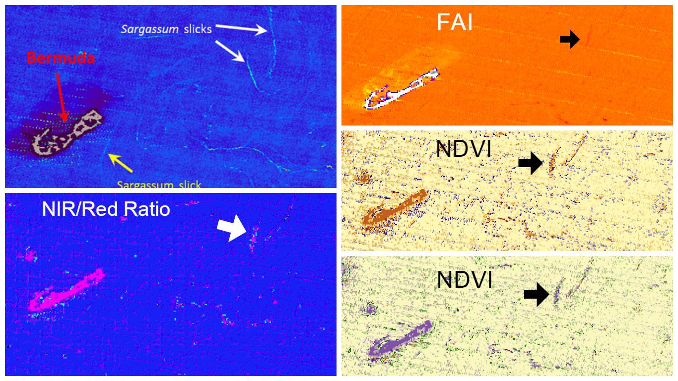

**Figure 1. Detection of *Sargassum* slicks using Terra MODIS near Bermuda in December 2009 using various indices including: NIR/Red Band Ratio, NDVI, and FAI. Compared with the Hu detection method (upper-left), all three detection methods were able to detect *Sargassum* strips at the same, or similar, locations. However, the NDVI (lower-right) exhibited more spectral noise than the FAI (upper-right). The detection of *Sargassum* using NIR/Red Band Ratio (lower-left) was less distinct than the other two methods.**

**V. Conclusions**

Final conclusions. Word count: 200-600 (~a page).

# **VI. Acknowledgments**

We would like to thank Chippie Kislik and Victoria Ly for their support and supervision for the project as the management team at NASA DEVELOP—Ames Research Center. Their connections with other researchers in the field and mentorship made the project possible.

We would also like to thank our partners:

-Dr. Sergio Cerdeira, Marine Monitoring Coordinator at Comisión Nacional para el Conocimiento y Uso de la Biodiversidad (CONABIO)

-Dr. Laura Carillo, Oceanographer at El Colegio de la Frontera Sur (ECOSUR)

-Dr. Eduardo Santamaria del Angel, Professor and Researcher at Universidad Autónoma de Baja California (UABC)

-Dr. Roy A. Armstrong, Bio-optical Oceanography Laboratory University of Puerto Rico, Department of Marine Sciences

-Dr. Porfirio Alvarez Torres, Executive Secretary at Consorcio de Instituciones de Investigación Marina del Golfo de México y del Caribe (CiiMarGoMC)

-Dr. Francisco Arreguin, researcher at Centro Interdisciplinario de Ciencias Marinas: Instituto Politécnico Nacional (CICIMAR-IPN)

Any opinions, findings, and conclusions or recommendations expressed in this material are those of the author(s) and do not necessarily reflect the views of the National Aeronautics and Space Administration.

This material is based upon work supported by NASA through contract NNL11AA00B and cooperative agreement NNX14AB60A.

# **VII. References**

Chen, S., & Zhang, T. (2015). An improved cloud masking algorithm for MODIS ocean colour data processing. *Remote Sensing Letters*, *6*(3), 218–227.

Dierssen, H. M., Chlus, A., & Russell, B. (2015). Hyperspectral discrimination of floating mats of seagrass wrack and the macroalgae *Sargassum* in coastal waters of Greater Florida Bay using airborne remote sensing. *Remote Sensing of Environment*, *167*, 247–258.

Gower, J., Hu, C., Borstad, G., & King, S. (2006). Ocean color satellites show extensive lines of floating *Sargassum* in the Gulf of Mexico. *IEEE Transactions on Geoscience and Remote Sensing: A Publication of the IEEE Geoscience and Remote Sensing Society*, *44*(12), 3619–3625.

Gower, J. F. R., & King, S. A. (2011). Distribution of floating *Sargassum* in the Gulf of Mexico and the Atlantic Ocean mapped using MERIS. *International Journal of Remote Sensing*, *32*(7), 1917–1929.

Gower, J., Young, E., & King, S. (2013). Satellite images suggest a new *Sargassum* source region in 2011. *Remote Sensing Letters*, *4*(8), 764–773.

Hu, C. (2009). A novel ocean color index to detect floating algae in the global oceans. *Remote Sensing of Environment*, *113*(10), 2118–2129.

Hu, C., Feng, L., Hardy, R. F., & Hochberg, E. J. (2015). Spectral and spatial requirements of remote measurements of pelagic *Sargassum* macroalgae. *Remote Sensing of Environment*, *167*, 229–246.

Laffoley, D.d’A., Roe, H.S.J., Angel, M.V., Ardron, J., Bates, N.R., Boyd, I.L., . . . Vats, V. (2011). The protection and management of the Sargasso Sea: The golden floating rainforest of the Atlantic Ocean. Summary Science and Supporting Evidence Case. *Sargasso Sea Alliance*, 44 pp.

Webster, R. K., Linton, T. (2013). Development and implementation of *Sargassum* Early Advisory System (SEAS). *Shore and Beach*, 81(3).

# **VIII. Content Innovation**

**Some options include:**

**AudioSlides**

Database Linking Tool

Data Profile

Executable Papers

Featured Author Videos

Featured Multimedia for this Article (video and podcast options)

Glossary Viewer

Inline Supplementary Material (figures, tables, computer code)

**Interactive Map Viewer**

Interactive MATLAB Figure Viewer

Interactive Plot Viewer

Nomenclature Viewer

# **IX. Appendix**

[*Sargassum* Questionaire Results]