**NASA DEVELOP National Program**



University of Georgia

*Spring 2014*

Great Smoky Mountains Ecological Forecasting

Utilizing NASA Earth Observations to Monitor Long Term

Hemlock Decline Caused by Invasive Hemlock Woolly Adelgid

in Great Smoky Mountains National Park

**Technical Report Final Draft**

April 4, 2014

Jiaying He, University of Georgia (Project Lead)

Steven Weaver (University of Georgia), weavers@warnell.uga.edu

Corbin Kling (University of Georgia), kling.cory@gmail.com

Zennure Ucar (University of Georgia), zennucar@uga.edu

Marguerite Madden, PhD, University of Georgia (Science Advisor)

**I. Abstract**

Eastern hemlock (*Tsuga canadensis L*.) plays an ecologically vital role within the Great Smoky Mountains (GRSM) by providing a unique habitat for many species of flora and fauna, which thrive in cool, shaded aquatic or terrestrial landscapes. The hemlocks are currently facing an infestation of the non-native Hemlock Woolly Adelgid (HWA, *Adelges tsugae*), which feed on and kill the trees. Discovered in the park circa 2002, the HWA have rapidly spread through the forest due to a lack of native predators. This project was designed to map the extent of spatiotemporal hemlock defoliation using NASA Earth Observing System (EOS) data and compare the results to those of ForWarn. Landsat 5 Thematic Mapper (TM) images, acquired during leaf-off conditions from 2000 to 2011, was used to create yearly Normalized Difference Vegetation Index (NDVI) and Enhanced Vegetation Index (EVI) maps to measure the greenness and to evaluate the health condition of eastern hemlock in GRSM. Change detection and trend analysis methods, including image differencing and Theil-Sen slope estimator were utilized to identify spatiotemporal defoliation extent across years using NDVI and EVI data. The annual forest defoliation time series maps of GRSM were created and compared with the results from ForWarn to assess the performance of mapping forest decline using datasets of varying resolution. The methodology and results from this project will support the forest management and insect control policies for the GRSM, and provide a reference to evaluate the results of the ForWarn system.

**Keywords**

NASA EOS, Remote Sensing, Hemlock Woolly Adelgid, Hemlock Defoliation, NDVI, EVI, Change Detection, Trend Analysis, ForWarn

**II. Introduction**

**Background Information**

Eastern hemlock plays an important role within forest and riparian ecosystems by providing a unique micro-habitat for wildlife. Its dense foliage maintains cool microclimates critical to the survival of cold water species, and stabilizes hydrologic budgets (Stadler et al., 2005). The hemlock population has declined across the eastern United States since the 1950s due to the hemlock woolly adelgid (HWA), a small invasive insect native to Japan (Orwig et al., 2002). HWA can kill hemlock trees within three to five years by attaching themselves to needle junctions and feeding off the tree’s nutrients. HWA was first reported in the Great Smoky Mountains National Park (GRSM) in 2002. Consequently, the GRSM has experienced a significant loss of hemlock canopy and reduced ecosystem stability during the past decade (Allen & Madden, 2009). Since HWA has no natural predators within the GRSM, it has become necessary for researchers and forest managers to intervene and control the spread of HWA (Bonneau et al., 1999).

Monitoring forest disturbance has always been a major concern in forest management due to the spatiotemporal limitations of on-site monitoring (Rullan-Silva et al., 2013). In many cases, forest defoliation caused by insect infestation is a major cause of forest disturbance and has deep negative impacts on the health condition of ecosystems (Czerwinski, 2012). Due to the development of remote sensing technologies during the past decades, the spread of invasive insects in forest areas have been investigated at larger spatiotemporal scales. Commonly, fixed and rotary wing aircraft have been used to collect aerial imagery to identify areas of hemlock decline (PA DCNR, Pontius et al., 2005). However, these methods are expensive, reducing their temporal resolution capabilities. The development of satellite sensors, especially NASA Earth Observing System (EOS) has allowed for improved measurements of forest extent and change at various spatial and temporal scales (Boyd & Danson, 2005). The United States Department of Agriculture (USDA) Forest Service utilizes the Moderate Resolution Imaging Spectroradiometer (MODIS) derived Normalized Difference Vegetation Index (NDVI) to monitor and assess forest disturbances across the United States of America(Spruce et al., 2011). Compared to MODIS, Landsat data has a moderate temporal (16 days) resolution and higher spatial resolutions (30m), which are adequate to extract detailed vegetation indices information for change detection studies (Cohen & Goward, 2004; Meigs et al., 2011). Maingi and Luhn (2005) used Landsat 5 Thematic Mapper (TM) and Landsat 7 Enhanced Thematic Mapper Plus (ETM+) images acquired in 1995 and 2002, respectively, to evaluate change detection techniques for mapping conifer damage caused by the Southern Pine beetle. Eschtruth et al. (2006) utilized Landsat 5 TM images to track forest response to HWA over 9-year study period. The ForWarn system generated by the United States Geological Survey (USGS) is a remote sensing database that monitors forest health nationwide. The results of ForWarn were compared against the results of this study to check for accuracy between the two different change detection methods.

**Project Objectives**

This project aimed to utilize remote sensing imagery from NASA EOS satellites, including Landsat 5, to analyze the spatial pattern and temporal change of eastern hemlock defoliation caused by HWA within the GRSM. The results and methodology will assist the forest management and decision making for project partners. Specifically, this project created annual NDVI and EVI maps to evaluate the greenness and health condition of forest in GRSM. Subsequently, change detection and trend analysis methods were used to detect the defoliation and regrowth condition of hemlock forest. Finally, the results were compared to those of ForWarn using statistical analyses.

**Study Area**

The Great Smoky Mountains National Park, located in the southern portion of the greater Appalachian Mountains, is one of the most biodiverse regions in the world and contains the largest virgin forest landmass in the United States (Jenkins, 2007). With elevation ranging between 267 to 2,025 meters within the park, it is believed heterogeneous geology and topographic features affect the distribution of the various species (Whittaker, 1956). The park contains at least 1,300 native plant species, 1,570 species of flowering plants, and 4,000 species of non-flowering plants (Walker, 1991; Kaiser, 1999). The study area is shown in Appendix Figure 1.

**National Application Addressed**

The national application area addressed in this project was Ecological Forecasting. The study provided methodologies and science based prediction tools necessary to properly monitor ecosystems within the GRSM. These methods are vital for understanding the stability and growth of natural ecosystems that foster biodiversity and provide a variety of resources such as fresh water and clean air.

**Project Partners**

The two main partners for this project are employees from the Great Smoky Mountains National Park and the ForWarn system. The GRSM contact was Thomas Remaley, an ecologist and the Inventory and Monitoring Coordinator for the park. Remaley is interested in mapping the spatiotemporal defoliation of eastern hemlock and in predictive mitigation applications. Decline maps derived from this project can aid in the general understanding of defoliation conditions and suggest mitigation locations. The methodology was made available to assist in the management of eastern hemlock protection and treatment within the park.

**III. Methodology**

**Data Preparation**

As HWA was first reported within the GRSM in 2002, Landsat 5 TM images of leaf-off conditions (November to February) were collected using EarthExplorer (USGS 2014) from years 2000 to 2011. Overstory vegetation classification data, created in 1997, were provided by the Center for Geospatial Research (CGR) at the University of Georgia (UGA) to extract the hemlock distribution information within the study area. ForWarn forest change data, 1-year baseline NDVI percent change results for 2009 to 2010 and 2010 to 2011, were also collected from ForWarn Web Coverage Service (WCS).

**Hemlock Extraction**

In order to observe the spatiotemporal trend of hemlock decline from Landsat images, the boundary of the eastern hemlock was delineated. Existing overstory vegetation classification data on hemlock extent and canopy presence, obtained through CGR, was used to define two hemlock classes for this project: hemlock dominant and hemlock secondary. CGR overstory classifications were developed based on species dominance and percentage in the canopy. The hemlock dominant class is comprised of areas with > 50% hemlock in the overstory, as defined in the CGR classification, and the hemlock secondary class contains areas with 20-50% hemlock in the overstory. This resulted in the two dominance classes shown in Appendix Figure 2.

**Atmospheric Correction**

Before image processing, atmospheric correction was conducted to remove the effects of the atmosphere on the reflectance values of images taken by satellite or airborne sensors for the Landsat 5 imagery. Two commonly used atmospheric correction methods, Quick Atmosphere Correction (QUAC) and Fast Line-of-sight Atmospheric Analysis of Spectral Hypercubes (FLAASH), were explored for this study using ENVI 5.0.

QUAC is a simplified atmosphere correction tool, only using parameters contained within the data itself. FLAASH on the other hand requires input of parameters such as atmospheric model (MODTRAN4+), time of image, ground elevation, and etc. Though considering these parameters makes FLAASH more accurate in atmospheric corrections, it should be noted that QUAC corrections are usually within +/-15% of FLAASH corrections (Guo & Zeng, 2012; ENVI, 2009).

The performance of both QUAC and FLAASH methods were explored on Landsat images for model selection. The spectrum curves of different surface features, including vegetation, a water body, and a road, were compared to the actual measurement reflectance spectrum curve. However, FLAASH actually over corrected the image pixels in dark areas, such as shadows and water bodies. Due to this, QUAC was chosen for atmospheric correction in this study.

**Topographic Correction**

The signal recorded by spaceborne optical sensors, including Landsat TM, is strongly influenced by the topography in mountain areas, which will cause variation of illumination of the same surface cover slopes (Richter et al., 2009). As a result, the topographic variation will affect the accuracy of analysis conducted based on satellite images, such as land-use classification and vegetation indices calculation (Matsushita et al., 2007). In this way, the complex topography and variant elevation in GRSM makes topographic correction necessary for remote sensing study in this area.

This study used a semi-empirical correction method, C correction, to conduct topographic correction. This method can modify the image values based on the observed empirical linear correlation between radiance and the cosine of the incidence illumination angle (Teillet et al., 1982). The C correction method can be defined as:

$$L_{H}=L_{T}\frac{(cosθ_{s}+c)}{(cosθ_{i}+c)}$$

$$c=\frac{b}{m}$$

where $L_{H}$ and $L_{T}$ stands for the reflectance of an horizontal and an inclined surface. $θ_{s}$ is the sun azimuth angle and $θ_{i}$ is the incidence angle. $c$ is determined by $b$ and $m$, the regression coefficients between the illumination and the different band reflectance.

**Vegetation Indices Calculation**

To examine hemlock greenness and evaluate hemlock decline, two types of vegetation indices, the normalized difference vegetation index (NDVI) and the enhanced vegetation index (EVI), were employed in this study.

NDVI, developed in the 1970s, is one of the most common vegetation indices. It is an index of photosynthetic activity, or plant “greenness” (“Normalized Difference Vegetation Index,” n.d.). EVI is an alternative index, and it addresses various issues that can arise when using NDVI. In areas of high biomass, NDVI becomes less sensitive. EVI is much more sensitive to these changes in areas of dense vegetation. Atmospheric changes can also have an effect on NDVI values. EVI helps minimize the influence of this on index values (“Enhanced Vegetation Index,” n.d.)

Chlorophyll within live plants absorbs visible light, wavelengths of 0.4 to 0.7 µm, for use in photosynthesis, but near-infrared light, wavelengths of 0.7 – 1.1 µm, is typically reflected. NDVI takes advantage of these differences, and it is calculated by using the surface reflectance of both the red and near-infrared bands where:

$$NDVI=\frac{(NIR-RED)}{(NIR+RED)}$$

EVI also takes advantages of reflectance differences, but it includes blue reflectance along with red and near-infrared reflectance. It is calculated as:

$$EVI=G\frac{NIR-RED}{NIR+C_{1}RED-C_{2}BLUE+L}$$

where NIR, RED, and BLUE are the reflectance in the near-infrared, red, and blue bands respectively. C1 and C2 are adjustment factors for atmospheric influences. G is a gain factor, and L is a canopy background adjustment factor. The suggested values for these adjustment factors are C1 = 6, C2 = 7.5, G = 2.5, and L = 1.

Values of the NDVI can range from -1.0 to +1.0 (Chen et al., 2005). Higher NDVI values indicate a larger difference in NIR and RED reflectance or areas of higher photosynthetically-active vegetation. Low values indicate less photosynthetic activity (“Normalized Difference Vegetation Index,” n.d.). Values for EVI will range from 0.0 to 1.0 (Chen et al., 2005).

Greenness maps were created from NDVI and EVI images, and decline maps were created by comparing NDVI images from subsequent years.

**Change Detection & Trend Analysis**

Remote sensing technology can overcome the limitations of traditional methods to measure forest health issues through providing wide spectral information, multiple temporal scales, and constant spatial resolution (Hayes & Sader, 2001). Specifically, change detection and trend analysis methods using images from different time periods can effectively monitor both abrupt and gradual forest defoliation effects caused by insect infestation. In this project, two types of methods were integrated to map the hemlock defoliation condition in GRSM: image differencing and Theil-Sen slope estimator.

Image differencing is one of the most widely used change detection methods. Inter-annual NDVI images were utilized to map the yearly defoliation condition which reflect gradual and abrupt spatiotemporal changes in the forest canopy. The difference of NDVI values between an initial state and a final state was calculated to represent the change of forest canopy (Hayes & Sader, 2001). The thresholds of different change level were estimated by analyzing pixel values of different surface object pixels manually. Theil-Sen slope estimator, first reported by Theil (1992) and then revised by Sen (1968), is a method to estimate the median slope of all pair-wise iterations in the forward direction. This method calculates the linear trend at each pixel using all pairwise combinations of images in time and takes the median of all slopes to create a slope image for each of the greenness parameters (Neeti et al., 2012). In addition, NDVI trend from different hemlock areas in GRSM were also identified using a temporal profile chart.

**Comparison with ForWarn**

For the ForWarn comparison, two 1-year time spans were chosen: 2009 to 2010 and 2010 to 2011. A 1-year baseline forest change image was acquired from ForWarn for each time period. These images are the percent NDVI change comparing a year’s maximum value compositing NDVI to the previous year. The LandSat percent NDVI change images compare a single November NDVI value from a year to the previous year. These Landsat images were then resampled to match the resolution of the ForWarn images (231 m resolution). For each year, 200 sample points were randomly selected within the hemlock areas of both the ForWarn and Landsat images, 100 from the hemlock dominant areas and 100 from mixed hemlock areas. Finally, these points were used to examine any correlations between the ForWarn and LandSat change images for each year using a Pearson’s *r* correlation analysis.

**IV. Results & Discussion**

NDVI change in the whole park from 2001 to 2010 (Appendix Figure 3) shows expected decline and then increase in NDVI values. Before the onset of HWA in 2002, the 2001 images shows relative high values for NDVI across the whole park, suggesting good forest health condition. By 2004, the values for NDVI began to fall, indicating a decline in forest greenness. This is expected due to the introduction of HWA in 2002. By 2006 the NDVI had maintained a steady state of low values, and 2008 shows a big increase in NDVI values indicating regrowth in the park following the large drought in 2007 in the southeast (GRSM staff interviews). The 2010 NDVI image shows more increase in NDVI values indicating even more regrowth.

The NDVI for hemlock areas in the park show the same patterns as the whole park NDVI maps do. In 2001, before HWA’s infestation, hemlock areas showed high NDVI values. By 2004 the NDVI values had obvious decreased. After the 2007 drought (GRSM park staff interviews), the NDVI values bounced back indicating some regrowth from the hemlock areas in the 2008 and 2010 image. Another thing to take into consideration is the effort of controlling HWA that park staff have been working on since they found HWA in 2002. Since 2004, the NDVI values successively get increasing after the big drop off during the initial introduction of HWA, indicating that efforts to control HWA are somewhat effective.

Change detection methods were used to monitor forest defoliation effects from insect infestation. One method of image differencing was calculated from 2001 to 2010. The result, shown in Appendix Figure 4, showed that the trend of the hemlock decline slightly increases. In particular, results indicate decline in the east part of the park. As a second method, the median trend (Theil-Sen) was used to assess the rate of the change for each year (Appendix Figure 5). Based on the analysis, the results indicated lower slope over the time and decline in forest defoliation. In general, eastern hemlock in the western side of the park indicated increased trend over the time; however, while comparing pixel size, the trend was lower. In contrast to the west side of the park, eastern hemlock in the east side of the park had lower trend in general and higher trend for pixel size (Appendix Figure 6-7).

Mixed results were found with the Pearson’s *r* correlation analysis between the ForWarn percent NDVI change images and the Landsat percent NDVI results (Appendix Figure 8). For the 2009 to 2010 time period, *r* values indicate a weak, positive relationship between the ForWarn and Landsat images in the hemlock dominant areas (*r* = 0.256) and the mixed hemlock areas (*r* = 0.236) (Appendix Table 1). The analysis of the 2010 to 2011 period indicated a weak, negative or no relationship between the images in both the dominant (*r* = -0.152) and mixed hemlock areas (*r* = -0.173) (Appendix Table 2). These differences may be attributed to differences in atmospheric and topographic correction methods. Change detection methods may also be a factor. ForWarn uses a maximum composite value method which takes the maximum NDVI value for a set of images in a year and compares them to the previous year. The methods used in this study only took into account a single image for a year and compared it to the previous year.

**V. Conclusions**

This study served as a prime example of how NASA Earth Observations can be used to detect and analyze trends of forest change in the Ecological Forecasting application area. The VI time series maps show a general decreasing trend after 2002 and regrowth after 2006. Change detection and trend analysis results indicate a slightly increasing trend of hemlock in the west and east side of the GRSM though a strong decrease has been detected from 2004 to 2006. For specific hemlock sites, the NDVI results illustrate different change patterns in the long term. In addition, our NDVI percent change results from 2009 to 2010 show a weak, positive relationship with the ForWarn results. Additionally, the results obtained from 2010 to 2011 were found to have no significant correlation. The change patterns of the whole GRSM are not comparable for both time spans.

Though this 10-week study has detected obvious hemlock change patterns within GRSM, further work could be conducted to improve this project. In order to optimize the study results, more accurate image preprocessing work should be conducted to better correct the atmospheric and topographic impacts. Also, the reflectance values of images from each year should be carefully matched. In addition, as maximum value compositing NDVI is not available for our study, the comparison results of ForWarn and Landsat data can be improved by integrating more images and more time periods. Moreover, field data collection would be necessary for effective result validation.

**VI. Acknowledgements**

We would like thank Dr. Marguerite Madden (University of Georgia), Dr. Sergio Bernardes (University of Georgia), and Steve Padgett-Vasquez (University of Georgia) advisors of this project, for their guidance and support. We would also like to thank past contributors Xiyu Li (Clark University), Shuvankar Ghosh (University of Georgia), Auryn Baruch (University of Georgia), and Ning Chen (University of Georgia) for their technical assistance and efforts during Phase I of this research. Special thanks to Steve Padgett-Vasquez, mentor and former team lead, and Caren Michelle Remillard, Centre Lead for NASA Develop at UGA for their support and inputs. Lastly, we would like to thank the Great Smoky Mountains National Park Service for their excellent interview and advice.

**VII. References**

Allen, H., & Madden, M. (2009). Geovisualization of forest dynamics: Hemlock woolly adelgid damage in Great Smoky Mountains National Park. Vasa. Retrieved from http://65.61.12.151/summer2009/studentpapers/allen_hunter.pdf

Bonneau, L., Shields, K., & Civco, D. (1999). Using satellite images to classify and analyze the health of hemlock forests infested by the hemlock woolly adelgid. Biological Invasions, 1(2-3), 255–267. Retrieved from http://link.springer.com/article/10.1023/A:1010021629127

Boyd, D. S., & Danson, F. M. (2005). Satellite remote sensing of forest resources: three decades of research development. Progress in Physical Geography, 29(1), 1–26. doi:10.1191/0309133305pp432ra

Chen, X., Vierling, L., & Deering, D. (2005). A simple and effective radiometric correction method to improve landscape change detection across sensors and across time. Remote Sensing of Environment, 98(2005), 63-79.

Cohen, W., & Goward, S. (2004). Landsat’s role in ecological applications of remote sensing. Bioscience. Retrieved from http://www.bioone.org/doi/abs/10.1641/0006-3568(2004)054%5B0535:LRIEAO%5D2.0.CO%3B2

Czerwinski, C. (2012). Forest Change Detection and Mapping in Gatineau Park, Québec, 1987 to 2010 using Landsat imagery. Retrieved from http://http-server.carleton.ca/~dking/papers/Czerwinski Thesis_2012.pdf

EarthExplorer. United States Geologic Survey, 26 Mar. 2014. http://earthexplorer.usgs.gov/. 03 Apr. 2014.

Enhanced Vegetation Index. (n.d.). In The Landscape Toolbox. Retrieved from http://wiki.landscapetoolbox.org/doku.php/remote_sensing_methods:enhanced_vegetation_index

ENVI. (2009). Atmospheric Correction Module: QUAC and FLAASH User’s Guide. (20AC47DOC). Eschtruth, A. K., Cleavitt, N. L., Battles, J. J., Evans, R. A., & Fahey, T. J. (2006). Vegetation dynamics in declining eastern hemlock stands: 9 years of forest response to hemlock woolly adelgid infestation. Canadian Journal of Forest Research, 36(6), 1435-1450.

Guo, Y., & Zeng, F. (2012). Atmospheric Correction Comparison of SPOT-5 Image Based on Model FLAASH and Model QUAC. International Achives of the Photogrammetry, Remote Sensing and Spatial Information Sciences, XXXIX (September), 7–11.

Hargrove, W., Spruce, J., Norman, S., Christie, W., Kumar, J., & Hoffman, F. (2013). ForWarn: A cross-cutting forest resource management and decision-support system. [slideshow]. Retreived from: http://www.geobabble.org/~hnw/first/fs_lsecol/

Hayes, D. J., & Sader, S. A. (2001). Comparison of change-detection techniques for monitoring tropical forest clearing and vegetation regrowth in a time series. Photogrammetric engineering and remote sensing, 67(9), 1067-1075.

Jenkins, M. A. (2007). Vegetation Communities of Great Smoky Mountains National Park. Southeastern Naturalist, 6(sp2), 35–56. doi:10.1656/1528-7092(2007)6[35:VCOGSM]2.0.CO;2

Kaiser, J. (1999). Great Smokies species census underway. Science, 284(5421), 1747-1748.

Landsat 5 TM data courtesy of the U.S. Geological Survey

Maingi, J., & Luhn, W. (2005). Mapping insect-induced pine mortality in the Daniel Boone National Forest, Kentucky using Landsat TM and ETM+ data. GIScience & Remote Sensing, (3), 224–250. Retrieved from http://bellwether.metapress.com/index/nv7218639g31m242.pdf

Matsushita, B., Yang, W., Chen, J., Onda, Y., & Qiu, G. (2007). Sensitivity of the enhanced vegetation index (EVI) and normalized difference vegetation index (NDVI) to topographic effects: a case study in high-density cypress forest. Sensors, 7(11), 2636-2651.

Meigs, G. W., Kennedy, R. E., & Cohen, W. B. (2011). A Landsat time series approach to characterize bark beetle and defoliator impacts on tree mortality and surface fuels in conifer forests. Remote Sensing of Environment, 115(12), 3707–3718. doi:10.1016/j.rse.2011.09.009

Neeti, N. N., Rogan, J. J., Christman, Z. Z., Eastman, J. R., Millones, M. M., Schneider, L. L., & ... Ghimire, B. B. (2012). Mapping seasonal trends in vegetation using AVHRR-NDVI time series in the Yucatán peninsula, Mexico. Remote Sensing Letters, 3(5), 433-442. doi:10.1080/01431161.2011.616238

Normalized Difference Vegetation Index. (n.d.). In The Landscape Toolbox. Retrieved from http://wiki.landscapetoolbox.org/doku.php/remote_sensing_methods:normalized_difference_vegetation_index

Orwig, D., Foster, D., & Mausel, D. (2002). Landscape patterns of hemlock decline in New England due to the introduced hemlock woolly adelgid. Journal of Biogeography, 1475–1487. Retrieved from http://onlinelibrary.wiley.com/doi/10.1046/j.1365-2699.2002.00765.x/full

Pontius, J., Hallett, R., & Martin, M. (2005). Using AVIRIS to assess hemlock abundance and early decline in the Catskills, New York. Remote Sensing of Environment, 97(2), 163–173. doi:10.1016/j.rse.2005.04.011

Richter, R., Kellenberger, T., & Kaufmann, H. (2009). Comparison of topographic correction methods. Remote Sensing, 1(3), 184-196.

Rullan-Silva, C. D., Olthoff, A. E., Delgado de la Mata, J. A., & Pajares-Alonso, J. A. (2013). Remote monitoring of forest insect defoliation. A review. Forest Systems, 22(3), 377-391. doi:10.5424/fs/2013223-04417

Sen, P. K. (1968). Estimates of the regression coefficient based on Kendall's tau. Journal of the American Statistical Association, 63(324), 1379-1389.

Spruce, J. P., Sader, S., Ryan, R. E., Smoot, J., Kuper, P., Ross, K., Prados, D., Russell, J., Gasser, G., McKellip, R., & Hargrove, W. (2011). Assessment of MODIS NDVI time series data products for detecting forest defoliation by gypsy moth outbreaks. Remote Sensing of Environment, 115(2), 427–437. doi:10.1016/j.rse.2010.09.013

Stadler, B., Müller, T., Orwig, D., & Cobb, R. (2005). Hemlock woolly adelgid in New England forests: Canopy impacts transforming ecosystem processes and landscapes. Ecosystems, 8(3), 233–247. doi:10.1007/s10021-003-0092-5

Teillet, P. M., Guindon, B., & Goodenough, D. G. (1982). On the slope-aspect correction of multispectral scanner data. Canadian Journal of Remote Sensing, 8(2), 84-106.

Theil, H. (1992). A rank-invariant method of linear and polynomial regression analysis. In Henri Theil’s Contributions to Economics and Econometrics (pp. 345-381). Springer Netherlands.

Walker, S. L. (1991). Great Smoky Mountains: The Splendor of the Southern Appalachians. Camelback Design Group.

Whittaker, R. (1956). Vegetation of the great smoky mountains. Ecological Monographs, 26(1), 1–80. Retrieved from http://www.esajournals.org/doi/abs/10.2307/1943577

**APPENDIX**

**Figures**

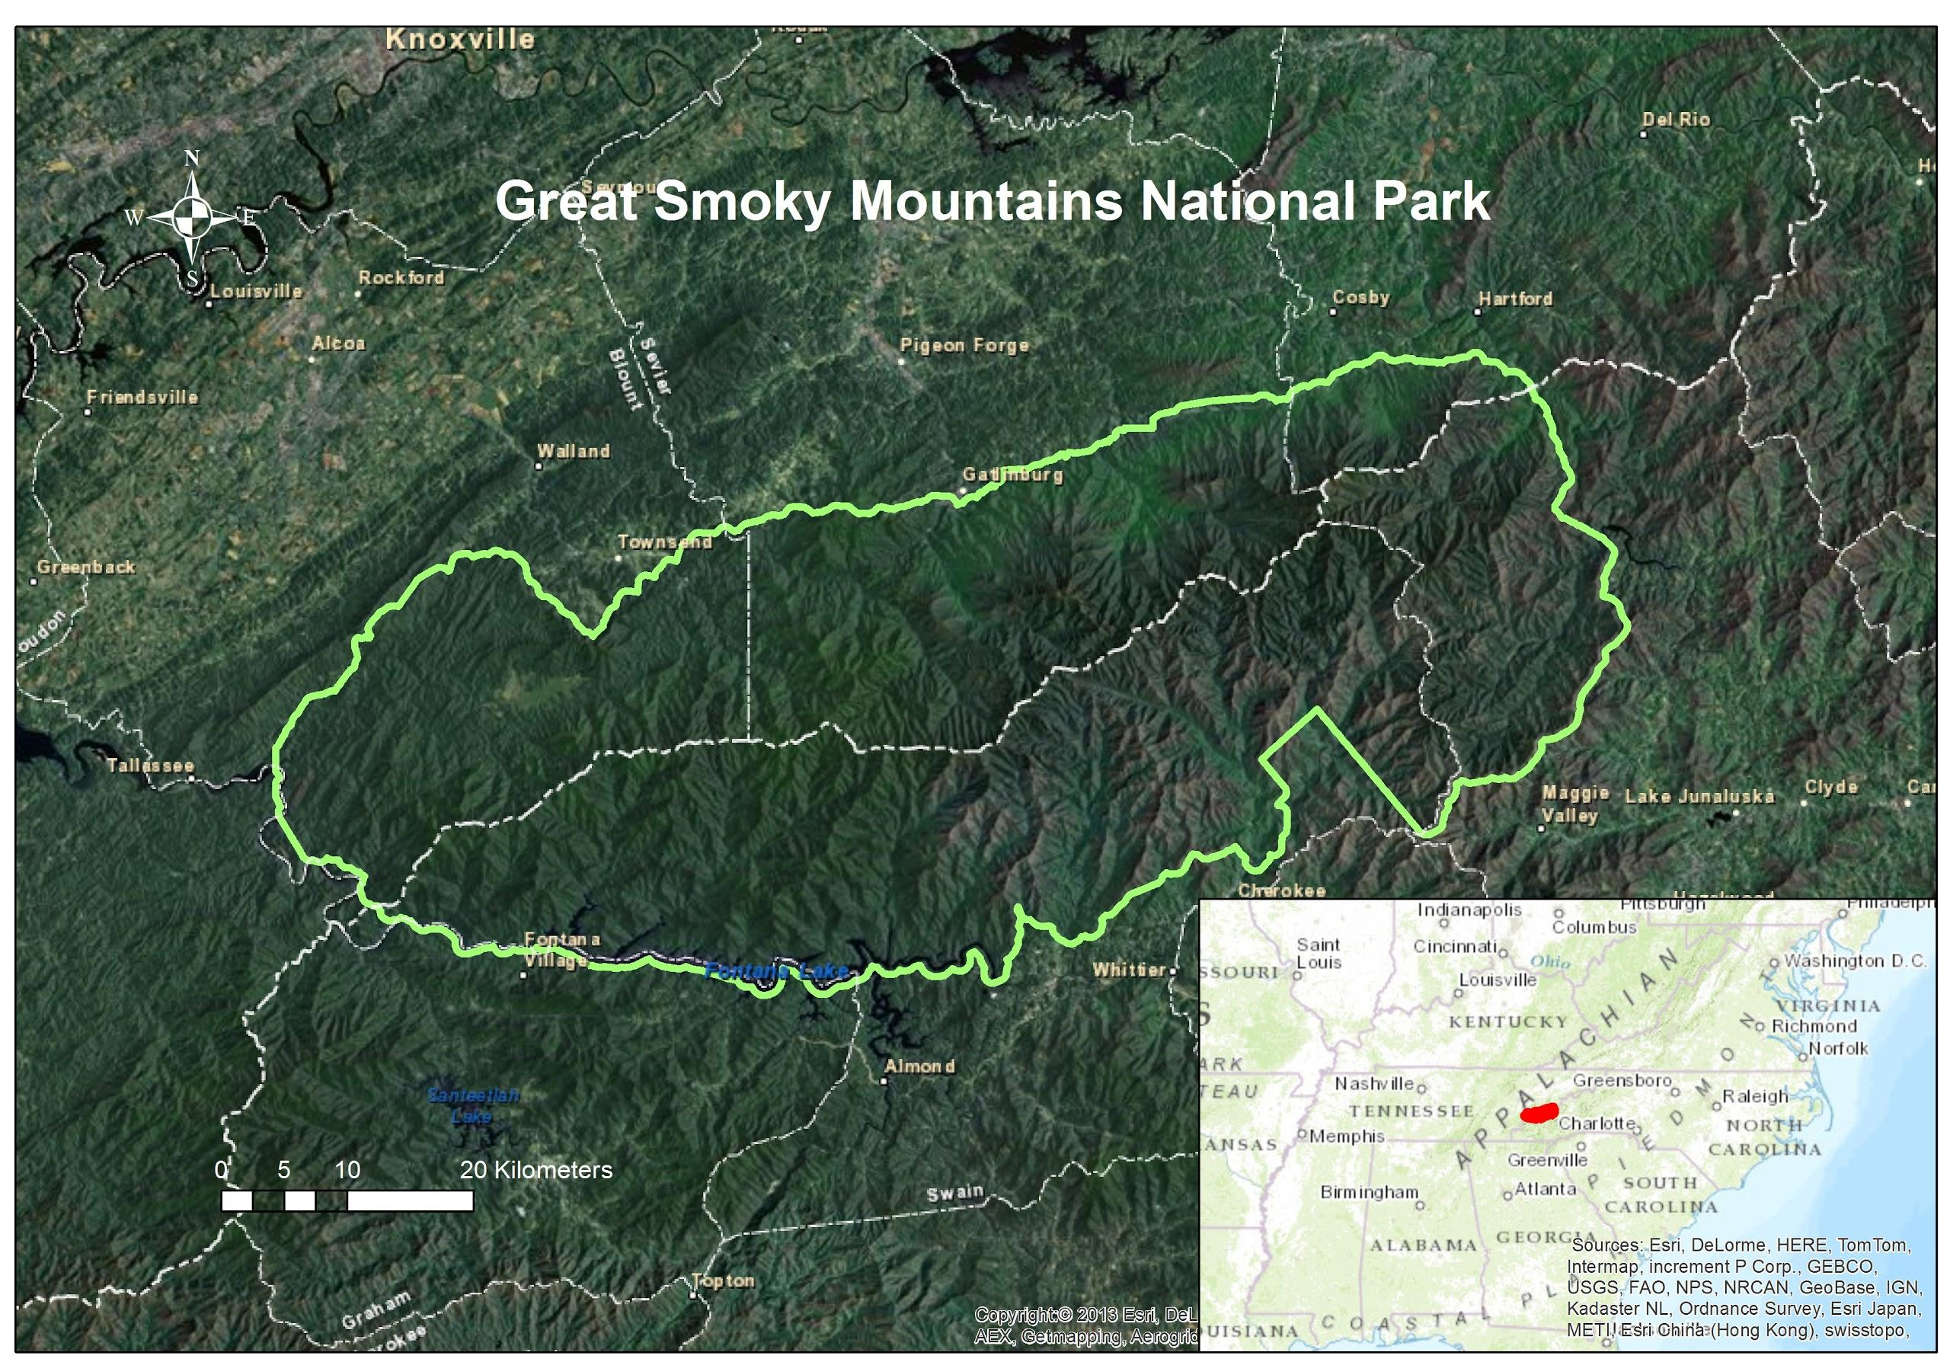

Figure 1. The project study area, Great Smoky Mountains National Park

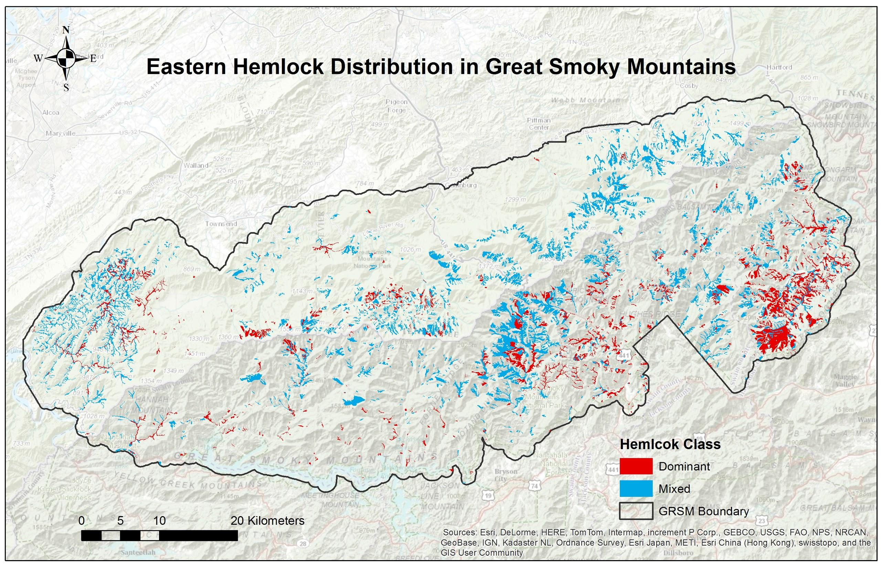

Figure 2. Eastern hemlock distribution map in Great Smoky Mountains National Park

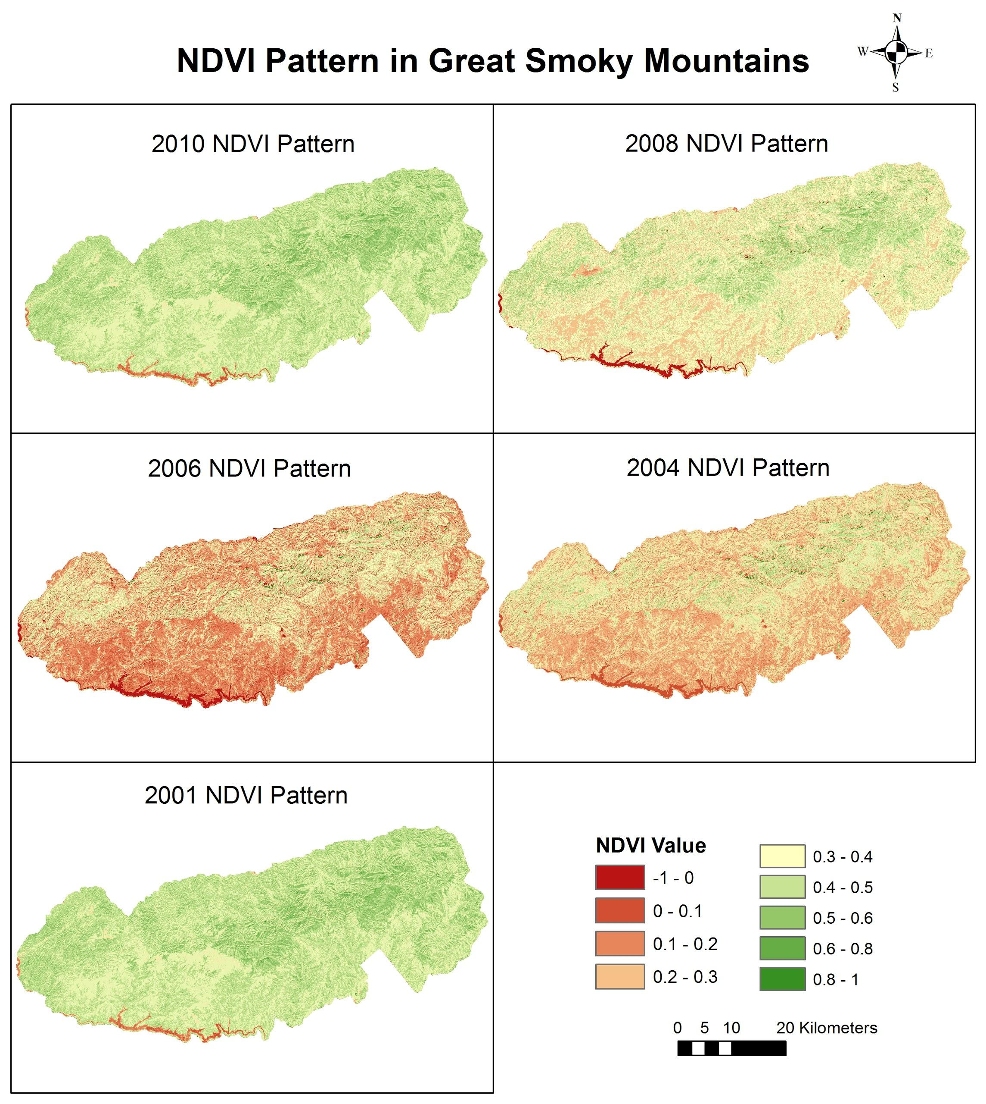

Figure 3. NDVI change from 2001 to 2010 for the Great Smoky Mountains National Park

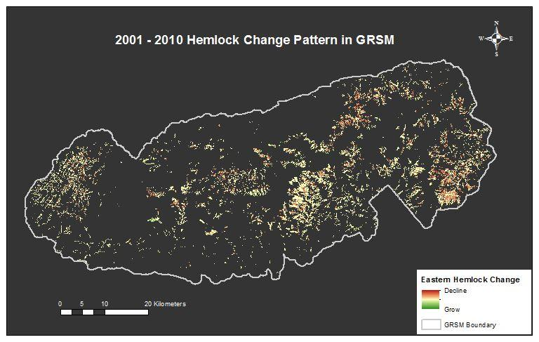

Figure 4. NDVI image differencing result for 2001 to 2010 in hemlock areas

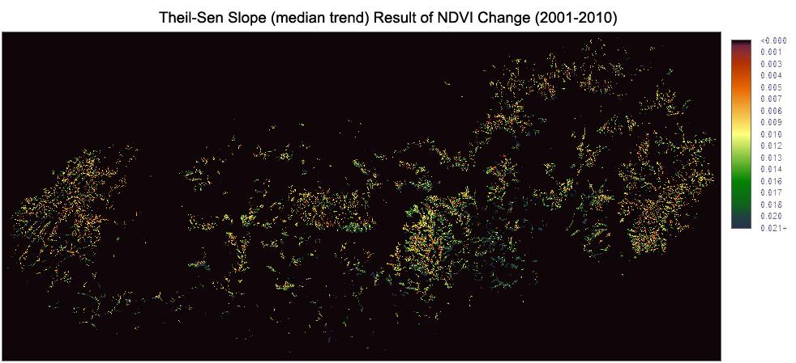

Figure 5. Theil-Sen slope result of NDVI change from 2001 to 2010

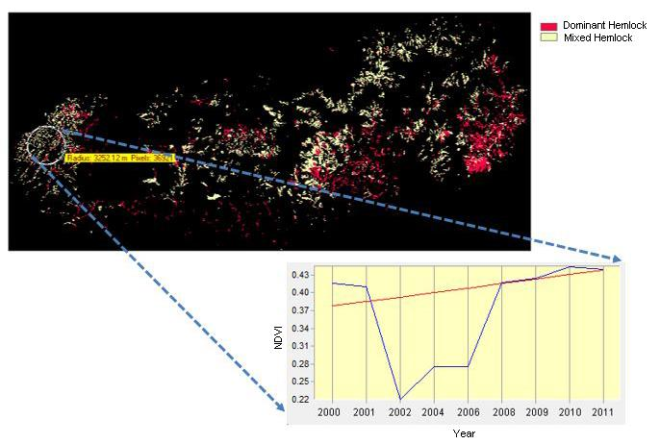

(a)

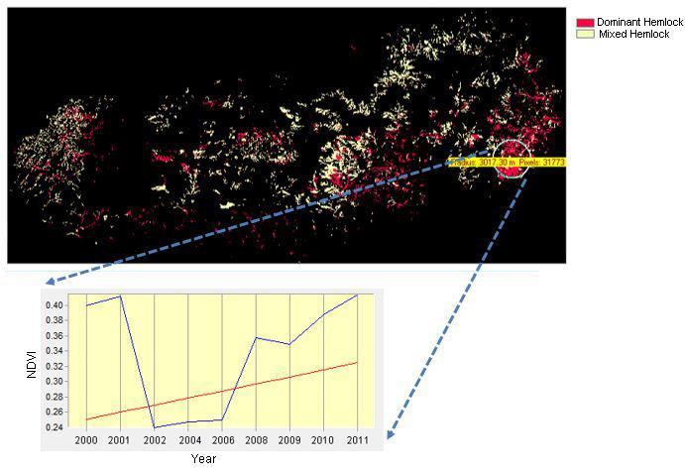

(b)

Figure 6. NDVI temporal profile of hemlock sites in GRSM: (a) Western part of GRSM; (b) Eastern part of GRSM

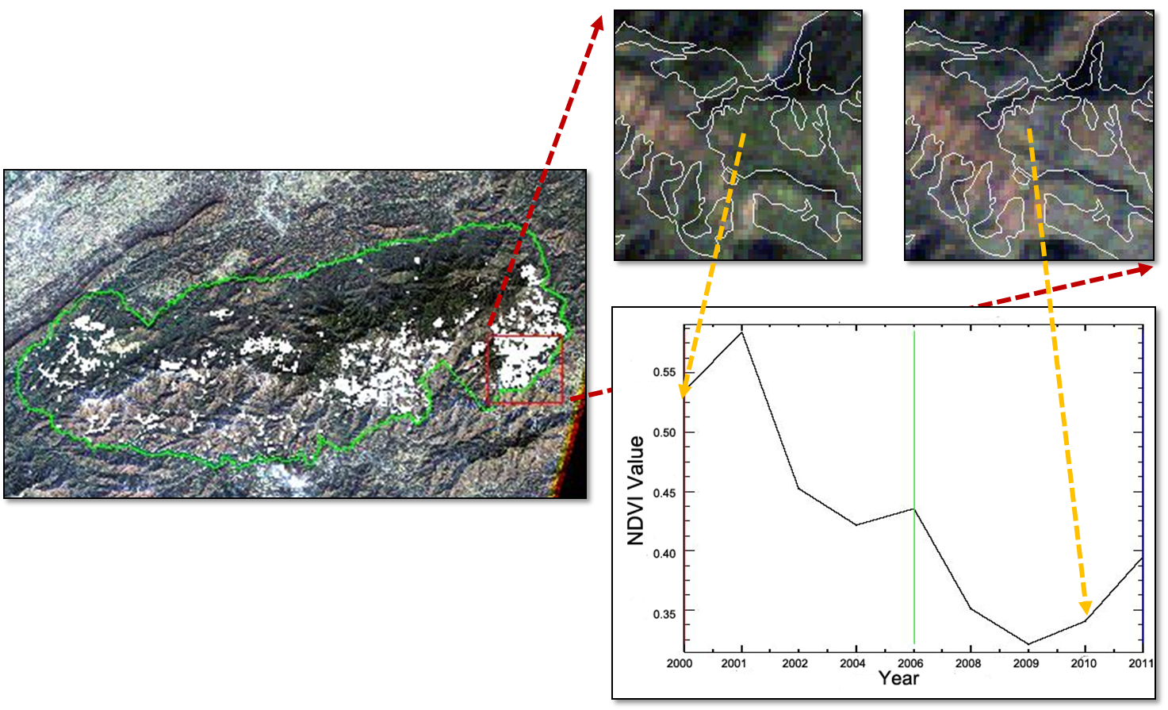

(a)

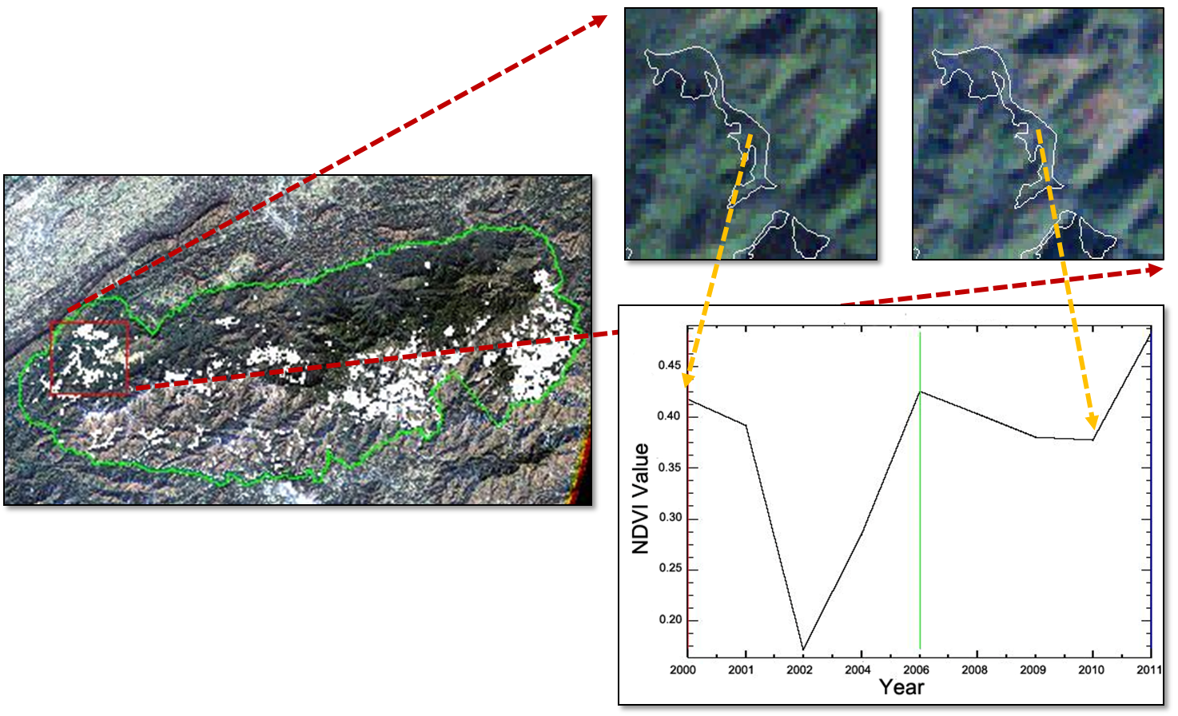

(b)

Figure 7. NDVI temporal profile of hemlock sites in GRSM: (a) Site A in western part of GRSM; (b) Site B in eastern part of GRSM

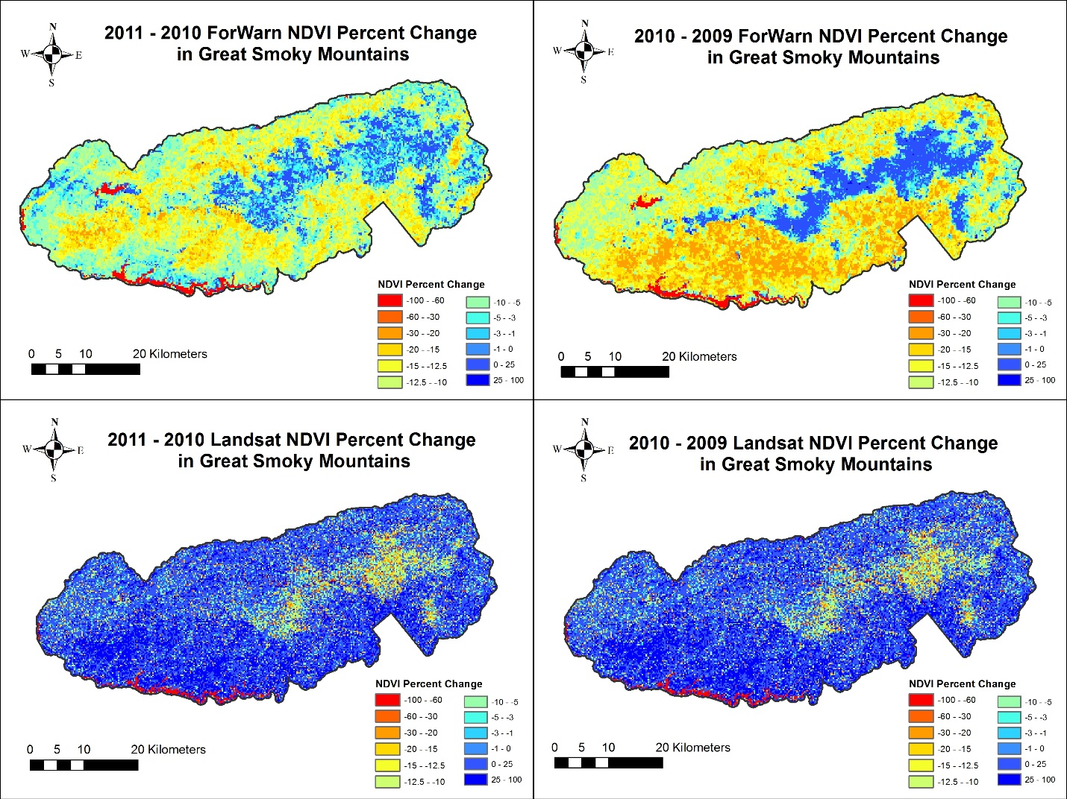

Figure 8. ForWarn and Landsat NDVI Percent Change Maps in GRSM

**Tables**

Table 1. Correlation Analysis Result for 2010 - 2011

|  |  |  |
| --- | --- | --- |
| 2010 - 2011 | Dominant | Mixed |
| Pearson’s r | -0.152958 | -0.1731579 |
| P-value | 0.1287 | 0.08492 |

Table 2. Correlation Analysis Result for 2009 - 2010

|  |  |  |
| --- | --- | --- |
| 2009 - 2010 | Dominant | Mixed |
| Pearson’s r | 0.2567295 | 0.2362854 |
| P-value | 0.009926 | 0.01865 |