**NASA DEVELOP National Program**

****NASA Jet Propulsion Laboratory

**Summer 2016**

**Short Title: Costa Rica Agriculture**

**Subtitle:** Applying ECOSTRESS Diurnal Cycle Land Surface Temperature and Evapotranspiration to Agricultural Soil and Water Management

**VPS Title:** Take the Stress out of ECOSTRESS

**Project Team & Partners**

**Project Team:**

Gregory Halverson (Project Lead)

Mark Barker

Savannah Cooley

Steven Pestana

**Advisors & Mentors:**

Dr. Christine Lee (Jet Propulsion Laboratory, California Technical Institute)

Dr. Joshua Fisher (Jet Propulsion Laboratory, California Technical Institute)

Dr. Glynn Hulley (Jet Propulsion Laboratory, California Technical Institute)

Dr. Simon Hook (Jet Propulsion Laboratory, California Technical Institute)

Dr. Laura Jewell (Jet Propulsion Laboratory, California Technical Institute)

Dr. Johan Perret (EARTH University, Costa Rica)

Adam Purdy (University of California, Irvine)

**Partner Organizations:**

|  |  |  |  |
| --- | --- | --- | --- |
| **Organization** | **POC (Name, Position/Title)** | **Partner Type** | **Boundary Org?** |
| EARTH University | Dr. Johan Perret, Professor | End-User | Yes |

**Project Details**

**Applied Sciences National Applications Addressed:** Agriculture, Ecological Forecasting, Water Resources

**Study Area:** Guanacaste, Costa Rica

**Study Period:** Jan 2008 – Dec 2009

**Earth Observations & Parameters:**

Terra, Moderate Resolution Imaging Spectroradiometer (MODIS) – LST, albedo, land cover type, NDVI, air temperature, dew-point temperature, upper atmospheric conditions

Suomi NPP, Visible Imaging Radiometer Suite (VIIRS) – LST, NDVI

Aster Global Emissivity Dataset (GED) version 3 – emissivity

**Ancillary Datasets Utilized:**

* EARTH University Shapefiles – study area
* EARTH University *in situ* data – crop type
* La Thuile Synthesis Dataset
* National Centers for Environmental Prediction (NCEP) Daily Long Term Mean Minimum Temperature

**Models Utilized:**

* Forest Light Environmental Simulator (FLiES)
* Breathing Earth Systems Simulator (BESS)
* Priestley-Taylor Jet Propulsion Laboratory (PT-JPL)

**Software Utilized:**

* MATLAB - Producing net radiation data using FLiES and BESS, analysis
* Python - Preprocessing MODIS data for net radiation, producing PT-JPL data, analysis
* R - data analysis and visualization
* ArcGIS - data analysis and visualization
* QGIS - data analysis and visualization

**Project Overview**

**80-100 Word Objectives Overview:**

This project demonstrates how diurnal ECOSTRESS evapotranspiration (ET) and flux tower data benefit agricultural communities by incorporating NASA remote sensing data into their efforts to improve water resource management. These datasets complement the *in situ* soil moisture samples taken at EARTH University and identify areas with ET hotspots, where additional focus should be given. Analysis of the diurnal cycle of the surface water and energy balance will advance the ECOSTRESS PT-JPL model in order to provide diurnal, high-resolution estimates of evapotranspiration to agricultural communities and complement *in situ* plant water stress monitoring.

**Abstract:**

Increased demand for agricultural products and limited water supplies in Costa Rica have encouraged decision makers to seek improved water management practices to increase the efficiency, allocation, and impact of their resources. Remotely sensed evapotranspiration data can provide officials with insights into variables like crop health and water loss, as well as provide direction as to when and how much water should be used. Currently, EARTH University’s data are limited to *in situ* observations and will greatly benefit from expanded measurement collection over larger areas. In this project, remotely sensed Moderate Resolution Imaging Spectroradiometer (MODIS) evapotranspiration data was modified for this purpose with increased spatial and temporal coverage through the resampling of ECOsystem Spaceborne Thermal Radiometer Experiment on Space Station (ECOSTRESS) data. The MODIS Priestly-Taylor Jet Propulsion Laboratory (PT-JPL) 5 km evapotranspiration product was resampled to 70 m resolution to simulate the Level-3 ECOSTRESS product. This simulated, high-resolution data can demonstrate the use of future ECOSTRESS data in managing and implementing healthy and productive sustainable farms throughout the region of Guanacaste. This investigation of the diurnal cycle of land surface temperature, net radiation, and evapotranspiration will advance the model science of ECOSTRESS to be launched in 2018 on the International Space Station (ISS).

**Keywords:**

PT-JPL, ECOSTRESS, MODIS, Agricultural Productivity, Plant Water Stress, Irrigation, Water Use Efficiency

**Community Concerns:**

* Precision agriculture using all available data is a necessity to maintain crop yields with a diminishing supply of fresh water
* EARTH University’s techniques of *in situ* soil moisture and quality measurements are labor and cost intensive
* The people of Guanacaste need to optimize water use to prevent over-irrigation and crop failure
* Building resilience of farming communities to cope with floods and droughts

**Current Management Practices & Policies**:

Farmers need adequate data to inform decision making for sustainable water management in agricultural practices. Data required to support irrigation decisions include soil characteristics, crop water requirements, and the ability to identify locations in the field where crops receive too much or too little water. EARTH University currently utilizes georeferenced and in-field soil, plant, and water variable measurements to inform agricultural sector management practices primarily through teaching and consulting activities. These *in situ* data are limited in their spatial and temporal extent and require significant processing to visualize regions that may require additional attention.

**Decision Support Tools & Benefits:**

|  |  |  |  |
| --- | --- | --- | --- |
| **End-Product** | **Earth Observations Used** | **Benefit & Impact** | **Software**  **Release** |
| Experimental Design | MODIS PT-JPL 5 km | Crop productivity, water resource management, advancing scientific inquiry of EARTH University | N/A |
| Sampling Design | MODIS PT-JPL 5 km | Identifying partner producers | N/A |
| Applied ET Training | MODIS PT-JPL 5 km,  VIIRS, GEDv3 | Community Engagement, ET Application Use Demonstration | N/A |
| MODIS PT-JPL 5km | MODIS PT-JPL 5 km | Validating Instituto Meteorológico Nacional data | N/A |
| ECOSTRESS 70m Simulation | VIIRS, GEDv3 | Precision agriculture | N/A |
| ECOSTRESS Overpass Calculator | N/A | Observation frequency analysis | 4 |

**Project VPS/Booklet Imagery**

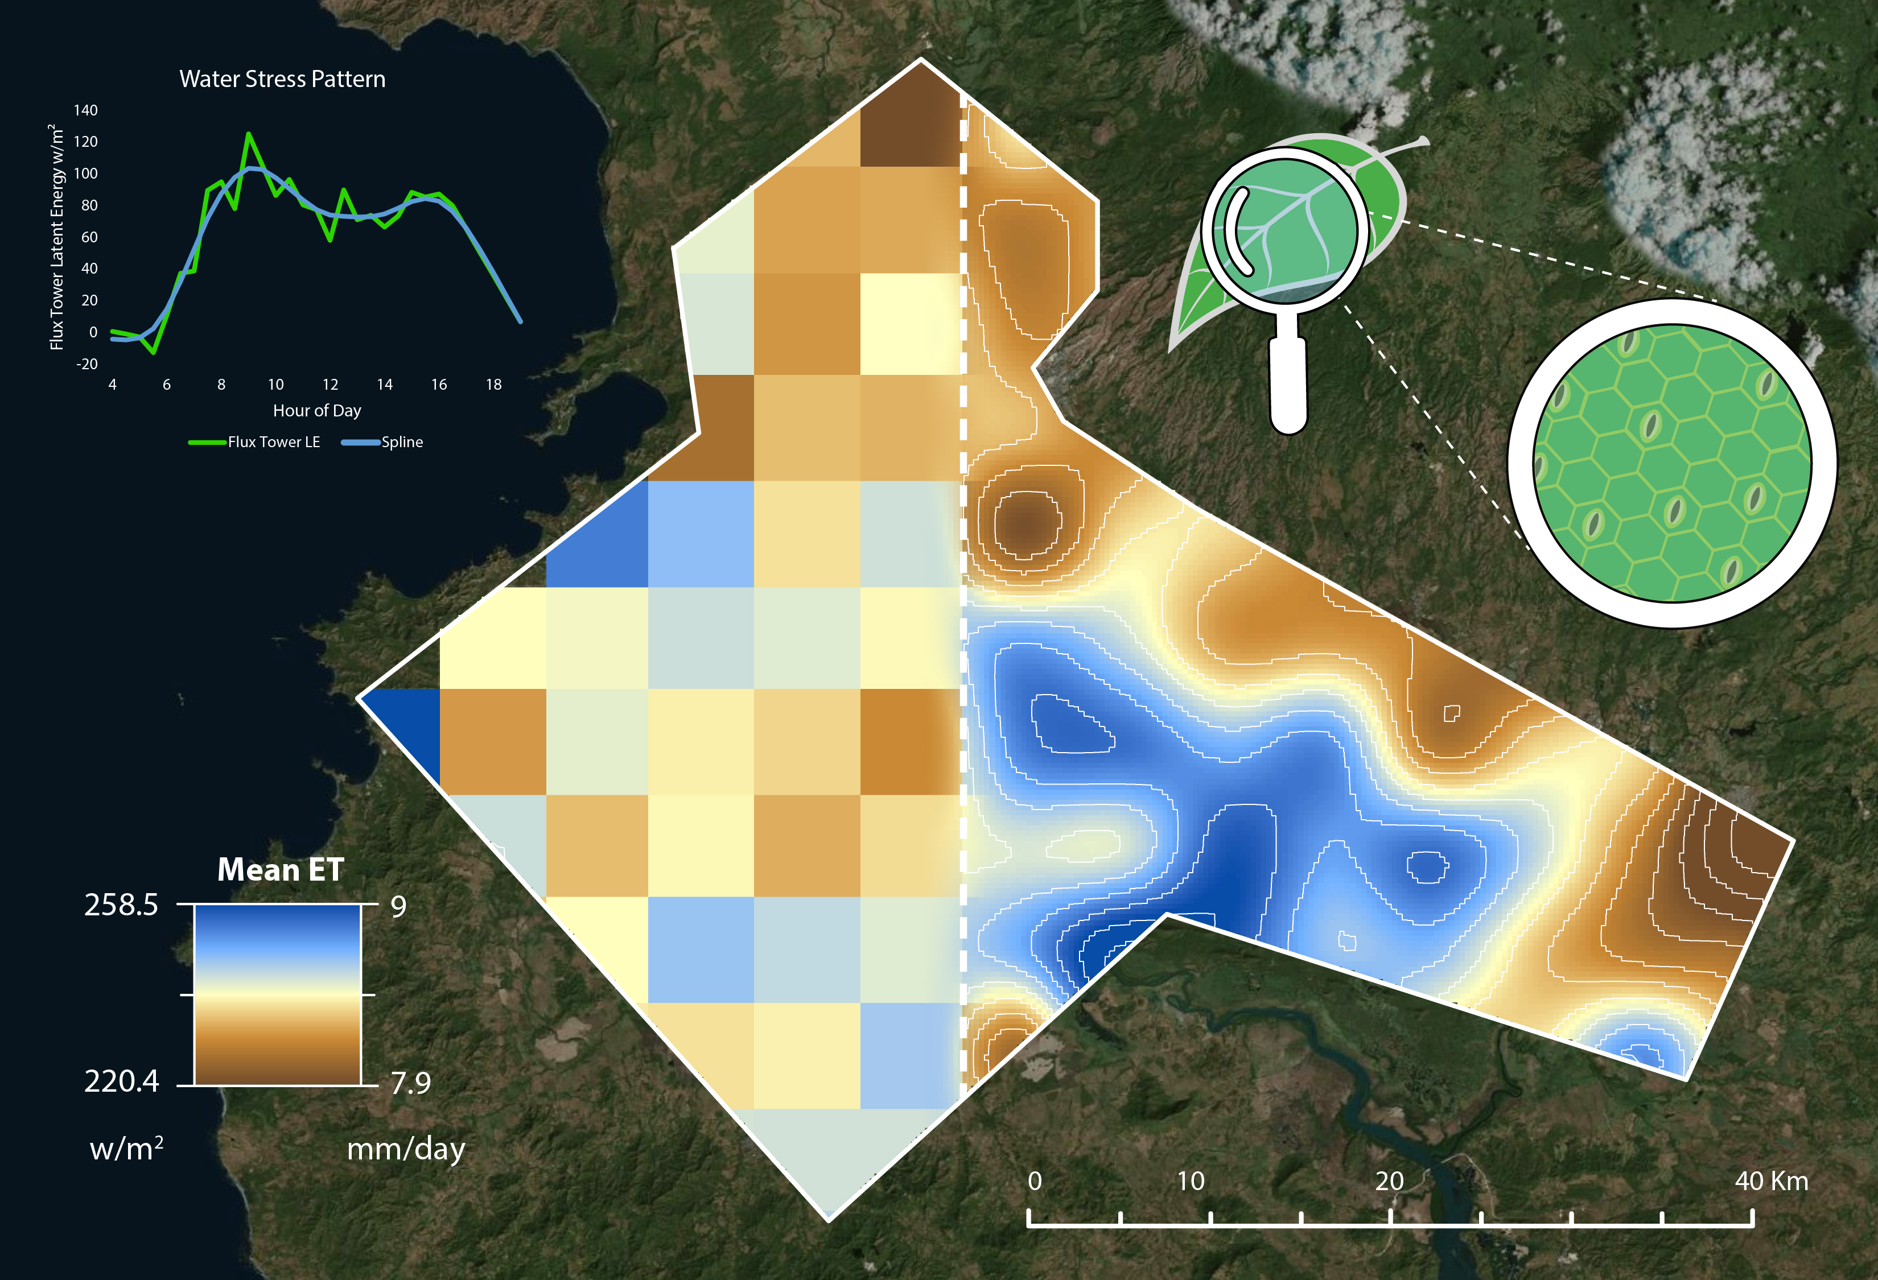

**Caption:** Costa Rica Study Area Demonstrating Transition from MODIS 5 km to ECOSTRESS 70m PT-JPL with Water Stress Pattern Graph and Stoma Diagram

Image Credit: Costa Rica Agriculture Team.

**Image:** Final Study Area Map.jpg