**NASA DEVELOP National Program**



Langley Research Center

*Spring 2015*

Great Lakes Climate II

Impact of Decreasing Lake Water Levels on Great Lakes Wetlands

 **Technical Report**

Final Draft - April, 4 2015

Emily Adams (Project Lead)

Idamis Del Valle Martinez

Miriam Harris

Stephen Zimmerman

Dr. Kenton Ross, DEVELOP National Program (Science Advisor)

Previous Contributors:

Janice M. Maldonado Jaime

Emily Adams

Lydia Cuker

Kathy Currie

Lacey Freese

Miriam Harris

Daniel Marx

Pamela King

# I. Abstract

The Laurentian Great Lakes region of North America includes several types of coastal wetlands (e.g., swamps and marshes) that support a high diversity of biota. The health of these ecosystems is very important for ecological communities and economic industries, which benefit from fisheries and tourism. Great Lakes wetlands have been estimated to provide over 10,000 USD per acre in economic and ecosystem services. The effects of climate change, including variations in temperature, precipitation, and evapotranspiration, could impact the water level of the Great Lakes directly, and therefore, the development and survival of coastal wetlands. Increasing environmental pressures from rising populations, invasive species, and pollution will also negatively affect these wetlands if they are not managed appropriately. An updated land cover classification was developed, using a Random Forest classification method, to evaluate and monitor changes in the wetlands around Georgian Bay and the Southern portion of Lake Ontario. NASA Earth observation data from Landsat 5 Thematic Mapper (TM) and Landsat 8 Operational Land Imager (OLI) provided historical images and current images to classify land cover. Terra Advanced Spaceborne Thermal Emission and Reflection Radiometer (ASTER) data provided digital elevation model (DEM) data, from which slope was calculated. Resultant land cover classifications were validated with ground truth data. Additionally, TOPEX/Poseidon Jason-1 and Ocean Surface Topography Mission (OSTM)/Jason-2 radar altimeters and *in situ* water gauge data served as a resource for tracking water levels over time. This methodology offers a more cost-effective approach to monitoring wetlands in the region.

**Keywords**

Wetlands, Climate Change, Remote Sensing, Land Cover Classification, Lake Water Levels

# II. Introduction

Wetlands are one of the most diverse natural systems in the world (Bardecki, 1991; Cvetkovic and Chow-Fraser, 2011; Midwood et al., 2012). They are transition zones between terrestrial and aquatic ecosystems and provide important ecological and economic benefits (Bardecki, 1991; Morstch, 1998). These benefits include water filtration, flood prevention, erosion control, ground water recharge, and habitats for a variety of biota (Bardecki, 1991; Li and Chen, 2005; Midwood et al., 2012; Mcleod et al., 2011). Wetlands also serve as natural carbon sinks (Mcleod et al., 2011). Despite the fact that wetlands are critical to support diverse biota, ecotourism and other economic enterprises, it has been estimated that their geographical extent has decreased up to 90% (Midwood et al., 2012). Therefore, conservation and restoration efforts for these ecosystems are crucial particularly because decreases in wetland extent will likely be exacerbated by climate change.

The Lauretian Great Lakes region of North America contains a significant amount of wetland area with more than 1500 complexes covering an area of 1700 km2 (Cvetkovic and Chow-Fraser, 2011; Herdendorf, 2004; Midwood et al., 2012). The predominant types of wetlands in the Great Lakes region are marshes and swamps (Cvetkovic and Chow-Fraser, 2011; Morstch, 1998). The Georgian Bay in Lake Huron has one of the most well preserved areas of wetlands in the Great Lakes basin and provides optimal characteristics that allow for a high diversity of biota (Cvetkovic and Chow-Fraser, 2011; Midwood et al., 2012). In contrast to that, the wetlands around Lake Ontario have faced significantly more pressures from many sources. Previous studies regarding wetlands in the northern shorelines of Lake Ontario have shown that wetland extent has decreased (Whillans, 1982). Anthropogenic influences such as urban development and agricultural expansion continue to degrade wetlands around Lake Ontario (Chow-Fraser, 1998; Chow-Fraser et al., 1998; Whillans, 1996). For instance, an urban degraded wetland in western Lake Ontario, Cootes Paradise Marsh, experienced high water levels that caused the disappearance of emergent vegetation and led to increased water turbidity (Chow-Fraser, 1998).

Water level fluctuations in the Great Lakes are dictated by climate variability (Mortsch, 1998; Mortsch et al., 2000; Wilcox and Xie, 2007). Lake level oscillations routinely occur on daily, seasonal, and decadal timescales. (Mortsch, 1998). These oscillations have a significant influence on wetland vegetation. Short periods of high water followed by short periods of low water levels allow for maximum species diversity (Morstch, 1998; Mirwood et al., 2012; Keddy and Reznieck, 1986). Since the late 1990s, water levels in Lakes Huron and Michigan have been decreasing, affecting wetlands in Georgian Bay (Assel et al., 2004; Canada Department of Fisheries and Oceans, 2015; Sellinger et al., 2008; Midwood et al., 2012). Lake Ontario water levels have been kept more consistent for the past 50 years by a series of locks and dams that allow for more effective hydroelectric power and shipping (Chow-Fraser et al., 1998). It is not well understood how human intervention of lake levels in Lake Ontario has affected wetland extent. Moreover, climate change models predict further declines of water levels in the Great Lakes basin (Bardecki, 1991; Mortsch, 1998; Mortsch and Quinn, 1996; Sellinger et al., 2008). Climate predictions suggest a change in variables that affect water storage in the Great Lakes basin including precipitation, temperature, and evapotranspiration (Morstch, 1998). Potential impacts of climate change include higher precipitation amounts, warmer air temperatures, and increased evapotranspiration rates, leading to decreased lake levels (Mortsch and Quinn, 1996; Mortsch, 1998). A changing climate will likely modify the hydrologic cycle of the Great Lakes and, considering wetland existence depends on specific hydrologic conditions, it is imperative to understand how wetlands are currently responding to fluctuations in the water levels (Bardecki, 1991; Morstch, 1998; Wilcox, 2004). Therefore, a clear understanding of how wetlands have responded to past and current trends in lake level fluctuations will help policy-makers prepare for future changes.

The goal of this project was to monitor changes in wetland extent due to decreasing lake levels and climate change. This project provided updated classification maps for two geographical regions within the Great Lakes Basin: Georgian Bay in Lake Huron, Ontario for July 1987 and June 2013 and the southern portion of Lake Ontario, including Rochester, NY for August 2007 and October 2014. The land cover classification maps, along with a time series, offered tools that highlighted changes in wetlands in the Great Lakes region. The Great Lakes Climate II team benefited from a partnership with the Great Lakes and St. Lawrence Cities Initiative, Georgian Bay Forever, and the Ontario Ministry of Natural Resources, which promote wetland preservation, restoration and policy in the region. Prior to this project, these partners did not have a cost-effective way to examine wetlands extent particularly at large spatial scales. This research provided a methodology that could easily be used to determine wetland extent in light of climate change. The NASA national application areas addressed in this project included Climate, Ecological Forecasting and Water Resources.

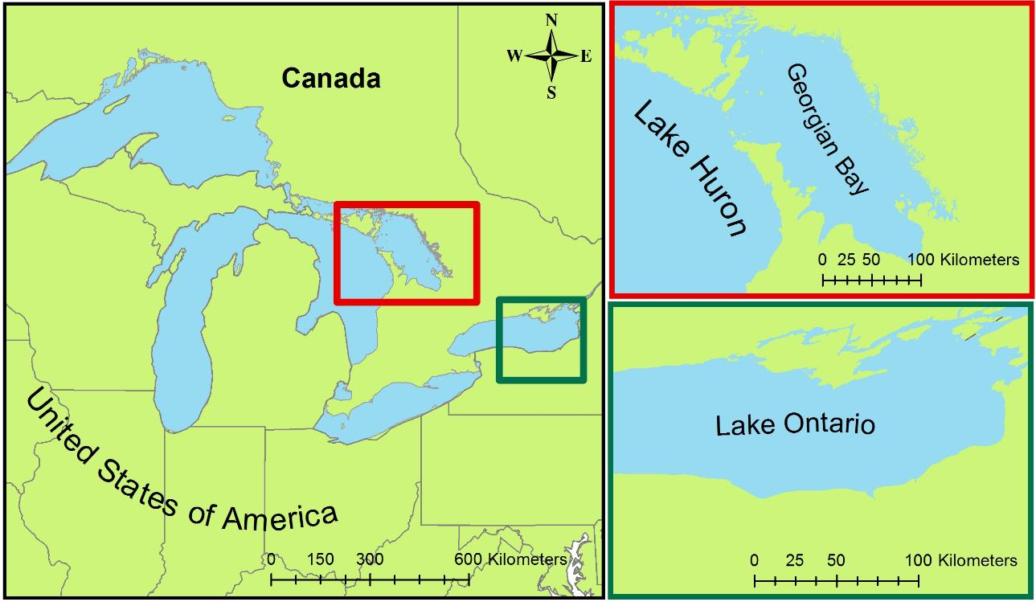

Figure 1. Study Area: Georgian Bay off of Lake Huron in Ontario, Canada and the southern portion of Lake Ontario.

# III. Methodology

In order to track fluctuations in water levels for Lake Huron and Lake Ontario, relative changes in water levels, recorded by Topography Experiment (TOPEX)/Poseidon, Jason-1 and Ocean Surface Topography Mission (OSTM)/Jason-2 radar altimeters were downloaded for the years 1992-2014 from the United States Department of Agriculture (USDA) website. Water level data from 1987 to 2012 for Parry Sound, Ontario, Canada was acquired from *in situ* water gauge measurements compiled by Environment Canada (2014). In situ water level data for Rochester, NY was obtained for the 1992-2014 period from NOAA Tides and Currents website.

Satellite imagery used in the land cover classification for Georgian Bay and for the southern portion of Lake Ontario, were acquired from Landsat 5 Thematic Mapper (TM) and Landsat 8 Operational Land Imager (OLI) for the 1987/2007 and 2013/2014 images, respectively (Table 1, Table 2). Two tiles were needed for Georgian Bay while only one was needed for the southern portion of Lake Ontario. Landsat images were selected for Georgian Bay based on historic high and historic low water levels (Figure 2). Lake Ontario has been heavily regulated through a series of locks and dams for over 50 years (Chow-Fraser et al., 1998) and thus does not show the same water level patterns as Georgian Bay (Figure A.1). Therefore Landsat images for southern Lake Ontario were instead selected to coincide with the NOAA Coastal Change Analysis Program recent land cover classifications. All Landsat images obtained from the United States Geological Service (USGS) Global Visualization Viewer (GLOVIS) website and were downloaded as Landsat Level 1 data.

After acquisition of the Landsat data the original digital numbers were converted to top of atmosphere reflectance through a python script in ArcGIS. The converted Landsat scenes were then mosaicked together to create one scene for the Georgian Bay tiles. Then, a 10 km buffer from the shoreline was applied using ArcGIS 10.2.2 Extract by Mask tool to define the study area. For the Georgian Bay mosaic the middle of the lake was clipped in an attempt to conserve RAM when running the Random Forests Model supervised classifier script using R programming software. This R script was used to produce the land cover classification. A 10 km buffer was needed to include a larger area for wetland extent as a means of building upon the previously classified area.

Table 1. Landsat Imagery Information for Georgian Bay, Ontario

|  |  |  |
| --- | --- | --- |
| **Sensor** | **Scene (Path/Row)** | **Date** |
| LANDSAT 8 (OLI) | Path 19/Row 28 | June, 2013 |
| LANDSAT 8 (OLI) | Path 19/Row 29 | June, 2013 |
| LANDSAT 5 (TM) | Path 19/Row 28 | July, 1987 |
| LANDSAT 5 (TM) | Path 19/Row 29 | July, 1987 |

Table 2. Landsat Imagery Information for Rochester, Lake Ontario

|  |  |  |
| --- | --- | --- |
| **Sensor** | **Scene (Path/Row)** | **Date** |
| LANDSAT 8 (OLI) | Path 16/Row 30 | October, 2014 |
| LANDSAT 5 (TM) | Path 16/Row 30 | August, 2007 |

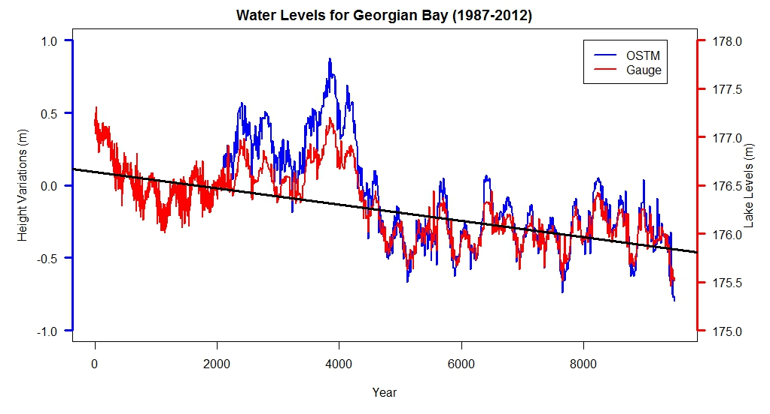

1987

1992

1997

2003

2008

R2 = 0.95

Figure 2. In-situ water levels in Parry Sound, Georgian Bay, ON and OSTM water levels for Lake Huron for the years 1987-2012

Categories for the Georgian Bay land cover classification were chosen from the Southern Ontario Land Resource Information System (SOLRIS) definitions, with some modifications. Not all classification categories were needed and some were consolidated, for example at the spatial scale used in this study it was not practical to delineate specific wetland types (i.e., bog, marsh, swamp). To help avoid map clutter, the SOLRIS category “built-up area impervious” is included in the SOLRIS classification titled “urban”, which also includes transportation. Because of difficulties differentiating between forest and bedrock classes at 30 m x 30 m resolution, a class called “Forested Bedrock” was created for the portion of the northeastern Georgian Bay shoreline where bedrock exposures intermixed with forest vegetation. The two classes “Crops” and “Bare Ground” were defined in this study but classified the same under the “Undifferentiated” class in SOLRIS. Overall, ten land cover classes were created for the Georgian Bay area. Categories for the southern portion of Lake Ontario were chosen according to the classes identified for the National Oceanic and Atmospheric Administration’s Coastal Change Analysis Program (NOAA C-CAP) land cover classification. The C-CAP is a nationally standardized database of land cover with a resolution of 30 m, database provided by NOAA. Overall, this project used fifteen classes for the southern portion of Lake Ontario.

Training sites were selected by examining true and false color composite images for both regions (Figure A.2). Training sites are representative groups of pixels that are selected and assigned to each class to delineate land cover classes. The selected pixels define the range of values associated with the spectral signatures of each individual class. Polygons, encompassing the pixels used to create the training sites, were created using ArcMap and saved into shapefiles. Training site shapefiles were created for each unique time stamp. The shapefiles were then input to a Random Forests Model supervised classifier script along with spectral bands from Landsat 5 TM (bands 1-5, 7) and Landsat 5 TM thermal band (band 6) or Landsat 8 OLI (bands 2-7) and Landsat 8 TIRS thermal bands (bands 10 & 11).Additionally, Digital Elevation Model (DEM) data were obtained from Terra ASTER, using NASA Reverb EOS Clearing House (ECHO), and was used as an input to the Random Forest Model. In ArcGIS, an elevation derivative, slope, was calculated and also used as an input in the script. The samples per training site was set to at least 1,500 to reduce the probability of random chance influencing the outputs (Breiman, 2001). After each classification by the Random Forests Model, the output map was evaluated. Training sites for the Georgian Bay maps were added or deleted based on errors detected in an effort to improve the land cover classification.

Upon finishing classification the land cover maps were simplified into two classes “Wetland” or “Non-Wetlands”, the latter of which includes all other classes excluding Wetlands. These simplified classifications were combined in ArcGIS to produce a four-class classification, where pixels were defined as Unchanged Non Wetland, Unchanged Wetland, Gain of Wetland, or Loss of Wetland. This simplified classification was used to determine the changes in wetland area from 1987 to 2013 for Georgian Bay.

Ground truth data for an accuracy assessment were not available for any study area or period. Instead comparisons were assessed using the 2008 SOLRIS classified map for the southern portion of the 2013 Georgian Bay Map and the 2006 NOAA C-CAP for the 2007 southern portion of Lake Ontario. This was accomplished using the reclassified wetlands, non-wetlands maps. The SOLRIS and C-CAP maps were also reclassified to the wetlands, non-wetlands scheme. ArcGIS was then used to create 200 stratified random points. These random points were evenly distributed across our classified map between wetland (100 points) and non-wetland (100 points) areas. The number of points met the recommended minimum requirements of at least 50 samples per class (Congalton and Green, 2009). Each random point was then identified as wetland or non-wetland in accordance with the SOLRIS or C-CAP map using the ArcGIS Extract Values to Points tool. The designation of these points were then compared to the designation of those points on our classified map.

# IV. Results & Discussion

Water level gauge measurements for the Parry Sound in the Georgian Bay reveal lake levels below the long-term average for more than a decade beginning 1987 and continued through 2014 (Figure 2). Measurements of lake levels variance from TOPEX/Poseidon Jason-1 and OSTM/Jason-2 radar altimeters have similar results as gauge measurements (Figure 3). A correlation between *in situ* water gauge observations and TOPEX/Poseidon Jason 1 & 2 was conducted (Figure 3). The relationship between these variables was very strong, with a R2= 0.95. Hence, TOPEX/Poseidon Jason 1 & 2 can be useful to track lake level changes.  Lake levels for Lake Ontario obtained from gauge measurements and Jason-1/Jason-2 radar altimeters indicate stable water level fluctuations equal to the long-term average (Figure A.1). This was expected as Lake Ontario water levels are managed by levees and dams. The correlation between *in situ* water gauge data and TOPEX/Poseidon Jason 1 & Jason 2 for Lake Ontario showed a similar pattern as the Lake Huron correlation (Figure A.3)

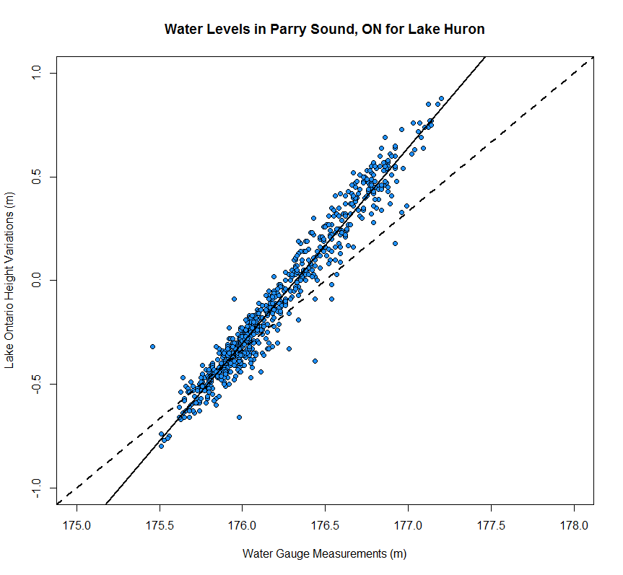

Scatter Plot for Water Levels

Figure 3. Scatter plot using TOPEX/Poseidon Jason 1 & 2 Lake Huron height variations and *in situ* water gauge measurements from Parry Sound, ON

Land cover classification maps for Georgian Bay 1987 and 2013 were produced from the Random Forests Model (Figures 4 and 5). The addition of the thermal band, the DEM from, and slope derived from the DEM reduced random forest classification error to approximately 2%. Also, Landsat images collected during the leaf-on season limited confusing vegetative classes with bare ground and urban classes.

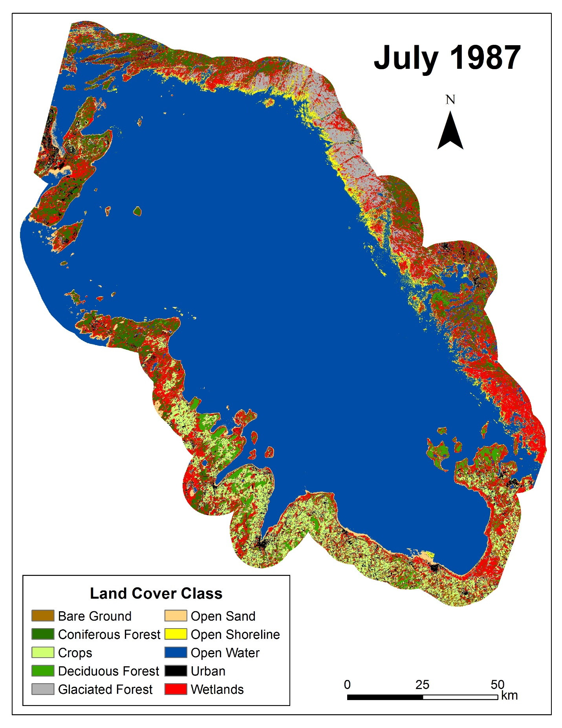

Figure 4. Land cover classification map for Georgian Bay in 1987

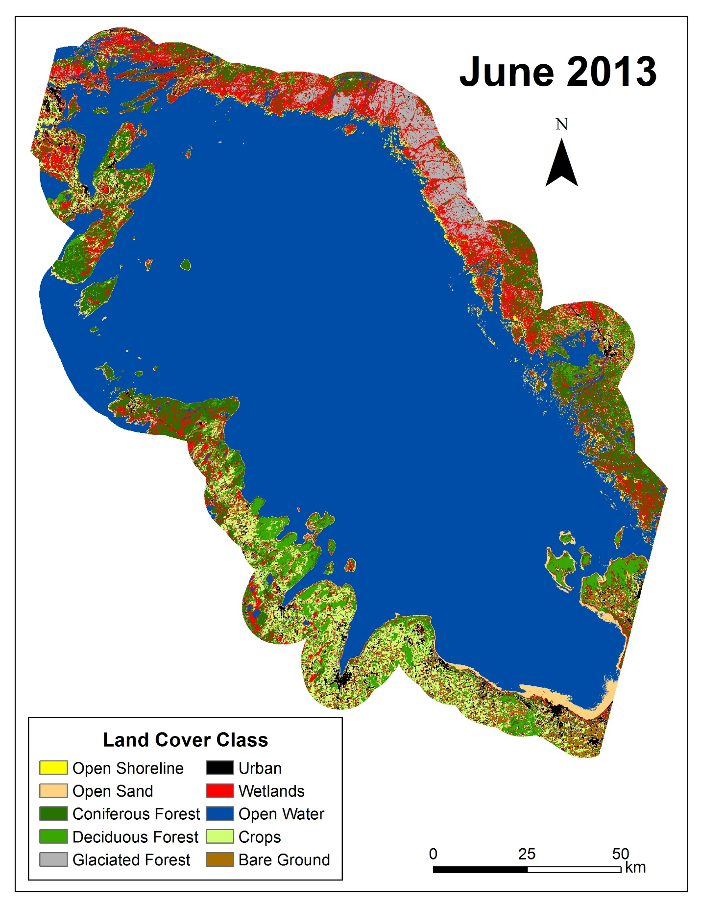

Figure 5. Land cover classification map for Georgian Bay in 2013

Reclassified wetland/non-wetland maps highlight wetland locations around Georgian Bay shoreline (Figures 6 and 7). After the wetland, non wetland maps were combined to create the wetland extent change maps a pattern of wetland gain and loss throughout the region for this time period became apparent (Figure 8). The Georgian Bay extent change map shows that there was a 10.8% loss of wetlands around the southern portion of region, while the northern portion of the region has an increase of 7.0% in wetlands extent.

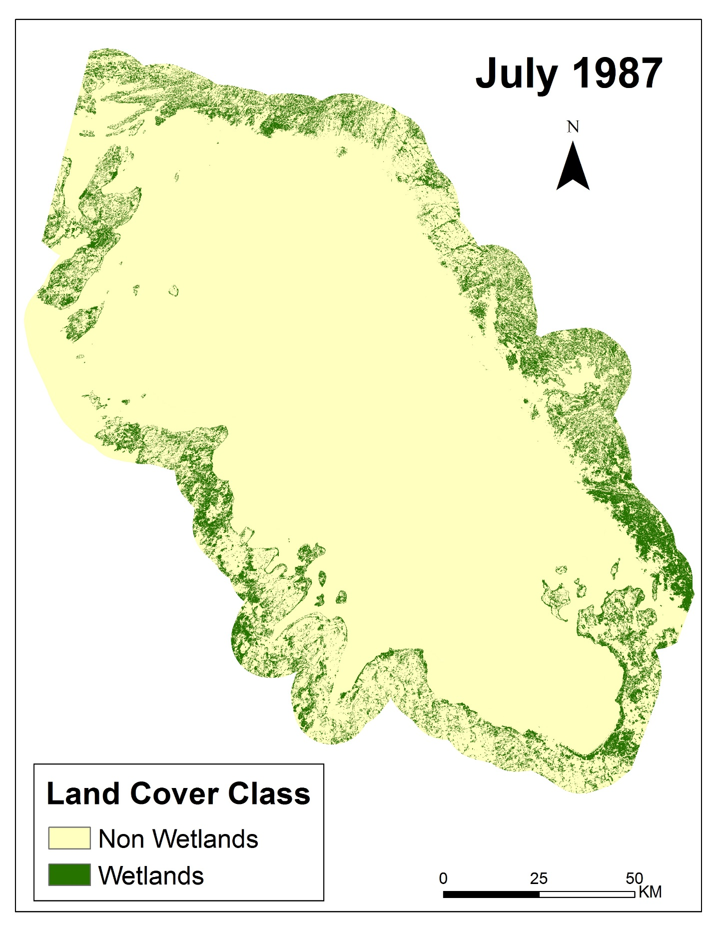

Figure 6. Wetlands vs Non Wetlands map for Georgian Bay in 1987

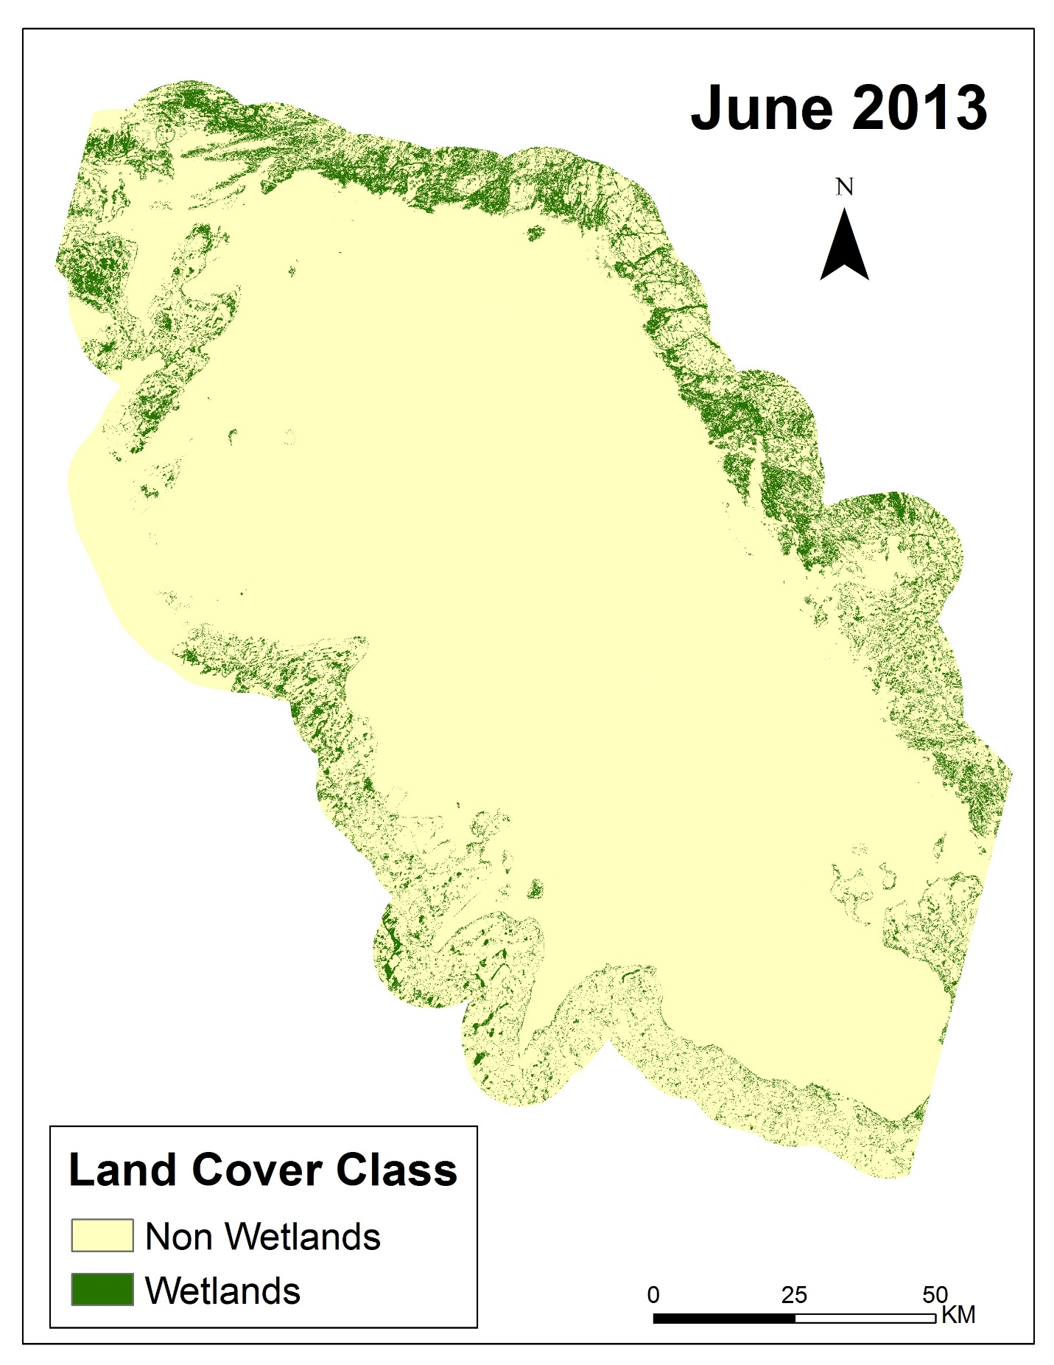

Figure 7. Wetlands vs Non Wetlands map for Georgian Bay in 2013

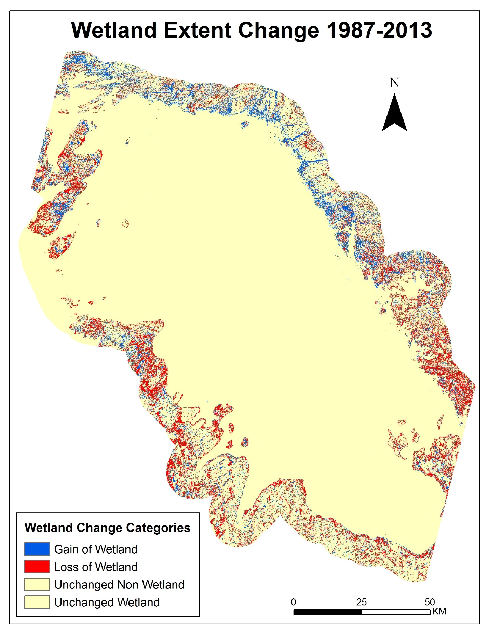

Figure 8. Wetland extent changes for Georgian Bay for the 1987-2013 period

The SOLRIS data were only available for the southern portion of the Georgian Bay (Figure A.4). The comparison of the 2013 Georgian Bay classified map to the 2008 SOLRIS map indicated an overall 64% similarity. The differences could be due to a difference in wetland definition. Other biases include that the SOLRIS data were collected over several years and were published in 2008, where as our classification was a snapshot of the region in 2013, making them not time co-incident. Also, SOLRIS has a much lower resolution of 5000 square meters opposed to the 30-m resolution of Landsat images.

Lake Ontario land cover classification maps for 2007 (Figure 9 and 10) and 2014 are preliminary. Wetlands were over-classified and training sites need of adjusted. The training sites also need to be reevaluated for the 2014 maps (Figure A.5 and A.6). The comparison of the 2007 land cover classification map to the 2006 NOAA C-CAP map indicates overall 62% similarity in classification with an overestimation of wetlands by 4.6% (Figure A.7).

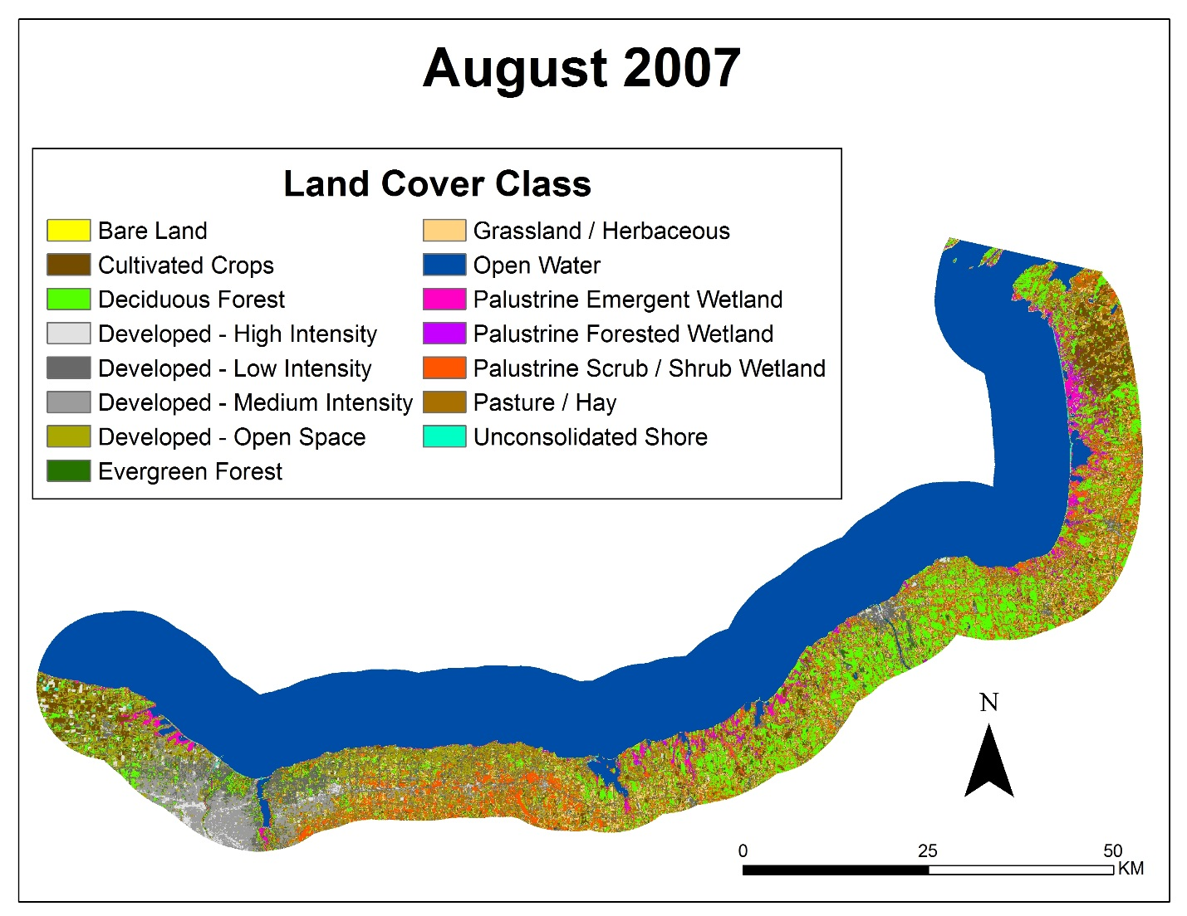

Figure 9. Land cover classification map for Lake Ontario in 2007

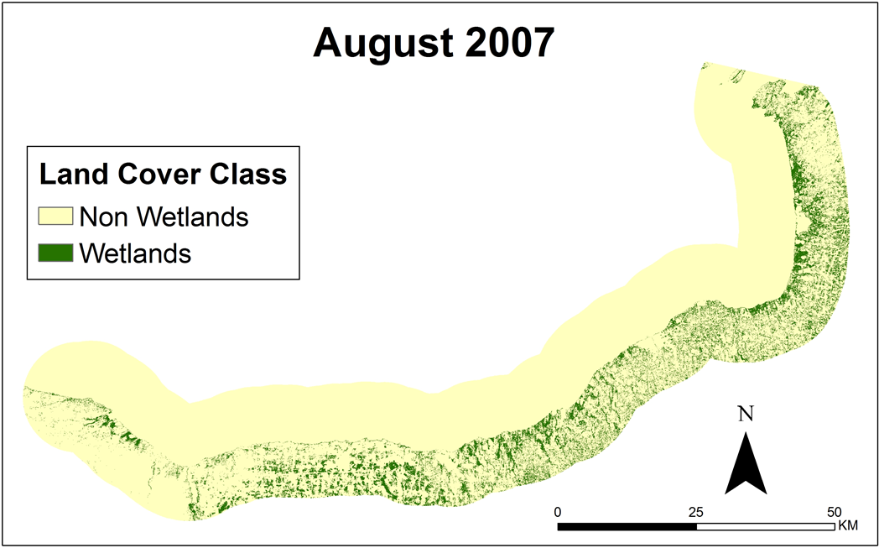

Figure 10. Wetlands vs. Non Wetlands map for Lake Ontario in 2007

# V. Conclusions

This project provides historic and current land cover classification maps for Georgian Bay in Lake Huron that can be used to support management and monitoring strategies for wetlands in the Great Lakes region. The random forest model produced land cover classification maps with confusion rates less than 2%. The incorporation of thermal bands from Landsat, the DEM, and the slope as inputs to the Random Forests Model significantly improved land cover classification. A comparison between SOLRIS and the produced land cover classification maps indicated a 64% agreement between the classification schemes. The differences between the classifications are largely due to a difference in wetland definition. Between 1987 and 2013 there was a 7% gain of wetland areas in northern Georgian Bay but a 10.8% loss of wetlands in southern Georgian Bay. The classified maps for southern Lake Ontario showed overclassification of wetlands. When compared to C-CAP, the classified maps had a 62% agreement. Therefore, a reevaluation of training sites is needed to improve classification. Lake height variations from OSTM/Jason-2 showed strong correlations with in situ water gauge measurements, demonstrating its ability to track water level fluctuations. It is expected that decreasing water levels could affect wetland extent and health (Mortsch, 1998). The methodology developed by this project provides a cost-effective solution to track long-term changes in wetland extent by using NASA Earth observations.

# VI. Acknowledgments

The Great Lakes Climate II team would like to acknowledge Dr. Kenton Ross, James Favors, Nathan Owen, and Jeff Ely for providing guidance and support to conduct this research. We would also like to thank our project partners David Sweetnam, David Ullrich, and Mike Robertson for providing assistance and data for this project. This project was a continuation of the Great Lakes Climate I team. This material is based upon work supported by NASA through contract NNL11AA00B and cooperative agreement NNX14AB60A.

# VII. References

Assel, R. A., F. H. Quinn, and C. E. Sellinger (2004), Hydroclimatic factors of the recent record drop in Laurentian Great Lakes water levels. Bull. Amer. Meteor. Soc., 85, 1143-1151.

Breiman, L. (2001), Random forests. Mach. Learn., 45, 5-32.

Bardecki, M. J. (1991), Wetlands and climate change: a speculative review. Can. Water Resour. J., 16, 9-22.

Canada Department of Fisheries and Oceans (2014), Historical monthly and yearly mean water level graphs 1918-2013 [Available online at http://waterlevels.gc.ca/C&A/netgraphs-eng.html].

Chow-Fraser, P. (1998), A conceptual ecological model to aid restoration of Cootes Paradise Marsh, a degraded coastal wetland of Lake Ontario, Canada. Wetl. Ecol. Manag. , 6, 43-57.

Chow-Fraser, P., V. Lougheed, V. Le Thiec, B. Crosbie, L. Simser, and J. Lord (1998). Long-term response of the biotic community to fluctuating water levels and changes in water quality in Cootes Paradise Marsh, a degraded coastal wetland of Lake Ontario. Wetl. Ecol. Manag., 6, 19-42.

Cvetkovic, M., and P. Chow-Fraser (2011), Use of ecological indicators to assess the quality of Great Lakes coastal wetlands. Ecol. Indic., 11, 1609-1622.

Herdendorf, C.E. (2004), Morphometric factors in the formation of Great Lakes coastal wetlands. Aquat. Ecosyst. Health & Manage., 7, 179-197.

Keddy PA, and AA. Reznicek (1986), Great lakes vegetation dynamics: the role of fluctuating water levels and buried seeds. J. Gt. Lakes Res.,12, 25-36.

Li J., and W. Chen (2005), A rule-based method for mapping Canada’s wetlands using optical, radar and DEM data. Int. J. Remote. Sens. 26, 5051-5069.

Mcleod, E., G.L. Chmura, S. Bouillon, R. Salm, M. Bjork, C.M. Duarte, C.E. Lovelock, W.H. Schlesinger, and B.R. Silliman (2011), A blueprint for blue carbon: toward an improved understanding of the role of vegetated coastal habitats in sequestering CO2. Front. Ecol. Environ., 9, 552-560.

Midwood, J., D. Rokitnicki-Wojcik, and P. Chow-Fraser (2012), Development of an inventory of coastal wetlands for eastern Georgian Bay, Lake Huron. ISRN Ecology 2012, 1-13.

Mortsch, L.D. (1998), Assessing the impact of climate change on The Great lakes shoreline wetlands. Climatic Change, 40, 391-416.

——, and F.H. Quinn (1996), Climate change scenarios for Great Lakes Basin ecosystem studies. Limnol. Oceanogr., 41, 903-911.

——, H. Hengeveld, M. Lister, L. Wenger, B. Lofgren, F. Quinn, and M. Slivitzky (2000), Climate change impacts on the hydrology of the Great Lakes-St. Lawrence system. Can. Water Resour. J., 25, 153-179.

Sellinger, C.E., C.A. Stow, E.C Lamon, and S.S. Qian (2008), Recent water level declines in the Lake Michigan-Huron System. Environ. Sci. Technol., 42, 367-373.

Whillans, T. (1982), Changes in marsh area along the Canadian shore of Lake Ontario. J. Gt. Lakes Res., 8, 570-577.

Whillans, T. (1996), Historic and comparative perspectives on rehabilitation of marshes as habitat for fish in the lower Great Lakes basin. Can. J. Fish. Aquat. Sci., 53, 58-66.

Wilcox, D. A. and Y. Xie, (2007), Predicting wetland plant community responses to proposed water-level-regulation plans for Lake Ontario: GIS-based modeling. J. Gt. Lakes Res., 33, 751-773.

# VIII. Appendix A

# 

1992

1998

2003

2009

2014

R2 = 0.94

Figure A.1 Water levels in Rochester, NY and Lake Ontario for the years 1992-2014

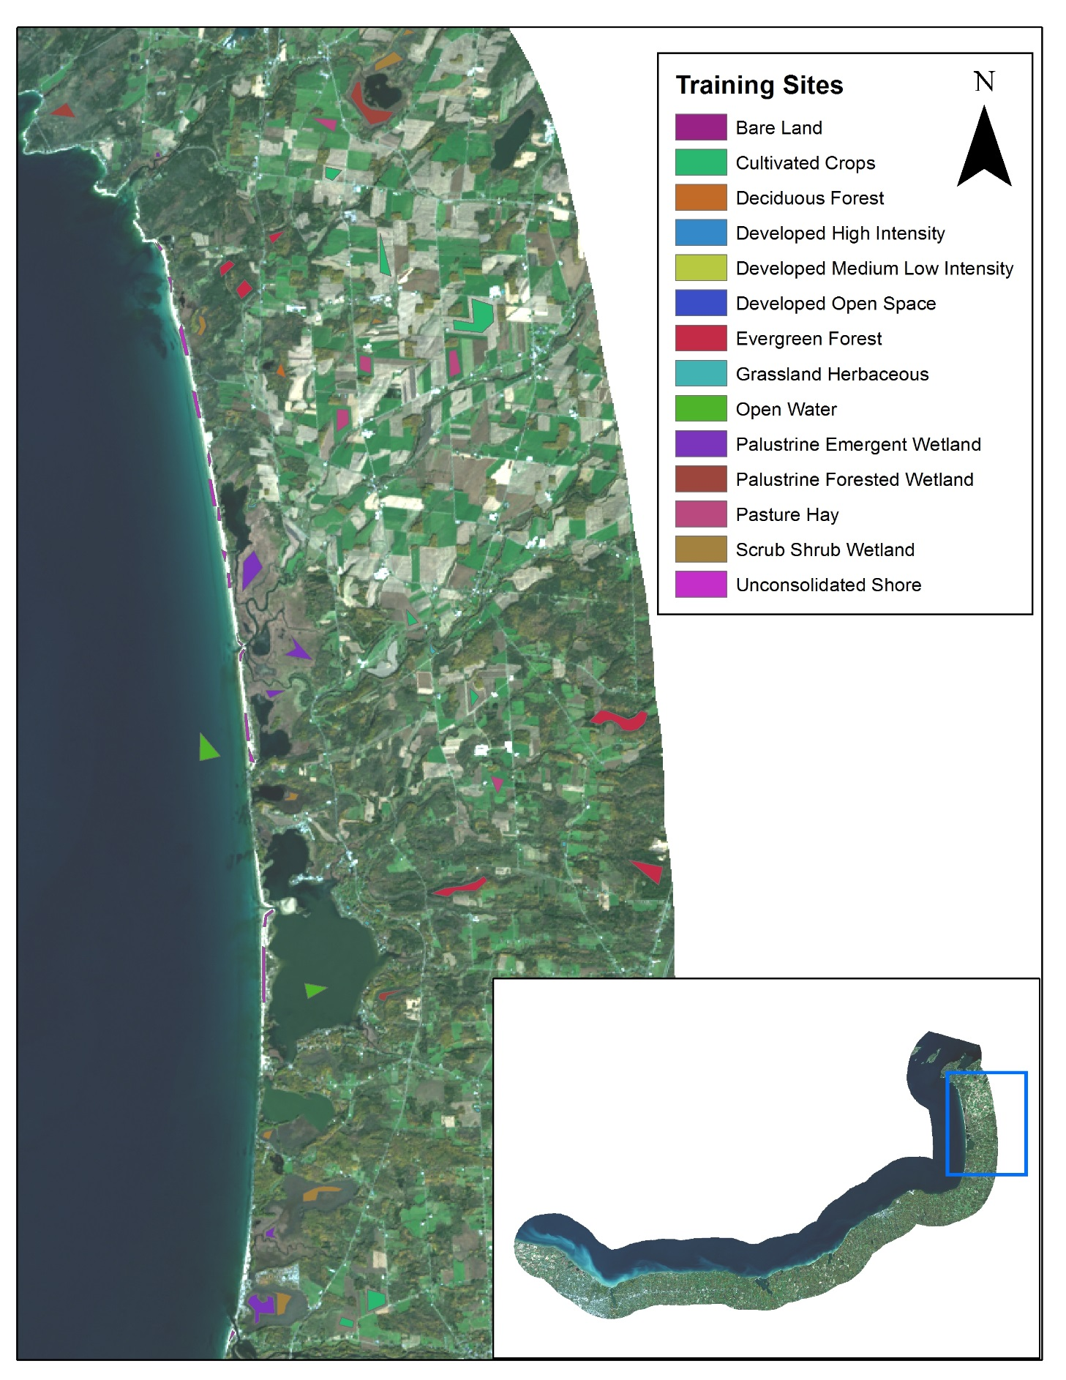

Figure A.2 Training sites selection for southern Lake Ontario.

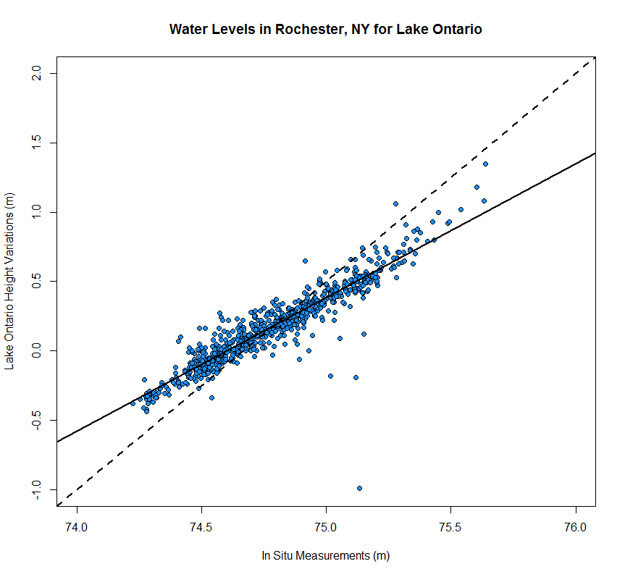

Figure A.3. Scatter plot using TOPEX/Poseidon Jason 1 & 2 Lake Ontario height variations and *in situ* water gauge measurements from Rochester, NY.

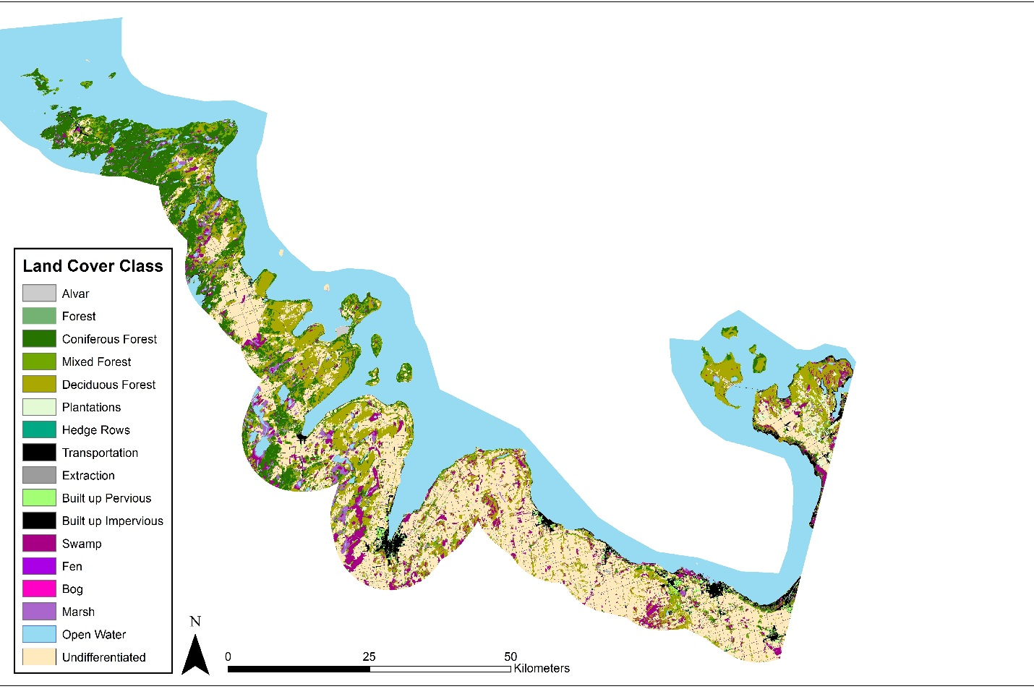

Figure A.4. SOLRIS land cover classification for the southern portion of Georgian Bay, Ontario.

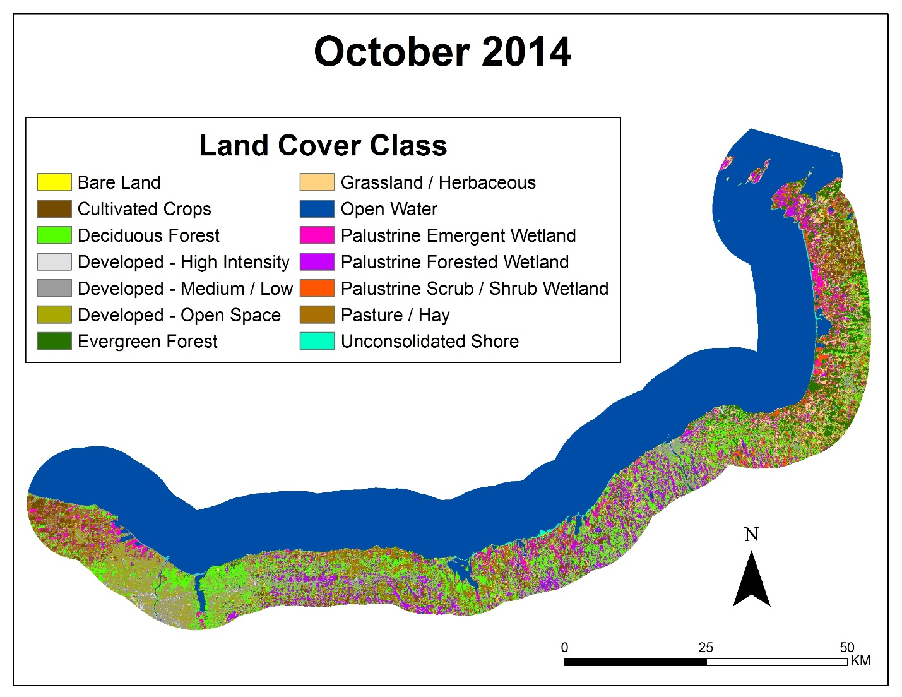

Figure A.5. Land cover classification for the southern portion of Lake Ontario.

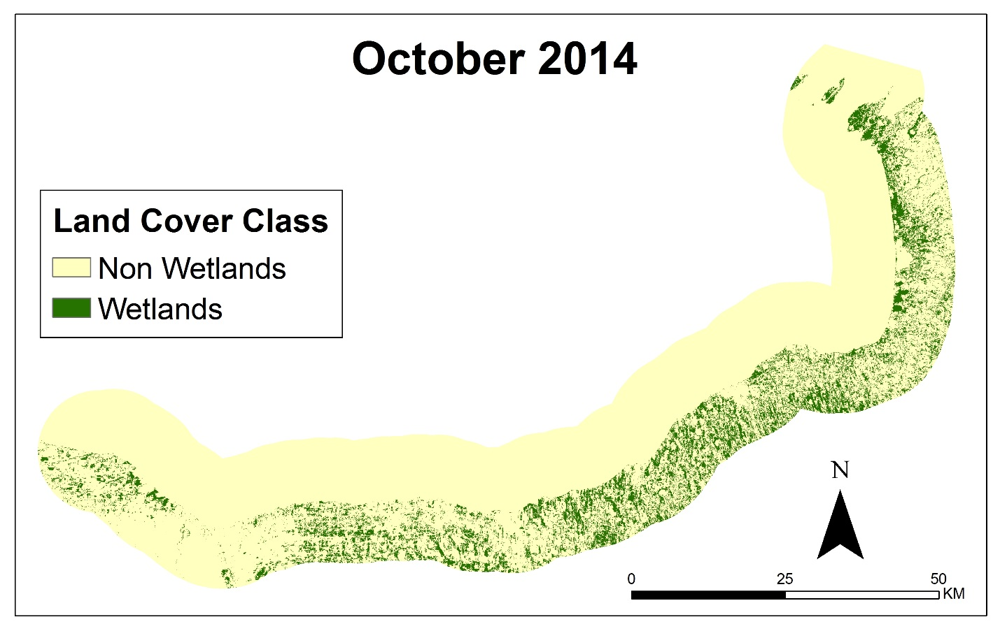

Figure A.6. Reclassified wetland, non wetland map for the southern portion of Lake Ontario.

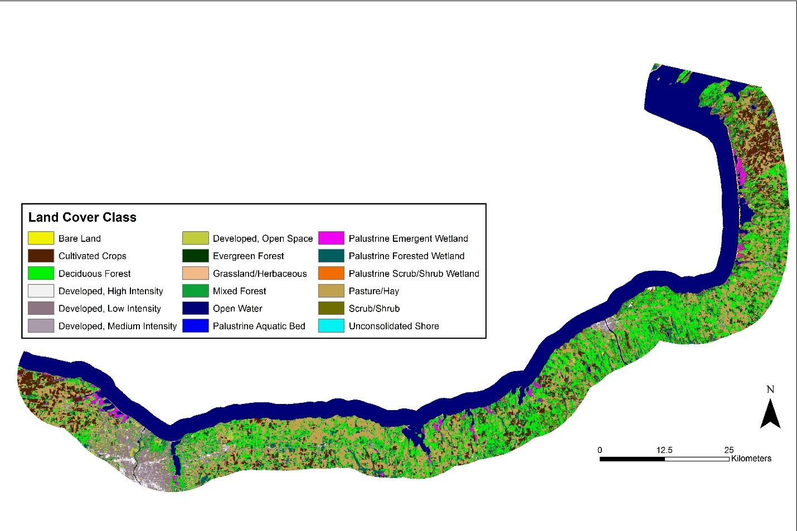

Figure A.7. NOAA C-CAP land cover classification for the southern portion of Lake Ontario.