**NASA DEVELOP National Program**

DEVELOPNASA Langley Research Center

**Spring 2015**

**Virtual Poster Session Wave 1 Submission**

**DEVELOP Short Title:** CALIPSO Health & Air Quality

**Team Location:** Langley Research Center – Hampton, Virginia

**Project Lead & Email:** Jordan Vaa, jordan.s.vaa@nasa.gov

**VPS Title:** Selecting and Classifying CALIPSO Data Elements for Future Use

**Image:** 2015Spring_LaRC_CALIPSO_VPSw1_image.png

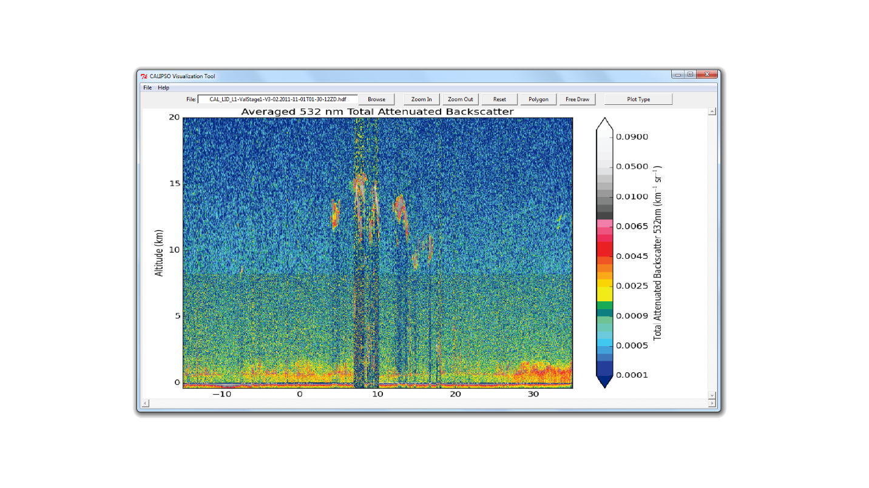

**Caption:** The updated GUI for the CALIPSO Visualization tool in action.

**Squib:** This project was done in order to extend the usefulness of CALIPSO data, by allowing researchers to easily share findings and data between one another. Utilizing internet and image processing software to build a database of useful data elements.

**Video Style**: We are going for a technical theme, thus our video will mostly be focused on computers and as well as the programs running on the computer. The opening will show the CALIPSO satellite with the CALIOP Lidar firing (We will include a citation). From there we will introduce the team and then introduce the community concerns. From there we will introduce our program and give a step through of its running. We will show how to access our tool, how to load an HDF file, and then how to plot the image from there. From here the video will end.

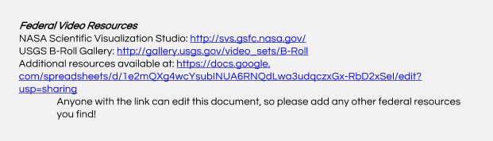

**Things to include in the video, other than the lead in and closing clips, the order of inclusion is entirely up to the team:**

Mandatory Lead in: DEVELOP Intro clip (available on the Exchange at: Start > Earthzine – Virtual Poster Sessions > Video Opening & Closing Clips)

Video Opening: Introduce team members. We will give our names as well as have them appear at the bottom of the screen.

Collaborators & End-Users:

* The CALIPSO Science team is the end user

Here we will explain who Chip is and what the CALIPSO does.

Community Concerns:

* Updating the Current tool/ Translating it into Python
* Enabling support for future connection to database

Here we will explain what our project is and why we are doing it, we will explain the IDL PDF_Harverster, and the issues with it, as well as what we have done to address them.  
After we explain the what and the why of the tool, we will give a technical demo, showing our tool as well as its various functionalities.  
We will explain which functions we have not yet implemented as well as why we decided to leave them out this term. From here we will explain our projected goals for improving them tool as well as how we expect our work to aid in this endeavor

Mandatory Video Closing: DEVELOP closing clip (available on the Exchange at: Start > Earthzine – Virtual Poster Sessions > Video Opening & Closing Clips)