**NASA DEVELOP National Program**



Wise County Clerk of Court’s Office

*Summer 2014*

Appalachian Energy I

NASA Earth Observation Detection of Burned and Blighted Areas for Creation of an Unhealthy Forest Index to Prioritize Forest Harvest for Biofuel Production

 **Technical Report**

August 6, 2014

Dieudonne Dusenge, Mountain Empire Community College (Project Lead)

Asongayi Venard, East Tennessee State University

Andrew Foxx, Radford University

Jessica Huff, Mountain Empire Community College

Rohini Swaminathan, Mountain Empire Community College

Dr. Kenton Ross, NASA DEVELOP National Program (Science Advisor)

# Abstract

The Appalachian Mountains are known for their extensive natural forest cover. However, these forests are under pressure from human activities such as residential development, agriculture and logging. The forests are also increasingly affected by forest fires, invasions of pests such as the gypsy moth and hemlock woolly adelgid and other natural factors. In addition, biomass energy production destroys a large amount of healthy trees. During the last 20 years, tens of thousands of acres of natural forest have been logged, many of them replanted as pine tree plantations (2). As a result of these threats, ecosystems are collapsing and species are being rendered extinct. This project utilized data from Landsat 8, Operational Land Imager (OLI) for forest monitoring to derive indices like Normalized Differential Vegetation Index (NDVI) and Relative Differenced Normalized Burn Ratio (RdNBR) to identify unhealthy forests. Pan sharpened Landsat 8 images provided targeted higher resolution analyses for areas demonstrated by Aqua and Terra’s Moderate Resolution Imaging Spectroradiometer (MODIS). The areas show locations that potentially could be harvested. MODIS provided vegetation dynamics and phenology products, along with fire-related datasets like fire occurrences and scarring. In Partnership with the U.S. Forest Service, Wise County and the Virginia Department of Agriculture and Forestry, this project facilitated the use of NASA Earth observations to identify unhealthy forests in this region.

**Keywords**

Remote Sensing, Biomass Fuel, forest fire, gypsy moth, hemlock woolly adelgid, MODIS, Landsat

# Introduction

The Appalachian Mountains are a system of mountain ranges in eastern North America. They extend from Georgia and Alabama in the United States to as far north as Newfoundland in Canada. These Mountains are known for their natural beauty and their natural forests. Nowadays, the forests are under threat from wildfires, diseases and pests. In addition to these natural factors, urbanization, recreation, logging, and biomass energy production are also destroying healthy trees. This project’s objective was to utilize NASA Earth observations to detect recently burned forest and forest that contained active blight to prioritize harvest of timber stocks on public lands in order to decrease fuel load and fire risk, and create biofuels to meet energy needs.

The US Forest Service (USFS) identifies four threats to the health of the Nation’s Forests and Grasslands: fire and fuels, invasive species, loss of open space, and unmanaged recreation. Synoptic analysis that monitors and detects unhealthy forest areas can provide industries with optimal material for creation of new biofuel technologies. There is a need for a system to locate unhealthy forest and prioritize areas to harvest dead trees. USFS actively monitors each of the four threats through a variety of methodologies that make use of NASA Earth observations. It conducts multiple activities related to forest health such as forest health indices, fire risk assessments, disease and insect mapping through remote sensing. However, it does not combine them into a comprehensive forest index aimed at pinpointing areas to target on public lands for biofuel production. The Virginia Department of Forestry currently carries out forest surveys and monitors forest health in cooperation with the USFS through annual evaluations of 100 permanent forest plots established throughout the state.

The study area for this project was the forests of the Central Appalachian Mountains in the states of North Carolina, Virginia, West Virginia, Kentucky and Tennessee over a ten year period from June 2004 June 2014. This project addressed three NASA national application areas: energy – through the identification of biomass fuels, ecological forecasting – via the study of vegetation species, and disasters – by the identification of forest fires and other pests. The research team partnered with Wise County and the US Forest Service. Unhealthy forest index will help the project partners to identify and prioritize timber harvest. This will lead to reduced deforestation of healthy land cover and also increase biofuel production efficiency.

# III. Methodology

**Data Acquisition:**

*NASA’s Earth Observations*

Data from Landsat 8, Operational Land Imager (OLI) and Landsat 5, Thematic Mapper (TM) was acquired from the United States Geological Survey’s (USGS) Earth Explorer database. The obtained Landsat 5 data was from 2004 to 2014, and Landsat 8 data was from 2012 to 2014. This data was used for land cover and vegetation analysis. Furthermore, data from Aqua/Terra’s Moderate Resolution Imaging Spectroradiometer (MODIS) was acquired. MYD13Q1 was acquired from Earth Explorer as well. MODIS hotspots were downloaded for the time period 2000 to 2012 from EOSDIS (NASA’s EOS Data and Information System) – FIRMS (Fire Information for Resource Information System) website as shape files.

*Ancillary (in-situ) Data Products*

A number of ancillary data products were obtained from the US Forest Service. These included the Burned Area Reflectance Classifications (BARC), forest types, USDA Forest Health Protection Mapping and Reporting’s Disease and Insect Conditions Maps and reports, and ForWarn satellite-based forest disturbance assessment maps and data for the conterminous US. The National Land Cover Datasets were also obtained.

**Data Processing**

Several vegetation indices have been developed over the years to investigate the growth of vegetation using satellite data (Koruyan *et al*.). In this regard, to identify changes brought by forest fires, pests and other factors, the following three indices were computed: Normalized Difference Vegetation Index (NDVI), Normalized Difference Water Index (NDWI) relative difference Normalized Burn Ratio (NBR). All the data used in this project was processed using Python scripts and ArcGIS. Figure 1 is a flow chart of how the acquired data was processed with respect to different indexes in order to determine the extent of dead forest.

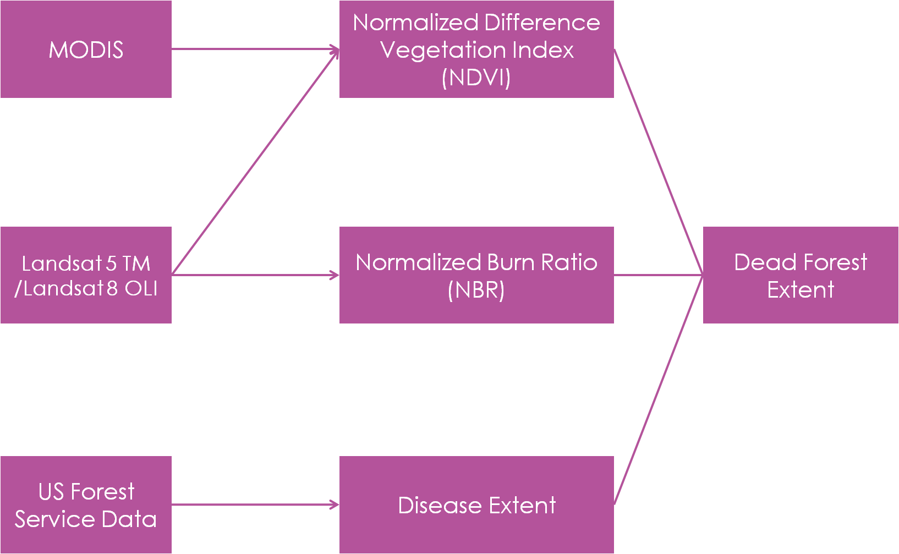

Figure 1: Flowchart of the data processing

1. **Normalized Difference Vegetation Index**

Both MODIS and Landsat data was used for NDVI calculations. For MODIS, NDVIis already processed and readily available in the MDY13Q1 dataset. For Landsatdata, NDVI was calculated in order to compare with MODIS. Since Landsat has a better spatial resolution, more changes could be easily observed.

MDY13Q1 was obtained and processed using the MODIS Reprojection Tool (MRT). All the resulting layers were cropped to the identified study area, which is the Appalachian portion of the five states. To analyze the change over the years, before and after NDVI images were subtracted and change analysis was computed. The change analysis studies were conducted in order to identify differences in vegetation that could have been brought by forest fires or diseases. This helped pinpoint areas of interest that were prone to defoliation. These areas were focused on in subsequent Landsat calculations.

***Eq. 1***

$$Change=\frac{Index before-Index after}{Index before}$$

The study area is very large and covers more than 30 Landsat tiles. This number of tiles in a 10 years study period presents a significant problem: the data is enormous and needs to be streamed down in order to focus on the most suitable data. Consequently, MODIS data was used to identify locations of interest. For the selected tiles, NDVI for Landsat 5 TM and Landsat 8 OLI raster was calculated. NDVI uses red (B3 for Landsat 5, and B4 for Landsat 8) and near infrared (B4 for Landsat 5, and B5 for Landsat 8) bands. The following equations were used to calculate Landsat 5 NDVI and Landsat 8 NDVI:

$$Lansat 5 NDVI=\frac{B4-B3}{B4+B3}$$

***Eq. 2***

$$Lansat 8 NDVI=\frac{B5-B4}{B5+B4}$$

After the NDVI calculations, equation 1 was used for the change analysis.

1. **Normalized Difference Water Index**

NDWI is an index that identifies areas of high water concentration. Trees with leaves have a high NDWI compared to defoliated trees because green and fresh leaves have high water content. NDWI was used to verify the accuracy of NDVI values. This water index was computed as follows:

***Eq. 3***

$$NDWI=\frac{B4-B5}{B4+B5}$$

After calculating NDWI for every year, equation 1 was used for the change analysis.

1. **Normalized Burn Ratio (NBR)**

MODIS hotspots were used to identify areas affected by forest fires. A high concentration of hotspots indicated a high likelihood that a fire had occurred in the hotspots area. Considering that there are not a lot of forest fires in Central Appalachia, it was necessary to know the areas to focus on so as to identify areas where most suitable Landsat 5 data had to be downloaded and the NBR calculated.

Level 1 data from Landsat obtained for each area was processed in ArcGIS to obtain the burn scar maps. Normalized Burnt Ratio (NBR) Index was derived using Band 4 and Band 7 data (7, 8, 9, 10). The Normalized Burn Ratio (NBR) indicates burnt areas and indexes the severity of a burn using Landsat 5 TM imagery. The formula for the NBR uses near-infrared band 4 (B4) and the short-wave infrared band 7 (B7):

***Eq. 4***

$$NBR=\frac{B4-B7}{B4+B7}$$

# IV. Results & Discussion

The MODIS NDVI difference maps show changes in vegetation over the last ten years. In this research, major negative changes in NDVI show degradation or complete destruction of forest cover resulting from the three causes of the death of trees that were studied, namely, gypsy moth infestation, hemlock woolly adelgid and forest fires.

**Gypsy Moth Infestation**

Figure 2 shows MODIS NDVI change resulting from infestation by the gypsy moth between 2004 and 2008 in a forest area in West Virginia and Virginia.

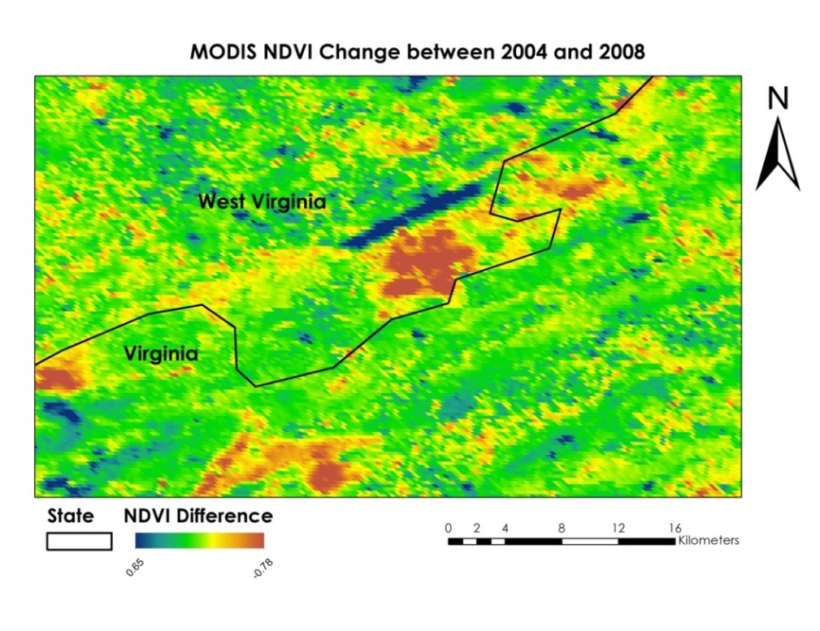

Figure 2: NDVI changes between 2004 and 2008.

Changes such as the ones observed in Figure 2 were used to locate where to focus the Landsat analysis. Figure 3 shows one such area affected by gypsy moth in 2013.

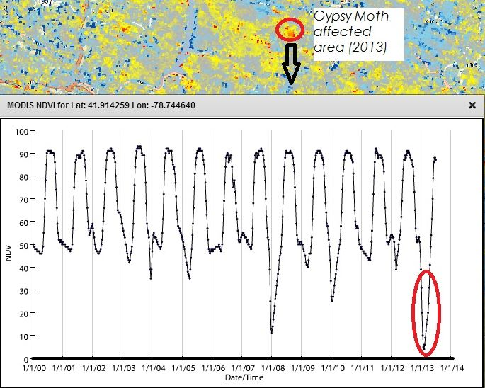

Figure 3: Graph computed using data from ForWarn shows loss of vegetation. Drops in NDVI values in 2008 and 2013 coincide with known gypsy moth infestations.

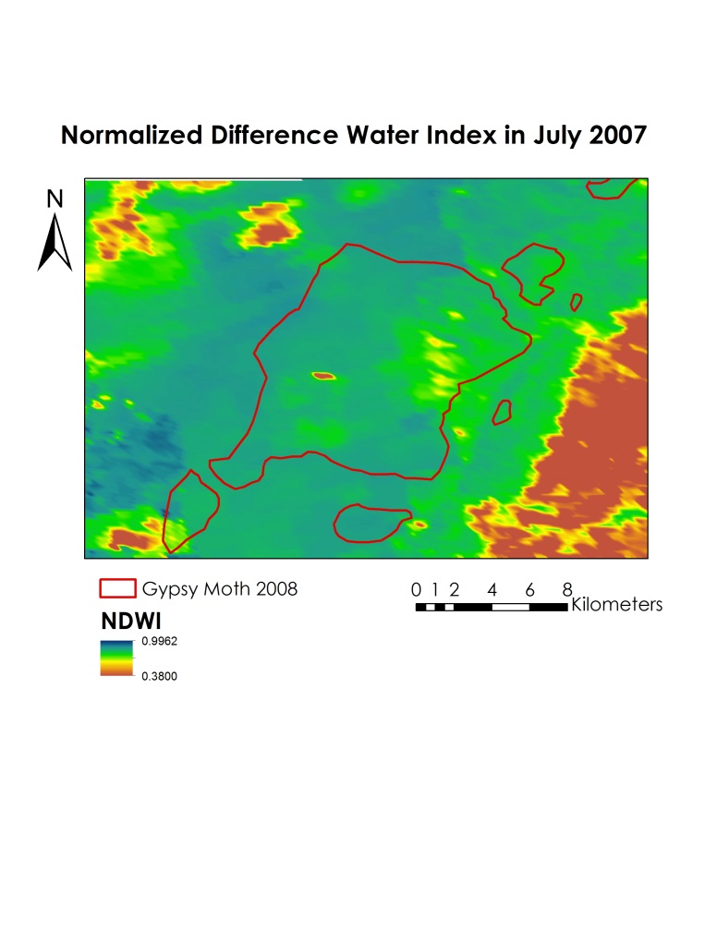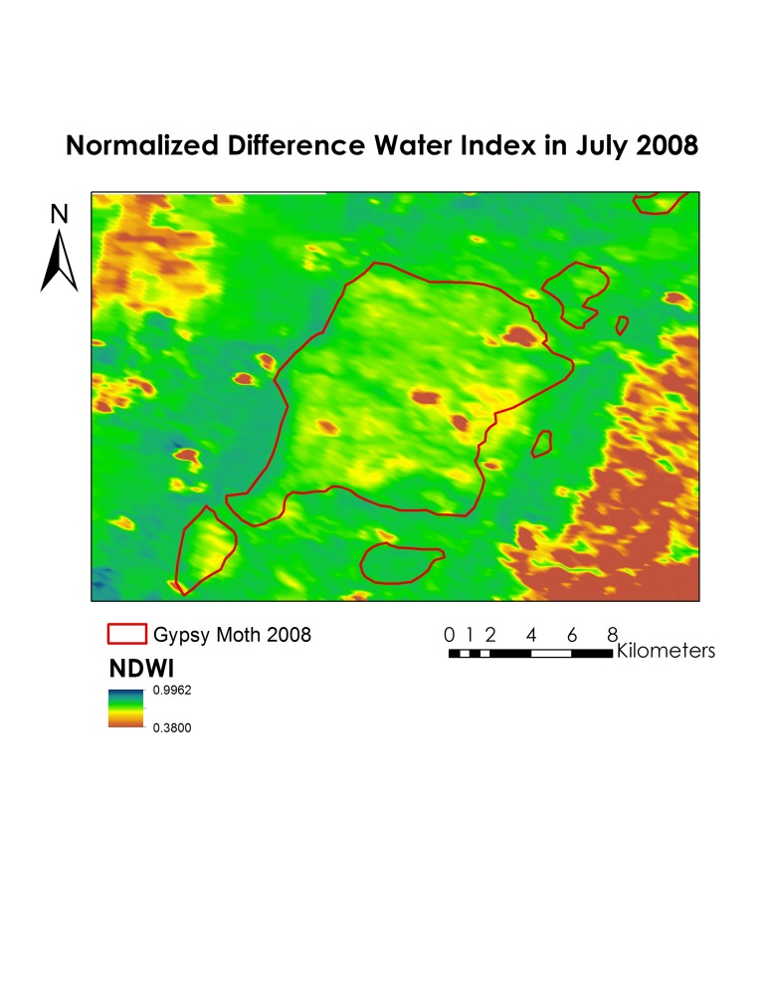

Figure 4: July 2007 and July 2008 NDWI of an area near Blacksburg, Virginia, computed using Landsat 5 TM data. The red boundary shows a forest area affected by the gypsy moth infestation of 2008 (data obtained from US Forest Service).

To identify the areas affected by pests such as the gypsy moth and the hemlock wooly adelgid, NDVI and NDWI were calculated (3). For the gypsy moth, defoliation can be observed as shown in Figure 4. An NDWI negative change indicates area affected by defoliation, while a positive change shows an improvement in the vegetation cover. The smaller the change, the more pronounced the defoliation. On site extent of the infestation obtained from the US matches the defoliation shown by NDWI changes.

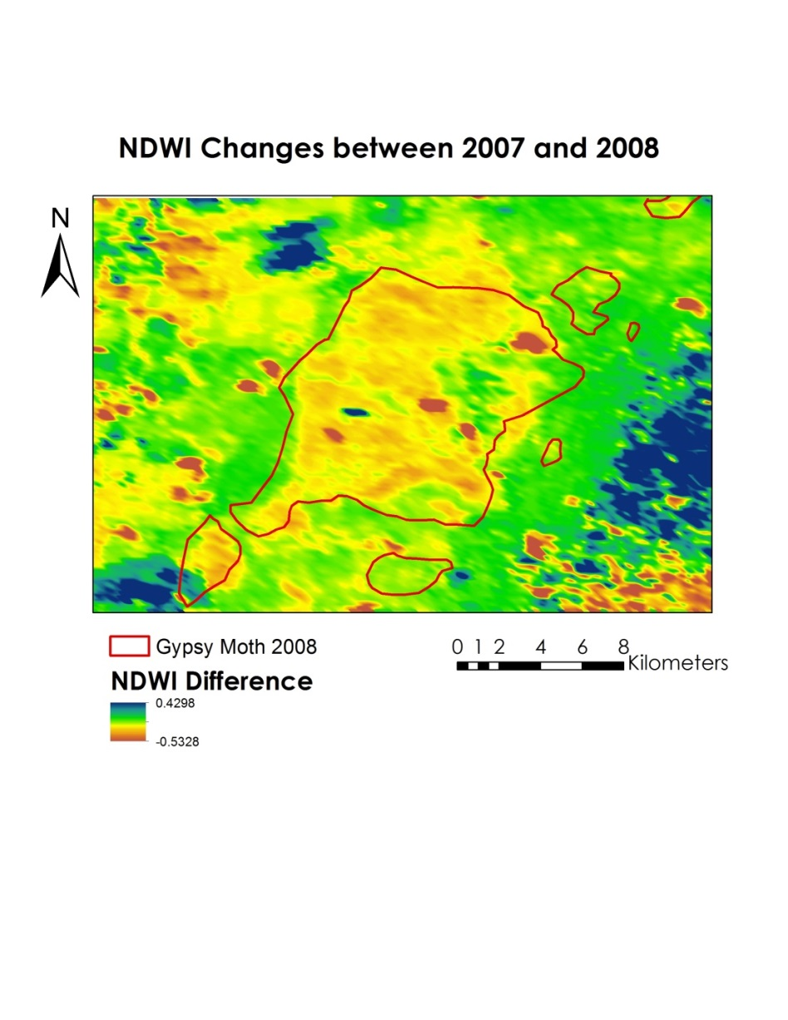

Figure 5: Changes in NDWI between 2007 and 2008 in a forest area in Virginia.

**Hemlock Wooly Adelgid**

Differences in NDVI between 2003 and 2013 were used to identify areas affected by the hemlock wooly adelgid. These NDVI changes were consistent with onsite observations. Figure 6 shows Landsat 5 NDVI change from 2003 to 2013 of a forest area in North Carolina that had been affected by the hemlock wooly adelgid.

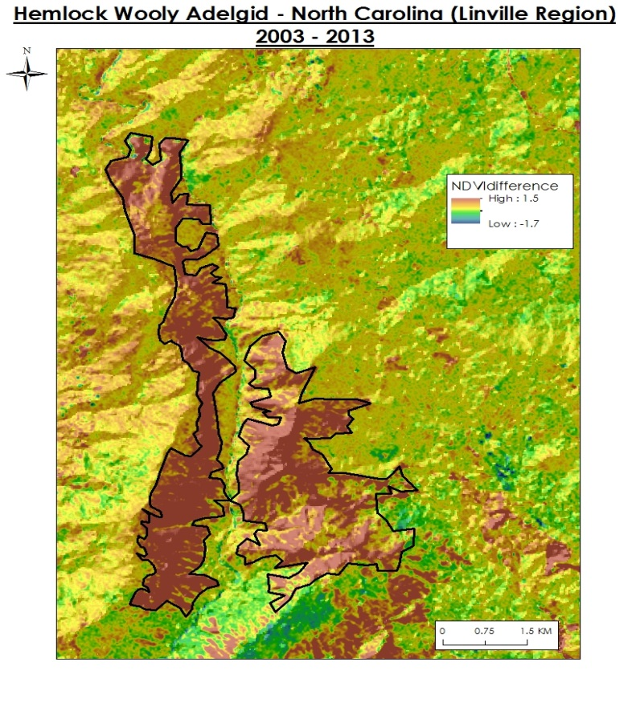

Figure 6: Landsat 5 NDVI change of an area affected by the hemlock wooly adelgid near Linville, NC

**Forest Fire:**

MODIS hotspots were used to identify regions likely affected by forest fires as shown in Figure 7. NBR was then calculated from Landsat 5 TM. The defoliation effect that forest fires had on forest in the study area was determined by how high the NBR was (Figure 8). There are not any large fires in Central Appalachia. The partners wanted areas larger than 3000 acres of dead wood for lucrative harvest. However over the study period, only smaller fires could be identified.

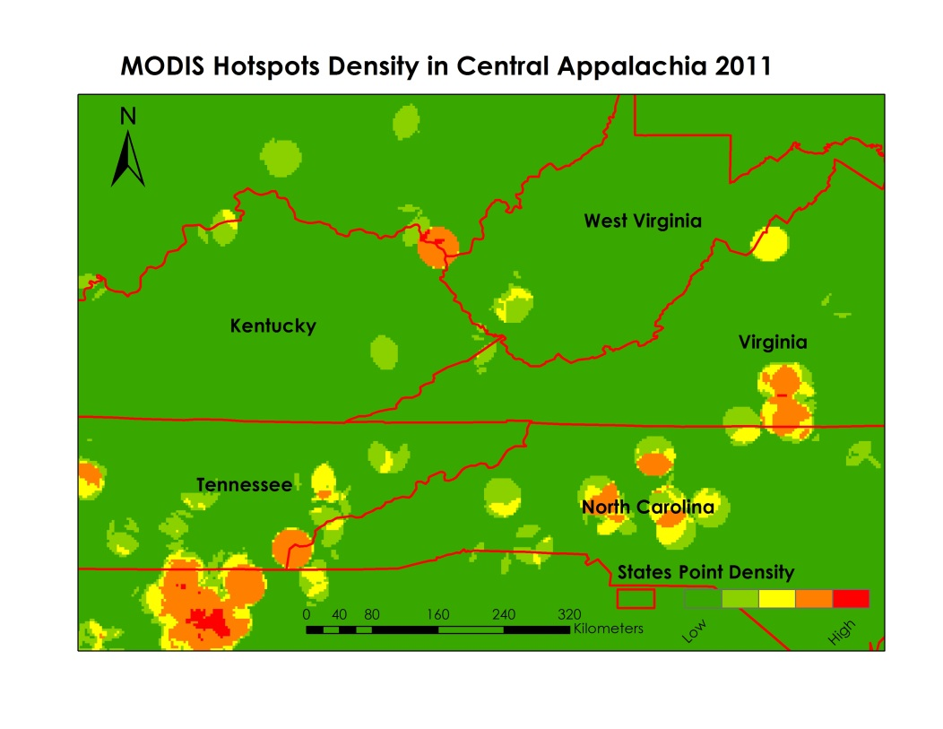

Figure 7: MODIS Hotspots density showing the likelihood of a fire occurrence

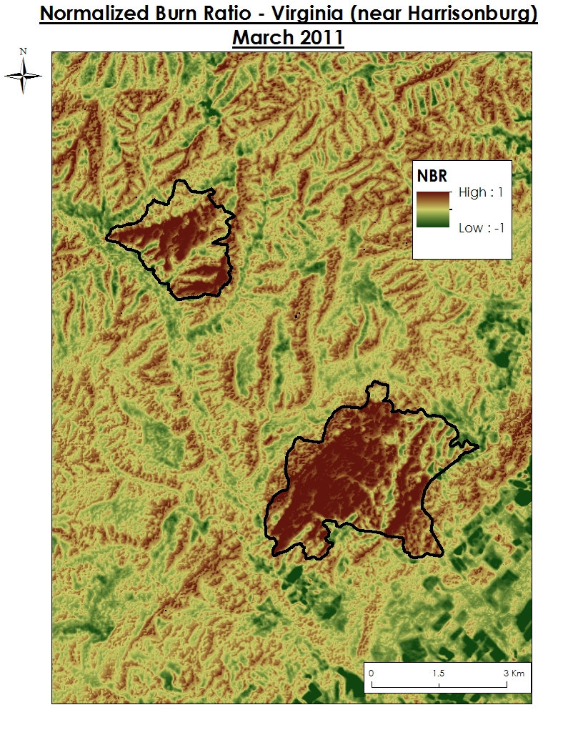

Figure 8: Normalized Burn Ratio from Landsat 5 TM showing an area of dead forest.

**Errors & Uncertainty**

Landsat images have extensive cloud cover and it was a challenge to find a focus area that did not have extensive cloud cover during the study period. In some locations, an extensive cloud cover in Landsat data made it impossible to observe the changes. The study was also limited by a number of other factors. One of these factors is that the presence of defoliation does not necessarily imply that dead trees are still standing in that area. Other uncertainties occurred mainly because changes in indices could also indicate complete destruction of a forest due to several factors such as mining, construction and other commercial activities. In this case, there would not be any dead wood.

**Future Work**

The main obstacle in this project was the extensive cloud cover in Landsat images. One consideration for the phase of the project is to use the STARFM model which fuses MODIS and Landsat data to give images high in both temporal and spatial resolution.

The team also will develop a tool that will help end users remotely identify areas that contain a high concentration of dead wood using NASA Earth Observations.

# V. Conclusions

This study focused on using data from NASA Earth observation systems to identify forest areas in the southeast Appalachian region that have been defoliated. Focusing on three main causative agents of tree death in the study area, namely, gypsy moth, hemlock woolly adelgid and forest fires, and calculating changes in vegetation indexes such as NDVI, NDWI and rdNBR from 2004 to 2014, some defoliated forest areas were identified. These areas may contain dead wood due to defoliation. The presence of cloud covers in some of the images that were downloaded negatively affected the suitability some of the data. Consequently, it will be necessary to explore the possibilities of field verification and accuracy assessment of MODIS data using Landsat by using STARFM. The results from this project will help our partners to identify unhealthy forests or dead wood for bio fuel production. This will substantially decrease the deforestation of healthy forests and also increase fuel production efficiency. Removing blighted trees will help curb the spread of the pests.

# VI. Acknowledgments

The team would like to acknowledge Dr. Kenton Ross, the NASA DEVELOP National Science Advisor for his continued insights on the project. We would like to thank Dr. Gary Hooper the CEO of EnviraCarbon Inc. for his support and guidance throughout the project. We would also like to extend our appreciation to Hon. Jack Kennedy, Clerk of Court and Ms. Melanie Salyer for their support throughout the duration of this project.

# VII. References

1. Bütler Sauvain, Rita. *Dead Wood In Managed Forests: How Much And How Much Is Enough?* Thesis. École Polytechnique Fédérale de Lausanne, 2003.
2. Evans, Alexander M. *Ecology of Dead Wood in the Southeast.* Forest Guild, 2012
3. Gitelson, Anatoly A., and Merzlyak, Mark N., “*Signature Analysis of Leaf Reflectance Spectra: Algorithm Development for Remote Sensing Chlorophyll*”, J. Plant Physiol. Vol 148, pp 494-500, 1996
4. Hussin , Yousif Ali , Matakala, Mutumwa, and Zagdaa, Narangeral, “*The Applications Of Remote Sensing And Gis In Modeling Forest Fire Hazard In Mongolia*” *The International Archives of the Photogrammetry, Remote Sensing and Spatial Information Sciences. Vol. XXXVII. Part B8. Beijing 2008*
5. K.M. de Beurs, P.A. Townsend, “*Estimating the effect of gypsy moth defoliation using MODIS*” Remote Sensing of Environment 112
6. Wang, Junming, Sammis, Ted W., and Gutschick , Vince P. “*Review of Satellite Remote Sensing Use in Forest Health Studies*” The Open Geography Journal, 2010, 3, 28-42
7. Chander, Gyanesh et al; *Summary of current radiometric calibration coefficients for Landsat MSS, TM, ETM+ and EO-1 ALI sensors.*
8. Eidenshink, Jeff et al; *A Project for Monitoring Trends in Burn Severity.*
9. Miller, Jay and Thode, Andrea; *quantifying burn severity in a heterogeneous landscape with a relative version of the delta Normalized Burn Ratio.*
10. Miller, Jay et al*; Calibration and validation of the relative differenced Normalized Burn Ration (RdNBR) to three measures of fire severity in the Sierra Nevada and Klamath Mountains, California, USA.*