NASA DEVELOP National Program
Marshal Space Flight Center
Fall 2013

Alabama Agriculture

Mapping Irrigation to Improve Input Data and model Evaluation for NASA Driven Crop-Hydrology Models

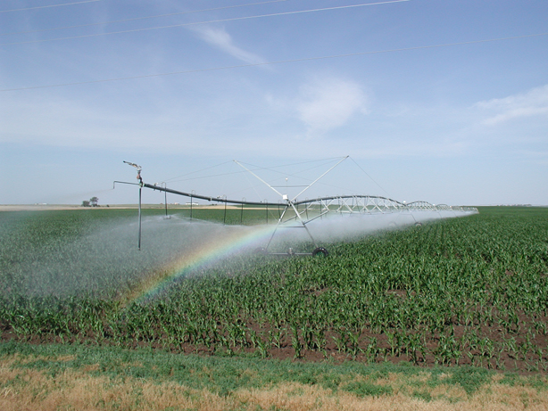

Casey L. Calamaio, University of Alabama in Huntsville (UAH)
Samuel Ayers, University of Alabama in Huntsville (UAH)
Kyle Pennington, University of Alabama in Huntsville (UAH)

Dr. Jeff Luvall, Global Hydrology Climate Center (GHCC) (Science Advisor)
Dr. Richard McNider, University of Alabama in Huntsville/Earth System Science Center (UAH/ESSC) (Science Advisor)
Dr. Rob Griffin, University of Alabama in Huntsville/Earth System Science Center (UAH/ESSC) (Science Advisor)
Mr. Cameron Handyside University of Alabama in Huntsville/Earth System Science Center (UAH/ESSC) (Science Advisor)
Contents
Abstract 2
Introduction 3
Methodology 5
Data Acquisition…………………………………………………………………………….….5
Data Processing…………………………………………………………………………….…..6
1. Initial Observation and Acquisition…………………………………………..….6
2. Statistical Analysis…………………………………………………………………..6
3. Feature Extraction……………………………………………………………….…7
Results & Discussion 7
Conclusion 14
Acknowledgments 15
Works Cited 15
Appendices 16

Abstract

Compared to neighboring states, Alabama has very little contribution of irrigation for crop management, according to the 2007 USDA National Agricultural Statistics Service (NASS) Agricultural Census. A real-time crop model, Grid Decision Support System for Agro-technology Transfer (GriDSSAT) driven by NASA Earth observation data was developed to improve drought delineation and calculate irrigation demand. A coupled crop/hydrology model for the Southeast region of the United States is designed for use by agricultural stakeholders to more accurately monitor and manage watershed health. The model helps facilitate more sustainable water usages by delineating impacts of irrigation and other stresses on sources of freshwater. Mapping irrigation acreage in northern Alabama and southwest Georgia determines irrigated cropland acreage for improved estimates of agricultural consumption of freshwater. The methodology outlined in this project can be used in such crop models and help to successively increase the area of irrigation acreage until an environmental threshold is discovered for individual watersheds. This acreage limit provides invaluable knowledge about the degree of stress a watershed can withstand, setting the foundation for water resources policy and planning for future sustainable agricultural activity in Alabama.

Keywords

Alabama Agriculture, remote sensing, Agro-ecosystem, center pivot irrigation, feature extraction, Normalized Difference Vegetation Index

Introduction
Current crop and hydrology models for the southeast produce meteorological, crop stress, and potential versus actual yield products. The USDA National Agriculture Statistics Service (NASS) executes an agricultural census every five years, most recently in 2007, which illustrates state and county level crop yield, acreage, and irrigation acreage (Tom Vilsack C. C., 2007). However, the NASS does not provide a clear delineation of rain-fed and irrigated yields in the southeast and the NASS CropScape Cropland Data Layer does not differentiate between irrigated and non-irrigated cropland.
The motivation behind this project is the lack of accurate irrigation data in Alabama. There simply does not exist a dataset that illustrates crop species, irrigation acreage, and water usage for agricultural purposes. Crop and hydrology models designed at the Earth System Science Center and associated with the University of Alabama in Huntsville have been working on ways to accurately estimate fresh water withdrawals from local watersheds to better manage water resources. The resulting methodology from this project, as well as resulting acreage and irrigation maps, are an effort to improve variable input for these and other crop models.
Project Objectives

There are multiple benefits that can be derived from this project. One benefit is a method to statistically infer irrigated cropland from greenness indices. A second benefit is to develop the ability to execute edge detection and segmentation analysis to extract irrigation networks. Finally, it can provide a methodology and models to state institutions and NASA-driven crop models.

- Develop a method to statistically infer irrigated cropland from greenness values of remotely sensed datasets.
- Assess and execute edge detection and segmentation analysis for feature extraction methods to detect irrigation networks
- Provide a methodology and potential model results to NASA driven crop-hydrology models, as well as state agriculture and water resources institutions

Study Area

The area of study for this project focused on the Tennessee River Valley in Northern Alabama, which are referred to as the mini corn belt because they contain much of the state's agricultural operations (Tom Vilsack C. C., 2007). Additionally, southwest Georgia has a plethora of irrigated crop land which made it easy to spot circle-pivot irrigation systems. Our study period is the summer of 2012, which was a drought year in the southeast.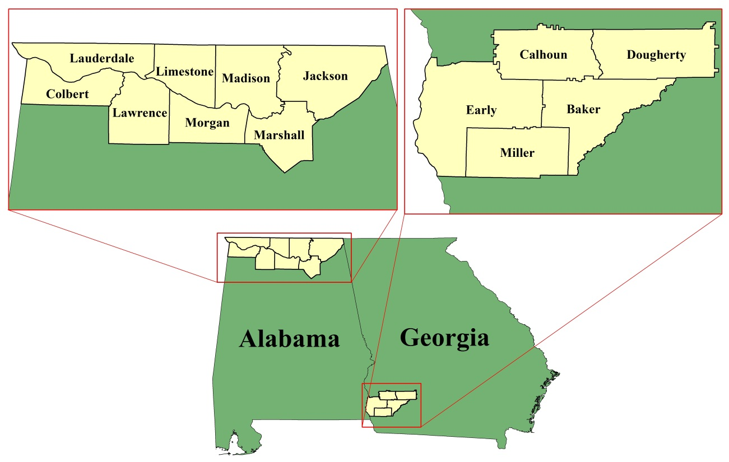
Fig. 1 Study area map showing the counties in north Alabama and southwest Georgia where the analysis was applied.
Study Period

- June and July, 2012

National Applications Addressed

- Agriculture
- Water Resources and Quality

Partners/Collaborators

- Earth System Science Center (UAH): Dr. Richard McNider
- NASA Global Hydrology and Climate Center (GHCC): Dr. Jeff Luvall
- USDA-NASS Office (Montgomery)
- Alabama Office of Water Resources
- Alabama Rivers Alliance

Methodology

Data Acquisition

Landsat 7 ETM+ data for June and July 2012 was acquired from USGS Glovis data portal. Only images with less than 15% cloud cover were accepted for this study to minimize the error in NDVI calculations and image preprocessing. Advanced Spacebourne Thermal Emission and Reflectance (ASTER) data from July 2013 was also acquired from the USGS. ASTER is at a higher, 15 meter pixel resolution than Landsat.
Cropland data layers available for downloaded from the National Agriculture Statistics Service, a division of the United States Department of Agriculture, via an online data portal. The 2007 Agriculture Census, the most recently published version, was also provided by the USDA as comparative data to our results.
Additional data for administrative boundary layers and hydrography was available from the Global Administrative Areas data pool.

Platform | Sensor | Geophysical Parameter
Terra | ASTER | Center Pivot irrigated fields
Landsat 7 | ETM+ | Identification of center pivot irrigated fields

Data Processing

Initial Observation and Acquisition

Google Earth was used as a preliminary search for and geo-tagging of center-pivot irrigation systems in Alabama. Center-pivot irrigation systems water crops from a central point and extend outward to the edge of the field. The system can be automated to move on its own and is most economically feasible when used to irrigated fields forty acres or more in area (Clemson University). Most center-pivot systems apply a maximum of 2 inches of water to the crops per week per their design.

- Statistical Methodology

To estimate the acreage of irrigated land in our study area, a statistical analysis was performed with Landsat 7 ETM+ (Enhanced Thematic Mapper) imagery from the summer of 2012, a known drought event year. Normalized Difference Vegetation Indices (NDVI) were calculated with the equation (NIR – Red)/(NIR + Red) to produce greenness values from the imagery. The ratio of the red and near-infrared wavelengths distinguishes vegetation from bare soil and other land cover types. Higher NDVI values are associated with healthier vegetation because of increased reflectance of the NIR wavelength. There is an overwhelming consensus that the NDVI is an important vegetation monitoring tool (Mutlu Ozdogan, 2008). It was reasoned that the irrigated cropland would have noticeably healthier plants and thus significantly higher greenness values.

CropScape illustrates the location and species of crops on a county level. The CropScape data layer was used as a mask to extract the specific NDVI pixel values associated with certain crops. The cropland data was first filtered to exclude any area less than four acres to prevent small anomalous values from being included in acreage estimates.

The images were classified to separate areas one standard deviation above the mean pixel value from the remaining areas. The resulting classified NDVI images were reclassified into two classes based on the greenness values, with pixel values above one standard deviation from the mean in one class and the other areas in the other class. The acreage of each class was calculated and saved in statistical tables where proportions for total and potentially irrigated acreage were calculated for each crop species.

- ENVI 5.0 Feature Extraction Toolkit

ASTER data proved more effective for feature extraction methods than Landsat due to its greater pixel resolution at fifteen meters. Feature extraction uses object-based approaches to classify an image, versus the traditional remote sensing classification technique of pixel value- based classification. Feature extraction defines regions of pixels via spectral, textural and spatial attributes of the image. Feature extraction combines the process of segmenting the image into regions of interest, computing attributes for each region to create the objects, and classifying the image through user defined, rules-based classification to extract desired features (Munzer Jahjah, 2010).
The goal of feature extraction for this project is to illustrate a proof of concept for extracting center-pivot irrigation systems from multispectral, NASA –EOS imagery. The concentration of center-pivot irrigation in the southwest Georgia area incited choosing Miller, Baker, Early, and Calhoun County to test the feature extraction toolkit.
For this particular test, a rule based classification of spatial compactness was applied to a 2013 ASTER false color image (green, red, and near-infrared band combination.) This band combination is known to emphasize the greenness of vegetation with the near-infrared. As for the rule-based classification, spatial compactness is a measure that indicates the topological relationship a shape has to compact space. For example, compactness measurements relate the ration of a shapes area to that of a circle with equal perimeters, which is the most compact shape (ENVI Feature Extraction Module User's Guide, 2008). Center-pivot irrigation systems are circular in nature, however there often exists three-quarter pivots, half pivots, or even quarter pivots which from initial consideration may have needed additional rules to extract. However, spatial compactness classification was able to detect these shapes as well.
Listed below is a reference for future work of the parameters used for the actual rule-based classification from ENVI feature extraction utilized in this project:

- Scale: 25.0
- Merge Scale: 98
- Spatial Compactness Threshold: 0.21 – 0.27

Results & Discussion

Analysis of Results

- Statistical Analysis Results:

The statistical analysis performed yielded imagery showing where each main crop was located within our study area and where the areas with high greenness values (one standard deviation above the mean) were within each image. In addition tables were produced to show the acreage of each crop, the acreage of high greenness values or each crop, and the percent of high greenness values per crop. Examples for one county in our study area are shown below:

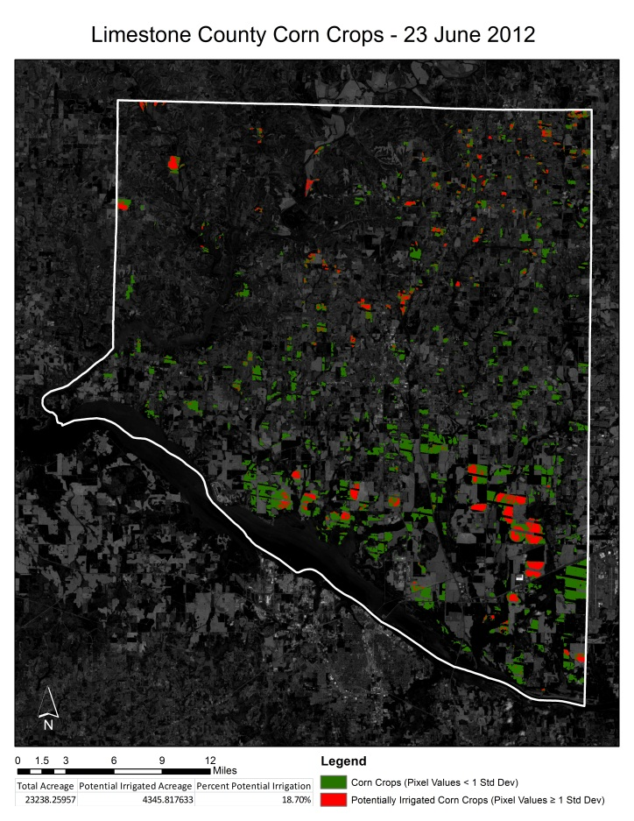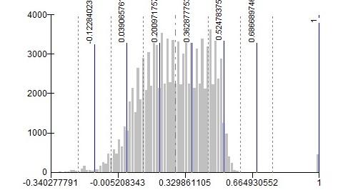
Fig. 3 - Map for corn crops in Limestone County with the histogram of the extracted pixel values from the NDVI image. The map shows areas of NDVI values above one standard deviation from the mean value. The histogram shows the mean pixel value in the alternated dash and period line and the period lines are standard deviations. A large amount of corn is above one standard deviation. Corn is the main irrigated crop in North Alabama.
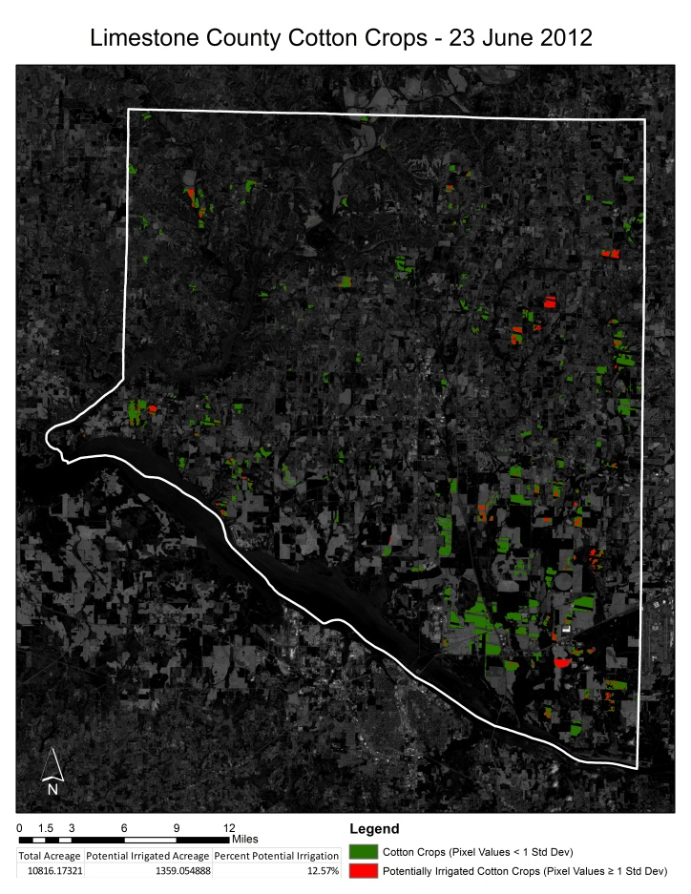
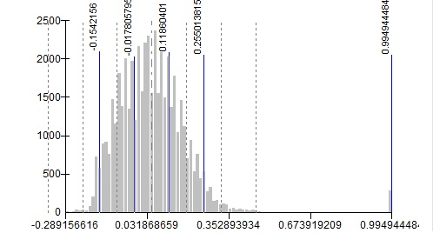

Figure 2) Map of the cotton crops in Limestone County with a histogram of the pixel values for the extracted NDVI image. The map shows areas of NDVI values above one standard deviation from the mean value. The histogram shows the mean pixel value in the alternated dash and period line and the period lines are standard deviations. Cotton is the less prevalent of the three main crops in Limestone County.
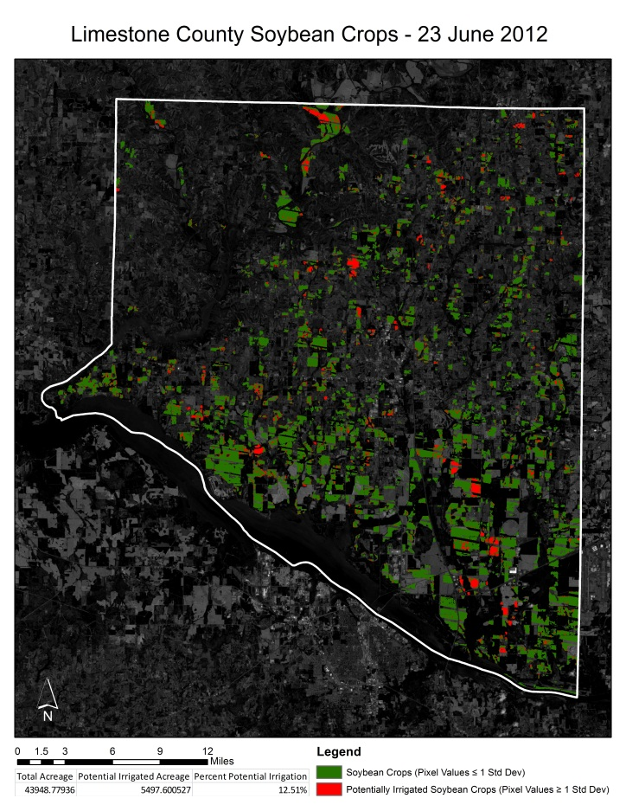
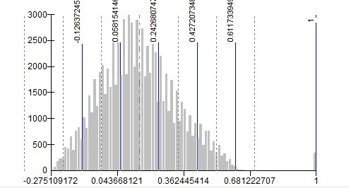
Figure 3) Map of the soybean crops in Limestone County with a histogram of the pixel values for the extracted NDVI image. The map shows areas of NDVI values above one standard deviation from the mean value. The histogram shows the mean pixel value in the alternated dash and period line and the period lines are standard deviations. Soybeans are shown as the dominantly grown crop in Limestone County.

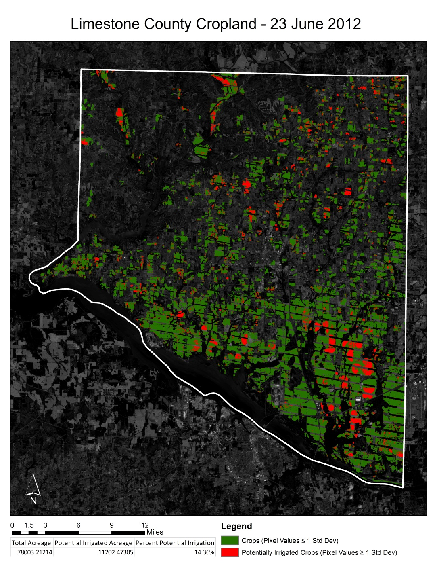
Figure 4) Map of all of the three main crops in Limestone County. The map shows areas of NDVI values above one standard deviation from the mean value. This image shows a large amount of irrigated land in the southeast corner of the county. These areas correspond to the locations of confirmed center-pivot irrigation systems and the shape of the circular fields may be made out in the image.

The maps for each county are included in Appendix A. Areas known to have center-pivot irrigation systems have appeared in the areas with high greenness values (figure 4). In addition, some areas within the image matched up with areas found from the feature extraction. The results showed that an estimated 13.37% of the agricultural areas in North Alabama are irrigated. In Georgia, the percentage was 8.1%.

- Feature Extraction Results:

Feature extraction results in “vectorized” features from classified ASTER imagery. These feature classes are easily integrated into ESRI ArcMap for statistical and acreage computation. Irrigation systems extracted from Miller County are illustrated below in the example result map:

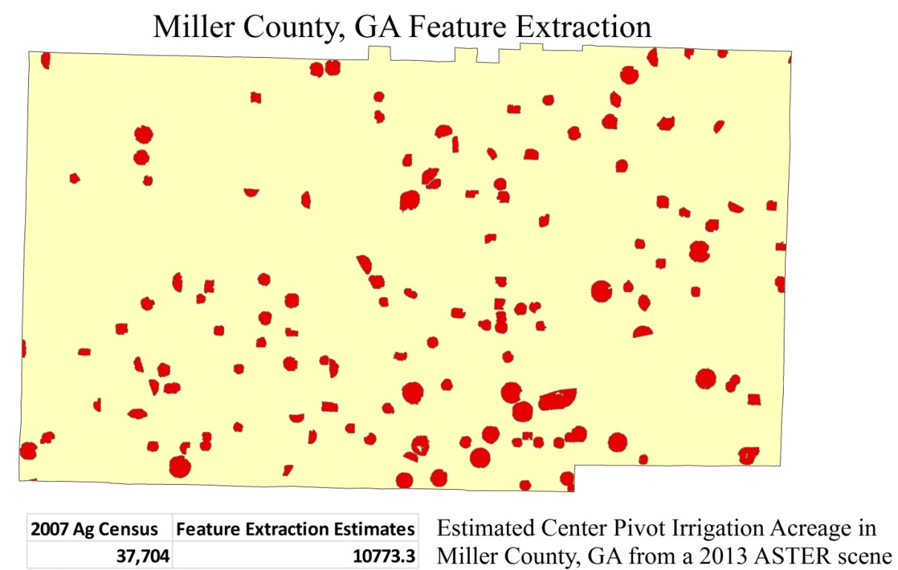

Fig. 2 – An example result map showing the extracted center-pivot irrigation fields, shown in red, from a 2013 ASTER scene of Miller County, Georgia. The acreage of irrigation on record from the USDA Agriculture Census is shown compared to the calculated acreage of irrigated cropland from this data.

The 2007 Agriculture Census, a U.S. Department of Agriculture initiative collected every five years, provides the total amount of irrigated cropland in Miller County. Although the estimates from the feature extraction results are low, identifying roughly one-third of the irrigation on record, this project endeavored only to extract center-pivot irrigation systems. The USDA Agriculture Census does not differentiate between center-pivot, drip, and other forms of irrigation practices. It is evident, however, that the feature extraction toolkit and user defined thresholds successfully detected center-pivot irrigation and corresponds directly with the statistical method. It is noteworthy that the two methods undergone to identify irrigation in this project utilized two different datasets but detected the same locations.

Error and Uncertainty

- Statistical Analysis

Current cropland data from CropScape dies not differentiate irrigated versus non-irrigated land. Irrigation data currently does not exist per crop species and location within Alabama. For this reason, this project focused in center pivot irrigation systems which are easily noticeable features in satellite imagery and commonly used for crops.

- Landsat has a 30 by 30 meter pixel resolution. The result of the NDVI values may be skewed due to the overlap of different land cover in the pixel.
- CropScape data is automatically derived from census data and not validated. There exist many inaccuracies with CropScape like improperly classified regions.
- The scan line error in Landsat ETM+ imagery since 2003 creates large gaps in the data, which get large towards the edges of the scene. These gaps result in large areas of missing data.
- The estimations of irrigated land have been based on finding areas one standard deviation above the mean. Further refinement of this method will be need to give more accurate irrigated land estimates based on the crop, location, date, and weather conditions.

- Feature Extraction:

The spatial compactness threshold defined to extract center-pivot irrigation systems successfully detected those types of features. However, it was also evident that many of the same desired features were not extracted and ultimately not included in the resulting acreage mapping. The power of the feature extraction toolkit is in the plethora of possibilities and parameter definitions available for the user, for example the choice between spectral, textural, or spatial based classifications. The error accepted in this project is a consequence from the following factors:

- The search parameters (region of interest scale and merging scale) are objective measurements that are defined by the user. Although the values chosen for circular fields were very effective, further testing could produce a more accurate representation for circular features.
- Textural and spectral properties of the image may prove useful in narrowing the search parameters and classification effectiveness.
- Many center-pivot systems were outside of the spatial compactness threshold, while many features that did exist within the threshold were not desired objects. Narrowing the threshold and increasing the number of classes assigned to the classification will certainly produce a more representative analysis.
- Due to their Euclidean shape and relative ease to identify by eye, this project focused predominantly on center-pivot irrigation systems. There exist many other forms of spray, injection, and drip irrigation systems that were not represented in the analysis.
Future Work

- Narrowing the search threshold and segmentation parameters is paramount if feature extraction is to be applied for irrigation detection. Spectral and textural classifications are available in ENVI Feature Extraction and may provide new methods at which to detect features of interest. These classifications are even applicable to specific bands from a composite image, narrowing the threshold even more.
- Extending this methodology to contemporary data will illustrate the actual acreage of current irrigated cropland. Recently acquired Landsat 8 Operational Land Imager (OLI) and ASTER scenes can facilitate this process.
- Thermal datasets like the Land Surface Temperature product from MODIS and the Thermal Infrared Sensor on Landsat 8 could expand the search for irrigation to the thermal perspective as an additional parameter for soil moisture.

Conclusion

Alternative methods to identify irrigation in Alabama are imperative to determining the actual usage of freshwater for agricultural purposes in local watersheds. Crop and hydrology models rely on accurate measurements of water consumption to better predict water withdrawal limitations of certain sources of water.

Rule-based feature extraction and the statistical inference of pixel data for feature identification can be applied to research that searches for potentially irrigated cropland. These products have the capability to enhance investigation on a large scale, e.g. for state or region, and even automate the process. Although, ground-truthing is necessary to evaluate the effectiveness of the classification, as it is with any supervised or unsupervised classification, these tools can help to expedite more time consuming mapping techniques and provide easily integrated data quickly for real-time crop and hydrology modeling.

Acknowledgments

This project was executed under the tutelage of many professionals from the University of Alabama in Huntsville and the Earth System Science Center (ESSC) located at the National Space Science and Technology Center (NSSTC). We would like to acknowledge the following individuals for their help and considerations during the course of the term:

- Dr. Richard McNider (UAH/ESSC)
- Dr. Jeff Luvall (NASA GHCC)
- Dr. Rob Griffin (UAH/ESSC)
- Mr. Cameron Handyside (UAH/ESSC)
- Mr. Lee Ellenburg (UAH/ESSC)

Works Cited
ENVI Feature Extraction Module User's Guide. (2008, December). ENVI User's Guide. ITT Visual Information Solutions.
Clemson University, C. (n.d.). South Carolina Irrigation Pages. Retrieved from Clemson Extension: http://www.clemson.edu/irrig/equip/pivot.htm
Munzer Jahjah, C. U. (2010). Automatic archaeological feature extraction from satellite VHR images. Acta Astronautica, 1302 - 1310.
Mutlu Ozdogan, G. G. (2008). A new methodology to map irrigated areas using multi-temporal MODIS and ancillary data: An application example in the continental US. Remote Sensing of Environment, 3520 - 3537.
Tom Vilsack, C. C. (2007). 2007 Census of Agriculture: Unted States Summary and State Data. United States Department of Agriculture.
Tom Vilsack, C. Z. (2007). 2007 Census of Agriculture: Georgia State and County Data. United States Department of Agriculture.

Appendices

Appendix A – Result Maps from NDVI Statistical Method (Alphabetical Order)

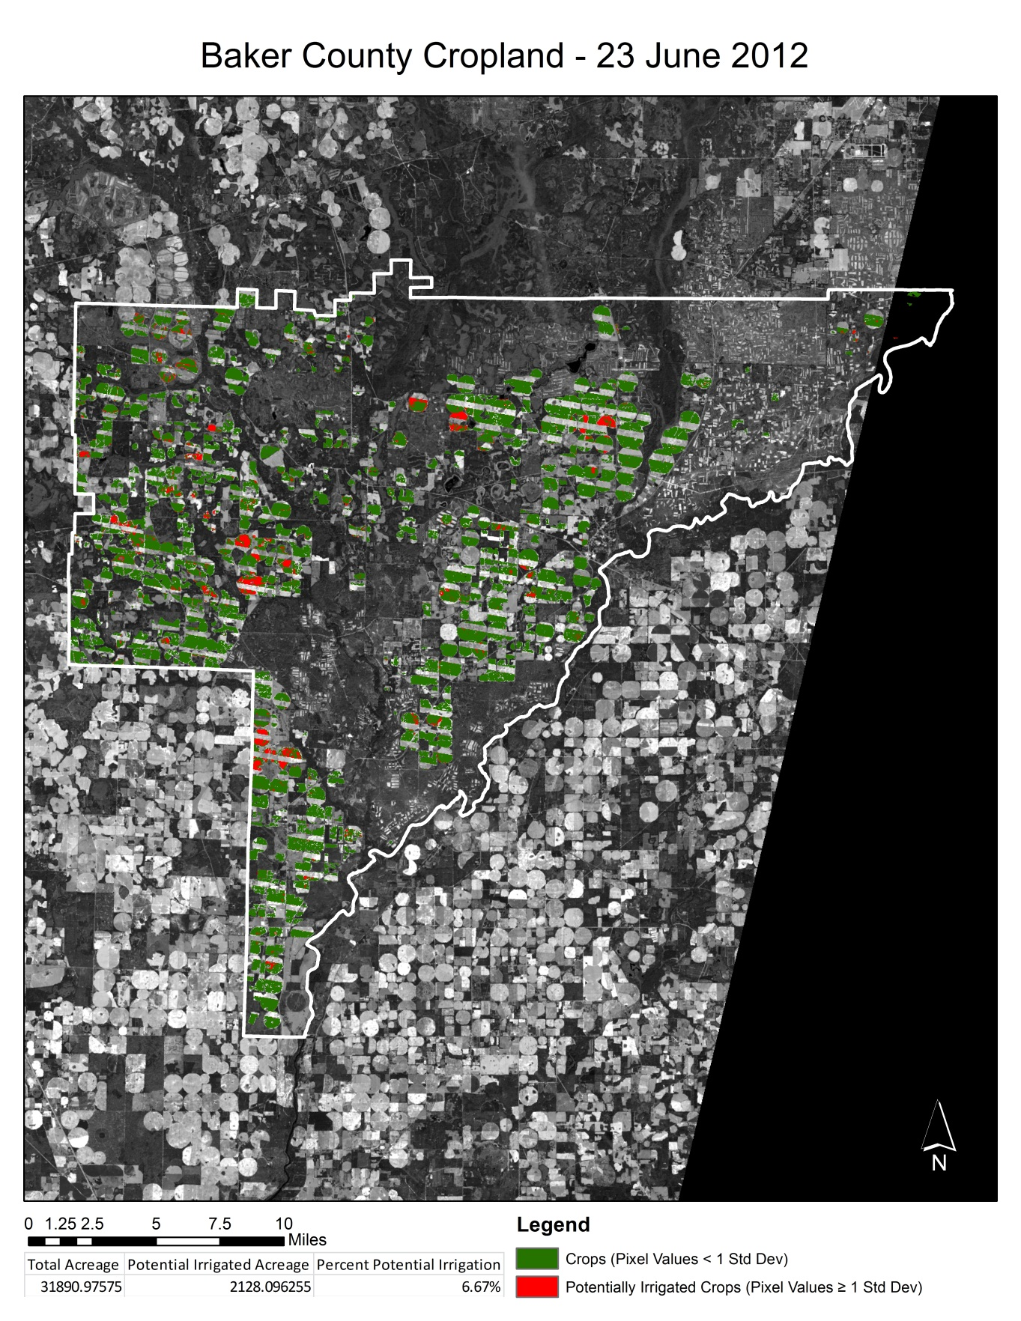
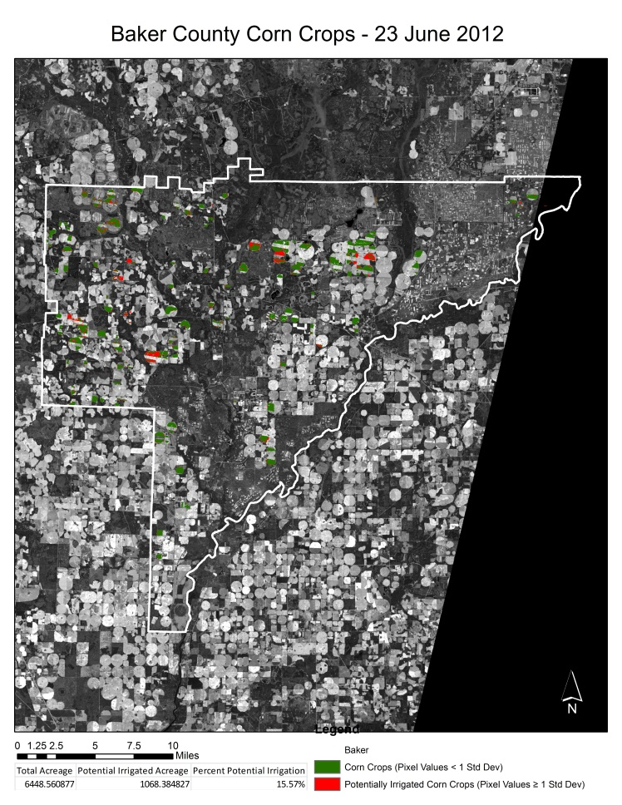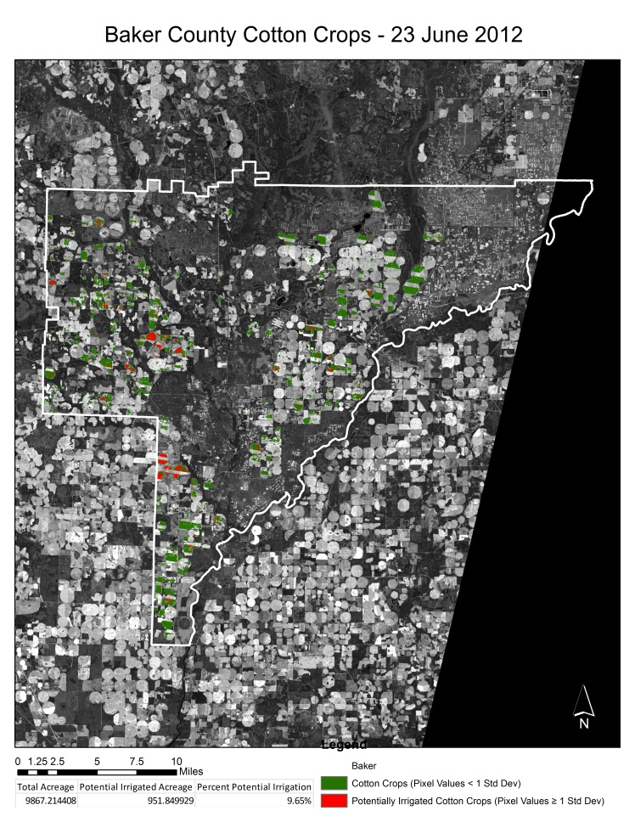33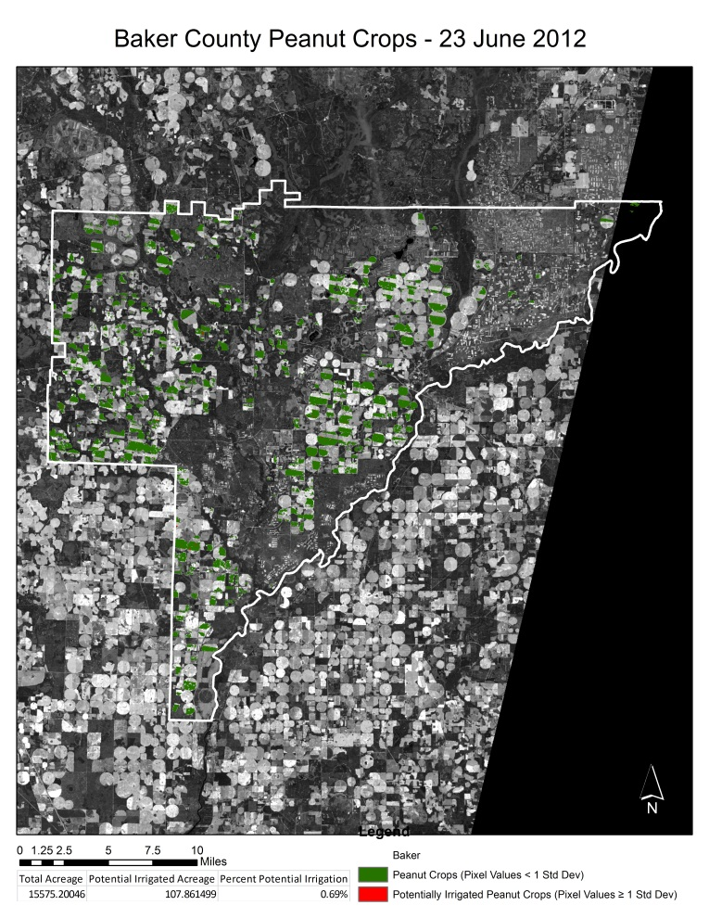
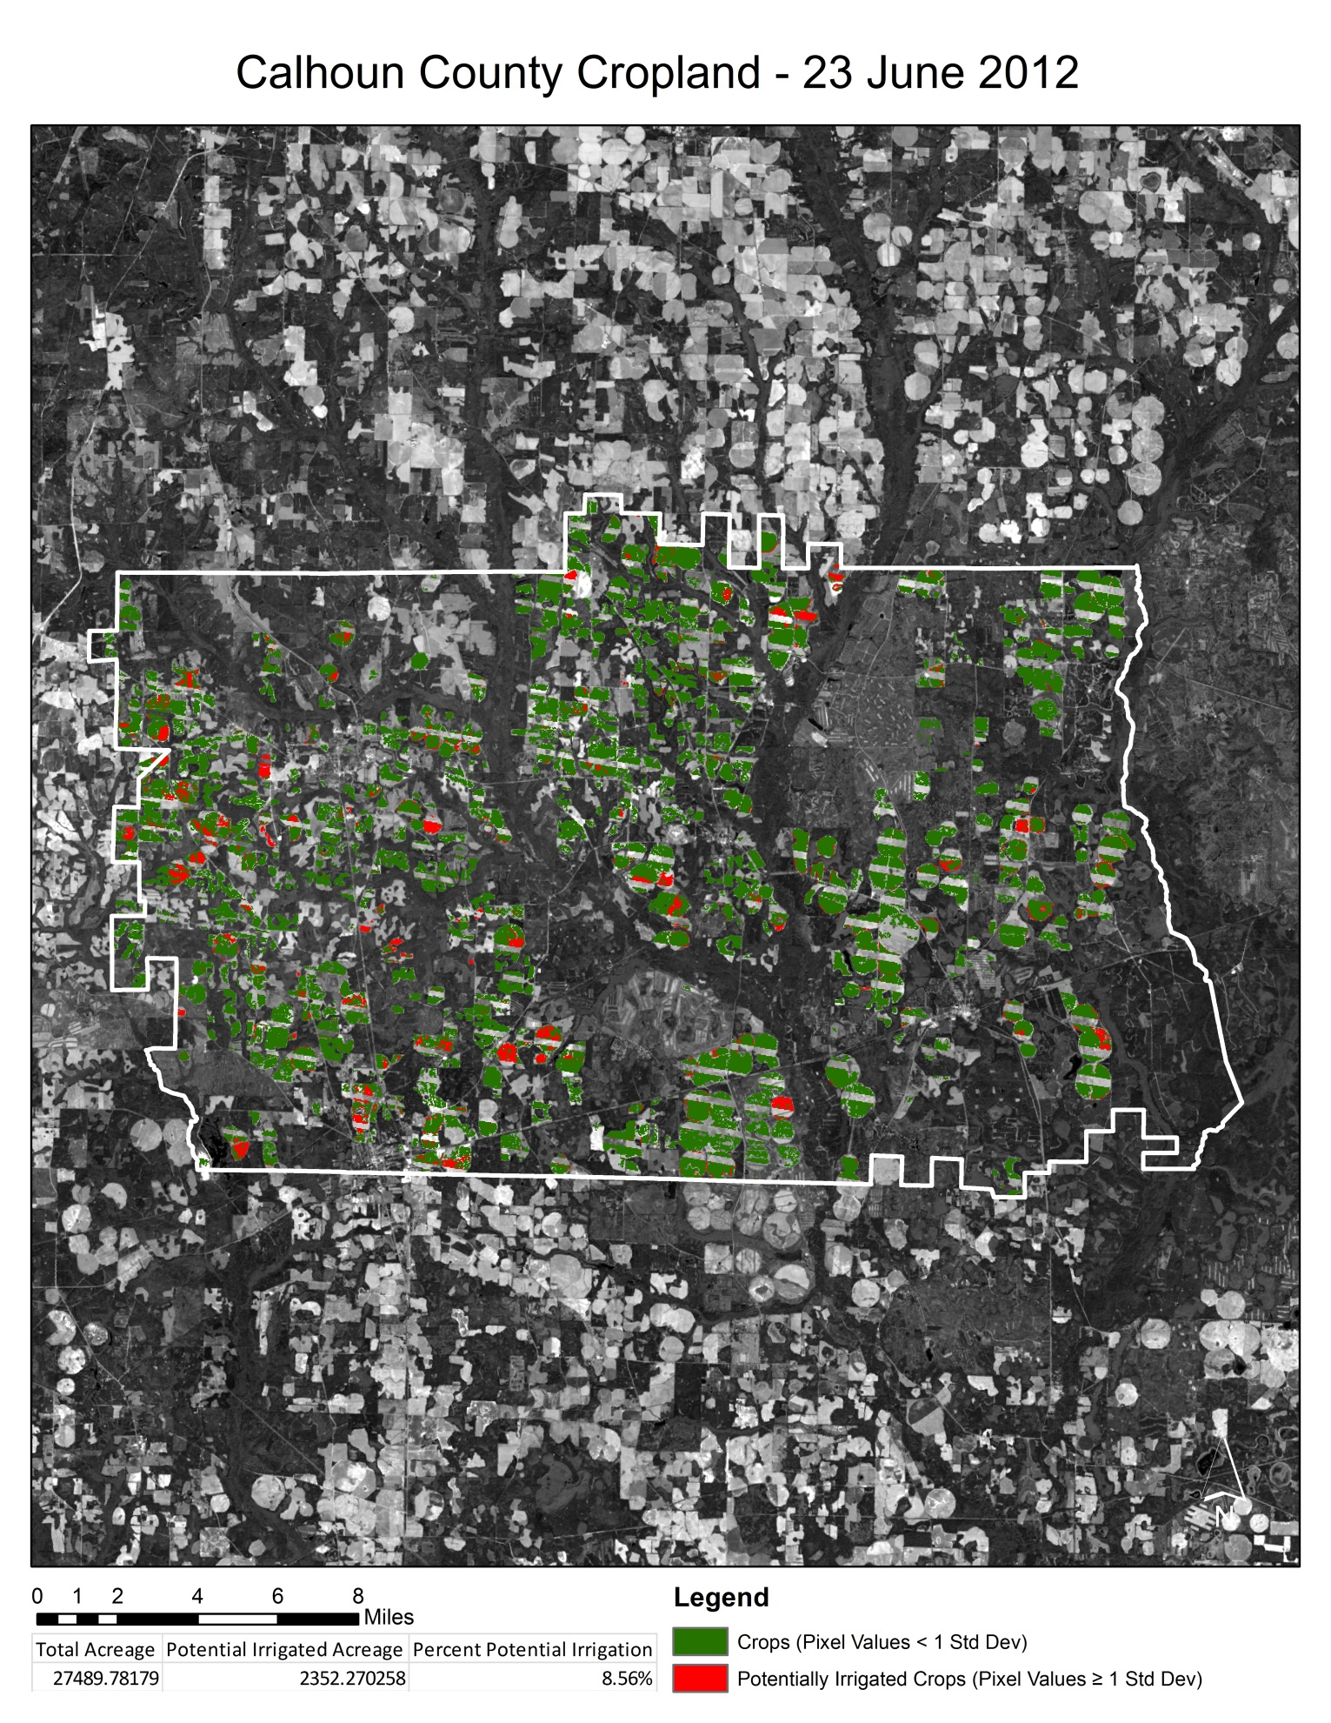

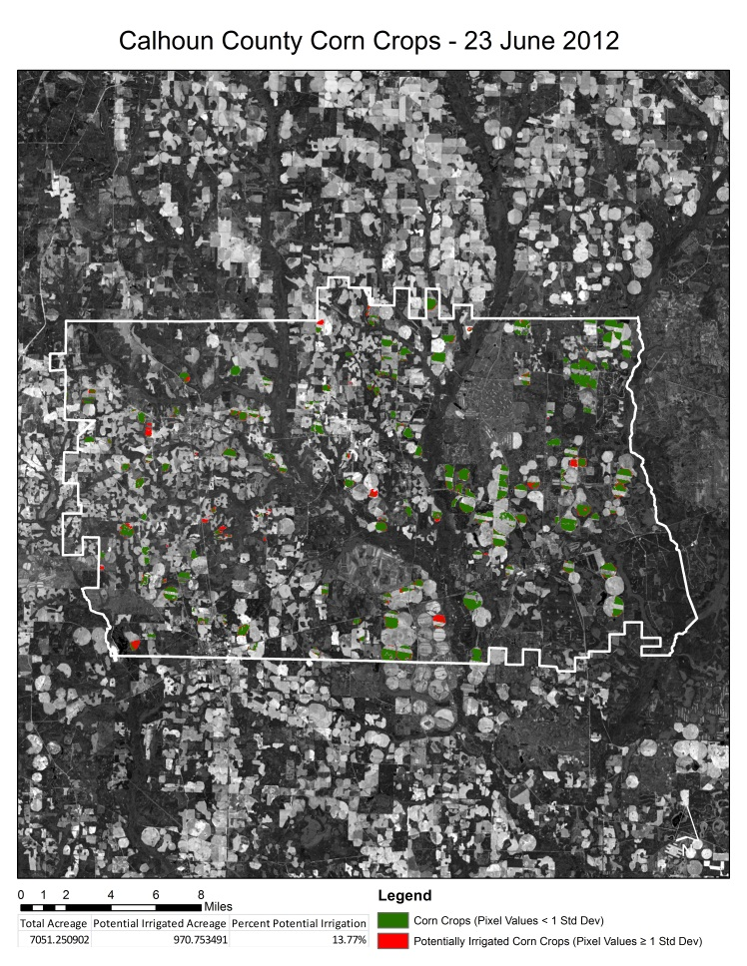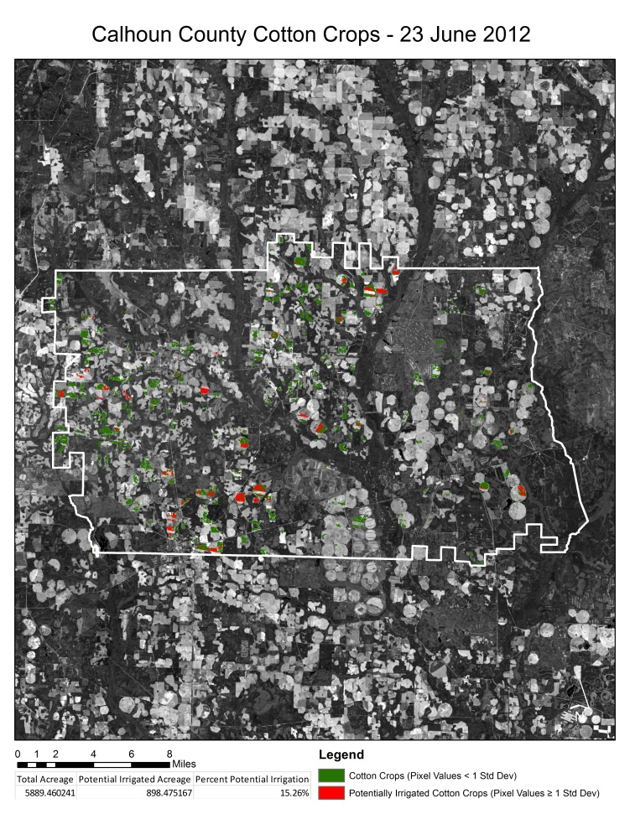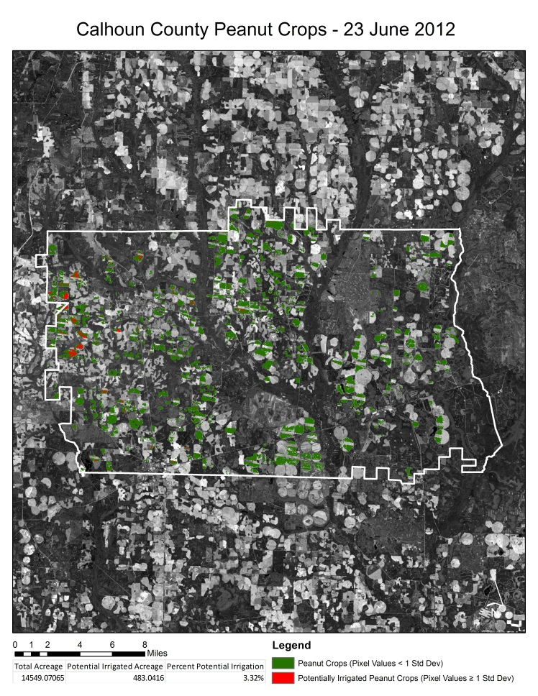

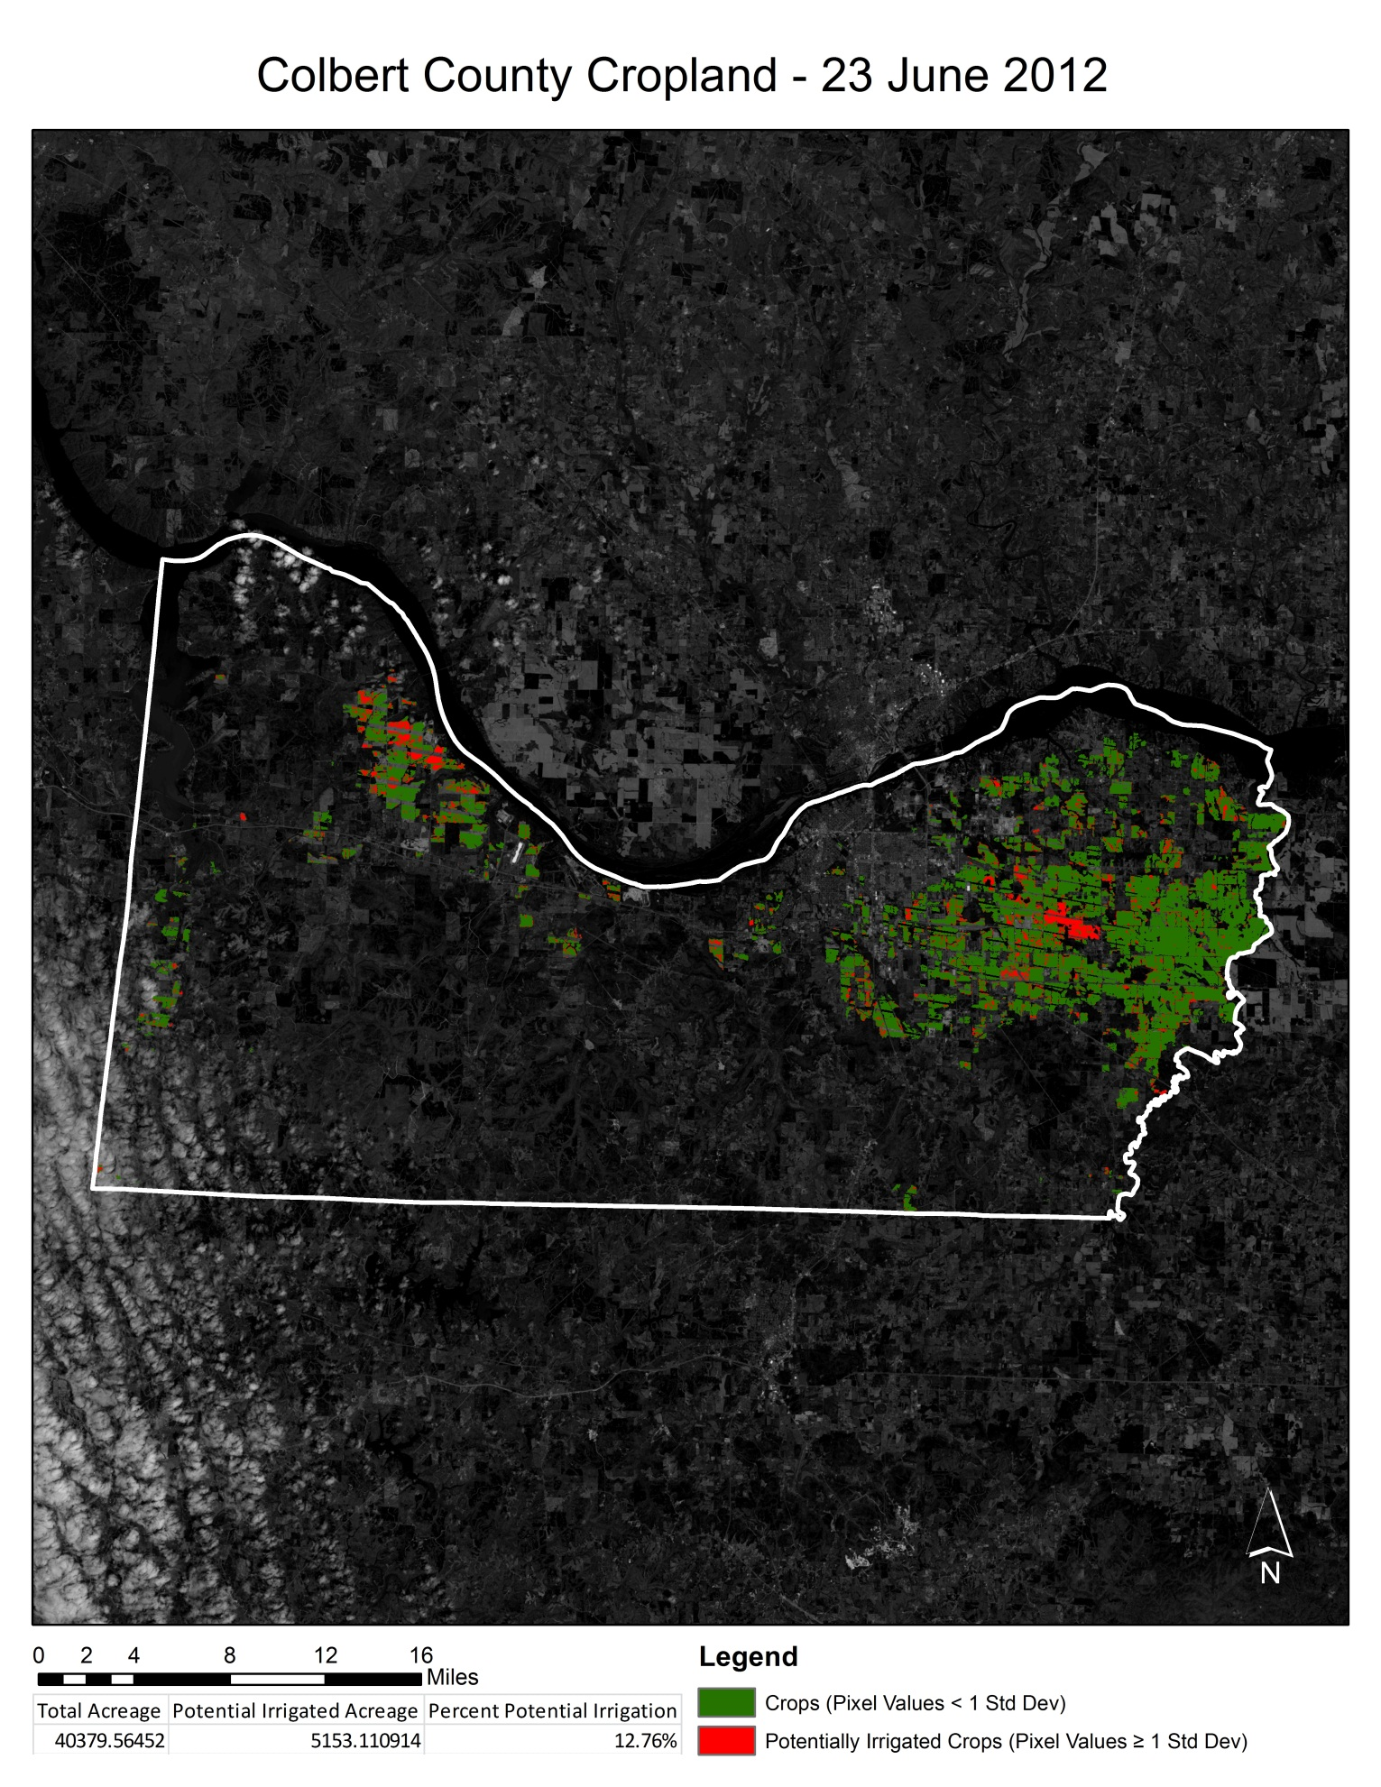
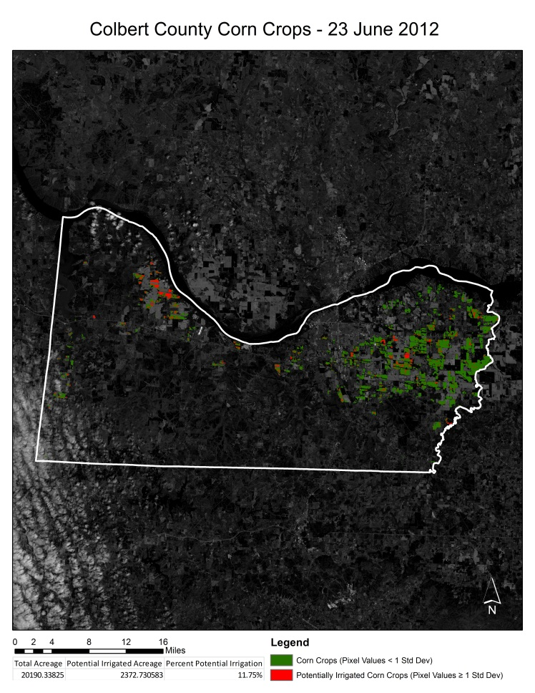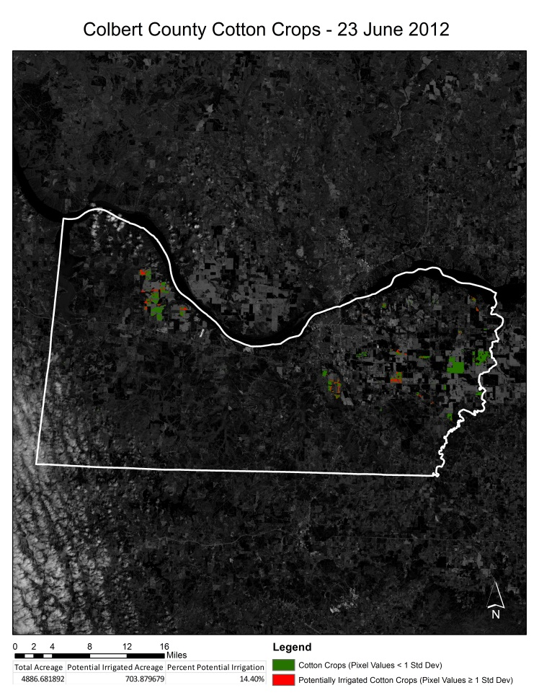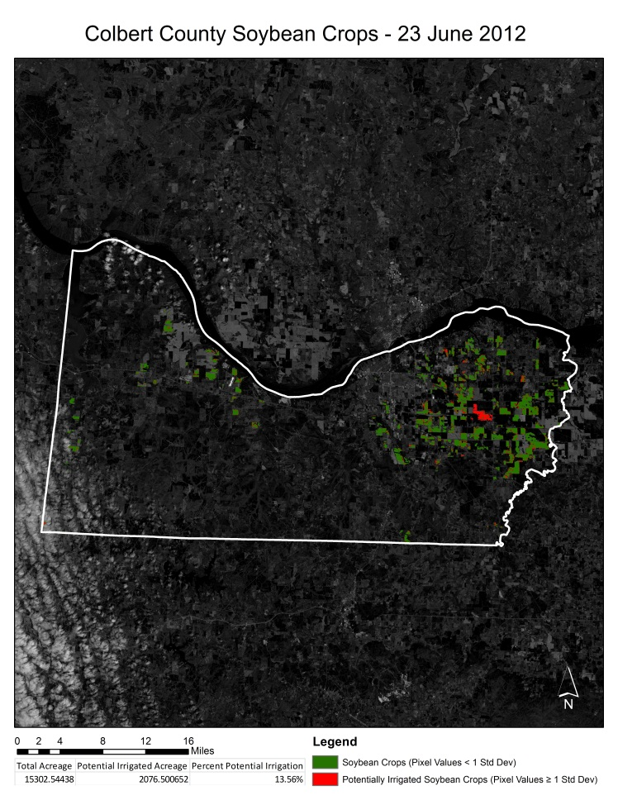

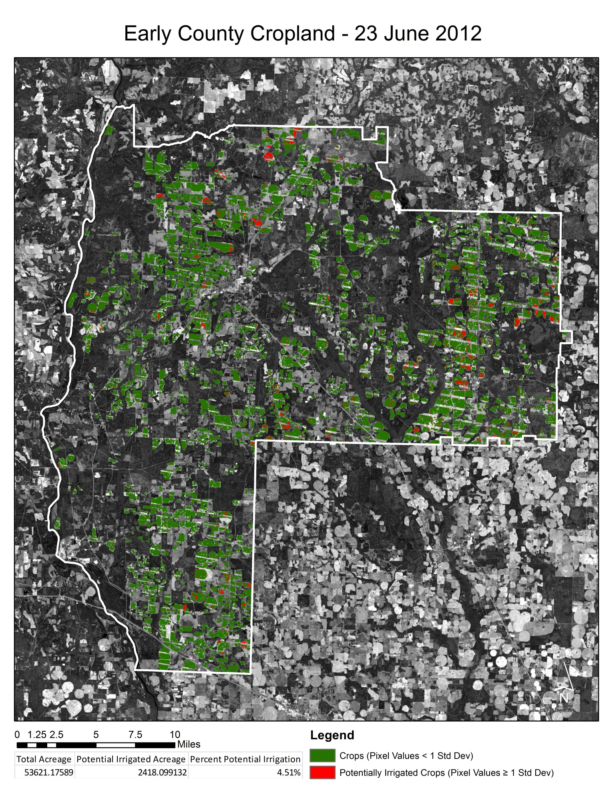
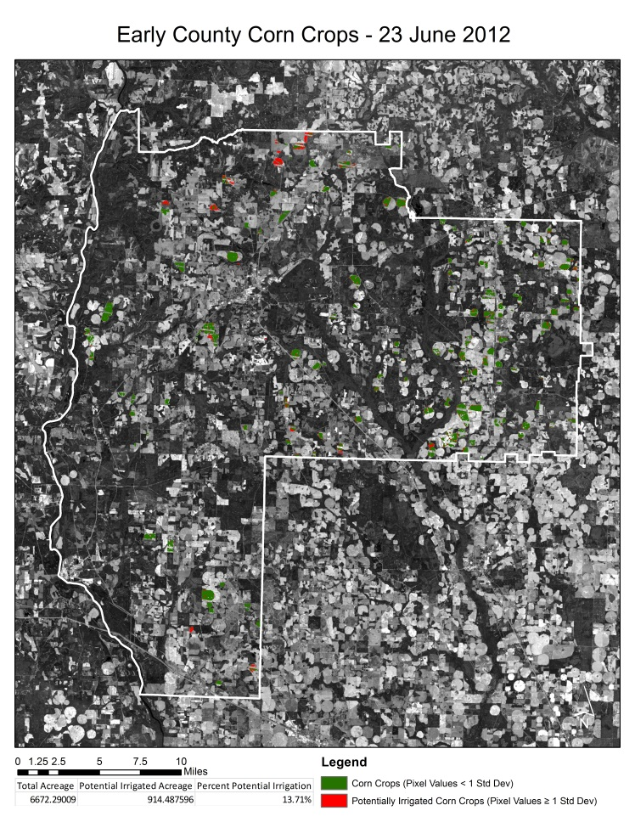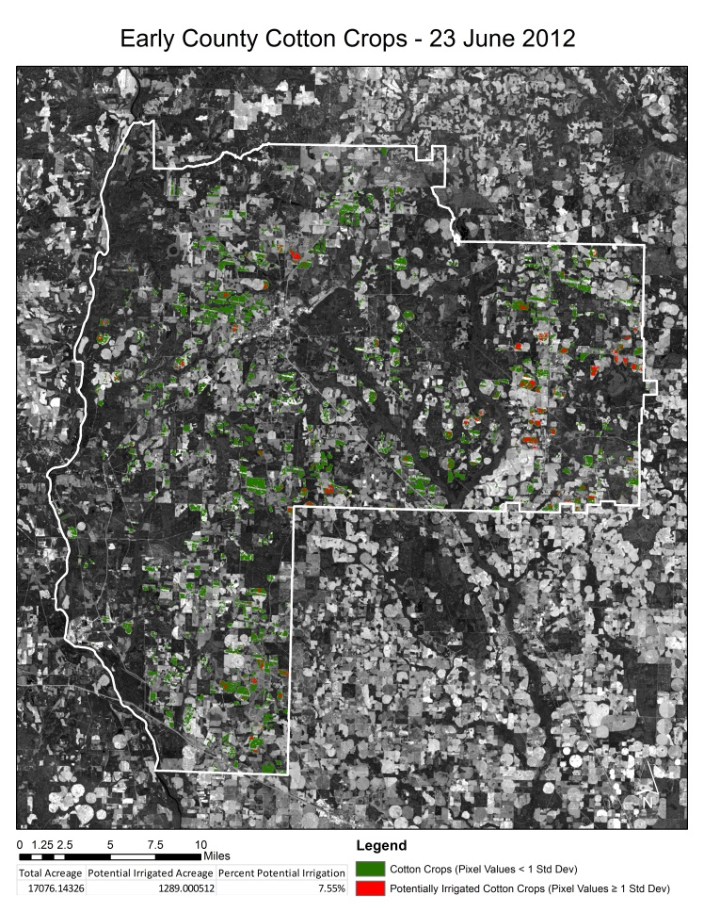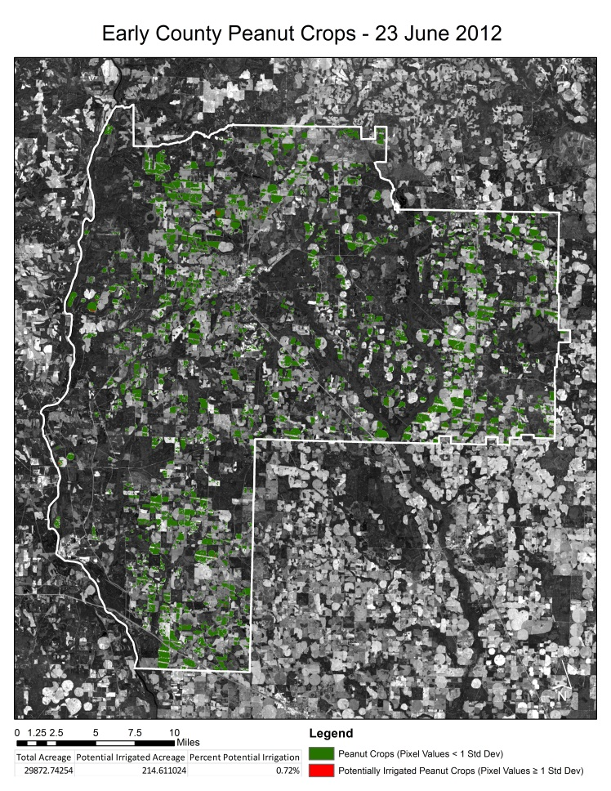

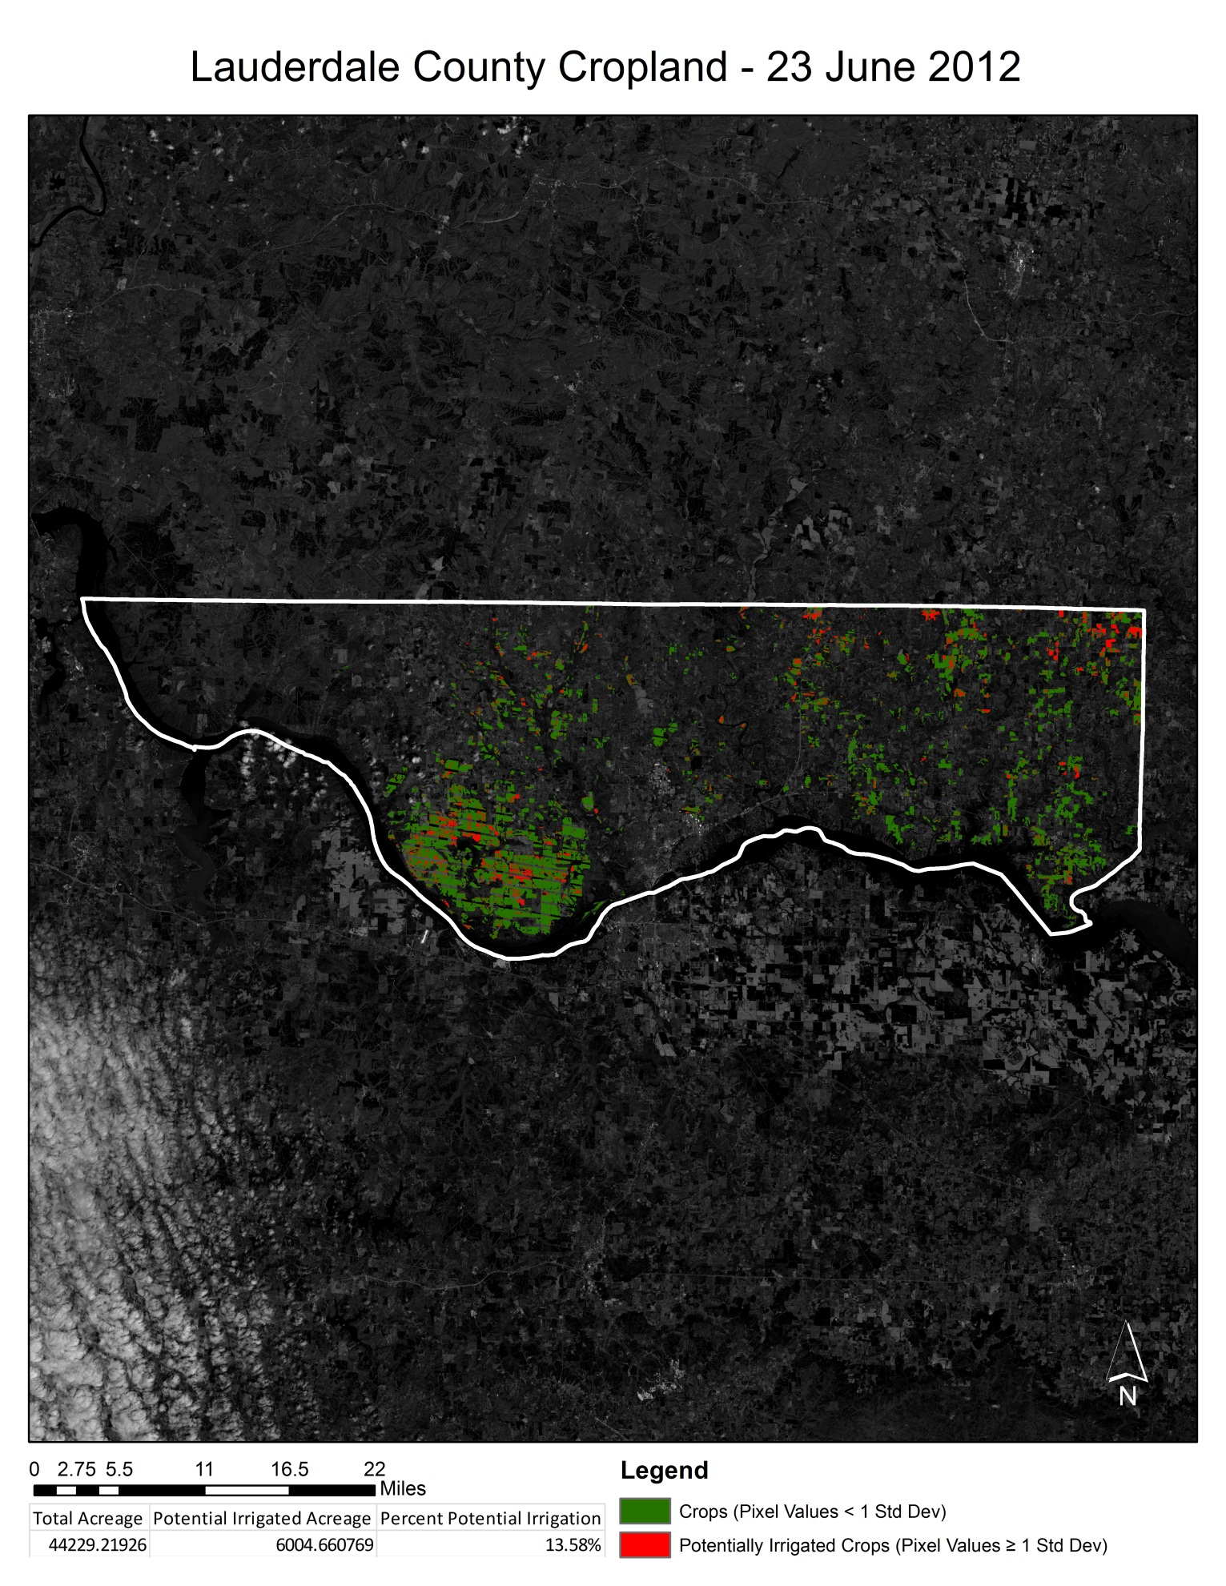
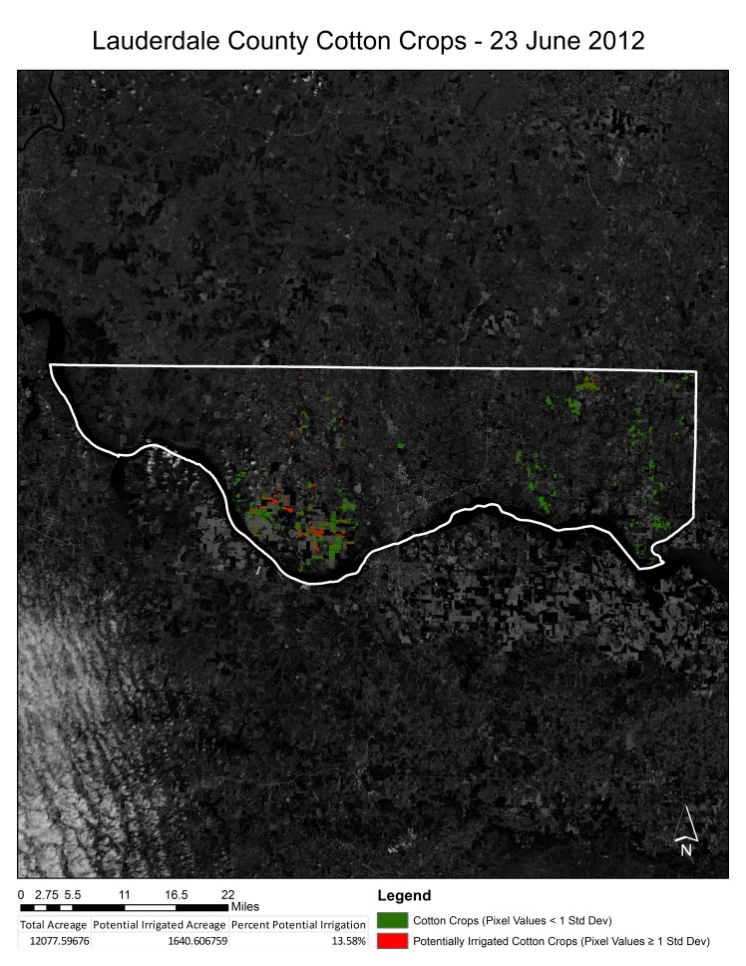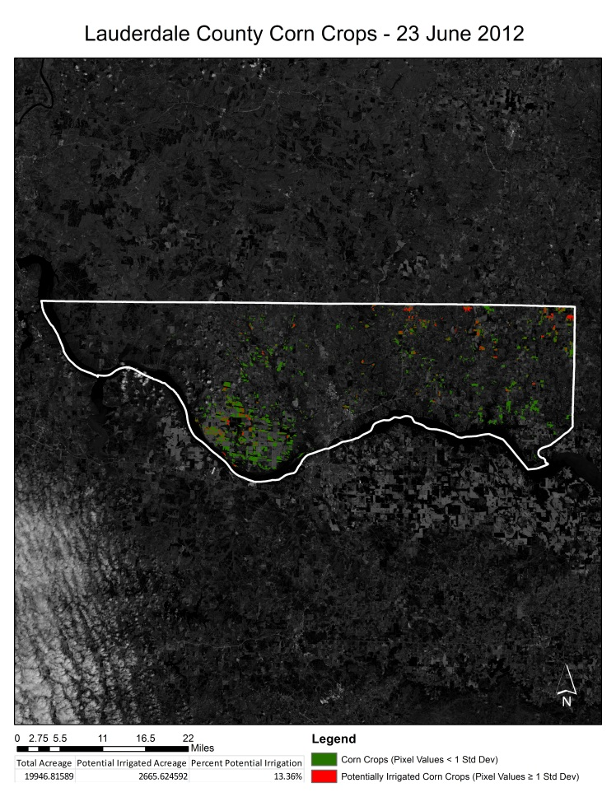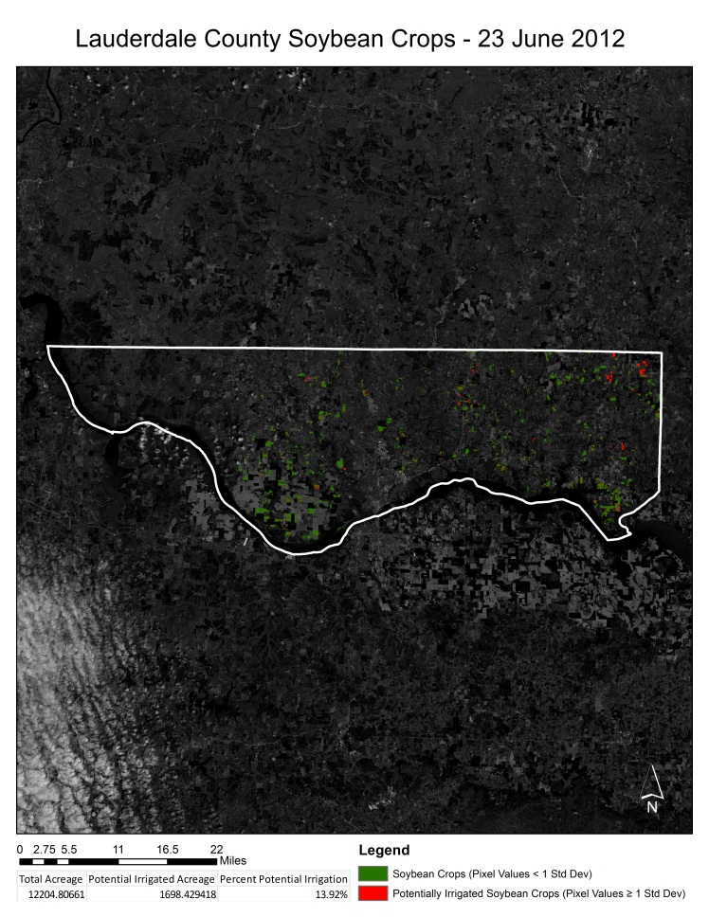

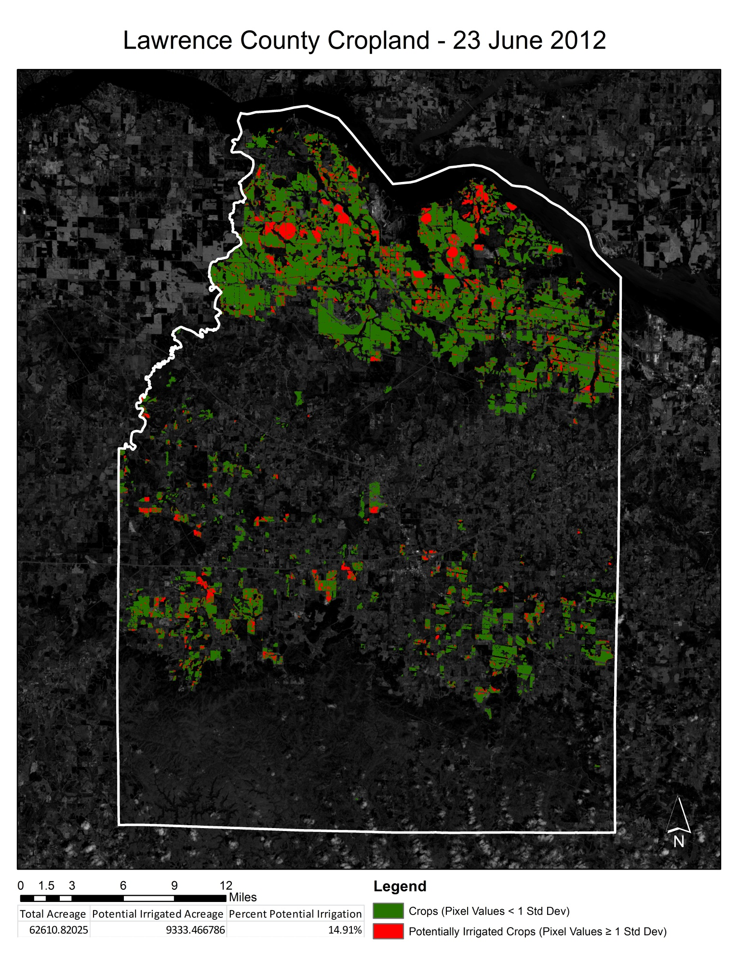
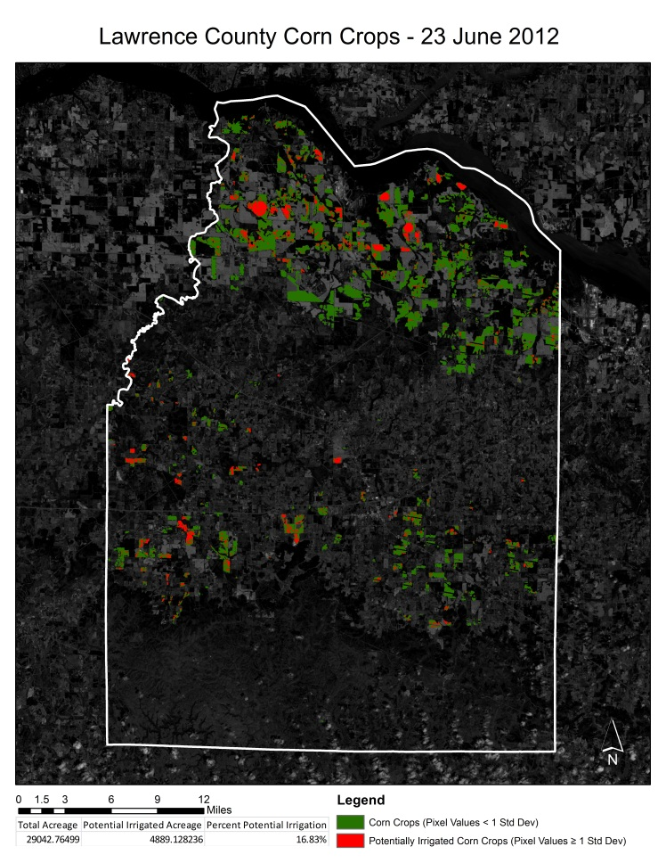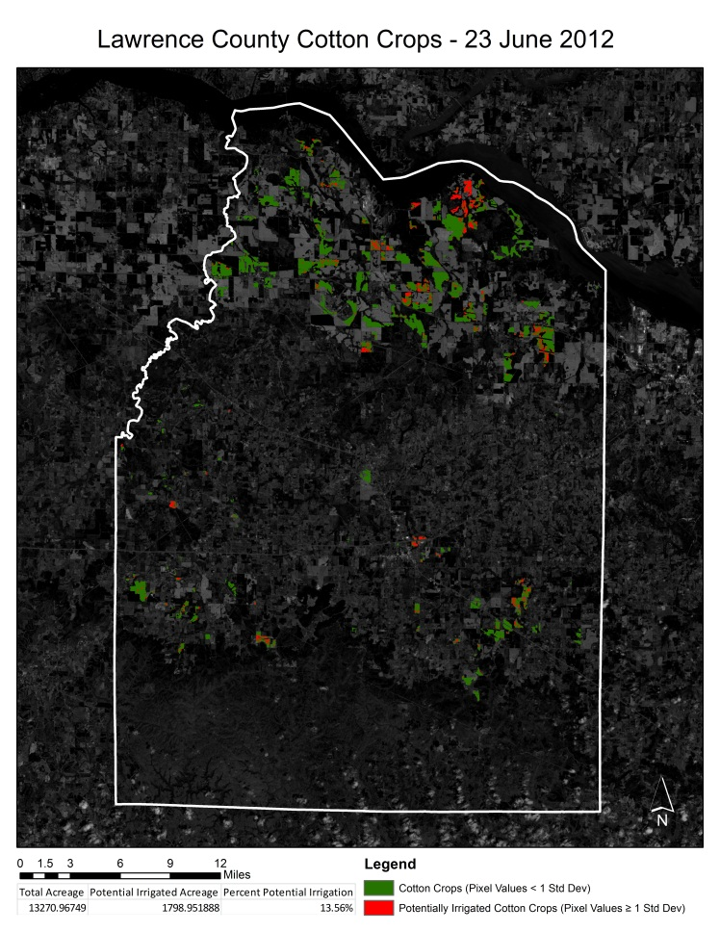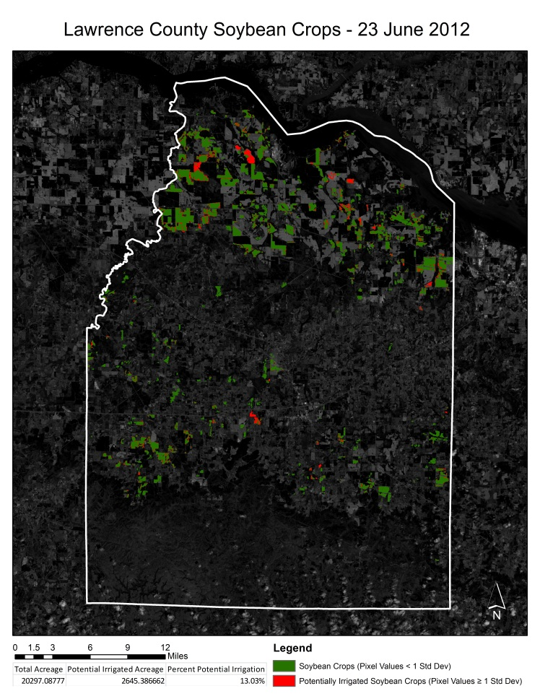

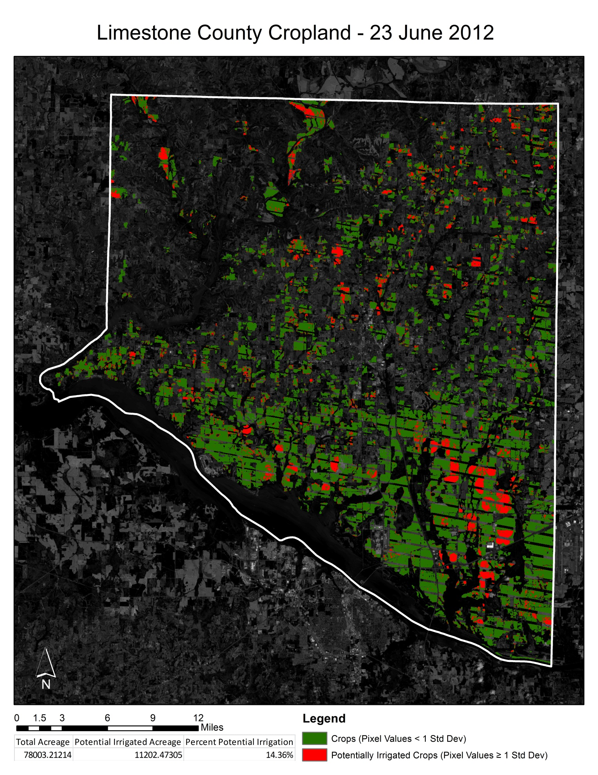
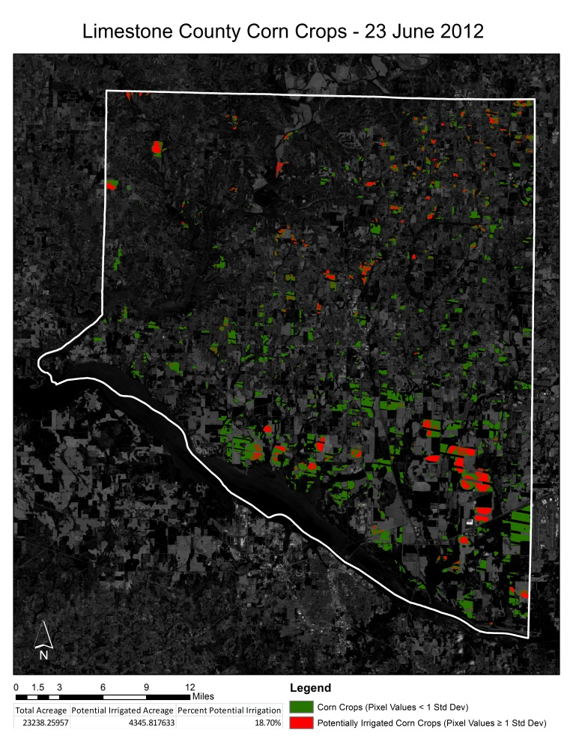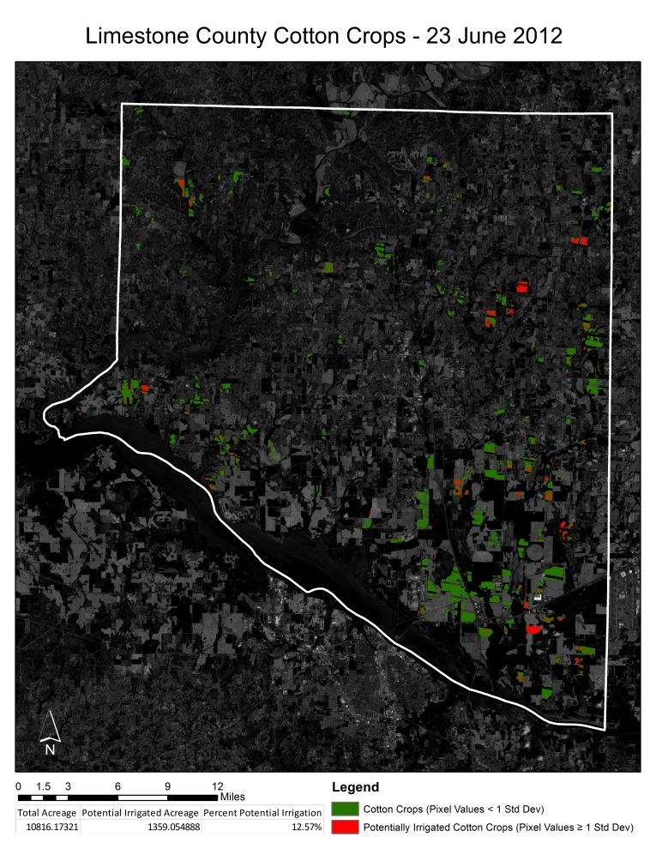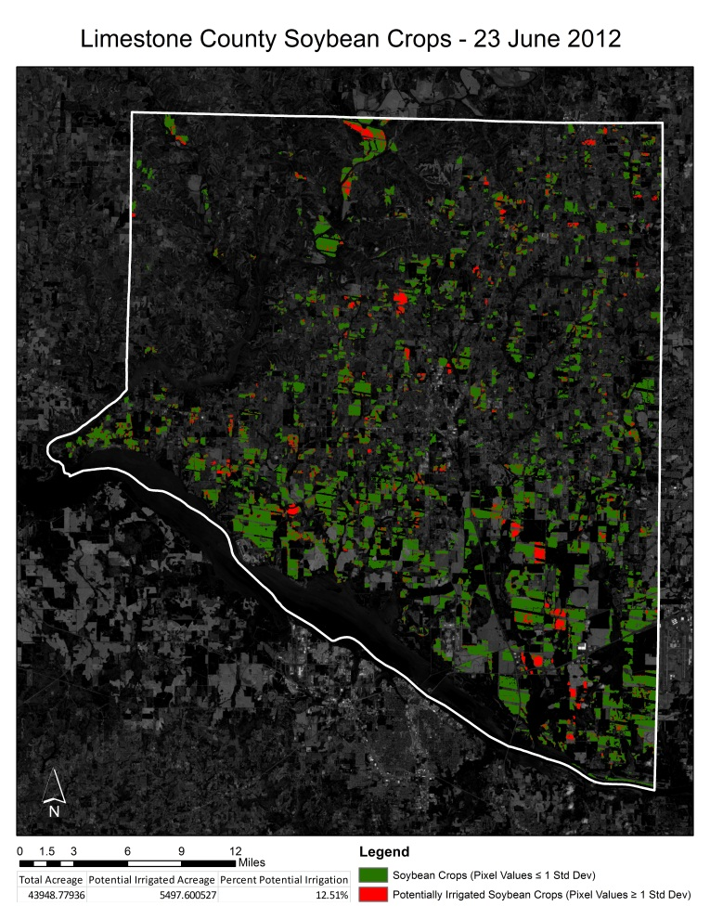
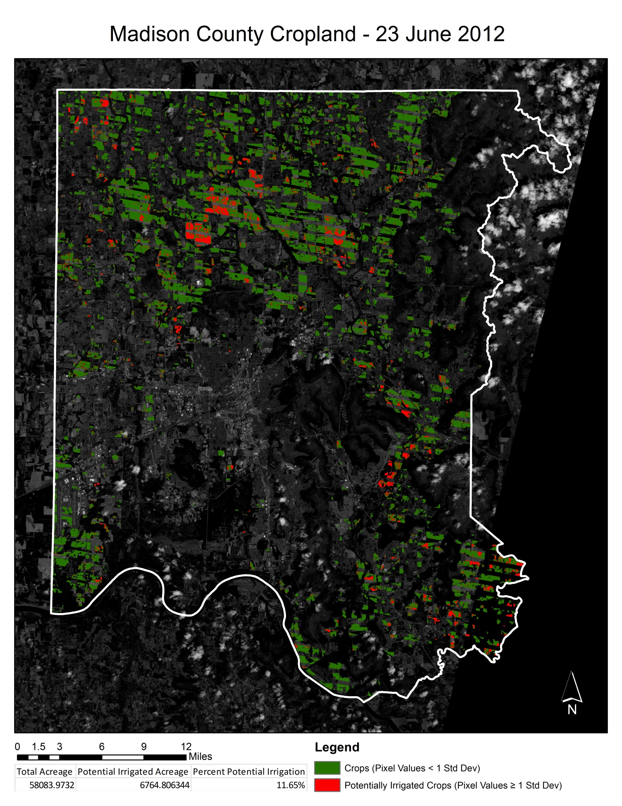
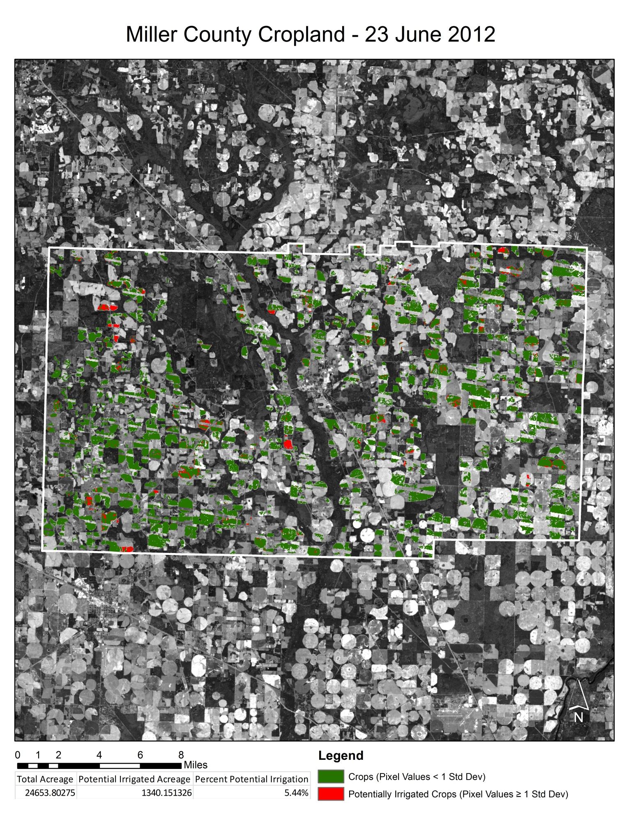
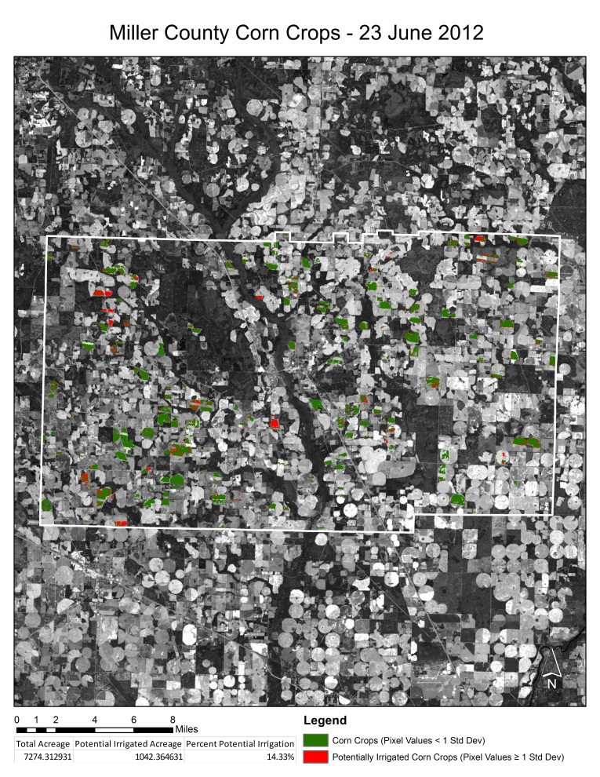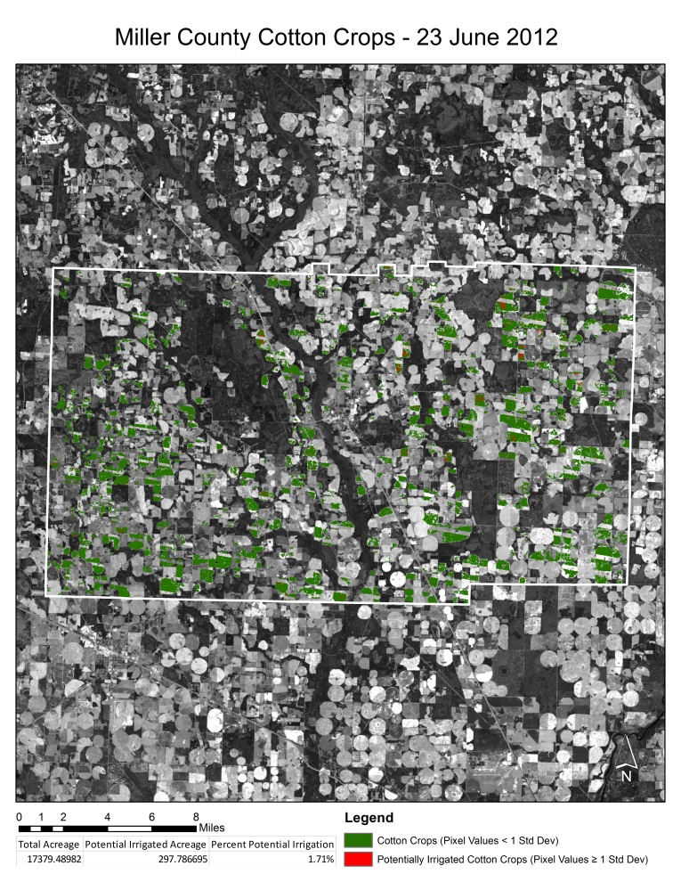

Note: Peanut data for Miller County was unavailable.
