Central America Dry Corridor Food Security & Agriculture

Assessing Vegetation Response to Remote Sensing Drought Indices within the Dry Corridor of Central America Using NASA Earth Observations

 **Technical Report**

Final Draft – November 21st, 2019

Adelaide Schmidt (Project Lead)

Jared Kelly

Cade Justad-Sandberg

Olivier Prat, North Carolina Institute for Climate Studies, NOAA National Centers for Environmental

Information (Science Advisor)

**1. Abstract**

The dry corridor resides primarily in the pacific region of Central America, which experiences severe drought during the El Niño Southern Oscillation cycle. El Niño causes severe climate variances in Central America that impact agriculture, livelihoods, and hydrological cycles. The region is rich with cash crops, including bananas, plantains, corn, sugar, and coffee, that are at risk during El Niño events. The region is also home to many subsistence farmers who rely on rainfed agriculture. These climate anomalies can lead to loss of livelihood and regional food insecurity. The team used remote sensing data from Global Precipitation Measurement (GPM) mission Integrated Multi-satellite Retrievals for GPM (IMERG) and Terra Moderate Resolution Imaging Spectroradiometer (MODIS) to generate Normalized Difference Vegetation Index and Standard Precipitation Index data to identify regions that have been negatively impacted by past El Niño events in the dry corridor of Guatemala, Honduras, and Nicaragua. The project identified the historic areas of socioeconomic vulnerability during the onset of El Niño related drought. Team members worked with Universidad del Valle de Guatemala to provide information regarding regional drought to the Nicaragua Ministry of Agriculture and Forestry and the Honduran Ministry of Agriculture and Livestock. The project concluded that there is an increase in the area of severe and extreme drought during El Niño events in the Central American dry corridor, and the team provided time series maps that visually demonstrated the progression of drought in the region.

**Keywords**

remote sensing, SPI, NDVI, GPM-IMERG, drought, Mesoamerica, Oceanic Niño Index

**2. Introduction**

***2.1 Background Information***

The dry corridor is a region on the pacific side of Central America that experiences greater aridity during El Niño Southern Oscillation (ENSO) events. The El Niño event that occurred from 2015 to 2016 succeeded two years of drought and had some of the worst crop impacts ever recorded in the region. It left about 3.5 million people in need of humanitarian assistance and 1.6 million moderately or severely food insecure (Food and Agriculture Organization of the United Nations, 2016). The negative effects were more pronounced for subsistence farmers and agricultural day laborers in the Dry Corridor (Food and Agriculture Organization of the United Nations, 2016). Additionally, El Niño has been shown to exacerbate the drought conditions in Central America with increased impacts in the Dry Corridor (Food and Agriculture Organization of the United Nations, 2016). Thus, it is fundamental to investigate the relationship between meteorological drought and agricultural drought in the context of El Niño events for proper agricultural management and assistance.

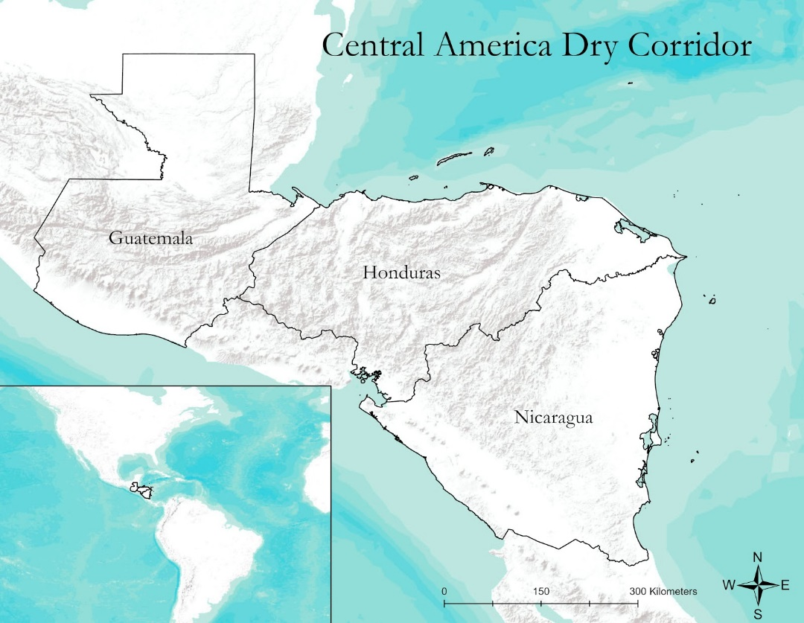

*Figure 1*.Map of study area consisting of Guatemala, Honduras and Nicaragua

The growing seasons in the Dry Corridor of Central America are defined by a May through October rainy season that is bisected by a mid-summer drought (MSD) an event where precipitation decreases in the month of July (Curtis, 2002). The Dry Corridor is a region which exists primarily in western Central America. It covers large land masses in the Guatemala, Nicaragua, and Honduras (*Figure 1*). Farming practices in the region have adapted to the rainy season and the MSD (Maurer, Roby, Stewart-Frey, & Bacon, 2017). However, the rainy season and MSD are expected to significantly deviate from standard patterns in the coming decade. One of the predicted effects of changes in climate on the region is an increase in the MSD duration by an average of one week and a decrease in the precipitation by 26% during the duration of the MSD (Maurer et al., 2017). These effects are expected to reduce the crop output of farmers who reside in the region. El Niño events in Central America bring an unusual and decreased spatial and temporal spread of precipitation. The irregular rainfall is likely to interfere with critical growing seasons and significantly impact crop output (Food and Agriculture Organization of the United Nations, 2016). In the future, the negative impact of El Niño is expected to increase and cause more problems in the affected area (Maurer et al., 2017).

The Standard Precipitation Index (SPI) is a popular precipitation index based on precipitation data. SPI was chosen as the best meteorological drought indicator at the December 2009 Inter-Regional Workshop on Indices and Early Warning Systems for Drought. 22 countries were represented at the workshop and concluded that all national meteorological services should use SPI to make drought severity measurements across countries possible in similar regions (Zargar, Sadiq, Naser, & Khan, 2011). Additionally, looking at SPI at various time scales shows the different forms of drought. A 1-2 month scale shows meteorological drought, 3-4 months shows agricultural drought and 9 or more months shows long-term drought. For the study region of the Dry Corridor and the surrounding land, a 6-month scale shows the impacts of the regional ENSO events (Keyantash & Dracup, 2002). A study by Keyantash and Dracup (2002) compared common drought indices and found that SPI was the more widely accepted international drought measurement tool. The comparability and international recognition make SPI an excellent tool to use on the international scale to allow for international collaboration.

The Normalized Difference Vegetation Index (NDVI) is a graphical indicator that is used to assesses whether the target being observed contains live green vegetation or not. NDVI shows what fraction of photosynthetically active radiation is absorbed by vegetation. NDVI averages a plants productive and unproductive seasons establishing an average for the plant to establish normal growing conditions for the vegetation in a given region for a given time of the year. As a result, a regions absorption and reflection of photosynthetic active radiation over a time is used to characterize the health of the vegetation there, relative to the norm. NDVI is calculated using spectral reflectance measurements acquired using near-infrared (NIR) and red (visible) regions. NDVI values range from -1 to 1, the interpretation of NDVI values can be seen in Table A1. As a result, temporal NDVI changes can be used as a tool to measure the drought related stress on vegetation.

***2.2 Project Partners & Objectives***

The Nicaragua Ministry of Agriculture and Forestry is creating an interdisciplinary climate change adaptation program. They want a product that will increase their ability to detect agricultural and meteorological drought remotely in order to react and prepare for future El Niño and drought events. It is the partner’s goal that this will increase their capacity to make informed decisions and allow them to incorporate new data. This project built remote sensing capacities which will benefit the country by allowing the Ministry to assess their risk from the impacts of drought and to incorporate their results into their climate action plan. The Honduran Ministry of Agriculture and Livestock is focused on collecting more precipitation related data to supplement field-collected data. They currently send field technicians to check crop health based on the Global Agriculture and Disaster Assessment System (GADAS) tool created by the United States Department of Agriculture (USDA). This project would allow them to expand their options in terms of using precipitation data, and tools to evaluate precipitation deficits. Additionally, the Honduran Ministry of Agriculture and Livestock is looking at incorporating our tutorials to build the capacity of the organization.

The Universidad del Valle de Guatemala is a collaborator that is focused on gathering more time specific data. They are looking to focus on the months when they receive no rain and would like training in the fundamentals of how to use SPI derived from Global Precipitation Measurement (GPM) mission (Integrated Multi-satellite Retrievals for GPM (IMERG). The Central American Agricultural Council is part of the Central American Integration System (SICA) Secretariat and worked with us and distributed our tutorials to other interested parties.

The objective of this project was to create an SPI measurement derived from NASA’s Earth observation GPM-IMERG. With the SPI from GPM-IMERG, we quantified the precipitation anomalies for each month from June 2000 to June 2019 (the range of available data from GPM-IMERG). Additionally, we compared anomalies to the Oceanic Niño Index, an index that looks at oceanic temperatures and identifies if the year is an El Niño or a La Niña event. We are primarily interested in rainfall deficits during ENSO events. We also looked at identifying the relationship between SPI and NDVI between rainfed planting seasons and growing seasons in the Dry Corridor agricultural cycle. With this information, we provided a tutorial for our partners so that they can continue updating the data.

**3. Methodology**

***3.1 Data Acquisition***

The GPM-IMERG imagery was collected for the years January 2000 to June 2019. The dataset utilized was the ‘final run’ product, meaning it is the most processed and corrected form of data available. The ‘final run’ product has been checked for accuracy against other satellites and weather records. This data is the best fit for research purposes. However, there is a 3.5-month time lag with the usage of this data. The research product contains a latency period, however interested parties are able to obtain uncorrected near real time GPM-IMERG data. As a result, the team was able to present results reaching the month of June 2019. The data has a spatial resolution of 0.1°, which generally equates to 10 x 10 km. The IMERG data were accessed via the Goddard Earth Sciences Data and Information Services Center (GES DISC). The information was then obtained through NASA EarthData, and the information was downloaded in GeoTiff, ASCII, and NetCDF formats for ease of usage in different programs.

The National Oceanic and Atmospheric Administration (NOAA) Climate Prediction Center (CPC) Oceanic Niño Index (ONI) was gathered from the CPC. This graph indicates the oceanic water temperature to identify months classified as strong El Niño/ Strong La Niña events. Our project used this information to identify the years that needed to be reviewed for extreme drought.

Terra Moderate Resolution Imaging Spectroradiometer (MODIS) Vegetation Index was gathered from the Application for Extracting and Exploring Analysis Ready Samples (AppEEARS) tool provided by the United States Geological Survey (USGS) and NASA. NDVI data were a monthly composite gathered at a 1 x 1 km resolution.

***3.2 Data Processing***

For use in ArcMap, the GPM-IMERG data that were downloaded in NetCDF format needed to be converted into a GeoTIFF format to be displayed and manipulated using ArcMap tools. To calculate SPI, the R package SPEI was installed. The package allowed the team to process SPI based on IMERG data monthly. Information was processed on a cell by cell basis from January 2000 to June 2019.

Using the SPEI R library raster stack was be created allowing for the input to be run (Beguería & Vicente-Serrano, 2017). The input was run through the SPI function within the SPEI library. The function calculates SPI based on precipitation values. The standard precipitation index (SPI) is a normalized comparison of precipitation values. The SPI values are the distance from the center of the normalized distribution with negative results indicating below normal precipitation and positive results indicating above normal precipitation (Table A2). Twelve rasters were created on a monthly bases (January 2000 to 2019, February 2000 to 2019, March 2000 to 2019 and so on). Change detection was run on the NDVI against the normal vegetation to look for any vegetation stress.

Long-term NDVI averages were processed and scaled in ArcMap using the years of 2001 to 2010 to create a ten-year average. Monthly averages were calculated for the months of January through December. NDVI derived from months during ENSO events were used to generate NDVI temporal change values.

***3.3 Data Analysis***

To identify a relationship between SPI and NDVI vegetation measurements we created maps to visually represent the data. To identify the correlation between SPI and NDVI, the data were overlaid in ArcMap to show the overlap between vegetation under stress and the driest areas. The team used statistical analysis to determine the area’s most disparately impacted by El Niño events.

**4. Results & Discussion**

The team was able to calculate SPI and create an overlay using NDVI tools to identify areas most impacted by past droughts. We provided a tutorial to project partners allowing them to identify areas most at risk. We were also able to show the decline in vegetation health through the use of NDVI.

The team was able to calculate SPI using the SPEI R package. This allowed the team to create SPI at different time scales. SPI time scales that were created were 1-month, 3-month, 6-month, 9-month, 12-month, and 24-month. Each of these times scales looks at drought different. For the purpose of this project, the team looked mostly at a 6-month time scale. This was due to the fact that the 6-month SPI gave the best overview of areas effected seasonally by drought. NDVI was also used to create an overlay in order to find vegetation most impacted by past droughts. With this data and analysis, the team was able to create a comprehensive tutorial on how to create SPI through using the SPEI R package, how to display SPI visually using ArcMap, and how to overlay NDVI layers to enhance analysis.

***4.1 Analysis of Results***

The team was able to create SPI for various time scales (1-month, 3-month, 6-month, 9-month, 12-month, and 24-month) in order to best display the regions of the Central America Dry Corridor that were experiencing precipitation anomalies. Initially the data were subset to a region confined to the Central American Dry Corridor in the countries of El Salvador, Guatemala, Honduras, and Nicaragua. However, the SPI data were then processed to extend over the entirety of the aforementioned countries to accommodate our end users requests to create data that encompasses the entirety of the countries. Such measurements were generated from GPM-IMERG data in the referenced areas. NDVI was processed using a team generated shapefile containing a 10 km clipped border surrounding our study area. NDVI data were processed at this scale to allow for more in depth pixel specific analysis to occur.

***4.1.2 Six-month SPI calculation***

A 6-month SPI was used for most of our analyses, the 6-month SPI compares the precipitation for a designated period within the same 6-month period over the historical record. As a result, 6-month SPI for the month of October would compare precipitation totals from May to October with all past totals for that same period. The advantage of 6-month SPI is it lies on the threshold of determining both seasonal to medium trends in precipitation. It is typically recommended that 3-month to 6-month SPI be used for agricultural drought and 6-month to 24-month measurements be used for hydrological drought analyses and applications. Additionally, the project team believed that a 6-month SPI would be the best metric as it was effective in showing the precipitation over distinct seasons. The 6-month SPI for the end of October gives a good indication of the amount of precipitation that has fallen and subsequent anomalies during the Central American wet season of May through October (roughly corresponding to the beginning and end of the wet season). *Figure 2* shows the SPI values calculated over a 6-month period for October 2015, an El Niño year, for our study area.

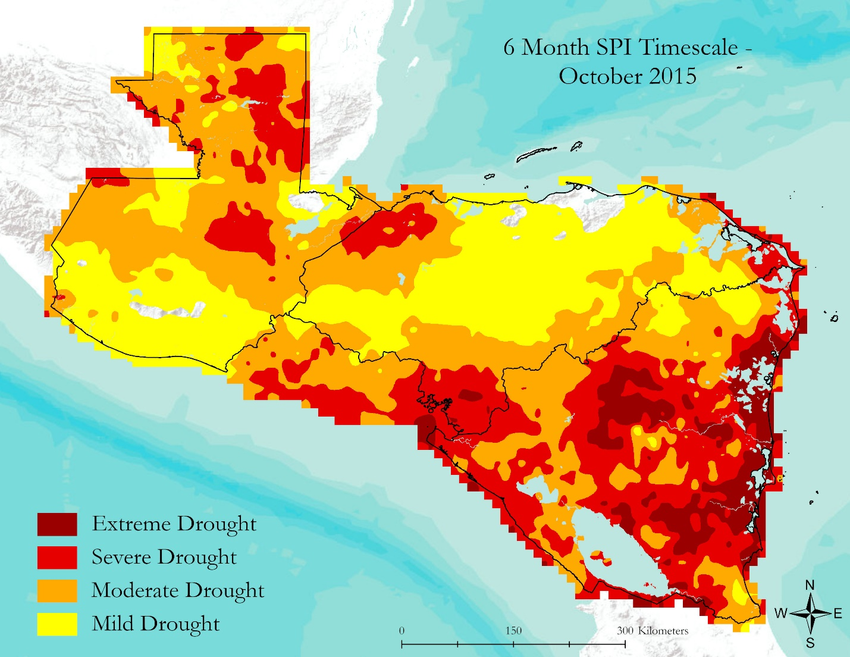Figure 2. Map showing the SPI values on a 6-month time scale for October 2015

SPI was calculated for the entirety of the study area at different time scales (1-month, 3-month, 6-month, 9-month, 12-month, and 24-month). However, when the data were displayed in a visual format, positive SPI values greater than 0 were given a transparent layer while all negative SPI values were given distinct colors and displayed visually. This prevented large amounts of positive values from being interspersed with negative values, as the goal of the project was to highlight the areas of Central America suffering from drought. These years were chosen as they are identified as both strong La Niña and El Niño events and mild La Niña and El Niño events by the ONI index, and demonstrate the latest available research product data on the current state of drought in the region. *Figure 2* represents the six-month SPI value of October 2015, this occurred during the 2014 to 2016 Central American drought and few transparent regions exist where vegetation would have remained at average levels or improved. The only areas containing transparent regions are swaths of land in the Northeast and Northwest situated in Guatemala and Honduras. Table 1 indicates what the colors in *Figure 2* represent and the summary of the likely impacts of the drought at each SPI value.

Table 1

The drought classification scale of SPI

|  |  |  |
| --- | --- | --- |
| **SPI Category** | **SPI Range** | **Summary** |
| Mild Drought | 0 to -0.99 | - Short-term dryness slowing planting, growth of crops of pasture  - Some lingering water deficits  - Pastures or crops not fully recovered |
| Moderate Drought | -1 to -1.49 | - Crop of pasture losses likely  - Water shortages common  - Water restrictions imposed |
| Severe Drought | -1.5 to -1.99 | - Major crop/pasture losses  - Widespread water shortages or restrictions |
| Extreme Drought | < -2 | - Exceptional and widespread crop/pasture losses  - Shortages of water in reservoirs, streams, and wells creating water emergencies |

***4.1.3 NDVI Analysis***

Monthly NDVI data from the years 2001 to 2010 were used to calculate long-term monthly averages for the months of January through December. Once long-term monthly averages were established, temporal change NDVI maps were generated for select months. Applying decade long monthly averages accounted for monthly unique seasonal events that occurred in the region and accounted for seasonal variability.

The NDVI scale was calculated at 1-kilometer resolution, resulting in a 1 km x 1 km grid, this differs from the 6-month SPI scale which was calculated at 10 km x 10 km scale. For SPI the 10 km scale was the finest resolution available and additionally captured microclimates and area specific trends without presenting too much noise. In terms of NDVI, finer resolution was available including data at a 500-meter and 250-meter scale. This presented too much noise and additionally the NDVI quality was diminished as results relied on 16-day composites which contained a greater amount of errors. The usage of 1 km data allowed a fine enough resolution to identify areas where vegetation had been impacted. The fine resolution also identified areas where our end users could find benefit and investigated specific areas while providing more accurate data on the areas that were impacted by ENSO onset related drought events.

The pacific region of the study area, which intersects the dry corridor, is experiencing the greatest NDVI temporal losses. Vegetation anomalies were most pronounced in the Dry Corridor particularly in western Nicaragua in the region bordering Lake Cocibolca and Lake Xolotlán (Figure 3). This occurred during the second year of the 2014 to 2016 Central American drought. In particular this El Niño event lead to severe drought and crop loss in the region.

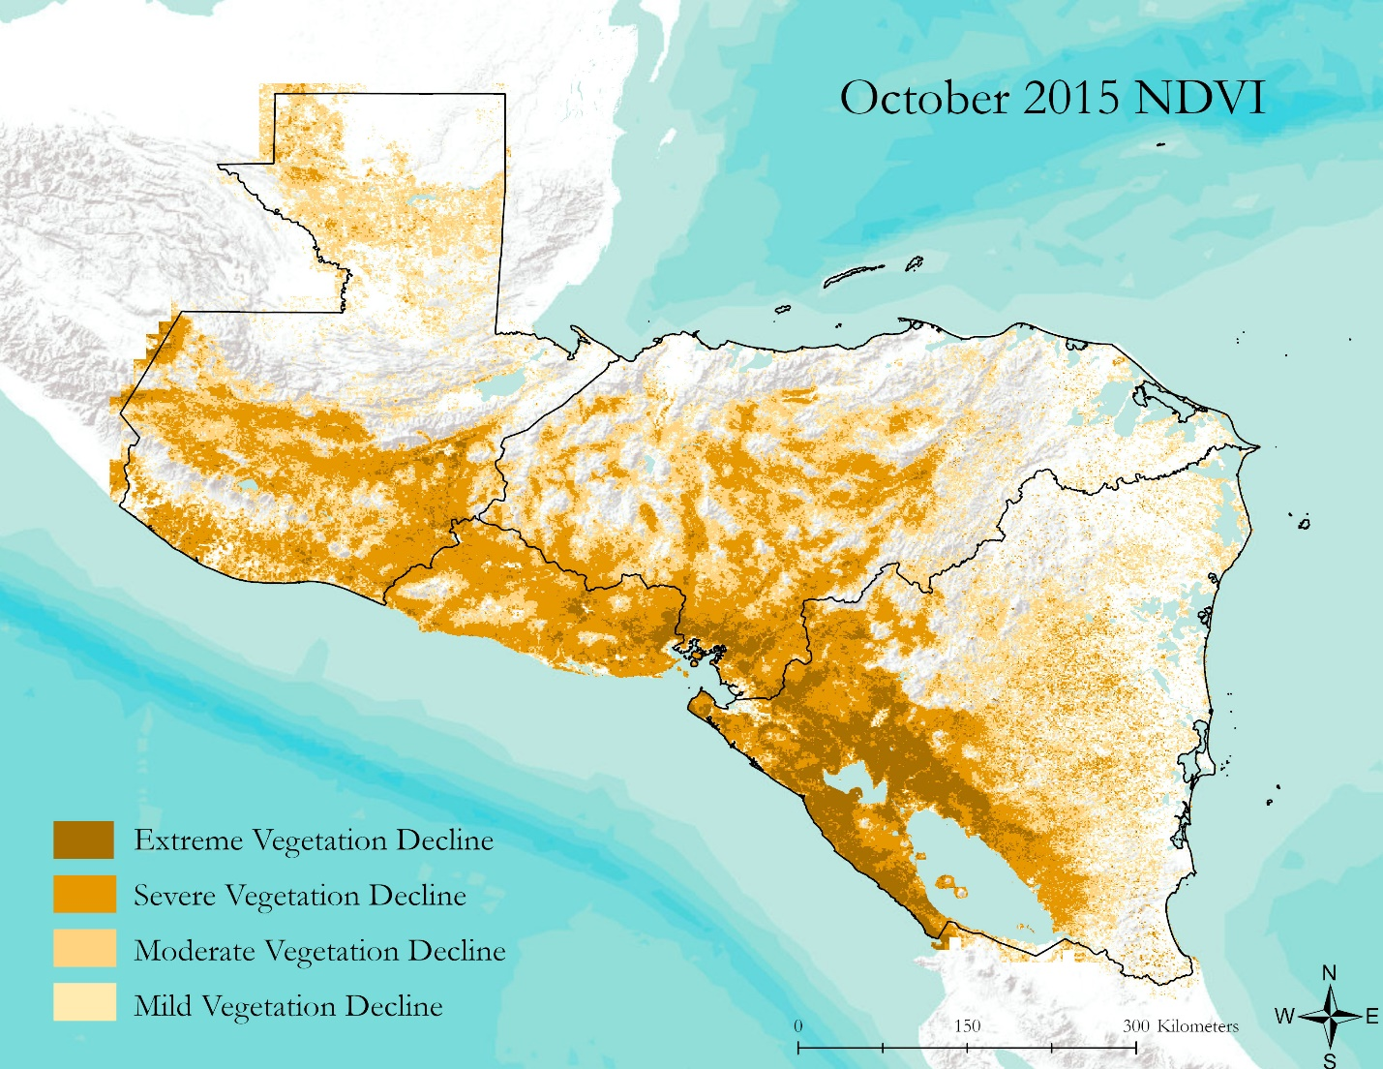Figure 3. Representation of regions in the study area which have seen temporal decreases in NDVI

***4.1.4 Processing SPI and NDVI Overlays***

Data from the SPI and NDVI analysis were reclassified so that only data of regions in severe or extreme drought were displayed in tandem with regions experiencing severe and extreme vegetation loss (Figure 4). This method of display allowed end-users to identify regions where drought occurred and there was a corresponding vegetation decline.

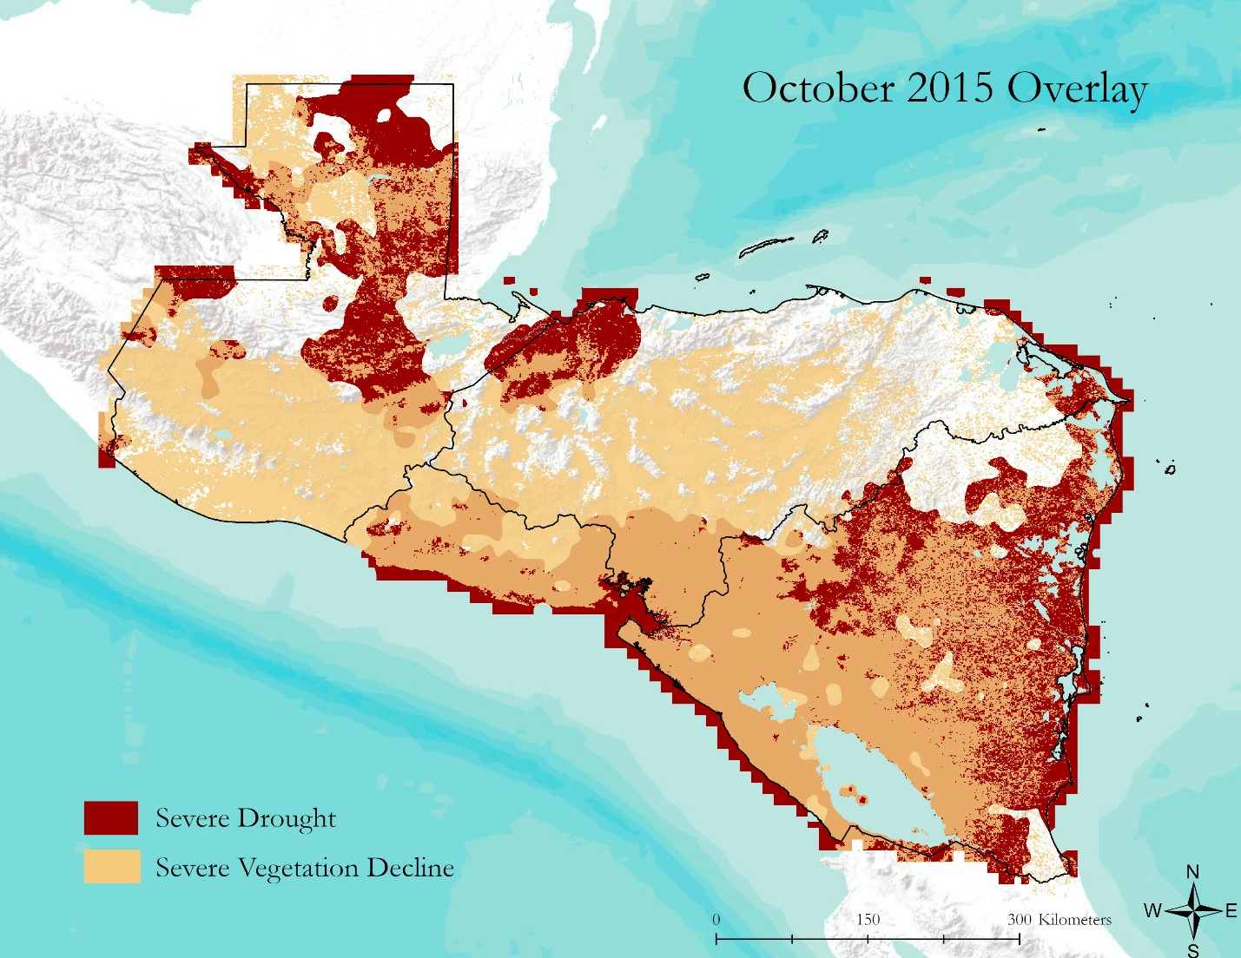

Figure 4. Figure demonstrates a large amount of severe vegetation decline and severe drought in Nicaragua and El Salvador. However, in both Honduras and Guatemala there are large tracts of severe drought with little vegetation decline and areas with large amounts of severe vegetation decline, which are not in severe drought in October 2015.

***4.2 Errors and Uncertainties***

The first error is that atmospheric composition impacts NDVI values as the composition of water vapors and aerosols can impact NDVI readings. The second error the team noted is that thin clouds can contaminate measurements, and cloud shadows that appear clear to sensors can lead to misinterpretations. The third error for users to be aware of when using NDVI are anisotropic effects, surfaces whether natural or anthropogenic reflect light differently in different directions. NDVI may develop on the particular anisotropy of a target within the time of passage of the satellite over the site. However, satellites can shift in the direction of their orbit leading to the potential for skewed data. Additionally, factors such as soil color may impact NDVI. As soils darken when wet so that that their reflectance is a direct function of water content, NDVI can appear to change because of soil moisture changes and not because of vegetation changes. When using MODIS NDVI, these considerations are significantly minimized with the usage of composite images (daily composites, 4-day, weekly, 8-day, 16-day, monthly, and yearly).

To address these shortcomings, we used the tool AppEEARS where we obtained monthly NDVI composites, quality control data, and pixel reliability information to see if there are any uncertainties with the data generated (*Figure 5*). This allowed our team to evaluate and select data that avoided or minimized the aforementioned shortcomings.

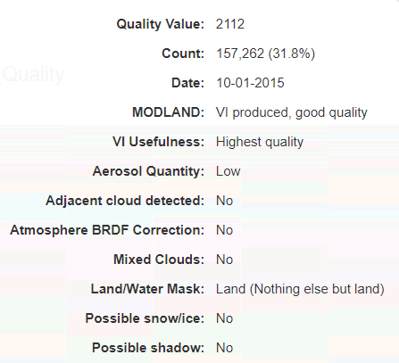

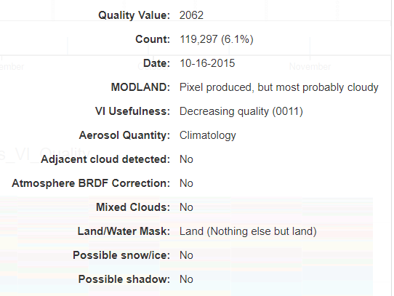

*Figure 5.*  Demonstration of AppEEARS quality tool. This chart demonstrates a comparison between pixels of two NDVI datasets.

***4.2.1 NDVI decline and confounding variables***

An additional issue with using just NDVI as a metric to co-analyze vegetation health is that NDVI is just a measurement of vegetation health. As a result, there are confounding variables that we were unable to account for. Declines in NDVI may not have been related to drought or precipitation deficits but other factors such as cold weather resulting in a shorter growing season, pathogens, pest infestations, natural disasters such as vegetation destroyed by hurricanes, landslides, hail, volcanic eruptions, fire, wind, flooding, or anthropologic means such as deforestation.

***4.2.3 SPI shortcomings***

SPI maintains short comings in its usage. The measurement relies only on precipitation which allows for consistent calculation globally based on satellite data. The precipitation data is loosely connected to ground conditions and other drought indication variables. Other precipitation indexes consider additional factors such as evapotranspiration and soil moisture for a more input. SPI calculations normalize data and allow a comparison of precipitation anomalies for different regions with highly variable climates. This means that SPI values can be compared across microclimates and regions with differing rainfall patterns. However, to interpret the degree of rainfall requires local climatology knowledge. SPI is a univariate measurement and lacks the ability to identify territories with a greater tendency toward drought.

***4.2.4 Overlay considerations***

Currently the relationship between SPI and NDVI is not clearly defined and is an active area of research. SPI may indicate dry conditions, however the impacts of this may not show up in vegetation for quite some time, if at all, depending on the timing with respect to growing cycles of the vegetation observed and the region under study. More variables would need to be brought into the equation such as evapotranspiration, anthropologic water usage, NDVI, and the relationship would need to be made clearer to better understand the comprehensive impacts of drought.

***4.3 Future Work***

In the future, it would be beneficial to include an in-depth crop analysis of the study area. This would allow for crop type specific indicators to be linked to a crop’s ideal growing conditions. As a result, co-analysis of NDVI and SPI would provide better results. This would be particularly constructive in areas of low flora biodiversity as viewing how precipitation deficits impact monocultures such as coffee, bananas, sugar, and maize would provide enhanced results. Understanding the link between drought and agriculture would be informative for policy makers. Our end users expressed interest in the prediction abilities of near real time data and SPI. Developing forecasting models and near real time results may be an area warranting further investigation.

Additionally, the application of a different drought index to the evaluate drought in Central America would be a good next step. SPI is adaptable and can be applied to monitor agricultural, meteorological, and hydrological drought. The development or application of a comprehensive or hybrid drought index for Central America will present a wide-ranging understanding of drought in the region. An example of a comprehensive drought index can be seen with the US Drought Monitor (USDM) which includes metrics such as SPI, The Palmer Drought Severity Index (PDSI), hydrologic conditions, and vegetation. These factors are aggregated into weekly maps of drought which are sent to local experts who refine the information. The USDM is dynamic and can respond to the needs of various water users including demands from urban, commercial, and agriculture uses (Zargar et al., 2011). Application of the PDSI or an index similar to USDM may provide a more comprehensive understanding of the drought.

The study of other vegetation indices may allow for better co-analysis with NDVI. Future usage should investigate the usage of the Enhanced Vegetation Index (EVI) and/or Leaf Area Index (LAI). The creation long-term NDVI averages would allow trends to be analyzed and could improve vegetation index calculations. For example, this could be creating a 20-year average in February 2020 using Terra MODIS. Establishing a 10-year average using the Visible Infrared Imaging Radiometer Suite (VIIRS) in 2021 would also be beneficial. Lastly, evaluating the differences between SPI data calculated from other Earth observations data including Precipitation Estimates from Remotely Sensed Information using Artificial Neural Networks (PERSIANN) and CPC MORPHing technique (CMORPH) would allow for an assessment of GPM-IMERG SPI accuracy.

**5. Conclusions**

This project relates to community concerns as the region faces significant impacts from El Niño related droughts. The most pernicious aspect of this natural weather pattern is it impacts a region where large swaths of the population experience food insecurity. In addition to the impacts on the food supply, economic consequences can be equally catastrophic impacting multiple cash crops such as tropical fruits and coffee. For project partners, the tutorial will instruct them on how to calculate SPI and replicate the team’s work to find vulnerable locations where they can implement drought mitigation policies in the future.

**6. Acknowledgements**

This project was made possible through the support and mentorship of select individuals and organizations.

We would like to thank:

* Dr. Jessica Matthews, North Carolina Institute for Climate Studies, North Carolina State University
* Dr. Olivier Prat, North Carolina Institute for Climate Studies, NOAA National Centers for Environmental Information
* Ronald Leeper, North Carolina Institute for Climate Studies, NOAA National Centers for Environmental Information
* Andrew Shannon, NASA DEVELOP – NC Node Fellow

Any opinions, findings, and conclusions or recommendations expressed in this material are those of the author(s) and do not necessarily reflect the views of the National Aeronautics and Space Administration.

This material is based upon work supported by NASA through contract NNL16AA05C.

**7. Glossary**

**Drought** – a prolonged period of abnormally low rainfall, leading to a shortage of water

**Earth observations** – Satellites and sensors that collect information about the Earth’s physical, chemical, and biological systems over space and time

**ENSO** – El Niño Southern Oscillation, an irregularly periodic variation in winds and sea surface temperature

**GPM** – Global Precipitation Measurement

**IMERG** – Integrated Multi-satellite Retrievals for GPM

**La Niña/El Niño** – Global Weather patterns part of the Oceanic Niño Index

**MODIS** – Moderate Resolution Imaging Spectroradiometer

**NDVI** – Normalized Distribution Vegetation Index, used to assess vegetation greenness

**ONI** – Oceanic Niño Index, the temperature of the ocean

**PERSIANN** – Precipitation Estimates from Remotely Sensed Information using Artificial Neural Networks

**SPI** – Standard Precipitation Index, the normalized precipitation that is used to identify meteorological

drought

**8. References**

Curtis, S. S. (2002). Interannual variability of the bimodal distribution of summertime rainfall over Central America and tropical storm activity in the far-eastern pacific. *Climate Research*, *22*(2), 141-146. https://doi.org/10.3354/cr022141

Didan, K. (2015). *MOD13Q1 MODIS/Terra Vegetation Indices 16-Day L3 Global 250m SIN Grid V006* [Data set]. NASA EOSDIS Land Processes DAAC. Accessed 2019-10-08 from <https://doi.org/10.5067/MODIS/MOD13Q1.006>

Food and Agriculture Organization of the United Nations. (30 June 2016).  To reduce El Niño's impact on Central America's Dry Corridor, build resilience and invest in sustainable agriculture. Retrieved October 8, 2019, from <http://www.fao.org/news/story/en/item/422132/icode/>

Huffman, G.J., Stocker, E.F., Bolvin, D.T., Nelkin, E.J., & Tan, J. (2019). GPM IMERG Final Precipitation L3 1 month 0.1 degree x 0.1 degree V06, Greenbelt, MD, Goddard Earth Sciences Data and Information Services Center (GES DISC), Accessed 2019-10-08. Doi: 10.5067/GPM/IMERG/3B-MONTH/06

Keyantash, J., & Dracup, J. (2002). The quantifications of drought: An evaluation of a drought indices. *American Meteorological Society*, *83*, 1167-1180. https://doi.org/10.1175/1520-0477-83.8.1167

Maurer, E. P., Roby, N., Stewart-Frey, I. T., & Bacon, C. M. (2017). Projected twenty-first-century changes in the Central American mid-summer drought using statistically downscaled climate projections. *Regional environmental change*, *17*(8), 2421-2432. <https://doi.org/10.1007/s10113-017-1177-6>

Beguería, S., & Vicente-Serrano, S. M. (2017). Package ‘SPEI’ [computer software].

Zargar, A., Sadiq, R., Naser, B., & Khan, F. I. (2011). A review of drought indices. *Environmental Reviews*, *19*, 333-349. doi: 10.1139/a11-013

**9. Appendix**

**Appendix A.**

**Values and Classes**

Table A1

*Outline of the NDVI scale*

|  |  |
| --- | --- |
| Type of Land Cover | NDVI (Scale from -1 to 1) |
| Thick Vegetation | 1.00 – 0.500 |
| Medium Vegetation | 0.500 – 0.140 |
| Scarce Vegetation | 0.140 – 0.090 |
| Bare Ground | 0.090 – 0.025 |
| Clouds | 0.025 – 0.002 |
| Ice and Snow | 0.002 – -0.046 |
| Water | -0.046 – -1.00 |

Table A2

*Outline of the SPI value scale*

|  |  |
| --- | --- |
| SPI Values | Class |
| ≥ 2.0 | Extreme Wetness |
| 1.5 - 1.99 | Severe Wetness |
| 1.0 – 1.49 | Moderate Wetness |
| 0.0 - 0.99 | Mild Wetness |
| -0.99 – 0.0 | Mild Drought |
| -1.49 – -1.0 | Moderate Drought |
| -1.99 - -1.5 | Severe Drought |
| ≤ -2.0 | Extreme Drought |